GEOLOGY, GEOPHYSICS AND HYDROGEOLOGY OF NANKA AND ITS ENVIRONS, SOUTHEASTERN NIGERIA

Abstract
This research work, presents an integrated geological, geophysical, and hydrogeochemical investigation of groundwater occurrence and quality in Nanka and its environs, located in Orumba North Local Government Area of Anambra State, Southeastern Nigeria. Increasing pressure on available water resources due to population growth and rural development necessitated a comprehensive evaluation of groundwater potential in the area. The study integrates geological field mapping, Vertical Electrical Sounding (VES), and laboratory-based water quality analyses to characterize aquifer geometry, lithology, and hydrochemical suitability. Geological mapping reveals that the area is predominantly underlain by the Eocene Nanka Formation, consisting of poorly consolidated, friable, medium to coarse-grained sands interbedded with shale and claystone units. These lithologies exert strong control on groundwater occurrence, storage, and vulnerability to erosion. Five VES stations were occupied using the Schlumberger array configuration to delineate subsurface stratigraphy and aquifer characteristics. The interpreted geoelectric sections show multilayered subsurface conditions comprising topsoil, dry sand, clayey sand, water-saturated sand, and shale. Aquifer units were identified at depths ranging approximately from 46 m to 146 m, with resistivity values between 289 Ωm and 3940 Ωm, indicating predominantly unconfined sandy aquifers of moderate to high transmissivity. Hydrochemical analysis of groundwater and surface water samples shows that while most physicochemical parameters fall within acceptable limits, certain trace metals such as iron (1.0020-1.2803 ppm), copper (0.143-0.243 ppm), and nickel (0.034-0.045 ppm) exceed recommended standards in some locations. The study confirms that groundwater potential in the area is significant but requires quality monitoring and treatment before domestic consumption. The integrated approach adopted in this work demonstrates its effectiveness in reducing uncertainty in groundwater evaluation and supports sustainable resource management in erosion-prone sedimentary terrains.
Keywords: Groundwater potential, Nanka, Southeastern Nigeria, Geological approach, Geophysical Survey, Hydrogeological.
Introduction
Groundwater plays a critical role in meeting domestic, agricultural, and small-scale industrial water demands in many parts of Southeastern Nigeria. In rural communities such as Nanka and its environs, dependence on groundwater is particularly high due to limited surface water infrastructure and increasing population pressure. The sustainable development of groundwater resources in such settings requires detailed understanding of the geological framework, aquifer characteristics, recharge mechanisms, and water quality conditions.
The study area lies within the eastern margin of the Niger Delta Basin, a major sedimentary province whose stratigraphic evolution and depositional history have been extensively documented (Reyment & Barber, 1956; Reyment, 1965; Nwajide, 2013). The basin comprises alternating sandy and shaly sequences that exert strong control on groundwater occurrence and movement. In Nanka and its surrounding communities, the dominant lithologic unit is the Nanka Formation, an Eocene sandy formation known for its high porosity and permeability (Nwajide, 1974; Nwajide & Hoque, 1979). These properties favor groundwater storage and transmission but also contribute to slope instability and severe gully erosion.
Hydrogeologically, groundwater recharge in the area occurs mainly through direct infiltration of rainfall and percolation of surface runoff, consistent with general principles of the hydrologic cycle (Heath, 1983; Fetter, 2001). The depth to water table and aquifer thickness vary spatially, influenced by topography, lithologic heterogeneity, and structural controls. Given the friable and poorly consolidated nature of the sandy formations, understanding subsurface conditions is essential not only for groundwater exploitation but also for environmental management.
Geophysical methods, particularly Vertical Electrical Sounding (VES), provide a reliable means of delineating subsurface lithology and identifying aquiferous horizons in sedimentary terrains. When integrated with geological mapping and hydrochemical analysis, such methods reduce uncertainty in groundwater exploration and improve borehole siting decisions.
This study therefore aims to investigate the geology and hydrogeology of Nanka and its environs through an integrated approach involving geological field mapping, resistivity-based geophysical survey, and laboratory analysis of water samples. The findings from this study are expected to contribute to improved groundwater resource development and management strategies within Nanka and similar sedimentary environments of Southeastern Nigeria.
Geology of the study area
The study area is situated within the eastern flank of the Niger Delta Basin, a major sedimentary basin in southern Nigeria whose stratigraphic architecture reflects a complex history of marine transgression, regression, and tectonic adjustments (Reyment & Barber, 1956; Reyment, 1965). The basin developed during the Paleogene–Neogene period as part of the broader evolution of the Gulf of Guinea margin and the Southern Benue Trough (Nwajide, 2013; Okpoko, 2017). The surface and near-surface geology of Nanka and its environs is dominated by sedimentary formations of Paleocene to Miocene age, which collectively influence the geomorphology, hydrogeology, and environmental stability of the region.
The principal lithostratigraphic units underlying the area include the Imo Formation, Ameki Formation, Nanka Formation, Nsugbe Formation, and Ogwashi-Asaba Formation. These formations represent a sequence of marine to paralic depositional environments, transitioning upward from deeper marine shales to shallow marine and continental sands. The Nanka Formation has been recognized as the loose sand facies of the Ameki Group (Nwajide, 2013). Although it is stratigraphically situated between the underlying transgressive marine Ameki Formation (Paleocene) and the overlying Nsugbe Formation (Miocene), Its boundaries with these adjacent units are transitional and have had to be arbitrarily placed. The lithology of the Formation is overwhelmingly loose, poorly cemented, flaser bedded, fine to medium sand, with a few mudrock breaks. The formation is of Eocene age and was deposited in an inter-tidal relatively high-energy marine environment (Nwajide, 2013) and consists of distinct units of sands, shale-siltstone and finely laminated shale (Nwajide, 2013). The Nanka Formation grades laterally into the very coarse-grained ferruginous sandstone called the Nsugbe Sandstone (Nwajide, 1980).
Water levels occur at shallow depths in the plains and valley courses while the water levels occur at greater depths in the highland areas (Okpoko, 2017). Groundwater recharge in the study area is by infiltration from rainfall and surface runoff. Through the Phases of hydrogeologic cycle the groundwater system is recharged from infiltration of part of Overland flow into the soil (Fetter, 2001; Heath, 1983). The drainage pattern of the basin is dentritic with individual streams flowing from sandy highlands to shaly lowlands.

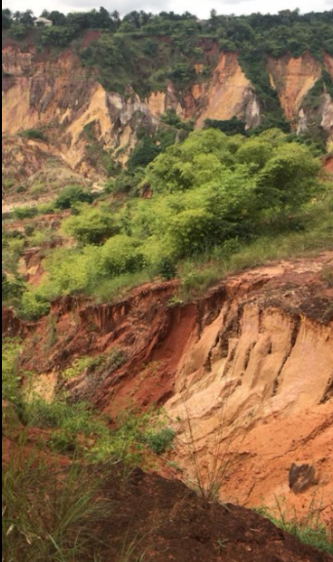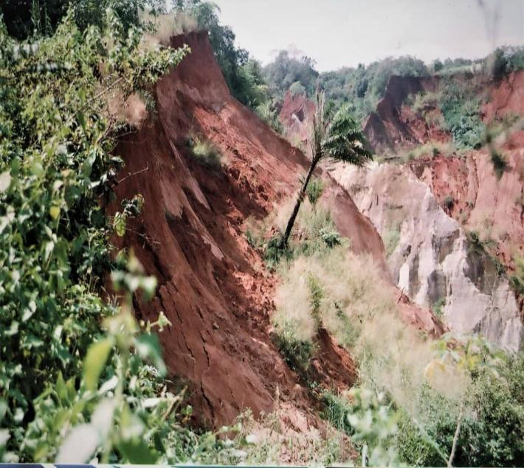
Fig. 1a. Amako gully erosion site Fig. 1b. Ugwu Okpana Erosion site.
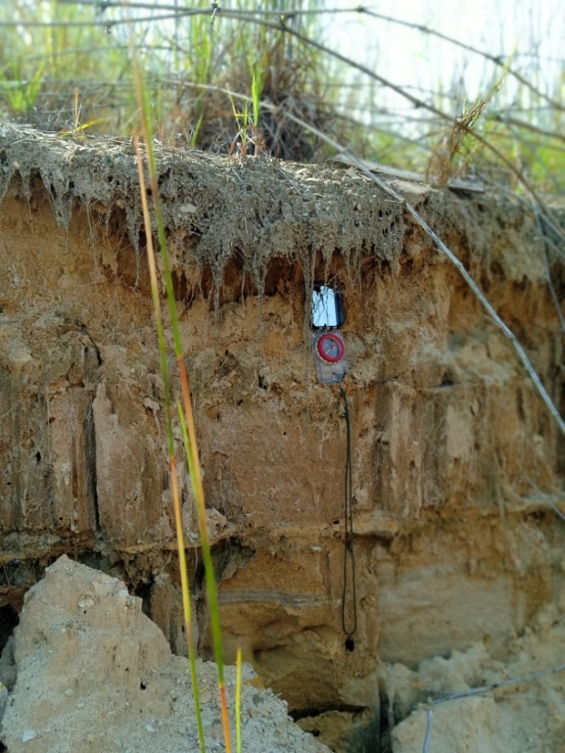
Fig. 2a. An outcrop at Obubu ntai dredging.
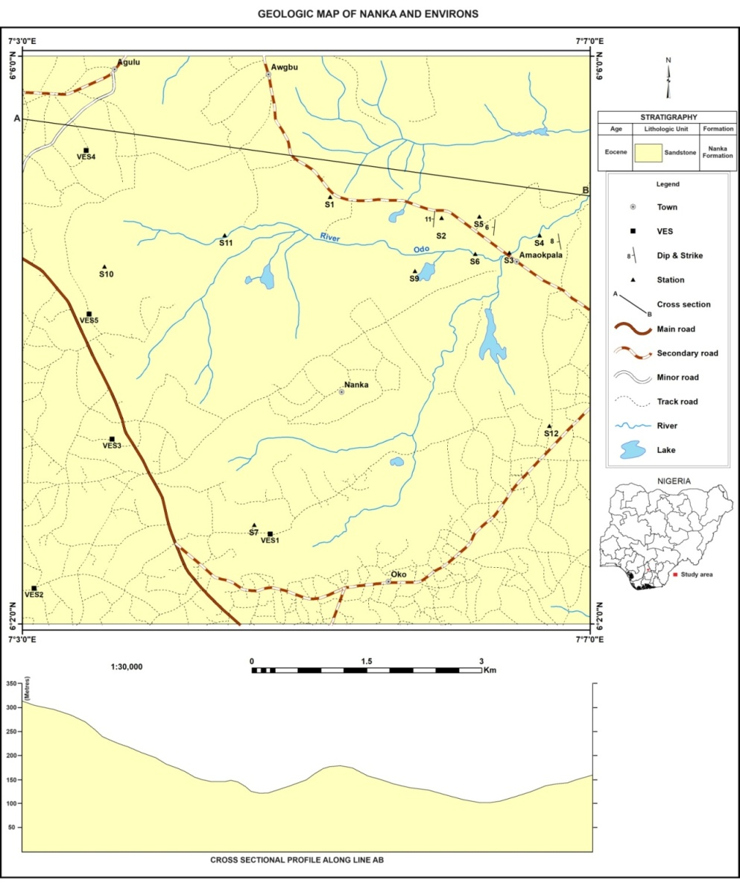
Fig. 2b. Geologic map of the study area

MATERIALS AND METHODS
Geological mapping
During the field work, outcrops were sited, observed and the positions marked using Global positioning system (GPS). This was followed by detailed logging of the outcrop taking note of the rock type (lateral extent, gross thickness, bed thickness) textural features (color, grain size, and sorting of grains, clay content, cementation/ compaction if present), sedimentary structures (nature of bedding, internal structure), tectonic structure (fracturing, joints, faults, folds), and biogenic structures. This constitutes the central part of this work.

Geophysical Survey.
A geophysical survey is a scientific method used to investigate the subsurface properties of the earth. It involves measuring and analyzing various physical parameters to gain information about the geological structures, subsurface composition and fluid content of an area. Geophysical surveys are commonly conducted in fields such as geology, environmental studies and engineering.

Vertical Electric Sounding
Vertical electric sounding (VES) is an example of geophysical survey. It is the process of sending electric current into the ground through the current electrodes in order to measure the potential difference across the terminals and determining the resistivity of each Formation/Layer. VES Equipments includes, Resistivity meter (ABEM Terrameter), electrodes, Hammers, Measuring Tapes, Global positioning system (GPS), Cables, clips and Battery.

Results and Discussions
The geophysical investigation of the study area was carried out using Schlumberger array. A total of five (5) Vertical Electrical Sounding (VES) was covered with AB/2 separation of 180m – 200m. This was carried out to investigate the depth to water table in the study area, the lateral extent of the aquifer and thickness.
The data is presented as follows;
VES Station 1
Table 1. Showing VES data for Station 1
AB/2 (m) | MN/2 (m) | K | R(Ω) | ρa(Ωm)
2 | 0.5 | 11.78 | 12.74 | 150.0772
4 | 0.5 | 49.5 | 6.6 | 326.7
6 | 0.5 | 112.36 | 2.69 | 302.2484
8 | 0.5 | 200.36 | 1.52 | 304.5472
10 | 0.5 | 313.5 | 0.8882 | 278.4507
15 | 0.5 | 706.36 | 0.3462 | 244.5418
20 | 3.5 | 174.09 | 1.49 | 259.3941
25 | 3.5 | 275.11 | 0.9062 | 249.3047
30 | 3.5 | 398.58 | 0.5859 | 233.528
40 | 3.5 | 712.87 | 0.2715 | 193.5442
50 | 3.5 | 116.83 | 0.1396 | 16.30947
60 | 3.5 | 1610.83 | 0.1039 | 167.3652
70 | 14 | 528 | 0.2619 | 138.2832
80 | 14 | 676.67 | 0.0995 | 67.32867
90 | 14 | 887.18 | 0.0764 | 67.78055
100 | 14 | 1100.45 | 0.0605 | 66.57723
120 | 20 | 1100 | 0.05004 | 55.044
140 | 20 | 1508.57 | 0.03278 | 49.45092
160 | 20 | 1980 | 0.02642 | 52.3116
180 | 20 | 2514.29 | 0.0205 | 51.54295
200 | 20 | 3111.43 | 0.00975 | 30.33644

The data gotten from Table 1 was interpreted as seen in Fig. 3, the Geo-electric curves was interpreted to be minimum of 4 layers. The first layer was interpreted as the top soil, it has an apparent resistivity of 144 Ωm at the depth of 2.01m with a thickness of 2.01m. The second layer was interpreted as dry sand, whose apparent resistivity is 346 Ωm, thickness of 12.4m at depth of 14.4m. The third layer has apparent resistivity of 289Ωm indicating presence of water. Hence the aquiferous unit, it has thickness of 50.9m with depth at 65.3m. The fourth layer has an apparent resistivity value of 10.5 Ωm indicating shale. It has an indeterminate thickness and depth.
Table 2. Geo-electric parameters of VES 1
Layers | Apparent resistivity  (Ωm) | Thickness (m) | Depth (m) | Inferred Lithology
1 | 144 | 2.01 | 2.01 | Top Soil
2 | 346 | 12.4 | 14.4 | Dry sand
3 | 289 | 50.9 | 65.3 | Water saturated sand
4 | 10.5 | - | - | Shale

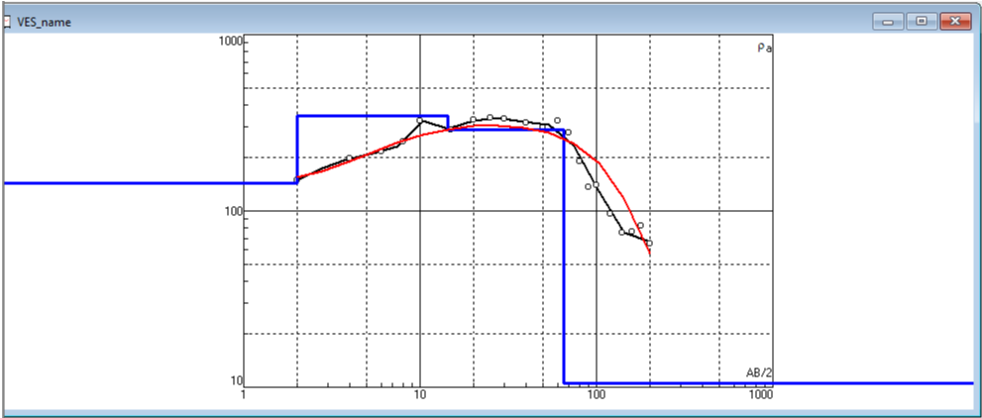
Fig. 3. Geoelectric of Amako Vertical Electrical Sounding data.

VES Station 3
Table 2 Showing VES data for Station 2.
AB/2 (m) | MN/2 (m) | K | R(Ω) | ρa(Ωm)
2 | 0.5 | 11.78 | 39.95 | 470.611
4 | 0.5 | 49.5 | 21.08 | 1043.46
6 | 0.5 | 112.36 | 12.84 | 1442.702
8 | 0.5 | 200.36 | 8.99 | 1801.236
10 | 0.5 | 313.5 | 6.57 | 2059.695
15 | 0.5 | 706.36 | 3.08 | 2175.589
20 | 3.5 | 174.09 | 15.11 | 2630.5
25 | 3.5 | 275.11 | 9.26 | 2547.519
30 | 3.5 | 398.58 | 6.74 | 2686.429
40 | 3.5 | 712.87 | 4.99 | 3557.221
50 | 3.5 | 116.83 | 3.89 | 4344.469
60 | 3.5 | 1610.83 | 3.2 | 5154.656
70 | 14 | 528 | 0.4762 | 251.4339
80 | 14 | 676.67 | 0.3794 | 264.3165
90 | 14 | 887.18 | 0.361 | 320.2719
100 | 14 | 1100.45 | 0.2433 | 267.7394
120 | 20 | 1100 | 0.1123 | 123.53
140 | 20 | 1508.57 | 0.1016 | 153.2707
160 | 20 | 1980 | 0.1123 | 214.2684
180 | 20 | 2514.29 | 0.1016 | 255.4518

The data gotten from Table 3 was interpreted as seen in Fig 4, the Geo-electric curves was interpreted to be minimum of 5 layers. The first layer represents the top soil, it has an apparent resistivity of 443Ωm at the depth of 2.23m with a thickness value of 2.23. The second layer was interpreted to be dry sand, whose apparent resistivity is 1959Ωm, thickness value of 7.9m at depth of 10.1m. The third layer has an apparent resistivity of 2410Ωm indicating increased in resistivity, it has thickness of 39m with depth at 49.1m and it was interpreted as sand. Hence the aquiferous unit. The fourth layer has an apparent resistivity value of 226Ωm indicating shale, it has a thickness of 92.7m and depth at 142m. The last geo-electric layer showed apparent resistivity of 7427, the base was not reached to determine the thickness and the depth, and it was interpreted as sand.
Table 4. Geo-electric parameters of VES 2
Layers | Apparent resistivity  (Ωm) | Thickness (m) | Depth (m) | Inferred Lithology
1 | 443 | 2.23 | 2.23 | Top Soil
2 | 1959 | 7.9 | 10.1 | Dry sand
3 | 2410 | 39 | 49.1 | Water bearing sand
4 | 226 | 92.7 | 142 | Shale
5 | 7427 | - | - | Sand

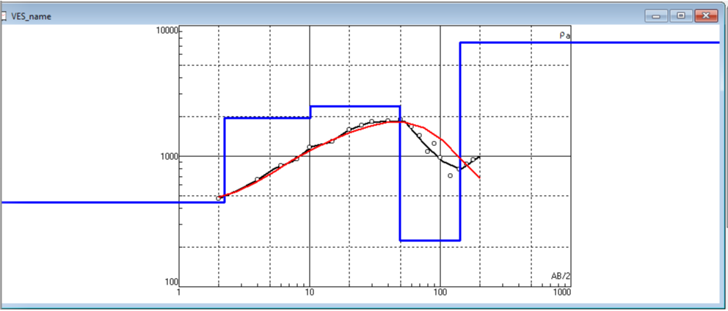
Fig. 4. Geoelectric of community High School Vertical Electrical Sounding data

VES Station 3
Table 5. Showing VES data for Station 3.
AB/2 (m) | MN/2 (m) | K | R (Ω) | ρa (Ωm)
2 | 0.5 | 11.78 | 39.95 | 470.611
4 | 0.5 | 49.5 | 21.08 | 1043.46
6 | 0.5 | 112.36 | 12.84 | 1442.702
8 | 0.5 | 200.36 | 8.99 | 1801.236
10 | 0.5 | 313.5 | 6.57 | 2059.695
15 | 0.5 | 706.36 | 3.08 | 2175.589
20 | 3.5 | 174.09 | 15.11 | 2630.5
25 | 3.5 | 275.11 | 9.26 | 2547.519
30 | 3.5 | 398.58 | 6.74 | 2686.429
40 | 3.5 | 712.87 | 4.99 | 3557.221
50 | 3.5 | 116.83 | 3.89 | 4344.469
60 | 3.5 | 1610.83 | 3.2 | 5154.656
70 | 14 | 528 | 0.4762 | 251.4336
80 | 14 | 676.67 | 0.594 | 264.3168
90 | 14 | 887.18 | 0.3794 | 320.2719
100 | 14 | 1100.45 | 0.361 | 267.7394
120 | 20 | 1100 | 0.1123 | 123.53
140 | 20 | 1508.57 | 0.1016 | 153.2707
160 | 20 | 1980 | 0.1123 | 214.2684
180 | 20 | 2514.29 | 0.1016 | 255.4518
200 | 20 | 3111.43 | 0.24337 | 757.2287

The data gotten from Table 5 was interpreted as seen in Fig 5, the Geo-electric curves was interpreted to be minimum of 5 layers. The first layer represents the top soil, it has an apparent resistivity of 466Ωm at the depth of 2.29m with a thickness value of 2.29. The second layer was interpreted to be dry sand, whose apparent resistivity is 2064Ωm, thickness value of 7.71m at depth of 10.m. The third layer has an apparent resistivity of 2851Ωm indicating increased in resistivity, it has thickness of 36m with depth at 46m and it was interpreted as sand. Hence the aquiferous unit. The fourth layer has an apparent resistivity value of 232Ωm indicating shale, it has a thickness of 92.2m and depth at 138m. The last geo-electric layer showed apparent resistivity of 2090Ωm, the base was not reached to determine the thickness and the depth, and it was interpreted as sand.

Table 6: Geo-electric parameters of VES 3
Layers | Apparent resistivity  (Ωm) | Thickness (m) | Depth (m) | Inferred Lithology
1 | 466 | 2.29 | 2.29 | Top Soil
2 | 2064 | 7.71 | 10. | Dry sand
3 | 2851 | 36 | 46 | Water bearing sand
4 | 232 | 92.2 | 138 | Shale
5 | 7427 | - | - | Sand

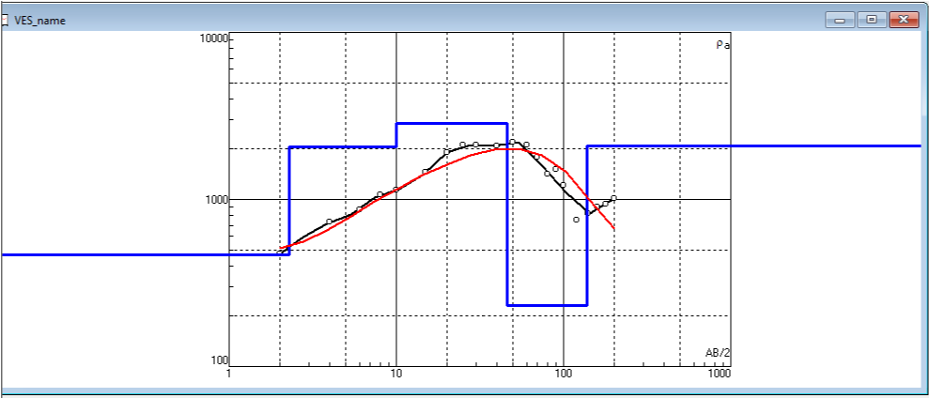
Fig. 5. Geoelectric of Ofu- Obi Comprehensive health care Vertical Electrical Sounding data

VES Station 4
Table 7. Showing VES data for Station 4.
AB/2 (m) | MN/2 (m) | K | R (Ω) | ρa (Ωm)
2 | 0.5 | 11.78 | 24.23 | 285.4294
4 | 0.5 | 49.5 | 8.95 | 443.025
6 | 0.5 | 112.36 | 4.54 | 510.1144
8 | 0.5 | 200.36 | 2.55 | 510.918
10 | 0.5 | 313.5 | 1.98 | 620.73
15 | 0.5 | 706.36 | 1.25 | 882.95
20 | 3.5 | 174.09 | 11.87 | 2066.448
25 | 3.5 | 275.11 | 7.73 | 2126.6
30 | 3.5 | 398.58 | 3.21 | 2148.356
40 | 3.5 | 712.87 | 2.44 | 2288.313
50 | 3.5 | 116.83 | 1.79 | 2725.065
60 | 3.5 | 1610.83 | 4.23 | 2883.386
70 | 14 | 528 | 3.29 | 2233.44
80 | 14 | 676.67 | 2.6 | 2292.044
90 | 14 | 887.18 | 2.07 | 2306.668
100 | 14 | 1100.45 | 3.56 | 2277.932
120 | 20 | 1100 | 2.44 | 2684
140 | 20 | 1508.57 | 2.26 | 3409.368
160 | 20 | 1980 | 1.51 | 2881.08
180 | 20 | 2514.29 | 0.7949 | 1998.609
200 | 20 | 3111.43 | 0.5549 | 1726.533

The data gotten from Table 7 was interpreted as seen in Fig 6, the Geo-electric curves was interpreted to be minimum of 5 layers. The first layer represents the top soil, it has an apparent resistivity of 278Ωm at the depth of 1.98m with a thickness value of 1.98m. The second layer was interpreted to be clayey sand, with apparent resistivity of913Ωm, thickness value of 4.8m at depth of 6.78m. The third layer has an apparent resistivity of 2926Ωm, it has thickness of 9.15m with depth at 15.9m and it was interpreted as dry sand. The fourth layer has apparent resistivity value of 3599Ωm, indicating the presence of water, hence the aquiferous unit, it has a thickness of 130m and depth at 146m. The last geo-electric layer showed apparent resistivity of 100Ωm, the base was not reached to determine the thickness and the depth, and it was interpreted as shale.
Table 8 Geo-electric parameters of VES 4
Layers | Apparent resistivity  (Ωm) |  | Thickness (m) |  | Depth (m) |  | Inferred Lithology
1 | 278 |  | 1.98 |  | 1.98 |  | Top Soil
2 | 913 |  | 4.8 |  | 6.78 |  | Clayey sand
3 | 2926 |  | 9.15 |  | 15.9 |  | Dry sand
4 | 3599 |  | 130 |  | 146 |  | Water saturated sand
4 | 3599 | 130 |  | 146 |  | Water saturated sand
5 | 100 | - |  | - |  | Shale

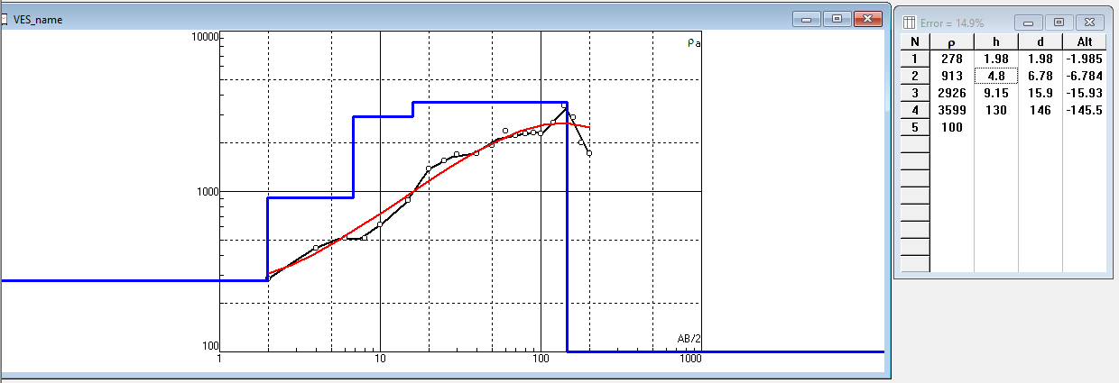
Fig 6. Geoelectric of Agunkwo primary school Vertical Electrical Sounding data
VES Station 5
Table 9. Showing VES data for Station 5
AB/2 (m) | MN/2 (m) | K | R (Ω) | ρa (Ωm)
2 |  | 11.78 | 24.35 | 51.248
4 |  | 49.5 | 11.76 | 582.12
6 |  | 112.36 | 7.4 | 831.464
8 | 0.5 | 200.36 | 4.57 | 915.6452
10 |  | 313.5 | 3.58 | 1122.33
15 |  | 706.36 | 1.88 | 2014.221
20 |  | 174.09 | 11.57 | 2470.488
25 |  | 275.11 | 8.98 | 3108.924
30 | 3.5 | 398.58 | 7.8 | 4398.408
40 |  | 712.87 | 6.17 | 4478.488
50 |  | 116.83 | 4.01 | 5396.281
60 |  | 1610.83 | 3.35 | 5216.64
70 | 14 | 528 | 9.88 | 5420.093
80 |  | 676.67 | 7.78 | 4489.131
90 |  | 887.18 | 5.06 | 2729.116
100 |  | 1100.45 | 2.48 | 1749
120 |  | 1100 | 1.59 | 1659.427
140 |  | 1508.57 | 1.1 | 194.4252
160 | 20 | 1980 | 0.9019 | 2066.746
180 |  | 2514.29 | 0.822 | 1239.594
200 |  | 3111.43 | 0.3984 | 757.2287

The data gotten from Table 9 was interpreted as seen in Fig 7, the Geo-electric curves was interpreted to be minimum of 5 layers. The first layer represents the top soil, it has an apparent resistivity of 204Ωm at the depth of 1.98m with a thickness value of 1.98m. The second layer was interpreted to be clayey sand, with apparent resistivity of 1168Ωm, thickness value of 3.32m at depth of 5.31m. The third layer has an apparent resistivity of 2851Ωm, it has thickness of 18.2m with depth at 23.5m and it was interpreted as dry sand. The fourth layer has apparent resistivity value of 3940Ωm, indicating the presence of water, hence the aquiferous unit, it has a thickness of 76.5m and depth at 100m. The last geo-electric layer showed apparent resistivity of 117Ωm, the base was not reached to determine the thickness and the depth, and it was interpreted as shale.
Table 10. Geo-electric parameters of VES 5
Layers | Apparent resistivity  (Ωm) | Thickness (m) | Depth (m) | Inferred Lithology
1 | 204 | 1.98 | 1.98 | Top Soil
2 | 1168 | 3.32 | 5.31 | Clayey sand
3 | 2851 | 18.2 | 23.5 | Dry sand
4 | 3940 | 76.5 | 100 | Water saturated sand
5 | 117 | - | - | Shale
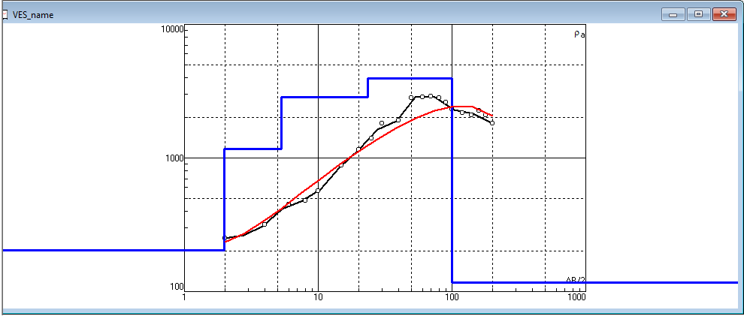
Fig. 7. Geoelectric of St. Faith Anglican Church Nanka Vertical Electrical Sounding data
Generally, aquifer depths in the study area range between approximately 46 m and 146 m, with thickness varying from 36 m to 130 m. Resistivity values between 289 Ωm and 3940 Ωm indicate saturated sandy formations with moderate to high transmissivity.

Water Table Map
The water table is the plane that marks the upper surface of the groundwater saturation zone in an unconfined aquifer, where pore spaces are completely filled with water. The elevation and depth of the water table are influenced by factors such as topography, the lithology of surface rocks, recharge rates, and climatic conditions. From the study area the VES 5 has the highest depth to the water while VES 2 has the closest. In general, the water table tends to mirror the shape of the land surface, rising beneath hills and dipping beneath valleys, but it can fluctuate due to seasonal variations, rainfall patterns, and human activities like groundwater extraction.
To map the water table, geoelectric survey data were used to determine the depth to the top of the aquifer. The data were then contoured using Surfer 13 to produce a detailed water table map, providing insight into the distribution and movement of groundwater across the study area.
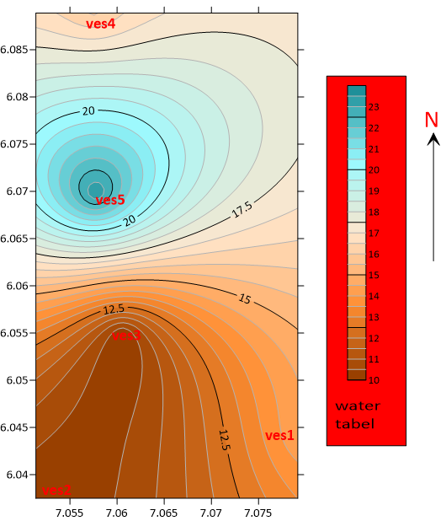

Fig. 8: Water table map
Water analysis result and interpretation
Hydrochemical evaluation was carried out on three representative water sources within the study area: Obubu Ntai Stream, Rock Tama Lake, and a borehole near St. Matthew Catholic Church, Nanka. The objective was to determine the physicochemical characteristics, mineral composition, and suitability of the water for domestic and potable use. The results reflect the interaction between groundwater and the sandy–shaly lithologic units of the Nanka Formation and associated stratigraphic units.

Physical Parameters
The measured pH values range from 7.62 to 7.76, indicating neutral to slightly alkaline water. This range falls within acceptable drinking water standards (6.5–8.5). The near-neutral pH suggests minimal acidic contamination and reflects buffering effects from dissolved bicarbonates and silicate minerals in the sandy aquifer system. Slight alkalinity is common in groundwater circulating through sandstone aquifers due to dissolution of feldspars and minor carbonate cement. TDS values range from 70 mg/L (borehole) to 210 mg/L (Rock Tama Lake). These values indicate low mineralization and classify the water as fresh. Generally, TDS below 500 mg/L is considered suitable for drinking. The relatively low TDS confirms limited evaporative concentration and moderate water–rock interaction, consistent with a predominantly sandy, high-permeability aquifer where groundwater residence time may not be excessively long. Electrical conductivity values range between 48 µS/cm and 84 µS/cm. These values correlate strongly with TDS concentrations and indicate low ionic content. The low conductivity further supports the interpretation of relatively dilute groundwater typical of recharge-dominated, unconfined sandy aquifers. Turbidity values range from 3.2 to 4.2 NTU. Although slightly elevated in surface water samples, they remain within tolerable limits for untreated natural waters. Higher turbidity in streams may be attributed to suspended sediments derived from intense gully erosion in the friable sandy terrain.
Major Anions and Hardness
Sulphate concentrations range from approximately 73.8 to 82.9 mg/L. These values fall within acceptable drinking water limits. Sulphate in the study area likely originates from oxidation of sulphide minerals or dissolution of sulphate-bearing sediments. The absence of excessive sulphate indicates limited influence from evaporite deposits or industrial contamination. Chloride values range from 25 to 50 mg/L. These concentrations are relatively low and suggest minimal saline intrusion or anthropogenic contamination. Chloride commonly enters groundwater through atmospheric deposition, rainfall recharge, or minor contributions from domestic waste. The low chloride concentration supports the conclusion that the aquifer is not influenced by saline water intrusion. Bicarbonate concentrations vary significantly, with the borehole sample recording the highest value (257.5 mg/L). Elevated bicarbonate indicates active silicate weathering and dissolution processes within the sandy formation. Bicarbonate is typically the dominant anion in sandstone aquifers and reflects carbon dioxide dissolution in recharge water followed by mineral interaction.

Total Hardness and Nitrate (NO₃⁻)
Total hardness values range from 86 to 108 mg/L. These values classify the water as moderately hard. Hardness is primarily controlled by calcium and magnesium concentrations. Moderate hardness is expected in groundwater interacting with feldspathic sandstones and minor carbonate cement. While not harmful to health, hardness may cause scaling in pipes and domestic appliances. Nitrate concentrations range from approximately 6.4 to 8.9 mg/L. These values are below the maximum permissible limit of 50 mg/L for drinking water. Low nitrate levels suggest minimal contamination from agricultural runoff, septic systems, or organic waste. However, given the rural nature of the area, continuous monitoring is advisable.

Dissolved Oxygen (DO) and Biochemical Oxygen Demand (BOD)
Dissolved oxygen values are relatively high, ranging from approximately 30.9 to 33.5 mg/L on day one and decreasing slightly by day five. The reduction over time reflects oxygen consumption by microbial activity. Biochemical Oxygen Demand (BOD) values range from 62 to 72 mg/L. Elevated BOD in surface water samples may indicate organic matter presence, possibly from runoff or decaying vegetation. In contrast, groundwater typically exhibits lower biological activity due to filtration through porous media.

Trace and Heavy Metals (Iron (Fe), Copper (Cu), Nickel (Ni))
Trace metal concentrations provide important insight into water quality and geochemical processes. Iron concentrations range from 0.5250 ppm (borehole) to 1.2803 ppm (Rock Tama). These values exceed the commonly recommended limit of 0.3 ppm for drinking water. Elevated iron is likely derived from ferruginous sandstone units within the Nanka Formation. Iron enrichment occurs through dissolution of iron oxides and hydroxides under reducing conditions. Copper concentrations range from 0.043 to 0.243 ppm. Some samples exceed the typical recommended limit of 0.01 ppm. Copper presence may result from natural mineralization or corrosion of metallic components in borehole systems. Elevated copper levels can cause gastrointestinal irritation if consumed in high concentrations. Nickel concentrations range from 0.034 to 0.045 ppm. In some cases, these values approach or exceed guideline limits. Nickel occurrence may be linked to trace mineral inclusions within the sandstone matrix or anthropogenic sources. Chronic exposure to elevated nickel levels may pose health concerns, necessitating periodic monitoring.

The major Cations (Calcium (Ca²⁺), Magnesium (Mg²⁺), Sodium (Na⁺), and Potassium (K⁺))
Calcium concentrations range approximately from 4.089 ppm to 4.992 ppm. These values are relatively low and fall well within permissible drinking water limits. The moderate calcium concentration contributes to total hardness but does not indicate excessive mineralization. Magnesium concentrations range between 3.278 ppm and 3.673 ppm. These values are low to moderate and comparable to calcium levels. From a health perspective, magnesium at these concentrations does not pose toxicity risks and may even contribute beneficial dietary intake. Sodium concentrations range from 4.893 ppm to 6.089 ppm. These values are relatively low and well below levels associated with salinity or sodicity problems. In irrigation contexts, sodium hazard is negligible at these levels. For drinking purposes, the sodium content poses no health concern. Potassium concentrations range from 4.893 ppm to 5.933 ppm. Potassium typically occurs in lower concentrations in groundwater because it is readily fixed by clay minerals during ion exchange processes. However, the absence of excessive potassium confirms limited contamination from fertilizers or waste disposal.

Table 11 Water Analysis Result Table.
Sample | Obubu ntai Stream | Borehole close to St Matthew Catholic Nanka. | Rock tama lake
Sulphate Mg/l | 73.788 | 76.898 | 82.899
Chloride Mg/l | 50 | 25 | 35
Bicarbonate Mg/l | 45 | 257.5 | 132.5
Total hardness Mg/l | 86 | 92. | 108
Nitrate Mg/l | 6.524 | 6.401 | 8.896
TDS mg/l | 110 | 70 | 210
PH | 7.62 | 7.76 | 7.76
Conductivity usm/cm | 54 | 48 | 84
Turbidity NTU | 4.0 | 4.2 | 3.2
D.O mg/l day 1 | 30.9 | 31.6 | 33.5
DO day 5 | 24.2 | 25.4 | 26.3
BOD mg/l | 67 | 62 | 72
Iron ppm | 1.2803 | 1.0020 | 0.5250
Copper ppm | 0.143 | 0.243 | 0.043
Nickel ppm | 0.034 | 0.045 | 0.034
Sodium ppm | 4.893 | 5.844 | 6.089
Magnesium ppm | 3.584 | 3.278 | 3.673
Potassium ppm | 5.933 | 4.893 | 4.995
Calcium ppm | 4.992 | 4.089 | 4.389

Conclusion.
This study has provided a comprehensive evaluation of the geology and hydrogeology of Nanka and its environs in Orumba North Local Government Area of Anambra State, Southeastern Nigeria. Through the integration of geological mapping, geophysical investigation using Vertical Electrical Sounding (VES), and hydrochemical analysis, the research has established a clearer understanding of aquifer characteristics, groundwater potential, and water quality conditions within the area.
Geologically, the study area is dominated by the sandy facies of the Nanka Formation, a unit characterized by poorly consolidated, friable, medium- to coarse-grained sands interbedded with shale and claystone. This formation forms part of the Ameki Group within the Niger Delta Basin stratigraphic succession. The high porosity and permeability of these sands make them effective aquifer units capable of storing and transmitting significant quantities of groundwater. However, the same unconsolidated nature of the sediments contributes to intense gully erosion, slope instability, and environmental degradation, which indirectly affect groundwater sustainability.
Geophysical investigation through five VES stations successfully delineated subsurface lithologic layering and identified aquiferous horizons across the study area. The interpreted geoelectric sections reveal a typical multilayered sequence consisting of topsoil, dry sand or clayey sand, water-saturated sand, and underlying shale. Aquifer depths range approximately from 46 m to 146 m, with thicknesses varying between about 36 m and 130 m. Resistivity values within aquifer units (approximately 289-3940 Ωm) confirm the presence of saturated sandy formations with moderate to high transmissivity. The aquifers are predominantly unconfined, with recharge occurring mainly through direct rainfall infiltration and surface runoff percolation. Water table configuration generally reflects surface topography, being shallower in valley areas and deeper beneath uplands.
Hydrochemical analysis indicates that groundwater in the area is generally fresh and low in total dissolved solids, with TDS values ranging from 70 to 210 mg/L and conductivity between 48 and 84 µS/cm. The pH values (7.62-7.76) show neutral to slightly alkaline conditions, consistent with groundwater circulating through sandstone aquifers. Major ions such as sulphate, chloride, and nitrate occur within acceptable limits, indicating minimal influence from saline intrusion or significant anthropogenic contamination.
However, elevated concentrations of iron (1.0020-1.2803 ppm), copper (up to 0.243 ppm), and nickel (up to 0.045 ppm) were recorded in some samples. These concentrations exceed recommended drinking water standards in certain cases and are most likely attributable to water-rock interaction within ferruginous sandstone units rather than industrial pollution. Although iron enrichment is common in sandy aquifers and does not pose severe toxicity risks, it can cause aesthetic and operational problems such as staining, unpleasant taste, and pipe clogging. Consequently, groundwater from the area requires appropriate treatment, particularly iron removal before domestic consumption.
REFERENCES
Fetter, C. W. (2001). Applied hydrogeology (4th ed.). Prentice Hall.
Heath, R. C. (1983). Basic ground-water hydrology. U.S. Geological Survey Water-Supply Paper 2220.
Nwajide, C. S. (1974). Sedimentology and stratigraphy of Nanka Sand (M.Phil. thesis). University of Nigeria, Nsukka, Nigeria.
Nwajide, C. S. (2006). A guide for geological field trips to Anambra and related sedimentary basins in southeastern Nigeria. University of Nigeria, Nsukka.
Nwajide, C. S. (2013). Nigerian sedimentary basins. CSS Press, Pp. 321-333.
Nwajide, C. S., & Hoque, M. (1979). Trace fossils from the Nanka Formation, southeastern Nigeria. Geologie en Mijnbouw, 58, 85–88.
Nwajide, C.S. (1986). The provenance of Nanka sand, Southeastern Nigeria; Geological Survey
Nwajide, C.S., A guide for geological field trips to Anambra and related sedimentary basins in Southeastern Nigeria. PTDF Fund, Univ. Of Nigeria, Nsukka, (2006), 68pp
Nwajide, S.C. 1974 Sedimentology and Stratigraphy of Nanka Sand. M. Phil) thesis. Dept of Geol, I Univ. Nig. Nsukka Nigeria.
Okpoko, C. B. (2017). The role of tectonics and climate in the evolution of the Niger Delta.
Reyment, R. A. (1965). Aspects of the Geology of Nigeria. Ibadan University Press, pp. 124-135
Reyment, R. A., & Barber, W. (1956). The geology of the Niger Delta. Geological Survey of
Reyment, R. A., & Barber, W. (1956). The geology of the Niger Delta. Geological Survey of Nigeria Bulletin, 31, 1–103.

