Hydrogeochemical Evaluation and Groundwater Quality Assessment for Drinking and Irrigation Purposes of Lokapavani River Basin, Mandya District, Karnataka

Abstract
Groundwater is a vital source of drinking and irrigation water in semi-arid and rural regions. The present study evaluates the hydrochemical characteristics and water quality of groundwater collected from 41 locations in the study area during the pre-monsoon and post-monsoon seasons of the year 2023. A total of physicochemical parameters including pH, total dissolved solids (TDS), total hardness (TH), electrical conductivity (EC), calcium (Ca), magnesium (Mg), sodium (Na), potassium (K), chloride (Cl), nitrate (NO₃), sulfate (SO₄), bicarbonate (HCO₃), and fluoride (F) were analyzed. Groundwater quality was assessed using the Water Quality Index (WQI) for drinking purposes and irrigation indices such as Sodium Adsorption Ratio (SAR), Sodium Percentage (Na%), Permeability Index (PI), USSL diagram, and Wilcox diagram. The WQI values range from 16.79 to 106.16, indicating water quality varying from excellent to unsuitable for drinking. Most samples fall within the good-to-poor water quality categories, whereas a few locations exhibit very poor-to-unsuitable water quality due to higher mineralization and anthropogenic influences. The fluoride (F⁻) concentration ranges from 0.22 to 1.90 mg/L, and although most samples fall within the permissible limit of 1.5 mg/L, slightly elevated concentrations in some locations may pose potential health risks if consumed over long periods. The irrigation indices indicate low sodium hazard and moderate salinity hazard, suggesting that groundwater is generally suitable for irrigation purposes with proper soil management practices. The study highlights the importance of continuous groundwater monitoring to ensure sustainable water resource management.
Keywords: Groundwater, Water Quality Index, USSL, Wilcox, Piper, Permeability Index, SAR, %NA

1. Introduction
Groundwater is one of the most important sources of freshwater used for domestic, agricultural, and industrial purposes worldwide. In many developing regions, groundwater serves as the primary source of drinking water due to its widespread availability and relatively stable quality compared to surface water sources (Li et al., 2021). The Lokapavani River is an important water resource for the surrounding communities, providing water for domestic use and irrigation for agricultural activities in nearby regions. Therefore, assessing the groundwater water quality of the Lokapavani River Basin is essential for the sustainable management and utilization of local water resources and for protecting the ecological environment. Hydrochemical analysis indicates that water chemistry in the study area is mainly influenced by natural geochemical processes such as rock–water interaction and mineral weathering (Sagar et al., 2025). These processes significantly influence groundwater chemistry in hard-rock terrains. The dominance of major ions suggests that silicate weathering plays a significant role in controlling the hydrochemical characteristics of groundwater in the Mandya region (Sagar et al., 2024; Sagar et al., 2025). Such hydrogeochemical processes are commonly observed in crystalline rock aquifers where weathering of silicate minerals contributes to the major ion composition of groundwater (Appelo & Postma, 2005). However, groundwater quality can be influenced by several factors, including geological formations, water–rock interaction, anthropogenic activities, agricultural practices and climatic conditions.
Hydrogeochemical processes such as mineral dissolution, ion exchange, and evaporation play a crucial role in controlling groundwater chemistry (Appelo and Postma, 2005). In addition, rapid urbanization, agricultural intensification, and improper waste disposal can significantly degrade groundwater quality (Zhang et al., 2023). Therefore, evaluating groundwater quality using scientific methods and indices is essential for sustainable water resource management.
Various hydrochemical indices and graphical methods have been widely used to assess groundwater suitability for drinking and irrigation. The Water Quality Index (WQI) integrates multiple water quality parameters into a single value to represent overall water quality (Vasanthavigar et al., 2020). Similarly, irrigation water suitability can be assessed using indices such as Sodium Adsorption Ratio (SAR), Sodium Percentage (Na %), Permeability Index (PI), USSL diagram and Wilcox diagram (Singh et al., 2022).

2. STUDY AREA
The Lokapavani River is a perennial tributary of the Cauvery River, located in the Mandya District of Karnataka, India. The river originates near Honakere and flows through the Arighatta Hills before joining the Cauvery River at Sangam, near Srirangapatna. The basin encompasses four taluks that are Nagamangala, Pandavapura, Srirangapatna, and Mandya and traverses approximately 150 villages along its course. Geographically, the Lokapavani River Basin lies between 12°30′ to 12°45′ North latitudes and 76°25′ to 76°50′ East longitudes, occupying a central position within the Cauvery River Basin in Karnataka. The basin covers an area of about 483.69 km² with a perimeter of 122.55 km. The river itself is approximately 48.59 km in length and has an average width of about 150 feet (Figure 1). The elevation within the basin ranges from a minimum of 668m above mean sea level 2 (MSL) to a minimum of 1109 m, reflecting moderate topographic variation. The annual rainfall in the catchment area ranges between 700 mm to 900 mm, with the majority of precipitation occurring during the southwest monsoon season (June–September), that supporting both surface flow and groundwater recharge. Groundwater in the basin occurs predominantly in weathered and fractured zones of hard rock aquifers, and its availability largely depends on the degree of weathering and fracture development.
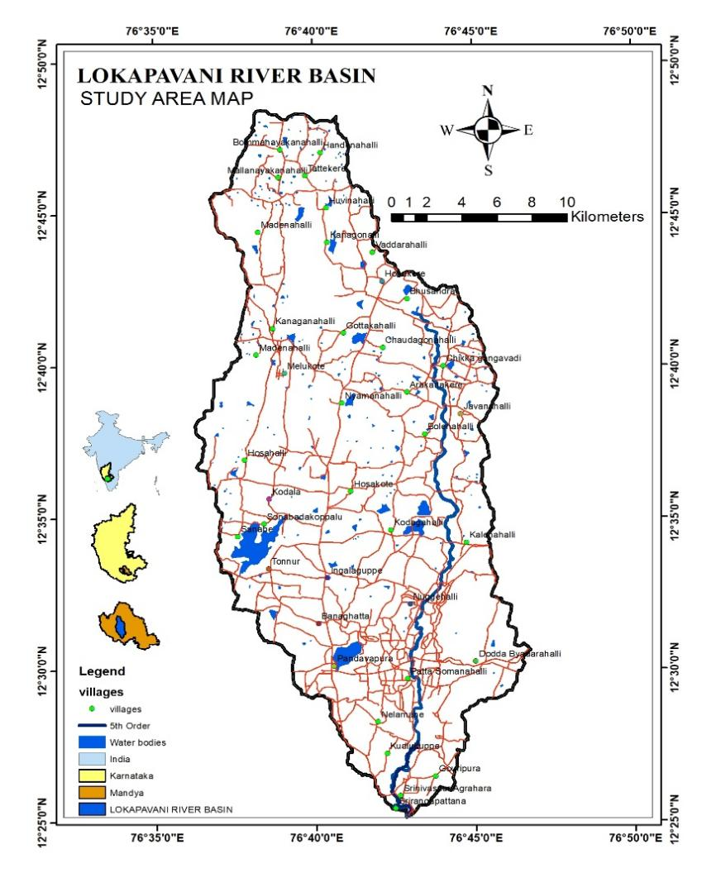
Figure 1. Location map of the study area
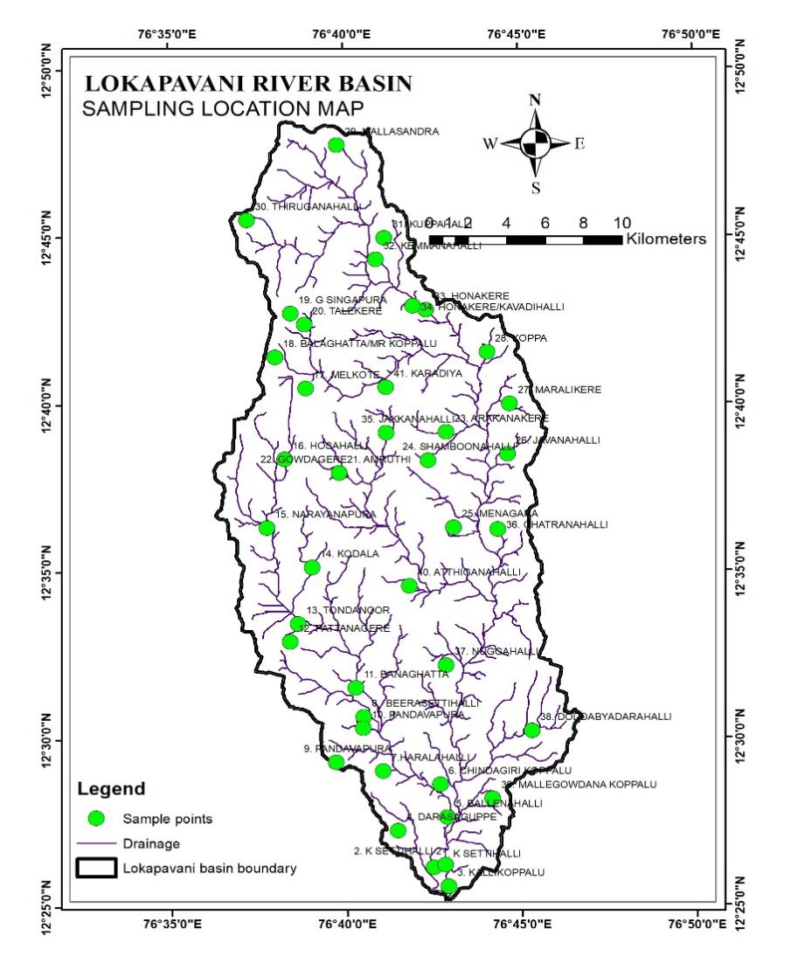
Figure 2. Sampling locations of the study area
3 Geology and Hydrogeology
The Lokapavani River Basin, located in Mandya district of Karnataka, is part of the Precambrian crystalline terrain of the southern Indian Peninsular Shield. The geology of the area is dominated by granitic gneiss, schist, and migmatite formations, which belong to the Archean age. These hard-rock formations control the occurrence and movement of groundwater in the region. The rocks are generally characterized by fractures, joints, and weathered zones, which act as secondary porosity structures and facilitate groundwater storage and movement.
Groundwater in the basin occurs mainly in two hydrogeological zones: the weathered zone and the fractured zone. The weathered zone generally extends to a depth of 10–30 meters, while deeper groundwater occurs in fractured rock formations. The productivity of groundwater wells largely depends on the thickness of the weathered mantle and the intensity of fracturing in the bedrock. Hydrogeochemical processes such as silicate weathering, ion exchange, and water–rock interaction plays a significant role in controlling groundwater chemistry in hard-rock aquifers (Appelo & Postma, 2005). These processes contribute to the presence of major ions such as calcium, magnesium, sodium, and bicarbonate in groundwater.
4 Materials and Methods
Groundwater samples were collected from 41 locations in the Lokapavani River Basin, Mandya district, Karnataka, during the pre-monsoon and post-monsoon seasons of 2023 to evaluate the hydrochemical characteristics and water quality of the region. The sampling locations were selected to represent different hydrogeological conditions and land-use patterns within the basin. Groundwater samples were collected from bore wells, which are commonly used for domestic and irrigation purposes.
Before sampling, the wells were pumped for several minutes to remove stagnant water and obtain representative groundwater samples. Water samples were collected in clean polyethene bottles that had been previously rinsed with distilled water and the sample water to avoid contamination. The samples were transported to the laboratory for analysis and stored under appropriate conditions until further analysis.
The physicochemical parameters analyzed in this study include pH, Electrical conductivity (EC), Total dissolved solids (TDS), Total hardness (TH), Calcium (Ca²⁺), Magnesium (Mg²⁺), Sodium (Na⁺), Potassium (K⁺), Chloride (Cl⁻), Nitrate (NO₃⁻), Sulfate (SO₄²⁻), Bicarbonate (HCO₃⁻) and Fluoride (F⁻). Laboratory analyses were carried out following the standard procedures recommended by the American Public Health Association (APHA, 2017).
To evaluate groundwater suitability for drinking and irrigation purposes, the following methods were adopted.
4.1 Drinking water quality indices
- Water Quality Index (WQI)
The Weighted Arithmetic Index method was used to calculate the Water Quality Index.
WQI = ∑Qi Wi
———
∑Wi
Where Qi = Quality rating of each parameter
Wi = Unit weight of parameter
4.2 Irrigation Water Quality Indices
- Sodium Adsorption Ratio (SAR)
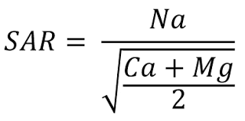

- Sodium Percentage
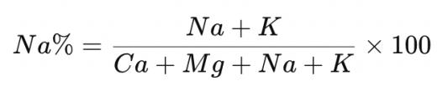

- Permeability Index (PI)

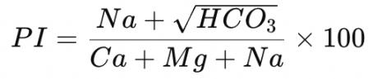

For irrigation water quality, all the ionic concentrations were converted to meq/L before calculation. The USSL diagram, Wilcox diagram and Piper trilinear diagrams were plotted. These indices provide a comprehensive understanding of groundwater suitability for agricultural applications.
The calculated results were compared with the drinking water standards recommended by the World Health Organization (WHO, 2022) and the Bureau of Indian Standards (BIS, 2012) to determine groundwater suitability for domestic use.
5 Results and Discussion
5.1 Drinking Water Suitability Based on WHO and BIS Standards
The physicochemical characteristics of groundwater samples collected from 41 locations (Figure 2) during the pre-monsoon and post-monsoon seasons (Table.1) were compared with the drinking water standards recommended by the World Health Organization and the Bureau of Indian Standards (table.2). The pH values of groundwater samples ranged from approximately 6.98 to 7.94, indicating slightly acidic to mildly alkaline conditions. All samples fall within the acceptable drinking water limit of 6.5–8.5 prescribed by WHO and BIS, suggesting that the groundwater is chemically stable with respect to acidity and alkalinity (World Health Organization, 2022; Bureau of Indian Standards, 2012).
The total dissolved solids (TDS) values varied between 310 and 1110 mg/L across the study area. According to BIS and WHO standards, the desirable limit for TDS in drinking water is 500 mg/L, while the permissible limit in the absence of an alternative source is 2000 mg/L. Many groundwater samples exceed the desirable limit, particularly in locations such as Melkote, Gowdagere, Doddabyadarahalli, and Banaghatta, indicating higher mineralization due to water–rock interaction and possible anthropogenic influences (Li et al., 2021; Subba Rao et al., 2022).
The total hardness (TH) values range from approximately 157 to 572 mg/L, indicating that groundwater in the study area varies from moderately hard to very hard water. Hardness is mainly controlled by calcium and magnesium ions derived from carbonate and silicate mineral dissolution. Although hard water does not pose significant health risks, it may affect domestic uses such as soap consumption and scaling in pipelines (World Health Organization, 2022).
Electrical conductivity values ranged from approximately 470 µS/cm to 1711 µS/cm, indicating moderate to high ionic concentration in groundwater. Higher EC values generally reflect greater mineralization and dissolution of rock-forming minerals within the aquifer system (Li et al., 2021). The presence of major cations such as calcium and magnesium suggest that groundwater chemistry in the basin is influenced by weathering of silicate and carbonate minerals, which is typical of crystalline rock terrains (Appelo & Postma, 2005; Subba Rao et al., 2022).
The concentrations of major cations such as calcium (Ca²⁺), magnesium (Mg²⁺) and sodium (Na⁺) generally fall within the permissible limits recommended by BIS. However, slightly elevated sodium concentrations observed in some locations may be associated with ion exchange processes and weathering of feldspar minerals (Appelo and Postma, 2005). Similarly, the concentrations of chloride (Cl⁻) remain mostly within the permissible limit of 250 mg/L, indicating limited influence of saline intrusion or anthropogenic contamination.
Among the anions, bicarbonate (HCO₃⁻) is the dominant ion in most groundwater samples, indicating that groundwater chemistry is largely controlled by carbonate weathering and rock–water interaction processes (Subba Rao et al., 2022). Chloride and sulfate concentrations are generally within acceptable limits, although slightly elevated values observed in some locations may be associated with agricultural activities, fertilizer usage, and anthropogenic influences (Zhang et al., 2023).
The nitrate (NO₃⁻) concentrations vary from about 2 to 52 mg/L, and a few locations approach or slightly exceed the WHO permissible limit of 45 mg/L. Elevated nitrate concentrations in Javanahall and Karadiya may indicate agricultural fertilizer leaching or contamination from domestic waste water sources (Zhang et al., 2023). The fluoride (F⁻) concentration ranges from 0.22 to 1.90 mg/L, and although most samples fall within the permissible limit of 1.5 mg/L, slightly elevated concentrations in some locations, such as Melkote, G. Singapura and Athiganahalli, may pose potential health risks if consumed over long periods.
Overall, the comparison with WHO and BIS drinking water standards indicates that most groundwater samples in the study area are suitable for drinking with minor treatment, while some locations with higher mineralization or nitrate concentrations require appropriate water treatment and continuous monitoring. Seasonal variations show slightly improved water quality during the post-monsoon period due to dilution effects caused by rainfall recharge (Subba Rao et al., 2022).

Table 1. Water quality results of pre-monsoon and post monsoon seasons.

LOCATIONS | SEASONS | pH | TDS | TA | TH | EC | Ca | Mg | Na | K | Cl | NO3 | SO4 | HCO3 | F | WQI
1. K SETTIHALLI  Latitude:12.436  Longitude:76.708 | PRE-MONSOON | 7.42 | 450 | 184.1 | 222.7 | 708 | 49.2 | 24.2 | 41.1 | 3.6 | 85.2 | 5.3 | 12.3 | 224.6 | 0.56 | 37.3
1. K SETTIHALLI  Latitude:12.436  Longitude:76.708 | POST MONSOON | 7.37 | 438 | 178.8 | 219.2 | 674 | 45.5 | 21.2 | 32.3 | 2.9 | 81.2 | 4.6 | 12.2 | 231.2 | 0.44 | 30.42
2. K SETTIHALLI 2  Latitude:12.43729  Longitude:76.71363 | PRE-MONSOON | 7.59 | 940 | 401 | 536.8 | 1466 | 135.2 | 48.3 | 56.2 | 8.4 | 143.6 | 17.4 | 42.1 | 489.2 | 0.96 | 66.8
2. K SETTIHALLI 2  Latitude:12.43729  Longitude:76.71363 | POST MONSOON | 7.59 | 960 | 486 | 572 | 1510 | 110.1 | 44.1 | 48.3 | 8.4 | 137.8 | 15.5 | 42.5 | 414.2 | 0.91 | 63.25
3. KALLIKOPPALU  Latitude:12.426591  Longitude:76.715125 | PRE-MONSOON | 7.15 | 410 | 173 | 212.8 | 624 | 51.2 | 20.6 | 36.4 | 2.9 | 76.4 | 4.4 | 15.4 | 211.1 | 0.41 | 27.12
3. KALLIKOPPALU  Latitude:12.426591  Longitude:76.715125 | POST MONSOON | 7.12 | 415 | 166.6 | 210.3 | 590 | 46.4 | 16.9 | 34.3 | 2.6 | 69.3 | 4.3 | 15.8 | 210.2 | 0.34 | 22.87
4. DARASAGUPPE  Latitude:12.454291  Longitude:76.691174 | PRE-MONSOON | 7.39 | 970 | 414.2 | 536.6 | 1510 | 150.1 | 39.2 | 66.3 | 5.6 | 132.1 | 12.1 | 69.5 | 505.3 | 0.78 | 54.48
4. DARASAGUPPE  Latitude:12.454291  Longitude:76.691174 | POST MONSOON | 7.29 | 920 | 412.3 | 519.5 | 1460 | 141.3 | 35.8 | 58.8 | 5.5 | 126.4 | 12.4 | 66 | 428.3 | 0.56 | 42.41
5. BALLENAHALLI  Latitude:12.460842  Longitude:76.714712 | PRE-MONSOON | 7.1 | 370 | 146.4 | 177.5 | 598 | 41.2 | 18.1 | 38.2 | 2.4 | 76.3 | 3.9 | 10.6 | 178.6 | 0.36 | 23.45
5. BALLENAHALLI  Latitude:12.460842  Longitude:76.714712 | POST MONSOON | 7.13 | 355 | 139.5 | 169.2 | 465 | 36.6 | 17.1 | 38.1 | 2.2 | 75.6 | 4.8 | 10.4 | 186.6 | 0.22 | 16.79
6. CHINDAGIRI KOPPALU  Latitude:12.477257  Longitude:76.711522 | PRE-MONSOON | 7.11 | 360 | 144.4 | 192.5 | 574 | 43.6 | 20.3 | 27.5 | 1.5 | 72.6 | 2.8 | 11.2 | 176.2 | 0.41 | 25.66
 | POST MONSOON | 7.1 | 355 | 143.2 | 174.4 | 510 | 41.1 | 19.2 | 25.4 | 1.4 | 69.1 | 2.3 | 11.1 | 177.9 | 0.36 | 22.91
7.HARALAHALLI  Latitude:12.483933  Longitude:76.68416 | PRE-MONSOON | 7.38 | 570 | 227.3 | 259.7 | 895 | 56.3 | 28.9 | 67.3 | 6.5 | 97.4 | 8.8 | 39.6 | 277.3 | 0.63 | 43
7.HARALAHALLI  Latitude:12.483933  Longitude:76.68416 | POST MONSOON | 7.29 | 558 | 220.6 | 225.4 | 860 | 52.8 | 26.6 | 63.2 | 6.2 | 95.7 | 8.1 | 39.3 | 289.2 | 0.46 | 33.71
8. BEERASETTIHALLI  Latitude:12.511138  Longitude:76.675178 | PRE-MONSOON | 7.24 | 360 | 144.6 | 187.6 | 576 | 39.8 | 21.4 | 26.7 | 3.2 | 67.5 | 6.2 | 10.6 | 176.4 | 0.45 | 29.63
8. BEERASETTIHALLI  Latitude:12.511138  Longitude:76.675178 | POST MONSOON | 7.16 | 370 | 189.7 | 183.2 | 580 | 73.2 | 28.2 | 29.4 | 4.7 | 87.4 | 7.5 | 17.2 | 210.2 | 0.61 | 38.75
9. PANDAVAPURA  Latitude:12.488584  Longitude:76.661945 | PRE-MONSOON | 7.49 | 370 | 155.2 | 186 | 572 | 45.6 | 17.5 | 35.6 | 4.4 | 98.6 | 5.1 | 14.2 | 189.3 | 0.39 | 29.16
9. PANDAVAPURA  Latitude:12.488584  Longitude:76.661945 | POST MONSOON | 7.44 | 375 | 162.2 | 175.2 | 548 | 41.2 | 16.1 | 33.8 | 4.1 | 93.3 | 4.7 | 13.7 | 198.2 | 0.32 | 25.03
10 PANDAVAPURA  Latitude:12.505392  Longitude:76.674904 | PRE-MONSOON | 7.28 | 540 | 250.5 | 238.3 | 958 | 51.2 | 26.8 | 54.3 | 4.1 | 58.4 | 13.2 | 23.6 | 243 | 0.54 | 36.48
10 PANDAVAPURA  Latitude:12.505392  Longitude:76.674904 | POST MONSOON | 7.19 | 524 | 233 | 236 | 980 | 27 | 27.8 | 53.2 | 4.8 | 52 | 12.6 | 18.2 | 208 | 0.51 | 34.17
11. BANAGHATTA  Latitude:12.525536  Longitude:76.671469 | PRE-MONSOON | 7.75 | 845 | 338 | 444.4 | 1320 | 126.4 | 31.2 | 66.2 | 7.2 | 136.2 | 14.2 | 49.5 | 412.3 | 0.87 | 60.59
11. BANAGHATTA  Latitude:12.525536  Longitude:76.671469 | POST MONSOON | 7.41 | 320 | 225 | 248 | 514 | 37.3 | 37.7 | 24.1 | 4.12 | 124.3 | 4.5 | 23 | 137.2 | 0.53 | 37.03
12. PATTANAGERE  Latitude:12.548629  Longitude:76.640233 | PRE-MONSOON | 7.54 | 430 | 161.1 | 218.9 | 675 | 51.2 | 22.1 | 38.6 | 2.6 | 89.6 | 3.9 | 14.5 | 196.5 | 0.42 | 30.87
12. PATTANAGERE  Latitude:12.548629  Longitude:76.640233 | POST MONSOON | 7.52 | 425 | 157.6 | 193.3 | 627 | 43.3 | 21.8 | 38.2 | 2.2 | 86.5 | 4.3 | 14.6 | 210.3 | 0.23 | 21.4
13. TONDANOOR  Latitude:12.557426  Longitude:76.644154 | PRE-MONSOON | 7.81 | 625 | 349 | 433 | 910 | 118 | 38.2 | 48.6 | 3.4 | 56 | 29.8 | 31 | 140 | 0.98 | 64.62
13. TONDANOOR  Latitude:12.557426  Longitude:76.644154 | POST MONSOON | 7.4 | 472 | 290 | 389 | 745 | 103 | 34 | 41 | 2.4 | 44 | 29.2 | 22 | 179 | 0.79 | 50.84
14. KODALA  Latitude:12.585526  Longitude:76.651006 | PRE-MONSOON | 7.72 | 830 | 346.1 | 444.2 | 1273 | 121.4 | 34.2 | 58.4 | 5.6 | 121.6 | 8.5 | 53.6 | 422.3 | 0.75 | 53.87
14. KODALA  Latitude:12.585526  Longitude:76.651006 | POST MONSOON | 7.67 | 470 | 268 | 358 | 730 | 55.3 | 52.5 | 56.9 | 10.4 | 42 | 9.7 | 42 | 163 | 0.78 | 56.62
15. NARAYANAPURA  Latitude:12.605313  Longitude:76.629578 | PRE-MONSOON | 7.51 | 490 | 200.9 | 265 | 758 | 57.6 | 29.4 | 45.1 | 5.1 | 112.7 | 5.1 | 15.3 | 245.1 | 0.65 | 43.95
15. NARAYANAPURA  Latitude:12.605313  Longitude:76.629578 | POST MONSOON | 7.28 | 380 | 215 | 262 | 612 | 46 | 35.7 | 30.63 | 1.78 | 37.5 | 22.1 | 41.2 | 131.2 | 0.73 | 45.1
16. HOSAHALLI  Latitude:12.639304  Longitude:76.638186 | PRE-MONSOON | 7.7 | 630 | 228.4 | 294.1 | 975 | 61.2 | 34.3 | 71.5 | 5.4 | 116.5 | 11.6 | 48.6 | 278.6 | 0.42 | 36.34
16. HOSAHALLI  Latitude:12.639304  Longitude:76.638186 | POST MONSOON | 7.2 | 678 | 319 | 368 | 990 | 51 | 60.8 | 92 | 7.6 | 68 | 15 | 34.4 | 196 | 1.1 | 68.08
17. MELKOTE  Latitude:12.674693  Longitude:76.648418 | PRE-MONSOON | 7.36 | 1050 | 419.9 | 569.1 | 1643 | 155.8 | 43.7 | 72.6 | 6.1 | 164.2 | 19.6 | 61.2 | 512.3 | 1.62 | 95.16
17. MELKOTE  Latitude:12.674693  Longitude:76.648418 | POST MONSOON | 6.98 | 940 | 346 | 486 | 1137 | 78.5 | 70.5 | 146.5 | 5.9 | 243 | 24.2 | 105.3 | 211 | 1.9 | 106.16
18. BALAGHATTA/MR KOPPALU  Latitude:12.690258  Longitude:76.63382 | PRE-MONSOON | 7.42 | 490 | 194.1 | 249.6 | 783 | 56.4 | 26.4 | 42.3 | 3.9 | 91.2 | 4.7 | 16.4 | 236.8 | 0.54 | 37.02
 | POST MONSOON | 7.4 | 485 | 178.9 | 233.2 | 697 | 51 | 24.1 | 38.2 | 3.3 | 88.4 | 5.3 | 19.4 | 227.8 | 0.46 | 32.36
19. G SINGAPURA  Latitude:12.711827  Longitude:76.641382 | PRE-MONSOON | 7.73 | 410 | 182.9 | 200.1 | 645 | 49.6 | 18.5 | 46.3 | 2.6 | 65.3 | 9.6 | 21.3 | 223.1 | 1.49 | 82.53
19. G SINGAPURA  Latitude:12.711827  Longitude:76.641382 | POST MONSOON | 7.45 | 395 | 228.6 | 223.3 | 638 | 42.2 | 22.4 | 63.3 | 3.5 | 17.5 | 8.8 | 33.5 | 210.2 | 1.51 | 81.83
20. TALEKERE  Latitude:12.706318  Longitude:76.648003 | PRE-MONSOON | 7.48 | 630 | 214.2 | 267.2 | 985 | 63.5 | 26.4 | 74.1 | 6.5 | 112.3 | 14.3 | 52.3 | 261.3 | 0.85 | 54.41
20. TALEKERE  Latitude:12.706318  Longitude:76.648003 | POST MONSOON | 7.44 | 620 | 212 | 242.2 | 948 | 56.8 | 26.8 | 65.8 | 6.1 | 109.4 | 13.8 | 56 | 243.3 | 0.88 | 55.07
21. AMRUTHI  Latitude:12.637145  Longitude:76.680534 | PRE-MONSOON | 7.73 | 670 | 267.6 | 325.4 | 1052 | 72.3 | 35.1 | 65.2 | 4.9 | 124.6 | 8.6 | 43.6 | 326.5 | 0.63 | 46.57
21. AMRUTHI  Latitude:12.637145  Longitude:76.680534 | POST MONSOON | 7.56 | 625 | 270.4 | 388.7 | 974 | 68.4 | 42.2 | 63.8 | 1.23 | 67 | 32.6 | 45 | 220.5 | 1.32 | 77.47
22. GOWDAGERE  Latitude:12.632381  Longitude:76.664103 | PRE-MONSOON | 7.63 | 910 | 403.8 | 466.2 | 1407 | 123.1 | 38.5 | 70.2 | 4.3 | 109.2 | 10.3 | 54.1 | 492.6 | 1.12 | 70.86
22. GOWDAGERE  Latitude:12.632381  Longitude:76.664103 | POST MONSOON | 7.56 | 720 | 289.3 | 423.2 | 980 | 81.1 | 43.2 | 66.4 | 5.12 | 79.2 | 14.2 | 73.6 | 289.4 | 1.01 | 64.51
23. ARAKANAKERE  Latitude:12.65269  Longitude:76.715276 | PRE-MONSOON | 7.26 | 380 | 166.7 | 210 | 589 | 48.6 | 21.5 | 22.3 | 2.9 | 59.4 | 4.3 | 13.5 | 203.4 | 0.39 | 27.01
23. ARAKANAKERE  Latitude:12.65269  Longitude:76.715276 | POST MONSOON | 7.22 | 375 | 162.2 | 199 | 524 | 43.3 | 18.2 | 21.1 | 2.6 | 54.7 | 4.5 | 17.6 | 212.2 | 0.21 | 17.58
24. SHAMBOONAHALLI  Latitude:12.6385  Longitude:76.706555 | PRE-MONSOON | 7.53 | 520 | 217.3 | 251.5 | 795 | 52.2 | 29.4 | 49.6 | 5.6 | 71.2 | 8.1 | 43.5 | 265.1 | 0.5 | 37.45
24. SHAMBOONAHALLI  Latitude:12.6385  Longitude:76.706555 | POST MONSOON | 7.43 | 510 | 210 | 236.4 | 764 | 44.5 | 27.3 | 43.3 | 5.2 | 68.7 | 7.2 | 42.3 | 254.4 | 0.29 | 26.04
25. MENAGARA  Latitude:12.60506  Longitude:76.71849 | PRE-MONSOON | 7.4 | 660 | 247.9 | 327.1 | 1041 | 65.8 | 39.5 | 65.2 | 6.4 | 134.1 | 29.5 | 40.2 | 302.4 | 0.42 | 36.1
25. MENAGARA  Latitude:12.60506  Longitude:76.71849 | POST MONSOON | 7.28 | 580 | 235.2 | 334.3 | 860 | 72.2 | 28.2 | 57.8 | 4.4 | 76.5 | 28.6 | 55.4 | 213.3 | 0.72 | 46.54
26. JAVANAHALLI  Latitude:12.64163  Longitude:76.744437 | PRE-MONSOON | 7.56 | 660 | 267.6 | 315.8 | 1078 | 67.4 | 35.8 | 69.5 | 4.9 | 112.6 | 7.1 | 43.6 | 326.5 | 0.96 | 60.56
26. JAVANAHALLI  Latitude:12.64163  Longitude:76.744437 | POST MONSOON | 7.47 | 645 | 259.6 | 277.4 | 925 | 55.6 | 31.1 | 66.7 | 4.5 | 106.6 | 6.8 | 47.8 | 278.8 | 0.78 | 50.1
27. MARALIKERE  Latitude:12.666634  Longitude:76.745502 | PRE-MONSOON | 7.48 | 540 | 247.6 | 262.2 | 860 | 56.1 | 29.6 | 50.2 | 3.5 | 72.8 | 11.3 | 18.6 | 302.1 | 0.57 | 39.7
27. MARALIKERE  Latitude:12.666634  Longitude:76.745502 | POST MONSOON | 7.44 | 536 | 233 | 233.8 | 780 | 53.3 | 26.8 | 46.6 | 3.4 | 66.8 | 10.4 | 22.6 | 310.4 | 0.43 | 32.25
28. KOPPA  Latitude:12.692278  Longitude:76.734957 | PRE-MONSOON | 7.63 | 420 | 183.8 | 191.5 | 676 | 48.4 | 17.1 | 39.4 | 4.1 | 51.2 | 9 | 21.4 | 224.2 | 0.54 | 37.57
28. KOPPA  Latitude:12.692278  Longitude:76.734957 | POST MONSOON | 7.59 | 412 | 177.7 | 188.2 | 642 | 43.4 | 16.2 | 34.4 | 3.8 | 45.8 | 8.5 | 24.8 | 233.2 | 0.45 | 32.63
29. MALLASANDRA  Latitude:12.795595  Longitude:76.663961 | PRE-MONSOON | 7.12 | 700 | 243 | 307.1 | 1093 | 74.2 | 29.5 | 87.6 | 6.4 | 132.6 | 15.2 | 65.2 | 296.4 | 0.63 | 42.01
29. MALLASANDRA  Latitude:12.795595  Longitude:76.663961 | POST MONSOON | 7.12 | 710 | 235.4 | 286.4 | 955 | 62.2 | 27.2 | 83.1 | 6.3 | 127.6 | 14.6 | 75.3 | 288.9 | 0.61 | 40.37
30. THIRUGANAHALLI  Latitude:12.758397  Longitude:76.620878 | PRE-MONSOON | 7.24 | 320 | 132.1 | 179.3 | 512 | 34.1 | 22.9 | 32.5 | 2.4 | 73.2 | 3.9 | 12.2 | 161.2 | 0.42 | 27.72
30. THIRUGANAHALLI  Latitude:12.758397  Longitude:76.620878 | POST MONSOON | 7.22 | 320 | 124 | 157.9 | 470 | 32.1 | 20.4 | 33.4 | 2.4 | 68.9 | 4.3 | 14.6 | 145.3 | 0.31 | 21.98
31. KUPPAHALLI  Latitude:12.749213  Longitude:76.68629 | PRE-MONSOON | 7.78 | 498 | 232 | 232 | 778 | 49.6 | 28.4 | 78 | 6.3 | 127 | 6.6 | 18.8 | 248 | 0.56 | 42.44
31. KUPPAHALLI  Latitude:12.749213  Longitude:76.68629 | POST MONSOON | 7.8 | 480 | 2OO | 227 | 756 | 46.2 | 28 | 72 | 6.2 | 134 | 5.5 | 16 | 244 | 0.49 | 39.05
32. KEMMANAHALLI  Latitude:12.738644  Longitude:76.682188 | PRE-MONSOON | 7.38 | 620 | 226.6 | 289.8 | 946 | 66.1 | 30.2 | 71.2 | 7.6 | 129.9 | 11.1 | 36.8 | 276.5 | 0.58 | 41.77
32. KEMMANAHALLI  Latitude:12.738644  Longitude:76.682188 | POST MONSOON | 7.35 | 615 | 222 | 266.5 | 890 | 56.8 | 28.6 | 67.4 | 6.8 | 124.3 | 10.7 | 44.1 | 243.3 | 0.39 | 31.69
33. HONAKERE  Latitude:12.713365  Longitude:76.705993 | PRE-MONSOON | 7.33 | 510 | 209.1 | 273.1 | 802 | 54.7 | 33.1 | 41.4 | 6.9 | 86.3 | 4.1 | 34.6 | 255.1 | 0.94 | 57.31
33. HONAKERE  Latitude:12.713365  Longitude:76.705993 | POST MONSOON | 7.36 | 495 | 199.8 | 256 | 725 | 52.9 | 29.8 | 44.5 | 6.8 | 83.6 | 4.7 | 33.3 | 246.7 | 0.84 | 52.33
34. HONAKERE/KAVADIHALLI  Latitude:12.715363  Longitude:76.699746 | PRE-MONSOON | 7.42 | 810 | 283.4 | 442.7 | 1321 | 109.2 | 41.2 | 61.2 | 8.4 | 165.4 | 13.5 | 54.2 | 345.8 | 0.85 | 58.15
 | POST MONSOON | 7.44 | 790 | 266.9 | 440 | 1210 | 98.8 | 36.7 | 55.8 | 7.8 | 158.3 | 12.3 | 52.3 | 341.2 | 0.74 | 51.95
35. JAKKANAHALLI  Latitude:12.652395  Longitude:76.686645 | PRE-MONSOON | 7.58 | 710 | 256.2 | 338.9 | 1092 | 79.4 | 34.1 | 70.6 | 5.1 | 116.2 | 112 | 68.2 | 312.6 | 1.38 | 56.55
35. JAKKANAHALLI  Latitude:12.652395  Longitude:76.686645 | POST MONSOON | 7.36 | 800 | 336 | 472 | 1291 | 89.7 | 60.3 | 82.4 | 4.7 | 74 | 104.2 | 128 | 201.3 | 1.45 | 90.42
36. CHATRANAHALLI  Latitude:12.60414  Longitude:76.739662 | PRE-MONSOON | 7.26 | 860 | 369.8 | 486.7 | 1353 | 129.5 | 39.6 | 54.3 | 5.8 | 124.3 | 16.3 | 58.1 | 451.2 | 0.96 | 61.4
36. CHATRANAHALLI  Latitude:12.60414  Longitude:76.739662 | POST MONSOON | 7.38 | 920 | 412 | 522 | 1326 | 72.4 | 76.5 | 56.6 | 9.7 | 112.2 | 48.9 | 78.8 | 220.3 | o.64 | 79.77
37. NUGGAHALLI  Latitude:12.535672  Longitude:76.714506 | PRE-MONSOON | 7.3 | 520 | 192.3 | 263.9 | 796 | 54.4 | 31.1 | 46.3 | 6.2 | 82.4 | 10.1 | 51.2 | 234.6 | 0.65 | 43.18
37. NUGGAHALLI  Latitude:12.535672  Longitude:76.714506 | POST MONSOON | 7.29 | 490 | 188.2 | 244.6 | 735 | 50.9 | 27.7 | 44.5 | 6.2 | 85.4 | 10.2 | 51.3 | 233.3 | 0.58 | 39.27
38. DODDABYADARAHALLI  Latitude:12.503876  Longitude:76.755213 | PRE-MONSOON | 7.64 | 1110 | 443.6 | 586.3 | 1711 | 150.2 | 51.2 | 84.2 | 9.1 | 164.8 | 15.3 | 83.6 | 541.2 | 0.84 | 63.07
 | POST MONSOON | 7.94 | 920 | 395 | 480 | 1400 | 129 | 42.8 | 72.2 | 8.7 | 157.8 | 13.3 | 72.3 | 328.9 | 0.78 | 60.02
39. MALLEGOWDANA KOPPALU  Latitude:12.470145  Longitude:76.736287 | PRE-MONSOON | 7.55 | 450 | 173.9 | 235.3 | 712 | 54.1 | 24.3 | 42.3 | 4.6 | 92.3 | 11.2 | 19.6 | 212.1 | 0.42 | 32.7
 | POST MONSOON | 7.49 | 442 | 169.3 | 224.6 | 680 | 51.2 | 23.1 | 39.2 | 4.2 | 89.4 | 10.8 | 22.3 | 218.4 | 0.33 | 27.55
40. ATTHIGANAHALLI  Latitude:12.57609  Longitude:76.697133 | PRE-MONSOON | 7.42 | 823 | 479 | 486 | 1164 | 102 | 28 | 122.2 | 7.4 | 87.6 | 29 | 109.4 | 230.4 | 1.59 | 91.37
40. ATTHIGANAHALLI  Latitude:12.57609  Longitude:76.697133 | POST MONSOON | 7.34 | 760 | 344 | 322 | 1174 | 106 | 49 | 144 | 8.5 | 65 | 36 | 175.4 | 210 | 1.06 | 69.17
41. KARADIYA  Latitude:12.675057  Longitude:76.686495 | PRE-MONSOON | 7.52 | 860 | 410 | 530.5 | 1350 | 86.8 | 78 | 82.2 | 6.6 | 101 | 42.3 | 133.2 | 278 | 0.83 | 62.71
41. KARADIYA  Latitude:12.675057  Longitude:76.686495 | POST MONSOON | 7.47 | 820 | 390 | 546 | 1267 | 73.7 | 88 | 75.4 | 5.4 | 95 | 46.76 | 142.4 | 238 | 0.7 | 56.63

Table 2. Drinking water quality standards according to BIS and WHO.
Parameter | Unit | BIS acceptable limit | WHO guideline
PH | mg/L | 6.5-8.5 | 6.5-8.5
Total Dissolved Solids | mg/L | 500 | 500
Electrical Conductivity | µS/cm | 400 | 400
Total Hardness | mg/L | 200 | 200
Total Alkalinity | mg/L | 200 | 200
Calcium | mg/L | 75 | 75
Magnesium | mg/L | 30 | 30
Sodium | mg/L | 200 | 200
Potassium | mg/L | 12 | 12
Chloride | mg/L | 250 | 250
Nitrate | mg/L | 45 | 45
Sulphate | mg/L | 200 | 200
Bicarbonates | mg/L | 200 | 200
Fluoride | mg/L | 1-1.5 | 1-1.5

5.2 Water Quality Index (WQI)
The Water Quality Index (WQI) was calculated to evaluate the overall suitability of groundwater for drinking purposes (Table.1 and Figure 3). The WQI values for the study area range from 16.79 to 106.16 during the pre- and post-monsoon seasons. According to the WQI classification (Table 2),

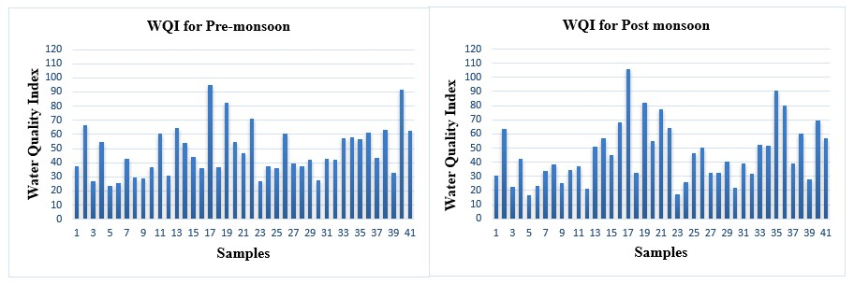
Figure 3. WQI for Pre-monsoon and Post monsoon samples.
Most of the groundwater samples in the study area fall within the good to poor water quality categories (WQI <25). Several locations such as Ballennahalli, Arakanakere, Chindagiri Koppalu, Pattanagere and Kallikoppalu, exhibit excellent water quality during the post-monsoon season, which may be attributed to dilution effects due to rainfall recharge. However, a few locations show very poor to unsuitable water quality particularly Melkote (WQI 95.16–106.16), G. Singapura (82), and Atthiganahalli (91) and Jakkanahalli (90.42) indicating higher mineralization and possible anthropogenic influences such as agricultural activities and domestic wastewater inputs. Overall, the results suggest that groundwater quality in the area is generally suitable for drinking with minor treatment in most locations, although some sites like Melkote, Atthiganahalli, Jakkanahalli and G Singapura require treatment before consumption.

Table 3. WQI Water quality classification.
WQI | Water class | Pre-monsoon | Post monsoon
<25 | Excellent | 1 | 7
26-50 | Good | 23 | 18
51-75 | Poor | 14 | 11
76-100 | Very poor | 3 | 4
>100 | Unsuitable | 0 | 1

5.3 Irrigation Water Quality Assessment
Groundwater suitability for irrigation was evaluated using several widely accepted indices, including Sodium Adsorption Ratio (SAR), Sodium Percentage (Na%), Permeability Index (PI), USSL diagram, and Wilcox diagram. These indices help determine the potential effects of irrigation water on soil structure, permeability, and crop productivity (Li et al., 2021; Singh et al., 2022). The results are tabulated in the table 7.
- Sodium Adsorption Ratio (SAR)
The Sodium Adsorption Ratio (SAR) is an important parameter used to assess the sodium hazard of irrigation water. SAR values in the study area range from approximately 0.73 to 2.90 (Table 6), indicating low sodium hazard. According to irrigation water classification (Table 4), SAR values less than 10 indicate excellent water quality with minimal sodium hazard to soils (Richards, 1954; Singh et al., 2022). The low SAR values suggest that sodium accumulation in soils is unlikely to affect soil permeability or crop growth significantly. Therefore, groundwater in the study area can generally be considered safe for irrigation with respect to sodium hazard.
Table 4. SAR Water quality classification
SAR | Water class | Pre-monsoon | Post monsoon
0-10 | Excellent | 41 | 41
10-18 | Good | 0 | 0
18-26 | Doubtful | 0 | 0
>26 | Unsuitable | 0 | 0

- Sodium Percentage (Na%)
The sodium percentage (Na%) values in the study area range from approximately 18% to 43%. According to irrigation water classification (Table 5), (Wilcox, 1955; Ravikumar & Somashekar, 2021).
Table 5. %NA Water quality classification
%NA | Water class | Pre-monsoon | Post monsoon
0-20 | Excellent | 3 | 3
20-40 | Good | 36 | 32
40-60 | Permissible | 2 | 6
60-80 | Doubtful | 0 | 0
>80 | Unsuitable | 0 | 0

Most groundwater samples fall within the good-to-permissible irrigation water categories, indicating a moderate sodium content. A few samples with Na% values slightly above 40% may require careful irrigation management and adequate drainage to prevent long-term soil sodicity.
- Permeability Index (PI)
The Permeability Index (PI) was calculated to evaluate groundwater suitability for irrigation based on the influence of sodium, calcium, magnesium, and bicarbonate ions on soil permeability (Table.4). The PI values in the study area range from 32.55 to 69.93 for both pre- and post-monsoon seasons.
According to the Doneen classification, irrigation water is divided into three classes:
Table 6. Water quality classification.
PI | Water class | Pre-monsoon | Post monsoon
>75% (Class I) | Excellent | 0 | 0
25-75% (Class II) | Suitable | 41 | 41
<25% (Class III) | Permissible | 0 | 0

All groundwater samples in the study area fall within the Class II category (PI 25–75), indicating that the groundwater is generally suitable for irrigation purposes. Locations such as Pandavapura, Kuppahalli, and Koppa show relatively higher PI values (above 65), suggesting better permeability characteristics of irrigation water. The absence of Class III water indicates that groundwater in the study area does not pose significant permeability hazards to soils.
Table 7. Results of Irrigation water quality indices.
Location | SEASONS | PI | %NA | SAR | RSC | Kelly's ratio
1. K SETTIHALLI | PRE-MONSOON | 59.45 | 29.69 | 1.2 | -0.77 | 0.40
1. K SETTIHALLI | POST MONSOON | 61.83 | 26.90 | 0.99 | -0.22 | 0.35
2. K SETTIHALLI 2 | PRE-MONSOON | 40.07 | 19.85 | 1.06 | -2.70 | 0.23
2. K SETTIHALLI 2 | POST MONSOON | 41.93 | 20.22 | 0.98 | -2.33 | 0.23
3. KALLIKOPPALU | PRE-MONSOON | 59.02 | 28.03 | 1.09 | -0.79 | 0.37
3. KALLIKOPPALU | POST MONSOON | 64.41 | 29.58 | 1.1 | -0.26 | 0.40
4. DARASAGUPPE | PRE-MONSOON | 42.36 | 22.00 | 1.24 | -2.43 | 0.27
4. DARASAGUPPE | POST MONSOON | 41.47 | 21.23 | 1.14 | -2.98 | 0.26
5. BALLENAHALLI | PRE-MONSOON | 64.77 | 32.68 | 1.25 | -0.62 | 0.47
5. BALLENAHALLI | POST MONSOON | 69.64 | 34.61 | 1.3 | -0.17 | 0.51
6. CHINDAGIRI KOPPALU | PRE-MONSOON | 57.42 | 24.28 | 0.86 | -0.96 | 0.31
6. CHINDAGIRI KOPPALU | POST MONSOON | 59.38 | 23.88 | 0.82 | -0.71 | 0.30
7. HARALAHALLI | PRE-MONSOON | 62.34 | 37.33 | 1.82 | -0.64 | 0.56
7. HARALAHALLI | POST MONSOON | 65.05 | 37.58 | 1.77 | -0.08 | 0.57
8. BEERASETTIHALLI | PRE-MONSOON | 58.3 | 24.89 | 0.85 | -0.86 | 0.31
8. BEERASETTIHALLI | POST MONSOON | 43.22 | 18.96 | 0.74 | -2.53 | 0.21
9. PANDAVAPURA | PRE-MONSOON | 62.87 | 30.87 | 1.14 | -0.61 | 0.42
9. PANDAVAPURA | POST MONSOON | 67.46 | 31.75 | 1.13 | -0.13 | 0.43
10. PANDAVAPURA | PRE-MONSOON | 61.18 | 34.11 | 1.53 | -0.78 | 0.50
10. PANDAVAPURA | POST MONSOON | 69.93 | 40.11 | 1.72 | -0.23 | 0.64
11. BANAGHATTA | PRE-MONSOON | 46.61 | 25.63 | 1.51 | -2.12 | 0.32
11. BANAGHATTA | POST MONSOON | 42.37 | 18.85 | 0.75 | -2.71 | 0.21
12. PATTANAGERE | PRE-MONSOON | 57.39 | 28.50 | 1.23 | -1.15 | 0.38
12. PATTANAGERE | POST MONSOON | 62.64 | 30.26 | 1.25 | -0.51 | 0.42
13. TONDANOOR | PRE-MONSOON | 32.55 | 19.57 | 1.12 | -6.74 | 0.23
13. TONDANOOR | POST MONSOON | 35.96 | 18.84 | 1.01 | -5.00 | 0.22
14. KODALA | PRE-MONSOON | 45.31 | 23.20 | 1.34 | -1.95 | 0.29
14. KODALA | POST MONSOON | 43 | 27.89 | 1.33 | -4.41 | 0.35
15. NARAYANAPURA | PRE-MONSOON | 54.66 | 28.30 | 1.21 | -1.28 | 0.37
15. NARAYANAPURA | POST MONSOON | 42.62 | 20.83 | 0.87 | -3.08 | 0.25
16. HOSAHALLI | PRE-MONSOON | 58.38 | 35.57 | 1.75 | -1.31 | 0.53
16. HOSAHALLI | POST MONSOON | 50.16 | 35.71 | 2.13 | -4.33 | 0.53
17. MELKOTE | PRE-MONSOON | 41.68 | 22.54 | 1.58 | -2.97 | 0.28
17. MELKOTE | POST MONSOON | 51.15 | 40.14 | 2.65 | -6.26 | 0.66
18. BALAGHATTA/MR KOPPALU | PRE-MONSOON | 55.8 | 27.98 | 1.31 | -1.10 | 0.37
18. BALAGHATTA/MR KOPPALU | POST MONSOON | 58.06 | 27.80 | 1.16 | -0.79 | 0.37
19. G SINGAPURA | PRE-MONSOON | 65.31 | 34.20 | 1.47 | -0.34 | 0.50
19. G SINGAPURA | POST MONSOON | 68.77 | 41.83 | 1.84 | -0.50 | 0.70
20. TALEKERE | PRE-MONSOON | 61.79 | 38.79 | 2.08 | -1.05 | 0.60
20. TALEKERE | POST MONSOON | 61.49 | 37.43 | 1.9 | -1.05 | 0.57
21. AMRUTHI | PRE-MONSOON | 55.17 | 31.29 | 1.55 | -1.15 | 0.44
21. AMRUTHI | POST MONSOON | 48.4 | 28.93 | 1.43 | -3.27 | 0.40
22. GOWDAGERE | PRE-MONSOON | 47.67 | 25.33 | 1.61 | -1.24 | 0.33
22. GOWDAGERE | POST MONSOON | 48.29 | 28.40 | 1.46 | -2.86 | 0.38
23. ARAKANAKERE | PRE-MONSOON | 54.13 | 19.91 | 0.76 | -0.86 | 0.23
23. ARAKANAKERE | POST MONSOON | 60.81 | 21.18 | 0.73 | -0.18 | 0.25
24. SHAMBOONAHALLI | PRE-MONSOON | 59.06 | 31.39 | 1.28 | -0.68 | 0.43
24. SHAMBOONAHALLI | POST MONSOON | 61.81 | 31.08 | 1.12 | -0.30 | 0.42
25. MENAGARA | PRE-MONSOON | 54.02 | 31.44 | 1.57 | -1.58 | 0.43
25. MENAGARA | POST MONSOON | 51.95 | 30.69 | 1.43 | -4.50 | 0.36
26. JAVANAHALLI | PRE-MONSOON | 57.17 | 33.26 | 1.69 | -2.43 | 0.42
26. JAVANAHALLI | POST MONSOON | 61.18 | 36.10 | 1.62 | -0.96 | 0.48
27. MARALIKERE | PRE-MONSOON | 59.42 | 30.25 | 1.36 | -0.76 | 0.54
27. MARALIKERE | POST MONSOON | 62.13 | 30.27 | 1.29 | -0.29 | 0.42
28. KOPPA | PRE-MONSOON | 65.58 | 32.21 | 1.32 | 0.22 | 0.42
28. KOPPA | POST MONSOON | 69.09 | 31.26 | 1.24 | -0.15 | 0.45
29. MALLASANDRA | PRE-MONSOON | 60.5 | 39.30 | 2.41 | 0.32 | 0.43
29. MALLASANDRA | POST MONSOON | 64.64 | 41.38 | 2.3 | -1.28 | 0.62
30. THIRUGANAHALLI | PRE-MONSOON | 60.78 | 29.12 | 1.07 | -0.61 | 0.68
30. THIRUGANAHALLI | POST MONSOON | 63.29 | 31.56 | 1.12 | -0.94 | 0.39
31. KUPPAHALLI | PRE-MONSOON | 65.92 | 42.45 | 2.14 | -0.90 | 0.44
31. KUPPAHALLI | POST MONSOON | 66.28 | 41.62 | 2.01 | -0.75 | 0.71
32. KEMMANAHALLI | PRE-MONSOON | 58.84 | 36.24 | 2.08 | -0.61 | 0.68
32. KEMMANAHALLI | POST MONSOON | 60.69 | 37.42 | 1.95 | -1.26 | 0.54
33. HONAKERE | PRE-MONSOON | 53.01 | 26.59 | 1.12 | -1.20 | 0.57
33. HONAKERE | POST MONSOON | 56.15 | 29.27 | 1.2 | -1.27 | 0.33
34. HONAKERE/KAVADIHALLI | PRE-MONSOON | 43.84 | 24.53 | 1.33 | -1.05 | 0.38
34. HONAKERE/KAVADIHALLI | POST MONSOON | 46.17 | 24.81 | 1.22 | -3.17 | 0.30
35. JAKKANAHALLI | PRE-MONSOON | 54.21 | 32.08 | 1.55 | -2.36 | 0.31
35. JAKKANAHALLI | POST MONSOON | 41.46 | 28.17 | 1.51 | -1.65 | 0.45
36. CHATRANAHALLI | PRE-MONSOON | 42.05 | 20.50 | 1.15 | -6.13 | 0.38
36. CHATRANAHALLI | POST MONSOON | 35.26 | 21.46 | 1.03 | -2.32 | 0.24
37. NUGGAHALLI | PRE-MONSOON | 54.54 | 29.15 | 1.21 | -6.29 | 0.25
37. NUGGAHALLI | POST MONSOON | 57.6 | 30.27 | 1.16 | -1.43 | 0.38
38. DODDABYADARAHALLI | PRE-MONSOON | 43.2 | 24.94 | 1.61 | -0.99 | 0.40
38. DODDABYADARAHALLI | POST MONSOON | 41.69 | 25.22 | 1.39 | -2.84 | 0.31
39. MALLEGOWDANA KOPPALU | PRE-MONSOON | 56.64 | 29.38 | 1.18 | -4.57 | 0.32
39. MALLEGOWDANA KOPPALU | POST MONSOON | 58.38 | 28.89 | 1.14 | -1.22 | 0.39
40. ATTHIGANAHALLI | PRE-MONSOON | 57.1 | 42.64 | 2.76 | -0.88 | 0.38
40. ATTHIGANAHALLI | POST MONSOON | 52.08 | 40.98 | 2.9 | -3.62 | 0.72
41. KARADIYA | PRE-MONSOON | 39.85 | 25.82 | 1.54 | -5.88 | 0.67
41. KARADIYA | POST MONSOON | 37 | 23.82 | 1.4 | -6.19 | 0.33

- Residual Sodium Carbonate (RSC)
Residual Sodium Carbonate (RSC) values in the study area are predominantly negative, indicating an excess of calcium and magnesium over carbonate and bicarbonate ions, which is favorable for irrigation. According to R. S. Ayers and D. W. Westcot (1985), RSC values less than 1.25 meq/L (Table 7) are considered safe; hence, the observed values suggest minimal risk of sodium accumulation and soil alkalinity. Only a few locations show slightly positive RSC, but they remain within permissible limits, suggesting overall suitability for irrigation use.
- Kelly’s Ratio (KR)
Kelly’s Ratio (KR) values across all sampling sites are less than 1 (Table 7), indicating that sodium levels are lower than calcium and magnesium, making the water suitable for irrigation. As per W. P. Kelly (1963), KR < 1 signifies good quality irrigation water, while values >1 indicate unsuitability. The consistency of KR within safe limits suggests no significant sodium hazard and supports the suitability of groundwater for long-term agricultural use.
- USSL Diagram
The irrigation suitability was further evaluated using the USSL (United States Salinity Laboratory) diagram which classifies irrigation water based on electrical conductivity (EC) and SAR (Richards, 1954). In the present study, the pre-monsoon groundwater quality samples are represented in the red color dots and the post monsoon samples are in the blue color dots (Figure 4).
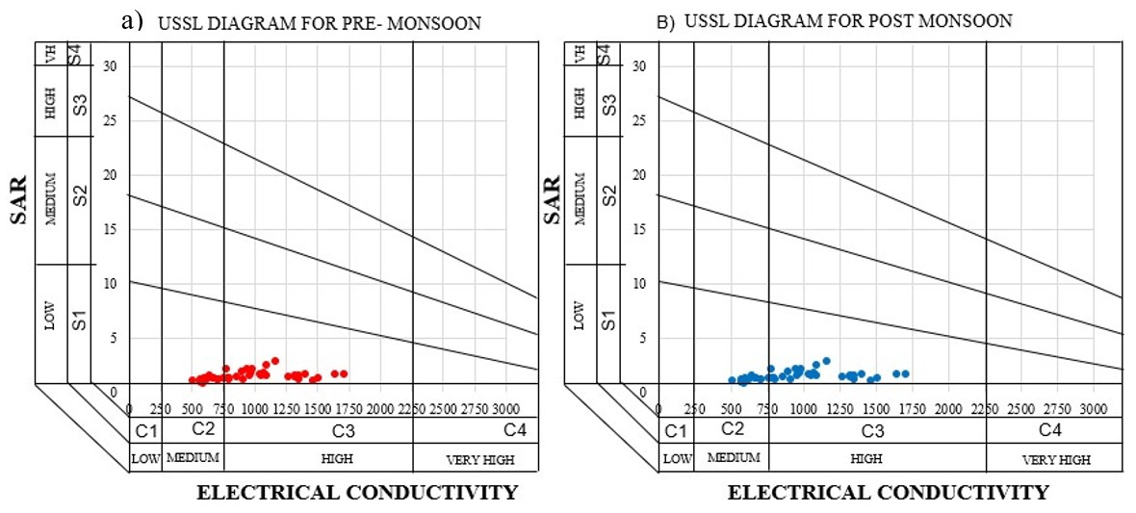
Figure 4. A and B showing USSL diagram for Pre-monsoon and Post monsoon samples.
The most groundwater samples fall within the C2–S1 and C3–S1 classes in both the seasons, indicating medium to high salinity hazard with low sodium hazard. Water belonging to these classes can generally be used for irrigation under moderate soil drainage conditions and salt-tolerant crops. The results indicate that salinity rather than sodium hazard may represent the primary concern for irrigation in certain locations.

- Wilcox Diagram
The Wilcox diagram is widely used to evaluate the suitability of groundwater for irrigation by plotting sodium percentage (Na %) against electrical conductivity (EC) (Leland Van Valen Wilcox, 1955). This diagram helps assess the combined influence of sodium hazard and salinity hazard on soil permeability and crop productivity (Robert S. Ayers and David W. Westcot, 1985). Based on this diagram, the red color dots showing pre-monsoon samples and blue dots color shows post monsoon seasonal variations of groundwater quality for 41 samples (Figure 5). Most groundwater samples fall within the excellent to good irrigation water categories. However, the EC values indicate medium to high salinity conditions, which may affect soil salinity when used continuously for irrigation. Therefore, irrigation using such groundwater may require proper drainage and suitable soil management practices to prevent salinity accumulation. Overall, the Wilcox diagram suggests that groundwater in the study area is generally suitable for irrigation with appropriate agricultural management practices. (Li et al., 2021; Zhang et al., 2023).
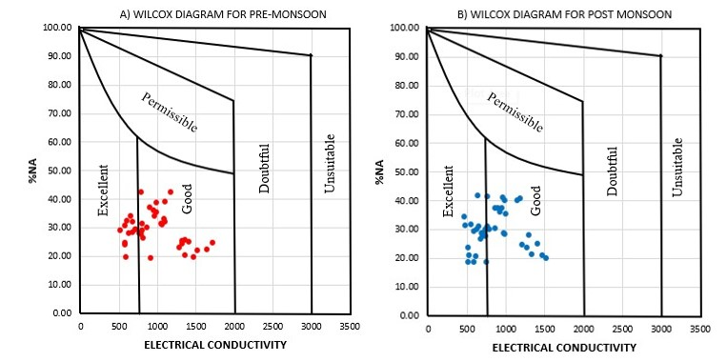
Figure 5. A and B showing Wilcox diagram for Pre-monsoon and Post monsoon samples.
- Piper Diagram
The Piper trilinear diagram is a widely used graphical method for identifying hydrochemical facies and understanding groundwater evolution based on the relative proportions of major cations and anions (Piper, 1944). In the present dataset, Series 1 represents pre-monsoon samples and Series 2 represents post-monsoon samples plotted on the Piper diagram to examine seasonal variations in groundwater chemistry (Figure 6).
The cation triangle indicates that most groundwater samples plot toward the calcium (Ca²⁺) and magnesium (Mg²⁺) fields, showing the dominance of alkaline earth metals over alkali metals. This suggests that groundwater chemistry is mainly controlled by carbonate dissolution and silicate weathering processes in the aquifer system (Panchabhai et al., 2024; Mishra et al., 2025).
In the anion triangle, the majority of samples are concentrated in the bicarbonate (HCO₃⁻) region, indicating that bicarbonate ions derived from carbonate mineral dissolution and soil CO₂ interaction dominate the groundwater chemistry. Such hydrochemical signatures are typical of recharge-dominated groundwater systems in hard-rock and sedimentary aquifers (Zhao et al., 2025) A few samples shift toward the chloride and sulphate zones, which may indicate minor anthropogenic influences such as agricultural activities or evaporation effects. These variations may also result from ion-exchange reactions between groundwater and aquifer materials (Islam et al., 2025).
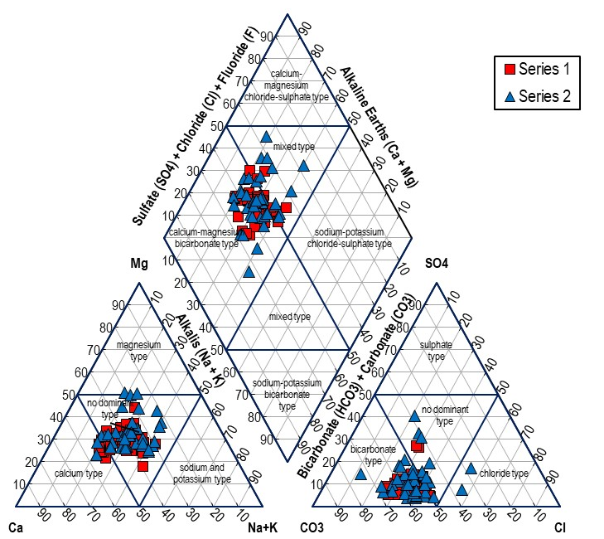
Figure 6. Piper Diagram for Pre-monsoon and Post monsoon seasons.

In the central diamond field of the Piper diagram, most samples fall in the calcium–magnesium bicarbonate facies, which represents relatively fresh groundwater and active recharge conditions. The pre-monsoon samples show relatively higher dispersion, indicating increased mineralization due to evaporation and prolonged water–rock interaction during dry seasons. In contrast, post-monsoon samples are more concentrated within the bicarbonate facies, suggesting dilution and recharge from rainfall during the monsoon period. Seasonal dilution effects caused by rainfall are commonly reported in hydrogeochemical studies of groundwater systems (Mishra et al., 2025).

6 Conclusion
The present study demonstrates that groundwater chemistry in the Lokapavani River Basin is predominantly governed by geogenic processes, particularly silicate weathering, mineral dissolution, and ion exchange, with limited anthropogenic inputs. The WQI classification indicates that the majority of groundwater samples fall within acceptable limits for drinking, though localized deterioration is observed in areas such as Melkote, G. Singapura, Atthiganahalli, and Jakkanahalli due to elevated concentrations of TDS, nitrate, and fluoride. Seasonal variations highlight improved water quality during the post-monsoon period as a result of dilution and recharge processes.
Irrigation suitability assessment through SAR, Na%, PI, RSC, Kelly’s ratio, USSL and Wilcox diagrams confirms low sodium hazard and moderate salinity conditions, indicating that groundwater is generally appropriate for agricultural use under controlled management practices. However, salinity management and drainage improvement are necessary in specific locations to prevent soil degradation. The Piper diagram states that the hydrochemical facies indicate that groundwater chemistry in the study area is primarily controlled by natural geochemical processes such as mineral weathering, groundwater recharge and minor anthropogenic influences. The findings emphasize the importance of long-term groundwater monitoring, pollution control and sustainable resource management to safeguard water quality in the study area.

7 Reference
- Appelo, C. A. J. and Postma, D. (2005). Geochemistry, Groundwater and Pollution (2nd edition). CRC Press.
- Ayers, R. S. and Westcot, D.W. (1985). Water Quality for Agriculture. FAO Irrigation and Drainage. Pp 29.
- Bureau of Indian Standards (2012). IS 10500: Drinking Water Specification.
- Doneen, L. D. (1964). Notes on Water Quality in Agriculture. Department of Water Science and Engineering, University of California.
- Islam, Rafiqul., Habib, Mohammad Ahsan. and Islam, MD. Nazrul. et al. (2025). Integrated Evaluation of Groundwater Hydrochemistry and Water Quality Using Piper Diagram and Statistical Approaches. Journal of Environmental Science and Pollution Research. Vol. 32, Pp 45612–45628.
- Kelly, W.P. (1963). Use of saline irrigation water. Soil Science, Vol. 95(4), Pp 355–391.
- Li, Peiyue., Wu, Jianhua. & Qian, Hailong (2014). Groundwater Quality Assessment Based on Entropy Weighted Osculating Value Method: A Case Study in an Industrial Park, Northwest China. Journal of Environmental Monitoring and Assessment. Vol. 186, Pp 6937-6945.
- Li, Peiyue., Wu, Jianhua. and Qian, Hailong. (2021). Groundwater Quality Assessment and Human Health Risk Evaluation. Journal of Science of the Total Environment. Vol. 791, pp 148310.
- Mishra, A., Singh, Rajesh Kumar. and Sandeep Kumar. (2025). Spatio-temporal Characterization of Groundwater Hydrochemistry and Controlling Processes. Journal of Applied Water Science. Vol. 15, Pp 148-162.
- Panchabhai, R. C., Wagh Nithin, D. and Singh, Prashant Kumar. (2024). Hydrochemical Insights of Groundwater for Drinking, Agriculture and Potential Nitrate Threats in Western India. Journal of Environmental Earth Sciences. Vol. 83, Pp 450-462.
- Piper, A. M. (1944). A Graphic Procedure in the Geochemical Interpretation of Water Analyses. Journal of Transactions, American Geophysical Union. Vol. 25, Pp 914–928.
- Ravikumar, P., and Somashekar, R. K. (2021). Evaluation of Groundwater Quality Using Water Quality Index Methods. Journal of Environmental Monitoring and Assessment. Vol. 193, Pp 1–15.
- Richards, L.A. (1954). Diagnosis and Improvement of Saline and Alkali Soils. USDA Agricultural Handbook No. 60.
- Singh, S., Kumar, A. and Singh, R. (2022). Irrigation Water Quality Assessment Using Hydrochemical Indices. Journal of Environmental Earth Sciences. Vol. 81, Pp 420.
- Subba Rao, N., Chaudhary, M., & Rao, P. (2022). Hydrogeochemical Processes Controlling Groundwater Quality. Journal of Environmental Geochemistry and Health. Vol. 44, Pp 1125–1143.
- Todd, D. K. and Mays, L.W. (2005). Groundwater Hydrology, (3rd Edition). John Wiley & Sons.
- Ubuoh, E. A., Okeke, Chinedu E. and Nwankwo, Samuel O. (2024). Evaluation of Hydro-chemical Facies and Water Quality Dynamics Using Multivariate Statistical Approaches. Journal of Environmental Monitoring and Assessment. Vol. 196, Pp 312–328.
- Vasanthavigar, M., Srinivasamoorthy, K., Vijayaragavan, K., Rajiv Gandhi, R., Chidambaram, S., Anandhan, P., Manivannan, R. And Vasudevan, S. (2010). Application of Water Quality Index for Groundwater Quality Assessment: Thirumanimuttar Sub-basin, Tamil Nadu, India. Journal of Environmental Monitoring and Assessment. Vol. 171, Pp 595–609.
- Wilcox. (1955). Classification and Use of Irrigation Waters. USDA Circular 969.
- World Health Organization (2022). Guidelines for Drinking-Water Quality, 4th Edition.
- Zhang, Y., Guo, H., & Li, P. (2023). Hydrochemical Characterization and Groundwater Quality Evaluation. Journal of Hydrology. Vol. 620, Pp 129422.
- Zhao, Yong., Guo, Qiang. and Li, Xiaoming. (2025). Shallow Groundwater Hydrochemical Facies and Nitrate Contamination Mechanisms. Sustainability, Vol. 17, Pp 10834-10848.
.

