Review Article

Migratory Waterbirds in Asan Wetland, Uttarakhand: Ecology and Conservation Status of a Ramsar Site

Abstract
The Asan Wetland, also known as the Asan Conservation Reserve, is a human-engineered freshwater ecosystem in the Shivalik foothills of Uttarakhand, India, and a Ramsar-designated site since 2020. Positioned along the Central Asian Flyway, it serves as a critical wintering and stopover habitat for migratory waterbirds, supporting over 330 avian species, including globally threatened taxa such as Aythya baeri, Aquila nipalensis, and Haliaeetus leucoryphus. This review synthesizes current knowledge on the wetland’s avian diversity, migratory patterns, and ecological functioning, highlighting functional guild structures, trophic interactions, and habitat heterogeneity. Comparative analysis of pre- and post-Ramsar data reveals a transition from qualitative, fragmented observations to systematic, quantitative monitoring via the Asian Waterbird Census (AWC), enhancing understanding of species abundance, seasonal dynamics, and ecosystem stability. Despite this, anthropogenic pressures, hydrological regulation, and climate variability continue to influence species composition and ecological resilience. The review emphasizes the need for adaptive, science-based management strategies, integration of local and flyway-scale ecological processes, and long-term monitoring to ensure conservation effectiveness and ecosystem sustainability.
Keywords: Asan Wetland; Ramsar Site; migratory Waterbirds; Central Asian Flyway; Wetland ecology; Asian Waterbird Census; Habitat heterogeneity
Introduction
The Asan Wetland, also known as the Asan Conservation Reserve, is a human-engineered freshwater wetland located at the confluence of the Asan and Yamuna rivers in the foothills of the Shivalik range, Uttarakhand, India. Covering approximately 444 hectares, it represents one of the most ecologically significant inland wetlands in northern India (Ramsar Convention Secretariat, 2020; WWF India, 2024). Wetlands are globally recognized as highly productive ecosystems that support rich biodiversity, regulate hydrological processes, and provide critical ecosystem services, particularly for migratory waterbirds (Mitsch & Gosselink, 2015; Keddy, 2010). The wetland gained international recognition in 2020 when it was designated as a Ramsar Site under the Ramsar Convention, becoming the first such site in Uttarakhand. This designation highlights its importance as a critical habitat for migratory and resident bird species and underscores its role in global wetland conservation frameworks (Ramsar Convention Secretariat, 2020; Finlayson et al., 2018).
Strategically positioned along the Central Asian Flyway (CAF), one of the major global migratory routes, the wetland serves as a key wintering and stopover site for waterbirds migrating between breeding grounds in northern Eurasia and wintering areas in the Indian subcontinent (BirdLife International, 2023; Wetlands International, 2023). Migratory birds depend on a network of wetlands along this flyway for resting, feeding, and energy replenishment, making sites such as Asan crucial for maintaining ecological connectivity across continents (Newton, 2008; CMS, 2020). Baseline studies conducted prior to Ramsar designation reported approximately 250–327 bird species, including nearly 80 waterbird species (Singh & Bhatt, 2016; Ramsar Convention Secretariat, 2020). However, these early assessments were largely descriptive and lacked standardized monitoring protocols. In contrast, post-2020 monitoring efforts, particularly through the Asian Waterbird Census (AWC), have generated more systematic, quantitative, and comparable datasets (Wetlands International South Asia, 2026).
Recent winter surveys (2025–2026) recorded over 120 bird species and approximately 5,200–5,800 individual birds, reaffirming the wetland’s importance as a major wintering ground within the Central Asian Flyway (Wetlands International South Asia, 2026). Despite its ecological significance, the wetland is increasingly subjected to anthropogenic pressures, including tourism, hydrological regulation through barrage operations, and land-use changes in surrounding areas (Sharma et al., 2024). In addition, climate variability is emerging as a critical factor influencing migratory dynamics, with studies indicating shifts in arrival timing and species composition linked to rising temperatures and altered precipitation patterns (Kumar & Joshi, 2025; IPCC, 2021). Overall, the Asan Wetland represents an important ecological system for understanding the interactions between migratory bird assemblages, wetland ecosystem functioning, and conservation interventions. As a Ramsar-designated site within a major global flyway, it provides valuable insights into how local ecological processes are shaped by broader climatic and biogeographic factors, while also highlighting the challenges of balancing conservation and human use in freshwater ecosystems.
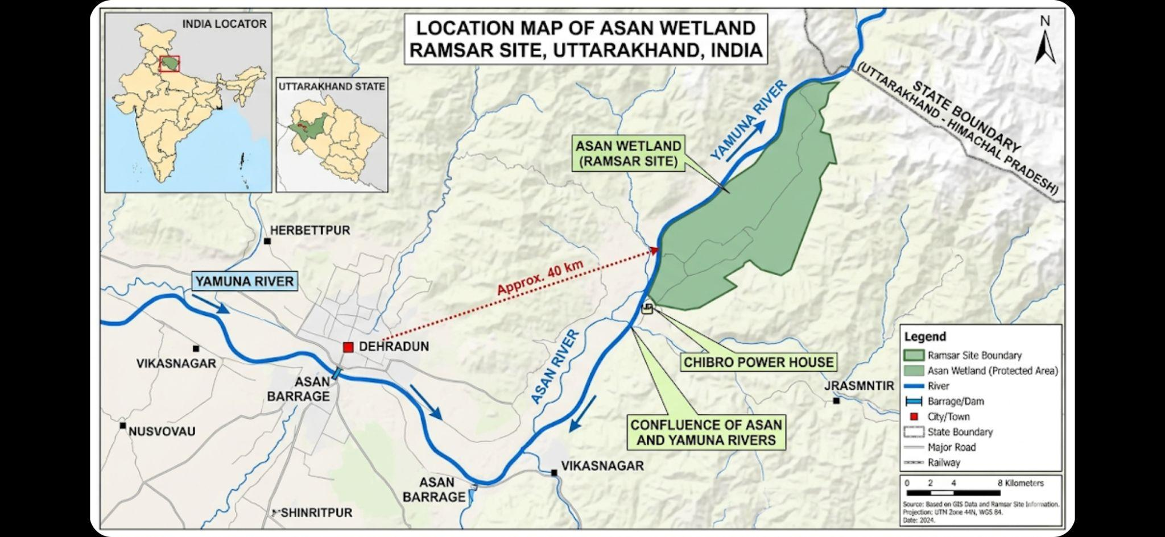
Fig. 1. Location Map of Asan Wetland, Uttarakhand, India

Avian Diversity of Asan Wetland
The Asan Wetland supports a high level of avian diversity, with approximately 330 species recorded, making it one of the most species-rich inland wetlands in northern India (WWF India, 2024; Wetlands International, 2020). Wetlands are known to support diverse bird assemblages due to their structural complexity, resource availability, and habitat heterogeneity, which allow coexistence of multiple ecological guilds (Keddy, 2010; Mitsch & Gosselink, 2015). A substantial proportion of the avifaunal diversity at Asan comprises waterbirds, including dabbling and diving ducks, geese, waders, piscivores, and marsh-associated species. This composition reflects the availability of diverse microhabitats such as open water, shallow margins, mudflats, and vegetated marshes, which facilitate niche partitioning and reduce interspecific competition (Weller, 1999; Singh et al., 2024). The dominance of Anatidae and associated guilds is consistent with patterns observed across wetlands within the Central Asian Flyway, where wintering assemblages are largely structured by habitat conditions and food availability (Wetlands International, 2023; Newton, 2008).
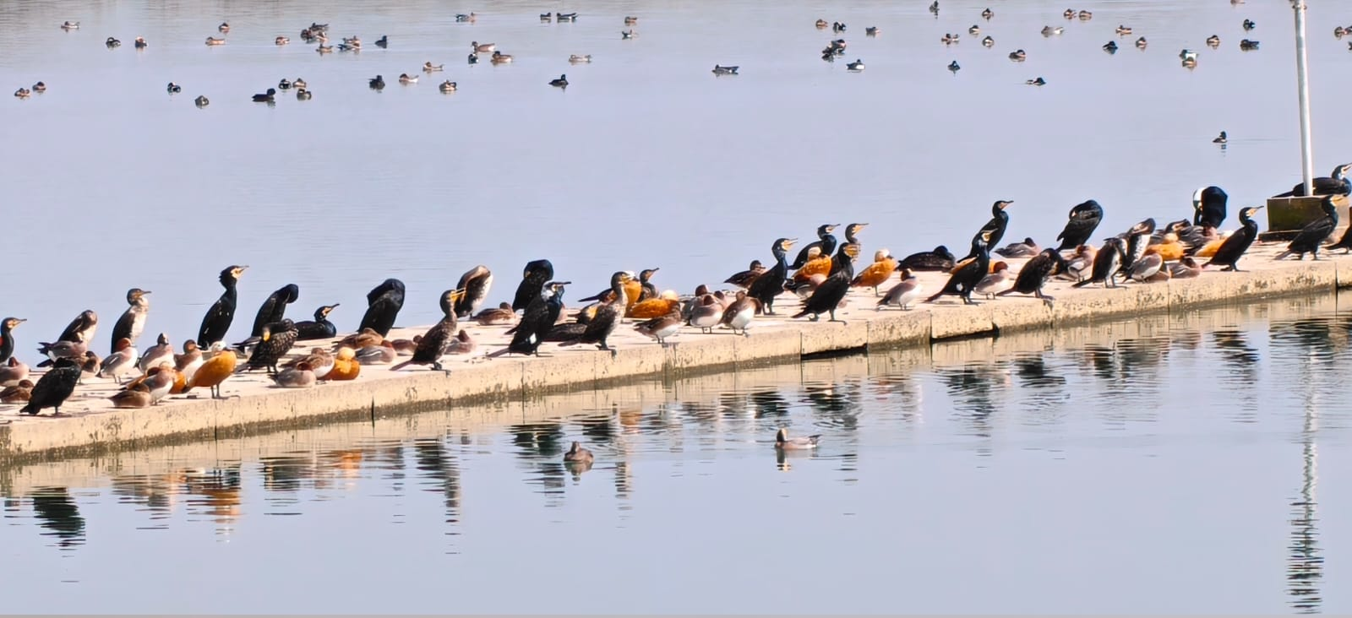
Fig. 2. A mixed flock of migratory waterbirds resting and foraging on the Asan Barrage
Recent data from the Asian Waterbird Census (AWC) indicate that 126 bird species and 5,806 individuals were recorded during the 2026 winter survey (Wetlands International South Asia, 2026). Similar counts reported in recent years suggest relatively stable wintering populations at the wetland, although minor inter-annual variations in species composition and abundance have been documented (Wetlands International South Asia, 2026). Such stability is generally associated with consistent habitat conditions and adequate resource availability within the wetland ecosystem (Mitsch & Gosselink, 2015). The wetland holds considerable conservation significance due to the presence of globally threatened species. The Critically Endangered Baer’s Pochard (Aythya baeri) has been recorded as a rare visitor, while Endangered species such as the Egyptian Vulture (Neophron percnopterus) and the Steppe Eagle (Aquila nipalensis) are regularly observed in the wetland landscape (WWF India, 2024; BirdLife International, 2023). Additionally, the occurrence of the Vulnerable Common Pochard (Aythya ferina) further underscores the ecological importance of the site. The presence of these species supports the qualification of the wetland under Ramsar Criterion 2, which recognizes sites supporting threatened species (Ramsar Convention Secretariat, 2020; Finlayson et al., 2018). In terms of species abundance patterns, the Ruddy Shelduck (Tadorna ferruginea) was the most dominant species during the 2026 winter survey, with approximately 983 individuals recorded (Wetlands International South Asia, 2026). Large congregations of geese and diving ducks indicate high primary productivity and favorable hydrological conditions, particularly suitable water depth and food availability (Singh et al., 2024; Weller, 1999). Furthermore, the regular occurrence of apex predators such as the Steppe Eagle and the Pallas’s Fish Eagle (Haliaeetus leucoryphus) reflects a well-structured trophic hierarchy and functional ecosystem stability (Sharma et al., 2024; Mitsch & Gosselink, 2015). The high species richness, presence of multiple ecological guilds, and occurrence of threatened species collectively highlight the ecological integrity and conservation importance of the Asan Wetland. At the same time, observed variations in species composition indicate that the system is dynamic and responsive to environmental and climatic drivers, emphasizing the need for continued long-term monitoring (Wetlands International South Asia, 2026; Kumar & Joshi, 2025).
Table 1. Ecological guild classification of waterbirds at Asan Wetland based on taxonomic groups and functional roles
Group | Representative Families | Ecological Role
Dabbling and Diving Ducks | Anatidae (Aythya, Anas) | Herbivory, Omnivory
Geese | Anatidae (Anser) | Grazing
Waders | Scolopacidae, Charadriidae | Benthic Feeders
Piscivorous Birds | Ardeidae, Phalacrocoracidae | Fish Predation
Raptors | Accipitridae | Top Predators

This guild-based organization reflects a well-structured trophic pyramid, indicating efficient energy transfer, resource availability, and overall ecological stability within the wetland ecosystem (Singh et al., 2024).
Table 2. Taxonomic and ecological profile of major waterbird species at Asan Wetland Sources: WWF India, 2024; Wetlands International, 2020; AWC Reports, 2026

Common Name | Scientific Name | IUCN Status | Migration Status | Flyway Origin | Habitat Use
Ruddy Shelduck | Tadorna ferruginea | Least Concern | Winter Migrant | Central Asia | Open water
Bar-headed Goose | Anser indicus | Least Concern | Long-distance Migrant | Tibet/Mongolia | Shallow wetlands
Greylag Goose | Anser anser | Least Concern | Migratory | Eurasia | Wet grasslands
Common Pochard | Aythya ferina | Vulnerable | Migratory | Europe/  Central Asia | Deep Water
Ferruginous Duck | Aythya nyroca | Near Threatened | Migratory | West Asia | Marshes
Red-crested Pochard | Netta rufina | Least Concern | Migratory | Central Asia | Lakes
Northern Pintail | Anas acuta | Least Concern | Migratory | Arctic Eurasia | Shallow wetlands
Gadwall | Mareca strepera | Least Concern | Migratory | Eurasia | Freshwater wetlands
Eurasian Wigeon | Mareca penelope | Least Concern | Migratory | Northern Eurasia | Wetlands
Tufted Duck | Aythya fuligula | Least Concern | Winter migrant | Central Asia /Eurasia | Deep water (diving duck)
Common Teal | Anas crecca | Least Concern | Winter migrant | Eurasia | Shallow wetlands
Northern Shoveler | Spatula clypeata | Least Concern | Migratory | Eurasia | Shallow water (filter feeding)
Mallard | Anas platyrhynchos | Least Concern | Winter migrant | Eurasia | Open Freshwater wetlands
Common Merganser | Mergus merganser | Least Concern | Winter migrant | Central Asia / Eurasia | Deep open water (fish-eating)
Great Crested Grebe | Podiceps cristatus | Least Concern | Winter migrant | Eurasia | Deep open water
Eurasian Coot | Fulica atra | Least Concern | Migratory / Resident | Eurasia | Open water & marsh edges
Great Cormorant | Phalacrocorax carbo | Least Concern | Resident / Migratory | Eurasia | Open water (piscivorous)
River Lapwing | Vanellus duvaucelii | Near Threatened | Resident /Migrant | South Asia | Riverbanks
Black-bellied Tern | Sterna acuticauda | Endangered | Migratory | South Asia | Riverine
Pallas’s Fish Eagle | Haliaeetus leucoryphus | Endangered | Migratory | Central Asia | Large water bodies

Migratory Patterns of Waterbirds at Asan Wetland
The Asan Wetland forms an integral component of the Central Asian Flyway (CAF), one of the world’s major migratory corridors connecting breeding grounds in northern Eurasia with wintering habitats in South Asia. The conceptualization and delineation of this flyway have been established through the work of organizations such as BirdLife International and Wetlands International, along with early synthesis by Miyabayashi and Mundkur. Their work forms the baseline framework for understanding long-distance waterbird migration across Asia. Migratory waterbirds depend on a network of wetlands distributed along this flyway for resting, feeding, and energy replenishment. Within this network, Asan Wetland functions as a critical wintering and stopover site, particularly for Anatidae (ducks and geese) and wader species (Wetlands International, 2023; BirdLife International, 2023). Species utilizing this site originate from diverse biogeographic regions, including Siberia, Central Asia, and the Tibetan Plateau, reflecting the broad spatial connectivity of the flyway. Waterbirds at Asan exhibit varied migration strategies.
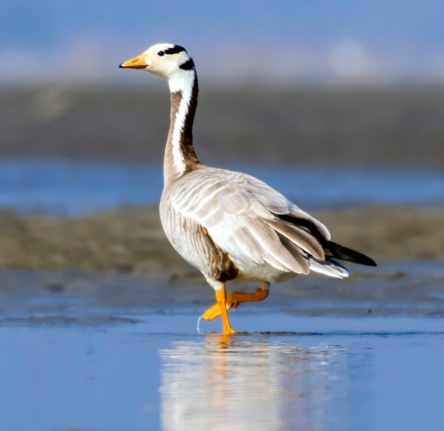
Fig. 3. Bar-headed Goose (Anser indicus), a long-distance migrant seen in Asan during winter (Photo Source: A. Islam, Macaulay Library ML 181031211)
Long-distance migrants such as the Bar-headed Goose (Anser indicus) undertake high-altitude trans-Himalayan flights, a phenomenon extensively documented in avian migration studies. Other species, including the Northern Pintail (Anas acuta) and Common Pochard (Aythya ferina), follow stepwise migration routes, utilizing a chain of wetlands across Eurasia (Wetlands International, 2023). These movement patterns are supported by global waterbird population assessments and flyway mapping initiatives led by Wetlands International and partner organizations.
Seasonal migration at Asan follows a well-defined temporal pattern, with arrival occurring during October–November, peak abundance in December–January, and departure between February and March. Recent observations from the Wetlands International South Asia under the Asian Waterbird Census (AWC 2026) report relatively stable wintering populations, with approximately 5,200–5,800 individuals recorded annually (Wetlands International South Asia, 2026). These standardized census efforts provide the most reliable long-term datasets for monitoring migratory waterbird populations in the region. However, emerging research highlights subtle shifts in migration dynamics. Studies such as Kumar and Joshi indicate delayed arrival patterns and changes in species composition, potentially linked to rising temperatures and altered climatic conditions across breeding and stopover sites.
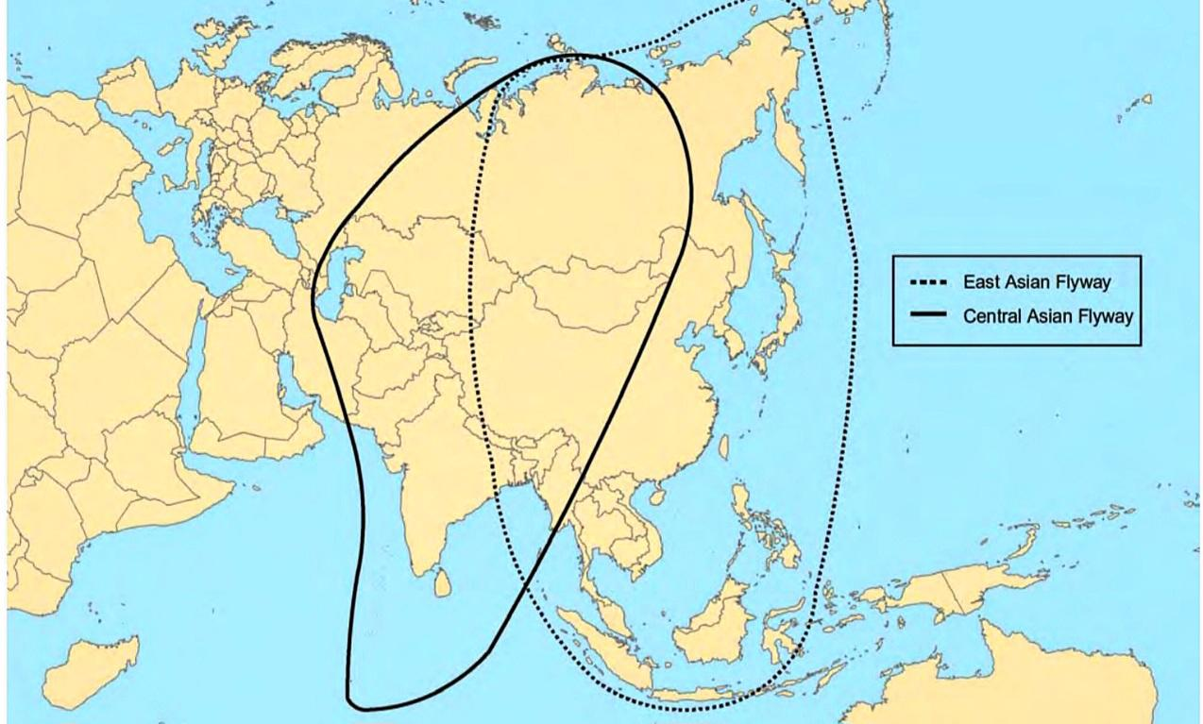
Fig. 4. Central Asian Flyway Map (Source: Miyabayashi & Mundkur 1999)
These findings align with broader global research demonstrating that migratory systems are highly sensitive to climate variability and environmental change. In general, migratory patterns at Asan Wetland are shaped by a combination of local habitat conditions and large-scale ecological processes operating across the Central Asian Flyway. This underscores the importance of integrating site-level observations with flyway-scale research to fully understand and conserve migratory waterbird populations.
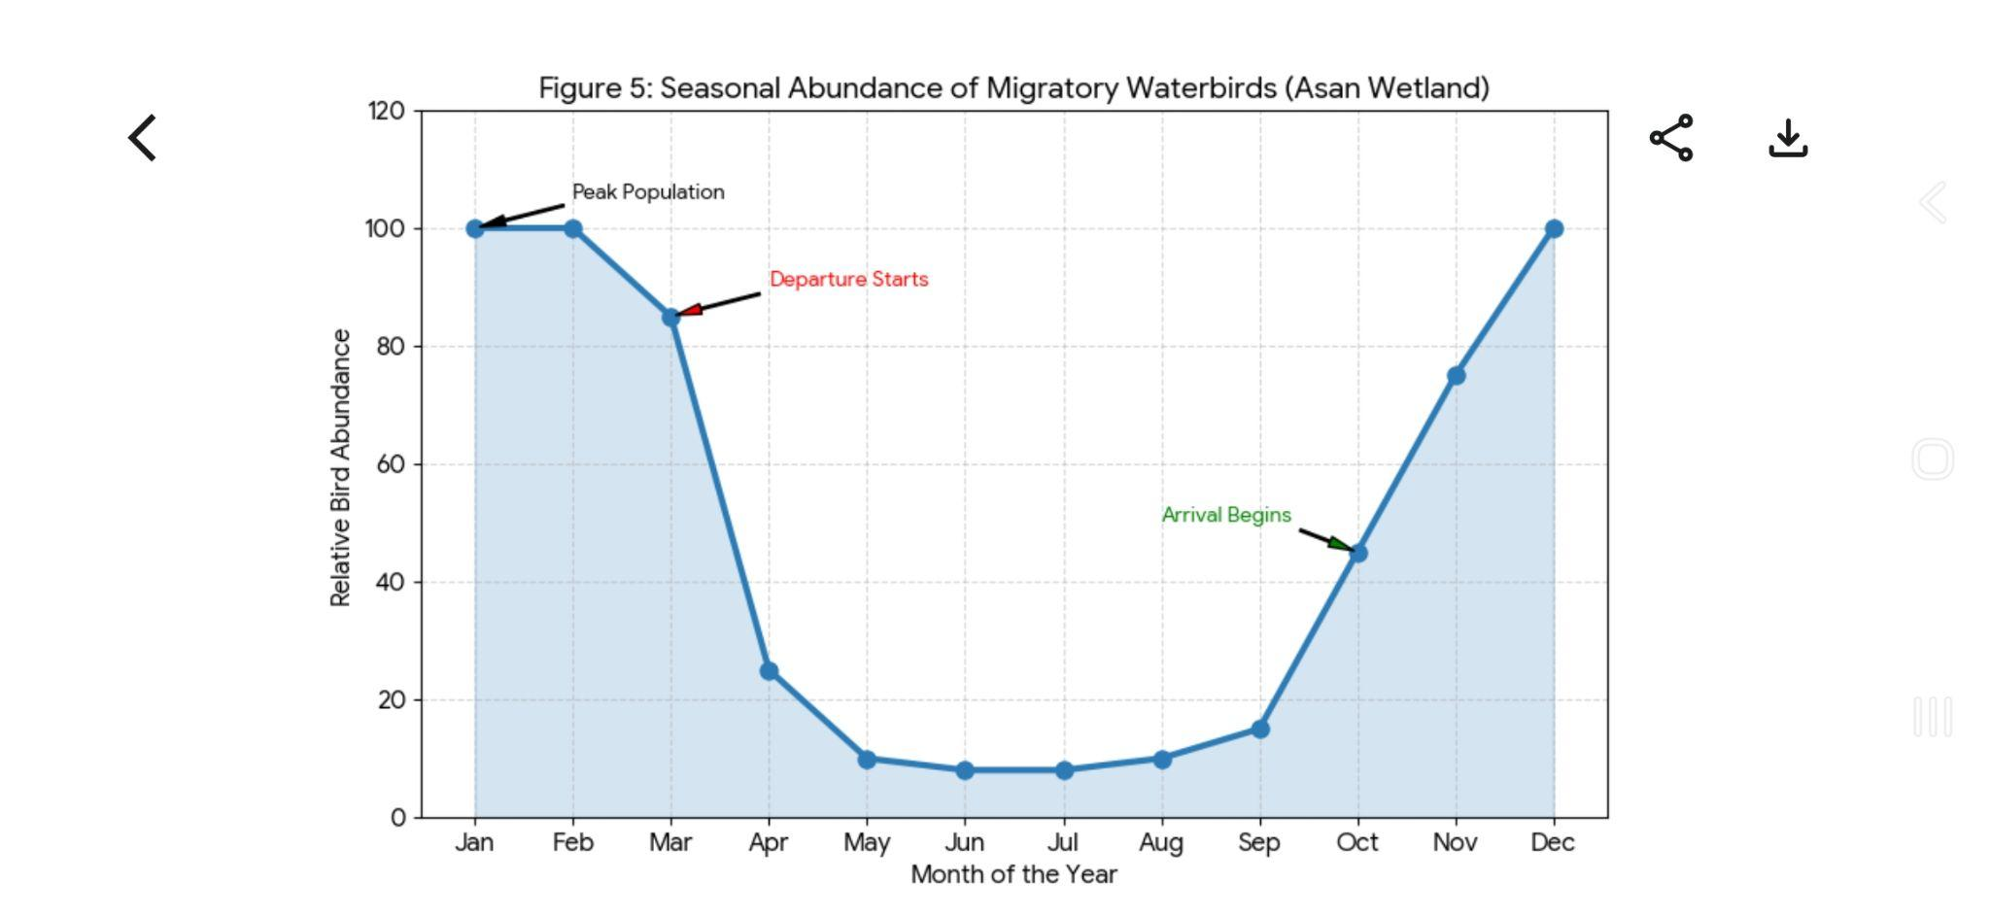
Fig. 5. Seasonal Abundance of Migratory Waterbirds in Asan Wetland

Waterbird Ecology
Waterbird communities at Asan Wetland exhibit high functional diversity structured around feeding strategies, habitat use, and trophic interactions. These ecological processes play a central role in maintaining wetland productivity, nutrient cycling, and overall ecosystem stability (Singh et al., 2024). Recent advances in wetland ecology emphasize a functional approach—focusing on guild structure, niche partitioning, and energy flow—rather than simple species inventories, enabling a more comprehensive understanding of ecosystem functioning and resilience (Kumar et al., 2025). The waterbird assemblage at Asan can be broadly categorized into distinct feeding guilds, including omnivores (primarily ducks), herbivores (geese), piscivores (cormorants and herons), insectivores (waders), and apex predators (raptors). This organization reflects classical trophic frameworks proposed by Eugene Odum, where energy is transferred across hierarchical levels from primary producers to top predators. The dominance of omnivorous and generalist species indicates ecological flexibility, while the consistent presence of diving ducks suggests suitable water depth and stable foraging conditions. Habitat heterogeneity further enhances ecological stability through niche partitioning, a concept widely developed by G. Evelyn Hutchinson. At Asan, different bird groups utilize distinct microhabitats: diving ducks occupy deep open waters, dabbling ducks prefer shallow zones, waders forage along exposed mudflats, and raptors use elevated perches and surrounding vegetation. This spatial segregation minimizes interspecific competition and promotes efficient resource utilization. Behavioral adaptations also contribute significantly to ecological functioning. Flocking behavior enhances predator avoidance and foraging efficiency, while mixed-species assemblages improve resource exploitation. Migratory species exhibit strong site fidelity and energy-maximization strategies upon arrival, ensuring optimal use of resources during the wintering period (Kumar et al., 2025).
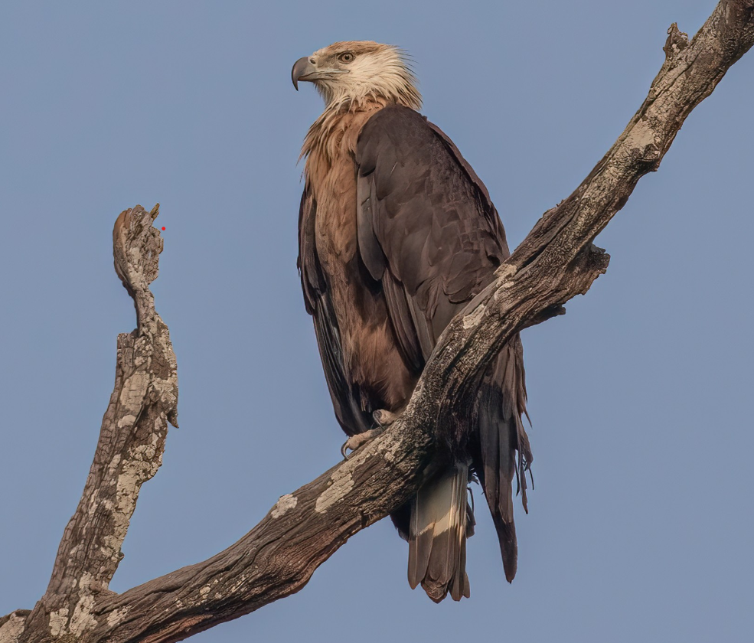
Fig. 6. Pallas’s Fish Eagle (Haliaeetus leucoryphus), an endangered raptor recorded during winter surveys at Asan Wetland, Uttarakhand, India (Photo Source: George Armistead, Macaulay Library ML 614237607)
Piscivorous species regulate fish populations, and raptors such as the Steppe Eagle and Pallas’s Fish Eagle occupy the highest trophic levels, indicating a functionally structured trophic system. Energy flow within the wetland follows a classical pathway, beginning with primary producers such as phytoplankton and aquatic macrophytes, which support invertebrates and small fish, and subsequently higher trophic levels including waterbirds. This pattern aligns with ecosystem energy models proposed by Howard T. Odum. Efficient energy transfer enables the wetland to sustain large congregations of migratory birds during winter. Beyond trophic interactions, waterbirds play a critical role in ecosystem processes. They contribute to nutrient cycling through guano deposition, facilitate seed dispersal, regulate prey populations, and act as bioindicators of wetland health (Wetlands International, 2023). However, emerging ecological concerns are evident. Fluctuations in water levels have been linked to altered feeding behavior and habitat use, while increasing human disturbance has reduced habitat utilization in certain areas (Sharma et al., 2024). Additionally, subtle shifts in species composition suggest ongoing ecological adjustments. These patterns indicate that although the ecosystem remains functionally stable, it is increasingly sensitive to environmental variability and anthropogenic pressures.
Habitat and Environmental Factors
The Asan Wetland is a human-engineered freshwater ecosystem characterized by a heterogeneous mosaic of habitats, including deep open water, shallow littoral zones, exposed mudflats, marsh vegetation, and adjacent riparian areas. This habitat diversity is a primary driver of high waterbird richness, as it provides distinct ecological niches for feeding, roosting, and shelter (Ramsar Convention Secretariat, 2020; WWF India, 2024). The role of habitat heterogeneity in sustaining biodiversity is well established in landscape ecology, as highlighted by Richard T. T. Forman. Hydrological dynamics represent the most critical driver of ecological processes at the wetland. Water levels, regulated by the Asan Barrage, exhibit seasonal variation, remaining relatively stable during winter and receding in summer. Stable winter water levels support large congregations of migratory ducks and diving species, while seasonal drawdown exposes mudflats essential for wader foraging. However, abrupt fluctuations can disrupt feeding behavior, nesting activity, and habitat availability (Singh et al., 2024), demonstrating the strong linkage between hydrology and ecological functioning. Vegetation and primary productivity form the ecological foundation of the wetland. Submerged macrophytes, emergent vegetation such as Typha and Phragmites, and phytoplankton communities support invertebrates and fish populations that sustain higher trophic levels. These dynamics align with wetland ecosystem models described by William J. Mitsch and James G. Gosselink, which emphasize the role of vegetation in regulating nutrient cycling and habitat structure.
Climatic factors further influence waterbird distribution and migration patterns. Temperature regulates migration timing, while precipitation affects hydrological regimes and habitat availability. Recent studies indicate that warmer winters and irregular rainfall patterns have contributed to delayed migration and fluctuating water levels (Kumar & Joshi, 2025). These observations are consistent with global assessments by the Intergovernmental Panel on Climate Change, which highlight the sensitivity of wetlands and migratory species to climate variability. Water quality is another key determinant of ecological health. Parameters such as dissolved oxygen, nutrient concentrations, and turbidity directly influence productivity and food availability. While moderate nutrient levels enhance productivity, excessive inputs—primarily from agricultural runoff—can lead to eutrophication, negatively affecting aquatic communities and disrupting trophic interactions (Singh et al., 2024). Despite its ecological importance, the wetland is subject to increasing anthropogenic pressures. Tourism and recreational activities disturb feeding and roosting behavior, fishing may create resource competition, and agricultural runoff contributes to nutrient loading and habitat alteration. Additionally, hydrological regulation through barrage operations modifies natural flow regimes, potentially affecting long-term habitat stability (Sharma et al., 2024).
Conservation Status and Management of Asan Wetland
The designation of Asan Wetland as a Ramsar Site in 2020 by the Ramsar Convention Secretariat marked a significant milestone, recognizing its importance as a critical habitat for migratory waterbirds within the Central Asian Flyway. The site meets Ramsar Criterion 2 due to its support for globally threatened species, including the Critically Endangered Aythya baeri, Endangered raptors such as Aquila nipalensis and Haliaeetus leucoryphus, and the Vulnerable Aythya ferina (WWF India, 2024; Wetlands International, 2023).
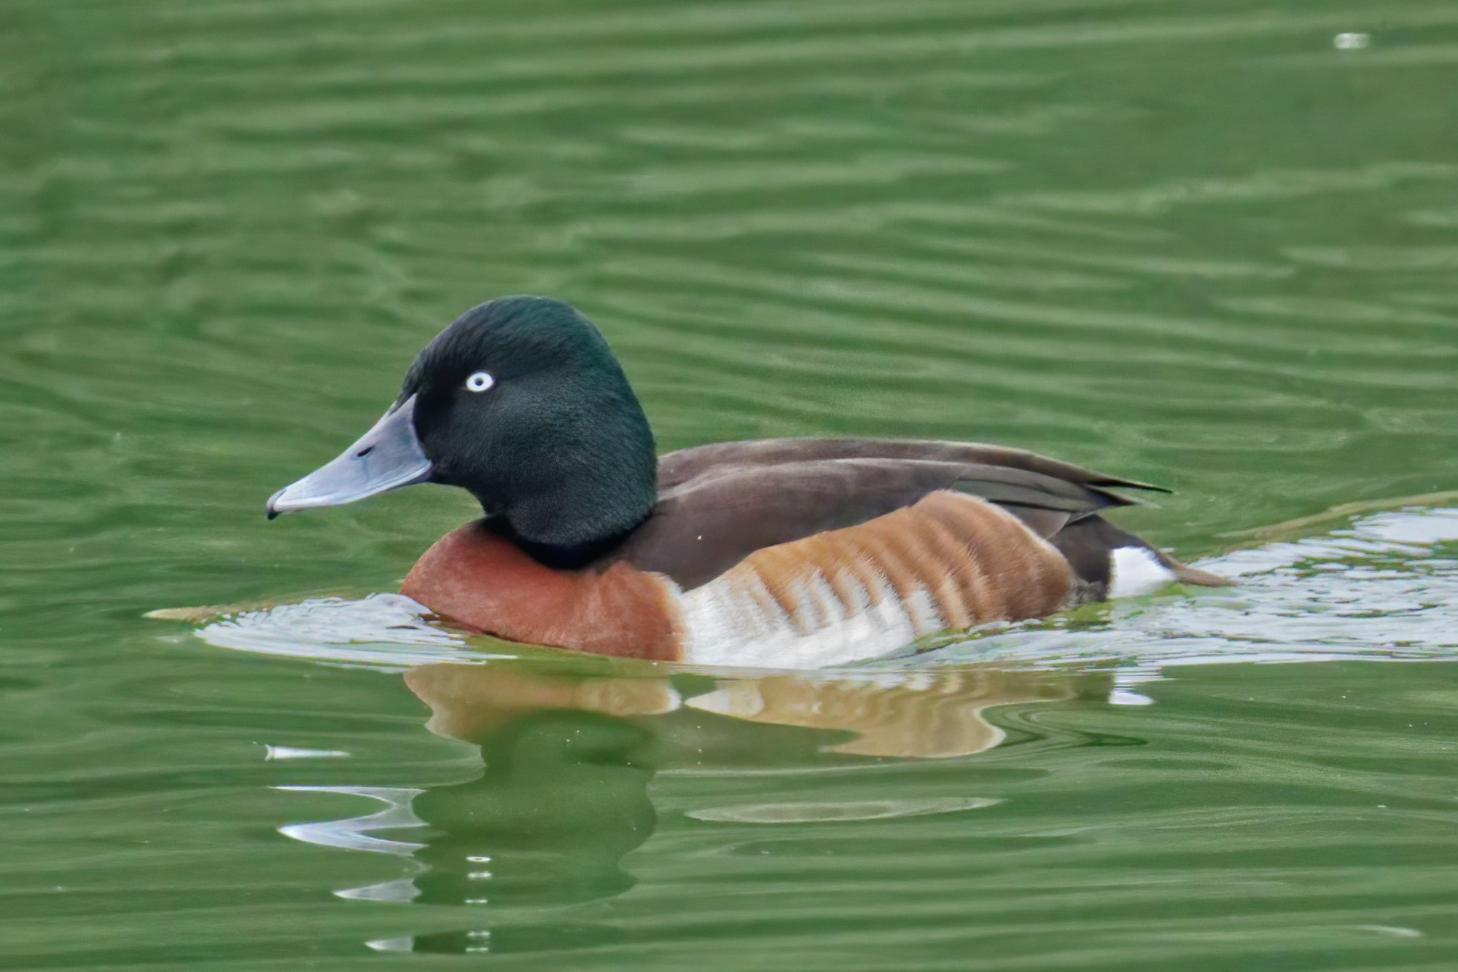
Fig. 7. Baer’s Pochard (Aythya baeri) — a Critically Endangered diving duck species recorded as a rare visitor in inland wetlands including India (Photo Source: By Sun Jiao (Interaccoonale) - Own work, CC BY 4.0, https://commons.wikimedia.org/w/index.php?curid=121061916)
Following this designation, monitoring efforts have improved substantially through standardized programs such as the Asian Waterbird Census conducted by Wetlands International South Asia. These initiatives have generated more reliable datasets on species diversity, abundance, and seasonal patterns, replacing earlier checklist-based observations (Wetlands International South Asia, 2026). Increased participation of local stakeholders, researchers, and citizen scientists has further strengthened monitoring and awareness, while eco-tourism initiatives have enhanced public engagement (WWF India, 2024). Despite these advancements, several studies identify persistent challenges limiting effective conservation outcomes. Hydrological regulation remains insufficiently aligned with ecological requirements, leading to fluctuations in water levels that affect habitat availability and feeding dynamics (Singh et al., 2024). Anthropogenic pressures—including tourism disturbance, fishing, and agricultural runoff—continue to influence water quality and bird behavior (Sharma et al., 2024). Additionally, climate variability has been linked to shifts in migration timing and species composition (Kumar & Joshi, 2025), reflecting broader global patterns.
A critical synthesis of available studies indicates a clear policy–practice gap. While Ramsar designation has improved monitoring, awareness, and institutional recognition, its translation into effective ecological management remains partial (Wetlands International, 2026; WWF India, 2024). This conclusion is based on the contrast between improved data availability and the continued persistence of ecological pressures. To address these challenges, the literature emphasizes the need for adaptive, science-based management strategies. Proposed measures include ecologically informed hydrological regulation, integration of functional ecology into conservation planning, strengthening long-term monitoring frameworks, and incorporating climate-adaptive approaches (Singh et al., 2024; Kumar et al., 2025; Wetlands International, 2023).

Discussion
Asan Wetland functions as a critical node within the Central Asian Flyway, where local species diversity and abundance are shaped by both site-specific habitat conditions and broader migratory dynamics (BirdLife International; Wetlands International). Habitat heterogeneity and regulated hydrology support multiple ecological guilds, though the increasing dominance of generalist species suggests gradual ecological homogenization. Despite stable species richness, subtle signals—altered migration timing, localized habitat avoidance, and shifts in community composition—indicate early-stage responses to environmental change, likely driven by regional climate trends and local anthropogenic modifications. While Ramsar designation has enhanced monitoring, stakeholder engagement, and data reliability, persistent pressures such as hydrological alteration, nutrient enrichment, and human disturbance highlight a policy–practice gap common in managed wetlands. Comparisons with other Himalayan wetlands and Central Asian Flyway sites suggest that Asan’s patterns reflect broader regional trends: increasing human pressure and climate variability are reshaping ecological dynamics across interconnected wetlands. Addressing these challenges requires adaptive, process-based management integrating hydrology, biodiversity, and human use. Long-term ecological sustainability will depend on maintaining functional habitats, systematic monitoring, and regional collaboration.

Table 3. Changes at Asan Conservation Reserve Pre and Post Ramsar Designation

Aspect | Parameter | Pre-Ramsar  (~2020) | Post Ramsar (2020-2026) | Reference
Avian diversity | Total bird species | ~330 sp. known | ~330 sp. confirmed | Ramsar Sites Information Service, 2020
Waterbird census | Counts | Irregular | Annual systematic counts (~126–141 species) | AsianWaterbird Census (AWC), 2024; 2026
Migration ecology | Migration & flyway data | Limited systematic data | Quantitative seasonal AWC data | Asian Waterbird Census (AWC), 2026
Habitat & management | Habitat monitoring | Limited | Improved under Ramsar status | Ramsar Sites Information Service, 2020
Pollution/  disturbance | Monitoring | Limited | Some monitoring, ongoing | -
Conservation status | Legal protection | Conservation Reserve | Ramsar Site designation (Jul 2020) | Ramsar Sites Information Service, 2020
Scientific monitoring | Data type/quality | Qualitative | Quantitative system (AWC) | Asian Waterbird Census (AWC), 2026
The transition from pre- to post-Ramsar phases at Asan Wetland reflects a significant shift from descriptive and fragmented observations toward systematic, quantitative, and functionally oriented ecological research. While improvements in monitoring, data reliability, and scientific understanding are evident—largely driven by initiatives such as the Asian Waterbird Census and increased institutional involvement—key management challenges persist. Hydrological regulation, pollution control, and long-term ecological monitoring remain insufficiently addressed, indicating a continued gap between enhanced recognition and effective on-ground conservation outcomes (Wetlands International, 2026; WWF India, 2024).
Conclusion
The Asan Wetland represents a key freshwater ecosystem within the Central Asian Flyway, supporting a diverse and functionally organized assemblage of migratory waterbirds. This review highlights that the ecological significance of the wetland lies not only in its species richness but also in its role as an integral component of a larger migratory network linking distant geographic regions. Despite continued support for substantial waterbird populations, emerging evidence indicates that the ecosystem is undergoing gradual ecological change. Shifts in migration timing, evolving patterns of habitat use, and increasing sensitivity to environmental disturbances suggest that the wetland is in a transitional phase, where structural stability is maintained but underlying processes are being modified. The Ramsar designation has played an important role in enhancing scientific monitoring, institutional recognition, and public awareness. However, the findings of this review emphasize that conservation effectiveness depends less on designation status and more on the implementation of evidence-based management strategies. Persistent challenges related to hydrological regulation, habitat quality, and anthropogenic pressures highlight the need for stronger integration between scientific research and on-ground management. A critical implication of this study is that conservation planning for Asan Wetland must adopt a multi-scale perspective, recognizing its dependence on broader flyway dynamics. Future efforts should prioritize long-term ecological monitoring, incorporation of climate variability into management frameworks, and the application of advanced tools such as remote sensing and movement ecology techniques to better understand migratory connectivity.
In conclusion, the Asan Wetland remains a resilient yet increasingly sensitive ecosystem. Its long-term sustainability will depend on the adoption of adaptive, science-driven conservation strategies capable of responding to both local pressures and large-scale environmental change.

References
Asian Waterbird Census (AWC) (2024). Annual Waterbird Census Data for Asan Wetland.
Asian Waterbird Census (AWC) (2026). Annual Waterbird Census Data for Asan Wetland.
Bar-headed Goose (Anser indicus) photo. Photo Source: A. Islam, Macaulay Library ML 181031211.
BirdLife International (2023). Central Asian Flyway factsheet.
Finlayson, C. M., Davidson, N., Spiers, A., & Stevenson, N. J. (2018). The Ramsar Convention and Wetlands Conservation. Springer.
Kumar, A., & Joshi, R. (2025). Climate-driven changes in migratory bird patterns. Journal of Avian Ecology, 12(2), 45–58.
Kumar, A., Singh, P., & Rawat, G. (2025). Functional ecology of waterbirds in Himalayan wetlands. Wetland Ecology Journal, 14(1), 33–52.
Miyabayashi, Y., & Mundkur, T. (1999). Asian Waterbird Census and Central Asian Flyway Overview. Wetlands International.
Pallas’s Fish Eagle (Haliaeetus leucoryphus) photo. Photo Source: G. Armistead, Macaulay Library ML 614237607.
Ramsar Convention Secretariat (2020). Ramsar Information Sheet: Asan Conservation Reserve (Site No. 2437).
Ramsar Sites Information Service (2020). Asan Wetland – Pre- and Post-Ramsar Status.
Sharma, V., Singh, P., & Rawat, G. (2024). Anthropogenic pressures on Himalayan wetlands. Environmental Monitoring Review, 18(1), 77–92.
Singh, R., & Bhatt, D. (2016). Avian diversity of Asan Barrage, Uttarakhand. Indian Journal of Ecology, 43(1), 123–130.
Singh, S., Naik, R., Bahuguna, A., Kumar, A., & Sharma, N. (2024). Habitat quality characterization and management of Asan Wetland Biodiversity. International Journal of Ecology and Environmental Sciences, 50, 557-575. https://doi.org/10.55863/ijees.2024.0098
Sun Jiao (Aythya baeri) photo. Photo Source: Sun Jiao, Wikimedia Commons, CC BY 4.0, https://commons.wikimedia.org/w/index.php?curid=121061916
Wetlands International (2020). Waterbird Population Estimates for Asan Wetland.
Wetlands International (2023). Waterbird Population Estimates.
Wetlands International South Asia (2026). Asian Waterbird Census Report 2026.
WWF India (2024). Asan Conservation Reserve Biodiversity Profile.
Zoological Survey of India (ZSI) (2002). Wetland Birds of India. ZSI Publication, Kolkata.
Zoological Survey of India (ZSI) (2004). Checklist of Indian Wetland Birds. ZSI Publication, Kolkata.

