Original Research Article
Analysis of the Spatio-Temporal Evolution of Land Cover Using Remote Sensing in the Ziama Biosphere Reserve (Guinea) from 2000 to 2024

.
ABSTRACT

The Ziama Biosphere Reserve (ZBR) is recognized as one of the last remaining areas of dense rainforest in the Republic of Guinea. It is the only known habitat for forest elephants in the country due to its low-altitude topography, which is conducive to their survival. However, this ecosystem is increasingly subjected to significant human pressure, particularly due to the search for arable land. The objective of this study was to identify and analyze land-use types within the ZRB.
To do so, we collected LANDSAT satellite images from the Earth Explore portal (http://earthexplorer.usgs.gov/). Of these, 6 bands (B2, B3, B4, B5, B6, and B7) were selected for analysis. Processing these bands allowed us to extract the study area in order to visualize the different land cover classes for the periods 2000, 2010, and 2024 using confusion matrices to assess accuracy.
The results reveal a decrease in the area of fallow land between 2000 and 2010, from 0.2328 to 0.1367, representing a reduction of 9.61%. In contrast to the 2010–2024 period, a considerable increase in area is observed for the fallow land (49.88%), rocky outcrop (20.51%), and bare soil (11.64%) classes.
This trend reflects an expansion of degraded areas, indicating increased anthropogenic pressure on the ZRB. With the aim of restoring the integrity
Keywords: Soil degradation, Dense Forest, Human pressure, Ziama Biosphere Reserve, Remote sensing.

1. INTRODUCTION

Over the past decade, the management and conservation of forest ecosystems have become a major global concern. These forest ecosystems play a vital role in regulating greenhouse gases due to their high biodiversity, while also contributing significantly to hydrological cycles and the formation of heavy rainfall in tropical regions (Fall, 2017; Sène, 2018). With the aim of sustainably conserving these forest ecosystems, most were designated during the colonial period for environmental and economic reasons. Subsequently, some of these ecosystems were incorporated into the Biosphere Reserves network as strategic sites for maintaining ecosystem services (FAO, 2016). The creation of the “Man and the Biosphere” program in 1971 was a major asset for involving local communities in forest resource management to plan for sustainable conservation (Soropogui et al., 2023; Barma et al., 2026). Similarly, the Earth Summit in Rio de Janeiro (Brazil) in 1992, which led to the development of Agenda 21, strengthened the commitment of more than 150 signatory member countries to the protection of biodiversity and sustainable development (Lamah, 2017).
Indeed, the commitment of these signatory members reflects the dedication of national and international institutions to ensuring the sustainability of forest resources. It is in this context that rural communities have been granted usage rights to meet their basic needs while ensuring the conservation of forest ecosystems (Ibouanga, 2022).
Despite these reforms, anthropogenic pressures are intensifying on the ground, affecting forest ecosystems through the reduction of forest areas and the disappearance of numerous plant and animal species due to population growth (UNESCO, 2017). Consequently, global forest areas, estimated at 4.077 billion hectares in 1990, were reduced to 3.952 billion hectares in 2005, representing an annual loss of more than 10 million hectares (FAO, 2018).
In Africa, as in other parts of the world, agriculture remains the primary source of human pressure, leading to the fragmentation of forest ecosystems, with 3.4 million hectares of forest land degraded each year. In West Africa, nearly 20% of forest cover was lost between 2000 and 2010 due to human activity (FAO, 2020; OFAC, 2012).
In the Republic of Guinea, as in other African countries, the colonial period marked the beginning of the establishment of protected areas due to their ecological richness, vulnerability, and the importance of their biodiversity (Barima et al., 2010a; Barima et al., 2010b; FRA, 2015).
Furthermore, the country has adopted Articles 138 and 139 of its Forest Code, granting usage rights to local communities for the purpose of safeguarding forest resources (DNEF, 2017).
Despite these concerns, significant human pressures are often observed. Local residents exercise their rights of use in ways that negatively impact Guinea’s forest resources. As a result, the country’s forest area decreased from 7264000 ha in 1990 to 6364000 ha in 2015, representing a loss of 900,000 ha per year (FRA, 2015).
The Ziama Biosphere Reserve (ZBR), located in southeastern Guinea in the Macenta prefecture, is one of the country’s last remaining areas of dense rainforest and has not been spared from these human-induced threats. Designated a forest reserve in 1942 and established as a Biosphere Reserve by UNESCO in 1981, it grants local communities usage rights for the exploitation of lowland areas and Non-Timber Forest Products (NTFPs) to meet their basic needs (UNESCO, 2017; Soropogui et al., 2025).
Today, with population growth, logging operations are no longer limited to the lowlands or non-timber forest products (NTFPs) as stipulated in the Forest Code. On the contrary, the forest resources of the reserve are being exploited along the edges of the lowlands (Soropogui et al., 2024). Similarly, the overexploitation of lowland areas can have negative impacts on the production of ecosystem services within the reserve. With the aim of contributing to the study of sustainable management of protected areas in the Republic of Guinea, we proposed to assess the effects of anthropogenic pressure on ecological changes at the edges of exploited lowlands within the Ziama Biosphere Reserve. The objective of this research was to identify the ecological changes associated with land use in this reserve through remote sensing.

2. materialS and methods
2.1. Overview of the Study Area
The Ziama Biosphere Reserve was designated a forest reserve in 1942 and subsequently designated a Biosphere Reserve in 1981 by UNESCO (CFZ, 2020). It covers an area of 119,019 ha in the Macenta Prefecture between 8°03’ and 8°32’ north latitude and 9°08’ and 9°32’ west longitude.
It is located 30 km northwest of Macenta Prefecture, 5 km before the N’Zébéla Subprefecture, and southwest of the Liberian border (CFZ, 2020).
According to the reserve’s new Development and Management Plan (PAG), it is surrounded by five rural communes comprising 35 villages (Fig. 1).
Apart from its legal status, the RBZ is recognized as an ecological heritage site representing the last remaining forest in Guinea and a refuge for pygmy forest elephants, due to its topography, which is unique among the country’s other forests (Diabaté et al., 2021).
It is essentially composed of two vegetation zones, including a lower zone that encompasses the plant communities of the plains located at the foot of the mountains at altitudes below 1,000 meters. A second, so-called montane layer, overlooks the first up to 1,400 m on ridges and summit areas that are distributed according to ecological factors (Diabaté et al., 2021).
The study area has a humid tropical climate characterized by a rainy season and a dry season, with an estimated average annual rainfall of approximately 2,700 mm. It is also crisscrossed by rivers and backwaters such as the Diani, Lélé, Veleoro, Véré, Loffa, Avilli, Laoua, and Libiguié (Camara, 2016). This hydromorphic landscape promotes the formation of numerous low-lying areas within the reserve (Diallo et al., 2020). This study was conducted throughout the RBZ using remote sensing to collect all data related to land use in order to identify the current state of anthropogenic degradation in this reserve.

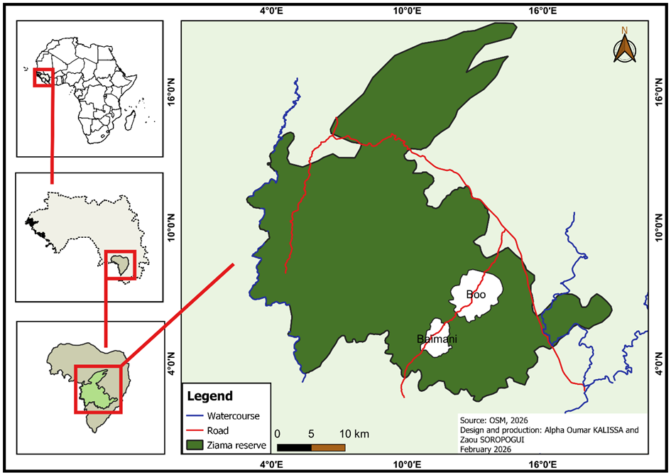
Fig. 1. Map of the Ziama Biosphere Reserve

2.2. Data Collection
The data collected for this study consisted of satellite imagery obtained through remote sensing, which was processed to generate land-use maps for the RBZ between 2000 and 2024. To this end, three time periods (2000, 2010, and 2024) were selected for the production of land-use maps in order to compare these images and their Kappa coefficient values. This allowed us to identify the least degraded period and the most degraded period.
2.3. Collection of Spatial Data
The spatial images used were primarily derived from Landsat satellites and provided free of charge by the United States Geological Survey (USGS). They were downloaded from the EarthExplore portal (http://earthexplorer.usgs.gov/). Among the various available bands, bands B2, B3, B4, B5, B6, and B7 (Table) were selected for this study due to their relevance for analyzing land cover and vegetation (Table 1).
Table 1: Satellite image bands (Landsat 8/9)
N° | Name (band) | Description | Wavelength
 | B2 | Blue | 496.6nm (S2A) / 492.1nm (S2B)
 | B3 | Green | 560nm (S2A) / 559nm (S2B)
 | B4 | Red | 560nm (S2A) / 559nm (S2B)
 | B5 | Red Edge 1 | 664.5nm (S2A) / 665nm (S2B)
 | B6 | Red Edge 2 | 703.9nm (S2A) / 703.8nm (S2B)
 | B7 | Red Edge 3 | 740.2nm (S2A) / 739.1nm (S2B)

2.4. Image Preprocessing
2.4.1. Radiometric Correction
The Landsat images used in this study were at the Level 1 (L1) processing stage, where pixels are represented solely as raw energy levels. To make them usable for analysis, it was necessary to apply radiometric correction to obtain top-of-atmosphere (TOA) reflectance. This step was performed using the Semi-Automatic Classification Plugin (SCP) in QGIS, version 7.9.5, which automates the process. It uses information from the MTL.txt metadata file (Earth–Sun distance, Sun elevation, satellite viewing angle) to apply the necessary adjustments. Once processing was initiated via SCP, the preprocessing of the LANDSAT images was performed directly. The corrected bands were then generated with the prefix “RT” and transferred directly into the QGIS processing software for analysis (Roy et al., 2016; Padro et al., 2017).
2.4.2. Study Area Delineation
The study area was delineated using QGIS. The boundaries of the Ziama Biosphere Reserve served as the reference vector file (shapefile) for the delineation.
2.5. Classification
The classification method used in this study was supervised classification. It requires knowledge of the study area based on the calculation of K-MEANS algorithms for each class. It consists of a training phase and a classification phase. Thus, the training phase concerns the area of the image whose land cover is known to the user. Similarly, the classification phase involves classifying all images by comparing each pixel with known domains across land-use categories (Lillesand et al., 2015). Supervised classification uses several algorithms, including K-MEANS, which was the only one used in this study.
This algorithm uses training areas to refine the distribution of each land-use class according to a normal probability distribution. It is based primarily on the statistical analysis of the distribution of elements within the area to determine the probabilities of each class (Richards, 2013).
2.6. Rate of Change
The rate of change in land use classes was assessed by calculating the rate of change E(i,k). (Moons & Vandervieren, 2025).
Let Gi be the area of the land use class in year i and Gk be that of a land use category through the Kappa coefficient (k, where k > i) according to the following equation:

E_{(i,k)} = $\frac{G_{k}-G_{i}}{G_{i}} ×100$

If E(i,k) = 0, we conclude that this land-use class is stable;
If E(i,k) < 0, we conclude that this land-use class is declining;
If E(i,k) > 0, we conclude that this land-use class is growing.

2.7. Development of the Transition Matrix
The transition matrix is a method for concisely describing, in the form of a square matrix, the changes in the state of the elements comprising a given site over a specific period (Chen et al., 2018). Thus, this matrix allowed us to quantify and analyze changes in land use for the years 2000, 2010, and 2024, while providing a clear representation of gains, losses, and persistence’s for each land cover class.

2.8. Overall accuracy (Pg)
Overall accuracy is the proportion of correctly classified pixels relative to the total number of pixels evaluated (Roy et al., 2016). It is calculated using the following equation:

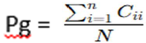

Where Cii is the number of pixels correctly classified into class i, yielding the value of the matrix;
N is the total number of pixels included in the transition matrix.
2.9. Expected proportion of agreement by chance (Pd)
The expected random agreement rate is the probability that a pixel in a particular class in the image corresponds to a pixel in the same class in the field (Roy et al., 2016). It is calculated using the following equation:
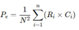
Where Ri: is the total of prediction row i;
Ci: corresponds to the total of the truth column for ground truth class i;
N: indicates the total number of pixels included in the transition matrix.
2.10. Kappa coefficient (k)
Furthermore, the Kappa coefficient typically ranges from -1 to 1, corresponding to the agreement rate corrected for chance. This coefficient accounts for both omission and confusion errors. Similarly, it is the most commonly used measure for validating classifications. It also measures the agreement between the classification and the ground truth, corrected for chance (Moons & Vandervieren, 2025). It is obtained using the following equation:

$$K=\frac{Pg-Pd}{1-Pd}$$

According to Foody (2020), the classification is satisfactory when the Kappa coefficient ranges between 0.61 and 0.80 (Table 2).
The quality of the classification in this study was assessed using overall classification accuracy and the Kappa coefficient. After validation, the land-use maps were used to define new reference areas in order to evaluate the quality of the classification of the earlier images.

Table 2: Interpretation of Cohen's Kappa Coefficient
Kappa (K) |  | Interpretation
< 0.00 |  | No agreement
0.00 – 0.20 |  | Slight
0.21 – 0.40 |  | Weak
0.41 – 0.60 |  | Moderate
0.61 – 0.80 |  | Substantial
0.81 – 1.00 |  | Almost perfect
>1 |  | Perfect

The Kappa coefficient is generally considered a measure of inter-rater reliability for categorical data. This coefficient applies only to two raters. When there are more than two raters, other formulas are used, such as Kleiss’s Kappa (Moons & Vandervieren 2025).

3. results AND Discussion
3.1. Mapping changes in land use

Mapping of changes in land use was carried out by producing three maps for the years 2000, 2010, and 2024. These maps primarily served to visually illustrate the transformations in the landscape of the reserve.
Thus, they describe the different categories of land use during the selected periods. This highlights gradual changes, such as fallow land and bare soil, which indicate the presence of anthropogenic threats to the reserve (Fig. 2). These results provide a foundation for spatiotemporal studies aimed at making decisions regarding the improvement of the landscape of this forest ecosystem. Similarly, they provide insights into the processes shaping the current configuration of this reserve.
In this study, the presence of fallow land and bare soil within the various land-use classes examined in the Ziama Biosphere Reserve indicates that human activities are occurring within the reserve. These activities, such as slash-and-burn agriculture and overgrazing, are considered detrimental to the natural development of a forest landscape. This finding corroborates those of Atakpama et al. (2023), who observed in the Fosse Doungh Forest in Togo that slash-and-burn agriculture is the most concerning form of anthropogenic degradation among the types identified at their study site.

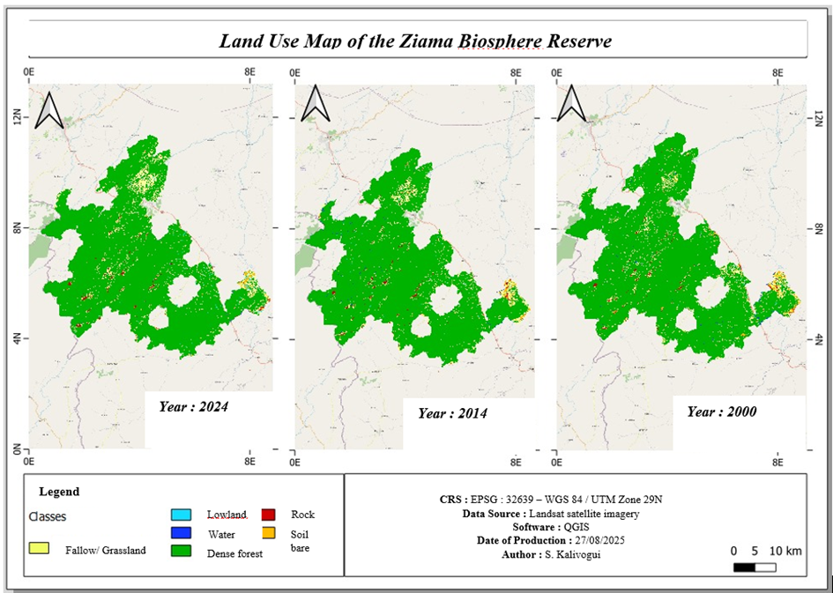
Fig. 2. Land-use map of the RBZ from 2000 to 2024

3.2. Validation of Land Use Maps
3.2.1. Confusion Matrix for the Year 2000
Analysis of this matrix indicates an overall accuracy of 87.49% and a Kappa coefficient of 0.21%, indicating low agreement with the reference data after correction for chance.
However, an examination of Producer’s Accuracy (PA)—which involves dividing the sum of all positive and negative values by the total number of class types—reveals varying performance metrics in the classification depending on the nature of the forest cover.
Consequently, dense forest is the best-performing class, with a PA of 91.97%, which may indicate stability and a strong spectral signature in the satellite images.
Conversely, the fallow land (PA = 23.28%), bare soil (PA = 19.34%), water (PA = 14.30%), and shallow water (PA = 4.68%) classes show lower accuracy rates, primarily due to confusion with dense forest or other closely related spectral classes.
In fact, rocky outcrops account for 60.25% of the spectral signature in satellite images but are still prone to confusion with bare soil and fallow land (Table 3).
This result indicates that the fallow land class (PA = 23.28%) and bare soil class (PA = 19.34%) exhibit low levels of human pressure on the RBZ. This could be explained by the fact that, at that time, there was an abundance of arable land and high crop yields coupled with low population density. Similarly, this result is confirmed by a high rate of dense forest formation (PA = 91.97%). Meanwhile, there are few signs of human activity related to the search for means of subsistence, as highlighted by the FAO, 2011.

Table 3: Confusion Matrix 2000

Class of 2000 | Fallow land | Shallow water | Water | Dense forest | Roche | Bare ground | Total (ranked)
Fallow land | 12628 | 474 | 107 | 76188 | 1476 | 1462 | 92335
Shallow water | 872 | 284 | 123 | 3729 | 43 | 256 | 5307
Water | 144 | 90 | 1185 | 9100 | 10 | 50 | 10579
Dense forest | 33582 | 4959 | 6812 | 1111353 | 846 | 4402 | 1161954
Roche | 2553 | 102 | 25 | 2486 | 4802 | 1020 | 10 988
Bare ground | 4458 | 158 | 31 | 5412 | 793 | 1725 | 12577
Totals (ref) | 54237 | 6067 | 8283 | 1208268 | 7970 | 8915 | 1293740
Overall accuracy |  |  |  | 87.49 %
Kappa coefficient |  |  |  | 0.21

3.2.2. Confusion Matrix 2010
The 2010 confusion matrix indicates good overall agreement, with an overall accuracy of 85.30% and a low Kappa coefficient of 0.18. Thus, dense forest is the best-classified category (PA = 95.64%). However, the bare soil (13.71%), fallow land (13.67%), water (11.20%), and low-lying areas (5.35%) classes exhibit significant errors, mainly due to confusion with dense forest and closely related spectral classes. Rock outcrops are thus correctly classified 63% of the time (Table 4).
These results show that the bare soil (PA = 13.71%) and fallow land (PA = 13.67%) classes observed by satellites in 2010 within this reserve continue to decline gradually. However, dense forest (PA = 95.64%) is increasing significantly. These changes could be explained by government efforts regarding development and management projects in the reserve. This finding contradicts the work of Kamto (2016), who found in the forest ecosystem of the Dja district in eastern Cameroon that local residents were appropriating arable land due to the inefficiency of the actors involved in management.

Table 4: Confusion matrix 2010

Class of 2010 | Fallow land | Shallow water | Water | Dense forest | Roche | Bare ground | Total (ranked)
Fallow land | 12628 | 872 | 144 | 33582 | 2553 | 4458 | 55290
Shallow water | 474 | 284 | 90 | 4959 | 102 | 158 | 6 237
Water | 107 | 123 | 1185 | 6812 | 25 | 31 | 9080
Dense forest | 76188 | 3 729 | 9100 | 1111353 | 2486 | 5412 | 1238901
Roche | 1476 | 43 | 10 | 846 | 4802 | 793 | 8149
Bare ground | 1462 | 256 | 50 | 4 402 | 1020 | 1725 | 9254
Totals (ref) | 92335 | 5307 | 10579 | 1161954 | 10988 | 12577 | 1326911
Overall accuracy |  |  |  |  |  |  | 85.30 %
Kappa coefficient |  |  |  |  |  |  | 0.18

3.2.3. Confusion Matrix 2024
The 2024 confusion matrix shows good overall accuracy of 92.25% and a moderate Kappa coefficient of 0.48. Similarly, dense forest is the best-classified land cover type (PA = 95.17%). However, the fallow land (63.55%), bare soil (25.35%), water (17.07%), and lowland (11.31%) classes also exhibit significant errors, mainly due to confusion with dense forest and closely related spectral classes. Rock outcrops are classified correctly 64.62% of the time, but still show confusion with fallow land and bare soil (Table 5).
The results of this matrix indicate a gradual increase in the fallow land (63.55%) and bare soil (25.35%) classes, indicating overexploitation of the RBZ’s forest resources. This could be explained by heavy human pressure on the RBZ in the search for fertile land to meet family needs. Furthermore, this human pressure may lead to the fragmentation of the reserve.
Similarly, these findings align with those of Amani & Touré (2015) in the Banko Forest in Côte d’Ivoire. They demonstrated that (illegal) agricultural exploitation by farmers within protected areas is often the cause of poor floristic composition in these areas.

Table 5: Confusion Matrix 2024

Class of 2024 | Fallow land | Shallow water | Water | Dense forest | Roche | Bare ground | Total (ranked)
Fallow land | 35142 | 2186 | 485 | 54208 | 1026 | 5567 | 98614
Shallow water | 1733 | 706 | 15 | 857 | 183 | 262 | 3756
Water | 121 | 50 | 1 550 | 3 318 | 0 | 55 | 5094
Dense forest | 12932 | 2838 | 6969 | 1179102 | 86 | 577 | 1202504
Roche | 924 | 11 | 1 | 71 | 5266 | 447 | 6720
Bare ground | 4438 | 446 | 60 | 1345 | 1588 | 2346 | 10223
Totals (ref) | 55290 | 6237 | 9080 | 1238901 | 8149 | 9254 | 1326911
Overall accuracy |  |  |  |  |  |  | 92.25 %
Kappa coefficient |  |  |  |  |  |  | 0.48

3.3. Analysis of the Rate of Change in Land Use Classes
The confusion matrices recorded for land use classes during the periods 2000, 2010, and 2024 show significantly different values (Table 6; Fig. 3). Similarly, a gradual change in the values of the different classes was observed.
The fallow land class decreased from 0.2328 in 2000 to 0.1367 in 2010, a decrease of -9.61%, and increased to 0.6355, or 49.88%, in 2024. There was an increase in the fallow land class in 2024. The shallow water class, in turn, increased from 0.0468 in 2000 to 0.0535 in 2010, representing a 0.67% increase, and gradually rose to 0.1131 in 2024, representing a 5.96% increase. Regarding the water class, it decreased from 0.143 in 2000 to 0.112 in 2010, a decrease of -3.10%, and increased to 0.1707, or 5.87%, in 2024. The dense forest class thus increased from 0.9197 in 2000 to 0.9564 in 2010, representing a 3.67% increase, and decreased to 0.9297, a 2.67% decline, by 2024. There has been a loss of dense forest area. Similarly, rock outcrops decreased from 0.6025 in 2000 to 0.437 in 2010, representing a decline of 16.55%, and increased to 0.6421, or 20.51%, in 2024. The bare soil class also decreased from 0.1934 in 2000 to 0.1371, representing a 5.63% decline in 2010, and is projected to increase to 0.2535, or 11.64%, by 2024.
Analysis of these results shows that fallow land decreased significantly in 2010 (-9.61%) due to the intervention of the government and its partners. Despite these efforts, there has been a gradual increase of 49.88% in this category (fallow land) during the period from 2010 to 2024. This sudden change could be explained by increased human pressure in search of agricultural land. Additionally, the lowland class shows a slight increase of 5.96% over the same period, which could be attributed to the expansion of wetland use.
Regarding the water class, a significant increase in area of 5.87% was observed, rising from 0.143 to 0.1707. This trend could be explained by improved water availability or an expansion of wetlands. In contrast, dense forest decreased slightly by –2.67%, indicating a slight loss of forest area. Thus, as rock exposure is likely linked to the degradation of vegetation cover, a gradual increase (20.51%) is observed. Finally, the proportion of bare soil increased significantly by 11.64%, rising from 0.1337 to 0.2535, reflecting a process of deforestation and land degradation.
Overall, these results show a general trend of decline in forest resources due to human activities. This trend reflects growing pressure from local residents on natural resources and is significantly destroying the flora of this forest ecosystem through the violation of usage rights. These results are consistent with the work of Atakpama et al. (2023), who demonstrated in their study that agriculture was the most damaging form of human-induced degradation in the Fosse Doungh Forest in Togo. Thus, the intense pressure from farmers seeking fertile land is significantly degrading the biodiversity of the Ziama Biosphere Reserve.

Table 6: Growth rates of land-use categories.
Class | Year
Class | 2000 | 2010 | 2024
Fallow land | 0.2328 | 0.1367 | 0.6355
Shallow water | 0.0468 | 0.0535 | 0.1131
Water | 0,143 | 0.1120 | 0.1707
Dense forest | 0.9197 | 0.9564 | 0.9297
Roche | 0.6025 | 0.4370 | 0.6421
Bare ground | 0.1934 | 0.1371 | 0.2535

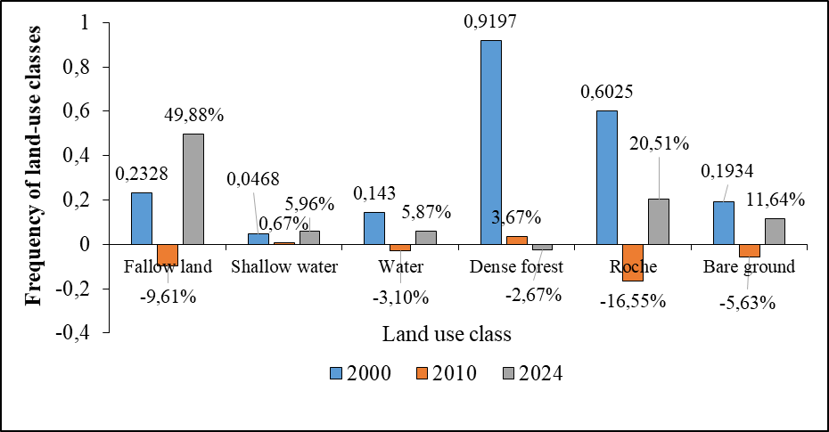
Fig. 3. Growth rates of land-use categories

4. Conclusion

This study, conducted in the Ziama Biosphere Reserve, has made it possible to characterize the various types of land-use classes and to highlight changes in forest cover resulting from human pressure. Six land-use classes were identified: fallow land, lowlands, water bodies, dense forests, rocks or rocky outcrops, and bare soil. Among these classes, the presence of fallow land, rocks, and bare soil indicates an anthropogenic threat. This approach revealed that the decrease in the areas of rocky outcrops (-16.55%), fallow land (-9.61%), and bare soil (-5.63%) between 2000 and 2010 indicates that dense forest was still less impacted by the local population. However, the period from 2010 to 2024 marks a sudden change in forest cover, leading to an increase in classes associated with degradation. Thus, the area of fallow land increased from 0.1367 to 0.6355, representing a 49.88% increase in degraded areas. Similarly, the exposure of rocky outcrops increased from 0.437 to 0.6421, representing a 20.51% increase. For the bare soil class, it rose from 0.1371 to 0.2535, representing 11.64% deforestation within the reserve.
These trends negatively impact ecological integrity and contribute to the fragmentation of habitats within the Ziama Biosphere Reserve. With a view to the sustainable conservation of this forest ecosystem, it would be necessary to expand training programs for conservation officers and equip them with appropriate monitoring tools to improve the effectiveness of conservation efforts.

COMPETING INTERESTS DISCLAIMER:
Authors have declared that they have no known competing financial interests OR non-financial interests OR personal relationships that could have appeared to influence the work reported in this paper.

ReferenceS

Amani Y. C. & Touré A. (2015). Human Settlements and Degradation of Classified Forests in Southwestern Côte d’Ivoire: The Case of Rapides Grah. Article in the Revue de l’Institut de Civilisations, Musée d’Art et d’Archéologie (MadaRevue), 21 pp. http://www.taloha.info/document.php.
Anonymous. (2006). Parallels between tissue repair and embryo morphogenesis: A conceptual framework. Globalization and Health, 16(4). http://www.globalizationandhealth.com/content/1/1/14
Atakpama W., Komlan B., Ktime B.B. & Koffi A. (2023). Alarming Degradation of Forest Resources in the Doungh Depression Classified Forest, Togo. African Journal on Land Geospatial Sciences, 6(3): 20 pp., ISSN: 2657-2664. DOI: 10.48346/IMIST.PRSM/ajlp-gs. v6i3.39046.
Barima Y. S. S., Barbier N., Ouattara B. & Bogaert J. (2010b). Relationship between Floristic Composition and Landscape Fragmentation Indicators in an Ivorian Forest-Savanna Transition Region. Biotechnologie, Agronomie, Société et Environnement, 14(4): 617–625.
Barima Y. S. S., Egnankou W. M., N'Doumé C. T. A., Kouamé F. N. & Bogaert J. (2010a). Modeling Forest Landscape Dynamics in the Forest-Savanna Transition Region of Eastern Côte d’Ivoire. Télédétection, 9(2): 129–138.
Barma M. A., Illiasou S. A. & Diouf A. (2026). Spatio-temporal Dynamics of Bushfires in The Gadabedji Biosphere Reserve. Journal of Applied Life Sciences International.
Camara, I. (2016). State, Governance, and Environment in Guinea: Issues and Perspectives. Paris: Harmattan, 214 pp., pp. 78–91.
Chen, L., Sun, Y., & Saeed, S. (2018). Monitoring and predicting land use and land cover changes using remote sensing and GIS techniques — A case study of a hilly area, Jiangle, China. PLoS ONE, 13(7), e0200493. https://doi.org/10.1371/journal.pone.0200493
Diabaté, M., Diabaté, M., Koné, F., Haba, O. O., Hubert de Foresta, & Labouisse, J. P. (2022). Biodiversity of Intertropical Ecosystems. IRD Éditions, 18 pp., 60.
Diabetes Prevention Program Research Group. (2009). A study of digit fusion in the mouse embryo. Journal of Embryology and Experimental Morphology, 49(2), 259–276.
Diallo, M., Bah, S., & Barry, F. (2020). Environmental Policies and Biodiversity Conservation in Guinea: Between Ambition and Reality. Paris: Harmattan. 232 pp.
Floristic Diversity and Uses of Forest Plants in Rural Areas of Forested Guinea.
DNEF (2017). National Directorate of Water and Forests. Updating of Core Documents for the Water and Forests Sector: Forestry Code and Implementing Regulations in the Republic of Guinea. 55 pp., pp. 44; [Case Study] of Southwestern Côte d’Ivoire: The Rapides Grah Case. Taloha, 21. http://www.taloha.info/document.php. 23 pp. Fall A., 2017. Women, Market Gardening, and Local Development in the Kankan Administrative Region. Doctoral Thesis. Higher Institute for Training and Applied Research (ISFRA), University of Social Sciences and Management of Bamako (USSGB), 286 p.
FAO, (2011). State of the World’s Forests, 193 p.
FAO, (2020). State of the World’s Forests: Forests, Biodiversity, and Human Activity (Full Version), 202 p.
FAO, 2016. State of the World’s Forests: The First Ten Issues. Food and Agriculture Organization of the United Nations, Rome. ISBN 97892-510-729.
FAO, 2018. Working Across Sectors to Halt Deforestation and Expand Forest Areas: From Aspiration to Action. International Conference. FAO Headquarters, Rome, Italy, 30 p.
Foody, G. M. (2020). Explaining the Unsuitability of the Kappa Coefficient in the Assessment and Comparison of the Accuracy of Thematic Maps Obtained by Image Classification. Remote Sensing of Environment, 239, Article 111630. https://doi.org/10.1016/j.rse.2019.111630
FRA. (2015). Global Forest Resources Assessment 2015. 75 p. Unikis. 59 p.
Hugo, J. T., & Mondal, S. C. (2006). Parallels Between Tissue Repair and Embryo Morphogenesis: A Conceptual Framework. Global Health, 16, 4. https://doi.org/10.1186/1744-8603-1-14
Ibouanga S., (2022). Humans and Protected Areas in Gabon: Between Proximal Biodiversity Protection and the Preservation of Local Interests in the Moukalaba–Doudou National Park—The Discourse of Residents, Environmental Technicians, and Elected Officials. Doctoral Thesis. 525 pp., pp. 1–6.
ISSN: 2394-1103, 12 pp. DOI: https://doi.org/10.9734/jalsi/2026/v29i1748
Kamto M. G. (2016). Evolutionary Dynamics of the Forest Socio-ecosystem in the Dja District, Eastern Cameroon: Actors, Interactions, and Future Prospects. Agronomist Engineer’s Thesis. Specialization: Rural Economics and Sociology. No. 59, 114 pp.
Lamah G.O. (2017). Dynamics of Farmer Organization Participation in Forest Ecosystem Management: The Case of Diécké in the Republic of Guinea. Doctoral Thesis, Université du Québec à Montréal. 187 pp., pp. 7–8. OFAC. 2012. The Forests of the Congo Basin—State of the Forests 2010. Publications Office of the European Union, Luxembourg, p. 276.
Lillesand, T. M., Kiefer, R. W., & Chipman, J. W. (2015). Remote Sensing and Image Interpretation (7th ed.). Hoboken, NJ: John Wiley & Sons. 768 pages. ISBN 978-1-118-34328-9.
Moons, F., & Vandervieren, E. (2025). Measuring agreement among several raters classifying subjects into one or more (hierarchical) categories: A generalization of Fleiss’ kappa. Behavior Research Methods, 57p, pp 287. https://doi.org/10.3758/s13428-025-02746-8
Padró, J.-C., Pons, X., Aragonés, D., Díaz-Delgado, R., García, D., Bustamante, J., Pesquer, L., Domingo-Marimón, C., González-Guerrero, Ò., Cristóbal, J., Doktor, D., & Lang, M. (2017). Radiometric Correction of Simultaneously Acquired Landsat-7/Landsat-8 and Sentinel-2A Imagery Using Pseudoinvariant Areas (PIA): Contributing to the Landsat Time Series Legacy. Remote Sensing, 9(12), 1319. https://doi.org/10.3390/rs9121319
Richards, J. A. (2013). Remote Sensing Digital Image Analysis: An Introduction (5ᵉ ed.). Springer Berlin Heidelberg. XIX, 494 p. ISBN (eBook) : 978-3-642-30062-2. DOI : 10.1007/978-3-642-30062-2
Roy, D. P., Zhang, H., Ju, J., Gómez-Dance, J. L., Lewis, P. E., Schaaf, J. B., Sun, Q., Li, J., Huang, H., & Kovalskyy, V. (2016). A General Method to Normalize Landsat Reflectance Data to Nadir BRDF Adjusted Reflectance. Remote Sensing of Environment, 176, 255-271. https://doi.org/10.1016/j.rse.2016.01.023.
Sène M, 2018. Degradation of lowland rice paddies in a context of climate change in lower Casamance (Senegal). Revue espace Géographique & Moroccan Society, 15, 137-138. DOI : https://doi.org/10.34874/IMIST.PRSM/EGSM/11030.
Compare Z ; Monemou P ; Diallo A. S ; Simmy P. L ; Magassouba D. (2023). Perception of riparian populations for sustainable management of Ziama Biosphere Reserve, Republic of Guinea. Article, African and Malagasy Journal of Scientific Research (RAMReS). New series, Humanities N°020 – 1st Semester 2023 ISSN 2630-1121, 11p.
Compare Z ; Soumaoro G. P; Monemou P ; Ibrahima Kalil Baldé I. K ; Chamber A (2024). Flora diversity impacted by the exploitation of the bottomlands of the Ziama Biosphere Reserve in the Republic of Guinea. Issue 2, Vol. 3, ISSN : 2957- 9279, p. 130-146, https://espacesafricains.org/
Soropogui Z, Monemou P, Kouakou A. K, Sangne ​​C. Y, Camara A, (2025). Effect of Types of Anthropic Activities at the Lowland Lisière exploited on the Ziama Biosphere Reserve (RBZ), Republic of Guinea. African Journal of Environment and Agriculture (RAFEA). 8(1), 47-56. DOI : https://dx.doi.org/10.4314/rafea.v8i1.5.
UNESCO, 2017. Pedagogical Kit on Biodiversity-Volume 1. United Nations Educational, Scientific and Cultural Organization. 191p. Flight. 29, Issue 1, Page 55-66, 2026; Article no.JALSI.150582.

