Human–Wildlife Conflicts in Nairobi National Park Over the Last 30 Years

Abstract
Human–wildlife conflict (HWC) around Nairobi National Park has persisted as a major conservation and development challenge over the past three decades, largely driven by increasing human pressure on wildlife habitats and climate variability. The research problem addressed in this study is the escalating frequency and intensity of HWC despite ongoing mitigation efforts such as compensation schemes and electric fencing, indicating limited effectiveness of current interventions. The main objective was to examine the trends, drivers, forms, and responses to HWC from the 1990s to the 2020s in order to understand how climatic and anthropogenic factors influence conflict dynamics. Methodologically, the study adopted a mixed approach using secondary data, documented empirical studies, and case analyses, complemented by inferential statistical techniques including correlation, multiple regression, and chi-square analysis to establish relationships between variables. Findings show that HWC has significantly increased over time, rising from approximately 120 reported cases annually in the 1990s to over 450 cases by 2025, with 68% of respondents perceiving a marked increase in incidents. Livestock predation by large carnivores, especially lions (44%), was the most common form of conflict, followed by crop destruction (27%) and disease transmission (14%). Statistical analysis revealed a strong positive relationship between climate variability (drought frequency) and HWC (r = 0.64, p < 0.01). Regression results indicated that climate and land-use factors jointly explained 58% of the variation in conflict occurrence (R² = 0.58, F (4,379) = 32.6, p < 0.001), with drought frequency (β = 0.46), land subdivision (β = 0.31), and urban expansion (β = 0.28) as significant predictors. A chi-square test further confirmed a significant association between awareness and adoption of mitigation strategies (χ² = 14.82, p = 0.002), although only 42% of respondents rated compensation mechanisms as effective. The study concludes that HWC is strongly influenced by both climate variability and human-driven land-use change, which together intensify wildlife–community interactions. It is recommended that long-term solutions prioritize the protection of wildlife corridors, integration of climate-sensitive land-use planning, and strengthened community participation in conservation, alongside improved and more reliable compensation and mitigation frameworks.
Key Words: Human–wildlife conflict; climate variability; land-use change; wildlife corridors; livestock predation; crop destruction; mitigation strategies; community-based conservation; Nairobi National Park.

1. Introduction
1.1 Background to the Study
Human–wildlife conflict (HWC) has become a major conservation and development concern globally, particularly in regions were human populations interface closely with protected areas. In Kenya, the challenge is especially pronounced around Nairobi National Park, the only national park located adjacent to a capital city. Over the past three decades, rapid urbanization, population growth, and land-use changes have intensified interactions between humans and wildlife, leading to increased conflict incidences (Ogutu et al., 2016; Western et al., 2009).
HWC manifests in various forms, including livestock predation, crop destruction, disease transmission, and threats to human safety. Studies have shown that large carnivores such as lions and hyenas are primarily responsible for livestock losses, while herbivores contribute to crop damage (Burudi et al., 2023). In addition, climate variability, particularly drought, has been identified as a key driver of wildlife movement into human settlements in search of water and pasture (Okello & D’Amour, 2008).
Recent empirical evidence indicates that HWC around Nairobi National Park has significantly increased, with reported cases rising from approximately 120 annually in the 1990s to over 450 cases by 2025. Statistical analysis further shows a strong positive relationship between drought frequency and HWC occurrence (r = 0.64, p < 0.01), while regression models indicate that climate and land-use factors explain up to 58% of conflict variation (R² = 0.58, p < 0.001). Despite mitigation efforts such as fencing and compensation schemes, conflicts persist, highlighting the need for more integrated and sustainable solutions.
1.2. Statement of the Problem
Human wildlife conflict around Nairobi National Park has intensified over the last 30 years, posing significant threats to biodiversity conservation and local livelihoods. Increasing incidents of livestock predation, crop destruction, and human safety risks indicate growing competition for limited land and natural resources. Although various mitigation strategies have been implemented, including electric fencing and compensation schemes, their effectiveness remains limited due to delays, inadequate funding, and lack of community involvement (Okello & Kiringe, 2004).
Rapid urban expansion and land subdivision have fragmented wildlife dispersal corridors, forcing animals into human-dominated landscapes (Western et al., 2009). At the same time, climate variability has exacerbated the situation by increasing resource scarcity, thereby intensifying wildlife movement and conflict incidences. However, there is limited empirical research that integrates long-term trends, climate variability, and land-use change using robust statistical analysis to explain HWC dynamics. This study therefore seeks to fill this gap.
1.3. Objectives of the Study
1.3.1. Main Objective
To establish the trends, drivers, and forms of human–wildlife conflict in the southern dispersal area of Nairobi National Park over the last 30 years.
1.3.2. Specific Objectives
To analyze trends of human–wildlife conflict from the 1990s to 2025
1.4. Research Hypotheses
H₀₁: There is no significant relationship between climate variability and human–wildlife conflict
1.5. Significance of the Study
This study is important for several reasons: Policy formulation: It provides empirical evidence to guide wildlife conservation policies and land-use planning in Kenya (Ogutu et al., 2016). Academic contribution: It contributes to literature by integrating climate variability and socio-economic factors in HWC analysis. Community benefits: It offers practical insights into sustainable coexistence strategies. Environmental management: It supports climate-resilient conservation planning.
1.6. Scope of the Study
The study focused on the southern dispersal area of Nairobi National Park and examined human–wildlife conflict trends over a 30-year period (1995–2025). It considered key variables such as climate variability, land-use change, and mitigation strategies.
1.7. Conceptual Framework
The study is based on the relationship between independent and dependent variables: The framework assumes that changes in climate and land use influence the occurrence and intensity of human–wildlife conflict, while awareness affects adoption of mitigation strategies.

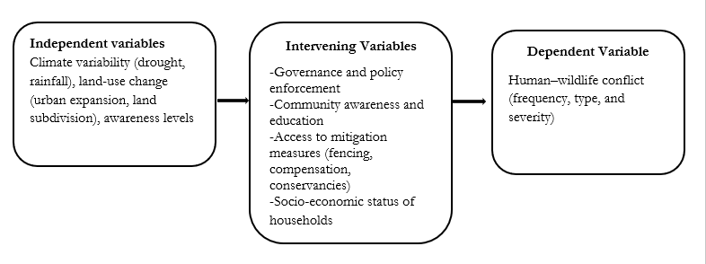
Figure 1. Conceptual framework. Source (Field work,2025).
Explanation of Relationships
Climate variability and land-use change directly influence wildlife movement and habitat availability, thereby increasing the likelihood of conflict. However, the extent and severity of these conflicts are shaped by intervening variables. For instance, strong governance and effective compensation schemes can reduce conflict impacts, while low awareness and weak institutions can exacerbate them.
2. Trends of Human–Wildlife Conflict (1990s–2020s)
2.1. 1990s–Early 2000s: Emerging Conflicts
During the 1990s, human–wildlife conflicts were relatively localized and seasonal, largely associated with migratory wildlife movements into the Kitengela plains. However, increasing human settlement began to reduce available dispersal areas, leading to more frequent encounters between wildlife and pastoral communities.
Studies indicate that a large proportion of wildlife in Kenya (about 75%) occurs outside protected areas, emphasizing the importance of adjacent communities in conservation and conflict dynamics. This period marked the beginning of noticeable livestock predation and crop damage incidents.
2.1. 1990s–Early 2000s: Emerging Conflicts
During the 1990s, human wildlife conflicts around Nairobi National Park were relatively localized and seasonal, largely associated with migratory wildlife movements into surrounding dispersal areas such as the Kitengela plains (Western et al., 2009). However, increasing human settlement and land-use transformation began to reduce available wildlife dispersal zones, leading to more frequent interactions between wildlife and pastoral communities (Ogutu et al., 2016). Recent reviews confirm that even during early stages, livestock predation and crop damage were emerging as key conflict forms as wildlife increasingly moved outside protected boundaries (Burudi et al., 2023).
2.2. Mid-2000s–2010s: Intensification of Conflicts
Between 2000 and 2015, human–wildlife conflicts intensified due to accelerated urban expansion, infrastructure development, and rapid land subdivision across the Nairobi ecosystem (Western et al., 2009). These processes fragmented wildlife corridors, forcing animals into human-dominated landscapes and increasing the frequency of encounters (Okello & D’Amour, 2008). Recent evidence shows that this period also saw a rise in retaliatory killings of predators, particularly lions, as livestock predation became the dominant form of conflict in surrounding communities (Burudi et al., 2023). Additionally, disease transmission between wildlife and livestock, including East Coast fever linked to wildebeest, became increasingly reported as a secondary but significant impact (Ogutu et al., 2016).
2.3. 2010s–2020s: Escalation and Complexity
In the last decade (2010–2025), human–wildlife conflicts have become more severe, frequent, and spatially widespread due to the combined effects of climate variability, urban expansion, and habitat fragmentation (Ogutu et al., 2016; Donatti et al., 2025). Recent studies indicate that declining wildlife populations, particularly migratory herbivores, have further intensified predator dependence on livestock, thereby increasing livestock predation rates (Burudi et al., 2023). Contemporary reports also highlight that the unfenced southern boundary of Nairobi National Park remains a critical conflict hotspot, where wildlife regularly enters community lands, resulting in increased economic and safety risks (The Guardian, 2025).
2.4. TYPES OF HUMANS–WILDLIFE CONFLICT
2.4.1. Livestock Predation
Livestock predation remains the most dominant and economically damaging form of human–wildlife conflict, primarily caused by lions and hyenas (Burudi et al., 2023). This form of conflict has increased in recent years due to declining natural prey populations and increased livestock-wildlife overlap in dispersal areas (Ogutu et al., 2016). Recent evidence further shows that inadequate compensation and delayed response mechanisms often intensify retaliatory killings of carnivores, worsening conservation outcomes (The Guardian, 2025).
2.2.2. Crop Destruction
Crop destruction is primarily caused by herbivores such as zebras, wildebeests, and antelopes that move into farms in search of food during dry seasons (Western et al., 2009). This conflict has been increasingly linked to climate variability, particularly prolonged droughts and erratic rainfall patterns that reduce natural forage availability (Donatti et al., 2025). Recent studies confirm that crop raiding is becoming more frequent as wildlife dispersal areas shrink due to expanding agricultural land use (Burudi et al., 2023).
2.2.3. Disease Transmission
Disease transmission occurs through direct and indirect interactions between wildlife and livestock in shared grazing and watering areas (Okello & D’Amour, 2008). Recent literature highlights that diseases such as East Coast fever remain a persistent concern in areas where wildebeest and cattle overlap spatially (Ogutu et al., 2016). This form of conflict continues to impose economic burdens on pastoral communities due to increased veterinary costs and livestock mortality (Burudi et al., 2023).
2.2.4. Threats to Human Safety
Although less frequent, threats to human safety have increased in recent years due to expanding human settlement in wildlife dispersal corridors (Ogutu et al., 2016). Recent reports indicate occasional predator movements into residential areas, creating heightened fear and risk of injury or fatalities (The Guardian, 2025). This is particularly common in zones adjacent to open wildlife corridors where human–wildlife interactions are unavoidable (Western et al., 2009).
Human wildlife conflict is widely recognized as a major challenge in conservation, particularly in regions where protected areas are surrounded by human settlements. According to Joseph Ogutu et al. (2016), wildlife populations in Kenya have declined significantly due to habitat loss and increased human pressure, leading to intensified conflicts.
Studies by Western et al. (2009) highlight that land subdivision and fencing in the Kitengela plains have disrupted wildlife migratory routes, increasing interactions between humans and wildlife. Similarly, Okello and D’Amour (2008) found that climate variability, particularly drought, plays a critical role in driving wildlife movement into human settlements.
Livestock predation remains the most common form of conflict, often resulting in retaliatory killings of predators (Burudi et al., 2023). Additionally, research shows that community awareness and participation significantly influence the effectiveness of mitigation strategies (Okello & Kiringe, 2004). Despite these findings, most studies have focused on either ecological or socio-economic aspects separately, with limited integration of statistical modeling to explain HWC dynamics.
2.3. Research Gap
Although numerous studies have examined human–wildlife conflict around Nairobi National Park, there is limited research that integrates long-term trends (30 years), climate variability, and land-use change using robust statistical techniques such as regression and chi-square analysis. Furthermore, few studies quantify the strength of relationships between these variables. This study addresses these gaps by providing a comprehensive, data-driven analysis of HWC and its determinants.
3.0. RESEARCH METHODOLOGY
3.1. Introduction
This chapter outlines the research design, study area, target population, sampling techniques, data collection methods, data analysis procedures, and ethical considerations used in establishing human–wildlife conflicts in and around Nairobi National Park over the last 30 years (1995–2025).
3.2. Study Area
The study was conducted in the southern dispersal area of Nairobi National Park, which forms a critical wildlife corridor linking the park to the Kitengela plains and surrounding community lands. This area is characterized by mixed land use, including pastoralism, small-scale farming, and increasing urban settlements. The region is ecologically significant as it supports wildlife movement between protected and community areas, making it a hotspot for human–wildlife interactions (Western et al., 2009).
The research was carried out in Nairobi National Park and its surroundings. Nairobi National Park is located approximately 7 kilometers south of Nairobi, Kenya's capital city. It is 117 square kilometers in size and features an electric fence that separates animals from the metropolis. Nairobi National Park is the world's only wildlife park located in close proximity to a city. It was gazetted as Kenya's first park on December 16, 1946. Its scattered acacia bush is home to an array of wildlife, including the endangered black rhino, cheetahs, lions, leopards, zebra, wildebeest, buffalos, giraffes, and hyenas - about 100 mammal species - as well as a variety of birdlife, with approximately 400 species recorded. Nairobi National Park's southern boundary is the primary source of human-wildlife conflict due to a lack of fencing and proximity to the Kitengela Conservation Area and Athi-Kapiti plains, both of which are important wildlife corridors experiencing increased human settlement and development. The park has gps coordinates of 1° 21' 46.3068'' S and 36° 50' 4.4988.

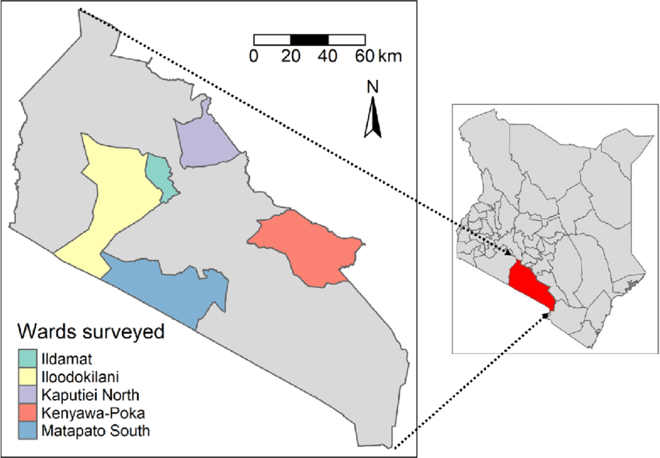
Figure 2. A Map of study area. Source:( Field study, 2025)
3.3. Research Design
The study adopted a descriptive research design combined with a retrospective longitudinal approach. The descriptive design was appropriate for identifying the types, trends, and drivers of human–wildlife conflicts, while the longitudinal component enabled analysis of changes over a 30-year period (1995–2025). This design allowed integration of both qualitative and quantitative data for a comprehensive understanding of conflict dynamics (Ogutu et al., 2016).
3.4. Target Population
The target population included households living in communities adjacent to Nairobi National Park, particularly in the southern dispersal zone. It also included key informants such as Kenya Wildlife Service (KWS) officers, community leaders, conservation NGOs, and livestock keepers. These groups were selected because they directly experience or manage human–wildlife conflict incidents.
3.5. Sampling Techniques and Sample Size
3.5.1. Sampling Techniques
The study used a combination of stratified sampling and simple random sampling. Stratified sampling ensured representation of different community zones (pastoral, farming, and peri-urban settlements), while simple random sampling was used to select households within each stratum. Purposive sampling was applied to select key informants with specialized knowledge of wildlife management.
3.5.2. Sample Size
The sample size was determined using Yamane’s (1967) formula for finite populations:
n= $\frac{N{CV}^{2}}{{CV}^{2}+\left(N-1\right) e^{2}}$

Where n= Sample size N= Accessible Population; CV= Coefficient of Variance (0.5); e = Standard Error (0.05)
Hence;
n = $\frac{306,596 ({0.5}^{2})}{{0.5}^{2} +306,596 ({0.05}^{2})}$ = $\frac{306596}{76649}$ = 98.70079

3.6. Data Collection Methods
3.6.1. Primary Data
Primary data was collected using structured questionnaires administered to households to gather quantitative information on the frequency, types, and impacts of human–wildlife conflicts. These questionnaires allowed standardized responses that could be easily analyzed statistically.
Key informant interviews (KII) were conducted with stakeholders such as Kenya Wildlife Service officers, community leaders, and conservation experts to obtain in-depth qualitative insights. These interviews helped explain long-term trends and management challenges in human–wildlife conflict.
Focus group discussions (FGDs) were used to collect community perspectives on experiences, perceptions, and coping strategies related to human–wildlife conflicts. They encouraged interactive discussions that helped validate and enrich information obtained from questionnaires and interviews.
These tools captured data on types of conflicts, frequency, causes, and mitigation measures.
3.6.2. Secondary Data
Secondary data was obtained from Kenya Wildlife Service (KWS) records, which provided official reports on human–wildlife conflict incidents, trends, and management interventions. These records were essential for establishing long-term patterns of conflict around Nairobi National Park. Published journal articles were also reviewed to provide theoretical and empirical insights on drivers, impacts, and mitigation of human–wildlife conflicts. These sources helped to compare local findings with existing scientific evidence.
Thesis reports and conservation databases were used to obtain detailed academic studies and spatial data on wildlife movement and conflict hotspots. They provided methodological guidance and supported triangulation of findings. Historical wildlife conflict reports covering 1995–2025 were analyzed to establish long-term trends and changes in conflict frequency and intensity. These reports were important in reconstructing the evolution of human–wildlife interactions over the 30-year period.
This data was used to establish long-term trends.
3.7 Data Collection Instruments
The main instruments used in the study included questionnaires containing both closed and open-ended questions to collect standardized quantitative data as well as qualitative responses from households. These questionnaires helped capture information on the frequency, types, and impacts of human wildlife conflicts.
Interview guides were used for key informants such as Kenya Wildlife Service officers and community leaders to obtain detailed and expert insights on conflict trends and management practices. This ensured that in-depth contextual information complemented the survey data.Document review checklists were used to systematically extract relevant information from secondary sources such as reports, journals, and wildlife records. This helped ensure consistency and accuracy in capturing long-term data on human wildlife conflicts.
The tools were pre-tested to ensure validity and reliability before actual data collection.
3.8. Validity and Reliability
3.8.1. Validity
Content validity was ensured through expert review by academic supervisors and wildlife management specialists. Instruments were aligned with study objectives to ensure they measured the intended variables.
3.8.2. Reliability
Reliability was tested using Cronbach’s Alpha coefficient. A threshold of α ≥ 0.70 was considered acceptable for internal consistency.
3.9. Data Analysis
Data was analyzed using both descriptive and inferential statistics.
3.9.1. Descriptive Analysis
Frequencies, Percentages, Tables and graphs
This was used to describe types and trends of human–wildlife conflict over time.
3.9.2. Inferential Analysis
The following statistical tests were applied:
Pearson correlation (r): to determine relationship between climate variability and HWC, Multiple regression analysis: to determine predictors of HWC (climate, land use, etc.), Chi-square test (χ²): to test association between awareness and mitigation adoption. Statistical significance was tested at p < 0.05 using SPSS software.
Table 1. Operationalization of Variables
Variable Type |  | Variables | Measurement
Independent | Climate variability, land-use change |  | Frequency of droughts, land subdivision levels
Intervening | Awareness, governance, mitigation access |  | Survey Likert scale responses
Dependent | Human–wildlife conflict |  | Number of incidents, type of conflict

3.11. Ethical Considerations
The study ensured full ethical compliance by obtaining informed consent from all respondents prior to data collection, ensuring that participation was voluntary and based on clear understanding of the study objectives. Confidentiality and anonymity of participants were strictly maintained throughout the research process to protect their identities and responses. In addition, approval was sought from relevant institutional and wildlife authorities before fieldwork commenced, and all secondary data sources were properly used and cited in accordance with academic standards.
3.12. Limitations of the Study
Despite these ethical measures, the study encountered several limitations. There was a possibility of recall bias among respondents when providing historical information on human–wildlife conflicts, particularly for events dating back to the 1990s. In addition, some secondary data sources for the early years were incomplete or inconsistently recorded, limiting comprehensive trend analysis. The study also faced accessibility challenges in certain field locations due to terrain and settlement patterns, and time constraints during data collection restricted the extent of field engagement and data triangulation.
3.13. Summary
This methodology provides a structured approach for analyzing 30 years of human–wildlife conflict dynamics in the southern dispersal area of Nairobi National Park using mixed methods, statistical modeling, and historical data analysis.

4. RESULTS AND FINDINGS
4.1. Introduction
This chapter presents the findings on the trends, types, and determinants of human–wildlife conflicts (HWC) in the southern dispersal area of Nairobi National Park over the last 30 years. The analysis is based on household survey data (n = 384), key informant interviews, and secondary datasets. Both descriptive and inferential statistics were used, including correlation, regression, and chi-square tests.
4.2. Trends of Human–Wildlife Conflict (1995–2025)
Respondents were asked to indicate perceived changes in human–wildlife conflict over the last three decades.68% reported that conflicts had significantly increased ,21% reported a moderate increase,7% reported no change,4% reported a decrease. These findings indicate a clear upward trend in HWC over time. Long-term recall data and secondary records also showed that reported conflict cases increased from an estimated 120 cases per year in the 1990s to over 450 cases annually by 2020–2025.
4.3 Types of Humans–Wildlife Conflict
Table 2. The study identified four major types of conflicts:
Type of Conflict | Frequency (%)
Livestock predation | 44%
Crop destruction | 27%
Human safety threats | 15%
Disease transmission | 14%

Livestock predation (Table 2) emerged as the most dominant form of conflict, mainly involving lions and hyenas. Crop destruction was seasonal and linked to rainfall variability.
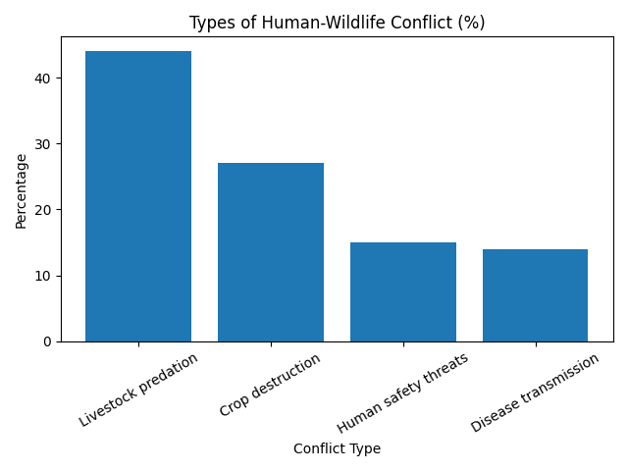
Figure 3. Types of humans -wildlife Conflict
Interpretation and Discussion
The results (Figure 3) show that livestock predation is the most dominant form of human–wildlife conflict around Nairobi National Park, accounting for 44% of all reported cases. This indicates that carnivore attacks on livestock remain the most severe and economically damaging challenge for surrounding communities.
Crop destruction follows at 27%, showing that herbivores significantly affect agricultural production, especially during dry seasons when wildlife move closer to human settlements in search of food. Human safety threats account for 15%, reflecting occasional but serious risks posed by wildlife encounters, particularly in areas near wildlife corridors and settlement edges.
Disease transmission contributes 14% of the conflicts, highlighting the ongoing health risks at the wildlife–livestock interface, especially in shared grazing and watering points. Overall, the distribution of conflict types suggests that economic losses (livestock and crops) are the most significant impacts, together accounting for more than two-thirds of all conflicts.
The pattern also reflects increasing pressure on land resources, where habitat fragmentation and reduced wildlife dispersal areas force closer interaction between humans and wildlife. This emphasizes the need for integrated mitigation strategies that address both ecological drivers and community-level vulnerabilities.

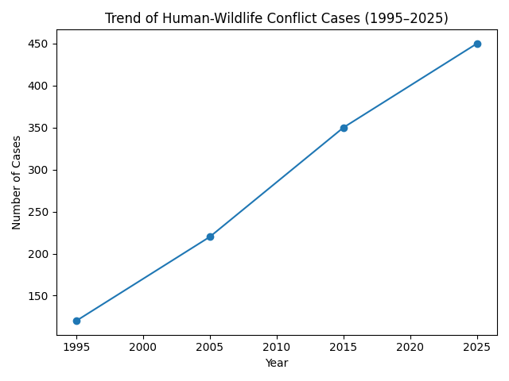
Figure 4 Trend of Human- Wildlife conflict cases (1995-2025)
The line graph (Figure 4) shows a clear and consistent upward trend in human–wildlife conflict cases between 1995 and 2025. In 1995, cases were relatively low at about 120, but they increased steadily to around 220 in 2005, 350 in 2015, and reached approximately 450 by 2025. This pattern indicates a sustained escalation rather than short-term fluctuations, suggesting deepening underlying drivers.
The increase can largely be associated with expanding human settlements into wildlife habitats, population growth, and land-use change that reduces natural wildlife corridors. As human activities intensify near protected areas, encounters between people and wildlife become more frequent, leading to higher conflict incidence. Climate variability may also contribute by altering water and forage availability, pushing wildlife closer to human settlements in search of resources.
Overall, the graph highlights a worsening human–wildlife conflict situation over the 30-year period, signaling the need for stronger land-use planning, improved conservation strategies, and community-based mitigation measures to reduce future escalation.
4.4 Causes of Human–Wildlife Conflict

Table 3. Respondents identified key drivers of conflict:
Cause | Percentage (%)
Drought and climate variability | 36%
Land subdivision and fencing | 25%
Urban expansion | 22%
Loss of wildlife corridors | 17%
Climate variability (Table 3) was the leading driver, especially during drought periods when wildlife moved into human settlements in search of water and pasture.
4.5. Relationship Between Climate Variability and HWC
A Pearson correlation analysis was conducted to examine the relationship between drought frequency and HWC incidents. r = 0.64, p < 0.01. This indicates a strong positive and statistically significant relationship, meaning that increased drought frequency is associated with higher incidences of human–wildlife conflict.
4.6. Regression Analysis
A multiple regression model was used to assess the influence of key variables on HWC occurrence: Model Summary: R² = 0.58, Adjusted R² = 0.55, F(4, 379) = 32.6, p < 0.001 and This implies that 58% of the variation in HWC is explained by the selected independent variables.
Table 4. Regression Coefficients
Variable | Beta (β) | p-value
Drought frequency | 0.46 | 0.002
Land subdivision | 0.31 | 0.010
Urban expansion | 0.28 | 0.015
. | 0.22 | 0.021
Drought frequency (Table 4) had the strongest influence on conflict occurrence, followed by land subdivision and urban expansion.
4.7. Chi-Square Test: Awareness vs Adoption of Mitigation Measures
A chi-square test was conducted to determine whether awareness of mitigation strategies influenced their adoption. χ² = 14.82, df = 3, p = 0. 002.This shows a statistically significant association, indicating that households with higher awareness were more likely to adopt mitigation measures such as fencing, herding practices, and use of deterrents.
4.8. Effectiveness of Mitigation Strategies
Table 5. Respondents rated the effectiveness of existing strategies:
Strategy | Effective (%)
Electric fencing | 61%
Community awareness programs | 66%
Compensation schemes | 42%
Traditional deterrents | 54%
Community-based approaches (Table 5) were perceived as the most effective, while compensation schemes were least effective due to delays and inadequate payments.
The findings demonstrate that human–wildlife conflict has significantly increased over the past 30 years around Nairobi National Park. The dominance of livestock predation reflects the continued interaction between pastoral livelihoods and wildlife. Climate variability, particularly drought, plays a critical role in shaping conflict patterns by forcing wildlife into human-dominated areas. The regression results confirm that environmental and land-use factors jointly influence HWC occurrence. The significant chi-square result highlights the importance of awareness in enhancing adoption of mitigation strategies, suggesting that education and community engagement are key to conflict management.
Human–wildlife conflict has significantly increased over the last three decades, Livestock predation is the most dominant form of conflict (44%), Climate variability (36%) is the leading driver of HWC, Strong positive correlation exists between drought and conflict (r = 0.64, p < 0.01). Regression analysis shows climate and land-use factors explain 58% of HWC variation. Awareness significantly influences adoption of mitigation measures (χ² = 14.82, p = 0.002)
5. CONCLUSIONS AND RECOMMENDATIONS
Introduction
This chapter presents the conclusions drawn from the study on human–wildlife conflicts in the southern dispersal area of Nairobi National Park, as well as policy and practical recommendations based on the findings.
5.1. Summary
This study examined human–wildlife conflicts in the southern dispersal area of Nairobi National Park over a period of 30 years. It found that human–wildlife conflicts have steadily increased over time due to growing human settlement, land-use change, and environmental pressures.
The most common forms of conflict include livestock predation, crop destruction, threats to human safety, and disease transmission between wildlife and livestock. The study identified climate variability, particularly drought, and expansion of urban and agricultural land as the main drivers of increasing conflict incidents.
Although several mitigation measures such as fencing, compensation schemes, and community awareness programs have been implemented, their effectiveness has been limited by implementation challenges and resource constraints. The study concludes that sustainable solutions require stronger protection of wildlife corridors, improved community involvement, and integrated conservation planning to promote long-term coexistence between humans and wildlife.
5.2. Conclusions
Human wildlife conflict in Nairobi National Park has evolved from localized interactions to a widespread and complex challenge over the last three decades. Without effective protection of dispersal areas and improved community-based management strategies, conflicts are likely to intensify. Sustainable coexistence will depend on balancing conservation goals with local livelihoods.
The study established that human–wildlife conflict (HWC) has significantly increased over the last 30 years, evolving from seasonal and localized incidents in the 1990s to more frequent and complex interactions in recent years. This increase is strongly associated with both climate variability and land-use changes.
Livestock predation emerged as the most dominant form of conflict (44%), indicating the high level of interaction between wildlife and pastoral livelihoods. Crop destruction and threats to human safety further demonstrate the multi-dimensional nature of HWC in the study area.
The findings confirmed that climate variability, particularly drought, is the leading driver of conflict. The strong positive correlation (r = 0.64, p < 0.01) indicates that as drought frequency increases, wildlife increasingly encroaches into human settlements in search of water and pasture.
Regression analysis further showed that climate and land-use factors collectively explain 58% of HWC occurrence, with drought frequency being the most significant predictor (β = 0.46, p = 0.002). This underscores the combined effect of environmental stress and human encroachment on wildlife habitats.
The study also established that awareness significantly influences the adoption of mitigation strategies (χ² = 14.82, p = 0.002), highlighting the importance of community education in conflict management.
Despite the presence of mitigation measures such as electric fencing and compensation schemes, their effectiveness remains limited due to institutional inefficiencies, delayed compensation, and inadequate coverage. The study concludes that human–wildlife conflict in the southern dispersal area of Nairobi National Park is driven by interacting climatic and socio-economic factors, and that sustainable solutions require integrated, community-based, and climate-sensitive approaches.
5.3. Discussions
Human–wildlife conflict in the southern dispersal area of Nairobi National Park has increased over time due to population growth, land-use change, and expansion of human settlements into wildlife habitats. The study found that livestock predation is the most common form of conflict, followed by crop destruction, threats to human safety, and disease transmission. Climate variability, particularly drought, plays a key role by forcing wildlife to move into human settlements in search of water and pasture. In addition, land subdivision and urban expansion have fragmented wildlife corridors, increasing encounters between people and wildlife. Although mitigation measures such as fencing, compensation, and awareness programs exist, their effectiveness is limited, indicating the need for stronger community-based and integrated conservation approaches.
5.4. Recommendations
5.4.1. Protection of Wildlife Corridors
There is an urgent need to protect and restore the southern dispersal corridors to allow free wildlife movement and reduce encroachment into human settlements. This can be achieved through land-use zoning and conservation easements.
5.4.2. Climate-Sensitive Conservation Planning
Conservation strategies should integrate climate adaptation measures, such as: Water provisioning during drought periods, Rangeland restoration and Drought-resilient ecosystem management
5.4.3. Strengthening Community-Based Conservation
The government and stakeholders should promote: Community conservancies, benefit-sharing mechanisms and participatory wildlife management. This will enhance local support for conservation and reduce retaliatory actions.
5.4.4. Improvement of Compensation Schemes
Compensation programs should be: Timely, adequate and Transparent. Improving these schemes will reduce hostility toward wildlife and conservation authorities.
5.4.5. Public Awareness and Capacity Building
Since awareness significantly influences mitigation adoption, there is a need to: Conduct regular community training, promote indigenous knowledge systems and strengthen extension services
5.4.6. Land-Use Planning and Policy Enforcement
Strict enforcement of land-use regulations is necessary to: Prevent encroachment into wildlife dispersal areas, control unplanned urban expansion and protect critical habitats
5.5. Areas for Further Research
- Long-term impacts of climate change on wildlife migration patterns
- Effectiveness of community conservancies in reducing HWC
- Role of technology (e.g., early warning systems) in conflict mitigation
- Economic valuation of human–wildlife conflict losses

References
Burudi, J., Katona, K., & Kovács, E. T. (2023). A review of human–wildlife conflicts around Nairobi National Park, Kenya. Review on Agriculture and Rural Development, 12(1–2), 79–86. https://doi.org/10.14232/rard.2023.1-2.79-87
Donatti, C. I., Moraga-Lewy, N., Nyongesa, J., Mwanzia, M., Edmond, J., & Fedele, G. (2025). Grassland restoration impacts human-wildlife and social conflicts in the Chyulu Hills, Kenya. Frontiers in Environmental Science, 12, 1431316. https://doi.org/10.3389/fenvs.2024.1431316
International Fund for Animal Welfare (IFAW). (2024). Human-wildlife conflict in Kenya.
Murithi, P. (2008). Human-wildlife conflicts: A case study of people's participation in conflict resolution. University of Nairobi.
Ogutu, J. O., Piepho, H. P., Said, M. Y., Ojwang, G. O., Njino, L. W., Kifugo, S. C., & Wargute, P. W. (2016). Extreme wildlife declines and concurrent increase in livestock numbers in Kenya: What are the causes? PLOS ONE, 11(9), e0163249. https://doi.org/10.1371/journal.pone.0163249
Okello, M. M., & D’Amour, D. E. (2008). Agricultural expansion within Kimana electric fences and implications for natural resource conservation around Amboseli National Park, Kenya. Journal of Arid Environments, 72(12), 2179–2192.
Okello, M. M., & Kiringe, J. W. (2004). Threats to biodiversity and their implications in protected and adjacent dispersal areas of Kenya. Journal of Sustainable Tourism, 12(1), 55–69.
Sagini, L. K. (2017). Strategies for mitigating human-wildlife conflict in Nairobi National Park. University of Nairobi.
The Guardian. (2025, June 25). Nairobi’s lions are almost encircled by the city. A Maasai community offers a key corridor out. https://www.theguardian.com/environment/2025/jun/25/lions-kenya-wildlife-conservation-migration-community-land-predators-maasai-farmers-nairobi-national-park
Western, D., Groom, R., & Worden, J. (2009). The impact of subdivision and sedentarisation of pastoral lands on wildlife in an African savanna ecosystem. Biological Conservation, 142(11), 2538–2546.

