Changes in physico-chemical properties of sesame seed oil due to infestation of Aspergillus flavus Link. and Penicillium implicatum Biourge.

ABSTRACT
The present study was undertaken to investigate the seed-borne mycoflora associated with sesame (Sesamum indicum L.) and to evaluate the impact of fungal infestation on the physico-chemical properties of sesame seed oil. Seed samples were collected from four districts of Rajasthan, namely Jodhpur, Bikaner, Udaipur, and Chittorgarh. Mycoflora were isolated using standard blotter and agar plate methods, both with and without surface sterilization using 0.1% mercuric chloride. A total of 23 fungal species belonging to 18 genera were identified, with Aspergillus, Fusarium, Penicillium, and Alternaria being the predominant genera. The incidence of mycoflora was comparatively lower in pretreated seeds than in untreated seeds, indicating the effectiveness of surface sterilization. Seed germination percentage ranged from 32% to 87% in blotter method and 30% to 90% in agar plate method, with higher germination observed in pretreated seeds. The effect of two storage fungi, Aspergillus flavus and Penicillium implicatum, on oil quality was evaluated. Both fungi caused a reduction in oil content, with P. implicatum showing greater deterioration. A significant increase in free fatty acid content was observed, particularly in seeds infected with A. flavus, indicating lipid hydrolysis. Saponification value increased with fungal infestation, suggesting the formation of lower molecular weight fatty acids, whereas iodine value decreased, reflecting a reduction in unsaturated fatty acids. The study highlights the significant role of seed-borne fungi in deteriorating seed quality and oil composition, emphasizing the need for proper storage and management practices to ensure seed health and oil quality.
Keywords : Sesame, seed borne mycoflora, fatty acids, Saponification value, Iodine value.

1. INTRODUCTION
Sesame (Sesamum indicum L.), belonging to the family Pedaliaceae, is one of the oldest cultivated oilseed crops and holds significant agricultural, nutritional, and economic importance worldwide. It is widely grown in tropical and subtropical regions, with India being one of the leading producers (Bedigian, 2012; FAO, 2010; DOR, 2013; DRMR, 2015). Sesame seeds are rich in oil (44–58%), proteins, carbohydrates, minerals, and bioactive compounds such as lignans, tocopherols, and phytosterols, which contribute to their antioxidant and therapeutic properties (Amienyo et al., 2015; Chavan, 2011; Ghosh et al., 2018; Srivastava et al., 2021).
Despite their high nutritional value, sesame seeds are highly susceptible to deterioration during storage due to infestation by seed-borne fungi. These fungi adversely affect seed viability, germination, and biochemical quality (Christensen, 1957; Jyoti and Malik, 2013; McDonald, 1999). A wide range of fungal genera, including Aspergillus, Penicillium, Fusarium, Alternaria, and Rhizopus, have been reported in association with sesame and other oilseeds (Mishra and Kanaujia, 1973; Altaf et al., 2004; Kumar et al., 1984; Rao et al., 2015; Reddy, 1993). Similar observations have been reported in other oilseed crops across different agro-climatic regions (Chukunda et al., 2015; Dawar and Ghaffar, 1991; Nandi et al., 1982; Ghosh et al., 2018).
Seed mycoflora may originate from field conditions, harvesting processes, or storage environments, and their development is largely influenced by environmental factors such as moisture, temperature, and storage duration (Mondal et al., 1981; Nandi et al., 1982). Prolonged storage under unfavorable conditions promotes fungal growth and mycotoxin production, posing serious risks to seed quality and human health (Alemayehu et al., 2023; Ouali et al., 2023). Fungal invasion leads to depletion of seed reserves, as microorganisms utilize lipids, proteins, and carbohydrates for their metabolic activities (Kakde et al., 2012; Kakde and Chavan, 2011; Mukherjee et al., 1992).
Standard seed health testing techniques such as the blotter method and agar plate method are commonly used for the detection of seed-borne fungi (De Tempe, 1953; Anonymous, 1966; Muskett, 1948; ISTA, 1976). However, their efficiency varies depending on fungal growth characteristics (Kaur et al., 1990; Khattak et al., 1993). Seed pretreatment methods have been shown to reduce fungal load and improve germination (Enikuomehin, 2010; Upadhyay and Singh, 1978).
Fungal infestation also causes significant physico-chemical changes in oil quality. Lipolytic enzymes secreted by fungi hydrolyze triglycerides into free fatty acids, leading to increased acidity and oil deterioration (Mbah and Akueshi, 2001; Sharma, 1977). Changes in saponification and iodine values further indicate breakdown of fatty acids and reduction in unsaturation (Chavan, 2011; Sarkate and Badar, 2022). Previous studies have identified storage fungi such as Aspergillus flavus and Penicillium spp. as major contributors to oil degradation (Begum et al., 2013; Mbah and Akueshi, 2001).
In view of the economic importance of sesame and the detrimental effects of fungal infestation, the present study aims to investigate the seed mycoflora associated with sesame seeds from different districts of Rajasthan and to evaluate changes in physico-chemical properties of sesame oil caused by Aspergillus flavus and Penicillium implicatum.

2. MATERIALS AND METHODS
2.1 Isolation of seed mycoflora and their percentage frequency
2.1.1 Incubation testes- Standard International rules for seed testing (ISTA, 1976) has been followed throughout these studies. For determining the range of mycoflora associated with the seeds. The sample were used separately. Seed mycoflora was isolated by two methods viz. The Blotter Test and Agar Plate tests.
2.1.1.1 The Blotter Test- The blotter test is a combination of in vitro and in vivo principles of investigation. In these studies, sterilized blotters of the size of the petriplates were placed in sterilized petriplates and moist them. 200 seeds of each sample were tested. 25 seeds were kept in each petriplate containing moist blotters. The plates were incubated in a growth chamber at 28°C under alternate cycle for 12 hours lights and 12 hours darkness. Seven days after planting, the fungal growth from seeds was examined under microscope for the types of spores produced. Final observations were recorded after fifteen days and percentage seed germination was also recorded after fifteen days and percentage seed germination was also recorded. Same procedure was repeated when seeds was pretreated with 0.1 percent mercuric chloride for two minutes followed by three washing in sterile distrilled water.
2.1.1.2 The Agar Plate test
200 seeds of each sample were tested without pretreatment with 0.1 percent mercuric chloride for two minutes followed by three washing in sterile distilled water. 25 seeds were kept in each petriplate containing Potato Dextrose Agar (PDA). The plates were incubated in growth chamber under alternate cycle of 12 hours light and 12 hours darkness. Seven days after planting, the fungal growth from seeds was examined under microscope for the types of spores produced and percentage seed germination was also recorded.
2.2 Seed Inoculation and Incubation
ealthy Sesamum seeds (25 g) were sterilized by autoclaving at 15 lbs pressure for 15 min and placed in 250 ml conical flasks. The seeds were separately inoculated with Aspergillus flavus and Penicillium implicatum under aseptic conditions. The inoculated samples were incubated at room temperature under approximately 65% relative humidity (Ward and Diener, 1961). Uninoculated sterilized seeds served as the control.

2.3 Oil Extraction
Oil was extracted from inoculated and control seeds after 7 and 14 days of incubation using petroleum ether in a Soxhlet apparatus for 8 h (Meara, 1955).
2.4 Free Fatty Acid Content
Free fatty acid (FFA) content was determined following A.O.A.C. (1960). Oil samples were heated with a mixture of 95% ethanol and ether (1:1, v/v), cooled, and titrated against 0.1 N KOH using phenolphthalein as an indicator.
2.5 Iodine Value
The iodine value was determined according to A.O.A.C. (1960). A known quantity of oil was dissolved in chloroform and treated with iodine monochloride solution. The mixture was kept in the dark for 30 min with intermittent shaking. Potassium iodide and distilled water were added, and the liberated iodine was titrated with 0.1 N sodium thiosulphate using starch as an indicator until the endpoint was reached.
2.6 Saponification Value
The saponification value was determined by refluxing the oil sample with alcoholic KOH for 30 min. After cooling, excess alkali was titrated with 0.5 N HCl using phenolphthalein as an indicator (A.O.A.C., 1960).
3. RESULT
3.1 Mycoflora on seed samples
23 different fungal species of 18 genera were isolated by blotter test and Agar Plate test with pretreatment and without pretreatment with 0.1 percent HgCl₂ solution (Fig. 1, 2).
- Alternaria alternata (Fr.) Keissler
- Alternaria sesami (Kawamura) Mohanty & Behera
- Aspergillus fumigatus Fresenius
- Aspergillus niger Van Tieghem
- Aspergillus flavus Link.
- Aspergillus terreus Thom
- Chaetomium globosum Kunze
- Cladosporium cladosporioides (Fres.) de Vries
- Colletotrichum gloeosporioides (Schw.) Atr
- Curvularia lunata (Wakker) Boedijn
- Drechslera tetramera (McKinney) Subram. & B.L. Jain,
- Fusarium oxysporum f.sp. vasinfectum (G.F. Atk.) W.C. Snyder & H.N. Hansen
- Gonatobotrys simplex corda
- Macrophomina phaseolina (Tassi) Goid
- Memmoniella echinata (Rivolta) L.D. Galloway
- Penicillium implicatum Biourge
- Penicillium variabile Sopp
- Phoma exigua Desm
- Pyrenochaeta lycopersici R.W. Schneid. & Gerlach
- Rhizoctonia bataticola (Taub.)Butl.
- Rhizopus nigricans Ehrenb.
- Stachybotrys atra Corda
- Trichothecium roseum (Pers) Link.
Tables I and II show the percentage of frequency of different mycoflora isolated from different seed samples. The percent association of mycoflora was less in pretreated seeds as compared to untreated seeds in all the samples in both the methods.
Table-I: Mycoflora associated with seeds of different samples of Sesame by STD. Blotter Method (in%)
Fungi Isolated | Seed samples
Fungi Isolated | Jodhpur |  | Bikaner |  | Udaipur |  |  | Chittorgarh
Fungi Isolated | P | U | P | U | P |  | U |  | P | U
Aspergillus spp. | 48 | 57 | 11 | 30 | 6 |  | 8 |  | 7 | 17
Alternaria spp. | - | 15 | 10 | - | 16 | 10 |  | 16 |  | 42
Chaetomium globosum | - | 2 | - | 8 | - | - |  | - |  | -
Cladosporium cladosporioides | 2 | - | - | - | 8 | - |  | 7 |  | -
Curvularia lunata | - | 4 | - | 7 | - | - |  |  |  | 2
Colletotrichum gloeosporioides | - | - | - | 8 | - | - |  | 2 |  | -
Drechslera tetramera | - | - | - | 8 | - | - |  | - |  | -
Fusarium vasinfectum | 4 | 18 | 38 | 6 | 22 | 35 |  | 28 |  | 40
Gonatobotrys simplex | - | - | - | - | - | 2 |  | - |  | -
Penicillium spp. | - | 3 | 10 | 20 | 14 | 6 |  | - |  | -
Phoma exigua | - | - | 3 | 8 | 1 | 9 |  | 2 |  | 5
Pyrenochaeta lycopersici | - | - | - | 5 | - | - |  | - |  | -
Macrophomina phaseolina | - | 20 | - | - | - | - |  | - |  | -
Memnoniella echinata | 12 | 15 | 7 | - | 16 | 22 |  | 20 |  | 30
Rhizoctonia bataticola | - | 20 | 7 | 31 | 9 | 17 |  | 10 |  | 15
Stachybotrys atra | - | - | 4 | 8 | - | - |  | - |  | -
Trichothecium roseum | - | - | 10 | 15 | - | - |  | - |  | -
U = Untreated seeds P = Pretreated seeds

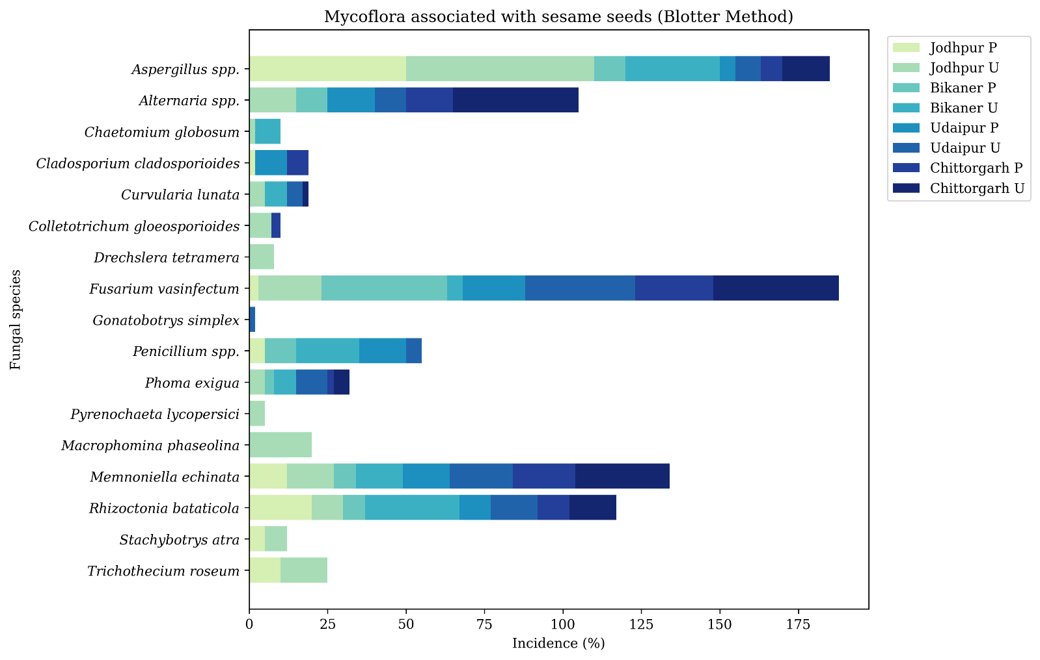

Fig. 1. Mycoflora Associated with Sesamum Seeds by Location and Condition (Blotter Method)

Table-II: Mycoflora associated with seeds of different samples of Sesamum by Agar Plate method (in%)

Fungi Isolated |  | Seed samples
 |  | Jodhpur |  | Bikaner |  | Udaipur |  | Chittorgarh
 |  | P | U | P | U | P | U | P | U
1. | Alternaria spp. | 5 |  | 6 | 12 | 2 | 4 | 33 | 4
2. | Aspergillus spp. | 32 | 51 | 34 | 37 | 32 | 34 | 27 | 31
3. | Cladosporium cladosporioides | 10 | 15 | 7 | 9 | - | 10 | 20 | 35
4. | Curvularia lunata | - | 10 | - | - | - | - | - | -
5. | Drechslera tetramera | - | 2 | - | 10 | - | - | - | -
6. | Fusarium vasinfectum | - | - | - | 2 | - | 24 | 2 | 10
8. | Penicillium spp. | 28 | 32 | 22 | 23 | 37 | 40 | - | 8
7. | Phoma exigua | - | - | - |  | - | 2 | - | -
10. | Rhizoctonia bataticola | - | - | 13 | 19 | 3 | 8 | - | -
9. | Rhizopus nigricans | - | 12 | 2 | 4 | - | 6 | - | 13
11. | Trichothecium roseum | - | - | 3 | 10 | - | - | - | 2
U = Untreated seeds P = Pretreated seeds

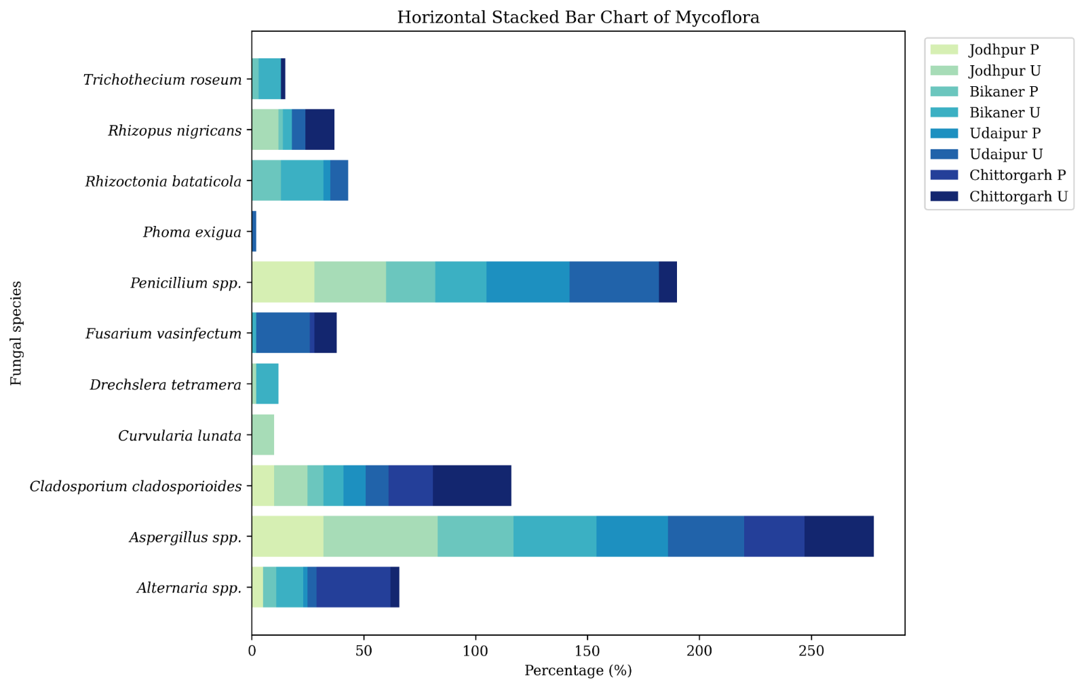

Fig. 2. Mycoflora Associated with Sesamum Seeds by Location and Condition (Agar Plate Method)

3.2 Germination percentage of seeds
The germination percentage of seeds ranged from 32 (Untreated seeds of Chittorgarh district) to 87 (Pretreated seeds of Bikaner district) on blotter method and 30% to 90% in Agar medium. Further, it was observed that pretreatment of seeds enhanced germination percentage and resulted in lesser number of mycoflora in all the samples. (Table IV, Fig.3)

Table-IV: Germinating percentage of different seed samples
Seed samples | Treatment | Germination Percent (%)
Seed samples | Treatment | On Blotter | On Agar Medium
Jodhpur | P | 80 | 68
Jodhpur | U | 66 | 45
Bikaner | P | 87 | 92
Bikaner | U | 70 | 80
Udaipur | P | 82 | 81
Udaipur | U | 78 | 68
Chittorgarh | P | 62 | 42
Chittorgarh | U | 32 | 30

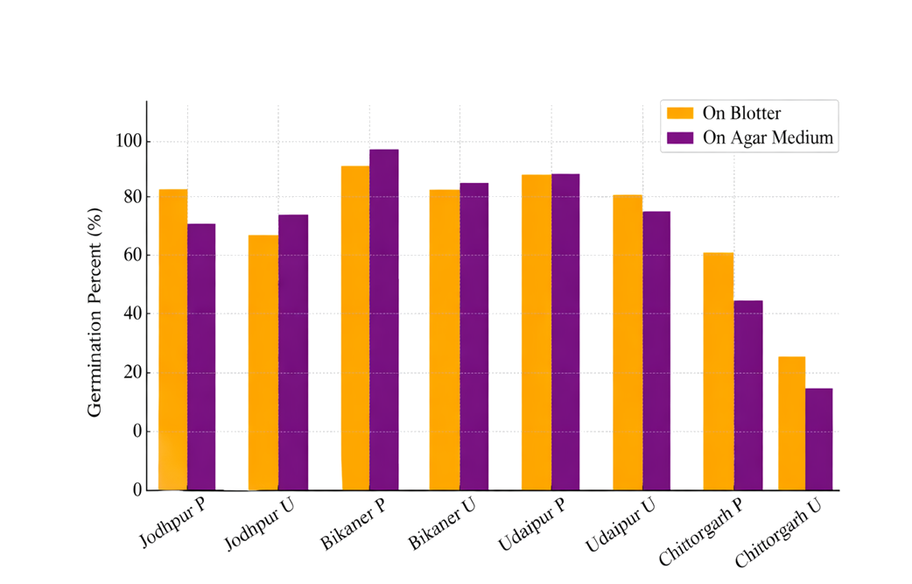

Fig. 3. Germination Percentage of Different Seed Samples

3.3 Changes in physico-chemical properties of sesame seed oil due to fungal infestation
Effect of Aspergillus flavus and Penicillium implicatum on oil content, free fatty acid content, saponification value and iodine value of sesame seed oil were observed. It is evident that a considerable amount of decrease in oil content of seed was caused by P. implicatum whereas A. flavus caused the minimum reduction (Table V, Fig. 4).

Table-V. Changes in oil contents
Fungi | 7 days |  | 14 days
Fungi | % oil | % increase (+) or decrease (-) over control | % oil | % increase (+) or decrease (-) over control
Aspergillu flavus | 45.2 | -6.22 | 43.7 | -9.34
Penicillium implicatum | 42.8 | -11.20 | 38.6 | -19.92
Control | 48.2 | - | 48.2 | -

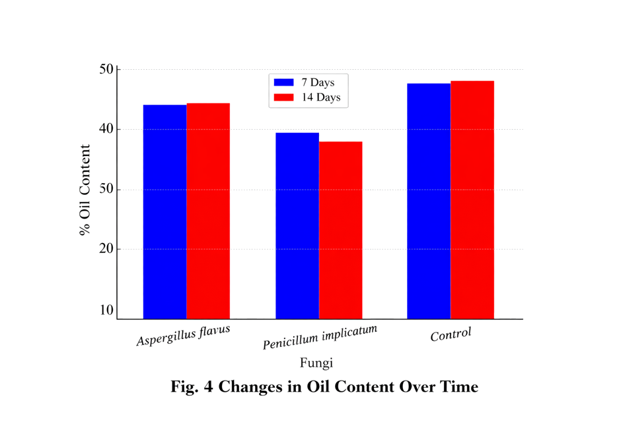

Fig. 4. Changes in Oil Content Over Time

3.3.1 Effect on chemical properties of oil
3.3.1.1 Free fatty acids Oils extracted from seeds infested with different seed borne fungi showed a significant increase in free fatty acid contents. A. flavus caused the severe damage and a very large increase in the free fatty acid content was observed even on the seventh day of incubation. However, P. implicatum caused comparatively lower increase in free fatty acid content than A. flavus (Table VI, Fig. 5).

Table-VI. Changes in free fatty acid contents
Fungi | 7 days |  | 14 days
Fungi | % free fatty acid | % increase (+) or decrease (-) over control | % free fatty acid | % increase (+) or decrease (-) over control
Aspergillu flavus | 30.8 | 266.75 | 43.6 | 419.05
Penicillium implicatum | 28.2 | 235.75 | 29.1 | 246.43
Control | 8.4 | - | 8.4 | -

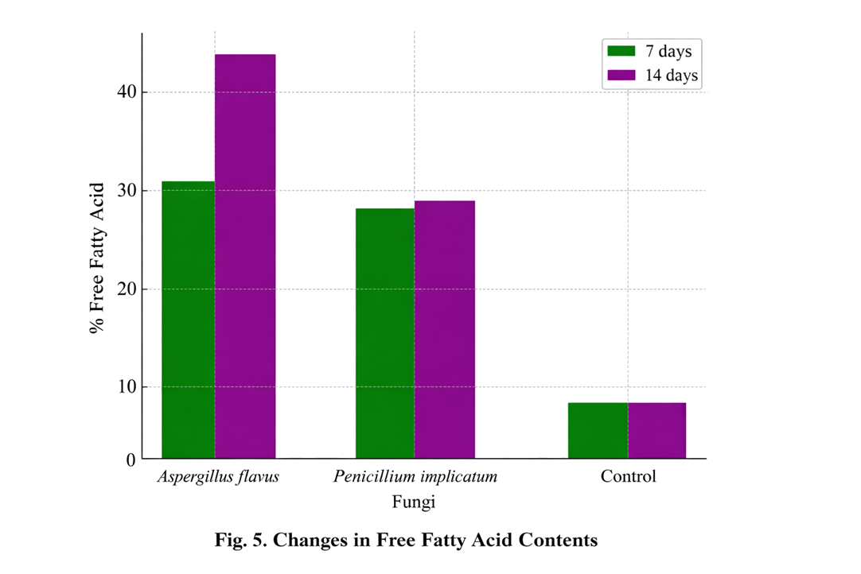

Fig. 5. Changes in Free Fatty Acid Contents

3.3.1.2 Saponification value
In the saponification value the maximum increase was caused by A. flavus while P. implicatum resulted in a comparatively lower increase in saponification value (Table VII, Fig. 6).

Table-VII. Changes in Saponification value
Fungi | 7 days |  | 14 days
Fungi | Saponification value | % increase (+) or decrease (-) over control | Saponification value | % increase (+) or decrease (-) over control
Aspergillu flavus | 208.5 | 9.51 | 219.8 | 15.42
Penicillium implicatum | 204.6 | 7.68 | 216.2 | 13.55
Control | 190.4 | - | 190.4 | -

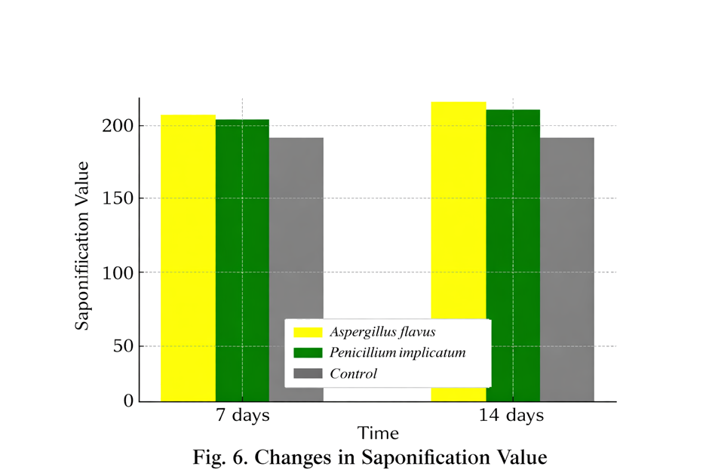

Fig. 6. Changes in Saponification Value

3.3.1.3 Iodine value
The iodine number of oil extracted from infested sesamum seeds by A. flavus and P. implicatum was assessed. Table VIII clearly reveals that both the fungi viz. A. flavus and P. implicatum reduced the iodine number appreciably in the seeds of sesame ( Fig. 7).

Table-VIII. Changes in Iodine value
Fungi | 7 days |  | 14 days
Fungi | Saponification value | % increase (+) or decrease (-) over control | Saponification value | % increase (+) or decrease (-) over control
Aspergillu flavus | 119.9 | -0.58 | 114.7 | -4.89
Penicillium implicatum | 101.7 | -15.65 | 99.8 | -17.25
Control | 121.0 | - | 121.0 | -

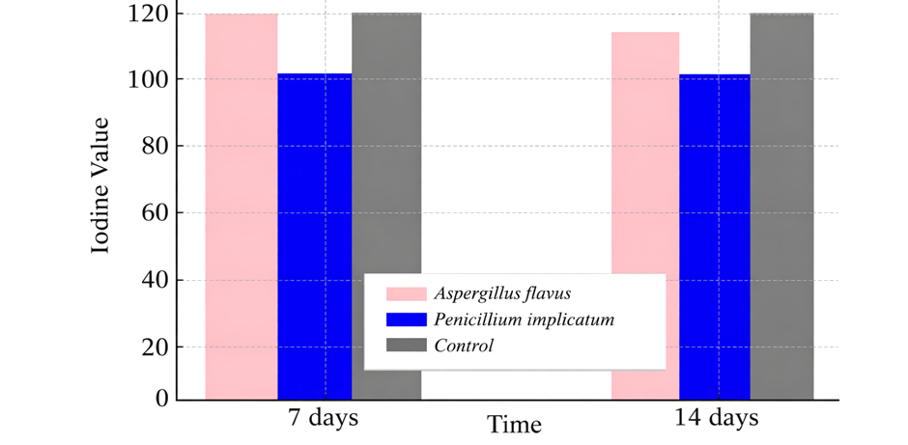

Fig. 7. Changes in Iodine value

4. Discussion
The present investigation revealed a wide diversity of seed-borne fungi associated with sesame seeds collected from different districts of Rajasthan, with 23 species belonging to 18 genera. Similar diversity has been reported in oilseeds, indicating that oil-rich substrates favor fungal colonization (Altaf et al., 2004; Kumar et al., 1984; Mishra and Kanaujia, 1973; Rao et al., 2015; Ghosh et al., 2018). The predominance of genera such as Aspergillus, Fusarium, Penicillium, and Alternaria observed in this study is consistent with earlier findings on storage fungi (Chavan, 2011; Kakde et al., 2012).
The variation observed between blotter and agar plate methods supports previous findings that different detection techniques influence the recovery of seed mycoflora (Kaur et al., 1990; Khattak et al., 1993). The absence of certain fungi in agar plate cultures may be due to the rapid growth of dominant fungi such as Aspergillus and Rhizopus, which suppress slower-growing species. Similar observations have been reported by Dawar and Ghaffar (1991), Chukunda et al. (2015), and Ghosh et al. (2018), emphasizing the importance of using multiple detection methods.
The study demonstrated that seed pretreatment significantly reduced fungal incidence and enhanced germination percentage. These findings are in agreement with earlier reports that surface sterilization improves seed viability by reducing pathogen load (Enikuomehin, 2010; Upadhyay and Singh, 1978). Improved germination may also be attributed to reduced fungal competition and lower accumulation of toxic metabolites (Jyoti and Malik, 2013; Kapoor et al., 2011).
The deterioration of oil quality observed in this study due to fungal infestation aligns with previous research on oilseed storage. The reduction in oil content caused by Aspergillus flavus and Penicillium implicatum may be attributed to lipid utilization by fungi as a carbon source (Amienyo et al., 2015; Mukherjee et al., 1992; Sarkate and Badar, 2022). The greater reduction caused by P. implicatum suggests variability in metabolic efficiency among fungal species (Kakde and Chavan, 2011).
A significant increase in free fatty acid content, particularly in seeds infected with A. flavus, indicates active lipid hydrolysis due to lipase activity (Mbah and Akueshi, 2001; Sharma, 1977). Similar increases have been reported in various oilseeds (Chavan, 2011; Sarkate and Badar, 2022). Variations among fungi may be due to differences in enzymatic activity and metabolic potential.
The increase in saponification value observed in the present study suggests the formation of lower molecular weight fatty acids due to lipid degradation, which is consistent with earlier findings (Chavan, 2011; Sarkate and Badar, 2022). The progressive increase with incubation time further confirms continuous oil degradation during storage.
The decrease in iodine value reflects a reduction in unsaturated fatty acids, indicating oxidative and enzymatic degradation of lipids. Similar results have been reported by Mukherjee et al. (1992) and Sarkate and Badar (2022), suggesting a decline in oil stability and nutritional quality.
Overall, the observed changes in physico-chemical properties of sesame seed oil can be attributed to the metabolic activities of storage fungi, which utilize seed reserves for growth and proliferation (Christensen, 1957; McDonald, 1999; Nandi et al., 1982). Environmental factors such as temperature, humidity, and storage duration play a crucial role in determining the extent of fungal infestation (Alemayehu et al., 2023; Ouali et al., 2023).
The study highlights the importance of proper storage conditions and seed treatment strategies to minimize fungal infestation. Effective management of seed-borne fungi is essential for maintaining seed viability, preserving oil quality, ensuring food safety, and reducing post-harvest losses (Enikuomehin, 2010; Upadhyay and Singh, 1978).

5. CONCLUSION
The present investigation demonstrated that sesame seeds harbour a diverse range of seed-borne fungi. Study confirmed that both blotter and agar plate methods are effective for the detection of mycoflora, although variations exist depending on the growth characteristics of fungi. Seed pretreatment with mercuric chloride proved to be effective in reducing fungal incidence and enhancing germination, indicating the importance of seed sanitation in maintaining seed viability. The study further revealed that storage fungi, particularly Aspergillus flavus and Penicillium implicatum, significantly influence the physico-chemical properties of sesame seed oil.
Fungal infestation resulted in a reduction in oil content, an increase in free fatty acid content and saponification value, and a decrease in iodine value, indicating deterioration in oil quality. These changes can be attributed to the metabolic and enzymatic activities of fungi, especially lipase-mediated lipid degradation. Overall, the findings highlight the need for effective storage practices, proper seed treatment, and fungal management strategies to minimize post-harvest losses, maintain oil quality, and ensure food safety. Improving seed health is essential not only for better crop productivity but also for enhancing the economic value of sesame as an important oilseed crop.

DISCLAIMER (ARTIFICIAL INTELLIGENCE)
Author(s) hereby declares that NO generative AI technologies such as Large Language Models (ChatGPT, COPILOT, etc.) and text-to-image generators have been used during the writing of this manuscript. For Grammar corrections ChatGPT 5.2 is used.
COMPETING INTERESTS
The author declares that there are no competing interests regarding the publication of this paper.

6. REFERENCES
- Adithya G, Rajeshwari B, Keshavulu K, Sudini H, Swathi Y (2017) Mycoflora associated with roundnut seeds collected from selected groundnut growing districts of Telangana State, India.Int J Curr Microbiol App Sci 6(7):4335–4342
- Afzal R, Mughal SM, Munir M, Sultana K, Qureshi R, Arshad M, Laghari AK (2010) Mycoflora
- Alemayehu, S., Abera, F. A., Ayimut, K. M., Darnell, R., Mahroof, R., Harvey, J., & Subramanyam, B. (2023). Effects of Storage Duration and Structures on Sesame Seed Germination, Mold Growth, and Mycotoxin Accumulation. Toxins, 15(1), 39. https://doi.org/10.3390/toxins15010039
- Altaf N, Khan SA, Ahmed M, Asghar R, Ahmed RA, Shaheen S, Zafar M, Saqib M (2004) Seed borne mycoflora of sesame (Sesamum indicum L.) and their effect on germination and seedling. Pak J Biol Sci 7:243–245
- Ameer Junaithal Begum M, B Venudevan and M Jayanthi (2013). Storage Fungi in Groundnut and the Associate Seed Quality Deterioration. Plant Pathology Journal. 12:127-134.
- Amienyo, Charity & Gugu, Ming & Oshatuyi, Mary. (2015). Effects of Fungal Deterioration on Lipid Content of Sesame Seeds (Sesanum indicum L.). International Journal of Phytopathology. 4. 01-04. 10.33687/phytopath.004.01.0872.
- A.O.A.C. (1960). Official methods of analysis of the Association of Official Agricultural Chemists.
- Association, I. S. T. International rules for seed testing rules, 1996 : International Seed Testing Association.
- Bedigian, D. (2012). Sesame: the genus Sesamum. CRC Press.
- Chavan AM (2011) Nutritional changes in oilseeds due to Aspergillus spp. J Exp Sci 2:29–31
- Chavan, A. M. and Kakde, R. B. (2008). Studies on abnormal oilseeds mycoflora from Marathwada region. Bionano Frontier 2 (2): 101-104
- Christensen CM (1957) Deterioration of stored grain by fungi. Bot Rev 23:108–134
- Chukunda FA, Emri UN, Ukoima HN (2015) Studies of seed-borne mycoflora of castor bean (Ricinus communis L.). Acad J Microbiol Res 3(1):006–009
- Dawar S, Ghaffar A (1991) Detection of the seed borne mycoflora of sunflower. Pak J Bot 23(2):173–178
- De Tempe J (1953) The blotter method of seed health testing. Proc Int Seed Test Assoc 21:133–151
- DOR (2013) Vision 2050. ICAR - Indian Institute of Oilseeds Research (IIOR), Andhra Pradesh, p 33
- DRMR (2015) Vision 2050. ICAR - Directorate of Rapeseeds-Mustard Research, Bharatpur, p 26
- Enikuomehin OA (2010) Seed sorting of sesame (Sesamum indicum L.) by salt density and seedborne fungi control with plant extracts. Arch Phytopath Plant Prot 43(6):573–580
- FAO. (2010). Production Crops. Sesame seeds. In.: Food and Agricultural Organisation of the United Nations, 150.
- Ghosh T, Biswas MK, Aikat K (2018) A review on seed borne mycoflora associated with different oilseed crops and their management. Int J Pure App Biosci 6(1):1526–1538
- International Seed Testing Association (1976) International rules for seed testing. Seed Science and Technology, 4, 51-177
- Jyoti, Malik CP (2013) Seed deterioration: a review. Int J Life Sci Biotechnol Pharm Res 2(3):374
- Kakde RB, Badar KV, Pawar SM, Chavan AM (2012) Storage mycoflora of oilseeds: a review. Int Multidiscipl Res J 2(3):39–42
- Kakde, R. B. and A. M. Chavan. (2011). Deteriorative changes in oilseeds due to storage fungi and efficacy of botanicals. Curr. Bot. 2: 17-22.
- Kapoor N, Arya A, Siddiqui MA, Kumar H, Amir A (2011) Physiological and Biochemical changes during seed deterioration in aged seeds of Rice (Oryza sativa L.). Am J Plant Physiol 6:28–35
- Kaur J, Chahal SS, Aulakh KS (1990) Differential efficiency of different methods in detection and location of seed-borne fungi in sunflower. Plant Dis Res 5(1):53–58
- Khattak I, Hussain S, Ali A, Shah SJA (1993) Efficacy of various methods employed for the study of seed borne microflora of soybean. Sarhad J Agric 9:45–48
- Kumar K, Singh J, Saksena HK (1984) Fungi associated with sesame seeds- their nature and control. Indian Phytopath 37:330–332
- Mbah, M. and C. Akueshi. (2001). Some Physico-chemical changes induced by Aspergillus flavus and Aspergillus niger on Sesamum indicum and Sesamum radiatum. J. Sci. Agric. Food Technol. Environ. 1: 65-9.
- Mbah, M. and C. Akueshi. (2001). Effect of seed borne Fungi Aspergillus flavus and Aspergillus niger on the germinability of sesame seeds. Niger. J. Hort. Soc. 4: 57-64.
- McDonald, M. (1999). Seed deterioration: physiology, repair and assessment. Seed Science and technology. 27: 177-237.
- Meara, M.L. (1955). Fats and other lipids. In Modern Methods of Plant Analysis, Vol. II (Paech, K. and Tracey, M.V., Eds.), Springer-Verlag, Berlin, Gottingen, Heidelberg, 317–402.
- Mishra RR, Kanaujia RS (1973) Studies on certain aspects of seed-borne fungi. II. Seed-borne fungi on certain oil-seeds. Indian Phytopath 25:284–294
- Mondal GC, Nandi D, Nandi B (1981) Studies on deterioration of some oil seeds in storage :Variation in seed moisture, infection and germinability. Mycologia 73(1):157–166
- Mukherjee PS, Nandi SK, Nandi B (1992) Deteriorative changes in groundnut seeds in storage. J Mycopathol Res 30(2):113–119
- Muskett AE (1948) Technique for the examination of seed for the presence of seedborne fungi. Trans Br Mycol Soc 30:74–83
- Nandi D, Mondal GC, Nandi B (1982) Studies on biodeterioration of some oilseeds. III. Effect of different storage temperatures and relative humidities on seed moisture, germinability and infection. Seed Sci Technol 10:141–150
- Ouali, D. , Zida, P. , Soalla, W. and Guissou, K. (2023). Morphological Identification of the Main Fungi Associated with Sesame in Burkina Faso. American Journal of Plant Sciences, 14, 882-895. doi: 10.4236/ajps.2023.148059.
- Rao TV, Rajeswari B, Keshavulu K, Varma VS (2015) Studies on seedborne fungi of soybean. Int J Agric Environ Sci 2(1):16–24
- Reddy MJ (1993) Varietal differences in seed mycoflora of sunflower. Seeds Farms 15:17–20
- Sarkate P.S. and Badar K.V(2022). Impact of Storage Fungi on Biochemical Changes in some oil Seeds. IJCSPUB Volume 12, Issue 1 February 2022
- Sharma, K.D. (1977). Biochemical changes in stored oilseeds. Indian J. agric. Res. 11: 134-144
- Srivastava, Dr. Seweta & Bindal, Sumant & Gopalakrishnan, Pavithra & Kumar, Ravindra & Rana, Meenakshi. (2021). Seed-Borne Mycoflora of Edible Oilseed Crops of India. 10.1007/978-981-15-4198-8_14.
- Upadhyay RS, Singh DB (1978) Seed mycoflora of mustard and their responses to storage and seed treatments with fungicides. J Sci Res BHU 29:171–181
- Ward, H.S. and U.L. Diener (1961). Biochemical changes in shelled peanuts caused by storage fungi. Phytopathology 51: 244–250.

