Original Research Article
COMPOSITION AND DIVERSITY OF FISH POPULATIONS IN THE MIDDLE COURSE OF THE COMOE RIVER (COTE D’IVOIRE)

ABSTRACT
The present article was conducted to identify the factors governing fish distribution based on physicochemical characteristics. Sampling took place from March 2021 to March 2022 along the middle reaches of the Comoé River. Physicochemical parameters, including temperature, pH, dissolved oxygen and conductivity, were measured using a multiparameter analyzer. Turbidity was determined in the laboratory after water sampling. Fishing was carried out using monofilament and multifilament nets, traps, and lines. Nets and traps were set at 5:00 PM and retrieved at 8:00 AM the following day. The results showed significant differences in dissolved oxygen, conductivity, and turbidity between sampling stations. The Siluriformes (35.71%) are the most represented order, with abundant species including Chrysichthys nigrodigitatus, Schilbe mandibularis and Synodontis bastiani. The Bettié station has the highest number of species and abundances, followed by the M'basso, Yêrê-yêrê, Abradinou, and Manzan stations. Fish distribution, as measured by Shannon and evenness indices, reveals poor population organization at the Bettié station compared to the other stations. Allometric length–mass relationships suggest variations in growth strategies along the Comoé River.
Keywords : Inventory, Ichthyofauna, middle course of the Comoé River, Côte d’Ivoire

INTRODUCTION
Population growth is often accompanied by the development of human activities that can influence the environment. This influence is sometimes referred to by some authors as the Anthropocene period (Crutzen, 2002). Aquatic environments, being important natural resources, are not immune to human actions. Indeed, these environments are influenced by activities such as fishing, agriculture, livestock farming, sand extraction, agro-industrial activities, and industrial or artisanal mining. These human activities, which require water to function, unfortunately have consequences for the various surrounding watercourses (Lévêque, 1998). The middle course of the Comoé River is no exception to this proliferation of activities. This environment is subject to activities such as rubber cultivation, cocoa farming, gold panning, and fishing. Furthermore, Vanga et al. (2002) indicates that over-intensive fishing leads to a decrease in fish lifespan, reduced size of caught individuals, and a decline in abundance and yields. Furthermore, the use of fertilizers of all kinds for agriculture is introduced through leaching or infiltration into nearby waterways (Laurent, 2006). These substances can be toxic to many fish and aquatic invertebrates. Given all these threats to the middle reaches of the Comoé River, this study was initiated to understand the structure and organization of the fish population in the face of the impacts of various activities on the fish fauna.

MATERIAL AND METHODS

Study site
The section of the middle course of the Comoé River used as the study area is located in south-eastern Côte d'Ivoire, in the Bettié department, between latitudes 6°14.54' and 6°03.49' North and longitudes 3°27.6' and 3°25.23' West (Figure 1). This area is characterized by four seasons: a major and a minor rainy season, as well as a major and a minor dry season (UEMOA, 2015). The major rainy season extends from March to July, while the minor rainy season lasts from September to November. These two seasons are separated by two dry seasons: the major dry season, which extends from December to February, and the minor dry season, which occurs in August. Five stations were selected for sampling in this study. These five (5) stations are distributed as follows, on the main channel: M'basso, Yêrê-yêrê, Abradinou and Bettié; only the Manzan station is located on a tributary of the Comoé River. The choice of stations was made taking into account their accessibility at all times, the permanence of water, but above all their connection with surrounding human activities.

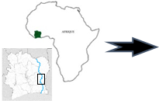
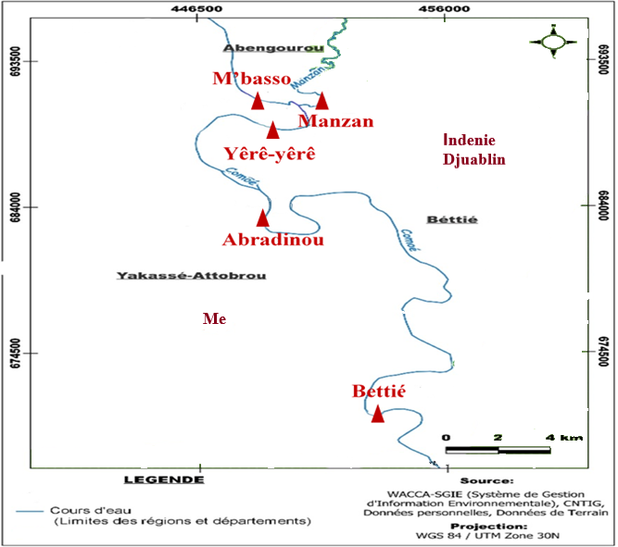

Figure 1: Geographical location of the middle course of the Comoé River and location of sampling stations
  - Collection of abiotic data
Data were collected over four campaigns, corresponding to the seasons, from March 2021 to March 2022. Physicochemical parameters were measured in situ at each station between 8:00 and 10:00 AM, prior to fish sampling. These parameters temperature, pH, electrical conductivity and dissolved oxygen were measured in the top 30 centimeters of water using a Lovibond SensoDirect 150 multiparameter meter. Turbidity was determined in the laboratory. A water sample was collected from each station using 1.5 L containers.

Biotic data collection
For the experimental fishing, fish were caught using a battery of monofilament gillnets with mesh sizes of 10, 12, and 13 mm and multifilament gillnets with mesh sizes of 15, 30 and 35 mm. The monofilament gillnets were 25 m long with a drop height of 1.5 m. The multifilament gillnets were composed of several overlapping layers mounted on a single rope. At each station, the nets were laid between 4 p.m. and 5 p.m. and recorded the following day between 8 a.m. and 10 a.m. regarding commercial fishing, the fish come from catches by local fishermen. The fishobtained were identified using Paugy et al. (2003a; 2003b) and updated on fishbase (Froese and Pauly, 2025). Next, the standard length of each specimen was measured with an ichthyometer to the nearest millimeter.

Data processing
The characterization of the fish fauna was carried out using relative importance and ecological indices. The diversity of the fish fauna was studied through species richness and diversity indices:
- Shannon index (H') (Shannon and Weaver, 1963) with: $H'=\sum_{i=1}^{s}{p_{i}.\log_{2}(p_{i})}$
(pi = number of species i in the catch and S = total number of species observed in the catch). H' tends towards 0 when diversity is minimal and towards 5 when it is maximal. This index is used to measure the degree of organization of the population.
- Pielou's equitability index (E) allows to measure the degree of community organization by studying the regularity of species distribution in a given ecosystem (Frontier et al., 2008). Its formula is: $E=H'/(log_2 (S))$
(H = Shannon index; S = species richness). The value of E is between 0 and 1. It tends towards 0 when almost all the individuals are concentrated in one species, and towards 1 when all species have the same abundance.
- Sorensen's similarity coefficient (1948): This coefficient was used to compare different stations. It allowed for an assessment of the degree of similarity between the species lists of the different stations. Its formula is:
$C_{s}=(2a / (a + b+c)) x 100)$.
(a = number of species present in the first station, b = number of species present in the second station and c = number of species common to both stations).
The relationship between standard length and mass of different species is used to determine their weight gain. Its formula is as follows (Le Cren, 1951):
$$P=a×{Ls}^{b}$$
P: uneviscerated mass of the fish (g), LS: standard length (mm), a: constant and b: allometric coefficient.
After transforming the equation into its logarithmic form (Log P = Log a + b × Log Ls), the parameters a and b of the standard length-mass relationship were estimated using linear regressions (Zar, 1999). The nature of the growth was determined using a Student's t-test, which verifies whether the coefficient b differs significantly from the theoretical value of 3, characteristic of isometric growth. Thus, growth is positive allometric when b > 3, negative allometric when b < 3, and isometric when b = 3, indicating proportional growth of the fish.
  - Statistical processing
The physicochemical data were subjected to a univariate descriptive analysis (Kruskal-Wallis test). This test was used to determine the significance of the abiotic parameters and indices. The variations of the different abiotic descriptors between the different stations were illustrated using box plots. The box plots and the Kruskal-Wallis test were performed using the R software (Legendre and Vaudor, 1991). A principal component analysis (PCA) was performed to interpret the relationships between the 38 observed species and their variations in the environment.

- RESULTS AND DISCUSSION
  - Characteristics of the environment
The physico-chemical characterization of the waters in the study environment was carried out based on water temperature, pH, dissolved oxygen, conductivity and turbidity (Figure 2).
The median temperatures recorded at the five stations are relatively close, ranging from 28.05 °C to 29.9 °C. The Abradinou station has the highest median (29.9 °C), while the Manzan and Yêrê-yêrê stations have slightly lower medians of 28.2 °C and 28.05 °C, respectively. No significant spatial differences were observed for temperature (Kruskal-Wallis test P= .203) (Figure 2A).
pH values ​​varied among the five study stations (Figure 2B). The M'basso station had the highest median pH in the alkaline range (7.48). The Manzan, Abradinou, and Bettié stations had lower median values ​​of 4.98, 5.28, and 5.45, respectively. No significant spatial differences were observed for pH (Kruskal-Wallis test P= .111).
Dissolved oxygen concentrations showed marked spatial variations among the five sampled stations. The M'basso station exhibited the highest values, with a median of 5.2 mg/L, reflecting significantly better oxygenated conditions than the other stations. Conversely, the other stations showed lower dissolved oxygen levels, with medians ranging from 0.6 mg/L to 1.4 mg/L. The Kruskal-Wallis test showed a significant spatial difference for dissolved oxygen (P=.031) (Figure 2C). The Mann-Whitney test revealed a significant difference between the Manzan station and the Manzan, Yêrê-yêrê, and Abradinou stations.
Conductivity values ​​vary from station to station. The M'basso station stands out from the others with a lower median value of 62.5 µS/cm. The Manzan station has the highest median value, at 116 µS/cm. The Kruskal-Wallis test shows a significant spatial difference in conductivity (P= .011) (Figure 3A). The Mann-Whitney U test reveals significant differences between the M'Basso, Manzan, and Yêrê-Yêrê stations, indicating that these stations are distinct from one another. The Abradinou station also differs from the Manzan station. In contrast, no significant difference is observed between the Bettié station and the Manzan, Yêrê-Yêrê and Abradinou stations.
Analysis of median turbidity values ​​shows that the Manzan station has the highest median value, reaching 1406 NTU. Conversely, the M'basso station recorded the lowest median value, at 27.5 NTU. The Kruskal-Wallis test revealed a significant spatial difference (P= .006) (Figure 3B). The Mann-Whitney test also highlighted a significant difference between the Manzan station and the other stations.

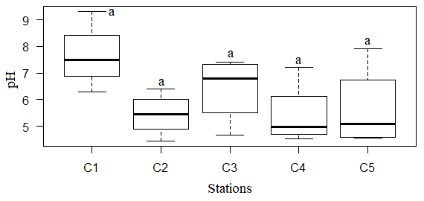
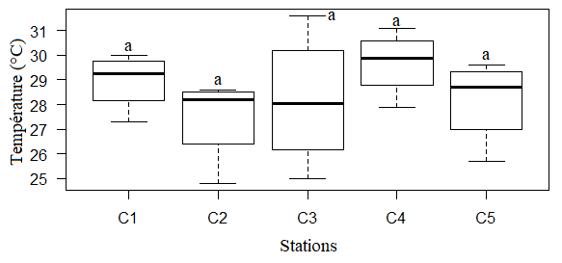

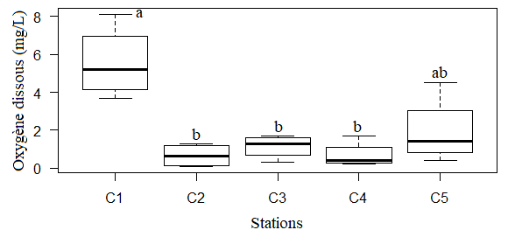
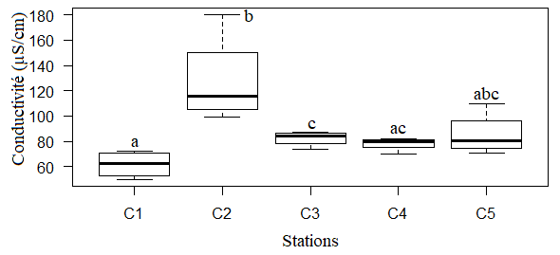

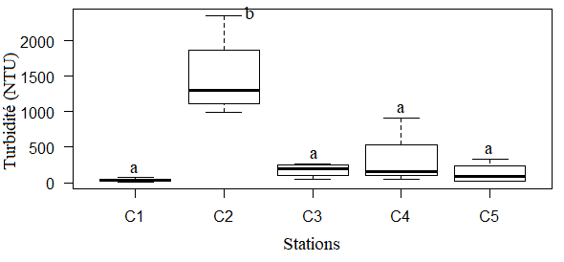

Figure 2 : Variation of the physico-chemical parameters of the middle course of the Comoé River
C1: M'basso, C2: Manzan, C3: Yêrê-yêrê, C4: Abradinou, C5: Bettié, a, b and c = significant difference between the stations
  - Species richness and distribution of fish populations
The inventory results highlight 38 species distributed across 8 orders and 14 families (Table 1). The Siluriformes are the most diverse, with five families (35.71%), representing the best-represented order. They are followed by the Perciformes and Characiformes, each comprising two families (14.29%). The five other orders Osteoglossiformes, Cichliformes, Synbranchiformes, Polypteriformes, and Cypriniformes each contain only one family (7.14%) (Figure 3a).
The species composition by family indicates that the Mormyridae are the most diverse family with seven species (18.42%). They are followed by the Alestidae with six species (15.79%), and then by the Cichidae with five species (13.16%). The Mochokidae and Cyprinidae each have four species (10.53%), while the Clariidae and Claroteidae have three species (7.89%) and two species (5.26%), respectively. Finally, all the other families (Mastacembelidae, Latidae, Channidae, Malapteruridae, Schilbeidae, Distichodontidae and Polypteridae) represent 18.42% with only one species each (Figure 3b).
Table I: List of fish species sampled at the different sampling stations in the middle course of the Comoé River
Orders | Families | Species | M'basso |  | Manzan | Yêrê-yêrê | Abradinou | Bettié
Polypteriformes | Polypteridae | Polypterus endlicherii |  |  |  | + |  | +
Osteoglossiformes | Mormyridae | Marcusenius furcidens | + |  | + | + | + | +
Osteoglossiformes | Mormyridae | Marcusenius senegalensis | + |  |  | + |  | +
Osteoglossiformes | Mormyridae | Marcusenius ussheri | + |  | + | + |  | +
Osteoglossiformes | Mormyridae | Mormyrops anguilloides | + |  |  | + | + | +
Osteoglossiformes | Mormyridae | Mormyrus rume | + |  |  | + | + | +
Osteoglossiformes | Mormyridae | Petrocephalus bovei |  |  | + |  |  | +
Osteoglossiformes | Mormyridae | Pollimyrus isidori | + |  |  |  |  | +
Characiformes | Alestidae | Alestes baremoze | + |  | + | + | + | +
Characiformes | Alestidae | Brachyalestes imberi | + |  |  | + |  | +
Characiformes | Alestidae | Brycinus macrolepidotus |  | + | + | + | + | +
Characiformes | Alestidae | Brachyalestes nurse |  |  |  |  |  | +
Characiformes | Alestidae | Micralestes elongatus |  |  |  |  |  | +
Characiformes | Alestidae | Hydrocynus forskahlii |  | + | + | + |  | +
Characiformes | Distichodontidae | Distichodus rostratus |  | + | + | + | + | +
Cypriniformes | Cyprinidae | Barbus sp. |  | +
Cypriniformes | Cyprinidae | Enteromius trispilos |  |  |  |  |  | +
Cypriniformes | Cyprinidae | Labeo parvus |  | + |  | +
Cypriniformes | Cyprinidae | Labeo coubie |  | + |  | + | + | +
 | Claroteidae | Chrysichthys nigrodigitatus |  | + |  | + | + | +
 | Claroteidae | Chrysichthys maurus |  |  |  |  |  | +
 | Schilbeidae | Schilbe mandibularis |  | + | + | + | + | +
siluriformes | Clariidae | Clarias anguillaris |  | + |  | + |  | +
 | Clariidae | Heterobranchus isopterus |  |  |  | + |  | +
 | Clariidae | Heterobranchus longifilis |  | + | + |  |  | +
 | Malapteruridae | Malapterurus electricus |  |  |  | + |  | +
 | Mochokidae | Synodontis bastiani |  | + |  | + |  | +
 | Mochokidae | Synodontis comoensis |  |  |  |  |  | +
 | Mochokidae | Synodontis punctifer |  |  |  |  |  | +
 | Mochokidae | Synodontis schall |  | + |  | + | + | +
Cichliformes | Cichlidae | Coptodon zillii |  | + |  | + |  | +
Cichliformes | Cichlidae | Oreochromis niloticus |  | + |  |  |  | +
Cichliformes | Cichlidae | Hemichromis fasciatus |  | +
Cichliformes | Cichlidae | Chromidotilapia guntheri |  |  |  |  |  | +
Cichliformes | Cichlidae | Sarotherodon galilaeus |  | + |  |  |  | +
Perciformes | Channidae | Parachanna obscura |  |  |  |  |  | +
Perciformes | Latidae | Lates niloticus |  | + | + | + | + | +
Synbranchiformes | Mastacembelidae | Mastacembelus nigromarginatus |  |  | + | + |  | +
8 | 14 | 38 |  | 25 | 11 | 23 | 11 | 35
Number of individuals of fish caught (%) |  |  |  | 7,47 | 1,06 | 9,25 | 1,27 | 80,95
+ : Present
a
b

Figure 3 : Relative abundance of orders (a) and families (b) of fish in the middle course of the Comoé River

At the station level, the Bettié station is the most diverse with 34 species and contains 81% of the collected specimens. Chrysichthys nigrodigitatus, Schilbe mandibularis and Synodontis bastiani are the most abundant species at the Bettié station. It is followed by the Yêrê-yêrê station with 23 species. This station contains 9.2% of the collected specimens, with Synodontis schall, Schilbe mandibularis and Synodontis bastiani being the most frequently captured species. The M'basso station, with 25 species, represents 7.5% of the specimens. Brachyalestes imberi, Synodontis schall and Alestes baremoze are the most abundant species. The Manzan and Abradinou stations have fewer species, with 11 each. They each contain 1% of the captured specimens. The most frequently captured species at the Manzan station are Schilbe mandibularis and Hydrocynus forskalii. Whereas at the Abradinou station the most numerous species are Chrysichthys nigrodigitatus and Brycinus macrolepidotus.

Fish assembly patterns:
The minimum (2.05 ind/bits) and maximum (2.717 ind/bits) values ​​of the Shannon index were obtained at the Manzan and M'basso stations, respectively. The minimum (0.5997 ind/bits) and maximum (0.8916 ind/bits) values ​​of the fairness index were given respectively by the station of Bettié and Abradinou. The Kruskal-Wallis test revealed significant differences in the Pielou's equitability index between certain stations (p= .028), particularly between the Bettié and Abradinou stations, as well as between Bettié and Manzan. In contrast, no significant difference was observed between the stations for the Shannon index (p= .158) (Table II).
Table II: Variations in the diversity indices of the middle course of the Comoé River
 | M'Basso | Manzan | Yêrê-yêrê | Abradinou | Bettié
Pielou's equitability index (E') | 0,8488 | 0,8545 | 0,7864 | 0,8916 | 0,5954
Shannon index (H') | 2,698 | 1,967 | 2,466 | 2,138 | 2,1

Similarity between stations
The results of the Sorensen index indicate that the M'basso and Yêrê-yêrê stations exhibit very high taxonomic similarity (79%). Low similarity is recorded between the Bettié and Abradinou stations (49%) and between the Bettié and Manzan stations (49%) (Table III).

Table III : Sorensen similarity index between stations
 | M’basso | Manzan | Yêrê-yêrê | Abradinou | Bettié
M’basso
Manzan | 0.79
Yêrê-yêrê | 0.61 | 0.65
Abradinou | 0.71 | 0.74 | 0.49
Bettié | 0.5 | 0.53 | 0.54 | 0.49

  - Relationship between standard length and mass of fish
In total, 38 species were recorded, representing a population of 2,357 individuals. 16 of the 38 recorded species, representing at least 1% of the total abundance, were taken into account for the calculations. At the M'basso station, 147 individuals belonging to 14 species were examined. The allometric coefficients (b) of L. niloticus, M. anguilloides, S. schall and S. mandibularis did not show a significant difference from the theoretical value of 3 (t-test, p > 0.05), indicating isometric growth. The species D. rostratus, L. coubie, S. bastiani and C. nigrodigitatus had allometric coefficients statistically greater than 3 (t-test, p < 0.05), reflecting positive allometric growth. The species H. forskalii, B. imberi, M. senegalensis, B. macrolepidotus and A. baremoze had allometric coefficients statistically less than 3 (t- test, p < 0.05), indicating negative allometric growth (Figure 4).
The Manzan station comprises 20 individuals distributed among seven (7) species. Allometric growth calculations were performed for three species (H. forskalii, L. niloticus and S. mandibularis) due to the small number of individuals (1) for the other species. H. forskalii and L. niloticus exhibit negative allometric growth with allometric coefficients statistically less than 3 (t-test, p < 0.05). In contrast, S. mandibularis shows allometric growth statistically greater than 3 (t-test, p < 0.05), thus positive allometric growth (Figure 4).
At the station Yêrê-yêrê 184 individuals belonging to 14 species were examined. Allometric growth was calculated for 12 species, the other two being represented by only one individual each. The allometric coefficients (b) show that M. furcidens, B. macrolepidotus, D. rostratus, L. coubie, A. baremoze, M. anguilloides, S. schall and C. nigrodigitatus differ significantly from the theoretical value of 3 (t-test, p < 0.05). These species thus exhibit negative allometric growth. The species H. forskalii, L. niloticus, S. bastiani, and S. mandibularis exhibit positive allometric growth, with allometric growth statistically greater than 3 (t-test, p < 0.05) (Figure 4).
At the Abradinou station, 29 individuals belonging to 10 species were examined. Allometric growth could be calculated for six species, as the others were represented by only one individual. The species L. niloticus, B. macrolepidotus, D. rostratus, S. schall and C. nigrodigitatus showed positive allometric growth with allometric coefficients statistically higher than 3 (t-test, p < 0.05). The species S. mandibularis showed an allometric coefficient less than 3 (t-test, p < 0.05), therefore negative allometric growth (Figure 4).
The Bettié station contains 1821 individuals distributed among 16 studied species. The species S. comoensis, B. imberi, B. macrolepidotus, P. bovei, A. baremoze, S. schall and S. mandibularis exhibit allometric coefficients greater than 3 (t-test, p < 0.05), indicating positive allometrics. Allometric coefficients less than 3 (t-test, p < 0.05) were determined for L. niloticus, M. furcidens, H. forskalii, M. senegalensis, D. rostratus, L. coubie, M. anguilloides, S. bastiani and C. nigrodigitatus. This indicates that the species exhibit negative allometrics (Figure 4).

Figure 4 : Variation in allometric types across stations

Multivariate analyses
The eigenvalues ​​of the two axes are 91.61%, with 66.97% for axis 1 and 24.65% for axis 2 (Figure 5). Conductivity and turbidity have negative effects on the Manzan station. Conversely, the Mbasso station at Abradinou, projected onto the positive side of axis 1, is influenced by pH and dissolved oxygen (M'basso) and by temperature (Abradinou). The position of M'basso reflects more favorable physicochemical conditions and a lower level of disturbance compared to the Manzan station.

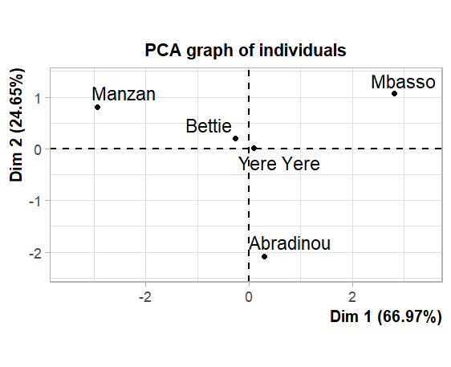
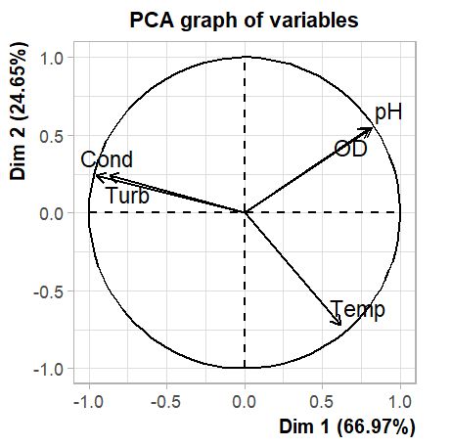

Figure 5: Species distribution by Principal Component Analysis (PCA)

- DISCUSSION
Water quality assessments along the middle course of the Comoé River reveal distinct impacts from agricultural and gold mining activities. The upstream station at M'basso is characterized by an alkaline pH and near-optimal oxygenation. Low turbidity and conductivity values ​​indicate very low ionic and particulate loads. Overall, these parameters suggest acceptable water quality, corresponding to a minimally disturbed state, without, however, excluding the possible presence of local stressors (Dubey et al., 2022). The Manzan station, located on a tributary of the river, is distinguished by relatively low pH, temperature, and dissolved oxygen levels. This could indicate that the aquatic environment is experiencing environmental stress resulting from high oxygen consumption due to the decomposition of organic matter (Graham et al., 2025). Conversely, it records the highest conductivity and turbidity values. The state of the environment suggests anthropogenic pressure, likely resulting from activities at the station, such as gold mining and rubber tree cultivation, whose agricultural runoff and soil erosion are carried into the watercourse. The intermediate station, Abradinou, is characterized by temperatures varying by 29.9°C. This variation can be attributed to several factors, notably direct solar radiation, which warms the water. The near-total absence of vegetation cover along the stations leads to direct exposure of the water surface to the sun, thus contributing to a rise in temperature. Studies have demonstrated that riparian vegetation cover plays a role in the thermal regulation of watercourses. Miñana-Albanell (2024) indicates that a 10% increase in shade can lower the water temperature by 1.2°C. The stations of Yêrê-yêrê, Abradinou, and Bettié exhibit chemical conditions ranging from slightly acidic (Yêrê-yêrê) to distinctly acidic (Abradinou and Bettié), with lower oxygenation compared to the M'basso station. These parameters can be explained by the higher temperatures observed at these stations, ranging from 28.05°C to 29.9°C indeed, rising temperatures simultaneously lead to a reduction in oxygen and a decrease in pH. On the one hand, increased temperature stimulates the metabolism of aquatic organisms as well as that of bacteria responsible for the decomposition of organic matter. This process increases oxygen consumption through bacterial and other decomposition, depleting the environment of oxygen (Graham et al., 2025). On the other hand, rising temperatures promote water dissociation and accelerate the production of CO2 from respiration and decomposition. CO2 is transformed into carbonic acid (H2CO3) and releases hydrogen ions (H⁺), thus acidifying the environment and consequently reducing pH (Talling, 2010). These stations also exhibit low conductivity and turbidity values, indicating a low ionic and particulate load.
In this study, 38 species, distributed across 8 orders and 14 families, were sampled. The number of species identified in this study is lower than that of Yao (2006), which was 70 species. This decrease in species numbers could be explained by the methods used by Yao (2006). He conducted electrofishing and passive fishing with a battery of 17 monofilament nets (8, 10, 12, 15, 20, 25, 30, 35, 40, 45, 50, 55, 60, 65, 70, 80 and 90 mm mesh size), unlike the methods used in our study, which involved passive fishing with gillnets and hooks. However, the absence of certain species does not allow us to conclude that these species have disappeared, but their absence suggests that our sampling may not be exhaustive. The quantitative inventory of the population showed that, numerically, Chrysichthys nigrodigitatus and Schilbe mandibularis are the most numerous species. These species also exhibit a tolerance to variations in ecological factors such as dissolved oxygen levels, conductivity, and transparency, giving them an advantage over more sensitive species (Plisnier et al., 1988).
The Shannon index (H') values ​​indicate that the river community is moderately diverse. The M'basso station exhibits greater species diversity compared to Manzan, which is less diverse. This difference can be explained by several factors. The M'basso station benefits from lower anthropogenic pressure (gold panning, agriculture, pollution discharges). Habitat diversity (rocky areas, riparian vegetation and substrate diversity) at M'basso may offer more ecological niches favorable to a greater variety of species and better habitat quality (Ramazotti et al., 2020). Regarding evenness, it is high at the M'basso, Manzan and Abradinou stations, but medium at the Yêrê-yêrê station and low at the Bettié station. The low value of Pielou’s equitability index at Bettié could be reflected in a poorly organized fish community. At the Bettié station, 56.21% of the captured individuals belonged to just two of the thirty-four species sampled there. This high abundance relative to the species distribution could be the cause of the poor organization of the population. This situation is explained by heavy fishing pressure at Bettié, linked to the influx of fishermen, which favors the dominance of a few species. Furthermore, habitat alteration due to human activities (gold mining, pollution, agriculture) disrupts the ecosystem and favors tolerant species at the expense of the more sensitive ones (Allan et al., 2005).
Analysis of the standard length-mass relationship reveals variations across sites. At M'basso, the dominance of species with negative allometric growth is observed, along with a few species exhibiting positive and isometric growth. This suggests a community dominated by small individuals, but benefiting from relatively balanced ecological conditions. At Manzan, the strong dominance of negative allometric growth and the near absence of isometric growth species indicate a highly unbalanced size structure, typical of a disturbed or food-poor environment where large sizes are rare or absent. At Yêrê-yêrê, the predominance of negative allometric growth is accompanied by a relatively high presence of species with positive and isometric growth. This would indicate a slight improvement in ecological conditions, likely related to greater depth or habitat heterogeneity. At Abradinou, the decrease in species with negative allometric growth coincides with a relative increase in species with positive allometric growth. However, species with isometric growth remain almost nonexistent, indicating a restoration of the population under the combined influence of anthropogenic disturbances and underexploitation of the fish population. Finally, at Bettié, positive and negative allometric growth predominate. This reflects the coexistence of species of different sizes and a certain capacity to adapt to local conditions. These results confirm that the length-mass relationship can be influenced by several factors, including habitat, diet, physiological state, and environmental conditions (Froese, 2006).
Principal component analysis (PCA) concluded that the Manzan station is highly mineralized. The high levels of conductivity and turbidity characterize the station as an environment heavily impacted by human activities such as gold mining, fishing, and rubber tree cultivation. The Manzan station contrasts with the M'basso station, which reflects more favorable physicochemical conditions and a low level of disturbance.

CONCLUSION
This study identified 38 fish species belonging to 8 orders and 14 families. Abundance analysis showed that the fish population of the middle Comoé River is dominated by the order Siluriformes. Fish distribution, as measured by Shannon indices, showed moderate diversity. Furthermore, evenness analysis revealed poor population organization at the Bettié station compared to the other stations.
DISCLAIMER (ARTIFICIAL INTELLIGENCE)
These guidelines cover acceptable uses of generative AI technologies such as Large Language Models (ChatGPT, COPILOT, etc) and text-to-image generators in the writing or editing of manuscripts.

COMPETING INTERESTS
Authors have declared that no competing interests exist.

CONSENT
All authors declare that ‘written 220 informed consent was obtained from the patient (or other approved parties) for publication of 221 this case report and accompanying images. A copy of the written consent is available for 222 review by the Editorial office/Chief Editor/Editorial Board members of this journal.

REFERENCES
Allan, J. D., Erickson, D. L, & Fay, J. (2005). The influence of catchment land use on stream integrity across multiple spatial scales. Freshwater Biology, 50(3), 552–566.
Crutzen, P. (2002). Geology of Mankind, Nature 415 no23.
Dubey, S. S., Singh, A. K., & Tripathi, U. N. (2022). Water Quality-A Review. International Journal of Chemical Sciences, 20(3), 430.
Froese, R. (2006). Cube law, condition factors and weight-length relationships: history, meta-analysis and recommendations. Journal of Applied Ichthyology, 22, 241-253.
Froese, R., & Pauly, D. (2025). FishBase.www.fishbase.org Version (04/2025).
Frontier, S., Pichod-Viale, D., Lepretre, A., Davoult, D., & Luczak, C. (2008). Écosystèmes : structure, fonctionnement, évolution, 4e édition, Dunod, Paris.
Graham, D., Bierkens, M., Jones, E., Sutanudjaja, E., & van Vliet, M (2025). Climate change drives low dissolved oxygen and increased hypoxia rates in rivers worldwide. Nature Climate Change, 15, 1-7.
Laurent, F. (2006). Agricultural Pollution of Water Resources in Western France. "Water: Source of Life, Source of Conflict," 15th *Le Monde Diplomatique* Forum, "Carrefours de la Pensée," Rennes, France, pp. 143–150.
Le Cren, E. D. (1951). The length-weight relationships and seasonal cycle in gonad weight and condition in perch (Perca fluviatilis). Journal of animal Ecology, 20(2), 201-219.
Legendre, L. & Vaudor, A. (1991). The R Software Package: Multidimensional Analysis, Spatial Analysis. 3rd Edition. Montreal: Department of Biological Sciences, Université de Montréal.
Lévêque, C. (1998). Biodiversity and Management of Continental Aquatic Systems. *Revue des sciences de l'eau*, 11, 211–221.
Paugy, D., Lévêque, C., & Teugels, G. G. (2003a). Freshwater and Brackish-Water Fish Fauna of West Africa. Volume 1. IRD, Paris; MNHN, Paris; MRAC, Tervuren.
Paugy, D., Lévêque, C., & Teugels, G. G. (2003b). Freshwater and Brackish-Water Fish Fauna of West Africa. Volume 2. IRD, Paris; MNHN, Paris; MRAC, Tervuren.
Plisnier, P. D., Micha, J. C., & Frank, V. (1988). Biology and Exploitation of the Fish of Lake Ihema (Akagera Basin, Rwanda). Namur: Presses Universitaires de Namur.
Ramazotti, G., Degiorgis, M., Paltrinieri, G., & Torricelli, P. (2020). Fish Communities, Habitat Use, and Human Pressures in the Upper Volta Basin, Burkina Faso, West Africa. Sustainability, 12(13), 5444.
Shannon, C. E., & Weaver, W. W. (1963). The mathematical theory of communications. University of Illinois Press, Urbana.
Sorensen, T., (1948). A method of establishing groups of equal amplitude in plant sociology based on similarity of species content. Det Kongelige Danske Videnskabernes Selskabs Kopenhague, Biologiske Skrifter, 5(4), 1-34.
Talling, J. F. (2010). pH, the CO2 System and Freshwater Science. Freshwater Reviews, 3, 133-146.
Vanga, A. F., Gourene, G., Ouattara, M. (2002). Impact of fishing on fish availability in the Lake Ayamé and Lake Buyo regions (Côte d’Ivoire). *Archives Scientifiques du Centre de Recherches Océanographiques, Abidjan*, 17(2), 1–12.
Yao, S. S. (2006). *Study of the biological diversity and feeding ecology of the ichthyofauna of a West African hydrosystem: The case of the Comoé Basin (Côte d’Ivoire)*. Doctoral Thesis, University of Cocody, Côte d’Ivoire, 280 p.
Zar, J. H. (1999). Biostatistical Analysis. 4th Edition. Prentice Hall, Englewood Cliffs, New Jersey, USA.

