PHOTOGRAMMETRIC ANALYSIS OF BEAUTIFUL FACE OF THE IJAWS AND ISOKOS ETHNIC GROUPS

ABSTRACT
BACKGROUND: Facial beauty is often considered to follow a universal standard characterized by symmetry and balanced proportions, regardless of race, age, or sex. This study therefore examined the proportional and symmetrical relationships of facial features among the Ijaw people and Isoko people using photogrammetric analysis.
MATERIAL AND METHODS: Facial attractiveness was evaluated in 400 participants (200 Ijaw people and 200 Isoko people), aged 18–35 years. Using Cunningham’s anthropometric landmarks, facial measurements were obtained from anterior and lateral photographs of students from Rivers State, Bayelsa State, and Delta State, which were printed on A4 paper and measured at life scale with a meter rule.
RESULTS: All the parameters were higher in the Ijaw males except the total height of the face, height of visible eye ball, ear, nose length, width of eye, length of the upper lip and chin length when compared to Isoko males. In the females, all the parameters were higher except chin length, vertical distance from the centre of the eye to the bottom of the eyebrow, width of eye, nose length, width of eye, width of face at mouth level, width of mouth, usual ration between the distance the nose project from the face, length of the upper lip, when compared to Isoko females. Furthermore, comparison of the obtained proportion of the both sexes of the Ijaw and Isoko ethnic groups with that of the Cunningham's proportion at both normal state, there is a perfect and very strong relationship been observed in all measured parameters.
CONCLUSION: This study provides baseline data on facial attractiveness for the Ijaw people and the Isoko people. Their facial proportions closely match the benchmarks described by Cunningham, indicating that perceived facial beauty, whether in Asian people or European people is largely dictated by symmetric, proportional relationships between facial features and the face as a whole, regardless of age or sex.

Key Word: Beautiful face, Ijaws and Isoko ethnic groups

INTRODUCTION
Photogrammetry is as old as modern photography and can be dated to the mid-nineteenth century. Photogrammetry is the practice of determining the morphometric properties of objects from photographic images; in other words, photogrammetry is the science or art of obtaining reliable measurements by means of photographs (Savara, 1965a; Thompson, 1996). In photogrammetry, the face is illuminated by either a structured or a speckled light pattern and in order to reduce inaccuracy due to movement, images are recorded simultaneously from several views. Then, the images are processed to calculate facial surface coordinates. Physical appearance is an important characteristic of the face. It has long been established that self-esteem is strongly influenced by facial appearance (Hershon and Giddon, 1980). The perception of a beautiful face is largely subjective, with ethnicity, age, gender. Culture, and personality influencing average facial traits (Mandall et al., 2000; Saglam and Gazilerli, 2001). Interestingly, facial features are usually studied in profile and various methods have been used to evaluate facial characteristics, such as anthropometry (Farka, 1981), photogrammetry (Gavan et al., 1952; Stoner, 1955; Neger, 1959), computer imaging (Guess and Solzer, 1989), and cephalometry (Garner, 1974; Roos, 1977). Czarnecki et al., (1993) evaluated the perception of facial balance by varying the length of the nose, lip protrusion, and chin development. They found that the interrelationships of these facial features must be in balance in order to achieve facial harmony.

Concept of a Beautiful Face:
The perception of facial beauty has been researched extensively over the years. The form and balance of the face, and how it is perceived, has been a fascination to mankind since the beginning of any human records (Peck and Peck, 1970). The physiognomists of the seventeenth, eighteenth, and early nineteenth centuries studied and wrote about facial aesthetics with an enthusiasm far exceeding their scientific resources. They promised to uncover profound personality traits and biologic truths by examining facial features. Some of their crafty conclusions were that the width of the mouth indicated the breadth of the stomach; that the mouth was the coarsest part of the face, being the greatest distance from the brain; that abundant facial folds and dimples labelled a wildly temperamental individual. Furthermore, lip drape and lip protrusion were related to "animal passion": the shorter or more protrusive the lips, the more bestial the person. (Burr, 1935; Cross, 1817) A 1992 Craniofacial Biology Symposium described Woolnoth's 1865 study on human facial aesthetics where he states, ''There are three forms of the face seen in the profile view: the straight, the convex, and the concave. The straight face is considered the handsomest and may be detected by drawing a straight line from the top of the forehead to the bottom of the chin without intersecting more than a portion of the nose and a very small part of the upper lip. The convex faces have this ulterior advantage, that they retain a youthful appearance beyond the natural periods. The concave faces give young person’s somewhat of an old fashioned appearance, and most unfortunately being the face too soon to its maturity. Every feature is in balance with every other feature and all lines are wholly incompatible with mutilation or malocclusion.”

Beautiful Faces
Beauty is that “which gives the highest degree of pleasure to the senses or to the mind and suggests that the object of delight approximates one’s conception of an ideal.” (Webster, 1988). Ever since primitive people first smears their faces and bodies with pigments from the earth and admired the result, the quest for beauty has been expressed by every human culture. Since antiquity, man has sought the secret of a beautiful face. Many women spend a lot of money on beauty products and grooming to enhance their beauty. Research had shown that there is a significant wage disparity between the beautiful and the average woman (Engemann et al., 2005). Extensive research had been conducted on the morphometric analysis of beauty (Patnaik et al., 2003; Milutinovic et al., 2014; Pero et al., 2012; Brickacek et al., 2013). Showing the idea of what constitutes an attractive face is very similar whether you are Asian or European. What defines a beautiful face transcend racial boundaries. Thus, there is a common element of what constitute beautiful across all ethnicities (De La Cruz, 2011). The ancient Greeks believed that all beauty of a face was studied mathematically since the 5th century BC by the Greek sculptor, Polykleitos, using a system of ideal mathematical proportions. Polykleitos developed a set of aesthetic principles and wrote a treatise called the “Canon”.
- The ideal distance between the eyes should be equal to the width of the nose.
- The length of the ears should be equal to the length of the nose.
Greek sculptors also believed that the relationship between many pairs of measurement, such as the lips, should be equal to the “Golden ratio” (φ), which is approximately equal to 1.618. This is exemplified by what constitutes a beautiful lip with an upper to lower lip ratio of 1:1.618 (De La Cruz, 2011). Facial features identified on a beautiful face includes: facial shape (chin, cheeks), facial symmetry, eyebrow shape, eye size. Others are nose shape, lips and skin texture. Narrow jaw, large eyes, thick lips, short chin and lips proximity to the nose are some traits having the greatest effect on facial beauty (Cornwell et al. 2006).

Facial Symmetry and Beauty
There is a significant correlation between a symmetric face and beauty. It has been shown that a symmetrical face is a sign of good health and genetic quality. Several studies have shown that the perceived age can be lowered when facial asymmetry is improved. With aging, any facial asymmetry presented becomes more pronounced as revealed by one study on patients who were about to undergo a facelift. Prior to surgery, all patients were found to have asymmetry in their facial features which was improved after surgery (De La Cruz, 2011).

The Ideal Beautiful Cheeks
One of the features of a beautiful face in a woman is a pronounced cheek bone with narrow cheeks. The ideal beautiful cheek has been found to be oval, not round. It is also angled which extends from the angle of the mouth to the base of the helix of the ear (De La Cruz, 2011).

The Beautiful Lip
Having fuller lips, like that of Angelina Jolie, have been considered a desirable trait. A study conducted by Bisson and Grobbelaar (2004) shown that female models who are selected in the fashion industry, in general, have fuller lips (upper and lower) than non-models, leading to the conclusion that lip fullness is a major contributing factor. Over the past several years, there have been an increasing number of women who are seeking for lip augmentation to achieve these voluptuous lips (De La Cruz, 2011).

The Ideal Beautiful Brow
The eyebrow brings attention to the eyes and help frame the face. A beautiful brow should arch at the junction of the medial 2/3 and outer 1/3 of the eyebrow. The lateral tip of a beautiful brow should be higher that the medial tip of the brow. Any alteration of this brow pattern, such as found in an incorrect Botox injection, will have an unnatural and less attractive appearance.

Standards of Beauty
The human brain functions like a computer, storing and recalling information at a later time. Standards for measuring beauty are actually a compilation and comparison of everything you have seen or experienced. When you look at a flower and think. “That’s beautiful,” you are comparing your response to this flower in relative terms to every other flower you have seen; and also considering the symmetry of its parts simultaneously. The same is true when you look at a smile. It is true that standards of beauty change over time and across cultures (Romo and Abraham, 2003). For example, to show class and beauty members of some African tribes, perforate their lips, ears, or noses in order to insert shells, colored stones, or gems while among the Chinese nobility, the tiny bound feet of females were an important standard of beauty and status. However classical cultures of Greece and Rome based their standards of beauty on set rules of proportion and composition. (Goldstein, 1998) While the various cultures of the world, past and present may differ widely in their standards of beauty, the response to beauty is universal and spans all time.

Proportions of Beauty
Many factors influence the perception of beauty, including makeup, clothing, jewellery and facial expressions. However, it is the relational proportion of our physical features that is the primary factor in determining our perception of beauty. Cunningham (1986) attempted to mathematically assess physical beauty. In a study rating the attractiveness of 50 females, more than half of whom were finalists in an international beauty pageant, he concluded that:

1. The width of an eye should be three tenths that of the face as measured at eye level.
2. The chin length should be one-fifth the total height of the face.
3. The vertical distance from the center of the eye to the bottom to the eyebrow should be one-tenth the height of the face and the height of the visible eyeball should be one-four-teenth the height of the face.
4. The total area of the nose should be less than five percent of the total area of the face.
5. The ideal mouth is 50 percent of the width of the face measured at mouth level.
Cunningham’s findings suggest that large eyes, a small nose and chin, high cheek bones, and a large, balanced smile are considered to be the physical attributes of a beautiful female face. Similarly, the handsome male face will have these same attributes but with the modifications of a relatively small nose, bushy eyebrows, and prominent chin. These mathematical calculations reveal a harmony of proportion between features. When any one of these features is out of harmony an individual, tend to perceive that person as deviating from normal. If the features are brought into harmony and symmetry, the person is then viewed as attractive (Patnail et al. 2003).

The Response to Beauty
Psychologists have amassed considerable evidence that society places a great amount of importance on appearance. A report by Lanylois et al., (1987) found that infants respond more positively to attractive faces than to unattractive ones, and prefer faces with soft curves to those with sharp angles. Research also demonstrated that attractive men and women tend to have higher paying and more prestigious jobs (Patnaik et al., 2003). Criminologists report that good-looking criminals are treated more leniently by juries and, in general, are more likely to received lighter sentences than their less attractive counterparts (Patnaik et al., 2003).
Teachers tend to be less harsh when disciplining attractive children, while both students and teachers perceive good-looking children to be smarter and more likely to succeed. Thus, there should be no question that it is advantageous in our society for individuals to make every effort to optimize their appearance (Goldstein, 1993).
Standards of beauty vary across cultures and over time, and facial attractiveness is often considered subjective. While social, cultural, ethnic, and age-related factors influence perceptions of a beautiful face and smile, anatomical assessment relies on measurable parameters. Facial beauty is associated with symmetrical relationships between facial features such as the eyes, ears, nose, and mouth relative to the overall width and height of the face. However, such morphometric data are scarce in Nigeria. Therefore, this study investigated the symmetrical relationships between facial structures and overall facial dimensions among the Ijaw people and Isoko people using photogrammetry.
MATERIALS AND METHODS
Research Design
The research design for this study was the analytical research method investigating the photogrammetric analysis of beautiful face among two ethnic groups (Ijaw and Isoko) in Nigeria.

Population of Study
In this study, the population covers all registered Ijaws and Isoko University students in Rivers, Bayelsa and Delta State. In each State two tertiary institution were selected, the University of Port Harcourt of Science and Technology, Niger Delta University and Federal University Otuoke and College of Eudcation Warri and Ozoro Polytechnic were selected from Rivers, Bayelsa and Delta State respectively

Sample Size and Sampling Technique
A total of 400 (200 females and 200 males) individuals of Ijaw and Isoko origin, between the ages 18 to 35 years were selected and examined in the study. Multistage sampling technique was used to selected study participants.

Method of Data Collection
Well structured questionnaire (questionnaire A and B) were used to get demographic data. Using anthropometric landmarks as stated by Cunningham, horizontal and vertical direct measurements were made on the faces with a meter rule. The method include taking of photographs in an anterior and lateral position of the faces of students who are of Ijaws and Isoko, this photographs were then transferred to a widows 7 Hp lap top, were the photographs were printed in colours A4 paper and were measured using a meter ruler to life scale since there is difference between the actual size of the face and size of the photograph.

Data collections were done in phases:
1. Phase 1: Distribution of Questions A.
2. Phase 2: Sorting of Questionnaires for the highest nominees
3. Phase 3: Distribution of Questionnaire B highest ranking nominees
4. Phase 4: Photographing
5. Phase 5: Measurement of parameters.

A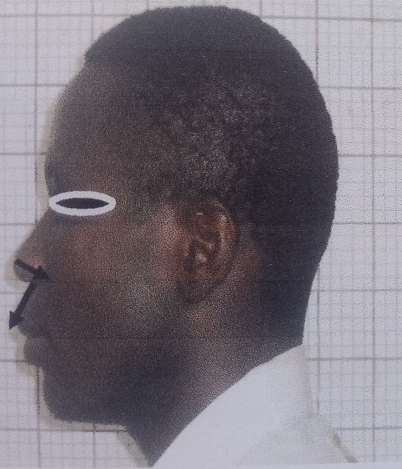 B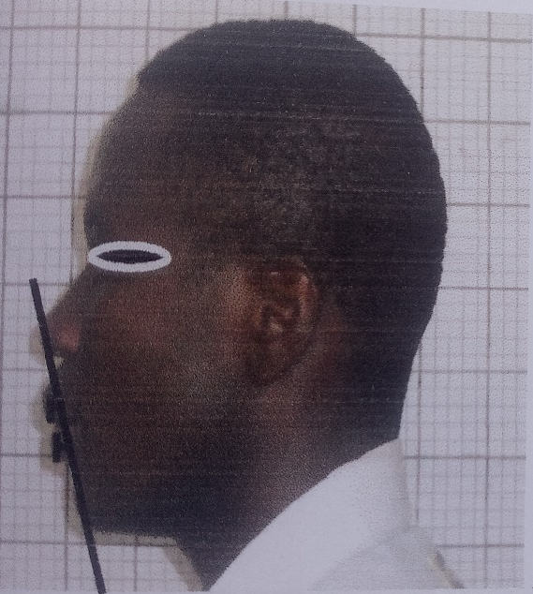
Figure 1: The distances the nose projects from the face and the length of the upper lip measured in lateral view at normal state (A). The ricket e-plane of the upper and lower lips measured in lateral view at normal state (B).

A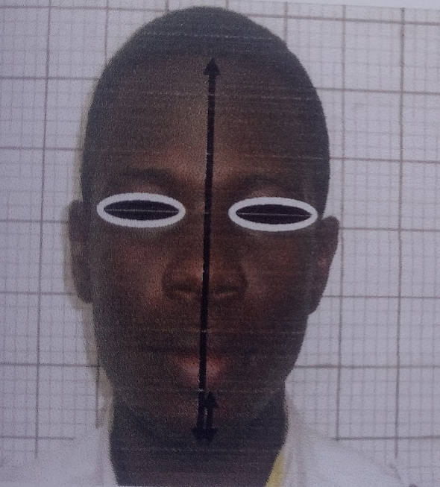 B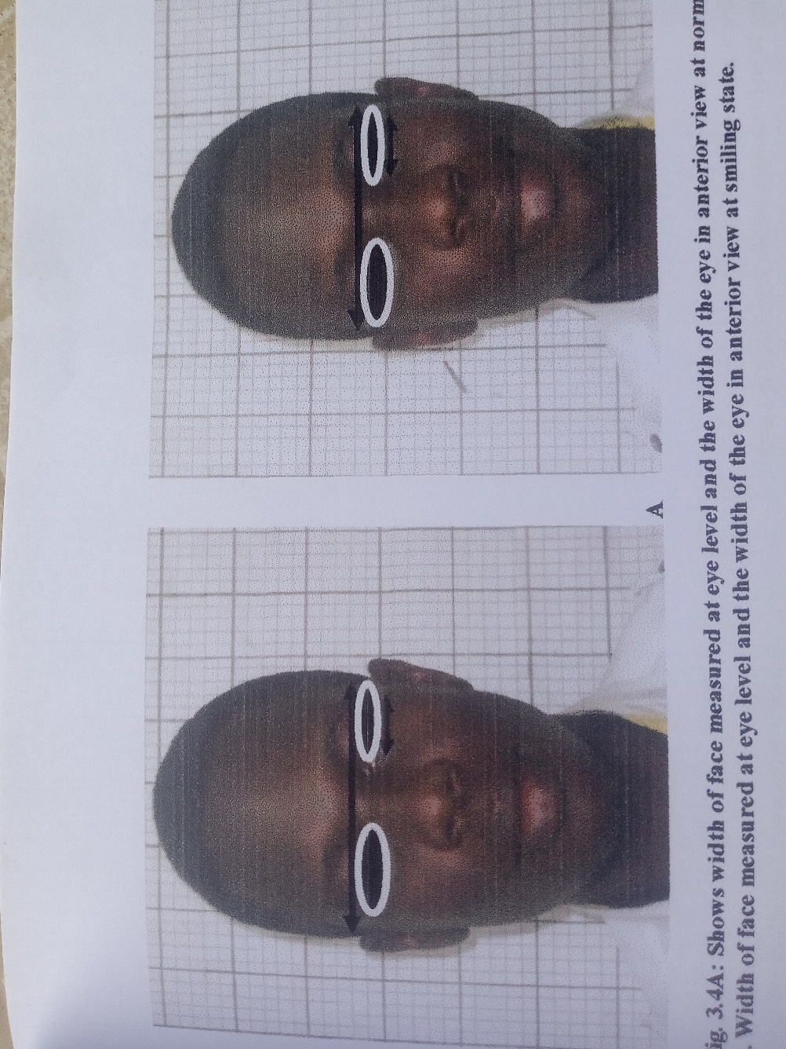
Figure 2: The chin length measured in anterior view at normal state (A). Width of the face measured at eye level and the width of the eye in anterior view at normal state (B).

Selection Criterial
Participants selected must fall within the ages of 15 and 35, their both parent and grandparents must be a native of the ethnic groups Ijaw and Isoko, must not have any form of facial deformation, and must be willing to provide consents. Subjects that do not meet the inclusion criterial were excluded from the study.

Date Analysis
The data obtained from the measurement of facial parameters among individuals across all levels were subjected to statistical analysis. Descriptive statistical data including minimum, maximum, mean, standard error and standard deviations for the photographic measurements of facial parameters together with the results of the Z-test comparing male and female of Ijaw and Isoko ethnic groups were presented in tables and also illustrated in bar charts. To ascertain the perceived degree of beauty of the studied ethnic groups, Cunningham’s facial proportion for ideal beautiful face was compared with that of calculated facial proportion of Ijaw and Isoko using the method introduced by Bob-Manuel et al., (2023).

RESULTS
The human face shows differences among age, races and genders. The results of the study are presented in tables:

Table 1: Comparison of the various calculated facial parameters and total mean±SEM values of Ijaw and Isoko males at normal state.
Parameters | Ijaw  Mean | SEM | Isoko  Mean | SEM | df | Z  Cal | Z  Crit | p-value | Inference
THF | 21.52 | 0.94 | 21.73 | 1.17 | 198 | 1.29 | 1.96 | 0.197 |  | No significant
WFEL | 16.26 | 0.99 | 15.09 | 1.44 | 198 | 6.07 | 1.96 | <0.001 |  | Significant
CL | 3.58 | 0.42 | 3.88 | 0.42 | 198 | 4.78 | 1.96 | <0.001 |  | Significant
VCEE | 2.34 | 0.40 | 2.34 | 0.38 | 198 | 0.00 | 1.96 | 1.00 |  | No significant
HVE | 1.24 | 0.21 | 1.30 | 0.29 | 198 | 1.52 | 1.96 | 0.128 |  | No significant
WE | 3.36 | 0.40 | 3.44 | 0.41 | 198 | 1.31 | 1.96 | 0.190 |  | No significant
NL | 4.82 | 0.51 | 4.93 | 0.47 | 198 | 1.51 | 1.96 | 0.131 |  | No significant
EL | 5.84 | 0.54 | 5.86 | 0.58 | 198 | 0.23 | 1.96 | 0.818 |  | No significant
WFML | 14.18 | 1.21 | 13.47 | 1.30 | 198 | 3.75 | 1.96 | <0.001 |  | Significant
WM | 6.84 | 0.71 | 6.97 | 0.86 | 198 | 1.07 | 1.96 | 0.284 |  | No significant
VLNEB | 7.19 | 0.58 | 7.07 | 0.73 | 198 | 1.18 | 1.96 | 0.238 |  | No significant
LNEB | 7.79 | 0.55 | 7.49 | 0.80 | 198 | 2.80 | 1.96 | 0.005 |  | Significant
rVLEM | 7.85 | 0.54 | 7.66 | 0.72 | 198 | 1.93 | 1.96 | 0.054 |  | No significant
lVLEM | 7.86 | 0.52 | 7.68 | 0.69 | 198 | 1.90 | 1.96 | 0.057 |  | No significant
NLA(⁰) | 81.32 | 9.30 | 79.43 | 10.28 | 198 | 1.27 | 1.96 | 0.204 |  | No significant
e-plane UPL | -0.17 | 0.15 | -0.09 | 0.16 | 198 | 3.42 | 1.96 | <0.001 |  | Significant
e-plane LL | -0.29 | 0.13 | -0.19 | 0.25 | 198 | 3.14 | 1.96 | 0.002 |  | Significant
URDNF | 2.70 | 0.40 | 3.29 | 3.59 | 198 | 1.38 | 1.96 | 0.167 |  | No significant
LUPL | 2.52 | 0.52 | 2.63 | 0.56 | 198 | 1.35 | 1.96 | 0.177 |  | No significant
THF-Total height of the face, WFEL-Width of face at eye level, CL-Chin length, V-CEE, Vertical distance from the center of the eye to the bottom of the eyebrow, HVE-Height of visible eye, WE-Width of eye, NL-Nose length, EL-Ear length, WFML-Width of face at mouth level, WM-Width of mouth, (VLNEB)-Vertical line that extends from the lateral margin of the nostril to the tip of medial margin of the eyebrow, (LNEB)-Line extending from lateral margin of the nostril to the lateral margin of the eyebrow, rVLEM-A vertical line that extend from the centre of the eyeball to side of the face at mouth level on the right side, lVLEM-A vertical line that extends from the centre of the eyeball to side of the face at mouth level on the left side, NLA-Nasolabial angle, e-PLANE-UPL-Rickets e-plane of the upper lip, e-PLANE LL-Rickets e-plane of the lower lip, URDNF-The usual ratio between the distance the nose projects from the face, LUPL-The length of the upper lip.

Table 2: Comparison of the various calculated facial parameters and total mean±SEM values of Ijaw and Isoko females at normal state.
Parameters | Ijaw  Mean | SEM | Isoko  Mean | SEM | df | Z  Cal | Z  Crit | P-Value | Inference
THF | 21.41 | 0.96 | 21.32 | 1.05 | 198 | 0.63 | 1.96 | 0.529 | No significant
WFEL | 16.18 | 1.08 | 15.30 | 1.27 | 198 | 5.35 | 1.96 | <0.001 | Significant
CL | 3.66 | 0.35 | 3.85 | 0.43 | 198 | 3.49 | 1.96 | <0.001 | Significant
VCEE | 2.33 | 0.40 | 2.37 | 0.48 | 198 | 0.65 | 1.96 | 0.516 | No significant
HVE | 1.36 | 0.23 | 1.32 | 0.23 | 198 | 1.22 | 1.96 | 0.222 | No significant
WE | 3.10 | 0.38 | 3.32 | 0.40 | 198 | 3.99 | 1.96 | <0.001 | Significant
NL | 4.70 | 0.45 | 4.82 | 0.48 | 198 | 1.82 | 1.96 | 0.069 | No significant
EL | 5.81 | 0.53 | 5.74 | 0.57 | 198 | 0.96 | 1.96 | 0.337 | No significant
WFML | 13.52 | 1.44 | 13.69 | 1.31 | 198 | 0.86 | 1.96 | 0.389 | No significant
WM | 6.36 | 0.69 | 6.85 | 0.78 | 198 | 4.75 | 1.96 | <0.001 | Significant
VLNEB | 7.08 | 0.56 | 6.77 | 0.65 | 198 | 3.66 | 1.96 | <0.001 | Significant
LNEB | 7.74 | 0.55 | 7.39 | 0.67 | 198 | 4.11 | 1.96 | <0.001 | Significant
rVLEM | 7.67 | 0.54 | 7.31 | 0.68 | 198 | 4.23 | 1.96 | <0.001 | Significant
lVLEM | 7.74 | 0.49 | 7.37 | 0.76 | 198 | 4.27 | 1.96 | <0.001 | Significant
NLA(⁰) | 85.27 | 8.36 | 80.17 | 9.77 | 198 | 4.02 | 1.96 | <0.001 | Significant
e-plane UPL | -0.14 | 0.09 | -0.06 | 0.23 | 198 | 3.53 | 1.96 | <0.001 | Significant
e-plane LL | -0.25 | 0.09 | -0.20 | 0.17 | 198 | 2.77 | 1.96 | 0.005 | Significant
URDNF | 2.53 | 0.36 | 2.59 | 0.49 | 198 | 1.01 | 1.96 | 0.312 | No significant
LUPL | 2.37 | 0.39 | 2.51 | 0.52 | 198 | 2.21 | 1.96 | 0.027 | Significant
THF-Total height of the face, WFEL-Width of face at eye level, CL-Chin length, V-CEE, Vertical distance from the center of the eye to the bottom of the eyebrow, HVE-Height of visible eye, WE-Width of eye, NL-Nose length, EL-Ear length, WFML-Width of face at mouth level, WM-Width of mouth, (VLNEB)-Vertical line that extends from the lateral margin of the nostril to the tip of medial margin of the eyebrow, (LNEB)-Line extending from lateral margin of the nostril to the lateral margin of the eyebrow, rVLEM-A vertical line that extend from the centre of the eyeball to side of the face at mouth level on the right side, lVLEM-A vertical line that extends from the centre of the eyeball to side of the face at mouth level on the left side, NLA-Nasolabial angle, e-PLANE-UPL-Rickets e-plane of the upper lip, e-PLANE LL-Rickets e-plane of the lower lip, URDNF-The usual ratio between the distance the nose projects from the face, LUPL-The length of the upper lip.

Table 3: Comparison of Cunningham’s facial proportion for males with that of obtained facial proportion of Ijaw and Isoko males at normal state.
Ethnic Groups | Paired Parameters | Measured Parameters | Cunningham's  Proportion | Obtained Poroportions | Difference | Inference
 | Pair 1 | WFEL WE | Three-tenth
Ijaw | WFEL & WE | 16.26 3.36 | 4.88 | One-fifth (21%) | 1.52 | Very strong
Isoko | WFEL & WE | 15.09 3.44 | 4.52 | One-fourth (23%) | 1.08 | Very strong
 | Pair 2 | THF CL | One-fifth
Ijaw | THF & CL | 21.52 3.58 | 4.30 | One-sixth (17%) | 0.72 | Very strong
Isoko | THF & CL | 21.73 3.88 | 4.35 | One-sixth (17%) | 0.47 | Perfect
 | Pair 3 | THF VCEE | One-tenth
Ijaw | THF & VCEE | 21.52 2.34 | 2.15 | One-nineth (11%) | 0.19 | Perfect
Isoko | THF & VCEE | 21.73 2.34 | 2.17 | One-nineth (11%) | 0.17 | Perfect
 | Pair 4 | THF HVE | One-fourteenth
Ijaw | THF & HVE | 21.52 1.24 | 1.54 | One-seventeenth (6%) | 0.30 | Perfect
Isoko | THF & HVE | 21.73 1.30 | 1.55 | One-seventeenth (6%) | 0.25 | Perfect
 | Pair 5 | WFML WM | 50%
Ijaw | WFML & WM | 14.18 6.84 | 7.09 | 48% | 0.30 | Perfect
Isoko | WFML & WM | 13.47 6.97 | 6.74 | 52% | 0.23 | Perfect
 | Pair 6 | NL EL | Equal
Ijaw | NL & EL | 4.82 5.84 | 4.82 | 121% | 1.02 | Very strong
Isoko | NL & EL | 4.93 5.86 | 4.93 | 119% | 0.93 | Very strong
THF-Total height of the face, WFEL-Width of face at eye level, CL-Chin length, V-CEE, Vertical distance from the center of the eye to the bottom of the eyebrow, HVE-Height of visible eye, WE-Width of eye, NL-Nose length, EL-Ear length, WFML-Width of face at mouth level, WM-Width of mouth, (VLNEB)-Vertical line that extends from the lateral margin of the nostril to the tip of medial margin of the eyebrow, (LNEB)-Line extending from lateral margin of the nostril to the lateral margin of the eyebrow, rVLEM-A vertical line that extend from the centre of the eyeball to side of the face at mouth level on the right side, lVLEM-A vertical line that extends from the centre of the eyeball to side of the face at mouth level on the left side, NLA-Nasolabial angle, e-PLANE-UPL-Rickets e-plane of the upper lip, e-PLANE LL-Rickets e-plane of the lower lip, URDNF-The usual ratio between the distance the nose projects from the face, LUPL-The length of the upper lip.

Table 4: Comparison of Cunningham’s facial proportion for males with that of obtained facial proportion of Ijaw and Isoko females at normal state.
Ethnic Groups | Paired Parameters | Measured Parameters |  | Cunningham's Proportion | Obtained  Proportions | Difference | Inference
 | Pair 1 | WFEL | WE | Three-tenth
Ijaw | WFEL & WE | 16.18 | 3.10 | 4.85 | One-fifth (19%) | 1.75 | Very strong
Isoko | WFEL & WE | 15.30 | 3.32 | 4.59 | One-fifth (22%) | 1.27 | Very strong
 | Pair 2 | THF | CL | One-fifth
Ijaw | THF & CL | 21.41 | 3.66 | 4.28 | One-sixth (17%) | 0.62 | Very strong
Isoko | THF & CL | 21.32 | 3.85 | 4.26 | One-sixth (18%) | 0.41 | Perfect
 | Pair 3 | THF | VCEE | One-tenth
Ijaw | THF & VCEE | 21.41 | 2.33 | 2.14 | One-nineth (11%) | 0.19 | Perfect
Isoko | THF & VCEE | 21.31 | 2.37 | 2.13 | One-nineth (11%) | 0.24 | Perfect
 | Pair 4 | THF | HVE | One-fourteenth
Ijaw | THF & HVE | 21.41 | 1.36 | 1.53 | One-sixteenth (6%) | 0.17 | Perfect
Isoko | THF & HVE | 21.32 | 1.32 | 1.52 | One-sixteenth (6%) | 0.20 | Perfect
 | Pair 5 | WFML | WM | 50%
Ijaw | WFML & WM | 13.52 | 6.36 | 6.76 | 47% | 0.40 | Perfect
Isoko | WFML & WM | 13.69 | 6.85 | 6.84 | 50% | 0.01 | Perfect
 | Pair 6 | NL | EL | Equal
Ijaw | NL & EL | 4.70 | 5.81 | 4.70 | 123% | 1.11 | Very strong
Isoko | NL & EL | 4.82 | 5.74 | 4.82 | 119% | 0.92 | Very strong
THF-Total height of the face, WFEL-Width of face at eye level, CL-Chin length, V-CEE, Vertical distance from the center of the eye to the bottom of the eyebrow, HVE-Height of visible eye, WE-Width of eye, NL-Nose length, EL-Ear length, WFML-Width of face at mouth level, WM-Width of mouth, (VLNEB)-Vertical line that extends from the lateral margin of the nostril to the tip of medial margin of the eyebrow, (LNEB)-Line extending from lateral margin of the nostril to the lateral margin of the eyebrow, rVLEM-A vertical line that extend from the centre of the eyeball to side of the face at mouth level on the right side, lVLEM-A vertical line that extends from the centre of the eyeball to side of the face at mouth level on the left side, NLA-Nasolabial angle, e-PLANE-UPL-Rickets e-plane of the upper lip, e-PLANE LL-Rickets e-plane of the lower lip, URDNF-The usual ratio between the distance the nose projects from the face, LUPL-The length of the upper lip.

Figure 3: Bar chart showing comparison of various calculated facial parameters and total mean values of Ijaw and Isoko males at normal state.

THF-Total height of the face, WFEL-Width of face at eye level, CL-Chin length, V-CEE, Vertical distance from the center of the eye to the bottom of the eyebrow, HVE-Height of visible eye, WE-Width of eye, NL-Nose length, EL-Ear length, WFML-Width of face at mouth level, WM-Width of mouth, (VLNEB)-Vertical line that extends from the lateral margin of the nostril to the tip of medial margin of the eyebrow, (LNEB)-Line extending from lateral margin of the nostril to the lateral margin of the eyebrow, rVLEM-A vertical line that extend from the centre of the eyeball to side of the face at mouth level on the right side, lVLEM-A vertical line that extends from the centre of the eyeball to side of the face at mouth level on the left side, NLA-Nasolabial angle, e-PLANE-UPL-Rickets e-plane of the upper lip, e-PLANE LL-Rickets e-plane of the lower lip, URDNF-The usual ratio between the distance the nose projects from the face, LUPL-The length of the upper lip.

Figure 4: Bar chart showing comparison of various calculated facial parameters and total mean values of Ijaw and Isoko males at normal state.

THF-Total height of the face, WFEL-Width of face at eye level, CL-Chin length, V-CEE, Vertical distance from the center of the eye to the bottom of the eyebrow, HVE-Height of visible eye, WE-Width of eye, NL-Nose length, EL-Ear length, WFML-Width of face at mouth level, WM-Width of mouth, (VLNEB)-Vertical line that extends from the lateral margin of the nostril to the tip of medial margin of the eyebrow, (LNEB)-Line extending from lateral margin of the nostril to the lateral margin of the eyebrow, rVLEM-A vertical line that extend from the centre of the eyeball to side of the face at mouth level on the right side, lVLEM-A vertical line that extends from the centre of the eyeball to side of the face at mouth level on the left side, NLA-Nasolabial angle, e-PLANE-UPL-Rickets e-plane of the upper lip, e-PLANE LL-Rickets e-plane of the lower lip, URDNF-The usual ratio between the distance the nose projects from the face, LUPL-The length of the upper lip.

DISCUSSION
The desire to identify ideal facial aesthetics dates to antiquity. Greek artists sought to identify ideal facial symmetric proportions and began to formally analyze beauty. The classical Greek canons of facial balance that were developed consequently influenced anatomy scholars of the Renaissance period, and many of these form the foundation of facial analysis today by anatomical scientist. To do this, morphometry of the facial features are compared to the vertical and horizontal dimensions of the face to create proportional relationships. In this study, a difference was observed in the facial beauty of the Ijaw males of Bayelsa State and Isoko males of Delta State and Ijaw females of Bayelsa and Isoko females of Delta State at normal states.
In this study, nineteen anthropometric measurements of faces of the Ijaw and Isoko ethnic groups collected at normal state, were compared with those reported by Karaca et al., (2012); Kurkcuoglu et al., (2013); Legan and Burstone, (1998) and Epkeret al., (1998) for Turkish and North American Caucasian and proportions determined for the study population in line the morphometric pairs used by Cunningham, (1986) as reviewed by Patnaik et al., (2003).
At normal state, all the parameters were higher in the Ijaw males except the total height of the face, height of visible eye ball, ear, and nose length, width of eye, length of the upper lip and chin length when compared to Isoko males. In the females, all the parameters were higher except chin length, vertical distance from the centre of the eye to the bottom of the eyebrow, width of eye, nose length, width of eye, width of face at mouth level, width of mouth, usual ration between the distance the nose projects from the face, length of the upper lip, when compared to Isoko females. Also, the Ijaw females, were found to have some higher parameters which were significant (p<0.05) except in width of eye, nose length and chin length when compared to Isoko females.
Furthermore, comparison of the obtained proportion of the both sexes of the Ijaw and Isoko ethnic groups with that of the Cunningham’s proportion at normal state. There was a perfect and very strong relationship being observed in all measured parameters. The width of face at eye level (WFEL) of the Ijaw males showed higher mean values than the of the Isoko males with a significant difference however, both values were higher when compared with those of the Amercian Caucasians, Malaysian Indians and the Turkish adult males respectively Karaca et al., (2012). The mean chin length of the Ijaw males was lower than that of the Isoko males, with a significant difference, both were higher than the value of the Turkish as reported by Kurkcuoglu et al., (2013). Karaca et al. (2012) revealed that the width of the eye was longer in Turkish adults males than in American Caucasians and Malaysian Indians, when compared with the findings of this study, the mean width of the eye of the Ijaw males, was lower than that of the Turkish adult males while for the Isoko males, it was higher than that of the Turksih adults males. The nose is an important criterion used for purposes of racial classification. The mean nose length of the Ijaw males was lower than the Isoko males’ with no significant difference but the mean value of the nose length in the Turkish adults males was higher than both and was similar to the mean values of the American Caucasians (Farkas, 1994). The mean ear length for the Ijaw males was lower than the of Isoko males with no significant difference (p<0.05), but higher when compared with the American Caucasians and Turkish adults Karaca et al. (2012). The width of the face at mouth level of the Ijaw males was higher than the Isoko males values with a significant difference (p<0.05); both values were higher than the values of Turkish adult males Karaca et al. (2012). The width of mouth of the Ijaw males both values were higher than the values of Turkish adult males Koraca et al. (2012). The width of mouth of the Ijaw males was lower than the Isoko males with no significant difference, but when compared to the American Caucasians and Turkish adult males had a higher width of mouth. The nasolabial angle, evaluating the relationship of the nasal base and upper lip, is one of the measurements with greater clinical relevance during orthodontic diagnosis and treatment planning because its magnitude depends on

the anteroposterior position and inclination of the upper anterior teeth, and it can be altered by orthodontics ororthognathic surgery Wamalwa et al., (2011). Nasolabial angel showed no significant difference and the means values were higher in Ijaw males than Isoko males. When compared with the Garo whose mean value of nasolabial angles was higher than both Ijaw and Isoko males. Both were farless when compared with the Turkisk, White European population and North American Caucasians Reddy et al., (2011); Anic-Milosievecy et al., (2008) and Legan and Birstone, (1980). The ricket e-plane of upper lip (e-plane UPL) of the Ijaw males showed a higher value than the Isoko males with a significant difference, with the Turkiah and North American Caucasian showing more higher mean value when compared as revealed by Legan and Burstone, (1980). Also the ricket e-plane of lower lip (e-plane LL) of the Ijaw males was higher than that of the Isoko males with a significant difference, when compared to Turkish and North America Caucasian values; it showed a higher value as revealed by Legan and Burstone (1980). The usual ration between the distances at which the nose projects from the face showed that the mean value were lower in Ijaw males than Isoko males but much higher than North American Caucasians and Turkish males Karaca et al. (2010). Furthermore, the Ijaw males showed lower mean values for the length of the upper lip (LUPL) than Isoko males. Both were however, higher than Turkish males’ mean value but that of the North American Caucasians were higher Epker et al., (1998).
The mean width of face at eye level (WFEL) of Ijaw females was found to be higher than that of the Isoko female with a significant difference, with both showing higher values when compared with Turkish females and North American Caucasian females Karaca et al. (2012). The mean chin length (CL) of the Ijaw females was found to be lower than the Isoko females with a significant difference, both also were higher compared to the Turkish female as reported by Kurkeuoglu et al. (2013). The means of the width of eye (WE) of the Ijaw female was found to be lower than the Isoko females with significant difference; on comparison, the Turkish females showed a higher value, than the other groups whereas the North American Caucasians females showed a lower value. The mean nose length (NL) of the Ijaw females was found to be lower than the Isoko females with no significant difference with the Turkish females showing a higher mean value while the North American Caucasian female value was higher than the Ijaw female values but lower than the Isoko female values Karaca et al. (2012). The mean ear length (EL) of the Ijaw females was found to be higher than the Isoko females however, the Turkish females higher mean values while North American Caucasian females showed higher values Karaca et al. (2012). The Ijaw females showed a lower width of face at mouth level (WFML) than the Isoko female with no significant difference (p<0.05) and the Turkish females showed the lower mean values Karaca et al. (2012). The width of the mouth (MW) of the Ijaw females was lower than that of the Isoko females with significant difference while those of the Turkish females and North American Caucasian females showed lower mean values when compared Karaca et al. (2012). Nasolabial angle (NLA) showed higher values in Ijaw females than in Isoko females with a significant difference while in North India females, Turkish females and North American Caucasians the values were higher Reddy et al. (2011); Malkoc et al. (2009); Anic-Milosivecy et al. (2008) and Legan and Burstone, (1980). The mean values for ricket e-plane of upper lip (e-plane UPL) of the Ijaw females was found to be lower than the Isoko females with a significant difference, with the Turkish females and North American Caucasian females showing higher mean values (Legan and Burstone, 1980). The ricket e-plane of the lower lip (e-plane LL) of the Ijaw females was higher than the Isoko females with a significant difference, but with the Caucasian females population showing lower mean values (Legan and Burstone, 1980). The usual ratio between the distances the nose projects from the face (URDNF) of the Ijaw females was lower than Isoko females with no significant difference with the Turkish females and North American Caucasians females showing lower values than Karaca et al. (2012). The length of the upper lip (LUPL) of the Ijaw females showed a lower mean value than the Isoko females with a significant difference, while the Turkish females and North American Caucasians females showed a lower mean value on comparison Epker et al. (1998).
The Ijaw males had a lower facial height (21.52±0.09) and the higher width of face at eye level was (16.26±0.09) whereas the Isoko males had higher facial height (21.73±0.14) and lower width of face at eye level (15.26± 0.17) values at normal state. Ijaw males had width of eye (WE) to be two-tenth (2/10) which is 21% the width of the face at the eye level (WFEL) while the Isoko males had width of eye to be (1/4) which is 23% the width of the face at eye level, this implies that there is a very strong relationship between the width of the eye of the Ijaw and Isoko males when compared to that of the Cunningham’s proportion of three-tenth the width of the face at eye level. Both Ijaw and Isoko males had chin length (CL) one-sixth (1/6) which is 17% the total height of face (THF) which implies that there is a very strong relationship between the chin length of the Ijaw males and a perfect relationship for that of the Isoko males when compared to Cunningham’s proportion which is one fifth the total height of face. Another notable finding is that the vertical distance from the centre of the eye to the bottom of the eyebrow (VCEE) for both Ijaw and Isoko males was found to be one-nineth (1/9) which is 11% the total height of face, which implies that there is a perfect correlation between the vertical distance from the centre of the eye to the bottom of the eyebrow for both Ijaw and Isoko males when compared to Cunningham’s proportion which is one-tenth the total height of the face in this study. In addition, the height of visible eye (HVE) was proportional for both Ijaw and Isoko males which is one-seventeenth (1/17) and is 6% the total height of face. This implies that there is a perfect relationship between the height of visible eye for both Ijaw and Isoko males when compared to Cunningham’s proportion which is one-fourteenth the total height of face. The width of the mouth (WM) of Cunningham’s proportion is 50% the width of the face at mouth level, but in this study, it was found to be 48% for Ijaw males and 52% Isoko males, and this implies that there is a perfect relationship of the width of the mouth when compared to Cunningham’s proportion. Furthermore, nasal and ear length of Ijaw males were 4.82 and 5.84cm, which is 121% while those of the Isoko males were 4.93 and 5.86cm which is 119%, which implies that there is a very strong relationship in both ethnic groups when compared to Cunningham’s proportion however, this study does not agree with that of De La Cruz (2011) which state “for a beautiful face the length of the ears should be equal to the length of the nose”.
It was observed that Ijaw females had the higher facial height (21.41±0.11) and width of face to eye level (16.18±0.12) as compare to Isoko females in Delta State which have lower facial height (21.32±0.09) and width of face at eye level be (15.30±0.11) at normal state. Both Ijaw and Isoko females had width of eye (WE) to be two-tenth (2/10) which is 19% the width of the face at eye level, this implies that there is a very strong relationship between the width of the eye of the Ijaw and Isoko females when compared to that of the Cunningham’s proportion which is three-tenth the width of the face at eye level. Both Ijaw and Isoko females had chin length (CL) one-sixth (1/6) which is 17% and 18% the total height of face (THF) respectively, this imply that there is a perfect relationship between the chin length of the Ijaw and Isoko females when compared to Cunningham’s proportion which is one-fifth the total height of face. Another notable finding is that the vertical distance from the centre of the eye to the bottom of the eyebrow (VCEE) for both Ijaw and Isoko females was found to be one-ninth (1/9) which is 11% the total height of face. This implies that there is a perfect correlation between the vertical distance from the centre of the eye to the bottom of the eyebrow for both Ijaw and Isoko females when compared to Cunningham’s proportion which is one-tenth the total height of the face for this research. In addition, the height of visible eye (HVE) was proportional for both Ijaw and Isoko females when compared Cunningham’s proportion which is one-fourteenth the total height of face. The width of the mouth (WM) of Cunningham’s proportion is 50% the width of the face at mouth level, but in this research it was found to be 47% for Ijaw females and 50% Isoko females which correspondents with Cunningham’s proportion which imply that there was a perfect relationship of the width of the mouth when compared to Cunningham’s proportion. Furthermore, nose and ear length of Ijaw females were 4.70 and 5.81cm, which is 123% while those of the Isoko females were 4.82 and 5.74cm which is 119%, this implies that there is a very strong relationship in both ethnic groups when compared to Cunningham’s proportion however, this study does not agree with that of De La Cruz (2011) “for a beautiful face the length of the ears should be equal to the length of the nose”.

CONCLUSION
Conclusively, all the parameters were higher in the Ijaw males except the total height of the face, height of visible eye ball, ear, nose length, width of eye, length of the upper lip and chin length when compared to Isoko males. In the females, all he parameters were higher except chin length, vertical distance from the centre of the eye to the bottom of the eyebrow, nose length, width of eye, width of face at mouth level, width of mouth, usual ration between the distance the nose project from the face, length of the upper lip, when compared to Isoko females. As a conclusion, to achieve maximum facial aesthetic results after plastic or orthognathic surgery, the facial anatomy of the Ijaw and Isoko ethnic groups must be understood. The knowledge of the most striking facial characteristic of Ijaw and Isoko ethnic groups is essential to preparation of the corrective surgery or analysis of postoperative results. This study has provided a baseline data on beautiful faces of the Ijaw and Isoko ethnic groups in Nigeria. Also both the Ijaw and Isoko ethnic groups shows a close relationship with that of the Cunningham’s proportion, this showed that whether you are Asian or European or Africa, the idea of what constitutes a beautiful face is similar and is determine by the symmetrical proportional relationship existing between the measurement of the features of the face and that of the face itself, regardless of age and sex. This study also concludes that the method of comparing obtained proportion of perceived beautiful face and smile with Cunningham’s proportion for ideal beautiful face and smile as employed in this study to determine the degree of beauty amongst participants could be used as one an anatomical instrument for deciding the most beautiful during beauty pageantry.

RECOMMENDATION
The research was an in-depth study to show the facial differences and markers that compare facial beauty among two ethnic groups in Nigeria namely Ijaw and Isoko; therefore, it is recommended that future studies should take into consideration of other ethnic groups in Nigeria. Also, this study recommends the use of facial photogrammetry as employed in this study as an anatomical tool for determine the most beautiful during pageantry.

ETHICAL APPROVAL
All procedures involving anthropometry in this study were approved by the Ethics Committee for use of human face in Research at University of Port Harcourt.

CONFLICT OF INTERESTS
The authors declare there is no conflict of interest in the current study.

REFERENCES
- Anic-Milosevic, S., Lapter-Varga, M., and Slaj, M. (2008). Analysis of soft tissue profile by means of angular measurements. European Journal of Orthodontics, 30, 135-140.

- Bisson, M., and Grobbelaar, A. (2004). The esthetic properties of lips: a comparison of models and non-models. The Angle Orthodontist, 74(2), 162-166.

- Bob-Manuel IF, Okerulu AL, and Onwuka OM (2023). Estimation of facial attractiveness as biomarker of ovulation using facial photogrammetry during phases of female sexual cycle. Archives of Current Research International. Volume 23, Issue 5, Page 10-16.

- Brichacek, M., and Moreland, R. (2013). Is Beauty Truly in the Eye of the Beholder?” – The Universal Nature of Facial Beauty. University of Western Ontario Medical Journal, 80, 2 Fall 2011.

- Burr, C.W. (1935). Personality and physiognomy. The human face, a symposium, 81-85.

- Cornwell, R.E., Smith, L.M.J., Boothroyd, L.G., Moore, F.R., Davis. H.P., Stirrat, M., Tiddeman, B., and Perrett, D.I. (2006). Reproductive strategy, sexual development and attraction to facial characteristics. Philosophical Transaction Royal Society B: Biological Sciences, 361, 2143-2154.

- Cross, J. (1817). An attempt to establish physiognomy upon scientific principles. Glasgow University Press, 172-173, 207-208.

- Cunningham, M. (1986). Measuring the physical in physical attractiveness: Quasi-experiments on the socio-biology of female facial beauty. Journal of Personality and Social psychology, 50, 925-35.

- Czarnecki, S.T., Nanda, R.S., and Currier, G.P. (1993). Perceptions of a balanced facial profile. American Journal of Orthodontics and Dento facial Orthopedics; 104(2), 180-187.

- De La Cruz, E. (2011). What makes a beautiful face: The secret of a beautiful face. The Woodlands Plastic Surgeon. Retrieved from https://www.delacruzplastic surgery.com/ facial urgery, 2-10-2014.

- Engemann, K., and Michael, O. (2005). So Much for That Merit Raise: The Link between Wages and Appearance. The Regional Economist.

- Farkas, L.G. (1994). Anthropometry of the head and face. (2nd ed.). New York: Raven Press: 21- 25.

- Fracas, L.G. (1981). Anthropometry of the head and face in Medicine. Elsevier North Holland Incorporation, New York, 285.

- Garner, L.D. (1974). Soft tissue changes concurrent with orthodontic tooth movement. American Journal of Orthodontics; 66, 367-377.

- Gavan, J.A., Washburn, S.l., and Lewis. P.H. (1952). Photography: an anthropometric tool. American Journal of Physical Anthropology; 10, 331-351.

- Goldstein, R.E. (1993). Esthetic Dentistry-a health service? Journal of Dental Research; 72 641- 642.

- Goldstein, R.E. (1998). Esthetics in Dentidtry. (2nd ed.). Vol-1. Decker, Toronto.

- Guess, M.B., and Solzer, W.V. (1989). Computer treatment estimates in orthodontics and orthognathic surgery. Journal of Clinical Orthodontics, 23, 262 – 268.

- Hershon, L.E., and Giddon, D.B. (1980). Determinants of facial profile self-perception. American Journal of Orthodontics; 78, 278-295.

- Karaca, Ö., Gülcen, B., Abdulgani, M., Elmali, F., and Kus, I. (2012). Morphometric facial analysis of Turkish adults. Balikesir Saglik Bilimleri Dergisi; 1(1), 7-11.

- Kurkcuoglu, A., Bahadiroglu, S.S., Buyukberber, G., Guclu S., Gurbuz S., Karslioglu., A.A., Yazici., C., and Pelin, C. (2013). Evaluation of lower face heights and ratios according to sex. Revista Argentia de Anatomia Clinica; 5 (3), 213-221.

- Langlois, H.L, Roggman, L.A., and Casey, R.H (1987). Infant preferences for attractive faces: Rudiments of a stereotype? Developmental Physchology, 23, 363-369.

- Legan, H.L, and Burstone, C.J. (1980). Soft tissue cephalometric analysis for orthognathic surgery. Journal of Oral Surgery, 38: 744-51.

- Malkoc, S., Demir, A., and Uysal, T. (2009). Angular photogrammetric analysis of the soft tissue facial profile of Turkish adults. European Journal of Orthodontics, 31, 174-179.

- Mandall, N.A., McCord, J.F., Blinkhor, A.S., Worthington, H.V., and O’Brien K.D. (2000). Perceived asthetics impact of malooccusion and oral selfperceptionsin 14-15yrs old Asia and Caucasian children in Greater Manchester. European Journal of Orthodontics, 21, 175-183.

- Milutinovic, J., Zelic, K., and Nedeljkovic, N. (2014). Evaluation of facing beauty using anthropometric proportions. Hindawi Publishing Corporation (The Scientific World Journal). Retrieved from http://www. Hindawi.com 2-10-2014.

- Neger, M.A. (1959). A quantitative method for the evaluation of the soft tissue facial profile. Amercian Journal of Orthodontics, 45, 738 – 751.

- Patnaik, V.V. G., Singla, R., and Bala, S. (2003). Anatomy of ‘A Beautiful Face and Smile”. Journal of Anatomical Society of India. 52 (1), 74-80.

- Peck H, Peck S. (1970). A concept of facial esthetics. The Angle Orthodontist; 40(4):284- 318.

- Person, A.P.L., Morosini, I.C., Correia, K.R., Moresca, R., and Petrelli, E. (2012). Photometric study of divine proportion and its correlation with facial attractiveness. Dental Press journal of Orthodontics, 17(2), 124-31.

- Reddy, M., Ahuja, N.K., Raghav, P., Kundu, V., and Mishra V.A. (2011). Computer- assisted angular photogrammetric analysis of the soft tissue facial profile of North Indian adults. The Journal of Indian Orthodontic Society, 3, 119-123.

- Romo, T., and Abraham, M.T. (2003). The ethnic nose. Facial Plastic Surgery. 19, 269-77.

- Roos, N. (1997). Soft tissue changes in Class II treatment. American Journal of Orthodontics; 72, 165-175.

- Sahin Saǧlam, A.M., and Gazileri, U. (2001). Analysis of Holdaway soft tissue measurement in children between 9 and 12 years of age. European Journal of Orthodontics, 23, 287- 294.
- Thompson, M.M. (1966). Manual of photogrammetry, 3rd ed. American Society of photogrammetry, Faith Church. VA.

- Stoner, M.M. (1955). A photometric analysis of the facial profile. American Journal of Orthodontics, 41, 453-469.

- Wamalwa, P., Amisi, S.K., and Chen, S. (2011). Angular photogrammetric comparison of the soft-tissue facial profile of Kenyans and Chines. The Journal of Cranio facial Surgery, 3, 1064-1072.

- Webster (1988). New world dictionary of American English. (3rd ed.)

- Woolnoth’s (1865). The study of Human face. London, W. Tweedie.

