Original Research Article
ASSOCIATION BETWEEN DIGIT RATIO AND ONSET OF MENOPAUSE AMONG WOMEN IN PORT HARCOURT, RIVERS STATE.

ABSTRACT
Aim: The aim of this study was to investigate the relationship between digit ratio and age at menopause among women residing in Port Harcourt, Rivers State, Nigeria.
Study Design: A cross-sectional correlational research design was employed.
Place of Study: The study was carried out in Port Harcourt, Rivers State.
Methodology: Although 402 women were initially recruited, only 191 participants were able to accurately report their age at menopause and were included in the final analysis. Participants were selected using a simple random sampling technique. Anthropometric measurements were obtained using a digital Vernier caliper, while demographic information was collected using a structured questionnaire.
Results: The results revealed a mean menopausal age of 45.63 ± 5.55 years, with mean digit ratios of 0.96 ± 0.04 for the right hand and 0.97 ± 0.04 for the left hand. A statistically significant association was observed between digit ratio and age at menopause, as indicated by the chi-square test of independence (chi-square value = 13.324, degrees of freedom = 4, p<0.00). Women with higher digit ratios demonstrated fewer cases of early menopause and were the only group in which late menopause was recorded.
Conclusion: The findings suggest that a low digit ratio is associated with an increased likelihood of early menopause, whereas higher digit ratios are more commonly associated with normal or delayed onset of menopause.
Keywords: Anthropometry, Digit ratio, Menopause, Port Harcourt.

1. INTRODUCTION
The ratio of the lengths of the human digits, commonly referred to as the digit ratio, has attracted increasing scientific interest, with the second-to-fourth digit ratio (2D:4D) being the most widely studied. The 2D:4D ratio is calculated by dividing the length of the index finger by that of the ring finger, measured from the midpoint of the basal crease to the fingertip (Alperovitch-Najenson et al., 2004; Gwunireama and Collins, 2025). Although early views regarded digit ratio research as pseudoscientific, accumulating empirical evidence has established the 2D:4D ratio as a biologically meaningful trait. It is a sexually dimorphic characteristic, with women generally exhibiting higher ratios than men. Men typically have a mean digit ratio of approximately 0.96, while women tend to have ratios closer to 1.0, reflecting nearly equal lengths of the index and ring fingers in females (Manning, 2008; Gwunireama et al., 2010; Gwunireama and Collins, 2025).
The sexual dimorphism observed in the 2D:4D ratio is believed to originate during prenatal development. The ratio is largely fixed in utero between the 13th and 14th weeks of gestation and is influenced by the balance of prenatal testosterone and estrogen exposure (Lutchmaya et al., 2004; Galis et al., 2010; Ventura et al., 2013; Viveka et al., 2014). A lower, more masculine 2D:4D ratio is associated with higher prenatal testosterone exposure, whereas a higher, more feminine ratio reflects greater prenatal estrogen exposure (Manning et al., 1998). The development of digit ratios is genetically regulated by Homeobox genes, which also play a role in urogenital system differentiation, suggesting a shared developmental pathway between digit formation and reproductive system development. Once established, the 2D:4D ratio remains largely stable throughout an individual’s lifetime (Ventura et al., 2013; Viveka et al., 2014; Gwunireama and Collins, 2025).
Because of its prenatal origin and lifelong stability, the 2D:4D ratio has been proposed as a non-invasive biomarker of the intrauterine hormonal environment, with long-term implications for physiology, behaviour, cognition, fertility, and handedness (Manning, 2011; Manning et al., 2014; Jeevanandam & Muthu, 2016). Numerous studies have demonstrated significant associations between digit ratio and somatic features, fertility parameters, behavioral traits, and certain pathologies, including breast cancer risk (Muller et al., 2012; Klimek et al., 2014; Klimek et al., 2016; Kirchengast et al., 2019). In women, earlier research suggests that digit ratio may be linked to reproductive outcomes across the lifespan, including the duration of reproductive life and overall reproductive success. Specifically, women with more feminine (higher) 2D:4D ratios have been reported to have longer reproductive lifespans and higher numbers of offspring (Kalichman et al., 2013; Klimek et al., 2016).
Menopause marks a critical transition in female life history and is defined as the permanent cessation of menstruation for at least 12 consecutive months, reflecting irreversible reproductive senescence (Gold, 2011; Kirchengast et al., 2019). It is typically diagnosed retrospectively and results primarily from ovarian oocyte depletion and declining estrogen production, most commonly occurring between the ages of 45 and 56 years (Santoro, 2016; Cappola et al., 2023; Stuenkel, 2024). Age at menopause serves not only as an indicator of reproductive ageing but also as a marker of general health, and it is influenced by socioeconomic, lifestyle, ecological, and prenatal factors (Lujan Barroso et al.,2018; Kirchengast et al., 2019). Emerging evidence suggests that lower 2D:4D ratios, indicative of higher prenatal androgen exposure, may be associated with earlier puberty and earlier natural menopause (Manning et al., 2001; Jeevanandam & Muthu, 2016). However, in Rivers State, Nigeria, factors influencing menopause timing remain poorly understood, and no study has specifically examined the association between digit ratio and menopause in this population. This study, therefore, aims to investigate whether women in Rivers State with lower 2D:4D ratios experience earlier menopause compared to those with higher ratios, thereby contributing to a better understanding of reproductive ageing in this specific population.
2. MATERIALS AND METHODS
2.1 Research Design
This study employs a cross-sectional correlational research design to investigate the relationship between the second-to-fourth digit ratio (2D:4D) and age at menopause among women in Port Harcourt, Rivers State, Nigeria. Structured questionnaires are utilised to collect relevant demographic data from the study participants.
2.2 Study Area and Population
The study was conducted in Port Harcourt, the capital city of Rivers State in southern Nigeria, located within the Niger Delta region and characterised by a tropical climate with high humidity and substantial rainfall, particularly during the wet season. Rivers State has a diverse population and varying socio-economic conditions, providing a suitable context for health-related research, including studies on reproductive health and its association with anthropometric markers such as digit ratio. The study population comprised women aged 28 years and above who reside in Port Harcourt, Rivers State, Nigeria, and who had already attained natural menopause.
2.3 Selection Criteria
The study excluded women who had undergone surgical procedures affecting their reproductive health, those currently receiving hormone replacement therapy, and individuals with severe chronic health conditions that could potentially influence the timing of menopause. Women with abnormalities of the second or fourth digits were also excluded. Only participants who had experienced natural menopause, whose spouses were alive at least until the time of menopause, and who had normal second and fourth digits were included in the study.
2.4 Sampling
A total of 402 women were initially selected for the study; however, only 191 participants were able to accurately report their age at menopause. Participants were chosen using a simple random sampling technique, which ensured that each eligible woman within the target age range had an equal probability of selection. This approach was employed to minimize selection bias and enhance the generalizability of the findings to the broader population of women in Rivers State. For analysis, age at menopause was categorised as early (<45 years), normal (45–55 years), and late (>55 years), while digit ratios were classified as low (<0.95), normal (0.95–1.00), and high (>1.00).
2.5 Data Collection
The digit length of the index (2D) and ring (4D) fingers were measure from the tip of the fingers to the basal crease, for the right and left fingers. A digital Vernier caliper with an accurate reading of 0.01 mm was used to take measurements. All parameters were measured three times, and the average was used as the measured value. Structured questionnaires are utilised to collect relevant demographic data from the study participants.
2.6 Data Analysis
The study data were analysed using IBM SPSS (Statistical Package for the Social Sciences) version 25 to perform both descriptive and inferential statistical analyses. Descriptive statistics, including mean, standard deviation, range, frequency, and percentage, were used to summarise the data. The Chi-square test of independence was employed to assess the association between age at menopause and digit ratio among the participants. A significance level of 0.05 was adopted, with p-values less than 0.05 considered statistically significant.
3. RESULTS AND DISCUSSION
The results were presented in tables and figures.

Table 1: Descriptive statistics of the study.
Variables | N | Range | Min. | Max. | Mean±SD
Right Digit Ratio | 402 | 0.23 | 0.84 | 1.07 | 0.96±0.04
Left Digit Ratio | 402 | 0.24 | 0.85 | 1.09 | 0.97±0.04
Average Digit Ratio | 402 | 0.20 | 0.87 | 1.07 | 0.97±0.04
Age | 402 | 41.00 | 34.00 | 75.00 | 47.76±7.79
Age at Menopause | 191 | 32.00 | 28.00 | 60.00 | 45.63±5.55
Number of Children | 370 | 12.00 | 1.00 | 13.00 | 4.08±1.92

Figure 1. Age at Menopause demographics of the study sample
EM= Early Menopause, NM= Normal Menopause, LM= Late Menopause

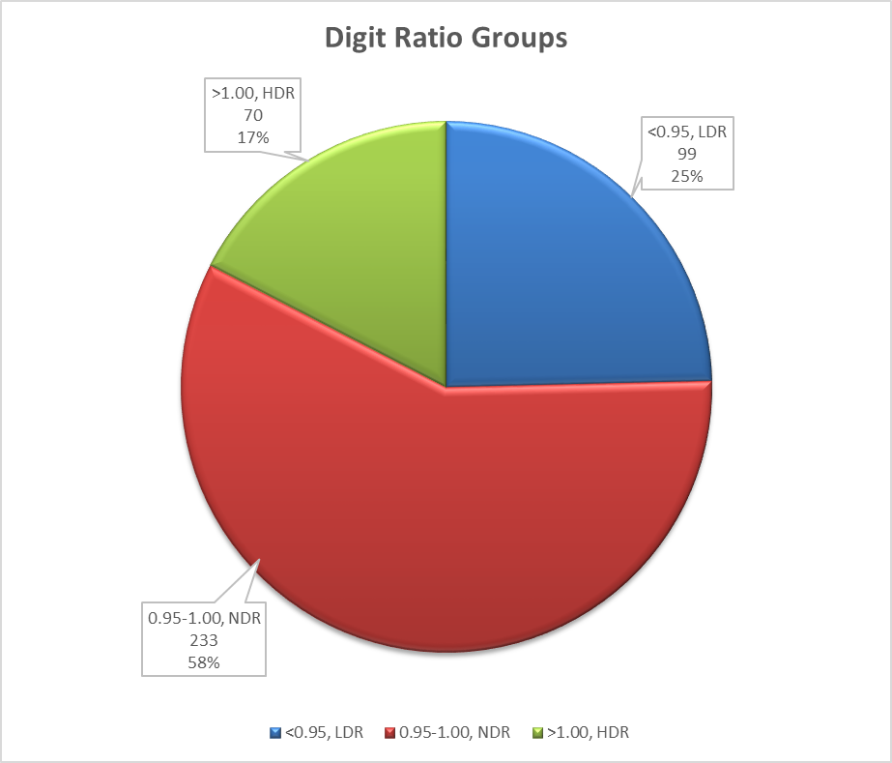
Figure 2. Digit ratio groups demographics of the study sample.
LDR= Low Digit Ratio, NDR= Normal Digit Ratio, HDR= High Digit Ratio

Table 2. Chi-Square test of independence between digit ratio groups and age at menopause
Digit Ratio Groups | Age at Menopause |  |  | Total | X² | df | p-value | Inference
Digit Ratio Groups | Early Menopause | Normal Menopause | Late Menopause
Low Digit Ratio | 31 | 34 | 0 | 65 | 13.324 | 4 | 0.01 | Sig
Normal Digit Ratio | 46 | 47 | 0 | 93
High Digit Ratio | 21 | 10 | 2 | 33
Total | 98 | 91 | 2 | 191
X²= Chi-Square value, df= degree of freedom, Sig= Significant

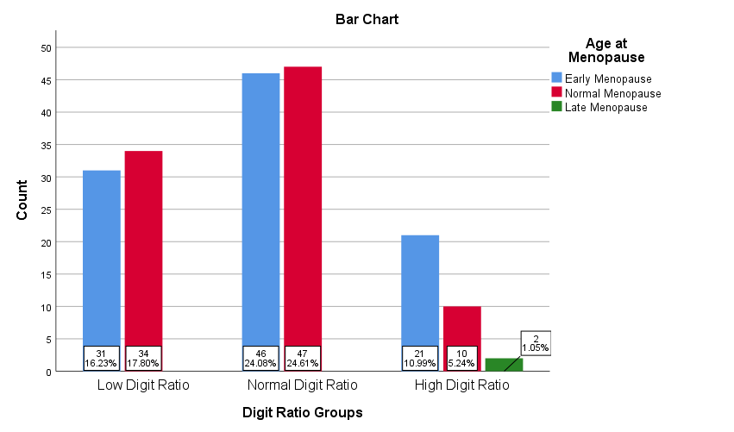
Figure 3. Bar chart showing the relationship between digit ratio group and age at menopause.
The present study examined the association between second-to-fourth digit ratio and age at menopause among women in Port Harcourt, Rivers State, Nigeria, and the findings provide important anthropometric and reproductive health insights within a Nigerian population. The mean right-hand digit ratio (0.96 ± 0.04), mean left-hand digit ratio (0.97 ± 0.04), and overall average digit ratio (0.97 ± 0.04) observed in this study fall within the established normal female range, indicating typical sexual dimorphism in digit ratios with minimal variability among participants. These values are comparable to those reported by Kirchengast et al. (2019), who documented mean right- and left-hand digit ratios of 0.983 ± 0.047 and 0.981 ± 0.050, respectively, and similarly found no significant bilateral asymmetry. The absence of marked right–left differences in the present study supports the notion that digit ratio is a relatively stable trait, reflecting prenatal hormonal influences rather than postnatal environmental variation.
The mean age at menopause of 45.63 ± 5.55 years among postmenopausal participants in this study is lower than the mean age reported by Kirchengast et al. (2019), who observed menopausal onset at 49.8 ± 4.3 years, but closely aligns with the findings of Ghosh et al. (2023), who reported a mean age of 46.78 ± 1.71 years in an Indian population. The wide age range at menopause observed in the present study (28–60 years) indicates the coexistence of early, normal, and late menopause within the population studied, emphasising the influence of both biological and possibly environmental or genetic factors on menopausal timing.
A major finding of this study is the statistically significant association between digit ratio group and age at menopause, as demonstrated by the chi-square analysis (χ² = 13.324, df = 4, p = 0.01). Women with low digit ratios accounted for a substantial proportion of early menopause cases, whereas women with high digit ratios exhibited fewer early menopause cases and were the only group in which late menopause was observed. This pattern strongly supports the hypothesis that a lower digit ratio, indicative of higher prenatal androgen exposure, is associated with an earlier onset of menopause. These findings are in agreement with the report by Ghosh et al. (2023), who found a significant association between low digit ratio and early age at menopause, with women experiencing early menopause showing lower mean digit ratios compared to those with later menopausal onset. The consistency between these studies, despite differences in population and sample characteristics, strengthens the evidence for digit ratio as a potential biomarker of reproductive ageing.
The present findings also align with the observations of Kirchengast et al. (2019), who reported a significant positive correlation between right-hand digit ratio and age at menopause, indicating that women with a more feminine digit ratio experienced menopause at a later age. Although the current study employed a categorical rather than correlational analytical approach, both studies converge on the conclusion that a higher, more feminine digit ratio is associated with delayed menopausal onset. This convergence suggests that prenatal estrogen dominance, reflected in higher digit ratios, may contribute to prolonged ovarian function and extended reproductive lifespan.
Furthermore, the association between low digit ratio and early menopause observed in this study is supported by broader evidence linking masculine digit ratios to increased susceptibility to hormonal and chronic disorders. Previous studies have demonstrated that a low second-to-fourth digit ratio may reflect heightened prenatal androgen exposure, which has been associated with various androgen-related traits and health outcomes (Klimek et al., 2016; Kirchengast et al., 2019; Mondal and Chakraborty, 2023). The relationship between digit ratio and reproductive milestones such as menarche and menopause has also been well documented, with several studies reporting that women with higher digit ratios tend to have longer reproductive lifespans, higher age at menopause, and greater reproductive success (Kirchengast et al., 2019; Tabachnik et al., 2020; Mondal and Chakraborty, 2023).
The biological mechanism underlying these associations may be rooted in prenatal hormonal programming. Higher prenatal androgen exposure, reflected by lower digit ratios, may accelerate ovarian follicular depletion or influence hypothalamic–pituitary–ovarian axis regulation, thereby predisposing women to earlier reproductive senescence. Conversely, a more feminine digit ratio, indicative of higher prenatal estrogen exposure, may support sustained ovarian reserve and delayed menopausal onset, as suggested by earlier reports linking digit ratio with fertility measures and reproductive outcomes (Klimek et al., 2016; Kirchengast et al., 2019; Mondal and Chakraborty, 2023).
In contrast to the findings of Ghosh et al. (2023), who reported no association between socio-demographic variables and age at natural menopause, the present study did not directly assess these variables. However, the significant association observed between digit ratio and menopausal age in this population suggests that prenatal biological factors may play a more dominant role than postnatal socio-demographic influences in determining menopausal timing. This further highlights the value of digit ratio as a stable, non-invasive anthropometric marker for predicting reproductive ageing.
4. CONCLUSION
The findings of this study contribute novel data from a Nigerian population and corroborate existing evidence that low digit ratio is associated with a higher likelihood of early menopause, whereas higher digit ratios are linked to normal or delayed menopausal onset. By aligning closely with previous studies while addressing a population that has been underrepresented in digit ratio research, this study strengthens the generalizability of the association between prenatal hormonal exposure and menopausal timing. These results underscore the potential utility of digit ratio in reproductive health research and may have implications for early identification of women at risk of premature or early menopause.

REFERENCES
Alperovitch-Najenson, D., Carmeli, E., Coleman, R., & Ring, H. (2004). Handgrip strength as a diagnostic tool in work-related upper extremity musculoskeletal disorders in women. Scientific World Journal, 4:111-7
Cappola, A.R., Auchus, R.J., El-Hajj Fuleihan G, et al. (2023). Hormones and ageing: An Endocrine Society scientific statement. J Clin Endocrinol Metab, 108:1835-1874. doi: 10.1210/clinem/dgad225
Eresheim, R., Schaufler, S., & Kirchengast, S. (2020). Association patterns between 2D:4D ratio and age at menarche: the impact of methodology. Anthropological Review, 83: 377–386. https://doi.org/10.2478/anre-2020-0026.
Galis, F., Ten Broek, C.M., Van Dongen, S., & Wijnaendts, L.C. (2010). Sexual dimorphism in the prenatal digit ratio (2D: 4D). Arch Sex Behav., 39:57–62.
Ghosh, K., Chatterjee, D., & Bandyopadhyay, A. R. (2024). Association of digit ratios (2D: 4D) and age at menopause: possibility of an economizing biomarker. Anthropologie, 62(2), 151-155.
Gold, E.B. (2011). The timing of the age at which natural menopause occurs. Obstetrics and Gynaecology Clinics North America, 38:425–440.
Gwunireama, I.U., & Collins, G.U. (2025). Comparative study of the digit ratio and hand pattern of the Ogoni and Ikwerre ethnic groups in Rivers State, Nigeria. Jorjani Biomedicine Journal, 13(X):X. http://dx.doi.org/10.29252/jorjanibiomedj.13.X.X
Gwunireama, I.U., Osunwoke, E.A., & Orish, C.N. (2010). Anthropometrical study of the second-and fourth-digit ratio of Andoni (Obolo) Groups of Ijaw Ethnic Nationality in Nigeria. J Appl Biosci., 27:1732-5.
Hönekopp, J., Bartholdt, L., Beier, L., & Liebert, A. (2007). Second to fourth digit length ratio (2D:4D) and adult sex hormone levels: New data and a meta-analytic review. Psychoneuroendocrinology, 32(4), 313-321.
Jeevanandam, S., & Muthu, P. K. (2016). 2D: 4D ratio and its implications in medicine. Journal of clinical and diagnostic research, 10(12), CM01.
Kalichman, L., Batsevich, V., & Kobyliansky, E. (2013). 2D:4D finger length ratio and reproductive indices in a Chuvashian population. Am J Hum Biol., 25:617–621.
Kalichman, L., Batsevich, V., & Kobyliansky, E. (2019). Digit ratio (2D:4D) and its relations to age at menarche and menopause among females of the Chuvashian population. American Journal of Human Biology, 31(3), e23236.
Kirchengast, S., Dottolo, E., Praxmarer, E., & Huber, J. (2019). Low digit ratio (2D:4D) is associated with early natural menopause. Am J Hum Biol., e23374. https:// doi.org/10.1002/ajhb.23374
Klimek, M., Galbarczyk, A., Nenko, I., Alvarado, L.C., & Jasienska, G. (2014). Digit ratio (2D:4D) as an indicator of body size, testosterone concentration and number of children in human males. Annals of Human Biology, 41: 518–523.
Klimek, M., Galbarczyk, A., Nenko, I., & Jasienska, G. (2016). Women with a more feminine digit ratio (2D:4D) have higher reproductive success. American Journal of Physical Anthropology, 160: 549–553.
Li, T., Meng, Y., Yao, R., Han, H., Wu, L., Zhou, Y., Li, Z., Zhang, Y., & Fu L. (2019). The associations between left-hand digit ratio (2D:4D) and puberty characteristics among Chinese girls. Early Hum Dev., 130: 22–26.
Lujan-Barroso, L., Gibert, K., Obon-Santacana, M., Chirlaque, M. D., Sanchez, M. J., Larranga, N., …Duell, E. J. (2018). The influence of lifestyle, diet and reproductive history on age at natural menopause in Spain: Analysis from the EPIC-Spain sub-cohort. American Journal of Human Biology, 30:e23181.
Lutchmaya, S., Baron–Cohen, S., Raggatt, P., Knickmeyer, R, & Manning, J.T. (2004). 2nd to 4th digit ratios, fetal testosterone and estradiol. Early Hum Dev., 77:23–28.
Mackus, M., de Kruijff, D., Otten, L.S., Kraneveld, A.D., Garssen, J., & Verster, J.C. (2017). The 2D:4D Digit Ratio as a Biomarker for Autism Spectrum Disorder. Autism Res Treat., 1048302. doi: 10.1155/2017/1048302.
Manning, J.T., Scutt, D., Wilson, J., & Lewis–Jones, D.I. (1998). The ratio of 2nd to 4th digit length: a predictor of sperm numbers and concentrations of testosterone, luteinizing hormone and oestrogen. Hum Reprod., 13:3000–3004.
Manning, J.T. (2008). The Finger book: Sex, behavior, and disease revealed in the fingers. London: Faber & Faber.
Manning, J. T., Henzi, P., & Bundred, P. E. (2001). The ratio of 2nd to 4th digit length: a proxy for testosterone, and susceptibility to HIV and AIDS?. Medical hypotheses, 57(6): 761-763.
Stuenkel, C. A. (2024). What is menopause?. Menopause, 31(9):837-838.
Tabachnik, M., Sheiner, E., & Wainstock, T. (2020). The association between second to fourth digit ratio, reproductive and general health among women: findings from an Israeli pregnancy cohort. Sci Rep 10: 6341. doi:10.1038/s41598-020-62599-3.
Ventura, T., Gomes, M.C., Pita, A., Neto, M.T., & Taylor, A. (2013). Digit ratio (2D:4D) in newborns: Influences of prenatal testosterone and maternal environment. Early Hum Dev., 89(2):107-12.
Viveka, S., Sudha, M.J., Udyavar, A., & Bidarkotimath, S. (2014). Digit ratio and Down syndrome correlation with perinatal androgen levels. International Journal of Comprehensive Medical Physiology and Research, 1(1):25-33.

