Nutritional and Anti-Nutrient Profiling of Conoclinium coelestinum Leaves

ABSTRACT
This study investigated the proximate, mineral composition, vitamin and anti-nutrient contents of Conoclinium coelestinum leaves. The proximate, mineral, vitamins and anti-nutrient analysis were carried out using standard procedures. The results obtained were analysed using descriptive statistics and presented as Mean ± SD (Standard Deviation) of triplicate determinations. Proximate analysis revealed % moisture content (7.77 ± 0.03), carbohydrate (45.52 ± 0.03 g/100g), crude protein (28.71 ± 0.02 g/100g), ash (13.53 ± 0.04 g/100g), % crude fat (4.40 ± 0.01 g/100g) and crude fibre (11.66 ± 0.03 g/100g). Results of the mineral content analysis were; K (1.02 ± 0.05mg/kg), Z (24.99 ± 0.05 mg/kg), Na (45.04 ± 0.04mg/kg), Ca (1.07 ± 0.02mg/kg), Co (0.10 ± 0.01mg/kg), Mg (0.01 ± 0.01mg/kg), Se (1.01 ± 0.10mg/kg), Fe (75.06 ± 0.04mg/kg), Mn (10.05 ± 0.04mg/kg), and P (0.12 ± 0.01mg/kg). The results also revealed the presence of thiamine (0.057mg/100g), niacin (0.148mg/100g) riboflavin (0.025mg/100g), ascorbic acid (00.150mg/100g) and vitamin A (0.681mg/100g). Anti-nutrients present in the leaf extract were cardiac glycosides, tannins and terpenoids. The results revealed that Conoclinium coelestinum leaves is a beneficial forb with high content of iron, zinc, sodium, manganese, calcium, potassium and appreciable content of moisture, ash, fiber, carbohydrates, protein and calorie crucial for healthy physiological function and immunity. Although minutes quantities of anti-nutritional factors were found in the leaves, the nutritional benefits of iron in hemoglobin formation and oxygen transport makes the C. coelestinum a potential hit in the management of iron deficiency disorders and anemia.

KEYWORDS: Proximate Composition, Phyto-minerals, Vitamins, Anti-nutrients, Conoclinium Coelestinum.

1. Introduction
Plants have gained recognition globally as a source of micronutrients and macronutrients, due to their significant pivotal relevance in the field of medicine and health sciences [1]. Human civilization has always included the use of therapeutic and other purposes for medicinal plants [2]. By the close of the 20th century, it was projected that over two billion people worldwide relied mostly on medicinal plants for their medical needs [3].
Plant’s biomolecules such as phyto-minerals, vitamins, carbohydrates, proteins, lipids are grossly responsible for their nutritional and therapeutic roles [4-6]. Phyto-minerals are an essential class of micronutrients needed by the body for multiple health benefit which include regulation of chemical reactions and maintenance of healthy body structures. They are chemical elements with specific metabolic functions, cannot be produced by the human system, but are available in diverse quantities in medicinal plants [7-8]. A class of chemicals known as vitamins is required for healthy cell development, growth, and function. These are vital micronutrients needed for a wide range of physiological processes. According to Lawson et al. [9], they are essential for immune system performance, cellular metabolism, and the preservation of bone and skin health. These nutrients are present in the body in small amounts, so correspondingly lower levels ranging from a few grams to a few milligrams are required in the diet. It is of great importance to note that imbalances in the nutritional composition of the food consumed have significant effect on the health and wellbeing of an individual [10].
Over the recent years, medicinal plants have demonstrated various beneficial health effect such as antioxidant potential [11,12], antimicrobial [7], and hepatoprotective effects [13]. Nevertheless, anti-nutritional components found in plants also limit the body's ability to fully utilize nutrients including proteins, vitamins, and minerals. They lessen the food's ability to utilize its nutrients to their full potential and lower its nutritional value [14]. According to Egbune et al. [15], anti-nutritional factors include tannins, phytate, oxalates, and cyanogenic glycoside. Plants can only be as nutritious as possible if their anti-nutritional contents are identified and reduced [15, 16].
Given man’s heavy reliance on plants for food and medicine, phytochemical screening, nutrient and anti-nutrient profiling of plants is still being conducted to determine their phytochemical contents, prowess and methods of action [17,18]. Nonetheless. Conoclinium coelestinum is one such plant, whose proximate, phyto-mineral, vitamin and anti-nutrient have not been reported.
C. coelestinum, a perennial herbaceous plant of the Asteraceae family, is also referred to as wild ageratum or blue mistflower [19] (Schilling et al., 2019) (Figure 1). This species is indigenous to North America, where it can be found in a variety of settings, such as forests, meadows, and the banks of streams [9]. C. coelestinum is distinguished by its upright, branching stems, which may grow to a maximum height of one meter. The leaves have a characteristic bluish-green coloring, are opposite, lanceolate to ovate in shape, and have serrated edges. Indigenous peoples have traditionally used blue mistflower as a traditional medicine, especially for infections, fevers, respiratory issues, wound healing, skin diseases, and hematophagous invertebrate control [20,21]. The plant's phytochemicals are thought to play a role in its medicinal qualities, despite the paucity of studies detailing the proximate, phytochemical, vitamin, and anti-nutrient contents of the plant. The increase in awareness of the relevance of medicinal plants use and the growing request for detailed information regarding the potency and side effects of plant extract employed traditionally in the treatment of diseases necessitate this study. By examining the phytochemical, vitamin, and anti-nutrient content of C. coelestinum leaves, the plant's potential as a source of naturally occurring substances that promote health and offer a scientific foundation for its traditional medical usage will be shown. Thus, this study looked at the proximate, mineral, vitamin and anti-nutrient content in the leaf of C. coelestinum grown in Nigeria because different soil types, textures, and exposure to environmental hazards can affect a plant's nutritional and phytochemical compositions [22, 23]. To the best of our knowledge, this is perhaps the first study detailing the proximate, mineral composition, vitamin and anti-nutrient contents of C. coelestinum.

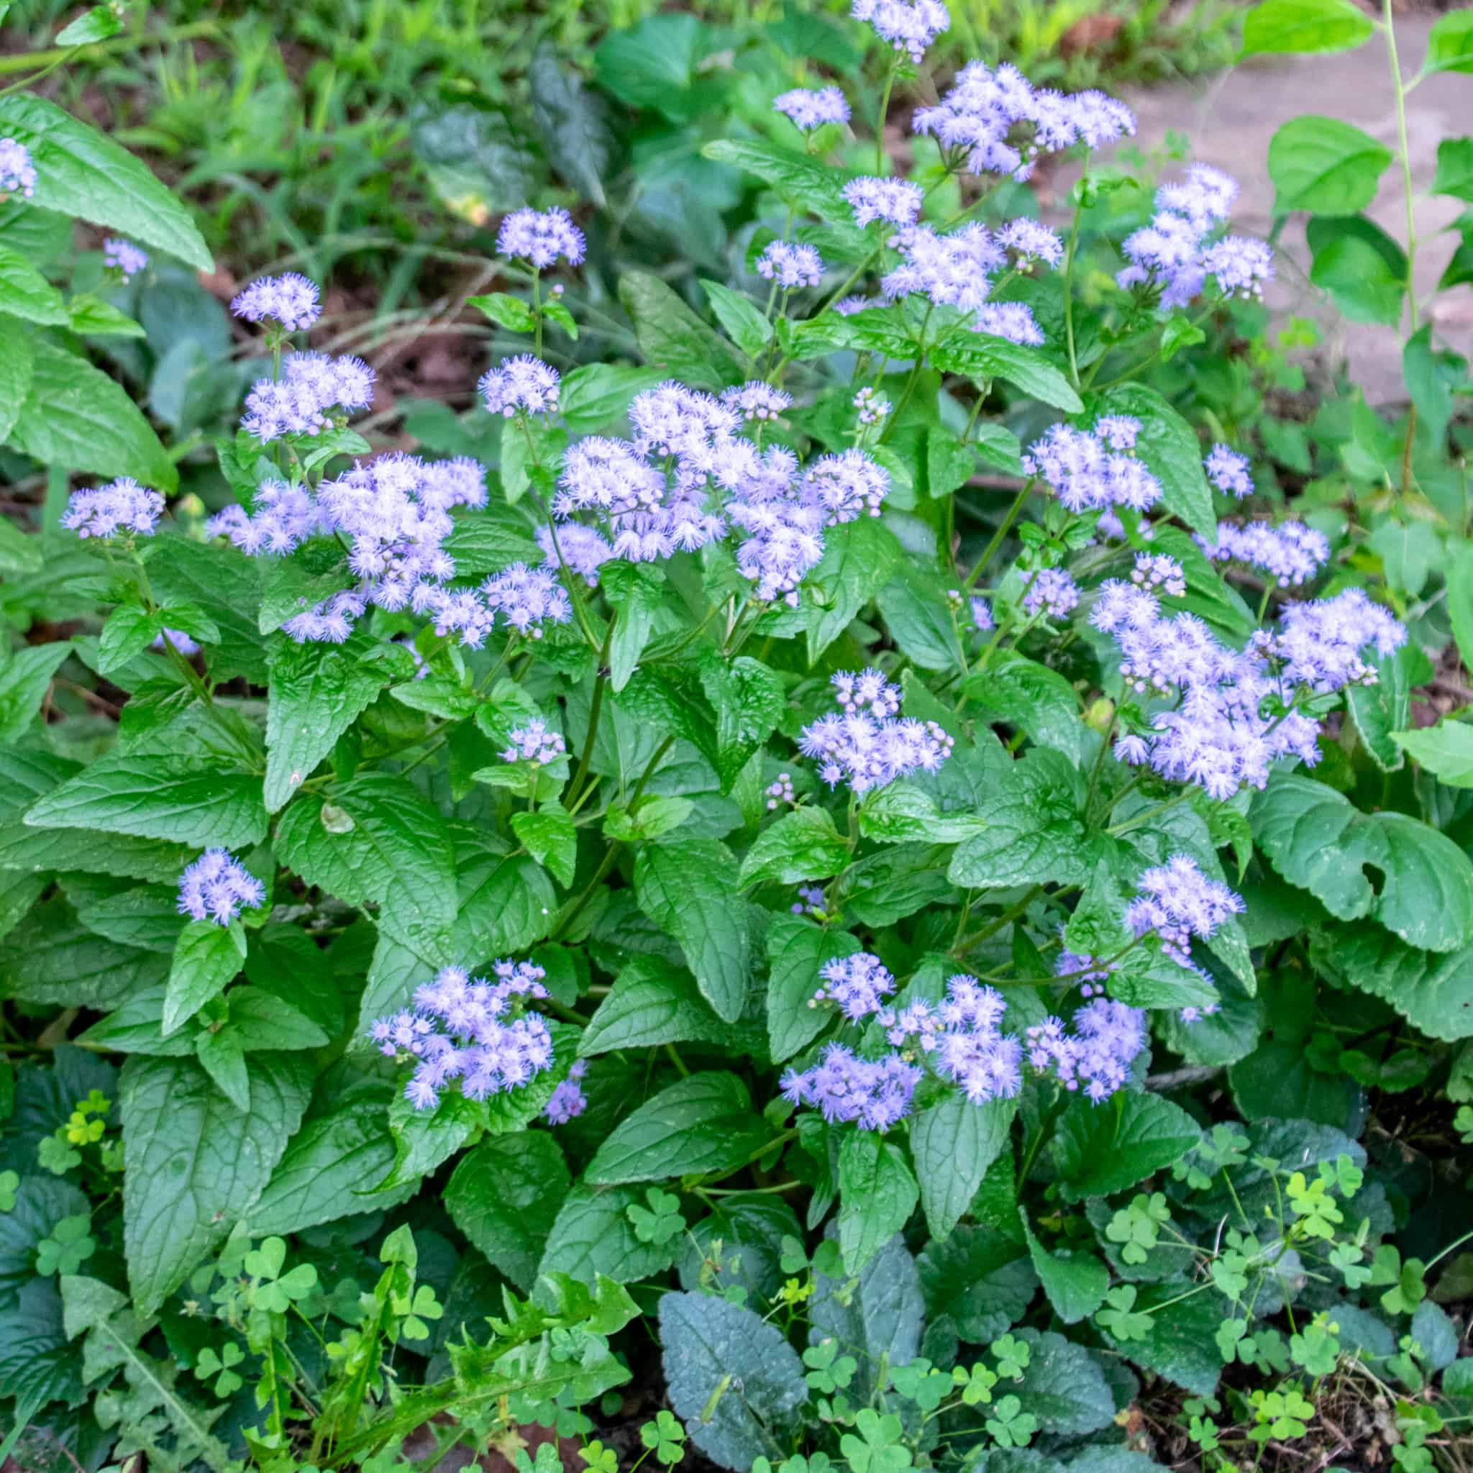
Fig 1: Conoclinium coelestinum (L.)

2. METHODS
2.1 Collection and Preparation of Plant Material
Conoclinium coelestinum (L.) DC (Asteraceae) leaves were obtained directly from Abraka, Ethiope East Local Government Area, Delta State, Nigeria. A taxonomist identified and verified the plant material, and a voucher specimen was placed in the Department of Botany's Herbarium at Delta State University in Abraka (DELSUN269). The fresh Conoclinium coelestinum plant material collected were weighed (initial weight), and allowed to air dry at 28–32°C for a duration of two weeks in a laboratory until a constant weight was achieved. To enhance surface area, the dried leaves were ground into a fine powder using a mechanical grinder. Final weight was obtained and then stored in a plastic container till further use. Portions were then immersed in 70% ethanol for 72 hours while being stirred occasionally. Whatman No. 1 filter paper was then used to filter the mixture. The filtrate was dried to produce a crude extract and concentrated under decreased pressure using a rotary evaporator at 40°C. The extract was then kept at 4°C until needed again.

2.2 Proximate Analysis
The proximate analysis of C. coelestinum leaves which entails content determination of moisture, ash, crude protein, crude ash and crude fiber was carried out according to the method of AOAC [24]. The method used for the determination of moisture content was the oven drying method, ash content was determined using the muffle furnace method, crude protein content was determined according to the Kjeldahl method, crude fat content was determined using the Soxhlet extraction method, crude fiber content was determined using the acid-base digestion method according to the method of AOAC (2000), while carbohydrate content was calculated with the formula; Carbohydrates (%) = 100 – (Moisture + Ash + Crude Protein + Crude Fat + Crude Fiber), in line with the method outlined by AOAC [24]. By adding the multiplied values for crude protein, crude fat, and carbohydrate, using the factors (4 kcal, 9 kcal, and 4 kcal, respectively), the calorific value of the leaf was calculated and expressed as kcal/100g.

2.3 Mineral analysis
Initially digested one gram (1g) of C. coelestinum in a digestion vessel at 60°C temperature with 10 mL of concentrated nitric acid on a low heat microwave digester (MA133-003, Milestone Ethos One Sorisole, BG, Italy). Also, 2 mL of hydrogen peroxide (H₂O₂) was added to assist in the complete oxidation of organic material. Heating continued until the solution became clear and allowed to cool. The resulted assimilated clear content of the sample was transferred into 50 mL volumetric flask and the volume was made up with deionized-double purified water to 5 ml, filtered and the filtrate was assimilated into a clean beaker. Standard solutions of known concentrations for the elements of interest were prepared. The AAS (SensAA Dual GBC Scientific, Australia) was calibrated with known concentrations of standard solutions for the elements of interest. The filtered sample solution was introduced into the AAS and the concentrations of each mineral were recorded and documented.

2.4 Vitamins Determination
The vitamins in the leaves were examined using the HPLC technique outlined by Giorgi et al. [25]. The Agilent LC 1100 series HPLC equipment was utilized. A reversed-phase C18 column (Prontosil, 250 x 4.0 mm, 5 μm, Bischoff), a high pressure pump, a degasser, and an autosampler automatic injector make up the system. It was also connected to a Windows XP workstation and featured a UV/visible detector that could detect waves at various wavelengths. Trifluoroacetic acid (HPLC grade) and acetonitrile were employed in the analysis. The mobile phase consisted of 0.1% trifluoroacetic acid in acetonitrile (a binary gradient eluent) and 0.1% trifluoroacetic acid in water. This solution was used to dissolve precisely 300 mg of the extract, which was then injected via the injection port into the HPLC apparatus. At 521 nm, the chromatograms were observed with a flow rate of 0.8 ml/min. The compounds in the extract's retention duration and UV-Vis spectral characteristics were then contrasted with available data and standards.
The presence and quantities of the following were determined: provitamin A carotenes, ascorbic acid (Vitamin C), tocopherol (Vitamin E), thiamine (Vitamin B), riboflavin (Vitamin B), niacin (Vitamin B), pyridoxine (Vitamin B), and cobalamine (Vitamin B).

2.5 Quantification of Anti-Nutrients
The titration method, as detailed by Unuofin et al. [26] was used to determine the samples' oxalate content. After weighing 1 g of the ground-up material into a conical flask, 75 mL of 3 mol/L H₂SO₄ was added, and the mixture was agitated for an hour using a magnetic stirrer. After filtering, 25 milliliters of the filtrate were gathered and heated to between 80 and 90 degrees Celsius. This filtrate was always maintained at or above 70 °C. The end point, indicated by a light pink color that lasted for 15 seconds, was attained after the heated aliquot was continually titrated with 0.05 mol/L of KMnO4. One milliliter of 0.05 mol/L KMnO4 was used to compute the oxalate content, which is equal to 2.2 milligrams of oxalate.
The phytic acid content of the sample was determined using the procedure described by Aina et al. (2012). The sample (2 g) was weighed into a flask, and then 100 mL of 2% HCl was added. It was then allowed to stand for three hours before being filtered. Five milliliters of an indicator solution containing 0.3% ammonium thiocyanate were mixed with 25 milliliters of the filtrate in a separate 250 milliliter conical flask. 53.5 mL of distilled water was added to achieve the desired acidity. This was then titrated with the standard iron III chloride solution (0.001 95 g of iron per mL) until a brownish yellow hue persisted for five minutes. Phytic acid = titre value × 0.001 95 × 1.19 × 100 was the formula used to compute phytotic acid.
Tannins were determined using the A.O.A.C. [24] method. For one hour, the tannins were extracted in boiling distillation water. Folin-dennis reagent and sodium carbonate solution were used to create the color. At 750 nm, absorbance was determined using spectophotometry. The tannic acid standard curve was used to determine the tannic acid content.

The method described by Soetan [27] was followed in order to determine the trypsin inhibitor. To do this, 0.2g of the samples was weighed and placed in a screw-cap centrifuge tube. After adding 10 milliliters of 0.1M phosphate buffer, the mixture was shaken on a UDY shaker for an hour at room temperature. The resulting suspension was filtered through Whatman No. 42 filter paper after being centrifuged for five minutes at 5000 rpm. Using phosphate buffer, the volume of each was brought to 2 milliliters. The test tube was kept at 37 °C in a water bath. One of the tubes was used as a blank, and six milliliters of a 5% TCA solution was added. All of the tubes, which had been stored at 37°C, received 2 milliliters of casein solution.
For twenty minutes, these were incubated. After 20 minutes, 6 ml of TCA solution was added to the experimental tubes, and the tubes were shook to halt the process. At room temperature, the reaction was permitted to continue for one hour. Whatman No. 42 filter paper was used to filter the mixture. At 280 nm, the absorbance of the filtered sample and the trypsin standard solutions was measured.

A modified version of Nwokoro et al. [28]'s alkaline picrate impregnated filter paper strips method was used to determine the test samples' cyanogenic potentials. A stock solution of KCN (0.2 g%) is used to prepare standard KCN solutions in a range of concentrations (1 to 10 PPM). The KCN solutions in glass bottles were then sealed right away with three strips of picrate-impregnated filter paper after being acidified with a 20% HCl acid solution in a 1:1 ratio to liberate the free cyanide as HCN. After 10 minutes of maintaining the setup at 80°C in a water bath, it was taken out of the bath and left at room temperature for 24 hours in the lab. Each glass bottle's red Picrate paper strips were taken out, rinsed in five milliliters of 50% ethanol solution, and left for half an hour. A spectrophotometer set to 510 nm wavelength was then used to test the solution's absorbance in comparison to a blank that was prepared in the same way but did not contain KCN solution. The cyanide concentration in the test samples was assessed using a standard calibration curve that plotted absorbance against cyanide concentration in PPM HCN equivalent.

2.6 Statistical Analysis
The results obtained were analysed using descriptive statistics and presented as Mean ± SD (Standard Deviation) of triplicate determinations [29]. Data analysis was conducted using Graph Pad Prism.

3. RESULTS
3.1 Proximate analysis of C. coelestinum leaves
The concentrations of moisture, ash, fiber, calorie, crude lipid, crude protein, and crude carbohydrate concentrations of C. coelestinum leaves are presented in Table 1. The crude carbohydrates had the highest concentration while the crude lipid had the lowest concentration. Moisture content of the leave is 7.77mg/100g; Ash content is 13.53mg/100g and crude lipid content is 4.40mg/100g. C. coelestinum leaves contained carbohydrate content of 45.52mg/100g and a fibre content of 11.66mg/100g. the calculated caloric content of the sample is 336.86 kcal/100g.

TABLE 1: Proximate analysis of C. coelestinum leaves
Parameters | Composition
Moisture content (mg/100g) | 7.77 ± 0.03
Ash content (mg/100g) | 13.53 ± 0.04
Crude lipid content (mg/100g) | 4.40 ± 0.01
Crude protein content (mg/100g) | 28.71 ± 0.02
Carbohydrate (mg/100g) | 45.52 ± 0.03
Calorie content (kcal/100g) | 336.86 ± 0.03
Fibre content (mg/100g) | 11.66 ± 0.03
Values presented as mean ± standard deviation of three determinants

3.2 Mineral analysis of C. coelestinum leaves
The mineral composition of C. coelestinum leaves is presented in Table 2. C. coelestinum leaf contains nitrogen, phosphorus, calcium, magnesium, potassium, sodium, iron, boron, molybdenum, cobalt, selenium and manganese. The highest mineral content of C. coelestinum was iron, while the lowest was molybdenum. Results of the mineral content analysis were; K (1.02 ± 0.05mg/kg), Z (24.99 ± 0.05 mg/kg), Na (45.04 ± 0.04mg/kg), Ca (1.07 ± 0.02mg/kg), Co (0.10 ± 0.01mg/kg), Mg (0.01 ± 0.01mg/kg), Se (1.01 ± 0.10mg/kg), Fe (75.06 ± 0.04mg/kg), Mn (10.05 ± 0.04mg/kg), and P (0.12 ± 0.01mg/kg).

TABLE 2: Mineral analysis of C. coelestinum leaves
Mineral | Quantity (mg/kg)
Phosphorus | 0.12 ± 0.01
Calcium | 1.07 ± 0.02
Magnesium | 0.01 ± 0.01
Potassium | 1.02 ± 0.05
Sodium | 45.04 ± 0.04
Iron | 75.06 ± 0.04
Zinc | 24.99 ± 0.05
Boron | 0.36 ± 0.02
Molybdenum | 0.01 ± 0.01
Cobalt | 0.10 ± 0.01
Selenium | 1.01 ± 0.10
Manganese | 10.05 ± 0.04
Values presented as mean ± standard deviation of three determinants

3.3 Vitamin Content of Conoclinium coelestinum Leaves
Figures 2 and 3 shows output obtained after determining both the qualitative and quantitative Vitamin content of C. coelestinum leaves. Thiamine, niacin, riboflavin, ascorbic acid, vitamin E and vitamin A were detected in C. coelestinum leaves. The result revealed the presence of thiamine (0.057mg/100g), niacin (0.148mg/100g) riboflavin (0.025mg/100g), ascorbic acid (00.150mg/100g) and vitamin A (0.681mg/100g).

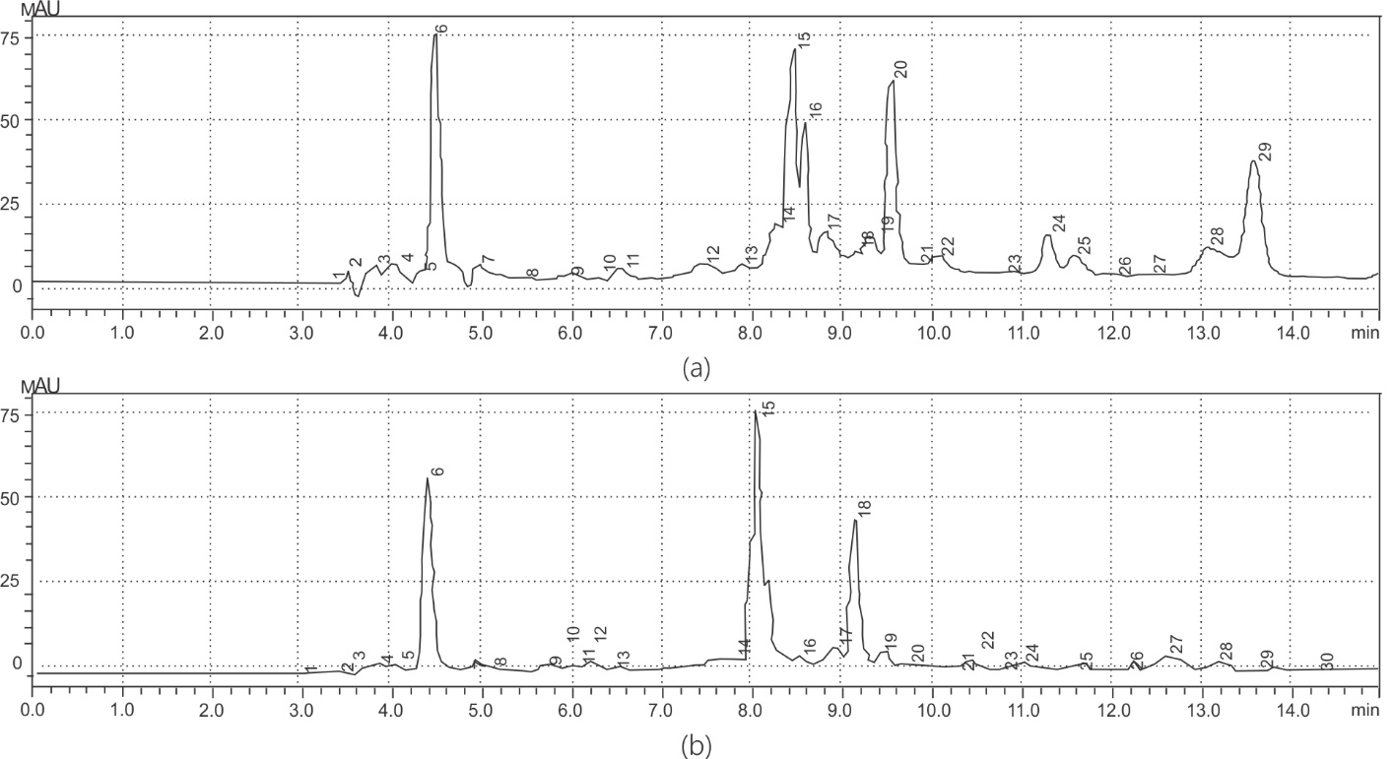
Figure 2: Chromatogram of HPLC analysis of: (a) Standard Vitamins: peak 6 – vitamin; peak 15,
16 – vitamin B₁; peak 20 – vitamin B₃, peak 24 – vitamin B₂; (b) C. coelestinum: peak 6 – vitamin C; peak 15, 16 – vitamin B₁, peak 20 – vitamin B₃; peak 24 – vitamin B₂

Concentration (mg/100g)
Figure 3: Vitamin Content of C. coelestinum Leaf Extract
3.4 Anti-nutritional of Conoclinium coelestinum Leaves
The anti-nutritional of C. coelestinum leave extract is presented in Table 3. Trypsin inhibitor, phyates, tannins, oxalates and cyanogenc glycosides were detected, although in minute quantities.
The result showed that C. coelestinum leave contain 0.681mg/100g of Trypsin inhibitor, 2.12mg/100g Phytic acid and 0.101mg/100g oxalic acid.

Table 3: Anti-nutritional Content of C. Coelestinum Leaf Extract
Parameter | Concentration (mg/100g)
Trypsin inhibitor | 0.681±0.03
Phytic acid | 2.12±0.51
Cyanogenic glycosides) | 1.50±0.05
Tannins | 0.110±0.02
Oxalate | 0.101±0.01

4. DISCUSSION
The proximate analysis of C. coelestinum leaves as shown in Table 1, revealed a moisture content of 7.77% which is within the range of some herbs. The low moisture content indicates that C. coelestinum have reduced susceptibility to microbial infestation and allows for high storage capacity. This is due to the fact that food spoilage microorganisms thrive in plant with adequate moisture content [30]. (Alagbe et al. 2020). This finding is in tandem with the moisture content of Oreganum vulgare leaves (7.33%) reported by Yusulf et al. [31]. This low moisture content could be due to the preliminary air drying of the leaves. Although higher moisture contents were reported in Icacina trichantha leaves (26.97%) by Alawode [32] and Maerua crassifolia leaves (62%) by Aletan and Kwazo [33]. This could be due to the difference in specie and method of processing.
Ash content in a plant’s leaf is a reflection of the mineral content available in the plant. High ash content suggest great mineral content [31]. The ash content of C. coelestinum (13.53g/100g) obtained is comparatively lower than the values reported 12.17g/100g in Maerua crassifoia [33], 12.54g/100g in Cymbopogon citratus and 10.24g/100g in Oreganum vulgare [31].
The presence of high levels of calorie (336.86kcal/g), protein (28.70g/100g), Carbohydrate (45.60g/100g) and crude lipid (4.40g/100g) in C. coelestinum makes it a nutritionally significant forb. These values were comparable to the values reported for calorie (348.29kcal/g), crude protein (15.17g/100g), crude carbohydrate (64.83g/100g), crude lipid (3.17g/100g) reported in Maerua crassifolia leaves [33]. Although, Boradum et al. [34] reported a slightly lower values of calorie (220kcal/g), crude protein (19.0g/100g), crude carbohydrate (20.05g/100g) and crude lipid (6.70 g/100g) in Piper umbellatum leaves. Fiber is a macro nutrient present in plant referred to as the indigestible carbohydrate and lignin [35]. The intake of high fiber diet can reduce the level of low-density lipoprotein (LDL) cholesterol, which can further reduce the risk of hypertension and cardiovascular disorders [36]. The recommended dietary fiber intake by the Food and Agriculture Organization (FAO), European Food Safety Authority (EFSA) and World Health Organization is 25 g/day for adults, 25 - 38g/day to prevent type 2 diabetes, cardiovascular disease, colorectal cancer, overweight, and obesity and 2 g/MJ for children from the age of 1 year [37]. The fiber content of C. coelestinum (11.66g/100g) obtained is comparatively higher than 9.85g/100g reported in Delonix regia leaf [30], although a higher fiber value (34.75g/100g) was reported in Piper umbellatum leaves [34].
The mineral analysis presented in Table 2, revealed Iron (75.06mg/kg), Sodium (45.04mg/kg), Zinc (24.99mg/kg), Manganese (10.05mg/kg), potassium (1.02g/kg) and Calcium (1.07g/kg) as the major minerals available in leaves. The obtained results were consistent with the mineral constituents of Rauvolfia vomtoria leafs report on by Onobrudu et al. [7]. However, the levels of iron, zinc, maganese C. coelestinum were higher when compared to iron (0.95mg/kg), zinc (1.25mg/kg) and Manganese (0.94mg/kg) reported in Cymbopogon citratus reported by Yosuf et al. [31]. Iron is essential mineral necessary for the formation of hemoglobin, myoglobin, ferritin, heme-enzymes and other iron containing enzymes involved in the transfer of electrons as well as oxidation-reduction reactions [38], Sodium is a significant cation in the extracellular fluid, while potassium is the major intracellular cation and they are pivotal to the regulation of extracellular fluid volume and electrolytes, although potassium also plays a key role in the regulation of cellular membrane potential and thus in the regulation of nerve and muscle activities [39]. The World Health Organization recommended a daily dietary sodium intake of 2g and potassium intake of 3.50g for the prevention of cardiovascular diseases [34, 40]. Zinc is an essential cofactor for most enzyme complexes, critical in the metabolism of lipid, protein, and carbohydrate, ribonucleic acids and immune functions [30, 41]. While, manganese is essentially required as components of metalloenzymes such as pyruvate carboxylase, arginase, and mitochondria superoxide dismutase, and as cofactor to some enzymes involved in metabolism such as hydrolases, transferases, kinases and decarboxylases [42]. Hence the high levels of iron and zinc in C. coelestinum makes forb a potential hit may improve lipid and carbohydrate metabolism, hormone synthesis, growth, skeletal defect, reproduction and anemia. The presences of these mineral is crucial for healthy physiological function and immunity.
Six different vitamins were found in the C. coelestinum leaf extract analysis, as shown in Figure 2: thiamine, niacin, riboflavin, ascorbic acid, vitamin E, and vitamin A. The plant's measured fat-soluble vitamin A content (0.681±0.03 mg/100g) is comparable to the average requirement (AR) of vitamin A recommended by the European Union (EU) for adult men and women with average body weights of 68.1 kg and 58.5 kg, respectively. The established ARs for these groups are 0.57 mg and 0.49 mg of retinol equivalent (RE) per day, respectively [43]. The ability of the plant to provide protection against oxidative stress is demonstrated by its fat-soluble antioxidant, which aids in preventing oxidative damage to cell membranes. Vitamin A is essential for healthy skin, immunological system, and vision. According to its vitamin profile, C. coelestinum may be a useful supplement or addition to functional foods meant to help with vitamin deficits. Specifically, the high content of vitamin A suggests that it may be used to build nutraceuticals that boost the immune system and promote eye health.
Another essential component that was measured in this study was vitamin C. Strong aqueous-phase antioxidant, it lessens oxidative stress and scavenges free radicals [44]. It is also necessary for maintaining good skin and preventing scurvy. The vitamin C concentration was less than that of Vernonia calvoana (11.33 mg/100 g) and Moringa oléifera and Ipomoea aquatica (2.17 mg/100 g) as reported by [45] and [46], respectively.
Niacin is necessary for DNA repair and the adrenal gland's ability to produce steroid hormones, whereas thiamine (B1) is necessary for energy metabolism and the healthy operation of the neurological system. The amount of vitamins found corresponds with the usual nutrient profiles found in a variety of therapeutic plants. For the synthesis of energy as well as for cellular growth, development, and function, riboflavin is essential. According to Smith et al. [47], the comparatively low content of riboflavin in C. coelestinum may be caused by the vitamin's unique extraction efficiency or intrinsic synthesis routes. It is well known that ascorbic acid has antioxidant qualities. It is essential for the production of collagen, iron absorption, and immune system upkeep. The presence of these vitamins in the leaf extract makes C. coelestinum a potential source of natural antioxidants [48]. Riboflavin (B2) concentration (0.025±0.01 mg/100 g) was higher than that of fruits (0.01-0.05 mg/100 g), common vegetables (0.01-0.3 mg/100 g), and most common cereals (0.11-0.18 mg/100 g) [48]. Vitamin B3 is essential for metabolism and DNA repair. The B3 concentration in C. coelestinum leaf is substantially greater than that observed by Hasan et al. [49] and that documented for fruits like Docynia indica (0.38 mg/100 g) and Myrica esculenta (0.46 mg/100 g) [50].
According to Alelign et al. [14], anti-nutritional factors limit the optimal utilisation of nutrients such as proteins, vitamins, and minerals, hence lowering the food's nutritional value and optimal exploitation of its components. Tannins have an impact on the bioavailability of non-heme iron, protein, and carbohydrate digestibility. As a result, they can cause inadequate protein supply, poor iron and calcium absorption, and a decrease in the energy value of diets high in tannin. However, since 1.5 – 2.5g is the maximum daily consumption of tannic acid that is tolerable for men, the tannin found in this study may not be hazardous or significant. The extract also included extremely small amounts of phytate and oxalates [51]. Low mineral absorption is caused by phytate and oxalates binding to certain key mineral elements, particularly calcium. Since calcium oxalate stones account for the majority of urinary stones that occur in people, oxalates and calcium can bind together to create kidney stones. It is recommended that people restrict the amount of food they eat, with the total amount of oxalate and phytate ingestion not to exceed 5–6μg/g or ml and 1-6μg/g or ml, respectively. While oxalate serves a variety of biological purposes in plants, such as controlling calcium levels, providing resistance to heavy metals, shielding plants from herbivores, and promoting plant growth, in humans, it can result in the formation of bigger kidney stones that can obstruct renal tubules [52]. However, the very low levels of phytate and oxalates present in the leaf under investigation, makes it safe.

5. CONCLUSIONS
The study affirms that C. coelestinum leaves are good natural sources of minerals such iron, zinc, sodium, and manganese with appreciable content of moisture, ash, fiber, carbohydrates protein and calorie. The leaves also contain thiamine, niacin, riboflavin, ascorbic acid, vitamin E and vitamin A in appreciable quantities. Although minutes quantities of anti-nutritional factors were found in the leaves, the nutritional benefits of iron in hemoglobin formation and oxygen transport makes the C. coelestinum a potential hit in the management of iron deficiency disorders and anemia. Assessment of the levels of antioxidant molecules (anthocyanins, flavonoids) present in C. coelestinum leaves as well as the effect of different cooking or processing methods on its nutrients and anti-nutrients levels are interesting areas that should be explored in further studies.

List of Abbreviations
CC - Conoclinium coelestinum
AOAC – Association of Official Analytical Collaboration
AAS – Atomic absorption spectrometry

DECLARATIONS

Ethics approval and consent to participate
Not applicable.

Consent for publication
Not applicable.

Availability of data and materials
Data utilized in analysis for this project are available for presentation upon request.

Competing interests
The authors of this manuscript have no financial or non-financial conflicts of interest to disclose.

REFERENCES

- Achikanu CE, Eze-steven PE, Ude CM, Ugwuokolie OC (2013) Determination of the Vitamin and Mineral Composition of Common Leafy Vegetables in South Eastern Nigeria. Inter J Current Microbio Appl Sci 2(11):347-353. doi/full/10.5555/20143029491
- Oladayo AI, Olubunmi AW, Afolayan AJ (2019) Comparison of the Proximate Composition, Vitamins (Ascorbic Acid, - Tocopherol and Retinol), Anti-Nutrients (Phytate and Oxalate) and the GC-MS Analysis of the Essential Oil of the Root and Leaf of Rumex crispus L. Plants, 8, 51; doi:10.3390/plants8030051
- Kujawska M, Hilgert IN, Keller AH, Gil G (2017) Medicinal Plant Diversity and Inter-Cultural Interactions between Indigenous Guarani, Criollos and Polish Migrants in the Subtropics of Argentina. PLoS ONE 2017, 1-12. https://doi.org/10.1371/journal.pone.0169373
- Orororo OC, Asagba SO (2022) Treatment with Hibiscus sabdarrifa L Anthocyanins Improve Hematological Parameters in Rats Exposed to Cadmium. J Exploratory Res Pharma 7(3):146-150, 10.14218/JERP.2022.00003
- Onobrudu DA (2017) Saponins and polyphenolics of methanol leaf extract of Boswellia dalzielii hutch. Arch Current Res Inter 8(3):1-6. DOI: 10.9734/ACRI/2017/34716
- Adam AA, Omogbene TO (2020) Phytochemical and Phytomineral (macro and trace) compositions of the leaf, stem bark and root of Blighia sapida K.D. Koenig. J Med Plants Studies 8(5): 20-24. https://doi.org/10.22271/plants.2020.v8.i5a.1190
- Onobrudu DA, Nzebude PC, Orororo OC (2024) Comparative Analysis of the Phytochemicals, Minerals, Antioxidant and Antimicrobial Activities of Aqueous and Ethanolic Extracts of Rauvolfia Vomtoria Leafs. Asian Plant Res J 12 (5):67-81. DOI: 10.9734/aprj/2024/v12i5271
- Irabor EEI, Eze PN, Unuigbe CA, Imafidon MI, Omoruyi U, Emmanuel V (2023) Proximate Analysis AND Mineral Determination of Calliandra surinamensis Seed. J Chem Soc Nig 48(1). https://doi.org/10.46602/jcsn.v48i1.859
- Lawson SK, Sharp LG, Satyal P, Setzer WN (2019) Volatile components of the aerial parts of Conoclinium coelestinum from North Alabama. Am J Essential Oils Nat Products 7(3): 8 -10.
- Adeyeye EI, Olaleye AA (2020) Proximate and Mineral Composition analysis of the leaves of Gongronema latifolium and Piper guineense. Dutse J Pure Appl Sci (DUJOPAS),6 (1): 60-67.
- Odeghe OB, Opajobi AO, Ajala MO, Orororo CO (2023) Enzyme inhibitory properties, free radical scavenging activity and phytochemical profile of Vitex simplicifolia leaf. Eur Chem Bull 12(8):8666-8682. 10.48047/ecb/2023.12.8.707
- Opajobi AO, Onobrudu DA, Ojugbeli ET, Uzuegbu UE, Toloyai PY, Elu CO, Oshiegbu W, Onyesom I (2022) Levels of Cerebral Malaria Indices, Free radical Scavengers and Preventive Antioxidants in Plasmodium berghei Infected Mice Treated with Phytochemical Extracts of Phyllanthus amarus Schum and Thonn. Neuro Quantology 20(6):374-390. 10.14704/nq.2022.20.6.NQ22039
- Efekemo O, Orororo OC (2022) Effect of mixture of leaf extract of Ocimum gratissimum and Vernonia amygdalina on cadmium induced hepatotoxicity in wistar rats. J Biochem Inter 9(4):73-81. 10.56557/jobi/2022/v9i47807
- Alelign T, Chalchisa D, Fekadu N, Solomon D, Sisay T, DEbella A, Petros B (2020) Evaluation of Acute and Sub-Acute Toxicity of Selected Traditional Antiurolithiatic Medicinal Plant Extracts in Wister Albino Rats. Toxicology Rep 7:1356-1365. https://doi.org/10.1016/j.toxrep.2020.10.001
- Egbune EO, Ezedom T, Orororo OC, Egbune OU, Avwioroko OJ, Aganbi E, Anigboro AA, Tonukari NJ (2023) Solid-state fermentation of cassava (Manihot esculenta Crantz): a review. World J Microbiol Biotech 39:259; 1-20. doi: 10.1007/s11274-023-03706-0.
- Tonukari NJ, Egbune EO, Avwioroko OJ, Orororo OC, Anigboro AA (2016) A Novel Pig Feed Formulation containing Aspergillus niger CSA35 pretreated cassava peels and its effect on growth and selected biochemical parameters of pigs. Afri J Biotech 15(9): 776-785. https://doi.org/10.5897/AJB2015.15181
- Odeghe OB, Orororo CO, Egbune EO, Onobrudu DA, Nwiloh BI, Utibe EB, Adegoke OA, Effiong GC, Oviri MO, Ofoke IH, Mordi JC, Ejimole LO (2023) Phytochemical analysis, antioxidant capability, and inhibition studies of the aqueous extract of Phyllanthus discoideus root. Biomed Biotech Res J 7:411- 419. 10.4103/bbrj.bbrj_126_23
- Uraku AJ, Onuoha SC, Edwin N, Ezeani N, Ogbanshi ME, Ezeali C, Nwali BU, Ominyi MC (2015) Nutritional and Anti-nutritional Quantification Assessment of Cymbopopgon citratus Leaf. Pharmacology Pharm 6: 401-410. 10.4236/pp.2015.68041.
- Schilling EE, Panero JL, Crozier BS, Patterson TF (2019) Relationships of Conoclinium, a recently diverged genus (Asteraceae, Eupatorieae) and description of a new species from Western Mexico. Plant Res Center Lundellia, 22:14–27. https://doi.org/10.25224/1097-993X-22.1.14
- Gou Y, Zhennan G, Li G, Fan, R, Qiu Z, Wang L, Wang C (2020) Ethnobotanical survey of plants traditionally used against hematophagous invertebrates by ethnic groups in the mountainous area of Xishuangbanna, Southwest China. Plant Diversity, 42: 415-426. https://doi.org/10.1016/j.pld.2020.07.009
- Linthiya E, Malini RP, Betty T, Vasini V, Sumathi P (2023) Survey on the ethnomedicinal plants used by the communities around buliyar, the Nilgiri district, Tamilnadu, India. Kongunadu Res J 10 (1): 9-15. DOI: https://doi.org/10.26524/krj.2023.2
- Paetsch L, Mueller CW, Rumpel C, Angst Š, Wiesheu AC, Girardin C, Ivleva NP, Niessner R, Kögel-Knabner I (2017) A multi-technique approach to assess the fate of biochar in soil and to quantify its effect on soil organic matter composition. Organic Geochem 112, 177–186. http://dx.doi.org/10.1016/j.orggeochem.2017.06.012
- Jimoh MO, Afolayan AJ, Lewu FB (2018) Suitability of Amaranthus species for alleviating human dietary deficiencies. South Afr J Botany, 115: 65–73. https://doi.org/10.1016/j.sajb.2018.01.004
- AOAC (2006) American Journal of Food Science and Technology (Association of Official Analytical Chemists). 15th ed., Washington D.C. U. S. A. 1121 – 1180.
- Giorgi MG, Howland K, Martin C, Bonner AB (2012) A Novel HPLC Method for the Concurrent Analysis and Quantitation of Seven Water-Soluble Vitamins in Biological Fluids (Plasma and Urine): A Validation Study and Application. The Sci World J 2012:1-8. doi:10.1100/2012/359721
- Unuofin JO, Otunola GA, Afolayan AJ (2017) Nutritional evaluation of Kedrostis africana (L.) Cogn: An edible wild plant of South Africa. Asian Pacific J Tropical Biomed 7:443–449. https://doi.org/10.1016/j.apjtb.2017.01.016
- Soetan KO (2012) Comparative evaluation of phytochemicals in the raw and aqueous crude extracts from seeds of three Lablab purpureus varieties. Afr J Plant Sci 6(15):410-415.
- Nwokoro O, Ogbonna JC, Ubani CS, Okpala GN, Ofodile OE (2010) Determination of cyanide in Amanitia Muscaria samples using alkaline picrate method. Pakistan J Nutri 9 (2):134-136. DOI: 10.3923/pjn.2010.134.136
- Steel RG, Torrie JH (1981) Principles and Procedures of Statistics: A Biometrical Approach. 2nd Edn., McGraw Hill Book Co., New York.
- Alagbe JO, Adeoye A, Oluwatobi AO (2020) Proximate and Mineral Analysis of Delonix regia leaves and roots. Annals Nutri Food Sci 4(1): 1044. https://doi.org/10.31149/ijie.v3i10.705
- Yusuf AM, Ogundeko TO, Abu T, Ramyil MSC, Nadabo C, Adeniyi OG, Bassi AP, Bello CSS, Onwuliri FC (2023) Proximate composition, mineral, vitamins and antioxidant activities of Cymbopogon (lemon grass) and Oregamun vulgare (linn) leaves extracts harvested in Jos, North-Central Nigeria. World J Advanced Res Rev 20(03): 1366–1375. https://doi.org/10.30574/wjarr.2023.20.3.2239
- Alawode TT (2024) Phytochemical, Proximate and Mineral analysis of leaves and tubers of Icacina trichantha. J Chem Soc Nig 49(4):606–614. https://doi.org/10.46602/jcsn.v49i4.99
- Aletan UI, Kwazo HA (2019) Analysis of the proximate composition, anti-nutrients and mineral content of Maerua Crassifolia leaves. Nig J Basic Appl Sci 27(1): 89-96. DOI: http://dx.doi.org/10.4314/njbas.v27i1.12
- Baradum SR, Peters DE, Ohiri RC (2021) Proximate analysis, anti-nutrient and mineral compositions of Piper umbellatum Linn leaves. J Biochem Inter 8(1): 62-70. https://ikprress.org/index.php/JOBI/article/view/7313.
- Saini A, Morya SA (2021) Review based study on Soymilk: Focuses on production technology, prospects and progress scenario in last decade. The Pharma Innovation J 10(5):486 – 494. https://doi.org/10.22271/tpi.2021.v10.i5g.6254
- Tejani VN, Dhillon SS, Damarlapally N, Usman NUB, Winson T, Roy PB, Panjiyar BK (2023) The relationship between dietary fiber intake and blood pressure worldwide: A systematic review. Cureus 15(9), e46116. 10.7759/cureus.46116
- Suresh AS, Salariaa M, Moryab S, Khalidc WD, Afzale FA, Khand AA, Safdarf S, Khalidf M Z, Kasongog ELM (2024) Dietary fiber: an unmatched food component for sustainable health. Food Agric Immunology 35(1): 2384420. https://doi.org/10.1080/09540105.2024.2384420
- Abbaspour N, Hurrell R, Kelishadi R. (2014). Review on iron and its importance for human health. J Res Med Sci 19:164-174. https://pmc.ncbi.nlm.nih.gov/articles/PMC3999603/
- Kaur P, Yadav AK, Pal A, Jassal RS, Shafiq N, Sahni N, Kumar V, Jha V. (2024). Estimation of dietary intake of sodium, potassium, phosphorus and protein in healthy Indian population and patients with chronic kidney disease. Frontiers Nutri 11:1312581. doi: 10.3389/fnut.2024.1312581.
- Stiles LI, Ferrao K, Mehta KJ (2024) Role of zinc in health and disease. Clin Exper Med 24(1):38. https://doi.org/10.1007/s10238-024-01302-6
- D’Elia L (2024) Potassium Intake and Human Health. Nutrients 16: 833-80. https://doi.org/10.3390/nu16060833
- Kippler M, Oskarsson A (2024) Manganese – a scoping review for Nordic Nutrition Recommendations 2023. Food Nutri Res 68. https://doi.org/10.29219/fnr.v68.10367
- EFSA (2012). EFSA Panel on Dietetic Products, Nutrition, and Allergies (NDA). Scientific Opinion on Dietary Reference Values for protein. EFSA J. 2012, 10, 2557. https://doi.org/10.2903/j.efsa.2012.2557
- Juraschek SP, Guallar E, Appel LJ, Li ERM (2012) Effects of vitamin C supplementation on blood pressure: A meta-analysis of randomized controlled trials. The Am J Clin Nutri 4, 1079–1088. doi: 10.3945/ajcn.111.027995.
- Igile GO, Iwara IA, Mgbeje BIA, Uboh FE, Ebong PE (2013) Phytochemical, proximate and nutrient composition of Vernonia calvaona Hook. (Asterecea): a green-leafy vegetable in Nigeria. J Food Res 2 (6): 1-11. doi:10.5539/jfr.v2n6p1
- Misra S, Misra MK (2014) Nutritional evaluation of some leafy vegetable used by the tribal and rural people of south Odisha, India. J Nat Prod Plant Res 4 (1):23-28
- Smith AM, Zeeman SC, Smith SM (2011). Starch degradation. Annual Rev Plant Biol 62:209-234. 10.1146/annurev.arplant.56.032604.144257.
- Kaur C, Kapoor HC (2001) Antioxidants in fruits and vegetables – the millennium’s health. Int J Food Sci Tech 36(7), 703-725. https://doi.org/10.1111/j.1365-2621.2001.00513.x
- Hasan MM, Uddin N, Hasan MR, Islam AF, Hossain MM, Rahman AB, Hossain MS, Chowdhury IA, Rana MS (2014) Analgesic and anti-inflammatory activities of leaf extract of Mallotus repandus (Willd.) Muell. Arg. Biomedical Res Int 2014, 539807. doi: 10.1155/2014/539807.
- Seal T, Chaudhuri K, Pillai B (2017) Water soluble vitamin estimation in five wild edible fruits consumed by the tribal people of North-Eastern region in India by High Performance Liquid Chromatography. Int J Chem Studies, 5 (5): 576-1584.
- Aina VO, Sambo B, Zakari A, Haruna HM, Umar H, Akinboboye RM, Mohammed A (2012) Determination of nutritional and anti-nutrient content of Vitis vinifera (Grapes) grown in Bomo (Area C) Zaria, Nigeria. Adv J Food Sci Tech 4(6): 445-448,4:445–448.
- Nakata PA (2012) Plant calcium oxalate crystal formation, function, and its impact on human health. Frontiers Biol 7: 254-266. http://dx.doi.org/10.1007/s11515-012-1224-0

