Impact of Temperature Stress on Adaptive Mechanisms in Zebra Fish (Danio rerio).

Abstract
Environmental temperature plays a crucial role in regulating physiological and biochemical processes in ectothermic organisms such as zebrafish (Danio rerio). Thermal stress can disrupt homeostasis by elevating reactive oxygen species (ROS), leading to oxidative damage in vital tissues. The present study investigates the impact of gradual temperature stress on antioxidant and metabolic enzyme responses in zebrafish, with a focus on key antioxidant enzymes like superoxide dismutase (SOD), catalase (CAT), glutathione (GSH) and metabolic markers such as acid phosphatase (ACP), alkaline phosphatase (ALP), Β amylase, and Acetylcholinesterase (AChE) along with the lipid peroxidation marker malonaldehyde (MDA). Results demonstrated significant elevation in MDA, SOD and CAT activities suggesting a compensatory response to elevated oxidative stress. GSH levels varied depending on exposure type and tissue, indicating tissue-specific redox modulation. ACP, ALP, Β amylase, and AChE levels showed marked increases under thermal extremes, reflecting metabolic stress and possible tissue injury. These findings highlight the sensitivity of zebrafish antioxidant systems to temperature fluctuations and underscore the importance of rate and duration of thermal exposure. This study contributes to understanding how climate-induced temperature changes can affect aquatic vertebrate physiology at the molecular and biochemical levels.

Keywords: Zebra fish (Danio rerio), temperature stress, reactive oxygen species (ROS), superoxide dismutase, acetylcholinesterase, lipid peroxidation.

Introduction
Temperature is a primary environmental factor modulating physiological and biochemical processes in ectotherms like fish. Thermal fluctuations lead to shifts in metabolic rate and can generate excessive reactive oxygen species (ROS) from mitochondrial respiration and other redox reactions (Banh et al., 2016). If unchecked, ROS such as superoxide anions (O₂⁻), hydrogen peroxide (H₂O₂), and hydroxyl radicals (·OH) can oxidize lipids, proteins, and DNA, disrupting cellular integrity and function. To counteract ROS, organisms employ antioxidant defence mechanisms (Guderley, 2004). Fish as Ectothermic organisms depend on external environmental temperatures to regulate their physiological processes. Even slight variations in water temperature can significantly affect their survival. Such fluctuations disrupt metabolic homeostasis, leading to energy imbalance and cellular stress, particularly during sensitive life stages such as embryonic development, early growth, and reproduction (Portner et al., 2007). Despite this sensitivity, fish play a crucial role in maintaining the survival, distribution, and overall health of aquatic ecosystems. Temperature directly impacts metabolic rate in fish, leading to increased oxygen consumption, heart rate, and ATP turnover (Guderley, 2004). This escalation is often accompanied by increased mitochondrial activity, resulting in the excessive generation of reactive oxygen species (ROS) (Saha et al., 2025). Under normal conditions, ROS play crucial roles in cell signaling and homeostasis. Thermal stress, either hypothermic or hyperthermic, can disrupt this balance, causing oxidative stress. Temperature stress can also modify membrane fluidity, alter ion gradients, and destabilize protein structure.
Zebrafish (Danio rerio), native to the warm, slow-moving freshwater streams of South Asia, are a crucial model organism in environmental biology and toxicology due to their genetic tractability, transparent embryos, rapid development, and physiological similarities to higher vertebrates (Basu et al., 2013). Their well-annotated genome and the availability of transgenic and mutant lines enable advanced studies in stress physiology, oxidative biology, and metabolism. The small size Zebrafish and ease of maintenance make them suitable for high-throughput assays and temperature-controlled experiments. Understanding their biochemical and molecular responses to thermal stress provides valuable insights into resilience mechanisms and potential tipping points in aquatic environments (Saha et al., 2024). Their utility extends to conservation physiology, aquaculture, and ecotoxicology, where managing temperature stress has ecological and economic implications. Reactive oxygen species (ROS) are chemically reactive molecules produced by normal cellular metabolism, essential for cell signaling and immune responses (Gao et al., 2024). They can cause oxidative damage and cellular dysfunction under stress conditions (Saha et al., 2024). In aerobic organisms, mitochondria are the primary sources of ROS, while environmental temperature significantly affects mitochondrial production (Banh et al., 2016). Understanding these interactions is crucial for interpreting the physiological responses of zebrafish to temperature fluctuations and for integrating oxidative stress biomarkers into ecological risk assessment and conservation physiology. Organisms have evolved intricate antioxidant defense systems to combat reactive oxygen species (ROS) and restore redox homeostasis (Liu et al., 2024; Saha et al., 2026). In zebrafish (Danio rerio), the immune system plays a crucial role in maintaining cellular homeostasis under environmental stress. Understanding the physiological and biochemical responses of Danio rerio to thermal stress is essential for integrating oxidative stress biomarkers into ecological risk assessment and conservation physiology (Wei et al., 2018). The present study evaluated the physiological responses of Danio rerio (zebrafish) to varying degrees of thermal stress through a comprehensive biochemical analysis. Enzymatic assays were performed to quantify the activities of alkaline phosphatase (ALP), acid phosphatase (ACP), β-amylase, acetylcholinesterase (AChE), superoxide dismutase (SOD), catalase, as well as the levels of malondialdehyde (MDA) and reduced glutathione (GSH). The results revealed significant correlations between thermal stress and the modulation of stress-related enzymes and antioxidant defense mechanisms. These findings provide valuable insights for future research and practical applications across various subfields of fisheries science, including aquaculture management, environmental monitoring, and fish health assessment.
Materials and Methods
- Experimental animal
Selected fresh water fish species, Danio rerio after being collected from ornamental fish farm by hand net, immediately shifted to water filled bucket and acclimatize in laboratory aquarium for seven days. Samples size 3 ± 0.5 cm and weight 400 ± 50 mg. After that heat stress treatment (28-38⁰C) was start in thermostatic aquarium for 30 days by increasing 1ºC in the interval of 3 days. 28ºC set as control temperature. Triplicate the experimental data and tissues was collected from heat adapted fishes for further biochemical studies (Fig 1 & 2).
- Protein Estimation
Total protein content was estimated by the standard method (Lowry et al., 1951). Bovine Serum Albumin was used as standard. The absorbance was recorded at 720 nm in spectrophotometrically against blank. Protein concentration was calculated and the protein concentrations were expressed as µg/ml wet tissue (Dednath et al., 2007).
- Estimation of malonaldehyde (MDA)
MDA was conducted following the protocol as in Buege and Aust,1978. The MDA is measured at 540 nm in spectrophotometer against blank. Enzyme activity was calculated using the molar extinction coefficient of MDA (1.56 × 10⁵ M⁻¹cm⁻¹) and expressed as nmol of MDA/mg protein (Osazee et al., 2024).
- Superoxide dismutase (SOD)
Superoxide dismutase (SOD) activity was assessed by the ability of the enzyme to inhibit the auto-oxidation of pyrogallol (Marklund et al., 1974). The absorbance at 560 nm was recorded spectrophotometrically for 60 seconds against blank. Enzyme activity was calculated using One unit of SOD activity is defined as the amount of enzyme that inhibits the rate of pyrogallol auto-oxidation by 50% and express activity as units/mg protein (Kaur et al., 2014).

5. Catalase (CAT)
Catalase activity was estimated following the method of Aebi (1984), which involves monitoring the decomposition of hydrogen peroxide (H₂O₂) by catalase. The absorbance at 240 nm was recorded spectrophotometrically for 60 seconds against blank. Enzyme activity was calculated using the molar extinction coefficient of H₂O₂ (43.6 M⁻¹ cm⁻¹) and expressed as μmol H₂O₂ decomposed per minute per mg protein (Hadwan et al., 2016).
6. Estimation of GSH
Reduced Glutathione (GSH) has been estimated as initially described by Ellman (1959) and modified according to the method of Davila et al., (1991). The absorbance at 412 nm was recorded spectrophotometrically against blank. Absorbance values were compared with a standard curve generated from known GSH concentration to compute tissue GSH levels. The enzyme activity was expressed as µmol of GSH/mg protein (Maiti et al., 2001).
7. Estimation of β-amylase
Β-amylase activity was estimated by measuring the amount of maltose released from starch substrate followed by Miller (1959). The absorbance at 540 nm was recorded in spectrophotometrically against blank, Absorbance values were compared with a standard curve generated from known maltose concentration to compute tissue maltose levels. Enzyme activity was expressed as μmol maltose released/minute/mg protein (Araujo-Silva et al., 2018).

8. Estimation of Alkaline Phosphatase
The ALP activity will be determined by the method of Garen and Levinthal (1960). Then the absorbance was recorded at 410 nm in spectrophotometer against the blank. Absorbance values were compared with a standard curve generated from known p-Nitrophenol concentration. Enzyme activity was expressed as units/mg protein (Debnath et al., 2007).
9. Estimation of Acid Phosphatase
The procedure will be adopted for ACP activity same as for ALP activity except the buffer will be used in ACP assay is acetate buffer (0.2 M, pH 5.0) instead of bicarbonate buffer (0.2 M, pH 9.5) followed by Bergmeyer, H.U. (1974). Then the absorbance was recorded at 410 nm in spectrophotometer against the blank. Absorbance values were compared with a standard curve generated from known p-Nitrophenol concentration. Enzyme activity was expressed as units/mg protein (Yengkokpam et al., 2013).
10. Estimation of Acetylcholinesterase
The enzyme activity was measured by the method of Ellman’s colorimetric method (1961). The absorbance at 412 nm was recorded spectrophotometrically blank. Enzyme activity was calculated using the molar extinction coefficient of DTNB (13600 M⁻¹cm⁻¹) and expressed as µmol/min/mg protein (Sinko et al., 2007).
Results
Malondialdehyde (MDA) levels were significantly elevated in Zebrafish tissues exposed to thermal stress compared to the control group. Activity was found almost 6.20 folds, and 6.48 folds increase than the control sample in 32⁰C, and 38⁰C respectively (Fig. 3). This increase in MDA concentration reflects enhanced lipid peroxidation, indicating greater oxidative damage to cellular membranes due to excessive generation of reactive oxygen species (ROS).
Superoxide dismutase (SOD) activity showed a significant increase (p < 0.05) in thermally stressed zebrafish compared to controls, indicating an enhanced antioxidant response to elevated levels of superoxide radicals. It was found almost 1.87 folds, and 2.43 folds increased than the control sample in 32⁰C, and 38⁰C respectively (Fig. 5). This upregulation suggests that Danio rerio mounts an initial defense mechanism against reactive oxygen species (ROS) during thermal stress.
Catalase (CAT) activity was significantly elevated in zebrafish exposed to elevated temperatures. Specifically, CAT activity increased by approximately 1.97 folds in the 32°C group and 2.41folds in the 38°C group compared to the control maintained at ambient temperature. This rise indicates an adaptive enzymatic response to elevated hydrogen peroxide levels generated under thermal stress. The enhanced catalase activity suggests an effective upregulation of antioxidant defenses aimed at minimizing oxidative damage caused by the accumulation of reactive oxygen species (ROS) during heat stress (Fig. 6).
Reduced glutathione (GSH) levels exhibited a marked increase in response to thermal stress in Danio rerio. GSH activity was found to be approximately 1.97-fold higher at 32°C and 2.02-fold higher at 38°C compared to the control group maintained at ambient temperature. This elevation indicates the activation of non-enzymatic antioxidant defenses to counteract the rise in reactive oxygen species (ROS) induced by heat stress. The increased GSH concentration reflects its critical role in maintaining redox homeostasis and protecting cellular components from oxidative damage under elevated temperature conditions (Fig. 4).
β -Amylase activity showed a notable increase in zebrafish (Danio rerio) subjected to elevated temperature conditions. The enzyme activity was approximately 1.20 folds higher at 32°C and 1.70-fold higher at 38°C compared to the control group. This rise in activity suggests enhanced starch degradation and mobilization of energy reserves as part of the metabolic adjustment to thermal stress. The increase in β-amylase activity reflects a physiological adaptation to meet higher energy demands and maintain cellular homeostasis under heat-induced stress conditions. (Fig. 10).
Alkaline phosphatase (ALP) activity significantly increased in zebrafish subjected to elevated temperature stress. At 32°C, ALP activity was approximately 1.63-fold higher, and at 38°C, it rose to about 2.09-fold compared to the control group. This enhancement indicates increased membrane turnover and cellular metabolic activity in response to thermal stress. The elevated ALP levels suggest its potential role as a biochemical marker for tissue remodeling and stress adaptation under rising temperature conditions (Fig. 7).
Acid phosphatase (ACP) activity showed a significant elevation in Danio rerio under thermal stress. The activity increased by approximately 1.57-fold at 32°C and 1.66-fold at 38°C compared to the control group. This increase suggests enhanced lysosomal activity and cellular turnover as a response to stress-induced tissue remodeling or damage. The rise in ACP levels under heat stress conditions indicates its involvement in intracellular degradation processes and serves as a potential biomarker of physiological stress in zebrafish (Fig. 8).
Acetylcholinesterase (AChE) activity exhibited a moderate but significant increase in zebrafish exposed to elevated temperatures. At 32°C, AChE activity rose by approximately 1.18 folds, and at 38°C, it increased to about 1.56 folds compared to the control group. This elevation suggests enhanced cholinergic neurotransmission and neural excitability in response to thermal stress. The increase in AChE activity may reflect adaptive neurophysiological adjustments or early signs of stress-related neural stimulation in Danio rerio" (Fig. 9).
Interpretation of Correlation Results (Table 1)
Correlation analysis provides insight into the interrelationships between different biochemical markers in response to thermal stress. In your study, the analysis reveals both positive and negative correlations among antioxidant enzymes (SOD, CAT, GSH), oxidative damage marker (MDA), metabolic enzymes (ALP, ACP, β-amylase), and the neuroenzyme AChE. A strong positive correlation was observed among SOD, CAT, and GSH. This suggests a coordinated antioxidant defense system, where activation of one enzyme supports or induces the upregulation of others. Such relationships are expected under oxidative stress, as superoxide radicals (handled by SOD) are converted to hydrogen peroxide (handled by CAT), while GSH contributes to detoxification and redox balance. This alignment reflects the synergistic action of enzymatic and non-enzymatic antioxidants to maintain redox homeostasis. The positive correlation of MDA with ALP and ACP indicates that increased oxidative stress is linked with elevated phosphatase activity. As MDA levels rise due to lipid peroxidation, ALP and ACP likely respond to membrane damage and cellular stress, possibly as part of a tissue repair or remodelling mechanism. These results suggest that ALP and ACP may serve as secondary stress markers triggered by ROS-induced membrane instability. The significant positive correlation between AChE and SOD/CAT indicates a neuroprotective relationship, where the nervous system increases AChE activity alongside antioxidant defenses to maintain neurotransmission under stress.This suggests that AChE is not only a neurotoxicity marker but also may reflect adaptive neural responses in early or moderate thermal stress. β-Amylase showed a moderate to strong positive correlation with both GSH and MDA, indicating a link between energy metabolism and oxidative status. This may reflect increased glycogen breakdown to meet energy demands, which in turn could exacerbate ROS generation through elevated metabolic activity.
Discussion
Thermal stress is a significant environmental factor affecting the physiological and biochemical balance in ectothermic aquatic organisms such as Danio rerio. The present study explored the effects of elevated temperature (32°C and 38°C) on various biochemical markers, including antioxidant enzymes (SOD, CAT, GSH), lipid peroxidation (MDA), metabolic enzymes (ALP, ACP, β-amylase), and the neurotoxicological marker acetylcholinesterase (AChE). The findings indicate a coordinated but variable stress response among different biochemical systems in zebrafish, reflective of their adaptive physiological mechanisms. The activity of superoxide dismutase (SOD) showed a significant increase under both temperature conditions, indicating an upregulation of the primary antioxidant defense mechanism (Yu et al., 2017). SOD catalyzes the dismutation of superoxide radicals into hydrogen peroxide, which is subsequently neutralized by catalase (CAT). In the current study, CAT activity also exhibited a strong positive response, with a 1.97-fold increase at 32°C and a 2.41-fold increase at 38°C, demonstrating an enhanced enzymatic ability to detoxify hydrogen peroxide generated during oxidative stress. This synergistic rise in SOD and CAT highlights a well-coordinated antioxidant response to thermal challenge (Okogwu et al., 2014). Similarly, reduced glutathione (GSH) levels were elevated (1.97-fold at 32°C and 2.02-fold at 38°C), suggesting reinforcement of the non-enzymatic antioxidant defense system (Li et al., 2020). GSH plays a critical role in ROS scavenging and maintaining redox balance, and its upregulation is consistent with heightened oxidative load. Together, the increased activities of SOD, CAT, and GSH underline the organism’s effort to maintain redox homeostasis under thermal stress. Despite the activation of antioxidant defences, malondialdehyde (MDA) levels an index of lipid peroxidation were significantly elevated in all heat-exposed groups (Forgati et al., 2017). This indicates that while antioxidant enzymes were upregulated, they were not fully able to neutralize all ROS, leading to oxidative damage of membrane lipids (Hoseinifer et al., 2020). The elevated MDA content suggests that cell membrane integrity was compromised, especially at higher temperatures, reinforcing the notion of oxidative damage despite the antioxidant response (Chowdhury et al., 2020) (Fig. 11). Thermal stress also altered the activity of key metabolic enzymes (Yang et al., 2020). ALP activity increased significantly 1.63-fold at 32°C and 2.09-fold at 38°C suggesting enhanced cellular membrane activity, tissue remodelling, or stress-induced changes in phosphate metabolism. Similarly, ACP activity was elevated 1.57-fold and 1.66-fold, respectively which may reflect increased lysosomal activity and autophagic processes triggered by heat-induced cellular stress. β-Amylase activity showed a rising trend with temperature 1.20-fold at 32°C and 1.70-fold at 38°C, indicating enhanced carbohydrate metabolism. This likely reflects increased energy demands for coping with thermal stress. The upregulation of β-amylase suggests that zebrafish may mobilize stored glycogen more rapidly under elevated temperatures to support heightened metabolic activity (Webb et al., 2019). AChE activity also increased in a temperature-dependent manner 1.18-fold at 32°C and 1.56-fold at 38°C, which may represent an adaptive response to increased neural activity under stress. AChE regulates synaptic acetylcholine levels and thus controls neurotransmission; its elevation may be a compensatory mechanism for enhanced cholinergic signalling or mild neurotoxic stress (Yuan et al., 2025). Although often associated with inhibition under toxicant exposure, a moderate increase in AChE under thermal stress may also suggest increased neural excitation or metabolic compensation. Overall, the results point to a complex interplay between stress perception, metabolic compensation, and antioxidant activation. Thermal stress in Danio rerio activates both enzymatic and non-enzymatic antioxidant systems, elevates metabolic enzyme activities, and induces lipid peroxidation, highlighting cellular strain despite protective responses. The tissue-specific elevations of ALP, ACP, and β-amylase further suggest active involvement of liver and muscle tissues in coping with thermal changes. The coordinated increase in SOD, CAT, GSH, and metabolic enzymes indicates an adaptive physiological adjustment, while elevated MDA and AChE levels serve as early markers of oxidative and neuro-metabolic strain. These findings are consistent with previous studies reporting thermal stress-induced ROS generation, antioxidant modulation, and enzyme fluctuation in fish species (Liu et al., 2024; Zheng et al., 2019). The correlation data support the notion that thermal stress in Danio rerio induces a system-wide biochemical response, involving tightly linked pathways of oxidative defense, membrane integrity, metabolic adjustment, and neural activity. The strong positive associations among antioxidant enzymes confirm the existence of a well-orchestrated defense mechanism, while the relationship of MDA with phosphatases emphasizes their roles as indirect oxidative stress indicators. Furthermore, the correlations involving AChE and β-amylase reflect the neuro-metabolic integration in stress adaptation, providing a holistic picture of how zebrafish cope with environmental heat challenges. These correlations not only validate the individual biochemical findings but also demonstrate that these markers can be used together to form a multi-biomarker index for evaluating thermal stress in aquatic organisms.
Conclusion
The study investigates the physiological and biochemical responses of Danio rerio (Zebrafish) to thermal stress, focusing on antioxidant defense mechanisms, oxidative damage, metabolic enzyme activity, and neurophysiological adaptation. It found that thermal stress increases oxidative stress, leading to upregulation of antioxidant enzymes like SOD, catalase, and GSH. Metabolic enzymes like ALP, ACP, and β-amylase also show increased activity, suggesting increased tissue metabolism and energy mobilization. The study suggests that thermal stress induces a systemic biochemical shift in zebrafish, providing valuable tools for ecotoxicological assessment and environmental monitoring.
Conflict of Interest: The writers say they have no competing interests.
Data and Materials Availability: Every dataset that was examined for this study is accessible on request.
References
- Araujo-Silva, R., Mafra, A. C. O., Rojas, M. J., Kopp, W., Giordano, R. D. C., Fernandez-Lafuente, R., & Tardioli, P. W. (2018). Maltose production using starch from cassava bagasse catalyzed by cross-linked β-amylase aggregates. Catalysts, 8(4), 170. https://doi.org/10.3º0/catal8040170
- Banh, S., Wiens, L., Sotiri, E., & Treberg, J. R. (2016). Mitochondrial reactive oxygen species production by fish muscle mitochondria: potential role in acute heat-induced oxidative stress. Comparative Biochemistry and Physiology Part B: Biochemistry and Molecular Biology, 191, 99-107. https://doi.org/10.1016/j.cbpb.2015.10.001
- Basu, S., & Sachidanandan, C. (2013). Zebrafish: a multifaceted tool for chemical biologists. Chemical reviews, 113(10), 7952-7980. https://pubs.acs.org/doi/10.1021/cr4000013
- Chowdhury, S., & Saikia, S. K. (2020). Oxidative stress in fish: a review. Journal of Scientific Research, 12(1), 145-160. https://doi.org/10.3329/jsr.v12i1.41716
- Debnath, D., Pal, A. K., Sahu, N. P., Yengkokpam, S., Baruah, K., Choudhury, D., & Venkateshwarlu, G. (2007). Digestive enzymes and metabolic profile of Labeo rohita fingerlings fed diets with different crude protein levels. Comparative Biochemistry and Physiology Part B: Biochemistry and Molecular Biology, 146(1), 107-114. https://doi.org/10.1016/j.cbpb.2006.09.008
- Forgati, M., Kandalski, P. K., Herrerias, T., Zaleski, T., Machado, C., Souza, M. R. D. P., & Donatti, L. (2017). Effects of heat stress on the renal and branchial carbohydrate metabolism and antioxidant system of Antarctic fish. Journal of Comparative Physiology B, 187(8), 1137-1154. https://doi.org/10.1007/s00360-017-1088-3
- Gao, F., Zhao, Y., Shi, X., Qiao, D., Pei, C., & Kong, X. (2024). Signalling regulation of reactive oxygen species in fish inflammation. Reviews in Aquaculture, 16(3), 1266-1285. https://doi.org/10.1111/raq.12895
- Guderley, H. (2004). Metabolic responses to low temperature in fish muscle. Biological reviews, 79(2), 409-427. https://doi.org/10.1017/S1464793103006328
- Hadwan, M. H., & Abed, H. N. (2016). Data supporting the spectrophotometric method for the estimation of catalase activity. Data in brief, 6, 194-199. https://doi.org/10.1016/j.dib.2015.12.012
- Kaur, R., Gupta, A. K., & Taggar, G. K. (2014). Role of catalase, H2O2 and phenolics in resistance of pigeonpea towards Helicoverpa armigera (Hubner). Acta Physiologiae Plantarum, 36(6), 1513-1527. https://doi.org/10.1007/s11738-014-1528-6
- Li, S., Wang, A., Li, Z., Zhang, J., Sang, C., & Chen, N. (2020). Antioxidant defenses and non-specific immunity at enzymatic and transcriptional levels in response to dietary carbohydrate in a typical carnivorous fish, hybrid grouper (Epinephelus fuscoguttatus♀× E. lanceolatus♂). Fish & Shellfish Immunology, 100, 109-116. https://doi.org/10.1016/j.fsi.2020.03.015
- Liu, Y., Tian, C., Yang, Z., Huang, C., Jiao, K., Yang, L., ... & Li, G. (2024). Effects of chronic heat stress on growth, apoptosis, antioxidant enzymes, transcriptomic profiles, and immune-related genes of Hong Kong catfish (Clarias fuscus). Animals, 14(7), 1006. https://doi.org/10.3390/ani14071006
- Maiti, S., & Chatterjee, A. K. (2001). Effects on levels of glutathione and some related enzymes in tissues after an acute arsenic exposure in rats and their relationship to dietary protein deficiency. Archives of Toxicology, 75(9), 531-537. https://doi.org/10.1007/s002040100240
- Okogwu, O. I., Xie, P., Zhao, Y., & Fan, H. (2014). Organ-dependent response in antioxidants, myoglobin and neuroglobin in goldfish (Carassius auratus) exposed to MC-RR under varying oxygen level. Chemosphere, 112, 427-434. https://doi.org/10.1016/j.chemosphere.2014.05.011
- Osazee, K., Anya, C. J., & Iribhogbe, O. I. (2024). Impact of Malondialdehyde (MDA) Level on Semen Plasma In Male Infertility. Ibom Medical Journal, 17(3), 417-422. https://doi.org/10.61386/imj.v17i3.485
- Pörtner, H. O., Peck, L., & Somero, G. (2007). Thermal limits and adaptation in marine Antarctic ectotherms: an integrative view. Philosophical Transactions of the Royal Society B: Biological Sciences, 362(1488), 2233-2258. https://doi.org/10.1098/rstb.2006.1947
- Saha, R., & Dutta, S. M. (2024). Pesticides’ mode of action on aquatic life. Toxicology Reports, 13, 101780. https://doi.org/10.1016/j.toxrep.2024.101780
- Saha, R., & Dutta, S. M. (2025). Pyrethroids have become a barrier to the daily existence of molluscs. Journal of Hazardous Materials Letters, 100144. https://doi.org/10.1016/j.hazl.2025.100144
- Saha, R. (2026). Pyrethroid Induced Neuro-Behavioural Alterations and Physiological Responses in Molluscs (Review). Preprints. https://doi.org/10.20944/preprints202603.0616.v1
- Šinko, G., Čalić, M., Bosak, A., & Kovarik, Z. (2007). Limitation of the Ellman method: Cholinesterase activity measurement in the presence of oximes. Analytical biochemistry, 370(2), 223-227. https://doi.org/10.1016/j.ab.2007.07.023
- Webb, A. A., Seki, M., Satake, A., & Caldana, C. (2019). Continuous dynamic adjustment of the plant circadian oscillator. Nature communications, 10(1), 550. https://doi.org/10.1038/s41467-019-08398-5
- Wei, J., Zhou, T., Hu, Z., Li, Y., Yuan, H., Zhao, K., ... & Liu, C. (2018). Effects of triclocarban on oxidative stress and innate immune response in zebrafish embryos. Chemosphere, 210, 93-101. https://doi.org/10.1016/j.chemosphere.2018.06.163
- Yang, S., Zhao, T., Ma, A., Huang, Z., Liu, Z., Cui, W., ... & Yuan, C. (2020). Metabolic responses in Scophthalmus maximus kidney subjected to thermal stress. Fish & Shellfish Immunology, 103, 37-46. https://doi.org/10.1016/j.fsi.2020.04.003
- Yengkokpam, S., Debnath, D., Pal, A. K., Sahu, N. P., Jain, K. K., Norouzitallab, P., & Baruah, K. (2013). Short-term periodic feed deprivation in Labeo rohita fingerlings: effect on the activities of digestive, metabolic and anti-oxidative enzymes. Aquaculture, 412, 186-192. https://doi.org/10.1016/j.aquaculture.2013.07.025
- Yuan, M., Fang, Q., Lu, W., Wang, X., Hao, T., Chong, C. M., & Chen, S. (2025). Stress in Fish: Neuroendocrine and Neurotransmitter Responses. Fishes, 10(7), 307. https://doi.org/10.3390/fishes10070307
- Yu, H., Deng, W., Zhang, D., Gao, Y., Yang, Z., Shi, X., ... & Ji, H. (2017). Antioxidant defenses of Onychostoma macrolepis in response to thermal stress: insight from mRNA expression and activity of superoxide dismutase and catalase. Fish & Shellfish Immunology, 66, 50-61. https://doi.org/10.1016/j.fsi.2017.04.027
- Zheng, J., Cao, J., Mao, Y., Su, Y., & Wang, J. (2019). Effects of thermal stress on oxidative stress and antioxidant response, heat shock proteins expression profiles and histological changes in Marsupenaeus japonicus. Ecological Indicators, 101, 780-791. https://doi.org/10.1016/j.ecolind.2018.11.044

Enzymes Correlation values Comments
Table 1: Correlation table between different enzymes and antioxidants following Pearson Correlation method.
MDA/SOD | 0.938547 | Very high positive correlation
MDA/CAT | 0.817918 | High positive correlation
MDA/GSH | 1 | perfect correlation
MDA/ALP | 0.927729 | Very high positive correlation
MDA/AChE | 0.784708 | High positive correlation
MDA/β-amylase | 0.75114 | High positive correlation
MDA/ACP | 0.996192 | Very high positive correlation
SOD/ALP | 0.999547 | Very high positive correlation
SOD/ACP | 0.965067 | Very high positive correlation
SOD/β-amylase | 0.932829 | Very high positive correlation
SOD/AChE | 0.950433 | Very high positive correlation
SOD/CAT | 0.966232 | Very high positive correlation
SOD/GSH | 0.938281 | Very high positive correlation
CAT/AChE | 0.998457 | Very high positive correlation
CAT/ALP | 0.973553 | Very high positive correlation
CAT/ACP | 0.864966 | High positive correlation
CAT/β-amylase | 0.994174 | Very high positive correlation
GSH/ALP | 0.927441 | Very high positive correlation
GSH/ACP | 0.996124 | Very high positive correlation
GSH/β-amylase | 0.750631 | High positive correlation
GSH/AChE | 0.78423 | High positive correlation

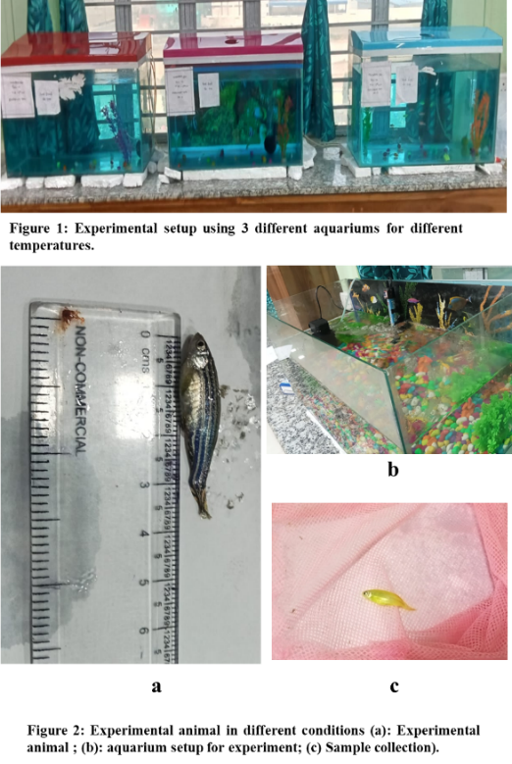
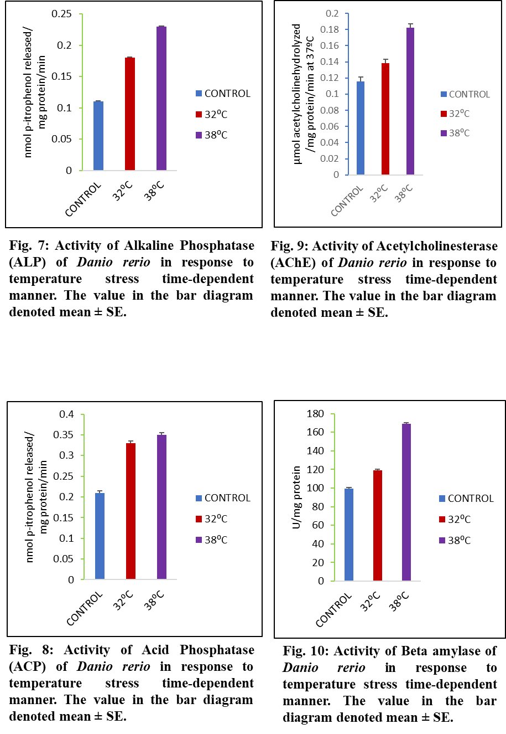
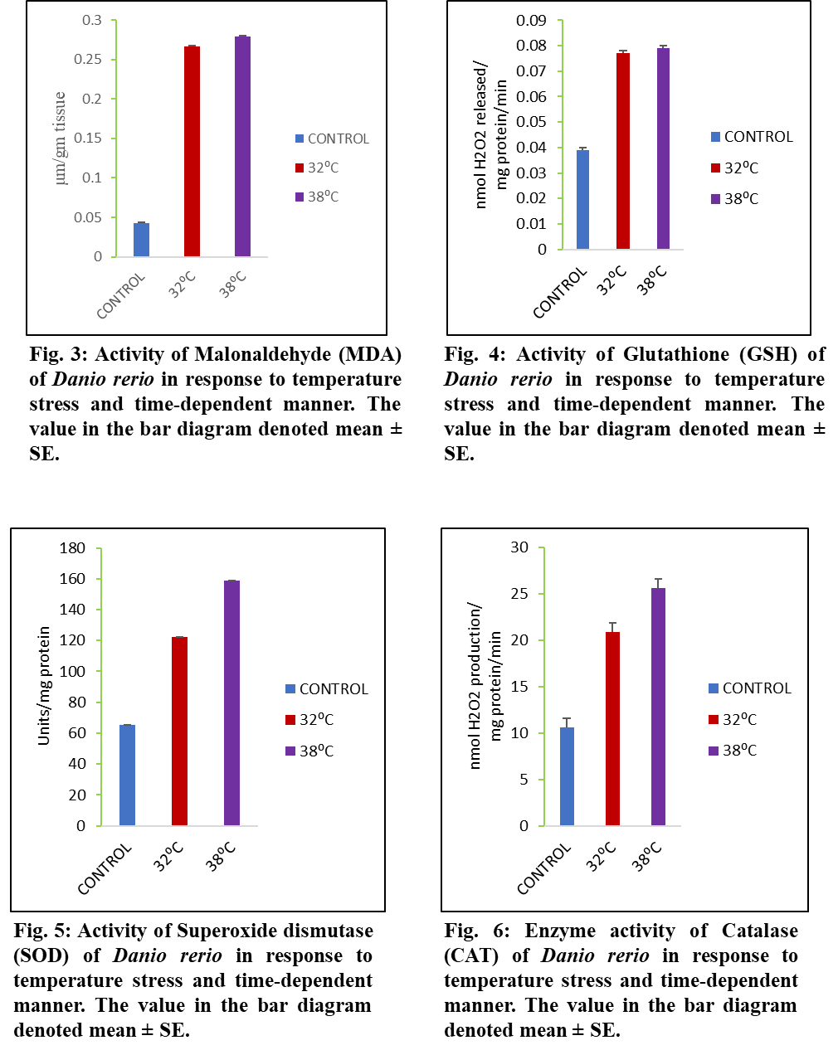
Figures
Fig. 11: Thermal stress mechanism in Danio rerio.

