Original Research Article
Seasonal availability, and proximate composition and mineral analysis of edible cephalopods at Digha coast, West Bengal, India

ABSTRACT

The present study investigates the seasonal availability, proximate composition, and mineral content of edible cephalopods from the Digha coast, West Bengal, India. Cephalopods, including species like squids, cuttlefish, and octopuses, are economically and nutritionally important seafood, contributing significantly to the local fisheries and export markets. Sampling was conducted across different seasons to assess fluctuations in species abundance and biochemical properties. The proximate analysis revealed that cephalopods are rich sources of protein (ranging from 15-17%) with less amount of lipid content, making them a healthy dietary option. Seasonal variations influenced the moisture content (70-80%) and carbohydrate levels, reflecting metabolic changes and reproductive cycles. Mineral analysis showed that these species are high in essential elements such as calcium, phosphorus, and iron highlighting their nutritional significance. Seasonal availability patterns indicated peak landings during the post-monsoon i.e. winter months, corresponding to favorable environmental conditions and spawning activities. The study underscores the importance of sustainable harvesting practices to maintain the ecological balance and long-term productivity of cephalopod resources in this region. These findings contribute to understanding the nutritional potential of cephalopods and support their effective utilization in the food industry.

Keywords: Cephalopods, seasonal availability, proximate composition, mineral analysis, sustainable fisheries

- INTRODUCTION:
Molluscs are the largest phylum among the marine water invertebrates. They serve as the primary food source for humans and other secondary consumers within ecosystems, which also include significant biological resources such as fish. Molluscs play a major role in ecosystem by filtering phytoplankton and then acting as a good source of food for higher organisms living in upper tropic level such as fishes. A number of molluscs particularly bivalves and cephalopods are consumed by human and others animals. They are also used as biological indicators as they can provide information on environmental conditions either due to the sensitivity of single species (indicator species) or because of some general feature that makes them integrate environmental signals for a long period of time.
Class Cephalopoda represents the most advanced class of the phylum Mollusca, and include some interesting members, for example, squids, octopods, cuttlefishes and so forth ^{[1]}. These species are exclusively marine, and are distributed throughout the seas of the world. The vast majority of them are free swimming shallow water predators characterized by rapid growth. More than 700 species are described today, and their number tends to increase every year as new species are discovered, particularly in tropical and polar seas ^{[2]}. These species occupy a leading place among the exploited marine fishery resources in the world, and are receiving greater importance due to their increasing demand in export ^{[3]}. These species were reported to be one-time spawners with a comparable shorter lifespan, and therefore, are favourably adapted for rapid growth ^{[1]}.
The increasing demand for cephalopods in the international market is mainly due to the increased awareness of their nutritional qualities ^{[4, 5]}. Cephalopods were reported to contain greater protein content and more than 80 percent of their total body weight comprises the edible part for consumption by human beings ^{[4]}. This speaks to a significant effect on the marketability of cephalopods, especially when contrasted with about 40 percent for shellfish and a maximum of 75 percent for teleosts ^{[3]}. In addition to this, their good sensory properties make them a preferred human delicacy. Proximate compositions and mineral analysis of cephalopods can provide nutritional value information. The cephalopods were accounted to be a rich source of long-chain n-3 polyunsaturated fatty acids, essential amino acids, antioxidants and minerals ^{[6]}. Cephalopods were found to possess a greater protein content, with over 80 percent of their entire body weight being comprised of edible parts suitable for human consumption ^{[4]}. This has noteworthy implications for the market appeal of cephalopods, particularly when compared to shellfish, which typically have around 40 percent edible content, and teleost, with a maximum of 75 percent ^{[3]}.
The cephalopods meat is utilized by local common people as their food. There is some shell fish processing industry at Digha and adjacent area like Talsari of Odisha where the shell without meat is dried unhygienically in sun shine and crushed in machine for preparation of shell dust using for preparation of lime and feed of poultry birds. Therefore, the molluscan species diversity is now going down year after year owing to water pollution, over exploitation by repeatedly collecting the same organisms, anthropogenic activities, over fishing. We make aware all the owners and workers of shell fish industries about the various utilizations of molluscs shell and meat. These cephalopod species will face significant threats in future if awareness programs are not started immediately among the fishermen, villagers, tourists, students etc. Government has taken some immediate action to protect biodiversity at Digha coast but it is not sufficient and will not be prolific until local people change themselves to acquire knowledge.
On this backdrop a research study was carried out on the marine molluscan fauna found at the Digha coast, concentrating on the edible species, their nutritional value, and the consumption habits of the local population. An effort was made to analyze the proximate compositions and minerals of cephalopods (Octopus sp., Sepia sp., Loligo sp.) from Digha, West Bengal.

- MATERIALS AND METHODS:
The present work was carried out from June 2023 to May 2024.Our total study period is divided into three seasons: pre monsoon (March - May), monsoon (June - August), post monsoon (September – February).

2.1 Study area:
Digha coastal belt (latitude 21⁰ 36´N and longitude 87⁰ 30´E) was selected for our present study. In the present work, three contrasting study sites viz. study site I (A I Digha Mohana), study site II (A II New Digha) and study site III (A III Udaypur) located along the intertidal belts of an ecotone at the confluence of water basin estuary with Bay of Bengal, West Bengal - Odisha coast, India have been selected.

2.2 Collection and identification of edible cephalopods specimen:
The cephalopods were collected from inshore water by drag net operation from three different sampling sites. The specimens were identified ^{[7, 8]}. The selected species were Sepia sp., Loligo sp. and Octopus sp.

2.3 Analysis of physico-chemical parameters of interstitial water sample:
The parameters of water viz., temperature, pH, dissolved oxygen, salinity were determined (APHA, 1998) ^{[9]}.

2.4 Analysis of proximate composition and mineral contents of edible cephalopods:
From fresh samples, 100g muscle of each was taken in a falcon tube for nutrient analysis. Only the edible parts of the cephalopods, such as the whole body of Sepia and Loligo (except viscera) and arms of octopus were taken. Proximate analysis and mineral analysis were carried out according to the standard procedure of The Association of Official Analytical Chemist ^{[10]}.

- RESULTS AND DISCUSSION:
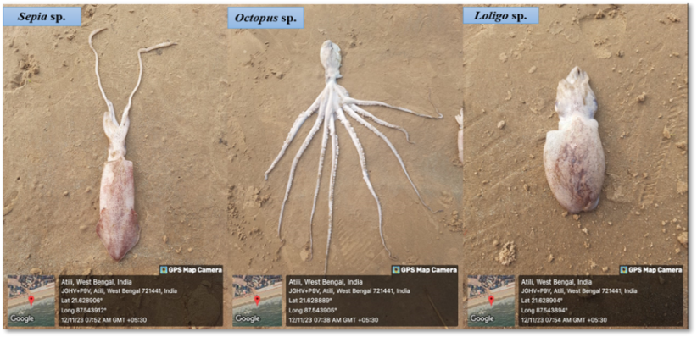
During our study period from June 2023 to May 2024, 3 species of cephalopods belonging to 3 orders, 3 families and 3 genera have been identified at Digha coast of West Bengal. Edible cephalopods molluscs species are available at Digha coast more or less throughout the year. Highest population density was in post monsoon period i.e. winter from the months of September to February due to optimum water salinity and temperature. Availability dropped down lowest in monsoon period mainly from the months of June to August due to lowest water salinity. Population density was optimum in pre monsoon season from March to May.

Fig1: During study period, 3 species of cephalopods have been identified at Digha coast of West Bengal
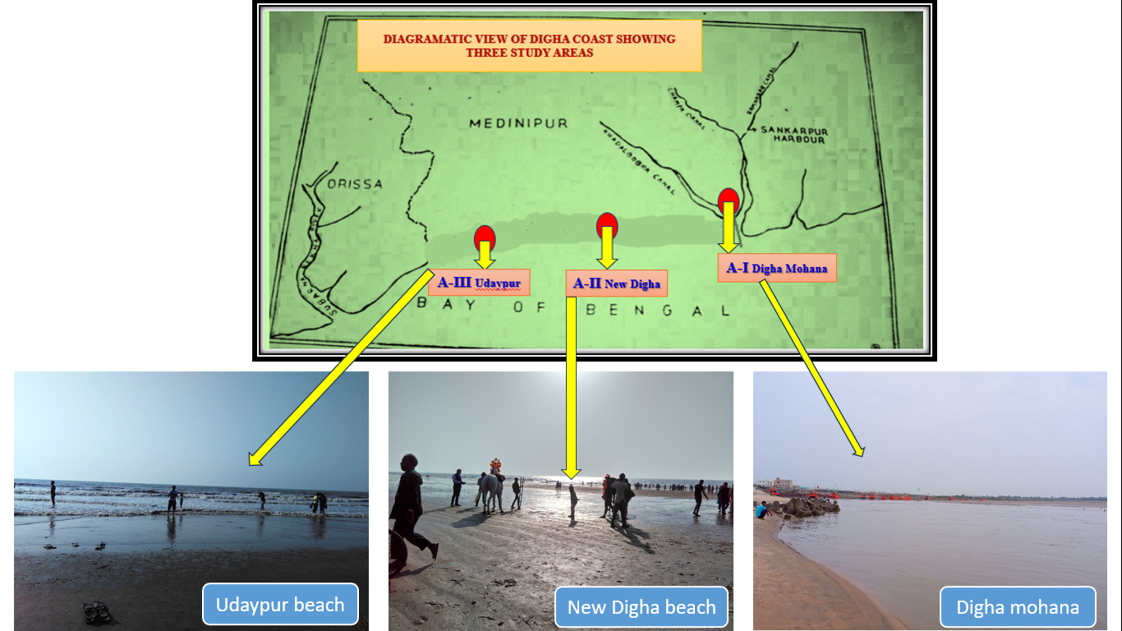

Fig2: Three different study sites of along Digha coastal belt.
This study of natural population of cephalopods at three different sampling sites revealed several points of interest with respect to sustainability of the species as well as impact of different levels of anthropogenic activities in the area. The prevalence of cephalopod species was found to be highest in the intertidal zone in these localities, which can likely be ascribed to their greater tolerance to environmental stresses such as atmospheric exposure, salinity fluctuations caused by the influx of freshwater, and pollution-induced pressure. This is especially evident in Mohana, where pollution effects include discharges from fishing boats, sewage, and land drainage. In the present study, population density of cephalopods was comparatively more at Digha Mohana. It was noted that in estuarine environments characterized by significant fluctuations in salinity, the highest abundance of numerous organisms was found at remarkably low salinity levels. Difference between populations at different locations may represent the response to different levels of stress. The differences in the densities can be accounted to the greater number of younger individuals settled and grown. Such differences of the reproductive success are common in species that use an indirect mode of reproduction and several biotic and abiotic factors can be responsible. A huge number of eroded sediments, fly ash along with several other industrial discharges mixed with the water of Bay of Bengal and have made every year this coast unsuitable for living fishes, prawns, shrimps, molluscs and other biodiversity which are economically important or not but play important role in existence of human life directly or indirectly. The water pollution is directly reflected by the steady decline of the abundance of finfish and shellfish seeds, smaller fin fishes and other nektonic forms. The data collected during last 10 years from the Department of Fishery, Government of West Bengal, relating to fish and shellfish landings at Digha and surrounding coast, reveals a rapid reduction of total landings of different fishery resources ^{[13]}.

Table 1: Familywise distribution of edible cephalopods

Specimen | A–I: Digha Mohana | A–II: New Digha | A–III: Udaypur
Loligo sp. |  |  | X
Octopus sp.
Sepia sp.

Fig3: Showing distribution of edible cephalopods in family-wise (%) from study area

Table 2: Seasonal abundance of edible cephalopod species at Digha coast
Sl No. | Specimen | Jun | July | Aug | Sep | Oct | Nov | Dec | Jan | Feb | Mar | Apr | May
Sl No. | Specimen | monsoon |  |  | post monsoon |  |  |  |  |  | pre monsoon
1 | Loligo sp. | X | X | X | + | + | + | + | + | + | + | + | +
2 | Octopus sp. | X | X | X | X | + | + | + | + | + | + | X | X
3 | Sepia sp. | X | X | X | + | + | + | + | + | + | + | + | +

Fig 4: Seasonal abundance (month wise and also season wise) of cephalopods species at Digha coast

Table 3: Seasonal (Mean) variations of Temperature (°C) of Interstitial Water collected from Digha Mohana, New Digha and Udaypur at A-I, A-II and A-III respectively during June 2023 to May 2024.

Season | A–I: Digha Mohana | A–II:New Digha | A–III:Udaypur
Monsoon ‘23 | 30 ±0.2 | 29 ±0.8 | 30 ±0.2
Post monsoon ’23- ‘24 | 15 ±0.2 | 14 ±0.9 | 13 ±0.8
Pre monsoon ‘24 | 30 ±0.7 | 30 ±0.9 | 31 ±0.9

Table 4: Seasonal (Mean) variations of pH of Interstitial Water collected from Digha Mohana, New Digha and Udaypur at A-I, A-II and A-III respectively during June 2023 to May 2024.
Season | A–I:Digha Mohana | A–II:New Digha | A–III:Udaypur
Monsoon ‘23 | 7 ±0.4 | 7 ±0.5 | 7 ±0.3
Post monsoon ’23- ‘24 | 7 ±0.7 | 7 ±0.8 | 7 ±0.5
Pre monsoon ‘24 | 8 ±0.2 | 8 ±0.5 | 7 ±0.9

In case of water pH, it is highest (8 ±0.5 ) during pre-monsoon period, 2024 at New Digha and lowest (7 ±0.3 ) during monsoon period, 2023 at Udaypur.

Table 5 : Seasonal (Mean) variations of Dissolved Oxygen (mg/l) of Interstitial Water collected from Digha Mohana, New Digha and Udaypur at A-I,A-II and A-III respectively during June 2023 to May 2024.

Season | A–I: Digha Mohana | A–II: New Digha | A–III: Udaypur
Monsoon ‘23 | 4 ±0.9 | 5 ±0.4 | 4 ±0.6
Post monsoon ’23- ‘24 | 4 ±0.2 | 3 ±0.9 | 3 ±0.6
Pre monsoon ‘24 | 3 ±0.7 | 3 ±0.8 | 3 ±0.2

The mean value of Dissolved Oxygen (DO) in water are recorded during our study. The highest DO level is 5 ± 0.4 mg/l during monsoon, 2023 at New Digha and lowest level is 3 ± 0.2 ppm during pre-monsoon, 2024 at Udaypur ghat. Overall DO level is high throughout the year due to high-speed airflow and tidal amplitude.

Table 6: Seasonal (Mean) variations of Salinity (ppt) of Interstitial Water collected from Digha Mohana, New Digha and Udaypur at A-I, A-II and A-III respectively during June 2023 to May 2024.

Season | A–I: Digha Mohana | A–II: New Digha | A–III: Udaypur
Monsoon ‘23 | 11 ±0.4 | 10 ±0.1 | 8 ±0.5
Post monsoon ’23- ‘24 | 17 ±0.1 | 15 ±0.8 | 14 ±0.2
Pre monsoon ‘24 | 25 ±0.9 | 22 ±0.6 | 21 ±0.3

The highest salinity of water (25 ± 0.9 ppt) is recorded during pre-monsoon period, 2024 at Digha Mohana and lowest (8 ± 0.5 ppt) during monsoon, 2023 at Udaypur ghat. The high-water salinity fluctuation is occurred due to high temperature in summer hours and direct rainfall on sea water in rainy season.
From time immemorial, Cephalopods have been considered as a dietary component by human beings due to their nutritive value. The proximate analysis of our study has shown a promising value in every parameter that is similar to the proximate analysis of cephalopods by Zlatanos et al. (2006) ^{[6]}. The average protein was found 17.08%, 15.63%, and 14.98% where ash was 0.41%, 0.39%, and 0.77% for Sepia, Loligo, and Octopus, respectively. In terms of fat composition, Sepia, Loligo, and Octopus, exhibited small amounts at 1.39%, 1.78%, and 2.89% respectively. The carbohydrate content (%), on the other hand, was determined as 0.61%, 0.73%, and 0.57% for Sepia, Loligo, and Octopus, respectively. The moisture content (%) for the three cephalopods was 82.01%, 82.76.%, and 81.29% for Sepia, Loligo, and Octopus respectively.

Table 7:Proximate composition of marine edible cephalopods available at Digha coast:

Contents | Sepia | Loligo | Octopus
Protein (%) | 17.08% | 15.63% | 14.98%
Ash (%) | 0.41% | 0.39% | 0.77%
Fat (%) | 1.39% | 1.78% | 2.89%
Carbohydrate (%) | 0.61% | 0.73% | 0.57%
Moisture (%) | 82.01% | 82.76.% | 81.29%

Three essential mineral elements were measured during our study. Sepia, Loligo, and Octopus exhibit calcium levels of 431.83mg, 382.39mg, and 471.89 mg per 100g, respectively. In terms of phosphorus and iron content, Sepia, Loligo, and Octopus contain 415.6 mg, 404.65mg, and 389.43 mg of phosphorus, and 56.46mg, 99.49mg, and 26.24 mg of iron, respectively, per 100g. Both the Octopus and Sepia showed a good amount of calcium and phosphorus, while the Loligo proved to be an ideal source of iron.

Table 8: Mineral contents of marine edible cephalopods available at Digha coast:

Contents | Sepia | Loligo | Octopus
Calcium (mg/100g) | 431.83 mg | 382.39 mg | 471.89 mg
Phosphorus (mg/100g) | 415.6 mg | 404.65mg | 389.43 mg
Iron (mg/100g) | 56.46mg | 99.49mg | 26.24 mg

Therefore, these deep-sea species were found to be significantly valuable sources of protein. The increasing demand for cephalopods in the global market is mostly because of the increased awareness about their nutritional qualities. Cephalopods include various fascinating creatures such as octopuses, squids, cuttlefishes. They are known for their advanced intelligence among invertebrates and are highly adapted to their aquatic environments. They are undoubtedly an essential seafood source for human consumption. All the three cephalopods have shown quite the same amount of protein as commonly consumed fishes (Rohu, Catla, Hilsa) and one shrimp species ^{[14]}. The findings suggest that these organisms serve as outstanding sources of protein while containing minimal amounts of fat. The lower amount of fat of cephalopods also proves them leaner than other groups in the comparison. Thus, cephalopods can be a promising source of animal protein in our country. On the other hand, Minerals are an essential part of the diet of any living organism, as it is required by the body to carry out various important metabolic functions. Both the octopus and cuttlefish showed a good amount of calcium and phosphorus, while the squid proved to be an ideal source of iron.

4.CONCLUSION:
Our research study demonstrated that the commonly available cephalopods are a rich storehouse of key nutritional elements required by the human nutrition and metabolic pool. Notwithstanding this, these species were found to be the valuable source of numerous critical micro and macro minerals and vitamins, which are fundamental for the metabolic functioning of the body. The results obtained from this study will provide useful information for seafood industries and the utilization of the cephalopod species as potential health food. But Digha is now under heavy pressure due to gathering of tourists in huge number. The molluscan species diversity is now going down year after year owing to water pollution, over exploitation by repeatedly collecting the same organisms, anthropogenic activities, over fishing. These cephalopod species will face significant threats in future if awareness programs are not started immediately among the fishermen, villagers, tourists, students etc. Government has taken some immediate action to protect biodiversity at Digha coast but it is not sufficient and will not be prolific until local people change themselves to acquire knowledge.

- DISCLAIMER:
Author(s) hereby declare that NO generative AI technologies such as Large Language Models (ChatGPT, COPILOT, etc.) and text-to-image generators have been used during the writing or editing of this manuscript.

- COMPETING INTERESTS:
Authors have declared that no competing interests exist.

- REFERENCES:
- Boyle, P.R. and Rodhouse, P. (2005). Cephalopods. Ecology and Fisheries. Oxford: Blackwell Science, p. 452
- Sweeney, M.J. and Roper, C.F.E. (1998). Classification, type localities, and type repositories of recent Cephalopoda. Contributions to Zoology. 586:561-599.
- Kreuzer, R. (1984). Cephalopods: handling, processing and products. Fisheries Technical Paper No. 254, FAO, Italy: Rome, p. 108.
- Lee, P.G. (1994). Nutrition of cephalopods: Fuelling the system. Marine and Fresh water Behaviour and Physiology, 25:35-51.
- Okuzumi, M. and Fujii, T. (2000). Nutritional and functional properties of squid and cuttlefish. In Okuzumi, M., and Fujii, T. (Eds). National Cooperative Association of Squid Processors, Tokyo: 35th Anniversary Commemorative Publication. p. 223.
- Zlatanos, S., Laskaridis, K., Feist, C. and Sagredos, A. (2006). Proximate composition, fatty acid analysis and protein digestibility‐corrected amino acid score of three Mediterranean cephalopods. Molecular nutrition & food research, 50(10): 967-970.
- Roper, C.F.E., Sweeney, M.J. and Nauen, C.E. (1984). FAO species catalogue. Vol. 3. Cephalopods of the world. An annotated and illustrated catalogue of species of interest to fisheries. FAO Species Catalogue for Fishery Purposes, FAO: Rome. 1(4), 277p.
- Mujiono, N. and Ibrahim, P.S. (2022). Relationship of Cephalopods Orders Based on Morphological Characters. Jurnal Kelautan Tropis, 25(1):11-19.
- APHA. (1998). Standard methods for the examination of water and waste water. 20th Ed., American public health Association, Washington DC 20005-2605, USA. ISBN: 0-87553-235-7. ISSN: 55-1979.
- William, H. (2005). AOAC, Official Methods of Analysis of the Association of Official Analytical Chemists. Chapt, 4: 01-45.
- McNichol, J., MacDougall, K., Melanson, J. and McGinn, P. (2012). Suitability of Soxhlet extraction to quantify microalgal fatty acids as determined by comparison with in situ Transesterification. Lipids. 2012(47): 195-207.
- Lall, S.P. and Lewis-McCrea, L.M. (2007). Role of nutrients in skeletal metabolism and pathology in fish-an overview. Aquaculture. 267(1-4): 3-19.
- Chakraborty S.K. (2010). Coastal Environment of Midnapore, West Bengal: Potential Threats and Management, India. Journal of Coastal Environment. 1(1): 27-40
- Bogard, J.R., Thilsted, S.H., Marks, G.C., Wahab, M.A., Hossain, M.A., Jakobsen, J. and Stangoulis, J. (2015). Nutrient composition of important fish species in Bangladesh and potential contribution to recommended nutrient intakes. Journal of Food Composition and Analysis. 42: 120-133.

