Fish Assemblage Structure and Biodiversity in the Han and Cu De Rivers, Central Vietnam

.
ABSTRACT

Estuarine ecosystems are among the most biodiverse yet increasingly threatened environments worldwide, particularly in tropical coastal regions where river and marine systems interact. This study investigated the structure, species composition, and seasonal variation of fish assemblages in the Han River and Cu De River systems in Da Nang City, central Vietnam. Field surveys were conducted during the rainy season (September–December 2024) and dry season (March–June 2025) at major fish landing sites and aquatic product collection points along the two river basins. A total of 957 specimens were collected and analyzed using morphological identification methods. Overall, 166 fish species belonging to 122 genera, 64 families, and 21 orders were recorded. The Han River supported 109 species, whereas 99 species were recorded in the Cu De River, with only 42 species shared between the two rivers, indicating clear spatial differentiation in fish assemblage structure. Taxonomic composition showed that Cypriniformes dominated the freshwater fauna, particularly in the Cu De River, whereas Acanthuriformes, Carangiformes, and Gobiiformes were more abundant in the Han River due to strong estuarine and tidal influences. Seasonal variation was also evident, with 121 species recorded during the dry season compared with 75 species in the rainy season, reflecting hydrological influences on fish migration and habitat availability. Comparative analyses with other Vietnamese river systems suggest that the fish fauna of the study area represents a distinct assemblage characteristic of central Vietnamese coastal rivers, functioning as a biogeographical transition zone between freshwater and marine ecosystems. In addition, 12 species of conservation concern were identified according to the Vietnam Red Data Book and the IUCN Red List, highlighting the ecological importance of these river systems. These findings provide important baseline data for biodiversity conservation and sustainable fisheries management in central Vietnam.

Keywords: Fish assemblage; species composition; estuarine; seasonal variation; central Vietnam

1. INTRODUCTION

Freshwater ecosystems support a disproportionately high share of global biodiversity while occupying only a small fraction of the Earth's surface. Among these ecosystems, rivers and estuaries form highly dynamic environments that sustain diverse biological communities and provide essential ecosystem services for human societies. River systems regulate hydrological processes, transport nutrients and sediments, and maintain ecological connectivity between terrestrial and marine environments. Estuaries, where freshwater mixes with seawater, represent transitional habitats characterized by strong environmental gradients in salinity, turbidity, and productivity. These conditions often support high levels of biological diversity and productivity, particularly for fish communities that utilize these areas for feeding, spawning, and nursery functions (Blaber, 2000; McDowall, 1976; Whitfield et al., 2023).

Fish assemblages are widely recognized as key indicators of ecological integrity in river and estuarine ecosystems. Because fish occupy multiple trophic levels and respond sensitively to environmental changes, variations in their diversity, distribution, and community structure can reflect broader ecosystem conditions (Karr, 1981; Moyle & Cech, 2004a). In river–estuary systems, fish assemblage structure is often shaped by interactions between freshwater discharge, tidal influence, habitat heterogeneity, and seasonal hydrological variability. These environmental drivers influence species composition by regulating migration patterns, habitat availability, and reproductive cycles of many freshwater, estuarine, and marine species.

Despite their ecological importance, river and estuarine ecosystems are among the most threatened aquatic environments worldwide. Rapid urbanization, industrialization, land-use change, and hydrological modification have significantly altered many river systems, leading to habitat degradation, water pollution, and declining biodiversity (Dudgeon et al., 2006; Vörösmarty et al., 2010). In coastal regions, estuarine habitats are particularly vulnerable to anthropogenic disturbances because they often coincide with areas of intense human development. Climate change further exacerbates these pressures by altering rainfall patterns, increasing the frequency of extreme flooding events, and intensifying salinity intrusion in coastal rivers (IPCC, 2021). Understanding the structure and dynamics of fish assemblages in river–estuary systems is therefore essential for developing effective conservation and fisheries management strategies.

Vietnam possesses an extensive network of river systems that play a critical role in supporting aquatic biodiversity and local livelihoods. Inland and coastal fisheries provide an important source of food and income for many communities, particularly in coastal provinces where river–estuary systems support productive fisheries resources (Nguyen & De Silva, 2006). However, many Vietnamese river ecosystems are currently experiencing increasing environmental pressures associated with rapid socio-economic development. Urban expansion, industrial discharge, agricultural runoff, and aquaculture activities have contributed to declining water quality and habitat degradation in several river basins (Khoi & Suetsugi, 2014; Tram et al., 2022). These environmental changes may significantly affect fish communities by altering ecological connectivity and modifying habitat conditions.

Central Vietnam represents a particularly important region for studying river and estuarine biodiversity because of its distinctive geographical and hydrological characteristics. Rivers in this region are typically short and steep, originating from the Truong Son mountain range and flowing directly into the East Sea. As a result, strong environmental gradients develop along the river continuum, from upstream freshwater habitats to downstream estuarine environments influenced by tidal processes. These gradients promote the coexistence of freshwater species, estuarine specialists, and marine migrants within relatively small spatial scales. Consequently, many coastal rivers in central Vietnam function as biogeographical transition zones where fish assemblages integrate elements from both freshwater and marine ecosystems (Nguyen & De Silva, 2006; Rainboth, 1996).

Da Nang City, located along the central Vietnamese coastline, contains several river systems that play important ecological and socio-economic roles. Among these, the Han River and Cu De River represent two major hydrological systems that significantly influence water resources, fisheries production, and environmental conditions in the region. The Han River functions as the main drainage outlet of the Vu Gia–Thu Bon river basin, which covers an area of approximately 5,180 km². Flowing through the urban center of Da Nang before discharging into the East Sea, the river is strongly influenced by tidal dynamics and estuarine processes. This river–estuary connectivity allows the Han River to support diverse fish communities including freshwater, estuarine, and marine-associated species.

In contrast, the Cu De River, located in the northern part of Da Nang, forms a relatively independent watershed with an area of approximately 426 km². Compared with the Han River, the Cu De River basin is less urbanized and retains stronger freshwater characteristics. The river has been identified as a strategic freshwater resource for Da Nang City and is planned to supply approximately 360,000 m³ of water per day by 2030 to meet increasing domestic and industrial demand (Thoa & Minh, 2014). Maintaining ecological integrity and biodiversity in this river system is therefore critical for both environmental conservation and sustainable water resource management.

Despite their ecological importance, both river systems are increasingly exposed to environmental pressures associated with urban development, tourism expansion, and land-use change. Increased wastewater discharge, sedimentation, and habitat modification may affect water quality and aquatic habitats, particularly in the lower reaches of the Han River. Meanwhile, agricultural activities and aquaculture operations in upstream areas may introduce nutrient enrichment and organic pollutants into the Cu De River basin. Such environmental changes may alter fish assemblage structure by affecting habitat availability, migration pathways, and ecological connectivity between riverine and estuarine environments.

Although several studies have investigated hydrological conditions and water resources in the Han and Cu De rivers, comprehensive assessments of fish assemblage structure and biodiversity across the river–estuary continuum remain limited. Most existing research has focused on environmental monitoring or water management, while systematic surveys of fish communities are still scarce. The lack of baseline information on fish diversity and distribution presents a major challenge for biodiversity conservation and fisheries management in these river systems.

Therefore, the present study aims to investigate the fish assemblage structure and biodiversity of the Han River and Cu De River systems in Da Nang City, central Vietnam. Specifically, the objectives of this study are to: document the species composition and taxonomic diversity of fish communities in the two river systems; and evaluate the ecological and conservation significance of fish biodiversity within these coastal river ecosystems. By providing comprehensive baseline information on fish assemblages in the Han and Cu De rivers, this study contributes to a better understanding of river–estuary biodiversity dynamics in central Vietnam and supports the development of sustainable fisheries management and aquatic biodiversity conservation strategies.

This study provides one of the first comprehensive assessments of fish assemblage structure and biodiversity in the Han and Cu De river systems, two important coastal rivers in central Vietnam that have received limited attention in ichthyological research. By integrating seasonal field surveys, taxonomic identification, and comparative ecological analyses, the study generates a baseline inventory of fish diversity and reveals clear spatial and seasonal patterns in fish assemblages across river–estuary gradients. In addition, the research highlights the biogeographical significance of central Vietnamese rivers as transition zones between freshwater and marine ecosystems, while documenting several species of conservation concern. These findings contribute new knowledge to regional freshwater biodiversity studies and provide essential scientific information to support biodiversity conservation, fisheries management, and sustainable river ecosystem management in central Vietnam.

2. material and methods

2.1 Study period, study area, and target organisms

Study period: Field surveys were conducted during two sampling campaigns representing the main seasonal hydrological conditions in central Vietnam. The first campaign was carried out from September to December 2024, corresponding to the rainy season, whereas the second campaign was conducted from March to June 2025, representing the dry season. Each campaign lasted four months, with sampling activities performed twice per month in order to capture temporal variability in fish assemblages.

Study area: Sampling was conducted at fish landing sites, fishing ports, and major aquatic product collection points distributed along the Han River and Cu De River basins in Da Nang City, central Vietnam. These locations represent important areas where locally captured fish are concentrated and traded, thereby allowing efficient collection of representative fish specimens from different fishing activities occurring along the rivers. The Han River serves as the principal drainage outlet of the Vu Gia River system and flows through the urban center of Da Nang before discharging into the East Sea. Due to its urban setting, the river is influenced by various anthropogenic activities including urban wastewater discharge, tourism development, and transportation. In contrast, the Cu De River, located in the northern part of Da Nang, drains a relatively smaller and less urbanized watershed. This river system retains more natural environmental characteristics and has been identified as a key freshwater supply source for the city under regional water resource planning. The two rivers therefore represent distinct ecological settings that may influence fish diversity and community composition.

Target organisms: The study focused on fish species composition and economically valuable fish groups occurring within the Han River and Cu De River systems. Both freshwater and estuarine fish species captured by local fisheries were included in the investigation.

2.2 Field survey and specimen collection

Sample collection and preservation: Fish specimens were obtained through field surveys conducted at fishing ports and landing sites where local fishermen landed their catches. Specimens representing different species were selected from the catches and immediately processed in the field. Each specimen was photographed for documentation, labeled with a unique identification code, and temporarily preserved under cold storage conditions during transport to the laboratory. This procedure ensured that morphological characteristics remained intact for subsequent taxonomic analysis.

Interviews and local ecological knowledge: To complement field sampling, direct interviews with local fishermen were conducted to obtain additional information regarding fish diversity and fishery resources in the study area. Fishermen provided valuable insights on commonly encountered species, seasonal occurrence, and economically important fish species in both river systems. Such information was used to supplement the species inventory and to identify key fishery resources in the region.

2.3 Laboratory processing and specimen identification

A total of 957 fish specimens were collected during the study period (Table 1). All specimens were transported to the laboratory of the University of Science and Education – The University of Danang for detailed examination.

Table 1. Sampling period, study sites, and number of collected specimens

Sampling period | Number of specimens (n) |  | Total (n)
Sampling period | Han River | Cu De River | Total (n)
Rainy season (Sep–Dec 2024) | 235 | 140 | 375
Dry season (Mar–Jun 2025) | 312 | 270 | 582
Total | 547 | 410 | 957

In the laboratory, each specimen underwent morphometric measurements and meristic counts following standard ichthyological procedures. Morphological characteristics including body length, fin ray counts, scale counts, and other diagnostic features were recorded to facilitate species identification.

After analysis, the specimens were fixed and preserved in 4–10% formalin solution to ensure long-term storage and to allow future verification or reference.

2.4 Study period, study area, and target organisms

Fish specimens were identified to the lowest possible taxonomic level based on morphological characteristics and meristic measurements. The identification process followed established taxonomic keys and reference literature including works by Allen (1985), Böhlke & McCosker (2001), Mai et al. (1992), Shen et al. (1993), Truong & Tran (1993), Rainboth (1996), Allen (1997) Allen et al. (2015), Carpenter & Niem (1999a, 1999b, 2001a, 2001b), Böhlke & McCosker (2001), Nguyen (1999, 2001a), Nguyen (2001b, 2008), Nguyen & Ngo (2001), Nakabo (2002), Nguyen (2005a, 2005b), Do (2007), Nguyen & Truong (2007), Nguyen et al. (2007), Rainboth et al. (2012), Smith (2012), Tran et al. (2013), Kimura et al. (2018), Smith et al. (2019), Koeda & Ho (2020a, 2020b), Shibukawa (2021), Nguyen (2022), and Apinun & Utsugi (2023).

To ensure taxonomic consistency and accuracy, the scientific names of all recorded fish species were verified and standardized according to the FishBase database (Froese & Pauly, 2025). This process helped eliminate taxonomic synonyms and update species names to their currently accepted nomenclature, thereby ensuring the reliability of the species checklist.

2.5 Data analysis and statistical processing

All collected data were compiled and organized using Microsoft Excel to generate the primary dataset, including species presence, abundance, sampling period, and sampling location. Prior to statistical analysis, the data matrix consisting of species abundance per sampling site and season was standardized to minimize the influence of highly abundant species and to improve comparability among samples.

Community analysis: The similarity in species composition between the Han River and Cu De River was evaluated using the Bray–Curtis similarity index, which is commonly used in ecological community analysis due to its sensitivity to species abundance patterns (Clarke & Warwick, 2001). The similarity matrix was calculated using PRIMER-E version 6.0 (Clarke & Gorley, 2006). Cluster analysis and similarity matrices were then used to examine the degree of similarity in fish assemblage structure between sampling sites and seasons.

Multivariate analysis: To further explore patterns in fish community composition and identify major gradients influencing species distribution, Principal Component Analysis (PCA) was performed using CANOCO version 4.5. PCA is an unconstrained ordination technique that reduces multidimensional ecological data into a smaller number of orthogonal axes, thereby facilitating interpretation of species–site relationships and community patterns (Legendre & Legendre, 1998; ter Braak & Smilauer, 2002).

Analytical framework: All multivariate analyses followed the methodological frameworks described by (Legendre & Legendre, 1998) for numerical ecology and (ter Braak & Smilauer, 2002) and (Lepš & Šmilauer, 2003) for community ordination analysis. These approaches are widely used in aquatic ecology to examine patterns in species assemblages and to interpret ecological gradients influencing community structure.

3. results and discussion

3.1 Taxonomic structure and diversity of the fish fauna

Based on the combined results of field surveys conducted during the rainy season and dry season, a total of 166 fish species were identified from the Han River and Cu De River basins in Da Nang City. These species belong to 21 orders, 64 families, and 122 genera (Table 2 and Appendix).

Table 2. Taxonomic structure of fish fauna in the Han River and Cu De River, Da Nang

No. | Order | Families |  | Genera |  | Species
No. | Order | n | % | n | % | n | %
1 | Osteoglossiformes | 1 | 1.6 | 1 | 0.8 | 1 | 0.6
2 | Elopiformes | 1 | 1.6 | 1 | 0.8 | 1 | 0.6
3 | Anguilliformes | 4 | 6.3 | 5 | 4.1 | 5 | 3.0
4 | Clupeiformes | 3 | 4.7 | 8 | 6.6 | 9 | 5.4
5 | Cypriniformes | 7 | 10.9 | 24 | 19.7 | 32 | 19.3
6 | Siluriformes | 5 | 7.8 | 8 | 6.6 | 12 | 7.2
7 | Aulopiformes | 1 | 1.6 | 3 | 2.5 | 3 | 1.8
8 | Gobiiformes | 3 | 4.7 | 12 | 9.8 | 16 | 9.6
9 | Syngnathiformes | 1 | 1.6 | 1 | 0.8 | 1 | 0.6
10 | Scombriformes | 2 | 3.1 | 2 | 1.6 | 2 | 1.2
11 | Synbranchiformes | 2 | 3.1 | 3 | 2.5 | 3 | 1.8
12 | Anabantiformes | 3 | 4.7 | 3 | 2.5 | 4 | 2.4
13 | Carangiformes | 8 | 12.5 | 12 | 9.8 | 19 | 11.4
14 | Atheriniformes | 1 | 1.6 | 1 | 0.8 | 1 | 0.6
15 | Beloniformes | 3 | 4.7 | 3 | 2.5 | 4 | 2.4
16 | Cichliformes | 1 | 1.6 | 2 | 1.6 | 3 | 1.8
17 | Mugiliformes | 2 | 3.1 | 4 | 3.3 | 10 | 6.0
18 | Perciformes | 2 | 3.1 | 3 | 2.5 | 4 | 2.4
19 | Centrachiformes | 1 | 1.6 | 3 | 2.5 | 4 | 2.4
20 | Acanthuriformes | 11 | 17.2 | 16 | 13.1 | 24 | 14.5
21 | Tetraodontiformes | 2 | 3.1 | 7 | 5.7 | 8 | 4.8
Total |  | 64 | 100 | 122 | 100 | 166 | 100

Analysis of the taxonomic structure indicates that the fish fauna in the study area is relatively diverse but strongly dominated by several major taxonomic groups.

Order-level diversity: Fish assemblages were largely dominated by six orders: Cypriniformes, Acanthuriformes, Carangiformes, Gobiiformes, Siluriformes, and Mugiliformes. Among these, Cypriniformes exhibited the highest diversity, comprising 32 species (19.3%), as well as the highest diversity of families and genera. Other relatively abundant groups included Clupeiformes and Tetraodontiformes, accounting for 4.8–5.4% of the total species richness. The remaining 13 orders were represented by only 1–5 species each, accounting for 0.6–3.0% of the total species (Table 2).

Family-level diversity: Among the 64 recorded families, species richness was concentrated in several families characteristic of freshwater and estuarine habitats. The most diverse family was Cyprinidae, with 16 species (9.6%) distributed across 12 genera. This was followed by Gobiidae (11 species; 6.6%), Carangidae (8 species; 4.8%), and Tetraodontidae (7 species; 4.2%). Most of the remaining families were represented by 1–4 species, indicating a relatively even but dispersed taxonomic distribution.

Genus-level diversity: A notable characteristic of the fish fauna in the study area is the high proportion of monotypic genera. Among the 122 recorded genera, 94 genera (77.0%) were represented by only a single species. In contrast, 23 genera contained two species (e.g., Oreochromis, Sardinella, Balitora, Cobitis, Misgurnus, Cyprinus, Onychostoma, Poropuntius, and Tor), while only a few genera contained 3–4 species, such as Ambassis, Lutjanus, and Tachysurus.

This pattern indicates that although the fish fauna exhibits high taxonomic diversity, it also reflects strong local ecological specialization, where each river basin hosts distinctive assemblages. Such taxonomic patterns are typical of tropical aquatic ecosystems, where species richness is high but many taxa have relatively restricted distributions.

3.2 Spatial distribution patterns and ecological characteristics of the fish fauna

Although the Han River and Cu De River are located within the same geographic region of Da Nang City, the fish species composition between the two river systems shows clear spatial ecological differentiation. Out of the 166 recorded species, only 42 species (25.3%) were found in both river systems. Meanwhile, 67 species (40.4%) were recorded exclusively in the Han River and 57 species (34.3%) were found only in the Cu De River. The relatively low proportion of shared species indicates substantial differences in environmental conditions, hydrological regimes, and habitat structures between the two river basins. These environmental differences have shaped distinct fish assemblages in each river system, leading to clear spatial differentiation in fish community structure even within the same geographic region.

The Han River exhibited relatively high diversity, with 109 species belonging to 53 families and 86 genera. The fish assemblage was dominated by marine and estuarine-associated taxa, particularly Acanthuriformes (20.2%), Carangiformes (12.8%), and Gobiiformes (10.1%). Other notable groups included Cypriniformes (8.3%), Mugiliformes (7.3%), and Clupeiformes (5.5%) (Figure 1). This taxonomic composition clearly reflects the estuarine–marine transitional nature of the Han River, where tidal influence and connectivity with coastal waters allow the occurrence of many marine or euryhaline species.
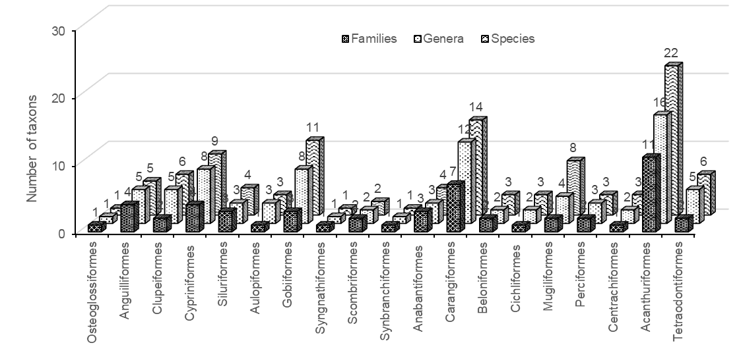

Figure 1. Taxonomic structure of the fish community in the Han River

In contrast, the Cu De River supported 99 species belonging to 45 families and 80 genera. The fish assemblage exhibited characteristics typical of freshwater river ecosystems, with Cypriniformes dominating (28.3%), followed by Carangiformes (10.1%), Siluriformes, and Gobiiformes (9.1%) (Figure 2). Compared to the Han River, marine influence in the Cu De River is relatively limited, and the fish fauna is primarily composed of freshwater species adapted to riverine habitats, especially those associated with fast-flowing upstream environments.

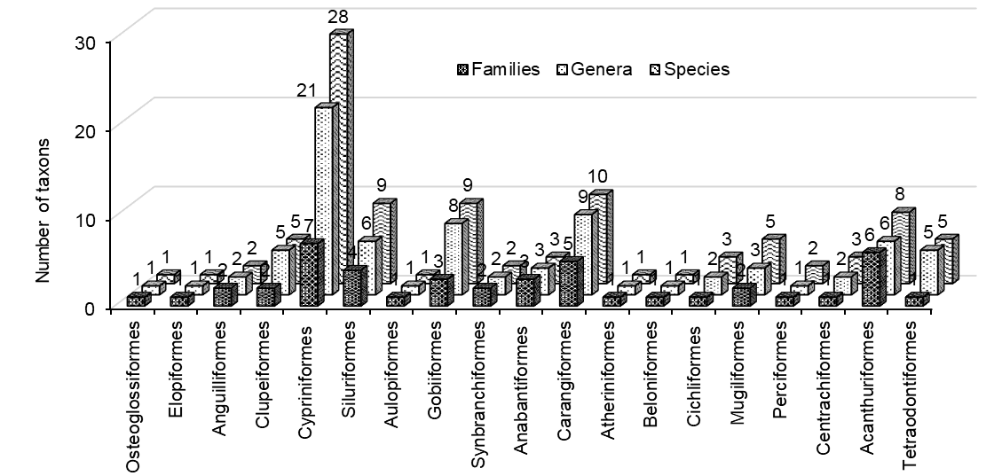

Figure 2. Taxonomic structure of the fish community in the Cu De River

3.3 Seasonal variation in species richness and taxonomic composition

Seasonal variation in fish assemblages was clearly observed in the study area. The total number of recorded species during the dry season reached 121 species, which was approximately 1.6 times higher than that recorded during the rainy season (75 species).

A similar trend was observed in both river systems, Han river having 81 species in dry season and 46 species in rainy season, whereas Cu De River having 70 species in dry season and 44 species in rainy season. Interestingly, the number of species occurring in both seasons was relatively low (30 species in the dry season and 15 species in the rainy season) (Figure 3).

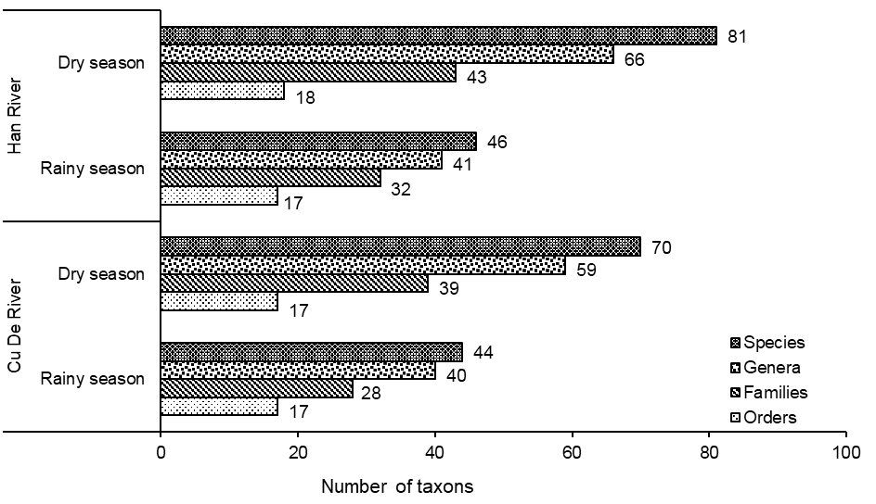

Figure 3. Seasonal variation in taxonomic structure (rainy vs. dry season) in the Han and Cu De Rivers

This pronounced seasonal variation likely reflects fish migration patterns associated with spawning, feeding, and avoidance of unfavorable environmental conditions. During the rainy season, increased river discharge, high turbidity, and sudden changes in salinity may cause many fish species to migrate toward more stable habitats such as estuarine or coastal waters. In contrast, the dry season typically provides more stable environmental conditions, allowing greater species diversity to be recorded in the river systems.

3.4 Comparison of fish assemblages with other river systems in Vietnam

To better understand the biogeographical characteristics of the fish fauna in the study area, species composition was compared with fish assemblages reported from six other river systems in Vietnam: O Lau River, Truoi River (Hue City), Ba River (Dak Lak – Phu Yen), Soai Rap River (Ho Chi Minh City), Co Chien River (Ben Tre), and Cai Lon River (An Giang–Kien Giang). Cluster analysis based on species similarity revealed two major ecological–geographical groups of fish assemblages: Group 1 (Soai Rap River and Co Chien River) and Group 2 (Truoi River, O Lau River, Ba River, Han River, Cu De River, Phan River, and Cai Lon River) (Figure 4).

The similarity index among river systems ranged from 0.0% to 53.2%, indicating considerable geographical differentiation in fish assemblages (Table 3). The highest similarity values were observed between O Lau – Truoi (53.2%), Cu De – Han (40.4%), Cu De – Truoi (40.0%), O Lau – Ba River (39.4%), O Lau – Cu De (36.9%), and Truoi – Han (36.1%). These results reflect the shared hydrological characteristics of central Vietnamese rivers, which are generally short, steep, and discharge directly into the sea. In contrast, the Phan River showed very low similarity with southern river systems (0.0–9.2%), reflecting strong ecological differentiation between northern inland rivers and southern estuarine systems influenced by tidal regimes (Table 3 and Figure 4).

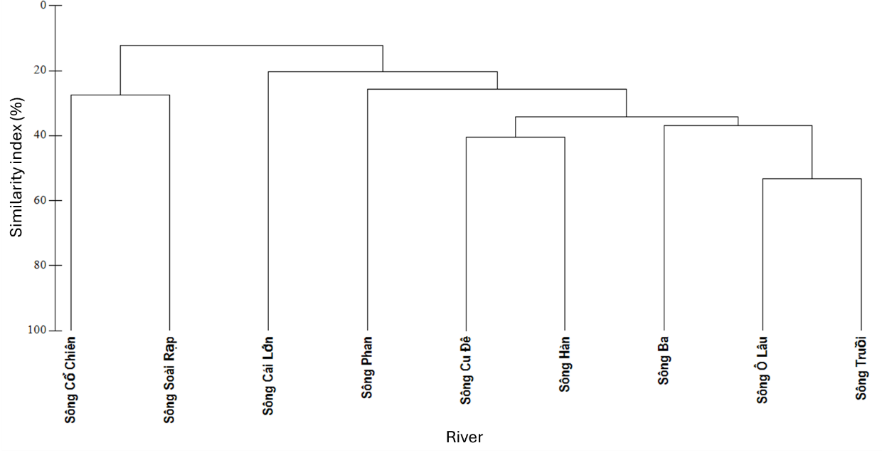

Figure 4. Percent similarity of fish assemblages among study sites.

Table 3. Bray–Curtis similarity index of fish assemblages among rivers

River | River Ba | River Cai Lon | River Co Chien | River Cu De | River Han | River O Lau | River Phan | River Soai Rap | River Truoi
River Ba
River Cai Lon | 29.2
River Co Chien | 13.4 | 27.1
River Cu De | 31.7 | 16.7 | 14.9
River Han | 29.9 | 26.7 | 26.3 | 40.4
River O Lau | 39.4 | 21.5 | 11.2 | 36.9 | 30.6
River Phan | 21.8 | 9.2 | 3.0 | 23.1 | 19.3 | 34.1
River Soai Rap | 9.3 | 8.2 | 27.4 | 13.2 | 20.3 | 3.4 | 0.0
River Truoi | 34.3 | 17.9 | 10.1 | 40.0 | 36.1 | 53.2 | 30.1 | 10.7

The fish diversity recorded in the Han River and Cu De River (166 species) reflects a relatively high level of biodiversity compared with many other surveyed river systems in Vietnam. For example, surveys conducted in the Red River basin in Yen Bai Province identified approximately 110 fish species belonging to 69 genera and 20 families, with Cypriniformes being the dominant order in terms of species richness.

Similarly, earlier investigations in the Dong Nai River basin reported around 107–130 species of freshwater and brackish-water fishes, highlighting the ecological importance of large river systems in southern Vietnam for maintaining fish diversity.

Compared with these systems, the diversity recorded in the present study is relatively high despite the smaller watershed area of the Han and Cu De rivers. This pattern may partly reflect the strong connectivity between freshwater and marine environments, particularly in the Han River estuary, which allows the coexistence of freshwater, estuarine, and marine-associated species. In many tropical river systems, such connectivity significantly increases species richness because estuarine areas function as ecological transition zones where species from multiple habitats overlap.

Another important feature shared between the present study and other Vietnamese river studies is the dominance of Cypriniformes in freshwater habitats. Numerous investigations across Vietnam consistently report Cypriniformes as the most species-rich order in inland waters due to the ecological adaptability and evolutionary diversification of the family Cyprinidae in Southeast Asian river systems. This pattern has been observed not only in the Red River basin but also in mountainous river systems across northern and central Vietnam.

Furthermore, the relatively high proportion of monotypic genera (77%) recorded in the present study is consistent with biodiversity patterns in tropical river ecosystems, where many fish taxa have restricted distributions and are often confined to specific river basins or habitat types. Studies of riverine biodiversity in the central Truong Son region have similarly reported that several fish species are restricted to particular river sections or drainage systems, reflecting strong environmental filtering and local adaptation.

Overall, these comparisons suggest that the fish fauna of the Han and Cu De rivers represents a transitional ichthyofaunal assemblage combining characteristics of freshwater upland rivers and coastal estuarine systems, which contributes to the relatively high species richness observed in the study area.

3.5 Threatened species and economically important fish species

Under increasing pressures from habitat alteration and fishing activities, the study identified 12 fish species of conservation concern in the study area according to the IUCN Red List 2025 (Table 4, Figure 5). Among them, four species are listed in the Vietnam Red Data Book (2024): Anguilla marmorata – Endangered (EN); Poropuntius deauratus – Vulnerable (VU), Sewellia lineolata – VU, Tor sinensis – VU. These species are considered important targets for conservation due to their ecological significance and declining populations.

Table 4. Fish species of conservation concern in the study area

No | Scientific name | Vietnam Red Data Book (2024) | IUCN 2025
1 | Anguilla marmorata Quoy & Gaimard, 1824 | EN | LC
2 | Sewellia lineolata (Valenciennes, 1846) | VU | VU
3 | Poropuntius deauratus (Valenciennes, 1842) | VU | EN
4 | Tor sinensis Wu, 1977 | VU | VU
5 | Tenualosa reevesii (Richardson, 1846) |  | LC
6 | Megalobrama terminalis (Richardson, 1846) |  | NE
7 | Megalops cyprinoides (Broussonet, 1782) |  | DD
8 | Konosirus punctatus (Temminck & Schlegel, 1846) |  | LC
9 | Onychostoma gerlachi (Peters, 1881) |  | NT
10 | Onychostoma laticeps Günther, 1896 |  | NE
11 | Spinibarbus denticulatus (Oshima, 1926) |  | LC
12 | Tor tambroides (Bleeker, 1854) |  | DC
Notes: EN: Endangered; VU: Vulnerable; LC: Least Concern; NT: Near Threatened; CR: Critically Endangered; DD: Data Deficient; NE: Not Evaluated.
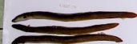  Anguilla marmorata Quoy & Gaimard, 1824 | 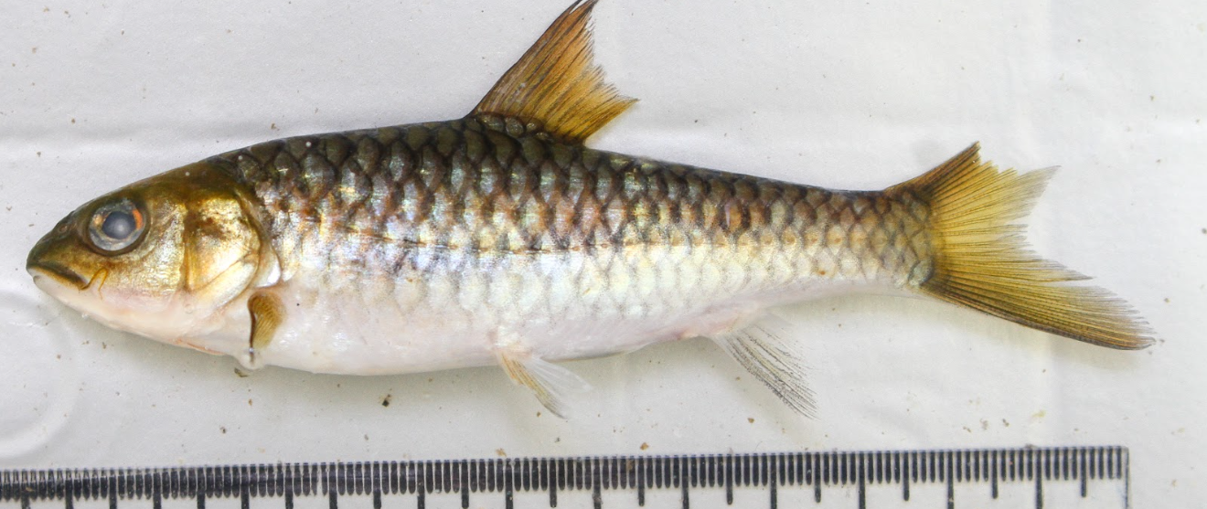  Spinibarbus denticulatus Oshima, 1926
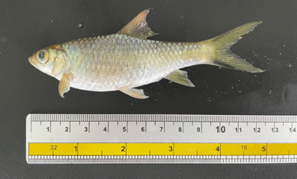Poropuntius deauratus (Valenciennes, 1842) | 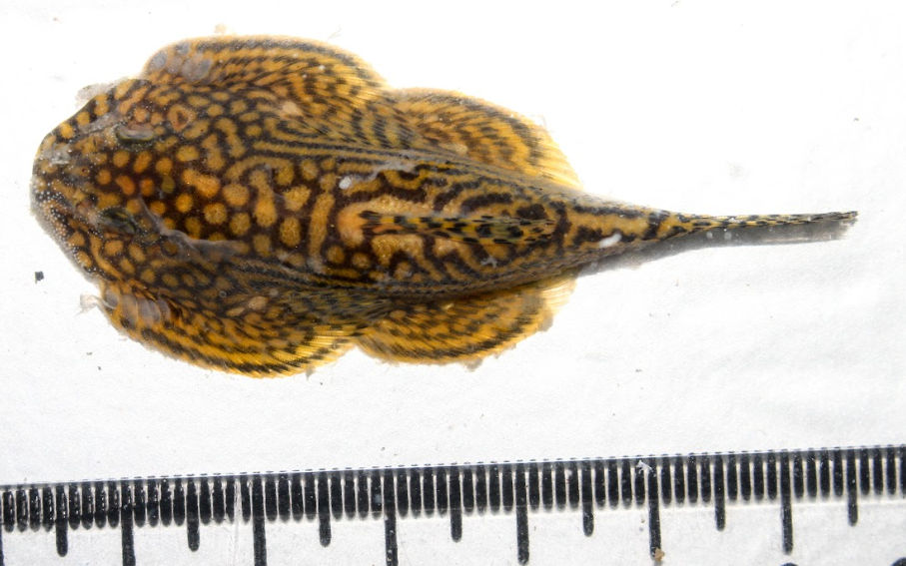  Sewellia lineolata Valenciennes, 1846
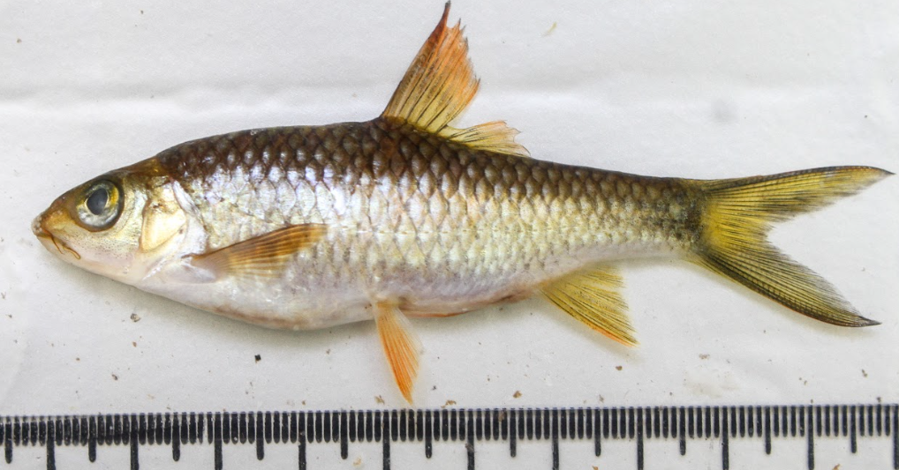  Tor sinensis Wu, 1977 | 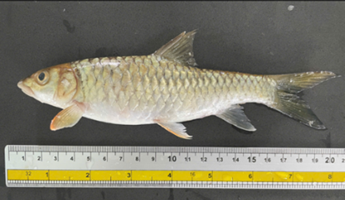  Tor tambroides (Bleeker, 1854)
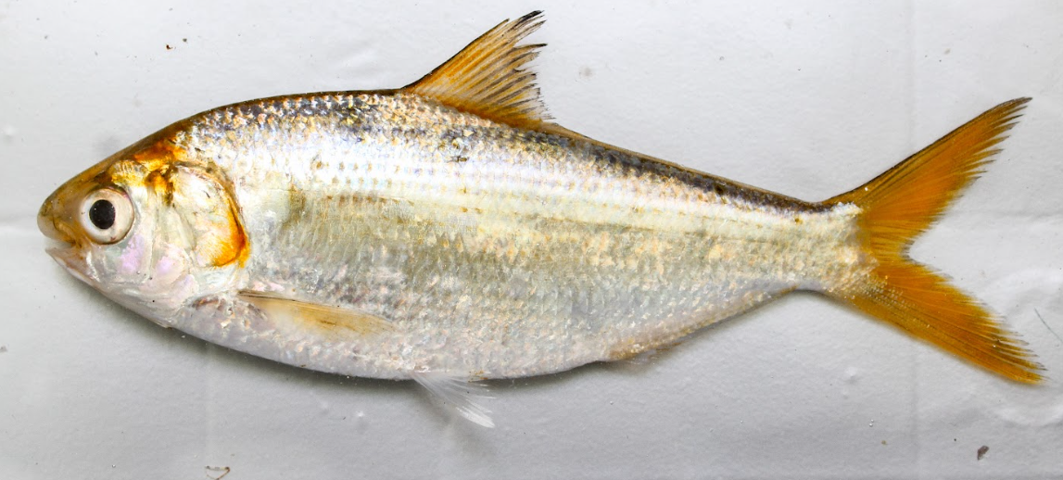  Konosirus punctatus (Temminck & Schlegel, 1846) | 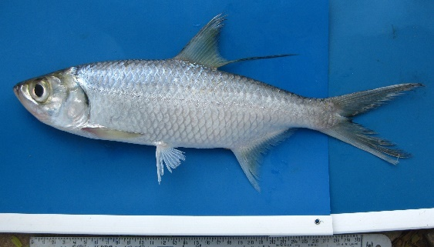  Megalops cyprinoides (Broussonet, 1782)
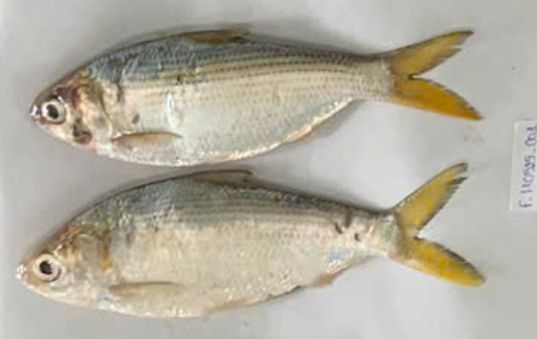  Tenualosa reevesii (Richardson, 1846) | 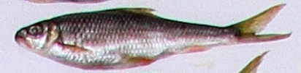  Onychostoma laticeps (Günther, 1896)

Figure 5. Fish species of conservation concern
Based on specimen records and market observations, most fish species recorded in the study area (91.2%) are used as food fish. In contrast, a small proportion (8.8%) consists of species containing potentially dangerous toxins, particularly pufferfishes (order Tetraodontiformes), which are not recommended for consumption.

From an economic perspective, 68 out of 166 species (41.0%) belonging to 16 orders and 40 families were identified as commercially valuable species. These species were primarily distributed in the Han River (83.8%) and Cu De River (60.3%).

The composition of economically important species reflects the ecological characteristics of each river system. In the upper reaches of the Cu De River, fisheries resources are dominated by freshwater species adapted to flowing waters, such as: Onychostoma spp., Spinibarbus denticulatus, Tor tambroides, Barbodes semifasciolatus, Puntius brevis, Carassius auratus. In contrast, the middle and lower reaches of the Han River are dominated by freshwater and estuarine commercial species, including: Anguilla marmorata, Channa striata, Cyprinus carpio, Oreochromis spp., Monopterus albus, Mugilidae, Polynemidae, Lutjanus spp., Gerreidae, Sillago sihama.

Several families such as Gobiidae, Mugilidae, Gerreidae, Leiognathidae, Sparidae, Dorosomatidae, Sciaenidae, and Carangidae play particularly important roles in local fisheries due to their stable catch yields and high market value. These species groups contribute significantly to the income and livelihoods of fishing communities along the Han River and Cu De River basins in Da Nang City.

3.6 Discussion

The present study provides a comprehensive assessment of fish assemblage structure and biodiversity in the Han and Cu De river systems, revealing a relatively high level of taxonomic diversity with 166 recorded species across 21 orders. This level of diversity is notable given the relatively small size of the river basins and reflects the ecological complexity of tropical coastal river systems. Similar patterns have been reported in Southeast Asia, where biodiversity is enhanced by strong connectivity between freshwater and marine environments (Dudgeon, et al., 2006; Nguyen & De Silva, 2006; Rainboth, 1996). In particular, estuarine-associated rivers are known to support higher species richness due to the overlap of freshwater and marine faunas (Blaber, 2000; Whitfield et al., 2021). The high diversity observed in this study therefore underscores the importance of the Han - Cu De system as a representative model of river - estuary ecosystems in central Vietnam.

A key finding of this study is the strong taxonomic dominance of Cypriniformes in the Cu De River, which is consistent with patterns observed in freshwater river systems across Southeast Asia. Cypriniformes, especially the family Cyprinidae, are among the most diverse and ecologically versatile freshwater fishes, occupying a wide range of habitats from lowland rivers to mountainous streams (Moyle & Cech, 2004b). This dominance has also been reported in the Mekong and Red River basins, where cyprinids form the backbone of freshwater fish communities (Nguyen & De Silva, 2006; Rainboth, 1996). In contrast, the Han River exhibited a higher proportion of euryhaline and marine-associated taxa, including Acanthuriformes, Carangiformes, and Gobiiformes, reflecting strong tidal influence and salinity gradients. Such patterns are typical of estuarine ecosystems, where fish assemblages are structured by salinity tolerance and habitat connectivity (Elliott & Hemingway, 2002; Whitfield, et al., 2021).

The clear spatial differentiation between the Han River and Cu De River, with only 25.3% shared species, highlights the role of environmental gradients in shaping fish communities. Differences in salinity, flow regime, and habitat structure likely drive this separation, as has been demonstrated in other coastal river systems (Barletta et al., 2005; Rueda & Defeo, 2003). The Han River represents a river–estuary continuum, whereas the Cu De River functions primarily as a freshwater system. According to the river continuum concept (Vannote et al., 1980), longitudinal gradients in physical and chemical conditions strongly influence biological communities, leading to distinct assemblages along the river profile. In coastal systems, this concept is further modified by tidal dynamics and salinity intrusion, resulting in complex ecological zonation (Elliott & McLusky, 2002).

Seasonal variation also played a significant role in structuring fish assemblages, with species richness during the dry season being approximately 1.6 times higher than in the rainy season. This pattern is consistent with observations in tropical rivers, where hydrological stability during the dry season enhances habitat availability and species detectability (Lowe-McConnell, 1987). In contrast, high discharge and turbidity during the rainy season can reduce habitat suitability and trigger fish migration to more stable environments. Many tropical fish species exhibit seasonal movements linked to spawning and feeding strategies, particularly in river–floodplain and estuarine systems (Blaber, 2000). The low overlap in species composition between seasons further supports the importance of hydrological variability in regulating fish assemblages.

From a biogeographical perspective, the fish fauna of the Han and Cu De rivers reflects the transitional nature of central Vietnam between the Indo-Chinese and Mekong ichthyofaunal regions. The coexistence of freshwater taxa such as Onychostoma, Tor, and Spinibarbus with estuarine and marine species highlights the influence of both inland and coastal processes. This pattern is consistent with studies in central Vietnamese rivers, which have been identified as biogeographical transition zones with mixed faunal composition (Nguyen & De Silva, 2006). The relatively high proportion of monotypic genera observed in this study also suggests ecological specialization and potential local adaptation, which are common features of tropical river systems (Dudgeon, et al., 2006).

The importance of river–estuary connectivity emerges as a key ecological driver of fish diversity in the study area. Estuarine ecosystems provide critical nursery, feeding, and migration habitats for many fish species, contributing to both biodiversity and fisheries productivity (Beck et al., 2001; Whitfield, et al., 2021). In the Han River, strong connectivity with coastal waters allows the movement of marine and estuarine species into the river system, increasing species richness. In contrast, the Cu De River supports freshwater species adapted to upstream habitats, emphasizing the role of habitat heterogeneity across the river continuum. Disruptions to this connectivity, such as dam construction or water abstraction, have been shown to significantly reduce fish diversity and alter community structure in river systems worldwide (Grill et al., 2019; Vörösmarty, et al., 2010).

The presence of 12 species of conservation concern further highlights the ecological importance of the study area. Species such as Anguilla marmorata and Tor spp. are particularly vulnerable due to their dependence on specific habitats and migratory pathways. Similar declines in freshwater fish biodiversity have been reported across Southeast Asia due to overfishing, habitat degradation, and hydrological modification (Dudgeon, et al., 2006; Reid et al., 2019). The coexistence of threatened and economically valuable species underscores the need for integrated conservation and fisheries management strategies.

In addition to biodiversity significance, the study area supports a high proportion of economically important fish species, particularly in estuarine and lower river sections. Estuarine environments are known to sustain productive fisheries due to high nutrient availability and habitat diversity (Blaber, 2000; Elliott & Hemingway, 2002). The Han River, with its strong estuarine influence, supports a diverse assemblage of commercially valuable species, while the Cu De River contributes important freshwater fisheries resources. This dual role highlights the importance of coastal river systems as both biodiversity hotspots and socio-economic assets.

Overall, the ecological patterns observed in this study can be explained by the interaction of three key drivers: hydrological connectivity, environmental gradients, and seasonal variability. These factors regulate species distribution, community composition, and ecosystem functioning in coastal river systems. Similar mechanisms have been identified in river–estuary systems worldwide, emphasizing the generality of these processes (Elliott & McLusky, 2002; Whitfield, et al., 2021). Given increasing pressures from urbanization and climate change, maintaining these ecological processes will be critical for sustaining fish biodiversity in central Vietnam.

4. Conclusion

This study provides the first comprehensive assessment of fish diversity in the Han River and Cu De River systems in Da Nang City. A total of 166 fish species belonging to 122 genera, 64 families, and 21 orders were documented across the two river basins. The Han River supported 109 species, while the Cu De River contained 99 species, reflecting clear spatial differentiation in fish community structure. The Han River was dominated by euryhaline and estuarine-associated taxa, particularly members of Acanthuriformes, Carangiformes, and Gobiiformes, indicating strong marine influence driven by tidal dynamics. In contrast, the Cu De River exhibited characteristics typical of a freshwater inland river system, with Cypriniformes representing the most species-rich taxonomic group. Comparative analyses with other Vietnamese river systems further confirmed that the fish assemblages of the study area represent a distinct ichthyofaunal structure characteristic of central Vietnamese coastal rivers.

The results highlight the important role of the river–estuary continuum in shaping fish biodiversity in central Vietnam. The coexistence of freshwater, estuarine, and marine-associated taxa in the Han River reflects the ecological significance of hydrological connectivity between inland waters and coastal environments. In contrast, the Cu De River provides critical habitats for freshwater species adapted to flowing-water ecosystems, particularly in upstream sections. The presence of 12 species of conservation concern, including several species listed in the Vietnam Red Data Book (2024) and the IUCN Red List, further emphasizes the ecological and conservation value of these river systems. These findings suggest that maintaining longitudinal connectivity, habitat heterogeneity, and stable hydrological regimes will be essential for sustaining fish biodiversity and supporting local fisheries resources in the region.

Future studies should focus on long-term monitoring of fish assemblages in order to better understand the impacts of environmental change, urbanization, and climate variability on riverine biodiversity in central Vietnam. Integrating molecular taxonomy, environmental DNA (eDNA), and ecological modeling approaches could significantly improve the accuracy of species identification and biodiversity assessments. In addition, further research should examine ecological connectivity between upstream freshwater habitats, estuaries, and adjacent coastal ecosystems, particularly for migratory and economically important species. Such multidisciplinary approaches will provide stronger scientific foundations for sustainable fisheries management and biodiversity conservation strategies in the Han and Cu De river basins.

References

Allen, G.-R. (1985). FAO species catalogue. Vol.6. Snappers of the world: An annotated and illustrated catalogue of lutjanid species known to date. Rome, Italy: FAO - the Food and Agriculture Organization of the United Nations.
Allen, G., Steen, R., Humann, P. & DeLoach, N. (2015). Reef Fish Identification – Tropical Pacific. 2nd ed. Singapore: New World Publications.
Allen, G.R. (1997). Marine fishes of tropical Australia and South-East Asia. Perth, W.A.: Western Australian Museum.
Apinun, S. & Utsugi, K. (2023). A Field guild of the Northern Thai Fishes. Ubon Ratchathani University, Thailand: UBU Press.
Barletta, M., Barletta-Bergan, A., Saint-Paul, U. & Hubold, G. (2005). The role of salinity in structuring the fish assemblages in a tropical estuary. Journal of Fish Biology, 66(1), 45-72. https://doi.org/10.1111/j.0022-1112.2005.00582.x.
Beck, M.W., Heck, K.L., Able, K.W., Childers, D.L., Eggleston, D.B., Gillanders, B.M., Halpern, B., Hays, C.G., Hoshino, K., Minello, T.J., Orth, R.J., Sheridan, P.F. & Weinstein, M.P. (2001). The Identification, Conservation, and Management of Estuarine and Marine Nurseries for Fish and Invertebrates: A better understanding of the habitats that serve as nurseries for marine species and the factors that create site-specific variability in nursery quality will improve conservation and management of these areas. BioScience, 51(8), 633-641. https://doi.org/10.1641/0006-3568(2001)051[0633:Ticamo]2.0.Co;2.
Blaber, S.J.M. (2000). Tropical Estuarine Fishes: Ecology, Exploitation and Conservation. Great Britain, UK: Blackwell Science. https://doi.org/10.1002/9780470694985.
Böhlke, E.B. & McCosker, J.E. (2001). The moray eels of Australia and New Zealand, with the description of two new species (Anguilliformes: Muraenidae). Records of the Australian Museum, 53(1), 71–102. https://doi.org/10.3853/j.0067-1975.53.2001.1325.
Carpenter, K.E. & Niem, V.H. (1999a). FAO species identification guide for fishery purposes. The living marine resources of the Western Central Pacific. Volume 3. Batoid fishes, chimaeras and bony fishes part 1 (Elopidae to Linophrynidae). Rome, Italy: Food and Agriculture Organization of the United Nations.
Carpenter, K.E. & Niem, V.H. (1999b). FAO species identification guide for fishery purposes. The living marine resources of the Western Central Pacific. Volume 4. Bony fishes part 2 (Mugilidae to Carangidae). Rome, Italy: Food and Agriculture Organization of the United Nations.
Carpenter, K.E. & Niem, V.H. (2001a). FAO species identification guide for fishery purposes. The living marine resources of the Western Central Pacific. Volume 5. Bony fishes part 3 (Menidae to Pomacentridae). Rome, Italy: Food and Agriculture Organization of the United Nations.
Carpenter, K.E. & Niem, V.H. (2001b). FAO species identification guide for fishery purposes. The living marine resources of the Western Central Pacific. Volume 6. Bony fishes part 4 (Labridae to Latimeriidae), estuarine crocodiles, sea turtles, sea snakes and marine mammals. Rome, Italy: Food and Agriculture Organization of the United Nations.
Clarke, K. & Gorley, R.N. (2006). PRIMER v6: user manual/tutorial. Plymouth: PRIMER-E.
Clarke, K. & Warwick, R.M. (2001). Change in Marine Communities: An Approach to Statistical Analysis and Interpretation (2nd Edition). Plymouth, UK: PRIMER-E.
Do, T.N.N. (2007). Fauna of Vietnam. Ha Noi, Vietnam: Science and Technology Publishing House.
Dudgeon, D., Arthington, A.H., Gessner, M.O., Kawabata, Z.-I., Knowler, D.J., Lévêque, C., Naiman, R.J., Prieur-Richard, A.-H., Soto, D., Stiassny, M.L.J. & Sullivan, C.A. (2006). Freshwater biodiversity: importance, threats, status and conservation challenges. Biological Reviews, 81(2), 163-182. https://doi.org/10.1017/S1464793105006950.
Elliott, M. & Hemingway, K. (2002). Fishes in Estuaries. Great Britain, UK: Blackwell Science. https://doi.org/10.1002/9780470995228.
Elliott, M. & McLusky, D.S. (2002). The Need for Definitions in Understanding Estuaries. Estuarine, Coastal and Shelf Science, 55(6), 815-827. https://doi.org/10.1006/ecss.2002.1031.
Froese, R. & Pauly, D. (2025). FishBase. World Wide Web electronic publication. www.fishbase.org. (11/2025).
Grill, G., Lehner, B., Thieme, M., Geenen, B., Tickner, D., Antonelli, F., Babu, S., Borrelli, P., Cheng, L., Crochetiere, H., Ehalt Macedo, H., Filgueiras, R., Goichot, M., Higgins, J., Hogan, Z., Lip, B., McClain, M.E., Meng, J., Mulligan, M., Nilsson, C., Olden, J.D., Opperman, J.J., Petry, P., Reidy Liermann, C., Sáenz, L., Salinas-Rodríguez, S., Schelle, P., Schmitt, R.J.P., Snider, J., Tan, F., Tockner, K., Valdujo, P.H., van Soesbergen, A. & Zarfl, C. (2019). Mapping the world’s free-flowing rivers. Nature, 569(7755), 215-221. https://doi.org/10.1038/s41586-019-1111-9.
IPCC (2021). Climate Change 2021: The Physical Science Basis. Contribution of Working Group I to the Sixth Assessment Report of the Intergovernmental Panel on Climate Change. Masson-Delmotte, V., Zhai, P., Pirani, A., Connors, S.L., Péan, C., Berger, S., Caud, N., Chen, Y., Goldfarb, L., Gomis, M.I., Huang, M., Leitzell, K., Lonnoy, E., Matthews, J.B.R., Maycock, T.K., Waterfield, T., Yelekçi, O., Yu, R. & Zhou, B. eds. Cambridge, United Kingdom and New York, NY, USA: Cambridge University Press. https://doi.org/10.1017/9781009157896.
Karr, J.R. (1981). Assessment of Biotic Integrity Using Fish Communities. Fisheries, 6(6), 21-27. https://doi.org/10.1577/1548-8446(1981)006<0021:AOBIUF>2.0.CO;2.
Khoi, D.N. & Suetsugi, T. (2014). Impact of climate and land-use changes on hydrological processes and sediment yield—a case study of the Be River catchment, Vietnam. Hydrological Sciences Journal, 59(5), 1095-1108. https://doi.org/10.1080/02626667.2013.819433.
Kimura, S., Imamura, H., Quan, N.V. & Duong, P.T. (2018). Fishes of Ha Long Bay: the World Natural Heritage Site in Northern Vietnam. hima, Japan.: Fisheries Research Laboratory, Mie University.
Koeda, K. & Ho, H.C. (2020a). Fishes of southern Taiwan, 2nd edition. Pingtung, Taiwan: National Museum of Marine Biology & Aquarium.
Koeda, K. & Ho, H.C. (2020b). Fishes of southern Taiwan, 2nd edition. Pingtung, Taiwan: National Museum of Marine Biology & Aquarium.
Legendre, P. & Legendre, L.F.J. (1998). Numerical Ecology (2nd ed). Amsterdam, the Netherlands: Elsevier Science.
Lepš, J. & Šmilauer, P. (2003). Multivariate Analysis of Ecological Data using CANOCO. Cambridge: Cambridge University Press. https://doi.org/10.1017/CBO9780511615146.
Lowe-McConnell, R.H. (1987). Ecological Studies in Tropical Fish Communities. Cambridge Tropical Biology Series. Cambridge: Cambridge University Press. https://doi.org/10.1017/CBO9780511721892.
Mai, D.Y., Nguyen, V.T., Nguyen, V.T., Le, H.Y. & Hua, B.L. (1992). Định loại các loài cá nước ngọt Nam Bộ [Identification of freshwater fish species of southern Vietnam]. Hanoi, Vietnam: Science and Technology Publishing House.
McDowall, R.M. (1976). The role of estuaries in the life cycles of fishes in New Zealand. Proceedings of the New Zealand Ecological Society. JSTOR, 27-32.
Moyle, P.B. & Cech, J.J. (2004a). Fishes: An Introduction to Ichthyology: Pearson Prentice Hall.
Moyle, P.B. & Cech, J.J. (2004b). Fishes: An Introduction to Ichthyology. Upper Saddle River, NJ, USA: Pearson Prentice Hall.
Nakabo, T. (2002). Fishes of Japan with pictorial keys to the species, English edition. Tokyo, Japan: Tokai University Press.
Nguyen, H.P. (1999). Checklist of Marine Fishes of Vietnam. Hanoi, Vietnam: Science and Technology Publishing House.
Nguyen, H.P. (2001a). Marine fish section: Orders Elopiformes, Anguilliformes, Clupeiformes, and Gonorhynchiformes. Fauna of Vietnam: Marine Fishes. Ha Noi, Vietnam: Science and Technology Publishing House.
Nguyen, K.H. (2022). Rare and Economically Valuable Fish Orders and Families in the East Sea and Southwestern Waters of Vietnam. Monograph Series on Natural Resources and Environment of Vietnam. Ha Noi, Vietnam: Publishing House for Natural Science and Technology.
Nguyen, K.H. & Truong, S.K. (2007). Fauna of Vietnam: Marine Fishes. Ha Noi, Vietnam: Science and Technology Publishing House.
Nguyen, N.T. (2001b). Fauna of Vietnam: Marine Fishes – Suborder Gobioidei. Ha Noi, Vietnam: Science and Technology Publishing House.
Nguyen, N.T. (2008). Marine Fishes of Vietnam. Ha Noi, Vietnam: Science and Technology Publishing House.
Nguyen, T.T.T. & De Silva, S.S. (2006). Freshwater finfish biodiversity and conservation: an asian perspective. Biodiversity & Conservation, 15(11), 3543-3568. https://doi.org/10.1007/s10531-005-0312-8.
Nguyen, V.H. (2005a). Class Chondrichthyes and Four Superorders of Osteichthyes—Notopteroidei, Clupeoidei, Elopoidei, and Cyprinoidei. Freshwater Fishes of Vietnam. Ha Noi, Vietnam: Agriculture Publishing House.
Nguyen, V.H. (2005b). Three Superorders of Osteichthyes—Anabantoidei, Synbranchoidei, and Percoidei. Freshwater Fishes of Vietnam. Ha Noi, Vietnam: Agriculture Publishing House.
Nguyen, V.H. & Ngo, S.V. (2001). Family Cyprinidae. Freshwater Fishes of Vietnam. Ha Noi, Vietnam: Agriculture Publishing House.
Nguyen, V.L., Le, T.T.T. & Nguyen, P.U.V. (2007). Fauna of Vietnam: Marine Fishes (Order Perciformes)—Families Chaetodontidae and Labridae). Ha Noi, Vietnam: Science and Technology Publishing House.
Rainboth, W.J. (1996). FAO Species Identification Field Guide for Fishery Purposes. Fishes of the Cambodian Mekong. Rome, Italy: FAO - the Food and Agriculture Organization of the United Nations.
Rainboth, W.J., Vidthayanon, C. & Yen, M.D. (2012). Fishes of the Greater Mekong Ecosystem with Species List and Photographic Atlas: Ann Arbor: Museum of Zoology, University of Michigan.
Reid, A.J., Carlson, A.K., Creed, I.F., Eliason, E.J., Gell, P.A., Johnson, P.T.J., Kidd, K.A., MacCormack, T.J., Olden, J.D., Ormerod, S.J., Smol, J.P., Taylor, W.W., Tockner, K., Vermaire, J.C., Dudgeon, D. & Cooke, S.J. (2019). Emerging threats and persistent conservation challenges for freshwater biodiversity. Biological Reviews, 94(3), 849-873. https://doi.org/10.1111/brv.12480.
Rueda, M. & Defeo, O. (2003). Spatial structure of fish assemblages in a tropical estuarine lagoon: combining multivariate and geostatistical techniques. Journal of Experimental Marine Biology and Ecology, 296(1), 93-112. https://doi.org/10.1016/S0022-0981(03)00319-8.
Shen, S.C., Lee, S.C., Shao, K.T., Mok, H.C., Chen, C.H., Chen, C.C. & Tzeng, C.S. (1993). Fishes of Taiwan. Taipei: Department of Zoology, National Taiwan University.
Shibukawa, K. (2021). Fishes of the Indochinese Mekong. Tokyo, Japan: Nagao Natural Environment Foundation.
Smith, D. (2012). A checklist of the moray eels of the World (Teleostei: Anguilliformes: Muraenidae). Zootaxa, 3474, 1-64. https://doi.org/10.1097/01.ede.0000416893.50277.7e.
Smith, D.G., Bogorodsky, S.V., Mal, A.O. & Alpermann, T.J. (2019). Review of the moray eels (Anguilliformes: Muraenidae) of the Red Sea, with description of a new species. Zootaxa, 4704(1), 1–87. https://doi.org/10.11646/zootaxa.4704.1.1.
ter Braak, C.J.F. & Smilauer, P. (2002). CANOCO Reference Manual and CanoDraw for Windows User's Guide: Software for Canonical Community Ordination (version 4.5). Ithaca NY, USA: Microcomputer Power.
Thoa, N.T.K. & Minh, V.V. (2014). Assessment of water resources and management strategies for the Cu De River basin, Da Nang City. Journal of Science and Technology, University of Da Nang, 9(82), 79-82.
Tram, V.N.Q., Somura, H., Moroizumi, T. & Maeda, M. (2022). Effects of local land-use policies and anthropogenic activities on water quality in the upstream Sesan River Basin, Vietnam. Journal of Hydrology: Regional Studies, 44, 101225. https://doi.org/10.1016/j.ejrh.2022.101225.
Tran, D.D., Shibukawa, K., Nguyen, T.P., Ha, P.H., Tran, X.L., Mai, V.H. & Uehara, K. (2013). Taxonomic Identification and Description of Fishes of the Mekong Delta, Vietnam. Can Tho, Vietnam: Can Tho University Publishing House.
Truong, T.K. & Tran, T.T.H. (1993). Identification of freshwater fishes of the Mekong Delta. Can Tho, Vietnam: Faculty of Fisheries, Can Tho University.
Vannote, R.L., Minshall, G.W., Cummins, K.W., Sedell, J.R. & Cushing, C.E. (1980). The River Continuum Concept. Canadian Journal of Fisheries and Aquatic Sciences, 37(1), 130-137. https://doi.org/10.1139/f80-017.
Vörösmarty, C.J., McIntyre, P.B., Gessner, M.O., Dudgeon, D., Prusevich, A., Green, P., Glidden, S., Bunn, S.E., Sullivan, C.A., Liermann, C.R. & Davies, P.M. (2010). Global threats to human water security and river biodiversity. Nature, 467(7315), 555-561. https://doi.org/10.1038/nature09440.
Whitfield, A., Elliott, M., Blaber, S.J.M. & Able, K. (2021). Fish and Fisheries in Estuaries: A Global Perspective: Wiley.
Whitfield, A.K., Able, K.W., Barletta, M., Blaber, S.J.M. & Harrison, T.D. (2023). Life-history guilds of fishes associated with estuaries: opportunism versus dependency. Estuarine, Coastal and Shelf Science, 292, 108456. https://doi.org/10.1016/j.ecss.2023.108456.

APPENDIX

Appendix. Species composition of fish assemblages in the Cu De and Han rivers, Da Nang City.
No | Scientific name | English name | Rivers |  |  |  | Economic species
No | Scientific name | English name | Cu De |  | Han |  | Economic species
No | Scientific name | English name | Rainy season | Dry season | Rainy season | Dry season | Economic species
A | Actinopteri- Teleostei | Teleosts
I | Osteoglossiformes | Bony tongues
1 | Notopteridae | Featherbacks or knifefishes
1 | Notopterus notopterus (Pallas, 1769) | Bronze featherback | + | + | + | + | +
II | Elopiformes | Tarpons and tenpounders
2 | Megalopidae | Tarpons
2 | Megalops cyprinoides (Broussonet, 1782) | Indo-Pacific tarpon | +
III | Anguilliformes | Eels and morays
3 | Anguillidae | Freshwater eels
3 | Anguilla marmorata Quoy & Gaimard, 1824 | Giant mottled eel | + | + |  | + | +
4 | Muraenidae | Moray eels
4 | Strophidon sathete (Hamilton, 1822) | Slender giant moray |  | + |  | +
5 | Uropterygius concolor Rüppell, 1838 | Unicolor snake moray |  |  |  | +
5 | Ophichthidae | Snake eels
6 | Pisodonophis boro (Hamilton, 1822) | Rice-paddy eel |  |  | + |  | +
6 | Muraenesocidae | Pike congers
7 | Muraenesox cinereus (Forsskål, 1775) | Daggertooth pike conger |  |  |  | + | +
IV | Clupeiformes | Herrings
7 | Engraulidae | Anchovies
8 | Stolephorus commersonnii Lacepède, 1803 | Commerson's anchovy |  |  |  | + | +
9 | Thryssa hamiltonii Gray, 1835 | Hamilton's thryssa |  |  | + | +
8 | Ehiravidae | River sprats
10 | Corica laciniata Fowler, 1935 | Bangkok river sprat |  | + |  |  | +
9 | Dorosomatidae | Gizzard shads and sardinellas
11 | Escualosa thoracata (Valenciennes, 1847) | White sardine |  |  | + | + | +
12 | Herklotsichthys quadrimaculatus  (Rüppell, 1837) | Bluestripe herring | + |  | +
13 | Konosirus punctatus  (Temminck & Schlegel, 1846) | Dotted gizzard shad |  | + |  |  | +
14 | Sardinella albella (Valenciennes, 1847) | White sardinella |  |  |  | +
15 | Sardinella gibbosa (Bleeker, 1849) | Goldstripe sardinella | + | + |  | + | +
16 | Tenualosa reevesii (Richardson, 1846) | Reeves shad |  | +
V | Cypriniformes | Carps
10 | Cobitidae | Spined loaches
17 | Cobitis sinensis Sauvage & Dabry de Thiersant, 1874 | Siberian spiny loach |  | +
18 | Cobitis taenia Linnaeus, 1758 | Spined loach |  | +
19 | Misgurnus anguillicaudatus (Cantor, 1842) | Pond loach | + | + |  | +
20 | Misgurnus mizolepis Günther, 1888 | Chinese muddy loach | +
11 | Gastromyzontidae | Hillstream loaches
21 | Sewellia lineolata (Valenciennes, 1846) | Hillstream loaches |  | +
22 | Sewellia speciosa Roberts, 1998 | Hillstream loaches |  | +
12 | Balitoridae | River loaches
23 | Balitora brucei Gray, 1830 | Gray's stone loach |  | +
24 | Balitora kwangsiensis (Fang, 1930) | Sucker-belly loach |  | +
13 | Nemacheilidae | Brook loaches
25 | Traccatichthys taeniatus (Pellegrin & Chevey, 1936) | Brook loaches |  | +
14 | Cyprinidae | Minnows or carps
26 | Acrossocheilus aluoiensis (Nguyen, 1997) | Minnows or carps |  | + |  |  | +
27 | Barbodes semifasciolatus (Günther, 1868) | Chinese barb | + |  |  |  | +
28 | Carassioides acuminatus (Richardson, 1846) | Harilik idakoger |  |  | +
29 | Carassius auratus (Linnaeus, 1758) | Goldfish |  | + | + |  | +
30 | Cyprinus carpio Linnaeus, 1758 | Common carp |  | + |  | + | +
31 | Cyprinus melanes (Mai, 1978) | Minnows or carps |  |  |  | +
32 | Henicorhynchus siamensis (Sauvage, 1881) | Siamese mud carp | + |  | +
33 | Onychostoma gerlachi (Peters, 1881) | Minnows or carps | + |  |  |  | +
34 | Onychostoma laticeps Günther, 1896 | Minnows or carps |  | + |  |  | +
35 | Osteochilus salsburyi Nichols & Pope, 1927 | Minnows or carps |  | +
36 | Poropuntius angustus Kottelat, 2000 | Lauge poorpuntius | +
37 | Poropuntius deauratus (Valenciennes, 1842) | Goldbarbe | + |  |  |  | +
38 | Puntius brevis (Bleeker, 1849) | Swamp barb | + |  | + |  | +
39 | Spinibarbus denticulatus (Oshima, 1926) | Minnows or carps |  | + |  |  | +
40 | Tor sinensis Wu, 1977 | Red mahseer |  | +
41 | Tor tambroides (Bleeker, 1854) | Thai mahseer | +
15 | Xenocyprididae | East Asian minnows
42 | Hainania serrata Koller, 1927 | Hainan minnow | +
43 | Megalobrama terminalis (Richardson, 1846) | Black Amur bream |  |  | +
44 | Metzia lineata (Pellegrin, 1907) | East Asian minnows |  | +
45 | Opsariichthys bidens Günther, 1873 | East Asian minnows |  | +
46 | Sinibrama macrops (Günther, 1868) | East Asian minnows | +
16 | Gobionidae | Gudgeons
47 | Microphysogobio labeoides (Nichols & Pope, 1927) | Gudgeon |  |  |  | +
48 | Squalidus atromaculatus (Nichols & Pope, 1927) | Gudgeon |  | +
VI | Siluriformes | Catfishes
17 | Plotosidae | Eeltail catfishes
49 | Plotosus lineatus (Thunberg, 1787) | Striped eel catfish |  |  | + |  | +
18 | Bagridae | Bagrid catfishes
50 | Mystus gulio (Hamilton, 1822) | Long whiskers catfish |  | +
51 | Tachysurus fulvidraco (Richardson, 1846) | Yellow catfish |  | +
52 | Tachysurus sinensis Lacepède, 1803 | Bagrid catfishes |  | +
53 | Tachysurus vachellii (Richardson, 1846) | Bagrid catfishes |  | +
54 | Tachysurus virgatus (Oshima, 1926) | Bagrid catfishes |  | +
19 | Siluridae | Sheatfishes
55 | Pterocryptis cochinchinensis (Valenciennes, 1840) | Catfish |  | +
56 | Silurus asotus Linnaeus, 1758 | Amur catfish |  | +
20 | Clariidae | Airbreathing catfishes
57 | Clarias fuscus (Lacepède, 1803) | Hong Kong catfish |  | + |  | + | +
58 | Clarias gariepinus (Burchell, 1822) | North African catfish |  |  | +
21 | Ariidae | Sea catfishes
59 | Arius arius (Hamilton, 1822) | Threadfin sea catfish | +
60 | Netuma thalassina (Rüppell, 1837) | Giant catfish |  |  |  | + | +
VII | Aulopiformes | Grinners
22 | Synodontidae | Lizardfishes
61 | Harpadon nehereus (Hamilton, 1822) | Bombay-duck |  |  | +
62 | Saurida tumbil (Bloch, 1795) | Greater lizardfish |  | + |  | +
63 | Trachinocephalus myops (Forster, 1801) | Snakefish |  |  |  | +
VIII | Gobiiformes | Gobies
23 | Eleotridae | Bully sleepers
64 | Eleotris balia Jordan & Seale, 1905 | Sleeper |  |  |  | +
65 | Eleotris fusca (Forster, 1801) | Dusky sleeper | + | +
66 | Eleotris melanosoma Bleeker, 1853 | Broadhead sleeper |  | + |  | + | +
24 | Butidae | Gudgeon gobies
67 | Butis butis (Hamilton, 1822) | Duckbill sleeper | + |  | + |  | +
68 | Oxyeleotris marmorata (Bleeker, 1852) | Marble goby |  | + |  | + | +
25 | Gobiidae | Gobies
69 | Acentrogobius caninus (Valenciennes, 1837) | Tropical sand goby |  |  | + | +
70 | Arcygobius baliurus (Valenciennes, 1837) | Isthmus goby |  |  |  | + | +
71 | Aulopareia janetae Smith, 1945 | Scalycheek goby | +
72 | Exyrias puntang (Bleeker, 1851) | Puntang goby | +
73 | Glossogobius aureus Akihito & Meguro, 1975 | Golden tank goby |  |  | + |  | +
74 | Glossogobius giuris (Hamilton, 1822) | Tank goby |  | + |  | + | +
75 | Odontamblyopus rubicundus (Hamilton, 1822) | Gobies |  | +
76 | Oligolepis acutipennis (Valenciennes, 1837) | Sharptail goby | +
77 | Oxyurichthys microlepis (Bleeker, 1849) | Maned goby |  |  | +
78 | Oxyurichthys tentacularis (Valenciennes, 1837) | Mollon |  |  |  | +
79 | Rhinogobius giurinus (Rutter, 1897) | Gobies |  |  |  | +
IX | Syngnathiformes | Pipefishes and seahorses
26 | Mullidae | Goatfishes
80 | Upeneus sulphureus Cuvier, 1829 | Sulphur goatfish |  |  |  | + | +
X | Scombriformes | Mackerels
27 | Scombridae | Mackerels, tunas, bonitos
81 | Rastrelliger kanagurta (Cuvier, 1816) | Indian mackerel |  |  |  | +
28 | Trichiuridae | Cutlassfishes
82 | Lepturacanthus savala (Cuvier, 1829) | Savalai hairtail |  |  |  | + | +
XI | Synbranchiformes | Spiny eels
29 | Mastacembelidae | Spiny eels
83 | Mastacembelus armatus (Lacepède, 1800) | Zig-zag eel |  | +
30 | Synbranchidae | Swamp-eels
84 | Monopterus albus (Zuiew, 1793) | Asian swamp eel | + |  |  |  | +
85 | Ophisternon bengalense McClelland, 1844 | Bengal eel |  |  | +
XII | Anabantiformes | Gouramies, snakeheads
31 | Anabantidae | Climbing gouramies
86 | Anabas testudineus (Bloch, 1792) | Climbing perch | + | + | + | + | +
32 | Osphronemidae | Gouramies
87 | Trichopodus microlepis (Günther, 1861) | Moonlight gourami |  |  | +
88 | Trichopodus trichopterus (Pallas, 1770) | Three spot gourami | + |  | +
33 | Channidae | Snakeheads
89 | Channa striata (Bloch, 1793) | Striped snakehead | + | + | + | + | +
XIII | Carangiformes | Jacks
34 | Latidae | Lates perches
90 | Lates calcarifer (Bloch, 1790) | Barramundi |  |  | + |  | +
35 | Lactariidae | False trevallies
91 | Lactarius lactarius (Bloch & Schneider, 1801) | False trevally |  |  |  | +
36 | Sphyraenidae | Barracudas
92 | Sphyraena jello Cuvier, 1829 | Pickhandle barracuda |  | + | + |  | +
37 | Polynemidae | Threadfins
93 | Eleutheronema tetradactylum (Shaw, 1804) | Fourfinger threadfin |  |  |  | + | +
94 | Polydactylus plebeius (Broussonet, 1782) | Striped threadfin |  |  | +
38 | Paralichthyidae | Large-tooth flounders
95 | Pseudorhombus neglectus Bleeker, 1865 | Largetooth flounder |  | +
96 | Tephrinectes sinensis (Lacepède, 1802) | Chinese Brill | + | +
39 | Soleidae | Soles
97 | Brachirus harmandi (Sauvage, 1878) | Soles |  | +
98 | Brachirus orientalis (Bloch & Schneider, 1801) | Oriental sole | + | +
99 | Synaptura commersonnii (Lacepède, 1802) | Commerson's sole |  |  | +
40 | Toxotidae | Archerfishes
100 | Toxotes microlepis Günther, 1860 | Smallscale archerfish |  | + |  | + | +
41 | Carangidae | Jacks and pompanos
101 | Megalaspis cordyla (Linnaeus, 1758) | Torpedo scad | + |  |  | + | +
102 | Platycaranx chrysophrys (Cuvier, 1833) | Longnose trevally |  |  | + | + | +
103 | Platycaranx malabaricus (Bloch & Schneider, 1801) | Malabar trevally | + | + |  | + | +
104 | Platycaranx talamparoides (Bleeker, 1852) | Imposter trevally |  |  | +
105 | Scomberoides lysan (Forsskål, 1775) | Doublespotted queenfish |  |  |  | +
106 | Scomberoides tol (Cuvier, 1832) | Needlescaled queenfish | +
107 | Scyris indica Rüppell, 1830 | Indian threadfish |  |  |  | +
108 | Selaroides leptolepis (Cuvier, 1833) | Yellowstripe scad |  | + |  | + | +
XIV | Atheriniformes | Silversides
42 | Atherinidae | Silversides
109 | Atherinomorus forskalii (Rüppell, 1838) | Red Sea hardyhead silverside |  | +
XV | Beloniformes | Needle fishes
43 | Belonidae | Needlefishes
110 | Strongylura strongylura (van Hasselt, 1823) | Spottail needlefish |  |  | +
44 | Hemiramphidae | Halfbeaks
111 | Hyporhamphus limbatus (Valenciennes, 1847) | Congaturi halfbeak |  |  | +
112 | Hyporhamphus unifasciatus (Ranzani, 1841) | Common halfbeak |  |  |  | +
45 | Zenarchopteridae | Internally fertilized halfbeaks
113 | Zenarchopterus dunckeri Mohr, 1926 | Duncker's river garfish | +
XVI | Cichliformes | Cichlids, convict blennies
46 | Cichlidae | Cichlids
114 | Coptodon rendalli (Boulenger, 1897) | Redbreast tilapia |  | + |  | + | +
115 | Oreochromis mossambicus (Peters, 1852) | Mozambique tilapia | + | + | + | + | +
116 | Oreochromis niloticus (Linnaeus, 1758) | Nile tilapia | + | + | + | + | +
XVII | Mugiliformes | Mullets
47 | Ambassidae | Asiatic glassfishes
117 | Ambassis gymnocephalus (Lacepède, 1802) | Bald glassy |  |  |  | +
118 | Ambassis kopsii Bleeker, 1858 | Singapore glassy perchlet | + |  | +
119 | Ambassis miops Günther, 1872 | Flag-tailed glass perchlet | + | + | + | +
120 | Ambassis vachellii Richardson, 1846 | Vachelli's glass perchlet |  |  |  | +
48 | Mugilidae | Mullets
121 | Mugil cephalus Linnaeus, 1857 | Flathead grey mullet |  |  |  | + | +
122 | Osteomugil cunnesius (Valenciennes, 1836) | Longarm mullet |  | + |  | + | +
123 | Osteomugil engeli (Bleeker, 1858) | Kanda |  |  |  | +
124 | Planiliza haematocheilus (Temminck & Schlegel, 1845) | So-iuy mullet |  | + |  |  | +
125 | Planiliza macrolepis (Smith, 1846) | Largescale mullet | +
126 | Planiliza subviridis (Valenciennes, 1836) | Greenback mullet |  |  |  | +
XVIII | Perciformes
49 | Epinephelidae | Groupers
127 | Cephalopholis boenak (Bloch, 1790) | Chocolate hind |  |  |  | +
128 | Epinephelus coioides (Hamilton, 1822) | Orange-spotted grouper |  |  | + | + | +
50 | Platycephalidae | Flatheads
129 | Platycephalus endrachtensis  Quoy & Gaimard, 1825 | Bar-tailed flathead | +
130 | Platycephalus indicus (Linnaeus, 1758) | Bartail flathead |  | + |  | + | +
XIX | Centrachiformes | Basses
51 | Terapontidae | Grunters or tigerperches
131 | Helotes sexlineatus (Quoy & Gaimard, 1825) | Eastern striped grunter |  | +
132 | Pelates quadrilineatus (Bloch, 1790) | Fourlined terapon |  |  |  | +
133 | Terapon jarbua (Fabricius, 1775) | Jarbua terapon |  | + |  | + | +
134 | Terapon theraps Cuvier, 1829 | Largescaled terapon | + |  | + | + | +
XX | Acanthuriformes | Surgeonfishes
52 | Gerreidae | Mojarras
135 | Gerres filamentosus Cuvier, 1829 | Whipfin silverbiddy |  | + | + | + | +
136 | Gerres japonicus Bleeker, 1854 | Japanese silver-biddy |  | +
137 | Gerres oyena (Fabricius, 1775) | Common silver-biddy |  |  |  | +
53 | Sillaginidae | Smelt-whitings
138 | Sillago sihama (Fabricius, 1775) | Silver sillago |  |  |  | + | +
54 | Sciaenidae | Drums or croakers
139 | Dendrophysa russelii (Cuvier, 1829) | Goatee croaker |  |  | + |  | +
140 | Johnius belangerii (Cuvier, 1830) | Belanger's croaker |  |  | + | +
141 | Nibea soldado (Lacepède, 1802) | Soldier croaker |  |  | + |  | +
142 | Otolithes ruber (Bloch & Schneider, 1801) | Tigertooth croaker |  |  | + | + | +
55 | Haemulidae | Grunts
143 | Pomadasys argenteus (Forsskål, 1775) | Silver grunt | + | + |  | +
56 | Monodactylidae | Moonyfishes or fingerfishes
144 | Monodactylus argenteus (Linnaeus, 1758) | Silver moony | + | + | + | + | +
57 | Caesionidae | Fusiliers
145 | Caesio cuning (Bloch, 1791) | Redbelly yellowtail fusilier |  |  | + |  | +
58 | Lutjanidae | Snappers
146 | Lutjanus argentimaculatus (Forsskål, 1775) | Mangrove red snapper |  |  |  | + | +
147 | Lutjanus fulviflamma (Forsskål, 1775) | Dory snapper | + |  |  | + | +
148 | Lutjanus johnii (Bloch, 1792) | John's snapper |  |  |  | + | +
59 | Leiognathidae | Slimys, slipmouths, or ponyfishes
149 | Eubleekeria splendens (Cuvier, 1829) | Splendid ponyfish |  |  |  | +
150 | Leiognathus brevirostris (Valenciennes, 1835) | Shortnose ponyfish |  |  | + | + | +
151 | Leiognathus equula (Forsskål, 1775) | Common ponyfish |  |  | + | + | +
152 | Photopectoralis bindus (Valenciennes, 1835) | Orangefin ponyfish |  |  |  | +
60 | Sparidae | Porgies
153 | Acanthopagrus berda (Fabricius, 1775) | Goldsilk seabream |  | + |  |  | +
154 | Acanthopagrus latus (Houttuyn, 1782) | Yellowfin seabream |  | + |  | + | +
61 | Siganidae | Rabbitfishes
155 | Siganus canaliculatus (Park, 1797) | White-spotted spinefoot |  |  |  | + | +
156 | Siganus guttatus (Bloch, 1787) | Orange-spotted spinefoot |  |  |  | + | +
157 | Siganus virgatus (Valenciennes, 1835) | Barhead spinefoot |  |  |  | +
62 | Scatophagidae | Scats
158 | Scatophagus argus (Linnaeus, 1766) | Spotted scat |  | + |  | + | +
XXI | Tetraodontiformes | Puffers and filefishes
63 | Triacanthidae | Triplespines
159 | Triacanthus biaculeatus (Bloch, 1786) | Short-nosed tripodfish |  |  |  | +
64 | Tetraodontidae | Puffers
160 | Arothron hispidus (Linnaeus, 1758) | White-spotted puffer |  | + |  | +
161 | Auriglobus nefastus (Roberts, 1982) | Greenbottle pufferfish |  | +
162 | Chelonodontops patoca (Hamilton, 1822) | Milkspotted puffer |  | + |  | +
163 | Dichotomyctere fluviatilis (Hamilton, 1822) | Green pufferfish |  |  |  | +
164 | Lagocephalus spadiceus (Richardson, 1845) | Half-smooth golden pufferfish | +
165 | Takifugu oblongus (Bloch, 1786) | Lattice blaasop | + |  | +
166 | Takifugu ocellatus (Linnaeus, 1758) | Eclipse Puffer |  |  |  | +
Total |  |  | 44 | 70 | 46 | 81

