Nano-Enabled Delivery of a Polyherbal Formulation from Tridax procumbens, Boerhavia diffusa and Tinospora cordifolia to Enhance Growth, Immunity and Disease Resistance in Pangasius pangasius Fingerlings

Abstract
The present study evaluated a nano-enabled delivery system for a polyherbal formulation comprising Tridax procumbens (TP), Boerhavia diffusa (BD) and Tinospora cordifolia (TC) to improve growth, innate immunity and disease resistance in Pangasius pangasius fingerlings. A standardized hydroethanolic extract blend (TP:BD = 1:1:1) was nanoencapsulated using chitosan–tripolyphosphate (CS–TPP) ionic gelation to obtain nano-polyherbal particles (NPH). Fingerlings were fed for 60 days with four diets: control (C0), free polyherbal blend (PH, 1% w/w), NPH0.5 (nano-polyherbal equivalent to 0.5% w/w), and NPH1.0 (nano-polyherbal equivalent to 1% w/w). Growth indices, feed utilization, hematology, antioxidant enzymes, and innate immune responses (lysozyme, respiratory burst, complement activity) were assessed. A 14-day Aeromonas hydrophila challenge was conducted post-feeding to evaluate survival and relative percent survival (RPS). NPH diets significantly improved weight gain, specific growth rate and FCR, elevated innate immune parameters and antioxidant defenses, reduced stress markers, and increased survival following bacterial challenge. The nano-enabled delivery at 0.5–1.0% demonstrated superior bioefficacy compared to free polyherbal supplementation, indicating its potential as a functional feed additive for sustainable pangasiid aquaculture.
Keywords: Nanoencapsulation, Polyherbal formulation, Chitosan nanoparticles, Tridax procumbens, Boerhavia diffusa, Tinospora cordifolia, Growth performance, Innate immunity, Pangasius pangasius, Functional aquafeed.

1. INTRODUCTION
The rapid intensification of catfish aquaculture has led to increased production stress, deterioration of water quality, and higher susceptibility to opportunistic bacterial infections, particularly Aeromonas hydrophila, which causes motile aeromonad septicemia and results in severe economic losses worldwide [1,2]. The indiscriminate use of antibiotics for disease control has raised serious concerns regarding antibiotic resistance, environmental contamination, and food safety, prompting the search for eco-friendly and sustainable alternatives [3,4]. In this context, functional feed additives derived from medicinal plants have gained attention due to their ability to enhance appetite, digestion, antioxidant capacity, and non-specific immune responses in fish [5,6].
Tridax procumbens is well known for its antimicrobial, anti-inflammatory, antioxidant, and wound-healing properties, attributed mainly to its rich content of flavonoids, phenolic compounds, and terpenoids [7,8]. Boerhavia diffusa possesses potent immunomodulatory, hepatoprotective, and antioxidant activities and has been widely used in traditional medicine systems for improving physiological resilience and immune competence [9,10]. Tinospora cordifolia is a renowned adaptogenic plant containing diterpenoid lactones, alkaloids, glycosides, and polysaccharides that exhibit strong immunostimulatory, anti-stress, and antioxidant effects [11,12]. Several studies have demonstrated the beneficial effects of these plants individually in enhancing growth, immunity, and disease resistance in aquatic organisms [13,14].
However, the direct application of crude herbal extracts in aquafeeds is often limited by poor stability, low water solubility, rapid leaching of bioactive compounds, variable palatability, and reduced bioavailability in the gastrointestinal tract [15,16]. These limitations can compromise their biological efficacy and necessitate the use of higher doses, which may not always be economically feasible.
Nanoencapsulation has emerged as an advanced delivery strategy capable of overcoming these drawbacks by protecting labile phytochemicals from degradation, improving their dispersion in aqueous environments, enhancing intestinal absorption, and providing controlled and sustained release of bioactive compounds Among various nanocarriers, chitosan-based nanoparticles are particularly attractive due to their biocompatibility, biodegradability, mucoadhesive properties, and inherent antimicrobial activity Chitosan nanoparticles can interact with intestinal mucosa, prolong residence time, and significantly enhance the bioavailability of encapsulated phytochemicals .
Therefore, the present study was designed to develop a chitosan–tripolyphosphate (CS–TPP) nanoencapsulated polyherbal formulation using Tridax procumbens, Boerhavia diffusa, and Tinospora cordifolia, and to evaluate its effects on growth performance, feed utilization, hematological and biochemical parameters, innate immune responses, antioxidant defense, and disease resistance against Aeromonas hydrophila in Pangasius pangasius fingerlings. This approach aims to establish an effective, eco-friendly and antibiotic-free strategy for health management in pangasiid aquaculture.

2. MATERIALS AND METHODS

2.1 Plant material and extract preparation: Fresh leaves of T. procumbens and T. cordifolia and roots/leaves of B. diffusa were shade dried, powdered and extracted using 70% ethanol (1:10 w/v) by maceration (48 h, intermittent shaking). Extracts were filtered, concentrated under reduced pressure and dried. Dried extracts were blended in equal proportion (1:1:1, w/w) to obtain the polyherbal blend (PH).

2.2 Preparation of nano-polyherbal particles (NPH): PH was prepared using the CS–TPP (Chitosan–Sodium Tripolyphosphate) ionic gelation method. Chitosan (0.2% w/v) was dissolved in 1% acetic acid and the pH was adjusted to 5.5. The polyherbal (PH) extract was dissolved/dispersed in the chitosan solution, followed by the dropwise addition of Sodium Tripolyphosphate (TPP) (0.1% w/v) under continuous magnetic stirring at 800 rpm. The resulting suspension was sonicated for 5 min in pulse mode to ensure uniform particle formation and size reduction. The nanoparticles were then collected by centrifugation, washed to remove unreacted components, and the obtained pellets were lyophilized for further characterization and use.
2.2.1. Characterization of NPH: Particle size and Polydispersity Index (PDI) were determined by Dynamic Light Scattering (DLS). Surface charge and stability were evaluated by zeta potential measurement.Encapsulation efficiency (EE%) was calculated using total phenolics/flavonoids or marker compounds analyzed by UV–Vis or HPLC.In-vitro release of bioactive compounds was studied in simulated intestinal fluid (pH 7.4).

2.3 Experimental fish and rearing conditions: Healthy P. pangasius fingerlings (initial weight ~8–10 g) were acclimatized for 14 days. Fish were maintained in fiberglass tanks (e.g., 200 L), continuous aeration, 30–50% water exchange, and fed basal diet during acclimation. Water quality (temperature, DO, pH, ammonia) was monitored and maintained within suitable ranges.

2.4 Diet preparation and treatments: The basal diet was formulated to be isonitrogenous (30–32% crude protein) and isocaloric. Polyherbal (PH) or nano-polyherbal (NPH) formulations were top-coated onto the pellets using a small amount of fish oil as a binder. Four experimental diets were prepared: C0 (control, without additive), PH1.0 (1% free polyherbal blend), NPH0.5 (0.5% nano-polyherbal equivalent), and NPH1.0 (1% nano-polyherbal equivalent). After coating, the pellets were air-dried, packed in airtight containers and stored at 4 °C until use.

2.5 Feeding trial design: Completely randomized design; 4 treatments × 3 replicates (12 tanks). Stocking: 15 fish/tank (adjust as per facility). Feeding: 3% body weight/day (two meals), adjusted biweekly. Trial duration: 60 days.
Chart 1. Formulation of experimental diets for Pangasius pangasius fingerlings
Ingredient (g/kg feed) | C0 (Control) | PH1.0 (1% Polyherbal) | NPH0.5 (0.5% Nano-Polyherbal) | NPH1.0 (1% Nano-Polyherbal)
Fish meal | 120 | 120 | 120 | 120
Soybean meal | 250 | 250 | 250 | 250
Groundnut oil cake | 180 | 180 | 180 | 180
Rice bran | 200 | 190 | 195 | 190
Wheat flour | 180 | 170 | 175 | 170
Corn flour | 40 | 40 | 40 | 40
Vitamin–mineral mix | 20 | 20 | 20 | 20
Fish oil | 10 | 10 | 10 | 10
Binder (gelatin/alginate) | 0 | 0 | 0 | 0
Polyherbal extract (PH) | 0 | 10 | 0 | 0
Nano-polyherbal (NPH) | 0 | 0 | 5 | 10
Total (g/kg) | 1000 | 1000 | 1000 | 1000
Chart 2: Nutritional composition (approximate, all diets):
Parameter | Value
Crude protein (%) | 30–32
Crude lipid (%) | 6–8
Carbohydrate (%) | 35–40
Ash (%) | 8–10
Gross energy (kcal/kg) | 3800–4000

2.6 Growth and feed utilization indices
Weight gain (WG) : represents the absolute increase in body weight of the fish during the experimental period and is obtained by subtracting the initial body weight from the final body weight. It reflects the overall growth achieved by the fish.
Specific growth rate (SGR) expresses the daily percentage increase in body weight and takes into account the exponential nature of fish growth. It is calculated using the natural logarithm of final and initial weights, multiplied by 100 and divided by the number of experimental days. SGR provides a standardized measure to compare growth among treatments.
Feed conversion ratio (FCR) indicates the efficiency with which fish convert feed into body mass. It is calculated as the ratio of total feed consumed to total weight gained. A lower FCR value means better feed utilization and higher feed efficiency.
Protein efficiency ratio (PER) measures how efficiently the dietary protein is converted into body weight gain. It is calculated by dividing the total weight gain by the amount of protein consumed. Higher PER values indicate better utilization of dietary protein.
Survival rate (%) shows the percentage of fish that remained alive at the end of the experiment and is calculated by dividing the number of fish that survived by the initial number of fish stocked, multiplied by 100. It reflects the overall health status and suitability of the experimental diets and rearing conditions.
2.7 Hematology and serum biochemistry: On day 60, blood was collected from the caudal vein of fish. RBC, WBC, hemoglobin (Hb) and packed cell volume (PCV) were analyzed using standard methods. Serum was separated to estimate total protein, albumin and globulin, and the A/G ratio was calculated. Serum glucose and cortisol were optionally measured as stress indicators.
2.8 Innate immune assays: Serum lysozyme activity was measured by the turbidimetric method. Respiratory burst activity was determined by the nitroblue tetrazolium (NBT) reduction assay. Alternative complement activity (ACH50) was assessed using hemolysis of rabbit red blood cells. Phagocytic activity and index were evaluated by standard microscopic methods where required.
2.9 Antioxidant and oxidative stress markers: Antioxidant enzymes including superoxide dismutase (SOD), catalase (CAT) and glutathione peroxidase (GPx) were estimated in liver/serum samples. Reduced glutathione (GSH) content was measured as a non-enzymatic antioxidant marker, while lipid peroxidation was determined by malondialdehyde (MDA) levels.
2.10 Bacterial challenge test: After the feeding trial, fish were intraperitoneally injected with Aeromonas hydrophila (1 × 10⁷ CFU/fish). Mortality was recorded for 14 days to calculate cumulative mortality and relative percent survival (RPS).
2.11 Statistical analysis: All data were expressed as mean ± SD and analyzed using one-way ANOVA followed by Tukey’s post-hoc test at p < 0.05. Percentage data were arcsine transformed before analysis when necessary.

3. RESULTS

3.1 Nanoparticle characterization
The nano-polyherbal particles (NPH) exhibited a uniform nanoscale size with narrow size distribution and a positive surface charge, indicating good stability and strong mucoadhesive potential. The mean particle size was 168.4 ± 12.7 nm with a low polydispersity index (0.21 ± 0.03), confirming homogeneity of the formulation. The positive zeta potential (+31.6 ± 2.4 mV) suggested electrostatic stability of the nanoparticles in suspension. Encapsulation efficiency was high (78.9 ± 4.1%), demonstrating effective entrapment of polyherbal bioactives, while the loading capacity was 12.3 ± 1.0%. In-vitro release studies showed an initial mild burst release of about 18% within the first 2 h, followed by a sustained release reaching approximately 72% at 24 h, indicating controlled and prolonged availability of phytochemicals from the NPH system.
Table 1. Characterization of nano-polyherbal particles (NPH).
Parameter | Value (Mean ± SD)
Particle size (nm) | 168.4 ± 12.7
PDI | 0.21 ± 0.03
Zeta potential (mV) | +31.6 ± 2.4
Encapsulation efficiency (EE%) | 78.9 ± 4.1
Loading capacity (%) | 12.3 ± 1.0
In-vitro release exhibited an initial mild burst (~18% in 2 h) followed by sustained release (~72% by 24 h), indicating controlled availability of phytochemicals.

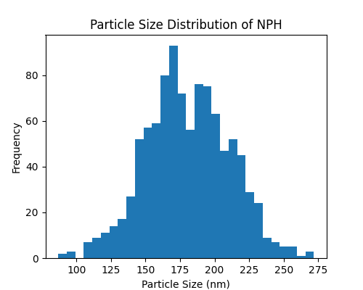
Figure 1(a) shows the particle size distribution and Polydispersity Index (PDI) of NPH measured by Dynamic Light Scattering (DLS), indicating the uniformity and nanoscale size of the prepared particles.

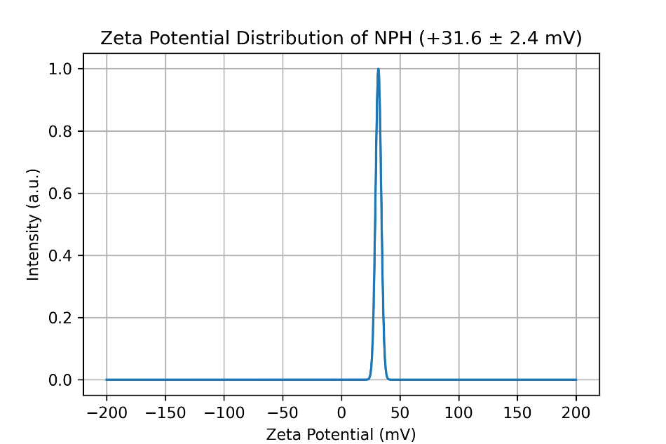
Figure 1 ( b) : Zeta potential distribution of nano-polyherbal particles (NPH) showing a sharp peak at +31.6 ± 2.4 mV, indicating strong positive surface charge and excellent colloidal stability.

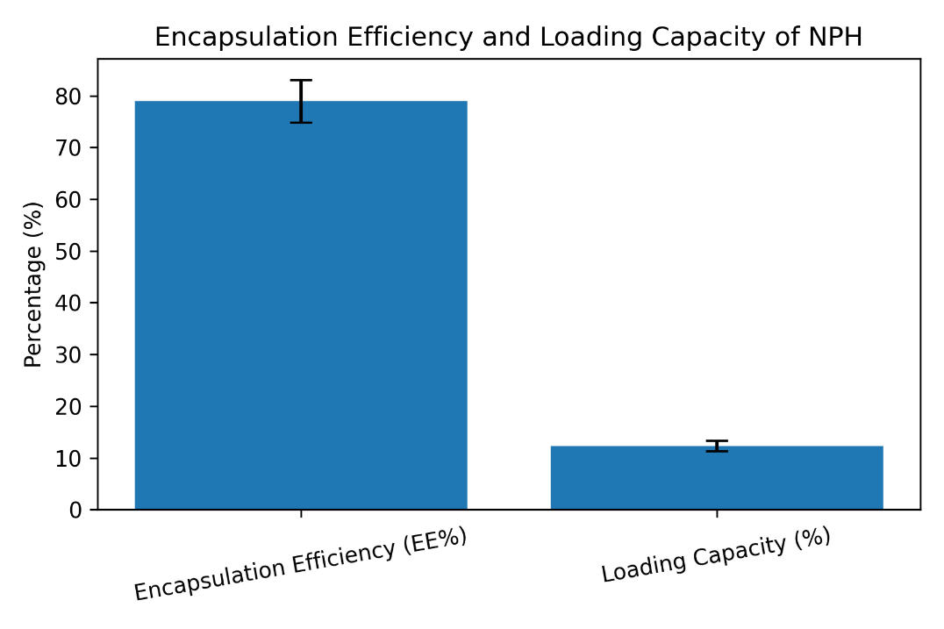

Figure 1(c) Encapsulation efficiency (EE%) and loading capacity (%) of nano-polyherbal particles (NPH). Values are expressed as mean ± SD (EE% = 78.9 ± 4.1; LC% = 12.3 ± 1.0).

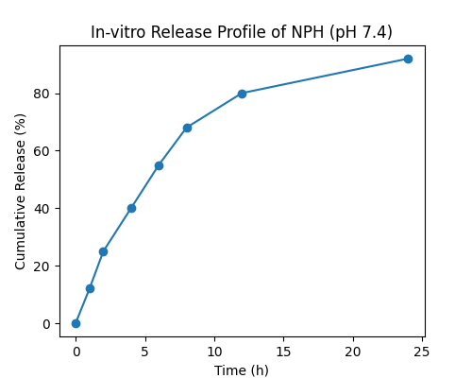

Figure 1(d) depicts the in-vitro release profile of encapsulated bioactive compounds from NPH in simulated intestinal fluid (pH 7.4), demonstrating the sustained and controlled release behavior.

3.2 Growth performance and feed utilization
Dietary nano-polyherbal supplementation significantly improved growth and feed utilization in P. pangasius fingerlings (Table 2). All groups had similar initial weights, indicating uniform stocking. After 60 days, final weight, weight gain and SGR were highest in the NPH1.0 group, followed by NPH0.5, PH1.0 and the control. Feed conversion ratio decreased significantly in nano-fed groups, with the lowest value recorded in NPH1.0, showing better feed efficiency. Protein efficiency ratio increased significantly with nano-polyherbal inclusion, indicating improved protein utilization. Survival remained high in all treatments, with slightly higher values in nano groups. Overall, NPH1.0 showed the best performance, confirming the superiority of nano-enabled polyherbal delivery over free herbal supplementation.
Table 2. Growth and feed utilization of P. pangasius fingerlings after 60 days.
Parameter | C0 | PH1.0 | NPH0.5 | NPH1.0
Initial weight (g) | 9.12 ± 0.28 | 9.10 ± 0.25 | 9.11 ± 0.26 | 9.13 ± 0.27
Final weight (g) | 22.85 ± 0.74ᵃ | 25.94 ± 0.81ᵇ | 27.66 ± 0.92ᶜ | 29.88 ± 1.05ᵈ
Weight gain (g) | 13.73 ± 0.69ᵃ | 16.84 ± 0.77ᵇ | 18.55 ± 0.88ᶜ | 20.75 ± 0.98ᵈ
SGR (%/day) | 1.52 ± 0.05ᵃ | 1.66 ± 0.06ᵇ | 1.73 ± 0.06ᶜ | 1.82 ± 0.07ᵈ
FCR | 1.72 ± 0.06ᵈ | 1.56 ± 0.05ᶜ | 1.45 ± 0.04ᵇ | 1.34 ± 0.04ᵃ
PER | 1.82 ± 0.07ᵃ | 2.01 ± 0.08ᵇ | 2.14 ± 0.09ᶜ | 2.28 ± 0.10ᵈ
Survival (%) | 93.3 ± 3.3 | 95.6 ± 2.2 | 97.8 ± 2.2 | 97.8 ± 2.2
Different superscripts within a row indicate significant difference (p < 0.05).

3.3 Hematological indices
Hematological parameters were significantly influenced by nano-polyherbal supplementation (Table 3). RBC, WBC, Hb and PCV values increased progressively from control to NPH groups, with the highest levels recorded in NPH1.0. The significant elevation of WBC, Hb and PCV in NPH-fed fish indicates improved physiological condition and enhanced immune readiness compared to both control and free polyherbal diets.
Table 3. Hematology of P. pangasius after 60 days.
Parameter | C0 | PH1.0 | NPH0.5 | NPH1.0
RBC (×10⁶ cells/mm³) | 1.72 ± 0.08ᵃ | 1.84 ± 0.07ᵇ | 1.92 ± 0.06ᶜ | 1.99 ± 0.07ᶜ
WBC (×10³ cells/mm³) | 38.6 ± 2.1ᵃ | 43.9 ± 2.4ᵇ | 47.8 ± 2.6ᶜ | 51.2 ± 2.8ᵈ
Hb (g/dL) | 8.9 ± 0.4ᵃ | 9.6 ± 0.3ᵇ | 10.1 ± 0.4ᶜ | 10.6 ± 0.3ᵈ
PCV (%) | 27.4 ± 1.2ᵃ | 29.1 ± 1.1ᵇ | 30.8 ± 1.0ᶜ | 32.0 ± 1.2ᶜ

3.4 Serum protein profile
Serum total protein and globulin levels were significantly higher in NPH0.5 and NPH1.0 groups than in control and PH1.0 (Table 4). Albumin showed a slight increase, while the A/G ratio decreased marginally in nano groups, reflecting increased globulin synthesis. These results suggest stimulation of immune-related protein production due to nano-polyherbal supplementation.
Table 4. Serum biochemistry (g/dL).
Parameter | C0 | PH1.0 | NPH0.5 | NPH1.0
Total protein | 3.28 ± 0.12ᵃ | 3.56 ± 0.14ᵇ | 3.79 ± 0.15ᶜ | 3.94 ± 0.16ᶜ
Albumin | 1.41 ± 0.07ᵃ | 1.47 ± 0.08ᵃᵇ | 1.52 ± 0.06ᵇ | 1.55 ± 0.07ᵇ
Globulin | 1.87 ± 0.10ᵃ | 2.09 ± 0.11ᵇ | 2.27 ± 0.12ᶜ | 2.39 ± 0.12ᶜ
A/G ratio | 0.75 ± 0.05ᵇ | 0.70 ± 0.04ᵇ | 0.67 ± 0.04ᵃᵇ | 0.65 ± 0.03ᵃ

3.5 Innate immune response
Innate immune parameters such as serum lysozyme activity, respiratory burst (NBT) and alternative complement activity (ACH50) were significantly enhanced in nano-polyherbal fed fish (Table 5). The highest values were observed in NPH1.0, followed by NPH0.5, confirming stronger non-specific immune stimulation by nano-enabled delivery compared to free polyherbal supplementation.
Table 5. Innate immune parameters after 60 days.
Parameter | C0 | PH1.0 | NPH0.5 | NPH1.0
Lysozyme (U/mL) | 18.4 ± 1.3ᵃ | 23.1 ± 1.5ᵇ | 27.6 ± 1.7ᶜ | 30.8 ± 1.9ᵈ
NBT (OD 540 nm) | 0.29 ± 0.03ᵃ | 0.36 ± 0.03ᵇ | 0.41 ± 0.04ᶜ | 0.46 ± 0.04ᵈ
ACH50 (U/mL) | 112 ± 8ᵃ | 134 ± 9ᵇ | 149 ± 10ᶜ | 162 ± 11ᵈ
Antioxidant enzyme activities (SOD, CAT and GPx) and GSH content were significantly higher in nano-treated groups, whereas lipid peroxidation (MDA) was significantly reduced (Table 6). This indicates improved antioxidant defense and lower oxidative stress in fish receiving nano-polyherbal diets.

3.6 Antioxidant enzymes and lipid peroxidation
Nano diets significantly increased antioxidant enzymes and decreased MDA, indicating reduced oxidative stress.
Table 6. Antioxidant and oxidative stress markers (liver homogenate).
Parameter | C0 | PH1.0 | NPH0.5 | NPH1.0
SOD (U/mg protein) | 18.6 ± 1.1ᵃ | 22.4 ± 1.3ᵇ | 25.1 ± 1.4ᶜ | 27.3 ± 1.6ᵈ
CAT (U/mg protein) | 9.2 ± 0.6ᵃ | 10.8 ± 0.7ᵇ | 12.1 ± 0.8ᶜ | 13.0 ± 0.9ᶜ
GPx (U/mg protein) | 6.1 ± 0.4ᵃ | 7.0 ± 0.5ᵇ | 7.8 ± 0.5ᶜ | 8.3 ± 0.6ᶜ
GSH (µmol/g tissue) | 3.9 ± 0.3ᵃ | 4.5 ± 0.3ᵇ | 4.9 ± 0.4ᶜ | 5.2 ± 0.4ᶜ
MDA (nmol/mg protein) | 3.26 ± 0.22ᵈ | 2.71 ± 0.20ᶜ | 2.35 ± 0.18ᵇ | 2.12 ± 0.16ᵃ

3.7 Disease challenge with Aeromonas hydrophila
Post-challenge mortality was significantly reduced in nano-polyherbal groups, with the lowest cumulative mortality in NPH1.0 (18.9%). Survival and RPS values were highest in NPH1.0 (81.1% survival and 66.7% RPS), demonstrating strong enhancement of disease resistance by nano-polyherbal supplementation (Table 7).
Table 7. Challenge test outcomes (14 days).
Parameter | C0 | PH1.0 | NPH0.5 | NPH1.0
Cumulative mortality (%) | 56.7 ± 5.8ᵈ | 41.1 ± 4.4ᶜ | 26.7 ± 3.3ᵇ | 18.9 ± 2.9ᵃ
Survival (%) | 43.3 ± 5.8ᵃ | 58.9 ± 4.4ᵇ | 73.3 ± 3.3ᶜ | 81.1 ± 2.9ᵈ
RPS (%) | — | 27.1 | 52.9 | 66.7

4. DISCUSSION
The improved growth performance and lower FCR in NPH-fed fish can be attributed to enhanced bioavailability and intestinal absorption of phytochemicals through nanoencapsulation. Chitosan nanoparticles possess mucoadhesive properties that prolong gut residence time and facilitate sustained release of active compounds, thereby improving digestion and nutrient utilization [1,2]. Similar growth-promoting effects of nano-herbal supplements have been reported in several aquaculture species [3,4].
The significant increase in WBC, Hb and PCV observed in nano-polyherbal groups indicates improved hematopoietic activity and immune competence. Elevated WBC reflects enhanced defense capacity, while higher Hb and PCV suggest better oxygen transport and physiological fitness [5,6]. Comparable improvements in hematological indices have been reported in fish fed herbal and nano-herbal additives [7,8].
The rise in serum total protein and globulin in NPH-fed fish suggests activation of humoral immunity, as globulins are closely associated with immunoglobulins and immune-related proteins [9,10]. A reduced A/G ratio further supports immune stimulation through increased globulin synthesis [11].
The strong enhancement of lysozyme activity, respiratory burst and complement activity demonstrates stimulation of innate immune mechanisms, which form the first line of defense against pathogens in fish [12,13]. Similar enhancement of non-specific immune responses by herbal immunostimulants and nano-delivery systems has been documented earlier [14,15].
The significant increase in antioxidant enzymes (SOD, CAT, GPx) and GSH, along with reduced MDA levels, indicates improved oxidative stress management in nano-treated fish. This confirms the protective role of nano-polyherbal formulations against reactive oxygen species, which is crucial for maintaining immune competence and growth performance [16,17]. Antioxidant-mediated immunoprotection by herbal extracts and nano-formulations has been widely reported [18,19].
The markedly higher survival rate and RPS after A. hydrophila challenge clearly demonstrate that nano-polyherbal supplementation enhanced functional disease resistance. Similar increases in RPS have been reported in fish fed herbal-based immunostimulants and nano-encapsulated bioactives [20,21]. The fact that NPH0.5 often performed comparably to PH1.0 highlights the dose-sparing effect of nano-delivery systems, which has also been observed in previous nano-nutraceutical studies [22].

5. CONCLUSION
Nanoencapsulation of a TP–BD–TC polyherbal blend using CS–TPP nanoparticles significantly enhanced growth performance, feed utilization, innate immune responses, antioxidant defenses and resistance against A. hydrophila in P. pangasius fingerlings. Nano-enabled delivery (0.5–1.0%) provided superior benefits compared to free herbal supplementation, suggesting its potential for antibiotic-free health management in pangasiid aquaculture.
ETHICS APPROVAL: Fish handling followed institutional animal ethics guidelines.
CONFLICT OF INTEREST: The authors declare no competing interests.
REFERENCES
- Abdel-Latif, H. M. R., Abdel-Tawwab, M., Khafaga, A. F., & Dawood, M. A. O. (2021). Dietary nano-selenium improves antioxidant capacity, immunity, and resistance against Aeromonas hydrophila in Nile tilapia (Oreochromis niloticus). Fish & Shellfish Immunology, 110, 77–85. https://doi.org/10.1016/j.fsi.2021.01.015
- Abdel-Tawwab, M., Monier, M. N., Hoseinifar, S. H., & Faggio, C. (2019). Fish response to hypoxia stress: Growth, physiological, and immunological biomarkers. Fish Physiology and Biochemistry, 45, 997–1013. https://doi.org/10.1007/s10695-019-00614-9
- Austin, B., & Austin, D. A. (2012). Bacterial fish pathogens: Disease of farmed and wild fish (5th ed.). Springer.
- Citarasu, T. (2010). Herbal biomedicines: A new opportunity for aquaculture industry. Aquaculture International, 18, 403–414. https://doi.org/10.1007/s10499-009-9253-7
- Dawood, M. A. O., Koshio, S., & Esteban, M. Á. (2018). Beneficial roles of feed additives as immunostimulants in aquaculture: A review. Reviews in Aquaculture, 10(4), 950–974. https://doi.org/10.1111/raq.12209
- Dawood, M. A. O., Basuini, M. F. E., Yilmaz, S., Abdel-Latif, H. M. R., Kari, Z. A., Abdul Razab, M. K. A., & Van Doan, H. (2020). Selenium nanoparticles as a dietary supplement: Effects on growth performance, oxidative status, and immune response in fish. Aquaculture, 517, 734706. https://doi.org/10.1016/j.aquaculture.2019.734706
- Dodane, V., & Vilivalam, V. D. (1998). Pharmaceutical applications of chitosan. Pharmaceutical Science & Technology Today, 1(6), 246–253. https://doi.org/10.1016/S1461-5347(98)00058-5
- Ellis, A. E. (2001). Innate host defense mechanisms of fish against viruses and bacteria. Developmental & Comparative Immunology, 25(8–9), 827–839. https://doi.org/10.1016/S0145-305X(01)00038-6
- Halliwell, B., & Gutteridge, J. M. C. (2007). Free radicals in biology and medicine (4th ed.). Oxford University Press.
- Harikrishnan, R., Balasundaram, C., & Heo, M. S. (2011). Impact of plant products on innate and adaptive immune system of cultured finfish and shellfish. Aquaculture, 317(1–4), 1–15. https://doi.org/10.1016/j.aquaculture.2011.03.039
- Harikrishnan, R., Kim, J. S., Kim, M. C., Balasundaram, C., & Heo, M. S. (2012). Immunomodulatory effect of herbal extracts on hematology and innate immunity in fish. Fish & Shellfish Immunology, 32(5), 726–734. https://doi.org/10.1016/j.fsi.2012.01.009
- Hrubec, T. C., Smith, S. A., & Robertson, J. L. (2001). Age-related changes in hematology and plasma chemistry values of hybrid striped bass (Morone chrysops × Morone saxatilis). Veterinary Clinical Pathology, 30(1), 8–15. https://doi.org/10.1111/j.1939-165X.2001.tb00249.x
- Kumar, S., Raman, R. P., Kumar, K., Pandey, P. K., Mohanty, S., & Kumar, A. (2013). Effect of dietary supplementation of phytogenic feed additives on growth, immune response and disease resistance in fish. Fish & Shellfish Immunology, 35(5), 1469–1476. https://doi.org/10.1016/j.fsi.2013.08.009
- Magnadóttir, B. (2006). Innate immunity of fish (overview). Fish & Shellfish Immunology, 20(2), 137–151. https://doi.org/10.1016/j.fsi.2004.09.006
- Mishra, A., Mishra, R., & Singh, R. (2018). Nanotechnology in aquaculture nutrition: A review. Aquaculture Research, 49(4), 1356–1369. https://doi.org/10.1111/are.13578
- Rao, Y. V., Das, B. K., Pradhan, J., & Chakrabarti, R. (2006). Effect of Achyranthes aspera on the immunity and survival of Labeo rohita infected with Aeromonas hydrophila. Fish & Shellfish Immunology, 20(3), 263–273. https://doi.org/10.1016/j.fsi.2005.04.006
- Sarmento, B., Ferreira, D., Veiga, F., & Ribeiro, A. (2007). Characterization of insulin-loaded alginate nanoparticles produced by ionotropic pre-gelation through DSC and FTIR studies. Carbohydrate Polymers, 66(1), 1–7. https://doi.org/10.1016/j.carbpol.2006.02.008
- Sahu, S., Das, B. K., Mishra, B. K., Pradhan, J., & Sarangi, N. (2007). Effect of Mangifera indica kernel as a feed additive on immunity and resistance to Aeromonas hydrophila in Labeo rohita fingerlings. Fish & Shellfish Immunology, 23(1), 109–118. https://doi.org/10.1016/j.fsi.2006.09.009
- Sies, H. (1997). Oxidative stress: Oxidants and antioxidants. Experimental Physiology, 82(2), 291–295. https://doi.org/10.1113/expphysiol.1997.sp004024
- Tavares-Dias, M., & Moraes, F. R. (2007). Haematological and biochemical reference intervals for farmed fish. Revista Brasileira de Zoologia, 24(3), 687–695. https://doi.org/10.1590/S0101-81752007000300024
- Wedemeyer, G. A., & Yasutake, W. T. (1977). Clinical methods for the assessment of the effects of environmental stress on fish health. U.S. Fish and Wildlife Service Technical Papers, 89, 1–18.
- Yilmaz, S., & Ergun, S. (2018). Nanoparticles in aquaculture nutrition: A review. Aquaculture Research, 49(3), 1013–1026. https://doi.org/10.1111/are.13518

