Original Research Article

A Preview on the Relational Leadership of School Heads

.
ABSTRACT

This study examined how school heads build and sustain relationships with teachers in secondary schools, guided by Relational Leadership Theory and Leader Member Exchange (LMX) Theory. It sought to explore the lived experiences of teachers, the strategies used by school heads, and the insights gained from these interactions in shaping professional relationships within the school setting. Anchored in a constructivist and qualitative research paradigm, the study employed a phenomenological design to capture and understand the meanings teachers assign to their interactions with school leaders. Eight purposively selected Junior High School teachers participated in in-depth interviews and a focus group discussion using a validated semi-structured interview guide to ensure consistency and depth in data collection. Ethical protocols were strictly observed, including informed consent, confidentiality, and voluntary participation, to protect the rights and well-being of participants. Data was collected through audio-recorded interviews and analyzed using thematic analysis, with the researcher maintaining reflexivity throughout the process to ensure accurate and unbiased interpretation. Trustworthiness was ensured through credibility, transferability, dependability, and confirmability. Findings revealed that trust building, empathy, open communication, and supportive leadership practices strengthen teacher relationships and enhance motivation, commitment, and collaboration. The study underscores the importance of relational competence in school leadership and recommends leadership development initiatives and future research across varied educational contexts to further strengthen leadership practices.

Keywords: relational leadership, leader member exchange, teacher relationships, school leadership, qualitative research

1. INTRODUCTION

Relational capability refers to a leader’s ability to foster trust, open communication, respect, and mutual understanding in professional interactions. In school settings, principals play a central role in shaping a positive climate through their daily relationships with teachers, influencing not only the working environment but also the overall effectiveness of the school. Effective relational practices contribute to collaboration, teacher motivation, and improved instructional outcomes, making leadership relationships a critical area of inquiry. When school heads demonstrate strong relational capability, they are better able to create supportive environments that encourage teachers to engage actively, share ideas, and work collectively toward common goals. This perspective aligns with Relational Leadership Theory, which emphasizes that leadership emerges through social interactions and shared meaning-making rather than positional authority (Uhl-Bien, 2006).
International studies highlight the significant influence of principal leadership on teacher collaboration and school effectiveness. Meyer et al. (2020) found that school heads who actively support professional development create environments that enhance collaborative practices and student outcomes. This suggests that leadership actions directly shape the professional culture within schools. However, Honingh and Hooge (2014) noted that administrative demands often limit school heads’ ability to sustain instructional leadership and collaboration, indicating a tension between managerial responsibilities and relational leadership practices. Further, research emphasized the role of collective teacher efficacy as a mediating factor between leadership and collaboration, reinforcing the importance of trust and shared goals (Meyer et al., 2020). These findings collectively highlight that relational leadership is not only about interpersonal interaction but also about enabling structures that support collaboration and shared success, particularly through high-quality leader–teacher relationships as emphasized in Leader Member Exchange Theory (Graen & Uhl-Bien, 1995).
In the Philippine context, School-Based Management underscores the importance of leadership in fostering collaborative school cultures. Bantilan et al. (2024) reported that transformational leadership among school heads is positively associated with teachers’ organizational commitment and collaborative behaviors. This indicates that leadership style significantly influences how teachers engage with their work and with one another. However, challenges such as limited resources and varying leadership competencies continue to affect program implementation, making it difficult for school heads to consistently apply relational leadership practices. In Davao City, Loyola (2024) observed that while school heads demonstrate leadership skills, the consistent translation of these into sustained collaborative practices remains a concern. This indicates a gap between leadership intentions and actual relational practices, highlighting the need for deeper exploration of how leadership is experienced by teachers in real contexts and how relational competence can be strengthened through targeted professional development.
Despite existing studies, limited research explores how school heads’ relational capability is experienced from the teachers’ perspective, particularly in the Philippine secondary school context. Most studies focus on leadership from an administrative or organizational standpoint, with less emphasis on the lived experiences of teachers who directly interact with school leaders. Addressing this gap is essential in identifying strategies that strengthen leadership practices and support school improvement. Understanding these experiences provides valuable insights into how relational leadership is enacted in practice and how it influences teacher engagement and school climate, which are critical components of effective and sustainable educational leadership (Creswell & Poth, 2018).
The purpose of this study was to explore the relational capability of school heads as perceived by teachers. Specifically, it examined how principals build and sustain professional relationships that promote trust, collaboration, and a positive school climate. By focusing on teachers’ perspectives, the study aimed to capture authentic experiences that reflect both the strengths and challenges of relational leadership in schools.
The study aimed to answer the following questions:
- What are the experiences of teachers working with school heads with varying levels of relational leadership competence?
- What coping mechanisms do teachers use to manage relational-related challenges with school heads?
- What insights can be generated from their experiences?
The study further examined how relational leadership practices influence teacher engagement and interaction that support collaboration, trust, and a positive school climate. It aimed to understand how relational leadership practices influence teacher engagement and interaction, while generating insights that may inform leadership development and school improvement efforts. This focus highlights the importance of examining both leadership actions and teacher responses in understanding the dynamics of school relationships.
The literature synthesis emphasized that school heads play a critical role in fostering collaboration through trust building, open communication, and supportive leadership. Effective relational practices enhance teacher motivation, collective efficacy, and organizational commitment, which are essential for achieving positive educational outcomes. However, school heads often face challenges such as administrative workload, limited resources, and varying leadership competencies that hinder the consistent application of relational practices. Addressing these challenges requires strategies such as clear communication, shared decision-making, professional development, and continuous reflection to strengthen relational capability in school settings. These approaches enable school heads to create more inclusive and responsive leadership practices that support both teachers and students.
This study was guided by relational leadership theory and leader member exchange (lmx) theory to explain how school heads build and sustain relationships with teachers. Relational leadership theory highlights the importance of trust, mutual respect, and meaningful interaction in leadership processes, emphasizing that leadership is constructed through social relationships rather than authority alone. Leader member exchange theory, on the other hand, emphasizes the quality of relationships between leaders and subordinates as a determinant of organizational outcomes, suggesting that stronger relationships lead to higher levels of trust, satisfaction, and performance. Together, these theories provide a comprehensive framework for understanding how relational dynamics influence teacher engagement and school effectiveness
2. METHODS

This study employed a qualitative phenomenological design to explore how school heads develop relationships with teachers. Anchored in a constructivist paradigm, it assumed reality is shaped by participants’ lived experiences and meaning is co-constructed through interaction (Creswell & Poth, 2018). The researcher maintained reflexivity to ensure interpretations remained grounded in participants’ perspectives.
A phenomenological approach captured shared experiences of Junior High School teachers interacting with school heads (Neubauer et al., 2019). Data were collected using a validated semi-structured interview guide with open-ended and probing questions, translated into Bisaya for clarity and reviewed by experts following established qualitative procedures (Kallio et al., 2016). Participants were eight purposively selected teachers with at least five years under the same school head (Palinkas et al., 2015).
Ethical protocols included informed consent, confidentiality, voluntary participation, and secure data handling. Data were gathered through in-depth interviews and a focus group discussion (Boyce & Neale, 2006; Krueger & Casey, 2021). The researcher served as the primary instrument, and data were analyzed using thematic analysis (Braun & Clarke, 2006). Trustworthiness was ensured through credibility, dependability, confirmability, and transferability (Lincoln & Guba, 1985), supported by triangulation, member checking, audit trails, and detailed contextual descriptions of participants and research setting.

3. RESULTS AND DISCUSSIONS

The findings of the study revealed that teachers’ experiences in working with school heads with varying levels of relational leadership competence were characterized by several interconnected themes. These included unclear communication, inconsistent treatment among staff, lack of emotional support, limited involvement in decision-making, unmotivating feedback practices, and avoidant responses to conflict. Unclear communication often led to confusion in expectations and responsibilities, affecting teachers’ performance and confidence in carrying out their tasks, which aligns with studies emphasizing the importance of clear leadership communication in supporting collaboration (Meyer et al., 2020). When communication is inconsistent or insufficient, teachers are left to interpret expectations independently, which may lead to errors, inefficiencies, and reduced instructional quality.
Inconsistent treatment among staff created perceptions of unfairness, weakening trust and negatively influencing morale within the school environment. The lack of emotional support made teachers feel undervalued, particularly in situations where guidance and understanding were needed, highlighting the importance of supportive leadership in fostering teacher engagement (Bantilan et al., 2024). Limited involvement in decision-making further reduced teachers’ sense of ownership and participation in school initiatives, making them feel disconnected from institutional goals. These conditions reflect how leadership practices directly influence teachers’ professional experiences and their level of commitment to school programs.
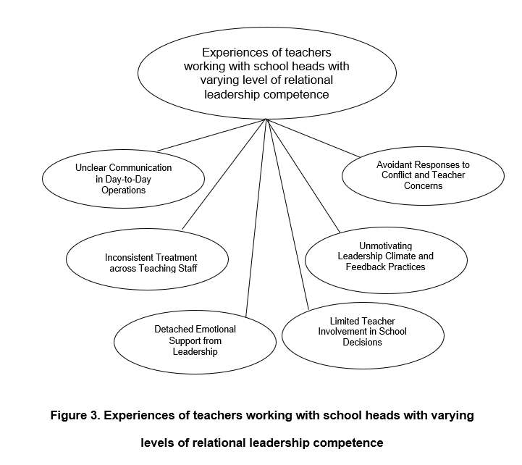
Additionally, unmotivating feedback practices hindered professional growth and diminished enthusiasm, while avoidant responses to conflict allowed issues to remain unresolved, contributing to tension and strained relationships among staff. These patterns reflect gaps in relational leadership practices, where the absence of open communication and trust limits effective interaction (Uhl-Bien, 2006). The findings further support the idea that the quality of leader–member relationships significantly affects workplace dynamics and organizational outcomes (Graen & Uhl-Bien, 1995). Overall, these themes illustrate how relational gaps in leadership influence teacher engagement, workplace dynamics, and the overall school climate, reinforcing the importance of strong relational competence in fostering a supportive, inclusive, and collaborative school environment.

Figure1.

The results further indicated that teachers employed a range of coping mechanisms to manage relational challenges in the school setting. These were organized into key themes such as initiating clarification and peer collaboration, maintaining professionalism and personal boundaries, practicing self-regulation, navigating influence through informal channels, sustaining motivation through internal and peer support, and managing tensions through diplomacy. Teachers often sought clarification and collaborated with colleagues to compensate for unclear communication and limited guidance from school heads, allowing them to maintain alignment in their work. This reflects the importance of collaborative practices in sustaining professional functioning despite leadership challenges (Meyer et al., 2020). Through peer interaction and shared understanding, teachers were able to fill communication gaps and ensure continuity in instructional practices, highlighting the role of collegial support in maintaining workplace effectiveness.
Maintaining professionalism and setting personal boundaries helped teachers manage expectations and avoid unnecessary conflict, while self-regulation enabled them to control emotional responses in demanding situations. Some teachers navigated influence through informal channels, relying on trusted peers or senior colleagues to address concerns indirectly, demonstrating adaptive relational strategies within organizational contexts (Uhl-Bien, 2006). Sustaining motivation through internal drive and peer support also played a crucial role in helping teachers remain committed despite relational difficulties (Fox & Walter, 2022). Additionally, managing tensions through diplomacy allowed them to maintain harmonious working relationships and avoid escalation of conflicts. Collectively, these strategies demonstrate how teachers adapt to leadership limitations while maintaining professional commitment and effectiveness (Graen & Uhl-Bien, 1995).

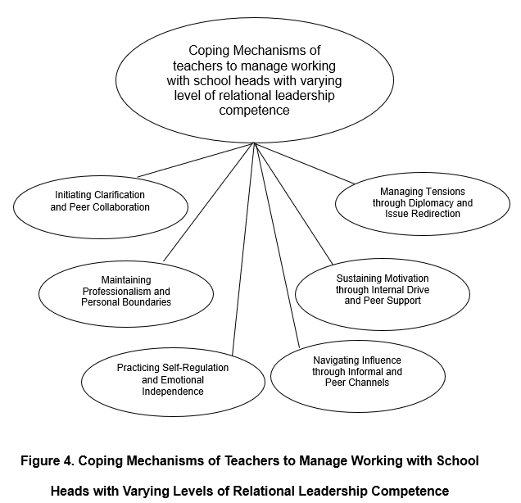

Figure 2.

The findings also highlighted central insights drawn from teachers’ lived experiences. These emphasized that teachers actively seek clarity and fairness when leadership falls short, sustain motivation through internal resilience and collegial support, and manage exclusion and conflict through strategic and diplomatic approaches. Teachers demonstrated a strong sense of agency by taking initiative to clarify expectations, ensure fairness in their work environment, and maintain alignment with school goals despite relational challenges. Their actions reflect a proactive stance in addressing gaps in leadership practices, enabling them to remain effective in their roles. This sense of responsibility allowed teachers to navigate uncertainties while continuing to contribute meaningfully to school operations and student learning outcomes.
Their ability to sustain motivation was largely driven by personal commitment, professional values, and support from colleagues, which helped them remain engaged and productive. This internal drive strengthened their resilience and sustained their commitment despite challenges. This aligns with research emphasizing the role of teacher resilience and collaborative support in sustaining engagement despite leadership challenges (Fox & Walter, 2022). In situations involving exclusion or unresolved conflict, teachers adopted strategic and diplomatic approaches to preserve relationships and maintain a positive working atmosphere. These practices reflect relational processes in leadership (Uhl-Bien, 2006) and the influence of leader–member relationships on workplace dynamics (Graen & Uhl-Bien, 1995). Collectively, these insights underscore teacher agency, adaptability, and relational awareness in maintaining stability and collaboration.
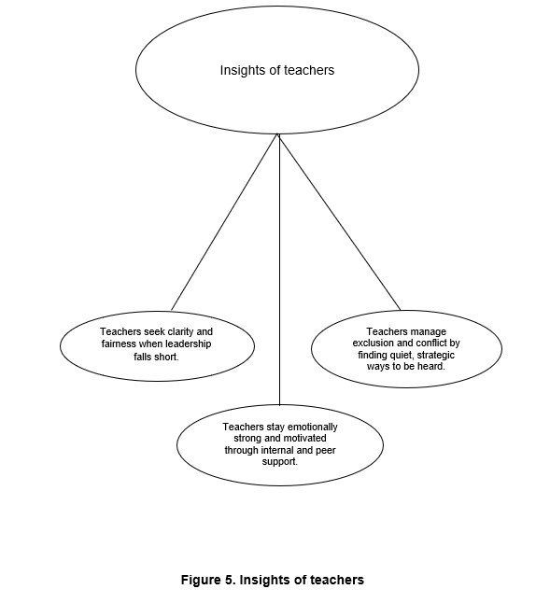
Figure 3.

The findings show that relational leadership plays a critical role in shaping school climate and professional interactions. Clear communication, fairness, and emotional support enhance teacher engagement and motivation, while their absence leads to uncertainty, reduced morale, and challenges in collaboration. These results emphasize the importance of relational competence in fostering trust and positive working relationships within educational settings. Relational leadership, as emphasized by Relational Leadership Theory, highlights that leadership is not merely based on authority but is constructed through meaningful interactions, mutual respect, and shared understanding (Uhl-Bien, 2006). In this context, school heads who demonstrate relational competence are more likely to create environments that promote openness, trust, and collaboration among teachers. Similarly, the principles of Leader Member Exchange Theory suggest that the quality of relationships between leaders and subordinates significantly influences organizational outcomes such as job satisfaction, commitment, and performance (Graen & Uhl-Bien, 1995). When these relational elements are present, teachers are more engaged and motivated, contributing to a more positive and productive school climate. Conversely, when these elements are lacking, teachers may experience disengagement, reduced collaboration, and increased workplace tension, which can ultimately affect instructional effectiveness and student outcomes (Meyer et al., 2020). These findings further reinforce that relational leadership is not an optional aspect of school management but a central component that directly shapes both teacher experiences and institutional effectiveness.
To address these challenges, teachers adopt adaptive strategies such as seeking clarification, strengthening peer collaboration, regulating emotions, and navigating influence through informal channels. These approaches reflect teachers’ resilience and their ability to sustain professionalism despite relational limitations. For instance, seeking clarification helps teachers compensate for unclear communication from school heads, ensuring that they can still perform their roles effectively. Strengthening peer collaboration allows teachers to build support systems within their professional community, which is essential in maintaining morale and productivity. This aligns with findings by Fox and Walter (2022), who emphasized that supportive relationships among teachers can enhance resilience and buffer the negative effects of leadership challenges. Additionally, emotional regulation enables teachers to manage stress and maintain composure in difficult situations, which is critical in sustaining a positive work environment. Navigating influence through informal channels further demonstrates teachers’ adaptability, as they find alternative ways to address concerns and maintain alignment with school goals. These coping strategies illustrate that teachers are not passive recipients of leadership practices but are active participants in shaping their professional experiences. Moreover, these adaptive responses highlight the dynamic nature of school environments, where teachers continuously adjust to relational conditions while striving to maintain instructional quality and professional integrity.
The findings also indicate that teachers are active agents in managing their professional experiences. Through internal motivation, peer support, and strategic interaction, they maintain engagement and navigate relational complexities, highlighting the role of agency and adaptability in educational settings. This perspective aligns with qualitative research approaches that emphasize the importance of understanding participants’ lived experiences and meanings (Creswell & Poth, 2018; Neubauer et al., 2019). Teachers’ ability to remain motivated despite relational challenges reflects a strong sense of professional commitment and responsibility. Their reliance on peer support further reinforces the importance of collaborative culture within schools, where teachers work together to overcome challenges and achieve shared goals. Moreover, their use of strategic interaction, including diplomacy and careful communication, demonstrates relational awareness and the ability to manage complex social dynamics within the school environment. These findings suggest that teacher agency plays a crucial role in maintaining stability and continuity in school operations, even in the presence of leadership limitations. In addition, this highlights the importance of empowering teachers as key contributors to organizational resilience and school improvement.
Overall, effective school leadership extends beyond administrative functions to include building and sustaining meaningful relationships. Relational leadership, characterized by trust, communication, fairness, and support, is essential in promoting collaboration and enhancing teacher engagement. These findings are consistent with studies showing that leadership practices significantly influence teacher commitment and school climate (Bantilan et al., 2024). When school heads prioritize relational competence, they are more likely to foster a culture of collaboration, shared responsibility, and mutual respect, which contributes to improved organizational outcomes. However, challenges such as administrative workload and policy demands may hinder the consistent application of relational practices (Honingh & Hooge, 2014), highlighting the need for targeted interventions. Addressing these challenges requires intentional efforts to balance administrative responsibilities with relational leadership practices to ensure that both organizational efficiency and human relationships are sustained.
These findings underscore the need for leadership development programs that strengthen relational competence and support effective school management. Training programs should focus on enhancing communication skills, emotional intelligence, conflict management, and collaborative leadership practices to better equip school heads in managing relationships. Additionally, continuous professional development and reflective practices can help school leaders adapt to changing demands and improve their relational effectiveness. Ensuring trustworthiness and rigor in understanding these experiences, as emphasized by Lincoln and Guba (1985), is essential in informing evidence-based leadership practices. Furthermore, incorporating structured approaches to data gathering and reflection, such as interviews and focus group discussions (Boyce & Neale, 2006; Krueger & Casey, 2021), can provide valuable insights into improving leadership practices. Strengthening these areas can lead to more responsive and adaptive leadership that aligns with the evolving needs of teachers and school communities.

Conclusion

In conclusion, relational leadership is a critical component of effective school management, influencing not only teacher engagement and collaboration but also the overall school climate. Strengthening relational competence among school heads can lead to more supportive, inclusive, and productive educational environments. By addressing relational gaps and promoting positive leadership practices, schools can enhance both teacher well-being and student outcomes, ultimately contributing to sustainable school improvement.

COMPETING INTERESTS DISCLAIMER:
Authors have declared that they have no known competing financial interests OR non-financial interests OR personal relationships that could have appeared to influence the work reported in this paper.

.

4. REFERENCES
Bantilan, J. C., Sombilon, E. J. J., Regidor, A. R., Mondoyo, D. P., & Edig, M. M. N. (2024). Impact of transformational leadership and school environment on organizational commitment of teachers. Journal of Social, Humanity, and Education, 4(2), 99–116.​Goodwood Publishing
Boyce, C., & Neale, P. (2006). Conducting in-depth interviews: A guide for designing and conducting in-depth interviews for evaluation input. Pathfinder International. https://www.alnap.org/help-library/conducting-in-depth-interviews-a-guide-for-designing-and-conducting-in-depth-interviews
Braun, V., & Clarke, V. (2006). Using thematic analysis in psychology. Qualitative Research in Psychology, 3(2), 77–101. https://doi.org/10.1191/1478088706qp063oa
Creswell, J. W., & Poth, C. N. (2018). Qualitative inquiry and research design: Choosing among five approaches (4th ed.). SAGE Publications.
Fox, A., & Walter, M. (2022). Linking supportive school leadership and teacher resilience: The mediating role of collaboration. Frontiers in Education, 7, 999086. https://doi.org/10.3389/feduc.2022.999086
Graen, G. B., & Uhl-Bien, M. (1995). Relationship-based approach to leadership: Development of leader–member exchange (LMX) theory of leadership over 25 years: Applying a multi-level multi-domain perspective. The Leadership Quarterly, 6(2), 219–247. https://doi.org/10.1016/1048-9843(95)90036-5
Honingh, M., & Hooge, E. (2014). The effect of school reform on teachers' collaboration: A longitudinal study. Educational Management Administration & Leadership, 42(5), 576–592.​ResearchGate
Kallio, H., Pietilä, A.-M., Johnson, M., & Kangasniemi, M. (2016). Systematic methodological review: Developing a framework for a qualitative semi-structured interview guide. Journal of Advanced Nursing, 72(12), 2954–2965. https://doi.org/10.1111/jan.13031
Krueger, R. A., & Casey, M. A. (2021). Focus groups: A practical guide for applied research (6th ed.). SAGE Publications.
Lincoln, Y. S., & Guba, E. G. (1985). Naturalistic inquiry. SAGE Publications.
Loyola, A. S. (2024). Predictive model on leadership skills of school heads towards school climate in Cluster 3, Davao City Division. Pedagogy Review: An International Journal of Educational Theories, Approaches and Strategies, 4(6), 62–70.​Digi Journal Phils+1OAPub+1
Meyer, A., Richter, D., & Hartung-Beck, V. (2020). The relationship between principal leadership and teacher collaboration: Investigating the mediating effect of teachers' collective efficacy. Educational Management Administration & Leadership, 48(5), 888–908.​ResearchGate
Neubauer, B. E., Witkop, C. T., & Varpio, L. (2019). How phenomenology can help us learn from the experiences of others. Perspectives on Medical Education, 8(2), 90–97. https://doi.org/10.1007/s40037-019-0509-2
Palinkas, L. A., Horwitz, S. M., Green, C. A., Wisdom, J. P., Duan, N., & Hoagwood, K. (2015). Purposeful sampling for qualitative data collection and analysis in implementation research. Administration and Policy in Mental Health and Mental Health Services Research, 42(5), 533–544. https://doi.org/10.1007/s10488-013-0528-y
Uhl-Bien, M. (2006). Relational leadership theory: Exploring the social processes of leadership and organizing. The Leadership Quarterly, 17(6), 654–676. https://doi.org/10.1016/j.leaqua.2006.10.007

