Action Research: Improving Students’ Participation in Learning

.
ABSTRACT

Aims: This Action Research investigated the factors affecting students' participation in learning in classroom. It examined the impact of various factors, including the 'teacher factor,' 'subject factor,' and 'environmental factor,' on student motivation to promote participatory learning.
Study design: Action Research.
Place and Duration of Study: Bayta Primary School Wangdue Phodrang, Bhutan, between April 2025 and June 2025.
Methodology: The research comprised pre- and post-intervention stages strategically designed to address challenges related to student participation and foster active engagement. A total of 35 students participated in this action research cycle.
Results: The results indicated that over 80% of students believed that enhanced participation had a positive impact on their learning. Looking ahead, more than 69% expressed a commitment to increased participation in future classes, suggesting sustained positive changes in their attitude towards active engagement.
Conclusion: The findings underscore the importance of a nuanced approach, recognizing students as dynamic individuals who respond positively to the dedication and engagement of their teachers.

Keywords: participation, learning, classroom, teacher

- INTRODUCTION
Managing a classroom and engaging all the students can be difficult for teachers, especially when students come from diverse backgrounds with different personalities and learning abilities. A teacher needs to understand the importance of student participation in the learning process and be informed that no single method will work for everyone involved. To address these challenges, the teacher should promote participatory learning by creating a conducive environment and teaching strategies that would encourage student participation. As such, the selected strategies should cater to the needs of diverse learners and consider their interests.
The classroom activities should be fun for students to learn, which would encourage students to work in pairs or groups. For instance, Problem-Based Learning (PBL) can increase student engagement by helping educators create meaningful, real-world educational experiences (Haque, 2023). As a result, students who actively engage in classroom discussions could score on average 25% higher on assessments than their peers with lower participation (Precourt & Gainor, 2019). This trend is consistent across key factors of participation, including how often students contribute, their consistency, and their presence in class. Letting students think about what they have learned and share their ideas can also help them stay more involved.
It is important to create an open environment where students feel respected and safe to share their thoughts without fear of criticism. Teachers should create opportunities for all the students to contribute their ideas and ensure their contributions are valued. A clear outline of the expectations for respectful classroom interactions can guide conversations to allow fair participation from everyone. Therefore, this action research aims to enhance classroom participation by identifying factors such as teacher-related practices, subject content, and environmental conditions that affect their motivation to be involved. Two main objectives of this study are:
- Explore the underlying reasons for students' reluctance to participate in class.
- Examine the impact of teacher factor, subject factor, and environmental factor on student motivation to participate in class.

- Problem Statement and significance of the study

Active student participation is a crucial aspect of effective teaching and meaningful learning. Yet, at Bayta Primary School in Wangdue Phodrang District, Bhutan, many students demonstrated limited engagement and involvement in classroom discussions and learning activities. This lack of participation not only impacted their academic progress but also undermined their self-confidence, communication abilities, and overall learning experience. Various factors may contribute to this challenge, such as low motivation, instructional methods that fail to actively involve students, an unsupported classroom environment, or cultural and contextual influences that shape students’ willingness to engage. Although Bhutan’s education reforms emphasise the importance of learner-centred and participatory teaching practices, implementing these approaches effectively remains difficult in some classrooms—including my own. This action research project seeks to explore the root causes of low participation among students and to develop and evaluate strategies aimed at fostering greater involvement in classroom activities. The overarching goal is to build a more interactive, inclusive, and student-focused learning environment at Bayta Primary School.
This five-week action research, carried out at Bayta Primary School in Wangdue Phodrang Dzongkhag, Bhutan, aimed to improve student participation in classroom activities. The study began with the observation that many students showed a lack of enthusiasm for actively engaging in the learning process. Acknowledging the critical role of class participation in effective learning, the researcher sought to foster positive behavioral changes among students in the classroom setting. The research was organized into two main phases, each carefully designed to address the challenges related to low student participation and to promote more active involvement. A key foundation of this study was the belief that identifying the root causes of low participation is essential before introducing interventions. This step-by-step approach was intended to ensure that the solutions implemented would be meaningful and relevant to the classroom context. Relevant literature highlights the complex nature of improving student engagement, pointing to factors such as effective classroom management, motivational techniques, and the teacher’s role in building an inclusive and stimulating learning atmosphere. Importantly, students themselves reported that their participation improved their learning and expressed a willingness to be more actively involved in future lessons. This indicates a lasting shift in their attitudes toward classroom engagement. This case study offers practical insights into how teacher-led initiatives can positively influence student behavior and motivation. It reinforces the idea that thoughtful, research-informed interventions can play a significant role in enhancing student participation and creating a more dynamic classroom environment.

- RESEARCH QUESTION
This study seeks to answer the following research questions:
- What are the factors affecting students’ participation in learning at Bayta Primary School?
- How do students perceive class participation in their day-to-day learning?
- What is the impact of the intended intervention on students’ confidence and participation to learn?

- LITERATURE REVIEW
As aptly noted by Baker (2005), educators face the challenging task of maintaining safe classrooms while concurrently ensuring the education of all students. Mettelal (2002) asserts that classroom action research serves as a valuable tool for uncovering effective practices in the teaching and learning environment. Addressing students' hesitancy to engage in classroom discussions stands out as a significant concern for educators. In tackling the challenge of student passivity in the classroom, proactive measures are necessary. According to Newmann (1989), educators can inspire students by meeting their requirements for competence, providing extrinsic rewards, fostering intrinsic interest, offering social and moral support, and demonstrating recognition of students' efforts in the classroom. Dallimore, Hertenstein, and Platt (2004) concur with Newmann, emphasizing the significant role teachers play in motivating students. They advocate for teachers to comprehend students' reactions in the classroom, especially during pedagogical strategies involving active student participation, such as classroom discussions.
Furthermore, Wagaman (2009) recommends incorporating provocative techniques into teaching, such as posing questions without a single correct answer, positively reinforcing students even when they provide incorrect responses (e.g., using a thumbs-up gesture), and recognising efforts. She contends that employing these provocative strategies ensures that every student has an equal chance to participate in the classroom. Wagaman also highlights the importance of not solely relying on the most active students, as consistently calling on them may lead other students to refrain from participating.
Wubbles and colleagues (1999), as cited in Marzano, Marzano, and Pickering (2003), highlight that teachers need to excel not only as effective instructors and lecturers but also as approachable, supportive, and amicable individuals. They emphasize the importance of teachers possessing the ability to comprehend their students and being adept communicators within the classroom. Bloom (1980), as cited in DiGiulio (2000), recommends that posing questions to students constitutes a fundamental skill through which teachers can gain insights and contribute to students' improvement. This extends beyond just asking questions. O’Leary and O’Leary (1977) emphasized that a teacher's expressions of warmth, words of encouragement, praise, assessments, and even silence wield significant influence in shaping students' social and academic behaviors (p.55).
In 2016, Kasa delved into diverse action strategies and recommendations, encompassing alterations in seating arrangements and the implementation of reinforcement for students. This marked a significant shift from the previous state of participation, signalling a notable transformation in students' behaviour towards more active engagement in the classroom.
In summary, the literature underscores the multifaceted nature of improving student class participation, involving effective classroom management, motivational strategies, and the crucial role of teachers in creating an inclusive and engaging learning environment.

- METHODS
  - Research Design
This action research was conducted over a period of five weeks. It was conducted in two phases. This study focused on establishing the challenges related to student class participation and promoting active engagement. The fundamental principle guiding this action research is rooted in the approach of first identifying the causes of the problem before implementing solutions. This design is grounded in the belief that understanding the root causes is essential for bringing about meaningful improvements in the classroom setting.
During the first phase, the study delved into an in-depth examination of the underlying causes behind students' hesitancy to engage actively in class. To identify the motivating and inhibiting factors influencing student participation, this initial stage was meticulously crafted based on the insights garnered from the literature review. The literature review has revealed a spectrum of factors contributing to student passivity, encompassing both the content taught in class and external environmental influences. Additionally, it highlights the significant impact of teacher personality and teaching methodologies on student participation levels. The primary objective of the pre-intervention phase was to empirically assess the influence of these identified factors on student participation. The questionnaires utilized in this stage categories the factors into three broad variables: subject-related factors, teacher-related factors, and environmental factors.
The second phase of this study involved implementing intervention strategies based on the findings obtained from baseline data. To evaluate the effectiveness of these interventions in enhancing student class participation, I conducted the second stage of the research. The primary objective of this stage was to assess the outcomes or improvements resulting from the implementation of the intervention strategies. This assessment was conducted through a set of research questions specifically designed to measure the success of the dedicated efforts throughout the five-week Teaching Practice period.
  - Sample and site selection
This study employed purposive sampling as the researcher intended to examine the students’ participatory learning at his work site. Therefore, 35 students who are in grade six at Bayta Primary School, Wangdue Phodrang District, Bhutan, were recruited. The author is the principal of the school.
  - Data Collection
There were two phases of data collection. In the first phase, a survey was administered to collect data. Based on the findings, an intervention was planned and conducted over a period of five weeks. In the second phase, the survey was again administered to collect data. The second phase of data collection focused on evaluating the impact of my classroom interventions on students' motivation to participate actively.

  - Data Analysis
The data obtained from 'Research Question Set A' underwent analysis utilising a straightforward statistical tool based on respondent numbers. The outcomes were then visually represented through graphical elements, including bar graphs and pie charts.

- RESULTS AND DISCUSSION
The findings from this study are presented in three parts: pre-intervention, intervention and post-intervention.
6.1 Pre-intervention results
In the initial analysis, the focus was on gauging students' awareness of the significance of class participation. The findings revealed that more than 74% of students acknowledged the importance of class participation. These results are illustrated in Table 1 and Figure 1.
Table 1: Response on the Importance of Class Participation
Group | No. Of Students | Percentage
Strongly disagree | 0 | 0%
Disagree | 9 | 26%
Agree | 21 | 60%
Strongly agree | 5 | 14%
Total | 35 | 100%

Figure 1. Response on the Importance of Class Participation
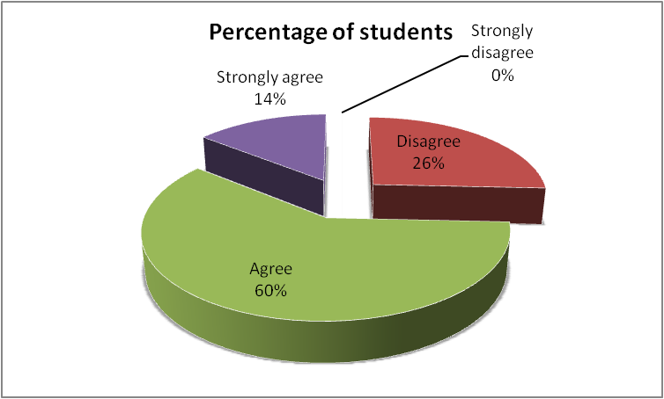
As shown in Table 1 and Figure 1, there was over 74% of students demonstrated an understanding of the significance of active involvement in class by agreeing or strongly agreeing that class participation is important for their learning. These results highlight a positive awareness among the student population regarding the importance of class participation.
Table 2: Importance of Subject factor
Group | No. Of Students | Percentage
Strongly disagree | 5 | 14%
Disagree | 10 | 29%
Agree | 15 | 43%
Strongly agree | 5 | 14%
Total | 35 | 100%

Figure 2: Importance of the Subject factor

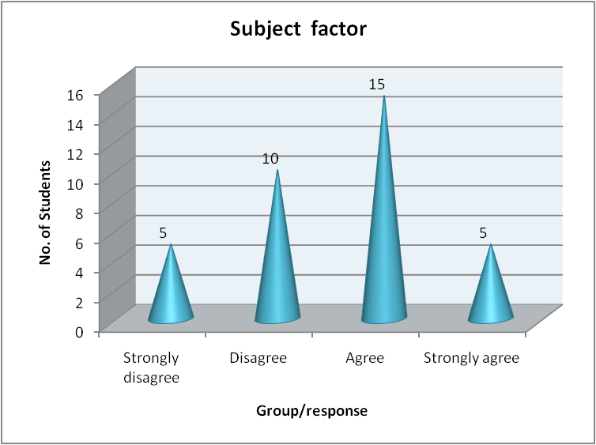
As shown in Table 2 and Figure 2, 57% of the students agreed or strongly agreed that the subject matter plays a vital role in motivating class participation. However, 43% of the respondents express disagreement regarding the significance of the subject matter in motivating participation.
Table 3. Importance of the teacher factor
Group | No. Of Students | Percentage
Strongly disagree | 0 | 0%
Disagree | 3 | 9%
Agree | 7 | 20%
Strongly agree | 25 | 71%
Total | 35 | 100%

Figure 3. Importance of the teacher factor
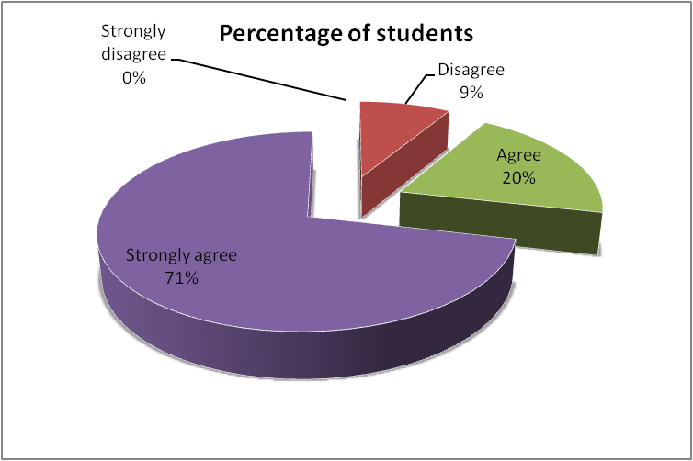

In Table 3 and Figure 3, regarding students' responses concerning the teacher factor, a significant majority, comprising 32 out of 35 respondents (more than 91 per cent), believe that the 'teacher factor' holds substantial importance in motivating students to participate in class.

Table 4. Importance of Environmental Factors
Group | No. Of Students | Percentage
Strongly disagree | 10 | 29%
Disagree | 20 | 57%
Agree | 4 | 11%
Strongly agree | 1 | 3%
Total | 35 | 100%

Figure 4. Importance of Environmental Factors

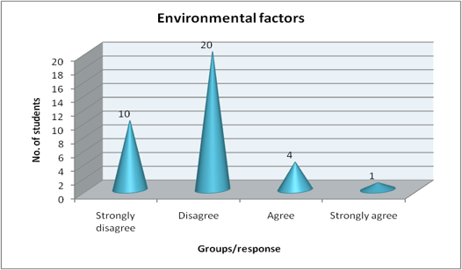

Table 4 and Figure 4 present the findings related to the 'environmental factor variable.' An analysis of responses indicates that the majority of respondents believe that environmental factors are not significant influencers of students' class participation efforts. Specifically, nearly 90% of students express the view that their motivation for class participation is not impacted by the classroom or external environmental factors.
To summarize, the analysis of overall responses before the conduct of the intervention plan, it is evident that more than 70% of respondents understand the importance of class participation in their learning process. Although the majority of students are aware of its significance, paradoxically, this awareness is not consistently reflected in their behaviour. This suggests that students can be motivated to participate in class when appropriate reinforcement activities are implemented. Additionally, analyzing students' responses to the three motivating factors suggests that the 'teacher factor' is most important to them, followed by the 'subject factor'. The 'environmental factor' was found to be the least relevant for motivating them to participate in class.
6.2 Intervention Plan
In this phase of the action research process, I seamlessly transitioned from the insights gained in Stage I to implement targeted interventions aimed at enhancing students' class participation. Recognizing the pivotal role of the 'teacher factor' as perceived by students, I dedicated the next three weeks to conscientiously shaping my teaching approach to fuel their motivation. My strategic initiatives encompassed:
- Instituting regular affirmations to openly acknowledge and celebrate students' efforts.
- Cultivating a genuine teacher-student relationship founded on trust and understanding.
- Establishing an inclusive platform where students feel comfortable sharing their challenges, fostering a student-friendly atmosphere in teaching and learning.
- Actively encouraging students to voice their concerns and engage in open communication.
- Presenting myself as a facilitator of learning, creating an environment that instilled a sense of ease and comfort among students."
The detailed intervention plan can be seen in Appendix 1.
6.3 Post-intervention result
After the implementation of the intervention, I sought to evaluate the impact on students' motivation to participate actively. While early behavioral indicators were promising, indicating positive shifts in students' attitudes toward class engagement, a comprehensive understanding necessitated a systematic and scientifically rigorous investigation. To establish the efficacy of my efforts in enhancing classroom behavior and participation, I initiated Stage II of my action research.
The findings revealed that the intervention had a positive impact on changing students’ minds in understanding the importance of class participation. This is presented in the following Table 5 and Figure 5.
Table 5: Student Responses on the Importance of Class Participation
Group | No. Of Students | Percentage
Strongly disagree | 0 | 0%
Disagree | 2 | 20%
Agree | 10 | 43%
Strongly agree | 23 | 66%
Total | 35 | 100%

Figure 5 Student Responses on the Importance of Class Participation

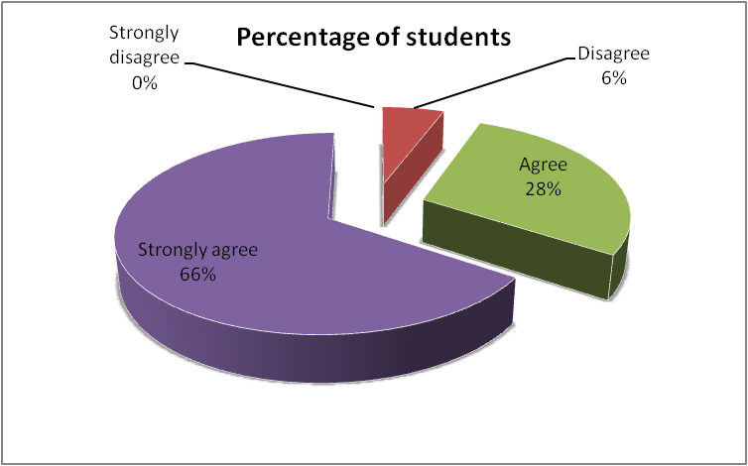

The results indicated a substantial improvement in students' understanding of the importance of class participation, with over 94% agreeing or strongly agreeing. This contrasts significantly with the initial stage of the action research, where only 74% agreed, with a mere 14% strongly agreeing. This noteworthy 20% enhancement, particularly the substantial increase in the strongly agree category, suggests that, by the conclusion of the action research period, I successfully instilled in students a heightened appreciation for the role of class participation in their effective learning.
The subsequent analysis of Stage II further reveals positive changes in students' perceptions of their ability to improve class participation. This shift is graphically presented in the following section, reaffirming the notion that teachers can indeed contribute to positive behavioral changes in students, particularly in the context of their classroom engagement and participation.

Group | No. Of Students | Percentage
Huge improvement | 14 | 40%
Improvement | 18 | 51%
No improvement | 0 | 0%
Can't say | 3 | 9%
Total | 35 | 100%
Figure 6
(b) Percentage presentation of Figure 6 (a) data
Table 6. Students’ self-rating in terms of class participation improvement

Figure 6: . Students’ self-rating in terms of class participation improvement
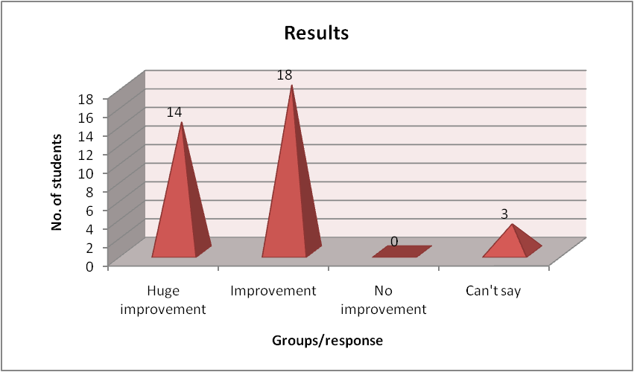

Figure 6 highlights students' perceptions of their improvement in terms of class participation. Over 51% of students indicated an improvement, while an additional 40% reported a significant and positive change, stating they have experienced a huge improvement. These findings affirm the positive impact of the interventions on students' self-perceived progress in class participation. The absence of responses indicating no improvement suggests a notable success in fostering a sense of growth and development among the student body. The findings underscore the effectiveness of the implemented strategies in positively influencing students' active engagement and participation in the classroom.

Table 7. Learning effect (improved my learning ability)
Group | No. Of Students | Percentage
Strongly disagree | 0 | 0%
Disagree | 4 | 11%
Agree | 20 | 58%
Strongly agree | 11 | 31%
Total | 35 | 100%

Figure 7 . Learning effect (improved my learning ability)
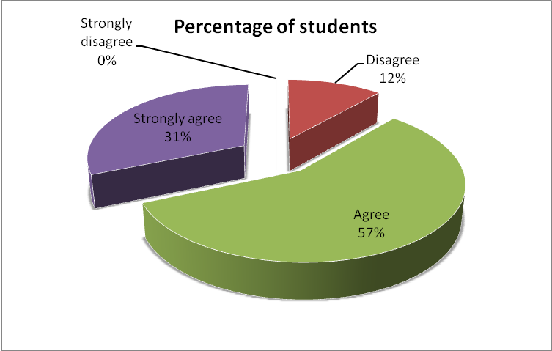
As shown in Figure 7, it was revealed that more than 80% of students believe that their class participation has positively affected their learning. This significant endorsement from the student body underscores the connection between active class participation and enhanced learning outcomes. Moreover, as depicted in Figure 8, over 69% of students express a willingness to participate more in future classes, indicating a positive shift in their attitude towards class engagement. This attitudinal change aligns with their newfound understanding of the importance of class participation, as facilitated by the action research initiatives.

Table 8. Future participation
Group | No. Of Students | Percentage
Participate more | 24 | 69%
Participate less | 2 | 6%
Don't know, depends | 9 | 25%
Total | 35 | 100%
Figure 8 Future participation
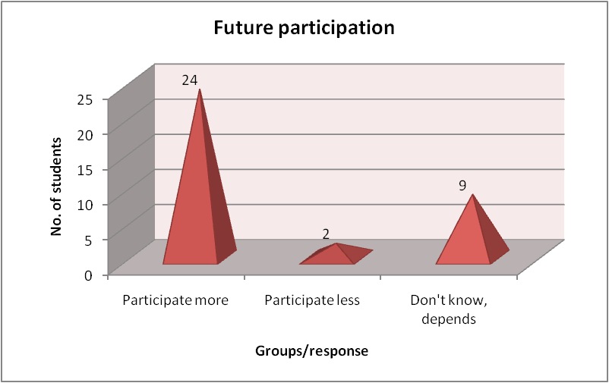

Figure 8 illustrates the students' intentions regarding future class participation. Over 69% express their commitment to participate more in future classes, indicating a positive and enduring change in their attitude toward active engagement in the learning process. Meanwhile, only 6% anticipate participating less, and 25% express uncertainty, suggesting that a significant majority is inclined towards sustained active participation.
To summarize, the outcomes of Stage II in this action research indicated a heightened understanding among students regarding the importance of class participation by the end of the research period. The substantial increase of over 20% in respondents agreeing with the idea of increased understanding reinforces the effectiveness of the interventions. Moreover, these findings align with classroom observations, affirming a notable improvement in student class participation with positive spillover effects on learning ability. The data also indicates that, as a result of efforts to motivate students in class participation, more than 68% intend to sustain their positive learning attitude in future class participation. This finding underscores the enduring impact of teacher interventions in shaping students' behaviors and attitudes toward active participation in the learning process.
- CONCLUSION
This action research, conducted over five weeks at Bayta Primary School in Wangdue Phodrang Dzongkhag, Bhutan, aimed to elevate student class participation. The study began with an acknowledgment of the prevailing lack of enthusiasm among students for active involvement in the learning process. The multifaceted nature of student passivity was addressed through a comprehensive action research methodology, divided into two stages.
The initial stage involved an in-depth exploration of factors influencing student participation, guided by insights from the literature review. The analysis of responses from students revealed a high level of awareness (over 70%) regarding the importance of class participation. Paradoxically, this awareness did not consistently translate into behavior, highlighting the need for targeted interventions. The 'teacher factor' emerged as the most influential element, with more than 91% of students recognizing its significance in motivating class participation. Subject matter also played a role, though not as pronounced, while environmental factors were perceived as less relevant. These findings laid the foundation for targeted interventions in Stage II.
In Stage II, the researcher implemented strategic interventions over three weeks based on the insights gained in Stage I. The interventions focused on affirmations, building teacher-student relationships, creating a conducive learning environment, encouraging open communication, and presenting the teacher as a facilitator of learning. The post-intervention data analysis revealed positive shifts in students' understanding of the importance of class participation. The percentage of students strongly agreeing on the importance increased by 20%, indicating a successful instillation of appreciation for active engagement. The self-rated improvement in-class participation was significant, with 91% reporting improvement or huge improvement. Moreover, over 80% of students believed that their improved participation positively affected their learning. Looking to the future, more than 69% expressed a commitment to participating more in upcoming classes, indicating sustained positive changes in their attitude toward active engagement.
This action research has provided valuable insights into student behaviour and the pivotal role of class participation in the learning process. The findings, while specific to the Bhutanese classroom context, offer valuable lessons and considerations for educators globally. The central theme that emerges from this research is the significant impact of the 'teacher factor' in motivating and shaping student classroom participation. The dynamic nature of students' classroom behaviour, as revealed in this study, underscores the responsiveness of students to teachers' efforts and commitment. The findings emphasise the need for a nuanced approach, recognising that students are not static entities but individuals who can positively respond to the dedication and engagement of their teachers.

Consent

Written informed consent was obtained from the parents of all the participating students and submitted to the School Action Research and District Action Research Committee for kind review.

COMPETING INTERESTS DISCLAIMER:
Authors have declared that they have no known competing financial interests OR non-financial interests OR personal relationships that could have appeared to influence the work reported in this paper.

References

- Dallimore, E. J., Hertenstein, J. H., & Platt, M. B. (2004). Classroom participation and discussion effectiveness: Student-generated strategies. Communication Education, 53(1).
- DiGiulio, R. (2000). Positive classroom management. A step-by-step guide to successfully running the show without destroying student dignity. Corwin Press, Inc., A Sage Publications Company, 2455 Teller Road, Thousand Oaks, CA 91320.
- Jones, V. F., & Jones, L. S. (2004). Comprehensive classroom management: Creating communities of support and solving problems. Boston: Pearson/Allyn and Bacon.
- Marzano, R. J., Marzano, J. S., & Pickering, D. J. (2003). Classroom management that works: Research-based strategies for every teacher. ASCD.
- Mettetal, G. (2002). Improving teaching through classroom action research. Essays on teaching excellence: Toward the best in the Academy, 14(7), 1-4.
- Newmann, F. M. (1989). Student engagement and high school reform. Educational leadership, 46(5), 34-36.
- O'Leary, K. D., & O'Leary, S. G. (1977). Classroom management: The successful use of behavior modification. Pergamon.
- Smith, J. L., Wagaman, J., & Handley, I. M. (2009). Keeping it dull or making it fun: Task variation as a function of promotion versus prevention focus. Motivation and Emotion, 33, 150-160.
- Baker, P. H. (2005). Managing student behavior: How ready are teachers to meet the challenge? American secondary education, 51-64.
- Bloom, B. S. (1980). The new direction in educational research: Alterable variables. The Journal of Negro Education, 49(3), 337-349.
- DiGiulio, R. (2000). Positive classroom management. A step-by-step guide to successfully running the show without destroying student dignity. Corwin Press, Inc., A Sage Publications Company, 2455 Teller Road, Thousand Oaks, CA 91320.
- Kasa, Y. (2016). Improving student’s participation in the classroom in chemistry freshman students at Assosa University: An experimental action research. International Journal of Education, Culture, and Society, 1(1), 5-10.
- Haque, M. R. (2023). The use of problem-based learning to enhance student participation. Edulingua: Jurnal Linguistiks Terapan dan Pendidikan Bahasa Inggris, 10(2), 41-52.
- Precourt, E., & Gainor, M. (2019). Factors affecting classroom participation and how participation leads to a better learning. Accounting Education, 28(1), 100-118.

APPENDIx 1- Action Research Planning and Implementation Procedure
This action research project was conducted at Bayta Primary School, located in the Wangdue Phodrang District of Bhutan, to enhance the students' learning experience. The following procedures and weekly schedules were systematically adopted during this research:
Week 1: Initial Classroom Observation and Recognition of Issues
During the first week of my teaching assignment at Bayta Primary School, I was assigned to five sections, each consisting of 35 students. As I commenced teaching, it became apparent that the students lacked enthusiasm and were not actively participating in class activities. The communication in the class seemed unidirectional, and I sensed reluctance among the students to engage.
While teaching all the classes during the week, I observed this common pattern of minimal participation, and it raised concerns about the effectiveness of my teaching methods. Considering my relatively new presence to the students, I speculated that the unfamiliarity might be hindering effective communication. Despite patiently hoping for a natural shift as we got to know each other, there was little improvement by the end of the week.
This situation prompted me to see an opportunity to delve deeper into the reasons behind the students' reluctance to participate actively in the class. I recognized it as an ideal scenario for conducting action research, aligning with the requirements of the teaching program. Over the weekend, I began formulating my research plan to investigate the issue of lack of student class participation.
While planning, I divided the action research into two stages, covering weeks 2 to 6. The first stage aimed to identify the reasons behind students' reluctance to participate, and I scheduled it to conclude by the end of week 2. This allowed me the weekend to analyze the findings. The subsequent three weeks (week 3 to week 5) were dedicated to implementing interventions based on the first-stage findings. The final week (week 6) was reserved for the second stage of the action research, evaluating the effectiveness of my interventions.
The primary objective of the first stage was to understand the factors contributing to students' reluctance to participate in class. Identifying these factors was crucial for planning targeted interventions to enhance classroom behavior. The second stage, to be conducted later in the action research period, aimed to assess the outcomes of my interventions and evaluate their impact on improving student learning through increased class participation. This systematic approach ensured a comprehensive understanding of the issue and the effectiveness of the implemented strategies.
Week 2: Development and Distribution of Questionnaires for Stage 1
In the second week of my action research, I commenced the development of questionnaires as per the outlined plan. Relying on insights from existing literature, I gathered ideas related to student behavior in the classroom, especially focusing on their hesitancy to participate actively. However, the lack of specific studies on Bhutanese students made the task challenging. Drawing from available literature and my own experiences, I crafted a set of questionnaires designed to uncover the factors contributing to student's lack of enthusiasm for class participation.
By the middle of the week, I successfully circulated my research questionnaires among the students. Due to time constraints, I had to limit the scope of my research to one section (a single class) despite teaching five classes. This decision was made to ensure the efficiency and thoroughness of the data collection process. As the week concluded, I collected the data required for analysis during the upcoming weekend.
Analyzing the collected data at the start of the following week allowed me to identify the root causes of students' reluctance to participate in the class. The findings from the first stage of my action research emphasized the pivotal role of the teacher in motivating students. According to the students, the teacher's personality, teaching methods, and ability to create a conducive classroom environment significantly influenced their motivation to participate in class activities. This understanding served as a valuable foundation for shaping the interventions I would implement in the subsequent weeks to address the identified issues and enhance student class participation.
Weeks 3-5: Implementation of Interventions
Building upon the insights gained from the first stage of my action research, weeks 3 to 5 were dedicated to the implementation of targeted interventions in the classroom. The primary objective was to foster a conducive environment that would encourage students to actively participate in the learning process. Throughout this period, my interventions were strategically designed to motivate and engage the students, aiming for a positive transformation in their participation levels.
These interventions were carefully tailored based on the identified issues from the initial stage of the study, primarily focusing on the teacher's role, teaching methods, and the overall classroom atmosphere. The interventions were implemented to address these factors and create a more participatory and dynamic learning environment.
As the intervention strategies were deployed, there were observable signs of improvement in students' attitudes and participation levels. The positive changes served as encouraging indicators that the implemented interventions were making a meaningful impact on the learning atmosphere within the classroom. These weeks provide valuable insights into the effectiveness of the interventions, setting the stage for the subsequent evaluation in the second stage of the action research.
Week 6: Evaluation of Interventions
In the final week of the action research period, I conducted a second set of studies to comprehensively evaluate the impact of the interventions implemented during weeks 3 to 5. This evaluation aimed to gauge the effectiveness of the strategies employed in motivating students to actively participate in the classroom setting.
To conduct this evaluation, I developed a second set of questionnaires. These questionnaires were meticulously designed to assess the students' perceptions, attitudes, and experiences regarding the interventions. The focus was on understanding whether the implemented strategies had indeed influenced their willingness to participate and engage in the learning process.
The data collected during this week served as a crucial component for validating the outcomes of the action research. Analyzing the responses and feedback from the students provided valuable insights into the sustained impact of the interventions on their behavior and participation levels. This final stage was essential for drawing conclusive findings and determining the overall success of the action research in elevating student involvement in classroom activities.

