A Critical Study on Phenol and Phenolic Derivatives in Shitalakshya River Water and in Portable Water System at Dhaka City, Bangladesh

ABSTRACT
Phenolic compounds have been recognized as priority pollutants with significant environmental and health impacts due to their toxicity and carcinogenic properties. This study investigates the presence of phenol and selected phenolic derivatives (2-methyl phenol, 3-methyl phenol, 2-methoxy phenol) in water samples from the Shitalakshya river and Dhaka City Corporation's water supply system. Sixteen water samples were collected from five sampling sites along the Shitalakshya river (including surface and 60 cm depth samples) and seven locations within Dhaka city's water distribution network. Analysis was performed using Gas Chromatography-Mass Spectrometry (GC-MS) following liquid-liquid extraction with dichloromethane. The results showed phenol concentrations ranging from <0.0003 ppb (below minimum detection limit) to 1.25 ppb, with the highest levels detected in the 60 cm depth water at Siddirgonj Salurghat station. 3-methyl phenol exhibited the highest concentration among all investigated compounds, reaching 2.73 ppb at the surface water of Siddirgonj Salurghat station. In tap water samples, phenol was detected in Fakirapool (0.5 ppb) and Segunbagicha (0.24 ppb) regions. The recovery rates ranged from 54.24% to 96.12% for the investigated compounds. Although most concentrations were below permissible limits, the detection of these carcinogenic compounds in drinking water sources calls for continued monitoring and identification of their sources.
Keywords: Phenolic compounds, Water contamination, Shitalakshya river, GC-MS analysis, Environmental monitoring
1. Introduction
Water contamination by phenolic compounds represents a critical environmental challenge in Bangladesh's rapidly industrializing river systems and urban regions, and Dhaka is its center piece.[1] The Shitalakshya river serves as a vital water source for Dhaka's metropolitan population through the Dhaka Water Supply and Sewerage Authority (WASA) treatment and distribution system.[2] The Shitalakshya River, historically renowned for its clear and cool waters that once supported the famous muslin industry, now faces significant PAHs pollution pressures from extensive industrial development along its banks.[3] The dual role, as both an industrial waste receptor and a primary drinking water source, creates a particularly acute public health concern, particularly from phenolic derivative compounds.
Phenolic compounds and their derivatives are widespread environmental pollutants originating from both natural and anthropogenic sources.[4] Phenolic compounds and their derivatives represent significant environmental contaminants originating from diverse industrial sources including synthetic resins, paper manufacturing, petroleum refining, pharmaceutical production, and agricultural applications as pesticides.[4,5] Due to their toxicity and carcinogenic properties, phenolic compounds are quite risky and threatening to living organisms even at low concentrations.[6]
The presence of phenols in water supplies manifests as objectionable and noticeable taste and odor, particularly when subjected to chlorination, which produces chlorophenolic compounds with a subtle medicinal tastes.[7] The chlorination process employed by Dhaka WASA for water treatment introduces additional complexity to phenolic contamination assessment. When phenolic compounds reacts with chlorine during disinfection, they form chlorophenolic derivatives with characteristic medicinal tastes and enhanced toxicity profiles.[8] This transformation process means that even low-level phenolic contamination in source water can result in organoleptic problems and increased health risks in the final treated water supply.
The United States Environmental Protection Agency (USEPA) has classified several phenolic compounds as priority pollutants, establishing a permissible limit of 0.10 mg/L in waste water. [4,9] The Agency has also established a provisional Reference Concentration (R_{f}C) for phenol of 0.006 mg/m³ based on animal studies. These compounds enter aquatic environments through various pathways, including petroleum refining, textile industries, coal tar processing, steel manufacturing, pesticide production, and pharmaceutical operations.
1.1. Study Area Description
The Shitalakshya River, locally known as "Shitalokkha Nodi", is located in the Narayanganj District near Bangladesh's capital city, Dhaka. This river is a distributary of the Brahmaputra, flowing approximately 110 km through Gazipur and Narayanganj districts before merging with the Dhaleswari River near Kalagachhiya. At its widest point near Narayanganj, the river spans 300 meters. (Figure 1)
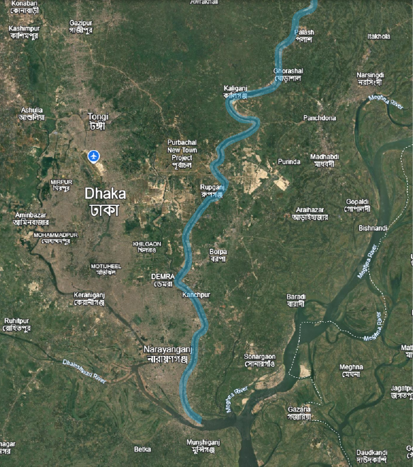
Figure 1: A satellite view of Shitalakshya River, the focus for the experimental sampling.
The Shitalakshya River basin hosts significant industrial development, with Narayanganj serving as a major industrial hub. According to the Bangladesh Bureau of Statistics, 2,409 industrial units operate in this area, including food and beverage processing (377 units), jute and textile industries (1,320 units), chemical manufacturing (104 units), and various other sectors.[10] The river supports critical infrastructure, including the important port of Narayanganj and three thermal power stations at Palash, Ghorashal, and Siddhirganj.
The water from the Shitalakshya River is treated by the Dhaka Water Supply and Sewerage Authority (WASA) and distributed throughout the Dhaka City Corporation for domestic use.[11] This study examines the quality of both the source water from the river and the treated water supplied to consumers.

1.2. Rationale and Objectives
Despite Bangladesh's rapid industrialization, limited research has been conducted to investigate the comparative contamination levels between source river water and treated supply water. The selection of target compounds, that are phenol, 2-methyl phenol (o-cresol), 3-methyl phenol (m-cresol), and 2-methoxy phenol (guaiacol), reflects both their prevalence in industrial discharges and their documented health significance. [12-14] These compounds are prevalent in the effluents from textile dyeing operations, chemical synthesis processes, coal tar production, and petroleum refining, all major industrial activities within the Shitalakshya watershed. This study addresses this gap by examining phenolic contamination in both the Shitalakshya River and Dhaka's water distribution system.
The specific objectives are:
- To determine the concentrations of phenol and phenolic derivatives (2-methyl phenol, 3-methyl phenol, 2-methoxy phenol) in Shitalakshya river water at various depths.
- To assess phenolic contamination in Dhaka City Corporation's water supply.
- To compare contamination levels between source and treated water.
- To evaluate the effectiveness of water treatment processes
2. Materials and Methods
2.1. Chemicals and Standards
All solvents used were of chromatographic grade. Dichloromethane (GC grade) and deionized water were obtained from Merck (Darmstadt, Germany). Analytical standards of phenol, 2-methyl phenol (o-cresol), 3-methyl phenol (m-cresol), and 2-methoxy phenol (guaiacol) were purchased from Merck. Anhydrous sodium sulfate (Merck, Germany) was activated by heating at 200°C before use for water removal. Orthophosphoric acid (Merck) was used for pH adjustment. Standard stock solution (100 ppm) was prepared by dissolving 0.01000 g of solid phenol, 9.6 μL of liquid o-cresol, 9.7 μL of liquid m-cresol, and 8.8 μL of liquid 2-methoxy phenol in 100 mL dichloromethane.
2.2. Sample Collection
Sixteen water samples were collected in January 2015 from two distinct locations: nine samples from the Shitalakshya River and seven from Dhaka City Corporation's water distribution system. River samples included:
- Horipur Power house region (S-1): From surface and at 60 cm depth
- Siddirgonj Power house region (S-2): From surface and at 60 cm depth
- Salurghat region (S-3): From surface and at 60 cm depth
- Salurghat middle (S-4): From surface and at 60 cm depth
- Horipur power house direct (S-5): Single sample from surface
Tap water samples were collected from:

- Baldha Garden (S-6)
- Bijoynagar (S-7)
- Kaptanbazar direct (S-8)
- Fakirapool (S-9)
- Kaptanbazar (S-10)
- Segunbagicha and (S-11)
- Wari (S-12)

Each sample was collected in pre-cleaned 1.1 L amber glass bottles. For depth samples, bottles were lowered to 60 cm depth, opened manually, filled, and closed carefully before retrieval. After collection, 100 mL was discharged from each bottle, and 10% CuSO₄ solution was added as a stabilizing agent.
2.3. Sample Extraction and Preparation
2.3.1. Liquid-Liquid Extraction
Water samples (100 mL) were filtered through Whatman filter paper into 1 L separatory funnels. The pH was adjusted to 2.0 using orthophosphoric acid to ensure optimal extraction of phenolic compounds. Dichloromethane (10 mL) was added, and the mixture was vigorously shaken for 30 minutes, then allowed to stabilize for one hour. After phase separation, the organic layer was collected. The aqueous phase was re-extracted with 5 mL dichloromethane for 10 minutes. The combined organic extracts were dried with anhydrous sodium sulfate and filtered through Whatman No. 41 filter paper.
2.3.2. Preconcentration
Extracts were concentrated to 1-2 mL using Kuderna-Danish evaporation at temperatures below 45°C. The concentrated samples were stored at -20°C until the analysis by GC-MS.
2.4. GC-MS Analysis
2.4.1. Instrumentation
Analysis was performed using a Varian GC-MS (Model CP 3800, USA) equipped with a VF-5 fused silica capillary column (30 m × 0.25 mm i.d., film thickness 0.25 μm). The system operated with electron ionization at 70 eV energy. Helium was used as a carrier gas at a constant flow of 1.0 mL/min.

2.4.2. Operating Conditions
- Injection volume: 1 μL (20% split mode)
- Solvent delay: 4 minutes
- Injector temperature: 250°C
- Transfer line temperature: 280°C
- Initial column temperature: 40°C (hold 1 min)
- Temperature program: 10°C/min to 160°C, then 15°C/min to 280°C
- Mass range: 40-500 m/z
2.4.3. Calibration and Quantification
Working standard solutions were made in a high-grade dichloromethane solvent system. The four specific concentrations utilized for the calibration curve were 5 ppm, 2.5 ppm, 1.25 ppm, and 0.625 ppm. Calibration curves were generated by plotting peak areas against concentrations, yielding the following regression equations:
- Phenol: y = 5007.97x - 397.02 (r² = 0.996)
- 2-methyl phenol: y = 18966x - 1281.25 (r² = 0.996)
- 3-methyl phenol: y = 19947x - 993.54 (r² = 0.997)
- 2-methoxy phenol: y = 13933x - 978.40 (r² = 0.992)
Compounds were identified by comparing their retention times with the standards and confirmed using the NIST library matching. Quantification was performed using the external standard method.
Compound Identification
The preconcentrated solutions were injected into the GC-MS instrument, and different peaks of phenolic derivatives were obtained in the chromatogram. The phenol was identified and quantified by comparing its retention time and peak area with those of a known concentration of standard solution, which was also injected into the GC-MS system under the same conditions. This methodology allowed for a precise determination of the concentration of each type of contaminant present in the original samples. The concentration of phenolic derivatives was calculated by using the following equations:
Sample strength:
S = [(A_{s} - A_{b}) × C_{std}] / A_{std} — (Eq 1)
Where:
As = peak area of the samples
Ab = peak area of the blank sample
Astd = peak area of the standard solutions
Cstd = concentration of the standard solutions
Actual conc. of Phenolic derivatives (ppb): [(S × V) / 100 mL] × 1000 — (Eq 2)
Where:
S = concentration of samples
V = volume of preconcentrated sample extract in Litres

2.5. Recovery Studies
Method recovery was evaluated by spiking water samples with known amounts of phenolic standards at 2.5 and 5.0 ppm concentrations. Spiked samples underwent the same extraction and analysis procedures as regular samples.
Recovery (%):
RS = (Actual concentration of the sample spike area/concentration of the spike)×100 %— (Eq 3)
3. Results and Discussion
3.1. Method Performance and Analytical Validation
3.1.1. Chromatographic Separation and Detection
The GC-MS method successfully achieved baseline separation of all target phenolic compounds within a reasonable analysis time. The chromatographic separation demonstrated excellent peak resolution with retention times of 6.723 minutes for phenol, 7.929 minutes for 2-methyl phenol, 8.269 minutes for 3-methyl phenol, and 8.516 minutes for 2-methoxy phenol (Figure 2).
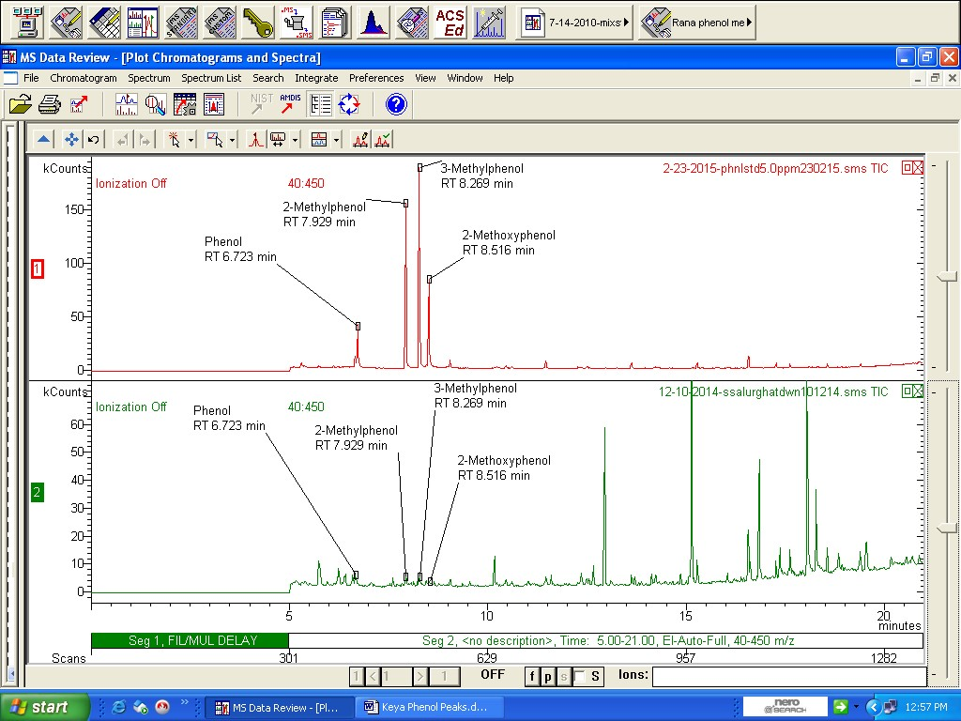
Figure 2: Comparative retention times of different phenolic derivatives in the chromatograms of Phenolic mixture standard solution (A) and a sample solution collected from down water at Siddirgonj Salurghat station (B).
The VF-5 capillary column (30m×0.25mm i.d., 0.25μm film thickness) provided adequate selectivity for the target analytes, with no observable peak interference from matrix components. Mass spectral identification was confirmed through comparison with NIST library spectra, yielding match factors greater than 85% for all compounds. For electron ionization (EI), total ion chromatograms showed clean baseline separation with signal-to-noise ratios exceeding 10:1 for all target compounds at their respective detection limits.
3.1.2. Method Detection Limits and Sensitivity
Method detection limits (MDL) were established at 0.0003 ppb (0.3 ng/L) for all investigated phenolic compounds, calculated as three times the standard deviation of replicate blank analyses. These detection limits demonstrate the method's high sensitivity and are well below the tolerance limits established by Bangladesh's Department of Environment (2 ppb for phenolic compounds in drinking water).[15] The method's sensitivity is significant given that phenolic compounds can cause taste and odor problems in drinking water at concentrations as low as 0.005 mg/L when subjected to chlorination.[16]
3.1.3. Recovery Assessment and Method Accuracy
Recovery studies were conducted using matrix-matched samples spiked at two concentration levels (2.5 and 5.0 ppm) to evaluate method accuracy across the working range. Recovery percentages were calculated from replicate analyses (n=3) and yielded the following results:
- Phenol: 84.76% ± 5.2% (acceptable range: 70-120%)
- 2-methyl phenol: 96.12% ± 3.8% (excellent)
- 3-methyl phenol: 71.74% ± 6.1% (acceptable)
- 2-methoxy phenol: 54.24% ± 8.9% (below optimal, quantifiable)
The recovery rates for phenol and 2-methyl phenol demonstrate excellent method performance, with values well within the acceptable range for environmental analytical methods (typically 70-120% for organic compounds in water matrices).[17] The slightly lower recovery for 3-methyl phenol (71.74%) remains within acceptable limits but suggests some loss during the extraction or concentration steps, possibly due to volatilization during the Kuderna-Danish evaporation process.[18] The recovery of 2-methoxy phenol (54.24%) was below the optimal range, which may be attributed to its higher volatility (boiling point 204-206°C) compared to other target compounds.[19] Despite the lower recovery, the precision was acceptable, and the method bias was corrected through the use of recovery factors in concentration calculations.
3.1.4. Method Calibration and Reproducibility
Calibration curves demonstrated excellent linearity across the working range (0.625 to 5.0 ppm) with correlation coefficients (r²) exceeding 0.991 for all compounds:
- Phenol: r² = 0.996 (excellent linearity)
- 2-methyl phenol: r² = 0.996 (excellent linearity)
- 3-methyl phenol: r² = 0.997 (excellent linearity)
- 2-methoxy phenol: r² = 0.992 (very good linearity)
These high correlation coefficients indicate strong linear relationships between concentration and instrumental response, validating the quantitative reliability of the method.[20]
Intra-day precision was evaluated through replicate analyses of the same sample extract, yielding relative standard deviations (RSD) below 10% for all target compounds. Inter-day precision was assessed over a five-day period, with RSDs ranging from 8.2% to 12.5%, indicating good method reproducibility.
3.1.6. Quality Control Measures
Blank Controls: Solvent blanks and method blanks were analyzed with each sample batch to identify potential contamination sources. No target compounds were detected above the MDL in any blank samples, confirming the absence of systematic contamination.
Matrix Effects: Potential matrix effects were evaluated by comparing standard addition curves with external standard curves. No significant matrix suppression or enhancement was observed, validating the use of solvent-based calibration standards.
3.2. Distribution in Shitalakshya River
3.2.1. Siddirgonj Salurghat Station (S-3)
The Siddirgonj Salurghat exhibited the highest contamination levels among all sampling sites, with phenol concentrations ranging from 1.02 ppb in surface water to 1.25 ppb at 60 cm depth. 3-methyl phenol showed the highest concentration of all investigated compounds, reaching 2.73 ppb at the surface and 1.23 ppb at depth, while 2-methyl phenol (1.44 ppb) and 2-methoxy phenol (0.77 ppb) were detected only in the 60 cm depth samples (Table 1).
Table 1: Concentrations of individual phenolic derivatives in water samples at Siddirgonj Salurghat Station (S-3) of Shitalakhsya river.
Sampling depth | Phenol (ppb) | 2-methylphenol (ppb) | 3-methylphenol (ppb) | 2-methoxyphenol (ppb)
Surface | 1.02 | <MDL | 2.73 | <MDL
60 cm depth | 1.25 | 1.44 | 1.23 | 0.77

The elevated concentrations at this location are attributed to proximity to industrial discharge points, effluent from Siddirgonj Power Station, limited water circulation in this river section, and historical contamination accumulation that has created persistent pollution hotspots. These factors combine to create conditions conducive to phenolic compound retention and concentration (Figure 3).

Figure 3: Concentrations of individual phenolic derivatives in surface and 60 cm depth water at Salurghat Station of the Shitalakshya River.
The higher concentrations in deeper waters reflect density-driven settling of phenolic compounds, formation of polymeric aggregates through hydrogen bonding interactions, reduced volatilization at depth, and potential accumulation at the sediment-water interface. This vertical distribution pattern indicates that subsurface waters serve as contamination reservoirs with reduced natural decomposition compared to surface waters.
3.2.2. Salurghat Middle Station
This site showed moderate contamination, with 3-methyl phenol as the only detected compound at concentrations of 0.21 ppb in surface water and 0.73 ppb at 60 cm depth (table 2). Other phenolic compounds remained below detection limits, indicating selective contamination patterns compared to more heavily impacted locations (Figure 4).
Table 2: Concentrations of individual phenolic derivatives in water samples at Salurghat middle station (S-4) of Shitalakhsya river.
Sampling depth | Phenol (ppb) | 2-methylphenol (ppb) | 3-methylphenol (ppb) | 2-methoxyphenol (ppb)
Surface | <MDL | <MDL | 0.21 | <MDL
60 cm depth | <MDL | <MDL | 0.73 | <MDL
Figure 4: Concentrations of individual phenolic derivatives in surface and 60 cm depth water at SSalurghat Station of the Shitalakshya River.
The relatively low contamination levels may reflect the station's distance from major industrial sources, better water circulation patterns that enhance dilution and dispersion processes, limited point-source pollution inputs, and the presence of predominantly domestic effluent in the area. These factors collectively contribute to reduced phenolic compound accumulation compared to locations with direct industrial discharge or poor circulation characteristics.

3.2.3. Other Stations
Horipur Power house, Siddirgonj Power house, and Horipur power house direct stations showed concentrations below detection limits for all investigated compounds. Similarly, multiple sampling locations including Baldha Garden, Bijoynagar, Kaptanbazar Direct, Kaptanbazar, and Wari demonstrated phenolic concentrations below minimum detection limits. The predominantly non-detectable concentrations at these locations indicate successful source water treatment effectiveness in maintaining water quality standards.
3.3. Distribution in Tap Water
Fakirapool Station: This location showed the highest tap water contamination among all samples, with phenol detected at 0.5 ppb and 2-methyl phenol at 0.8 ppb, representing the most significant drinking water quality concerns observed in this study.
Figure 5: Concentrations of individual phenolic derivatives in tap water at Fakirapool.
The presence of these compounds in treated water indicates incomplete removal during conventional treatment processes, potential secondary contamination within the distribution network infrastructure, possible formation during chlorination as disinfection by-products, and the urgent need for enhanced treatment protocols.
Segunbagicha Station: Only phenol was detected at Segunbagicha station at 0.24 ppb, showing the lowest detected contamination levels observed across all sampling locations.
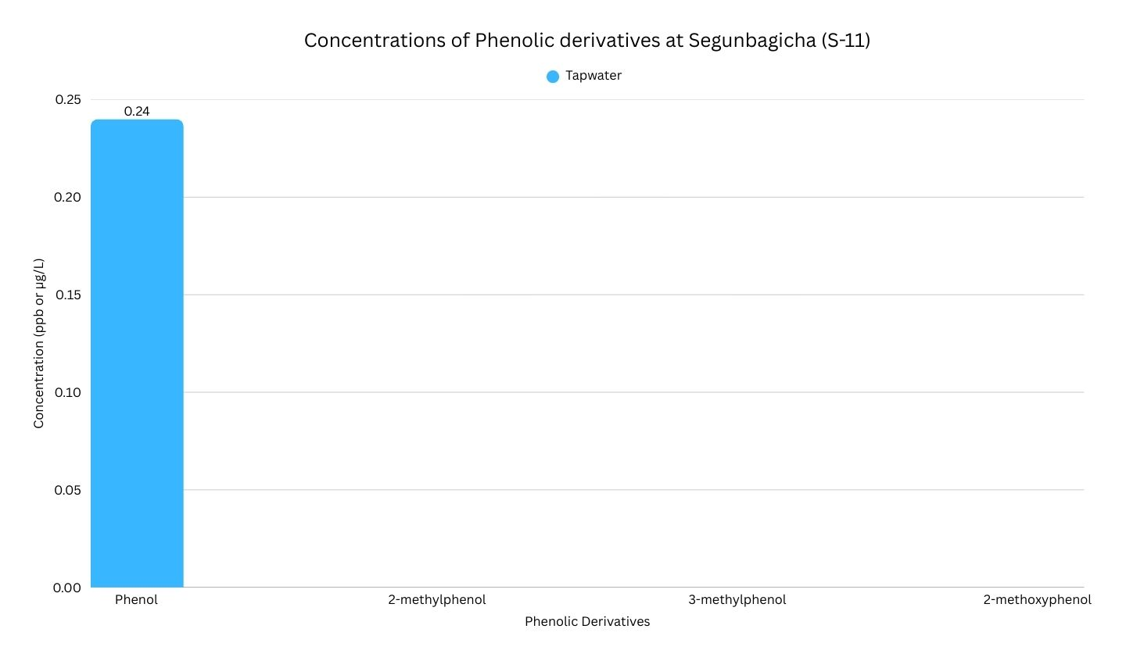
Fig 6: Concentrations of individual phenolic derivatives in tap water at Segunbagicha.
This suggests partial treatment effectiveness, lower source water contamination levels, or different distribution network conditions that minimize phenolic compound accumulation compared to other monitored stations.

3.3.3. Other Locations
All phenolic compounds were below detection limits in Baldha Garden, Bijoynagar, Kaptanbazar direct, Kaptanbazar, and Wari sampling stations, indicating effective treatment and distribution for these areas.
3.4. Depth Profile Analysis
The consistent trend of higher concentrations in 60 cm depth samples compared to surface waters indicates:
- Physical properties: Higher density of phenolic compounds (phenol: 1.07 g/cm³, 2-methyl phenol: 1.05 g/cm³, 3-methyl phenol: 1.03 g/cm³, 2-methoxy phenol: 1.112 g/cm³) compared to water facilitates downward movement.
- Chemical interactions: Formation of hydrogen bonds between phenolic hydroxyl groups and water molecules creates polymeric aggregates with increased molecular mass.
- Environmental factors: Reduced volatilization at depth and potential accumulation in low-flow zones.
- Degradation rates: Slower aerobic degradation in deeper, potentially oxygen-limited waters.
3.5. Comparative Source Analysis
The phenolic contamination in both river and tap water samples can be attributed to multiple sources depicted by the comparative concentration data (Table 3,4) and the trends (Figure 7,8). Industrial activities represent the primary contamination pathway, including chemical manufacturing facilities, textile and dyeing industries, petrochemical operations, coal tar production, and pharmaceutical manufacturing processes that discharge phenolic compounds directly into water systems.
Table 3: Concentrations of individual phenolic derivatives in 60 cm depth water at different stations of Shitalakhsya river.
Sampling Stations | Phenol (ppb) | 2-methylphenol (ppb) | 3-methylphenol (ppb) | 2-methoxyphenol (ppb)
Horipur power house (S-1) | <MDL | <MDL | <MDL | <MDL
Siddirgonj (S-2) | <MDL | <MDL | <MDL | <MDL
Siddirgonj Salurghat (S-3) | 1.25 | 1.44 | 1.23 | 0.77
Salurghat middle (S-4) | <MDL | <MDL | 0.73 | <MDL
Horipur Direct (S-5) | <MDL | <MDL | <MDL | <MDL
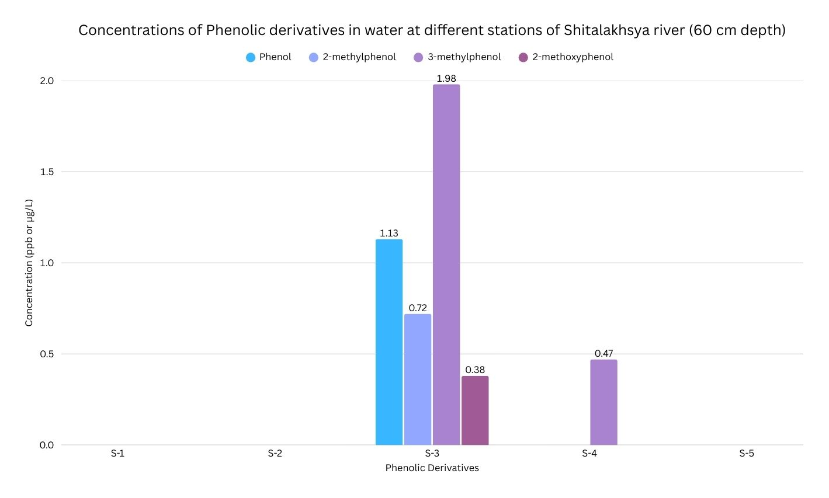
Figure 7: Concentrations of phenolic derivatives in Shitalakhsya river water samples at 60 cm depth.
Urban sources contribute significantly through domestic wastewater discharge, vehicular emissions deposited via rainfall, urban runoff, and incomplete combustion of fossil fuels that introduce phenolic compounds into both surface and groundwater systems. These diffuse pollution sources create widespread contamination across urban watersheds.
Table 4: Concentrations of individual phenolic derivatives in different places in Dhaka city corporation.
Sampling Stations | Phenol (ppb) | 2-methylphenol (ppb) | 3-methylphenol (ppb) | 2-methoxyphenol (ppb)
Baldha Garden (S-6) | <MDL | <MDL | <MDL | <MDL
Bijoynagar (S-7) | <MDL | <MDL | <MDL | <MDL
Kaptanbazar Direct (S-8) | <MDL | <MDL | <MDL | <MDL
Fakirapool (S-9) | 0.5 | 0.8 | <MDL | <MDL
Kaptanbazar (S-10) | <MDL | <MDL | <MDL | <MDL
Segunbagicha (S-11) | 0.24 | <MDL | <MDL | <MDL
Wari (S-12) | <MDL | <MDL | <MDL | <MDL
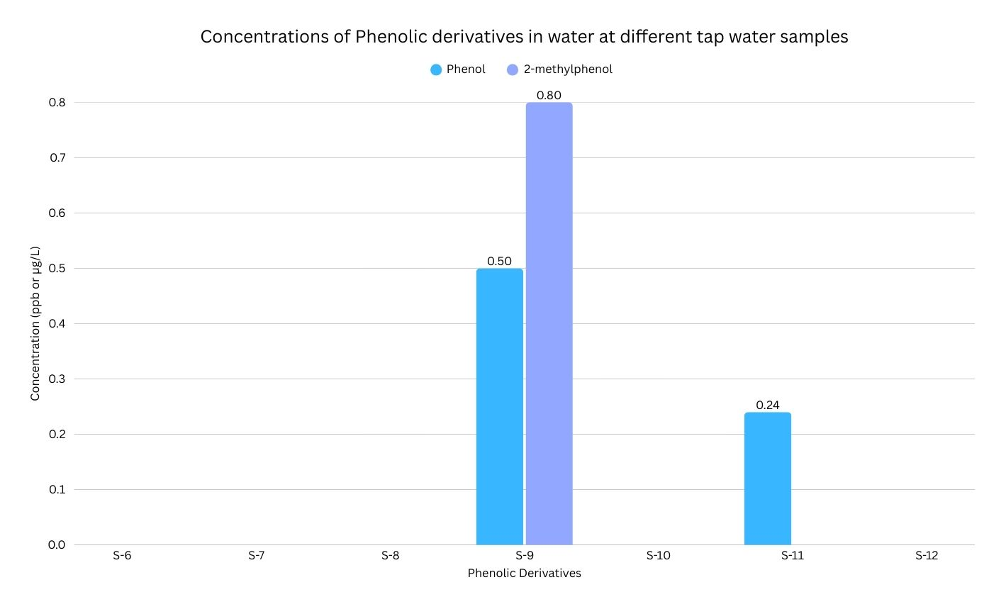
Figure 8: Concentrations of phenolic derivatives in tap water samples.
Treatment-related contamination occurs through chlorination by-products formed during disinfection processes, incomplete removal of phenolic compounds during conventional water treatment, and potential contamination within distribution systems. These sources highlight limitations in current treatment technologies and infrastructure maintenance practices.

3.6. Compliance Assessment
The Department of Environment (DoE) Bangladesh has established a tolerance limit of 0.002 mg/L (2 ppb) for phenolic compounds in drinking water. Most detected concentrations in this study were below this regulatory threshold, indicating generally acceptable water quality conditions across the majority of sampling locations.
However, specific concentrations exceeded this threshold at Siddirgonj Salurghat, where 3-methyl phenol reached 2.73 ppb in surface water and 1.23 ppb at depth, while phenol concentrations reached 1.25 ppb at depth. These exceedances, though marginal, represent regulatory non-compliance requiring immediate attention. Findings highlight the importance of continuous water quality surveillance and adaptive management strategies to ensure regulatory compliance and public health protection.
3.7. Environmental and Health Implications
The presence of phenolic compounds, even at low concentrations, raises significant health concerns due to the carcinogenic potential of certain phenolic derivatives, formation of chlorophenols during water treatment processes, bioaccumulation potential in human tissues, and chronic toxicity risks associated with prolonged exposure. These compounds pose particular risks through multiple exposure pathways and potential synergistic effects with other contaminants.
Environmental impacts include direct toxicity to aquatic organisms, disruption of natural biodegradation processes in aquatic ecosystems, taste and odor issues that affect water acceptability for consumers, and potential transformation into more toxic compounds under varying environmental conditions. These effects compromise both ecosystem health and water resource sustainability.
Treatment challenges arise from phenolic compounds' resistance to conventional treatment methods, formation of harmful disinfection by-products during chlorination, requirements for advanced oxidation processes that increase treatment costs, and concerns regarding distribution system integrity and secondary contamination. These technical limitations necessitate comprehensive treatment system upgrades and enhanced monitoring protocols to ensure effective contaminant removal and regulatory compliance.
4. Conclusion
This comprehensive investigation of phenolic contamination in the Shitalakshya River and Dhaka City Corporation's water supply system reveals several critical findings:
- Contamination Patterns: Phenolic compounds were detected at concentrations ranging from below detection limit to 2.73 ppb, with 3-methyl phenol showing the highest levels among investigated compounds.
- Spatial Distribution: The Siddirgonj Salurghat station exhibited the highest contamination, likely due to industrial activities and power plant operations. Depth profiles consistently showed higher concentrations in 60 cm samples compared to surface waters.
- Treatment Effectiveness: While most tap water samples showed phenolic compounds below detection limits, the presence of these compounds in Fakirapool and Segunbagicha indicates incomplete removal or distribution system contamination.
- Method Performance: The developed GC-MS method demonstrated good sensitivity and recovery rates (54.24% to 96.12%), suitable for routine environmental monitoring.
- Regulatory Compliance: Most samples were within permissible limits, though certain locations showed marginal exceedances requiring attention.
This study establishes baseline phenolic contamination levels in the Shitalakshya River and demonstrates that while current contamination levels are generally acceptable, the presence of carcinogenic phenolic compounds in both source and treated water necessitates immediate action. The findings warrant implementation of advanced treatment technologies, regular monitoring programs, comprehensive source identification and control measures, enhanced water quality management strategies, and public health advisories for affected areas.
Future research priorities should focus on seasonal variation assessment in phenolic contamination, investigation of additional phenolic derivatives, evaluation of treatment plant efficiency, long-term health impact studies, and development of cost-effective remediation technologies. These research directions will provide essential data for evidence-based decision making and policy development.
The findings emphasize the critical need for integrated water resource management approaches to protect both the Shitalakshya River ecosystem and public health through the water distribution system serving Dhaka City Corporation. This comprehensive approach must address source protection, treatment optimization, and distribution system integrity to ensure sustainable water quality management.
Declaration of competing interest
The authors declare that they have no known competing financial interests or personal relationships that would influence this paper.

Declaration of Using Generative AI
Generative AI models were used solely for the purpose of improving readability and linguistics. The authors take full responsibility for the content and interpretation of the manuscript.
References
(1) Yin, H.; Islam, M. S.; Ju, M. Urban River Pollution in the Densely Populated City of Dhaka, Bangladesh: Big Picture and Rehabilitation Experience from Other Developing Countries. J. Clean. Prod. 2021, 321, 129040. https://doi.org/10.1016/j.jclepro.2021.129040.
(2) Jamal, A. H. M. S. I. M.; Ahsan, M. A.; Ahmed, S.; Akter, S.; Sultana, R.; Nahar, A.; Uddin, M. R. Physicochemical and Microbiological Quality of Potable Water Supplied by DWASA in Dhaka City of Bangladesh. Am. J. Biol. Environ. Stat. 2020, 6 (1), 1–6. https://doi.org/10.11648/j.ajbes.20200601.11.
(3) Hasan, G. M. M. A.; Rinky, F.; Ahmed, K. S.; Sikdar, K.; Moniruzzaman, M. Assessment of Polycyclic Aromatic Hydrocarbons (PAHs) and Heavy Metal Contamination in Shitalakshya River Water: Ecological and Health Risk Implications. Environ. Monit. Assess. 2025, 197 (3), 282. https://doi.org/10.1007/s10661-025-13750-y.
(4) Mahugo Santana, C.; Sosa Ferrera, Z.; Esther Torres Padrón, M.; Juan Santana Rodríguez, J. Methodologies for the Extraction of Phenolic Compounds from Environmental Samples: New Approaches. Molecules 2009, 14 (1), 298–320. https://doi.org/10.3390/molecules14010298.
(5) Application of Adsorption Process for Phenolic Compounds Removal from Aqueous Environments: A Systematic Review. Glob. NEST J. 2016, 18 (1), 146–163. https://doi.org/10.30955/gnj.001709.
(6) A.M. Hammam; Mona S. Zaki; Refaat A. Yousef and Olfat Fawzi, Toxicity, Mutagenicity and carcinogenicity of phenols and phenolic compounds on human and living organisms [A Review]. Adv. Environ. Biol., 9(8), 38-48, 2015
(7) Acero, J. L.; Piriou, P.; von Gunten, U. Kinetics and Mechanisms of Formation of Bromophenols during Drinking Water Chlorination: Assessment of Taste and Odor Development. Water Res. 2005, 39 (13), 2979–2993. https://doi.org/10.1016/j.watres.2005.04.055.
(8) Lee, G. F.; Morris, J. C. Kinetics of Chlorination of Phenolchlorophenolic Tastes and Odors. Air Water Pollut. 1962, 6, 419–431.
(9) Toxic and Priority Pollutants Under the Clean Water Act | US EPA. https://www.epa.gov/eg/toxic-and-priority-pollutants-under-clean-water-act (accessed 2025-09-22).
(10) Narayanganj - Banglapedia. https://en.banglapedia.org/index.php/Narayanganj (accessed 2025-09-22).
(11) Water Quality Aspects in and around Dhaka City | Request PDF. In ResearchGate.
(12) Michałowicz, J.; Duda, W. Phenols – Sources and Toxicity. Polish J. of Environ. Stud. Vol.16, No. 3 (2007), 347-362
(13) Dietz, D. NTP Technical Report on the Toxicity Studies of Cresols (CAS Nos. 95-48-7, 108-39-4, 106-44-5) in F344/N Rats and B6C3F1 Mice (Feed Studies). Toxic. Rep. Ser. 1991, 9, 1–128.
(14) Duan, W.; Meng, F.; Cui, H.; Lin, Y.; Wang, G.; Wu, J. Ecotoxicity of Phenol and Cresols to Aquatic Organisms: A Review. Ecotoxicol. Environ. Saf. 2018, 157, 441–456. https://doi.org/10.1016/j.ecoenv.2018.03.089.
(15) Water-Quality-Parameters- - Department of Public Health Engineering-Government of the People\’s Republic of Bangladesh. https://dphe.gov.bd/site/page/15fa0d7b-11f1-45c0-a684-10a543376873/Water-Quality-Parameters- (accessed 2025-09-22).
(16) Young, W. F.; Horth, H.; Crane, R.; Ogden, T.; Arnott, M. Taste and Odour Threshold Concentrations of Potential Potable Water Contaminants. Water Res. 1996, 30 (2), 331–340. https://doi.org/10.1016/0043-1354(95)00173-5.
(17) Ask Reitzel, L.; Ledin, A. Determination of Phenols in Landfill Leachate-Contaminated Groundwaters by Solid-Phase Extraction. J. Chromatogr. A 2002, 972 (2), 175–182. https://doi.org/10.1016/S0021-9673(02)01098-1.
(18) Issenberg, P.; Kornreich, M. R.; Lustre, A. O. Recovery of Phenolic Wood Smoke Components from Smoked Foods and Model Systems. J. Food Sci. 1971, 36 (1), 107–109. https://doi.org/10.1111/j.1365-2621.1971.tb02048.x.
(19) Gayubo, A. G.; Aguayo, A. T.; Atutxa, A.; Aguado, R.; Bilbao, J. Transformation of Oxygenate Components of Biomass Pyrolysis Oil on a HZSM-5 Zeolite. I. Alcohols and Phenols. Ind. Eng. Chem. Res. 2004, 43 (11), 2610–2618. https://doi.org/10.1021/ie030791o.
(20) Moosavi, S. M.; Ghassabian, S.; Moosavi, S. M.; Ghassabian, S. Linearity of Calibration Curves for Analytical Methods: A Review of Criteria for Assessment of Method Reliability. In Calibration and Validation of Analytical Methods - A Sampling of Current Approaches; IntechOpen, 2018. https://doi.org/10.5772/intechopen.72932.

