Original Research Article

HYDROGEOCHEMICAL ASSESSMENT OF GROUNDWATER SUITABILITY FOR DRINKING AND IRRIGATION IN THE LIMESTONE TERRAIN OF SOUTHERN KALADGI SUB-BASIN(PRE-MONSOON), KARNATAKA, INDIA.

Abstract

This study evaluates the suitability of pre-monsoon groundwater in the Limestone Terrain of Southern Kaladgi Sub-Basin of Bagalkote district, Karnataka, for drinking and irrigation purposes. The region is predominantly underlain by sandstone, limestone, dolomite, and granite formations. A total of 44 groundwater samples were collected and analyzed to determine their physicochemical characteristics. The Drinking Water Quality Index (DWQI) was calculated using the Weighted Arithmetic WQI method based on the permissible limits from the Indian Standard (IS 10500:2012). The analysis showed that the water in all sampled locations (44 out of 44) is currently suitable for drinking, with 38 villages classified as Excellent (DWQI< 50) and 6 villages classified as Good (50 < DWQI< 100). Hydrogeochemically, the water is defined by the Ca – HCO₃ facies which is characteristic of systems dominated by the dissolution of carbonate and dolomitic rocks. The system is considered geochemically immature. For irrigation suitability, indices like the Sodium Adsorption Ratio (SAR) and Magnesium Hazard Ratio (MHR) were calculated. While the majority of samples show a low sodium hazard, the sample from Kalabandakeri was a consistent outlier, classified as a severe sodium hazard (SAR of 9.77) Crucially, the Magnesium Hazard Ratio (MHR) indicated a significant magnesium hazard, classifying 34 out of 44 samples (approximately 77.3%) as unsuitable for irrigation based on this index This highlights that while the water is safe for consumption, its long-term use for irrigation is constrained by a pervasive Magnesium Hazard.

Keywords: Groundwater Quality, Drinking Water Index (DWI), Irrigation Suitability, Dolomite, Magnesium Hazard, Southern Kaladgi Sub-Basins.

Introduction
Water is the most essential natural resource for sustaining life, the environment, and all living organisms. However, available water resources are increasingly under pressure due to growing demands each day. The time may not be far when water once considered abundant and a free gift of nature becomes a scarce and highly valued resource. Conservation of water is very much required so that by reducing wastage, recycling and reuse, artificial recharge is essential and required to minimize the scarcity. Water management has been practiced since ancient times by using various methods, but now a days this has to be done on priority and demand basis to ensure water for all. In Karnataka majority of the water supply schemes are dependent on groundwater. The number of wells and bore wells has increased fivefold during the last thirty years. So that groundwater levels are declining at the rate of one meter or more than one meter per year on account of following reasons. Over a large area has been observed in several parts of the study area in order to meet the increasing demand of water. This is also related to the following other issues:
Non-availability of other source of water, this is the main reason for declination of groundwater, disuse of ancient means of water conservation, unreliability of municipal water supplies in terms of quality, quantity and time drives the people to have their own source, failure of monsoon and also large scale quarrying and mining activities in the study area. Rapid urbanization, industrial and intensive agricultural activities have led to a high stage of groundwater development. Indiscriminate development of groundwater often leads to groundwater overdraft. As a result, constant decreasing trend of groundwater levels, deterioration in water quality, sea water intrusion, etc., are observed in many parts of the state. Hence, there is a continuous reducing of groundwater table in many parts of the state (Reports on dynamic Groundwater resources of Karnataka by Central Groundwater Board-2024). With the increasing use of groundwater for various purposes the fast decline in groundwater takes place. In order to control the aquifer from fast depletion, we have to keep this in mind to avoid fast decrease in groundwater levels in various parts of Karnataka, a study has been undertaken to identify the favourable areas for artificial recharge and suggest suitable recharge structure like rain water harvesting to augment the aquifers system.
Remote sensing with its advantages of spatial, spectral and temporal availability of data covering large areas within short time has become a very easy tool in assessing, monitoring and conserving groundwater resources. The Satellite data provides quick and useful data baseline information on the parameters like geology, land-use and land cover, geomorphology, lineaments etc. controlling the occurrence and movement of groundwater. Thematic representation or layers generated using remote sensing data can be integrated in a Geographic Information System (GIS) for the framework and analysed using a model developed with logical conditions to derive groundwater recharge zones. By combining the remote sensing information with correct field data, particularly well inventory and yield data, it is possible to arrive at prognostic models to predict the ranges of depth, the yield, the success rate and the types of wells suited to different litho units under different hydrogeological domains.
STUDY AREA
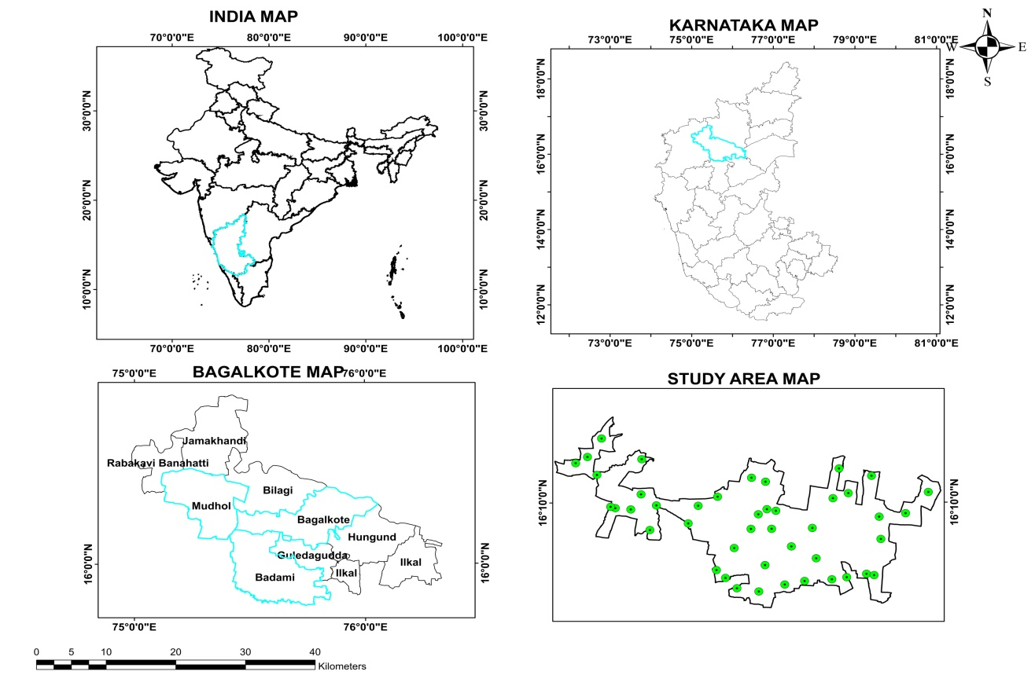
Figure 1|. STUDY AREA

Location map of the study area
In the present investigation, the study area, Southern Kaladgi Sub-Basins, Bagalkote district,
Karnataka falling in the survey of India toposheet No. 47P/4, 47P/7, 47P/8 and 47P/12. The area is about of 571sq.Km and surrounded by Bilgi, Mudhol, Badami, Hungund taluks of Bagalkote district. Geologically the area is covered by sandstone, limestone, dolomite and granite. District Groundwater Directorate and Central Groundwater Board have established some observation wells for their regular water level monitoring.

Methodology
Sampling and Analysis: A total of 44 groundwater samples were collected during the pre -monsoon season. Samples were collected in pre-washed 1Liter high-density polyethylene bottles and analyzed in accordance with IS:3025 and APHA (2023) protocols. Parameters analyzed included pH, TDS, Electrical Conductivity (EC), Total Hardness (TH), major cations (Ca²⁺ + Mg²⁺, Na⁺, K⁺) and major anions (Cl⁻, SO₄²⁻, NO₃⁻, F⁻).
Table No-01: Parameters Analysis
Parameter | Standard Method Cited
1. pH Value @ 25∘C | IS 3025 (Part-11) : 2022
2. Specific Conductance, μS/cm @ 25∘C | IS 3025 (Part-14) : 2013
3. Odour | IS 3025 (Part-5 & 6) : 2018
4. Colour, Hazen Units | IS 3025 (Part-4) : 2021
5. Turbidity, NTU | IS 3025 (Part-10) : 2023
6. Total Dissolved Solids @ 180∘C,mg/l | IS 3025 (Part-16) : 2023
7. Alkalinity as CaCO₃​,mg/l | IS 3025 (Part-23) : 2023
8. Total Hardness as CaCO₃​,mg/l | IS 3025 (Part-21) : 2009
9. Calcium as Ca,mg/l | IS 3025 (Part-40) : 2024
10. Magnesium as Mg,mg/l | IS 3025 (Part-46) : 2023
11. Chloride as Cl,mg/l | IS 3025 (Part-32) : 1988
12. Sulphate as SO₄​,mg/l | IS 3025 (Part-24, Sec.1) : 2022, Method.a
13. Fluoride as F,mg/l | APHA 24th Edition
14. Nitrate as N O₃​,mg/l | APHA 24th Edition
15. Iron as Fe,mg/l | IS 3025 (Part-53) : 20

RESULT & DISCUSSION
The Drinking Water Quality Index (DWQI)
This has been calculated for all the villages using the Weighted Arithmetic Water Quality Index (WAWQI) method, which is the standard methodology corresponding to the “Weighted Arithmetic Method.”
The calculation utilizes the Permissible Limits from the Indian Standard (IS 10500:2012) for the water quality parameters.
Water Quality Index Calculation Methodology
The Weighted Arithmetic WQI is calculated in three main steps:
1. Calculation of Weight (Wi​) and Unit Weight (wi​)
The weight (Wi​) for each parameter is inversely proportional to its permissible limit (Si​), reflecting the idea that parameters with lower permissible limits are more significant to water quality.

- Weight (Wi​): Wi​=1/Si​
- Unit Weight (wi​): wi​=Wi​/∑Wi​

Table No-02: Weight (Wi​) and Unit Weight (wi​) measured for Parameters
Parameter | Permissible Limit (Si​) | Weight (Wi​) | Unit Weight (wi​)
pH | 8.5 | 0.1176 | 0.0718
Turbidity (NTU) | 5.0 | 0.2000 | 0.1221
TDS (mg/L) | 2000.0 | 0.0005 | 0.0003
Nitrate (mg/L) | 45.0 | 0.0222 | 0.0136
Fluoride (mg/L) | 1.5 | 0.6667 | 0.4071
Chloride (mg/L) | 1000.0 | 0.0010 | 0.0006
Alkalinity (mg/L) | 600.0 | 0.0017 | 0.0010
Hardness (mg/L) | 600.0 | 0.0017 | 0.0010
Calcium (mg/L) | 200.0 | 0.0050 | 0.0031
Magnesium (mg/L) | 100.0 | 0.0100 | 0.0061
Sulphate (mg/L) | 400.0 | 0.0025 | 0.0015
∑Wi​ | - | 1.6293 | 1.0000

2. Calculation of Quality Rating Scale (qi​) and Sub-Index (SIi​)
Quality Rating Scale (qi​): qi​=(Ci​/Si​)×100, where Ci​) is the measured concentration.
Sub-Index (SIi​): SIi​=qi​×wi​

3. Calculation of DWQI
DWQI: DWQI=∑SIi​

Water Quality Index Results

The calculated DWQI for each village and their corresponding water quality categories are provided in the table below. The full results, including the measured concentrations of the parameters,

Water Quality Categories:
Table No-03 : Water Quality Categories analysis
DWQI Value | Water Quality Status
≤50 | Excellent
50<DWQI≤100 | Good
100<DWQI≤200 | Poor
200<DWQI≤300 | Very Poor
>300 | Unsuitable for drinking

The analysis shows that 38 out of 44 villages have water quality categorized as Excellent (DWQI≤50),and 6 villages have water quality categorized Good (50<DWQI≤100). This indicates that, based on the measured parameters and the IS 10500:2012 permissible limits, the water in all sampled locations is currently suitable for drinking.

Table No-04: DWQI Category of Different Villages

S.No | Village Name | Latitude | Longitude | DWQI | DWQI Category
1 | Kerakalmatti | 16.13088 | 75.57575 | 48.47 | Excellent
2 | Yandigeri | 16.12977 | 75.49337 | 34.87 | Excellent
3 | Neerbudihal | 16.12983 | 75.52109 | 48.8 | Excellent
4 | Anaval | 16.10286 | 75.47076 | 50.42 | Good
5 | Kainakatti | 16.07185 | 75.4469 | 37.61 | Excellent
6 | Hosakoti | 16.06083 | 75.459 | 46.12 | Excellent
7 | Sagnur | 16.04631 | 75.47435 | 56.4 | Good
8 | Narenur | 16.04174 | 75.50367 | 42.14 | Excellent
9 | Malagi | 16.0514 | 75.53853 | 45.45 | Excellent
10 | Agaskoppa | 16.05629 | 75.56516 | 46.01 | Excellent
11 | Kalabandakeri | 16.07876 | 75.5121 | 50.4 | Good
12 | Jalageri | 16.10502 | 75.54749 | 42.79 | Excellent
13 | Hoolageri | 16.08826 | 75.58083 | 48.51 | Excellent
14 | Jummanakatti | 16.05858 | 75.60177 | 50.42 | Good
15 | Lakkasakoppa | 16.06149 | 75.62169 | 43.1 | Excellent
16 | Katageri | 16.06621 | 75.64823 | 43.1 | Excellent
17 | Hangaragi | 16.06433 | 75.65848 | 42.27 | Excellent
18 | Mallapur | 16.18102 | 75.73161 | 50.25 | Good
19 | Shigikeri | 16.15131 | 75.70102 | 45.98 | Excellent
20 | Sulikeri | 16.11509 | 75.6677 | 43.89 | Excellent
21 | Muchkhandi | 16.14648 | 75.66556 | 50.08 | Good
22 | Muranal | 16.20403 | 75.65538 | 48.06 | Excellent
23 | Seemikeri | 16.17265 | 75.60353 | 41.56 | Excellent
24 | Hireshellikeri | 16.15515 | 75.52686 | 48.6 | Excellent
25 | Chikkshellikeri | 16.15736 | 75.51481 | 46.99 | Excellent
26 | Govinakoppa | 16.1961 | 75.51304 | 48.45 | Excellent
27 | Kaladgi | 16.2017 | 75.49427 | 59.57 | Good
28 | Kajjidoni | 16.17509 | 75.4487 | 35.79 | Excellent
29 | Kalaskoppa | 16.15028 | 75.50328 | 31.95 | Excellent
30 | Jalikatti | 16.16238 | 75.42258 | 32.55 | Excellent
31 | Kadarakoppa | 16.13763 | 75.40917 | 47.78 | Excellent
32 | Lokapur | 16.16301 | 75.36639 | 38.65 | Excellent
33 | Killa hosakote | 16.15929 | 75.3113 | 47.93 | Excellent
34 | Dadanahatti | 16.16114 | 75.30498 | 39.88 | Excellent
35 | Ningapur | 16.23126 | 75.27399 | 48.16 | Excellent
36 | Naganapur | 16.17863 | 75.34589 | 42.71 | Excellent
37 | Lakshanatti | 16.15742 | 75.33207 | 43.76 | Excellent
38 | Budni | 16.20605 | 75.28667 | 51.52 | Good
39 | Halaki | 16.22253 | 75.25814 | 43.51 | Excellent
40 | Chichkhandi | 16.25727 | 75.29294 | 40.59 | Excellent
41 | Muddapur | 16.22805 | 75.3469 | 46.54 | Excellent
42 | Varchagal | 16.12843 | 75.3577 | 48.33 | Excellent
43 | Gaddanakeri | 16.17972 | 75.62411 | 46.03 | Excellent
44 | Yadahalli | 16.21448 | 75.61182 | 44.97 | Excellent

Hydrogeochemical facies ;A Piper diagram is a graphic procedure proposed by Arthur M. Piper in 1944 for presenting water chemistry data to help in understanding the sources of the dissolved constituent salts in water. This procedure is based on the premise that cations and anions in water are in such amounts to assure the electroneutrality of the dissolved salts, in other words the algebraic sum of the electric charges of cations and anions is zero
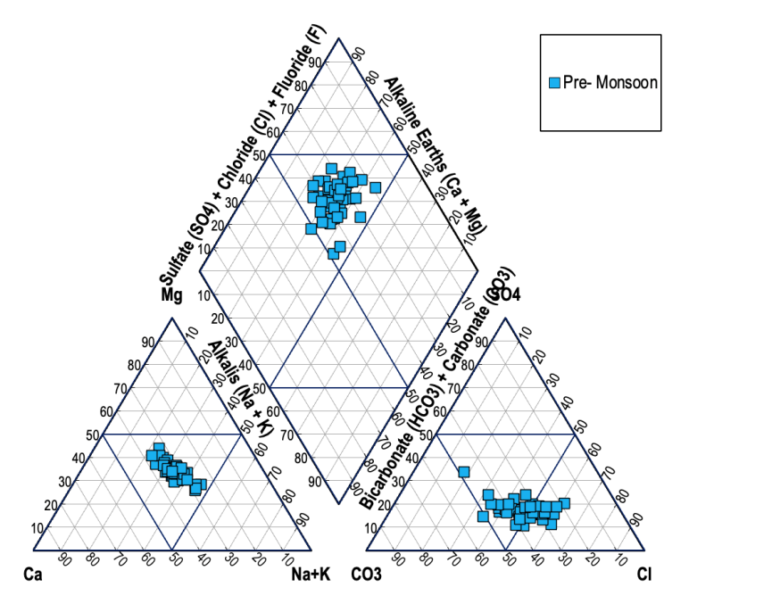

Figure 2. Piper diagram
The analysis based purely on the provided Piper trilinear diagram confirms the singular hydrochemical identity of the Pre-Monsoon water samples. The groundwater is defined by the Ca–HCO₃​ facies, a characteristic feature of systems dominated by the dissolution of carbonate and dolomitic rocks.(Arthur M. Piper 1944).
The observed hydrogeochemical homogeneity is a key conclusion, indicating that the sampled region is likely hydraulically connected, uniformly lithified, and governed by short groundwater residence times where the ingress of carbonic acid is the overriding chemical driver. Secondary processes, such as silicate weathering, cation exchange, and evaporite dissolution, are currently minimal and have not yet exerted substantial influence on the water chemistry. The system is geochemically immature, representing the initial stages of water-rock interaction.
The following table summarizes the estimated composition derived from the visual interpretation of the Piper diagram, providing a precise quantification of the ionic dominance structure.

Estimated Ionic Composition and Dominance Structure (Pre-Monsoon Samples)

Table No-05: Dominance Classification of Ion Group
Ion Group | Visual Estimation (% meq/L Range) | Dominance Classification | Supporting Hydrogeochemical Evidence
Ca²⁺ + Mg²⁺ | 75%−95% | Alkaline Earth Dominant (Field 1) | Strong evidence for carbonate/dolomitic rock lithology.
Na⁺ + K⁺ | 5%−25% | Alkali Minor | Indicates short residence time and restricted secondary processes.
HCO₃⁻ + CO₃²⁻ | 90%−100% | Weak Acid Dominant (Field 3) | Evidence of active carbonic acid weathering.
Cl⁻ + SO₄²⁻ | 0%−10% | Strong Acid Negligible | Negligible influence from salinization or evaporite mineral dissolution.
Overall Facies Type | N/A | Ca−HCO3​ | The defining signature of initial groundwater evolution in carbonate terrain.

In summary, the Pre-Monsoon groundwater system is fundamentally stable and chemically controlled by primary weathering in a carbonate environment. This analysis establishes a clear hydrochemical baseline, against which future temporal or spatial variations can be measured to identify subsequent flow path maturation, mixing, or anthropogenic impact.
Groundwater suitableness for irrigation purposes
Groundwater suitability for irrigation depends on salt content, especially sodium, which impacts soil structure and plant health; key indicators include Electrical Conductivity (EC) for salinity, Sodium Adsorption Ratio (SAR) for sodium hazard, and Residual Sodium Carbonate (RSC) for alkalinity, with high levels of sodium, bicarbonate, or boron making water unsuitable, while indices like Wilcox and Kelley's ratio help classify water as excellent, good, permissible, or unsuitable to protect soil and crop yield.
The Sodium Adsorption Ratio (SAR)
The Sodium Adsorption Ratio (SAR) is a critical indicator for assessing the suitability of water for agricultural irrigation, as it evaluates the risk of sodium damaging the soil structure.
The SAR values for the available water samples were calculated using the concentrations of Sodium (Na⁺), Calcium (Ca²⁺), and Magnesium (Mg²⁺).

SAR Calculation Methodology
The calculation of SAR is based on the relative proportions of these key cations, expressed in milli equivalents per litre (meq/L):
SAR = Na⁺ / √[(Ca²⁺ + Mg²⁺) / 2]
The concentrations provided in milligrams per litre (mg/L) were first converted to meq/L using the equivalent weights of the respective ions (Na=23, Ca=20, Mg=12).

The calculated SAR values across the sampled area demonstrate a strong consistency with the geochemically dominant Ca–HCO₃ water type, where Ca²⁺ and Mg²⁺concentrations are naturally high and act to suppress the relative impact of Na⁺.
General Suitability (Excellent/Good)
The vast majority of samples (42/43) recorded SAR values ranging from a low of 0.16 (Muddapur, Sl.No. 41) to a maximum of 2.12 (Halaki, Sl.No. 39)table no-04.
According to common agricultural standards, water with a SAR below 3.0 is generally considered to present a low sodium hazard and is suitable for irrigating most plant types without major impact on soil permeability. The strong dominance of Ca²⁺ and Mg²⁺ effectively ensures soil flocculation and stable soil structure in these locations.
Severe Sodium Hazard (Unsuitable)
The single outlier is the sample from Kalabandakeri , which exhibited a calculated SAR value of 9.77 meq/L.

Hazard Classification: Water with a SAR greater than 9.0 is classified as presenting a severe sodium hazard, particularly in fine-textured soils (like clay or silt-loam).
Implications: The elevated sodium concentration in this water relative to Ca²⁺ and Mg²⁺ suggests a specific localized influence such as prolonged cation exchange or mixing with a highly Na-rich source—that has significantly altered the water chemistry from the dominant Ca–HCO₃ type. The use of this water for irrigation will likely lead to reduced water infiltration and permeability, salt concentration near the surface, and consequently, inhibited plant growth.

Kelly's Ratio (KR)

The Kelly's Ratio (KR) is an established index used in hydrogeochemistry to determine the suitability of water for irrigation based on the potential alkali hazard. The ratio specifically compares the concentration of sodium to the combined concentrations of calcium and magnesium, which are essential for maintaining stable soil structure.
The Kelly's Ratio (KR) formula for water quality assesses irrigation suitability by comparing sodium (Na+) to calcium (Ca²⁺) and magnesium (Mg²⁺) ions.
KR = Na⁺ / (Ca²⁺ + Mg²⁺)

The calculation for all 44 sampled locations confirms the general suitability of the water sources, with one major exception that corroborates the findings from the previous Sodium Adsorption Ratio (SAR) analysis.

Soluble Sodium Percentage (Na%)
The Soluble Sodium Percentage (Na%, often referred to as Percent Sodium or SSP) is a critical quality indicator used to evaluate the potential sodium hazard of irrigation water. When the percentage of sodium and potassium ions relative to total cations is too high, it can lead to the displacement of beneficial calcium and magnesium ions in the soil, resulting in a breakdown of soil structure (sodicity) and reduced permeability.

Calculation of Soluble Sodium Percentage
The Na% is calculated as the ratio of the sum of sodium (Na⁺) and potassium (K⁺) concentrations to the sum of all major cations (Ca²⁺, Mg²⁺, Na⁺, and K⁺),multiplied by 100. All concentrations must be expressed in milli equivalents per litre (meq/L) to accurately represent the ions' chemical combining power.
Na% = [(Na⁺ + K⁺) / (Ca²⁺ + Mg²⁺ + Na⁺ + K⁺)] × 100

The results indicate that the majority of the pre-monsoon water samples are acceptable for irrigation based on the Sodium Percentage index, aligning with the low sodium hazard identified by the SAR and Kelly's Ratio analyses.
Dominantly Acceptable Water: 30 out of 44 samples (approximately 68%) are classified as Excellent or Good (Na%<40). This confirms the overwhelming stability of the water's cationic balance, where calcium and magnesium from carbonate rock dissolution efficiently counteract the influence of sodium.

Permissible Range: 13 samples fall into the Permissible range (Na%-40-60%). These sources present a moderate, manageable sodium hazard. They are generally safe for irrigation but require adequate soil drainage and potentially good leaching practices to prevent long-term sodium build-up.

Doubtful/High Hazard: The water from Kalabandakeri (Sl.No. 11), which was previously identified as a severe hazard by the SAR test, shows a Na% of 73.45%. This places it in the Doubtful category, confirming a high concentration of sodium relative to the total cation load. Irrigation using this source will significantly increase the risk of sodicity and permeability issues, demanding strict, regular soil amendments and water management controls.

The Magnesium Hazard Ratio (MHR), often referred to as the Magnesium Ratio (MR) or Magnesium Hazard (MH), is an index utilized to evaluate the potential detrimental effect of high magnesium concentration on soil quality and crop yields during irrigation.
Excessive magnesium content in irrigation water can negatively impact soil structure, particularly when it exceeds the concentration of calcium. In such scenarios, the magnesium ions may be adsorbed onto the clay particles, leading to soil dispersion and reduced soil permeability, which ultimately affects water infiltration.
$$MHR=\frac{\left[{Mg}^{2+}\right]}{{[Ca}^{2+}]+\left[{Mg}^{2+}\right]} 100$$

The MHR analysis indicates a significant magnesium hazard across the study area:
High Prevalence of Unsuitable Water: A total of 34 out of 44 samples (approximately 77.3%) exhibit an MHR greater than 50, classifying them as unsuitable for irrigation based on this index.

The Permeability Index (PI) is a vital indicator for assessing the long-term suitability of irrigation water, as it relates to the soil’s ability to absorb water. The long-term use of water with an unfavourable PI can reduce soil permeability due to the accumulation of sodium and the resulting breakdown of clay aggregates.
Permeability Index (PI) Calculation
The Permeability Index, developed by Doneen (1964), evaluates the proportional concentrations of sodium, bicarbonate, calcium, and magnesium ions. A high concentration of sodium combined with bicarbonate is particularly detrimental, as these ions can interact with the soil matrix to decrease hydraulic conductivity.
The PI is calculated using concentrations expressed in milliequivalents per litre.
PI = [(Na⁺ + √HCO₃⁻) / (Ca²⁺ + Mg²⁺ + Na⁺)] × 100
The Permeability Index analysis largely confirms the suitability of the water sources for irrigation but highlights three extreme deviations from the norm:
Dominant Moderate-to-Good Suitability (Class II): 41 out of 44 samples fall into the Class II range (25-75%), indicating that the water's ionic composition is generally acceptable and presents a moderate to low risk of long-term permeability issues. This is consistent with the hydrochemical facies, where the dominance of divalent cations helps maintain soil structure.

Highly Suitable Anomaly (Class I): The sample from Kalabandakeri (Sl.No. 11), which was highly problematic in the SAR and Kelly's Ratio assessments due to very high sodium, surprisingly falls into Class I (PI 80.59%). In the PI formula, the exceptionally high concentration in the numerator and the denominator causes the ratio to stabilize at a high value. While the PI suggests good permeability, this PI classification must be viewed with caution. The high concentration (which led to a severe hazard rating in the SAR and KR indices) implies that actual soil degradation remains a very high risk, potentially contradicting the PI's suggestion of excellent permeability.
Unsuitable/Poor Suitability (Class III): Two samples are classified as Class III.

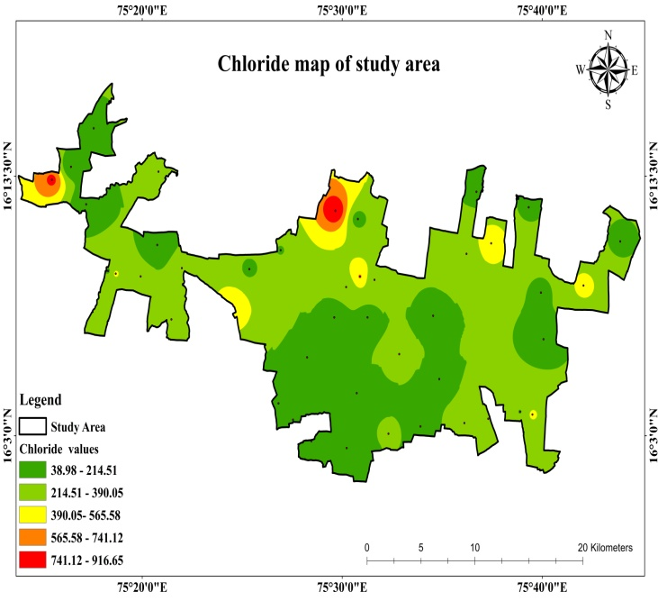
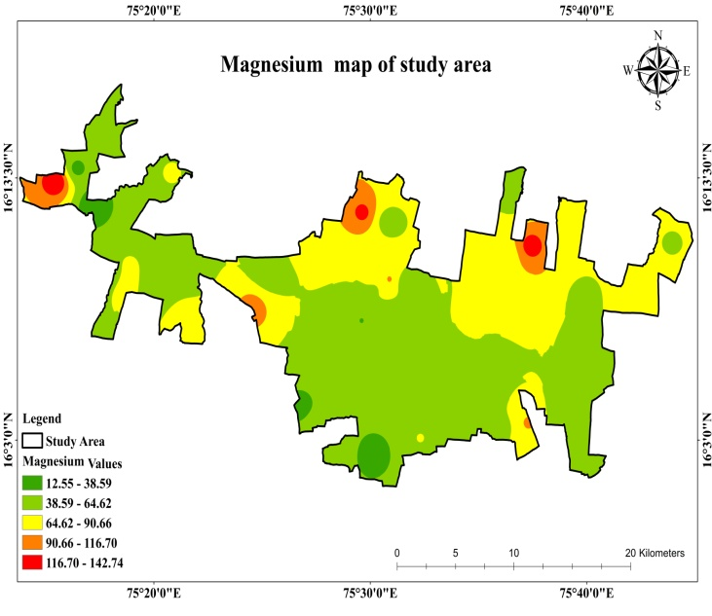
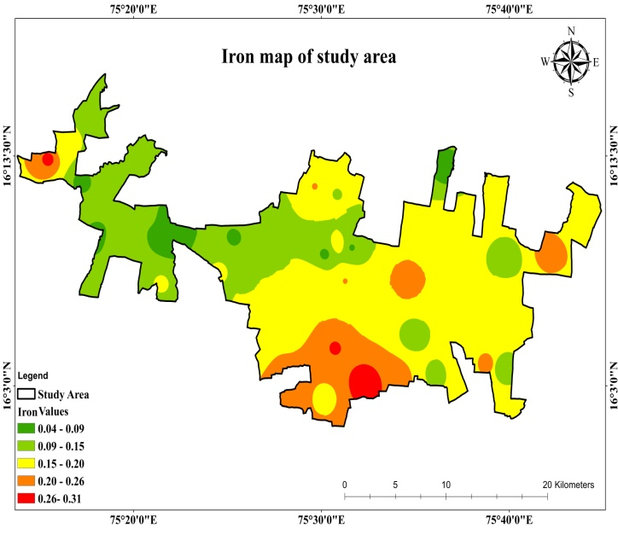
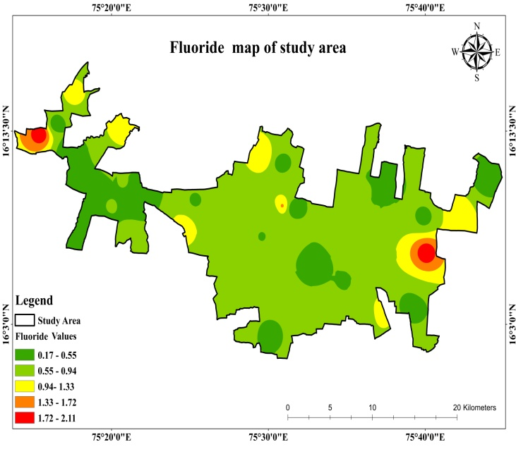
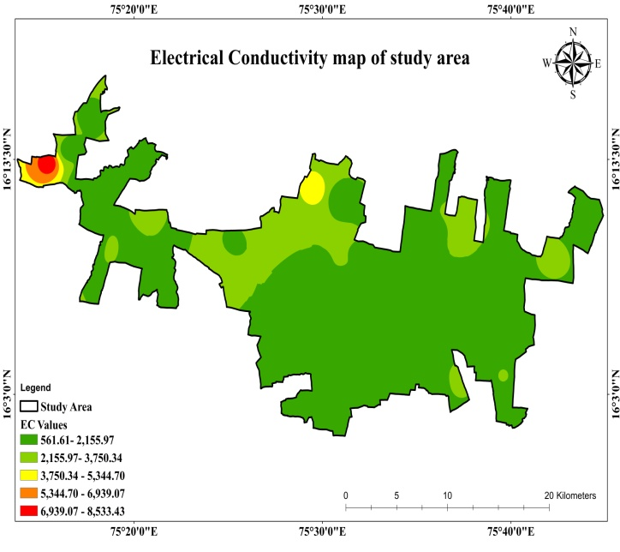
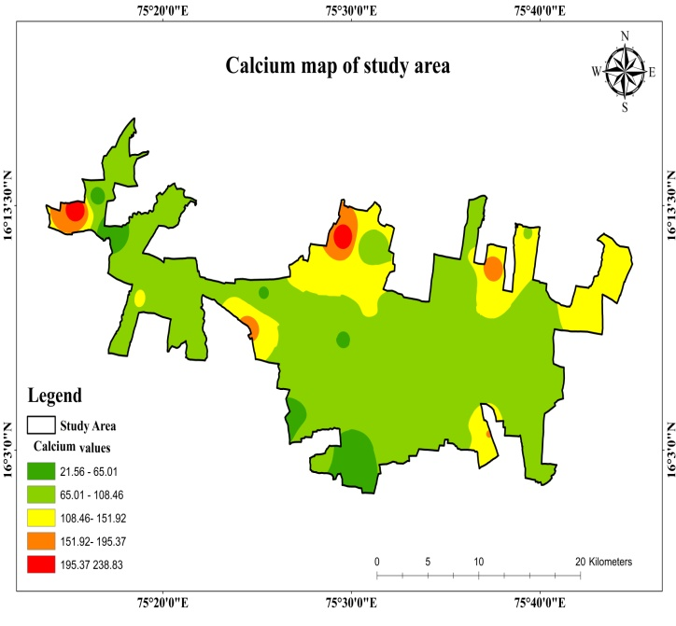
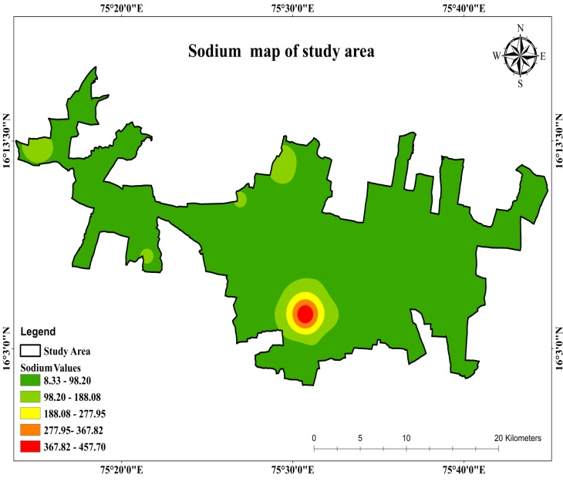
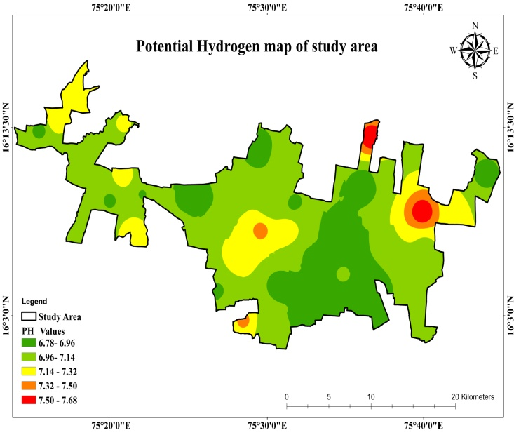
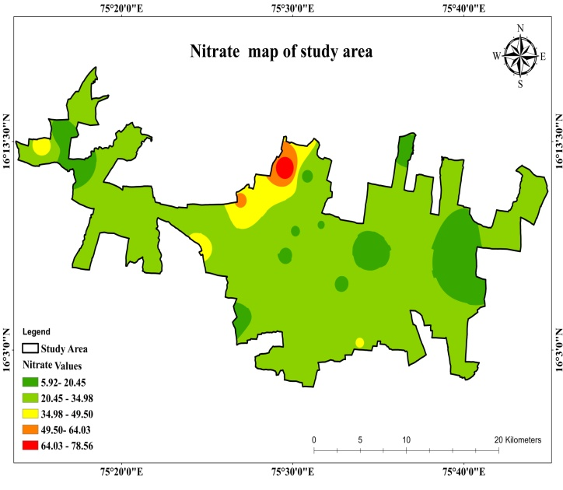
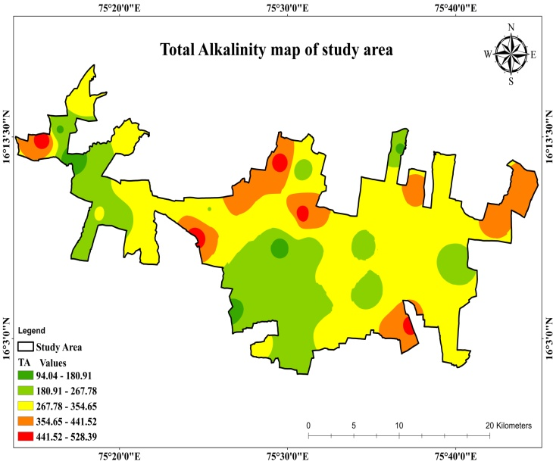
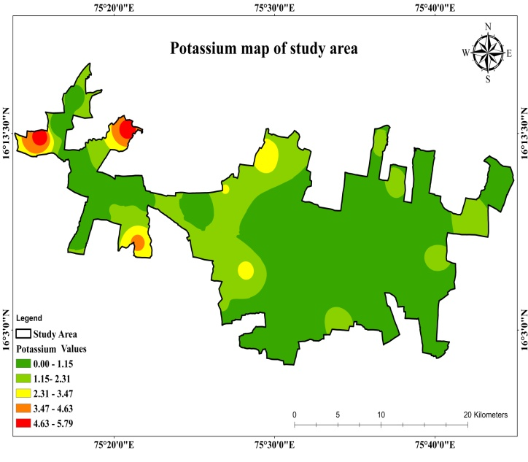
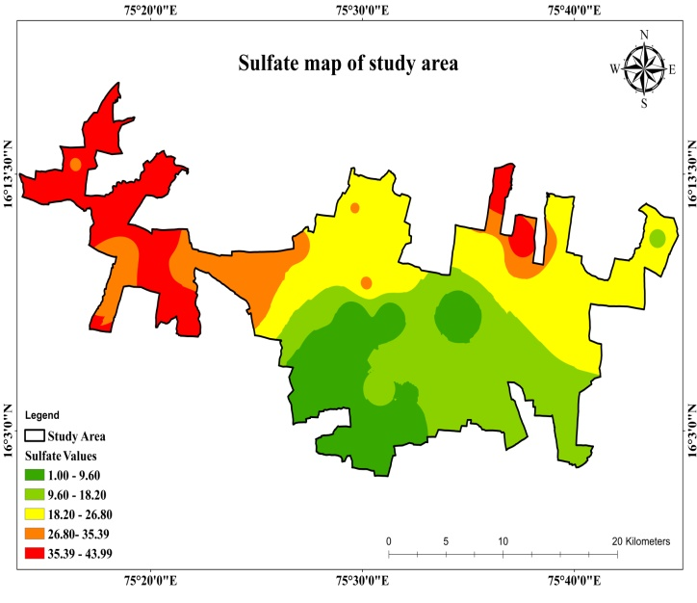

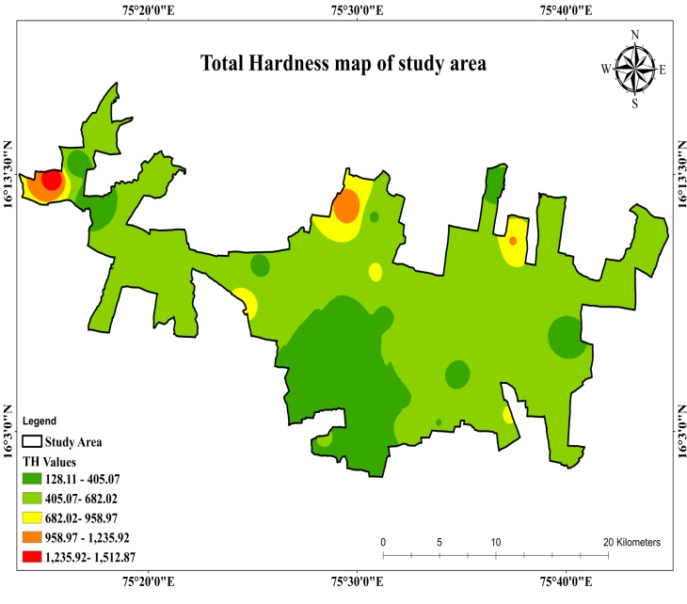
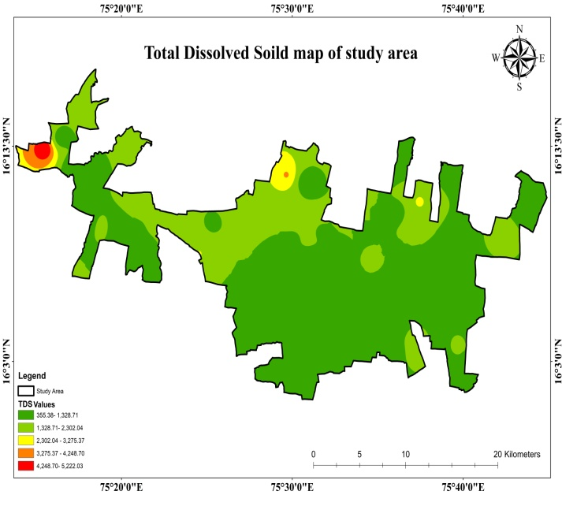
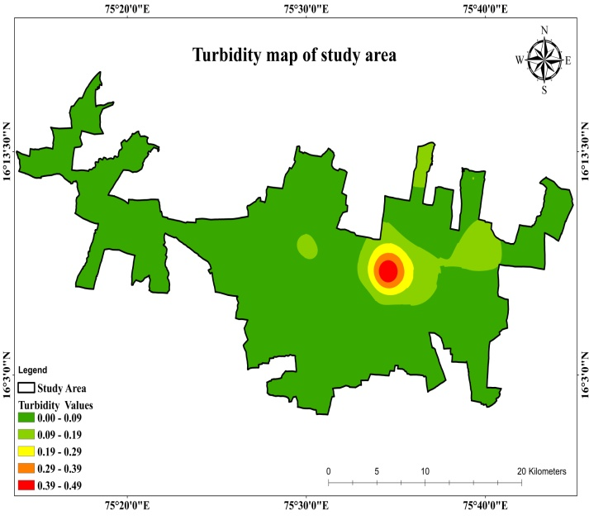

Figure 3| Thematic(Spatial distribution of iso-concentration map of various physio-chemical parameters analysed In the study area. Fluoride (F⁻), pH Value Electric conductivity (Ec) , Calcium (Ca²⁺) , Chloride (Cl⁻), Potassium(K⁺), Sodium (Na⁺⁾ , Magnesium (Mg²⁺), Nitrate (NO₃), Sulphate (SO₄), Iron (Fe),Total Dissolved Solids (TDS) , Total Hardness, Turbidity and Total Alkalinity.

Conclusion:
Drinking water quality: The calculated DWQI indicates that groundwater from all 44 sampled locations is presently suitable for drinking purposes, with 38 samples classified as Excellent and 6 samples as Good.
Hydrochemical Control: The groundwater is characterized by the Ca–HCO₃ facies, with its chemistry primarily controlled by the dissolution of carbonate and dolomitic rocks under geochemically immature conditions.
Irrigation Suitability -Overall Constraint: The major constraint for irrigation suitability is the Magnesium Hazard Ratio (MHR), which categorizes more than 77% of the samples as unsuitable for irrigation.
Localized Hazard: The groundwater sample from Kalabandakeri represents a severe localized hazard, as it is classified as unsuitable for irrigation based on both SAR and Na%, owing to its extremely high sodium concentration.
Recommendations:
Based on the findings of the present study, the following recommendations are proposed:
1. Although groundwater from all 44 locations is presently suitable for drinking, periodic monitoring is essential to prevent future deterioration. Protection of recharge zones and regulation of anthropogenic activities are necessary to maintain the existing water quality.
2. As groundwater belongs to the Ca–HCO₃ facies and is geochemically immature, controlled abstraction and artificial recharge measures should be implemented to preserve the natural hydrochemical regime and sustain aquifer health.
3. The high Magnesium Hazard Ratio (MHR), which renders more than 77% of samples unsuitable for irrigation, requires corrective measures such as gypsum application, blending with better-quality water, and adoption of salt-tolerant crops. Regular soil quality monitoring is also recommended to prevent long-term soil degradation.
4. The groundwater at Kalabandakeri, characterized by high sodium content (elevated SAR and Na%), should not be used for irrigation without appropriate treatment or blending. Site-specific management strategies and detailed hydrogeochemical investigations are recommended to address the localized sodium hazard.

References:
APHA, (2000), Standard methods for examination of water and wastewater
20th Ed. American Publ. Health Assoc., Washington D.C.
Biggs, T., Gaur, A., Scott, C., Thenkabail, P., Gangadhara Rao, P., Gumma, M., Acharya, S.,
and Turral, H., (2007), closing of the Krishna Basin: irrigation, stream flow depletion
and macro scale hydrology. Colombo, Sri Lanka: International Water
Management Institute (IWMI), Research Report 111, pp 38-39.
WHO (1997) Guidelines for drinking-water quality, 2nd ed. Vol. 3: Surveillance and control
of community supplies. Geneva, World Health Organization (
https://www​
.who.int/publications​/i/item/9241545038).
Central Groundwater Board. Groundwater information Booklet, Bagalkote,
District,Karnataka, 2024.
Amiri, V., et al. (2014). "Groundwater quality assessment using entropy weighted Water
Quality Index (EWQI) in Lenjanat, Iran." Environmental Earth Sciences.
Piper, A. M. (1944). "A graphic procedure in the geochemical interpretation of water-
analyses." Transactions, American Geophysical Union.
Stigter, T. Y., et al. (1998). "A hydrogeological and hydrochemical explanation of the
groundwater composition under irrigated land in a Mediterranean
environment." Journal of Hydrology.
Subramani, T., et al. (2005). "Groundwater geochemistry and its suitability for drinking and
irrigation in the Palar and Cheyyar river basins." Environmental Geology.
Hakanson, L. (1980). "An ecological risk index for aquatic pollution control. A
sedimentological approach." Water Research.
Ali, S., et al. (2024). "Groundwater quality assessment using water quality index and
principal component analysis..." Environmental Science and Pollution Research.
Shrestha, S., et al. (2023). "Groundwater quality evaluation for drinking purpose using water
quality index..." Environmental Monitoring and Assessment.
Abbasi, T., & Abbasi, S. A. (2012). Water Quality Indices. Elsevier.
Horton, R. K. (1965). "An index number system for rating water quality." Journal of Water
Pollution Control Federation.
Ayers, R. S., & Westcot, D. W. (1994). Water quality for agriculture FAO irrigation and
drainage. FAO Irrigation and Drainage Paper No, 29(1),174.
Naik, M. R., Mahanty, B., Sahoo, S. K., Jha, V. N., & Sahoo, N. K. (2022). Assessment of
groundwater geochemistry using multivariate water quality index and potential health
risk in industrial belt of central Odisha, India. Environmental Pollution, 303, 119161.
https://doi.org/10.1016/j.envpol.2022.119161

