Original Research Article

Spatio-temporal dynamics of vegetation cover and flood vulnerability in Uvira City of DRC, from 1990 to 2024

ABSTRACT
Background: Secondary African cities are increasingly trapped between rapid, unplanned urbanization and escalating climate-related hazards. Uvira (DRC), strategically located between the steep Mitumba Mountains and Lake Tanganyika, exemplifies this critical vulnerability. Methods: This study investigates the 34-year (1990-2024) spatio-temporal interactions between vegetation dynamics and flood hazards using an integrated remote sensing and GIS approach. Multi-temporal Landsat and Sentinel-2 imagery were processed to derive NDVI and NDWI indices, coupled with Random Forest LULC classification (Kappa &gt; 0.85) and Digital Elevation Model (DEM) analysis. Results: Our findings quantify a profound ecological collapse, characterized by a 39.6% net reduction in vegetation cover and a sixfold increase in bare soils since 2010. This loss of green infrastructure has fundamentally altered the catchment;s hydrological response, as evidenced by a 7.8% expansion of water surface area (NDWI) in low-lying coastal zones. The topographic "funnel effect" of Uvira;s steep slopes, combined with the erosion of natural hydraulic resistance, has transformed seasonal discharge into destructive flash floods. Conclusion: The study demonstrates that the "coastal squeeze";the convergence of rising lake levels and urban encroachment;has institutionalized flood risk as a structural component of the landscape. We argue for the urgent integration of Nature-based Solutions (NbS), specifically upstream reforestation and strict enforcement of non-aedificandi zones, to restore essential hydraulic regulation services and safeguard vulnerable populations.

- INTRODUCTION
Floods represent one of the most pervasive and destructive natural hazards worldwide, accounting for nearly 90% of climate-related disasters (Food & Nations, 2016). Their increasing frequency and intensity are driven by the combined effects of climate variability, rapid and often unplanned urban expansion, and widespread environmental degradation. In Sub-Saharan Africa, these interacting processes disproportionately affect rapidly growing secondary cities, where institutional and infrastructural capacities remain limited (Walsh et al., 2005).
The Democratic Republic of Congo (DRC) exemplifies this vulnerability. The city of Uvira, located along the northern shore of Lake Tanganyika and bordered by the steep slopes of the Mitumba mountain range, is particularly exposed to hydrometeorological hazards. Its geomorphological setting, combined with dense hydrographic networks and uncontrolled urban expansion, creates favorable conditions for recurrent flooding. Major flood events recorded in 2007, 2014, 2020, and 2023 have highlighted the critical role of anthropogenic drivers, including hillside deforestation, floodplain encroachment, and inadequate drainage systems.
Concurrently, the Congo Basin is experiencing rapid land-cover transformations driven by agricultural expansion, mining activities, and urban growth. These processes significantly alter ecosystem functions, particularly those related to hydrological regulation, soil stability, and runoff control (Heri‐Kazi & Bielders, 2021a). The degradation of vegetative cover reduces infiltration capacity and amplifies surface runoff, thereby increasing both the magnitude and frequency of flood events (Geist & Lambin, 2002).
Despite the growing recurrence of flood disasters, there remains a significant lack of integrated, long-term assessments linking vegetation dynamics to flood vulnerability at the local scale. While remote sensing and Geographic Information Systems (GIS) have proven effective in analyzing land-use change and flood susceptibility in various contexts, their application in medium-sized African cities such as Uvira remains limited (Kulimushi et al., 2021).
Against this background, the present study aims to investigate the spatio-temporal relationships between vegetation cover dynamics and flood vulnerability in the city of Uvira over the period 1990–2024. By integrating multi-source satellite data, spatial analysis techniques, and environmental indicators, this research seeks to enhance the understanding of hydrological risk drivers and to support evidence-based strategies for sustainable urban and environmental management.
The overarching objective of this study is to investigate the spatio-temporal interactions between vegetation cover dynamics and flood vulnerability in the city of Uvira, located along the northern shoreline of Lake Tanganyika, over the period 1990–2024. By integrating multi-temporal remote sensing data, Geographic Information Systems (GIS), and spatial analytical approaches, the study seeks to elucidate how land cover transformations influence hydrological processes and contribute to the increasing exposure of urban areas to flood hazards.
More specifically, this research aims to characterize the spatio-temporal dynamics of land use and vegetation cover through the analysis of multi-date satellite imagery, with particular attention to patterns of vegetation degradation, urban expansion, and landscape transformation. It also seeks to model the spatial evolution of flood-prone areas using an index-based approach that integrates key biophysical and topographic parameters, including elevation, slope, land cover, and drainage characteristics. In addition, the study aims to assess socio-environmental vulnerability by examining the interactions between biophysical changes, human settlement patterns, and the exposure of populations and infrastructure to flood-related risks.

2. MATERIALS AND METHODS

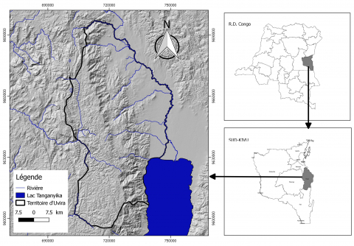
2.1. Study Area and Data Acquisition

Map 1- Study Area

(Nacishali Nteranya, 2021)
The study focuses on the city of Uvira, located in the South Kivu province of the Democratic Republic of Congo (DRC), on the northern shore of Lake Tanganyika. The area’s topography is characterized by a sharp transition between the Mitumba mountain ranges and the coastal plain, a configuration that increases flood sensitivity, particularly under rising anthropogenic pressures (OCHA_RDC.,2025).
To analyze vegetation dynamics and flood-prone areas over the period 1990–2024, a multi-temporal database was compiled using Landsat 5 TM (1990), Landsat 7 ETM+ (2000 and 2010), Landsat 8 OLI, and Sentinel-2 MSI (2015–2024). These images, with spatial resolutions ranging from 10 to 30 m, were selected during the dry season to minimize cloud cover and ensure optimal radiometric comparability (Khaing et al., 2019 ; Seto et al., 2012). A summary table of the images, indicating acquisition dates, sensors, and cloud cover percentages, was prepared to ensure data traceability.

2.2. Image Preprocessing
A standardized preprocessing protocol was applied to all images to ensure temporal consistency and analytical quality. The steps included:
- Radiometric and atmospheric correction: conversion to Top-of-Atmosphere (TOA) reflectance to minimize atmospheric scattering and inter-sensor variations.
- Geometric registration: projection into the UTM Zone 35S (WGS 84) coordinate system to guarantee precise overlay across dates.
- Masking of corrupted pixels: identification and exclusion of cloudy or shadowed pixels using quality assessment (QA) bands.
This approach ensures the reliability of diachronic analyses and the reproducibility of the workflow (Addo et al., 2008; Seto et al., 2012; Kulimushi et al., 2021).

2.3. Land Use/Land Cover (LULC) Classification
LULC mapping was performed using a supervised classification approach with the Random Forest (RF) algorithm, which is well-suited to tropical urban environments and non-linear spectral responses. The Maximum Likelihood Classifier (MLC) was applied as a comparative method (Lou et al., 2025)
The following classes were delineated:
- Dense vegetation ; Sparse vegetation / savannas ; Built-up areas and impervious surfaces; Agricultural lands; Water bodies
Training and validation samples were selected from high-resolution imagery and field data. Classification performance was evaluated using confusion matrices, the Kappa coefficient, and overall accuracy, following FAO standards (2020). RF parameters, including the number of trees and variables per split, were optimized via cross-validation to ensure robustness (Talukdar et al., 2020).

2.4. Flood-Prone Area Detection
Flood-prone areas were identified using the Normalized Difference Water Index (NDWI) (McFEETERS, 1996):
$$NDWI=\frac{Green-NIR}{Green+NIR}$$
Water pixels were extracted for each reference year. NDWI-derived maps were combined with topographic variables from a Digital Elevation Model (DEM), including elevation, slope, and flow direction. This integration refined the delineation of flood-prone zones and linked hydrological hazard to the biophysical characteristics of the area (Douglas et al., 2008; Niyongabire et al., 2016).

2.5. Integrated Environmental Vulnerability Assessment
Vulnerability assessment was conducted in a GIS environment (QGIS 3.34) using an integrated approach combining three dimensions:
- Hazard: occurrence and spatial extent of flood-prone areas.
- Sensitivity: degradation of vegetation cover and soil characteristics (Heri-Kazi & Bielders, 2020).
- Exposure: distribution of critical infrastructure and inhabited areas (Wamba, 2021; UNDP DRC, 2021).
Each component was normalized (0–1) and weighted using the Analytic Hierarchy Process (AHP) based on expert criteria. Spatial overlay allowed identification of priority intervention zones and generation of a final vulnerability map, reflecting the convergence of hazard, sensitivity, and exposure. This approach provides a robust framework for developing sustainable flood risk management strategies in a coastal urban context (Niyongabire et al., 2016).

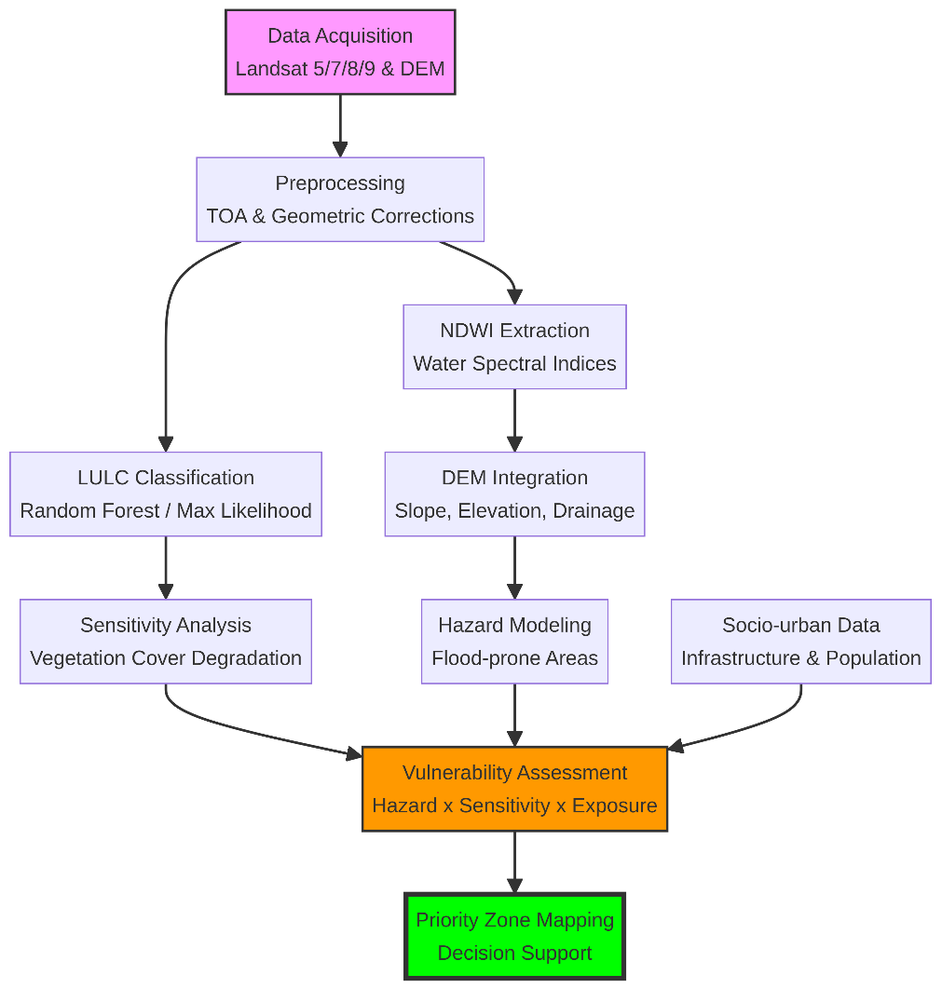
Fig 1 : Workflow methodologique

3. RESULTS AND DISCUSSION
3.1. Normalized Difference Vegetation Index (NDVI) between 1990 and 2024
The multi-decadal monitoring of Uvira (1990–2024) reveals a trajectory of severe ecological degradation, characterized by a systematic decline in NDVI-derived biomass. The transition from a robust forest-savanna baseline in 1990 (NDVI > 0.52) to a fragmented urban landscape in 2024 reflects a broader regional trend of “unplanned peri-urbanization” typical of the Great Lakes region (Lambin & Meyfroidt, 2011a). This loss of green infrastructure is not merely a spatial change but a functional collapse; as noted by Seto et al., 2012, the replacement of photosynthetic surfaces with impervious urban materials fundamentally alters the local energy balance and hydrological response. The localized secondary succession observed in 2010 highlights a transient resilience, yet it remains insufficient to counteract the dominant trend of habitat loss driven by demographic pressure (Geist & Lambin, 2002).
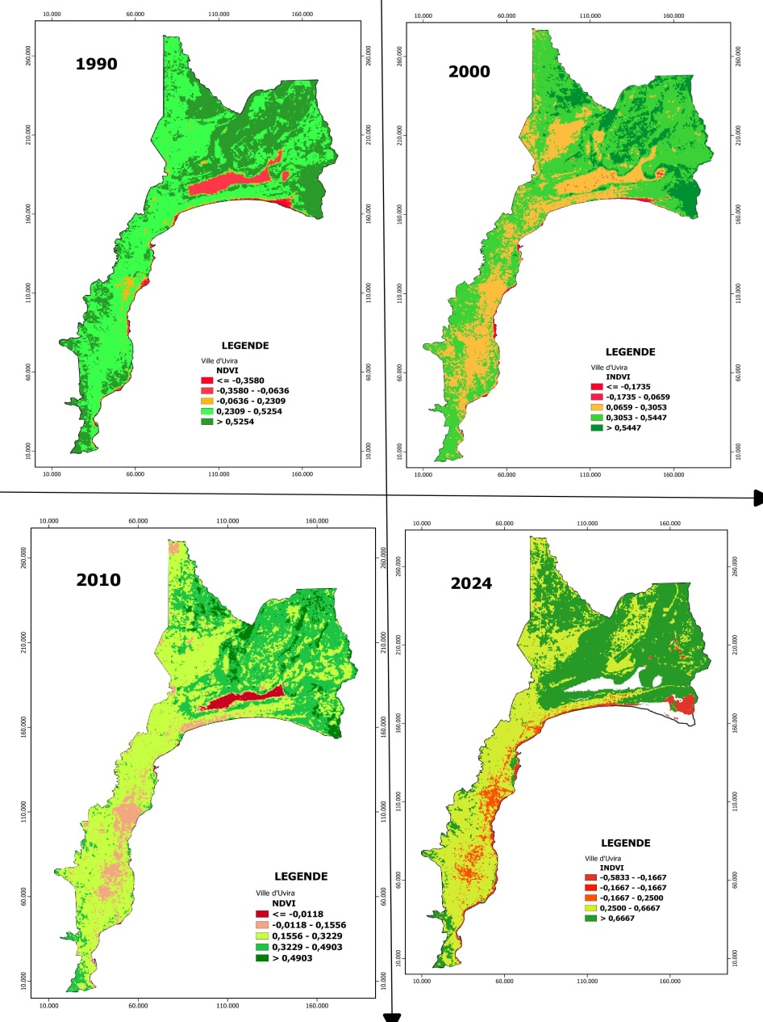
Figure 2: Résultats du NDVI indiquent, d’une manière générale, une dynamique plus importante entre 1990 et 2024
The critical threshold reached in 2024, where negative NDVI values dominate the urban core and southern littoral, directly amplifies flood vulnerability. This biophysical shift aligns with the "urban stream syndrome" (Walsh et al., 2005), where the reduction in canopy interception and root-mediated infiltration accelerates surface runoff. In the specific context of Uvira’s steep topography, this loss of vegetative buffer zones transforms moderate precipitation into high-velocity flash floods, confirming the findings of Heri‐Kazi & Bielders, 2021 on the link between land degradation and hydrological disasters in the Kivu ridge. Consequently, the observed vegetation regression serves as a precursor to the increased flood hazards identified via NDWI, necessitating an urgent integration of nature-based solutions into Uvira’s territorial planning to restore essential hydraulic regulation services (FAO, 2020).
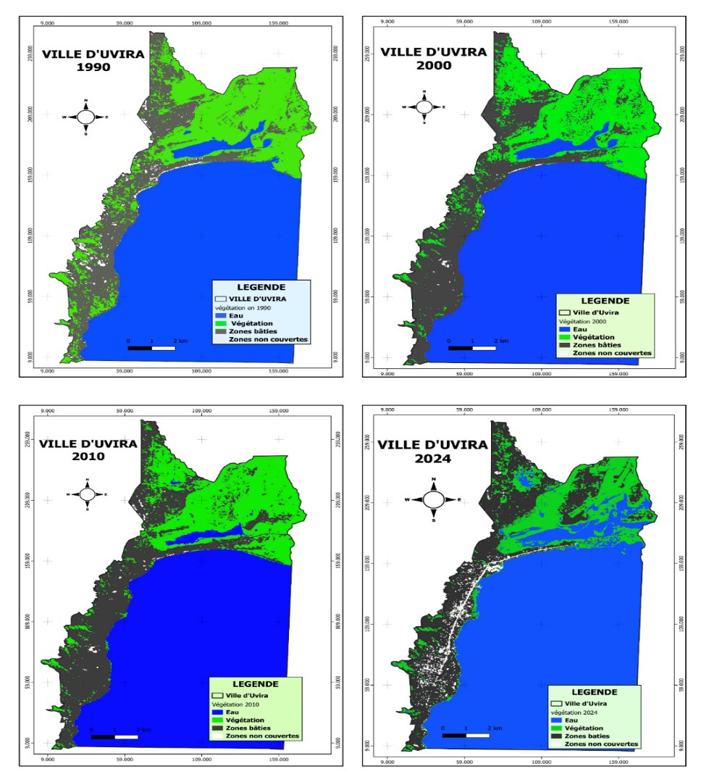Figure3: Spatio-temporal dynamics of vegetation form1990 à 2024
Table 1: Trends in the spatial extent of land use types
Surface type | 1990 |  | 2000 |  | 2010 |  | 2024
Surface type | Km² | % | Km² | % | Km² | % | Km² | %
water | 82.3 | 62.49 | 82.1 | 62.34 | 80.7 | 61.28 | 87 | 66.06
Vegetation | 26.5 | 20.12 | 23.7 | 18.00 | 23.9 | 18.15 | 16 | 12.15
Urban/built-up land | 21.7 | 16.48 | 25.5 | 19.36 | 26.6 | 20.20 | 25.7 | 19.51
Barren land surfaces | 1.2 | 0.91 | 0.4 | 0.30 | 0.5 | 0.38 | 3 | 2.28
Total | 131.7 | 100 | 131.7 | 100 | 131.7 | 100 | 131.7 | 100
3.2. Quantitative LULC Transitions and Environmental Risk Assessment
The multi-temporal analysis of Land Use/Land Cover (LULC) changes between 1990 and 2024 (Table 1) highlights a profound transformation of Uvira’s landscape, characterized by a 39.6% net reduction in vegetation cover, from 26.5 km² to 16 km². This trend reflects an aggressive process of urban encroachment, in which natural buffer zones have been progressively replaced by impervious surfaces and degraded soils, a pattern widely documented in rapidly urbanizing regions (Lambin & Meyfroidt, 2011a). The observed decline in vegetated areas suggests a systematic erosion of ecological functions that are critical for hydrological regulation and soil stabilization.
A particularly critical finding is the sixfold increase in uncovered zones (bare soils) between 2010 and 2024, expanding from 0.5 km² to 3 km². This sharp rise indicates a substantial loss of soil-protective vegetation and root systems, which play a key role in controlling erosion and limiting surface runoff. In parallel, water surface areas increased by 7.8% during the same period, from 80.7 km² to 87 km², providing a quantitative proxy for the spatial expansion of flood-prone zones and the permanent inundation of low-lying coastal areas. This pattern is consistent with the concept of “coastal squeeze,” whereby unplanned urbanization combined with fluctuating water levels progressively eliminates natural flood-mitigation zones (Doody, 2004). The strong correspondence between vegetation loss and water surface expansion confirms that the degradation of natural capital has significantly increased runoff coefficients, thereby transforming seasonal hydrological flows into destructive flood events, as previously reported in similar contexts (Heri‐Kazi & Bielders, 2021).

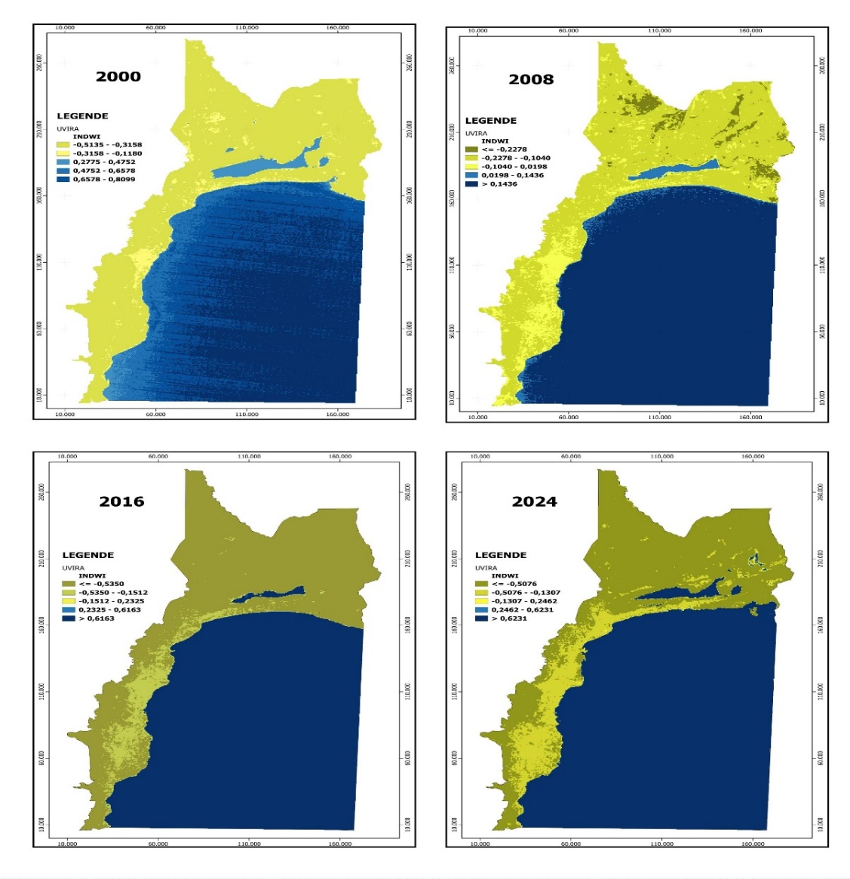
3.3. Analysis of Normalized Difference Water Index (NDWI) in Uvira between 2000 and 2024.

Figure4: Analysis of Normalized Difference Water Index (NDWI) in Uvira between 2000 and 2024.

3.4. Spatio-temporal Flood Hazard Assessment through NDWI from 2000 to 2024
The diachronic analysis of the Normalized Difference Water Index (NDWI) reveals a marked transformation of Uvira’s hydrological regime, shifting from a condition of relative stability in 2000 toward a state of recurrent and increasingly persistent inundation by 2024. The baseline year (2000) shows a well-defined separation between terrestrial and aquatic surfaces, reflecting a hydrological system that was still largely regulated. In contrast, the 2008 observations underscore the system’s pronounced sensitivity to seasonal variability, as evidenced by a noticeable contraction of water surfaces during the dry season. However, the subsequent expansion observed in 2016, followed by an unprecedented increase in 2024, points to a fundamental alteration of the catchment’s water balance. By 2024, NDWI values exceeding 0.62 extend into areas that were previously terrestrial, indicating the permanent inundation of residential and agricultural zones along the southern littoral.
This hydrological evolution cannot be interpreted solely as a response to regional climatic variability, but must be understood in close connection with the land cover degradation documented in Section 3.1. The progressive removal of vegetation has substantially reduced canopy interception and soil infiltration capacity, thereby promoting what has been described as an “accelerated runoff syndrome” (Niyongabire et al., 2016; Nyesheja et al., 2019). In the steeply sloping context of Uvira, the loss of natural hydraulic resistance facilitates the rapid conversion of intense rainfall events into high-velocity surface flows, which exceed the capacity of the city’s limited drainage infrastructure. Moreover, the spatial expansion of water surfaces observed in 2024 is consistent with the “coastal squeeze” phenomenon, whereby the combined effects of rising Lake Tanganyika water levels and unplanned urban expansion progressively eliminate natural buffer zones, effectively embedding flood risk as a structural and persistent component of the urban landscape (FAO, 2020 ; Heri-Kazi & Bielders, 2021).

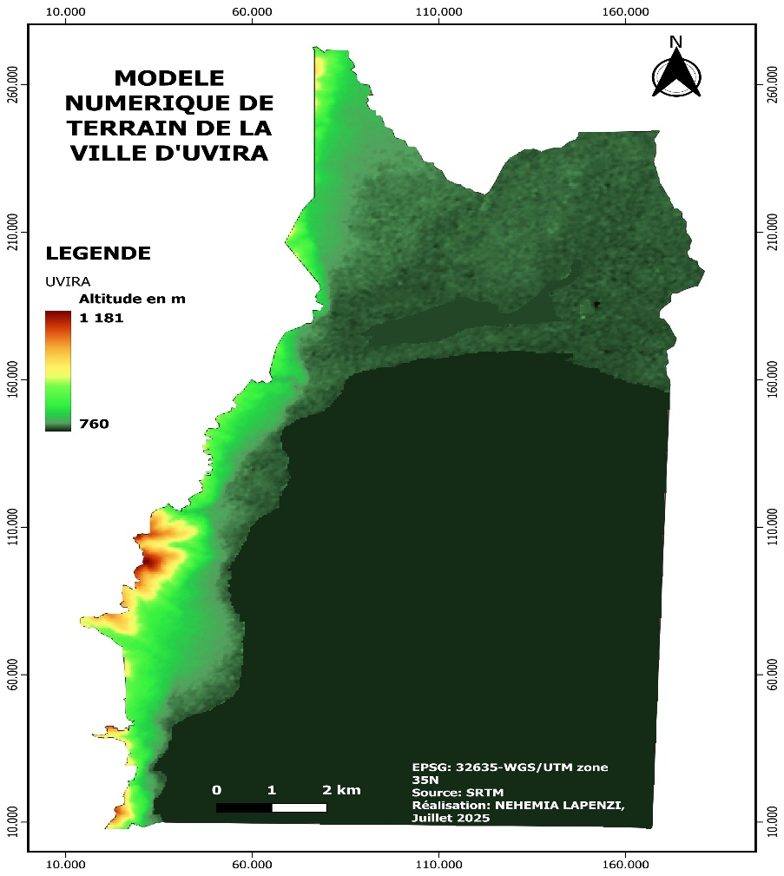

Figure5: Digital Elevation Model (DEM) of the city of Uvira

3.5. Geomorphological Analysis and Topographic Control of Flood Hazards
The Digital Elevation Model (DEM) of Uvira depicts a sharply contrasted topographic setting, marked by a pronounced altitudinal gradient extending from approximately 760 m along the shoreline of Lake Tanganyika to 1,181 m at the foothills of the Mitumba Mountains over a horizontal distance of less than 5 km. Such an abrupt relief configuration constitutes a fundamental control on the city’s hydrological behavior. The rapid transition from steep upstream slopes (red to orange classes) to the low-lying coastal plain (dark green classes) generates a pronounced “funnel effect,” whereby gravitational forces concentrate and accelerate surface runoff from the upland catchments toward the densely urbanized littoral zone.
From a flood-risk assessment perspective, this geomorphological context establishes a condition of structurally embedded hydrological vulnerability. In catchments characterized by steep relief and short flow paths, the time of concentration is markedly reduced, resulting in rapid hydrological responses to intense rainfall events (Rwanyiziri et al., 2020). When this inherent topographic constraint is combined with the substantial loss of vegetation cover documented in Section 3.1 (−39.6% between 1990 and 2024), the system shifts from a regime of seasonal runoff to one dominated by high-magnitude flash floods. The removal of vegetative roughness on slopes between 760 m and 1,181 m has effectively dismantled the natural hydraulic “braking mechanisms” of the watershed, allowing high-energy flows to propagate downslope and exceed the conveyance capacity of the urban drainage network in the lower elevation zones (<780 m).
In addition, the DEM analysis reveals a critical spatial convergence between geomorphological accumulation zones and patterns of urban settlement. The most densely populated neighborhoods of Uvira are located within the low-elevation coastal plain, where flow accumulation and sediment deposition are maximized. This superposition of high-exposure land uses onto high-hazard geomorphological units illustrates a classic case of “geomorphological blindness” in urban and territorial planning, as described by Heri-Kazi & Bielders, 2021. The expansion of water surfaces detected through NDWI analysis in 2024 (Section 3.5) is spatially constrained to these same low-lying sectors, demonstrating that the observed “coastal squeeze” is not solely driven by climatic variability but is strongly dictated by topographic controls. Accordingly, effective and sustainable flood mitigation in Uvira must prioritize interventions at the catchment scale, particularly the restoration of upstream vegetative buffers capable of dissipating runoff energy before it reaches the vulnerable coastal plain (Walsh et al., 2005; FAO, 2020).

4. DISCUSSION

4.1. Anthropogenic Drivers of Landscape Fragmentation and Land Degradation
The documented 39.6% reduction in vegetation cover between 1990 and 2024 reflects a profound ecological transition in the city of Uvira, driven predominantly by unplanned urban expansion and agricultural encroachment into peri-urban and hillside areas. This trajectory is consistent with the forest transition framework observed across Sub-Saharan Africa, where rapid demographic growth in secondary cities accelerates the depletion of green infrastructure and natural buffer zones (Lambin & Meyfroidt, 2011b). The sixfold increase in bare soils recorded since 2010 represents a critical indicator of land degradation, highlighting the progressive removal of soil-stabilizing root systems and the exposure of steep slopes to intensified erosive processes.
Beyond spatial transformation, these land-cover changes entail a functional degradation of the landscape. As emphasized by Seto et al., 2012, the replacement of vegetated surfaces with impervious or degraded land fundamentally alters surface energy exchanges, carbon storage capacity, and ecosystem resilience. In the case of Uvira, the fragmentation of vegetation has effectively weakened the ecological integrity of the urban–mountain interface, locking the system into a trajectory of increasing environmental vulnerability.

4.2. The Nexus Between Vegetation Loss and Hydrological Hazard Amplification
The strong correspondence between declining NDVI values and the 7.8% expansion of water surfaces derived from NDWI analysis provides robust empirical evidence of the link between vegetation loss and flood hazard amplification. The systematic degradation of the vegetative mantle has undermined two critical ecosystem services: rainfall interception by canopy cover and soil infiltration facilitated by root networks. The collapse of these functions has triggered hydrological responses consistent with the “urban stream syndrome,” whereby reduced surface roughness accelerates the transformation of rainfall into rapid surface runoff (Walsh et al., 2005).
In Uvira’s geomorphological setting, characterized by steep slopes and short hydrological response times, this process is particularly severe. The loss of natural hydraulic resistance results in the rapid concentration of flows, converting moderate precipitation events into destructive flash floods that exceed the capacity of existing drainage infrastructure. Similar mechanisms have been documented in the Kivu highlands, where land degradation acts as a key amplifier of hydrological extremes (Rwanyiziri et al., 2020; (Heri‐Kazi & Bielders, 2021). These findings confirm that flood risk in Uvira is not solely climate-driven but is strongly conditioned by anthropogenic land-cover change.

4.3. Coastal Squeeze and the Institutionalization of Vulnerability
The unprecedented expansion of flood-prone areas observed in 2024 reflects a classic coastal squeeze dynamic, in which urban growth is constrained between rising lake levels and increasingly unstable mountain slopes (Doody, 2004). The permanent inundation of residential and agricultural areas along the southern littoral suggests that Uvira has crossed a biophysical threshold beyond which conventional, infrastructure-based flood management solutions are insufficient. This condition signals the institutionalization of flood risk as a structural feature of the urban landscape.
This vulnerability is further exacerbated by the occupation of high-risk zones, a pattern commonly observed in secondary cities of the Democratic Republic of Congo, where land-use regulation remains weak and largely disconnected from environmental monitoring and risk assessment (Kulimushi et al., 2021). The results of this study underscore the urgent need to shift toward preventive and ecosystem-based approaches. In particular, the integration of Nature-based Solutions (such as upstream reforestation, slope stabilization, and the restoration of riparian buffer zones) emerges as a critical pathway for restoring hydrological regulation and reducing future flood impacts under increasing climate variability (FAO, 2020).
- CONCLUSION
This study examined the spatio-temporal interactions between vegetation cover dynamics and flood vulnerability in Uvira (Democratic Republic of the Congo) over a 34-year period (1990–2024), using an integrated framework combining multi-temporal remote sensing indices (NDVI, NDWI) and GIS-based land use/land cover (LULC) analysis. The results reveal a profound environmental transformation marked by a 39.6% decline in natural vegetation and a concomitant expansion of flood-prone areas, confirming the central role of anthropogenic land degradation in reshaping local hydrological processes.
The systematic loss of vegetation has critically weakened key ecosystem services, particularly rainfall interception, soil stabilization, and infiltration capacity. This functional degradation has intensified surface runoff, converting seasonal rainfall into destructive flash floods through an accelerated runoff syndrome. The threshold reached in 2024 (characterized by the permanent inundation of coastal and riparian zones) illustrates a clear “coastal squeeze” dynamic, whereby unregulated urban expansion converges with increasing hydrological hazards and limited geomorphological accommodation space.
From a management perspective, these findings underscore the urgent need to transition from reactive flood response strategies toward proactive, ecosystem-based territorial planning. Priority actions should include the reforestation of upstream mountain slopes to restore hydraulic resistance and slope stability, the strict enforcement of non-aedificandi regulations in high-risk floodplains, and the establishment of continuous environmental monitoring systems based on satellite-derived indicators to support evidence-based urban governance. Beyond the local context, this study provides a transferable methodological framework for secondary African cities facing similar challenges of rapid urbanization, environmental degradation, and increasing hydro-climatic risks under climate change.
DISCLAIMER (ARTIFICIAL INTELLIGENCE)
Author(s) hereby declare that NO generative AI technologies such as Large Language Models (ChatGPT, COPILOT, etc) and text-to-image generators have been used during writing or editing of this manuscript.

COMPETING INTERESTS

Authors have declared that no competing interests exist.

REFERENCES

Addo, K. A., Walkden, M., & Mills, J. t. (2008). Detection, measurement and prediction of shoreline recession in Accra, Ghana. ISPRS Journal of Photogrammetry and Remote Sensing, 63(5), 543‑558. https://www.sciencedirect.com/science/article/pii/S0924271608000282
Doody, J. P. (2004). ‘Coastal squeeze’ – an historical perspective. Journal of Coastal Conservation, 10(1), 129. https://doi.org/10.1652/1400-0350(2004)010[0129:CSAHP]2.0.CO;2
Douglas, I., Alam, K., Maghenda, M., Mcdonnell, Y., Mclean, L., & Campbell, J. (2008). Unjust waters : Climate change, flooding and the urban poor in Africa. Environment and Urbanization, 20(1), 187‑205. https://doi.org/10.1177/0956247808089156
FAO. (2020). Global Forest Resources Assessment 2020 : Main report. Rome.
Food, & Nations, A. O. of the U. (2016). State of the world’s forests 2016. Forests and agriculture : Land-use challenges and opportunities. FAO Report.
Geist, H. J., & Lambin, E. F. (2002). Proximate causes and underlying driving forces of tropical deforestation : Tropical forests are disappearing as the result of many pressures, both local and regional, acting in various combinations in different geographical locations. BioScience, 52(2), 143‑150. https://academic.oup.com/bioscience/article-abstract/52/2/143/341135
Heri-Kazi, A. B., & Bielders, C. L. (2021). Cropland characteristics and extent of soil loss by rill and gully erosion in smallholder farms in the KIVU highlands, DR Congo. Geoderma Regional, 26, e00404. https://www.sciencedirect.com/science/article/pii/S2352009421000493
Heri‐Kazi, A. B., & Bielders, C. L. (2021a). Erosion and soil and water conservation in South‐Kivu (eastern DR Congo) : The farmers’ view. Land Degradation & Development, 32(2), 699‑713. https://doi.org/10.1002/ldr.3755
Heri‐Kazi, A. B., & Bielders, C. L. (2021b). Erosion and soil and water conservation in South‐Kivu (eastern DR Congo) : The farmers’ view. Land Degradation & Development, 32(2), 699‑713. https://doi.org/10.1002/ldr.3755
https://www.academia.edu/download/107505862/IJSMES.pdf
Khaing, Z. M., Zhang, K., Sawano, H., Shrestha, B. B., Sayama, T., & Nakamura, K. (2019). Flood hazard mapping and assessment in data-scarce Nyaungdon area, Myanmar. PLoS One, 14(11), e0224558. https://journals.plos.org/plosone/article?id=10.1371/journal.pone.0224558
Kulimushi, L. C., Choudhari, P., Mubalama, L. K., & Banswe, G. T. (2021a). GIS and remote sensing-based assessment of soil erosion risk using RUSLE model in South-Kivu province, eastern, Democratic Republic of Congo. Geomatics, Natural Hazards and Risk, 12(1), 961‑987. https://doi.org/10.1080/19475705.2021.1906759
Kulimushi, L. C., Choudhari, P., Mubalama, L. K., & Banswe, G. T. (2021b). GIS and remote sensing-based assessment of soil erosion risk using RUSLE model in South-Kivu province, eastern, Democratic Republic of Congo. Geomatics, Natural Hazards and Risk, 12(1), 961‑987. https://doi.org/10.1080/19475705.2021.1906759
Lambin, E. F., & Meyfroidt, P. (2011a). Global land use change, economic globalization, and the looming land scarcity. Proceedings of the National Academy of Sciences, 108(9), 3465‑3472. https://doi.org/10.1073/pnas.1100480108
Lambin, E. F., & Meyfroidt, P. (2011b). Global land use change, economic globalization, and the looming land scarcity. Proceedings of the National Academy of Sciences, 108(9), 3465‑3472. https://doi.org/10.1073/pnas.1100480108
Lou, C., Al-qaness, M. A. A., AL-Alimi, D., Dahou, A., Abd Elaziz, M., Abualigah, L., & Ewees, A. A. (2025). Land use/land cover (LULC) classification using hyperspectral images : A review. Geo-Spatial Information Science, 28(2), 345‑386. https://doi.org/10.1080/10095020.2024.2332638
McFEETERS, S. K. (1996). The use of the Normalized Difference Water Index (NDWI) in the delineation of open water features. International Journal of Remote Sensing, 17(7), 1425‑1432. https://doi.org/10.1080/01431169608948714
Nacishali Nteranya, J. (2021). Cartographie de l’érosion hydrique des sols et priorisation des mesures de conservation dans le territoire d’Uvira (République démocratique du Congo). VertigO-la revue électronique en sciences de l’environnement, 20‑3. https://journals.openedition.org/vertigo/28888
Niyongabire, E., Hassan, R., Elhassan, E., & Mehdi, M. (2016). Use of digital elevation model in a GIS for flood susceptibility mapping : Case of Bujumbura City. Proceedings, 6th international conference on cartography and GIS, Albena: Bulgaria, 241‑248. https://www.researchgate.net/profile/Temenoujka-Bandrova/publication/309772611_6th_International_Conference_on_Cartography_and_GIS/links/5d13644a299bf1547c7f9906/6th-International-Conference-on-Cartography-and-GIS.pdf#page=241
Nyesheja, E. M., Chen, X., El-Tantawi, A. M., Karamage, F., Mupenzi, C., & Nsengiyumva, J. B. (2019). Soil erosion assessment using RUSLE model in the Congo Nile Ridge region of Rwanda. Physical Geography, 40(4), 339‑360. https://doi.org/10.1080/02723646.2018.1541706
OCHA_RDC_Rapport de situation Sud-Kivu Novembre 2025 (1). (s. d.).
Rwanyiziri, G., Kayitesi, C., Mugabowindekwe, M., Byizigiro, R. V., Muyombano, E., Kagabika, M. B., & Bimenyimana, T. (2020). Spatio-temporal analysis of urban growth and its effects on wetlands in Rwanda : The case of Rwampara wetland in the city of Kigali. Journal of Applied Sciences and Environmental Management, 24(9), 1495‑1501. https://www.ajol.info/index.php/jasem/article/view/200601
Seto, K. C., Güneralp, B., & Hutyra, L. R. (2012). Global forecasts of urban expansion to 2030 and direct impacts on biodiversity and carbon pools. Proceedings of the National Academy of Sciences, 109(40), 16083‑16088. https://doi.org/10.1073/pnas.1211658109
Talukdar, S., Singha, P., Mahato, S., Pal, S., Liou, Y.-A., & Rahman, A. (2020). Land-use land-cover classification by machine learning classifiers for satellite observations—A review. Remote sensing, 12(7), 1135. https://www.mdpi.com/2072-4292/12/7/1135
Walsh, C. J., Roy, A. H., Feminella, J. W., Cottingham, P. D., Groffman, P. M., & Morgan, R. P. (2005). The urban stream syndrome : Current knowledge and the search for a cure. Journal of the North American Benthological Society, 24(3), 706‑723. https://doi.org/10.1899/04-028.1

