Original Research Article

From Local Markets to Digital Platforms: A Study on Usage and Barriers of Affordable Digital Marketing Tools Among Rural Women Entrepreneurs in Karnataka

Abstract
Aim: To determine the most critical obstacles to the utilisation of affordable digital tools and digital engagement among rural women entrepreneurs in Karnataka.
Study Design: Mono-method quantitative approach based on descriptive research design.
Place and Duration of Study: The study was carried out throughout the state of Karnataka, including the North, South, Coastal, Central and Eastern regions and the data was collected in the period between January and February 2026.
Methodology: Fifty rural women entrepreneurs were sampled through a stratified random sampling technique and multiple regression analysis was employed in the analysis of the data.
Results: Majority of participants (84%) are using digital marketing tools actively to a great or considerable extent. Regression results show that, financial (b = 0.031, p = 0.895), social (b = 0.188, p = 0.079), security (b = 0.306, p = 0.072), and infrastructural barriers (b = 0.042, p = 0.820) were not statistically significant. Nevertheless, a lack of digital skills proved to be a significant obstacle to successful usage (b = 0.561, p = 0.005).
Conclusion: The paper indicates that despite the prevailing government programs on digital inclusions, a shift in priorities to practical and mobile based approach of digital marketing training is necessary. The effective use of these tools can be reinforced by increasing digital literacy and offering specific skills development programs that would foster the business growth, better income opportunities and inclusive rural development.

Keywords: Affordable Digital Marketing Tools, Rural Women Entrepreneurs, Barriers to Usage, Karnataka.

1.0 Introduction
In today’s dynamic world, digital marketing has transformed the process by which businesses reach their customers. There are numerous affordable and low-cost digital marketing solutions that help the entrepreneurs to have a larger reach and drive sales. Despite the availability of numerous low-cost and free digital marketing tools, not all the entrepreneurs are able to avail the fullest advantage of it. Women entrepreneurs particularly in rural and underserved geographic location are facing distinct challenges in terms of lack of awareness about digital tools, poor digital literacy, infrastructural constraints and sociocultural constraints in accessing these benefits. In many circumstances, women led rural enterprises still operate with conventional business network and have not recognized the potential of digital tools for enhancing growth and sustainability. Digital inclusion acts as a catalyst for driving economic empowerment for rural women in organized sector (B & Pai, 2025). Digital technology offers a transformative opportunity for rural women entrepreneurs, offering solutions to some of the most pressing challenges they face. With advancements in AI digital tools these women can access new markets, improve their operational efficiency and enhance customer engagement (Kaur & Jyotsana, 2025).However, the lacuna of basic digital skills remains a significant barrier, preventing many rural women from fully capitalizing on these opportunities (X. Bai & Yang, 2025). Women entrepreneurs in rural areas encounter wide range of challenges that limit the growth and success of their businesses. These include limited access to financial resources, insufficient skill development opportunities, the struggle to balance business and family responsibilities, and societal biases that affect their confidence and business prospects (Srivastava & Mohan, 2025) .In general women encounter unique socio cultural challenge when trying to exhibit their entrepreneurial skills and these challenges are more in rural areas (Aravamudhan et al., 2024). Despite the technological and economic development, due to economic and gender disparity, digital divide is still prevalent in some of developing countries like Afghanistan and Kenya (Ameri et al., 2025) .Though rural women entrepreneurs are increasingly aware of the potential of digital marketing, the rate of adoption and its impact on success of businesses in rural areas varies a lot (Goel et al., 2024) .
All of these obstacles diminish the readiness and capability of the rural woman to take full advantage of the opportunity of digital marketing. Consequently, their enterprises might fail to access broader markets and attain targeted growth. Minimal empirical data is also available particularly to study these challenges in the context of Karnataka. In this context, the present study is an attempt to understand the prevalence and usage of affordable and low-cost digital marketing tools among rural women entrepreneurs in Karnataka. The research will also explore barriers to adopting digital marketing tools amongst rural women entrepreneurs.

2.0 Literature Review
Although the use of low-cost digital marketing tools has been increasing, their application among rural women in businesses is not extensive. Most women encounter obstacles that include the digital illiteracy, lack of awareness as well as lack of training on how to use these tools (Paramasivam, 2022). Women entrepreneurs in rural India face an array of issues related to social, economic and market environment (Aravamudhan et al., 2024). The challenges that are being faced by women entrepreneurs in rural India stem from deep rooted social stereotype to obstructive cultural norms that differentiates men and women entrepreneurs (Igwe et al., 2018). In addition to socio cultural barriers, large proportion of women face infrastructural challenges like lack of physical buildings and difficulties in accessing markets in remote areas (Nsengimana et al., 2017). Inspite of understanding the benefits of adopting digital marketing for market and business growth, they continue to encounter challenges such as lack of adequate technical skills, limited funding and poor access to capital and gender bias (Gupta, 2025; Mannummel & Jerome, 2024). Without digital literacy, rural women entrepreneurs are unable to identify and leverage technology-based business opportunities, limiting their growth potential (Rah et al., 2021). Thus, conducting the detailed study on these challenges is essential to enable rural women entrepreneurs to effectively leverage digital marketing for business sustainability and growth.
3.0 Research Methodology
The research design used in the current study is descriptive because it will describe and analyse the barriers encountered by the rural female entrepreneur in the application of affordable digital marketing tools (Helen, 2015). The research population includes rural women entrepreneurs in Karnataka that operate small or medium sized enterprises and those who have embraced digital marketing tools. The research involved rural locations in various parts of Karnataka such as North, South, Coastal, Central and Eastern Karnataka in order to have wider representation (Madur, 2015). The sampling frame was secured through Karnataka State Women Development Corporation (KSWDC), which is a government organization that facilitates women development activities in the state (KSWDC, 2024). The research used a stratified random sampling method with the population stratified into five geographical strata in terms of regions of Karnataka (Swarooprani, 2022). Ten respondents were sampled in every stratum and the total sample was 50 rural women entrepreneurs. This sample size was deemed to be sufficient to conduct a multiple regression analysis to investigate the barriers hindering the use of affordable digital marketing tools (Green, 1991).
The conceptual framework developed for the study is shown in Figure 1.
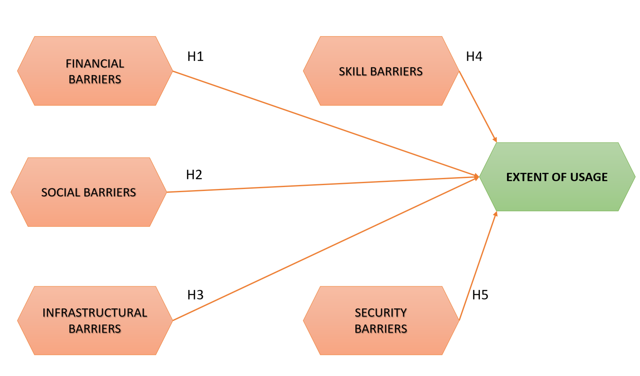
Figure 1: Conceptual Framework
Source: Created by Author
The hypotheses framed are as below:
H1: Financial Barriers have a significant negative impact on extent of usage of affordable digital marketing tools among rural women entrepreneurs
H2: Social Barriers have a significant negative impact on extent of usage of affordable digital marketing tools among rural women entrepreneurs
H3: Infrastructural Barriers have a significant negative impact on extent of usage of affordable digital marketing tools among rural women entrepreneurs
H4: Skill Barriers have a significant negative impact on extent of usage of affordable digital marketing tools among rural women entrepreneurs
H5: Security Barriers have a significant negative impact on extent of usage of affordable digital marketing tools among rural women entrepreneurs

4.0 Data Analysis and Interpretation
The process of data analysis and interpretation was used to investigate the association between the identified barriers and the extent of adoption of affordable digital marketing tools among rural women entrepreneurs. Data gathered were analysed through IBM SPSS version 21.
Table 1: Demographic and Business-Related Details
Variable | Category | Frequency | Percentage
Age | 20-30 | 18 | 36
Age | 31-40 | 22 | 44
Age | 41-50 | 8 | 16
Age | Above 50 | 2 | 4
Age | Total | 50 | 100
Educational Qualification | No formal education | 2 | 4
Educational Qualification | Primary | 8 | 16
Educational Qualification | Secondary | 13 | 26
Educational Qualification | PUC | 8 | 16
Educational Qualification | Graduation | 13 | 26
Educational Qualification | Postgraduation | 6 | 12
Educational Qualification | Total | 50 | 100
Marital Status | Single | 13 | 26
Marital Status | Married | 29 | 58
Marital Status | Widowed | 5 | 10
Marital Status | Divorced / Separated | 3 | 6
Marital Status | Total | 50 | 100
Size of Household | 1-3 | 23 | 48
Size of Household | 4-6 | 23 | 46
Size of Household | More than 6 | 3 | 6
Size of Household | Total | 50 | 100
Frequency of usage of affordable digital marketing tools for business | Very Frequently | 34 | 68
 | Frequently | 14 | 28
 | Moderately | 2 | 4
 | Rarely | 0 | 0
 | Never | 0 | 0
 | Total | 50 | 100

The demographic profile, as depicted in Table 1 indicates that the majority of the rural women entrepreneurs fall under the age group of 20-40 (80%), translating to most of the rural women being in their working age. Educational attainment indicates that most of the respondents have attained secondary education or higher (54%) indicating a fairly high level of literacy amongst the respondents. In terms of marital status, most of them are married (58%). The majority of the respondents live in small to medium-size households, with 48% of them containing members between 1 and 3 and 46% containing members between 4 and 6. The findings also show that adoption of tools of digital marketing is high, with 68% reporting that they utilize the same very frequently to conduct their business activities. Just 4% indicated moderate use, none out of them indicated rare use or no use. In general, the results imply that rural women entrepreneurs are vigorously adopting low-cost digital marketing resources to facilitate their businesses.
The extent of usage of affordable digital marketing tools among rural women entrepreneurs is depicted in the Figure 2.
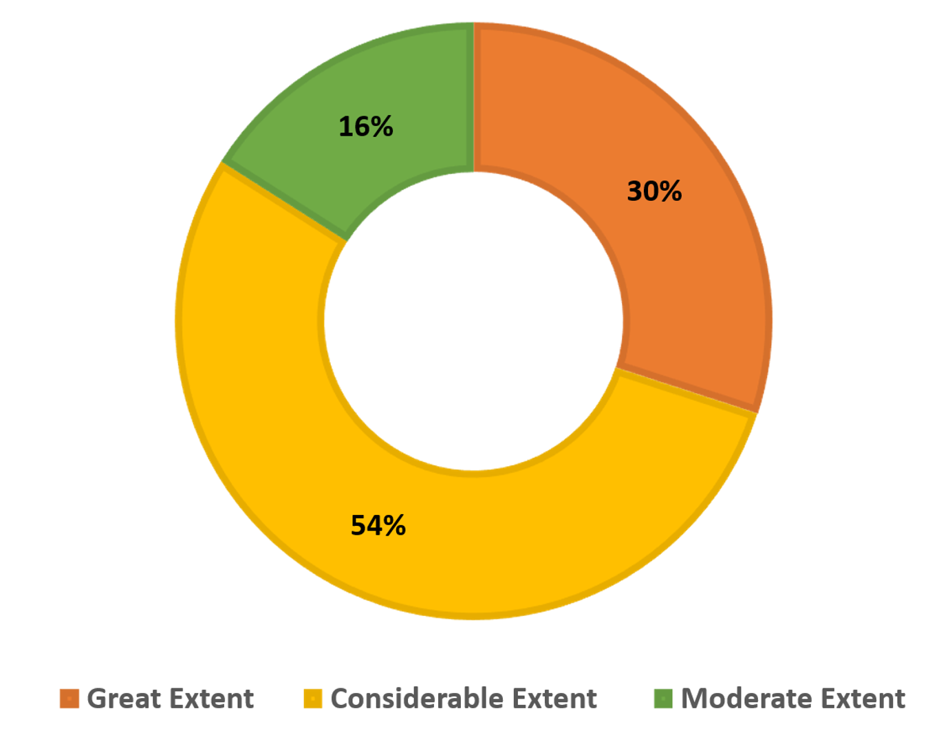
Figure 2: Extent of Usage of Affordable Digital Marketing Tools
Source: Created by Author
The findings indicate that most of the respondents use digital tools to great or considerable extent (84%). This means that rural women entrepreneurs are widely using affordable digital marketing tools to promote their businesses.
The research then sought to determine the obstacles that impede the use of affordable digital marketing resources among rural women entrepreneurs. In this regard, Multiple Regression Analysis (MRA) was used. MRA helps in examining how several independent variables (barriers) together influence a single dependent variable, in this case the extent of usage of digital marketing tools (Halinski & Feldt, 1970).

Table 2: Model Summary
Model Summary
Model | R | R Square | Adjusted R Square | Std. Error of the Estimate
1 | .776ª | .602 | .557 | .446
a. Predictors: (Constant), Skill Barrier, Social Barrier, Infrastructural Barrier, Security Barrier, Financial Barrier

The model summary, as shown in Table 2, depicts that the independent variables explain a significant percentage of the variation in the extent of usage of affordable digital marketing tools among rural women entrepreneurs. The R square value of 0.602 is within the acceptable range of 0.51 to 0.99 and shows that about 60 percent of the usage variation can be attributed to identified barriers that include financial, infrastructural, security, social and skill barriers (Ozili, 2022).
Table 3: ANOVA Test
ANOVAª
Model |  | Sum of Squares | df | Mean Square | F | Sig.
1 | Regression | 13.263 | 5 | 2.653 | 13.328 | .000^{b}
1 | Residual | 8.757 | 44 | .199
1 | Total | 22.020 | 49
a. Dependent Variable: Extent of usage of affordable digital marketing tools
b. Predictors: (Constant), Skill Barrier, Social Barrier, Infrastructural Barrier, Security Barrier, Financial Barrier

Table 3 shows that the regression model is significant as the p-value is less than 0.05 (p < 0.001)
at 5% level of significance. This implies that a combination of the barriers that are taken into account in the study plays a major role in determining the extent to which rural women entrepreneurs utilize low-cost digital marketing tools.
Table 4: Regression Coefficients
Coefficientsª
Model |  | Unstandardized Coefficients |  | Standardized Coefficients | t | Sig.
 |  | B | Std. Error | Beta | t | Sig.
1 | (Constant) | .293 | .568 |  | .516 | .609
1 | Financial Barrier | .031 | .236 | .024 | .133 | .895
1 | Infrastructural Barrier | .042 | .184 | .032 | .229 | .820
1 | Security Barrier | .306 | .166 | .260 | 1.843 | .072
1 | Social Barrier | .188 | .104 | .192 | 1.798 | .079
1 | Skill Barrier | .561 | .189 | .524 | 2.974 | .005
a. Dependent Variable: Extent of usage of affordable digital marketing tools

The results in Table 4 indicate that the impact of skill barriers on the use of affordable digital marketing tools is significant (b= 0.561, p=0.005). Financial (b= 0.031, p=0.895), social (b= 0.188, p=0.079), security (b= 0.306, p=0.072) and infrastructural impediments (b= 0.042, p=0.820) were not statistically significant in this model as their respective p-values were above 0.05. Overall, the findings suggest that among the examined factors, lack of digital skills appears to be the most critical barrier affecting the use of affordable digital marketing tools among rural women entrepreneurs.

5.0 Results and Discussions
The study results indicate that social barriers did not significant influence the utilization of low-cost digital marketing tools among the rural women entrepreneurs, rejecting H2. This finding is in contrast to findings of (Saha et al., 2024) , (Md Faudzi et al., 2024) and (Pathak & Varshney, 2017), who emphasized that socio-cultural norms and negative social attitudes play a role, with some women not accessing the internet because of social restrictions or unfavourable family conditions. The social barriers in the current study consisted of insufficient family support, peer encouragement as well as being judged by society over using digital platforms in conducting business. Nevertheless, the findings show that majority of the respondents do not see these factors as significant barriers. Instead, most women said that their families encouraged them, which allowed them to participate in digital marketing much more confidently. This observation is consistent with those of (Ghouse et al., 2017) which contend that family support, personal motivation and role models are significant in determining the entrepreneurial choices and career paths of women.
The financial and infrastructural barriers were determined to be statistically non-significant in affecting the degree of utilization of the available low-cost digital marketing tools, refuting H1 and H3. The affordability of digital tools, the recurring costs of mobile recharges and the cost of the internet were some financial barriers in this study. The findings indicate that the respondents tend to believe that digital marketing is an alternative cost-effective method to the traditional marketing techniques. The majority of the women business owners mentioned using WhatsApp Business, Instagram, Facebook Business accounts and Google Business pages that are either free or low-price and enable them to attract more customers. This is in line with the findings by (Goel et al., 2024) who remarked that digital marketing provides an affordable means of promotion to rural micro-entrepreneurs. This contrasts with findings reported by (Robert et al., 2021) and (Saha et al., 2024), who found financial limitations as a significant obstacle that does not allow women to own or gain control over digital devices. Regarding infrastructure, the respondents did not perceive challenges like unstable internet connectivity, power outages and absence of local technical assistance as significant obstacles. This implies that the area under study possesses digital infrastructure which is rather sufficient. These results align with those of (Ameri et al., 2025), who emphasized the role of digital infrastructure in bolstering entrepreneurial journey of women in developing regions and (Amalia et al., 2025) observed that low access to infrastructure is one of the factors that can lead to the digital divide in rural areas.
The findings also expose that security barriers were not a key concern among most of the respondents, leading to rejection of H5. Women in the study region did not cite major concerns about online privacy, online insecurity or unfavourable comments in their online business marketing. This observation agrees with (Ameri et al., 2025) and (Nayak & Nayak, 2025), who proposed that increased levels of digital security and a regulatory environment can increase trust and confidence in digital tools.
Skill barriers, however, were discovered to significantly and negatively influence the utilization of the low-cost digital marketing tools, leading to acceptance of H4. According to many respondents, it was challenging to use these tools to its full potential because of the limited knowledge about digital marketing practices and insufficient training. The results are in line with those highlighted by (Mishra et al., 2020), who stated that the absence of digital skills may be a barrier to the uptake of technology among rural businesses. Equally, (Ghouse et al., 2017) observed that technical knowledge, management skills and work experience could greatly empower the entrepreneurial capabilities of rural women. (Q. Bai et al., 2023) also pointed out that increased digital literacy enhances the capacity of women entrepreneurs to efficiently exploit digital mediums and also gives them greater confidence in entrepreneurial endeavours. (Kumar & Shobana, 2025) noted that effective training in such spheres as digital marketing, online business management and cybersecurity can assist rural entrepreneurs in entry to the digital marketplace, whereas (Aiswarya & Sangeetha, 2025) emphasized that better digitization competencies enhance the sustainability of businesses over the long term. Also, (Aggarwal & Johal, 2021) noted that government promotion and training programs are important in ensuring women entrepreneurship. Even though there are a number of efforts being made to enhance digital inclusion, which could be in the form of Digital Shakti Campaign, PMGDISHA, Digital India and Common Service Centres (CSCs), most of their efforts are on basic computer literacy but not on mobile based, practical digital marketing. The little emphasis placed on mobile-based training makes the available programs less effective since digital marketing activities in rural regions are mainly undertaken using smartphones. As such, the rural women entrepreneurs require proactive measures in form of developing effective, smartphone based and practical-oriented training programs that are specific to digital marketing skills with a view of ensuring that the women in the rural regions make better use of digital platforms.

6.0 Conclusion
The paper emphasizes that rural women entrepreneurs are increasingly adopting affordable digital marketing tools, which are generally viewed as affordable and useful in promoting businesses. The findings reveal that social, financial, infrastructural and security obstacles are not considered to pose any significant hindrance to the utilization of these tools in the study area. This implies that availability of supportive family environments, cost effectiveness of digital platforms and enhancement of digital infrastructure have been positively contributing factors towards their use. Nonetheless, the most noteworthy obstacles that influence the successful use of digital marketing tools are the deficit of digital skills and awareness. To overcome this obstacle, specific attention needs to be paid to enhancing digital skills and offering effective training to rural female entrepreneurs. Development agencies and policymakers must develop specific programs to focus on mobile-based digital marketing skills and practical applications in business. Enhancing such efforts can boost the digital presence of rural women entrepreneurs and make rural economic development sustainable.

7.0 Limitations
The size of the sample for the study was relatively small which could reflect on the limited generalizability of the findings. Further studies could involve a bigger sample and diversify to other locations to gain more insight into the adoption of digital marketing by women entrepreneurs in rural areas.

Ethical Statements
The study was conducted in accordance with ethical research standards, ensuring informed consent, confidentiality, and voluntary participation of all respondents.

References
- Aggarwal, M., & Johal, R. K. (2021). Rural women entrepreneurship: a systematic literature review and beyond. World Journal of Science, Technology and Sustainable Development, 18(4), 373–392. https://doi.org/10.1108/WJSTSD-04-2021-0039
- Aiswarya, S., & Sangeetha, S. (2025). Bridging the Digital Divide: Empowering Rural Women Entrepreneurs through Digital Inclusion. International Research Journal of Education and Technology, 7(2), 50–54.
- Amalia, R., Aini, R. Q., Paradita, J., & Mirza BR, A. D. (2025). Bridging The Digital Divide : The Role of Technology in Enhancing Rural SMES in Indonesia. Jurnal Ilmu Manajemen Dan Bisnis, 16(1), 27–34. https://doi.org/10.17509/jimb.v16i1.82681
- Ameri, M. K., Mohammadi, A., Hekmat, A. M., & Amiri, K. (2025). Analyzing the Impact of Digital Infrastructure on Women’s Entrepreneurship in Low-Income Countries. https://doi.org/10.2139/ssrn.5123975
- Aravamudhan, V., Sivakumar, K., Vishnu, C. R., & Mohanasundaram, K. (2024). Challenges faced by women entrepreneurs in rural India: A mixed-method study on perception. The International Journal of Entrepreneurship and Innovation. https://doi.org/10.1177/14657503241254954
- B, S., & Pai, R. (2025). Digital Inclusion of Women Entrepreneurs in The Unorganized Sector – A Systematic Review. Advances in Consumer Research, 2(1), 71–85.
- Bai, Q., Chen, H., Zhou, J., Li, G., Zang, D., Sow, Y., & Shen, Q. (2023). Digital literacy and farmers’ entrepreneurial behavior—Empirical analysis based on CHFS2019 micro data. PLOS ONE, 18(7), e0288245. https://doi.org/10.1371/journal.pone.0288245
- Bai, X., & Yang, L. (2025). Digital literacy’s impact on digital village participation in rural left-behind women through serial mediation of political trust and self-efficacy. Scientific Reports, 15(1), 34226. https://doi.org/10.1038/s41598-025-16093-3
- Ghouse, S., McElwee, G., Meaton, J., & Durrah, O. (2017). Barriers to rural women entrepreneurs in Oman. International Journal of Entrepreneurial Behavior & Research, 23(6), 998–1016. https://doi.org/10.1108/IJEBR-02-2017-0070
- Goel, R., Veluri, D. K. K., & Mishra, D. S. (2024). Understanding The Use Of Digital Marketing By Rural Micro Entrepreneurs Of India: A Systematic Literature Review. Educational Administration Theory and Practices. https://doi.org/10.53555/kuey.v30i5.4217
- Green, S. B. (1991). How Many Subjects Does It Take To Do A Regression Analysis. Multivariate Behavioral Research, 26(3), 499–510. https://doi.org/10.1207/s15327906mbr2603_7
- Gupta, D. C. (2025). Exploring the Digital Startup Ecosystem: A Rural-Urban Comparison of Women Entrepreneurs in India. Journal Global Values, XVI(SI), 32–36. https://doi.org/10.31995/jgv.2025.v16iSI.006
- Halinski, R. S., & Feldt, L. S. (1970). The Selection of Variables in Multiple Regression Analysis. Journal of Educational Measurement, 7(3), 151–157. https://doi.org/10.1111/j.1745-3984.1970.tb00709.x
- Helen, L. (2015). Design : Descriptive Research Definitions of. Journal of Pediatric Oncology Nursing, 10(1), 154–157.
- Igwe, P., Newbery, R., & Icha-Ituma, A. (2018). Entrepreneurship Challenges and Gender Issues in the African Informal Rural Economy (pp. 91–111). https://doi.org/10.1007/978-3-319-59282-4_7
- Kaur, G., & Jyotsana, D. (2025). AI-Powered Customer Engagement In Women-Led Businesses. International Journal of Environmental Sciences, 564–569. https://doi.org/10.64252/fpvb7542
- KSWDC. (2024). Karnataka State Women’s Development Corporation. Department of Women & Child Development & Empowerment of Differently Abled & Senior Citizens. https://kswdc.karnataka.gov.in/en
- Kumar, S., & Shobana, D. (2025). A Study on Digital Literacy and Rural Entrepreneurship: Evaluating PMGDISHA’s Contribution in Nagaland. Naveen International Journal of Multidisciplinary Sciences (NIJMS), 1(4), 54–65. https://doi.org/10.71126/nijms.v1i4.38
- Madur. (2015). Physiography of Karnataka. https://www.karnataka.com/profile/physiography/#google_vignette
- Mannummel, A. D., & Jerome, D. V. B. (2024). Empowering Women Entrepreneurs: Bridging the Digital Divide through Digital Marketing Technology Adoption. Educational Administration Theory and Practices. https://doi.org/10.53555/kuey.v30i5.3488
- Md Faudzi, M. S., Abu Bakar, L. J., & Ahmad, S. (2024). Breaking Barriers: Investigating Technology Adoption in Micro, Small, and Medium Enterprises (MSMEs) Among Low-Income Women Entrepreneurs in Malaysia. PaperASIA, 40(5b), 126–135. https://doi.org/10.59953/paperasia.v40i5b.130
- Mishra, O., Sharma, R., & Agrawal, B. (2020). Facilitating Women Prosperity with Higher Purpose at Vyomini. South Asian Journal of Business and Management Cases, 9(2), 198–207. https://doi.org/10.1177/2277977920905820
- Nayak, M., & Nayak, P. M. (2025). Empowering women in rural India: characteristics and intentions for sustainable entrepreneurship. Cogent Business & Management, 12(1). https://doi.org/10.1080/23311975.2025.2461234
- Nsengimana, S., Tengeh, R., & Iwu, C. (2017). The Sustainability of Businesses in Kigali, Rwanda: An Analysis of the Barriers Faced by Women Entrepreneurs. Sustainability, 9(8), 1372. https://doi.org/10.3390/su9081372
- Ozili, P. K. (2022). The Acceptable R-Square in Empirical Modelling for Social Science Research. SSRN Electronic Journal. https://doi.org/10.2139/ssrn.4128165
- Paramasivam. (2022). A Study on Perception Towards Women Entrepreneurship in Digital Marjeting. Jurnal of Positive School Psychology, 6(4), 9265–9271.
- Pathak, A. A., & Varshney, S. (2017). Challenges faced by women entrepreneurs in rural India. The International Journal of Entrepreneurship and Innovation, 18(1), 65–72. https://doi.org/10.1177/1465750316686245
- Rah, N. S., Masduki, M., & Rahayu, N. E. E. (2021). Women Entrepreneurs and The usage of social Media for Business Sustainability In the time of Covid-19. https://doi.org/10.21203/rs.3.rs-907854/v1
- Robert, F. C., Frey, L. M., & Sisodia, G. S. (2021). Village development framework through self-help-group entrepreneurship, microcredit, and anchor customers in solar microgrids for cooperative sustainable rural societies. Journal of Rural Studies, 88, 432–440. https://doi.org/10.1016/j.jrurstud.2021.07.013
- Saha, P., Prusty, A. K., & Nanda, C. (2024). Extension strategies for bridging gender digital divide. Journal of Applied Biology & Biotechnology. https://doi.org/10.7324/JABB.2024.159452
- Srivastava, K., & Mohan, A. (2025). Identifying the Challenges Faced by the Women Entrepreneurs in Uttar Pradesh: Using Principal Component Analysis. SEDME (Small Enterprises Development, Management & Extension Journal): A Worldwide Window on MSME Studies, 52(4), 397–413. https://doi.org/10.1177/09708464251392735
- Swarooprani. (2022). An Study of Research Methodology. International Journal of Scientific Research in Science, Engineering and Technology, 537–543. https://doi.org/10.32628/IJSRSET2293175

