Review Article
Bridging the Gap: Emerging Orthodontic Strategies in Cleft Lip and Palate Regeneration – A Review

.
ABSTRACT

Cleft lip and palate (CLP) is a common congenital craniofacial anomaly that significantly affects facial aesthetics, oral function, and overall quality of life, requiring long-term multidisciplinary management. Conventional treatment approaches, including presurgical orthopedics and surgical repair, have improved outcomes but are often associated with limitations such as graft resorption, scarring, altered growth patterns, and the need for repeated interventions. From an orthodontic perspective, challenges persist in achieving stable alveolar bone continuity, optimal tooth eruption, and long-term occlusal harmony.
Recent advances in regenerative medicine and digital technology are transforming cleft care toward a more precise and patient-specific approach. Innovations such as tissue engineering, stem cell therapy, 3D and 4D bioprinting, nanotechnology, and artificial intelligence–assisted planning have demonstrated potential in enhancing alveolar bone regeneration, improving eruption guidance, and maintaining arch form. Digital workflows and telemedicine further improve accessibility and treatment efficiency.
This review highlights these emerging strategies and their orthodontic implications, emphasizing their role in improving treatment predictability and reducing intervention burden. Despite promising outcomes, challenges related to cost, accessibility, and long-term clinical validation remain. The integration of regenerative and digital approaches represents a significant step toward personalized, growth-adaptive cleft management.

Keywords: Alveolar bone regeneration, Regenerative orthodontics, Stem cell therapy, Tissue engineering, 3D bioprinting, Nanotechnology in orthodontics, Personalized treatment planning, Gene therapy.

INTRODUCTION

Cleft lip and palate (CLP) are among the most common congenital craniofacial anomalies, affecting both facial aesthetics and essential oral functions, and often requiring prolonged, multidisciplinary care. Conventional management relies on established approaches such as presurgical orthopedic techniques, including nasoalveolar molding (NAM) and passive alveolar plates, along with early surgical repair. These strategies help reduce cleft severity, approximate alveolar segments, and support maxillary development. However, limitations such as donor-site morbidity, graft resorption, delayed tooth eruption, soft tissue scarring, and the need for multiple surgical interventions continue to influence long-term outcomes.
From an orthodontic standpoint, CLP management extends beyond defect closure. Alveolar bone continuity, eruption patterns, dental arch form, occlusal relationships, and craniofacial growth are significantly impacted by both the cleft defect and its treatment. This necessitates careful planning of treatment timing, appliance design, and space management to achieve stable functional and aesthetic outcomes. Despite their effectiveness, traditional methods often require prolonged or repeated orthodontic interventions due to residual deficiencies and altered growth patterns.
Recent advances in regenerative medicine, digital technology, and bioengineering are reshaping cleft care. Innovations such as tissue-engineered scaffolds, stem cell therapy, 3D/4D bioprinting, and AI-assisted planning offer new possibilities for improving alveolar bone regeneration, guiding tooth eruption, and optimizing orthodontic outcomes. This review focuses on these emerging strategies from an orthodontic perspective, highlighting their role in bridging the gap between conventional treatment and next-generation regenerative care.

Early Diagnosis and Prenatal Detection

Early diagnosis of CLP allows for timely planning and improved treatment outcomes. Routine 2D ultrasonography remains the primary screening tool, while 3D and 4D ultrasonography provide enhanced visualization of facial structures, enabling better assessment of cleft severity and maxillary discrepancies.¹ Adjunctive imaging modalities such as color Doppler and fetal MRI further improve detection of palatal and craniofacial abnormalities.²

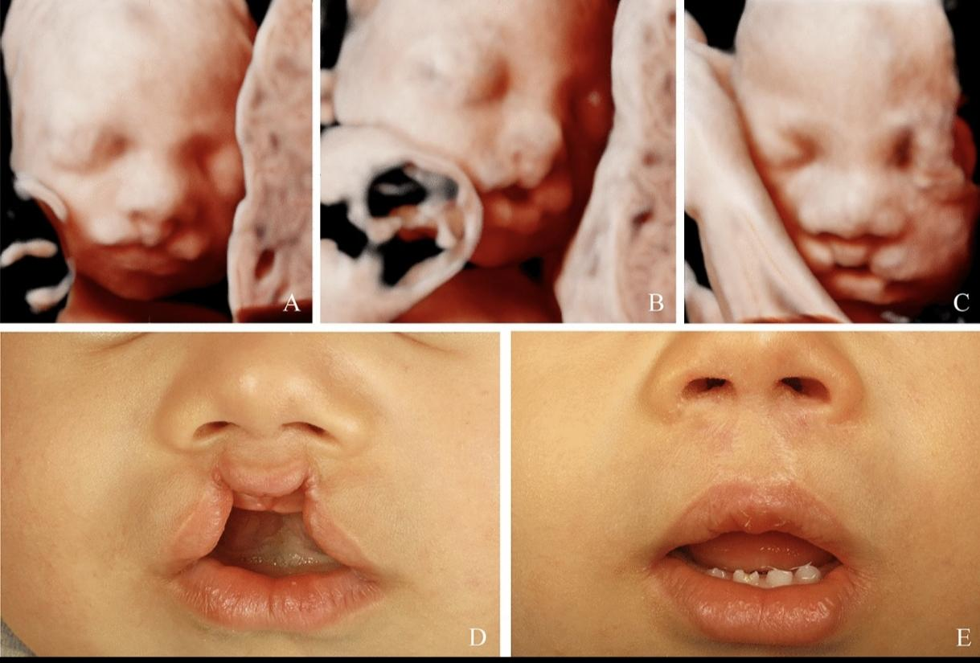
Fig 1: Bilateral cleft lip visualized on ultrasound during the prenatal period in 3D (A–C). Postnatal preoperative (D) and postoperative (E) result ⁴

Genetic screening techniques, including non-invasive prenatal testing (NIPT) and chromosomal microarray analysis, assist in identifying syndromic associations that may influence craniofacial growth and dental development.³ Although isolated cleft palate remains difficult to detect prenatally, combining imaging with genetic insights enables early multidisciplinary planning and improved treatment sequencing from infancy.

Genetic and Molecular Basis

CLP is a multifactorial condition resulting from complex interactions between genetic and environmental factors. Key genes such as IRF6, MSX1, PAX9, TGFB3, and TBX22 regulate craniofacial development, including epithelial differentiation, mesenchymal proliferation, and palatal shelf fusion.⁵ Disruptions in molecular pathways like Wnt, Sonic Hedgehog, and BMP signaling can impair maxillary growth and alveolar bone formation, influencing occlusion and eruption patterns.
eruption patterns.

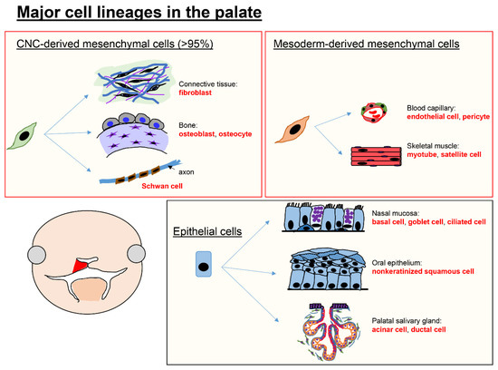
Fig 2: Major cell types in the palate. ⁶

Epigenetic mechanisms and environmental influences, including maternal smoking, nutritional deficiencies, and teratogenic exposure, further contribute to variability in cleft presentation and severity. Advances in next-generation sequencing and CRISPR-based technologies have enhanced understanding of these mechanisms, offering potential for personalized risk assessment.⁷
However, direct gene therapy for CLP remains largely experimental due to the complexity of craniofacial development and ethical considerations. Current applications are primarily focused on early diagnosis and risk prediction rather than clinical intervention.⁸

Digital Dentistry and 3D Printing in Cleft Care

The integration of digital workflows and 3D printing has revolutionized cleft management by enabling precision-based, patient-specific solutions. In presurgical orthopedics, intraoral scanning has replaced conventional impression techniques, allowing safe and accurate digital capture of neonatal oral structures.
These digital models are used to fabricate customized NAM appliances with improved fit, retention, and controlled force application.⁹ Compared to traditional methods, digital workflows significantly reduce fabrication time and allow batch production of sequential appliances, improving treatment efficiency and standardization.

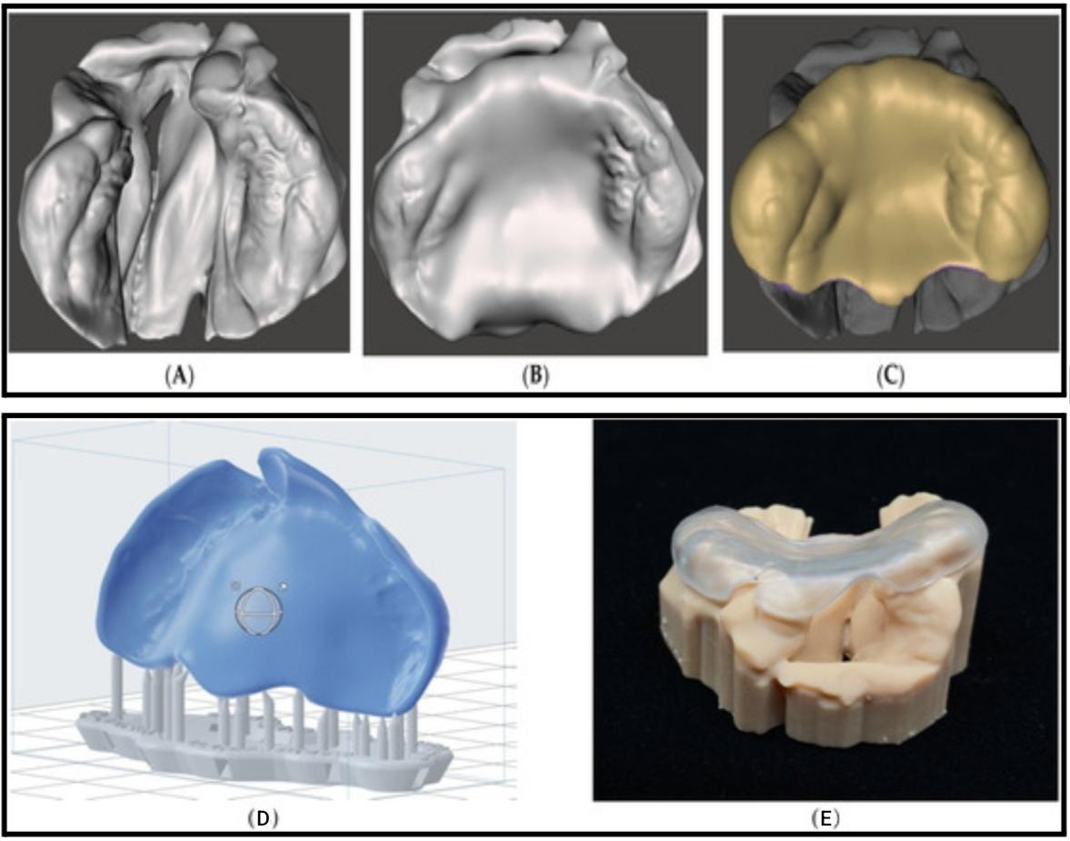
Fig 3. Unilateral cleft lip and palate model (A) as imported; (B) with blocked cleft area to mimic a normal palatal shape; (C) final passive presurgical orthopedic plate ready for 3D printing. (D) Manual-orientation of the presurgical plate and auto-generation of the support structure. (E) Digitally designed and 3D printed passive presurgical plate with corresponding anatomical cleft model. ⁹

3D printing has also transformed feeding management through the development of customized palatal obturators, which restore oral function and improve nutritional outcomes in neonates. In surgical planning, patient-specific anatomical models and surgical guides enhance precision, reduce operative time, and improve outcomes in procedures such as alveolar bone grafting and maxillary reconstruction.¹²
While these digital and 3D printing technologies primarily focus on appliance fabrication and surgical planning, newer advances such as bioprinting extend these concepts further into tissue regeneration.

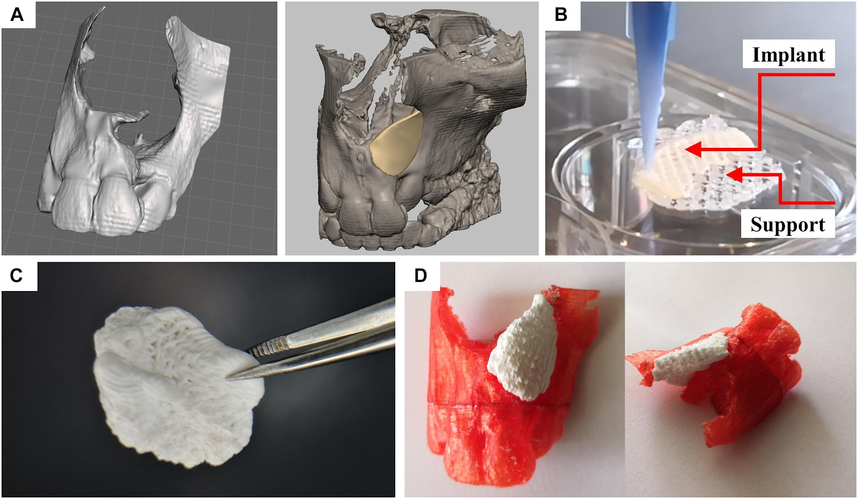
Fig 4. Design and fabrication process of a patient-specific implant consisting of a calcium phosphate cement. (A) Three-dimensional reconstruction of a CT scan of a patient and a designed model of a perfectly fitting implant. (B) Fabrication process by multichannel 3D plotting of a sacrificial ink and the CPC. (C) Photograph of the implant, after the sacrificial ink was washed away. (D) The hardened implant fits perfectly into the defect of the patient. Red: Plastic model of the maxilla with incisors, white: 3D plotted CPC implant. ¹⁰

The integration of 3D printing with telemedicine is emerging as a valuable advancement in cleft care, enabling remote and more accessible treatment delivery. Digital impressions of an infant’s oral cavity can be captured using scanners at peripheral centers or through caregiver-assisted methods at home, and then shared with specialized units for fabrication of customized appliances. These appliances can be produced remotely and delivered directly to patients, reducing the need for repeated hospital visits. This approach is particularly beneficial for families in rural or underserved areas, as it improves access to care, follow-up compliance, and reduces both financial and emotional burden.
Additionally, digital workflows allow parents to visualize treatment progress through 3D models and simulations, enhancing their understanding, involvement, and overall treatment compliance.

Table1. Flowchart of digital workflow in 3D printing of Appliance ¹¹
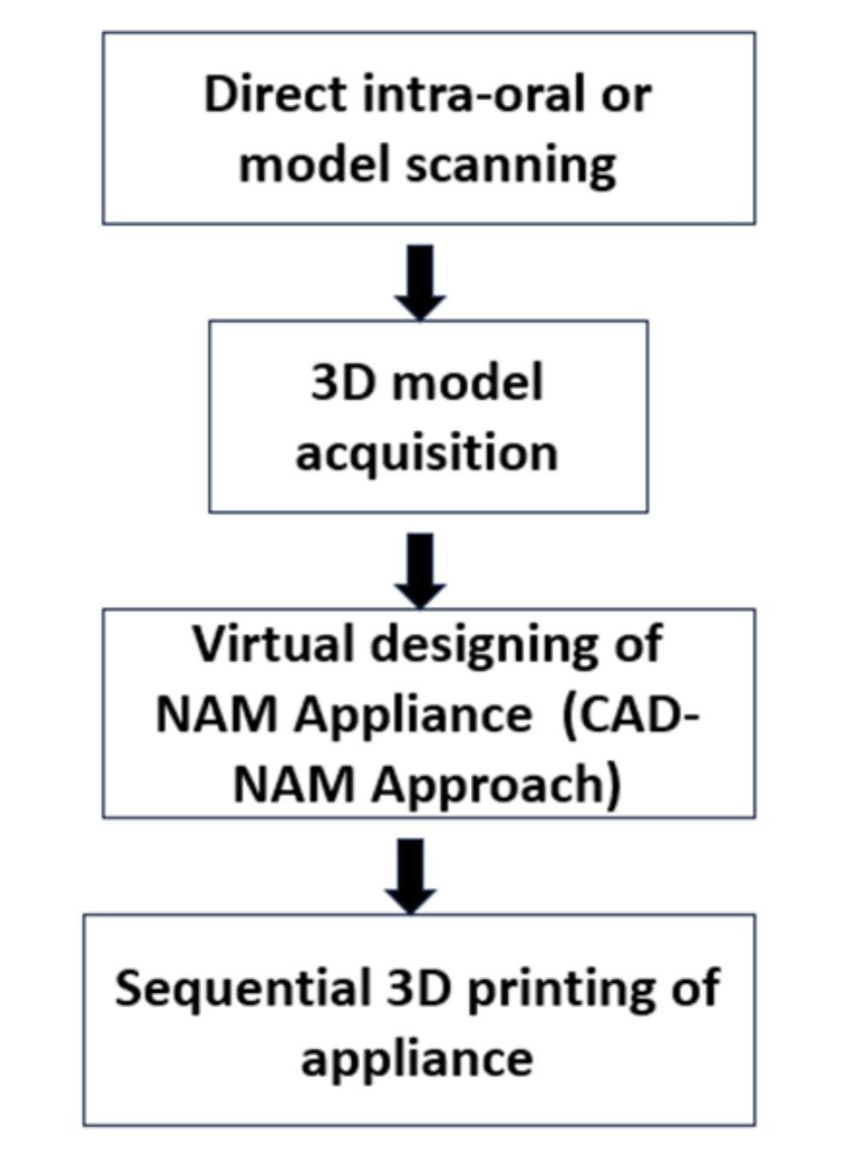

3D and 4D Bioprinting

3D bioprinting enables fabrication of highly precise, patient-specific scaffolds that replicate the complex geometry of alveolar and palatal defects. Integration of CAD and additive manufacturing allows controlled porosity, architecture, and mechanical strength, promoting osteogenesis and vascularization. Incorporation of stem cells and growth factors further enhances tissue regeneration, accelerates alveolar bone healing, and improves timing of orthodontic loading and eruption guidance.
4D bioprinting introduces dynamic, growth-responsive scaffolds capable of altering shape, stiffness, or bioactive molecule release in response to physiological stimuli. These smart materials accommodate craniofacial growth, reducing repeated interventions and supporting continuous orthodontic guidance. Additionally, in situ 4D printing during surgery improves anatomical adaptation, enhances vascularization, and enables localized molecular delivery, facilitating both bone and soft tissue integration essential for maintaining arch form, occlusal stability, and eruption timing.¹³’¹⁴

Tissue Engineering and Regenerative Medicine

Tissue engineering has emerged as a key approach in alveolar bone reconstruction in cleft lip and palate (CLP), with direct implications for orthodontic treatment. Biocompatible scaffolds derived from synthetic polymers (PLA, PCL) and natural materials (collagen, chitosan) support cellular infiltration, vascularization, and osteogenesis, enabling improved alveolar continuity and facilitating timely tooth eruption. ¹⁵
Mesenchymal stem cells (MSCs), sourced from bone marrow, adipose tissue, or dental pulp, further enhance bone regeneration when combined with these scaffolds, reducing dependence on autologous bone grafts. The addition of growth factors such as BMPs and VEGF accelerates osteoblastic activity and bone formation, improving alveolar ridge stability.¹⁵’¹⁶
These regenerative strategies collectively provide adequate bone volume for orthodontic space management, eruption guidance, and arch stabilization, thereby enhancing the predictability and outcomes of orthodontic interventions in CLP patients.

Nanotechnology and Targeted Delivery

Nanotechnology-based approaches offer precise, localized delivery of osteoinductive and angiogenic molecules (BMP-2, VEGF, FGF) to alveolar defects, promoting bone formation and ridge stability. Nanoparticle-mediated scaffolds and hydrogels enhance stem cell proliferation, osteogenesis, and soft tissue healing, which is particularly important for supporting orthodontic appliances and guiding eruption.¹⁷’¹⁸ Electrospun nanofiber scaffolds improve mucosal regeneration and reduce fibrosis, creating a more favorable environment for tooth movement and arch development.
Integration of nanotechnology with stem cells and tissue-engineered scaffolds allows personalized regenerative strategies, optimizing alveolar volume and shape for predictable orthodontic intervention while reducing post-operative complications.

Innovative Presurgical Orthopedic Approaches

Recent advancements in presurgical orthopedics focus on improving efficiency, accessibility, and patient compliance. Modified presurgical alveolar molding (PAM) appliances incorporating controlled force systems and extraoral elastics allow gradual approximation of cleft segments with improved precision and reduced treatment duration.

A study presents a rare and innovative clinical approach for managing a Tessier No. 0 craniofacial cleft, which typically involves the upper lip, nose, and palate. The authors describe the use of a modified Presurgical Alveolar Moulding (PAM) appliance as an alternative to conventional methods for approximating cleft segments prior to surgery.
Unlike standard PAM devices, this modified version featured reciprocal parts connected by a helix, with midline V-shaped stripping to allow gradual segment approximation. Extraoral elastics were employed to apply the necessary forces. Over 8 weeks, the anterior cleft gap reduced dramatically from 13 mm to 3 mm, marking a significant improvement in pre-surgical anatomy.
Importantly, at a 21-month follow-up, the reshaped alveolar segments remained stable, indicating long-term success of the oral moulding achieved. This method demonstrates how innovative appliance design can effectively reduce cleft severity preoperatively, potentially simplifying surgical closure and improving functional and aesthetic outcomes.²⁰

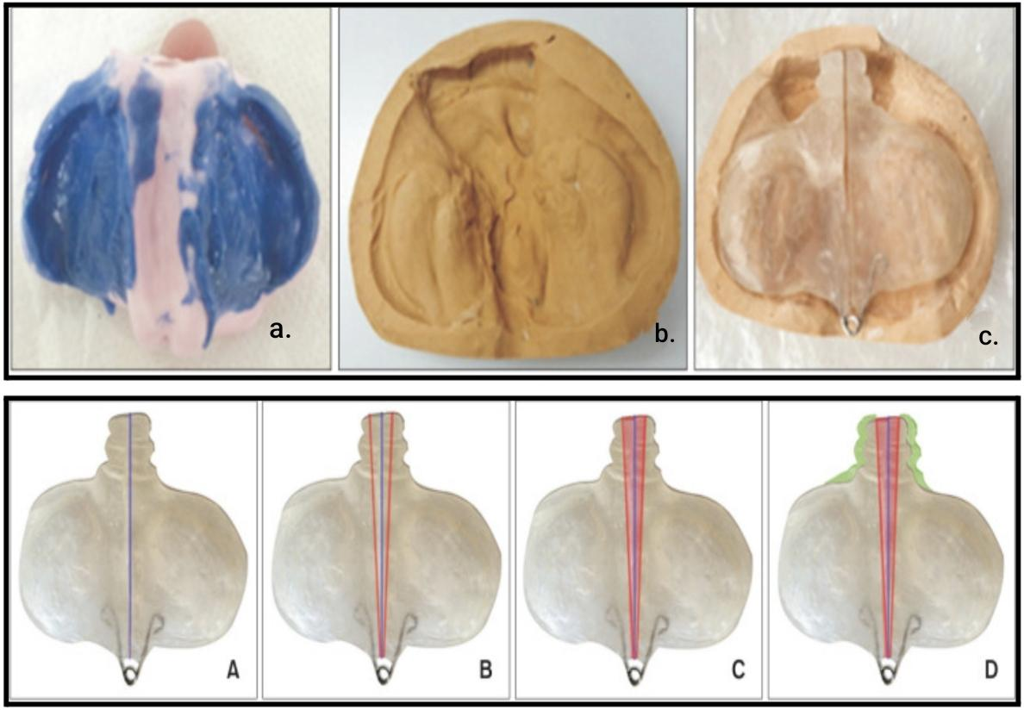

Fig 5. a. Polyvinyl siloxane impression of the infant’s maxilla, b. Stone cast, c. Modified presurgical alveolar molding appliance. A.Procedure of the modified presurgical alveolar molding (PAM) appliance. The purple line demonstrates that the PAM appliance consists of two reciprocal parts, B. The red line demonstrates the boundaries of the acrylic area to be stripped, C. The red area demonstrates the acrylic region that has been removed, D. The green area demonstrates the acrylic region where additions were made. ²⁰

Alternative approaches such as the DynaCleft system and nasal elevators provide less technique-sensitive options for nasal cartilage molding and alveolar alignment, particularly in resource-limited settings. These methods reduce the need for frequent adjustments and can be combined with telemonitoring for improved accessibility.
Collectively, these innovations contribute to better surgical outcomes by reducing cleft severity, improving nasal symmetry, and facilitating tension-free closure.

Emerging Surgical Approaches and Adjunctive Strategies

Advancements in surgical techniques in cleft care increasingly focus on functional reconstruction with minimal tissue trauma. Procedures such as functional cheiloplasty, refined palatoplasty, including techniques like Furlow Z-plasty, and precise muscle repositioning contribute to improved speech outcomes and reduced scar formation. The use of resorbable sutures and biomaterials has further minimized tissue damage compared to conventional methods. Additionally, while traditional alveolar bone grafting relied on autologous bone harvested from the iliac crest, current research is exploring stem cell–based and synthetic graft alternatives, aiming to eliminate donor-site morbidity and enhance long-term regenerative outcomes.

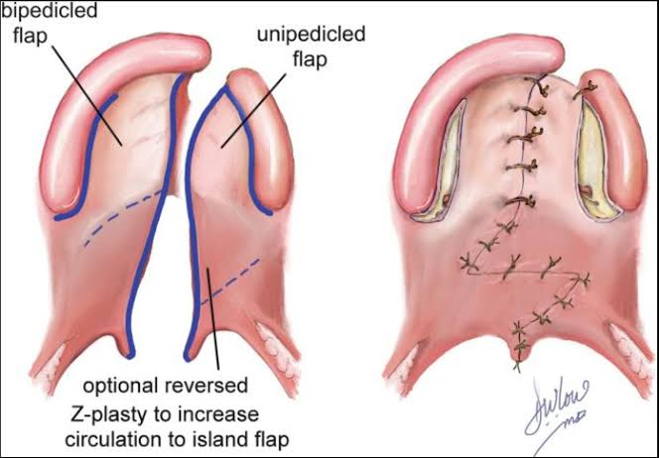
Fig 6. Cleft palate repair through Furlow double-opposing Z-plasty. ²¹

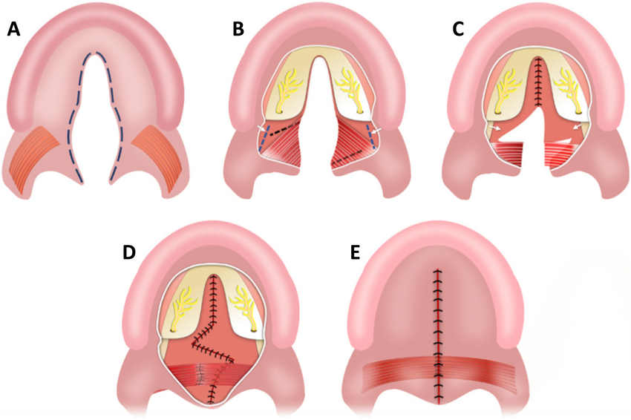
Fig 7. Sommerlad-Furlow modified technique: (A) An incision was made along the cleft margins to separate the oral and nasal mucosal layers. (B) A wide mucoperiosteal flap was elevated from the hard palate, with release of the greater palatine neurovascular pedicles, and a nasopharyngeal incision was made at the medial pterygoid plate using an electrotome. (C) The nasal mucoperiosteum was peeled anteriorly from the palatine bone and medially from the pterygoid plate toward the cranial base, followed by suturing of the nasal layer of the hard palate. Radical muscle dissection was done, and Z-plasty pflaps were designed on the nasal layer of the soft palate. (D) The nasal layer of the soft palate and palatal muscles were completely sutured. (E) Finally, the oral layer was closed without any relaxing incisions. ²²

Recent approaches also explore minimally invasive and growth-preserving interventions, aiming to reduce interference with maxillary development. The use of patient-specific surgical guides derived from 3D imaging enhances intraoperative precision.

Adjunctive strategies such as platelet-rich plasma (PRP) and platelet-rich fibrin (PRF) enhance bone and soft tissue regeneration during alveolar grafting, improving ridge volume for timely eruption of permanent teeth and predictable space maintenance.²³ Laser-assisted therapies improve soft tissue healing, reducing scarring and facilitating appliance placement. Hydrogel-based or nanomaterial-assisted grafting allows precise delivery of growth factors, accelerating bone regeneration and supporting orthodontic mechanics.²⁴
Such minimally invasive techniques maintain alveolar continuity, arch form, and tooth alignment, bridging regenerative innovations with orthodontic treatment. This integration enables more precise timing of orthodontic interventions, reduces the need for repeated interventions, and improves long-term functional and aesthetic outcomes for CLP patients.

Multidisciplinary and Holistic Care

Contemporary CLP management emphasizes a team-based approach involving orthodontists, surgeons, speech therapists, audiologists, and psychologists. This collaborative model ensures comprehensive care addressing functional, aesthetic, and psychosocial aspects.
Digital tools and telehealth platforms further enhance coordination, improve patient compliance, and support long-term follow-up.

Artificial Intelligence and Future Innovations

Artificial intelligence (AI) is rapidly transforming the landscape of cleft lip and palate (CLP) management by introducing data-driven precision into diagnosis, treatment planning, and long-term follow-up. Advanced machine learning algorithms can analyze large datasets from imaging modalities such as CBCT, 3D facial scans, and intraoral scans to enable early detection of cleft severity, prediction of craniofacial growth patterns, and assessment of treatment outcomes. AI-based tools are also being developed for automated landmark identification, orthodontic treatment simulation, and prediction of tooth eruption patterns, thereby enhancing clinical decision-making and reducing operator dependency.
In orthodontics, AI integration with digital workflows allows for personalized appliance design, optimized force systems, and improved treatment timing based on individual growth and regenerative responses. Additionally, AI-driven speech analysis systems are emerging as valuable tools for evaluating velopharyngeal function and monitoring post-surgical speech outcomes, offering objective and reproducible assessments.
Future innovations are expected to combine AI with regenerative medicine, including gene-modulated therapies, stem cell–based interventions, and smart biomaterials capable of responding to physiological stimuli. The integration of AI with genetic profiling may further enable risk prediction, early intervention strategies, and individualized treatment protocols. Moreover, advancements in fetal imaging and potential intrauterine interventions may open new avenues for early-stage correction and prevention.⁴⁸
Despite its promising potential, challenges such as data standardization, ethical considerations, algorithm transparency, and the need for high-quality clinical validation remain. Nevertheless, the incorporation of AI into multidisciplinary cleft care represents a significant step toward more predictive, personalized, and efficient management, ultimately improving both functional and aesthetic outcomes in CLP patients.

Future Scope and Limitations

Emerging regenerative approaches—including 4D bioprinting, stem cell–based therapies, smart biomaterials, and nanoparticle-mediated delivery systems—are rapidly transforming the landscape of cleft lip and palate management. These innovations have the potential to significantly enhance orthodontic outcomes by improving alveolar bone quality and stability, guiding physiologic tooth eruption, and maintaining dental arch integrity. By creating biologically active and patient-specific regenerative environments, these strategies may reduce the need for secondary interventions and improve long-term occlusal stability. Furthermore, the integration of artificial intelligence with advanced imaging modalities and genetic profiling is expected to enable highly personalized treatment planning, allowing orthodontists to optimize treatment timing, appliance selection, and biomechanical strategies based on individual growth patterns and regenerative responses.
Future research is likely to focus on the development of hybrid approaches that combine gene therapy with tissue-engineered scaffolds, aiming to modulate craniofacial development at a molecular level. The design of growth-adaptive and stimuli-responsive biomaterials, particularly for pediatric patients, may allow scaffolds to dynamically adjust to ongoing craniofacial growth, thereby minimizing the need for repeated surgical or orthodontic interventions. In addition, advancements in computational modeling and 3D imaging may enable accurate prediction of craniofacial growth, tooth eruption trajectories, and treatment outcomes, facilitating proactive and preventive orthodontic strategies. Enhanced scaffold vascularization, along with controlled and sustained delivery of growth factors, may further improve integration of both hard and soft tissues, leading to more stable and functionally effective results.
Despite these promising developments, several limitations currently hinder widespread clinical application. Most regenerative technologies are still in experimental or early clinical stages, with limited long-term evidence regarding alveolar bone stability, eruption patterns, periodontal health, and occlusal outcomes. High costs, complex fabrication processes, regulatory barriers, and ethical considerations associated with stem cells and gene-based therapies restrict accessibility and scalability. Additionally, biological variability among patients—including differences in genetic background, healing capacity, and growth patterns—may result in inconsistent clinical outcomes. The interaction between regenerated tissues and orthodontic forces also remains insufficiently understood, highlighting the need for well-designed clinical trials and standardized treatment protocols to ensure safety, predictability, and long-term success.
Nevertheless, the convergence of regenerative medicine, digital technology, and orthodontics represents a significant paradigm shift in cleft care. With continued research and technological refinement, these approaches hold the promise of delivering more precise, minimally invasive, growth-adaptive, and patient-specific treatment strategies, ultimately improving both functional rehabilitation and aesthetic outcomes in individuals with cleft lip and palate.

CONCLUSION

The approach to managing cleft lip and palate is steadily moving beyond conventional surgical correction toward a more precise, biologically oriented, and technology-driven model of care. Developments in tissue engineering, stem cell-based therapies, and scaffold design have significantly improved the potential for restoring alveolar bone continuity, which in turn supports more predictable tooth eruption and stable arch formation. At the same time, advancements in 3D and 4D bioprinting have made it possible to create patient-specific, adaptive constructs that respond to growth, thereby reducing the frequency of repeated surgical and orthodontic procedures.
In addition, the use of nanotechnology has enhanced targeted delivery of bioactive molecules, promoting controlled bone formation and improved soft tissue healing. Digital workflows and 3D printing have further optimized cleft care by enabling accurate presurgical orthopedics, efficient appliance fabrication, and detailed surgical planning, ultimately improving treatment precision and accessibility.
A notable emerging dimension is the role of artificial intelligence in cleft management. AI-based tools are increasingly being applied for early detection, treatment planning, and prediction of clinical outcomes, allowing clinicians to better understand craniofacial growth patterns and tailor interventions accordingly. This integration enhances clinical efficiency and supports more individualized treatment strategies.⁴⁸
From an orthodontic standpoint, these advancements allow improved control over eruption patterns, arch development, and occlusal relationships, leading to more stable functional and aesthetic results. Orthodontists now play a more proactive role, contributing not only to alignment but also to guiding developmental and regenerative processes.
However, despite these promising developments, challenges such as high costs, limited access to advanced technologies, ethical considerations, and insufficient long-term clinical data continue to restrict widespread implementation. Furthermore, variations in patient response and the interaction between regenerated tissues and orthodontic forces highlight the need for continued research and standardized treatment protocols.
Overall, the integration of regenerative approaches, digital innovations, and artificial intelligence is redefining cleft care into a more personalized, coordinated, and growth-responsive process. This evolving paradigm holds the potential to reduce treatment burden while improving long-term outcomes and quality of life for patients with cleft lip and palate.

References

- Brăila AD, Damian CM, Albu CC, Botoacă O, Dȋră LM, Albu ŞD, Brăila MG, Bănățeanu AM, Poalelungi CV, Bogdan-Andreescu CF. Prenatal Diagnosis of Cleft Lip and Palate: A Retrospective Study. J Clin Med. 2024 Aug 15;13(16):4804. doi: 10.3390/jcm13164804. PMID: 39200946; PMCID: PMC11355850.
- Lee MS, Cho JY, Kim SY, Kim SH, Park JS, Jun JK. Value of sagittal color Doppler ultrasonography as a supplementary tool in the differential diagnosis of fetal cleft lip and palate. Ultrasonography. 2017 Jan;36(1):53-59. doi: 10.14366/usg.16025. Epub 2016 Aug 6. PMID: 27764909; PMCID: PMC5207358.
- Baeza-Pagador A, Tejero-Martínez A, Salom-Alonso L, Camañes-Gonzalvo S, García-Sanz V, Paredes-Gallardo V. Diagnostic Methods for the Prenatal Detection of Cleft Lip and Palate: A Systematic Review. J Clin Med. 2024 Apr 3;13(7):2090. doi: 10.3390/jcm13072090. PMID: 38610855; PMCID: PMC11012824.
- Vibert, F., Schmidt, G., Löffler, K. et al. Accuracy of prenatal detection of facial clefts and relation between facial clefts, additional malformations and chromosomal abnormalities: a large referral-center cohort. Arch Gynecol Obstet 309, 1971–1980 (2024). doi.org/10.1007/s00404-023-07084-8
- Babai, A., & Irving, M. (2023). Orofacial Clefts: Genetics of Cleft Lip and Palate. Genes, 14(8),1603. doi.org/10.3390/genes14081603
- Iwaya, C., Suzuki, A., & Iwata, J. (2023). MicroRNAs and Gene Regulatory Networks Related to Cleft Lip and Palate. International Journal of Molecular Sciences, 24(4), 3552. doi.org/10.3390/ijms24043552
- Oliver JD, Jia S, Halpern LR, Graham EM, Turner EC, Colombo JS, Grainger DW, D'Souza RN. Innovative Molecular and Cellular Therapeutics in Cleft Palate Tissue Engineering. Tissue Eng Part B Rev. 2021 Jun;27(3):215-237. doi: 10.1089/ten.TEB.2020.0181. Epub 2020 Sep 28. PMID: 32873216; PMCID: PMC8349724.
- Dziedzic A, Kubina R, Skonieczna M, Madej M, Fiegler-Rudol J, Abid M, Nadhim D, Tanasiewicz M. CRISPR Genome Editing in Personalized Therapy for Oral and Maxillofacial Diseases: A Scoping Review. Biomedicines. 2025 Nov 10;13(11):2745. doi: 10.3390/biomedicines13112745. PMID: 41301838; PMCID: PMC12650159.
- Zarean, P., Zarean, P., Thieringer, F. M., Mueller, A. A., Kressmann, S., Erismann, M., Sharma, N., & Benitez, B. K. (2022). A Point-of-Care Digital Workflow for 3D Printed Passive Presurgical Orthopedic Plates in Cleft Care. Children, 9(8), 1261. doi.org/10.3390/children9081261
- Korn, Paula & von Strauwitz Né Ahlfeld, Tilman & Lahmeyer, Franziska & Kilian, David & Sembdner, Philipp & Stelzer, Ralph & Pradel, Winnie & Franke, Adrian & Rauner, Martina & Range, Ursula & Stadlinger, Bernd & Lode, Anja & Lauer, Günter & Gelinsky, Michael. (2020). 3D Printing of Bone Grafts for Cleft Alveolar Osteoplasty – In vivo Evaluation in a Preclinical Model. Frontiers in Bioengineering and Biotechnology. 8. 217. 10.3389/fbioe.2020.00217.
- Singh, Deepak & Tripathi, Tulika & Rai, Priyank. (2024). 3D nasoalveolar moulding: A complete digital workflow model. International Journal of Science and Research Archive. 11. 1713-1718. 10.30574/ijsra.2024.11.2.0665.
- Ergül T, Güleç A, Göymen M. The Use of 3D Printers in Orthodontics - A Narrative Review. Turk J Orthod. 2023 Jun 22;36(2):134-142. doi: 10.4274/TurkJOrthod.2022.2021.0074. PMID: 37346463; PMCID: PMC10318848.
- Brézulier D, Chaigneau L, Jeanne S, Lebullenger R. The Challenge of 3D Bioprinting of Composite Natural Polymers PLA/Bioglass: Trends and Benefits in Cleft Palate Surgery. Biomedicines. 2021 Oct 27;9(11):1553. doi: 10.3390/biomedicines9111553. PMID: 34829782; PMCID: PMC8615666.
- Luo D, Chen B and Chen Y (2022) Stem Cells-Loaded 3D-Printed Scaffolds for the Reconstruction of Alveolar Cleft. Front. Bioeng. Biotechnol. 10:939199. doi: 10.3389/fbioe.2022.939199
- Francisco, I., Paula, A. B., Oliveiros, B., Fernandes, M. H., Carrilho, E., Marto, C. M., & Vale, F. (2021). Regenerative Strategies in Cleft Palate: An Umbrella Review. Bioengineering, 8(6), 76. doi.org/10.3390/bioengineering8060076
- Ali, Y.H., El-Shazly, M., Taha, A., Ali, T., Bakri, S. (2022). Tissue Engineering Strategies in Cleft Palate. In: Fayyaz, G.Q. (eds) Surgical Atlas of Cleft Palate and Palatal Fistulae. Springer, Singapore. doi.org/10.1007/978-981-15-3889-6_127-1
- Matić, A., Sher, E.K., Farhat, E.K. et al. Nanostructured Materials for Drug Delivery and Tissue Engineering Applications. Mol Biotechnol (2023). https://doi.org/10.1007/s12033-023-00784-1
- Li Y, Xu C, Lei C. The Delivery and Activation of Growth Factors Using Nanomaterials for Bone Repair. Pharmaceutics. 2023 Mar 22;15(3):1017. doi: 10.3390/pharmaceutics15031017. PMID: 36986877; PMCID: PMC10052849.
- Funda G, Taschieri S, Bruno GA, Grecchi E, Paolo S, Girolamo D, Del Fabbro M. Nanotechnology Scaffolds for Alveolar Bone Regeneration. Materials (Basel). 2020 Jan 3;13(1):201. doi: 10.3390/ma13010201. PMID: 31947750; PMCID: PMC6982209.
- Gonca M, Ozel MB. A modified presurgical alveolar molding technique for treatment of cleft in Down syndrome. Korean J Orthod. 2021 Nov 25;51(6):428-434. doi: 10.4041/kjod.2021.51.6.428. PMID: 34803031; PMCID: PMC8607116.
- Birgfeld C, Obiri-Yeboah S. Cleft Palate repair: Double-Opposing Z-plasty Technique. Global Cleft Care Low Res Sett. 2021;3:189-9
- Elayah, Sadam & Yin, Jiayi & Al-gumaei, Waseem & Younis, Hamza & Sakran, Karim & Tang, Ziwei & Mashrah, Mubarak & Paka Lubamba, Grace & Wu, Min & Li, Yang & Shi, Bing. (2023). A comparison of maxillofacial growth in Chinese children with isolated cleft palate treated with two different palatoplasty techniques without relaxing incisions: a preliminary study. BMC Oral Health. 23. 10.1186/s12903-023-03588-6.
- Eslami N, Heidarian Miri H, Rastegar M, Sabzevari B. Effect of Platelet-rich Plasma on the Clinical Success of Alveolar Grafts in Patients With Cleft Lip and Palate: A Systematic Review and Meta-Analysis. J Craniofac Surg. 2023 Jun 1;34(4):1246-1251. doi: 10.1097/SCS.0000000000009315. Epub 2023 May 9. PMID: 37157129.
- Sun Y, Li Z, Qi X, Wang B, Yu N, Huang J, Ting W, Long X. Laser therapy for treating cleft lip or/and palate scarring-a systematic review and meta-analysis. Lasers Med Sci. 2024 Jun 20;39(1):160. doi: 10.1007/s10103-024-04082-3. PMID: 38902432; PMCID: PMC11189991.
- Zhou Y, Suzuki Y, Uchida K, Tominaga M. Identification of a splice variant of mouse TRPA1 that regulates TRPA1 activity. Nat Commun. 2013;4:2399. doi: 10.1038/ncomms3399. Erratum in: Nat Commun. 2018 Mar 29;9:16205. doi: 10.1038/ncomms16205. PMID: 24008932; PMCID: PMC5882232.
- Thierry M, Chatet A, Fournier E, Tharreau D, Ioos R. A PCR, qPCR, and LAMP Toolkit for the Detection of the Wheat Blast Pathogen in Seeds. Plants (Basel). 2020 Feb 21;9(2):277. doi: 10.3390/plants9020277. PMID: 32098075; PMCID: PMC7076445.
- Gonseth, S.; Shaw, G.; Roy, R.; Segal, M.; Asrani, K.; Rine, J.; Wiemels, J.; Marini, N. Epigenomic profiling of newborns with isolated orofacial clefts reveals widespread DNA methylation changes and implicates metastable epiallele regions in disease risk. Epigenetics 2019, 14, 198–213.
- Stavast, C.J.; Erkeland, S.J. The Non-Canonical Aspects of MicroRNAs: Many Roads to Gene Regulation. Cells 2019, 8, 1465.
- Wu X, Lu Y, Duan X, Zhang D, Deng W. Design and DOF Analysis of a Novel Compliant Parallel Mechanism for Large Load. Sensors (Basel). 2019 Feb 17;19(4):828. doi: 10.3390/s19040828. PMID: 30781589; PMCID: PMC6413144.
- Huang CH, Hsieh CY, Wang CW, Tu HP, Chen SC, Hung CH, Kuo CH. Associations and Interactions between Heavy Metals with White Blood Cell and Eosinophil Count. Int J Med Sci. 2022 Jan 9;19(2):331-337. doi: 10.7150/ijms.68945. PMID: 35165518; PMCID: PMC8795800.
- Li N, Liu X, Zhang P, Qiao M, Li H, Li X. et al. The effects of early life lead exposure on the expression of interleukin (IL) 1β, IL-6, and glial fibrillary acidic protein in the hippocampus of mouse pups. Hum Exp Toxicol. 2015;34:357–63. doi: 10.1177/0960327114529451
- Bitter K. Latham's appliance for presurgical repositioning of the protruded premaxilla in bilateral cleft lip and palate. J Craniomaxillofac Surg. 1992 Apr;20(3):99-110. doi: 10.1016/s1010-5182(05)80091-5. PMID: 1613111.
- Kalaskar R, Bhaje P, Balasubramanian S, Kalaskar A. Effectiveness of the novel impression tray "cleftray" for infants with cleft lip and palate: a randomized controlled clinical trial. J Korean Assoc Oral Maxillofac Surg. 2021 Apr 30;47(2):82-90. doi: 10.5125/jkaoms.2021.47.2.82. PMID: 33911040; PMCID: PMC8084743.
- Gunjan Kaushik, Gaurav Jasoria, Rahul Jeswani, Prateek Bhushan, Kaushal Gangil. Latham’s appliance: a comprehensive review.TMU J Dent 2020;7(4) 22-26.
- Efficacy of the maxillary anterior segmental distraction osteogenesis in patients with cleft lip and palate Panjun Pu, Shanying Bao, Yalin Zhan, Gonca M, Ozel MB. A modified presurgical alveolar molding technique for treatment of cleft in Down syndrome. Korean J Orthod. 2021 Nov 25;51(6):428-434.
- Almarshadi R, Hamdi S, Hadi F, Alshehri A, Alsahafi R, Aljohani N, Alyamani R, Alhbchi M, Alqahtani N, Almutiri R, Alqadi T, Alhabardi A, Abu Aziz K, Alshammeri T. Redefining Digital Dentistry: Multidisciplinary Applications of 3D Printing for Personalized Dental Care. Cureus. 2025 Jun 26;17(6):e86791. doi: 10.7759/cureus.86791. PMID: 40718273; PMCID: PMC12296917.
- Bühling S, Stuhlfelder J, Xandt H, Eslami S, Seifert LB, Sader R, Kopp S, Plein N, Sayahpour B. The Impact of Integrating 3D-Printed Phantom Heads of Newborns with Cleft Lip and Palate into an Undergraduate Orthodontic Curriculum: A Comparison of Learning Outcomes and Student Perception. Dent J (Basel). 2025 Jul 16;13(7):323. doi: 10.3390/dj13070323. PMID: 40710168; PMCID: PMC12293818.
- Jar, Alabbas & Alotaibi, Adel & Alqahtani, Hussain & Alshaqaqeq, Ghaida & Alandanoosi, Hosam & Alsulami, Sultan & Alosaimi, Latifa & Alyahya, Awatef & Alsulami, Musab & Almohammadi, Abdulrhman & Aljaghthami, Saud. (2023). Breastfeeding in children with cleft lip and palate and its effect on surgical outcomes. International Journal Of Community Medicine And Public Health. 10. 10.18203/2394-6040.ijcmph20233522.
- Elayah, S.A., Yin, J., Al-Gumaei, W.S. et al. A comparison of maxillofacial growth in Chinese children with isolated cleft palate treated with two different palatoplasty techniques without relaxing incisions: a preliminary study. BMC Oral Health 23, 914 (2023). doi.org/10.1186/s12903-023-03588-6
- Pitkanen, Veera V. PhD, MD*; Geneid, Ahmed PhD, MD†; Saarikko, Anne M. PhD, MD*; Hakli, Sanna PhD, MD‡; Alaluusua, Suvi A. PhD, MA*. Diagnosing and Managing Velopharyngeal Insufficiency in Patients With Cleft Palate After Primary Palatoplasty. The Journal of Craniofacial Surgery 36(3):p 1008-1016, May 2025. | DOI: 10.1097/SCS.0000000000009822
- Peter D. Witt, D’Antonio. Velopharyngeal insufficiency and secondary palatal management. Clinics in plastic surgery. 1993. Oct;20(4):707-21.
- Sweeney, T., & Sell, D. (2008). Relationship between perceptual ratings of nasality and nasometry in children/adolescents with cleft palate and/or velopharyngeal dysfunction. International Journal of Language and Communication Disorders, 43(3), 265–282.
- Hariri, F., Yoong Chin, S., Rengarajoo, J., Chao Foo, Q., Nur Nabihah Zainul Abidin, S., & Fadhli Ahmad Badruddin, A. (2019). Distraction Osteogenesis in Oral and Craniomaxillofacial Reconstructive Surgery. In Osteogenesis and Bone Regeneration. IntechOpen. doi.org/10.5772/intechopen.81055
- Aycart MA, Caterson EJ. Advances in Cleft Lip and Palate Surgery. Medicina (Kaunas). 2023 Nov 1;59(11):1932. doi: 10.3390/medicina59111932. PMID: 38003981; PMCID: PMC10672985.
- Gamble C, Persson C, Willadsen E, et al. Timing of Primary Surgery for Cleft Palate. New England Journal of Medicine. 2023;389(9):795–807.
- Stein MJ, Zhang Z, Fell M, Mercer N, Malic C. Determining postoperative outcomes after cleft palate repair: A systematic review and meta-analysis. Journal of Plastic, Reconstructive & Aesthetic Surgery. 2019;72(1):85–91.
- Naidu, Priyanka MBChB, MS*,†; Plonkowski, Alexander T. MBBS, MRes*,‡; Yao, Caroline A. MD, MS*,†; Magee, William P. III MD, DDS*,†,‡. Evolution of Cleft Lip and Palate Surgery and the Pursuit for Consensus on Standardized Algorithms of Care. Plastic & Reconstructive Surgery-Global Open 13(3):p e6643, March 2025. | DOI: 10.1097/GOX.0000000000006643
- Nguyen TM, Huynh UNT, Vo TTT, Wu YC, Tseng CF, Lee IT. Artificial intelligence applications in the diagnosis and management of cleft lip and palate: An updated review. Journal of Dental Sciences. 2026;21(1):22–30. doi:10.1016/j.jds.2025.09.014
- J.H. Ha, H. Lee, S.M. Kwon, et al. Deep learning-based diagnostic system for velopharyngeal insufficiency based on videofluoroscopy in patients with repaired cleft palates. J Craniofac Surg, 34 (2023), pp. 2369-2375
- Mann, R.J.; Fisher, D.M. Bilateral buccal ﬂaps with double opposing Z-plasty for wider palatal clefts. Plast. Reconstr. Surg.1997,100, 1139–1143

