Case report
ENDOCROWNS: A PARADIGM SHIFT IN POST-ENDODONTIC REHABILITATION-A CASE REPORT

Abstract
Ever since restorative dentistry began evolving, the ideal way to rehabilitate an endodontically treated tooth has remained both widely debated and clinically challenging. Coronal restoration of such teeth demands a careful balance between minimally invasive preparation and ensuring adequate retention and stability. With advancements in adhesive systems, the reliance on intraradicular anchorage and conventional post-and-core systems has significantly diminished.
The endocrown has emerged as a contemporary restorative solution for endodontically treated teeth, offering a reliable alternative to traditional post-core and full-coverage restorations. This innovative concept enhances retention and stability of the indirect restoration without requiring a cast metal core or intracanal post, thereby simplifying the procedure and reducing chairside time. As a result, endocrowns have gained recognition as a promising and efficient option for achieving both functional strength and esthetic excellence in the rehabilitation of endodontically treated teeth.¹
Introduction
Post-endodontic restoration aims to preserve and protect the remaining tooth structure while effectively restoring esthetics, anatomical form, and functional integrity. Contemporary restorative philosophy emphasizes minimally invasive preparation designs that maximize conservation of sound dental tissues. Preserving residual tooth structure enhances the mechanical stability of the tooth–restoration complex and increases the available surface area for adhesive bonding, thereby improving long-term prognosis.²
The selection of an appropriate restorative modality depends primarily on the remaining structural integrity of the tooth, the magnitude of functional loading, and esthetic requirements. In this context, the endocrown has emerged as a conservative and clinically effective alternative to the conventional post-and-core supported full-coverage crown, particularly in endodontically treated teeth with reduced clinical crown height but adequate coronal tissue for adhesive retention. By utilizing the pulp chamber for macro-mechanical retention and adhesive bonding for micro-mechanical stabilization, the endocrown design reduces the need for radicular post placement and preserves radicular dentin.³
Case Report :
Case 1:
A 21-year-old male patient, Joshua, reported to the Department of Conservative Dentistry and Endodontics with a chief complaint of pain in the lower left back tooth region since two weeks. The pain was sudden in onset, aggravated on chewing, and relieved upon taking medication. Clinical examination revealed deep Class I caries with buccal surface involvement with respect to tooth 36. (fig 1)
The radiographic examination of the tooth 36 revealed radiolucency involving enamel, dentin and pulp with an immature open apex in relation to the distal root. There was also associated periapical changes suggestive of apical periodontitis (fig 2). The patient was diagnosed with symptomatic irreversible pulpitis with apical periodontitis in relation to tooth 36.
Given the dental history and the open root apex, a biodentine apexification procedure was chosen for distal root of tooth 36, followed by conventional root canal treatment. An Endo access bur (Mani burs) was used to create an access opening under rubber dam isolation and local anesthesia with 2% lidocaine containing 1:100,000 epinephrine.(fig 3) A No. 15 K file was employed to achieve apical patency, with the working length measured using an apex locator (Root ZX Mini, J. Morita, Saitama, Japan) and confirmed radiographically (fig 4 ). Cleaning and shaping were accomplished with hand K-files (Mani, New Delhi, India) and ProTaper Universal rotary files (Dentsply Maillefer). The canals were irrigated with 3% sodium hypochlorite (Hyposol; PrevestDenPro, Jammu, India), 17% EDTA (Neoedta; Orikam, Gurgaon, India), and saline, followed by drying with sterile paper points. After two weeks of calcium hydroxide medication (RC Cal; Prime Dental, Thane, India), the root canal was disinfected using 3% sodium hypochlorite. Following the manufacturer’s guidelines, Bio dentine was mixed and delivered apically using a carrier, ensuring 3-4 mm of bio dentine placement in the distal root(fig 5). Radiographic verification confirmed proper placement. This was followed by obturation using lateral condensation method .(fig 6)
Following successful endodontic therapy, the gutta-percha was removed up to 2 mm below the level of each orifice, followed by complete sealing of the coronal orifices and the pulp chamber (2 mm thick) with glass ionomer (Type II) restorative cement (GC corporation Tokyo, Japan) .Preparation included occlusal reduction of approximately 2 mm, butt joint margin preparation,preservation of peripheral enamel and utilization of the pulp chamber for internal retention(fig 7).A putty impression was made, and the endocrown was processed in the laboratory(fig 8) . In the subsequent appointment, following the evaluation of final fit of fabricated ZrO2-based ceramic endocrown in 47(fig 9), final cementation was done with self-adhesive resin composite (Variolink N Dual-cure, Ivoclar Vivadent, Liechtenstein) under adequate isolation control.The final restoration demonstrated satisfactory marginal adaptation and occlusal harmony(fig 10). The patient was then reviewed after 3 months (fig 10a).

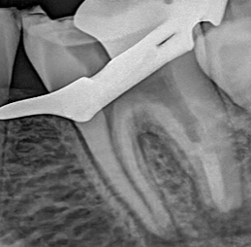
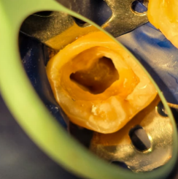
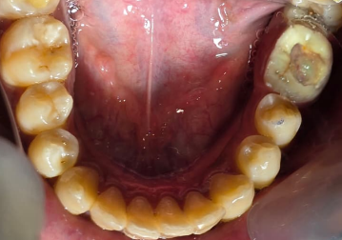

Fig 5
Fig 3
Fig 1
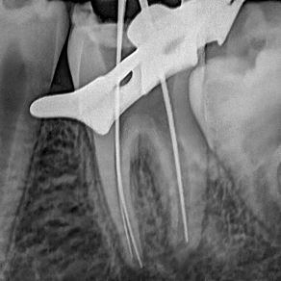
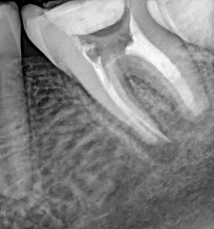
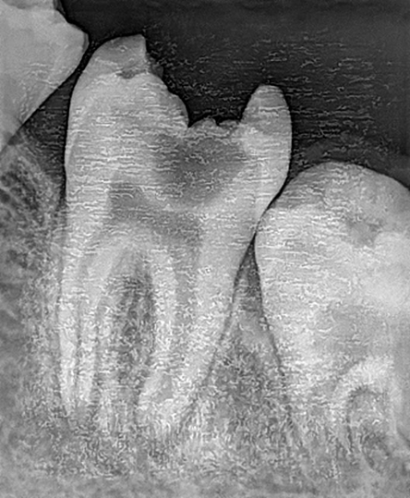

Fig 4
Fig 6
Fig 2

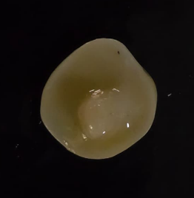
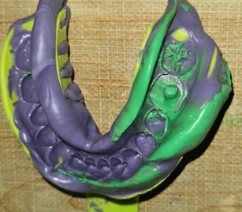
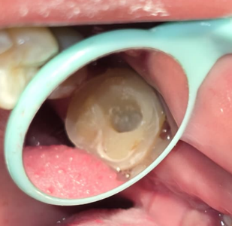

Fig 8 888288
Fig 9
Fig 7
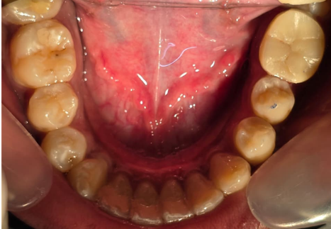

Fig 10

Fig 1and 2 -Preoperative clinical photo and radiograph Fig 3- access opening Fig 4-working length determination Fig 5-MTA apical plug Fig 6-Obturation Fig 7-Endocrown preparartion Fig 8-Putty impression Fig 9-Endocrown fabricated in lab Fig 10- Post operative clinical photographs and radiographs
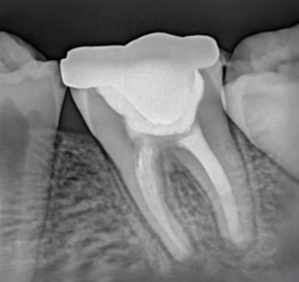

Fig 10a: State After 3 months

CASE REPORT 2
A 28-year-old male patient reported to the Department of Conservative Dentistry and Endodontics with a chief complaint of severe nocturnal pain in the lower right back tooth region since 2 weeks. Clinically, a fractured restoration with secondary caries wrt 47 was noted was noted. Following clinical and radiographical examination, a diagnosis of symptomatic irreversible pulpitis with apical periodontitis was made and root canal therapy was initiated wrt 47. Based on the amount of remaining tooth structure and thickness of the walls, a post endodontic restoration of zirconia endocrown was decided. 2M2 shade was chosen, and the preparation and cementation procedure was performed similar to the earlier case report.

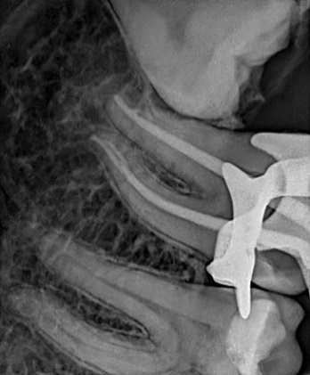
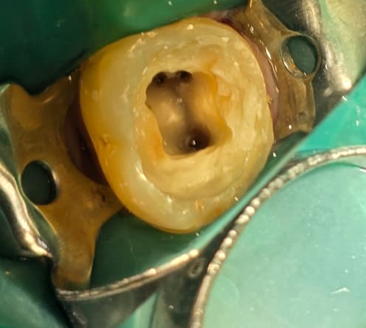
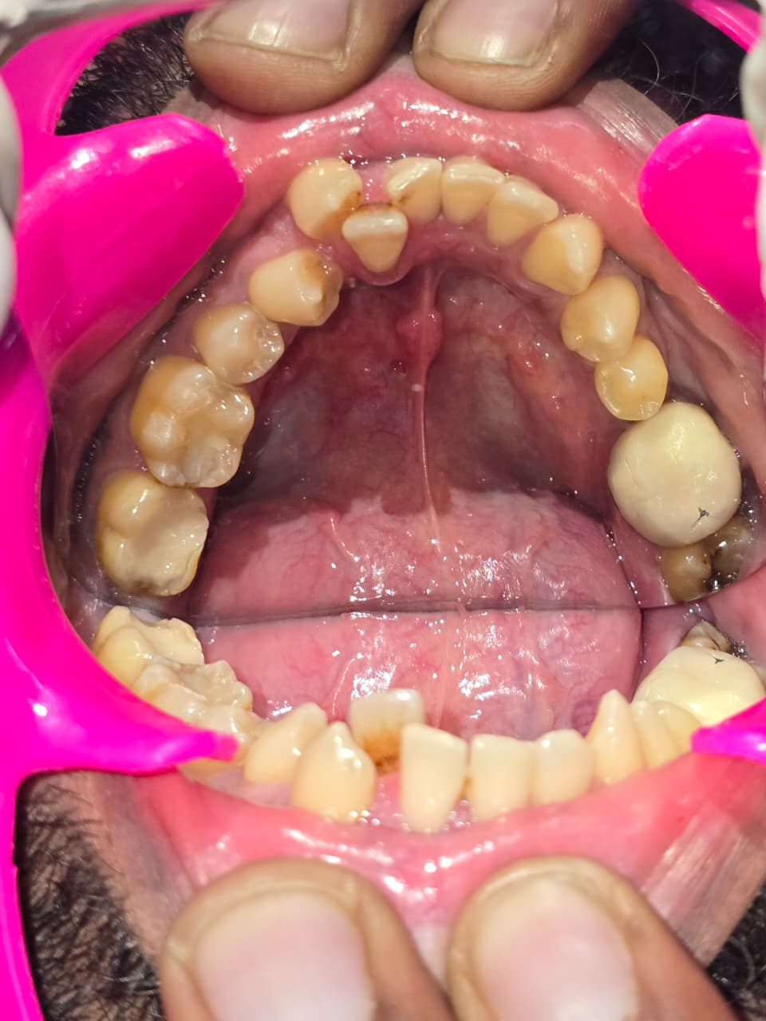

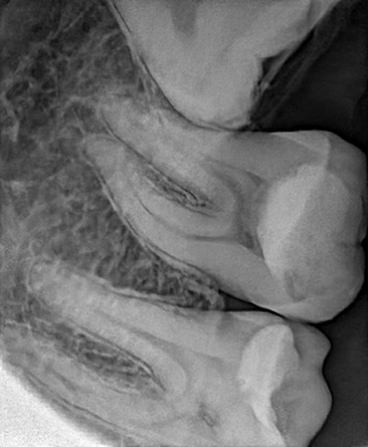
Fig 13

Fig 11
Fig 15

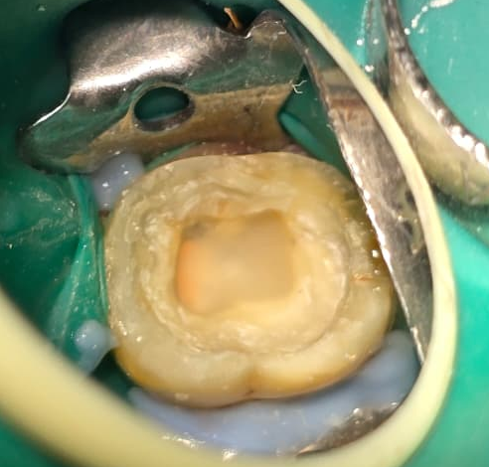
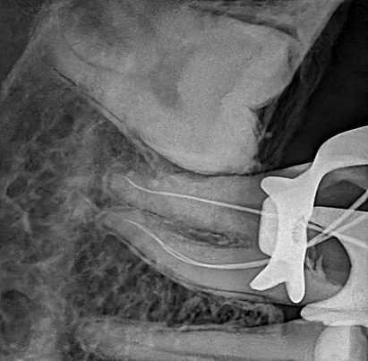

Fig 16

Fig 14

Fig 12

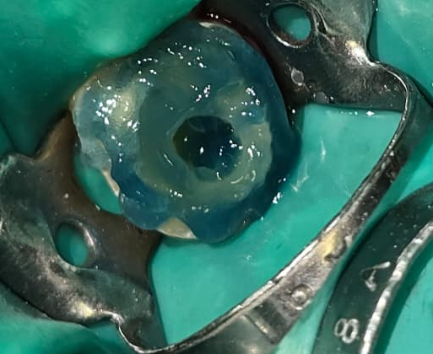
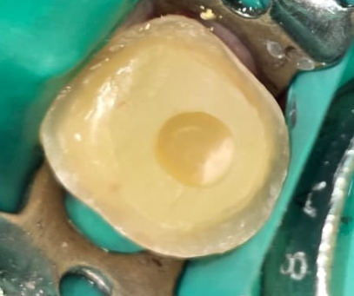
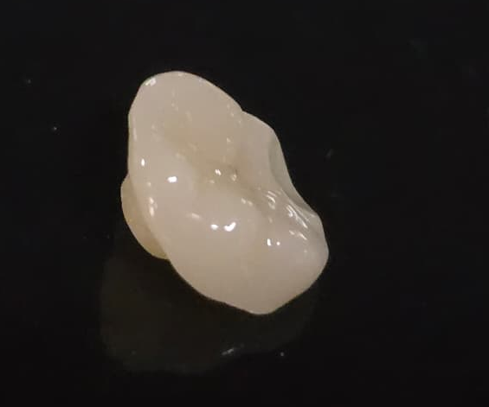

Fig 18

Fig 17

Fig 19

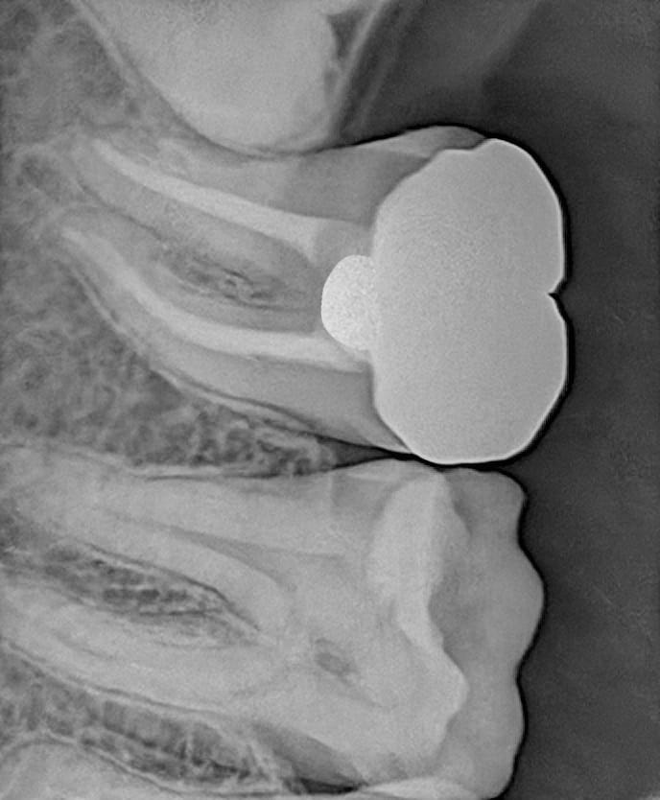
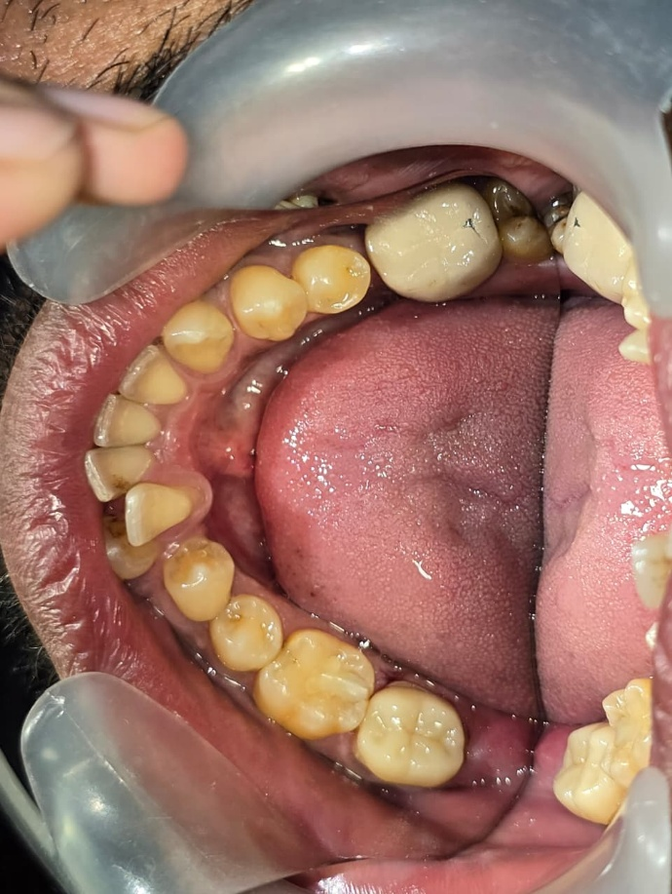

Fig 20

Fig 21 :PPost operative

Fig 11and 12 -Preoperative clinical photo and readiograph Fig 13- access opening Fig 14-working length determination Fig 15-Obturation Fig 16-GIC orifice barrier Fig 17-Endocrown preparartion Fig 18-Etching Fig 19-Endocrown fabricated in lab Fig 20- Post operative clinical photographs Fig 21 - Post operative radiographs

Discussion
In the contemporary era of adhesive dentistry, the endocrown has emerged as a conservative, practical, and reliable alternative to traditional post-and-core restorations. Designed for endodontically treated posterior teeth, the endocrown derives retention from the internal walls of the pulp chamber and the cavity margins. This design provides macromechanical retention through engagement of the pulpal walls, while micromechanical retention is achieved via adhesive cementation. Furthermore, the technique is relatively straightforward, requires reduced chairside time, and is generally well accepted by patients, making it an advantageous option among available restorative modalities. Clinical studies have reported high success rates with endocrowns, and the restorative concept has been described as both simple and clinically feasible, as noted by Bindl et al.³
Additionally, a two-year clinical evaluation conducted by Bernhart et al.concluded that endocrowns represent a highly promising restorative alternative for endodontically treated molars, demonstrating favorable functional and clinical performance.⁴The endocrown technique is considered simple, clinically advantageous, and protective of the surrounding periodontal tissues. Ceramic materials used for endocrowns offer additional benefits, as they possess a wear coefficient similar to that of natural enamel, along with excellent biocompatibility and biomimetic properties.
In posterior teeth, particularly molars, compressive forces predominate during mastication. Therefore, it is essential to design a preparation with a broad and stable surface capable of effectively resisting these stresses.Preparing the pulpal floor parallel to the occlusal plane enhances stress distribution along the long axis of the tooth, thereby improving resistance to functional loading.⁴Compared to conventional prosthetic crowns, which may concentrate higher stress levels within the restored structure, endocrowns demonstrate more favorable stress distribution patterns, contributing to their biomechanical advantage.⁵Thus, Zirconia endocrown is a reliable option for the restoration of root canal-treated posterior teeth. Long-term follow-up and longitudinal clinical studies are required to study their long-term success.⁶
Conclusion
Endocrowns represent a simple, conservative, and clinically effective restorative option for posterior teeth exhibiting extensive coronal destruction. This restorative approach adheres to the principles of minimally invasive dentistry by preserving maximum sound tooth structure and eliminating the need for intraradicular post placement. Compared to conventional post-and-core supported crowns, endocrowns require less chairside time, reduced clinical steps, and are generally more cost-effective, while still providing excellent functional and esthetic outcomes.
Additionally, the preparation design of endocrowns typically allows for supragingival margins, which contributes to better periodontal health. By avoiding subgingival margin placement, the restoration minimizes irritation to the surrounding soft tissues, facilitates oral hygiene maintenance, and reduces the risk of periodontal complications. Consequently, endocrowns not only restore structural integrity and esthetics but also support long-term biological and periodontal preservation.⁷

References

1.Endocrown – A Paradigm Shift in Rehabilitation: A Report of Two Cases
Rahul Gupta ^{1,✉}, Sophia Thakur ¹, Nitish Kumar Pandey ¹, B Roopa ¹, K T Fares

2.Endocrown-A Unique Way of Retention-Case Report B. Sunil Rao1 , Siddhesh Bandekar1 , Shirin Kshirsagar1 and Shah Naman Journal of Advances in Medicine and Medical Research 22(3): 1-5, 2017
3.Bindl A, Mörmann WH. Clinical evaluation of adhesively placed Cerec endocrowns after 2 years – preliminary results. J Adhes Dent. 1999;1(3):255–265.
4..Endocrown: An Approach Towards Management of Endodontically Treated Teeth - A Case Report Shanvi Agrawal Seema Sathe Kambala Dipak Manohar Shinde Surekha Godbole Dubey
5.“ENDOCROWN”—An Effective Viable Esthetic Option for Expurgated Endodontically treated Teeth: Two Case Reports 1 Selvanathan MJ Vinola, 2 Saravanakarthikeyan Balasubramanian, 3 Sekar Mahalaxmi
6. Endocrown restorations for extensively damaged posterior teeth: clinical performance of three casesKonstantinos Tzimas, Maria Tsiafitsa, Paris Gerasimou, Effrosyni Tsitrou
7. Restoration of Severely Damaged Tooth by Zirconia based Endocrown: Case Series Huong CQ,1 Duc NM,2 Hai TD3
8..Endocrown: A Minimal Intervention Approach for Grossly Decayed Teeth Mohsin Kamaal, Shrishti Shukla, Deepak Raisinghani, Ashwini B Prasad, Anubha Sejra, Rahul Chaudhari
9 Rocca GT, Krejci I. Crown and post-free adhesive restorations for endodontically treated posterior teeth: From direct composite to endocrowns. Eur J Esthet Dent. 2013;8(2):156–179.
10.Ferrari M, Vichi A, Fadda GM, Cagidiaco MC, Tay FR, Breschi L, et al. A randomized controlled trial of endodontically treated and restored premolars. J Dent Res. 2012;91(7 Suppl):72S–78S.
11. Biacchi GR, Basting RT. Comparison of fracture strength of endocrowns and glass fiber post-retained conventional crowns. Oper Dent. 2012;37(2):130–136.
- Belleflamme MM, Geerts SO, Louwette MM, Grenade CF, Vanheusden AJ, Mainjot AK. No post-no core approach to restore severely damaged posterior teeth: An up to 10-year retrospective study of documented endocrown cases. J Dent. 2017;63:1–7.
- Sedrez-Porto JA, da Rosa WL, da Silva AF, Münchow EA, Pereira-Cenci T. Endocrown restorations: A systematic review and meta-analysis. J Dent. 2016;52:8–14

