PREDICTORS OF ELEVATED TOTAL CHOLESTEROL AMONG HYPERTENSIVE PATIENTS IN EDO STATE, NIGERIA

ABSTRACT
Aims: To identify specific predictors of elevated Total Cholesterol (TC) among hypertensive patients in Edo State, Nigeria, to inform targeted cardiovascular intervention strategies.
Study Design: Retrospective hospital-based cross-sectional study.
Place and Duration of Study: Medical Outpatient Clinic (MOPC), University of Benin Teaching Hospital (UBTH), Benin City, Edo State, Nigeria.
Methodology: A total of 826 medical records of adult hypertensive patients were reviewed. Elevated TC was defined as ≥200 mg/dL. Data on sociodemographics, anthropometrics, and clinical parameters were extracted. Descriptive statistics and multiple binary logistic regression (Enter method) were used to identify independent predictors, reporting Adjusted Odds Ratios (AOR) and 95% Confidence Intervals.
Results: The prevalence of elevated TC was 38.4% (n = 317). No formal education (AOR = 2.501, P < .001), female sex (AOR = 1.562, P = .015), and increasing age (AOR = 1.015 per year, P = .015) significantly increased the odds of elevated TC. Being married was protective (AOR = 0.309, P < .001). Decreased eGFR (<60 mL/min) was a strong predictor (AOR = 2.245, P < .001), as was increased weight (AOR = 1.026 per kg, P = .025). Impaired glucose tolerance was associated with lower odds of elevated TC (AOR = 0.532, P = .008), likely reflecting active anti-lipid therapy in this high-risk group.
Conclusion: The high prevalence of elevated TC among hypertensive patients in Edo State necessitates aggressive clinical management. Targeted interventions should prioritise female, older, and obese patients alongside robust public health campaigns aimed at those with low educational attainment and stringent lipid management for patients with concurrent chronic kidney disease.
Keywords: Atherosclerosis, Cholesterol, Dyslipidaemia, Edo State, Hypertension
INTRODUCTION
Cardiovascular Diseases (CVDs) remain the leading cause of mortality worldwide, and two of the most significant modifiable risk factors contributing to this global burden are hypertension and dyslipidaemia, particularly elevated Total Cholesterol (TC).(Kjeldsen, 2018; Murphy et al., 2017; World Health Organization, 2026) According to the World Heart Federation, the prevalence of high total cholesterol (defined as >5.18 mmol/L or 200 mg/dL) affects approximately 39% of adults worldwide, accounting for an estimated 4.4 million deaths annually.(Murphy et al., 2017) The coexistence of hypertension and dyslipidaemia has a synergistic effect, geometrically heightening the risk of atherosclerotic events such as myocardial infarction and stroke.(Dąbrowska & Narkiewicz, 2023; Shafee & Kumar, 2021) A global study found that approximately 38% of outpatients with established vascular disease or three cardiovascular risk factors had elevated total cholesterol, a proportion associated with country-level economic development and health system performance.(Venkitachalam et al., 2012)
The burden of non-communicable diseases is rapidly shifting to low- and middle-income countries, with Sub-Saharan Africa bearing a disproportionately high share. The pooled crude prevalence of hypertension in Africa is estimated at 28.5 per 100 persons, a figure projected to increase dramatically due to rapid urbanization, ageing populations, and the adoption of unhealthy, Westernized lifestyles.(Jobe et al., 2025; Olowoyo et al., 2025) The prevalence of high TC among the general African population is estimated at 25.5%, signaling an epidemiological transition where CVDs are expected to surpass infectious diseases as the primary cause of death in the region by 2030.(Noubiap et al., 2018; Yuyun et al., 2020)
In Nigeria, the most populous black nation, the prevalence of hypertension ranges from 11% to 40% across different studies.(Adeloye et al., 2021; Nwankwo et al., 2026; Odili et al., 2020) Studies focusing on Nigerian hypertensive patients reveal a significant prevalence of dyslipidaemia, with elevated TC reported as high as 43.4% and even 90% in some cohorts.(Akintunde et al., 2010; Galtimari et al., 2025; Onyegbutulem et al., 2021) Notably, female hypertensive patients in Edo State have been observed to have significantly higher mean total cholesterol levels compared to their male counterparts.(Idemudia, 2014)
Understanding the modifiable and non-modifiable factors that predispose hypertensive patients to hypercholesterolaemia is critical for effective risk stratification and management. Common predictors of dyslipidaemia identified in Nigerian hypertensive populations include female sex, obesity, and socioeconomic status. This study aims to investigate the specific predictors of elevated Total Cholesterol among hypertensive patients in Edo State, Nigeria, providing granular, region-specific evidence to inform effective, targeted cardiovascular disease prevention and control strategies.
METHODOLOGY
Study Area and Setting
The study was conducted at the Medical Outpatient Clinic (MOPC) of the University of Benin Teaching Hospital (UBTH), located in Benin City, Edo State, Nigeria. UBTH is a major tertiary referral hospital serving a vast, socioeconomically diverse patient population from Edo State and neighbouring states in the South-South geopolitical zone of Nigeria. The MOPC is the primary clinic for the longitudinal management of chronic non-communicable diseases, including hypertension and its associated comorbidities.
Study Design
This was a retrospective, hospital-based cross-sectional study involving the review and abstraction of pre-existing clinical data from structured medical records of adult hypertensive patients attending the MOPC.
Study Population and Sample Size
The source population comprised all adult patients with a confirmed diagnosis of hypertension attending the MOPC at UBTH. The targeted sample size of 826 medical records was determined based on power calculation considerations for a cross-sectional study aiming to detect a medium effect size with 80% power and a 5% significance level, considering the expected prevalence of dyslipidaemia among hypertensive patients in the region.
Selection Criteria
Medical records were included if they belonged to adult patients aged 18 years and above with a documented confirmed diagnosis of hypertension, a minimum of three clinic visits over at least six months, and a complete lipid profile (Total Cholesterol, LDL-C, HDL-C, and Triglycerides) recorded within the most recent 12-month period. Records were excluded if patients had documented secondary causes of hypercholesterolaemia (severe hypothyroidism, nephrotic syndrome, or obstructive liver disease) or incomplete documentation for required variables.
Data Abstraction and Variables
Data were extracted using a structured, pre-tested proforma. Variables collected included age, sex, marital status, level of education, weight (kg), systolic and diastolic blood pressure (averaged across the three most recent clinic visits), Random Blood Sugar (RBS), serum creatinine, estimated Glomerular Filtration Rate (eGFR), and urine dipstick results for proteinuria and haematuria.

Outcome Variable Definition
The primary outcome variable was Elevated Total Cholesterol (hypercholesterolaemia), treated as a binary variable (Yes/No), defined as Total Cholesterol (TC) ≥5.2 mmol/L or ≥200 mg/dL.
Data Analysis
Data were analyzed using IBM SPSS Statistics version 27.0 (IBM Corp., Armonk, NY, USA). Continuous variables were reported as mean ± Standard Deviation (SD) and categorical variables as frequencies and percentages. Univariate analysis used independent samples t-tests for continuous variables and Chi-square tests for categorical variables; variables with P < .25 or clinical relevance were selected as candidates for multivariable analysis. Multiple binary logistic regression (Enter method) was used to identify independent predictors of elevated TC. Results were reported as Adjusted Odds Ratios (AOR) with 95% Confidence Intervals (CI) and corresponding P-values. Model fit was assessed using the Hosmer-Lemeshow Goodness-of-Fit test. A two-sided P-value below .05 was the threshold for statistical significance.
Ethical Considerations
Ethical approval was obtained from the Health Research Ethics Committee (HREC) of UBTH before data collection. The study adhered to the principles of the Declaration of Helsinki. All data were anonymized and handled with strict confidentiality, and no personal identifiers were retained in the final dataset.
RESULTS
Sociodemographic and Clinical Factors Associated with Elevated Total Cholesterol (Table 1, Figure 1)
Of the 826 hypertensive patients reviewed, 317 (38.4%) had elevated total cholesterol (≥200 mg/dL), while 509 (61.6%) had normal levels.
Age group was significantly associated with elevated TC (χ² = 13.984, P = .015), with the proportion of patients with elevated TC rising from 29.4% in the 31–40 year group to 50.0% among those aged above 70 years. Sex was not significantly associated at the bivariate level (χ² = 1.464, P = .248), though males showed a slightly higher proportion of elevated TC (40.7%) compared to females (36.6%).
Marital status showed a significant association (χ² = 10.223, P = .006), with single patients having the highest proportion of elevated TC (51.0%) compared to married (35.4%) and widowed individuals (43.4%). Educational attainment demonstrated the most marked variation (χ² = 24.208, P < .001), with 52.2% of those with no formal education having elevated TC compared to 30.8% with tertiary education. Blood glucose category was also significantly associated (χ² = 10.922, P = .004), with a notably lower proportion of elevated TC among patients with impaired glucose tolerance (28.1%) and diabetes (26.8%) compared to those with normal blood glucose (41.3%). Elevated serum creatinine was strongly and inversely associated (χ² = 29.922, P < .001), while mean weight was significantly higher in those with elevated TC (66.59 ± 9.4 kg vs 65.06 ± 9.3 kg; t = 2.277, P = .023).
Predictors of Elevated Total Cholesterol (Table 2, Figure 2)
The results of the multiple binary logistic regression are presented in Table 2. The model explained 13.5–18.3% of variance in elevated TC (R² = 13.5–18.3%). Age was a significant independent predictor (AOR = 1.015; 95% CI 1.003–1.027; P = .015), indicating that odds of elevated TC increased by approximately 1.5% for each additional year of age. After adjustment, female sex was independently associated with higher odds of elevated TC compared to males (AOR = 1.562; 95% CI 1.090–2.240; P = .015).
Being married was independently protective against elevated TC compared to single status (AOR = 0.309; 95% CI 0.180–0.531; P < .001), while widowed status did not reach statistical significance (P = .064). Educational attainment showed the strongest association: patients with no formal education had markedly higher odds of elevated TC compared to those with tertiary education (AOR = 2.501; 95% CI 1.564–4.000; P < .001), while primary and secondary education were not independently significant.
Impaired glucose tolerance was independently associated with lower odds of elevated TC (AOR = 0.532; 95% CI 0.334–0.850; P = .008), while diabetes did not reach significance (P = .061). Haematuria was a significant positive predictor (AOR = 1.985; 95% CI 1.061–3.713; P = .032). Elevated serum creatinine was strongly associated with lower odds of elevated TC (AOR = 0.240; 95% CI 0.150–0.386; P < .001), while reduced eGFR below 60 mL/min was an independent positive predictor (AOR = 2.245; 95% CI 1.450–3.477; P < .001). Weight was also a significant predictor, with each additional kilogram increasing the odds of elevated TC (AOR = 1.026; 95% CI 1.009–1.043; P = .025). Blood pressure parameters were not significantly associated.
Age Group and Mean Total Cholesterol Levels (Figure 3)
A trend of increasing mean total cholesterol with advancing age was observed. Patients aged 30 years and below had a mean TC of approximately 205 mg/dL, rising to approximately 210 mg/dL in the 31–50 age groups, with a further rise to approximately 215 mg/dL in the 51–70 age range. Patients aged above 70 years had the highest mean TC levels, exceeding 215 mg/dL (Figure 3).

Table 1. Sociodemographic and Clinical Factors Associated with Elevated Total Cholesterol
Variables | Elevated TC Yes (n=317) Freq. (%) | Elevated TC No (n=509) Freq. (%) | χ² | p-value
Age Group (years)
≤30 | 32 (40.5) | 47 (59.5) | 13.984 | 0.015*
31–40 | 25 (29.4) | 60 (70.6)
41–50 | 44 (32.6) | 91 (67.4)
51–60 | 71 (35.1) | 131 (64.9)
61–70 | 78 (40.8) | 113 (59.2)
>70 | 67 (50.0) | 67 (50.0)
Sex
Male | 145 (40.7) | 211 (59.3) | 1.464 | 0.248
Female | 172 (36.6) | 298 (63.4)
Marital Status
Single | 51 (51.0) | 49 (49.0) | 10.223 | 0.006*
Married | 217 (35.4) | 396 (64.6)
Widowed | 49 (43.4) | 64 (56.6)
Educational Attainment
None | 82 (52.2) | 75 (47.8) | 24.208 | <0.001*
Primary | 59 (30.6) | 134 (69.4)
Secondary | 111 (41.9) | 154 (58.1)
Tertiary | 65 (30.8) | 146 (69.2)
Random Blood Sugar (mg/dL)
Normal | 268 (41.3) | 381 (58.7) | 10.922 | 0.004*
Impaired glucose tolerance | 34 (28.1) | 87 (71.9)
Diabetic | 15 (26.8) | 41 (73.2)
Proteinuria
Negative/trace | 211 (41.7) | 295 (58.3) | 6.094 | 0.015*
Positive | 106 (33.1) | 214 (66.9)
Haematuria
Negative/trace | 289 (37.5) | 482 (62.5) | 3.913 | 0.061
Positive | 28 (50.9) | 27 (49.1)
Serum Creatinine (mg/dL)
Normal/low | 263 (44.1) | 333 (55.9) | 29.922 | <0.001*
Elevated | 54 (23.5) | 176 (76.5)
eGFR (mls/min)
≥60 | 195 (39.2) | 303 (60.8) | 0.322 | 0.609
<60 | 122 (37.2) | 206 (62.8)
Systolic BP in mmHg (mean ± SD) | 151.93 ± 20.6 | 151.12 ± 22.2 | t = 0.599 | 0.599
Diastolic BP in mmHg (mean ± SD) | 82.62 ± 13.0 | 83.18 ± 14.9 | t = −0.568 | 0.570
Weight in kg (mean ± SD) | 66.59 ± 9.4 | 65.06 ± 9.3 | t = 2.277 | 0.023*
* Statistically significant (P < .05).
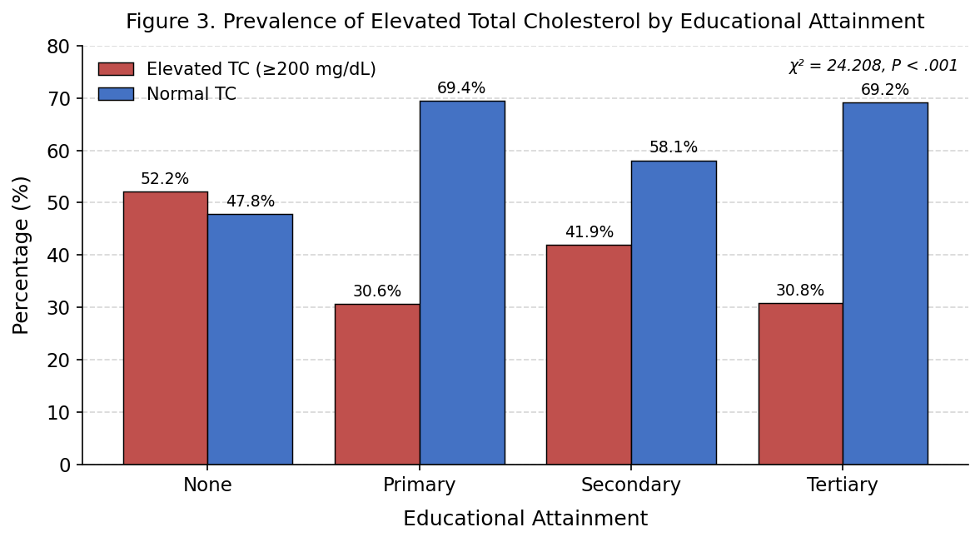
Figure 1. Prevalence of elevated total cholesterol by educational attainment (χ² = 24.208, P < .001).

Table 2. Predictors of Elevated Total Cholesterol: Logistic Regression Results (n = 826)
Variables | Crude OR (95% CI) | p-value | Adjusted OR (95% CI) | p-value
Age (years, continuous) | 1.010 (1.001–1.018) | .034 | 1.015 (1.003–1.027) | .015
Sex
Male* | 1 |  | 1
Female | 0.840 (0.633–1.114) | .226 | 1.562 (1.090–2.240) | .015
Marital Status
Single* | 1 |  | 1
Married | 0.526 (0.344–0.806) | .003 | 0.309 (0.180–0.531) | <.001
Widowed | 0.736 (0.428–1.263) | .265 | 0.508 (0.248–1.040) | .064
Educational Attainment
Tertiary* | 1 |  | 1
None | 2.456 (1.600–3.769) | <.001 | 2.501 (1.564–4.000) | <.001
Primary | 0.989 (0.648–1.510) | .959 | 0.966 (0.610–1.530) | .883
Secondary | 1.619 (1.106–2.369) | .013 | 1.492 (0.981–2.268) | .061
Random Blood Sugar (mg/dL)
Normal* | 1 |  | 1
Impaired glucose tolerance | 0.556 (0.363–0.851) | .007 | 0.532 (0.334–0.850) | .008
Diabetic | 0.520 (0.282–0.959) | .036 | 0.525 (0.267–1.029) | .061
Proteinuria
Negative/trace* | 1 |  | 1
Positive | 0.693 (0.517–0.928) | .014 | 0.763 (0.550–1.059) | .106
Haematuria
Negative/trace* | 1 |  | 1
Positive | 1.730 (0.999–2.993) | .050 | 1.985 (1.061–3.713) | .032
Serum Creatinine (mg/dL)
Normal/low* | 1 |  | 1
Elevated | 0.388 (0.275–0.549) | <.001 | 0.240 (0.150–0.386) | <.001
eGFR (mls/min)
≥60* | 1 |  | 1
<60 | 0.920 (0.690–1.226) | .571 | 2.245 (1.450–3.477) | <.001
Systolic BP mmHg (mean ± SD) | 1.002 (0.995–1.008) | .598 | 1.000 (0.992–1.008) | .943
Diastolic BP mmHg (mean ± SD) | 0.997 (0.987–1.007) | .582 | 0.997 (0.985–1.009) | .605
Weight in kg (mean ± SD) | 1.018 (1.002–1.033) | .023 | 1.026 (1.009–1.043) | .025
OR: Odds ratio; CI: Confidence interval; * Reference category; R² = 13.5–18.3%.
Note: P values reported without leading zero per convention (e.g. P = .015). All P values are two-sided.
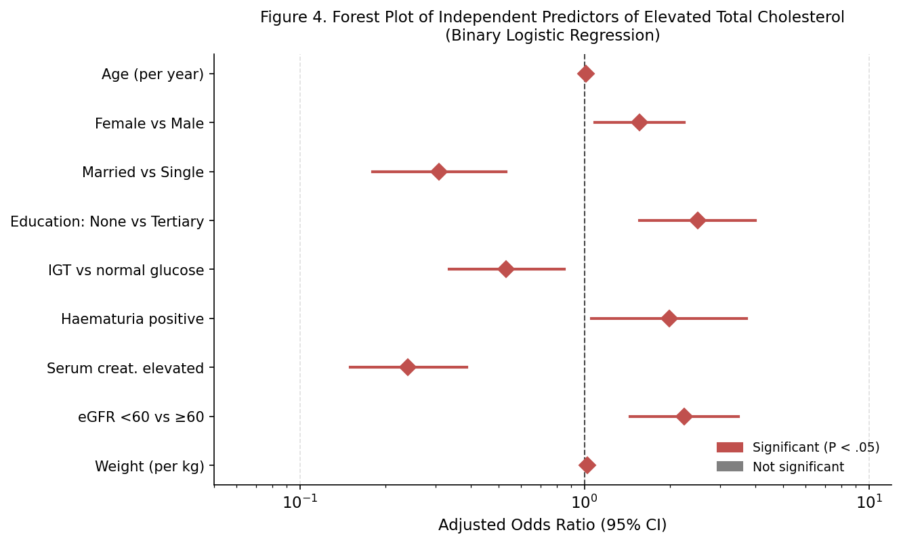
Figure 2. Forest plot of independent predictors of elevated total cholesterol (adjusted odds ratios, 95% CI). Red diamonds indicate significant predictors (P < .05).

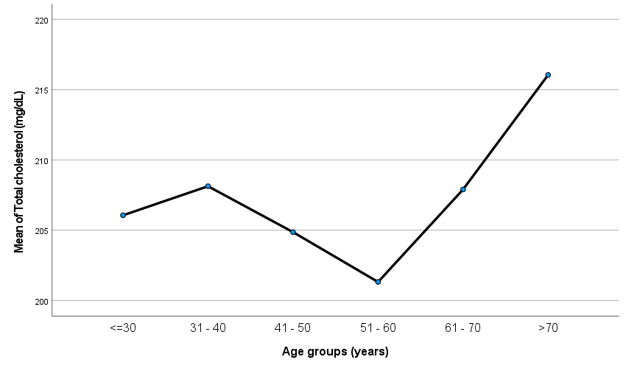
Figure 3. Prevalence of elevated total cholesterol among 826 hypertensive patients.

DISCUSSION
The prevalence of elevated TC among hypertensive patients in this study was 38.4%, indicating that nearly four in ten hypertensive individuals carry the compounding cardiovascular risk of hypercholesterolaemia. This figure aligns with Idemudia (2014) in Edo State, who reported a prevalence of 38.0%, and is within the range reported by Onyegbutulem et al. (2021) in Abuja (62.3%). The clinical significance is paramount, as the synergistic effect of hypertension and dyslipidaemia accelerates atherosclerosis and substantially increases the risk of stroke and myocardial infarction. These findings underscore the need for universal lipid screening and management protocols for all hypertensive patients at tertiary care facilities.
Increasing age was a continuous and significant independent predictor of elevated TC (AOR = 1.015 per year, P = .015). This observation is globally consistent; cholesterol levels tend to rise with age due to cumulative exposure to metabolic risk factors and age-related reductions in lipoprotein catabolism.(Downer et al., 2014; Feng et al., 2020) This finding mandates a lower threshold for initiating pharmacotherapy in older hypertensive patients, even when other risk factors appear controlled.
Female sex was independently associated with higher odds of elevated TC after multivariable adjustment (AOR = 1.562, P = .015), a finding consistent with the hormonal changes associated with menopause. The decline in protective oestrogen levels leads to detrimental shifts in the lipid profile, specifically increases in TC and pro-atherogenic LDL-C.21,22 This result corroborates findings from (Chori et al., 2021) across six Nigerian states, which identified female sex as a significant independent predictor of dyslipidaemia. Female hypertensive patients transitioning through or established in menopause, therefore represent a high-priority group requiring targeted and potentially prophylactic lipid management.
Educational attainment showed the most striking association, with patients having no formal education facing nearly three-fold higher odds of elevated TC compared to those with tertiary education (AOR = 2.501, P < .001). This finding strongly suggests that low educational status acts as a powerful proxy for health illiteracy, poor socioeconomic standing, and constrained access to quality nutrition and lifestyle resources, an inverse relationship between education and CVD risk is consistently observed internationally.(Pednekar et al., 2011; Zomeño et al., 2026) Health education materials must therefore be simplified, delivered in local languages, and disseminated widely beyond the clinic setting to reach this highly vulnerable group.
Increased weight was confirmed as an independent predictor (AOR = 1.026 per kg, P = .025), consistent with the established role of adiposity in driving dyslipidaemia via insulin resistance and increased hepatic lipogenesis.(Kerr et al., 2023; Sancar & Birkenfeld, 2024) This finding reinforces the aggressive promotion of weight reduction and physical activity counselling as integral, non-pharmacological components of hypertension care in Edo State.
The strong relationship between reduced eGFR and elevated TC (AOR = 2.245, P < .001) is consistent with the known phenomenon of secondary dyslipidaemia induced by chronic kidney disease (CKD), which independently elevates CVD risk.(Lacount & Tannock, 2025; Schunk & Zimmermann, 2025; Visconti et al., 2016) This identifies a patient subgroup facing a double burden of risk and supports the immediate and stringent use of lipid-lowering therapy, such as statins, in all hypertensive patients with confirmed CKD regardless of baseline TC levels, in accordance with contemporary international guidelines.
The inverse association between impaired glucose tolerance and elevated TC (AOR = 0.532, P = .008) warrants careful contextual interpretation. As patients on anti-lipid medications were not excluded from this retrospective analysis, patients with known glucose intolerance are more likely to be receiving active statin therapy, thus artificially suppressing TC levels and masking the true underlying risk association. Furthermore, the typical dyslipidaemia in insulin-resistant states is atherogenic dyslipidaemia characterized by high triglycerides and low HDL-C rather than isolated elevated TC. This observation likely reflects a combined treatment effect and the specific lipid pattern of pre-diabetes and does not negate the significant overall cardiovascular risk in this subgroup.

CONCLUSION
This retrospective study confirms a high prevalence of elevated Total Cholesterol (38.4%) among hypertensive patients in Edo State, emphasizing the co-existence of two major synergistic cardiovascular risk factors. The most significant predictors were low educational attainment and female sex, highlighting structural and biological vulnerabilities. Critical clinical predictors included increasing age, increased weight, and reduced eGFR as an indicator of concurrent chronic kidney disease. Effective cardiovascular disease prevention in Edo State must integrate routine lipid profile monitoring and targeted interventions prioritizing these high-risk subgroups.
LIMITATIONS
The retrospective cross-sectional design precludes the establishment of causality between predictors and elevated TC. As a single tertiary centre study, the findings may be subject to selection bias and information bias inherent in reliance on existing clinical records. Critical unmeasured confounders, including specific dietary patterns, physical activity levels, and concurrent use of lipid-lowering medications, could not be accounted for. Despite these limitations, the study provides significant region-specific evidence confirming the high prevalence of elevated TC and robustly identifying independent associations with low educational attainment, female sex, and concurrent renal impairment.

ETHICAL APPROVAL
Ethical approval was obtained from the Health Research Ethics Committee (HREC) of the University of Benin Teaching Hospital prior to data collection. All experiments have been examined and approved by the appropriate ethics committee and have been performed in accordance with the ethical standards laid down in the 1964 Declaration of Helsinki.
REFERENCES
Adeloye, D., Owolabi, E. O., Ojji, D. B., Auta, A., Dewan, M. T., Olanrewaju, T. O., Ogah, O. S., Omoyele, C., Ezeigwe, N., Mpazanje, R. G., Gadanya, M. A., Agogo, E., Alemu, W., Adebiyi, A. O., & Harhay, M. O. (2021). Prevalence, awareness, treatment, and control of hypertension in Nigeria in 1995 and 2020: A systematic analysis of current evidence. The Journal of Clinical Hypertension, 23(5), 963. https://doi.org/10.1111/jch.14220
Akintunde, A. A., Ayodele, E. O., Akinwusi, O. P., & Opadijo, G. O. (2010). Dyslipidemia among newly diagnosed hypertensives: pattern and clinical correlates. Journal of the National Medical Association, 102(5), 403–407. https://doi.org/10.1016/S0027-9684(15)30575-7
Chori, B., Danladi, B., Nwakile, P., Okoye, I., Abdullahi, U., Zawaya, K., Essien, I., Sada, K., Nwegbu, M., Ogedengbe, J., Aje, A., Isiguzo, G., & Odili, A. (2021). Prevalence, patterns and predictors of dyslipidaemia in Nigeria: a report from the REMAH study. Cardiovascular Journal of Africa, 33(2), 52. https://doi.org/10.5830/CVJA-2021-037
Dąbrowska, E., & Narkiewicz, K. (2023). Hypertension and Dyslipidemia: the Two Partners in Endothelium-Related Crime. Current Atherosclerosis Reports, 25(9), 605. https://doi.org/10.1007/s11883-023-01132-z
Downer, B., Estus, S., Katsumata, Y., & Fardo, D. W. (2014). Longitudinal Trajectories of Cholesterol from Midlife through Late Life according to Apolipoprotein E Allele Status. International Journal of Environmental Research and Public Health, 11(10), 10663. https://doi.org/10.3390/ijerph111010663
Feng, L., Nian, S., Tong, Z., Zhu, Y., Li, Y., Zhang, C., Bai, X., Luo, X., Wu, M., & Yan, Z. (2020). Age-related trends in lipid levels: a large-scale cross-sectional study of the general Chinese population. BMJ Open, 10(3), e034226. https://doi.org/10.1136/bmjopen-2019-034226
Galtimari, I. A., Baba, M. M., Buba, F., Talle, M. A., & Oyati, A. I. (2025). Prevalence, Pattern and Predictors of Dyslipidaemia amongst Individuals with Untreated Hypertension at a Nigerian Tertiary Hospital. Nigerian Journal of Medicine, 34(3), 180–186. https://doi.org/10.4103/njm.njm_30_25
Idemudia, J. O. (2014). Dyslipidaemia in Hypertensives in South-South Nigeria. Journal of Advances in Medicine and Medical Research, 4(28), 4742–4750. https://doi.org/10.9734/BJMMR/2014/10678
Jobe, M., Beye, S. M., Gaye, N. D., Ka, M. M., Perel, P., Perkins, A. D., Kane, A., Prentice, A. M., Ojji, D. B., Jaiteh, L. E. S., Etyang, A. O., Shah, A. S. V., & Gaye, B. (2025). Hypertension in Sub-Saharan Africa: Burden, Barriers and Priorities for Improving Treatment Outcomes. Circulation Research, 137(1), 106. https://doi.org/10.1161/CIRCRESAHA.124.323889
Kerr, A. G., Andersson, D. P., Dahlman, I., Rydén, M., & Arner, P. (2023). Adipose Insulin Resistance Associates with Dyslipidemia Independent of Liver Resistance and Involves Early Hormone Signaling. Arteriosclerosis, Thrombosis, and Vascular Biology, 43(6), 1054–1065. https://doi.org/10.1161/ATVBAHA.123.319227
Kjeldsen, S. E. (2018). Hypertension and cardiovascular risk: General aspects. Pharmacological Research, 129, 95–99. https://doi.org/10.1016/j.phrs.2017.11.003
Lacount, S., & Tannock, L. R. (2025). Dyslipidemia in Chronic Kidney Disease. Endotext. https://www.ncbi.nlm.nih.gov/books/NBK305899/
Murphy, A., Faria-Neto, J. R., Al-Rasadi, K., Blom, D., Catapano, A., Cuevas, A., Lopez-Jimenez, F., Perel, P., Santos, R., Sniderman, A., Sy, R., Watts, G. F., Zhao, D., Yusuf, S., & Wood, D. (2017). World Heart Federation Cholesterol Roadmap. Global Heart, 12(3), 179-197.e5. https://doi.org/10.1016/j.gheart.2017.03.002
Noubiap, J. J., Bigna, J. J., Nansseu, J. R., Nyaga, U. F., Balti, E. V., Echouffo-Tcheugui, J. B., & Kengne, A. P. (2018). Prevalence of dyslipidaemia among adults in Africa: a systematic review and meta-analysis. The Lancet Global Health, 6(9), e998–e1007. https://doi.org/10.1016/S2214-109X(18)30275-4
Nwankwo, M., Makena, W., Idris, A., Barnabas, D., Danborno, A. M., & Umoren, E. B. (2026). Prevalence of hypertension among adults in Nigeria: a systematic review and meta-analysis. BMC Cardiovascular Disorders 2026. https://doi.org/10.1186/s12872-026-05722-y
Odili, A. N., Chori, B. S., Danladi, B., Nwakile, P. C., Okoye, I. C., Abdullahi, U., Nwegbu, M. N., Zawaya, K., Essien, I., Sada, K., Ogedengbe, J. O., Aje, A., & Isiguzo, G. C. (2020). Prevalence, awareness, treatment and control of hypertension in Nigeria: Data from a nationwide survey 2017. Global Heart, 15(1). https://doi.org/10.5334/GH.848
Olowoyo, P., Okekunle, A. P., Asowata, O. J., Atolani, S., Morsy, M. I., Caiazzo, E., Gaye, B., Kadan, D. D., Bruzzese, D., Guzik, T. J., Maffia, P., & Owolabi, M. O. (2025). Prevalence of hypertension in Africa in the last two decades: systematic review and meta-analysis. Cardiovascular Research, 121(12), 1815–1829. https://doi.org/10.1093/cvr/cvaf125
Onyegbutulem, H. C., Dogo, D., Alu, F., Dankyau, M., Olorunfemi, D. S., Abdullahi, F. M., Akerele, I. O., Bala, N. J. afar, Ibeabuchi, U. N., & Mohammed, M. O. (2021). Patterns of dyslipidemia amongst hypertensive patients in Abuja, North Central Nigeria. PAMJ. 2021; 39:11, 39(11). https://doi.org/10.11604/PAMJ.2021.39.11.28807
Pednekar, M. S., Gupta, R., & Gupta, P. C. (2011). Illiteracy, low educational status, and cardiovascular mortality in India. BMC Public Health, 11, 567. https://doi.org/10.1186/1471-2458-11-567
Sancar, G., & Birkenfeld, A. L. (2024). The role of adipose tissue dysfunction in hepatic insulin resistance and T2D. The Journal of Endocrinology, 262(3), e240115. https://doi.org/10.1530/JOE-24-0115
Schunk, S. J., & Zimmermann, P. (2025). Cardiovascular Risk and Its Presentation in Chronic Kidney Disease. Journal of Clinical Medicine 2025, Vol. 14, 14(13). https://doi.org/10.3390/JCM14134567
Shafee, Md., & Kumar, E. S. (2021). Coexistence of Hypertension, Dyslipidemia, and Central Obesity as Predictors of Early-Onset Ischemic Heart Disease (IHD). European Journal of Cardiovascular Medicine, 11, 78–85. https://doi.org/10.5083/EJCM/2021-4-13
Venkitachalam, L., Wang, K., Porath, A., Corbalan, R., Hirsch, A. T., Cohen, D. J., Smith, S. C., Ohman, E. M., Steg, P. G., Bhatt, D. L., & Magnuson, E. A. (2012). Global variation in the prevalence of elevated cholesterol in outpatients with established vascular disease or 3 cardiovascular risk factors according to national indices of economic development and health system performance. Circulation, 125(15), 1858–1869. https://doi.org/10.1161/CIRCULATIONAHA.111.064378
Visconti, L., Benvenga, S., Lacquaniti, A., Cernaro, V., Bruzzese, A., Conti, G., Buemi, M., & Santoro, D. (2016). Lipid disorders in patients with renal failure: Role in cardiovascular events and progression of chronic kidney disease. Journal of Clinical & Translational Endocrinology, 6, 8–14. https://doi.org/10.1016/j.jcte.2016.08.002
World Health Organization. (2026). Cardiovascular diseases. https://www.who.int/health-topics/cardiovascular-diseases
Yuyun, M. F., Sliwa, K., Kengne, A. P., Mocumbi, A. O., & Bukhman, G. (2020). Cardiovascular diseases in sub-saharan Africa compared to high-income countries: An epidemiological perspective. Global Heart, 15(1). https://doi.org/10.5334/GH.403
Zomeño, M. D., Álamo-Junquera, D., Pericas, C., Vilaplana-Carnerero, C., Domínguez, À., Toledo, D., Soldevila, N., Pagès-Fernández, C., Redondo, A., Tor-Roca, A., & Grau, M. (2026). Cardiovascular disease prevention by personalized health promotion considering educational attainment. Scientific Reports, 16(1), 6604. https://doi.org/10.1038/s41598-026-36654-4

