Case report

HYPERTENSIVE RETINOPATHY ASSOCIATED WITH POLYCYTHEMIA IN A YOUNG ADULT WITHOUT PRIOR COMORBIDITIES: A CASE REPORT

ABSTRACT
AIM: This case study aims to emphasize the importance of maintaining a broad differential
diagnosis when evaluating young hypertensive patients with retinal manifestations. The case emphasizes the need for early identification of secondary causes of hypertension such as polycythemia.
CASE PRESENTATION: A 33-year-old male with no prior comorbidities presented with
blurred vision and severe hypertension (200/150 mmHg). Initial treatment with amlodipine was ineffective, requiring intensive care management with nitroglycerin infusion and a combination of oral antihypertensives, including cilnidipine, metoprolol, and prazosin. Laboratory evaluation revealed polycythemia (hemoglobin 19.9 g/dL) and hypercholesterolemia (266 mg/dL). Treatment included therapeutic venesection of 450 ml and lipid-lowering therapy. Following intervention, the patient’s blood pressure stabilized at 130/80 mmHg, and visual symptoms improved.
DISCUSSION: Polycythemia increases blood viscosity, which elevates systemic vascular
resistance and contributes to severe, refractory hypertension. This increased pressure causes mechanical and ischemic injury to retinal arterioles, manifesting as hypertensive retinopathy with hemorrhages and cotton wool spots. Management required a multi-drug regimen to address augmented sympathetic tone and hyperviscosity. Diagnostic workup included JAK2 mutation screening to differentiate between primary and secondary polycythemia, and negative autoimmune markers excluded inflammatory etiologies.
CONCLUSION: Hypertensive retinopathy in young adults without prior comorbidities should prompt immediate investigation for underlying hematological disorders like polycythemia. Early recognition and aggressive, integrated management of hypertension, lipids, and blood viscosity are vital to prevent permanent vision loss and systemic complications such as stroke or
myocardial infarction.
KEYWORDS: Hypertensive Retinopathy, Polycythemia, Secondary Hypertension, Blood
Viscosity, Therapeutic Venesection

- INTRODUCTION
Hypertension remains one of the most significant global public health challenges and is a major risk factor for cardiovascular, cerebrovascular, and renal diseases. Among the various systemic complications of hypertension, hypertensive retinopathy represents a critical ocular manifestation that reflects the severity and duration of elevated blood pressure. The retina provides a unique opportunity to directly visualize systemic microvascular changes, making retinal examination a valuable diagnostic tool for evaluating vascular damage caused by hypertension.
Hypertensive retinopathy is characterized by a spectrum of retinal microvascular abnormalities including generalized arteriolar narrowing, arteriovenous nicking, retinal hemorrhages, cotton wool spots, hard exudates, and in severe cases optic disc edema. These manifestations occur due to structural and functional changes in retinal arterioles resulting from sustained high blood pressure. While hypertensive retinopathy is commonly observed in elderly patients with long‑standing hypertension and other cardiovascular risk factors such as diabetes mellitus and smoking, its occurrence in young adults without known comorbidities is relatively uncommon and warrants further investigation.
Polycythemia is a hematological disorder characterized by an abnormal increase in red blood cell mass, which results in elevated hemoglobin and hematocrit levels. The condition can be broadly classified into primary polycythemia, commonly known as polycythemia vera, and secondary polycythemia, which occurs as a physiological response to chronic hypoxia or other underlying conditions. Increased red blood cell mass leads to elevated blood viscosity, which can significantly impair microcirculatory blood flow and increase systemic vascular resistance.
The resulting hyperviscosity can contribute to hypertension and increase the risk of thrombotic events, including stroke, myocardial infarction, and retinal vascular occlusions. When polycythemia coexists with hypertension, the combined effect of increased blood viscosity and vascular pressure may accelerate endothelial injury and microvascular damage, thereby worsening hypertensive retinopathy.
This report presents the case of a young adult male who presented with hypertensive retinopathy secondary to polycythemia. The case highlights the diagnostic challenges encountered in identifying secondary causes of hypertension in young individuals and underscores the importance of multidisciplinary management in preventing serious systemic and ocular complications.
- CASE PRESENTATION
A 33‑year‑old male with no known past medical history presented to the emergency department with complaints of sudden onset blurred vision that had persisted for several hours. The patient denied any previous history of hypertension, diabetes mellitus, cardiovascular disease, or chronic illness. He also reported no history of smoking, alcohol abuse, or use of illicit drugs.
On initial evaluation, the patient appeared anxious but was conscious and oriented. His vital signs revealed severe hypertension with a blood pressure of 200/150 mmHg. His pulse rate was 92 beats per minute and regular, respiratory rate was 18 breaths per minute, and oxygen saturation was within normal limits on room air.
Fundoscopic examination revealed features suggestive of hypertensive retinopathy including arteriolar narrowing, retinal hemorrhages, and cotton wool spots. Due to the severity of hypertension and ocular findings, the patient was immediately started on oral amlodipine; however, blood pressure control remained inadequate.
The patient was subsequently transferred to the cardiology intensive care unit for closer monitoring and aggressive blood pressure management. Intravenous nitroglycerin infusion was initiated and continued for approximately 24 hours. This intervention resulted in a gradual reduction in blood pressure levels but did not achieve optimal control.
A comprehensive laboratory evaluation was conducted to identify possible secondary causes of hypertension. Blood investigations revealed significantly elevated hemoglobin levels of 19.9 g/dL, suggesting polycythemia. Additional laboratory findings included elevated serum cholesterol levels of 266 mg/dL. Renal function tests, liver function tests, and electrolyte levels were within normal limits.
Further management involved initiating a combination antihypertensive regimen consisting of cilnidipine, metoprolol, and prazosin. This multidrug approach targeted different physiological mechanisms contributing to the patient’s hypertension, including vascular resistance and sympathetic nervous system activity.
Given the presence of polycythemia, an oncology consultation was obtained. The hematology team recommended therapeutic venesection to reduce blood viscosity and improve circulatory dynamics. A total of 450 ml of blood was removed through controlled venesection. The patient was also started on atorvastatin to address dyslipidemia.
Additional investigations were performed to determine the underlying cause of polycythemia. JAK2 mutation analysis was ordered to evaluate for polycythemia vera. Autoimmune markers, including antinuclear antibody (ANA) testing, were negative, effectively ruling out inflammatory or autoimmune causes of vascular injury. Abdominal ultrasonography revealed mild microlithiasis but no other significant abnormalities.
Following these interventions, the patient demonstrated significant clinical improvement. His blood pressure gradually stabilized at approximately 130/80 mmHg. Additionally, the patient reported noticeable improvement in visual symptoms, suggesting partial recovery of retinal function after stabilization of systemic hemodynamics.
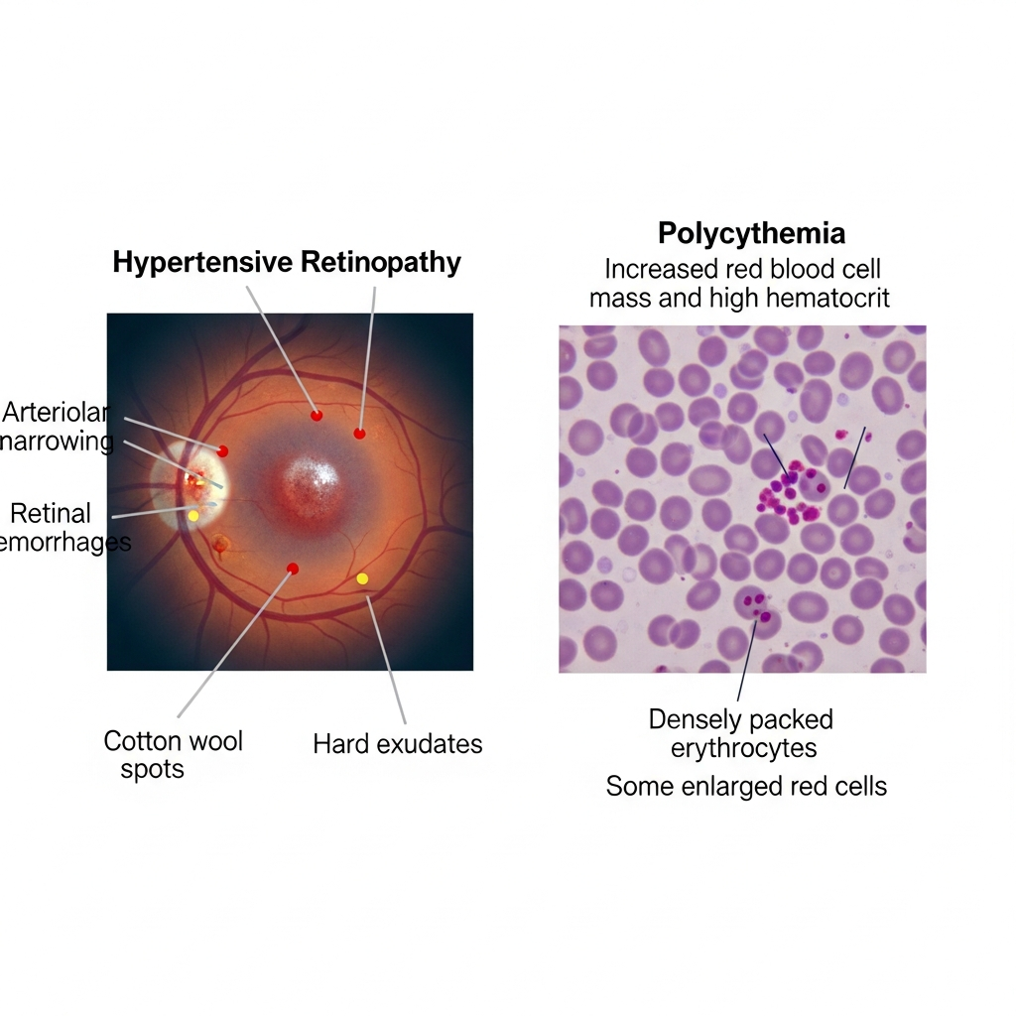
Figure 1: Clinical illustration of hypertensive retinopathy showing arteriolar narrowing, retinal hemorrhages, cotton wool spots, and hard exudates.
Figure 2: Blood smear indicative of polycythemia with increased red blood cell mass, showing densely packed erythrocytes.
- DISCUSSION
This case highlights the complex interplay between hematological abnormalities and cardiovascular pathology. The patient presented with severe hypertension accompanied by hypertensive retinopathy, an unusual occurrence in a young individual without previously known comorbidities. Further investigation revealed polycythemia as a contributing factor to the patient’s hypertensive crisis.
Polycythemia significantly increases blood viscosity due to the elevated concentration of red blood cells. Increased viscosity leads to impaired microcirculatory flow and increased systemic vascular resistance. As vascular resistance rises, the heart must generate higher pressures to maintain adequate tissue perfusion, ultimately resulting in systemic hypertension.
In the retina, elevated blood pressure causes damage to the delicate microvasculature. Persistent hypertension results in endothelial dysfunction, increased vascular permeability, and ischemic injury. These pathophysiological mechanisms manifest clinically as retinal hemorrhages, cotton wool spots, and hard exudates.
In this patient, the markedly elevated hemoglobin level of 19.9 g/dL likely played a major role in the development of refractory hypertension. The increased viscosity of blood would have impaired perfusion in small vessels, including retinal arterioles, thereby exacerbating vascular injury and retinal ischemia.
Initial treatment with a single antihypertensive agent was insufficient, highlighting the severity of the underlying pathophysiological process. The eventual combination therapy including cilnidipine, metoprolol, and prazosin targeted multiple mechanisms involved in blood pressure regulation. Cilnidipine acts on both L‑type and N‑type calcium channels, reducing vascular resistance and sympathetic nerve activity. Metoprolol decreases cardiac output and sympathetic stimulation, while prazosin blocks alpha‑1 adrenergic receptor to promote vasodilation.
Therapeutic venesection played a crucial role in the management of this patient. By removing a portion of the circulating blood volume, venesection reduces hematocrit and blood viscosity. This intervention improves microvascular circulation, reduces thrombotic risk, and contributes to improved blood pressure control.
Screening for the JAK2 mutation was an important step in distinguishing between primary and secondary polycythemia. Polycythemia vera is a myeloproliferative neoplasm associated with mutations in the JAK2 gene and carries an increased risk of thrombotic complications. Identifying the underlying cause of polycythemia is essential for determining long‑term management strategies.
The presence of dyslipidemia in this patient further increased the risk of vascular complications. Elevated cholesterol levels contribute to endothelial dysfunction and accelerate atherosclerotic processes. Initiation of statin therapy was therefore an essential component of comprehensive cardiovascular risk reduction.
This case emphasizes the importance of a multidisciplinary approach in managing complex medical conditions. Collaboration between cardiologists, hematologists, and ophthalmologists allowed for prompt diagnosis and comprehensive treatment, ultimately preventing permanent visual impairment and reducing the risk of life‑threatening systemic complications.
- CONCLUSION
Hypertensive retinopathy occurring in young adults without prior comorbidities should prompt clinicians to investigate potential secondary causes of hypertension. Polycythemia is an important yet often overlooked contributor to elevated blood pressure and vascular complications due to its effect on blood viscosity and systemic vascular resistance.
Early identification of polycythemia and appropriate interventions such as therapeutic venesection can significantly improve hemodynamic stability and reduce the risk of microvascular damage. Comprehensive management should include aggressive blood pressure control, treatment of associated metabolic abnormalities such as dyslipidemia, and evaluation for underlying hematological disorders.
This case demonstrates that timely multidisciplinary management can lead to favorable outcomes even in severe presentations of hypertensive crisis with retinal involvement. Increased clinical awareness of such associations is essential for preventing irreversible complications including permanent vision loss, stroke, and myocardial infarction.

- COMPETING INTERESTS
The authors declare that they have no competing interests (financial or non-financial) regarding the publication of this case study

8. REFERENCES
1. Wong, T. Y., & Mitchell, P. (2007). The eye in hypertension. *Lancet, 369*(9559), 425–435.

2. Dziedziak, J., Zaleska-Żmijewska, A., Szaflik, J. P., & Cudnoch-Jędrzejewska, A. (2022). Impact of arterial hypertension on the eye: Pathogenesis, diagnostic methods, and treatment of hypertensive retinopathy. *Medical Science Monitor, 28*, e935135.

3. Di Marco, E., Aiello, F., Lombardo, M., et al. (2022). A literature review of hypertensive retinopathy: Systemic correlations and new technologies. *European Review for Medical and Pharmacological Sciences, 26*(18), 6424–6443.

4. Wang, Z., Feng, L., Wu, M., et al. (2024). Hypertensive retinopathy can predict stroke: A systematic review and meta-analysis. *Journal of Stroke and Cerebrovascular Diseases, 33*(11), 107953.

5. Mishra, P., Kanaujia, V., Kesarwani, D., et al. (2024). Visual outcomes in malignant hypertensive retinopathy cases: A clinical and spectral domain OCT study. *Cureus, 16*(6), e62945.

6. Li, J., Zhang, W., Zhao, L., et al. (2023). Positive correlation between hypertensive retinopathy and albuminuria in hypertensive adults. *BMC Ophthalmology, 23*, 66.

7. Gudayneh, Y. A., Shumye, A. F., Gelaye, A. T., et al. (2025). Prevalence of hypertensive retinopathy and associated factors among adult hypertensive patients. *International Journal of Retina and Vitreous, 11*, 17.

8. Shukla, D., Dhawan, A., & Kalliath, J. (2025). Hypertensive retinopathy: The need for a change in perspective. *Indian Journal of Ophthalmology, 73*(11), 1552–1555.

9. Marchioli, R., Finazzi, G., Specchia, G., et al. (2013). Cardiovascular events and intensity of treatment in polycythemia vera. *New England Journal of Medicine, 368*(1), 22–33.

10. Tefferi, A. (2018). Polycythemia vera and essential thrombocythemia: Update on diagnosis, risk-stratification and management. *American Journal of Hematology, 93*(3), 442–459.

