Case report
Segmental Gangrene in an Hourglass Gallbladder: A Rare Morphological Variant with Surgical Implications

Abstract
Background
Hourglass gallbladder is a rare anatomical variant characterized by a constriction dividing the gallbladder into two compartments. It may be congenital or acquired and is frequently associated with chronic inflammation. Compartmentalized pathology within such a variant is exceedingly uncommon.

Case Presentation
A 70-year-old male presented with a one-day history of right upper quadrant pain, fever, and vomiting. Ultrasonography suggested acute cholecystitis with a bilobed gallbladder. Magnetic resonance imaging demonstrated an hourglass configuration with a constricted mid-body separating the fundal and neck compartments.

Management and Outcome
The patient underwent laparoscopic cholecystectomy. Intraoperatively, gangrene was confined to the fundal compartment, while the distal segment remained viable. The critical view of safety was achieved, and the procedure was completed laparoscopically without complications. Histopathological examination confirmed segmental gangrenous cholecystitis.

Conclusion
Selective segmental gangrene in an hourglass gallbladder is an extremely rare entity and poses diagnostic as well as intraoperative challenges. This case underscores the importance of recognizing anatomical variants, correlating preoperative imaging with intraoperative findings, and adhering to meticulous surgical technique to ensure safe outcomes.
Introduction
Anatomical variations of the gallbladder are uncommon but clinically relevant, particularly when they alter disease presentation or surgical anatomy. Hourglass gallbladder is a rare morphological variant characterized by a constriction dividing the gallbladder into two compartments^{1,} This deformity may be congenital or acquired due to chronic inflammation and fibrosis²

While acute cholecystitis is a common surgical condition, gangrenous transformation typically involves the entire gallbladder. Segmental gangrene confined to a single compartment of an hourglass gallbladder is exceptionally rare and poorly described in literature³. Such cases are important due to their potential to mislead both radiological interpretation and intraoperative decision-making⁴.

We present a rare case of selective gangrene in the fundal compartment of an hourglass gallbladder and discuss its clinical, diagnostic, and surgical implications.
Case Report
A 70-year-old male presented with acute onset right upper quadrant abdominal pain of one-day duration, associated with fever and vomiting. There was no history of jaundice or previous similar episodes.

On examination, the patient was febrile with localized tenderness in the right hypochondrium and a positive Murphy’s sign. Laboratory investigations revealed leukocytosis with neutrophilia. Liver function tests were within normal limits.

Ultrasonography demonstrated a distended gallbladder with wall thickening and internal echoes suggestive of acute cholecystitis. A bilobed morphology with a possible mid-body constriction was noted.

Magnetic resonance imaging provided better anatomical delineation, revealing an hourglass configuration with a distinct narrowing separating the fundal and neck compartments. The fundal compartment appeared more distended and inflamed.(figure 1)

The patient was taken up for laparoscopic cholecystectomy. Intraoperatively, the gallbladder showed a characteristic hourglass deformity with a fibrotic constriction. The fundal compartment was edematous and gangrenous, whereas the distal compartment appeared relatively normal. (figure 2) Adhesions were carefully lysed.

Meticulous dissection was performed to achieve the critical view of safety. The cystic duct and artery were identified, clipped, and divided. Laparoscopic cholecystectomy was completed successfully without complications.

The postoperative period was uneventful. Histopathological examination confirmed transmural necrosis in the fundal compartment consistent with gangrenous cholecystitis, while the distal segment showed mild inflammation.
Discussion
Clinical Significance
This case highlights an important but underrecognized concept: anatomical variations can fundamentally alter disease behavior. In an hourglass gallbladder, the constriction creates two functionally independent compartments, leading to non-uniform pathological processes⁵. This may result in discordance between clinical severity and imaging findings.

Pathophysiology and Mechanism of Segmental Gangrene
The pathogenesis of segmental gangrene can be explained by localized bile stasis, increased intraluminal pressure, and vascular compromise. The fundus is particularly susceptible due to its relatively tenuous blood supply⁶

Diagnostic Challenges
Preoperative diagnosis remains difficult. Ultrasonography may suggest a bilobed gallbladder but lacks specificity. MRI/MRCP provides superior anatomical delineation^{7.}However, predicting segmental gangrene preoperatively remains difficult.

Surgical Implications
Distorted anatomy increases the risk of bile duct injury⁸. Misinterpretation of partially normal segments may lead to intraoperative errors. Adherence to the critical view of safety is essential⁹.

Review of World Literature and Rarity
Hourglass gallbladder is rarely reported, and literature largely focuses on congenital anomalies or septate gallbladder⁸ Reports describing compartment-specific pathology are extremely limited, and segmental gangrene is scarcely documented³. Most cases of gangrenous cholecystitis involve diffuse necrosis and are associated with delayed presentation and vascular compromise ¹⁰

Key Clinical Message
Anatomical variations such as hourglass gallbladder can lead to compartmentalized disease processes, necessitating heightened diagnostic suspicion and meticulous surgical technique to ensure safe outcomes.
Conclusion
Segmental gangrene in an hourglass gallbladder is an exceptionally rare entity. This case underscores the importance of recognizing anatomical variations, understanding their pathophysiological implications, and adhering to sound surgical principles. Awareness of such presentations is essential to avoid diagnostic pitfalls and intraoperative complications.
References
- Harlaftis N, Gray SW, Skandalakis JE. Multiple gallbladders. Surg Gynecol Obstet. 1977;145(6):928-34.
- Madacsy L, Dubravcsik Z. Congenital anomalies of the gallbladder and biliary tree. World J Gastroenterol. 2015;21(12):3473-9.
- Sureka B, Bansal K, Patidar Y, Arora A. Imaging of gallbladder anomalies. Clin Imaging. 2014;38(3):245-52
- Bennett GL, Rusinek H, Lisi V, Israel GM, Krinsky GA, Slywotzky CM, et al. CT findings in acute gangrenous cholecystitis. AJR Am J Roentgenol. 2002;178(2):275-81
- Gigot JF, Legrand M, Hubens G, de Canniere L, Mother M, Wibin E, et al. Laparoscopic treatment of difficult bile duct stones using direct choledochoscopy and laser lithotripsy: report of six cases. Surg Endosc. 1997;11(7):647-51
- Hwang S, Lee SG, Park KM, Lee YJ, Ahn CS, Kim KH, et al. Fundus-first technique in difficult laparoscopic cholecystectomies. J Hepatobiliary Pancreat Surg. 2005;12(5):383-7
- Soto JA, Barish MA, Yucel EK, Siegenberg D, Ferrucci JT. Magnetic resonance cholangiography: comparison with endoscopic retrograde cholangiopancreatography. Gastroenterology. 1996;110(2):589-97
- Strasberg SM, Hertl M, Soper NJ. An analysis of the problem of biliary injury during laparoscopic cholecystectomy. J Am Coll Surg. 1995;180(1):101-25
- Sanford DE. An alternative to the critical view of safety in difficult laparoscopic cholecystectomies. Surg Clin North Am. 2014;94(2):233-48.
- Yokoe M, Takada T, Strasberg SM, Solomkin JS, Mayumi T, Gomi H, et al. Tokyo Guidelines 2018: diagnostic criteria and severity grading of acute cholecystitis . J Hepatobiliary Pancreat Sci. 2018;25(1):41-54

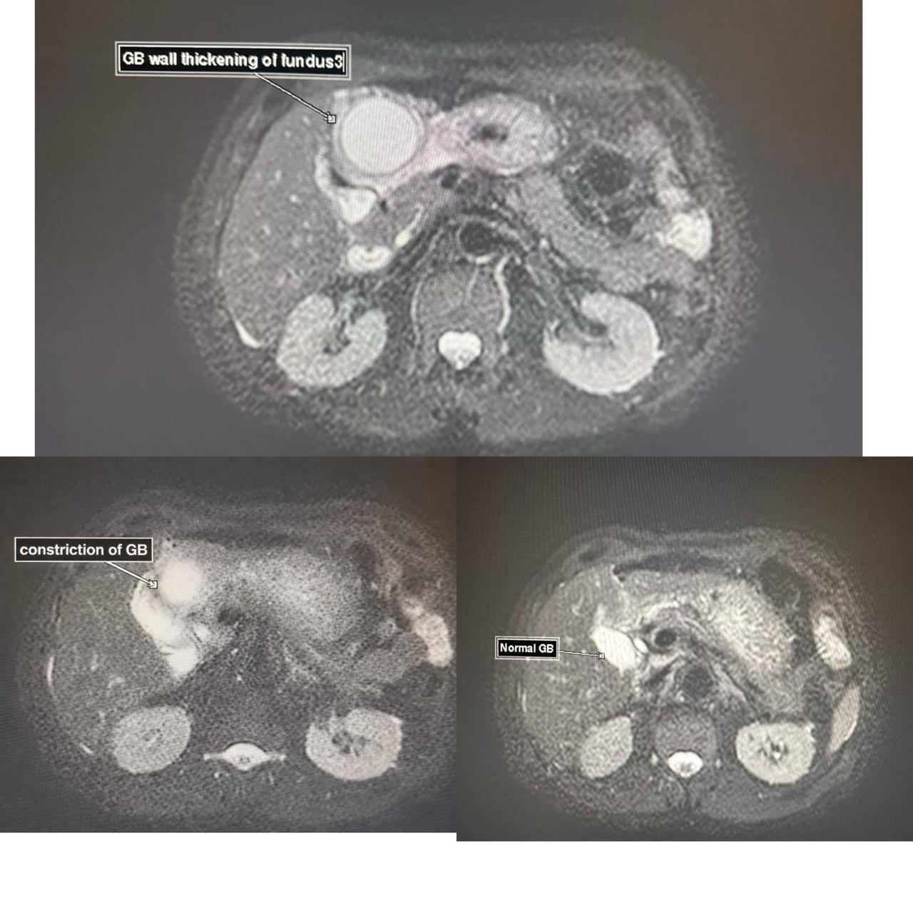

Figure 1 : Distended and inflamed fundal compartment
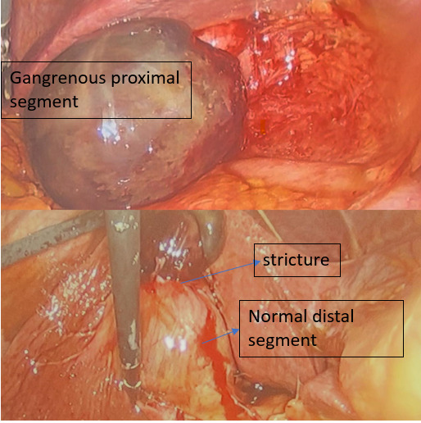
Fig 2 : Edematous and gangrenous fundal compartment and normal distal compartment

