Case report

Extensive Iatrogenic Tracheal Laceration Following Difficult Intubation in Elective Surgery: A Comprehensive Case Study and Clinical Review

.
ABSTRACT

Aims: Iatrogenic tracheal rupture is a rare but potentially life-threatening event. This report describes a complex case of extensive post-intubation tracheal injury (PITI) during elective surgery, focusing on diagnostic distractors like pneumoperitoneum and the critical need for early intervention.
Presentation of Case: A 63-year-old female patient underwent elective abdominal surgery (ventral hernia repair and abdominoplasty). Intubation was technically challenging, requiring three attempts. Postoperatively, she developed progressive dyspnea and cervicothoracic subcutaneous emphysema at 72 hours. Initial CT imaging showed pneumomediastinum and subdiaphragmatic pneumoperitoneum, raising suspicion of hollow viscus perforation. After negative findings in exploratory laparoscopy and endoscopy, fiberoptic bronchoscopy identified a 3.5 cm longitudinal laceration in the posterior membranous trachea. Urgent surgical repair via anterior cervicotomy and protective tracheostomy were performed. Despite successful surgical closure, the patient developed mediastinitis and septic shock, eventually resulting in death.
Discussion: PITI often presents with non-specific symptoms. The presence of pneumoperitoneum can act as a diagnostic distractor, leading to unnecessary abdominal exploration. Fiberoptic bronchoscopy remains the gold standard for defining the injury. Management is guided by the Cardillo classification, where lesions exceeding 2 cm or involving unstable patients usually mandate surgical intervention.
Conclusion: PITI must be a priority differential diagnosis in any patient with postoperative emphysema. Early diagnostic bronchoscopy and structured preoperative airway assessment are critical for prevention and survival.

Keywords: Tracheal injury; Endotracheal intubation; Pneumomediastinum; Tracheoplasty; Surgical complications.

1. INTRODUCTION

Iatrogenic tracheal rupture (ITR) is a rare but critical medical emergency, representing one of the most feared complications of airway management (1). Although endotracheal intubation is a standard and generally safe procedure, the loss of tracheal tissue continuity can lead to rapid clinical deterioration (2). The estimated incidence of ITR in conventional elective intubations ranges between 0.005% and 0.37% (3). However, this incidence increases dramatically to approximately 0.5% to 1% when double-lumen tubes are employed, or up to 15% in emergency settings where multiple attempts are often necessary (4).
Anatomically, the trachea is a semi-rigid structure composed of 18 to 22 hyaline cartilage rings that provide anterior and lateral support (5). The posterior wall, known as the pars membranosa, lacks cartilaginous protection and consists primarily of smooth muscle and fibroelastic tissue (6). Consequently, most iatrogenic injuries occur as longitudinal tears along this membranous wall, as it is highly susceptible to mechanical trauma from the tube tip or sudden increases in intraluminal pressure caused by cuff overinflation (7).
The clinical significance of PITI stems from its high morbidity and mortality rates, which can reach up to 22% in some cohorts. Factors such as female gender, age over 50 years, short stature (<160 cm), and pre-existing inflammatory airway conditions significantly heighten the risk of injury (8). Furthermore, a diagnostic delay is common, as symptoms may not manifest immediately, often leading to lethal complications such as mediastinitis and septic shock (9). This report presents a case of extensive tracheal laceration in an elective surgical setting, illustrating the diagnostic challenges and the rapid progression of associated complications.

2. PRESENTATION OF CASE

A 63-year-old female patient with no significant prior medical history was admitted for elective abdominal reconstruction, including a complex ventral hernia repair and abdominoplasty. During the induction of general anesthesia, the medical team encountered a difficult airway (Mallampati III), necessitating three intubation attempts for successful placement of the endotracheal tube. The surgery itself was reported as uneventful, and the patient was initially transferred to the recovery ward in stable condition.
In the immediate postoperative hours, the patient reported dysphagia and odynophagia, which were initially attributed to minor pharyngeal trauma during intubation. However, at 72 hours post-surgery, her clinical status deteriorated rapidly. She developed progressive dyspnea, tachycardia, and visible swelling of the neck and upper chest. Physical examination revealed extensive subcutaneous emphysema with palpable crepitus extending from the facial region down to the anterior thoracic wall.
A Computed Tomography (CT) scan of the neck and chest was urgently performed. The imaging confirmed severe, widespread surgical emphysema and extensive pneumomediastinum. Crucially, the CT also revealed bilateral subdiaphragmatic pneumoperitoneum and a 4.5 cm fluid collection in the hypogastric region. Given these abdominal findings, the primary surgical team initially suspected a hollow viscus perforation or a late-onset esophageal rupture. (Fig. 1).
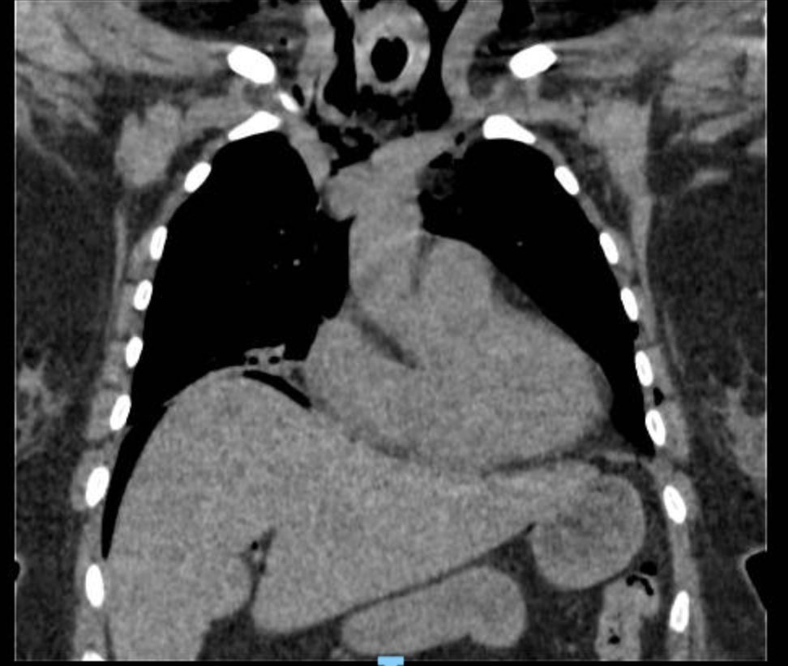
Fig. 1. CT scan showing extensive pneumomediastinum and subdiaphragmatic pneumoperitoneum.

Based on the suspicion of an intra-abdominal catastrophe, the patient underwent exploratory laparoscopy and upper gastrointestinal endoscopy. Both procedures were negative for structural abdominal lesions or esophageal perforation. As the subcutaneous emphysema persisted and respiratory distress increased, a diagnostic fiberoptic bronchoscopy—considered the "gold standard"—was performed. The procedure identified a 3.5 cm longitudinal laceration in the posterior membranous trachea, extending from the first down to the seventh tracheal ring. The esophageal wall was seen protruding into the tracheal lumen, but it remained intact, classifying the injury as Level IIIA according to the Cardillo scale. Fig. 2.

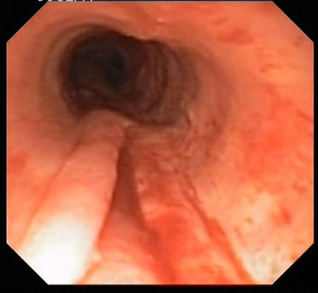
Fig. 2. Fiberoptic bronchoscopy revealing a 3.5 cm solution of continuity in the posterior membranous trachea.

The patient was immediately scheduled for emergency surgical intervention via an anterior cervicotomy. Intraoperative findings confirmed severe peritracheal edema and a full-thickness 3.5 cm longitudinal tear. Primary repair (rafia) was performed using interrupted 3-0 PDS absorbable sutures. To protect the suture line and ensure a stable airway, a protective tracheostomy was placed under bronchoscopic guidance distal to the repair. (Fig. 3). Following the procedure, the patient was moved to the Intensive Care Unit (ICU) for advanced mechanical ventilation.
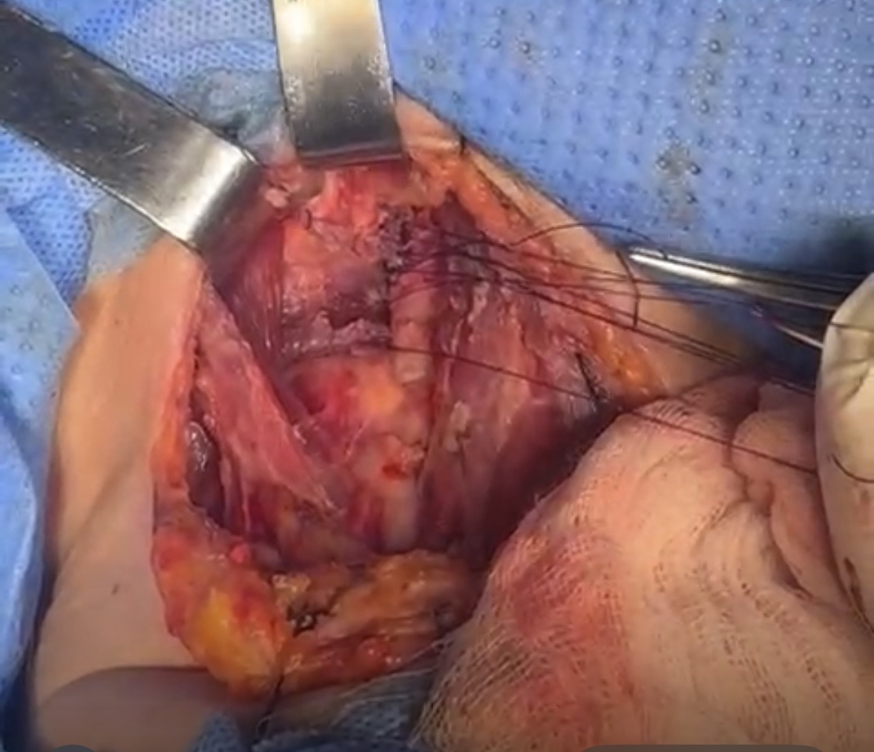
Fig. 3. Intraoperative view of the primary repair of the tracheal laceration via cervicotomy.

Her ICU course was complicated by the rapid development of ventilator-associated pneumonia and acute renal failure. Despite aggressive antibiotic therapy and vasopressor support, she developed refractory septic shock secondary to fulminant mediastinitis. The infection, likely established during the 72-hour diagnostic delay, proved untreatable, and the patient succumbed to multi-organ failure shortly thereafter.

3.discussion

3.1. Pathophysiology and Anatomical Vulnerability
The pars membranosa of the trachea is inherently vulnerable to iatrogenic trauma because it lacks the structural reinforcement of the cartilaginous rings (10). In this case, the injury was likely caused by a combination of direct mechanical friction from the tube tip during multiple intubation attempts and the potential overinflation of the cuff to pressures exceeding 30 cmH₂O (11). High cuff pressure compromises the perfusion of the tracheal mucosa, leading to mucosal ischemia, which can predispose the tissue to tearing even under minor mechanical stress (12).
3.2. Diagnostic Challenges and Pneumoperitoneum
A critical aspect of this case was the presence of subdiaphragmatic pneumoperitoneum, which served as a major diagnostic distractor (13). While pneumomediastinum is a classic sign of PITI, air can dissect through the deep cervical and mediastinal fascial planes, specifically following the periaortic and perioesophageal spaces into the retroperitoneum and eventually the abdominal cavity. This phenomenon has been documented in several series and often leads to unnecessary abdominal exploration, which delays the definitive diagnosis of the tracheal injury. Studies indicate that a diagnostic delay of more than 24 hours is associated with a twofold increase in mortality due to the rapid onset of mediastinitis.
Diagram 1. Diagnostic Algorithm for Iatrogenic Airway Injury

1 | Clinical Trigger | Subcutaneous emphysema, pneumomediastinum, or respiratory distress post-intubation.
2 | Initial Imaging | Chest and neck X-ray (can detect air leaks in 88% of cases)
3 | Advanced Imagin | Chest/Neck CT with 3D reconstruction, mandatory to map air distribution and rule out mediastinal collections.
4 | Definitive Confirmation (Gold Standard): | Urgent Fiberoptic Bronchoscopy.
5 | Characterization: | Use Cardillo Classification (Level I to IIIB).
6 | Rule-Out Concomitant Injury: | Upper GI Endoscopy or contrast study to rule out esophageal perforation.
*(Modified from Passera et al., 2023 and Cardillo et al., 2010)
3.3. Classification and Selection of Management
The morphological classification proposed by Cardillo et al. (2010) is the most widely used tool to guide treatment (14).
• Level I and II injuries (mucosal or muscular involvement only) in stable patients with minimal air leaks can often be managed conservatively with broad-spectrum antibiotics and close monitoring.
• Level IIIA injuries (full-thickness tears with herniation) represent a "gray zone" where management depends on the patient’s respiratory stability and the presence of infection.
• Level IIIB injuries (tears with mediastinitis or esophageal involvement) mandate immediate surgical intervention.
In our patient, the 3.5 cm length and the presence of significant clinical deterioration justified the surgical approach. While some authors advocate for conservative management in tears up to 4 cm if the patient is stable, the progressive nature of the emphysema in this case was a definitive surgical indication.
3.4. Role of Interventional Bronchoscopy
In recent years, a paradigm shift has occurred towards minimally invasive endoscopic management (15). The application of fibrin glue (Tisseel) via flexible bronchoscopy has shown a 100% success rate in sealing Level II and selected Level IIIA injuries in specialized centers (16). Additionally, the use of covered self-expanding metallic stents (SEMS) provides a temporary internal scaffold that allows the tracheal wall to heal by secondary intention while maintaining effective ventilation. These options are particularly valuable for poor surgical candidates with significant comorbidities. However, these techniques require a high level of institutional expertise and are generally not suitable for cases where mediastinitis is already suspected.
3.5. Prevention and Airway Assessment
Prevention remains the cornerstone of reducing PITI incidence. Standardized preoperative airway assessments, including the Mallampati score and thyromental distance, are essential to identify patients at risk for difficult intubations (17). In predicted difficult cases, the early use of video laryngoscopy should be prioritized over repeated conventional attempts to minimize trauma. Furthermore, strict protocols for cuff pressure monitoring (keeping pressures between 20–30 cmH₂O) and ensuring that stylets do not protrude beyond the tube tip are mandatory safety measures (18).

4. Conclusion

Iatrogenic tracheal laceration is an infrequent but devastating complication that carries a high risk of mortality, especially when the diagnosis is delayed. Clinicians must maintain a high index of suspicion in any patient presenting with postoperative subcutaneous emphysema or pneumomediastinum, regardless of the primary surgical site. The presence of pneumoperitoneum should be recognized as a potential distractor rather than a definitive sign of abdominal pathology.
Fiberoptic bronchoscopy should be performed as early as possible to characterize the injury and guide management. While conservative and endoscopic treatments are gaining traction for smaller or less severe injuries, urgent surgical repair remains the standard for large lacerations and cases complicated by mediastinitis. Finally, the implementation of rigorous airway management protocols and continuous training for anesthesia staff are the most effective strategies to prevent these life-threatening events.

Consent (where ever applicable)

Written informed consent was obtained from the patient’s next of kin for the publication of this case report and accompanying images.

Ethical approval (where ever applicable)

This study was performed in accordance with the ethical standards of the 1964 Declaration of Helsinki.

References

- Miñambres E, Burón J, Ballesteros MA, Llorca J, Muñoz P, González-Castro A. Tracheal rupture after endotracheal intubation: a literature systematic review. Eur J Cardiothorac Surg. 2009;35(6):1056–1062.
- Cardillo G, Carbone L, Carleo F, Batzella S, Jacono RD, Lucantoni G, et al. Tracheal lacerations after endotracheal intubation: a proposed morphological classification to guide non-surgical treatment. Eur J Cardiothorac Surg. 2010;37(3):581–587.
- Schneider T, Storz K, Dienemann H, Hoffmann H. Management of iatrogenic tracheobronchial injuries: a retrospective analysis of 29 cases. Ann Thorac Surg. 2007;83(6):1960–1964.
- Passera E, Orlandi R, Calderoni M, Cassina EM, Cioffi U, Guttadauro A, et al. Post-intubation iatrogenic tracheobronchial injuries: The state of art. Front Surg. 2023;10:1125997.
- Grewal HS, Dangayach NS, Ahmad U, Ghosh S, Gildea T, Mehta AC. Treatment of Tracheobronchial Injuries: A Contemporary Review. Chest. 2019;155(3):595–604.
- Leonardi B, Natale G, Messina G, Opromolla G, Mirra R, Capasso F, et al. The use of fibrin glue for the endoscopic management of post-intubation tracheal lacerations: a case series. Shanghai Chest. 2023;7:16.
- Panagiotopoulos N, Patrini D, Barnard M, Koletsis E, Dougenis D, Lawrence D. Conservative versus Surgical Management of Iatrogenic Tracheal Rupture. Case Rep Med. 2017;2017:218–220.
- Lee J, Lee HS, Lee CH. Iatrogenic tracheal laceration after endotracheal intubation: a case report focusing on diagnosis and anesthetic management. Med Biol Sci Eng. 2022;5(2):73-77.
- Zúñiga Quílez S, Urgel Yagüe L, Gómez Madrona J, Guiral Foz MP, Tesán Aznar IA, Bayod Carbó P, et al. Tratamiento de la laceración traqueal post-intubación. A raíz de un caso. Rev Sanitaria de Investigación. 2026;7(3).
- Boyko V, Kritsak V, Sochnieva A, Tkachenko V. Diagnosis and surgical treatment of tracheal cicatricial stenoses: literature review. Wiad Lek. 2025;78(1):177-186.
- Prokakis C, Koletsis EN, Dedeilias P, Fligou F, Filos K, Dougenis D. Airway trauma: a review on epidemiology, mechanisms of injury, diagnosis and treatment. J Cardiothorac Surg. 2014;9:117.
- Marty-Ané CH, Picard E, Jonquet O, Mary H. Membranous tracheal rupture after endotracheal intubation. Ann Thorac Surg. 1995;60(5):1367–1371.
- Rubio Jiménez ME, Cid París E, López Andrés N, Blázquez Arrabal B, Olloqui Escalona A, Jiménez Bustos JM. Rotura traqueal como complicación de una intubación endotraqueal. Acta Pediatr Esp. 2011;69(10):479-482.
- Ortiz Naretto AE. Rol de la endoscopía en la lesión traumática de la vía aérea. Rev Am Med Resp. 2017;17(2):162-171.
- Jaber S, Rollé A, Godet T, Terzi N, Riu B, Asfar P, et al. Effect of the use of an endotracheal tube and stylet versus an endotracheal tube alone on first-attempt intubation success: a multicentre, randomised clinical trial in 999 patients. Intensive Care Med. 2021;47(6):653–664.
- Barrón-Ángeles JCE. Lesiones traqueales iatrogénicas relacionadas con el abordaje de la vía respiratoria. Rev Mex Anestesiol. 2018;41(4):273-277.
- El-Ganzouri AR, McCarthy RJ, Tuman KJ, Tanck EN, Ivankovich AD. Preoperative airway assessment: predictive value of a multivariate risk index. Anesth Analg. 1996;82(6):1197–1204.
- Maldonado C, Saldaña Á, Cornejo R, Illanes V, Romero CM. Tracheal injury post intubation in COVID-19 patients. Rev Chil Anest. 2023;52(7):697-700.

