Case report

Brunner's Gland Hyperplasia of the Periampullary Region Mimicking Carcinoma and Leading to Pancreaticoduodenectomy: A Diagnostic Pitfall for Surgeons

Abstract
Brunner's gland hyperplasia is a rare benign proliferative lesion of the duodenal submucosa that occasionally presents as a periampullary mass with biliary obstruction, closely mimicking carcinoma. We report a 70-year-old woman who presented with recurrent upper abdominal pain without jaundice, weight loss or gastrointestinal bleeding. Ultrasonography showed marked dilatation of the common bile duct with intrahepatic biliary radicle dilatation. Cross-sectional imaging with contrast-enhanced computed tomography and magnetic resonance cholangiopancreatography revealed a heterogeneously enhancing periampullary lesion measuring approximately 10 × 10 × 14 mm involving the distal common bile duct, ampulla and medial duodenal wall. The pancreatic duct measured approximately 4 mm producing a classical double-duct sign strongly suggestive of
periampullary carcinoma. In view of these findings, the patient underwent pancreaticoduodenectomy. Histopathological examination of the resected specimen revealed Brunner’s gland hyperplasia without dysplasia or malignancy. Although nearly 200 cases of Brunner’s gland hyperplasia have been reported worldwide, periampullary localisation producing biliary obstruction and a double-duct sign is exceptionally uncommon and may closely mimic periampullary carcinoma, occasionally leading to radical surgery. This case highlights an important diagnostic pitfall and discusses imaging clues that may help differentiate benign periampullary lesions from malignancy.
Keywords: Brunner's gland hyperplasia; periampullary carcinoma; double-duct sign; pancreaticoduodenectomy; ampulla of Vater

Introduction
Brunner's glands are mucus-secreting glands located predominantly in the proximal duodenum, where they secrete alkaline mucus that neutralises gastric acid and protects the duodenal mucosa.¹ Hyperplastic or hamartomatous proliferation of these glands represents a rare benign entity, accounting for approximately 5–10% of benign duodenal tumours, with an estimated incidence of less than 0.01% in endoscopic series.²˒³ Most Brunner's gland lesions are small, asymptomatic and detected incidentally on endoscopy or imaging; larger lesions may present with abdominal pain, gastrointestinal bleeding, gastric outlet obstruction or, rarely, biliary obstruction.³˒⁴˒⁵
When these lesions arise near the ampulla of Vater, they can closely mimic periampullary carcinoma both clinically and radiologically, particularly when associated with biliary dilatation or the double-duct sign. Only a very small number of cases have been reported in which periampullary Brunner’s gland hyperplasia produced biliary obstruction or a double-duct sign leading to pancreaticoduodenectomy for presumed malignancy.⁴˒⁵˒⁶ The double-duct sign is traditionally regarded as highly suggestive of malignant periampullary obstruction, and in the appropriate clinical context it often leads to pancreaticoduodenectomy.⁵˒⁶˒⁷
For surgeons, the key challenge is to balance the risk of missing a potentially curable periampullary malignancy against the morbidity of unnecessary radical resection.⁶˒⁹ We describe a case of periampullary Brunner's gland hyperplasia in a 70-year-old woman that simulated carcinoma radiologically and led to pancreaticoduodenectomy, and we discuss imaging and endoscopic clues that may help differentiate this benign lesion from malignancy.

Case Report
A 70-year-old female presented with recurrent episodes of upper abdominal pain of several months duration. There was no history of jaundice, gastrointestinal bleeding, or significant weight loss. Physical examination was unremarkable.
Initial abdominal ultrasonography demonstrated dilatation of the common bile duct measuring approximately 16 mm with intrahepatic biliary radicle dilatation. No gallstones or obvious pancreatic mass were visualized.
Upper GI endoscopy showed mild prominence of the papilla.
Contrast-enhanced computed tomography of the abdomen revealed a heterogeneously enhancing lesion in the periampullary region measuring approximately 10 × 10 × 14 mm involving the distal common bile duct, ampulla, and medial wall of the duodenum with upstream dilatation of the common bile duct. The pancreatic duct measured approximately 4 mm producing the classical double-duct sign (Fig 1 and 2).
Magnetic resonance cholangiopancreatography confirmed distal biliary obstruction with abrupt narrowing at the periampullary region. No evidence of distant metastasis or regional lymphadenopathy was identified.
Based on these imaging findings, a diagnosis of periampullary carcinoma was made and the patient underwent pancreaticoduodenectomy (Whipple procedure). Intraoperatively, a small periampullary lesion was identified without evidence of metastatic disease.
Histopathological examination revealed nodular proliferation of Brunner’s glands within the duodenal submucosa forming hyperplastic lobules separated by fibrous septa, dilated ducts and smooth muscle fibres without dysplasia or malignancy, confirming the diagnosis of Brunner’s gland hyperplasia with nests of Brunner’s glands extending into the pancreas (Fig 3 and 4).

Discussion
Brunner's gland hyperplasia is an uncommon benign proliferative lesion arising from the duodenal submucosa. However, periampullary Brunner’s gland hyperplasia causing biliary obstruction and mimicking periampullary carcinoma is extremely rare and represents an important diagnostic pitfall.¹˒² Its pathogenesis is not fully understood, but proposed mechanisms include chronic acid stimulation, Helicobacter pylori-related inflammation, pancreatic exocrine stimulation and chronic mucosal injury.²˒³ Lesions typically occur in the first and second parts of the duodenum and are either incidentally detected or present with non-specific symptoms such as abdominal pain or dyspepsia.³˒⁴
The present case is particularly noteworthy because the lesion produced biliary obstruction and a classical double-duct sign—features that strongly favour malignancy and frequently lead surgeons to perform pancreaticoduodenectomy.
Proliferative Brunner's lesions are variably termed hyperplasia, hamartoma or adenoma, with some authors using size criteria (hyperplasia <10 mm, hamartoma ≥10 mm) and others emphasizing histoarchitectural features.¹˒²˒¹⁰ They are predominantly benign, but rare cases of dysplasia and adenocarcinoma arising within Brunner's gland lesions have been described, supporting complete excision and thorough histopathological evaluation of large or symptomatic lesions.¹¹
Periampullary localisation is rare but clinically significant, as such lesions may produce biliary obstruction, pancreatic duct dilatation and a double-duct sign, thereby closely simulating periampullary carcinoma. Most lesions occur in the first or second part of the duodenum and are typically small and asymptomatic. However, larger lesions may produce symptoms such as gastrointestinal bleeding, gastric outlet obstruction, or abdominal pain.²˒³
In rare cases, lesions located near the ampulla of Vater may cause biliary obstruction and mimic periampullary carcinoma.⁴ This situation creates a diagnostic dilemma because imaging findings such as biliary dilatation and pancreatic duct dilatation (double-duct sign) are traditionally considered highly suggestive of malignant periampullary obstruction.⁴˒⁵˒⁹
In the largest available series of double-duct sign cases, a substantial minority were ultimately found to have benign pathology, underscoring that this sign is not pathognomonic for malignancy.⁶˒⁸
Certain imaging features may favour a benign submucosal lesion over carcinoma, including a well-circumscribed mass, preservation of surrounding fat planes, absence of regional lymphadenopathy and lack of vascular invasion.⁷˒¹⁰ Smooth tapering of the distal bile duct may also suggest a benign cause, in contrast to the abrupt irregular narrowing more typical of malignancy.⁷ Nevertheless, these features often overlap, and in our patient, the combination of obstructive biliopathy, enhancing heterogenous periampullary lesion and double-duct sign strongly favoured carcinoma.
Endoscopic ultrasound can provide valuable information by defining the layer of origin and internal echotexture of periampullary lesions; Brunner's gland hyperplasia typically appears as a homogeneous, hypoechoic or isoechoic submucosal lesion arising from the duodenal wall.¹⁰ EUS-guided biopsy or fine-needle aspiration may allow preoperative histological diagnosis, but tissue sampling is frequently non-diagnostic because of the submucosal location and small size of these lesions. In centres where advanced endoscopic techniques and intra-operative frozen section are available, local excision or endoscopic resection may be feasible for lesions suspected to be benign.¹³
From a surgical perspective, multiple series of pancreaticoduodenectomy specimens have reported a non-trivial proportion of benign pathology, including Brunner's gland hyperplasia and other benign periampullary lesions.¹⁴ In the present case, and in similar reports, proceeding to pancreaticoduodenectomy was considered justified because the consequences of missing a resectable periampullary carcinoma outweighed the risks of surgery.⁴˒⁵˒⁶˒¹² However, increased awareness of Brunner's gland lesions among surgeons, radiologists and endoscopists, along with judicious use of EUS and endoscopic resection where available, may help avoid unnecessary Whipple procedures in select patients.¹⁵
Although nearly 200 cases of Brunner’s gland hyperplasia have been reported worldwide, only a very small number of cases have been described in which the lesion mimicked periampullary carcinoma and led to pancreaticoduodenectomy. Selected reported cases are summarised in Table 1.

Table 1. Reported Cases of Brunner’s Gland Hyperplasia/Hamartoma Mimicking Periampullary Malignancy
Author (Year) | Age/Sex | Location | Presentation & Imaging | Preoperative Diagnosis | Treatment | Final Pathology
Janes et al. (2005)¹² | 46/M | Ampulla of Vater | Abdominal pain, vomiting; periampullary mass on CT | Periampullary malignancy | Whipple resection | Brunner’s gland hyperplasia
Kostalas et al. (2016)⁶ | 52/F | Periampullary (D1–D2) | Weight loss, abnormal LFTs; double-duct sign on CT/MRCP | Ampullary/pancreatic carcinoma | Pylorus-preserving pancreaticoduodenectomy | Brunner’s gland hamartoma
McCafferty et al. (2021)⁴ | 73/F | Second part of duodenum | Obstructive symptoms, large duodenal mass | Duodenal adenocarcinoma | Proximal duodenectomy | Brunner’s gland hyperplasia
Wu et al. (2021)⁵ | 63/M | Ampulla of Vater | Epigastric pain, periampullary lesion on EUS | Benign ampullary tumour | Endoscopic/local excision | Brunner’s gland hyperplasia
Rao et al. (2014)⁸ | 55/F | Periampullary (D2) | Duodenal thickening on CT | Periampullary carcinoma | Whipple procedure | Brunner’s gland hamartoma

Conclusion
Although Brunner’s gland hyperplasia is a rare benign lesion, periampullary localisation producing biliary obstruction and a double-duct sign is exceptionally uncommon and may closely mimic periampullary carcinoma on imaging. Recognition of this rare entity is important because it may prevent misdiagnosis of periampullary carcinoma and unnecessary radical surgery in selected patients.

References
1. Stokes JF, Turnberg LA, Hawksley JC. Hyperplasia of Brunner's glands. Gut. 1964;5:459-62.
2. Patel ND, Levy AD, Mehrotra AK, Sobin LH, Ziminski KE, Abbott RM. Brunner's gland hyperplasia and hamartoma: imaging features with clinicopathologic correlation. AJR Am J Roentgenol. 2006;187(6):1491-8.
3. Tanabe H, Iwashita A, Hara S, Ando T, Sugimoto H, Ozeki K. Endoscopic mucosal resection of a large duodenal Brunner's gland hamartoma. Case Rep Gastroenterol. 2013;7(3):456-61.
4. McCafferty J, Tokhi A, Pande G. Case report of Brunner's gland hyperplasia: a rare "mimic" of malignant pathology. Int J Surg Case Rep. 2021;81:105775.
5. Wu YH, Wang HP, Su WC, Chen CY, Yang TH, Chen TH. An unusual cause of epigastric pain: Brunner's gland hyperplasia of the ampulla of Vater. Int Arch Intern Med. 2021;5(1):031-3.
6. O'Shea D, Kostalas M, Omorogbe J, Menon A, Steed H, Dennison AR. Brunner's gland hamartoma: a cause of the double-duct sign. Ann R Coll Surg Engl. 2016;98(5):e73-5.
7. Kim JH, Eun HW, Kim YJ, Lee JY, Park HS, Han JK, Choi BI. Imaging features of benign and malignant ampullary and periampullary lesions. Radiographics. 2014;34(3):624-41.
8. Rao RV, Kumar A, Sikri M, Gupta V, Yadav TD, Rao KL. Brunner gland hamartoma masquerading as malignancy: a rare case report. J Clin Diagn Res. 2014;8(10):FD13-4.

9 Peloso A, Viganò J, Vanoli A, Dominioni T, Zonta S, Bugada D, et al. Saving from unnecessary pancreaticoduodenectomy: Brunner’s gland hamartoma—case report on a rare duodenal lesion and exhaustive literature review. Ann Med Surg (Lond). 2017;17:43-49.
10. AlKhatib A, Lakhtakia S, Ramchandani M, Basha J, Nageshwar Reddy D. Brunner's gland hyperplasia: a massive duodenal lesion. Cureus. 2020;12(4):e7542.
11. Nakatsubo T, Ueda T, Matsuura Y, Ito T, Kachi K, Kawabe N. Adenocarcinoma in situ arising from Brunner's gland treated by endoscopic mucosal resection. Clin J Gastroenterol. 2017;10(3):259-63.
12. Janes SE, Zaitoun AM, Rahman S, Scott N, Shenoy HG. Brunner's gland hyperplasia at the ampulla of Vater. JOP. 2005;7(6):627-30.
13. Catalano MF, Linder JD, Chak A, Sivak MV Jr, Raijman I, Geenen JE. Endoscopic management of adenoma of the major duodenal papilla. Gastrointest Endosc. 2004;59(3):225-32.
14. Bhargav PR, Devi NV, Suresh V, Pawar S, Kumar KS. Benign pathologies encountered in the Whipple specimens: a review. Int Surg J. 2021;8(5):1532-7.
15. Gurusamy KS, Pamecha V, Sharma D, Nagala P, Davidson BR, Fusai G. Diagnostic accuracy of cross-sectional and endoscopic imaging in ampullary tumours: systematic review. Br J Surg. 2024;111(1):znad432.

Fig 1

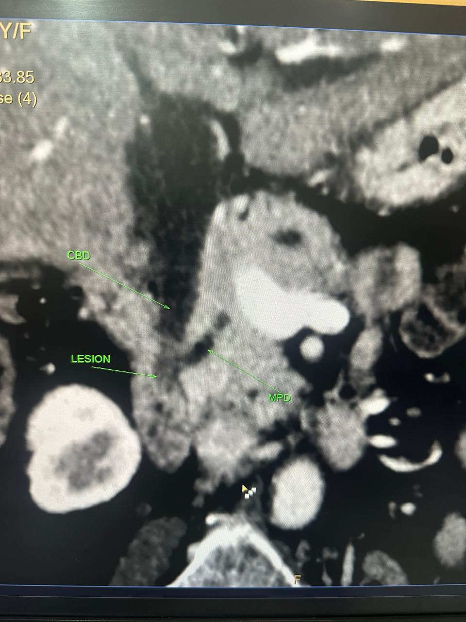
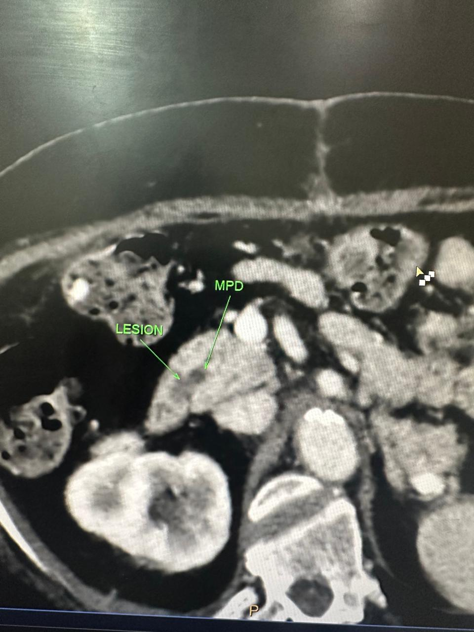

Fig 2

Fig 1 and 2: Double duct sign with tumor on cect

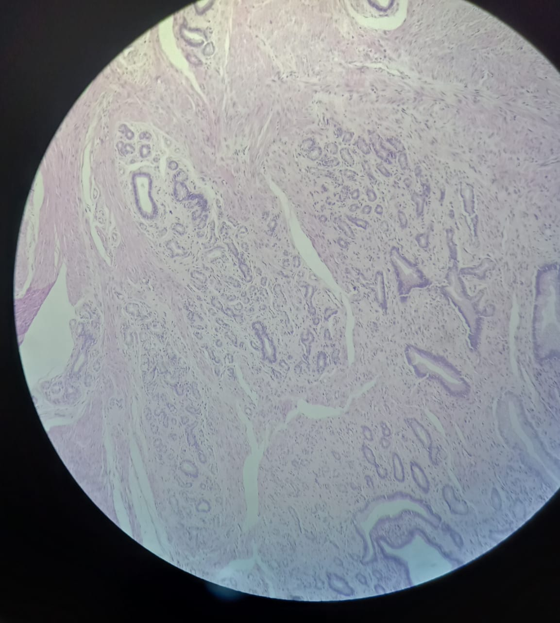

Figure 3Brunner gland hyperplasia

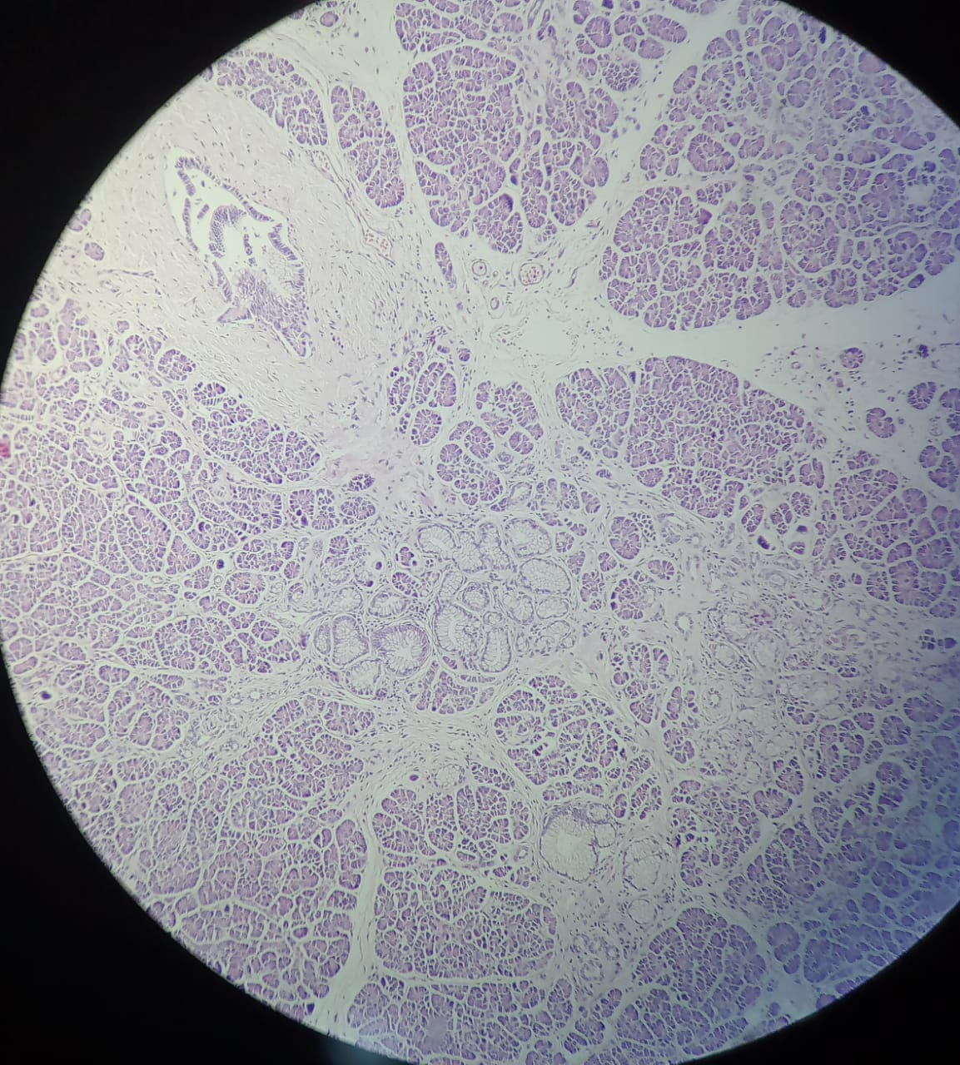
Figure 4 : Nests of Brunner’s glands extending into the pancreas

