Case report

DECEPTIVE IN THE PALM: FIBROLIPOMATOUS HAMARTOMA MASQUERADING AS A TUMOR

ABSTRACT
Fibrolipomatous hamartoma, also known as Neurolipoma or lipomatosis of nerve, is a rare, non-cancerous growth that happens when fibro-fatty tissue grows around peripheral nerves. It most often affects the median nerve and may show up as a soft tissue swelling that slowly gets bigger and is linked to symptoms of compression. It can be hard to make a diagnosis before surgery, especially with cytology, because the signs are similar to those of other benign spindle cell lesions. We describe a case involving a 48-year-old male who exhibited a 3-month history of swelling in the right hand, accompanied by numbness and tenderness. A clinical exam showed a swelling that was 3 × 3 cm. Fine needle aspiration cytology revealed aggregates of small, benign spindle cells, indicating a diagnosis of benign spindle cell lesion. Histopathological analysis of the excised specimen demonstrated fibro-fatty tissue containing distinctive nerve bundles situated within fibrocollagenous stroma and adipose tissue, indicative of neurolipoma. The case is presented due to its rarity, diagnostic challenges in cytology, and distinctive histopathological characteristics.
Keywords: Neurolipoma, fibrolipomatous hamartoma, lipomatosis of nerve, hand swelling, spindle cell lesion, histopathology, FNAC
Introduction
Fibrolipomatous hamartoma (FLH) also known as Neural fibrolipoma, is a rare benign tumor that usually develops in the upper limb and tends to arise around the median nerve. This disorder also affects the ulnar, radial, and brachial plexus and advance over a period of time. FLH usually occur within the first two or three decades of life and the etiology is not clear. It is currently believed that FLH is, quite simply, a hamartoma because fibrous and fatty tissues are normal constituents of the connective tissue stroma of the nerve. These diseases are associated with abnormal bone formation, which leads to macrodactyly in around 33 % of instances. The medical term for this illness is macrodystrophia lipomatosa (MDL) (Soedjana et al., 2024; Giri et al., 2024). Histopathology revealed the presence of enlarged nerve bundles admixed with mature fat cells and diffuse fibroblastic proliferation. Three months later, he underwent urgent contralateral carpal tunnel decompression for a similar presentation. The final diagnosis was bilateral fibrolipomatous hamartoma (FLH) of the median nerves causing acute bilateral compression neuropathy (Senger et al., 2014).

Case presentation
A 48-year-old male exhibited swelling in the right hand, accompanied by numbness and tenderness for three months. A 3 × 3 cm swelling was observed in the right hand during the clinical examination. Taking into account the location and sensory symptoms, a benign soft tissue lesion with possible neural involvement was clinically considered.
Fine needle aspiration cytology was done. Smears revealed aggregates of small, benign, non-descript spindle cells. The diagnosis of a benign spindle cell lesion was made based on the cytomorphology.
The lesion was then cut out and sent for histopathological testing. The specimen was a fibrofatty tissue mass that was 3.5 × 3 cm in size and had small areas of bleeding on the cut surface.
A microscopic examination showed fibro-fatty tissue with many nerve fascicles embedded in a dense fibrocollagenous stroma giving a ‘coaxial cable’ appearance . Mature adipose tissue was observed infiltrating and encircling the nerve bundles, resulting in the separation of the fascicles. The spindle cells exhibited cytological blandness, with no evidence of necrosis, notable mitotic activity, or atypia detected. These characteristics were indicative of fibrolipomatous hamartoma.
Discussion
Fibrolipomatous hamartoma is a rare benign tumor-like lesion of peripheral nerves, characterized by an overgrowth of fibrous and mature adipose tissue around and within the nerve sheath, especially involving the epineurium and perineurium. Histologically, the lesion shows nerve bundles splayed apart by infiltrating adipose tissue and fibrous tissue, which is the key diagnostic feature seen in the present case. [4,5]
This lesion most commonly affects the median nerve, particularly in the hand and wrist region, although involvement of digital nerves and unusual sites has also been reported. Patients may present with a mass lesion, pain, numbness, paresthesia, or symptoms related to compressive neuropathy. The patient in the present case had a right-hand swelling associated with numbness and tenderness, which fits with the known clinical spectrum of the disease. [1-3]. A major diagnostic issue is the inconsistent terminology used in the literature. Neural fibrolipoma, fibrolipomatous hamartoma, and lipomatosis of nerve have all been used for this lesion. More recent literature distinguishes fibrolipomatous hamartoma/lipomatosis of nerve from intraneural lipoma, the latter being a circumscribed lesion with different clinical, radiological, and surgical implications. [6] FNAC may be of limited diagnostic utility, as aspirates can be scant and nonspecific, often showing only benign spindle cells or fibroadipose fragments. In the present case, cytology suggested a benign spindle cell lesion, which was understandable given the sampling limitations. Definitive diagnosis was achieved only on histopathology, which demonstrated the characteristic admixture of fibrocollagenous tissue, mature adipose tissue, and entrapped nerve fascicles. [1,4]
The important histological differentials include neurofibroma, schwannoma, and intraneural lipoma. Neurofibroma and schwannoma do not show the same pattern of diffuse fibro-fatty infiltration splaying nerve fascicles. Intraneural lipoma, on the other hand, is generally more circumscribed and lacks the diffuse infiltrative pattern seen in fibrolipomatous hamartoma. Correct recognition is important because aggressive excision of a nerve-based lesion may risk neurological deficit. [1,6]
Microscopic surgery is the primary treatment for suspected neurolipomas. Typically, an exploratory operation with excisional biopsy was performed to confirm the diagnosis. Surgeons attempt to retain critical nerve branches when removing a neurolipoma, as radical nerve resection is not indicated. Extensive intraneural dissection is associated with a substantial risk of neurological damage from ischemic consequences. [7]
Because of its rarity, unusual presentation as a hand swelling, and the availability of cytological as well as histopathological correlation, the present case adds to the limited literature on this entity.
Conclusion
Neurolipoma is a rare benign peripheral nerve lesion that may present as a painful or tender swelling of the hand with associated sensory symptoms. Preoperative cytological diagnosis may be challenging and may only suggest a benign spindle cell lesion. Histopathological examination is crucial for definitive diagnosis. Awareness of this entity is important to avoid diagnostic confusion with other spindle cell and lipomatous lesions of the hand.
References
- Kini JR, Kini H, Rau A, Kamath J, Kini A. Lipofibromatous Hamartoma of the Median Nerve in Association with or without Macrodactyly. Turk Patoloji Derg. 2018;34(1):87-91. doi: 10.5146/tjpath.2014.01282. PMID: 25371022.
- Walker CW, Adams BD, Barnes CL, Roloson GJ, FitzRandolph RL. Case report 667. Fibrolipomatous hamartoma of the median nerve. Skeletal Radiol. 1991;20(3):237-9. doi: 10.1007/BF00241679. PMID: 2057803.
- Mahan MA, Amrami KK, Howe BM, Spinner RJ. Segmental thoracic lipomatosis of nerve with nerve territory overgrowth. J Neurosurg. 2014 May;120(5):1118-24. doi: 10.3171/2013.12.JNS13174. Epub 2014 Feb 7. PMID: 24506247.
- Venkatesh K, Saini ML, Rangaswamy R, Murthy S. Neural fibrolipoma without macrodactyly: a subcutaneous rare benign tumor. J Cutan Pathol. 2009 May;36(5):594-6. doi: 10.1111/j.1600-0560.2008.01088.x. Epub 2008 Mar 30. PMID: 19476532.
- Mam P, Lewis EB, Song T, Bakotic BW. Fibrolipomatous hamartoma of nerve in the great toe. J Am Podiatr Med Assoc. 2014 Sep-Oct;104(5):531-4. doi: 10.7547/0003-0538-104.5.531. PMID: 25275745.
- Okubo T, Saito T, Mitomi H, Takagi T, Torigoe T, Suehara Y, Katagiri H, Murata H, Takahashi M, Ito I, Yao T, Kaneko K. Intraneural lipomatous tumor of the median nerve: Three case reports with a review of literature. Int J Surg Case Rep. 2012;3(9):407-11. doi: 10.1016/j.ijscr.2012.05.007. Epub 2012 May 23. PMID: 22705575; PMCID: PMC3397293.
- Cui Q, Chhabra AB, Leo BM, Pannunzio ME. Lipofibromatous hamartoma of a digital nerve. Am J Orthop, 2008 Aug 1; 37(8): E146-8.
- Soedjana, H., Riestiano, B. E., Hasibuan, L. Y., & Kusumadiningrat, V. M. (2024). Fibrolipomatous hamartroma with macrodactyly in a 4 years old female patient: A case report. International Journal of Surgery Case Reports, 118, 109680.
- Giri S, Reddy MVS, Suba S, Purkait S, Jain M. Fibrolipomatous Hamartoma Over the Left Forearm and Palm. Journal of Orthopaedic Case Reports 2024 February, 14(02): 34-38.
- Senger JL, Classen D, Bruce G, Kanthan R. Fibrolipomatous hamartoma of the median nerve: A cause of acute bilateral carpal tunnel syndrome in a three-year-old child: A case report and comprehensive literature review. Plast Surg (Oakv). 2014 Fall;22(3):201-6. PMID: 25332651; PMCID: PMC4173870.

Figures:
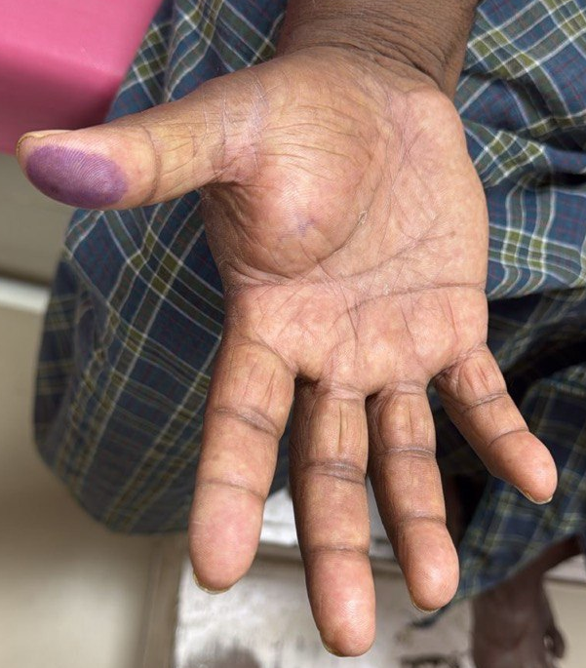
Figure 1: Clinical photograph of the right palm showing a diffuse, ill-defined soft tissue swelling involving the thenar region, producing fullness of the palm. The overlying skin appears unremarkable without ulceration.
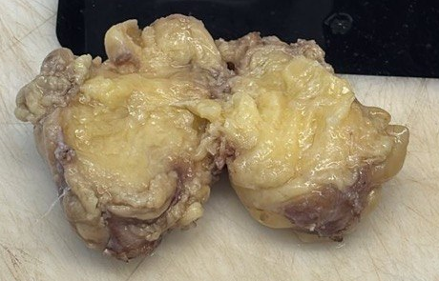
Figure 2: Gross specimen showing an ill-defined, lobulated, yellowish mass with a greasy cut surface. The lesion appears infiltrative with fibrofatty tissue interspersed within the specimen
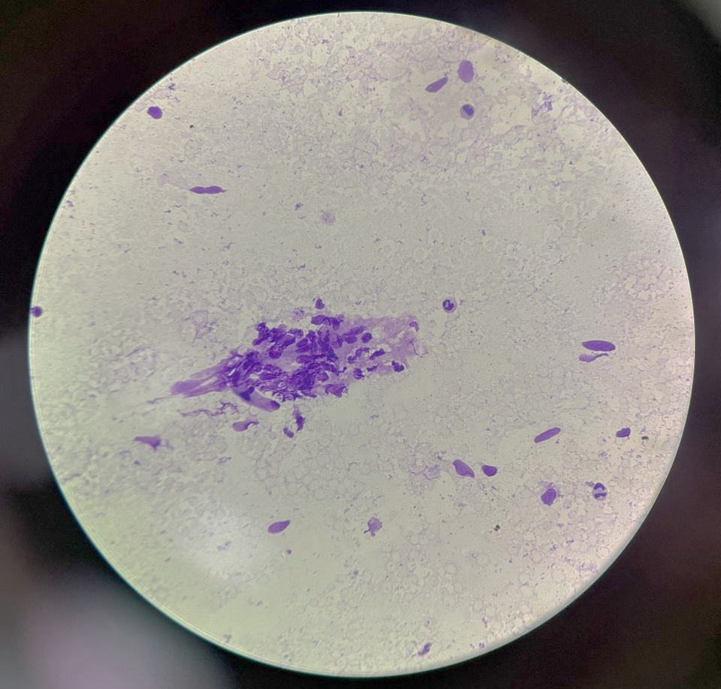
Figure 3: Cytology smear showing clusters of spindle-shaped cells with elongated nuclei embedded in a fibrillary stroma, admixed with adipocytic background (MGG Stain, 400x).

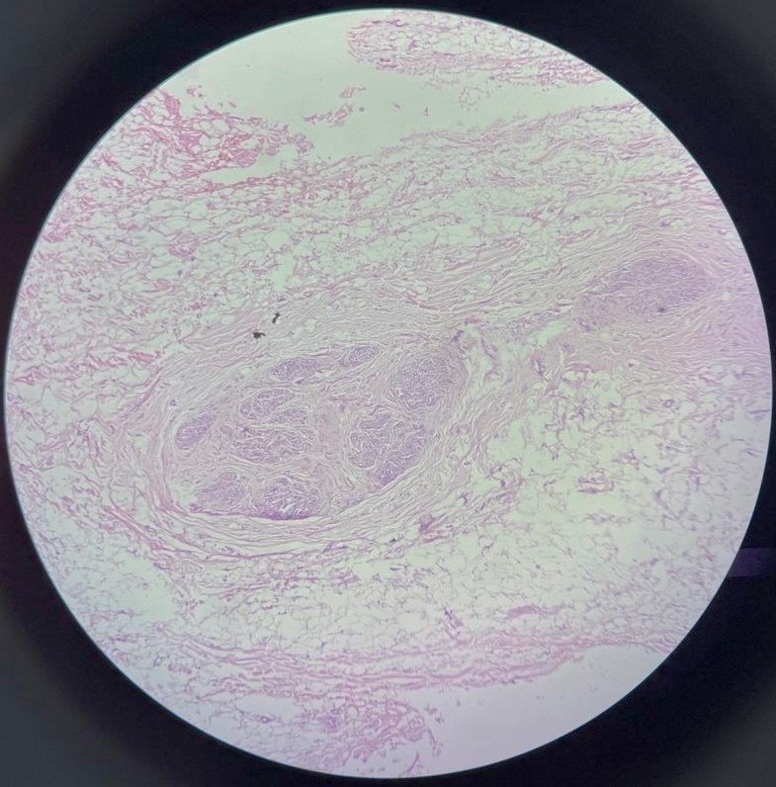
Figure 4: Photomicrograph (H&E), 100x, showing a peripheral nerve bundle with marked fibrofatty proliferation.
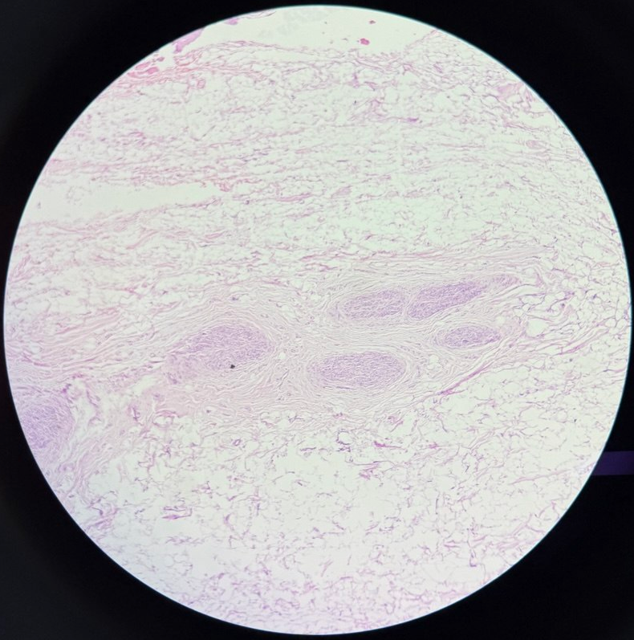
Figure 5 : Photomicrograph (H&E), 200x, showing mature adipose tissue infiltrates and surrounds the nerve fascicles.

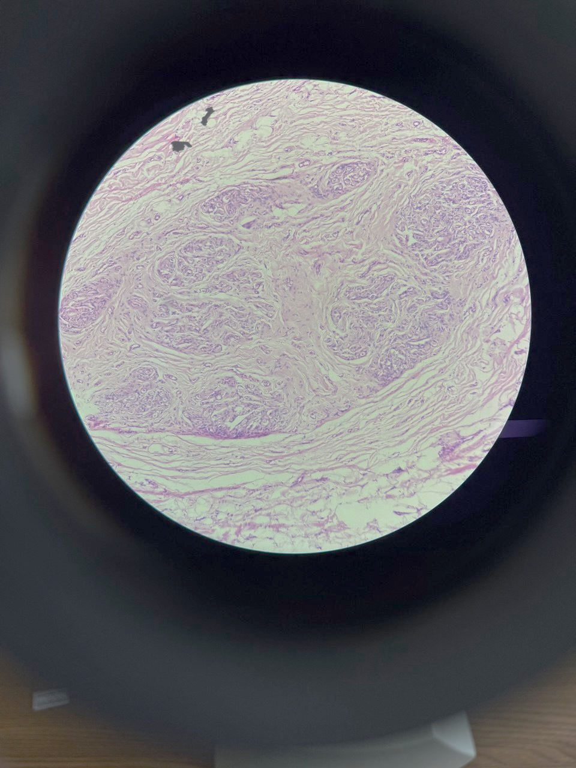
Figure 6: Photomicrograph (H&E), 400x, showing a peripheral nerve bundle with marked fibrofatty proliferation. Mature adipose tissue infiltrates and surrounds the nerve fascicles, which are separated by fibrous septae, producing a characteristic “coaxial cable” appearance.

