Unexpected congenital gallbladder malformation discovered during laparoscopic cholecystectomy for symptomatic cholelithiasis: a case report

Abstract

Background
Congenital anomalies of the gallbladder are rare anatomical variations that may involve its shape, number, or position. Most of these anomalies remain asymptomatic and are incidentally discovered during imaging studies or surgical procedures. Their recognition is important because they may complicate laparoscopic cholecystectomy and increase the risk of bile duct injury.

Case presentation
We report the case of a 19-year-old female with no significant past medical history who presented with right hypochondrial pain associated with vomiting evolving for one month. Clinical examination revealed a soft abdomen with a negative Murphy sign. Laboratory investigations showed mild cytolysis without cholestasis. Abdominal ultrasonography revealed a multilithiasic gallbladder without signs of complication. The patient underwent laparoscopic cholecystectomy. During specimen retrieval, an unusual difficulty was encountered requiring enlargement of the trocar incision. After extraction and opening of the gallbladder specimen, a congenital morphological malformation of the gallbladder was identified.

Conclusion
Congenital gallbladder anomalies are uncommon but clinically relevant. Surgeons should be aware of these anatomical variations, which may be discovered intraoperatively and may complicate surgical management. Careful dissection and adherence to the critical view of safety remain essential to prevent biliary injuries.
Keywords: congenital gallbladder anomaly, cholelithiasis, laparoscopic cholecystectomy, biliary anatomy variation.

Highlights
- Congenital anomalies of the gallbladder are rare and often asymptomatic.
- They are frequently discovered incidentally during surgery for gallstone disease.
- These anomalies may complicate laparoscopic cholecystectomy and increase the risk of bile duct injury.
- Awareness of biliary anatomical variations is essential for safe surgical practice.

Introduction
Congenital anomalies of the gallbladder are rare anatomical variations resulting from abnormalities in the embryological development of the hepatobiliary system. These anomalies may affect the number, shape, size, or location of the gallbladder [1].
They arise from disturbances in the development of the cystic bud originating from the hepatic diverticulum during the fourth to sixth week of embryogenesis [2].
Several types of anomalies have been described in the literature, including gallbladder duplication, bilobed gallbladder, septate gallbladder, and the so-called Phrygian cap deformity [3].
Although most of these anomalies remain asymptomatic, their recognition is important for surgeons performing laparoscopic cholecystectomy, as anatomical variations may increase the risk of bile duct injury [4].
We report a case of congenital gallbladder malformation discovered incidentally during laparoscopic cholecystectomy performed for symptomatic gallstone disease.

Case presentation
A 19-year-old female patient with no significant past medical history was admitted for evaluation of right hypochondrial pain.
The history of the illness dated back one month prior to admission and was characterized by intermittent right upper quadrant pain associated with vomiting. The patient reported no bowel disturbances, jaundice, or symptoms suggestive of cholestasis. The evolution occurred in a context of apyrexia with preserved general condition.
On clinical examination, the abdomen was soft with no guarding or tenderness, and Murphy’s sign was negative.

Laboratory investigations
Laboratory tests revealed:
- Hemoglobin: 12.9 g/dL
- White blood cell count: 3500/mm³
- Prothrombin time: 92%
- AST: 62 IU/L
- ALT: 134 IU/L
- Alkaline phosphatase: 86 IU/L
- GGT: 87 IU/L
- Total bilirubin: 6 mg/L
  - Conjugated bilirubin: 3 mg/L
  - Unconjugated bilirubin: 3 mg/L
- CRP: 6.4 mg/L

Imaging
Abdominal ultrasonography demonstrated a multilithiasic gallbladder without signs of acute cholecystitis or bile duct dilation.

Surgical management
A laparoscopic cholecystectomy was performed using the retrograde technique.
Intraoperative exploration showed no peritoneal effusion. The gallbladder appeared thin-walled and multilithiasic without signs of inflammation.
During extraction of the gallbladder specimen through the trocar site, an unusual resistance was encountered. An attempt to evacuate gallstones using a stone-grasping forceps was unsuccessful, and the fundus could not be retrieved.
The trocar incision was therefore enlarged to allow specimen extraction.
After removal and opening of the gallbladder, a congenital morphological malformation of the gallbladder was identified. (Figure 1)
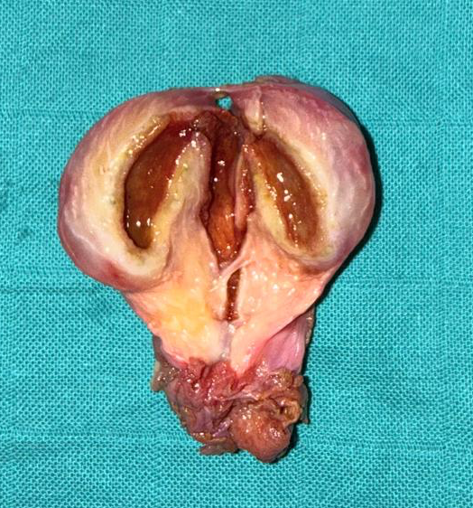
Figure 1: Operative specimen after extraction and opening showing a congenital morphological malformation of the gallbladder
The postoperative course was uneventful, and the patient recovered without complications.

Discussion
Congenital anomalies of the gallbladder represent a spectrum of anatomical variations resulting from abnormalities in embryological development [1].
During normal embryogenesis, the gallbladder and cystic duct arise from the cystic bud of the hepatic diverticulum. Disruption of this process may lead to structural anomalies of the gallbladder [2].
One of the most common anomalies is the Phrygian cap deformity, characterized by folding of the gallbladder fundus over the body. This variant is present in approximately 1–6% of the population and is usually asymptomatic [5].
More complex anomalies include gallbladder duplication, a rare condition with an estimated incidence of approximately 1 in 4000 births [6].
Boyden proposed one of the earliest classifications of gallbladder duplication, distinguishing true duplication from bilobed gallbladders [7].
Other morphological anomalies include septate gallbladder, which results from incomplete vacuolization of the gallbladder during embryogenesis [8].
Although these anomalies are usually asymptomatic, they may be associated with gallstone formation due to bile stasis and abnormal gallbladder motility [9].
Imaging plays an important role in the preoperative evaluation of gallbladder pathology. Ultrasonography remains the first-line modality for detecting gallstones and gallbladder disease. However, it may fail to identify certain anatomical anomalies, particularly subtle morphological variations [10].
Magnetic resonance cholangiopancreatography (MRCP) provides better visualization of the biliary tree and may help detect complex biliary anomalies [11].
From a surgical perspective, congenital anomalies of the gallbladder may complicate laparoscopic cholecystectomy by altering the usual anatomical landmarks of the Calot triangle. Such variations increase the risk of bile duct injury, one of the most severe complications of laparoscopic cholecystectomy [12].
The incidence of bile duct injury during laparoscopic cholecystectomy ranges from 0.3% to 0.7% according to large series [13].
To minimize this risk, Strasberg introduced the concept of the critical view of safety, which emphasizes the importance of clear identification of the cystic duct and cystic artery before division [14].
In our case, the congenital gallbladder malformation was not identified preoperatively and was discovered incidentally during specimen extraction. Similar intraoperative discoveries have been reported in the literature, highlighting the unpredictable nature of biliary anatomical variations [15].
Awareness of these anomalies and careful surgical technique remain essential for safe biliary surgery.

Conclusion
Congenital gallbladder malformations are rare and often discovered incidentally during surgery. Surgeons should be aware of these anatomical variations, which may complicate laparoscopic cholecystectomy. Careful dissection and strict adherence to the critical view of safety are essential to avoid biliary injuries.

References
- Rafailidis V, et al. Two congenital anomalies in one: ectopic gallbladder with Phrygian cap deformity. Ann Gastroenterol. 2014.
- Moore KL, Persaud TVN. The Developing Human: Clinically Oriented Embryology. 10th ed. Elsevier; 2015.
- Kannan NS, et al. Congenital bilobed gallbladder with Phrygian cap presenting as calculus cholecystitis. J Clin Diagn Res. 2014.
- Hugh TB. New strategies to prevent laparoscopic bile duct injury. Surg Endosc. 2002.
- Kokilavani J, Indiran V. Phrygian cap. Abdom Radiol. 2017.
- Causey MW, et al. Gallbladder duplication: evaluation, treatment, and classification. J Pediatr Surg. 2010.
- Boyden EA. The accessory gallbladder. Am J Anat. 1926.
- Desolneux G, et al. Gallbladder duplication: a case report and literature review. Int J Surg Case Rep. 2013.
- Gigot JF, et al. Laparoscopic treatment of gallbladder duplication. Surg Endosc. 1997.
- Paulson EK. Imaging of gallbladder disease. Radiol Clin North Am. 2002.
- Soto JA, et al. MR cholangiography of the biliary tract. Radiology. 2000.
- Deziel DJ, et al. Complications of laparoscopic cholecystectomy. Am J Surg. 1993.
- Strasberg SM. Avoidance of biliary injury during laparoscopic cholecystectomy. J Hepatobiliary Pancreat Surg. 2002.
- Strasberg SM. Critical view of safety in laparoscopic cholecystectomy. J Am Coll Surg. 1995.
- Desolneux G, et al. Gallbladder duplication discovered during laparoscopic cholecystectomy. Int J Surg Case Rep. 2013.

