Original Research Article
Hepatorenal Antioxidant Effects of Hibiscus sabdariffa and Zingiber officinale Combined Extract in Streptozotocin-induced Diabetic Rats

Abstract
Diabetes mellitus is associated with chronic hyperglycaemia promotes generation of excess reactive oxygen species, leading to oxidative stress and damage to vital organs such as the liver and kidney. Due to the side effects that sometimes accompany the use of synthetic antidiabetic drugs to ameliorate nephropathy, hepatopathy and other complications, attention has been drawn to Hibiscus sabdariffa. This study evaluated the hepatorenal antioxidant effects of combined aqueous extracts of Hibiscus sabdariffa and Zingiber officinale in streptozotocin-induced diabetic rats, with growing interest in plant-based therapies for managing oxidative stress–related diabetic complications. Finely powdered plant materials were extracted using an aqueous method, lyophilized, and reconstituted prior to administration. Diabetes was induced using streptozotocin (60 mg/kg body weight), and animals were treated orally for 14 days with a fixed dose (400 mg/kg body weight) of combined extracts at varying ratios (95% + 5%, 90% + 10%, and 80% + 20%), while metformin served as the reference drug. Antioxidant parameters including superoxide dismutase, catalase, glutathione peroxidase, glutathione S-transferase, reduced glutathione, and malondialdehyde were assessed in liver and kidney tissues. The results demonstrated significant reductions in antioxidant enzyme activities and glutathione levels, alongside elevated lipid peroxidation, in diabetic untreated rats. Treatment with the combined extracts markedly restored antioxidant defenses and reduced malondialdehyde concentrations, with some combinations producing effects comparable to or exceeding metformin. The findings indicate that the combined extracts exert strong hepatorenal antioxidant effects, likely mediated by synergistic phytochemicals, and support their potential as complementary agents in mitigating oxidative stress–induced diabetic complications.
Keywords: Diabetes, H. sabdariffa, Z. officinale, Combined, Antioxidant
Introduction
Diabetes mellitus (DM) is a chronic metabolic condition that is present due to uncontrolled hyperglycemia caused by insulin secretion defects, insulin action defects, or both (ADA, 2023). Diabetes is a significant issue in global public health and is considered to be the disease affecting 537 million adults (20-79 years) in 2021, with the number expected to reach 783 million by 2045 (IDF, 2021). First of all, in 2023 the World Health Organization stated that diabetes was the leading cause of death in the amount of about 1.6 million each year, and the prevalence of diabetes in the low- and middle-income countries was growing considerably (WHO, 2023). The pathophysiology of diabetes involves impaired glucose metabolism resulting from pancreatic b-cell dysfunction and insulin resistance. A critical aspect of its progression is oxidative stress, primarily driven by excessive production of reactive oxygen species (ROS) and reduced antioxidant defenses (Kaur et al., 2025). Elevated ROS disrupt cellular signaling, damage lipids and proteins, and impair insulin signaling pathways, contributing to complications affecting vital organs such as the liver and kidneys (Forbes et al., 2022; Zhang et al., 2023). Common symptoms of diabetes mellitus include polyuria, polydipsia, polyphagia, unexplained weight loss, blurred vision, fatigue, and delayed wound healing (ADA, 2023). The current treatment options are focused on glycemic control based on lifestyle modification and pharmacological tools, including insulin therapy, metformin, sulfonylureas, DPP-4, SGLT2, and GLP-1 receptor agonists (Davies et al., 2023). Although conventional antidiabetic medications such as metformin are effective in glycaemic control, their use is commonly associated with adverse effects, particularly gastrointestinal symptoms such as diarrhea, abdominal pain, and nausea, which can limit treatment adherence (Nabrdalik et al., 2024). Furthermore, the long-term effectiveness of many antidiabetic therapies is limited by progressive β-cell dysfunction and persistent insulin resistance, while the high cost of chronic treatment remains a major barrier to sustained diabetes management (McGill et al., 2024; Gkrinia et al., 2023). This has enhanced the curiosity of using plant-based therapies that have antioxidant and hypoglycemic properties (El-Tantawy, 2022). Hibiscus sabdariffa is a source of anthocyanin, flavonoid and phenolic compounds that have been recognized to be antioxidants, anti-inflammatory and hypolipidemic (Ali et al., 2023). Gingerols, shogaols, and paradols are the bioactive compounds found in Zingiber officinale with antioxidant, antidiabetic, and hepatoprotective properties (Kumar et al., 2024). Hibiscus sabdariffa and Zingiber officinale may act synergistically with regard to free radical scavenging and antioxidant enzyme activity leading to a better protection against hepatic and renal oxidative damage caused by diabetes. Although individual antioxidant activity has been developed in both plants, their interactive effects in vivo are not well comprehended, especially to counteract the oxidative stress related to hepatic and renal dysfunction in diabetes. Therefore, the purpose of the research was to test the in vivo hepatorenals antioxidant activity of the combined extracts of Hibiscus sabdariffa and Zingiber officinale on streptozotocin-induced diabetic rats.
Materials and Methods
Preparation and Reconstitution of Extracts
Extraction of plant sample was done using the aqueous extraction method. Concisely, 1000 g of each sample was boiled for 20 minutes, and then sieved. The liquid extracts were lyophilized to obtain the crude extracts. For the H. sabdariffa (HS) and Z. officinale (ZO) combination, 95 g of H. sabdariffa (HS) was mixed with 5 g of Z. officinale (95% HS + 5% ZO). For the 95% HS + 5% ZO composition, 90 g of H. sabdariffa (HS) and 10 g of Z. officinale (ZO) were mixed together, while 80 g of H. sabdariffa (HS) and 20 g of Z. officinale (ZO) were mixed together to form the 80% HS + 20% ZO composition. The mixtures were then kept in a refrigerator for further use.
Experimental Design
The experimental animals were housed in a tidy six-compartment ventilated cage at the Research Fulcrum Laboratory in Tanke, Ilorin, Nigeria. The rats were randomly grouped into six. Groups 1 were the non-diabetic control group that was treated with distilled water. The second group was the diabetic rats induced using 60 mg/kg body weight (b.wt.) of streptozotocin (Zaky et al., 2022), and it was the negative control group. Group 3 was treated using 14.3 mg/kg b.wt. of Metformin. The fourth to the sixth group was the test group treated with a combination of Hibiscus sabdariffa extract with Zingiber officinale at varied doses: 95% + 5%, 90% + 10% concentration levels, and 80% + 20% respectively. These were given in a single oral dose for 14 days using the intubation technique. The mixtures of the Hibiscus sabdariffa extract powder and the Zingiber officinale powder were given in a fixed dose of 400 mg/kg body weight.
In vivo Antioxidant Assays
Antioxidant Assays
All antioxidant parameters were carried out on both liver and kidney tissues. For superoxide dismutase (SOD) activity, the assay was assessed using the method described by Misra and Fridovich (1972), while catalase (CAT) activity was evaluated using the method of Beers and Sizer (1952). Glutathione peroxidase (GPx) was assessed using the method of Iskusnykh et al. (2013). Glutathione S-transferase activity was assayed using phosphate buffered saline and Cyclic Nucleotide-Binding Domain (CNBD) as described by Habig et al. (1974).. Reduced glutathione (GSH) and malondialdehyde (MDA) concentrations were determined according to Ellman (2022) and Ko (2010), respectively.
Statistical Analysis
Statistical analysis was performed using one-way Analysis of Variance (ANOVA), and differences were considered significant at a probability level of p < 0.05. Data were expressed as mean ± standard error of the mean (SEM) of four replicates (n=4). The analysis was conducted using GraphPad Prism software, version 8.0.2 (GraphPad Software, Inc., San Diego, California, USA).
Results
There was no significant difference (p < 0.05) in the liver SOD activity of the Normal Control, PC (14.3 mg/kg b.wt Metformin), and 95% HS + 5% ZO (400 mg/kg b.wt) groups (Figure 1). The liver SOD activity of the Diabetic Control group was significantly lower (p < 0.05) than all other groups. The liver SOD activity of the 90% HS + 10% ZO and 80% HS + 20% ZO (400 mg/kg b.wt) groups showed no significant difference (p < 0.05) between each other, and their SOD activities were significantly higher (p < 0.05) compared to the Normal Control, Metformin, and 95% HS + 5% ZO groups.

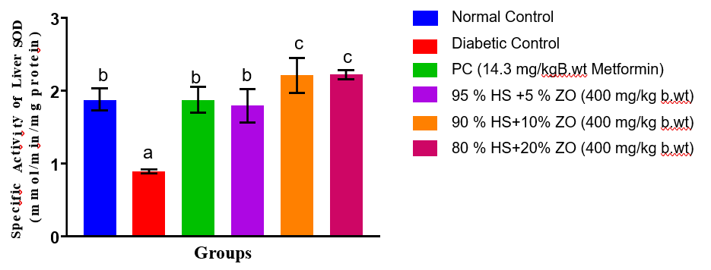
Figure 1. Specific Activity of Superoxide Dismutase (SOD) in the Liver of Streptozotocin-Induced Diabetic Rats Administered Combined Extracts of Hibiscus sabdariffa and Zingiber officinale
Values are expressed as Mean ± SEM of three replicates, and bars with different superscripts are significantly different (p < 0.05).
There was no significant difference (p < 0.05) in the kidney SOD activity of Normal Control, PC (14.3 mg/kg B.wt Metformin), and 80% HS + 20% ZO (400 mg/kg b.wt) groups (Figure 2). The kidney SOD activity of the Diabetic Control group was significantly lower (p < 0.05) than all other groups. The kidney SOD activity of the 95% HS + 5% ZO and 90% HS + 10% ZO groups showed no significant difference (p < 0.05) between each other, and their SOD activities were significantly lower (p < 0.05) compared to the Normal Control, Metformin, and 80% HS + 20% ZO groups.
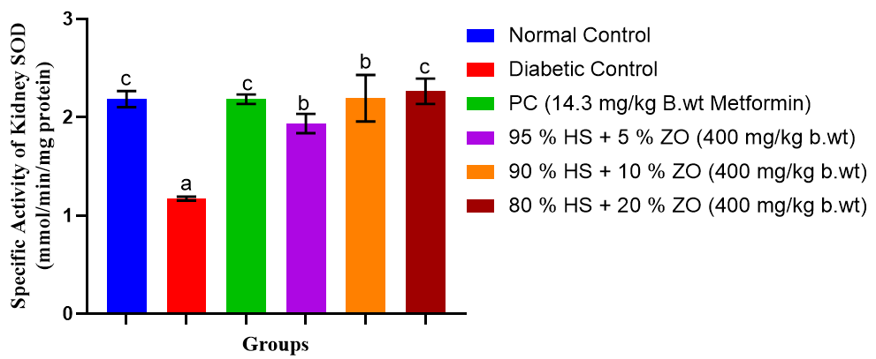
Figure 2. Specific Activity of Superoxide Dismutase (SOD) in the Kidney of Streptozotocin-Induced Diabetic Rats Administered Combined Extracts of Hibiscus sabdariffa and Zingiber officinale
Values are expressed as Mean ± SEM of three replicates, and bars with different superscripts are significantly different (p < 0.05)
There was no significant difference (p < 0.05) in the liver catalase activity of Normal Control, 95% HS + 5% ZO, 90% HS + 10% ZO, and 80% HS + 20% ZO (400 mg/kg b.wt) groups. Their liver catalase activities were significantly lower (p < 0.05) compared to the PC (14.3 mg/kg B.wt Metformin) group. The liver catalase activity of the Diabetic Control group was significantly lower (p < 0.05) compared to the Normal Control, Metformin, and all HS + ZO treated groups (Figure 3). The liver catalase activity of the PC (Metformin) group was significantly higher (p < 0.05) compared to all other groups.
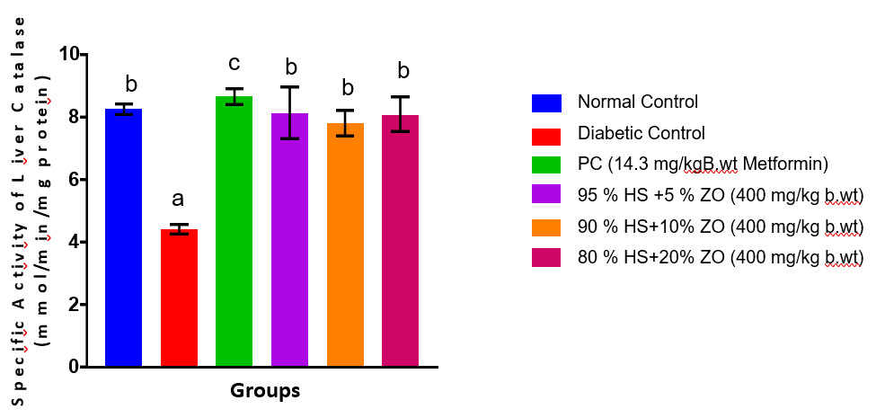
Figure 3. Specific Activity of Catalase (CAT) in the Liver of Streptozotocin-Induced Diabetic Rats Administered Combined Extracts of Hibiscus sabdariffa and Zingiber officinale
Values are expressed as Mean ± SEM of three replicates, and bars with different superscripts are significantly different (p < 0.05)
There was no significant difference (p < 0.05) in the kidney catalase activity of Normal Control, PC (14.3 mg/kg B.wt Metformin), 95% HS + 5% ZO, 90% HS + 10% ZO, and 80% HS + 20% ZO (400 mg/kg b.wt) groups (Figure 4). The kidney catalase activity of the Diabetic Control group was significantly lower (p < 0.05) compared to all other groups.
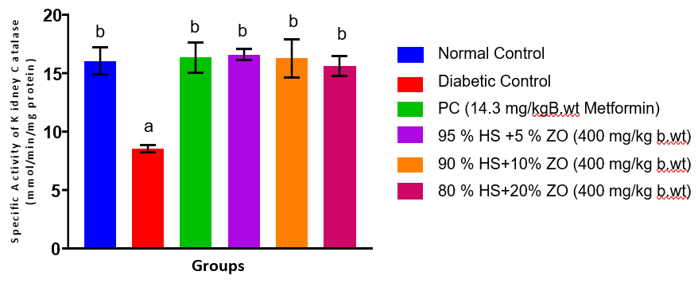
Figure 4. Specific Activity of Catalase (CAT) in the Kidney of Streptozotocin-Induced Diabetic Rats Administered Combined Extracts of Hibiscus sabdariffa and Zingiber officinale
Values are expressed as Mean ± SEM of three replicates, and bars with different superscripts are significantly different (p < 0.05)
There was no significant difference (p < 0.05) in the liver GPx activity of Normal Control, PC (14.3 mg/kg B.wt Metformin), 95% HS + 5% ZO, 90% HS + 10% ZO, and 80% HS + 20% ZO (400 mg/kg b.wt) groups (Figure 5). The liver GPx activity of the Diabetic Control group was significantly lower (p < 0.05) compared to all other groups.
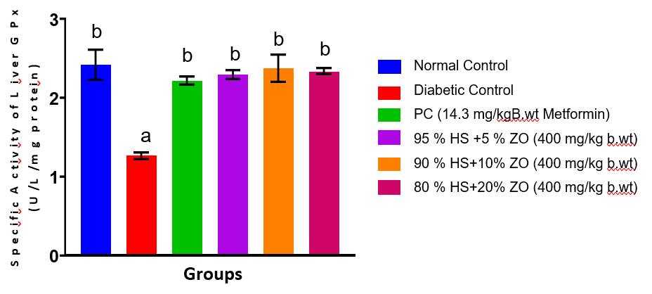
Figure 5. Specific Activity of Glutathione Peroxidase (GPx) in the Liver of Streptozotocin-Induced Diabetic Rats Administered Combined Extracts of Hibiscus sabdariffa and Zingiber officinale
Values are expressed as Mean ± SEM of three replicates, and bars with different superscripts are significantly different (p < 0.05)
There was no significant difference (p < 0.05) in the kidney GPx activity of Normal Control, PC (14.3 mg/kg B.wt Metformin), 90% HS + 10% ZO (400 mg/kg b.wt), and 80% HS + 20% ZO (400 mg/kg b.wt) groups, and their GPx concentrations were significantly lower (p < 0.05) compared to 95% HS + 5% ZO (400 mg/kg b.wt). The kidney GPx activity of the Diabetic Control group was significantly lower (p < 0.05) than all other groups (Figure 6). The kidney GPx activity of the 95% HS + 5% ZO (400 mg/kg b.wt) group was significantly higher (p < 0.05) compared to all other groups.
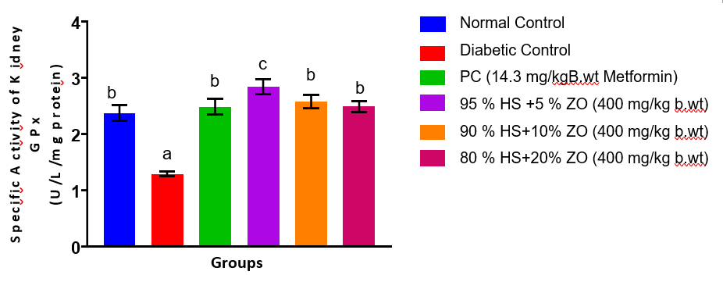
Figure 6. Specific Activity of Glutathione Peroxidase (GPx) in the Kidney of Streptozotocin-Induced Diabetic Rats Administered Combined Extracts of Hibiscus sabdariffa and Zingiber officinale
Values are expressed as Mean ± SEM of three replicates, and bars with different superscripts are significantly different (p < 0.05)
There was no significant difference (p < 0.05) in the liver GST activity of PC (14.3 mg/kg B.wt Metformin), 95% HS + 5% ZO, 90% HS + 10% ZO, and 80% HS + 20% ZO (400 mg/kg b.wt) groups (Figure 7), and their GST concentrations were significantly lower (p < 0.05) compared to the Normal Control group. The liver GST activity of the Diabetic Control group was significantly lower (p < 0.05) than all other groups. The liver GST activity of the Normal Control group was significantly higher (p < 0.05) compared to all other groups.

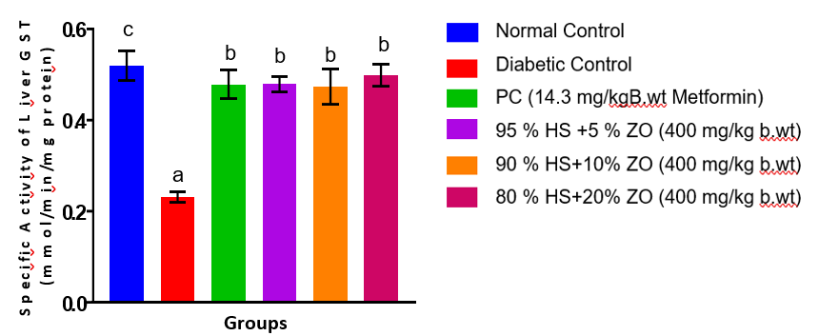
Figure 7. Specific Activity of Glutathione S-Transferase (GST) in the Liver of Streptozotocin-Induced Diabetic Rats Administered Combined Extracts of Hibiscus sabdariffa and Zingiber officinale
Values are expressed as Mean ± SEM of three replicates, and bars with different superscripts are significantly different (p < 0.05)
There was no significant difference (p < 0.05) in the kidney GST activity of Normal Control, PC (14.3 mg/kg B.wt Metformin), 95 % HS + 5 % ZO, 90 % HS + 10 % ZO, and 80 % HS + 20 % ZO (400 mg/kg b.wt) groups (Figure 8). The kidney GST activity of the Diabetic Control group was significantly lower (p < 0.05) than all other groups.
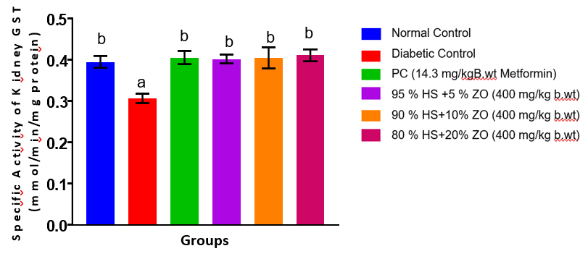
Figure 8. Specific Activity of Glutathione S-Transferase (GST) in the Kidney of Streptozotocin-Induced Diabetic Rats Administered Combined Extracts of Hibiscus sabdariffa and Zingiber officinale
Values are expressed as Mean ± SEM of three replicates, and bars with different superscripts are significantly different (p < 0.05)
There was no significant difference (p < 0.05) in the liver reduced glutathione levels of PC (14.3 mg/kg B.wt Metformin), 95% HS + 5% ZO, 90% HS + 10% ZO, and 80% HS + 20% ZO (400 mg/kg b.wt) groups (Figure 9), and their glutathione concentrations were significantly lower (p < 0.05) compared to the Normal Control group. The liver reduced glutathione level of the Diabetic Control group was significantly lower (p < 0.05) than all other groups. The liver reduced glutathione level of the Normal Control group was significantly higher (p < 0.05) compared to all other groups.
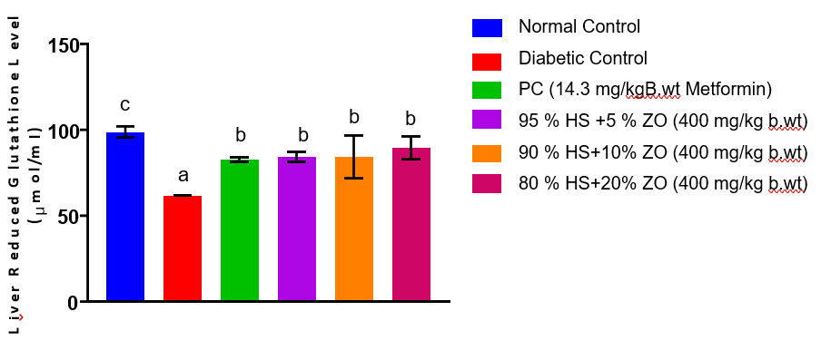

Figure 9. Reduced Glutathione (GSH) Concentrations in the Liver of Streptozotocin-Induced Diabetic Rats Administered Combined Extracts of Hibiscus sabdariffa and Zingiber officinale
Values are expressed as Mean ± SEM of three replicates, and bars with different superscripts are significantly different (p < 0.05).
There was no significant difference (p < 0.05) in the kidney reduced glutathione levels of Normal Control, PC (14.3 mg/kg B.wt Metformin), and 80 % HS + 20 % ZO (400 mg/kg b.wt) groups. Their kidney reduced glutathione concentrations were significantly higher (p < 0.05) compared to the 95 % HS + 5 % ZO and 90 % HS + 10 % ZO groups (Figure 10). The kidney reduced glutathione level of the Diabetic Control group was significantly lower (p < 0.05) than all other groups. There was no significant difference (p < 0.05) in the kidney reduced glutathione levels of the 95 % HS + 5 % ZO and 90 % HS + 10 % ZO groups.

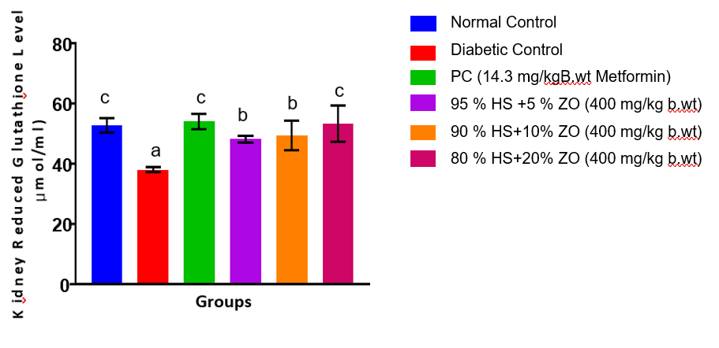

Figure 10. Reduced Glutathione (GSH) Concentrations in the Liver of Streptozotocin-Induced Diabetic Rats Administered Combined Extracts of Hibiscus sabdariffa and Zingiber officinale
Values are expressed as Mean ± SEM of three replicates, and bars with different superscripts are significantly different (p < 0.05).
There was no significant difference (p < 0.05) in the liver malondialdehyde levels of Normal Control, PC (14.3 mg/kg B.wt Metformin), and 80 % HS + 20 % ZO (400 mg/kg b.wt) groups (Figure 11). Their liver malondialdehyde concentrations were significantly lower (p < 0.05) compared to the 95 % HS + 5 % ZO and 90 % HS + 10 % ZO groups. The liver malondialdehyde level of the Diabetic Control group was significantly higher (p < 0.05) than all other groups. There was no significant difference (p < 0.05) in the liver malondialdehyde levels of the 95 % HS + 5 % ZO and 90 % HS + 10 % ZO groups, and their concentrations were significantly lower (p < 0.05) compared to the Diabetic Control group.
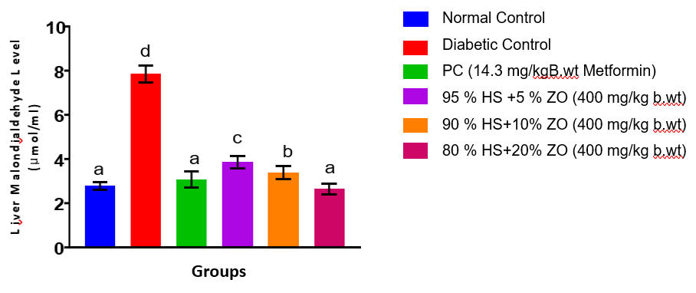
Figure 11. Malondialdehyde (MDA) Concentrations in the Liver of Streptozotocin-Induced Diabetic Rats Administered Combined Extracts of Hibiscus sabdariffa and Zingiber officinale
Values are expressed as Mean ± SEM of three replicates, and bars with different superscripts are significantly different (p < 0.05)
There was no significant difference (p < 0.05) in the kidney malondialdehyde levels of Normal Control, PC (14.3 mg/kg B.wt Metformin), 95 % HS + 5 % ZO, 90 % HS + 10 % ZO, and 80 % HS + 20 % ZO (400 mg/kg b.wt) groups (Figure 12). Their kidney malondialdehyde concentrations were significantly lower (p < 0.05) compared to the Diabetic Control group. The kidney malondialdehyde level of the Diabetic Control group was significantly higher (p < 0.05) than all other groups.
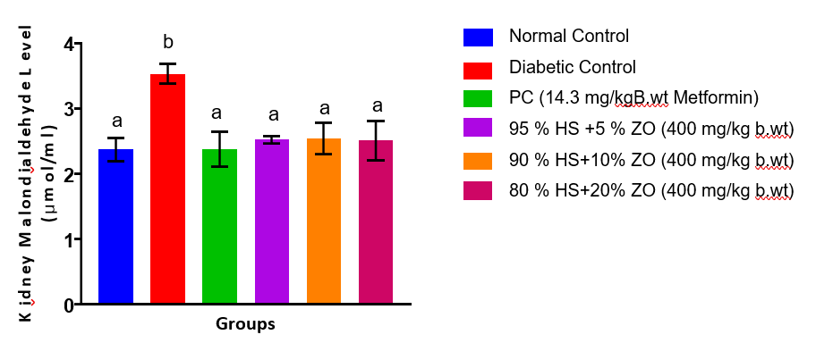
Figure 12. Malondialdehyde (MDA) Concentrations in the Kidney of Streptozotocin-Induced Diabetic Rats Administered Combined Extracts of Hibiscus sabdariffa and Zingiber officinale
Values are expressed as Mean ± SEM of three replicates, and bars with different superscripts are significantly different (p < 0.05)
Discussion
Diabetes mellitus is a disease with persistent hyperglycaemia, which facilitates the overproduction of reactive oxygen species (ROS) via the autoxidation of glucose, protein glycation, and polyol and hexosamine pathways. Diabetes caused by streptozotocin is specifically linked to mitochondrial dysfunction and β-cell destruction leading to oxidative stress as a result of the imbalance between the formation of ROS and the antioxidant defenses (Rains & Jain, 2011; Giacco and Brownlee, 2010). Continuous oxidative stress is at the forefront leading to the pathogenesis of diabetic complications by initiating lipid peroxidation, protein oxidation, and DNA damage in metabolically active organs like the liver and kidney.
Superoxide dismutase (SOD) is a first line antioxidant enzyme that dismutates superoxide radicals to hydrogen peroxide thus restricting cellular damage caused by superoxides. SOD activity is lower in the case of suppressing the antioxidants defense, which is more vulnerable to oxidation (Ighodaro & Akinloye, 2018). The liver and kidney SOD activities in the diabetic untreated group are highly lower than those in all other groups, which in this case represent the loss of detoxification of superoxide in diabetic conditions. The reinstatement of the SOD activity in the extract-treated and the metformin-treated groups relate to the possibility of increased antioxidant protection and possible by up-regulating the endogenous antioxidant enzymes. It is worth mentioning that the high liver SOD activity in the 90% HS + 10% ZO and 80% HS + 20% ZO groups in comparison with the normal control group and the metformin one could indicate an adaptation of enzymatic activity that is triggered by phytochemicals introduced in Hibiscus sabdariffa and Zingiber officinale, i.e., anthocyanins, flavonoids, and gingerols, which are capable of activating the antioxidant pathways (Lin et al.,)
Catalase (CAT) is a vital enzyme in the process of hydrogen peroxide detoxification which transforms hydrogen peroxide to water and molecular oxygen and as such, inhibits the formation of hydroxyl radicals through the Fenton reaction. A decrease in catalase activity is widely correlated with excessive oxidative load in diabetes (Maritim et al., 2003). The significantly reduced liver and kidney catalase activities in the diabetic control group that was found in this research study suggest that there is a lack of clearance of hydrogen peroxide. The observation of normalization of catalase activity in extract treated groups, especially the kidney where no significant difference was found in comparison with normal control indicates that the joint extracts maintained enzymatic antioxidant activity. The catalase activity in the metformin-treated group is much more pronounced than all others in the liver, which is correlated with reports that metformin has some antioxidant effects due to mitochondrial ROS inhibition (Foretz et al., 2019).
Glutathione peroxidase (GPx) is a selenium-dependent enzyme, which breaks hydrogen peroxide and lipid hydro peroxides with reduced glutathione (GSH) as its substrate in the process of preventing peroxidative damage to membranes. Reduced GPx activity is an indication of impaired peroxide detoxification and increased risk of lipid peroxidation (Brigelius-Flohe and Maiorino, 2013). Oxidative stress-induced loss in antioxidant enzymes is emphasized by the marked reduction of the GPx activity in both liver and kidney tissues of the diabetic untreated group. The high kidney GPx activity of the 95% HS + 5% ZO group as compared to all other groups is indicative of dose-related effect of the combined extract on antioxidant enzymes, potentially due to tissue-specific bioavailability or synergistic interaction of the plant components.
Glutathione S-transferase (GST) is a detoxification system in cells, through which reduced glutathione is conjugated with electrophilic molecules, thereby making them easy to get rid of. A decrease in GST activity impairs the defense of cells against oxidative and xenobiotic stress (Hayes et al., 2020). In the current study, the liver and kidney GST activities in the diabetic control group are significantly reduced, which is evidence of the inability to perform detoxification due to diabetic conditions. Though the levels of GST activity in extract-treated and metformin groups were still less than the normal control in the liver, their high level of increase above the diabetic untreated group indicates partial recovery of the phase II detoxification pathways. This finding is in line with the reports that plant extracts that contain polyphenols are able to regulate the expression and activity of GST (Kaur et al., 2021).
Glutathione (GSH) reduced is one of the key non-enzymatic antioxidants that preserve redox homeostasis, scavenge free radicals and are substrates of GPx and GST. One of the characteristics of oxidative stress in diabetes is the depletion of GSH (Lu, 2013). Enhanced oxidative stress and glutathione consumption is attested by the much lower liver and kidney GSH levels of the diabetic untreated group in this study. The rebounding of GSH levels in extract-treated groups, especially the normalization observed in the kidney of the 80% HS + 20% ZO group is an indication of better redox balance and higher glutathione regeneration. Such effects could be explained by the fact that bioactive compounds which are able to maintain the level of glutathione synthesis or to decrease its use by restraining the generation of ROS could be present.
Malondialdehyde (MDA) is a popular biomarker of lipid peroxidation and oxidative membrane damage. The presence of high levels of MDA indicates an increased degradation of the polyunsaturated fatty acids by ROS (Ayala et al., 2014). These higher liver and kidney MDA levels in the diabetic untreated group show that the hyperglycaemia-related oxidative stress leads to severe lipid peroxidation. The high level of attenuation of lipid peroxidation manifests itself by the substantial decrease in the MDA levels during metformin and extract-treated groups. Specifically, the similarity of the MDA levels of the normal control and the 80% HS + 20% ZO group in the liver indicates that there are very strong membrane-protective properties of the combined extract at bigger proportions of ginger.
Collectively, the experimentally recorded enhancement of the antioxidant enzyme activities, the increase in the reduced glutathione pools, and the decrease in the lipid peroxidation products in the extract-treated animals suggest that the combined aqueous extracts of Hibiscus sabdariffa and Zingiber officinale have strong hepatorenal antioxidant effects in streptozotocin-induced diabetic rats. It is presumed that these effects arise as the result of synergistic effects of polyphenols, flavonoids, anthocyanins and gingerols, which increases endogenous antioxidant defenses and inhibits the production of ROS. The results indicate that combined plant extracts have therapeutic effects as complementary therapies in alleviating complications of diabetes mellitus related to oxidative stress.
CONCLUSION
In this paper, streptozotocin-induced diabetes mellitus was linked to severe oxidative stress in the liver and kidney tissues, reflected by the loss of antioxidant enzyme activities, reduced glutathione concentration, and increasing levels of lipid peroxidation. These alterations signify a state of imbalance between the production of reactive oxygen species and the endogenous antioxidant mechanisms, and they cause diabetic tissue damage. Co-administration of the aqueous extracts of Zingiber officinale and Hibiscus sabdariffa showed great significance in antioxidant status to restore the enzymatic antioxidants, glutathione availability, and malondialdehyde in liver and kidney tissues. The effects were similar to that of metformin-treated animals and surpassed the effects in certain parameters indicating that there was good regulation of oxidative stress pathways. Comprehensively, the results suggest that the extracts have antioxidative and tissue-protective properties in experimental diabetes when combined. Nevertheless, additional research on molecular effects and active components as well as long-term safety is demanded to warrant therapeutic significance.

Ethical Approval
All authors hereby declare that Principles of laboratory animal care (NIH publication No. 85-23, revised 1985) were followed, as well as specific national laws where applicable. All experiments have been examined and approved by the appropriate ethics committee.

COMPETING INTERESTS DISCLAIMER:
Authors have declared that they have no known competing financial interests OR non-financial interests OR personal relationships that could have appeared to influence the work reported in this paper.

References
Ali, B. H., Al-Wabel, N., Blunden, G., & Nemmar, A. (2023). Phytochemical, pharmacological, and toxicological aspects of Hibiscus sabdariffa L.: A review. Phytotherapy Research, 37(2), 621–640.https://doi.org/10.1002/ptr.7645
American Diabetes Association. (2023). Standards of medical care in diabetes—2023. Diabetes Care, 46(1), S1–S291.https://doi.org/10.2337/dc23-SINT
Ayala, A., Muñoz, M. F., & Argüelles, S. (2014). Lipid peroxidation: Production, metabolism, and signaling mechanisms of malondialdehyde and 4-hydroxy-2-nonenal. Oxidative Medicine and Cellular Longevity, 2014, 360438.
https://doi.org/10.1155/2014/360438
Beers, R. F., Jr., & Sizer, I. W. (1952). A spectrophotometric method for measuring the breakdown of hydrogen peroxide by catalase. Journal of Biological Chemistry, 195(1), 133–140.
Brigelius-Flohé, R., & Maiorino, M. (2013). Glutathione peroxidases. Biochimica et Biophysica Acta (BBA) – General Subjects, 1830(5), 3289–3303.
https://doi.org/10.1016/j.bbagen.2012.11.020
Davies, M. J., Aroda, V. R., Collins, B. S., et al. (2023). Management of hyperglycaemia in type 2 diabetes, 2023. Diabetologia, 66, 129–176.
https://doi.org/10.1007/s00125-022-05787-2
El-Tantawy, W. H. (2022). Antioxidant effects of medicinal plants in diabetes mellitus. Journal of Traditional and Complementary Medicine, 12(3), 259–268
https://doi.org/10.1016/j.jtcme.2021.10.003
Ellman, G. L. (1959). Tissue sulfhydryl groups. Archives of Biochemistry and Biophysics, 82(1), 70–77.
https://doi.org/10.1016/0003-9861(59)90090-6
Forbes, J. M., Thorburn, D. R., & Cooper, M. E. (2022). Mitochondrial dysfunction in diabetic complications. Nature Reviews Endocrinology, 18(2), 115–130.
https://doi.org/10.1038/s41574-021-00578-7
Foretz, M., Guigas, B., & Viollet, B. (2019). Understanding the glucoregulatory mechanisms of metformin in type 2 diabetes mellitus. Nature Reviews Endocrinology, 15(10), 569–589.
https://doi.org/10.1038/s41574-019-0242-2
Giacco, F., & Brownlee, M. (2010). Oxidative stress and diabetic complications. Circulation Research, 107(9), 1058–1070.
https://doi.org/10.1161/CIRCRESAHA.110.223545
Gkrinia, E. M., Faour, A. K., Belančić, A., Bazile, J., Marland, E., & Vitezić, D. (2023). Economic burden of insulin therapy in type 2 diabetes: A systematic review. Diabetology, 4(4), 38.
https://doi.org/10.3390/diabetology4040038
Habig, W. H., Pabst, M. J., & Jakoby, W. B. (1974). Glutathione S-transferases: The first enzymatic step in mercapturic acid formation. Journal of Biological Chemistry, 249(22), 7130–7139.
Hayes, J. D., Dinkova-Kostova, A. T., & Tew, K. D. (2020). Oxidative stress in cancer. Cancer Cell, 38(2), 167–197.
https://doi.org/10.1016/j.ccell.2020.06.001
IDF. (2021). IDF diabetes atlas (10th ed.). International Diabetes Federation.
Ighodaro, O. M., & Akinloye, O. A. (2018). First-line defence antioxidants—Superoxide dismutase, catalase and glutathione peroxidase. Alexandria Journal of Medicine, 54(4), 287–293.
https://doi.org/10.1016/j.ajme.2017.09.001
Iskusnykh, I. Y., Zakharova, G. S., & Pathak, D. (2013). Glutathione peroxidase activity assay. Biochemistry (Moscow), 78(12), 1572–1578.
https://doi.org/10.1134/S0006297913120121
Kaur, H., Chauhan, A., & Singh, R. (2025). Oxidative stress in type 2 diabetes mellitus: From pathogenesis to therapeutic strategies. Oxidative Medicine and Cellular Longevity, 2025, 37623239.
Kaur, S., Mondal, P., & Banerjee, S. (2021). Modulation of phase II detoxifying enzymes by dietary polyphenols. Journal of Food Biochemistry, 45(1), e13501.
https://doi.org/10.1111/jfbc.13501
Ko, Y. H. (2010). Assessment of lipid peroxidation using malondialdehyde measurement. Methods in Molecular Biology, 594, 77–85.
https://doi.org/10.1007/978-1-60761-411-1_5
Kumar, S., Sharma, R., & Singh, V. (2024). Therapeutic potential of ginger (Zingiber officinale) in metabolic disorders. Journal of Ethnopharmacology, 322, 116065.
https://doi.org/10.1016/j.jep.2023.116065
Lin, H. H., Chen, J. H., Kuo, W. H., & Wang, C. J. (2019). Antioxidant properties of Hibiscus sabdariffa. Food Chemistry, 277, 439–446.
https://doi.org/10.1016/j.foodchem.2018.10.138
Lu, S. C. (2013). Glutathione synthesis. Biochimica et Biophysica Acta, 1830(5), 3143–3153.
https://doi.org/10.1016/j.bbagen.2012.09.008
Maritim, A. C., Sanders, R. A., & Watkins, J. B. (2003). Diabetes, oxidative stress, and antioxidants. Journal of Biochemical and Molecular Toxicology, 17(1), 24–38.
https://doi.org/10.1002/jbt.10058
McGill, J. B., Hirsch, I. B., Parkin, C. G., Aleppo, G., Levy, C. J., & Gavin, J. R. (2024). Current and future role of insulin therapy in type 2 diabetes. Diabetes Therapy, 15(5), 1085–1098.
https://doi.org/10.1007/s13300-024-01569-8
Misra, H. P., & Fridovich, I. (1972). The role of superoxide anion in the autoxidation of epinephrine. Journal of Biological Chemistry, 247(10), 3170–3175.
Nabrdalik, K., Hendel, M., Irlik, K., et al. (2024). Gastrointestinal adverse events of metformin treatment. BMC Endocrine Disorders, 24, 206.
https://doi.org/10.1186/s12902-024-01727-w
Rains, J. L., & Jain, S. K. (2011). Oxidative stress, insulin signaling, and diabetes. Free Radical Biology and Medicine, 50(5), 567–575.
https://doi.org/10.1016/j.freeradbiomed.2010.12.006
World Health Organization. (2023). Diabetes fact sheet. WHO.
Zaky, A. A., El-Sayed, A. S. A., & Hassan, A. M. (2022). Streptozotocin-induced diabetic rat model. Journal of Diabetes Research, 2022, 9876543.
https://doi.org/10.1155/2022/9876543
Zhang, Y., Li, W., & Liu, J. (2023). Oxidative stress and insulin resistance. Frontiers in Endocrinology, 14, 1189452.
https://doi.org/10.3389/fendo.2023.1189452

