Original Research Article

Hypolipidemic Effect of Avicennia marina Fruit in Combination High Fat Diet and Cigarette Smoke Exposure Induced Hyperlipid Rats

.
ABSTRACT

Aims: To evaluate the hypolipidemic effect of ethanol extract of Avicennia marina fruit (EEAF) in hyperlipidemic rats induced by a combination of a high-fat diet and cigarette smoke exposure by assessing total cholesterol and triglyceride levels..
Study design: In vivo experimental study
Place and Duration of Study: STIFAR Yayasan Pharmasi Semarang, between October and November 2025.
Methodology: An in vivo study was conducted using 25 male Wistar rats. Hyperlipidemia was induced by administering a high-fat diet consisting of quail egg yolk and lard (1:1) at a dose of 15 mL/kg body weight and exposure to cigarette smoke (30 cigarettes/10 rats/day) for 17 days. The rats were then randomly divided into five groups (n = 5): negative control (0.5% Na-CMC, 2.5 mL/animal), positive control (atorvastatin 2.52 mg/kgBW), and treatment groups receiving EEAF at doses of 30, 60, and 120 mg/kgBW. Treatments were administered orally for 28 days. Blood samples were collected before induction (T1), after induction (T17), and after treatment (T45). Serum total cholesterol and triglyceride levels were measured using enzymatic colorimetric methods.
Results: Induction significantly increased total cholesterol and triglyceride levels by 159.66 ± 64.30% and 121.88 ± 92.84%, respectively. EEAF significantly reduced total cholesterol at all doses, with reductions of 47.72 ± 11.20%, 50.90 ± 2.78%, and 58.51 ± 8.69%. Triglyceride levels also decreased by 31.61 ± 27.57%, 46.87 ± 9.18%, and 59.16 ± 13.40%. The reduction in triglyceride levels at 60 and 120 mg/kgBW EEAF was significantly different from the negative control and all doses for total cholesterol showed significant reductions.
Conclusion: The ethanol extract of Avicennia marina fruit showed significant hypolipidemic activity and potential as a natural agent for improving lipid profiles. Further studies are needed to confirm its safety and efficacy.

Keywords: Avicennia marina Fruit, Secondary Metabolic, Total Cholesterol, Triglycerides

1. INTRODUCTION

Cardiovascular diseases have become the leading cause of mortality worldwide, accounting for approximately 32% of all deaths, of which 85% are attributed to myocardial infarction and stroke. In Indonesia, the prevalence of cerebrovascular disease is 20.7%, while ischemic heart disease accounts for 14.9%. Dyslipidemia is a major contributor to global morbidity and mortality, serving as a primary etiological factor for cardiovascular diseases and related conditions such as atherosclerotic cardiovascular disease (Fularski et al., 2023). In general, secondary metabolites found in natural products, including polyphenols, flavonoids, and alkaloids, contribute to the regulation of lipoprotein metabolism and lipid homeostasis. The mechanisms underlying these effects include increased activity of endothelial nitric oxide synthase (eNOS) and modulation of reactive oxygen species (ROS), reduced lipid biosynthesis, decreased oxidized LDL levels, inhibition of lipid plaque deposition, enhanced cholesterol efflux, and reduced platelet activity (Alalawi et al., 2023).
The progression of metabolic disorders such as dyslipidemia may be mitigated through the use of natural products possessing synergistic activities that suppress the underlying causes of metabolic syndrome. These activities include anti-inflammatory, antioxidant, and antihyperlipidemic effects. The fruit of Avicennia marina has been reported to contain phenolic compounds and phenylethanoid glycosides with potent antioxidant and anti-inflammatory properties (Palupi et al., 2025; Setiyabudi et al., 2022). Phenolic compounds derived from caffeic acid present in A. marina fruit have demonstrated strong in vitro antioxidant activity using the 2,2-diphenyl-1-picrylhydrazyl (DPPH) method, with an IC₅₀ value of 8.72 µg/mL (Girsang et al., 2020). Phenylethanoid glycosides exhibit anti-inflammatory activity by scavenging free radicals and enhancing endogenous antioxidant capacity. Additionally, diethylhydroxylamine compounds present in all parts of A. marina have been reported to inhibit hepatic lipid peroxidation (ElDohaji et al., 2020). Based on these antioxidant, anti-inflammatory, and lipid peroxidation inhibitory activities, the ethanol extract of A. marina fruit has the potential to improve lipid profiles.
A high-fat diet can disrupt lipid homeostasis and induce dyslipidemia. This condition is associated with increased hepatic lipogenesis and hepatic insulin resistance, leading to impaired apolipoprotein B (ApoB) and very low-density lipoprotein (VLDL) production. Furthermore, it promotes hepatic steatosis, indicating abnormal fat redistribution due to the inability of adipose tissue to store lipids, ultimately contributing to systemic metabolic disorders. Increased lipid peroxidation resulting from a high-fat diet can also induce oxidative stress (Di Majo et al., 2023). In addition to a high-fat diet, cigarette smoke exposure for 1 hour per day, 5 days per week, over a duration of 19 weeks has been shown to increase lipid profiles, body weight, and blood pressure (Al-Sawalha et al., 2020).

2. material and methods

2.1 Materials and Equipments

Material for extraction is Technical grade ethanol 96%. Materials for screening phytochemical include: TLC layer, FeCl₃ 5%, Mg powder, Amyl alchohol, Liebermann-Burchard, Mayer, Hager, Glacial acetic acid, Chloroform, Etanol, Methanol, Etyl Acetic, Ammonia, Dragendorff, Anisaldehyde-Sulfuric Acid and Aquadest. Materials for in vivo studies include: Quail eggs, Cigarettes, Wistar Rat (Rattus norvegicus), Cholesterol MR kit (Glory Diagnostics), Triglyceride MR kit (Glory Diagnostics). Equipment include: Rotary evaporator, Water bath, Eppendorf, Microcentrifuge, Microlab 300 & 300LX

2.2 Plant Material

Avicennia marina (A. marina) fruits was collected from Tambakrejo Village (Semarang City, Indonesia). Determination was carried out by Biology Laboratorium of STIFAR Yayasan Farmasi Semarang (No: 095/EL-WL/XII/2025).

2.3 Extraction

A. marina fruit powder was extracted using remaceration method. The solvent used was thecnical garde ethanol 96% with a powder to solvent ratio 1:10. Remaceration was carried out for 3x24 hours. The macerate was evaporated at 50ºC and thickned at the same temperature using a water bath.

2.4 Screening Phytochemical

The EEAF was subjected to phytochemical screening using preliminary test and confirmation using TLC. The phytochemical screening test include flavonoid, alkaloid, and triterpenoid.

2.5 In Vivo Studies

2.5.1 Induction and Treatment Protocol

Wistar rats were acclimatized for 7 days. The rats were given an induction treatment with a combination of a high-fat diet and cigarette smoke exposure. The high-fat diet consisted of quail egg yolk and lard in a 1:1 ratio and a dose of 15 mL/kgBW. The number of cigarettes used was 30 cigarettes/10 rats/day. The induction was carried out for 17 days. The induced rats were divided into 5 intervention groups with 5 test animals per group. The intervention groups included group 1 was negative group (Na. CMC 0.5% 2,5ml/animal), group 2 was positive group (atorvastatin 2.52 mg/kgBW), and group 3 – 4 were EEAF groups (30, 60, and 120 mg/kgBW). The interventions were given for 28 days.

2.5.2 Total Cholesterol and Triglyceride Measurement

Blood was collected on the first day or before induction (T1), after induction (T17), and after treatment (T45) via retro orbital. The blood was centrifuged at 5000 rpm for 10 minutes at 4ºC. The serum obtained was measured for total cholesterol and triglycerides.

2.5.2.1 Total Cholesterol Analysis

Total cholesterol levels were determined using an enzymatic colorimetric method (CHOD-PAP method) with the Cholesterol MR kit according to the manufacturer’s instruction. Briefly, 5 µL of serum was mixed with 500 µL of the reagent. The mixture was incubated for 10 minutes at room temperature to allow complete color development. Absorbance (A) was measured at 500 nm using a spectrophotometer. Total cholesterol concentration was calculated using the following formula:
$\frac{A sample}{A standard}×Concentration Standard$
The Cholesterol MR reagent consisted of 200 mM PIPES buffer (pH 7.0), 1 mM sodium cholate, 250 kU/L cholesterol esterase, 0.33 mM 4-aminoantipyrine, 4 mM phenol, and 2 g/L non-ionic surfactants.

2.5.2.2 Triglyceride Analysis

Triglyceride levels were measured using the same procedure as described for total cholesterol analysis. Briefly, 5 µL of serum was mixed with 500 µL of triglyceride reagent. The mixture was incubated for 15 minutes at room temperature, and absorbance (A) was measured at 500 nm using a spectrophotometer. Triglyceride concentration was calculated using the following formula:
$\frac{A sample}{A standard}×Concentration Standard$
The triglyceride reagent consisted of 50 mM PIPES buffer (pH 6.8), lipoprotein lipase (LP) > 12 kU/L, glycerol kinase (GK) > 1 kU/L, glycerol-3-phosphate oxidase (GPO) > 10 kU/L, adenosine triphosphate (ATP) 2.0 mM, Mg²⁺ 40 mM, peroxidase (POD) > 2.5 kU/L, 4-aminoantipyrine (4-AA) 0.5 mM, phenol 3 mM, and non-ionic surfactants (g/L).

2.5.2.3 Statistical Analysis

The percentage decrease data was statistically tested using one-way ANOVA analysis, followed by multiple comparison with LSD. Differences were considered to be statistically significant when p < 0.05.

3. results

3.1 Extraction

The extraction yield of A. marina fruit obtained by maceration is presented in Table 1.

Table 1. Table 1. Extraction Yield (%) of A. marina Fruit Using the Maceration Method

Wet Sample Weight (g) | Dried Powder Weight (g) | Yield (%) | Color | Consistency
10.000 | 1326,3 | 45,98% | Dark Green | Semi Solid

3.2 Screening Phytochemical

The phytochemical constituents of the EEAF are shown in Table 2. The TLC chromatogram of the EEAF is presented in Figure 1.

Table 2. Presence of Flavonoids, Alkaloids, and Triterpenoids in the EEAF

Phytochemical Compound | Test Method / Reagent | Result
Flavonoid | Shinoda test (Mg + HCl) | +
Alkaloid | Mayer | +
Alkaloid | Hager | +
Triterpenoid | Liebermann-Burchard | +

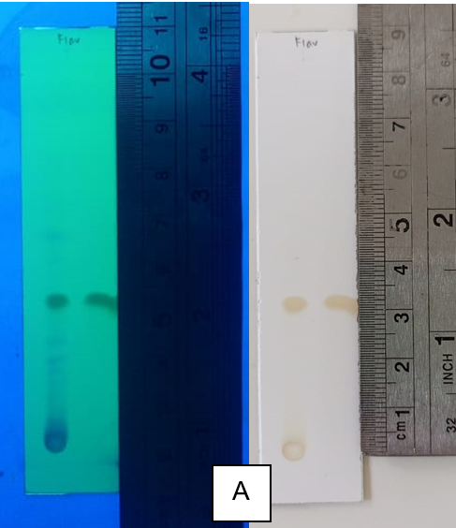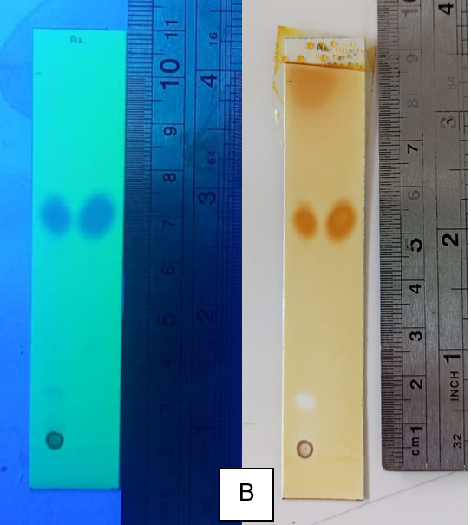

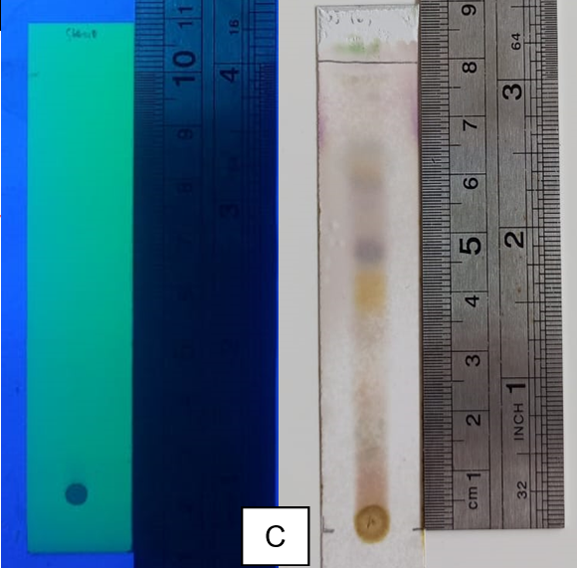
Figure 1. TLC chromatograms of the EEAF: (A) flavonoids, (B) alkaloids, and (C) triterpenoids. The chromatograms were observed under UV light at 254 nm (left) and after spraying with the respective detecting reagents (right).

3.2 In Vivo Studies

Induction using a high-fat diet in combination with cigarette smoke exposure led to a significant elevation in total cholesterol and triglyceride levels. The lipid profile parameters measured at T1 and T17 are presented in Table 3.

Table 3. Total cholesterol and triglyceride levels before and after induction with percentage increase (%)

Lipid | T1 (mg/dL) | T17 (mg/dL) | Percent Increase (%)
Total Cholesterol | 52.68 ± 12.80 | 130.48 ± 18.42**** | 159.66 ± 64.30
Triglyceride | 50.48 ± 22.95 | 96.88 ± 27.3**** | 121.88 ± 92.84
**** Indicates a statistically significant difference compared with T1 (P = .000)

Rats with elevated total cholesterol and triglyceride levels were subsequently treated according to their respective experimental groups for 28 days. The reductions in total cholesterol and triglyceride levels are presented in Table 4 and 5, while the percentage reductions are shown in Figure 2.

Table 3. Total cholesterol levels before and after induction with percentage decrease (%)

Groups | T17 (mg/dL) | T45 (mg/dL) | Percent Decrease (%)
Negative | 123.2 ± 27.82 | 90 ± 4.77 | 22.11 ± 21.76
Positive | 125.4 ± 13.15 | 74.8 ± 10.17 | 40.26 ± 6.77
EEAF 30mg/kgBW | 126.6 ± 6.65 | 65.6 ± 11.77 | 47.72 ± 11.2
EEAF 60mg/kgBW | 132.6 ± 4.72 | 65 ± 2.19 | 50.90 ± 2.78
EEAF 120mg/kgBW | 155.6 ± 5.39 | 64.2 ± 11.63 | 58.51 ± 8.69

Table 4. Triglyceride levels before and after induction with percentage decrease (%)

Groups | T17 (mg/dL) | T45 (mg/dL) | Percent Decrease (%)
Negative | 82.4 ± 21.27 | 74 ± 14.06 | 3.7 ± 27.86
Positive | 94.2 ± 16.31 | 44.4 ± 12.6 | 52.53 ± 11.69
EEAF 30mg/kgBW | 113.8 ± 34.74 | 70.2 ± 15.97 | 31.61 ± 27.57
EEAF 60mg/kgBW | 103.2 ± 24.55 | 53.4± 10.97 | 46.87 ± 9.18
EEAF 120mg/kgBW | 90.8 ± 21.68 | 34.4 ± 7.42 | 59.16 ± 13.40

Fig. 2. Effect of different doses of EEAF on total cholesterol and triglyceride reduction
** indicates a statistically significant difference (P = .01); * indicates a statistically significant difference (P = .05)

4. DISCUSSIONS

The EEAF obtained through a remaceration process for 3 × 24 hours using 96% ethanol as the solvent produced a yield of 45.98%. This value is slightly lower than that reported by (Utomo, 2025) who obtained a higher extraction yield of 48.06%, despite using the same extraction method, solvent, and powder-to-solvent ratio. Differences in extraction yield may be influenced by environmental factors, such as variations in salinity and soil nutrient composition, which can affect the accumulation of secondary metabolites in plants. Climatic conditions, including temperature, rainfall, and humidity, may also influence plant metabolism and the production of bioactive compounds. Additionally, the maturity level of the fruit at the time of harvest may contribute to variations in the extraction yield (Isah, 2019).
Phytochemical screening indicated that the EEAF contains flavonoids, triterpenoids, and alkaloids. These results are in agreement with the findings reported by (Fernandes & Fatmi, 2019), who demonstrated that the EEAF contains various secondary metabolites, including phenolic compounds, flavonoids, alkaloids, triterpenoids, tannins, and saponins. Mangrove plants, which inhabit coastal environments, are frequently exposed to high salinity conditions that can stimulate the production of secondary metabolites. Elevated salinity levels may induce stress because the ability of roots to absorb water decreases significantly. This condition can lead to physiological drought caused by osmotic stress resulting from high salt accumulation in plant tissues and surrounding soil. Consequently, changes in physiological processes and nutrient balance occur, which may influence primary metabolism that serves as a precursor source for secondary metabolite biosynthesis (Isah, 2019).
Administration of a high-fat diet composed of quail egg yolk and lard (1:1) at a dose of 15 mL/kg body weight significantly increased total cholesterol and triglyceride levels by 159.66 ± 64.30% and 121.88 ± 92.84%, respectively. A previous study by Lasker et al., (2019) demonstrated that administration of a high-fat diet increased lipid profile parameters, including total cholesterol, triglycerides, and LDL levels, while reducing HDL levels compared to a normal diet. Similar findings were reported by Hidayati et al., (2020), who demonstrated that a combination of egg yolk and lard increased triglyceride levels by 92.5%. Previous studies have reported that lard consumption providing approximately 60% of total caloric intake significantly increases the expression of sterol regulatory element-binding protein-1c (SREBP-1c). SREBP-1c is a key transcription factor that regulates the expression of genes involved in lipogenesis. Activation of SREBP-1c promotes the transcription of fatty acid synthase (FAS), a crucial enzyme responsible for the synthesis of fatty acids. Consequently, increased fatty acid synthesis contributes to elevated triglyceride production (Yan et al., 2020).
The use of cigarette smoke in the induction process was intended to exacerbate the hyperlipidemic condition. This finding is supported by a previous study by Nath et al., (2022), which reported that smokers have higher total cholesterol and triglyceride levels compared to non-smokers. Furthermore, the degree of smoking was associated with a more pronounced increase in total cholesterol and triglyceride levels. Similar findings were also reported by Ismail et al., (2022), who compared a high-fat diet with a combination of a high-fat diet and cigarette smoke exposure. The results showed that the combination of a high-fat diet and cigarette smoke exposure resulted in higher increases in total cholesterol and triglyceride levels. This effect is associated with the presence of nicotine, which influences lipid metabolism. Nicotine stimulates the sympathetic nervous system and promotes the release of catecholamines, which subsequently induce lipolysis. This process increases circulating free fatty acid concentrations and contributes to a reduction in plasma HDL cholesterol levels
Administration of EEAF resulted in a significant reduction in total cholesterol and triglyceride levels compared to the negative control group. This effect may be attributed to the presence of secondary metabolites in the extract. Compounds such as flavonoids, saponins, tannins, and β-sitosterol are known to exert pharmacological activities that contribute to the reduction of total cholesterol levels (Widiyanto et al., 2023). This finding is supported by the in silico study conducted by Aliifah et al., (2025), which investigated the interaction between the general structural features of secondary metabolites and one of the key enzymes involved in lipid metabolism, namely HMG-CoA reductase. Natural compounds containing hydroxyl groups and aromatic rings can form stable hydrogen bonds with the active site of the enzyme. The presence of multiple hydroxyl groups allows the formation of multiple hydrogen bond interactions, thereby enhancing binding affinity. In addition, steroidal compounds such as withanolides possess an ergostane skeleton that provides structural rigidity and favorable binding within the enzyme cavity. These structural characteristics enable such compounds to mimic natural substrate interactions, thereby competitively inhibiting the activity of HMG-CoA reductase.
At the cellular level, the improvement in total cholesterol and triglyceride levels may be associated with the activation of AMP-activated protein kinase (AMPK) by secondary metabolites such as flavonoids and other polyphenolic compounds. AMPK acts as a key energy-sensing enzyme that promotes catabolic pathways to generate energy while inhibiting anabolic processes such as lipid synthesis. Activation of AMPK has been reported to reduce lipid accumulation and improve non-alcoholic fatty liver disease (NAFLD) by inducing hepatic fatty acid oxidation (Gupta & Singh, 2025). This mechanism is further supported by the review conducted by Zhao et al., (2026), which reported that activation of AMPK will phosphorylates sterol regulatory element-binding proteins (SREBPs) at serine residues. This phosphorylation inhibits the proteolytic cleavage and activation of both SREBP-1c and SREBP-2, thereby suppressing the synthesis of fatty acids and triglycerides as well as the activity of HMG-CoA reductase. Under normal conditions, SREBP1 translocates to the nucleus and binds to sterol regulatory elements in the promoter regions of target genes, initiating the transcription of several lipogenic enzymes, including fatty acid synthase, acetyl-CoA carboxylase, and stearoyl-CoA desaturase.

5. Conclusion

The EEAF was found to contain several secondary metabolites, including flavonoids, triterpenoids, and alkaloids. Administration of this extract significantly reduced total cholesterol and triglyceride levels, which may be associated with the presence of these bioactive compounds. Administration of EEAF at doses of 30, 60, and 120 mg/kg body weight reduced total cholesterol levels by 47.72 ± 11.20%, 50.90 ± 2.78%, and 58.51 ± 8.69%, respectively, and also decreased triglyceride levels by 31.61 ± 27.57%, 46.87 ± 9.18%, and 59.16 ± 13.40%, respectively.

Consent (where ever applicable)

It’s not applicable

Ethical approval (where ever applicable)

Animal ethical clearance approval has been obtained and documented by the authors

References

Al-Sawalha, N. A., Almahmmod, Y., Awawdeh, M. S., Alzoubi, K. H., & Khabour, O. F. (2020). Effect of Waterpipe Tobacco Smoke Exposure on The Development of Metabolic Syndrome in Adult Male Rats. PLoS ONE, 15(6), 1–9. https://doi.org/10.1371/journal.pone.0234516
Alalawi, S., Albalawi, F., & Ramji, D. P. (2023). The Role of Punicalagin and Its Metabolites in Atherosclerosis and Risk Factors Associated with the Disease. International Journal of Molecular Sciences, 24(10), 1–19. https://doi.org/10.3390/ijms24108476
Aliifah, K., Marisa, H., Lestari, I., Septiani, J., Ihsani, J. Al, Sains, F., Farmasi, P. S., Muhammadiyah, U., Kampus, A., No, J. S., Kidul, C., Panyileukan, K., & Bandung, K. (2025). Literature Review : Potensi Senyawa Bahan Alam sebagai Inhibitor HMG- CoA Reduktase untuk Terapi Kolesterol Menurut World Health Organization ( WHO ), prevalensi hiperkolesterolemia sebesar 48 % terjadi di Amerika Serikat dan lebih banyak penderita di Ero. Jurnal Riset Rumpun Ilmu Kesehatan, 4(2), 615–622.
Di Majo, D., Sardo, P., Giglia, G., Di Liberto, V., Zummo, F. P., Zizzo, M. G., Caldara, G. F., Rappa, F., Intili, G., van Dijk, R. M., Gallo, D., Ferraro, G., & Gambino, G. (2023). Correlation of Metabolic Syndrome with Redox Homeostasis Biomarkers: Evidence from High-Fat Diet Model in Wistar Rats. Antioxidants, 12(1), 1–18. https://doi.org/10.3390/antiox12010089
ElDohaji, L. M., Hamoda, A. M., Hamdy, R., & Soliman, S. S. M. (2020). Avicennia marina A Natural Reservoir of Phytopharmaceuticals: Curative Power and Platform of Medicines. Journal of Ethnopharmacology, 263(February), 1–17. https://doi.org/10.1016/j.jep.2020.113179
Fernandes, A., & Fatmi, R. (2019). Uji Fitokimia dan GC-MS Buah Api-Api (Avicennia marina) (FORSSK.) VIERH). Jurnal Insan Farmasi Indonesia, 2(2), 261–270. https://doi.org/10.36387/jifi.v2i2.321
Fularski, P., Młynarska, E., Dybiec, J., Baran, W., & Bartłomiej, D. (2023). Advances in Treatment of Dyslipidemia. International Journal of Molecular Sciences, 24(13288), 1–19.
Girsang, E., Lister, I. N. E., Ginting, C. N., Sholihah, I. A., Raif, M. A., Kunardi, S., Million, H., & Widowati, W. (2020). Antioxidant and Antiaging Activity of Rutin and Caffeic Acid. Pharmaciana, 10(2), 147–156. https://doi.org/10.12928/pharmaciana.v10i2.13010
Gupta, A., & Singh, R. (2025). AMP-Activated Protein Kinase ( AMPK ): A Cellular Energy Sensor and the Guardian of Metabolism. 34(2), 147–153.
Hidayati, L., Widodo, A. D. W., & Hidayat, B. (2020). Animal Models with Metabolic Syndrome Markers Induced by High Fat Diet and Fructose. Medical Laboratory Technology Journal, 1(1), 13–20. https://doi.org/10.31964/mltj.v1i1.266
Isah, T. (2019). Stress and defense responses in plant secondary metabolites production. Biological Research, 52(39), 1–25. https://doi.org/10.1186/s40659-019-0246-3
Ismail, N. A., Nabila, T., Ramadhani, A. S., & Ahsani, D. N. (2022). Electronic and Conventional Cigarette Exposure Aggravate Metabolic Parameters in High-Fat Diet-Induced Rats. Physiologyhysiology, 10(A), 841–847.
Lasker, S., Rahman, M. M., Parvez, F., Zamila, M., Miah, P., Nahar, K., Kabir, F., Sharmin, S. B., Subhan, N., Ahsan, G. U., & Alam, M. A. (2019). High-fat diet-induced metabolic syndrome and oxidative stress in obese rats are ameliorated by yogurt supplementation. Scientific Reports, 9(1), 1–15. https://doi.org/10.1038/s41598-019-56538-0
Nath, M. C., Rahman, A. K. M. S., Nath, M. C., Dutta, A., Khan, Z. H., Ghosh, E., Akhter, S., Islam, S., & Sultana, S. (2022). The Effect of Cigarette Smoking on Fasting Lipid Profile : A Single Center Study. Fortune Journal of Health Sciences, 5(2), 363–373. https://doi.org/10.26502/fjhs.067
Palupi, D. H. S., Haryanti, S., Prahasiwi, M. S., & Utomo, R. S. (2025). Aktivitas Penghambatan Dipeptidyl peptidase-4 ( DPP-4 ) dan Skrining Fitokimia Ekstrak Buah Api-api ( Avicennia marina ). Journal of Pharmaceutical Science and Clinical Research, 10(1), 100–113.
Setiyabudi, L., Ulya, N. F., Indratmoko, S., & Swandari, M. T. K. (2022). In-silico Analysis Of Maricaffeoylide From Avicennia Marina Using Molecular Docking With Tumor Necrosis Factor Receptor. Biomedical Journal of Indonesia, 8(1), 20–24. https://doi.org/10.32539/bji.v8i1.141
Utomo, R. sari. (2025). Kajian Aktivitas Antidiabetes Melitus Fraksi Buah Api-Api (Avicennia marina) pada Tikus Jantan Terinduksi Streptozotocin dan Nikotinamid. Sekolah Tinggi Ilmu Farmasi Yayasan Pharmasi Semarang.
Widiyanto, B., Intan, N., Thoyibah, N. K., Sudjudi, Y., & Faza, A. S. (2023). Kombinasi Ekstrak Daun Sirsak Dan Kunyit Memperbaiki Profil Lipid Pada Tikus Model Metabolic Syndrome The Combination of Soursop and Turmeric Leaf Extracts Improves Lipid Fakultas Kedokteran , Universitas Islam Sultan Agung , Semarang , Indonesia Address. Jurnal Ilmiah Kesehatan, 5(1), 113–120.
Yan, S., Zhou, H., Liu, S., Wang, J., Zeng, Y., Matias, F. B., & Wen, L. (2020). Differential effects of Chinese high-fat dietary habits on lipid metabolism : mechanisms and health implications. Lipids in Health and Disease, 19(30), 1–9.
Zhao, Q., Lu, S., Guan, Y., Sun, Z., Qiu, S., & Zhang, A. (2026). Dysregulation of the AMPK-SREBP1-FASN axis in MASLD : driving a vicious cycle of lipotoxicity and metabolic-immune crosstalk. Lipids in Health and Disease, 25(62), 1–27.

.

