Original Research Article

Human skeletal remains: A comparative histomorphometric analysis of short and flat bones

Abstract
Background: Bone histomorphometry provides valuable microstructural information for forensic identification, even when skeletal remains are fragmented or morphologically compromised. However, comparative histomorphometric data across different bone types remain limited.
Aims: This study aimed to evaluate and compare histomorphometric parameters of short and flat bones in human skeletal remains, assess differences in bone remodeling, and identify bone types with superior histological preservation.
Study design: The study used a descriptive cross-sectional design that employed comparative anatomy.
Place & duration of study: The study was carried out using skeletal collections from the Department of Human Anatomy, Faculty of Basic Medical Sciences, Rivers State University within a period a one-year period, spanning Feb.2025 and Feb.2026.
Methodology: 30 adult bone samples comprising ribs, sternum, and calcaneus were used. Undecalcified bone sections were prepared and analyzed using digital microscopy and image analysis software. Quantitative parameters measured included primary and secondary osteons, osteon fragments, Haversian canal diameter, and maximum osteon diameter. Statistical analyses involved descriptive statistics, independent-samples t tests, and analysis of remodeling and preservation indices.
Results: Ribs exhibited the highest osteon population and remodeling activity, with a mean secondary osteon count of 8.00 ± 1.36 and the highest OS/OF ratio (0.58). Sternum bones demonstrated intermediate remodeling patterns, while calcaneus bones displayed minimal osteon population but significantly larger Haversian canals and osteon diameters. Osteon Fragmentation Index (OFI) analysis indicated superior histological preservation in ribs and sternum compared with calcaneus. These findings demonstrate statistically significant (p≤0.05) histomorphometric differences between short and flat bones, highlighting the importance of bone-specific reference data in forensic histology.
Conclusion: The ribs appear to provide the most reliable microstructural indicators for histomorphometric assessment in fragmented skeletal remains.
Keywords: Bone histomorphometry; forensic anthropology; osteons; short bones; flat bones; skeletal remains
INTRODUCTION
Bone histomorphometry is the quantitative microscopic assessment of bone microstructure and it has become an indispensable tool in forensic anthropology and biological anthropology for analyzing human skeletal remains, especially when gross morphology is unavailable or compromised. Histomorphometric techniques involve measuring cortical bone features such as osteon size, Haversian canal dimensions, osteon population density, and other microarchitectural parameters that provide insight into bone remodeling, species identification, and biological profiling of skeletal remains. These microscopic features reflect both developmental and biomechanical influences on bone tissue and thus vary across bone types and anatomical regions (Cummaudo et al., 2020; Stan et al., 2024). Human bones are traditionally categorized by shape and function, with flat bones providing protection and sites for muscular attachment, and short bones offering support and limited motion, but both types differ markedly in structure from long bones and from one another in how remodeling units are distributed. In forensic contexts where remains are fragmentary, histomorphometric assessment can reveal microstructural signatures that aid in identification (Crowder, 2013; Nor et al., 2013), age-at-death estimation (Cho et al., 2002; Maat et al., 2003; Meltem et al., 2014; Abdullah et al., 2018) and even inter-bone comparisons (Maat et al., 2006; Orupabo et al., 2020; Oghenemavwe et al., 2022), yet the degree to which short and flat bones differ in their histomorphometric patterns has received comparatively less focused investigation.
Despite advances in histological methods, a significant problem persists in forensic anthropology and bioarchaeology: the lack of comprehensive comparative data on histomorphometric variability across different bone types within the human skeleton. Much existing research has concentrated on long bones or on differentiating human from non-human skeletal remains, but few studies have systematically compared microstructural parameters between short and flat bones, which could affect the accuracy of identification and biological profiling when only fragmentary elements are available (Stan et al., 2024). This limitation hinders the development of robust forensic protocols that account for anatomical variation beyond long bones and may lead to inconsistencies in interpretation, especially in complex medico-legal contexts.
Recent literature highlights both the potential and the gaps in this area. Cummaudo and colleagues conducted a histomorphometric analysis across multiple bone types, revealing significant differences in Haversian system and canal sizes between bone categories, noting that long and irregular bones showed larger microstructural features as compared to flat bones, and emphasizing the need for broader sampling to understand intra-skeletal variability (Cummaudo et al., 2020). Orupabo and Chijioke’s comparative analysis of long bone segments provided baseline data for forensic case diagnosis, though it was limited to long bones and did not extend to short or flat bones (Orupabo & Chijioke, 2024). Furthermore, Bantavanou et al., (2025) advanced histomorphometric methods for age-at-death estimation using femoral cross-sections, showing the value of microstructural parameter densities in forensic applications but similarly without addressing short or flat bones. Orupabo et al., (2025) in a more recent study observed that the tibia exhibited significantly greater counts of secondary and primary osteons compared with the talus (P≤0.05). Stan et al., (2024) reaffirmed the importance of microstructural variables like osteon and canal dimensions, arguing for continued validation of histomorphometric approaches. However, what remains underexplored is how these metrics vary systematically between bone types of differing morphology, particularly short versus flat bones within human populations, an understanding that is crucial when fragmented skeletal elements are encountered.
This research gap underscores the need for a targeted comparative analysis of histomorphometric patterns in short and flat bones, as most forensic and anthropological models are extrapolated from long bone data with limited validation across other skeletal categories. Such gaps may lead to biases in interpretation and reduce the reliability of microstructural criteria in forensic contexts where short and flat bone fragments are encountered. Addressing this gap will enhance the forensic toolkit by providing normative data across a wider range of bone types and improve the precision of identification and biological profiling of skeletal remains. Therefore, this study aims to conduct a histomorphometric assessment of human skeletal remains, focusing on a comparative analysis of short and flat bones to characterize their microstructural differences, establish reference parameters, and evaluate their forensic applicability.

MATERIALS AND METHODS
This is a comparative descriptive study utilized to evaluate and compare histomorphometric parameters of short bones (tarsal bones) and flat bones (ribs and sternum) from human skeletal remains. Quantitative microscopic measurements were conducted to determine differences in osteon count, Haversian canal diameter (HCD), osteon diameter (OD), and osteon fragmentation index (OFI) across bone categories. This design allowed for a direct assessment and statistical comparison of microstructural features between the bone types.
Study Area
The research was carried out in the Forensic and Histology Laboratory of the Department of Human Anatomy, Faculty of Basic Medical Sciences, College of Medical Sciences, Rivers State University, Port Harcourt, Nigeria. Histological processing, slide preparation, and microscopic analyses were performed within the Image Analysis Unit, which is equipped with advanced digital microscopy and morphometric software suitable for histomophometric evaluation.

Sample Collection
Human skeletal remains used in this study were sourced from the approved skeletal collection maintained by the Anatomy Department. The collection consists of adult human bones preserved for academic and research purposes. Samples included short bones (selected tarsal bones such as talus and calcaneus) and flat bones (selected ribs from the 5th–7th ribs and sternum). A total of 30 bone specimens were analyzed, with 10 samples each from tarsal bones, ribs, and sternum, to ensure adequate representation for comparative analysis.
Inclusion criteria
Adult skeletal collections from 10 cadaveric specimens.
Exclusion criteria
Bones with severe postmortem damage or pathological alterations were excluded from the study.
Ethical Consideration
Ethical clearance for the study was obtained from the Faculty Research and Ethics Committee, College of Medical Sciences, Rivers State University (RSU/FBMS//REC/25/366). The Ethical Board of the Department of Human Anatomy granted approval for access to and use of the skeletal remains. All procedures complied with both institutional and internationally accepted ethical standards for research involving human skeletal materials.

Bone section preparation
Bone samples were cut into thin slices approximately 2–3 mm thick using an electric band saw. Abrasive sandpaper of sizes P220 was affixed to a greased glass slab to create a smooth grinding surface without bubbles or dirt to avoid damage to thin bone sections. A P220 smoother sandpaper was required as bone specimens needed gentler grinding to avoid breaking and scattering of sections. Glass slabs measured 30x10cm, and they were greased or coated with Vaseline ointment.
The bone slices were then placed on a glass slab and ground gently, holding the specimen in between the pulp of the thumb and the index finger until the desired thickness for microscopy was achieved, periodically checking the thickness. Grinding was done until the specimen became translucent and easily bendable, simultaneously using Frost’s holder when necessary to achieve sections less than 20 to 30 microns.
Slides were washed regularly with water during grinding to remove debris. Ground bone slices were thoroughly cleaned with liquid soap and rinsed with distilled water to remove particles.
Mounting and microscopy
Specimens were mounted on clean glass slides using DPX mounting medium and cover slips. Specimen slides were then placed on a glass slab with a black medium beneath to enhance image contrast and allowed to dry for 48 h. Prepared slides were then observed and photographed under Leica 50E photomicroscope.

Histomorphometric Analysis
Microscopic images were analyzed using ImageJ for quantitative parameters, including primary osteons and secondary osteons, mean Haversian canal diameter (µm), osteon fragment count, and maximum osteon diameter (µm). Measurements and osteon counts were taken from four microscopic fields (anterior, posterior, lateral, and medial) per slide and summed to represent each specimen, except for HCD and Maximum osteon diameter, where an average score was taken. Other parameters, such as OS/OF ratios and Osteon Fragmentation Index (OFI) were derived from the data obtained. OFI was calculated by dividing the total count of osteon fragments by the sum of the total count of secondary and primary osteons. Maximum osteon diameter (MaxOD) was obtained by measuring the widest diameter across the osteons. OS/OF ratio scores is used to assess the remodeling rates across each bone.

Data Presentation and Analysis
Data were presented as mean ± standard deviation (SD). Statistical analyses were conducted using SPSS (version 25). Independent-samples t tests were used to compare mean values between short and flat bones, with p < 0.05 considered statistically significant.

RESULTS
Table 1: Histomorphometric Parameters of Rib, Sternal and Tarsal Bones
Bone Type | N | OS (Mean ± SEM) | OP (Mean ± SEM) | OF (Mean ± SEM) | HCD(µm) (Mean ± SEM) | MaxOD (µm) (Mean ± SEM)
Rib | 10 | 8.00 ± 1.36 | 4.80 ± 1.48 | 13.80 ± 1.61 | 10.40 ± 1.23 | 40.63 ± 2.56
Sternum | 10 | 2.70 ± 0.74 | 1.40 ± 0.37 | 11.60 ± 1.94 | 13.05 ± 0.89 | 35.63 ± 1.06
Calcaneus | 10 | 0.20 ± 0.22 | 0.20 ± 0.13 | 11.30 ± 1.54 | 17.49 ± 1.18 | 44.16 ± 1.80
Note. OS = secondary osteons; OP = primary osteons; OF = osteon fragments; HCD = Haversian canal diameter; Max OD = maximum osteon diameter; SEM = standard error of mean.
Ribs demonstrated the highest osteon count, with mean secondary and primary osteon counts of 8.00 ± 1.36 and 4.80 ± 1.48, respectively, and a Haversian canal diameter of 10.40 ± 1.23 µm. Sternum showed low osteon population (OS = 2.70 ± 0.74; OP = 1.40 ± 0.37) but a larger mean Haversian canal diameter of 13.05 ± 0.89 µm. Calcaneus exhibited very low intact osteon counts (OS = 0.20 ± 0.22; OP = 0.20 ± 0.13) with the largest mean Haversian canal diameter (17.49 ± 1.18 µm) and maximum osteon diameter (44.16 ± 1.80 µm). Osteon fragments were higher for the ribs.

Table 2: Comparison of Histomorphometric Parameters between Flat and Short Bones using Student’s t Test
Flat Bone | Short Bone | Parameter | t value | p value
Rib | Calcaneus | Secondary osteons | 5.52 | < 0.001*
Rib | Calcaneus | Primary osteons | 3.09 | < 0.001*
Rib | Calcaneus | Osteon fragments | 1.11 | 0.140
Rib | Calcaneus | Haversian canal diameter | −4.16 | < 0.001*
Rib | Calcaneus | Maximum osteon diameter | −1.13 | 0.140
Sternum | Calcaneus | Secondary osteons | −2.96 | < 0.001*
Sternum | Calcaneus | Primary osteons | −3.04 | < 0.001*
Sternum | Calcaneus | Osteon fragments | −0.12 | 0.450
Sternum | Calcaneus | Haversian canal diameter | 3.01 | < 0.001*
Sternum | Calcaneus | Maximum osteon diameter | 4.09 | 0.010*
Note. p ≤ 0.05 indicates statistical significance (*)
Statistically significant differences were observed between flat bones and calcaneus in osteon population and Haversian canal diameter. Rib–calcaneus comparisons showed higher secondary osteon counts in ribs (t = 5.52, p < 0.001) and larger Haversian canal diameters in calcaneus (t = −4.16, p < .001). Sternum–calcaneus comparisons also demonstrated significantly higher osteon population in sternum (OS: t = −2.96, p < 0.001; OP: t = −3.04, p < .001) and larger Haversian canals and osteon diameters in calcaneus (HCD: t = 3.01, p < 0.001; Max OD: t = 4.09, p = 0.01). Osteon fragment counts were not significantly different (p > 0.05).

Table 3: Quantitative Indicators of Bone Remodeling Across Bone Types
Bone Type | Secondary Osteons(OS) Mean ± SEM | Osteon Fragments (OF) Mean ± SEM | OS/OF Ratio | HCD(µm)  Mean ± SEM
Rib | 8.00 ± 1.36 | 13.80 ± 1.61 | 0.58 | 10.40 ± 1.23
Sternum | 2.70 ± 0.74 | 11.60 ± 1.94 | 0.23 | 13.05 ± 0.89
Calcaneus | 0.20 ± 0.22 | 11.30 ± 1.54 | 0.02 | 17.49 ± 1.18
Note. Higher OS/OF ratios indicate increased remodeling activity through secondary osteon formation.
OS = secondary osteons; OP = primary osteons; OF = osteon fragments; HCD = Haversian canal diameter; Max OD = maximum osteon diameter; SEM = standard error of mean.
Rib bones showed the highest remodeling activity, with a secondary osteon mean of 8.00 ± 1.36 and an OS/OF ratio of 0.58. Sternum bones demonstrated intermediate remodeling, with OS = 2.70 ± 0.74 and an OS/OF ratio of 0.23. Calcaneus bones exhibited minimal remodeling activity, with a very low secondary osteon count (0.20 ± 0.22), an OS/OF ratio of 0.02, and the largest mean Haversian canal diameter (17.49 ± 1.18 µm).

Table 4: Quantitative Indicators of Histological Preservation across Bone Types
Bone Type | Intact Osteons (OS + OP)  Mean ± SEM | Osteon Fragments (OF) Mean ± SEM | Osteon Fragmentation Index  (OF / [OS + OP]) | MaxOD (µm) Mean ± SEM
Rib | 12.80 ± 1.98 | 13.80 ± 1.61 | 1.08 | 40.63 ± 2.56
Sternum | 4.10 ± 0.81 | 11.60 ± 1.94 | 2.83 | 35.63 ± 1.06
Calcaneus | 0.40 ± 0.25 | 11.30 ± 1.54 | 28.25 | 44.16 ± 1.80
Note. Lower fragmentation index values indicate better histological preservation.
OS = secondary osteons; OP = primary osteons; OF = osteon fragments; HCD = Haversian canal diameter; Max OD = maximum osteon diameter; SEM = standard error of mean.

Rib bones displayed the best histological preservation, with the highest intact osteon count (OS + OP = 12.80 ± 1.98) and the lowest OFI (1.08). Sternum bones showed moderate preservation (intact osteons = 4.10 ± 0.81; OFI = 2.83). Calcaneus bones demonstrated poor preservation, characterized by very low intact osteon counts (0.40 ± 0.25) and a markedly OFI (28.25), despite having the largest mean osteon diameter (44.16 ± 1.80 µm).

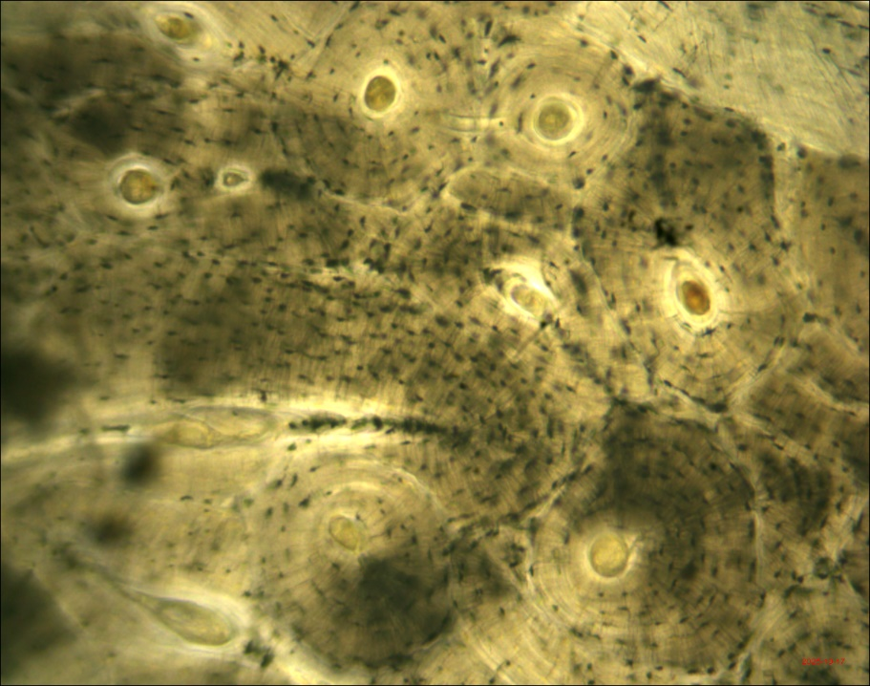
OS
OP
OF
Fig 1: Transverse section of a rib. X100. OS-Secondary osteon, OP-Primary osteon, OF-Osteon fragment

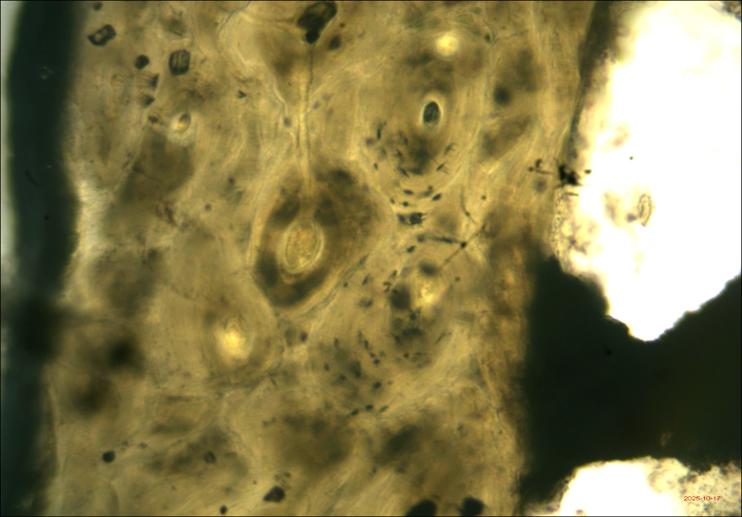
HC
Fig 2: Transverse section of calcaneus. X100. HC- Haversian canal

DISCUSSION
The data from the study show clear intra-skeletal microstructural differences among ribs, sternum, and calcaneus. Ribs recorded the highest intact osteon counts (secondary osteons = 8.00 ± 1.36; primary osteons = 4.80 ± 1.48) with a moderate mean Haversian canal diameter (10.40 ± 1.23 µm), whereas sternum sections exhibited lower osteon counts (OS = 2.70 ± 0.74; OP = 1.40 ± 0.37) but larger mean haversian canal diameters (13.05 ± 0.89 µm). Calcaneus samples displayed very low intact osteon numbers (OS = 0.20 ± 0.22; OP = 0.20 ± 0.13) alongside the largest mean Haversian canal diameter (17.49 ± 1.18 µm) and maximum osteon diameter (44.16 ± 1.80 µm) (Table 1). These numerical differences indicate systematic anatomical variation in cortical remodeling and microarchitecture that is consistent with recent work emphasizing strong intraskeletal heterogeneity in osteon population density and geometrical features. In particular, ribs frequently show relatively high remodeling indices and are widely used in histological age-estimation studies because of their consistent osteonal signatures across samples (García-Donas et al., 2022).
The inferential comparisons as reported in the study confirm that many of the observed contrasts are statistically robust (Table 2). Student’s t tests indicated significantly higher secondary and primary osteon counts in flat bones (rib and sternum) (Fig.1) compared with the calcaneus (p < 0.001 for several parameters studied), while calcanei demonstrated significantly larger Haversian canals (Fig.2) and, in some comparisons, larger osteon diameters (Table 2). Osteon fragment counts did not differ significantly between bone types, suggesting that fragment accumulation alone does not explain the differing intact osteon counts. This pattern of higher osteon population at some anatomical sites with correspondingly smaller canal/osteon sizes in others agrees with published interpretations that local loading environment, bone geometry, and turnover history drive microstructural trade-offs across the skeleton (Orupabo et al., 2025). Also, some recent histological and biomechanical studies have documented similar inverse relationships between osteon density and osteon/canal size across anatomical regions (Cooke et al., 2021; Pedersen et al., 2024).
The present study demonstrated quantitative indicators of remodeling (OS, OF, OS/OF ratio, and HCD) that help translate descriptive counts into an index of turnover (Table 3). Ribs showed the highest OS/OF ratio (0.58), indicating relatively abundant intact secondary osteons per fragment and thus an active and ongoing remodeling regime. Sternum sections were intermediate (OS/OF = 0.23), while the calcaneus presented a negligible OS/OF ratio (0.02) despite moderate fragment counts. Using a combined intact/fragment metric reduces misinterpretation due to fragmentation alone and aligns with contemporary recommendations to use multi-metric indices when assessing remodeling intensity in forensic and bioarchaeological samples. Recent intra-skeletal studies similarly argue for composite indices (rather than single counts) to capture cumulative remodeling versus recent turnover (García-Donas et al., 2022; Pedersen et al., 2024).
The study quantified histological preservation through intact osteon counts, fragmentation index (OF ÷ [OS + OP]), and Max OD (Table 4). Ribs displayed the highest intact osteon counts (12.80 ± 1.98) and the lowest fragmentation index (1.08), consistent with comparatively superior microstructural preservation. Sternum sections had lower intact osteon counts (4.10 ± 0.81) and a higher fragmentation index (2.83), whereas calcanei exhibited markedly poor preservation as indicated by very low intact osteon counts (0.40 ± 0.25) and a high fragmentation index (28.25) despite large osteon diameters (44.16 ± 1.80 µm). This is in consent with the activity exposure for ribs and sternum compared to the calcaneus, as the calcaneus is subject to more rapid destructive mechanisms and stressors. Hence it is not surprising that calcanei exhibited poorer osteon preservation. These quantitative preservation metrics support the practical conclusion that ribs offer more reliable microstructural targets for histomorphometric analyses used in forensic contexts, while calcaneal samples may be less suitable for osteon-based age or remodeling estimation without additional contextual information. This inference is concordant with García-Donas et al., (2022) validation that prioritize ribs for histological age estimation and caution about intraskeletal variability in preservation and interpretability. Studies using the ribs have been conducted by most authors (Stout et al., 1994; Oettle & Steyn, 2000), supporting the present study's finding that the ribs are more accurate, even for microstructural parameters.
The inverse association observed in the study (Tables 3 and 4) between osteon population (OS and OP) and canal/osteon size (HCD and MaxOD) between the flat bones (ribs and sternum) and short bones (calcanei) may reflect distinct remodeling dynamics and/or original bone formation patterns shaped by biomechanical loading. High remodeling rates typically produce multiple, smaller secondary osteons over time; conversely, low-turnover regions can retain fewer, larger osteonal structures and wider canals. Hence, these reports have been supported by the findings of this comparative histomorphometric study. The calcaneus, as a weight-bearing, impact-resistant tarsal bone, experiences loading regimes unlike those of ribs and sternum; such mechanical differences plausibly contribute to the observed microstructural signature of large osteon/canal sizes but few intact secondary osteons. These biomechanical and developmental explanations for intraskeletal differences have been highlighted in recent literature examining bone adaptation, osteon geometry, and regional remodeling (Cooke et al., 2021; Figus et al., 2025).
Practical implications follow directly from the data for forensic practitioners applying histomorphometry to fragmented remains; ribs appear to provide the most consistent and well-preserved microstructural information for estimating remodeling activity and, by extension, age-related signals. Calcaneal sections, while informative for canal and osteon size metrics, may be less reliable for osteon-count based approaches unless supplemented by other skeletal indicators or contextual taphonomic data. Finally, the OS/OF and fragmentation indices presented in this study are straightforward and reproducible numeric measures that merit validation across larger, more varied skeletal collections as potential standard tools for assessing remodeling intensity and preservation before applying age or identification models.
CONCLUSION
The quantitative findings document statistically significant and biologically meaningful microstructural differences between flat (rib, sternum) and short (calcaneus) human bones, clarify relative remodeling intensities, and provide numeric indices of preservation that can guide forensic sampling strategy. These results underscore the necessity of bone-specific reference data in histomorphometric practice and point to ribs as preferred targets for osteon-based analyses in many forensic investigations. Future studies should extend the present approach with larger, demographically characterized samples and multi-site validation to establish broadly applicable forensic guidelines.

REFERENCES
Cummaudo, M., Raffone, C., Cappella, A., Márquez-Grant, N., & Cattaneo, C. (2020). Histomorphometric analysis of the variability of the human skeleton: Forensic implications. Legal Medicine, 45, 101711. https://doi.org/10.1016/j.legalmed.2020.101711

Stan, E., Muresan, C., Daescu, E., Dumache, R., Ciocan, V., Ungureanu, S., Costachescu, D., & Enache, A. (2024). A Review of Histological Techniques for Differentiating Human Bone from Animal Bone. Methods and Protocols, 7(4), 51. https://doi.org/10.3390/mps7040051

Crowder, C. (2013). Estimation of Age at Death Using Cortical Bone Histomorphometry. Submitted to the U.S. Department of Justice Office of Justice Programs, National Institute of Justice, Award no.240692 2010-DN-BX- K035.

Nor, F.M, Pastor, R.F, Schutkowski, H. (2013). Age at death estimation from bone histology in Malaysian males. Medicine, Science and the Law. 0(0): 1-6.

Cho, H., Stout, S. D., & Madsen, R. W. (2002). Histomorphological analysis of the human midshaft femur: A validation study of the rib age estimation technique. Journal of Forensic Sciences, 47(1), 12–18. https://doi.org/10.1520/JFS15259J

Maat, G. J. R, Aarents, M. J, Nagelkerke, N. J. D. (2003). Age prediction from bone replacement: Remodeling of circumferential lamellar bone tissue in the anterior cortex of the femoral shaft of the present Dutch population. Barge's Anthropologica Leiden, Leiden University Medical Centre. 10:1-19.

Meltem, K, Dincer, A. (2014). Age determination and long bone histology in Stellagama stellio (Linnaeus, 1758) (Squamata: Sauria: Agamidae) populations in Turkey, Senckenberg Gesellschaft fur Naturforschung, 64 (1): 113- 126.
Abdullah, H, Jamil, M.M.A, Nor, F.M. (2018a). Histomorphometric variance of Haversian canal in cortical bone of Malaysian ethnic group. Journal of Physics conference series. 1019 (1): 012009.

Maat, G.J.R, Maes, A, Aarents, M.J, Nagelkerke, N.J.D. (2006). Histological age at death prediction from the femur in a contemporary Dutch sample* The decrease of non-remodeled bone in the anterior cortex. Journal of Forensic Sciences. 2006; 51:230-237.

Orupabo, C.D, Oghenemavwe, L.E, Diamond, T.E. (2020). Histomorphometric estimation of age from bone samples of Nigerians. International Journal of Medicine and Medical Research. 6(2): 67-76.

Oghenemavwe, L.E, Orupabo, C.D. (2022). Sex Estimation from Histomorphometric Analysis of Cortical Bone: A Hospital-based Study. Arab Journal of Forensic Sciences and Forensic Medicine. Vol.4 Issue (1): 1-12

Orupabo, C. D., & Chijioke, J. O. (2024). A comparative analysis on the histomorphometric pattern of various segments of adult male long bones: Forensic implication. Journal of Forensic Science and Medicine, 10(3), 171–175. https://doi.org/10.4103/jfsm.jfsm_98_23

Bantavanou, P., Siegmund, F., Moraitis, K., Pavlidis, P., Bertsatos, A., Valakos, E., Karakasi, M., Manthou, M., & Papageorgopoulou, C. (2025). Histomorphometric method for age-at-death estimation using the anterior side of the femoral midshaft. Journal of Archaeological Science Reports, 62, 105012.https://doi.org/10.1016/j.jasrep.2025.105012

Orupabo, C. D; Echomgbe, J. O; Bokoko, H. (2025). Histomorphometric Assessment of Human Skeletal Remains: Comparative Analysis of Long and Short Bones”. Archives of Current Research International 25 (12):533–542. https://doi.org/10.9734/acri/2025/v25i121691

García-Donas, J. G., Paine, R. R., Bonicelli, A., & Kranioti, E. F. (2022). Age estimation for two Mediterranean populations: rib histomorphometry applied to forensic identification and bone remodelling research. International Journal of Legal Medicine, 136(5), 1469–1481. https://doi.org/10.1007/s00414-022-02812-2
Cooke, K. M., Mahoney, P., & Miszkiewicz, J. J. (2021). Secondary osteon variants and remodeling in human bone. The Anatomical Record, 305(6), 1299–1315. https://doi.org/10.1002/ar.24646

Pedersen, L. T., Miszkiewicz, J., Cheah, L. C., Willis, A., & Domett, K. M. (2024). Age‐dependent change and intraskeletal variability in secondary osteons of elderly Australians. Journal of Anatomy, 244(6), 1078–1092. https://doi.org/10.1111/joa.14010

Stout, S. D, Dietze, W. H, İsçan, M. Y & Loth, S. R. (1994). Estimation of age at death using the cortical histomorphometry of the sternal end of the fourth rib. Journal of Forensic Sciences. 39(3):778-784.

Oettle, A. C & Steyn, M. (2000). Age estimation from the sternal ends of ribs by phase analysis in South African blacks. Journal of Forensic Sciences. 45(5):1071-1079.

Figus, C., Carlson, K. J., Bortolini, E., Saers, J., Seghi, F., Sorrentino, R., Bernardini, F., Vazzana, A., Erjavec, I., Novak, M., Tuniz, C., Belcastro, M. G., Stock, J., Ryan, T. M., & Benazzi, S. (2025). The Ontogeny of the human calcaneus: Insights from morphological and trabecular changes during postnatal growth. American Journal of Biological Anthropology, 186(2), e70007. https://doi.org/10.1002/ajpa.70007

