Case study

From Inflammation to Constriction: Tuberculous Pericarditis in a Young Postpartum Woman

Abstract
Tuberculous pericarditis remains a major cause of pericardial disease in endemic regions and continues to be associated with significant morbidity and mortality. Constrictive pericarditis represents one of its most severe complications and results from progressive pericardial inflammation leading to fibrosis, thickening, and impaired ventricular filling. We report the case of a 23-year-old pregnant woman who presented with febrile dyspnea and systemic inflammatory syndrome, whose clinical course was complicated by preterm labor and intrauterine fetal demise. Multimodal imaging revealed pericardial thickening, moderate pericardial effusion, respiratory variation of ventricular inflow velocities consistent with ventricular interdependence, and associated pleuropulmonary and lymph node involvement. Pleural fluid analysis demonstrated a lymphocyte-predominant exudate highly suggestive of tuberculous etiology in an endemic setting. Anti-tuberculous therapy combined with adjunctive corticosteroids was initiated promptly. This case highlights the diagnostic challenges of tuberculous constrictive pericarditis, particularly in young pregnant patients, and emphasizes the importance of early recognition of reversible inflammatory constriction to prevent progression toward irreversible fibrotic disease requiring pericardiectomy.

Introduction
Constrictive pericarditis is a severe clinical entity resulting from chronic inflammation of the pericardium that leads to fibrotic thickening, calcification, and loss of normal pericardial elasticity. The rigid pericardium limits diastolic filling, produces exaggerated ventricular interdependence, and ultimately leads to signs of right-sided heart failure. While post-surgical and post-radiation etiologies predominate in industrialized countries, tuberculosis remains a leading cause of pericardial disease in developing and endemic regions (1,2). According to the 2015 European Society of Cardiology Guidelines, tuberculosis accounts for a substantial proportion of large pericardial effusions and constrictive pericarditis cases in low- and middle-income countries (1).
The pathophysiology of tuberculous pericarditis follows a continuum beginning with an exudative inflammatory phase characterized by serous or serosanguinous effusion, progressing to fibrin deposition and granulomatous inflammation, and ultimately culminating in dense fibrotic scarring and constriction if untreated (3). Importantly, recent data suggest that some patients presenting with subacute constrictive physiology may have predominantly inflammatory rather than fibrotic disease, a potentially reversible stage if appropriate therapy is initiated promptly (4,5).
Pregnancy represents a unique immunological state characterized by relative immune tolerance, which may predispose to reactivation of latent tuberculosis or dissemination of active infection. However, tuberculous pericarditis during pregnancy remains uncommon and diagnostically challenging.

Case Presentation
A 23-year-old woman, gravida 1 para 0, at 27 weeks and 4 days of gestation, was admitted for progressive dyspnea associated with persistent fever evolving for approximately twenty days. Her past medical history was significant for hyperthyroidism treated with antithyroid medication, with recent thyroid function tests within normal limits. She reported progressive exertional dyspnea that had recently become present at rest, intermittent fever with night sweats, generalized fatigue, anorexia, and unintentional weight loss. She also described constrictive, non-radiating chest pain that was not influenced by posture or respiration. There was no documented history of previous tuberculosis treatment.
During hospitalization, her pregnancy was complicated by preterm labor leading to intrauterine fetal demise, followed by spontaneous vaginal delivery. On examination, she was febrile at 38.5°C and tachycardic at 110 beats per minute. Jugular venous distension was present, and heart sounds were distant. Mild bilateral lower limb edema was observed.
Laboratory investigations revealed a marked inflammatory syndrome with a C-reactive protein level of 169 mg/L. Hemoglobin was 8.1 g/dL, consistent with normocytic normochromic anemia of inflammation. Leukocyte and platelet counts were within normal limits. Renal and hepatic functions were preserved.
Electrocardiography demonstrated sinus tachycardia without specific abnormalities.(figure 1) Transthoracic echocardiography revealed diffuse pericardial thickening associated with moderate circumferential pericardial effusion. Doppler analysis demonstrated significant respiratory variation greater than 25% in mitral and tricuspid inflow velocities, consistent with ventricular interdependence. A septal bounce was observed, strongly suggestive of constrictive physiology (4,5).(figure 2)
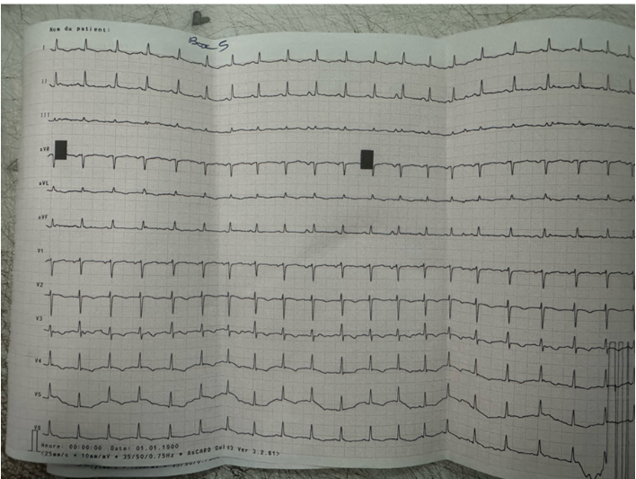
Figure 1 ECG
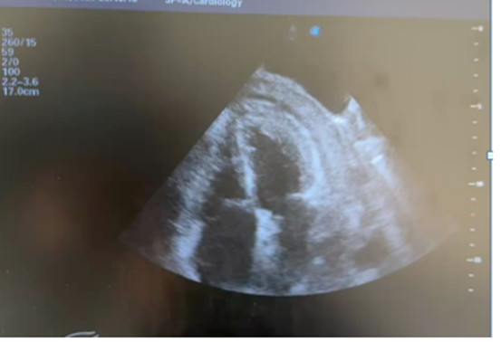
Figure 2 echocardiography
Thoracic computed tomography confirmed diffuse pericardial thickening with moderate pericardial and bilateral pleural effusion (figure3) . Bilateral pulmonary infiltrates and mediastinal, hilar, and axillary lymphadenopathy were also identified. Diagnostic thoracentesis yielded an exudative pleural effusion with protein concentration of 44 g/L and 100% lymphocytes. In an endemic context, a lymphocyte-predominant exudative effusion strongly suggests tuberculous etiology (2,3). Given the high clinical suspicion, empirical anti-tuberculous therapy was initiated promptly, in association with adjunctive corticosteroids.
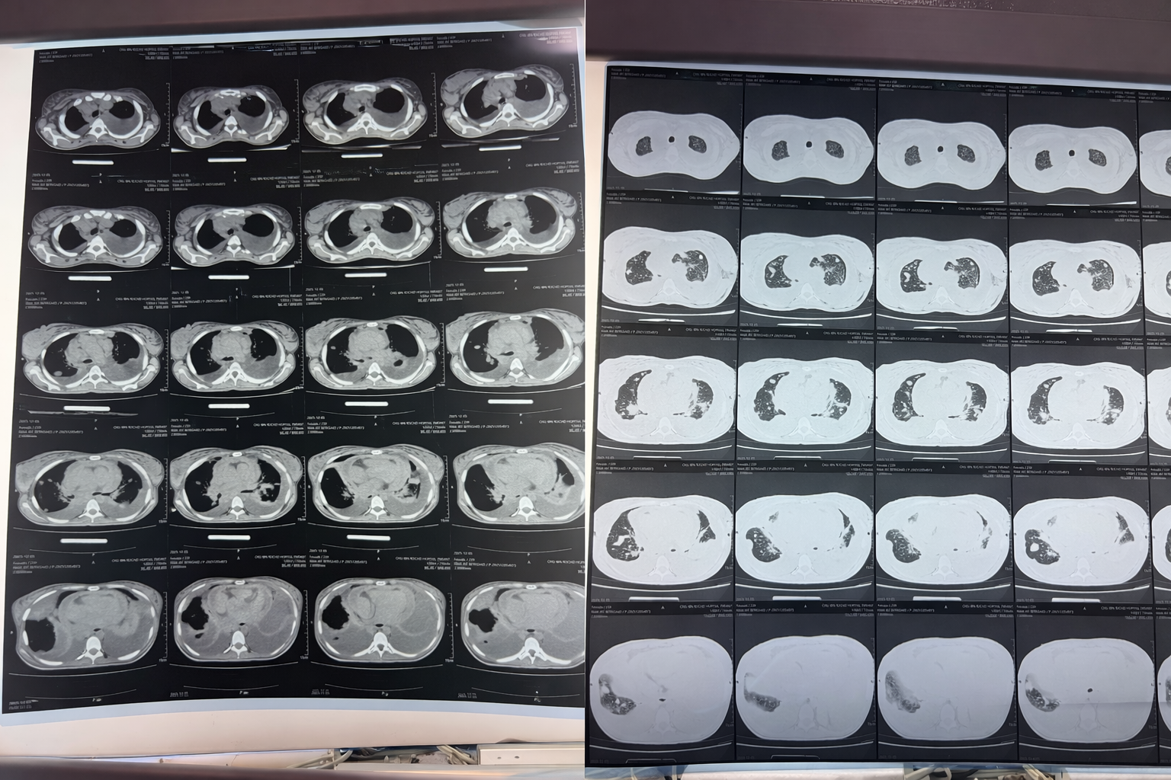

Figure 3 TDM

Discussion
Tuberculous pericarditis remains a major public health concern in endemic regions and represents one of the most serious extrapulmonary manifestations of Mycobacterium tuberculosis infection (2). It typically results from contiguous spread from infected mediastinal lymph nodes or hematogenous dissemination. Without treatment, mortality rates may approach 80 to 90 percent (2).
The disease classically evolves through fibrinous exudation, effusion formation, granulomatous organization, and finally constrictive scarring (3). The distinction between inflammatory and chronic fibrotic constriction is clinically crucial because inflammatory constriction may be reversible with medical therapy, whereas chronic constriction generally requires surgical pericardiectomy (4,5).
Echocardiography remains the first-line imaging modality and demonstrates characteristic findings such as septal bounce and respiratory variation of transvalvular flow velocities (4). Computed tomography can detect pericardial thickening and calcification, whereas cardiac magnetic resonance imaging is particularly useful in identifying pericardial edema and late gadolinium enhancement, markers of active inflammation (4).
Anti-tuberculous therapy remains the cornerstone of management (2). Adjunctive corticosteroids have been shown to reduce the incidence of constrictive pericarditis in selected patients (6). The IMPI trial demonstrated that prednisolone reduced the progression to constriction, although overall mortality benefit was limited (6). Pericardiectomy is reserved for patients with persistent symptomatic constriction despite optimal medical therapy, and surgical mortality ranges from 5 to 15 percent depending on timing and clinical status (7).
Early recognition of inflammatory constriction is therefore essential to prevent irreversible fibrosis. In our patient, the acute inflammatory presentation and absence of calcification suggested a potentially reversible stage.

Conclusion
Tuberculous pericarditis remains a significant cause of constrictive pericarditis in endemic regions. Early differentiation between reversible inflammatory constriction and chronic fibrotic disease is crucial, as it directly influences therapeutic strategy and prognosis. Prompt initiation of anti-tuberculous therapy combined with adjunctive corticosteroids may prevent progression to irreversible constriction requiring surgical intervention.

References
- Adler Y, Charron P, Imazio M, et al. 2015 ESC Guidelines for the diagnosis and management of pericardial diseases. Eur Heart J. 2015;36:2921–2964.
- Mayosi BM, Ntsekhe M. Tuberculous pericarditis with and without HIV. Circulation. 2013;127:241–249.
- Isiguzo G, Du Bruyn E, Howlett P, Ntsekhe M. Diagnosis and Management of Tuberculous Pericarditis. Cardiol Clin. 2017;35:525–537.
- Klein AL, Abbara S, Agler DA, et al. Multimodality imaging in pericardial disease. JACC Cardiovasc Imaging. 2013;6:1095–1110.
- Welch TD. Constrictive pericarditis: Diagnosis, management and clinical outcomes. Heart. 2018;104:725–731.
- Mayosi BM, et al. Prednisolone and Mycobacterium indicus pranii in tuberculous pericarditis. N Engl J Med. 2014;371:1121–1130.
- George TJ, Arnaoutakis GJ, Beaty CA, et al. Contemporary outcomes of pericardiectomy for constrictive pericarditis. Ann Thorac Surg. 2012;94:445–450.

