Integrating Traditional Ecological Knowledge with Community-Based Fish Farming in Deltaic Ponds of Tamil Nadu

Abstract
The present study documents the indigenous technical knowledge (ITK) associated with traditional fish pond management practices in the deltaic regions of Tamil Nadu, particularly in Kumbakonam (Thanjavur district) and Thiruvarur. Fifty traditional fish farmers were purposively selected to record their long-standing aquaculture practices using semi-structured interviews and participatory observation. The findings revealed that traditional pond systems locally called Kulam Meenvalam still play a significant role in ensuring fish productivity, biodiversity conservation, and community cohesion. Major traditional practices identified include the use of cow dung and goat manure for pond enrichment, neem and turmeric-based disinfection, natural lime sources for pH regulation, sun drying for mud conditioning, rainwater harvesting, and the use of locally made bamboo fish traps. These eco-friendly methods rely entirely on locally available organic inputs and community participation, ensuring minimal environmental impact. Scientifically, these methods promote nutrient cycling, water quality improvement, and fish health, aligning with the principles of sustainable aquaculture. The study concludes that integrating traditional knowledge with modern aquaculture technologies can enhance climate resilience and sustainability in small-scale fish farming systems.
Keywords: Indigenous Technical Knowledge, Traditional Fish Culture, Kulam Meenvalam, Pond Fertilization, Sustainable Aquaculture, Tamil Nadu.
1. Introduction
Aquaculture has been an integral component of rural livelihoods in South India for centuries, supported by traditional knowledge systems that harmonize ecological, social, and spiritual dimensions of water resource management (Vivekanandan, 2014; Sivaraman, 2020). In Tamil Nadu, particularly in the Cauvery Delta districts of Thanjavur and Thiruvarur, traditional fish farming is predominantly practiced in community-managed ponds locally known as kulam and irrigation tanks (eri) (Balasubramanian & Venkatesh, 2019). These water bodies serve multiple functions, including irrigation, livestock use, and domestic needs, while also supporting diverse fish species that contribute significantly to household nutrition and income (Department of Fisheries, 2021).
Traditional fish culture systems largely depend on natural ecological cycles, particularly rainfall and organic nutrient enrichment. Farmers utilize locally available resources such as cow dung, goat manure, wood ash, and neem leaves for pond fertilization and disinfection, thereby maintaining a self-sustaining aquatic ecosystem (Kumar, 2019; Subramanian & Manoharan, 2020). These practices represent centuries-old ecological wisdom transmitted across generations through oral traditions and experiential learning. For instance, the application of cow dung and ash acts as a slow-release nutrient source that promotes plankton growth, while neem–turmeric formulations function as eco-friendly disinfectants against fish pathogens (Shanmugam & Sundararajan, 2018; Singh, 2019).
Despite rapid modernization in aquaculture, traditional pond systems continue to demonstrate resilience, particularly under conditions of climate variability and water scarcity (Kumar & Singh, 2021). The collective management of ponds through community participation in activities such as cleaning, desilting, and maintenance fosters social cohesion and equitable sharing of resources (Sugumaran & Rajendran, 2020). Furthermore, cultural and ritual practices associated with these ponds reflect a deep-rooted spiritual connection with natural resources, which reinforces their conservation and sustainable use (Mahadevan, 2021).
Several studies have highlighted the scientific validity of indigenous aquaculture practices in maintaining ecological balance, enhancing productivity, and reducing dependency on external inputs (Ghosh & Sen, 2017; Gupta et al., 2018). However, systematic documentation of such traditional practices in the Kumbakonam–Thiruvarur region remains limited, and their integration into formal fisheries development policies is minimal. Therefore, documenting and scientifically validating these practices is essential for developing sustainable, low-cost, and locally adaptable aquaculture models. Therefore, the present study was undertaken with the following objectives:
- To document the indigenous technical knowledge (ITK) related to traditional fish pond management practices in Kumbakonam and Thiruvarur regions.
- To describe the preparation procedures and scientific rationale underlying each traditional method.
2. Materials and Methods
2.1. Study Area
The present study was conducted in the traditional fish farming regions of Kumbakonam (Thanjavur district) and Thiruvarur district, located in the fertile Cauvery delta zone of Tamil Nadu, India. This zone is renowned for its dense network of irrigation canals, tanks (eri), and village ponds (kulam), which support integrated rice–fish–livestock farming systems and traditional aquaculture practices.
Geographical Location
Kumbakonam lies between 10°57′ and 11°06′ N latitudes and 79°20′ and 79°30′ E longitudes, while Thiruvarur district is located between 10°20′ and 10°45′ N latitudes and 79°15′ and 79°45′ E longitudes. The region experiences a tropical humid climate with an average annual rainfall of 1050–1200 mm, mainly received during the northeast monsoon (October–December). The mean temperature ranges from 22°C to 37°C, and the relative humidity varies between 65% and 85% throughout the year.(Fig.1)
Agro-ecological Features
The area is characterized by alluvial and clay loam soils with high water-retaining capacity, making it ideal for pond-based aquaculture. The Cauvery River and its tributaries—Arasalar and Vettar—act as perennial water sources for replenishing ponds and tanks. Most ponds are community-owned or homestead-based, and fish culture is practiced alongside agricultural activities such as paddy cultivation.
Traditional Aquaculture Context
Local farmers in Kumbakonam and Thiruvarur follow traditional pond management practices transmitted across generations. These include the application of cow dung, goat manure, and ash for pond enrichment; neem leaves or turmeric water for disinfection; and sun drying and mud conditioning between cycles. Such practices are based on ecological understanding and resource recycling rather than chemical dependency.
Sampling and Data Collection
Data were collected from 50 traditional fish farmers, comprising 25 respondents from Kumbakonam block (Thanjavur district) and 25 respondents from Thiruvarur district. A purposive-cum-snowball sampling method was employed to identify experienced traditional practitioners. Information was gathered through voice-recorded interviews, participatory rural appraisal (PRA), and focus group discussions (FGDs). Direct field observation of pond preparation, fertilization, and maintenance practices was also conducted for validation.
Relevance of the Study Area
The Cauvery delta, often termed the “Rice Bowl of Tamil Nadu,” has a long history of water conservation and aquatic resource management. Documenting the indigenous pond fish farming practices in this ecologically sensitive region provides valuable insights for promoting sustainable, low-cost aquaculture aligned with traditional ecological knowledge (TEK) principles.
Data Collection and Documentation of Traditional Practices
To record the traditional knowledge associated with fish pond management, a qualitative ethnographic approach was adopted. The study focused on documenting and validating the indigenous aquaculture techniques still practiced by rural farming communities of Kumbakonam (Thanjavur district) and Thiruvarur district, Tamil Nadu.
Sampling Procedure
A total of 50 traditional fish farmers were selected using a purposive-cum-snowball sampling technique, ensuring the inclusion of elderly and experienced individuals who have practiced fish culture for more than 10 years. This sampling approach was considered appropriate for studying community-based indigenous knowledge that is largely transmitted orally rather than through formal training or extension services.
Tools and Techniques Used
- Voice-recorded Interviews
Semi-structured, open-ended interviews were conducted in the Tamil language. Farmers were asked about pond preparation, fertilization, water disinfection, fish breeding, and harvesting techniques. Their oral narratives were recorded using audio devices for accurate transcription.
- Focus Group Discussions (FGDs)
Two FGDs were organized—one in Kumbakonam and another in Thiruvarur—each involving 8 to 10 traditional practitioners. These discussions helped identify regional variations, local innovations, and cultural beliefs linked with pond management.

- Participant Observation
Field visits were made to observe the real-time application of traditional practices such as the use of cow dung, neem leaves, lime, and turmeric water. Observations were recorded on timing, dosage, and handling methods used by the farmers.
- Triangulation and Validation
The information collected was cross-checked among multiple farmers and validated through local fisheries officers and academic experts from Tamil Nadu Dr. J. Jayalalithaa Fisheries University (TNJFU), Nagapattinam. Only those practices confirmed by at least three independent sources were included in the final documentation.
Data Analysis
All voice-recorded interviews were transcribed verbatim in Tamil and later translated into English. Thematic analysis was performed by categorizing responses under major traditional management areas—such as pond fertilization, pond disinfection, fish trapping, breeding practices, and socio-cultural rituals. Recurrent patterns were coded, and each practice was interpreted with its possible scientific rationale, comparing the findings with relevant literature in indigenous aquaculture.
3. Results and Discussion
The field documentation among 50 traditional fish farmers from Kumbakonam (Thanjavur district) and Thiruvarur district revealed several enduring practices related to fish pond management. The farmers’ experiences, passed down through generations, demonstrate a deep understanding of ecological processes, water quality, and fish health. Their direct quotations, recorded during field visits, are presented to preserve authenticity and oral tradition.
3.1. Kulam Meenvalam – Traditional Village Pond Culture
The study findings revealed that traditional village ponds (kulam) and irrigation tanks (eri) play a significant role in sustaining fish culture practices in both Kumbakonam (Thanjavur district) and Thiruvarur regions. These water bodies, often several decades to centuries old, serve as multipurpose community resources supporting irrigation, livestock, and aquaculture. Their continued use reflects the effectiveness of indigenous water management systems and their cultural significance in rural livelihoods (Mahadevan, 2021; Sivaraman, 2020).
A notable observation from the field was the strong community participation in pond maintenance. Farmers collectively undertake cleaning and desilting activities, particularly after the harvest season. As expressed by a respondent, Mr. R. Venkatesan (62 years) from Ayyampettai, Kumbakonam, the kulam in their village was constructed nearly a century ago and is maintained annually through collective effort. This finding is in line with earlier studies emphasizing community-based pond management as a sustainable approach in rural fisheries (Balasubramanian & Venkatesh, 2019).
The pond preparation process followed by farmers reflects a systematic indigenous technical knowledge. The activities include marking of working zones, draining of water while retaining a small portion for ecological balance, and removal of aquatic weeds and debris. The removed biomass is often composted, indicating efficient resource utilization. Desilting is carried out manually, and the excavated silt is either applied to nearby agricultural fields or composted, contributing to soil fertility and promoting integration between aquaculture and crop production systems (Subramanian & Manoharan, 2020; Sugumaran & Rajendran, 2020).(f
Further, bunds (karai) are repaired using locally available materials such as clay, coconut husk, and grasses, followed by manual compaction and establishment of vegetative cover to prevent erosion. Inlet and outlet channels (vaikkal) are cleaned regularly, and bamboo screens are installed to restrict the entry of predatory organisms. Farmers also regulate pond depth by maintaining shallow zones (0.2–0.5 m) for fingerlings and deeper zones (0.8–1.2 m) for adult fish, ensuring better growth and survival. These practices are consistent with traditional fish culture systems reported in different parts of India (Gupta et al., 2018; Ghosh & Sen, 2017).
Traditional inputs such as the application of wood ash and organic materials were also observed in pond conditioning. Such practices enhance pond productivity and reduce dependency on chemical inputs (Kumar, 2019). In addition, eco-friendly approaches like natural disinfection and sun drying of pond beds help in minimizing pest incidence and improving overall pond health (Shanmugam & Sundararajan, 2018; Singh, 2019).
Thus, the findings indicate that traditional pond management practices are scientifically sound, cost-effective, and environmentally sustainable. These practices align well with the principles of sustainable aquaculture and ecosystem-based fisheries management (FAO, 2021; FAO, 2022). Furthermore, institutional reports also emphasize the importance of tank-based aquaculture and integrated water resource management in enhancing inland fish production in Tamil Nadu and India (Department of Fisheries, 2021; ICAR, 2022; ICAR, 2023; Kumar & Singh, 2021)
3.2. Use of Cow Dung, Goat Manure, and Ash for Pond Enrichment
The study revealed that all respondents practiced the use of organic materials such as cow dung, goat manure, and wood ash for pond enrichment prior to fish stocking. This practice was commonly observed across both study regions, indicating its widespread acceptance as a low-cost and effective method for enhancing pond productivity. A respondent, Mrs. A. Meenakshi (48 years) from Konerirajapuram village, explained that cow dung from household cattle and ash from kitchen fires are regularly applied to ponds, resulting in visible green coloration of water within a few days, which is associated with increased fish growth.
Farmers typically apply 200–400 kg of cow dung per acre depending on pond size and nutrient status. In some cases, goat manure and ash are added to improve nutrient composition and mineral balance. The application is generally carried out after pond cleaning and drying, or a few days prior to water filling during the onset of rains. This reflects a well-established indigenous practice aimed at preparing the pond ecosystem for fish culture.
The method of application involves preparation of a slurry by mixing cow dung with water, followed by partial fermentation for 3–4 days under shade conditions. This process reduces the risk of ammonia toxicity and enhances nutrient availability. The fermented mixture is then uniformly broadcast over the pond bed. Farmers reported waiting for 2–5 days until a green plankton bloom develops before introducing fingerlings, indicating their understanding of ecological readiness of the pond.
From a scientific perspective, cow dung serves as an organic fertilizer that enriches pond water with essential nutrients such as nitrogen and phosphorus, thereby promoting the growth of phytoplankton and zooplankton, which act as natural food for fish (Kumar, 2019; Natarajan & Jhingran, 2001). The addition of goat manure further enhances nutrient diversity, while wood ash contributes minerals and helps in improving pond bottom conditions.
However, improper application, particularly the use of fresh, unfermented dung, may lead to the accumulation of toxic ammonia and depletion of dissolved oxygen, adversely affecting fish health. Farmers were aware of such risks and adopted precautionary measures such as partial fermentation, delayed stocking, and monitoring fish behavior. In cases of oxygen stress, practices like water exchange and aeration were reported. These findings align with earlier studies emphasizing the importance of organic fertilization and proper pond conditioning for sustainable aquaculture (Singh, 2019; FAO, 2021).
The results indicate that the use of cow dung, goat manure, and ash is a scientifically valid, cost-effective, and eco-friendly practice that enhances natural productivity of ponds and supports sustainable fish farming systems
3.3 Lime Application Using Natural Sources
The findings indicated that nearly 80 per cent of the farmers practiced lime application using locally available materials such as shell lime (sunnambu) and burnt snail shells. This practice was commonly observed in Thiruvarur and surrounding areas, reflecting an indigenous adaptation to locally available resources. A respondent, Mr. K. Subramani (55 years) from Thirukannamangai, Thiruvarur, reported that crushed shells are applied to the pond bottom to improve soil quality and prevent fish mortality.
Farmers typically apply 20–25 kg of lime per acre, depending on pond condition. The lime is usually prepared by crushing and sieving shells, followed by pre-soaking in water to form a suspension. This suspension is then evenly broadcast over the dry pond bed, preferably during cooler hours of the day. Farmers ensure a gap of 2–3 days between lime application and the addition of organic manures such as cow dung, indicating their awareness of proper sequencing in pond preparation practices.
The primary purpose of lime application, as reported by farmers, is to “sweeten” the pond soil, which corresponds scientifically to the stabilization of soil and water pH. Lime also acts as a disinfectant, reducing harmful pathogens and improving overall pond health. Additionally, it enhances the availability of essential minerals, particularly calcium, which is beneficial for fish growth and survival (Singh, 2019; Natarajan & Jhingran, 2001).
The use of shell-based lime highlights a sustainable and eco-friendly approach, reducing dependence on commercial inputs while utilizing locally available materials. Similar traditional practices have been reported in aquaculture systems across India, emphasizing the role of indigenous knowledge in maintaining pond productivity (Ghosh & Sen, 2017; Gupta et al., 2018).
However, farmers also acknowledged the need for precaution during lime handling, as excessive or improper application may affect water quality. The use of protective measures such as cloth masks and careful storage of lime materials was observed in some cases. Monitoring of pond pH after filling was practiced by a few progressive farmers to ensure optimal conditions (pH 7.0–8.5) for fish culture. Overall, the results suggest that lime application using natural sources is a scientifically sound, cost-effective, and environmentally sustainable practice that contributes significantly to pond preparation and fish health management, aligning with recommended aquaculture practices (FAO, 2021; ICAR, 2022).
3.4 Neem and Turmeric-Based Pond Disinfection
The study revealed that about 70 per cent of the respondents practiced pond disinfection using natural materials such as neem leaves, neem oilcake, and turmeric. This practice was widely observed across the study areas, reflecting farmers’ reliance on eco-friendly and locally available resources for maintaining pond health. A respondent, Mr. A. Dhandapani (60 years) from Needamangalam block, reported that neem and turmeric are applied to pond water before stocking to maintain water quality and prevent disease symptoms such as white patches on fish.
Farmers typically prepare a plant-based extract by boiling neem leaves or neem oilcake in water, followed by the addition of turmeric in the form of powder or rhizomes. The prepared solution is cooled and applied along pond margins and shallow zones a few days prior to stocking. In some cases, farmers repeat the application after 20–25 days to ensure continued protection. This indicates an indigenous understanding of preventive health management in aquaculture systems.
From a scientific perspective, neem (Azadirachta indica) contains bioactive compounds such as azadirachtin, which possess antimicrobial and antiparasitic properties, while turmeric (Curcuma longa) contains curcumin, known for its antiseptic and anti-inflammatory effects. These compounds help in reducing bacterial load and controlling ectoparasites, thereby improving fish health and survival (Shanmugam & Sundararajan, 2018). Such plant-based treatments contribute to maintaining microbial balance in pond ecosystems without causing environmental harm.
The use of neem and turmeric represents a sustainable alternative to chemical disinfectants, aligning with the principles of eco-friendly aquaculture. Similar indigenous practices have been reported in traditional fish farming systems, highlighting the importance of ethnobiological knowledge in disease management (Ghosh & Sen, 2017; Vivekanandan, 2014).
Farmers also demonstrated awareness of application methods, ensuring that the extract is cooled before use and observing fish behavior after application to detect any stress symptoms. This reflects a practical understanding of dosage and safety considerations in traditional pond management. Overall, the findings indicate that neem- and turmeric-based disinfection is a cost-effective, environmentally safe, and scientifically valid practice that enhances biosecurity and supports sustainable aquaculture systems (FAO, 2021; Kumar & Singh, 2021).
3.5 Sun Drying and Mud Conditioning
The findings revealed that all farmers practiced sun drying and mud conditioning of ponds after fish harvest, indicating its universal importance in traditional pond management systems. This practice was consistently followed across both study regions as a preparatory step before the next production cycle. A respondent, Mrs. R. Ponnammal (65 years) from Valangaiman, reported that ponds are completely drained and left to dry for about two weeks until visible cracks appear on the soil surface, which farmers associate with the removal of foul odour and harmful organisms.
The process involves complete drainage of pond water, followed by removal of residual water pockets. Farmers then manually plough or loosen the exposed pond bed using tools such as mamatti (spade) to expose deeper soil layers. The pond bed is allowed to dry for 15–30 days, depending on climatic conditions, with occasional turning of soil to ensure uniform drying. In some cases, farmers apply small quantities of ash or lime during the drying phase to enhance oxidation and pathogen control. The dried silt is later collected and utilized as manure in agricultural fields or composted, reflecting efficient resource recycling.
From a scientific perspective, sun drying plays a critical role in oxidizing accumulated organic matter, eliminating harmful pathogens, and improving soil aeration. The exposure of pond bottom to sunlight also helps in the breakdown of toxic gases and enhances the overall soil structure, making it suitable for subsequent aquaculture operations. These benefits are comparable to modern biosecurity and pond conditioning practices recommended in scientific aquaculture (FAO, 2022; Natarajan & Jhingran, 2001).
Additionally, some farmers incorporate organic amendments such as fermented cow dung compost before refilling the pond, which further improves nutrient status and supports primary productivity. The observation of cracked soil and absence of foul smell were used by farmers as indicators of effective drying, demonstrating their experiential knowledge in assessing pond readiness. The results indicate that sun drying and mud conditioning are essential, low-cost, and scientifically valid practices that contribute significantly to pond health, disease prevention, and sustainable fish production systems (Kumar & Singh, 2021; ICAR, 2022).
3.6 Use of Locally Made Fish Traps
The study revealed that traditional fishing devices such as koodu, valai, and pari are still widely used by farmers in both Kumbakonam and Thiruvarur districts. These indigenous tools, primarily made from bamboo and locally available materials, were commonly employed for harvesting fish in small village ponds. A respondent, Mr. S. Murugan (52 years) from Nannilam, demonstrated a handmade bamboo trap and emphasized that such devices allow smaller fish to escape, thereby ensuring their growth for future harvests.
The construction of these traps involves the use of split bamboo, coir rope, and simple structural designs such as conical funnels that permit fish entry but restrict exit. Farmers typically bait the traps with rice bran or fermented oil cake and place them strategically near pond inlets, shallow areas, or natural fish movement pathways during evening hours. The traps are checked early in the morning, and larger fish are harvested while juveniles and non-target species are released back into the pond.
From a scientific perspective, these traditional traps are eco-friendly, biodegradable, and species-selective, reducing the risk of overharvesting and minimizing juvenile mortality. Unlike synthetic nylon nets, which may capture fish indiscriminately, these indigenous devices support sustainable harvesting practices by allowing selective removal of marketable fish while conserving breeding stock (Vivekanandan, 2014; Ghosh & Sen, 2017).
Additionally, the use of locally available materials makes these traps cost-effective and easily repairable, enhancing their suitability for small-scale farmers. The practice also reflects a deep understanding of fish behavior and habitat utilization among farmers. (Fig 3) Similar traditional fishing methods have been documented in various parts of India, emphasizing their relevance in sustainable fisheries management (Gupta et al., 2018). The findings highlight that the use of locally made fish traps is a sustainable, economically viable, and environmentally responsible practice that aligns with the principles of conservation-oriented aquaculture and resource management (FAO, 2021).
3.7 Rainwater Harvesting and Groundwater Recharge through Ponds
The study revealed that village ponds in low-lying regions are effectively utilized for rainwater harvesting and groundwater recharge, particularly during the northeast monsoon season. Farmers strategically manage these ponds to capture runoff and enhance water availability for multiple uses. A respondent, Mr. G. Rajendran (58 years) from Kodavasal, reported that canal gates are opened during monsoon rains to allow natural filling of ponds, which subsequently contributes to groundwater recharge in nearby wells.
Field observations indicated that farmers adopt several indigenous structural and management practices to optimize water harvesting. These include the design of gently sloping inlet channels (vaikkal) to facilitate smooth water flow, along with the use of bamboo screens and gravel filters to minimize silt entry into the pond. Temporary check bunds made of clay and coconut husk are constructed upstream to reduce water velocity and sediment load. Additionally, overflow channels are created to safely divert excess water to adjacent fields, thereby preventing bund damage and soil erosion.
Farmers also practice the creation of percolation pits along pond margins using locally available materials such as coconut husk, which enhances infiltration and groundwater recharge. Regular inspection and maintenance of these structures, especially after monsoon events, were reported as common practices. Some farmers also monitor changes in pond water levels before and after rainfall events, indicating an awareness of water management dynamics.
From a scientific perspective, such traditional pond systems play a crucial role in enhancing groundwater recharge, reducing surface runoff, and minimizing soil erosion. These practices are aligned with established principles of watershed management and integrated water resource utilization (Sugumaran & Rajendran, 2020; ICAR, 2022). The multifunctional use of ponds for water storage, aquaculture, and recharge reflects a sustainable approach to resource management that has been practiced for generations. Overall, the findings highlight that traditional rainwater harvesting and groundwater recharge practices through village ponds are ecologically sound, economically beneficial, and highly relevant in the context of climate variability and water scarcity (FAO, 2021; Department of Fisheries, 2021).
3.8 Spiritual and Cultural Practices in Pond Management
The study revealed that spiritual and cultural practices are closely integrated with fish farming activities in the study areas. Farmers commonly perform rituals before stocking fish, involving offerings such as turmeric water, flowers, and the lighting of lamps. These practices are typically conducted collectively by the community, reflecting the cultural significance attached to village ponds (kulam). A respondent, Mrs. Lakshmi (60 years) from Thiruvarur town, reported that rituals are performed to seek blessings from the kulam deivam before releasing fish, indicating a deep-rooted belief system associated with natural resource management.
Field observations showed that these rituals are often performed on auspicious days, as per traditional calendars, and involve basic preparatory activities such as cleaning the pond bund and setting up a temporary altar. Offerings including turmeric water, rice, flowers, and camphor are used, followed by prayers led by a community elder or priest. Fish fingerlings are then released collectively, marking the beginning of the culture cycle.
From a socio-cultural perspective, such practices play a vital role in strengthening community cohesion and ensuring collective participation in pond management activities. Rituals act as informal institutional mechanisms that regulate the timing of key interventions such as stocking, cleaning, and maintenance. They also reinforce a sense of ownership and responsibility among community members toward the sustainable use of shared water resources.
These findings are consistent with earlier studies highlighting the cultural and spiritual dimensions of traditional water resource management systems in South India (Sivaraman, 2020; Mahadevan, 2021). The integration of cultural values with ecological practices contributes to the long-term sustainability of pond ecosystems by promoting regular maintenance and community involvement.
3.9 Natural Fish Breeding in Seasonal Ponds
The study revealed that a section of farmers in Thiruvarur district utilize shallow seasonal ponds (kuttai) to support natural fish breeding. These ponds are typically left undisturbed during the monsoon period, allowing indigenous fish species to spawn and recruit naturally. A respondent, Mr. M. Ramasamy (63 years), reported that species such as catfish and murrel enter these ponds during the first rains and breed without any external stocking, indicating reliance on natural ecological processes.
Field observations indicated that farmers consciously preserve shallow, vegetated zones within these ponds to serve as spawning habitats. Unlike regular production ponds, these microhabitats are not cleaned or disturbed prior to the monsoon, thereby maintaining favorable conditions for breeding. Farmers also reported reducing fishing activities during peak breeding periods and, in some cases, following informal community norms to protect broodstock.
In addition, farmers adopt simple management practices such as creating nursery enclosures using bamboo partitions or fine-mesh screens to retain fry and fingerlings. Once the juveniles reach a suitable size (approximately 5–8 cm), these enclosures are opened to allow integration with the main pond population. Some farmers also monitor fish recruitment by observing fry density and species composition, reflecting a practical understanding of population dynamics.
From a scientific perspective, seasonal ponds provide ideal environmental conditions such as shallow water, vegetation cover, and nutrient availability, which support natural spawning and recruitment of indigenous fish species. These systems contribute to biodiversity conservation and reduce dependence on external seed supply (Natarajan & Jhingran, 2001; Vivekanandan, 2014).
The practice aligns with sustainable aquaculture principles by promoting in situ conservation of native species and enhancing ecosystem resilience. Similar traditional practices have been documented in different regions, highlighting the importance of integrating natural breeding systems into fisheries management (Ghosh & Sen, 2017; FAO, 2022).
3.10 Integration of Traditional and Modern Practices in Fish Culture
The study revealed that a small proportion of younger farmers (around 20%) have begun integrating modern aquaculture practices with traditional pond management systems. This hybrid approach includes the use of improved hatchery fingerlings and supplementary feeding, while continuing to rely on indigenous practices such as organic fertilization using cow dung and pond disinfection using neem-based preparations. A respondent, Mr. B. Dinesh (35 years) from Kumbakonam, reported that although hatchery fish are now used, traditional inputs are still preferred for maintaining water quality and preventing disease incidence.
Field observations indicated that farmers adopting this integrated approach follow a sequential method combining both traditional and scientific practices. Pond preparation is initially carried out using conventional methods such as sun drying, lime application, organic manuring, and neem-based disinfection. Subsequently, improved fish seed obtained from hatcheries is stocked at recommended densities. Supplementary feeding is introduced only after the establishment of natural plankton bloom, ensuring efficient feed utilization and minimizing waste.
Farmers also continue traditional monitoring practices, including periodic application of herbal disinfectants, observation of fish behavior, and use of selective harvesting methods such as bamboo traps. Some progressive farmers maintain records of inputs, yields, and disease occurrence, enabling comparison between purely traditional and integrated systems.
From a scientific perspective, this hybrid model enhances productivity while maintaining ecological balance. The use of improved seed and supplemental feeding contributes to higher yields, while traditional practices ensure pond health, disease resistance, and environmental sustainability (Kumar & Singh, 2021; ICAR, 2023). Such integration reflects adaptive capacity among farmers and supports the transition toward sustainable intensification of aquaculture systems.
These findings are consistent with broader recommendations emphasizing the integration of indigenous technical knowledge with modern scientific approaches to achieve resilient and sustainable aquaculture (FAO, 2021; Subramanian & Manoharan, 2020).
Policy Implications and Extension Strategies
The findings of the study highlight the importance of integrating indigenous technical knowledge (ITK) into formal aquaculture extension systems. Extension agencies should document and validate such eco-friendly practices and promote them through training programmes, demonstrations, and farmer field schools. Government support in the form of subsidies for organic inputs and community pond management can enhance adoption. Moreover, integrating traditional practices with modern scientific aquaculture technologies can improve productivity while ensuring environmental sustainability. These practices also align with climate-resilient agriculture and should be included in state fisheries development policies.
4.Conclusion
The study clearly establishes that traditional pond management systems such as Kulam Meenvalam (village pond culture) continue to serve as resilient and eco-friendly aquaculture models in the deltaic regions of Tamil Nadu. The documented practices—including desilting, sun drying, application of cow dung and shell lime, use of neem–turmeric decoctions, and collective maintenance—reflect generations of accumulated ecological wisdom. Farmers like Mr. R. Venkatesan of Ayyampettai, Mr. R. Rajasekar from Thirukannamangai, and Mrs. M. Kanimozhi of Valangaiman emphasized that such techniques not only improve water quality and fish yield but also preserve social unity and traditional ecological knowledge.
Scientific validation confirms that these practices regulate pond pH, enhance plankton productivity, minimize disease incidence, and sustain nutrient cycling. Moreover, the participatory and ritual aspects embedded in the culture promote community stewardship and equitable water sharing. Thus, these traditional systems provide a sustainable, low-cost alternative to intensive aquaculture
5.Ethics and Policies
Originality and Plagiarism
The authors declare that this manuscript is original and has not been published previously. All sources have been properly cited, and the manuscript is free from plagiarism.
Ethics Statement
No specific permits were required for the field study as no human or animal subjects were directly involved.
Conflict of Interest
The authors declare that there are no conflicts of interest.
Data Availability
The data supporting the findings of this study are available from the corresponding author upon reasonable request.
Use of Artificial Intelligence (AI) Tools
The authors declare that AI tools were used only for language editing and formatting purposes. No AI tools were used for data generation, analysis, or interpretation. All intellectual content and scientific conclusions are the sole responsibility of the authors.

COMPETING INTERESTS DISCLAIMER:
Authors have declared that they have no known competing financial interests OR non-financial interests OR personal relationships that could have appeared to influence the work reported in this paper.

References
Balasubramanian M, Venkatesh R. Community-based pond management: a traditional practice for sustainable fisheries in southern India. Indian Journal of Traditional Knowledge. 2019;18(4):740–747.
Department of Fisheries, Government of Tamil Nadu. Annual report on inland fisheries development and tank aquaculture in Tamil Nadu. Chennai; 2021.
FAO. Guidelines for sustainable aquaculture development and ecosystem approach to fisheries management. Rome: Food and Agriculture Organization of the United Nations; 2021.
FAO. The State of World Fisheries and Aquaculture. Rome; 2022.
Ghosh AN, Sen PR. Traditional knowledge systems in fisheries and aquaculture. Lucknow: ICAR-NBFGR; 2017.
Gupta SD, Singh AK, Chakraborty SC. Traditional fish culture practices in eastern India: relevance to sustainable aquaculture. Indian Journal of Traditional Knowledge. 2018;17(2):319–327.
ICAR. Annual report on fisheries research and development. New Delhi; 2023.
ICAR. Integrated water resource management for aquaculture and fisheries. Chennai: Central Institute of Brackishwater Aquaculture (CIBA), Indian Council of Agricultural Research; 2022.
Kumar B. Organic manure and cow dung-based fertilization for aquatic productivity enhancement. Journal of Eco-Agriculture. 2019;13(2):110–118.
Kumar R, Singh P. Sustainable aquaculture practices in India. Aquaculture Reports. 2021;20:100700.
Mahadevan A. Ethno-aquatic practices and cultural significance of village ponds in Tamil Nadu. Chennai: University of Madras Press; 2021.
Natarajan AV, Jhingran AG. Ecology and fisheries of man-made lakes in India. Bulletin No. 38. Barrackpore: Central Inland Fisheries Research Institute; 2001.
Shanmugam K, Sundararajan B. Eco-friendly disinfection techniques for pond preparation using neem and turmeric. Environment and Ecology. 2018;36(4):1456–1461.
Singh HN. Lime application in fish ponds: traditional and modern perspectives. Aquaculture Asia. 2019;14(3):32–37.
Sivaraman T. Cultural and spiritual dimensions of water resource management in South India. Indian Journal of Traditional Knowledge. 2020;19(1):82–90.
Subramanian S, Manoharan R. Indigenous technical knowledge in fish farming practices in Cauvery Delta region. Journal of Extension Education. 2020;31(4):6359–6363.
Sugumaran V, Rajendran M. Rainwater harvesting and groundwater recharge through traditional pond systems in deltaic Tamil Nadu. Indian Journal of Environmental Protection. 2020;40(6):567–573.
Vivekanandan E. Traditional aquaculture systems in coastal Tamil Nadu: an overview. Indian Journal of Fisheries. 2014;61(3):45–52.

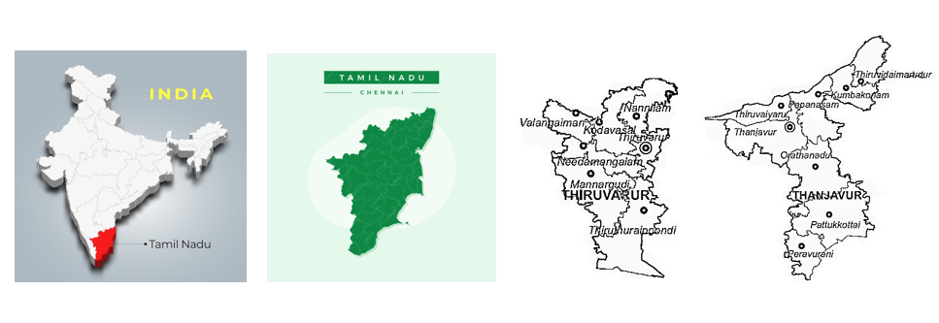
Fig .1: Geographical location

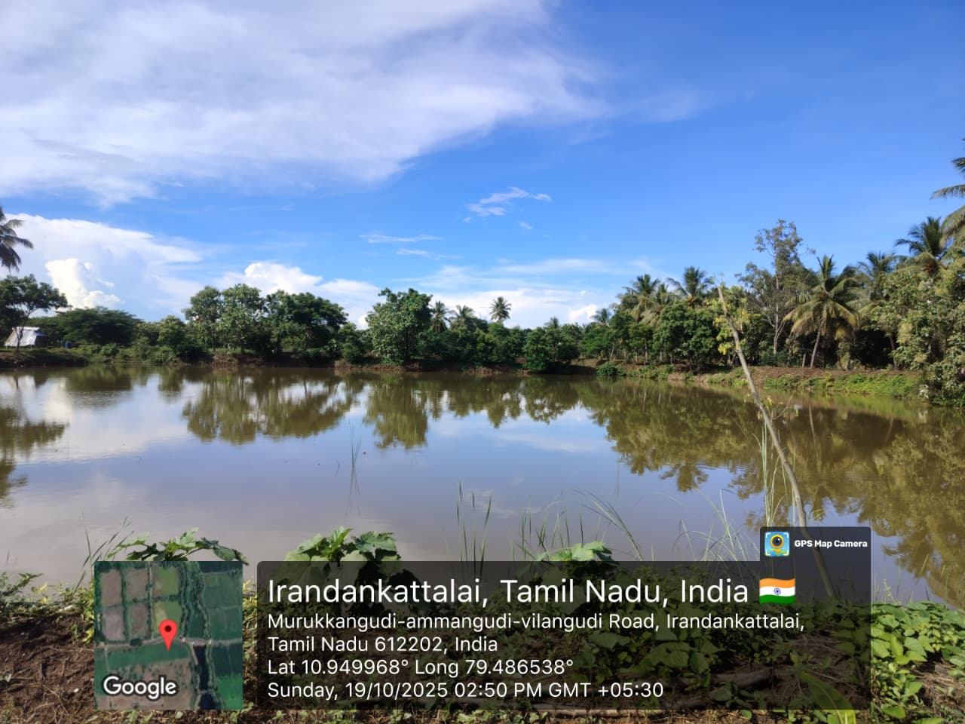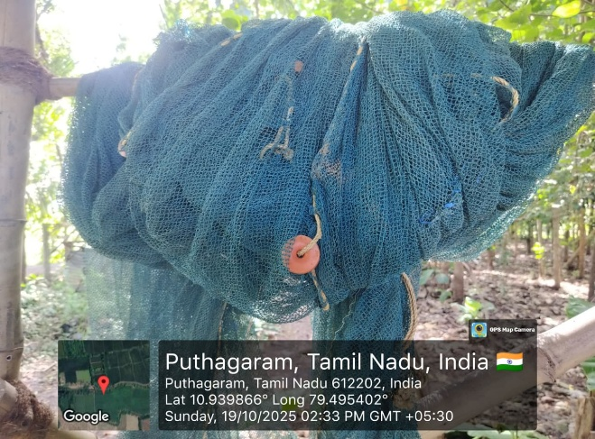
Fig 2: Traditional village pond culture Fig 3: Use of locally made fish traps

