Original Research Article

Social Innovation in Farm Business Development of Small Farmers in Bangladesh: A Case Study from Chattogram District

Abstract
The purpose of this study is to assess the multifunctionality of the Common Interest Group (CIG) approach in creating social innovation by transforming smallholder farming into a farm business for sustainable agriculture and rural development in Bangladesh. The study was carried out in Hathazari upazila of Chattogram district, Bangladesh. Data were collected through semi-structured interviews and key informants' interviews (KIIs) with various stakeholders. We have introduced a Trajectory Equifinality Model (TEM) analysis based on data from semi-structured interview case studies. The analytical results clarified that the CIG approach has been found to provide farmers with access to better knowledge and technologies. It is a service that meets the needs of rural households in order to improve their knowledge and skills for better farming practices and their livelihoods. Second, their efficiency in the use of resources, particularly land and labour, has improved, as their agriculture has been diversified. It has improved institutional access at the local level and empowered farmers. So, we could call this a social innovation. Third, the CIG approach helps farmers to promote their farming business both directly and indirectly. Therefore, our policy implications suggest that the CIG approach could be accepted as an effective extension approach in mainstream agricultural extension services. However, farmers have encountered major difficulties in entering the right value chain to sell their agricultural products. It therefore requires the necessary attention from policymakers.

Key words: Common Interest Group (CIG) approach, Farm business, Social innovation, Rural development, Bangladesh

JEL Classification: L26, O35

1. Introduction
Eighty percent of the world's poor reside in rural areas. They make up around 80% of the world's food supply and are primarily smallholder farmers (FAO, 2014). Agricultural productivity is rising, but the consequences of global climate change are making it more difficult (Rahman et al. 2022). While poverty is increasing in some parts of Bangladesh, farmers are producing more (Rana et al. 2022). Additionally, 83 percent of Bangladesh's farmers are small-scale farmers, with an average farm size of less than 2.5 acres (BBS, 2022). Due to their limited resources, the agricultural community finds it extremely difficult to meet the challenges. To reduce rural poverty, it is therefore vital to transform agriculture into a profitable business. Therefore, social innovation is crucial to addressing this issue. Because social innovation is defined as a new method, good, or service that addresses societal issues and needs by empowering local communities and organizations in a context-sensitive manner (Moulaert and MacCallum 2019).
In the face of climate change, it is crucial to provide farming households with agricultural extension services tailored to their needs. The FIACs are now working to provide one-stop agricultural extension services, including climate-smart agriculture, to farming communities in rural areas of Bangladesh through CIG approach. The CIG is an innovation reform process that offers practical training, business skill development, marketing facilities, and access to microfinance. It is an interactive platform for farm business development through the enabling environment to overcome the challenges in a resource-limited context (PMU NATP II 2021). FIAC is said to be an innovative approach promoted by the National Agriculture Technology Project (NATP) in which various stakeholders work together to transform subsistence farming into a profitable farm business. Therefore, it is important to examine the multifunctionality of CIG approach in Bangladesh. The aim of the study is to clarify the above-mentioned issues related to rural and agricultural development.
Therefore, the main purpose of this study is to assess the multifunctionality of common interest group (CIG) approach in creating social innovation through transforming smallholders’ agriculture into a farm business towards sustainable agricultural and rural development in Bangladesh.
2. A Selective Literature Review
Rural development cannot be achieved without attention being paid to the development of agriculture as an industry for diversifying rural economies (Kiminami and Kiminami 2017). Moreover, innovation is a major driver of job creation. Market-making innovations have the potential to transform the culture of society along with economic growth (Christensen et al. 2019). In this case, agricultural extension services play an important role in the paradigm of rural and agricultural development by creating innovation (Biswas et al. 2021). According to Torre et al. (2020) the agency has played a key role in creating societal innovation in various dimensions in rural Europe. An empirical study conducted in Nigeria to examine the efficacy of extension services, Oluwasusi and Akanni (2014) discovered that the majority of farmers (60%) had a favorable opinion of extension services, such as farmer training programs, in terms of their efficacy in fostering farmer capacity development. (Tambo and Wünscher 2017) studied how Ghana's capacity to generate innovation was affected by farmer-field-fora (FFF), a participatory extension strategy. The results showed that the participatory extension technique greatly increased farm households' ability to generate innovation. An extension approach is working with small and marginal farmers in rural Bangladesh called the common interest group (CIG) approach (AIS, 2022; Rana et al. 2022, 2024) to reach and provide demand-driven farm extension services to rural communities to transform their subsistence farming into a farm business. According to Rana et al. (2025a) and Farouque et al. (2024) the CIG approach has played a great role in developing the capacity of farmers to improve their farming practices in rural Bangladesh.
However, the role of these CIG approach in the farm business development of small farmers in view of sustainable rural and agricultural development in Bangladesh has yet to be explored.
2.1 Common Interest Group (CIG) Approach in Rural Bangladesh
The Common Interest Group (CIG) approach is a participatory model often used in community development, agriculture, and various grassroots initiatives. It involves forming groups of individuals who share common goals, challenges, and interests, enabling them to work together towards shared objectives (IFAD, 2016). The concept is grounded in the idea that collective efforts within a community can led to more sustainable, efficient, and impactful outcomes than individual efforts alone. Here is how it typically works:

2.1.1 Formation and working procedure of CIG
Each CIG is composed of 20-30 members. Although there are specific criteria for the selection of farmers to join the CIG, priority has been given to those who want to work in a group and in particular to small and marginal farmers (1-3 acres of farm size). 10 CIGs (6 male CIGs and 4 female CIGs) have been created in the Union (the smallest unit of local and rural administration). Each CIG shall have a management committee of nine members responsible for the overall management of the CIG. They meet once a month to discuss farming issues in the area and relevant agricultural technologies in the presence of the SAAO. They have been trained in better farming practices and participate in technical demonstrations organized by the local extension officers. They keep a bank account and deposit a small amount each month as savings (e.g. 50 Taka per member per month (depending on the financial conditions of the members of the group) to set up a self-help fund. The CIG farmers' group also received subsidies (e.g. minimum wage) for purchasing agricultural machinery) from the Ministry of Agriculture. CIGs typically invest their savings in various manufacturing and post-production activities and for small business purposes. In Bangladesh, the CIG approach has created more opportunities for rural farmers to improve their livelihoods significantly (Rana et al. 2024).

2.1.2 Key Features of the CIG Approach
Group formation based on common needs: A CIG usually consists of 20-30 members in the same locality (Rana et al. 2022). Members are grouped by shared interests, such as improving farming practices, enhancing business skills, or addressing health challenges. This ensures that the group is focused and driven by mutual goals.
Empowerment and ownership: Members are encouraged to take ownership of their activities and decisions. This fosters a sense of responsibility and commitment to group goals.
Knowledge and skill sharing: CIGs often provide a platform for members to exchange knowledge, experiences, and best practices, which can lead to better outcomes for all members. For example, farmers may share insights on crop techniques, or small business owners may exchange tips on financial management.
Collective problem solving: Group members work together to address challenges, offering a pool of ideas and resources that might be limited for individuals. They may also access resources (such as training, funding, or technology) that would be hard to obtain individually.
Facilitated support: CIGs can serve as focal points for external support from NGOs, government bodies, and private sector organizations. These entities may provide financial aid, technical training, or access to markets that support the group's common objectives (Rana et al. 2025a).
Sustainability and community resilience: By working together, communities develop social bonds and strengthen their capacity to face future challenges, increasing the sustainability of development initiatives.

3. Methodology
3.1 Study Area
In Bangladesh's agricultural policy, the five regions require special attention due to geographic and cultural differences. These are haor, hill, barind, char, and coastal ecosystems (Bokhtiar et al. 2023). In this study, we have selected Hathazari upazila under Chattogram district (Fig.1) for investigation. Hathazari upazila has a diversified agriculture. Many crops such as vegetables e.g. tomato, cabbage, cauliflowers etc. oil crop such as mustard are growing in this area now with the technical support of department of agricultural extension. Although integrated farming is increasing in the study area, the development of agricultural entrepreneurship is low.

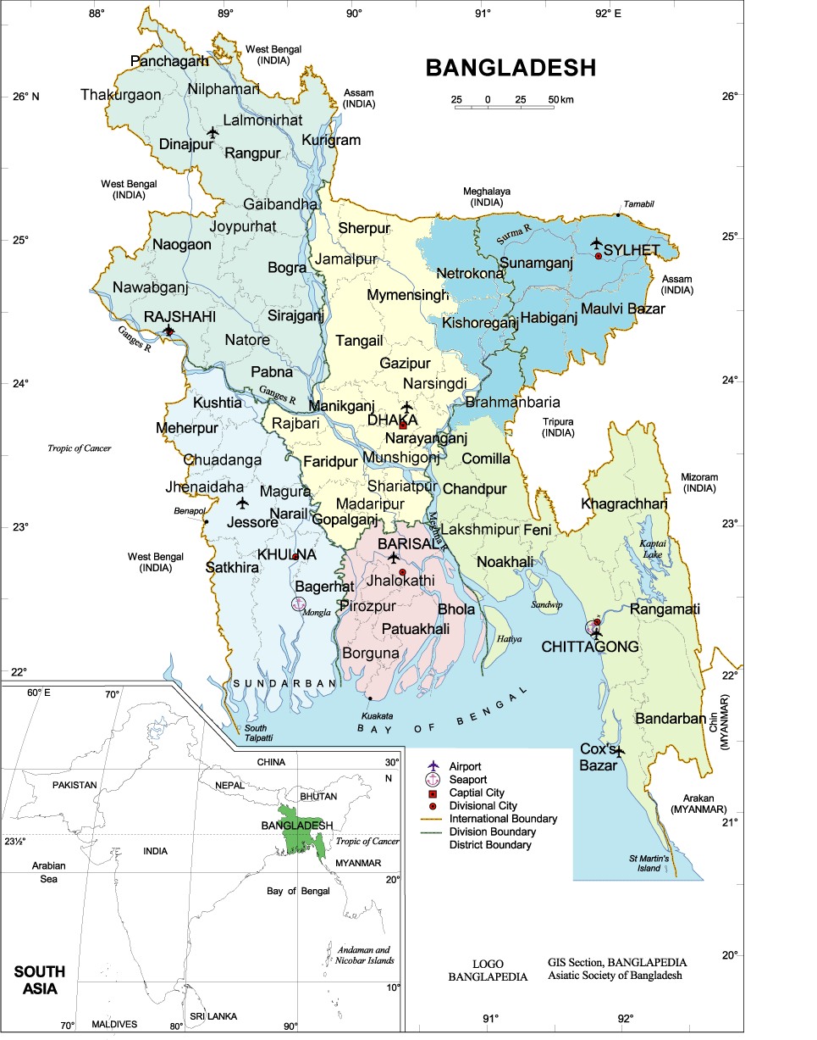
Study area
Fig. 1 Map of Bangladesh mentioning the target area of this study

Table 1. Farm households’ categories in Hathazari upazila
Farm household Categories | Percentages
Landless farm households  (Operating below 0.02 hectares) | 24%
Marginal farm households  (Operating between 0.02 and 0.2 hectares) | 49%
Small farm households  (Operating between 0.2 and 1.0 hectares) | 21%
Medium farm households  (Operating between 1.0 and 3.0 hectares) | 5%
Large farm households (Operating above 3.0 hectares) | 1%
Source: Upazila Agriculture Office, Hathazari, Chattogram
3.2 Data collection
Data were collected through key-informants interview (face-to-face) with different stakeholders during April to May 2025 including upazila agriculture officer, agriculture extension officer, farmers, and local entrepreneurs etc. to have a deeper understanding of the issues of this research.
In order to analyse the growth of farm entrepreneurship in the local context using the CIG approach, two case studies were carried out for in-depth analysis to understand the challenges and opportunities of agri-business ecosystems in rural Bangladesh. Trajectory Equifinality Modelling (TEM) was carried out using the results of the case studies analysis.

3.3 Trajectory Equifinality Model (TEM)
The trajectory equifinality model (TEM) is a qualitative method of analysis in the social sciences which can represent the change in individual trajectories for a society over an irreversible period of time (Sato et al. 2009; Sato and Valsiner 2010). It allows a detailed analysis of underlying socio-environmental factors affecting the pathways and the trajectories to fulfill the specific goals of an individual for example agri-business development (Sato et al. 2016). In the analytical framework of TEM shows the irreversible time period in the horizontal axis, but not in a specific unit, so that similar results can be obtained by varying the distance travelled. In this investigation, we analyze based on the analysis model shown in Fig.2. This identified changes in management decisions that appear to have had a significant impact on the development of the farm activity as a major bifurcation point (BFP). The social and economic factors which may influence management decisions are also taken into account, either in the form of a positive called social guideline (SG) or a negative called social direction (SD).
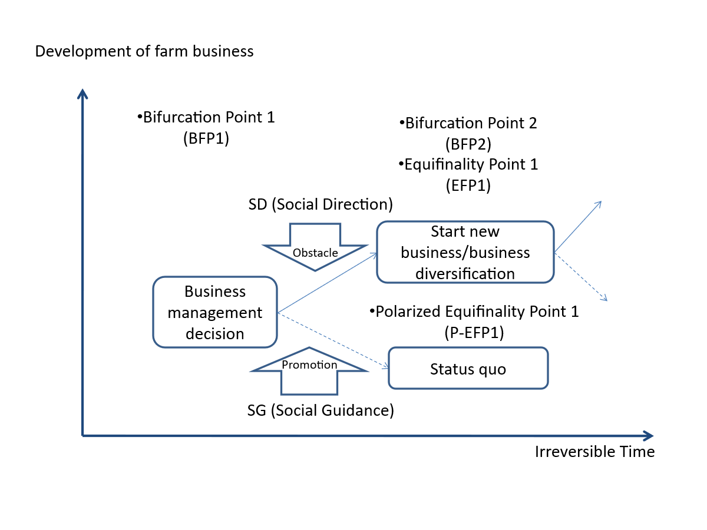
Fig. 2 TEM analytical model of farm business development (Source: Based on Kiminami et al. 2020; Rana et al. 2022)

4. Results and Discussions
The summary of the results of key-informants’ interviews with different stakeholders are described in Table 2.
4.1 Satisfaction of needs
For the majority of people in the study area, agriculture is their main source of income. Although rice farming still dominates farming practices, a wide variety of other crops, including fruits, vegetables, and spices, are now grown. By providing the farming community with access to local institutions and improved farming knowledge and technology, the CIG approach has taught farmers modern paddy cultivation, homestead vegetable gardening, crop diversification, mechanization in farming, and other cutting-edge farming techniques in livestock and fish farming. For improved output, farming households needed to have access to the most recent information and technologies.
4.2 Changing social relations
The effectiveness and efficiency of agricultural extension services, farmers' market connectivity, farmers' access to new farming technology, and farm business development are all critical to the sustainability of agriculture in Bangladesh. The mainstream agricultural extension organizations place a strong emphasis on knowledge-based and participatory agricultural extension services by establishing CIGs at the grassroots level to effectively transfer new farming technologies and socially mobilize farmers. It has created a foundation for boosting farmers' capacity for leadership, social capital by means of CIG formation. Through active communication between farmer groups and the local institutions, it creates opportunities for the farming communities especially for the women. Therefore, by offering a learning environment that encourages farmers to be passionate about enhancing their farming knowledge and to have confidence in diversified agricultural production such as vegetables, fruits, and oil crops cultivation.

Table 2. Summary of the results of key-informants’ interviews
Important codes | Key informants
Effects of CIG approach on farm business development | CIG Member | SAAO | UAO | Local Leader | Local Farm Entrepreneur
1. Agricultural production and resource use efficiency
- Increased agricultural production and income | Yes | Yes | Yes | Yes | Yes
- Increased farm mechanization | Yes | Yes | Yes | Yes | Yes
- Land, water, labor use efficiency increased | Yes | Yes | Yes | Yes | Yes
2. Community empowerment
- Women recognize as an individual farmer | Yes | Yes | Yes | Yes | Yes
- Bargaining power of farmers increased | Yes | Yes | Yes | Yes | Yes
- Farmer’s access to the local institutions is increased | Yes
- Strengthening role in decision making at community level | Yes | Yes | Yes | Yes | Yes
- Farmers received training on agricultural technologies | Yes | Yes | Yes | Yes | Yes
3. Farm business development
- Small farmers are started to think their farming as a business | Yes | Yes | Yes | Yes | Yes
- Entrepreneurial intension of farmers | Yes | Yes | Yes | - | Yes
- Started a farm business | Yes | Not all | Yes | - | Yes
- Diversification of farming practices | Yes | Yes | Yes | Yes | Yes
4. Other benefits from CIG approach
- Access to the local market | Yes | Yes | Yes | - | Yes
- Strengthening social capital | Yes | Yes | Yes | Yes | Yes
- Leadership development | Sometimes | Yes | Yes | Yes | Yes
UAO: Upazila Agriculture Officer
SAAO: Sub-Assistant Agriculture Officer

4.3 Farmers’ business development through CIG approach
The Common Interest Group (CIG) approach plays a significant role in farm business development, particularly in rural and smallholder farming contexts. Here's how it contributes in collective action and bargaining power of small-scale farmers to come together around shared goals, such as marketing a particular crop or accessing resources. Many government programs and NGOs offer funding or training only through organized groups. Being part of a CIG often qualifies farmers for start-up capital or revolving funds and infrastructure development (e.g., storage, irrigation). CIGs can attract buyers and partners by offering bulk quantities of standardized products. This leads to entry into value chains and direct links with processors, retailers, and exporters. The CIG approach fosters an enabling environment for smallholders to transform subsistence farming into sustainable agribusiness. It enhances productivity, profitability, and resilience through cooperation, shared learning, and improved market access.
4.5 Gender equality and economic empowerment
Besides regular household responsibilities, women were also engaged in small-scale economic activities such as vegetable cultivation in the backyard, indigenous chicken/duck farming and goat rearing etc. The institutional support form CIG including access to training, technical advisory services and microfinance enabling them to start their agri-business ventures. By increasing their contributions to household well-being and changing societal perceptions of gender roles, small business ventures benefit underprivileged women through income-generating capability. The financial contributions to family enhance their participation in household decision-making and improve their self-esteem. This highlights how important it is to acknowledge women's economic roles and provide them with equal rights and resources ownership. The findings are also consistent with Rana et al. (2025b) who conducted case studies focusing on entrepreneurship and gender empowerment in Bangladesh.
4.4 Case study result of Mr. PB (Development of integrated farm business model)
Because Mr. PB established an integrated and varied farming system in his region, his case was selected for this study (Fig. 3). Through his creative business model, he has improved local employment opportunities and the region's food security system by transforming the traditional rice farming system into diversified crop farming along with livestock and fish farming.
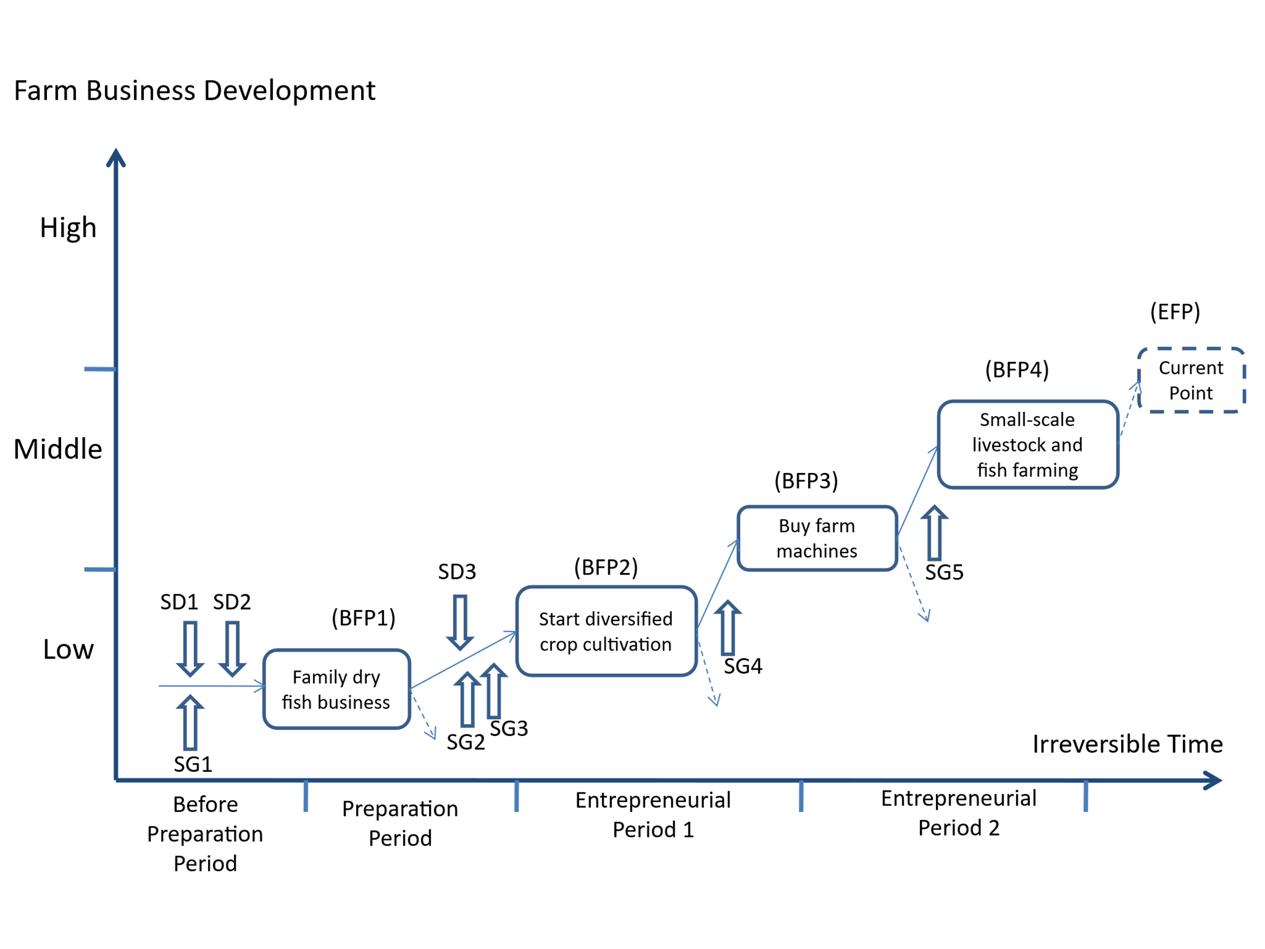
Fig. 3 Results of the TEM analysis of the case of Mr. PB
Mr. PB is a farmer, lives in Hathazari Upazila (sub-district) under Chattogram district of Bangladesh. He is fifty-four years old and has elementary level institutional education (SD1). He has been engaged with family dry-fish business (SG1) since his childhood (BFP1). However, he faced difficulties in running the dry-fish business and decided to stop his business due to lack of technical operation skills (SD2). He get introduced with local agricultural extension officer and received training on diversified crop farming (SG2) and started to crop cultivation in his small piece of land. For his farming activities he get technical and logistic support such as seed, fertilizers etc. from upazila agriculture office (SG3). Day by day he has increased his cultivable land area by getting lease from the neighbors. In the period of covid-19 he donated six thousands kg of vegetable to the upazila administration for the poor people. He realized the social responsibility. In recent years cultivated mustard in 2.0 Ha of land and sunflower for enhancing oil crops production. People in his area are frequently visited his sunflower and mustard plots to enjoy the beauty of flowers that made him very happy and influenced to continue his oil crops farming.
In his diversified crop cultivation include high value cash crops such as cauliflower, brinjal, beans, cabbage, green chili, cucumber, spinach, and pumpkin etc. As a result, farming households generate more income from growing diversified crops than from growing rice monocrop. To manage the large-scale farming operation he started to use farm machines like power tiller, power thresher, irrigation pump etc. with the subsidy from government through upazila agriculture office. Now he plays an important role to technology dissemination in his locality as a model farmer and local leader. Now he is the leader of two farmer associations in his locality.
He got a substantial amount of grass as a by-product from diversified vegetable fields (SG4) that can be used as animal fodder. Then he started dairy and fish farming (BFP4) with the technical support of livestock extension agent (CEAL) and fisheries extension agent (LEAF) respectively. In FIAC approach extension agents of crop, livestock, and fisheries sub-sectors are working together at grass-root level.
The summary of the TEM analysis of the case is as follows. First, the integrated farming model was developed by Mr. PB with the technical and logistical support from the local agriculture office through CIG approach. Second, self-motivation and social capital are also important for the development of his integrated farming model.

4.5 Case study result of Mr. SS (Development of diversified farm business model)
Mr. SS is a farmer who resides in Bangladesh's Chattogram district's Hathazari Upazila (sub-district). The TEM analysis of this case is explained as follows (Fig.4).

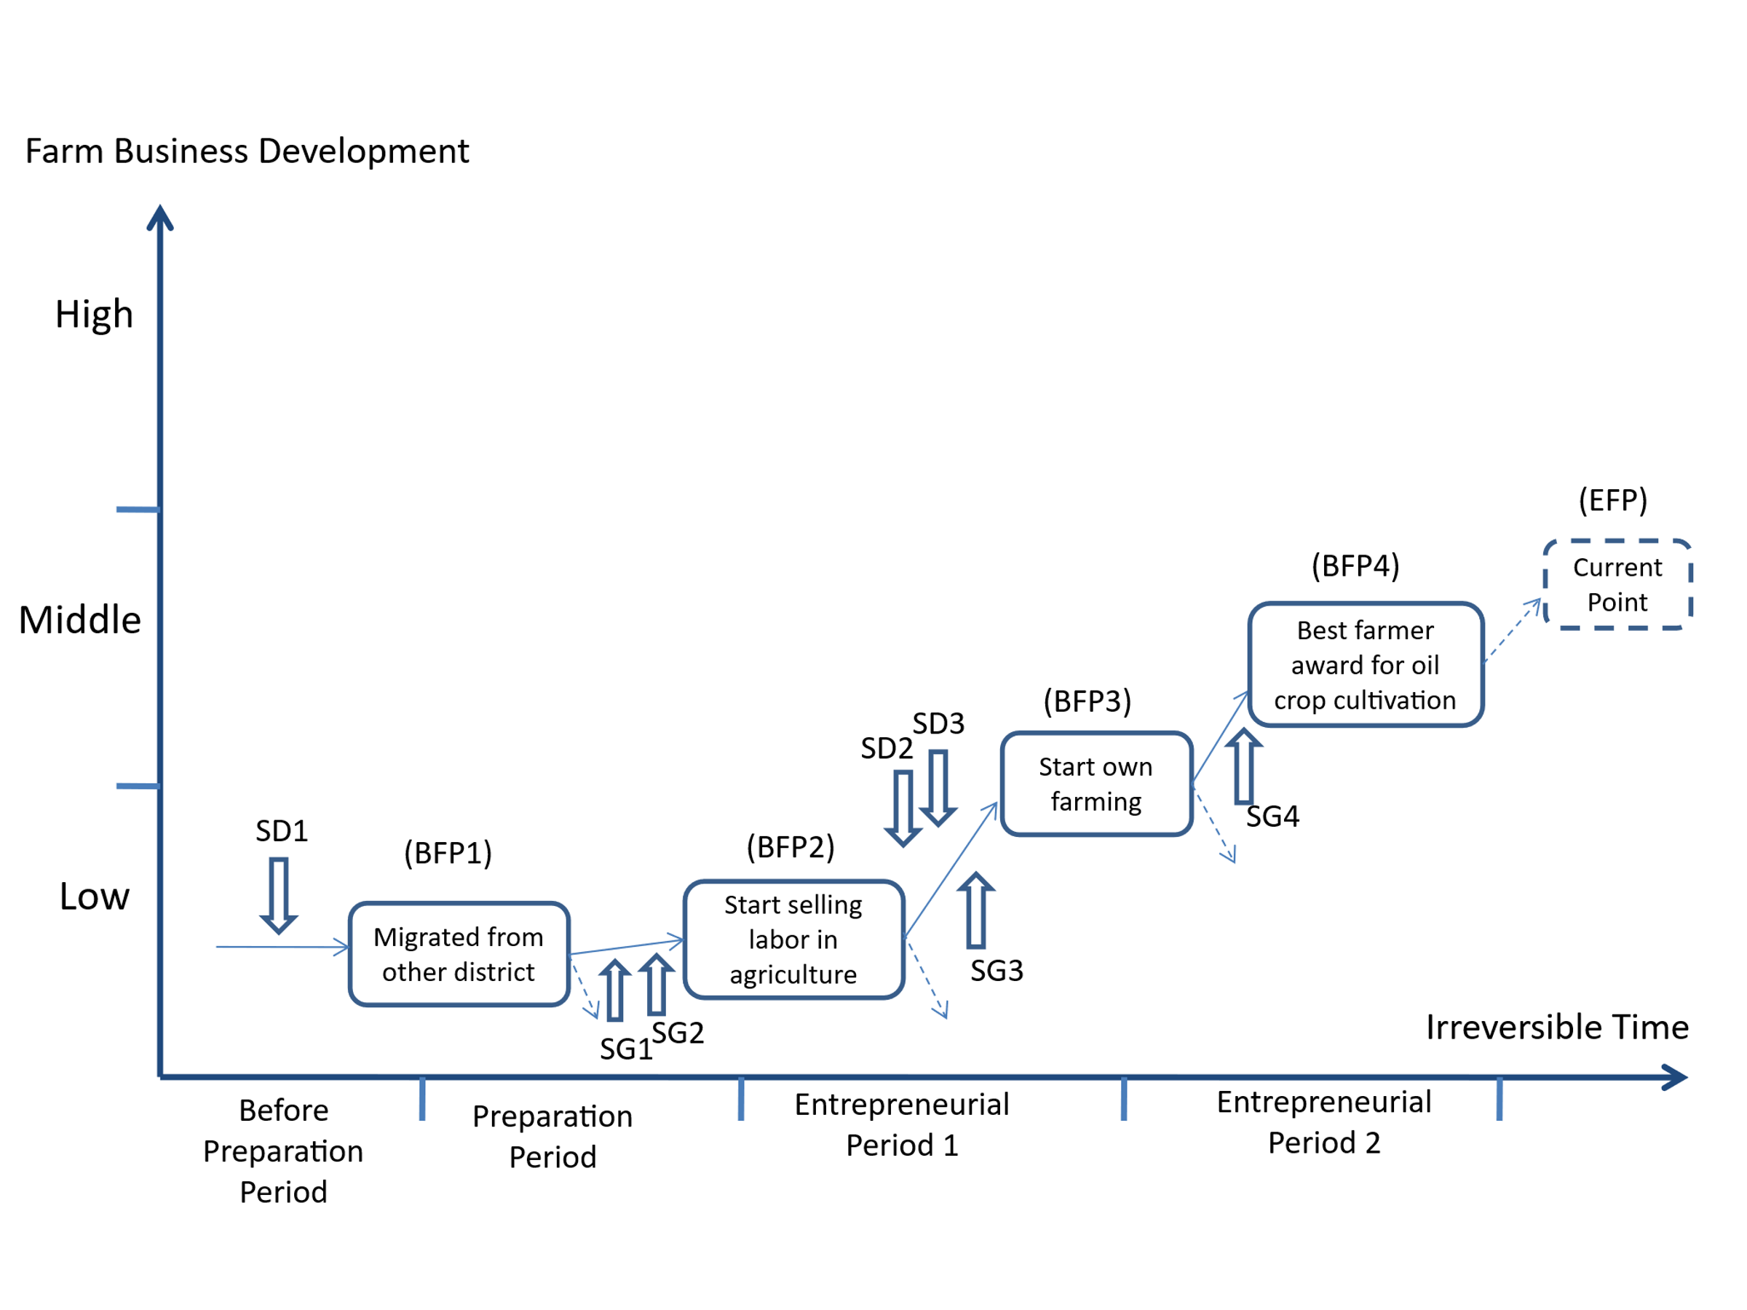
Fig. 4 Results of the TEM analysis of the case of Mr. SS

Due to poverty, he moved to Chattogram (BFP1) from Sunamganj district when he was a boy (SD1). He is 46 years old and has never attended formal school. He began selling labor in the agricultural sector (BFP2). He was trained by the local agricultural office as a marginal farmer (SG1) with the assistance of a local agricultural extension agent. He consequently acquired specialized skills for farming-related tasks (SG2). He had trouble, though, obtaining a land lease for crop cultivation (SD2). He developed a positive relationship as a result of his honesty and pleasant disposition. He began growing a variety of cash crops, including mustard, brinjal, pumpkin, and chili. However, he had trouble finding the right marketing channel to sell his agricultural goods (SD3). He was given the Department of Agricultural Extension's Best Farmer Award for growing mustard, an oil crop, in Hathazari Upazila (BFP4). He now serves as a local leader and an exemplary farmer. He considers it a privilege.
The summary of the TEM analysis of the case is as follows. First, the diversified farming model was developed by Mr. SS with the technical and logistical support from the local agriculture office through CIG approach. Second, gaining skill for farm operations is important for the development of his own diversified farming model. The comparative attributes between two farm business cases are presented in Table 3.
Table 3. Comparable attributes between two farm business models
Attributes | Case 1 (Mr. PB) | Case 2 (Mr. SS)
Starting phase | Engaged in dry-fish business run by his family | Agricultural laborer on daily wage basis
Formal education | Elementary education | No formal education
Motivational factors | Difficulties in running family business due to ack of operational skills | To overcome poverty
Major components | Integrating the components of crop, livestock and fish farming | Diversified crop farming e.g. Mustard, brinjal, pumpkin, and chili
Technology inclusion | Integrated farming approach along with useful machines e.g. power tiller, power thresher, irrigation pump etc. | Inclusion of variety of crops in the farming systems
Leadership role | As a successful farm businessman, he serves as a local leader and plays an important role in technology dissemination
Socio-economic impacts | Creating local employments and contributing to achieve food and nutritional security
Major constraints | Lack of financial access and underdeveloped marketing facilities

5. Conclusion and policy recommendation
We obtained the following conclusions based on the analysis results. First, the CIG approach gives farmers access to improved knowledge and technology. It is a need-satisfying service for the rural farming households to improve their knowledge and skills for better farming practices as well as their livelihoods. Second, their resource use efficiency has been increased, especially land and labour as their agriculture will be diversified. It has improved institutional access locally and farmers feel empowered. So, we can call it social innovation. Thirdly, CIG approach helps farmers to promote farming business directly and indirectly. Therefore, our policy implications suggests that the CIG approach could be accepted as an effective extension approach in the mainstream agricultural extension services. However, farmers faced a great difficulty to enter the proper value-chain for selling their farm products. Therefore, it requires necessary attention of the policy makers and this will be our future research agenda.

COMPETING INTERESTS DISCLAIMER:
Authors have declared that they have no known competing financial interests OR non-financial interests OR personal relationships that could have appeared to influence the work reported in this paper.
References
AIS (2022) Agriculture dairy 2022. Agricultural Information Service, Ministry of Agriculture, The Peoples Republic of Bangladesh, Dhaka.
BBS (2022) Yearbook of agricultural statistics of Bangladesh 2022. Bangladesh Bureau of Statistics, Ministry of Planning, Government of the People’s Republic of Bangladesh, Dhaka
Biswas B, Mallick B, Roy A, Sultana Z (2021) Impact of agriculture extension services on technical efficiency of rural paddy farmers in southwest Bangladesh. Environmental Changes 5: 100261
Bokhtiar, S. M., Samsuzzaman, S., Jahiruddin, M and Panaullah, G. M. (2023). Agricultural Development for Fragile Ecosystems in Bangladesh. Published by Bangladesh Agricultural Research Council, Dhaka, Bangladesh. p. 369
Christensen CM, Ojomo E, Dillon K (2019) The prosperity paradox: How innovation can lift nations out of poverty. Harper Business, New York
Farouque MG, Kabir KH, Roy D, Rana MM and Donaldson JL (2024) An assessment of capacity building activities for common interest farmer groups in Bangladesh. Development in Practice, 34(4), 491–511. https://doi.org/10.1080/09614524.2024.2325415
Food and Agriculture Organization of the United Nations. (2014). The state of food and agriculture: Innovation in family farming.
IFAD (2016) Project completion report validation. National agricultural Technology Project, People’s Republic of Bangladesh.
Kiminami L, Furuzawa S, Kiminami A (2020) Social entrepreneurship and social business associated with multiple functions of urban agriculture in Japan. Asia-Pacific Journal of Regional Science, 4:521-552
Kiminami L, Kiminami A (2017) Rural and agriculture development in regional science. In H. Shibusawa et al. (eds.) Socioeconomic environmental policies and evaluations in regional science, New frontiers in regional science: Asian perspectives 24, Springer Science Singapore, pp 537-555.
Moulaert F, MacCallum D (2019) Advanced introduction to social innovation. Edward Elgar Publishing, Cheltenham, UK and Northampton, MA, USA.
Oluwasusi, J.O. and Akanni, Y.O. (2014) Effectiveness of extension services among food crop farmers in Ekiti State, Nigeria. Journal of Agricultural & Food Information 15 (4): 324–341. https://doi.org/10.1080/10496505.2014.952175.
PMU: Project Management Unit (2021) NATP-II project annual progress report 2019-2020. National Agricultural Technology Program (phase II), AIC Building (3rd Floor), BARC Complex Farmgate, Dhaka-1215, Bangladesh
Rahman, M. C., Rahaman, M. S., Biswas, J. C., Rahman, N. M. F., Islam, M. A., Sarkar, M. A. R., Islam, M. S., & Maniruzzaman, M. (2022). Climate change and risk scenario in Bangladesh. Asia-Pac J Reg Sci, 7, 381–404.
Rana S, Kiminami L, Furuzawa S (2022) Entrepreneurship and social innovation for sustainability: focusing on a haor region of Bangladesh. Springer Nature Singapore Pte Ltd.
Rana S.; Halim, M. A.; Mohiuddin, M.; Rahman, M. S.; Rana, M. M. (2024) Role of Farmer Information and Advice Center in Providing Extension Services to Smallholder Farmers: Lessons from Bangladesh. Agricultural & Rural Studies, 2, 0001.
Rana, M.M., Farouque, M.G. and Rahman, M.Z. (2018) Change of livelihood status of common interest group members: interventions of National Agricultural Technology Program. Bangladesh Journal of Extension Education, vol. 30(2), pp. 37-46.
Rana, M.M., Kiminami, L. and Furuzawa, S. (2025a) An analysis of factors affecting farmers’ capacity building for sustainable rural and agricultural development in Bangladesh. Regional Science Policy & Practice 17,100202. https://doi.org/10.1016/j.rspp.2025.100202.
Rana, MM, Kiminami, L. and GE, Y (2025b) Qualitative case study on entrepreneurship and gender empowerment in Bangladesh. Studies in Regional Science 55(1):117-139. https://doi.org/10.2457/srs.55.117.
Sato T, Hidaka T, Fukuda M (2009) Depicting the dynamics of living the life: the Trajectory Equifinality Model. In: Valsiner J, Molenaar P, Lyra M, Chaudhary N (eds) Dynamic process methodology in the social and developmental sciences. New York: Springer, pp 217-240.
Sato T, Valsiner J (2010) Time in life and life in time: between experiencing and accounting. Ritsumeikan Journal of Human Sciences 20:79-92.
Sato, T., Mori, N. and Valsiner, J. (2016) Making of the future: the trajectory equifinality approach in cultural psychology. Information Age Publishing, Charlotte.
Tambo, J.A. and Wünscher, T. (2017). Building farmers’ capacity for innovation generation: Insights from rural Ghana. Renewable Agriculture and Food Systems 33(2):116–130. https://doi.org/10.1017/S1742170516000521.
Torre, Ravazzoli, E., Dijkshoorn-Dekker, M., Polman, N., Melnykovych, M., Pisani, E., Gori, F., Da Re, R., Vicentini, K., & Secco, L. (2020). The Role of agency in the emergence and development of social innovations in rural areas. Analysis of two cases of social farming in Italy and the Netherlands. Sustainability, 12(11), 4440.

Upazila Agriculture Office, Hathazari, Chattogram.

