Share Analysis of Pesticide Companies in Uttar Pradesh, India

Abstract

The agricultural input industry in India plays a pivotal role in supporting the country's vast and diverse agricultural sector. The market in India is highly dominated by the foreign players. The present study was undertaken with an overall objective of assessing the market share of different brands of pesticides and examine the promotional strategies employed by pesticide companies. Multi stage sampling design was used for the selection of samples. One hundred thirty pesticide retailers from districts of Uttar Pradesh and 400 farmers were selected randomly to study the market share and promotional approaches used by pesticide companies. Expenditure on pesticides per acre showed diversity among farmers, highlighting the need for targeted pest management strategies. The diversity in expenditure on pesticides per acre among farmers reflected the economic implications of pest management. Farmers who spend more on pesticides have higher production costs, potentially leading to lower profits. Conversely, those who use fewer pesticides reduced their production costs but might face yield losses due to pest damage. Striking the right balance is crucial for economic sustainability in agriculture. The data showed that Pexalon by Corteva Agrisciences holded the largest market share with 15.15%, followed closely by Chess from Syngenta India Ltd at 14.70%. Coragen and Ferterra, both by FMC India Pvt Ltd, accounted for 13.16% and 12.83%, respectively. Market share data revealed which pesticide brands dominate the market in each category (insecticides, fungicides, and herbicides). This information was essential for farmers and businesses alike as it helps them understand the competitive dynamics in the industry. Farmers' brand preferences were influenced by factors like quality, price, retailer recommendations, and previous experience, with a strong emphasis on practicality and local advice. Quality emerged as the third most important attribute with a mean score of 23.5, indicated that farmers prioritize the effectiveness and reliability of the pesticides they use. Competitive price comes in second place with a mean score of 24.5, highlighted the significance of cost-effectiveness in their decision-making process. Retailer recommendation tops the list as the most influential factor with a mean score of 25.5, suggested that farmers heavily rely on trusted local retailers for guidance. Promotional activities, particularly those involving local retailers and company representatives, had a significant impact on farmers' purchasing decisions, highlighting the importance of personalized interactions and practical demonstrations.
Keywords: Pesticides, market share, brands, promotional activities

Introduction
Agriculture is the primary growth engine of the Indian economy as nearly 59 per cent of the population of the country depends on agriculture. The agricultural input industry in India plays a pivotal role in supporting the country's vast and diverse agricultural sector. This industry encompasses a wide range of products and services, including seeds, fertilizers, pesticides, machinery, and agrochemicals, which are essential for enhancing agricultural productivity. India's agriculture is highly dependent on monsoons, making it crucial for farmers to have access to quality inputs to mitigate risks associated with unpredictable weather patterns. Pesticides and agrochemicals are essential for pest and disease management in agriculture. Companies like Syngenta, BASF, and local players like UPL have a significant presence in the Indian market. Integrated Pest Management (IPM) techniques are also gaining popularity to reduce chemical dependency and promote sustainable farming.
The worldwide consumption of pesticides is about two million tonnes per year. Out of which 45 per cent is used by Europe alone, 25 per cent is consumed in the USA, and 25 per cent in the rest of the world. The usage of pesticides in Korea and Japan is 6.6 and 12.0 kg/ha, respectively, whereas in India, it is only 0.5 kg/ha. Globally, the pesticides cover only 25 per cent of the cultivated land area. The three most commonly used pesticides are HCH (only gamma-HCH is allowed), DDT and Malathion, and these account for about 70 per cent of the total pesticide consumption. India’s consumption of pesticide is only 3 per cent of total world’s consumption of pesticides. Among different classes of pesticide, contribution of insecticide (60 per cent) is high followed by fungicide (19per cent), herbicide (16per cent), Bio-Pesticide (3per cent) and others (3per cent). It is estimated that 18- 20 per cent of total pesticides used in the country are applied on vegetables. Among different vegetable crops maximum pesticide usage is in brinjal followed by okra, chilli, Cole crops, etc. Uttar Pradesh is one of the largest agricultural states in India, and the use of pesticides plays a significant role in crop protection and increasing agricultural productivity. However, like in many other regions, the use of pesticides in Uttar Pradesh is a topic of concern due to potential health and environmental impacts.
Pesticide market is currently lead by insecticides products followed by fungicides and herbicides, reportedly insecticide demand accounts for 65per cent of the total pesticide market share. The market in India is highly dominated by the foreign players. Bayer AG is the largest agrochemical producer in the world. Some of the big names include Yara International ASA, BASF, Bayer Crop Science, Makhteshim Agan Industries Ltd, Dow Agro Sciences, Monsanto, Syngenta, Aventis, Agrium etc. Lallemand Inc., Arysta Life Science (Japan) and Sinofert Holdings Limited (China). Indian Farmers Fertiliser Cooperative, National Fertilizers Limited, Rashtriya Chemicals and fertilizers Ltd. Zuari Agro Chemicals, Nagarjuna Fertilizers and Chemicals Limited and Coromandel International Limited are some of the big local companies operating in the Indian sub-continent. Marketing of pesticides is a system of interacting activities of agencies; these agencies transport the pesticides from place of production to the ultimate buyer. Hence, distribution system is the nucleus of marketing system. Marketing wing of any pesticide company has a greater responsibility in making available pesticides to farmers at right time, at right place and at right price. The distribution system involves number of channels, marketing functionaries and interaction between them. Hence, the choice of right distribution channel plays a strategic role in the effective performance of pesticide marketing system. The pesticides distribution channel takes possession of goods on certain specified terms and cultivation like issue price, distribution margin, credit period, discount if any etc. The strategies and the policies followed by the pesticide distribution channel have to be in consonance with the marketing operations of the manufactures (Anang, 2015). The retail sale point being the last element in the distribution channel forms the most important link between the pesticide manufacturer and the buyers. The farmer looks at the retailer/dealer who are very close and have a good knowledge in providing quality Agro chemicals for a particular crop problem. The distribution of pesticides attains special significance, since agriculture in India predominantly dependent on traditional technology.
The importance of pesticide marketing system in the transformation of agricultural sciences thus, needs no emphasis. It is an important component of production and improved agronomic practices to achieve increased agricultural production. Keeping these issues in mind the present study was undertaken with an overall objective of assessing the market share of different brands of pesticides and examine the promotional strategies employed by pesticide companies.

Methodology

Multi stage sampling design was used for the selection of samples. One hundred thirty pesticide retailers from districts of Uttar Pradesh and 400 farmers were selected randomly to study the market share and promotional approaches used by pesticide companies.

Data collection
The primary data was collected to accomplish the objectives of the study. The primary data was collected through survey method by interviewing the farmers and retailer/Distributors with the help of prepared and pre-tested questionnaire.
Methods of analysing data
Analysis technique: - Tabular and functional analysis was done to find out the result of proposed objectives:
- Tabular analysis: This approach was used for the analysis of the market share of different pesticide companies. The companies present in the business in the state were tabulated, computed, and analysed using different statistical tools.
- Garret ranking technique: Garrett’s ranking technique was used to rank factors influencing farmers’ brand preference for various brands of pesticides & promotional approaches that influence on farmers’ in pesticide marketing. The order of the merit given by the respondents was converted into ranks by using the following formula. Accordingly, these ranks were converted to scores by referring to Garrets table.
Garrett’s formula for converting ranks into per cent was given by
Per cent position = 100*(Rij-0.50)/Nj
Where,
Rij = Rank given for i^{th} factor by j^{th} individual
Nj = Number of factors ranked by j^{th} individual
Descriptive statistics, Pie Chart, Bar Chart and other Statistical tools were adopted for analysis purpose.

Results and Discussion

Table 1: Market share of different brands of insecticides in Uttar Pradesh
S. No. | Brand Name | Companies | Average Sales/retailer or distributor/year (Rs.in Lakhs) | Total Val of 100 Retailers/Distributors | Percentage Share
1 | Pexalon | Corteva Agrisciences | 1.98 | 198.33 | 15.15%
2 | Chess | Syngenta India Ltd | 1.93 | 192.5 | 14.70%
3 | Coragen | FMC India PVt Ltd | 1.72 | 172.33 | 13.16%
4 | Ferterra | FMC India PVt Ltd | 1.68 | 168 | 12.83%
5 | Ampligo | Syngenta India Ltd | 0.97 | 97.07 | 7.41%
6 | Adama Acemain | Adama india private limited | 0.76 | 75.83 | 5.79%
7 | Largo | Dhanuka Agritech | 0.75 | 74.67 | 5.70%
8 | Ulala | UPL Limited | 0.72 | 72 | 5.50%
9 | Benevia | FMC India PVt Ltd | 0.61 | 60.67 | 4.63%
10 | Abacin | Crystal Crop Protection | 0.48 | 47.67 | 3.64%
11 | Barazid | Adama india private limited | 0.46 | 45.83 | 3.50%
12 | Takumi | Rallis india Ltd | 0.4 | 40.33 | 3.08%
13 | Furatox | Pi Industries Ltd | 0.4 | 40 | 3.06%
14 | Padan | Coromandal | 0.24 | 24 | 1.83%
 | Total |  | 13.09 | 1309.23 | 100

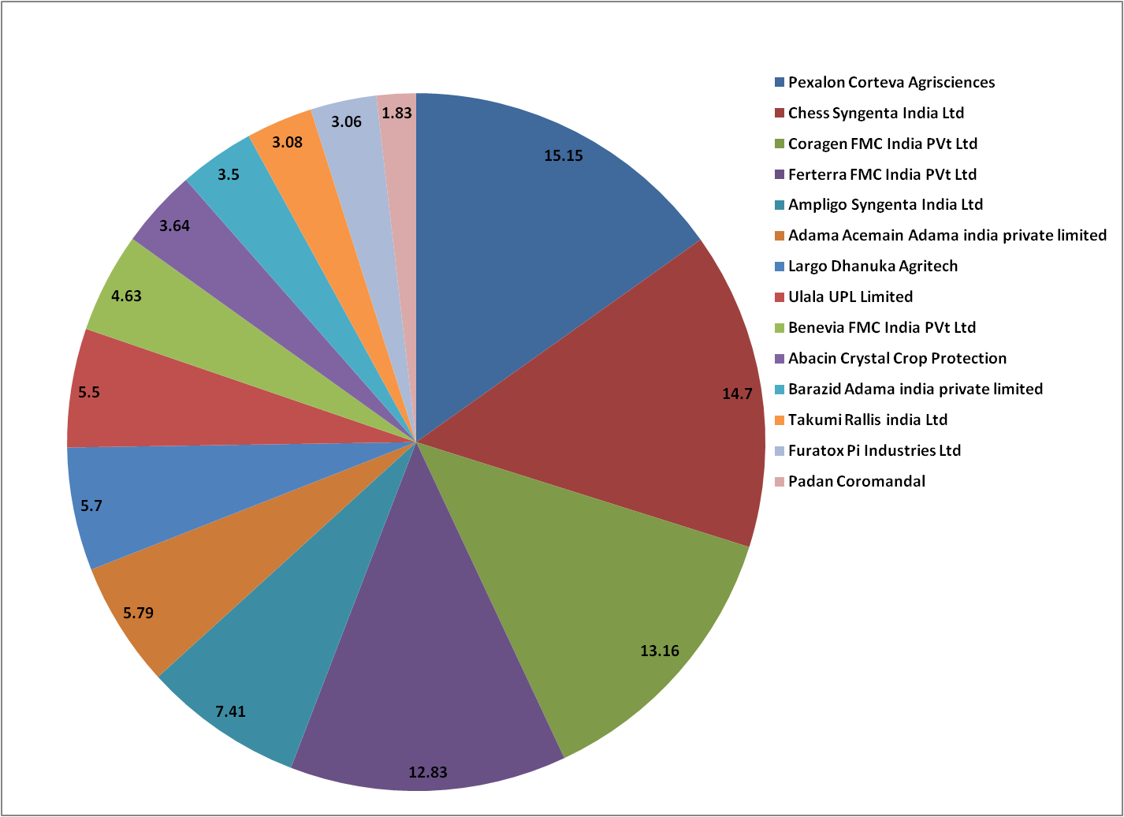
Fig 1: Percentage share of different brand of insecticides in Uttar Pradesh

Market share of different brands of insecticide in Uttar Pradesh

The market share of different brands of insecticide sold by the sample retail traders in Uttar Pradesh is presented in table 1. The table provides very interesting information about the insecticides sold in the market. The brand namely Pexalon of Corteva Agrosciences stands first in the sale of insecticides with a share of 15.15 per cent followed by Chess of Syngenta (14.70%), Coragen (13.16%) and Ferterra (12.83%) of FMC India Pvt Ltd. Rest of the companies have a very small percentage share in the prevailing market. The total sale for all the types of insecticides sold by respondent retailers/Distributors was found to the tune of Rs. 1309.09 lakhs. ₹13.09 Lakh is the per retailer total value of top 14 insecticide brands business of UP market. The top four brands dominated a significant portion of the market. Additionally, the table revealed a diverse range of insecticide brands, each with its own percentage share. This data is crucial for understanding the competitive landscape of the insecticide market in Uttar Pradesh and can assist both companies and farmers in making informed decisions about their product choices. The results are similar to the results obtained by Sharifzadeh 2018.

Table 2: Market share of different brands of fungicides in Uttar Pradesh
S.No. | Brand Name | Companies | Average Sales/retailer or distributor/year | Total Val of 100 retailers/Distributors | Percentage Share
S.No. | Brand Name | Companies | (Rs. in Lakhs) | Total Val of 100 retailers/Distributors | Percentage Share
1 | Indofil M-45 | Indofil Industries Ltd. | 1.21 | 121.00 | 33.09%
2 | Saaf | UPL Limited | 0.67 | 66.67 | 18.23%
3 | Mirador | Adama India | 0.36 | 36.17 | 9.89%
4 | Nativo | Bayer India Ltd. | 0.30 | 30.00 | 8.20%
5 | Custodia | Adama India | 0.22 | 22.00 | 6.02%
6 | Pulsor | IIL | 0.18 | 18.00 | 4.92%
7 | Acrobat | BASF | 0.15 | 14.93 | 4.08%
8 | Sprint | Indofil Industries Ltd. | 0.11 | 11.33 | 3.10%
9 | Cosavet DF | Sulphur Mills Ltd. | 0.11 | 10.67 | 2.92%
10 | Tilt | Syngenta India | 0.08 | 7.58 | 2.07%
11 | Ridomil | Syngenta India | 0.08 | 7.57 | 2.07%
12 | Rokko | Biostadt India | 0.07 | 6.91 | 1.89%
13 | Blitox | Rallis | 0.07 | 6.81 | 1.86%
14 | Bavistin | IIL | 0.06 | 6.08 | 1.66%
 | Total |  | 3.66 | 365.72 | 100
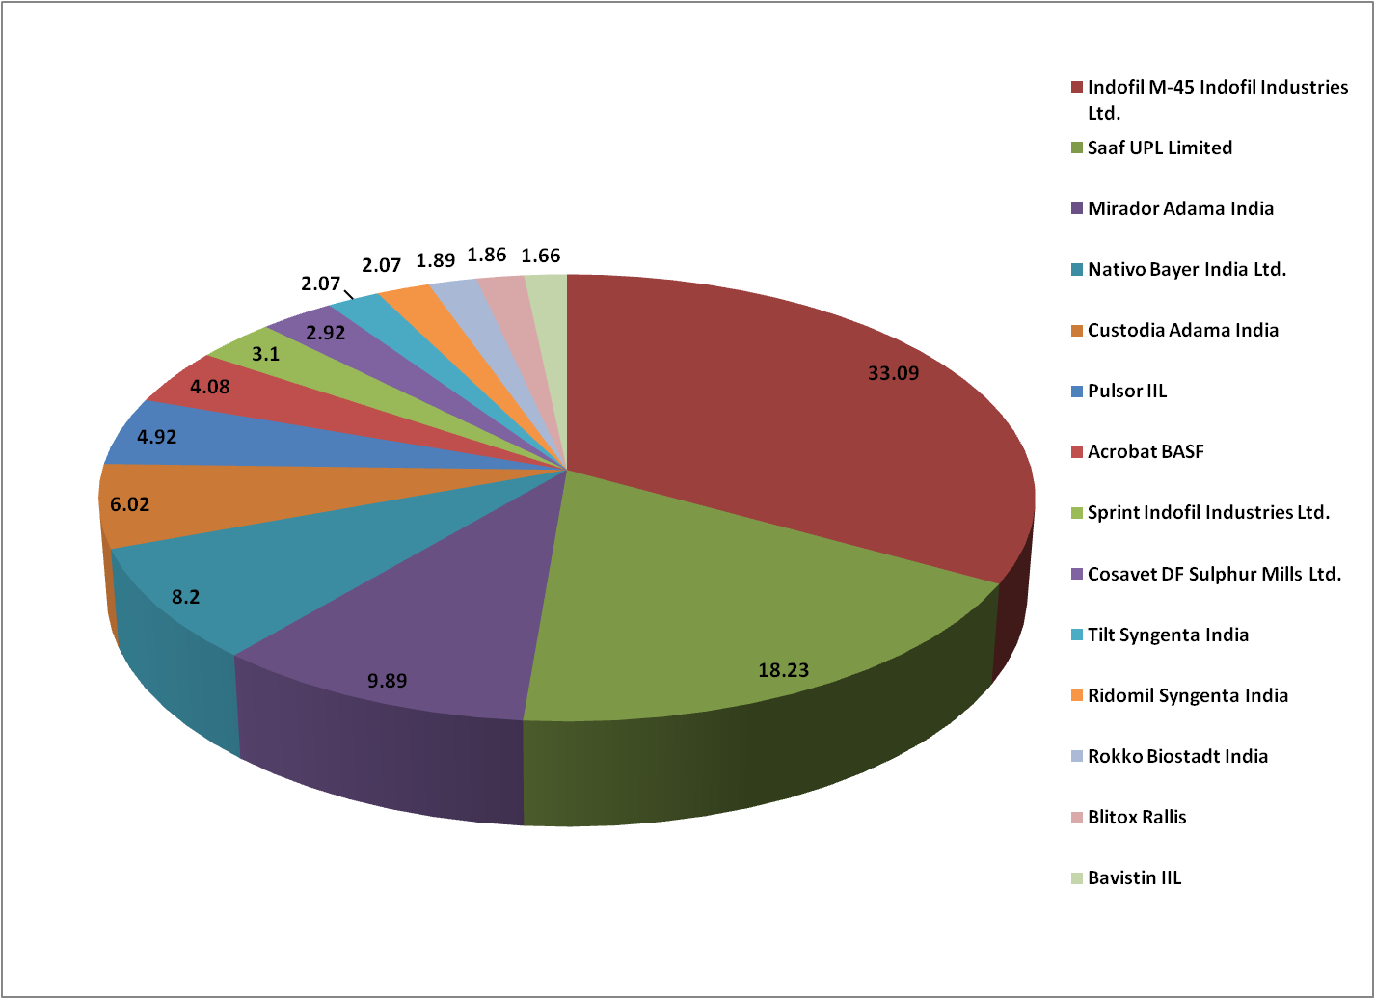

Fig 2: Percentage share of different brand of fungicides in Uttar Pradesh

Market share of different brands of fungicides in Uttar Pradesh
The market share of different brands of fungicides is presented in table 2. The Brand Indofil M-45 had Market share of 33.09 company is namely Indofil Industries limited had a market share of 36.19 with participation in 2 brands in top 14 fungicides (Indofil M-45 33.09% & Sprint 3.10%) followed by Saaf of UPL Limited (18.23%), Mirador of Adama India (9.89%), Nativo Brand of Bayer Crop Science had market share of 8.2% for brand custodia of Adama India whereas has a market share of 6.02%. The other brands share are Pulsar of IIL 4.92%, Acrobat of BASF 4.08%, Sprint of Indofil Industries Limited 3.1% Cosavet of Sulphur mills having share of 2.92%, Tilt 2.07%, Ridomil 2.07%, Rokko 1.89% Blitox 1.86% & Bavistin of BASF 1.66%. The total sale for all the types of fungicides sold by respondent retailers/Distributors was found to the tune of Rs. 365.72 lakhs & per retailer average sales 3.66 lakh. The table further displayed a diverse range of fungicide brands, each with its own market share. This information was valuable for stakeholders in the agriculture industry, enabling them to understand the competitive dynamics in the fungicide market within Uttar Pradesh.Notably, the total value of all brands sums up to 100, indicated comprehensive coverage of the market. The results are in close conformity with Udaya 2002.

Table 3: Markets share of different brands of Herbicides in Uttar Pradesh

S. No. | Brand Name | Companies | Average Sales/retailer or distributor/year | Total Val of 100 Retailers/Distributors | Percentage Share
S. No. | Brand Name | Companies | (Rs.in Lakhs) | Total Val of 100 Retailers/Distributors | Percentage Share
1 | Nomini Gold | PI Industries Ltd. | 0.96 | 95.83 | 24.2%
2 | Laudis | Bayer Crop Science | 0.73 | 72.80 | 18.4%
3 | Tinzer | Syngenta India Ltd | 0.60 | 60.00 | 15.1%
4 | Glycel | Excel Crop Protection | 0.38 | 38.00 | 9.6%
5 | Gramoxone | Syngenta India Ltd | 0.22 | 21.58 | 5.4%
6 | Council | Bayer Crop Science | 0.21 | 20.70 | 5.2%
7 | Rifit | Syngenta India Ltd | 0.19 | 19.33 | 4.9%
8 | Chempa | Dhanuka Agritech | 0.19 | 19.33 | 4.9%
9 | Dost supper | UPL Ltd. | 0.15 | 15.47 | 3.9%
10 | Tata Metri | Rallis India Ltd | 0.14 | 14.00 | 3.5%
11 | Tata Panida | Rallis India Ltd | 0.11 | 11.00 | 2.8%
12 | Clincher | Corteva Agrisciences | 0.09 | 8.62 | 2.2%
 | Total |  | 3.97 | 396.67 | 100%
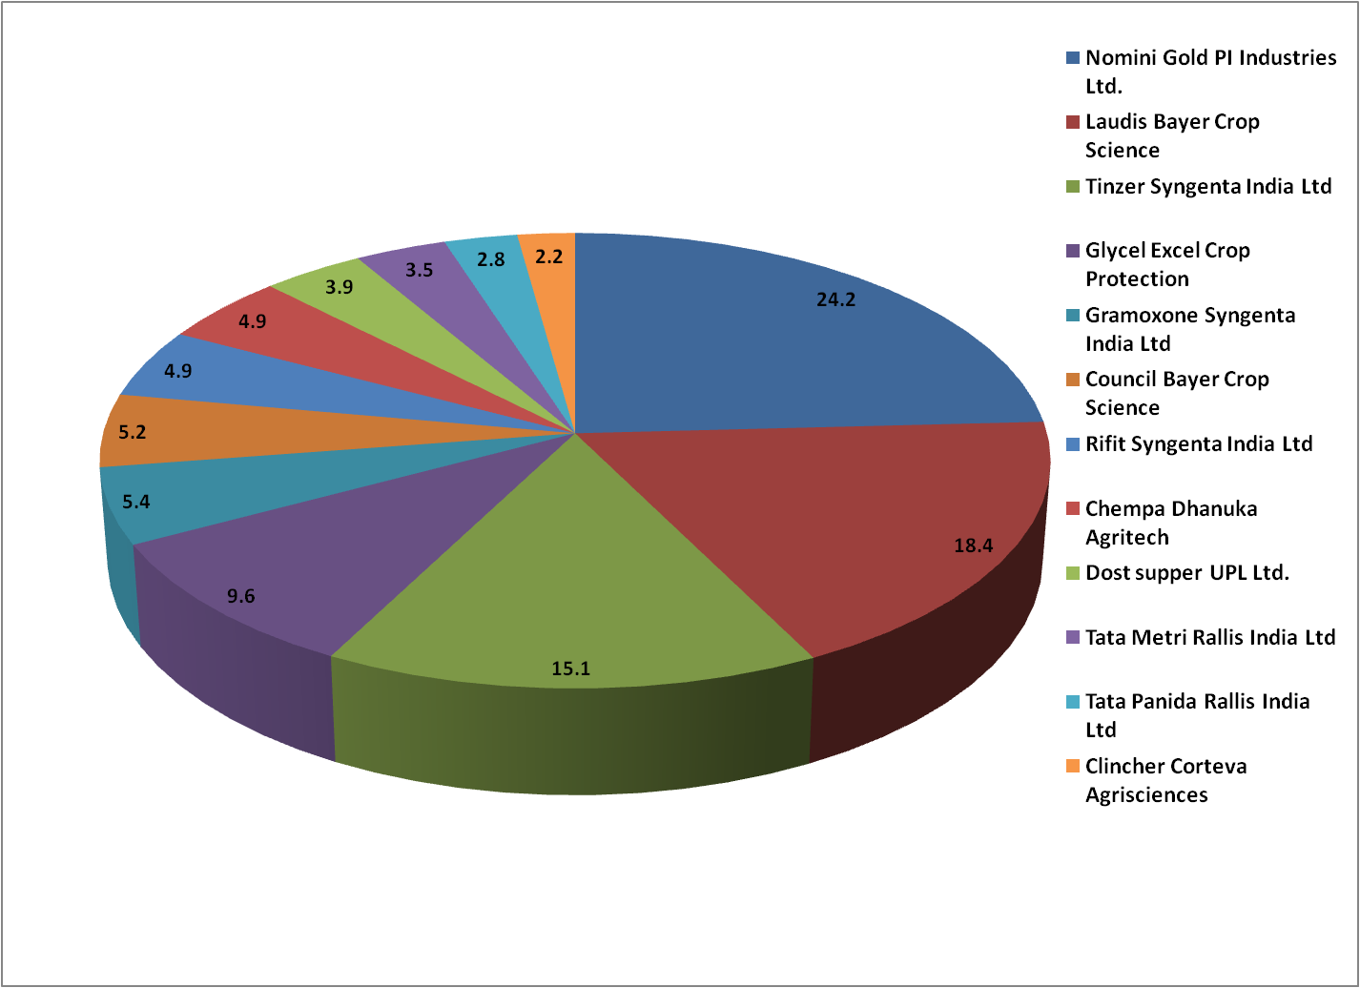

Fig 3: Percentage share of different brand of herbicides in Uttar Pradesh

Markets share different brands of herbicides in Uttar Pradesh.
The market share of different brands of herbicides is presented in Table 3. In addition to insecticide and fungicides, herbicides also emerged as one of the type of pesticides with a lot of market potential in the study area. This is further increasing very fast because of labor crisis and huge cast of weeding by labour. With respect to the important players in the market Nomini Gold of PI Industries Limited has highest share in the market (24.2%) followed by Laudis of Bayer Crop Science (18.4%), Tinzer of Syngenta (15.01%), Glycel of Sumitomo having market share of 9.6%, 5.4% for gramoxone of Syngenta and 5.4%, Council of Bayer Crop science 5.2%, Rifit 4.9% whereas Chempa of Dhanuka Agritech 4.9%, Dost Super 3.9%, Tata Metri 3.5%, Tata Panida 2.8% and clincher of Corteva agrisciences 2.2%.. The least share of 2.20%was found of Corteva agrisciences for product clincher. The total sale for all the 12 Herbicides sold by respondent retailers/ Distributor was found to the tune of Rs. 396.67 lakhs. The table also displayed a range of herbicide brands, each with its own market share. The data can assist farmers and businesses in making informed decisions about herbicide choices for crop management and weed control. Similar results are obtained by Manikandan 2015.

Factors influencing farmers’ preference for various brands of pesticides in Uttar Pradesh
The factors influencing the farmer’s preference for various brands of pesticides are presented in table 4. Retailer recommendation, competitive price, quality were the key influencing factors, which are ranked first, second and third with a mean score of 25.5, 24.5 and 23.5, respectively. The other factors like previous experience, brand popularity, timely availability was moderately influencing farmers’ preference for various brands of pesticides. However, it was also clear from the table that factors like co-farmer opinion, sales promotional activity and advertisement were least influencing factors on the farmers while purchasing pesticides. These results are in close conformity with Adejumo (2014).

Farmer’s preference for various brands of insecticides in Uttar Pradesh

A perusal of Table 5 indicated the information on farmer’s preference for 12 most accepted insecticides. Among the most popular insecticides, 90.00per cent of the sample farmers preferred philture brands their first preference followed by Imfi and JNFI(85%) and Hamla 505 brand, (76%) as their second and third preference, respectively. The other brands like Profex Super (65%), Tadka 71 (57%) and Noorani 505 (25%) were also popular among the farmers in the study area. However, farmers have given least preference to slayer pro with 5.00 percent. This ranking indicated that Philture and Imfi/JNFI were the most favoured insecticide brands among farmers in Uttar Pradesh, while the others have a comparatively lower market share. These results are in close conformity with Jallo (2017).

Table 4: Factors influencing farmer’s preference for various brands of pesticides in study area

S.no. | Attributes | Total Score | Mean Score | Rank
1. | Quality | 2350 | 23.5 | III
2. | Brand popularity | 1840 | 18.4 | V
3. | Competitive Price | 2400 | 24.5 | II
4 . | Timely availability | 1800 | 18.0 | VI
5. | Previous experience | 1850 | 18.5 | IV
6. | Retailer recommendation | 2500 | 25.5 | I
7. | Co-farmer opinion | 1350 | 13.5 | VII
8. | Sales promotional activity | 1260 | 12.6 | VIII
9. | Advertisement | 750 | 7.5 | IX

Table 5: Farmer’s preference for various brands of insecticides in Uttar Pradesh

S.no. | Insecticides | No. of farmers | Percent | Rank
1. | Philture | 90 | 90.00 | I
2. | Imfi and JNFI | 85 | 85.00 | II
3. | Hamla550 | 76 | 76.00 | III
4. | Profex Super | 65 | 65.00 | IV
5. | Tadka 71 | 57 | 57.00 | V
6. | Noorani 505 | 25 | 25.00 | VI
7. | Explod | 14 | 14.00 | VII
8. | Regent | 12 | 12.00 | VIII
9. | Token | 11 | 11.00 | IX
10. | Casled | 8 | 8.00 | X
11. | Akira | 7 | 7.00 | XI
12 | Slayer Pro | 5 | 5.00 | XII

Farmer’s preference for various brands of fungicides in Uttar Pradesh
Table 6 indicated that most of the sample farmers (87.00%) preferred Saaf brand as their first preference followed by Tebusulph (79%) and Indofil M-45 (63%) as their second and third preference respectively. However, Sofiya (51.00%), Sprint (39.00%), Miradore (24.00%), Haru (12.00%), Roko (9.00%) and Cocide (4.00%) were also moderately preferred brands among the farmers in Uttar Pradesh. This ranking suggested that Saaf and Tebusulp were the most preferred fungicide brands among farmers in Uttar Pradesh, reflecting their effectiveness and reliability in combating fungal diseases, while other brands have relatively lower acceptance in the market. Lokesh 2015 in his study also reported similar kind of results.

Farmer’s preference for various brands of weedicides in Uttar Pradesh
The farmers’ preferences for various brands of weedicides are presented in Table 7. 91 per cent of the sample farmer’s preferred Zura brand as their first choice followed by Sencor brand (83.00%) and Vesnit (62%) as their second and third choice, respectively. The other brands like Weednil 80 and Aura 58 (40.00%), Vesta (37.00%) and Sampra (24%) were also popular among the farmers in the study area. However, farmers have given least preference to Round up with7.00per cent. This ranking underscored that Zura and Sencor were the most favoured weedicide brands among farmers in Uttar Pradesh, suggesting a high level of trust and effectiveness associated with these products, while other brands have relatively lower market penetration and acceptance. Lokesh 2015 in his study also reported similar kind of results.

Table 6: Farmer’s preference for various brands of fungicides in Uttar Pradesh

S.no. | Fungicides | No. of farmers | Percent | Rank
1. | Saaf | 87 | 87.00 | I
2. | Tebusulp | 79 | 79.00 | II
3. | Indofil M-45 | 63 | 63.00 | III
4. | Sofiya | 51 | 51.00 | IV
5. | Sprint | 39 | 39.00 | V
6. | Miradore | 24 | 24.00 | VI
7. | Haru (Tebu+Sulphur) | 12 | 12.00 | VII
8. | Roko | 9 | 9.00 | VIII
9. | Cocide | 4 | 4.00 | IX
10. | Custodia | 4 | 4.00 | X

Table 7: Farmer’s preference for various brands of weedicides in Uttar Pradesh

S.no. | Weedicide | No. of farmers | Percent | Rank
1. | Zura | 91 | 91.00 | I
2. | Sencor | 83 | 83.00 | II
3. | Vesnit | 62 | 62.00 | III
4. | Weednil 80 and Aura 58 | 40 | 40.00 | IV
5. | Vesta | 37 | 37.00 | V
6. | Sampra | 24 | 24.00 | VI
7. | HAKAMA and Society | 15 | 15.00 | VII
8. | Paranex | 12 | 12.00 | VIII
9. | Round up | 7 | 7.00 | IX

Influence of promotional activities on farmers purchase behavior in pesticides marketing
The Influence of promotional activities on farmers’ purchase of pesticides is presented in table 8. Among various factors, the retail trader influence, company representative influence and on farm demonstration were the key factors, which were ranked first, second and third with the mean scores of 80.78,74.68 and 66.16, respectively. Farmers meeting, distribution of literature and samples, through participation in fairs and wall painting were moderately influencing factors, which were ranked fourth, sixth, and seventh with mean scores of 60.61, 56.29, 51.29 and 49.11, respectively. The remaining activities like banners, posters, radio, local papers and theaters were least influencing factors which were ranked eighth, ninth, tenth, eleventh and twelfth with the mean scores of 41.92,38.66, 33.20,28.04and19.27, respectively.

Table 8: Influence of promotional activities on farmers purchase behavior in pesticides marketing of Uttar Pradesh

S.no. | Attributes | Total score | Means core | Rank
1. | Retail traders influence | 7270 | 80.78 | I
2. | Company representative influence | 6721 | 74.68 | II
3. | On farm demonstration | 5954 | 66.16 | III
4. | Farmer meetings | 5455 | 60.61 | IV
5. | Distribution of literature | 5066 | 56.29 | V
6. | Through participation in fairs | 4616 | 51.29 | VI
7. | Wall paintings | 4420 | 49.11 | VII
8. | Banners | 3773 | 41.92 | VIII
9. | Posters | 3479 | 38.66 | IX
10. | Radio | 2988 | 33.20 | X
11. | Local papers | 2524 | 28.04 | XI
12. | Theaters | 1734 | 19.27 | XII

Conclusion
The market share data for insecticides, fungicides, and herbicides provided insights into the competitive landscape, helping farmers and businesses make informed choices. Market share data reveals which pesticide brands dominate the market in each /category (insecticides, fungicides, and herbicides). This information is essential for farmers and businesses alike as it helps them understand the competitive dynamics in the industry. For farmers, having access to market share data allows them to make informed choices when selecting pesticide products. They can consider factors such as the popularity of a brand and the reputation it holds within the agricultural community. Market share data can also provide insights into product availability. Farmers may prefer brands that have a larger market share because they are more likely to find these products readily available at their local retailers.

References
Adejumo, O. A., Ojoko, E. A., & Yusuf, S. A. (2014). Factors influencing choice of pesticides used by grain farmers in Southwest Nigeria. Journal of Biology, Agriculture and Healthcare, 4(28), 31-38. https://www.iiste.org/Journals/index.php/JBAH/article/view/15909
Anang, B. T., & Amikuzuno, J. (2015). Factors influencing pesticide use in smallholder rice production in Northern Ghana. Agriculture, Forestry and Fisheries, 4(2), 77-82. https://doi.org/10.11648/j.aff.20150402.19
Birthal, P. S., Sharma, O. P., Kumar, S., & Dhandapani, A. (2000). Pesticide use in rainfed cotton: frequency, intensity and determinants. Agricultural Economic Research Review, 13(2), 107-122. https://www.cabidigitallibrary.org/doi/abs/10.1079/PA20043162094
Hoi, P. V., Mol, A. P. J., Oosterveer, P., & Van den Brink, P. J. (2009). Pesticide distribution and use in vegetable production in the Red River Delta of Vietnam. Renewable Agriculture and Food Systems, 24(3), 174–185. https://doi.org/10.1017/S1742170509002567
Jallow, M. F. A., Awadh, D. G., Albaho, M. S., Devi, V. Y., & Thomas, B. M. (2017). Pesticide risk behaviors and factors influencing pesticide use among farmers in Kuwait. Science of The Total Environment, 574, 490-498. https://doi.org/10.1016/j.scitotenv.2016.09.085
Khooharo, A. A., Memon, R. A., & Mallah, M. U. (2008). An empirical analysis of pesticide marketing in Pakistan. Pakistan Economic and Social Review, 46(1), 57-74. https://pu.edu.pk/images/journal/pesr/PDF-FILES/46_1_2008/An%20Empirical%20Analysis%20of%20Pesticide%20Marketing%20in%20Pakistan.pdf
Kodandaram, M. H., Saha, S., Rai, A. B. and Naik, P. S. 2013. Compendium on Pesticide Use in Vegetables. Indian Institute of Vegetable Research, 1-6.
Lokesh, P., Samuel, M. P., & Seema. (2015). A Study on factors influencing farmers and dealers while selecting various brands of pesticides. The Journal of Research, PJTSAU, 43(1-2), 87-88. https://epubs.icar.org.in/index.php/TJRP/article/view/68081
Manikandan, S. 2015. Market share, market potential and farmers perception on herbicide, pesticides in Dhamtari district of Chhattisgarh with reference to Syngenta India Limited. MBA(ABM) thesis submitted to Jawaharlal Nehru Krishi Vishwa Vidyalaya, Jabalpur.
Ministry of Agriculture and Farmers Welfare, Directorate of Plant Protection, Quarantine & Storage. (2018). *Statistical Database*. https://www.ppqs.gov.in/
Sivakumar, S. D., Srinivasan, N., & Harini, K. (1994). Buying behavior of farmers with reference to pesticides-An analysis. Indian Journal of Agricultural Marketing, 8(1), 127-133.
Sharifzadeh, M. S., Abdollahzadeh, G., Damalas, C. A., & Rezaei, R. (2018). Farmers’ criteria for pesticide selection and use in the pest control process. *Agriculture*, *8*, Article 24. https://doi.org/10.3390/agriculture8020024
Udaya, P. 2002. Pesticides Marketing in Karnataka. M.Sc. (Agri) Thesis (Unpub.), University of Agricultural Sciences, Dharwad.

