Original Research Article

RESPONSE SURFACE OPTIMIZATION OF BIODIESEL PRODUCTION FROM Jatropha curcas (L.) SEED OIL USING A GREEN-SYNTHESIZED MgO NANOCATALYST

.
abstract

The growing demand for sustainable energy has intensified interest in biodiesel production from non-edible feedstocks. In this study, biodiesel was produced from Jatropha curcas seed oil using a green-synthesized magnesium oxide (MgO) nanocatalyst derived from Mangifera indica and Carica papaya leaf extracts via a solution combustion method. Process optimization was carried out using Response Surface Methodology (RSM) based on a Central Composite Design (CCD), considering ethanol-to-oil molar ratio, catalyst loading, reaction temperature, and reaction time as independent variables. A quadratic regression model was developed and validated using analysis of variance (ANOVA). The optimal conditions were found to be an ethanol-to-oil ratio of 9:1, catalyst loading of 1.6 wt%, reaction temperature of 65 °C, and reaction time of 90 min, resulting in a maximum biodiesel yield of 82.05% (R² = 0.9936). The physicochemical properties of the produced biodiesel were generally within acceptable limits of ASTM D6751 standards. The results demonstrate that the green-synthesized MgO nanocatalyst is an efficient and environmentally friendly alternative for sustainable biodiesel production.

Keywords Jatropha curcas, MgO nanocatalyst, Green synthesis, Transesterification, Response Surface Methodology, Biodiesel.

1. INTRODUCTION
The global energy sector remains predominantly dependent on fossil fuels, with petroleum, coal, and natural gas together accounting for approximately 80 % of total energy consumption worldwide. These non-renewable energy sources have driven industrial development, urbanization, and transportation expansion; however, they have also led to severe environmental consequences including greenhouse gas emissions, air pollution, and accelerated depletion of finite resources (Nisar et al., 2021).
As the global population is projected to approach 9–10 billion by 2050, concerns about long-term fossil fuel availability and climate change mitigation have accelerated the search for sustainable and renewable energy alternatives. Among these alternatives, biodiesel has emerged as a promising renewable substitute for conventional diesel due to its biodegradability, lower toxicity, and reduced net carbon emissions (Mhetras & Gokhale, 2025).
Biodiesel consists of fatty acid alkyl esters, commonly fatty acid methyl esters (FAME), produced through the transesterification of triglycerides derived from vegetable oils or animal fats using short-chain alcohols in the presence of a catalyst. Although edible oils such as soybean, rapeseed, sunflower, and palm oil currently dominate global biodiesel production, their utilization raises food-versus-fuel concerns and increases production costs. Feedstock cost alone may contribute up to 70–80% of total biodiesel production expenses. Consequently, research attention has shifted toward non-edible oil sources that do not compete with food supplies (Ruatpuia et al., 2023).
One of the most promising non-edible feedstocks is Jatropha curcas L., a drought-resistant perennial shrub capable of thriving on marginal and semi-arid lands unsuitable for food crops. The plant begins seed production within 12–15 months of cultivation and can remain productive for several decades. Its seeds contain an oil fraction ranging from 30 % to 40 % by weight, which is non-edible due to the presence of toxic compounds such as phorbol esters (Jayabal, 2024). The fatty acid profile, predominantly composed of C16–C18 chains (oleic and linoleic acids), makes the oil particularly suitable for biodiesel synthesis (Apuyor et al., 2026). The Food and Agriculture Organization (FAO) has identified Jatropha as a potential bioenergy crop for developing regions due to its adaptability and minimal competition with food agriculture.
Catalyst selection plays a decisive role in determining biodiesel yield, process efficiency, and overall production economics (Bharathiraja et al., 2022). Conventional homogeneous catalysts such as sodium hydroxide (NaOH) and potassium hydroxide (KOH) offer high reaction rates but present significant drawbacks, including soap formation, complex separation processes, catalyst non-reusability, and wastewater generation (Otieno et al., 2022). These limitations increase operational costs and environmental burdens.
To address these challenges, heterogeneous catalysts have gained increasing attention. Metal oxides such as MgO, ZnO, and CaO have demonstrated considerable promise, particularly in nanoparticle form. Magnesium oxide nanoparticles (MgO NPs) exhibit desirable properties, including high surface area, strong basicity, thermal stability, non-toxicity, and reusability (Clark et al., 2026; Gada et al., 2023). Their nanoscale dimensions (1–100 nm) provide increased surface contact and abundant active sites, thereby enhancing catalytic efficiency and biodiesel yield. Recent advances in green nanotechnology have further improved catalyst sustainability. Green synthesis methods utilize plant extracts rich in phytochemicals such as flavonoids, phenolics, and alkaloids as natural reducing and stabilizing agents for nanoparticle production. This approach eliminates the need for hazardous chemicals typically associated with conventional synthesis techniques such as sol–gel processing, chemical reduction, and co-precipitation, thereby reducing environmental impact and production costs.
To maximize biodiesel yield and process efficiency, statistical optimization tools such as Response Surface Methodology (RSM) are widely employed. RSM is a multivariate statistical technique that models and analyzes the interactions between multiple independent variables and desired responses, offering significant advantages over the traditional one-factor-at-a-time approach (Asiagwu, 2017; Abdel-Rahman et al., 2020). It reduces the number of experimental trials, improves predictive accuracy, identifies interaction effects, and enhances economic feasibility (Farouk et al., 2024). This methodology has been successfully applied in biodiesel production to determine optimal conditions for alcohol-to-oil ratio, catalyst loading, reaction temperature, and reaction time.
Against this backdrop, the present study investigates biodiesel production from Jatropha curcas seed oil using a green-synthesized MgO nanocatalyst. In addition, Response Surface Methodology was applied to optimize reaction parameters and maximize biodiesel yield.
This study presents a novel approach by integrating a green-synthesized magnesium oxide (MgO) nanocatalyst derived from dual plant extracts (Mangifera indica and Carica papaya) with statistical optimization using Response Surface Methodology for biodiesel production from Jatropha curcas seed oil. While previous studies have explored MgO-based catalysts and RSM optimization independently, the combined application of dual plant-mediated green synthesis and multivariate optimization for this feedstock has not been extensively reported in the literature. This integrated strategy enhances catalyst sustainability, reduces environmental impact, and improves process efficiency, thereby contributing to the advancement of eco-friendly biodiesel production technologies.

2. Materials and Methods

2.1 Materials
The materials used in this study included Jatropha curcas L. seeds as the oil source and analytical-grade magnesium sulfate hexahydrate (MgSO₄·6H₂O, 99.5% purity). Fresh leaves of Carica papaya (pawpaw) and Mangifera indica (mango) were used for green synthesis. Other reagents included distilled water, sodium hydroxide (NaOH), ethanol (C₂H₅OH), n-hexane, and phenolphthalein.
The equipment employed included a Soxhlet extractor for oil extraction, a rotary evaporator for solvent recovery, and standard laboratory apparatus such as round-bottom flasks, condensers, incubator, magnetic stirrers, hot plates, thermometers, glass rods, crusher, pH meter, density meter, viscometer, beakers, conical flasks, oven, separating funnels, filter papers, water bath, and analytical balance.
2.2 Sample Collection
Mature seeds of Jatropha curcas L. and fresh leaves of Carica papaya and Mangifera indica were collected from healthy, fruit-bearing trees in Orerokpe Town, Okpe Local Government Area, Delta State, Nigeria. The plant samples were authenticated by a qualified botanist at Delta State University, Abraka, with identification numbers DELSUH-287 (Jatropha curcas L.), DELSUH-010 (Mangifera indica), and DELSUH-127 (Carica papaya).
The seeds were sun-dried for one week to reduce moisture content, followed by dehusking to obtain the kernels. The kernels were further shade-dried and ground into fine powder prior to oil extraction.

2.3 Oil Extraction from Jatropha curcas Seeds
The oil was extracted from 100 g of pulverized Jatropha curcas L. seeds using n- hexane (b.p. 68 ⁰C) in a Soxhlet extractor. The pulverized seed samples were wrapped in a filter cloth and placed inside a thimble. A round-bottom flask containing 250 mL of n-hexane served as the extraction solvent. The system was assembled with a water-circulating reflux condenser and heated on a heating mantle maintained at approximately 68–80 °C, allowing for continuous solvent evaporation and condensation.
The extraction process was conducted for 4 hours, ensuring complete dissolution of the oil into the solvent. After completion, the solvent–oil mixture was concentrated using a rotary evaporator to recover the solvent and obtain the crude oil extract. The recovered solvent was stored for reuse in subsequent extractions.
The percentage oil yield was determined using Equation (1):
oil yield = $\frac{Mass of extracted oil }{Mass of sample before extraction}$ × 100 …Equation (1)

2.4 Green Synthesis of Magnesium Oxide (MgO) Nanocatalyst
The MgO nanocatalyst was synthesized via a modified green combustion method based on procedures described by Balakrishnan et al. (2020), Samal et al. (2021), and Rotti et al. (2023).
A 30 mL aliquot of 3 mM magnesium sulfate hexahydrate (MgSO₄·6H₂O) solution was mixed with 30 mL of the combined leaf filtrates of Mangifera indica and Carica papaya. The reaction mixture was heated at 100 °C for 30 minutes under constant magnetic stirring. During the heating process, a visible color transition from green to brown was observed, indicating the formation of magnesium oxide precursor complexes. The resulting mixture was oven-dried at 100 °C for 15 hours to obtain a solid precursor. The dried material was subsequently calcined in a muffle furnace at 600 °C for 2 hours to achieve crystallization and formation of well-defined MgO nanostructures. The calcined product was ground using a mortar and pestle to obtain a fine MgO nanocatalyst powder. The synthesized MgO nanocatalyst was characterized using X-ray diffraction (XRD) to determine crystalline structure and phase purity, and scanning electron microscopy (SEM) to evaluate surface morphology and particle size distribution. The catalyst was thereafter applied in biodiesel production studies.
2.5 Biodiesel Production (Transesterification)
Biodiesel production from the Jatropha curcas L seed oil utilizing green synthesized nano-MgO catalyst was performed using a method adapted from Vishnu et al., (2023), Samal et al., (2021) and Balakrishnan et al., (2020), with slight modifications.
The transesterification reaction was carried out in a 250 mL round-bottom flask covered with aluminum foil and was placed on a hot plate. The flask was then connected to a reflux condenser and placed on a magnetic stirrer which was used to minimize ethanol evaporation and maintain reaction stability under controlled temperature conditions. In this experiment, 30 ml of Jatropha oil was used for each experimental run, and a mixture of ethanol (99%) was used for the transesterification of the Jatropha curcas L. seed oil. A measured volume of ethanol was added to 250 ml conical flask followed by the addition of the known (measured) amount of catalyst (MgO nanocatalyst). The obtained mixture of ethanol and catalyst was stirred by magnetic stirrer for a specific time until a uniform suspension was obtained thereafter, added to a 250 ml conical flask containing the Jatropha curcas L seed oil. The reaction mixture was transferred into a separating funnel and allowed to stand for 24 hours to separate biodiesel from glycerol, ethanol and other impurities. The transesterification process was conducted under varying conditions started at different parameters that affect the yield of biodiesel. The resultant biodiesel, which exhibited a slight golden coloration, was analyzed for its physiochemical properties.

2.6 Purification of Biodiesel
The biodiesel layer, after separation from the glycerol phase, was purified through a water-washing process to remove residual impurities such as glycerol, catalyst, soap, and unreacted alcohol. Distilled water (approximately 30% v/v of the biodiesel volume) was added to the biodiesel, and the mixture was gently agitated for about 1 minute to enhance the dissolution of impurities into the aqueous phase. The washing procedure was repeated several times until the wash water became clear, indicating effective removal of residual impurities. Finally, the purified ethyl ester (biodiesel) was dried by heating at temperatures above 100 °C to eliminate residual moisture, as drying is necessary to meet biodiesel specifications regarding water content (Chozhavendhan et al., 2020). The optimum yield of biodiesel in percentage was calculated as follows using equation 2.
Yield of biodiesel (%) = $\frac{weight of biodiesel obtained from each experiment}{weight of jatropha seed oil used in each sample}$ × 100 Equation (2)
2.7 Design of Experiment (DoE)
The conversion yield of Jatropha curcas seed oil to biodiesel through the transesterification process using MgO nanocatalyst was influenced by four key process parameters. These parameters include the ethanol-to-oil molar ratio, catalyst concentration, reaction temperature, and reaction time. During the transesterification process, different ethanol-to-oil molar ratios (ranging from 6:1 to 12:1) were investigated, along with varying catalyst concentrations (1–3 wt%) at temperature ranges between 40°C and 70°C, and reaction durations between 60 and 90 minutes. Response Surface Methodology (RSM) from Design Expert (version 13.0) software package developed by State-Ease, Inc, USA was used to study the variation of the four factors on biodiesel yield (output)
Table 1: Experimental Design Matrix of CCD of factors and their levels.
variables (parameters) | Codes | Units | Levels
variables (parameters) | Codes | Units | Low | High
Ethanol-oil mole ratio | M | v/v | 6:1 | 12:1
Catalyst concentration | C | Wt. % | 1 | 3
Reaction temperature | T | ⁰C | 50 | 70
Reaction time | t | Mins | 60 | 90

2.8 Response Surface Methodology (RSM)

For the Response Surface Methodology (RSM) involving the Central Composite Design (CCD), a total of 30 experimental runs were conducted to study the effects of four process variables on biodiesel yield. The four independent factors considered were the ethanol-to-oil molar ratio (M), catalyst concentration (C), reaction temperature (T), and reaction time (t). Each factor was studied at two levels, with six replicates at the center point to ensure reproducibility and to estimate experimental error.
The total number of experiments required (N) in CCD is given by Equation (3)
N = 2^{k} + 2k + N₀… ​ Equation (3)
where:
N= total number of experimental runs
k = number of factors
N₀ = number of center points
For this study, k=4, and thus: N=24+2(4)+6 = 16+8+6 = 30
A second-order polynomial model was used to describe the relationship between the response (biodiesel yield) and the independent process variables, as expressed by Equation (4):
 Equation (4):
Where Y = Response variable,
${ β}_{0}$= constant,
${ β}_{i}$ = coefficients of quadratic terms
$β_{ii }$= coefficients of quadratic terms and
$β_{ij =}$ Interacting terms
For this study, the model in terms of the process parameters is represented as:
Yield = $a_{o}$ + $a_{m}$M + $a_{c}$C + $a_{T}$T + $a_{t}$t + $a_{MC}$MC + $a_{MT}$MT + $a_{Mt}$Mt + $a_{CT}$CT + $a_{Ct}$Ct + $a_{Tt}$Tt + ${ a}_{oMM}$M² + $a_{CC}$C² + $a_{TT}$T²+ $a_{tt}$t²
where$a_{m}$, $a_{c}$ , $a_{T}$ and $a_{t}$ are linear coefficients;
$a_{MC}$, , $a_{MT}$ , $a_{Mt}$ , $a_{CT}$ ,$a_{Ct}$ and $a_{Tt}$ are interaction coefficients;
$a_{oMM}$, $a_{CC}$, $a_{TT}$ and $a_{tt}$ are quadratic coefficients and
$a_{o}$ is a constant value.
The biodiesel yield (%) was considered as the response variable for optimization. The Central Composite Design (CCD) matrix for the experimental runs was generated using the Design-Expert software (Stat-Ease, Version XII), as presented in Table 2.
Table 2 Design matrix for random experiment using Design-Expert software (Stat-Ease, Version XII) CCD

 |  | Factor 1 | Factor 2 | Factor 3 | Factor 4 | Response 1
Std | Run | A:Ethanol-oil mole ratio | B:Catalyst concentration | C:Reaction temperature | D:Reaction time | Biodiesel
 |  | v/v | Wt. % | 0C | Mins | %
12 | 1 | 12 | 3 | 50 | 90
9 | 2 | 6 | 1 | 50 | 90
28 | 3 | 9 | 2 | 60 | 75
19 | 4 | 9 | 1 | 60 | 75
29 | 5 | 9 | 2 | 60 | 75
25 | 6 | 9 | 2 | 60 | 75
5 | 7 | 6 | 1 | 70 | 60
11 | 8 | 6 | 3 | 50 | 90
22 | 9 | 9 | 2 | 70 | 75
1 | 10 | 6 | 1 | 50 | 60
8 | 11 | 12 | 3 | 70 | 60
4 | 12 | 12 | 3 | 50 | 60
23 | 13 | 9 | 2 | 60 | 60
30 | 14 | 9 | 2 | 60 | 75
16 | 15 | 12 | 3 | 70 | 90
20 | 16 | 9 | 3 | 60 | 75
27 | 17 | 9 | 2 | 60 | 75
17 | 18 | 6 | 2 | 60 | 75
21 | 19 | 9 | 2 | 50 | 75
26 | 20 | 9 | 2 | 60 | 75
24 | 21 | 9 | 2 | 60 | 90
2 | 22 | 12 | 1 | 50 | 60
14 | 23 | 12 | 1 | 70 | 90
3 | 24 | 6 | 3 | 50 | 60
13 | 25 | 6 | 1 | 70 | 90
7 | 26 | 6 | 3 | 70 | 60
6 | 27 | 12 | 1 | 70 | 60
10 | 28 | 12 | 1 | 50 | 90
18 | 29 | 12 | 2 | 60 | 75
15 | 30 | 6 | 3 | 70 | 90

2.9 Characterization
The physicochemical properties and composition of the produced biodiesel were determined using standard analytical techniques. Gas chromatography–mass spectrometry (GC–MS) was employed for detailed compositional analysis of the fatty acid ethyl esters (FAEEs). The morphology and crystalline structure of the MgO nanocatalyst were characterized using scanning electron microscopy (SEM) and X-ray diffraction (XRD), respectively.
Key physicochemical properties, including density, kinematic viscosity, acid value, iodine value, cetane number, and calorific value, were evaluated in accordance with recognized standards such as ASTM D6751 and EN 14214. Density was measured using a digital densitometer, while kinematic viscosity was determined at 40 °C using a Brookfield viscometer. The calorific value was assessed using a bomb calorimeter, and the acid value was determined by titration following the ASTM D664 method. The Crystallite size (D) calculated using the Scherrer equation was approximately 19.0 nm, confirming the nanostructured nature of the material evidenced by the peak broadening, consistent with typical biosynthesized MgO nanoparticles (10–30 nm) reported in the literature (Ogunyemi et al., 2020; Samal et al., 2021).
D= $\frac{Kλ}{β cos θ}$ ………….Equation (3)
Where:
K = 0.9 (shape factor)
λ = 1.5406 Å (Cu Kα radiation)
β = FWHM (radians)
θ = Bragg angle

3. Results and Discussion

3.1 Oil Content of Jatropha seed .
The oil content of Jatropha curcas seeds obtained from five different locations in Orerokpe town was evaluated following solvent extraction. From 750 g of seed samples, 280 g of oil was recovered, giving an oil yield of 37.3 wt.%. This result lies within the previously reported range of 30–46 wt.% (Islam et al., 2022; Jonas et al., 2020; Aseibichin et al., 2024).
3.2 Biodiesel Production (transesterification process)
Biodiesel yield varied with changes in ethanol-to-oil molar ratio, catalyst concentration, reaction temperature, and reaction time, as presented in
Table 3: Experimental results for biodiesel yield
 |  | Factor 1 | Factor 2 | Factor 3 | Factor 4 | Response 1
Std | Run | A:Ethanol-oil mole ratio | B:Catalyst concentration | C:Reaction temperature | D:Reaction time | Biodiesel
 |  | v/v | Wt. % | ⁰C | Mins | %
12 | 1 | 12 | 3 | 50 | 90 | 63
9 | 2 | 6 | 1 | 50 | 90 | 80
28 | 3 | 9 | 2 | 60 | 75 | 78.6
19 | 4 | 9 | 1 | 60 | 75 | 79
29 | 5 | 9 | 2 | 60 | 75 | 80
25 | 6 | 9 | 2 | 60 | 75 | 80
5 | 7 | 6 | 1 | 70 | 60 | 72.1
11 | 8 | 6 | 3 | 50 | 90 | 73.5
22 | 9 | 9 | 2 | 70 | 75 | 80
1 | 10 | 6 | 1 | 50 | 60 | 80.4
8 | 11 | 12 | 3 | 70 | 60 | 63
4 | 12 | 12 | 3 | 50 | 60 | 64.6
23 | 13 | 9 | 2 | 60 | 60 | 79
30 | 14 | 9 | 2 | 60 | 75 | 80
16 | 15 | 12 | 3 | 70 | 90 | 68
20 | 16 | 9 | 3 | 60 | 75 | 73
27 | 17 | 9 | 2 | 60 | 75 | 80
17 | 18 | 6 | 2 | 60 | 75 | 76
21 | 19 | 9 | 2 | 50 | 75 | 80.8
26 | 20 | 9 | 2 | 60 | 75 | 78
24 | 21 | 9 | 2 | 60 | 90 | 80
2 | 22 | 12 | 1 | 50 | 60 | 67.6
14 | 23 | 12 | 1 | 70 | 90 | 71
3 | 24 | 6 | 3 | 50 | 60 | 74.8
13 | 25 | 6 | 1 | 70 | 90 | 78
7 | 26 | 6 | 3 | 70 | 60 | 66
6 | 27 | 12 | 1 | 70 | 60 | 65
10 | 28 | 12 | 1 | 50 | 90 | 67
18 | 29 | 12 | 2 | 60 | 75 | 68
15 | 30 | 6 | 3 | 70 | 90 | 71.2

Table 3, shows that the maximum experimental biodiesel yield (80.80%) was obtained at temperature 50 °C, ethanol-to-oil ratio 9:1, reaction time 75 min, and catalyst concentration 2 wt% (Run 19). However, the RSM-optimized conditions were 9:1, 1.6 wt%, 65 °C, and 90 min, yielding 82.05%.
The optimized biodiesel yield of 82.05% obtained in this study is comparable to or slightly higher than values reported in previous studies using heterogeneous catalysts. For instance, biodiesel yields in the range of 75–80% have been reported for MgO-based catalysts under optimized transesterification conditions, while higher yields (above 90%) have also been achieved under more stringent conditions or with modified nanocatalysts (Aboulbaba Eladeb, 2024). Similarly, studies employing Response Surface Methodology (RSM) for process optimization have reported biodiesel yields typically ranging between 78% and 97%, depending on catalyst type and operating conditions (Zhang et al., 2022).
The improved performance observed in this study may be attributed to the enhanced catalytic activity of the green-synthesized MgO nanocatalyst, which provides a high surface area and abundant active sites, thereby promoting efficient transesterification reactions (Rasouli & Esmaeili, 2019). Additionally, the use of dual plant extracts during catalyst synthesis may have contributed to improved catalyst morphology, dispersion, and surface functionality, leading to enhanced catalytic efficiency and biodiesel yield.
3.3 Optimization of Process Parameters
The numerical optimization using Design-Expert software generated 100 solutions with desirability values ranging from 0.821 to 1.000. The solution with the highest desirability (1.000) predicted optimal conditions of ethanol-to-oil ratio 8.6:1, catalyst concentration 1.6 wt%, reaction temperature 64.9 °C, and reaction time 89.4 min, yielding 82.05 % biodiesel. For practical application, these values were rounded up to 9:1, 1.6 wt%, 65 °C, and 90 min without significant loss of yield.
To validate the accuracy of the developed model, an experiment was conducted under the optimized conditions of ethanol-to-oil ratio (9:1), catalyst concentration (1.6 wt%), reaction temperature (65 °C), and reaction time (90 min). The experimental biodiesel yield obtained was approximately 81.80%, which is in close agreement with the predicted value of 82.05%. The small deviation confirms the reliability and predictive capability of the quadratic model developed using Response Surface Methodology.
3.4 reusability of the synthesized MgO nanocatalyst
The reusability of the synthesized MgO nanocatalyst was not investigated in this study. However, catalyst stability and recyclability are important factors influencing the economic viability of biodiesel production processes. Future research should focus on evaluating the reusability performance of the catalyst over multiple cycles to determine its durability and potential for industrial application.

Table 4: Fit Summary
The fit summary table tells us which model (Linear, (Two-Factor Interaction) 2FI, Quadratic, Cubic) best fits the biodiesel yield data.
Source | Sequential p-value | Lack of Fit p-value | Adjusted R² | Predicted R²
Linear | 0.0087 | 0.0003 | 0.3129 | 0.1442
Two-Factor Interaction (2FI) | 0.7654 | 0.0002 | 0.2294 | -0.7346
Quadratic | < 0.0001 | 0.9139 | 0.9877 | 0.9820 | Suggested
Cubic | 0.7578 | 0.9127 | 0.9843 | 0.9791 | Aliased

From the table it was shown that the quadratic model gave the best fit with a regression coefficient (R²) of 0.9820. The quadratic model is statistically valid, adequately represents the experimental data, and is suitable for optimizing biodiesel production parameters (ethanol-to-oil ratio, catalyst concentration, reaction temperature, and reaction time). This was shown through the following analysis.

3.5 Analysis of Variance (ANOVA)
The results obtained in Table 4. using design expert software 13.0.0 and used for the yield of biodiesel statistical analysis of variance (ANOVA) using central composite design (CCD) is shown in Table 5.

Table 5: ANOVA for Quadratic model for the yield of biodiesel from jatropha seed oil
Source | Sum of Squares | df | Mean Square | F-value | p-value
Model | 1098.79 | 14 | 78.49 | 167.33 | < 0.0001 | Significant
M-Ethanol-oil mole ratio | 310.84 | 1 | 310.84 | 662.71 | < 0.0001
C-Catalyst concentration | 102.72 | 1 | 102.72 | 219.01 | < 0.0001
T-Reaction temperature | 16.82 | 1 | 16.82 | 35.86 | < 0.0001
t-Reaction time | 20.48 | 1 | 20.48 | 43.66 | < 0.0001
MC | 10.56 | 1 | 10.56 | 22.52 | 0.0003
MT | 42.90 | 1 | 42.90 | 91.47 | < 0.0001
Mt | 0.0225 | 1 | 0.0225 | 0.0480 | 0.8296
CT | 0.0900 | 1 | 0.0900 | 0.1919 | 0.6676
Ct | 0.8100 | 1 | 0.8100 | 1.73 | 0.2085
Tt | 42.25 | 1 | 42.25 | 90.08 | < 0.0001
M² | 135.43 | 1 | 135.43 | 288.73 | < 0.0001
C² | 27.03 | 1 | 27.03 | 57.62 | < 0.0001
T² | 3.55 | 1 | 3.55 | 7.56 | 0.0149
t² | 0.1891 | 1 | 0.1891 | 0.4032 | 0.5350
Residual | 7.04 | 15 | 0.4690
Lack of Fit | 3.00 | 10 | 0.3002 | 0.3722 | 0.9139 | not significant
Pure Error | 4.03 | 5 | 0.8067
Cor Total | 1105.83 | 29

The ANOVA results (Table 5) show that the developed quadratic model is statistically significant, with an F-value of 167.33 and a P-value less than 0.0001. This confirms that the model adequately describes the relationship between the process variables and biodiesel yield. Among the main factors, the ethanol-to-oil molar ratio (M), catalyst concentration (C), reaction temperature (T), and reaction time (t) were all found to be statistically significant (P < 0.0001), indicating their strong influence on biodiesel production. Interaction effects between molar ratio and catalyst concentration (MC), molar ratio and temperature (MT), and temperature and time (Tt) were also significant, suggesting synergistic effects between these variables. However, other interaction terms (Mt, CT, and Ct) were not significant. The quadratic terms M², C², and T² were significant, indicating the presence of curvature in the response surface, while t² was not significant. The lack-of-fit test was not significant (P = 0.9139), confirming that the model fits the experimental data well. Additionally, the high coefficient of determination R² of approximately 0.994, indicating high predictive capability and showing that substantial proportion of the variability in biodiesel yield.

Table 6: Model adequacy measures (validity measures)

Fit Statistics
Std. Dev. | 0.6849 |  | R² | 0.9936
Mean | 73.92 |  | Adjusted R² | 0.9877
C.V. % | 0.9265 |  | Predicted R² | 0.9820
Adeq Precision |  |  |  | 38.3491

The validity measures presented in Table 6 further confirm the adequacy of the quadratic model developed for biodiesel yield optimization. The low standard deviation (0.6849) and coefficient of variation (0.9265%) indicate high precision and reproducibility of the experimental data, demonstrating minimal variation between predicted and actual, which is consistent with reliable response surface models reported in recent biodiesel optimization studies (Birhanu et al., 2025).
The model’s coefficient of determination (R² = 0.9936) shows that 99.36% of the variability in biodiesel yield is explained by the model, while the adjusted R² (0.9877) confirms that the model remains robust after accounting for the number of predictors. The predicted R² (0.9820) is in close agreement with the adjusted R², as the difference between them is less than 0.2, indicating good predictive reliability and consistency of the response surface model
Furthermore, the adequate precision value (38.3491), which is significantly greater than the minimum desirable value of 4, indicates an adequate signal-to-noise ratio and confirms that the model can be effectively used to navigate the design space.
The effectiveness of the model’s ability to describe the variation in the yield of the biodiesel can also be checked using the coefficient of regression and corresponding high and low confidence interval as shown in Table 7

Table 7:. Regression coefficients and corresponding 95% CI (low and high) parameter effects

Coefficients in Terms of Coded Factors
Factor | Coefficient Estimate | df | Standard Error | 95% CI Low | 95% CI High | VIF
Intercept | 79.33 | 1 | 0.2127 | 78.88 | 79.79
M -Ethanol-oil mole ratio | -4.16 | 1 | 0.1614 | -4.50 | -3.81 | 1.0000
C-Catalyst concentration | -2.39 | 1 | 0.1614 | -2.73 | -2.04 | 1.0000
T-Reaction temperature | -0.9667 | 1 | 0.1614 | -1.31 | -0.6226 | 1.0000
t-Reaction time | 1.07 | 1 | 0.1614 | 0.7226 | 1.41 | 1.0000
MC | 0.8125 | 1 | 0.1712 | 0.4476 | 1.18 | 1.0000
MT | 1.64 | 1 | 0.1712 | 1.27 | 2.00 | 1.0000
Mt | -0.0375 | 1 | 0.1712 | -0.4024 | 0.3274 | 1.0000
CT | 0.0750 | 1 | 0.1712 | -0.2899 | 0.4399 | 1.0000
Ct | -0.2250 | 1 | 0.1712 | -0.5899 | 0.1399 | 1.0000
Tt | 1.63 | 1 | 0.1712 | 1.26 | 1.99 | 1.0000
M² | -7.23 | 1 | 0.4255 | -8.14 | -6.32 | 2.78
C² | -3.23 | 1 | 0.4255 | -4.14 | -2.32 | 2.78
T² | 1.17 | 1 | 0.4255 | 0.2633 | 2.08 | 2.78
t² | 0.2702 | 1 | 0.4255 | -0.6367 | 1.18 | 2.78
The regression coefficients of the quadratic model are presented in Table 7. The intercept value of 79.33 represents the predicted biodiesel yield at the center point of the design space. The linear terms for molar ratio (M), catalyst concentration (C), and reaction temperature (T) exhibited negative coefficients, indicating that increasing these variables reduces biodiesel yield within the studied range. In contrast, reaction time (t) showed a positive coefficient, suggesting that prolonged reaction time enhances biodiesel yield. Among the interaction terms, MC, MT, and Tt exhibited positive and statistically significant, indicating synergistic effects between these variables in improving biodiesel production. However, Mt, CT, and Ct were not significant, as their confidence intervals included zero. The quadratic terms M² and C² exhibited negative coefficients, indicating the presence of a maximum point and confirming the existence of optimal conditions for these variables. The positive coefficient of T² suggests a curvature effect, while t² was not significant, indicating a predominantly linear influence of reaction time. The relatively low standard errors and narrow confidence intervals confirm the precision of the estimated coefficients. Furthermore, the variance inflation factor (VIF) values, which ranged from 1.00 to 2.78, indicate the absence of multicollinearity and confirm the independence and stability of the model terms. These findings are consistent with prior studies optimizing biodiesel yield using heterogeneous nanocatalysts ((Birhanu et al., 2025).

3.6. Regression Model Equations

3.6.1 Final Equation in Terms of Coded Factors
The equation in terms of coded factors can be used to make predictions about the response for given levels of each factor. By default, the high levels of the factors are coded as +1 and the low levels are coded as -1. The coded equation is useful for identifying the relative impact of the factors by comparing the factor coefficients.
Final equation in terms of Coded Factors:

Biodiesel yield = 79.33 − 4.16M − 2.39C − 0.9667T + 1.07t + 0.8125MC + 1.64MT − 0.0375Mt + 0.0750CT − 0.2250Ct + 1.63Tt − 7.23M² − 3.23C² + 1.17T² + 0.2702t² (Equation 5)
Where M = Ethanol –mole ratio C = Catalyst concentration T = Reaction temperature t = Reaction time.

3.6.2 Final Equation in Terms of Actual Factors
Biodiesel = 149.12317+9.32030Ethanol-oil mole ratio + 8.76791Catalyst concentration - 2.81963Reaction temperature - 0.721506Reaction time + 0.270833Ethanol-oil mole ratio * Catalyst concentration +0.054583Ethanol-oil mole ratio * Reaction temperature - 0.000833 Ethanol-oil mole ratio * Reaction time + 0.007500Catalyst concentration * Reaction temperature - 0.015000Catalyst concentration * Reaction time + 0.010833Reaction temperature * Reaction time - 0.803314Ethanol-oil mole ratio² - 3.22982Catalyst concentration² + 0.011702Reaction temperature² +0.001201Reaction time² ………………..Equation 6

The model equation (5) and (6) were developed from ANOVA. The model indicates that biodiesel yield is influenced by both linear and quadratic effects of the process variables. While moderate increases in ethanol-to-oil ratio, catalyst concentration, temperature, and reaction time enhance yield, excessive values lead to a decline due to quadratic effects and interaction limitations.

Table 8: Report
Run Order | Actual Value | Predicted Value | Residual | Leverage | Internally Studentized Residuals | Externally Studentized Residuals | Cook's Distance | Influence on Fitted Value DFFITS | Standard Order
1 | 63.00 | 63.01 | -0.0137 | 0.659 | -0.034 | -0.033 | 0.000 | -0.046 | 12
2 | 80.00 | 80.05 | -0.0526 | 0.659 | -0.131 | -0.127 | 0.002 | -0.176 | 9
3 | 78.60 | 79.33 | -0.7316 | 0.096 | -1.124 | -1.135 | 0.009 | -0.371 | 28
4 | 79.00 | 78.49 | 0.5094 | 0.485 | 1.037 | 1.040 | 0.068 | 1.010 | 19
5 | 80.00 | 79.33 | 0.6684 | 0.096 | 1.027 | 1.029 | 0.008 | 0.336 | 29
6 | 80.00 | 79.33 | 0.6684 | 0.096 | 1.027 | 1.029 | 0.008 | 0.336 | 25
7 | 72.10 | 72.04 | 0.0641 | 0.659 | 0.160 | 0.155 | 0.003 | 0.215 | 5
8 | 73.50 | 73.05 | 0.4502 | 0.659 | 1.125 | 1.136 | 0.163 | 1.578 | 11
9 | 80.00 | 79.54 | 0.4649 | 0.485 | 0.946 | 0.943 | 0.056 | 0.916 | 22
10 | 80.40 | 80.64 | -0.2442 | 0.659 | -0.610 | -0.597 | 0.048 | -0.829 | 1
11 | 63.00 | 62.90 | 0.1030 | 0.659 | 0.257 | 0.249 | 0.009 | 0.346 | 8
12 | 64.60 | 64.66 | -0.0553 | 0.659 | -0.138 | -0.134 | 0.002 | -0.186 | 4
13 | 79.00 | 78.54 | 0.4649 | 0.485 | 0.946 | 0.943 | 0.056 | 0.916 | 23
14 | 80.00 | 79.33 | 0.6684 | 0.096 | 1.027 | 1.029 | 0.008 | 0.336 | 30
15 | 68.00 | 67.76 | 0.2447 | 0.659 | 0.611 | 0.598 | 0.048 | 0.831 | 16
16 | 73.00 | 73.71 | -0.7129 | 0.485 | -1.451 | -1.512 | 0.132 | -1.468 | 20
17 | 80.00 | 79.33 | 0.6684 | 0.096 | 1.027 | 1.029 | 0.008 | 0.336 | 27
18 | 76.00 | 76.26 | -0.2573 | 0.485 | -0.524 | -0.511 | 0.017 | -0.496 | 17
19 | 80.80 | 81.47 | -0.6684 | 0.485 | -1.361 | -1.404 | 0.116 | -1.363 | 21
20 | 78.00 | 79.33 | -1.33 | 0.096 | -2.045 | -2.327 | 0.030 | -0.761 | 26
21 | 80.00 | 80.67 | -0.6684 | 0.485 | -1.361 | -1.404 | 0.116 | -1.363 | 24
22 | 67.60 | 67.51 | 0.0919 | 0.659 | 0.230 | 0.222 | 0.007 | 0.309 | 2
23 | 71.00 | 71.21 | -0.2081 | 0.659 | -0.520 | -0.507 | 0.035 | -0.704 | 14
24 | 74.80 | 74.54 | 0.2586 | 0.659 | 0.646 | 0.633 | 0.054 | 0.879 | 3
25 | 78.00 | 77.94 | 0.0558 | 0.659 | 0.139 | 0.135 | 0.002 | 0.187 | 13
26 | 66.00 | 66.23 | -0.2331 | 0.659 | -0.583 | -0.569 | 0.044 | -0.791 | 7
27 | 65.00 | 65.45 | -0.4498 | 0.659 | -1.124 | -1.135 | 0.163 | -1.576 | 6
28 | 67.00 | 66.77 | 0.2336 | 0.659 | 0.584 | 0.570 | 0.044 | 0.792 | 10
29 | 68.00 | 67.95 | 0.0538 | 0.485 | 0.110 | 0.106 | 0.001 | 0.103 | 18
30 | 71.20 | 71.24 | -0.0414 | 0.659 | -0.104 | -0.100 | 0.001 | -0.139 | 15

Table 8 presents a comparison of actual and model-predicted biodiesel yields. The residuals are generally small, and both internally and externally studentized residuals are within ±2.33, indicating the absence of significant outliers. Leverage, Cook’s distance, and DFFITS values confirm that no individual experimental run exerts undue influence on the regression model. Together, these diagnostic measures demonstrate the robustness, precision, and reliability of the developed quadratic model for accurately predicting biodiesel yield under the studied experimental conditions.

3.7: Diagnostic Plots
Graphical diagnostic tools are essential for evaluating the adequacy and reliability of the regression model. In this study, three key diagnostic plots were used to assess the fit and assumptions of the quadratic model for biodiesel yield: normal probability plot of residuals, predicted vs. actual plot, and residuals vs. predicted plot, Perturbation plot.

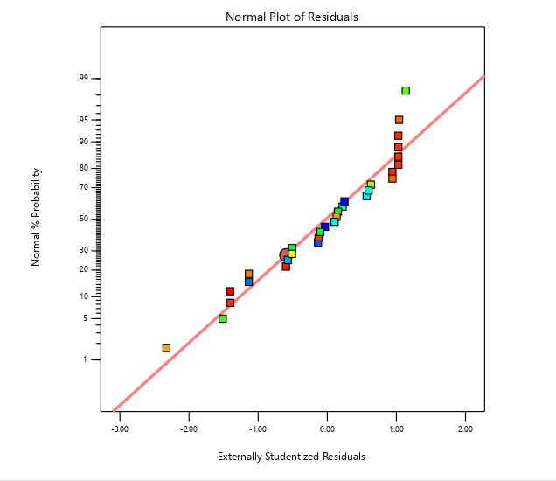
Figure 1: Normal Probability Plot of Residuals
Figure 1 shows the normal probability plot of externally studentized residuals for the quadratic regression model. Most points lie along the reference line, indicating that the residuals are approximately normally distributed. Minor deviations at the extremes are observed but are not significant. This validates that the assumption of normality is satisfied, supporting the reliability of the regression analysis and associated statistical inferences, such as p-values and confidence intervals, derived from the ANOVA and regression analysis.

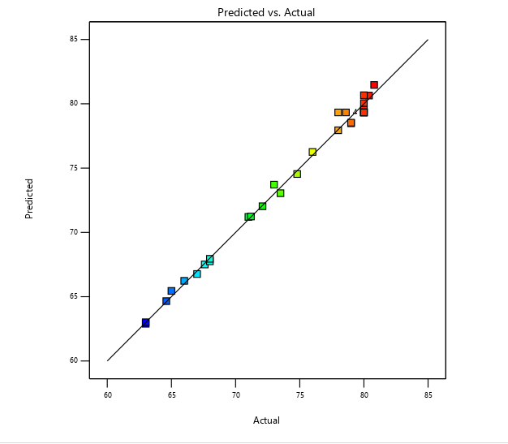
Figure 2: Predicted vs. Actual Plot
For this study, the predicted biodiesel yields closely followed the line of equality, indicating strong agreement between model predictions and experimental results. Only a few runs showed minor deviations, which is expected due to experimental variability. This confirms that the quadratic regression model can reliably predict biodiesel yield within the studied factor ranges.

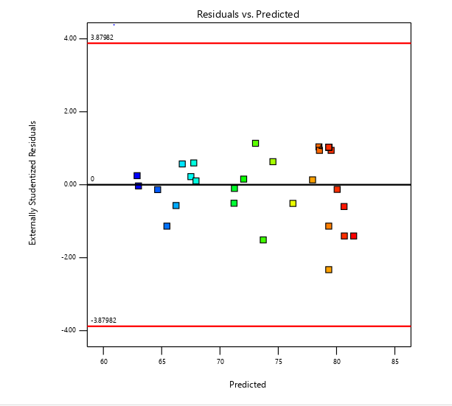
Figure 3: Residuals versus Predicted values

The residuals versus predicted plot shows that the residuals are randomly distributed around zero with no discernible pattern, indicating that the model adequately captures the relationship between the factors and biodiesel yield.. All externally studentized residuals fall within the acceptable limits (±3.88), confirming the absence of significant outliers. The relatively uniform spread of residuals suggests that the assumption of constant variance is satisfied, thereby validating the adequacy and reliability of the developed model.

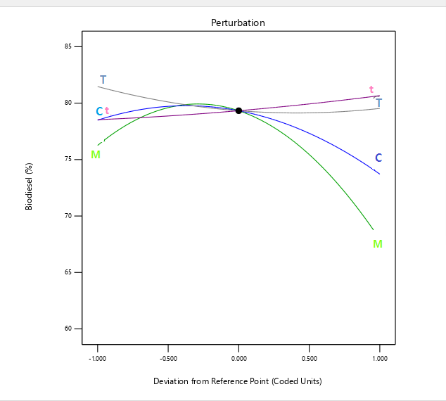
Figure 4: Perturbation Plot
The perturbation plot reveals the relative influence of process variables on biodiesel yield around the reference point. Ethanol-to-oil mole ratio (M) exhibits the highest sensitivity, as evidenced by its steep slope and pronounced curvature, indicating a strong influence on the response. Catalyst loading (C) shows a moderate effect with noticeable curvature, suggesting a quadratic relationship with biodiesel yield. In contrast, temperature (T) and reaction time (t) display relatively flat profiles, indicating minimal impact within the studied range. These results confirm that M and C are the most critical parameters governing biodiesel production, while T and t have comparatively lesser effects.

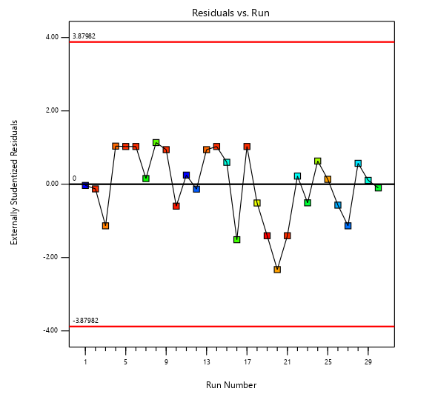
Figure 5: This Residuals vs Run plot
The residuals versus run plot shows that the residuals are randomly scattered around zero without any discernible trend or systematic pattern, indicating that the assumption of independence of errors is satisfied. The absence of run-order effects suggests that there are no time-dependent variations such as experimental drift or instability in operating conditions. Additionally, all externally studentized residuals fall within the acceptable limits (±3.88), confirming that there are no significant outliers. . This shows that the process was stable across runs, and the model’s predictions are not biased by run order. Hence, the model fits the data well without bias.
3.8 Effect of the interaction factors on biodiesel yield
An interaction effect occurs when the influence of one factor on biodiesel yield depends on the level of another factor.
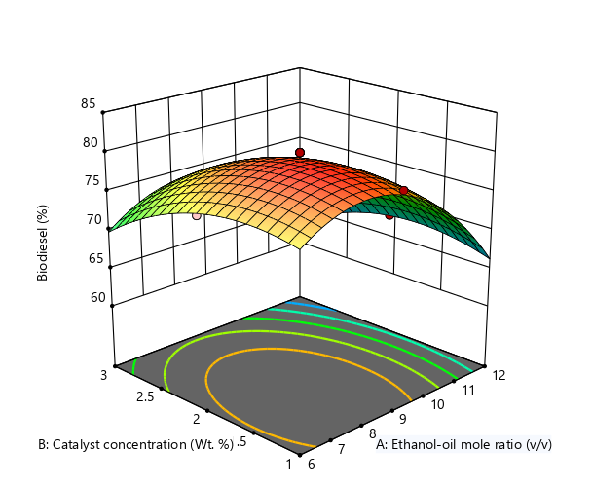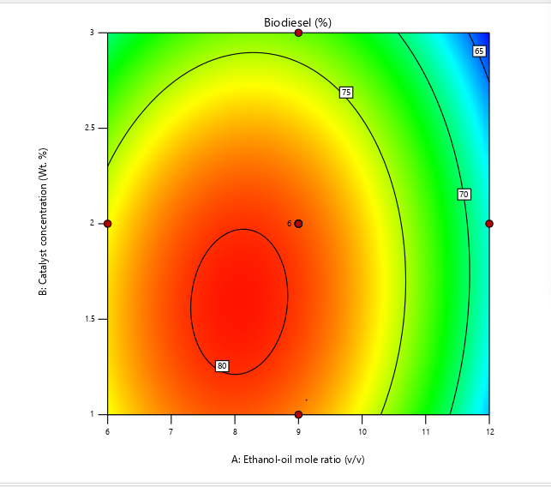
Figure 6: Ethanol-to-Oil Ratio × Catalyst Concentration
The contour plot illustrates the combined effects of ethanol–oil molar ratio (M) and catalyst concentration (C) on biodiesel yield. The response surface exhibits a distinct elliptical pattern, indicating a significant interaction between the two variables. Biodiesel yield increases progressively with an increase in ethanol–oil molar ratio from 6 to approximately 8–9 (v/v), after which a decline is observed at higher ratios. Similarly, increasing the catalyst concentration from 1.0 to about 1.5–1.8 wt.% enhances the yield, beyond which a decrease occurs.

The highest biodiesel yield, approximately 80%, is obtained within the region corresponding to an ethanol–oil molar ratio of about 7.5–9 (v/v) and a catalyst concentration of 1.3–1.8 wt.%. This optimal region is represented by the red/orange zone in the contour plot. In contrast, lower yields (65–70%) are observed at higher ethanol–oil ratios (above 10) and higher catalyst concentrations (above 2.5 wt.%), as indicated by the green to blue regions.

The observed decline in yield at excessive ethanol levels may be attributed to dilution effects and possible equilibrium limitations, while higher catalyst concentrations may promote side reactions such as soap formation, thereby reducing biodiesel yield.

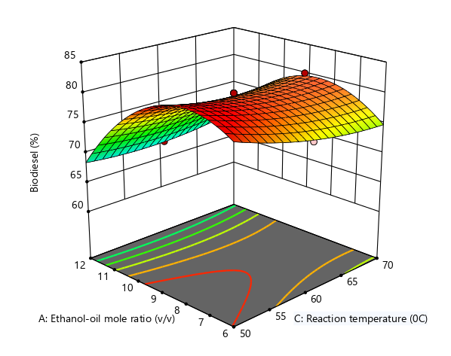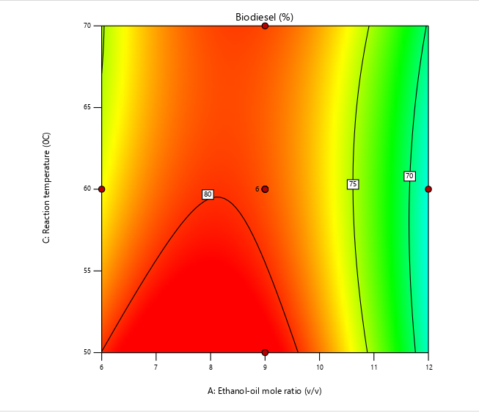
Figure 7: Reaction Temperature × Ethanol-to-Oil Ratio
The contour plot illustrates the interaction effects of ethanol–oil molar ratio (M) and reaction temperature (T) on biodiesel yield. The distribution of the contour lines indicates that both variables significantly influence the yield, with a noticeable curvature suggesting quadratic effects.
Biodiesel yield increases as the ethanol–oil molar ratio rises from 6 to approximately 8–9 (v/v), where the maximum yield of about 82% was observed. Beyond this range, a gradual decline in yield occurs with further increase in the molar ratio. This behavior may be attributed to the excess ethanol causing dilution of reactants and shifting the reaction equilibrium.

Similarly, reaction temperature shows a positive effect on yield within the studied range. Increasing the temperature from 50 °C to around 55–65 °C enhances biodiesel production, as higher temperatures improve reaction kinetics and mass transfer. However, beyond this optimal region, the yield does not show significant improvement and may slightly decrease, possibly due to ethanol evaporation or side reactions at elevated temperatures.
The optimal region for maximum biodiesel yield is therefore located around an ethanol–oil molar ratio of 8–9 (v/v) and a reaction temperature of approximately 55–60 °C, as indicated by the red/orange zone. Lower yields (around 50–55%) are observed at lower temperatures (≈50 °C) and higher molar ratios (>10), as shown by the greenish regions.

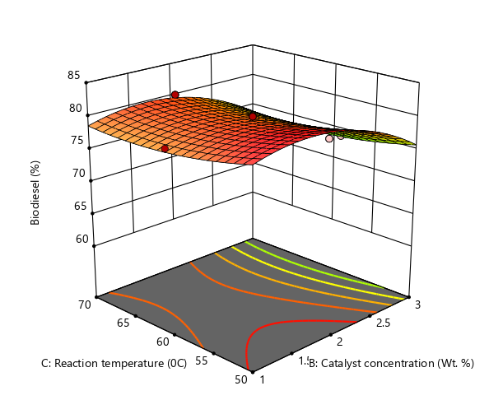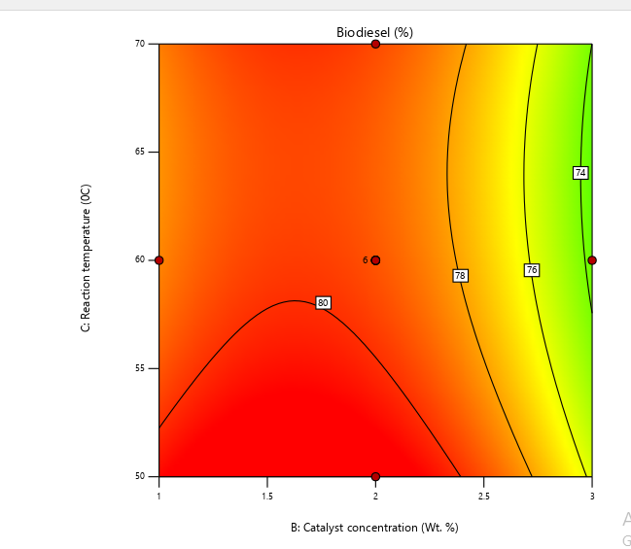

Figure 8: Reaction Temperature × Catalyst Concentration
The contour plot depicts the interaction effect of catalyst concentration (B) and reaction temperature (C) on biodiesel yield, while other process variables are maintained at constant levels. The color gradient, transitioning from green (lower yield) to red (higher yield), illustrates the variation in biodiesel production efficiency across the experimental domain.
The results indicate that catalyst concentration has a pronounced influence on biodiesel yield. An optimal region is observed at moderate catalyst loading, approximately 1.5–2.0 wt.%, where the yield reaches its maximum (around 80%), as indicated by the red zone and enclosed contour lines. Beyond this optimal range, particularly at higher catalyst concentrations (above 2.5 wt.%), the biodiesel yield decreases significantly to about 74–76%. This decline may be attributed to increased mixture viscosity, soap formation, or mass transfer limitations at excessive catalyst levels.
Reaction temperature (C), on the other hand, exhibits a relatively less pronounced effect within the studied range (50–70 °C). The contour lines are nearly vertical, indicating that changes in temperature do not substantially influence the yield compared to catalyst concentration. However, slightly higher yields are observed at moderate temperatures (~55–60 °C), suggesting favorable reaction kinetics within this range.
The curvature of the contour lines indicates the presence of quadratic effects, particularly for catalyst concentration, while the relatively uniform spacing suggests a weak interaction between the two variables.

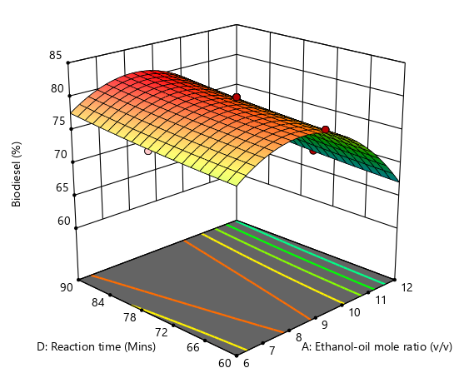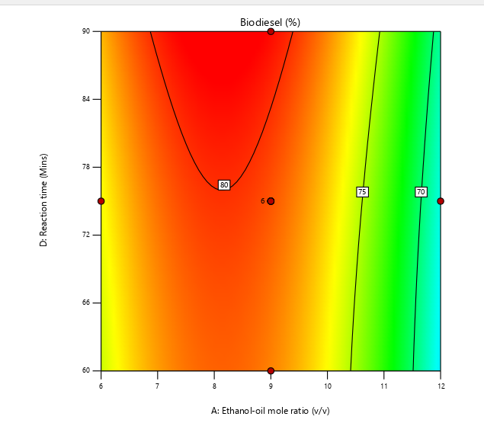

Figure 9: Reaction Time × ethanol mole ratio

The contour plot illustrates the combined effect of ethanol-to-oil molar ratio (A) and reaction time (D) on biodiesel yield, while other variables are held constant. The color gradient, ranging from blue/green (low yield) to red (high yield), represents the variation in biodiesel production efficiency across the experimental domain.
The plot reveals that biodiesel yield is strongly influenced by the ethanol-to-oil molar ratio. Maximum yield values (approximately 80% and above) are observed within the intermediate range of the molar ratio, around 8–9 (v/v), as indicated by the red region and the enclosed contour lines. As the molar ratio increases beyond this optimal range (towards 11–12), a noticeable decline in yield is observed, with values dropping to approximately 70–75%. This suggests that excessive ethanol may adversely affect the transesterification process, possibly due to dilution effects or equilibrium limitations.
In contrast, reaction time (D) exhibits a relatively mild influence on biodiesel yield within the studied range (60–90 minutes). The contour lines are nearly vertical, indicating that changes in reaction time do not significantly alter the yield compared to the molar ratio. However, a slight improvement in yield is observed around the mid-range of reaction time (~75 minutes), suggesting an optimal duration for sufficient reaction completion.
The elliptical shape of the contour lines indicates the presence of interaction effects between the variables, although the interaction appears to be less pronounced compared to the dominant effect of the molar ratio.

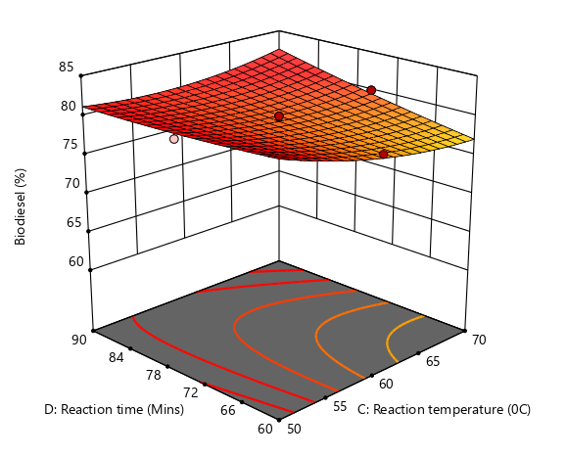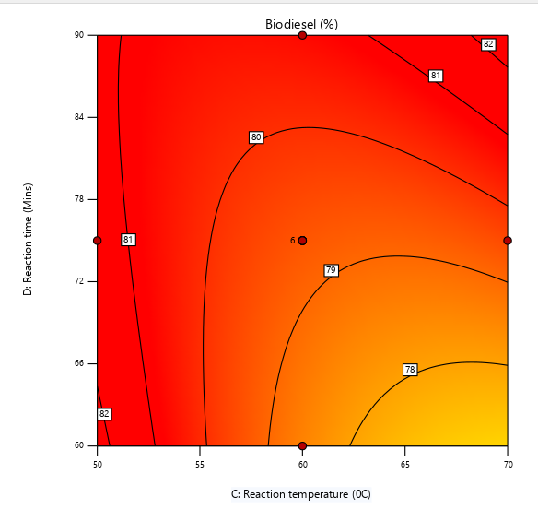
Figure 10: Reaction time × Temperature
The contour plot presents the interaction effects of reaction temperature (C) and reaction time (D) on biodiesel yield. The response surface is characterized by a predominantly high-yield region, as indicated by the extensive red coloration, suggesting that these two variables strongly influence the process within the studied range. Biodiesel yield generally increases with increasing reaction time from 60 to 90 minutes. The highest yields (approximately 81–82%) are observed at longer reaction times, particularly in the range of 80–90 minutes, across a broad span of temperatures. This indicates that sufficient reaction time is critical for the completion of the transesterification process. In terms of temperature, moderate values appear to favor higher yields. While the yield remains relatively high across much of the temperature range (50–70 °C), slightly lower yields (around 76–79%) are observed at higher temperatures (above ~65 °C) when combined with shorter reaction times. This may be due to ethanol evaporation or the onset of side reactions at elevated temperatures, which can reduce conversion efficiency.
The contour lines exhibit some curvature, indicating interaction between temperature and time, although the interaction is less pronounced compared to other factor combinations. The optimal region is broadly located at reaction times of 80–90 minutes and temperatures around 50–60 °C, where maximum biodiesel yield is achieved.The plot suggests that reaction time has a more dominant effect than temperature within the investigated range, and the presence of curvature supports the adequacy of a quadratic model for describing the system under response surface methodology.

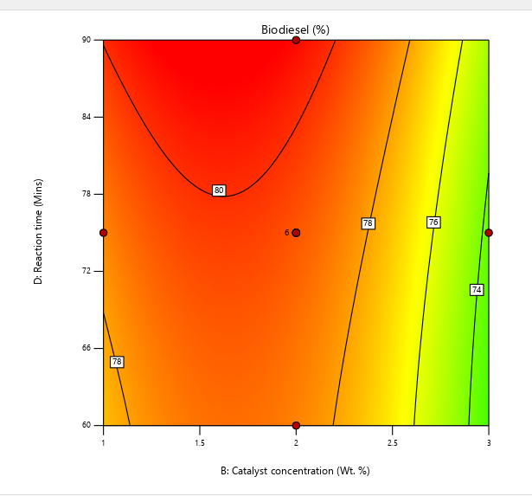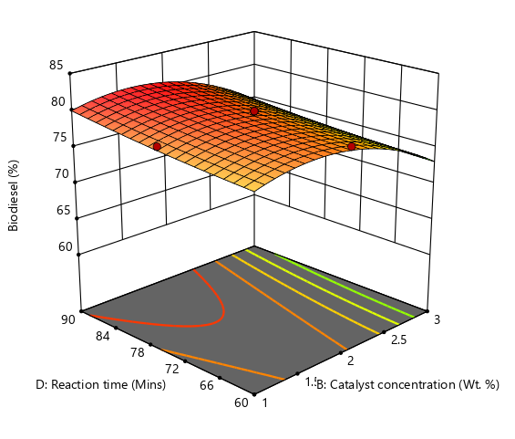
Figure 11: Reaction Time × catalyst
The contour plot illustrates the interaction effect between the ethanol-to-oil molar ratio (A) and the catalyst concentration (B) on biodiesel yield (%) during the transesterification of Jatropha curcas oil using MgO nanocatalyst derived from plant extract. The biodiesel yield increased progressively with rising ethanol-to-oil ratio up to an optimum point, after which a slight decline was observed. Likewise, catalyst concentration exhibited a similar trend, with moderate loading enhancing the reaction rate and excessive concentration leading to a slight reduction in yield.
At the lower end of the ethanol-to-oil ratio (6:1–7:1), the yield was relatively low (around 68–70%), likely due to insufficient alcohol molecules to drive the transesterification reaction to completion. Increasing the ratio up to 9:1–10:1 led to a noticeable improvement in biodiesel yield (approximately 74–76%), indicating an optimum molar ratio where triglycerides were effectively converted to fatty acid ethyl esters (FAEEs). This finding aligns with the work of (Danane et al., 2022)), who observed that increasing the ethanol-to-oil ratio enhances reaction kinetics and facilitates better miscibility between ethanol and the oil phase, but excessive alcohol beyond the optimum can hinder glycerol separation and shift the equilibrium backward.
Similarly, catalyst concentration played a crucial role in determining the conversion efficiency. Increasing catalyst loading from 1.0 to 2.0 wt% improved biodiesel yield due to the higher availability of active sites for transesterification. However, beyond 2.5 wt%, a reduction in yield was observed, as shown by the shift from yellow to green contour regions, possibly due to increased mixture viscosity and mass transfer resistance. Excess catalyst can also promote soap formation through saponification, which complicates product separation and reduces the effective recovery of biodiesel.
The overall contour pattern, characterized by a gradual transition from blue (low yield) to yellow (high yield), demonstrates a clear synergistic effect between ethanol–oil molar ratio and catalyst concentration. In summary, the contour plot indicates that biodiesel yield increases with ethanol–oil molar ratio and catalyst concentration up to optimal values, beyond which further increases cause yield reduction due to equilibrium reversal and mass transfer limitations. This highlights the importance of balancing reactant and catalyst proportions in biodiesel process optimization.

Table 9:. Constraints
Name | Goal | Lower Limit | Upper Limit | Lower Weight | Upper Weight | Importance
A:Ethanol-oil mole ratio | is in range | 6 | 12 | 1 | 1 | 3
B:Catalyst concentration | is in range | 1 | 3 | 1 | 1 | 3
C:Reaction temperature | is in range | 50 | 70 | 1 | 1 | 3
D:Reaction time | is in range | 60 | 90 | 1 | 1 | 3
Biodiesel | maximize | 63 | 80.8 | 1 | 1 | 3

Table 10: Solutions
100 Solutions found
Number | Ethanol-oil mole ratio | Catalyst concentration | Reaction temperature | Reaction time | Biodiesel | Desirability
1 | 8.600 | 1.598 | 64.902 | 89.361 | 82.048 | 1.000 | Selected
2 | 7.803 | 1.255 | 50.818 | 69.183 | 82.729 | 1.000
3 | 8.078 | 1.483 | 60.613 | 81.533 | 80.954 | 1.000
4 | 9.000 | 2.000 | 50.000 | 75.000 | 81.468 | 1.000
5 | 8.081 | 1.803 | 60.844 | 81.891 | 80.839 | 1.000
3.9 Physico-chemical Parameters of Jatropha curcas L Seed Oil and Biodiesel
The physical and chemical properties of Jatropha curcas L seed oil and biodiesel determined were found to be very similar to those reported values from literatures by other researchers. acid value, %free fatty acid (FFA), viscosity, density, specific gravity, calorific value, Iodine value and moisture content are the most important parameters used to describe the physiochemical properties of biodiesel produced from Jatropha curcas oil. The different parameters investigated affect the quality yield of biodiesel. The produced biodiesel complies with selected ASTM standard specifications for the properties analyzed, suggesting its suitability as a diesel fuel substitute. Physicochemical Properties of Jatropha curcas Oil and Its Ethyl Ester (Biodiesel) Produced Using MgO Nanocatalyst
Table 11: Physiochemical properties of biodiesel
Parameter | Jatropha Oil | Jatropha Biodiesel | ASTM D6751 / EN 14214 Standard
Moisture Content (%) | 0.45 | 0.05 | ≤0.05
Free Fatty Acid (% oleic acid) | 6.80 | 0.80 | 0.80
Acid Value (mg KOH/g) | 13.60 | 1.42 | 1.60
Peroxide Value (meq O₂/kg) | 8.40 | 2.10 | 2.10
Iodine Value (g I₂/100 g) | 102.50 | 92.70 | ≤ 120
Density (g/cm³ at 25°C) | 0.918 | 0.873 | 0.86 – 0.90
Kinematic Viscosity (cSt at 40°C) | 36.5 | 4.7 | 4.6
Flash Point (°C) | 254 | 176 | 150–180
Fire Point (°C) | 268 | 184 | 184
Pour Point (°C) | 9 | -3 | -3
Saponification Value (mg KOH/g) | 191.2 | 187.5 | 80–195 mg KOH/g
pH | 5.6 | 7.1 | 7.1
Cetane number | 44 | 56 | ≥ 47

4. Conclusion

This study successfully optimized biodiesel production from Jatropha curcas seed oil using a green-synthesized MgO nanocatalyst. Response Surface Methodology (RSM) demonstrated that ethanol-to-oil molar ratio, catalyst loading, temperature, and reaction time significantly influence biodiesel yield. Optimal conditions (9:1 molar ratio, 1.6 wt% catalyst, 65 °C, and 90 min) resulted in a biodiesel yield of approximately 82%. The produced biodiesel met ASTM D6751 standards, confirming its suitability as a renewable alternative to conventional diesel fuel.
Despite the promising results obtained in this study, certain limitations should be acknowledged. The experiments were conducted at laboratory scale, and further investigation is required to evaluate the feasibility of large-scale biodiesel production. Additionally, parameters such as catalyst reusability, long-term stability, and process economics were not extensively examined. Addressing these factors is essential for the practical implementation and commercialization of the developed process.

Competing interests

The authors declare no competing interests.

Consent (where ever applicable)
Not applicable

Ethical approval (where ever applicable)
Not applicable.

References

Aboulbaba Eladeb. (2024). Magnesium Oxide (MgO) as a Sustainable Catalyst for Biodiesel Production from Waste Cooking Oil: A Comparative Study with KOH. Engineering Technology & Applied Science Research, 14(2), 13751–13756. https://doi.org/10.48084/etasr.7055

Apuyor, K. E., Otobrise, C., Apuyor, S. E., Asiagwu, A. K., & Onofuevure, O. A. (2026). GC–MS analysis of Jatropha curcas seed oil and ethanol-derived biodiesel produced using green-synthesized MgO nanocatalyst. FUDMA Journal of Sciences, 10(2), 55–64. https://doi.org/10.33003/fjs-2026-1002-4346
A Abdel-Rahman, M.A., Hassan,S.E.D., El-Din, M,N., Arab.M.S., El-Belely.E.F,, Hassan M.A. Alrefaey & Tamer (2020) One- factor-at-a-time an Response surface statistical designs for improve Lactic acid production from beet molasses by Enterococcus hirae Applied Science. 2, 573,
https://doi.org/10.1007/s42453-020-2352-x
Aseibichin, C., Ulakpa, W. C., Doyah, I. O., Olaseinde, A. A., Anakpoha, O. C., Keke, M., & Karuppannan, S. (2024). Modeling and optimization of transesterification of Jatropha oil to fatty acid methyl ester: application of response surface methodology (CCD) and Taguchi orthogonal method. RSC Advances, 14(17), 11784–11796. https://doi.org/10.1039/d4ra01149j
Asiagwu (2017). Kinetics of fermentation of local species of cashew juice using saccharomyces cerevisiae (local extract). International journal of Engineering Research Technology (IJERT), 6(7),420-426
Balakrishnan, G., Velavan, R., Mujasam .B. K., Raslan, E. H. (2020). Microstructure, Optical and Photocatalytic Properties of MgO Nanoparticles. Results in Physics. 16:103013. https://doi.org/10.1016/j.rinp.2020.103013

Bharathiraja, B., Aberna E, S., Jayamuthunagai, J., Saravanaraj, A., Arumugam. A. (2022). Biodiesel production: key factors affecting the efficiency of the process.153-178. https://doi.org/10.1016/B978-0-12-824295-7.00006-1

Birhanu, B., Deshmukh, D., Hailelule, T., & Yeneneh, K. (2025). RSM-optimized biodiesel production from Ethiopian Podocarpus falcatus seed oil using a CaO-CeO2 heterogeneous composite catalyst and oxidative stability assessment. Scientific Reports, 16(1). https://doi.org/10.1038/s41598-025-34007-1
Clark P. D.1.,Ikechukwu S. C., Apuyor S. E., Apuyor K. E., Ndego C. C., Onwugbuta G. C..,Raymond Izoh., Naku J. U.., Amieye B. B. & Obruche E.. K.(2026). Green Synthesis of Magnesium Oxide Nanoparticles using Terminalia catappa Leaves for the Efficient Adsorption of Pyrethrin from Aqueous Solutions. Journal of Science Innovation & Technology Research (JSITR) P -ISSN 3027-1169. 11(9) 215-227
https://doi.org/10.70382/ajsitr.v11i9.081

Chozhavendhan, S., Singh, V. P., Fransila, M., Kumar, P. R., & Devi, K. G. (2020). A review on influencing parameters of biodiesel production and purification processes. Current Research in Green and Sustainable Chemistry, 1-2, 1–6. https://doi.org/10.1016/j.crgsc.2020.04.002
‌Danane, F., Bessah, R., Alloune, R., Tebouche, L., Madjene, F., Kheirani, A. Y., & Bouabibsa, R. (2022). Experimental optimization of Waste Cooking Oil ethanolysis for biodiesel production using Response Surface Methodology (RSM). Science and Technology for Energy Transition, 77, 14. https://doi.org/10.2516/stet/2022014

Farouk, S. M., Tayeb, A. M., Osman, R. M., & Abdel-Hamid, S. M. S. (2024). Sustainable production of biodiesel from waste cooking oil using magnesium oxide nano catalyst: An optimization study. Scientific Reports, 14(1). https://doi.org/10.1038/s41598-024-71930-1
Gada, P., Dusi.S. K., and Abrar, I., (2023) Enhanced Biodiesel Production from Waste Cooking Oil Using ZnO. Recent Advances in Nanotechnology, Springer Proceedings in Materials 28, https://doi.org/10.1007/978-981-99-4685-3_7

Islam, A., Zahira Yaakob, Ghani, J. A., Azza Alareefy, Abdulsalam, N. M., Khateeb, N. A., Zidan, N., Abdelazi, M. A., Ayman El Sabagh, Sakran, M. I., Omran, A., Ahmad El Askary, El-Sharnouby, M., Marzough Aziz albalawi, & Islam, M. (2022). Genotype and age of industrial plant Jatropha curcas L. affect physico-chemical properties of seed oil. Frontiers in Energy Research, 10. https://doi.org/10.3389/fenrg.2022.979217
Jayabal, R. (2024). Advancements in catalysts, process intensification, and feedstock utilization for sustainable biodiesel production. Results in Engineering, 24, 103668. https://doi.org/10.1016/j.rineng.2024.103668

Jonas, M., Ketlogetswe, C., & Gandure, J. (2020). Variation of Jatropha curcas seed oil content and fatty acid composition with fruit maturity stage. Heliyon, 6(1), e03285. https://doi.org/10.1016/j.heliyon.2020.e03285

Mhetras, N., & Gokhale, D. (2025). Sustainable biodiesel production: importance of feedstock resources and production methods. RSC Advances, 15(33), 26739–26754. https://doi.org/10.1039/d5ra03084f

Nisar, S., Hanif, M.A., Rashid, U., Hanif, A., Akhtar, M.N., Ngamcharussrivichai, C.,(2021). Trends in widely used catalysts for fatty acid methyl esters (Fame) production: a review. Catalysts 11 (9). https://doi.org/10.3390/catal11091085

Otieno, S., Kengara, F., Kowenje, C., & Mokaya, R. (2022). Optimization of biodiesel synthesis from Jatropha curcas oil using kaolin derived zeolite Na–X as a catalyst. RSC Advances, 12(35), 22792–22805. https://doi.org/10.1039/d2ra03278c

Ruatpuia, J. V. L., Changmai, B., Pathak, A. (2023). “Green biodiesel production from Jatropha curcas L seed oil using a carbon-based solid acid catalyst: a process optimization study,” Renewable Energy. 206, 597–608,
https://doi.org/10.1016/j.renene.2023.02.041

Rotti, R. B., Sunitha, D. V., Manjunath, R., Roy, A., Mayegowda, S. B., Gnanaprakash, A. P., Alghamdi, S., Almehmadi, M., Abdulaziz. O., Allahyani .M., Aljuaid .A., Alsaiari, A.A., Ashgar, S. S., Babalghith, A.O., Abd El-Lateef, A.E., and Khidir, E. B. (2023),Green synthesis of MgO nanoparticles and its antibacterial properties. Frontier in Chemistry. 11:1143614. https://doi:10.3389/fchem.2023.1143614

Saad, M., Baraa S., & Hussam A. (2023). Preparation and characterization of biodiesel from waste cooking oils using heterogeneous Catalyst(Cat.TS-7) based on natural zeolite. 9(6), e15836–e15836.
https://doi.org/10.1016/j.heliyon.2023.e15836

Samal, S., Balauch, A., Talpur, F., Memon, A.A., Mousav, B. M., and Verpoort, F. (2021). Green synthesis of MgO catalyst by using Ziziphus mauritiana leaves and seeds for biodiesel production. Applied organometallic chemistry Wiley
https://doi:10.1002/aoc6199

Vishnu, T.G., Vasu V., Saumya, K., Samita, M., Manjunatha. (2023)..synthesis of calcium oxide@magnesium oxide nanocatalyst for transesterification of waste cooking oil. Journal of Emerging Technologies and Innovation Research.www.jetir.org ISSN: 2349-5162 (10)6.
https://doi.org/10.5281/Zenodo.8154712
Zhang, Y., Duan, L., & Esmaeili, H. (2022). A review on biodiesel production using various heterogeneous nanocatalysts: Operation mechanisms and performances. Biomass and Bioenergy, 158, 106356. https://doi.org/10.1016/j.biombioe.2022.106356

‌

‌

