Preparation and Performance Study of Steel Slag-based Artificial Aggregate

Abstract: To address the issues of strength control and mix proportion optimization of steel slag-based artificial aggregate (SSAA), this study takes SSAA as the research object and designs experiments using response surface methodology. It focuses on investigating the influence of steel slag content (A), desulfurization gypsum content (B), and carbide slag content (C) on its 28d single-particle compressive strength, as well as optimizing the optimal mix proportion. A quadratic polynomial prediction model is established through single-factor analysis and response surface analysis, and its reliability is verified by experimental data combined with analysis of variance.
The results show that steel slag content and carbide slag content have significant effects on the compressive strength of SSAA, and high contents of both lead to strength reduction. The effects of steel slag content and desulfurization gypsum content on strength exhibit a trend of "first increasing and then decreasing", with steel slag content showing a greater influence than desulfurization gypsum content. The established quadratic polynomial prediction model features high fitting accuracy (R²=0.913) and good reliability (p=0.0055), which can be effectively used for strength analysis and prediction. The optimized and adjusted mix proportion is determined as 55% slag, 30% steel slag, 15% desulfurization gypsum, and 0% carbide slag. This proportion balances construction convenience and economic efficiency, ensuring favorable compressive performance of SSAA.
This study provides a theoretical basis and practical reference for the engineering application of steel slag-based artificial aggregate and realizes the rational utilization of steel slag resources.

- Introduction
With the sustained and rapid development of China’s national economy, the output of industrial solid waste has shown a trend of large-scale growth. ^{19,20} Its resource utilization and environmental management have become major issues urgently to be solved in the field of resources and environment in China. The annual output of industrial solid waste in China is about 3.3 billion tons, with a cumulative historical stockpile exceeding 6 billion tons, covering an area of more than 2 million hectares.
According to the 2017 Annual Report on the Prevention and Control of Environmental Pollution by Solid Waste in Large and Medium-Sized Cities issued by the Ministry of Environmental Protection, the generation of general industrial solid waste in 214 large and medium-sized cities in China reached 1.48 billion tons in 2016^{[1]}. Long-term stockpiling of massive industrial solid waste not only wastes land resources but also easily triggers a series of environmental risks such as soil, water and air pollution^{[2,18]}. The treatment process is time-consuming and is accompanied by considerable resource waste^{[3]}.Moreover, the overexploitation of natural resources, especially the mining of crushed stone and sand, has damaged natural landforms. To protect the natural environment, many countries have issued corresponding restrictive policies^{[4-8]}. However, in recent years, with the expansion of construction and urbanization, the demand for crushed stone and sand has been rising continuously, consuming a large amount of natural resources, especially coarse and fine aggregates commonly used in concrete^{[6,7,9-11]}.Studies have shown that sand and gravel used in construction and transportation infrastructure account for 79% of the total consumption ^{[5,7,12]}. From 2015 to 2020, global annual consumption of sand and gravel kept increasing, with the demand for construction aggregates ranging from 4 to 5 billion tons^{[7,13,14]}.With accelerated urbanization, the demand for sand and gravel is growing steadily. Restricted by national laws and policies, the mining of natural aggregates has been gradually replaced by artificial aggregates (AAs) to meet the needs of construction projects^{[15,16]}. Therefore, the research and development of AAs has long been a focus for scholars.
There are two main methods for preparing AAs: high-temperature sintering and cold-bound pelletizing. Artificial aggregates produced by high-temperature sintering have stronger bonding performance, but the process is not conducive to carbon neutrality and consumes excessive energy. At present, cold-bound pelletizing is more widely adopted to prepare AAs^{[17]}.In this paper, total solid-waste artificial aggregates were prepared by cold-bound pelletizing, and the relationship between mix proportion and compressive strength during the preparation process was discussed.
- Test Materials and Performance Indicators
The raw materials used for preparing full-solid-waste artificial aggregate include , Steel slag, granulated blast furnace slag, desulfurization gypsum, carbide slag, and water.
2.1 Experimental Raw Materials
（1）Steel Slag
Steel slag is a bulk industrial solid waste by-product generated during iron and steel smelting. It is obtained by cooling, crushing, and grinding the molten slag formed after adding fluxes during the smelting of pig iron and scrap steel. Table 1 presents the XRF analysis results. Its composition is complex, with high contents of SiO₂, CaO, and Fe₂O₃ accounting for 80% of the total mass fraction. In addition, elements such as Mg, Al, Ti, and Mn account for a considerable proportion.
Chemical Composition | MgO | Al₂O₃ | SiO₂ | SO₃ | CaO | TiO₂ | V₂O₅ | MnO | Fe₂O₃
Content/% | 4.569 | 5.336 | 16.223 | 0.559 | 39.570 | 1.354 | 0.864 | 3.244 | 24.880
Table. 1 Chemical composition of Steel Slag

In accordance with the specification Steel Slag Powder for Cement and Concrete (GB/T 20491—2017), various indicators were tested and analyzed. The results show that all indicators meet the requirements for steel slag powder specified in the standard, and the test results are presented in Table 2.
Performance Index | Specified Value (Grade I) | Measured Value
Density /（g/cm³） | ≥3.2 | 3.49
Activity Index/% | ≥350 | 486
Fineness (45 µm sieve residue, %)/% | 28d ≥80  7d ≥65 | 92.3  72.5
Loss on Ignition（LOI）/% | ≤3.0 | 2.3
Table 2 Performance indicators of steel slag

（2）Granulated Blast Furnace Slag Powder
The granulated blast furnace slag (referred to as slag for short) used in the test was tested in accordance with Ground Granulated Blast Furnace Slag for Cement, Mortar and Concrete (GB/T 18046-2017), and the test data are shown in Table 3. The results indicate that the material fully meets the performance requirements of S95 grade ground granulated blast furnace slag powder.
Performance Index | Standard Value (S95 Grade) | Measured Value
Density/（g/cm³） | ≥2.8 | 2.93
Specific Surface Area/（m²/kg） | ≥400 | 623
Activity Index/% | ≥95 | 98.3
Loss on Ignition（LOI） | ≤1.0 | 0.63
Table. 3 Performance index of granulated blast furnace slag powder

The granulated blast furnace slag powder was analyzed by XRF. As shown in Table 3, its main chemical components include CaO, SiO₂, Al₂O₃, MgO, etc., with a total mass fraction of more than 95%.
Chemical Composition | Na₂O | MgO | Al₂O₃ | SiO₂ | SO₃ | CaO | TiO₂ | MnO
Content/% | 0.541 | 10.114 | 18.23 | 32.312 | 2.125 | 34.719 | 0.672 | 0.497
Table. 4 Chemical composition of granulated blast furnace slag powder
（3）Carbide slag
The chemical composition of the carbide slag sample was determined by XRF, and the results are shown in Table 5.The analysis indicates that this batch of carbide slag is mainly composed of calcium oxide (CaO) as an industrial by-product.In addition to CaO, the contents of Mg, Al and Si are relatively high.
Chemical Composition | MgO | Al₂O₃ | SiO₂ | CaO | SO₃ | Fe₂O₃
Content/% | 2.027 | 0.62 | 0.811 | 95.667 | 0.344 | 0.385
Table.5 Ash analysis of calcium carbide slag samples
（4）Desulfurization gypsum
The desulfurization gypsum used in the test was analyzed by XRF. As shown in Table 6, its main components include SO₃, CaO, etc., with a total mass fraction exceeding 85%.
Chemical Composition | F | Na₂O | MgO | Al₂O₃ | SiO₂ | SO₃ | K₂O | CaO
Content/% | 2.065 | 0.116 | 2.234 | 1.559 | 3.258 | 51.655 | 0.267 | 38.002
Table. 6 Chemical Composition Analysis of Desulfurized Gypsum Samples

2.2 Performance Indicators

Single-particle compressive strength
The test was carried out using a universal testing machine. The prepared aggregate was placed at the center of the parallel plates of the machine. The universal testing machine was started to lower the upper pressure plate slowly until it contacted the particle surface. At this point, the distance between the pressure surface and the upper pressure plate was measured. The instrument was then operated continuously, and the artificial aggregate was compressed until it fractured, at which point loading was stopped and the peak pressure was recorded. The calculation method for single-particle compressive strength is given in Equation (2-1).
(2-1)
Where:
— single-particle compressive strength of artificial aggregate, MPa;
— peak pressure at failure of artificial aggregate, N;
— distance between the upper and lower pressure plates at the onset of loading, cm.
- Optimization Experiment on Mix Proportion of Steel Slag-Based Artificial Aggregate
3.1 Response Surface Methodology
The factors and levels to be investigated in the mix proportion optimization of steel slag-based artificial aggregate are listed in Table 7. Table 8 presents the optimization design and results obtained by response surface methodology.The dosage of steel slag ranges from 20% to 50%, desulfurization gypsum from 10% to 20%, and carbide slag from 0% to 10%. The content of blast furnace slag varies between 20% and 70% with the changes in the dosages of steel slag, desulfurization gypsum and carbide slag. The water-cement ratio is controlled at 0.2, and only standard curing is adopted.The dosages of steel slag, desulfurization gypsum and carbide slag are selected as research variables, designated as Factor A, Factor B and Factor C, respectively. When analyzing any two factors in the response surface, the remaining variable is set at the median value of its level range.
Factor | Level
Factor | -1 | 0 | 1
A: Steel Slag Content / % | 20 | 35 | 50
B: Desulfurization Gypsum Content / % | 10 | 15 | 20
C: Carbide Slag Content / % | 0 | 5 | 10
Table 7 The factor and level

Std | A/% | B/% | C/% | 28d Single-Particle Compressive Strength / MPa
1 | 20 | 20 | 5 | 2.87
2 | 50 | 20 | 5 | 1.8
3 | 50 | 10 | 5 | 2.48
4 | 35 | 20 | 0 | 4.4
5 | 35 | 10 | 0 | 4.32
6 | 20 | 15 | 0 | 4.91
7 | 35 | 15 | 5 | 4.87
8 | 20 | 15 | 10 | 3.61
9 | 20 | 10 | 5 | 3.34
10 | 35 | 15 | 5 | 4.52
11 | 35 | 15 | 5 | 3.68
12 | 50 | 15 | 10 | 1.56
13 | 35 | 15 | 5 | 4.56
14 | 35 | 15 | 5 | 4.72
15 | 35 | 10 | 10 | 3.83
16 | 35 | 20 | 10 | 2.89
17 | 50 | 15 | 0 | 2.73
Table. 8 Experiment result

(1) Effect of Steel Slag Dosage on Compressive Strength of SSAA
According to the results shown in Table 8 four control groups were compared: Group 1 vs. 2, Group 3 vs. 9, Group 6 vs. 17, and Group 8 vs. 12.Except for the differences in steel slag dosage and slag dosage, all other factors remained unchanged. The compressive strengths of Groups 1, 9, 6, and 8 were higher than those of Groups 2, 3, 17, and 12, respectively. The steel slag dosage in Groups 1, 9, 6, and 8 was 20%, while that in Groups 2, 3, 17, and 12 was 50%.From the perspective of hydration degree, the system with high steel slag dosage exhibits a slow hydration rate and low hydration degree. The insufficient amounts of hydration products such as C–S–H gel and ettringite cannot effectively fill the pores between aggregates, resulting in low cementing strength.In terms of particle characteristics, steel slag particles are mostly irregular and angular with rough surfaces, showing a weak ability to optimize particle gradation. When the steel slag dosage is excessively high, the system lacks sufficient fine slag particles to fill the voids among large particles, leading to an increase in internal porosity, loose structure, and reduced strength of the hardened body.

(2) Effect of Carbide Slag Dosage on Compressive Strength of SSAA

It can be seen from the results in Table 8 that among three control groups: Group 4 vs. 16, Group 5 vs. 15, and Group 6 vs. 8, with all other factors being the same except for the dosage of carbide slag and slag, the compressive strengths of Groups 4, 5, and 6 were higher than those of Groups 16, 15, and 8, respectively.The carbide slag dosage in Groups 4, 5, and 6 was 0%, while that in Groups 16, 15, and 8 was 10%.This is because the main component of carbide slag is Ca(OH)₂, which is a strongly alkaline substance. An excessive dosage will cause a sharp increase in the alkalinity of the system, exceeding the optimal hydration excitation range for cementitious components such as slag and steel slag. In addition, steel slag itself exhibits a certain alkalinity.

(3) Overall Analysis

The overall strength fluctuates considerably, indicating that the compressive strength of SSAA is significantly affected by the mix proportion when other factors remain constant. The minimum strength is only 1.56 MPa, while the maximum reaches 4.9 MPa.The compressive strength of SSAA varies more significantly with the steel slag dosage, whereas the influence of carbide slag dosage is relatively small. The effect of desulfurization gypsum dosage on compressive strength is related to other factors and cannot be clearly determined from this analysis alone; it needs to be further investigated combined with contour plots and response surface curves.
3.2 Mix Proportion Optimization Based on Response Surface Methodology

As shown in Figure 1, the response surface curve of steel slag–desulfurization gypsum was used to analyze the effects of steel slag and desulfurization gypsum on the 28d compressive strength of SSAA.With the carbide slag dosage fixed at 5%, as the steel slag content varied from 20% to 50%, the compressive strength first increased and then decreased, reaching the maximum at a steel slag dosage of approximately 32%.The rate of strength change can be observed from the sparsity of the contour lines. The strength growth trend in the range of approximately 20%–32% steel slag dosage was noticeably milder than the strength reduction trend from around 32% to 50%.As the desulfurization gypsum dosage varied from 10% to 20%, the strength also increased first and then decreased, reaching the maximum at 15% desulfurization gypsum.It can be seen from the contour plot that the vertical contours are less dense than the horizontal ones, indicating that the influence of desulfurization gypsum dosage on compressive strength is weaker than that of steel slag dosage.
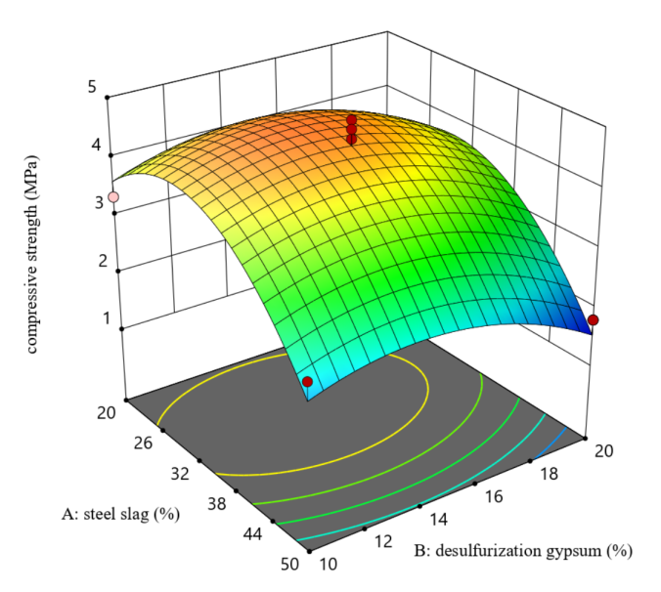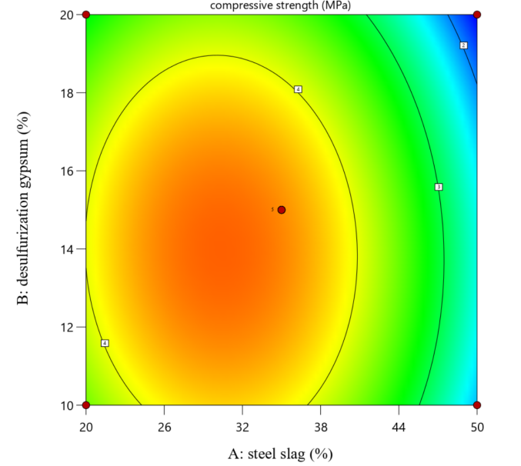
Figure. 1 Curves and contour plots of the effects of slag content, fly ash content/steel slag content on the compressive strength of SSFAA
As shown in Figure 2, the response surface curve of steel slag–carbide slag in the response surface methodology was used to analyze the effects of steel slag and carbide slag on the 28d compressive strength of SSAA.With the desulfurization gypsum dosage fixed at 15%, as the steel slag dosage varied from 20% to 50%, the compressive strength of SSAA first increased and then decreased, reaching the maximum at approximately 31% steel slag.When the carbide slag dosage varied from 0% to 10%, the compressive strength of SSAA decreased with the increase of carbide slag dosage.It can be seen from the contour plot that the angle between the contour lines and the vertical direction gradually decreases toward the right side, indicating that the influence of carbide slag dosage on the compressive strength of SSAA gradually weakens as the steel slag dosage continues to increase beyond 31%.The vertical contours are less dense than the horizontal ones, which also indicates that the effect of carbide slag dosage on compressive strength is significantly weaker than that of steel slag dosage.
As shown in Figure 3, the response surface curve of desulfurization gypsum–carbide slag was adopted to analyze the effects of desulfurization gypsum and carbide slag on the 28d compressive strength of SSAA.With the steel slag dosage fixed at 35%, as the desulfurization gypsum dosage varied from 10% to 20%, the compressive strength of SSAA first increased and then decreased, reaching the maximum at 15% desulfurization gypsum.It can be observed from the contour plot that the upper contours are denser than the lower ones, indicating that the influence of desulfurization gypsum on compressive strength gradually increases with the increase of carbide slag dosage.When the carbide slag dosage varied from 0% to 10%, the compressive strength gradually decreased with the increase of carbide slag dosage.
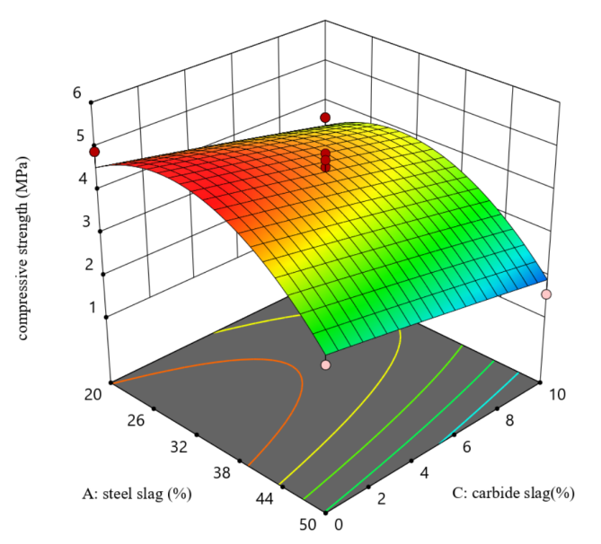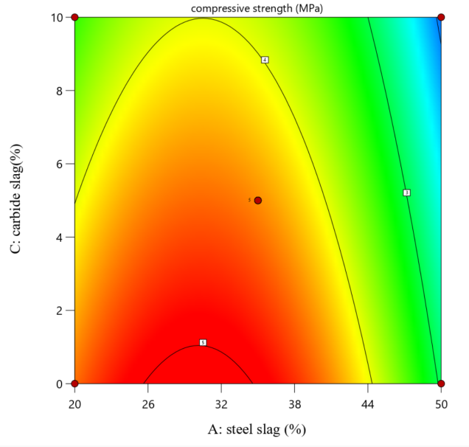
Figure 2 Effect curves and contour plots of steel slag and carbide slag on compressive
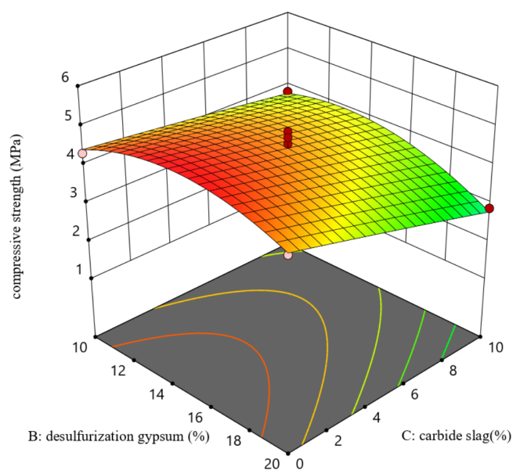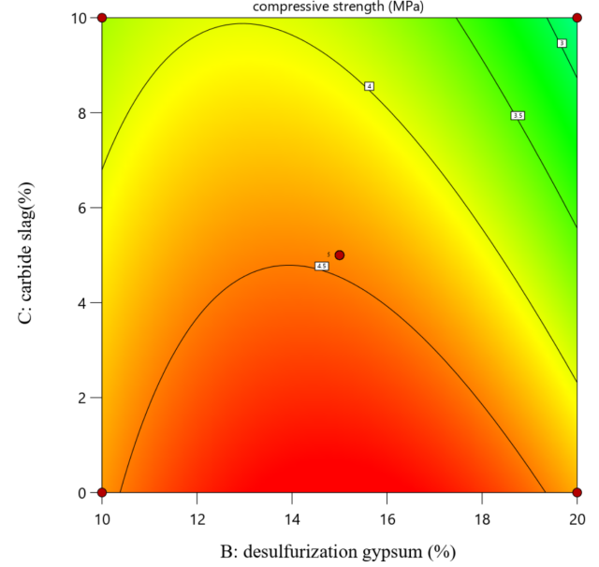
Figure 3 Effect curves and contour plots of desulfurization gypsum and carbide slag on

Based on the optimized test results of response surface methodology, regression fitting was performed on the response relationship between Factor A (steel slag dosage), Factor B (desulfurization gypsum dosage), Factor C (carbide slag dosage) and the 28d single-particle compressive strength.The quadratic polynomial prediction model is obtained as follows:
y=4.47−0.77A−0.2573B−0.5588C−0.052AB+0.032AC−0.255BC−1.256A²−0.5950B²−0.015C²
The ANOVA results of the model are listed in Table 9.The correlation coefficient R² of the fitted equation is 0.913, the model is extremely significant (p=0.0055), and the lack of fit term is not significant (p=0.4501), indicating that the established quadratic regression model has high fitting accuracy and good reliability. It can be used for the analysis and prediction of the 28d single-particle compressive strength of this system.
According to the fitted regression equation, the optimal mix proportion of SSAA is obtained as follows: blast furnace slag dosage 55%, steel slag dosage 30%, desulfurization gypsum dosage 14%, and carbide slag dosage 1%.In consideration of actual engineering conditions, the mix proportion is adjusted to: blast furnace slag dosage 55%, steel slag dosage 30%, desulfurization gypsum dosage 15%, and carbide slag dosage 0%.

Source | Sum of Squares | df | Mean Square | F-value | p-value
Model | 16.53 | 9 | 1.84 | 8.26 | 0.0055
A | 4.74 | 1 | 4.74 | 21.33 | 0.0024
B | 0.5050 | 1 | 0.5050 | 2.27 | 0.1755
C | 2.50 | 1 | 2.50 | 11.23 | 0.0122
AB | 0.0110 | 1 | 0.0110 | 0.0496 | 0.8302
AC | 0.0042 | 1 | 0.0042 | 0.0190 | 0.8942
BC | 0.2601 | 1 | 0.2601 | 1.17 | 0.3153
A2 | 6.61 | 1 | 6.61 | 29.70 | 0.0010
B2 | 1.49 | 1 | 1.49 | 6.70 | 0.0360
C2 | 0.0009 | 1 | 0.0009 | 0.0043 | 0.9498
Residual | 1.56 | 7 | 0.2224
Lack of Fit | 0.6994 | 3 | 0.2331 | 1.09 | 0.4501
Pure Error | 0.8572 | 4 | 0.2143
Total Correlation | 18.09 | 16
Table 9 Quadratic model test results and analysis of variance

4. Conclusion
Taking steel slag-based artificial aggregate (SSAA) as the research object, this study designed experiments using the response surface methodology, focusing on exploring the influence rules of steel slag content (A), desulfurized gypsum content (B), and carbide slag content (C) on the 28d single-particle compressive strength, and optimizing the optimal mix ratio. Based on the test results and data analysis, the main conclusions are as follows:
1. Single factor influence analysis shows that both steel slag content and carbide slag content have significant impacts on the compressive strength of SSAA. When the steel slag content is 20% (low content), the compressive strength is significantly higher than that when the steel slag content is at a high level; when the carbide slag content is 0%, the compressive strength is higher than that when the carbide slag content is 10%. The high-content steel slag leads to slow hydration rate, insufficient hydration products, and poor particle gradation, resulting in reduced strength; the excessive carbide slag makes the system alkalinity exceed the optimal hydration range, inhibiting the hydration of cementitious components and reducing strength.
2. Response surface analysis indicates that the effects of steel slag content and desulfurized gypsum content on the compressive strength of SSAA both show a trend of "first increasing and then decreasing". The maximum strength is achieved when the steel slag content is about 31-32% and the desulfurized gypsum content is 15%; the carbide slag content has a negative impact on the strength, and its influence degree gradually weakens with the increase of steel slag content. Overall, the influence degree of steel slag content on strength is greater than that of desulfurized gypsum and carbide slag.
3. The quadratic polynomial prediction model established based on the response surface test has high fitting accuracy, with a correlation coefficient R² of 0.913. The model is extremely significant (p=0.0055), and the lack-of-fit term is not significant (p=0.4501), which can effectively analyze and predict the 28d single-particle compressive strength of SSAA.
4. The optimal mix ratio of SSAA optimized by the regression model is: 55% slag, 30% steel slag, 15% desulfurized gypsum, and 0% carbide slag. This mix ratio can ensure that SSAA has good compressive performance, and is more in line with the convenience and economy of actual engineering construction, providing theoretical basis and practical reference for the engineering application of steel slag-based artificial aggregate.

COMPETING INTERESTS DISCLAIMER:
Authors have declared that they have no known competing financial interests OR non-financial interests OR personal relationships that could have appeared to influence the work reported in this paper.

Reference
[1] Ministry of Environmental Protection of the People’s Republic of China. 2017 Annual Report on the Prevention and Control of Environmental Pollution by Solid Waste in Large and Medium-Sized Cities. November 2017.
[2] Li Yadong, Xu Zheng, Fan Xingxiang, et al. Resource Treatment and Comprehensive Utilization of Metallurgical Solid Waste[J]. Chemical Engineering Design Communications, 2021, 47(9): 170-171.
[3] Sun Wanli. Research on Resource Comprehensive Disposal and Utilization Technology of General Industrial Solid Waste[J]. China Petroleum and Chemical Standards & Quality, 2024, 44(3): 178-180.
[4]Li Yancang, Chu Qingtao, Wang Yude, et al. Study on Preparation and Properties of Artificial Aggregate from Solidified Reservoir Sediment[J/OL]. China Rural Water and Hydropower, 1-17 [2024-12-07].
[5]Shi Haoliang. Study on Preparation and Properties of Unburned Aggregate by Wet Extrusion Granulation of Dredged Sediment[D]. Tianjin: Tianjin University of Science & Technology, 2019.
[6]LI X G , HE C H, LV Y , et al. .Effect of sintering temperature and dwelling time on the characteristics of lightweight aggregate produced from sewage sludge and waste glass powder[J].Ceramics International,2021,47(23):33435-33443.
[7] LIAO Y C, HUANG C Y, CHEN Y M. Lightweight aggregates from water reservoir sediment with added sodium hydroxide[J]. Construction and Building Materials, 2013, 46: 79–85.
[8]Bekkeri,G.B., Shetty, K. K., & Nayak, G. (2024). Effects of cold-bonded artificial aggregate properties on the behaviour of concrete. Materials Research Express,11(8).
[9]Shang Xiaoyu, Huang Wenyi, Fang Zeyu, et al. Preparation and Properties of High-Strength Concrete with Artificial Cold-Bonded Lightweight Aggregate[J/OL]. Acta Materiae Compositae Sinica, 1-11 [2024-12-07].
[10]Jin, H., Cheng, L., Liu, J., Chen, C., & Xing, F. (2024). Converting municipal solid waste incineration bottom ash into the value-added artificial lightweight aggregates through cold-bonded granulation technology. Construction and Building Materials,438.
[11] Ge Shixian, Cheng Shengming. Difficulties and Countermeasures of Preparing Artificial Sand and Aggregate for Roller Compacted Concrete from Tuff[J]. Hydropower and New Energy, 2015, (01): 63-65.
[12] Askci Consulting Co., Ltd. Market Size and Development Prospect Forecast Analysis of China's Industrial Solid Waste Treatment Industry in 2022[R]. 2022.
[13] Weng Xiaohan, Han Tao, Feng Wei, et al. Research status and progress of negative carbon emission technologies[J]. Journal of Clean Coal Technology, 2024, 30(10): 159-174. DOI:10.13226/j.issn.1006-6772.CCUS24051201.
[14] Andersson R，Hakan S，Gustafsson T，et al.Carbonation as a method to improve climate performance for cement-based mate－ rial[J].Cement and Concrete Research，2019，124（20）：105819.
[15]Chiang P C，Pan S Y.Carbon dioxide mineralization and utiliza－ tion[M].Springer Singapore，2017，9（19）：6673-6684.
[16]Seishi G，Kenzo S，Takeshi K.Calcium silicate carbonation prod－ ucts [J].Journal of the American Ceramic Society，1995，78（11）： 2867-2872.
[17] Zou Xiangbo, Chen Gongda, Rao Mumin, et al. Experimental study on carbon dioxide mineralization maintenance of all-solid waste lightweight aggregates[J/OL]. Clean Coal Technology, 1-14[2024-12-07].
[18] Klumpp, T., & Su, X. (2025). Stockpiling and Shortages. International Economic Review. https://doi.org/10.1111/iere.70029
[19] Gu, J., Liu, X., & Zhang, Z. (2023). Road base materials prepared by multi-industrial solid wastes in China: A review. Construction and Building Materials, 373, 130860.
[20] Wang, G., Xiang, J., Liang, G., Wang, J., Ma, S., & He, C. (2023). Application of common industrial solid waste in water treatment: a review. Environmental Science and Pollution Research, 30(52), 111766-111801.
‌

