Influence of Attitudes and Perceptions on Sustainable Farming Practices among the Maasai Community in Kajiado County, Kenya

Abstract
Sustainable farming in pastoral and agro-pastoral systems is shaped not only by ecological and economic factors but also by farmers’ attitudes and perceptions. This study assessed the extent to which attitudes and perceptions influence sustainable farming practices among the Maasai community in Kajiado County, Kenya. A mixed-methods research design was employed, involving a household survey of 320 respondents, focus group discussions, and key informant interviews. Quantitative data were analysed using descriptive statistics and multiple regression analysis, while qualitative data were analysed thematically. The results indicate that environmental stewardship attitudes, cultural valuation of land, perceived benefits of sustainable farming, perception of land degradation risk, and trust in indigenous knowledge systems significantly influence sustainable farming practices (R² = 0.54, p < .05). The study concludes that attitudes and perceptions play a substantial role in shaping sustainability-oriented behaviour among the Maasai and recommends that agricultural policies and extension programs integrate socio-cultural and cognitive dimensions alongside technical interventions.
Keywords: attitudes, perceptions, sustainable farming, Maasai, indigenous knowledge, Kajiado County
1. Introduction
Sustainable farming has become a central objective of agricultural development policy, particularly in arid and semi-arid lands (ASALs) where environmental degradation and climate variability threaten rural livelihoods. In Kenya, ASALs support a large proportion of pastoral and agro-pastoral communities, including the Maasai of Kajiado County (Government of Kenya, 2021). While numerous initiatives promote sustainable land management and climate-smart agriculture, adoption and sustained use of such practices remain uneven.
A growing body of literature suggests that farmers’ attitudes and perceptions strongly influence their engagement with sustainable farming practices (Ajzen, 1991; Knowler & Bradshaw, 2007). Attitudes toward environmental conservation, perceptions of risk and benefit, and cultural values related to land and livestock shape how farmers interpret and respond to sustainability interventions. Among the Maasai, farming and pastoral practices are deeply embedded within cultural worldviews that emphasize communal land use, livestock stewardship, and intergenerational responsibility (Galvin, 2009).
Despite this recognition, empirical studies quantifying the influence of attitudes and perceptions on sustainable farming practices in indigenous pastoral contexts remain limited. This study addresses this gap by assessing the extent to which attitudes and perceptions influence sustainable farming practices among the Maasai in Kajiado County.
2. Literature Review
2.1 Attitudes and Sustainable Farming Practices
Attitudes refer to individuals’ evaluative dispositions toward particular behaviours or outcomes (Ajzen, 1991). In agricultural contexts, positive attitudes toward soil conservation, biodiversity protection, and long-term productivity have been shown to increase the likelihood of adopting sustainable farming practices (Pretty, 2018). Conversely, negative attitudes or short-term economic priorities may discourage sustainability-oriented decision-making.
2.2 Perceptions of Risk and Benefit
Farmers’ perceptions of environmental risks, such as land degradation and climate variability, play a critical role in shaping management decisions. Studies in sub-Saharan Africa indicate that farmers who perceive land degradation and climate change as serious threats are more likely to adopt conservation practices (Deressa et al., 2011). Similarly, perceived benefits—such as improved productivity or resilience enhance willingness to engage in sustainable farming.
2.3 Cultural Values and Indigenous Worldviews
Among indigenous communities, attitudes and perceptions are closely linked to cultural values and belief systems. The Maasai traditionally view land as a shared resource and livestock as both an economic and cultural asset (Homewood et al., 2009). These values influence perceptions of sustainability, shaping attitudes toward grazing management, conservation, and resource sharing.
2.4 Research Gap
Although previous studies recognise the importance of attitudes and perceptions in agricultural decision-making, there is limited empirical evidence demonstrating their influence on sustainable farming practices among pastoral communities in Kenya. This study contributes to the literature by providing quantitative and qualitative evidence from Kajiado County.
3. Methodology
3.1 Research Design
The study adopted a mixed-methods research design to capture both measurable relationships and contextual meanings associated with attitudes, perceptions, and sustainable farming practices.
3.2 Study Area
The research was conducted in Kajiado County, a predominantly semi-arid region in southern Kenya inhabited largely by the Maasai community. Livelihoods in the area are mainly based on pastoralism and agro-pastoralism. Kajiado County is located on the southern part of Kenya. The county borders Nairobi and extends to the Tanzania border further south. Its latitude and longitude coordinates are 1°51'8.57"S, 36°46'36.59"E. The County has a population of 1,117,840 and 316,179 households (Kenya National Bureau of Statistics (KNBS), 2019). Kajiado County is primarily semi-arid; thus, it is characterized by warm and hot climate with temperatures ranging between 20º C and 28ºC with a mean of 25ºC the area receives about 500mm of rainfall annually, most of it falling in April. The month of August is usually extremely dry, (GOK, 2008). Rearing of livestock is one of the main activities in Kajiado County and it is considered the main livelihood source for many residents since most of the County lies in the semi-arid and arid zones (Evangelou, 2019)

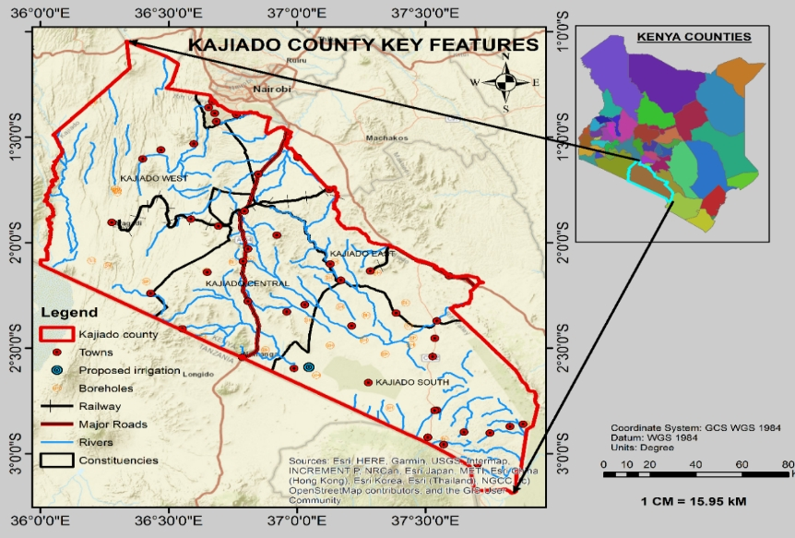
Figure.1: Map of Kajiado County (Physical planning Department Kajiado County)
3.3 Sampling Procedure and Sample Size
A multistage sampling technique was employed. Four sub-counties were purposively selected, after which 320 household heads were randomly sampled. Key informants included elders, agricultural extension officers, and community leaders.
3.4 Data Collection
Structured questionnaires measured attitudes and perceptions using Likert-scale items covering environmental stewardship, cultural value of land, perceived benefits of sustainable farming, perceived land degradation, and trust in indigenous knowledge. Sustainable farming practices were assessed using indicators such as soil conservation, grazing management, livestock health, and efficient resource use. Focus group discussions and key informant interviews provided qualitative insights.
3.5 Data Analysis
Quantitative data were analysed using descriptive statistics and multiple regression analysis. Qualitative data were analysed thematically to support and enrich quantitative findings.

4. Results & Discussion
4.1 Descriptive Analysis of Attitudes and Perceptions
The majority of respondents expressed positive attitudes toward environmental conservation and strong cultural attachment to land. Trust in indigenous knowledge systems was also high, reflecting the continued relevance of traditional worldviews.
Table 1: Descriptive Statistics of Attitudes and Perceptions
Variable | Mean | Std. Dev.
Environmental stewardship attitude | 4.01 | 0.83
Cultural value of land | 4.23 | 0.76
Perceived benefits of sustainable farming | 3.88 | 0.91
Perceived land degradation risk | 3.74 | 0.94
Trust in indigenous knowledge | 4.09 | 0.79

4.2 Influence of Attitudes and Perceptions on Sustainable Farming Practices

Attitudes and perceptions
The third objective was to evaluate the influence of attitudes and perceptions on the sustainability of farming practices. Analysis and interpretation of the responses revealed the existence of a significant relationship between attitude and perceptions and the sustainability of farming practices by the Maasai people in Kajiado County. Attitudes and perceptions were itemized, focusing on the perception that the temperatures in the area have been increasing, the weather in the region is currently unpredictable, fodder for livestock is decreasing, crop diseases and pests are increasing, soil erosion is increasing, and livestock deaths are increasing. An analysis of responses revealed that attitudes and perceptions have a likelihood of increasing the sustainability of farming practices.
These findings are similar to those of Ochola (2014), who, in her study, established that attitudes and perceptions had a significant influence on the sustainability of farming practices. In their investigation of the elements affecting smallholder farmers in western Kenya to adopt agricultural technology, they revealed that attitudes and perceptions are key constructs in decision-making.
Attitudes and perceptions about the sustainability of farming practices can significantly influence agricultural decisions, practices, and the overall trajectory of the agricultural sector (Peck et al., 2019). These attitudes and perceptions are shaped by a combination of individual beliefs, cultural influences, education, awareness, and exposure to information.
Factors that can impact attitudes and perceptions about the sustainability of farming practices, like environmental awareness and the ability to recognize the importance of minimizing negative impacts on soil, water, and ecosystems (Peck, 2019), In addition, education and awareness that enable the community to be exposed to information about sustainable agriculture can lead to more favorable attitudes. Some traditional farming methods may align with sustainable principles, while others may conflict with modern concepts of sustainability.
Knowledge and training, whereby farmers who receive training in sustainable farming techniques are more likely to have positive attitudes towards these practices. Knowledge empowers farmers to understand the benefits and adopt the necessary changes. In accordance with the study by Melash et al. (2023), it's important to recognize that attitudes and perceptions can vary widely among farmers, even within the same community. Strategies to promote sustainable farming practices should take into account these diverse factors and tailor approaches to address specific barriers and motivators. Education, awareness campaigns, technical assistance, and incentives can all play a role in fostering positive attitudes towards sustainable agriculture.
4.3: Information Access on Sustainable Farming
Figure 2 presents the relationship between the extent of access to information and the percentage of farmers practicing sustainable farming across three levels (Low extent, Moderate extent, and Great extent). The information is categorized into three levels of information access: very great extent, great extent, and moderate extent.
4.4: Very Great Extent Information Access:
When respondents rate their access to information as "Very Great Extent," they are more likely to perceive themselves as well-informed. The highest percentage of respondents (55%) who rate their access to information as "Great Extent" practice sustainable farming at a "Moderate Extent", indicating a broad perception of being well-informed across different domains. However, a notable proportion (12%) of respondents who rate their access to information as "Very Great Extent" also report a "Low Extent" in sustainable farming practices, suggesting discrepancies in perceived and actual access to information among some individuals.
4.5: Great Extent Information Access
When respondents rate their access to information as "Great Extent," they are more likely to perceive themselves as well-informed. The highest percentage of respondents (72%) who rate their access to information as "Great Extent" practice sustainable farming at a "Moderate Extent", indicating a broad perception of being well-informed across different domains. However, a notable proportion (9%) of respondents who rate their access to information as " Great Extent" also report a "Low Extent" in sustainable farming practices, suggesting discrepancies in perceived and actual practice of sustainable farming practice among some individuals.
4.6: Moderate Extent Information Access
Respondents who rate their access to information as "Moderate Extent" fall in between those with "Great Extent" and "Moderate extent" ratings level of sustainable farming practices. A significant proportion (80%) of respondents who rate their access to information as "Moderate Extent" perceive themselves as practicing sustainable farming to a "Moderate Extent", suggesting a generally positive perception of their information access. This indicates that a moderate level of information access strongly correlates with widespread adoption of sustainable farming practices.
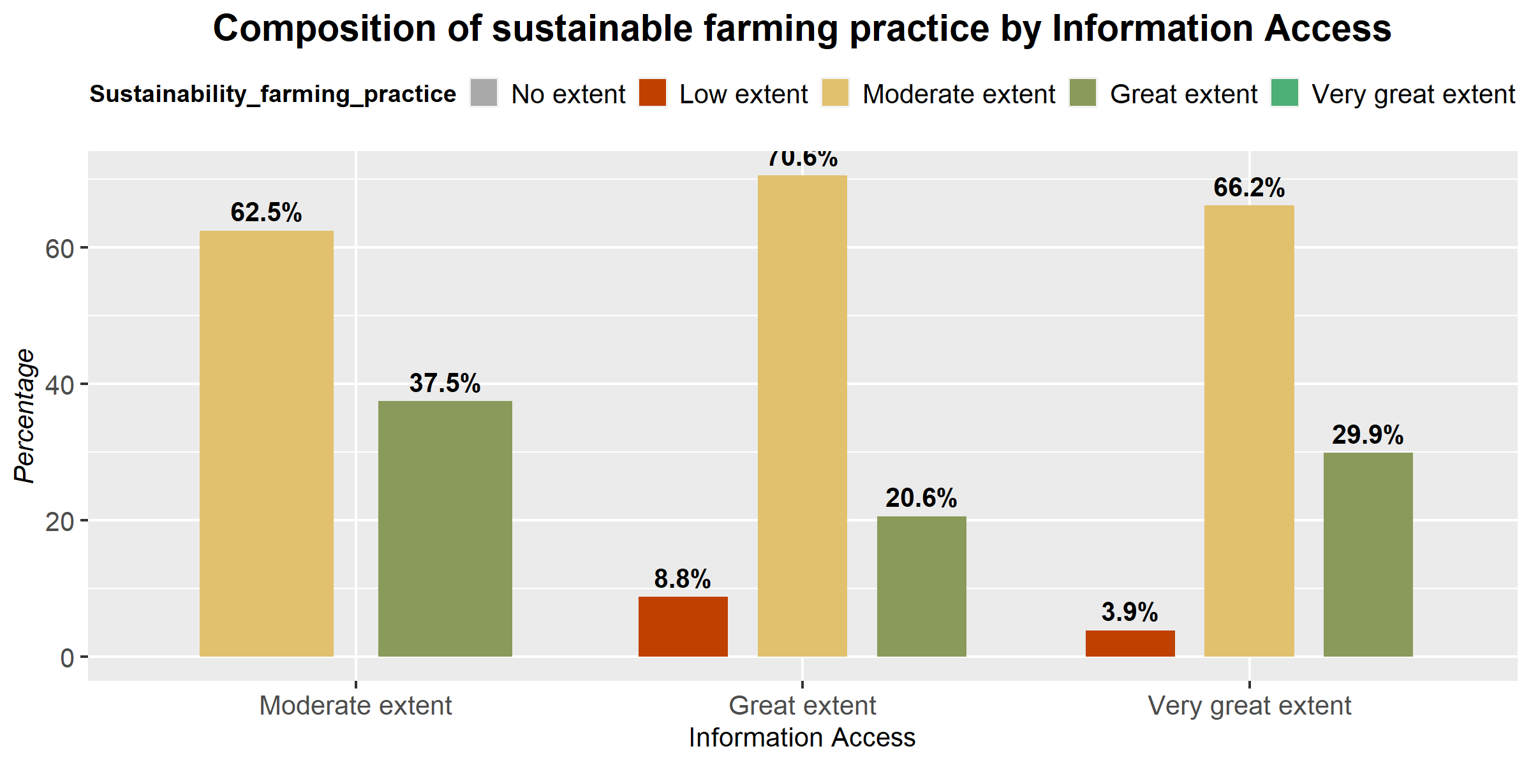
Figure 2: Extent of Information access on sustainable farming
The findings suggest that while many respondents perceive themselves as well-informed (either "Great Extent" or "Very Great Extent"), a relatively small percentage 20% and 33% respectively practice sustainable farming to a great extent. There seems to be a discrepancy between perceived and actual access to information among some respondents, as evidenced by the segments reporting a "Low Extent" of information access despite rating their access as "Great Extent" or "Very Great Extent.’’
These findings underscore the importance of not only assessing individuals' perceptions of their information access but also understanding the factors that contribute to discrepancies between perceived and actual access to information. Addressing gaps in information access and ensuring that individuals have access to accurate, relevant, and timely information is crucial for promoting informed decision-making, empowering individuals, and fostering equitable participation in socio-economic development initiatives.
The findings concur to that one conducted by Patel and Nguyen (2020) explored the role of farmers in moderating accessibility to information within agricultural communities. Through in-depth interviews and surveys, the researchers found that farmers serve as key intermediaries in the dissemination of agricultural knowledge and resources. By leveraging their social networks and local expertise, farmers play a crucial role in facilitating the flow of information among peers, thereby enhancing accessibility to valuable agricultural insights and best practices. Additionally, the study revealed that farmers' access to information is influenced by factors such as educational background, technological literacy, and institutional support, further underscoring their pivotal role in moderating information accessibility within agricultural contexts.

4.7: Attitudes and perceptions
Table 2: Model Parameter estimates
 |  | B | df | Sig. | Exp(B)
Step 1ª | Indigenous environmental knowledge. |  | 3 | 0.273
Step 1ª | Indigenous environmental knowledge (1) | -20.94 | 1 | 0.978 | 0.000
Step 1ª | Indigenous environmental knowledge (2) | -0.891 | 1 | .023 | 0.410
Step 1ª | Indigenous environmental knowledge (3) | -0.418 | 1 | 0.762 | 0.660
Step 1ª | Levels of education |  | 3 | 0.266
Step 1ª | Levels of education (1) | 1.721 | 1 | 0.035 | 4.678
Step 1ª | Levels of education (2) | -1.589 | 1 | 0.287 | 0.202
Step 1ª | Levels of education (3) | 1.955 | 1 | 0.447 | 7.064
Step 1ª | Attitudes and perceptions. |  | 3 | 0.458
Step 1ª | Attitudes and perceptions (1) | 1.544 | 1 | 0.021 | 4.683
Step 1ª | Attitudes and perceptions (2) | -1.851 | 1 | 0.313 | 0.1571
Step 1ª | Attitudes and perceptions (3) | -1.722 | 1 | 0.393 | 0.1787
Step 1ª | Accessibility to information sources |  | 3 | 0.356
Step 1ª | Accessibility to information sources (1) | 1.811 | 1 | 0.418 | 6.117
Step 1ª | Accessibility to information sources (2) | .712 | 1 | .013 | 2.038
Step 1ª | Accessibility to information sources (3) | -1.561 | 1 | .259 | 0.209
 | Constant | 2.871 | 1 | 1.000 | 17.6547

According to the model parameter estimates in Table 2 [attitudes and perceptions =1] was found to have a positive and statistically significant influence on sustainability, with an estimate coefficient of 1.544 and an associated p-value of 0.021<0.05. The sign of its beta is positive, indicating that attitudes and perceptions were found to be 4.683 times more likely to influence their farming practices, which in the end determine the sustainability of such practices. In other words, if a respondent agrees compared to disagreeing on attitudes and perceptions, he or she is 4.683 times more likely to agree that attitudes and perceptions have influenced their poor farming practices, which has led to a low extent of application of sustainable farming practices.
These findings therefore confirm those suggested by Table 2. Therefore, the study established those attitudes and perceptions in terms of focusing on the perception that the temperatures in the area have been increasing, the weather in the region is currently unpredictable, fodder for livestock is decreasing, there has been an increase in crop diseases and pests, there has been an increase in soil erosion, and there has been an increase in livestock deaths, all of which influence the sustainability of farming practices.
4.8: Model Fitting Statistics
The data was analyzed using a binomial logistic regression model to determine the influence of environmental awareness (indigenous environmental knowledge, levels of education, attitudes and perceptions, and accessibility to information sources) on sustainable farming practices among the Maasai in Kenya, with a specified location of Kajiado County. The results of the logistic regression model are summarized in Table 3.

 |  | Chi-square | df | Sig.
Step 1 | Step | 23.014 | 13 | 0.021
Step 1 | Block | 23.014 | 13 | 0.021
Step 1 | Model | 23.014 | 13 | 0.021
Table 3: Model Significance Test
The Results in Table 3 point out that the model has a chi-square value of 23.014 with a p-value of 0.021. This suggests that the predictor variables (environmental awareness) can statistically and significantly predict the response variable (sustainability) much better than the intercept alone. For that reason, the study recognized that environmental awareness influences sustainable farming practices among Masaai in Kajiado County. The researcher additionally performed the Nagelkerke (R²) test to determine the actual influence of environmental awareness on sustainability.
Table 4. Model Summary
Step | -2 Log likelihood | Cox & Snell R Square | Nagelkerke R Square
1 | 25.571ª | 0.339 | 0.607
As indicated in Table 4., a value of 0.607 was obtained. This confirms the results in Table 4., signifying that the four predictor variables statistically and significantly predict sustainable farming practices. Indigenous environmental knowledge, levels of education, attitudes and perceptions, and accessibility to information sources account for up to 60.7% of the variance in sustainable farming practices among Masaai in Kajiado County. This means that the Maasai pastoral farmers can improve the sustainability of farming by up to 60.7% by implementing Indigenous environmental knowledge, levels of education, attitudes and perceptions, and accessibility to information sources, other factors notwithstanding.
4.9: Attitudes and perceptions
The third objective of the study was to determine the influence of attitudes and perceptions on the sustainability of farming practices. Attitudes and perceptions were defined in terms of focusing on the perception that the temperatures in the area have been increasing, the weather in the region is currently unpredictable, fodder for livestock is decreasing, crop diseases and pests are increasing, soil erosion is increasing, and livestock deaths are increasing.
To achieve this objective, the target respondents were asked to agree or disagree on statements relating to attitudes and perceptions. The questionnaire items addressed the five indicators of attitudes and perceptions. A five-point Likert scale was provided, ranging from 5 to 1, where 5 = strongly agree, 4=agree, 3 = undecided, 2= disagree, and 1=strongly disagree. The responses were then compared against the corresponding answers given on the sustainability of farming practices. Data on this objective was analyzed under the research question “What is the influence of attitudes and perceptions on the sustainability of farming practices?” The results are summarized in Table 5.
Table 5: Attitudes and Perceptions
Item | 5 | 4 | 3 | 2 | 1 | Median
The average temperature in the areas has been increasing. | 30.1% | 40.2% | 16.3% | 13.4% |  | 4
Weather in the region is currently unpredictable | 25.3% | 49.3% | 15.2% | 5.5% | 4.7% | 4
Fodder for livestock has been decreasing | 28% | 49% | 13.4% | 4.3% | 5.3% | 4
There has been an increase in crop diseases and pests | 30% | 35% | 18.3% | 12% | 4.7% | 4
The problem of soil erosion has been increasing | 20% | 50.7% | 13% | 10% | 6.3% | 4
Livestock deaths have been increasing | 24.7% | 42.1% | 15.3% | 13.2% | 4.7% | 4
Category | 5 | 4 | 3 | 2 | 1 | Total
Avg_temp_increasing | 25% | 44% | 16% | 9% | 6% | 278
unpredictable weather | 31% | 44% | 19% | 3% | 3% | 279
fodder decreasing | 27% | 58% | 7% | 3% | 4% | 279
crop_disease_increase | 28% | 52% | 11% | 6% | 3% | 279
soil_erosion_increase | 27% | 56% | 4% | 7% | 8% | 279
Livestock_death_increase | 34% | 33% | 14% | 9% | 10% | 279
n=130, Key: 5= Strongly Agree, 4=Agree, 3= Undecided, 2=Disagree, 1=Strongly Disagree
From Table 5, the overall median for the indicators and their corresponding mean is 4, indicating that respondents agreed on the statements on attitudes and perceptions. This suggests that respondents agreed that attitudes and perceptions have an influence on the sustainability of farming practices.
4.10: Accessibility to information sources
According to the model parameter estimates in Table 5, [accessibility to information sources =2] was found to have a positive and statistically significant influence on sustainability, with an estimate coefficient of 0.712 and an associated p-value of 0.013<0.05. The sign of its beta is positive, indicating that accessibility to information sources was found to be 2.038 times more likely to influence their farming practices, which in the end determines the sustainability of such practices.
In other words, if a respondent agreed compared to disagreeing on accessibility to information sources, he or she is 2.038 more likely to agree that accessibility to information sources has influenced their poor farming practices, which has led to a low extent of application of sustainable farming practices. These findings therefore confirm those suggested by Table 6. Consequently, the study established that accessibility to information sources in terms of access to the internet, access to libraries, county government support, lead farmers and ICT, extension and field officers, and training influence the sustainability of farming practices.

4.11: Regression Model
[SFP_i = \beta_0 + \beta_1 EA_i + \beta_2 CVL_i + \beta_3 PBS_i + \beta_4 PLD_i + \beta_5 TIK_i + \varepsilon_i]
Table 6: Regression Results: Influence of Attitudes and Perceptions on Sustainable Farming
Variable | β | Std. Error | t | p
Constant | 0.716 | 0.198 | 3.62 | < .001
Environmental attitudes | 0.312 | 0.064 | 4.88 | < .001*
Cultural value of land | 0.274 | 0.071 | 3.86 | < .001*
Perceived benefits | 0.241 | 0.068 | 3.54 | .001*
Perceived land degradation | 0.167 | 0.061 | 2.74 | .007*
Trust in indigenous knowledge | 0.298 | 0.066 | 4.52 | < .001*
Model fit: R² = .54; Adjusted R² = .51; F (5,314) = 37.2, p < .05
*statistically significant

The findings demonstrate that attitudes and perceptions significantly influence sustainable farming practices among the Maasai in Kajiado County. Environmental stewardship attitudes and trust in indigenous knowledge systems emerged as strong predictors, underscoring the importance of culturally embedded values in shaping sustainability-oriented behaviour. This supports the Theory of Planned Behaviour, which posits that attitudes are key determinants of behavioural intention (Ajzen, 1991).
The significant influence of cultural valuation of land highlights the role of indigenous worldviews in promoting conservation practices. Additionally, perceptions of land degradation risk motivated households to adopt sustainable farming practices, consistent with previous studies in climate-vulnerable regions (Deressa et al., 2011). These findings suggest that sustainable farming initiatives must align with local attitudes and perceptions to achieve long-term impact.
6. Conclusion
This study establishes that attitudes and perceptions significantly influence sustainable farming practices among the Maasai community in Kajiado County. Socio-cultural values, environmental attitudes, and trust in indigenous knowledge systems play a central role in shaping farming decisions, alongside perceived risks and benefits. The research findings have shown that there is a significant influence of indigenous environmental knowledge, levels of education, attitudes and perceptions and accessibility to information sources on sustainability of farming practices. The research provides empirical evidence that supports the cause of environmental awareness practices and their influence on sustainability of farming practices. This study concludes that environmental awareness practices are crucial in influencing one's decision to either remain using poor farming practices or not. For a given pastoral community to embrace good farming practices and combat hunger and dependence on help, the National and County governments should put in place structures that would address the issue in environmental awareness among the local communities.
Level of education, attitudes and perceptions and accessibility to information sources should be given consideration in such structures. Indigenous environmental knowledge should be discouraged among the Maasai people and should be replaced with the modern scientific ones through training and sensitization. Conducting trainings on better and cheaper farming practices, regular focus on marketing their products, and implementing a flexibility program that take into account cost reduction in the new farming methods should be part of environmental awareness.
Future research in these four areas cultural identity, climate perception, education and information access, and gender dynamics would provide deeper insight into how attitudes and perceptions influence the adoption of sustainable farming practices among the Maasai in Kajiado County. Such studies can inform culturally sensitive, community-driven sustainability interventions.
7. Recommendations
- Agricultural extension programs should integrate behavioural change communication targeting attitudes and perceptions.
- Policies should recognised and strengthen indigenous values that support sustainable land management.
- Sustainable farming interventions should be culturally contextualized to enhance acceptance and long-term adoption.
8. Areas of further study
8.1: Cultural Beliefs and Traditional Livelihood Identity
Further research should examine how deep-rooted cultural values and identity influence attitudes toward sustainable farming. The Maasai traditionally identify as pastoralists, with cattle representing wealth, status, and social security. This cultural attachment may shape perceptions of crop farming, climate-smart agriculture, or land conservation practices.
Future studies could explore: Whether sustainable farming is perceived as a threat to cultural identity, how generational differences affect openness to diversified farming systems, the role of elders and community leaders in shaping collective attitudes. Understanding the interaction between cultural heritage and modern sustainability practices is critical in Kajiado County, where pastoralism remains dominant.
8.2: Perceptions of Climate Change and Environmental Risk
Attitudes toward sustainable farming may be strongly influenced by how farmers perceive climate variability and environmental degradation. Kajiado County experiences recurrent droughts and land degradation, which directly affect pastoral livelihoods. Further research could assess: Whether Maasai farmers attribute drought to climate change, spiritual beliefs, or natural cycles, how risk perception influences adoption of practices such as rotational grazing, water harvesting, and drought-resistant crops and the relationship between awareness campaigns and behavioral change. Understanding these perceptions can clarify whether sustainability practices are seen as adaptive necessities or externally imposed interventions.
8.3: Education, Information Access, and Extension Services
Educational level and exposure to agricultural extension services may shape attitudes toward sustainable farming. Research should investigate whether access to training programs influences positive perceptions of conservation agriculture, agroforestry, or improved livestock management.
Areas for, Differences in perception between formally educated youth and older herders and the role of digital platforms and mobile technology in reshaping attitudes. This area would help determine whether knowledge gaps or value-based resistance more strongly influence farming decisions.
8.4: Gender Roles and Intra-household Decision-Making
Gender dynamics may significantly influence sustainable farming adoption. Among the Maasai, men traditionally control livestock decisions, while women often manage household food production and small-scale farming.
Further study could explore: Whether women hold more favorable attitudes toward crop diversification and soil conservation, how decision-making power affects the implementation of sustainable practices and the influence of women’s groups and community-based organizations in promoting sustainability. Examining gendered perceptions will clarify whether attitudes differ within households and how this shapes overall farming practices.

COMPETING INTERESTS DISCLAIMER:
Authors have declared that they have no known competing financial interests OR non-financial interests OR personal relationships that could have appeared to influence the work reported in this paper.
References
Ajzen, I. (1991). The theory of planned behavior. Organizational Behavior and Human Decision Processes, 50(2), 179–211.
Deressa, T. T., Hassan, R. M., & Ringler, C. (2011). Perception of and adaptation to climate change by farmers in the Nile Basin of Ethiopia. The Journal of Agricultural Science, 149(1), 23–31.
Evangelou, F. (2019). Pastoral livelihoods and socio-economic development in Kajiado County, Kenya. Journal of Arid Land Studies, 29(2), 45–58.
Galvin, K. A. (2009). Transitions: Pastoralists living with change. Annual Review of Anthropology, 38, 185–198.
Government of Kenya. (2008). Kajiado District development plan 2008–2012. Government Printer.
Government of Kenya. (2021). Agricultural sector transformation and growth strategy (ASTGS) 2019–2029 progress report. Ministry of Agriculture, Livestock, Fisheries and Cooperatives.
Homewood, K., Kristjanson, P., & Trench, P. C. (2009). Staying Maasai? Livelihoods, conservation and development in East African rangelands. Springer.
Kenya National Bureau of Statistics (KNBS). (2019). 2019 Kenya population and housing census volume I: Population by county and sub-county. KNBS.
Knowler, D., & Bradshaw, B. (2007). Farmers’ adoption of conservation agriculture: A review and synthesis of recent research. Food Policy, 32(1), 25–48.
Melash, A., Tesfaye, W., & Alemu, D. (2023). Farmers’ attitudes and adoption of sustainable agricultural practices in sub-Saharan Africa. Sustainability, 15(4), 1–15.
Ochola, W. O. (2014). Factors influencing adoption of sustainable agricultural practices among smallholder farmers in Kenya. African Journal of Agricultural Research, 9(36), 2792–2800.
Patel, R., & Nguyen, T. (2020). Information accessibility and knowledge sharing among farming communities. Journal of Rural Studies, 75, 164–173.
Peck, G. M., Andrews, P. K., Reganold, J. P., & Fellman, J. K. (2019). Sustainable farming systems and grower perceptions: Implications for agricultural transition. Renewable Agriculture and Food Systems, 34(3), 205–216.
Pretty, J. (2018). Intensification for redesigned and sustainable agricultural systems. Science, 362(6417), eaav0294.

