Biomarkers Distribution to Define the origin of organic matter of Two crude oil samples from the Murzuq Basin –Libya

ABSTRACT
Two crude oil samples collected from wells B1 and H1 in the NC115 concession of the Murzuq Basin, Libya, were analyzed to determine the origin of their organic material. An analytical technique Gas chromatography (GC) joined with mass spectrometry (MS) was used to characterize key hydrocarbon biomarkers, including n-alkanes, isoprenoids, tricyclic and tetracyclic terpanes, hopanes, and steranes. The n-alkane distribution (C₁₅–C₂₅ dominance, CPI ≈ 1.0) and the ratios Pr/Ph = 1.21–1.13 and i-C₁₆/n-C₁₅ < 0.5 indicate deposition under sub-oxic to anoxic marine conditions with a minor terrestrial input. Hopane and sterane parameters (H31S/H31R ≈ 1.8; Sterane/Hopane = 0.42–0.58) further support a mixed algal– bacterial source deposited in a marine to fluvio-deltaic environment. Overall, the biomarker evidence suggests that the hydrocarbons of crude oils produced mainly from aquatic algal and bacterial living substance with a portion of terrestrial input, generated under reducing conditions within the Silurian age source rocks of the Murzuq Basin.
Keywords: Paleoenvironments; Murzuq Basin; Isoprenoid; Steranes and Hopanes

- Introduction
In the ancient Palaenvironmen, stigmastane, ergostane besides their aromatic analogues as well to cholestane and aromatic equivalents are Eukaryotes polycyclic biomarkers recognized in record environments to present in addition to other possible sources such as minor input from myxobacteria ^{1,2,3,4,5}. The cell membranes include sterols are the significant components of prokaryotic and Eukaryotic, formed by biosynthesise process of functional moieties. This is demonstrated through the number and position of bilocation to create alkyl groups and other complex substituents, which normally occur as biomarkers that originate in practically all eukaryotic assemblages¹. Publication pointed to some steroids such Planctomycetales, Methylococcales and Myxococcales, possible source independent groups of bacteria ⁶. In common, the precursors of sterane like stigmastane, ergostane and cholestane are generally create in all Eukaryotic assemblage ^{7, 8}. Tricyclic terpanes series also exist in geological record ^{9.} Tricyclohexaprenol groups have been suggested as precursors of carbon19 to carbon 30, ^{10, 11}. Hopanoids have been recognized as key compounds of metabolites and part of cell bacteria membranes 12. The aim of this search is to describe the origin of organic substance of crude oils collected from Murzuq Basin fileds, based using geochemical method.
  - Geological setting
The geological column of the Murzuq Basin includes deposits (Fig. 1), ranging from Precambrian to Quaternary ¹³. The acoustic basement comprises Precambrian metasediments, as remarked Mourizidie Formation, roofed via Cambrian fluvial also braided basic quartzites of formation named Hasawnah Fm. The overlying Lower Ordovician Ash Shabiyat Fm. represented by comparable facies, the conformable Hawaz Formation, which is the main reservoir, consists of sandy, transgressive-regressive marine sequences with traces of heavy bioturbation. The Middle Ordovician is really cut due to attrition, intense little stand, at late Ashgillian unconformity. The Ordovician age Melez Shuqran and Mamuniyat Formations occurred, filling censored valleys and resting on the Hawaz Fm. The Melaz Shuqran Formation is characterized by diamictite and slumped delta front shales nevertheless is only nearby existing, overlaying via incised series of coarsening up aquatic and fluvio-deltaic residues of the Mamuniyat Formationm. Lower Silurian-Tanezzuft Formation offerings organic-rich shale heights, particularly at base of formation, which found the best core source rock. The Tanezzuft Formation is covering Akackus Formation. Overhead this regional, the sheet of Devonian is symbolized thru structures of shales such as the Awaynat Wanin and Tahara Fms. Marar rocks is Lower Carboniferous, including formations of shallow sea water and deltaic structures. The Marar Fm.is overlain by the Upper Carboniferous Assedjefar, Dembaba and Tiguentourine Formations. This cover by the base nevertheless includes largely Triassic, Jurassic and Lower the Cretaceous deposits. The Quaternary - Recent Aeolian is the mound of sand covering large zones of the Murzuq basin. Furthermore, more information about the geological setting of the Murzuq Basin is available in many previously published papers ^{13, 14, 15, 16}.

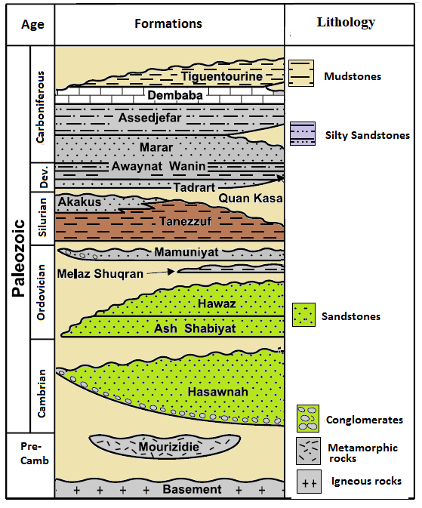
Fig. 1. The geological setting showing the lithology of the sediments and reservoir units, Murzuq basin. Adapted from ¹³.

- Materials and Methods
2.1. study location
Two crude oils from B1 and H1 Wells were selected from northern edge of the basin are showing the in the Fig. 2. The region of study is the Murzuq Basin, placed in south-western of Libya, one of Libyan productive oil basins.
2.2. Oil samples
Two petroleums were took directly from wellheads of B and H fileds, NC115 Concession from the Murzuq Basin. The two oils were collected to recognize group of biomarkers for a better understanding of geochemical characteristics, using geochemical techniques.
2.3. Crude Oils preparation and examination
The petroleums were parted into three portions, using a column chromatographic way. Briefly, about 10 to 20 mg of oil were dropped in size 5.5 cm x 0.5 cm of small column filled by functioned silica gel (120C, 8 h) for fractionation. The aliphatic hydrocarbons (Aliphatic) portion were extracted by n-pentane solvent about 2 mL. The fractionated aromatic hydrocarbon was eluted by mix of 2 mL n-pentane + DCM (7:3 v/v ratio). The remaining (polar NSO) rinsed by 2 mL mixture of dichloromethane and methanol ( 1:1 v/v ratio ) More detail in ¹⁷. The aliphatic hydrocarbons were examined via GC-MS, based on monitoring (SIM) that remained applied to detect terpenes and steranes, selecting display of m/z 191, 217 ions.

..

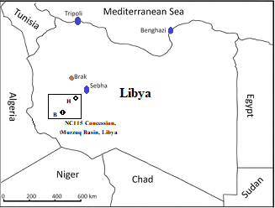
Fig. 2. Chart shows the site of the studied wells B1 and well H1 in the northern edge of Murzuq basin, Cited from ^{14,15, 16}.

- Results
3.1. n-alkanes
The n-alkanes profile is a kind of molecular fingerprint, determined by gas chromatography device, that displays the relative wealth of diverse n-alkanes (C_{n}H_{2n}+2) in hydrocarbon samples. This molecular fingerprint is widely used to identify the origin of a sample and study its climate and environmental situations ^{18, 19}. In this study, the allocation of n-alkanes and isoprenoid such isoprenoid Pristane and isoprenoids Phytane peaks were illustrated by gas chromatography and showed in Fig. 3.
3.2. Isoprenoid and n-C27/(n-C27+n-C17) vs. Sterane/Hopane
The ratio of Pristane (Pr)/phytane (ph) and isoprenoid to normal alkane ratios i-C15/n-C14, i-C₁₆/n-C₁₅ from the molecular fingerprints are summarized in Table 1. Low to medium values of C₂₇ to C₁₇ n-alkanes and the Sterane/Hopane ratio, with a range from 0.2 to .6. The distributions of Alkanes (Fig .4), ratio of n-alkanes (C₂₇ to C₁₇) and the ratio of Sterane/Hopane (Table 1).

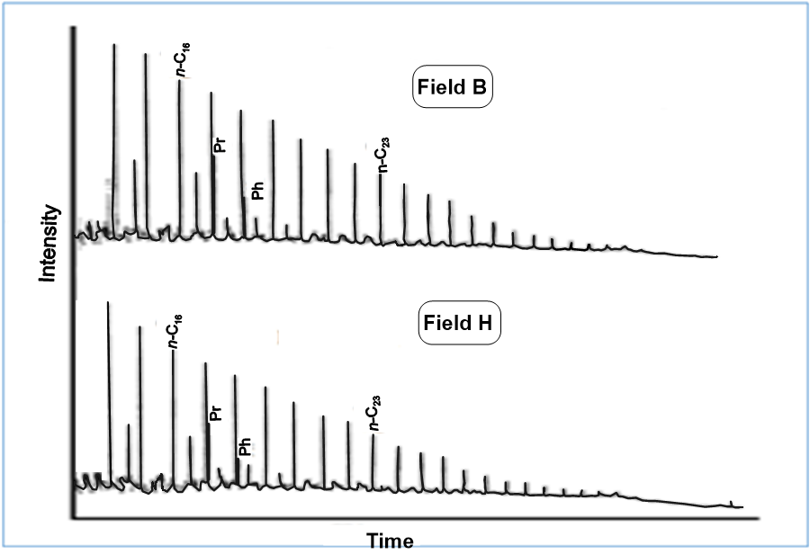
Fig. 3. Alkane compounds distributions of oil samples (GC)

Table 1. The Component ratio of tricyclic and tetracyclic terpanes and hopanes based on m/z 191 and steranes m/z 217.
Component ratio | Field B | Field H
n-C₁₉ | 0.07 | 0.06
n-C₂₃ (%) | 0.04 | 0.03
n-C₂₇ (%) | 0.02 | 0.01
n-C₂₉ (%) | 0.09 | 0.08
n-C₂₇/(n-C₂₇+n-C₁₇) | 0.21 | 0.40
CPI | 0.98 | 1.10
iso-C₁₅/n-C₁₄ | 0.34 | 0.27
iso-C₁₆/n-C₁₅ | 0.49 | 0.35
Pr/Ph | 1.21 | 1.13
H31S/H31R | 1.80 | 1.78
TT 23/H30αβ | 0.65 | 1.77
24TT/ H30αβ | 0.35 | 0.44
Sterane/Hopane ratio | 0.58 | 0.42
n-C₁₉ (%)= n-C₁₉ alkane; n-C₂₃ (%) alkane; n-C₂₇ (%) alkane, n-C₂₉ (%)alkane; i-C = isoprenoids;
Pr/Ph = Pristane/phytane; CPI (carbon preference indices), H31S/H31R= Hopane 31S/Hopane31R; 23TT/H30αβ= C₂₃ tricyclic terpane/ C₃₀Hopane; 24TT/ H30αβ=C24 tricyclic terpane/ C30Hopane.

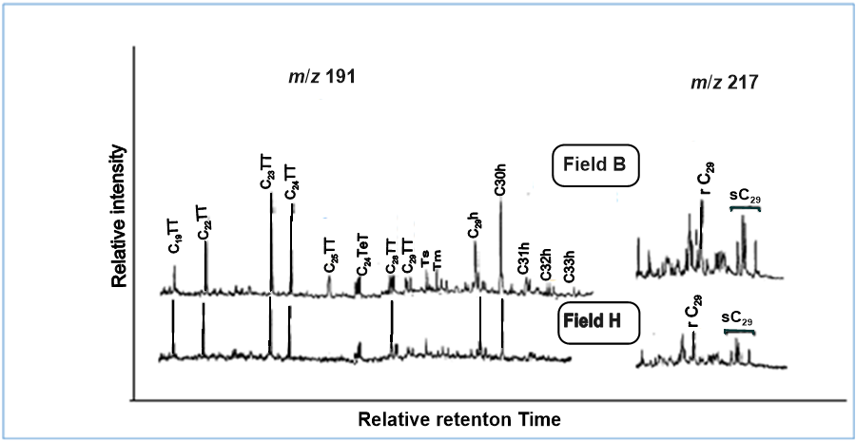
Fig. 4. Fractional mass chromatograms display m/z 191and m/z 217, showing tricyclic terpane and Hopane furthermore Steranes.

- Discussion
The total alkane chromatograms point to non-variations between oil samples; therefore, the organic matter can be attributed to a matching ecosystem. The n-alkane profile centered between C₁₅ - C₂₅ is usually categorized as an organic matter derived from marine phytoplankton, whereas alkanes in the C₂₅ - C₃₅ range show a higher concentration, points to organic matter derived from terrestrial ecosystems ²⁰. Thus, the organic matter of both oil samples is mainly formed from marine sources and approving by calculated data of n-C₁₉ (%), n-C₂₃ (%), n-C₂₇ (%), n-C₂₉ (%), CPI, i-C₁₅/n-C₁₄, i-C₁₆/n-C₁₅ are shown in Table 1. This is consistent with the finding of a prior papers around the Murzuq Basin hydrocarbon were published by ^{21, 15, 22}.
The ratio of iso- Pristane to phytane is > 1 and < 4 showing ecological deposition of marine to lacustrine (Hughes et al., 1995), indicated that the organic matter of oils appears to have created from marine and freshwater organisms, bury under sub-oxic circumstances. All the values of isoprenoid i-C15/n-C14, i-C16/n-C15 to normal alkane are <0.50 (Table 1), that indicate a deposition of organic matter was in a slightly less oxic environment, and/or possibly a mixture of kerogens that are the outcome of sourced hydrocarbons from mixing marine and lacustrine environments, collecting in reservoir ²³.
The n-alkanes present in terrestrial and marine organic matter exist in significant amounts. Mostly marine organic hydrocarbons have dominating n-alkanes, C15–C19, whereas n-alkanes from C27 to C31 are generally existing in significant amounts in terrestrial (land-based) organic matter (Peters et al.,2005). The source and type of the organic matter usually conclude based on discernible changes in the composition of n-alkanes. For instance, high-molecular-weight n-alkanes (C27–C31) are common in oils derived from rubble of eukaryotic organism that produce waxes organic matter. The oils from these environments are typically waxy taxonomies. Even though low-molecular-weight n-alkanes (C15 to C19) are abundant in crude oils obtained from marine creatures. The Sterane/Hopane ratio are important parameters as well to describe the source and type of the organic matter ^{2, 24}. Base on the ratio of C27 to C17 n-alkanes and the Sterane/Hopane ratio (Table 1) and the distributions of Alkanes (Fig .4), may appropriate to estimate the source of organic materials. The low to medium values of C27 to C17 n-alkanes and the Sterane/Hopane ratio, with a range from 0.2 to .6, obviously indicate that the organic matter was result of marine organisms, companioning with some input from a terrigenous source, buried under oxygenless conditions. Moreover, the relative values of the compounds are nearby, despite the clear effect of maturity between the two samples, which appears more mature for the field B sample, in line with previous studies on hydrocarbon maturity in the Murzuq Basin. This is also confirmed by the relative values of the compounds H31S/H31R, TT 23/H30αβ and 24TT/ H30αβ which are nearby, despite the clear effect of maturity between the two samples, which appears more mature for the field H sample, in line with previous studies about hydrocarbon maturity in the Murzuq Basin ¹⁵. The ratio of tetracyclic terpanes to tricyclic terpanes is primarily source related. The distribution of tetracyclic terpanes and hopanes (m/z 191) and steranes (m/z 217) illustrates in figure 4. The tricyclic terpane, hopane and sterane pattern is not regular, indicating differences in the origin of their sources. The tricyclohexaprenol was recommended as precursors of the compounds of TTC19 to TTC30 Tricyclic terpanes series ^{25, 26}. However, Hopanoids are biological precursors have been recognized as main structure of metabolites in cell membranes of bacteria ¹². Both Tricyclic terpanes and hopanes reveled the most important biomarkers who reserved the specific assembly of original biological components and usually used to define organic matter precursors. These biomarkers indicate to a conclusion that hydrocarbon of this samples are extremely enriched by Tricyclic terpanes and definitely occurred from precursors of tricyclohexaprenol ²⁶ in a marine depositional biota, generally algal substance ²⁷. The occurrence of hopanes is definitely resulting from precursors such as bacteriohopane polyols and aminopolyols through reworked/altered by bacterial activities headed to extensive hopanes ¹². The substantial components of Eukaryotic cell membranes contain sterols for instance ergosterol and cholesterol in addition sitosterol. Even though there are very limited reports, the known sterols are natural product precursors of steranes. Sterols are normal precursors of creation sterane and the commonly biomarkers originate from every eukaryotic assemblage ^{7, 2}, confirming that the origin of oil organic matter was marine creatures and terrigenous such as transferred debris by fluvio-land delta.

- Conclusion
Geochemical analyses were used to establish saturated hydrocarbons of two oils, obtained from the Murzuq Basin (South-West of Libya). The n-alkanes, Isoprenoid, Tetracyclic terpanes, Hopanes, and Steranes distributions were determined via GC-MS to understand the origin of organic matter of Crude Oils. Discussion of results concluded that the n-alkane profile of both oil samples is generally produced from sea organisms and with an input of terrestrial sources, confirmed via Pristane (Pr)/phytane (ph), i-C₁₅/n-C₁₄, i-C₁₆/n-C₁₅ ratios, who indicated freshwater organisms in marine and lacustrine ecosystem were buried under sub-oxic circumstances. The values of C₂₇ to C₁₇ n-alkanes and the Sterane/Hopane ratio clearly indicate that the hydrocarbon was resulting from aquatic creatures, together with a little contribution from terrestrial organisms. Description of organic matter precursors, both Tricyclic terpanes and hopanes, are biomarkers that preserve the specific assembly of original biological components, such as tricyclohexaprenol precursors known as algal substances deposited in a marine environment. The hopanes from bacteriohopane polyols precursors altered by bacterial activities and steranes derived from sterols as normal precursors found in every eukaryotic assemblage.

References
- Volkman K, Barrett M, Blackburn I, Mansour P, Sikes L, Gelin F. Microalgal biomarkers: a review of recent research developments. Org. Geochem. 1998; 29: 1163–1179.
- Volkman K. Sterols in microorganisms. Appl. Microbiol. Biotechnol. 2003; 60: 496–506.
- Summons E, Bradley S, Jahnke L, Waldbauer R. Steroids, triterpenoids and molecular oxygen. Philos. Trans. Roy. Soc. B: Biol. Sci. 2006; 36-51.
- Kohl W, Gloe A, Reichenbach H. Steroids from the myxobacterium nannocystis exedens. J. Gen. Microbiol. 1983; 129:1629–1635.
- Bode B, Zeggel B, Silakowski B, Wenzel C, Hans R, Müller R. Steroid biosynthesis in prokaryotes: identification of myxobacterial steroids andcloning of the first bacterial 2,3(S) oxidosqualene cyclase from the myxobacterium Stigmatella aurantiaca. Mol. Microbiol. 2003; 47: 471–481.
- Pearson A, Budin M, Brocks J. Phylogenetic and biochemical evidence forsterol synthesis in the bacterium Gemmata obscuriglobus. Natl. Acad. Sci. Proc. 2003;100: 15352–15357.
- Volkman K. A review of sterol markers for marine and terrigenous organic matter. Org. Geochem. 1986; 9: 83–99.
- Brocks J, Grice K. Biomarkers (Ancient biomolecules end evolution). In: Thiel, V., Reitner, J. (Eds.), Encyclopedia of Geobiology. Encyclopedia of EarthScience Series. Springer, 2010; (1) 167–182.
- Anders D and Robinson W. Cycloalkane constituents of bitumen from green river shale . Geochemica et Cosmochimica, 1971; (35): 61- 78.
- Aquino Neto R, Trendel M, Restle A, Connan J, Albrecht P. Occurrence and formation of Tricyclic and tetracyclic terpanes in sediments and petroleum. In: Bjorøy, M. (Ed.), Advances in Organic Geochemistry 1981. John Wiley & Sons Ltd, Chichester,1982;(1): 659-667.
- Moldowan M, Seifert K, Galloges J. 1983 Identification of an extended series of Tricyclicterpanes in petroleum. Geochimica et cosmochimica Acta. 1983; (47): 1531-1534.
- Rohmer M, Bisseret P, Neunlist, S. The hopanoids, prokaryotic, tritrerpenoids and precursors of ubiquitous molecular fossils. Prentice Hall, Englewood Cliffs, NJ. 1992; 1(1): 1-1.
- Rusk C. Petroleum potential of the underexplored basin centers. Libya. AAPG Memoir. 2001; (74): 429-452.
- Hallett D. Petroleum Geology of Libya, Elsevier Sci- ence Limited, Kidlington. 2002.
- Aboglila S, Abdulgader A, Albaghdady A, Hlal O, Farifr E. Biomarker ratios and stable carbon isotopes to describe crude oil characteristics in the Murzuq Basin Libya. Advances in Research.2019; 18 (3): 1-12.
- Albaghdady A, Aboglila S, Farifr E, Ramadan M, Alburki A. Source rock characterization of Silurian Tanezzuft and Devonian Awaynat Wanin formations the northern edge of the Murzuq Basin, South West Libya. Pet Petro Chem Eng J. 2020;4(1): 1-13.
- Bastow P, van Aarssen G, Lang D. Rapid small-scale separation of saturate, aromatic and polar components in petroleum. Organic Geochemistry. 2007; 38:1235-1250.
- Hall B, Douglas G. The distribution of cyclic alkanes in two lacustrine deposits. In: Bjoroy, M. et al. (eds.), Advances in organic geochemistry. John Wiley, London, 1983; 2: 576-587.
- Peters E, Moldowan M, Driscole R, Demaison J. Origin of Beatrice oil by co-sourcing from Devonian and Middle Jurassic source rocks, Inner Moray Firth, UK. Bull. Am. Assoc. Pet. Geol., v. 1989; 73: 454-471.
- Murray P, Summons E, Boreham J, Dowling M. Biomarker and nalkane isotope profiles for tertiary oils: relationship to source rock depositional setting. Organic Geochemistry. 1994; 22: 521–542.
- Aboglila S, Elaalem M, Ezlit Y, Farifr E. Geochemical characteristics of six formations based on organic geochemical parameters. Murzuq Basin, Libya. Advances in Research. 2018; 4: 1-11.
- Aboglila S, Albaghdady A, Farifr E and Alborky A. Petroleum Geochemistry Regional Study of Murzuq Basin: Insights from Biomarkers Characteristic, Stable Carbon Isotope and Environmental Characterization.2020; 21(3): 43-50.
- Peters E, Walters C, Moldowan M. The biomarker guide vol 1: biomarkers and isotopes in the environment and human history. Cambridge University Press, Cambridge, 2005; 471.
- Peters E, Moldwan M. The biomarker guide Murray, A.P., Summons, R.E., Boreham, C.J., Dowling, L.M., 1994. Biomarker and n-alkane isotope profiles for Tertiary oils: relationship to source rock depositional setting. Organic Geochemistry. 1993; 22: 521-542.
- Aboglila S. Specific Biomarkers to Determine Geochemical Characteristics of Oils from the East Sirte Basin, Libya. Azzaytouna University Journal Seventh Issue Second Year- Summer. 2013; (7): 37- 47.
- Aquino Neto R, Trendel M, Restle A, Connan J, Albrecht P. Occurrence and formation of Tricyclic and tetracyclic terpanes in sediments and petroleum. In: Bjorøy, M. (Ed.), Advances in Organic Geochemistry 1981. John Wiley & Sons Ltd, Chichester. 1982; 659-667.
- de Grande B, Aquino Neto R, Mello R. Extended Tricyclic terpanes in sediments and petroleum. Organic Geochemistry.1993; 20 1039-47.

