Exploring the Role of Nutraceuticals and Functional Foods as an Antiaging agent in Age-Related Degenerative diseases

Abstract
Age-related degenerative diseases, including osteoporosis, cardiovascular disease, and neurological disorders, are growing more common as the world's population ages, creating serious public health issues. Because of their bioactive ingredients, which can promote health at the cellular and systemic levels, nutraceuticals and functional foods have become attractive preventive and therapeutic therapies in this regard. The function of these natural compounds in controlling and preventing age-related deterioration is examined in this research. The possible advantages of these dietary interventions are emphasized through an analysis of different functional foods—like fruits, vegetables, and fermented products—and nutraceuticals that offer concentrated dosages of advantageous substances like antioxidants, polyphenols, and omega-3 fatty acids. The methods by which these compounds may lessen the impacts of aging—such as lowering oxidative stress, inflammation, and enhancing metabolic function—are also covered in the research. In conclusion, given the increased life expectancy, older people's health can be effectively prolonged by the careful use of nutraceuticals and the inclusion of functional foods. Such innovation and research remain crucial for this industry to realize its full potential and meet the dietary needs of the elderly.

Keywords : Nutraceuticals, Functional Foods, Age-Related Degenerative diseases, anti-Aging

Introduction
The global demographic shift towards older individuals has led to a growing focus on aging-related diseases and healthy aging. (Beard et al., 2016). Due to their possible therapeutic and preventative health properties, nutraceuticals and functional foods have also been identified as effective therapies. (Shahidi, 2009). As opposed to regular drugs, nutraceuticals include bioactive substances of food that are deemed medicinal or health-enhancing. Fortified foods, or functional foods, are products which are intended to improve health in some way other than simply to provide basic nutrition (Dwyer, Coates, & Smith, 2018). Elderly people suffer from a wide variety of age-associated diseases, such as cardiovascular diseases, diabetes, neurodegenerative diseases, and osteoporosis, that compromise their health and quality of life. It is believed that oxidative stress, chronic low-grade inflammation and poor nutrition are among the causes of most of these diseases and all these can be managed through dietary intervention. (Calder, 2017) Omega 3 fatty acids, antioxidants, polyphenols and probiotics, which are called nutraceuticals, have been widely evaluated for their ability to combat inflammation, improve antioxidant status, and maintain general metabolic wellness. (Joseph et al., 2009). The objective of this review is to investigate the available evidence regarding the efficacy of nutraceuticals and functional foods in a particular disease setting. Integration of nutraceuticals and functional foods into new food applications for an aging population may provide a non-pharmacological strategy to intervene most effectively on healthspan and reduce the burden of chronic disease. (Ouwehand, Salminen, & Isolauri, 2002). Development in technologies, omics and data-analysis combined with recent scientific insights from intervention trials will be highlighted in this review paper providing safety–efficacy matrices of representative classes of nutraceuticals and functional foods including those derived from cereals. Furthermore, node analysis-based hurdles hampering effective product development targeted at elderly are addressed. Improved knowledge on diet-healthrelationships at old age can support improved dietary recommendations thus improving PublicHealth Programs targeting aging people. (Roberfroid, 2000).

1.Aging Mechanism and Nutritional Interventions
1.1 Biological Processes responsible for Aging
Aging is a biological process, and it is associated with the accumulation of a progressive decline in physiological function and increased susceptibility to diseases (López-Otín et al., 2013). Several interrelated mechanisms contribute to aging such as oxidative stress, inflammation and mitochondrial dysfunction (Harman, 2001). Knowledge gained from the visome studies is primarily bioinfor- matics-driven research; Data generation is costly, difficult to obtain longitudinally in humans and often comes with data quality issues including missing values. (Johnson et al., 2022).
1.2 Oxidative Stress
Oxidative stress develops when an excess of reactive oxygen species (ROS) is formed by normal cellular metabolism, particularly in the mitochondria, and is not kept in check by the body’s antioxidant mechanisms. (Harman, 2001) Depressive free radicals, superoxides, and hydrogen peroxide are the free by-products of normal cellular metabolism and activity of mitochondria. (Liguori et al., 2018). Though several cellular mechanisms are activated for maintaining low ROS levels and modulation free radicals are involved in cellular signaling and homeostasis at the low range ROS excess levels can be found quite harmful to cellular components including DNA, proteins, and lipids. (Sies et al., 2017). Candera emphasizes that oxidative damage accumulated during lifetime is one of the reasons of aging and development of age-related diseases, which include cancer, cardiovascular diseases, and even neurodegenerative diseases” (Candela et al., 2021).
1.3 Inflammation
Another age-related hallmark involves chronic inflammation often termed "inflammaging". (Franceschi et al., 2000). As the body gets older, there is a systemic shift towards low-grade chronic inflammation. This can be attributed to cellular senescence, increased secretion of pro-inflammatory cytokines and accumulation of degraded cellular components leading to chronic tissue damage and subsequent many age-related diseases such as atherosclerosis, arthritis and Alzheimer's. (Calder et al., 2017; Ferrucci & Fabbri, 2018).
1.4 Mitochondrial Dysfunction
Mitochondria, the powerhouses of the cell, are integral to energy generation through oxidative phosphorylation. However, with age, mitochondrial function tends to decline (Bratic & Larsson, 2013). This results in decreased ATP synthesis and increased levels of ROS, which can potentially damage cellular structures (Sun et al., 2016). The accumulation of genetic changes in the mitochondrial DNA, compromised mitophagy and disturbances in the internal structure of the mitochondria brought on by an imbalance between fission and fusion could all contribute to mitochondrial dysfunction. (Lopez-Otín and others, 2013). A vicious cycle that speeds up aging is created when mitochondrial function declines, contributing to oxidative stress, inflammation, and energy deficiencies in aging cells. (Picca et al., 2023; Sun et al., 2016).
1.5 Interplay of Processes
Instead of being the result of distinct processes, aging is the culmination of a complex network of interrelated and related processes (Lopez-Otin et al., 2013). For example, oxidative stress can initiate inflammatory pathways; persistent inflammation can harm mitochondria and increase the production of reactive oxygen species (Franceschi et al., 2018). Additionally, tissue damage, oxidative stress, inflammation, and cellular senescence can all be exacerbated by mitochondrial dysfunction (Sun et al., 2016). Therefore, understanding how these mechanisms operate will be essential to developing comprehensive therapies to fight aging and extend health span. (Picca et al., 2023; Harman, 2001).
1.6 Nutraceutical and Functional Food Interventions
The intervention interest of nutraceuticals and functional foods is highly promising, particularly since oxidation stress, inflammatory conditions, and the mitochondrial dysfunctional functioning play crucial roles in aging. (Liguori et al., 2018). Oxidative damage can be responded by neutralizing ROS with antioxidants like to be vitamins C and E, polyphenols, as well as carotenoids (Sies et al., 2017).Inflammation can be controlled by modulating inflammatory pathways using anti-inflammatory compounds such as omega-3 fatty acids and curcumin (Calder, 2017). Nutrients that support mitochondrial health, including coenzyme Q10, resveratrol, and certain B vitamins, can enhance mitochondrial function and mitigate age-related decline (Sun et al., 2016; Mehrotra et al., 2021).

2. Nutraceuticals for Age-Related Diseases
The role and mechanism of action of nutraceuticals on diseases influenced by aging is summarized in Table 1
Table 1. Nutraceuticals and age-related diseases
Nutraceutical | Typical Dose | Disease Category | Sources | Mechanism of Action | Citations
Omega-3 Fatty Acids | 1,000-4,000 mg/day | Cardiovascular Diseases, Neurodegenerative Disorders | Fatty fish (salmon, mackerel), flaxseeds, walnuts | Anti-inflammatory, enhances cell membrane fluidity, promotes neuronal health | Calon et al., 2005; Cheng et al., 2014; Swanson et al., 2012
Curcumin | 500-1,000 mg/day | Inflammation, Neurodegenerative Disorders | Turmeric root (Curcuma longa) | Inhibits pro-inflammatory cytokines, modulates signaling pathways (NF-kB, MAPK) | Anand et al., 2007; Lopresti, 2017; Sarker et al., 2021
CoQ10 | 100-300 mg/day | Cardiovascular Diseases, Neurodegenerative Disorders | Organ meats (liver, heart), fatty fish, spinach | Enhances mitochondrial function, reduces oxidative stress | Qu et al., 2017; Löffler et al., 2019; Ohta et al., 2010
Vitamin D | 1,000-2,000 IU/day | Osteoporosis, Cognitive Decline | Sunlight, fatty fish, fortified dairy | Enhances calcium absorption, regulates gene expression related to immune function | Holick, 2007; Annweiler et al., 2012; McGrath et al., 2017
Ginkgo Biloba | 120-240 mg/day | Cognitive Decline, Dementia | Ginkgo tree leaves | Increases blood flow to the brain, antioxidant, modulates neurotransmitters | Ladd et al., 2016; Birks & Grimley Evans, 2009; McCarney et al., 2008
Alpha-Lipoic Acid | 300-600 mg/day | Diabetes, Neurodegenerative Disorders | Spinach, broccoli, potatoes | Regenerates other antioxidants, enhances mitochondrial function, reduces oxidative stress | Packer et al., 2001; Jacob & Sotiriou, 2006; Ziegler et al., 2011
Magnesium | 310-420 mg/day | Cardiovascular Diseases | Leafy greens, nuts, seeds, whole grains | Regulates calcium balance, acts as a cofactor in enzymatic reactions | Rosanoff et al., 2012; Barbagallo & Dominguez, 2010
Probiotics | 1-10 billion CFUs | Digestive Health, Mood Disorders | Yogurt, kefir, sauerkraut, kimchi | Balances gut microbiota, modulates gut-brain axis, supports immune function | Zhai et al., 2018; Mörkl et al., 2018; Foster & McVey Neufeld, 2013
Resveratrol | 100-500 mg/day | Cardiovascular Diseases, Aging | Grapes, red wine, berries, peanuts | Activates sirtuins (proteins involved in longevity), reduces oxidative stress | Baur & Sinclair, 2006; Si et al., 2013; Csiszar et al., 2013
Vitamin E | 15 mg/day | Neurodegenerative Disorders | Nuts, seeds, spinach, sunflower oil | Antioxidant, protects cell membranes, modulates gene expression related to inflammation | Chandra et al., 2008; Niki, 2014; Millar & Perdomo, 2019

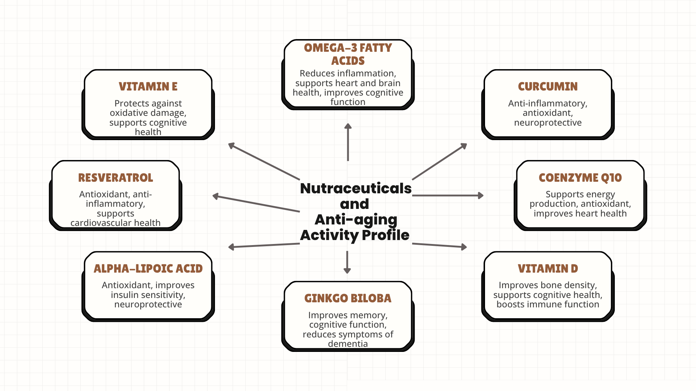

Fig 1. Nutraceuticals and Anti-Aging Activity Profile

3. Functional Foods for Healthy Aging
Functional foods with their dosage for reducing non communicable disease risk ultimately enhancing healthy life are summarized in table 2.
Table 2. Functional foods and Age-Related Diseases
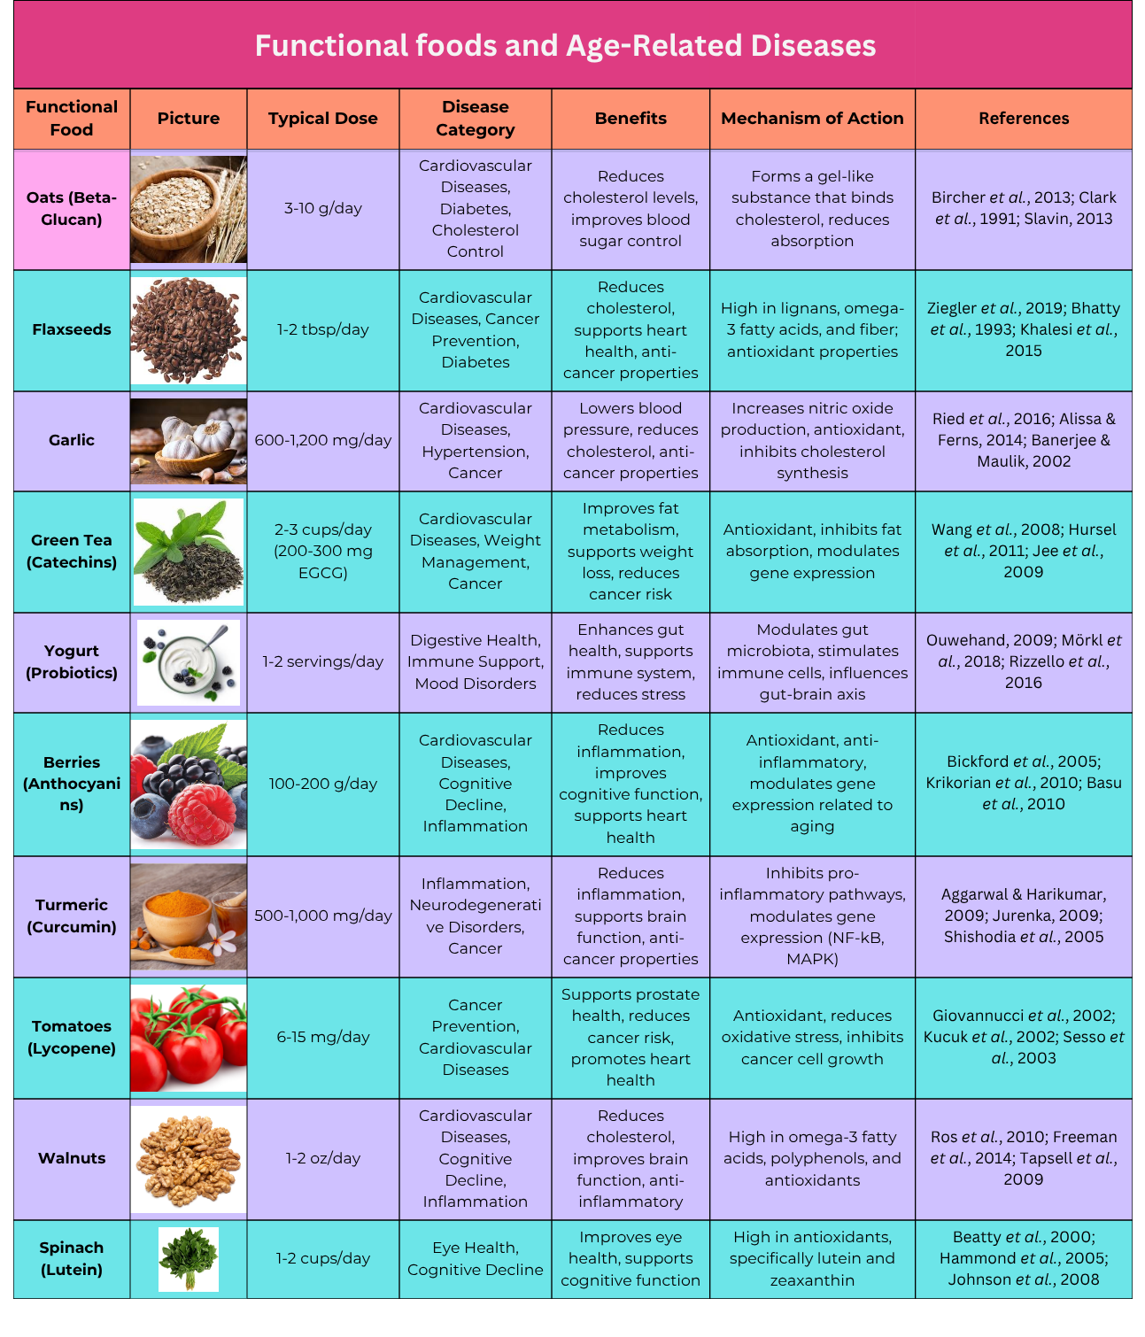

4. Synergistic Effects of Nutraceuticals and Functional Foods
The synergistic effects of nutraceuticals and functional foods refer to the enhanced or combined health benefits that occur when these substances are consumed together, as opposed to when they are consumed individually. When specific nutraceuticals (bioactive compounds or supplements) and functional foods (nutrient-rich foods that offer health benefits beyond basic nutrition) are combined, they can work in harmony to provide more significant effects on health. This synergy can optimize the body's ability to prevent or manage chronic diseases, reduce inflammation, support immune function, and improve overall well-being (Shahidi, 2012). Antioxidants like flavonoids, which are abundant in berries and green tea, aid in the body's defense against free radicals. Together with other antioxidants like vitamin C and E, they strengthen each other's defenses against oxidative damage to cells, lowering the risk of age-related disorders, cancer, and heart disease (Hanhineva et al., 2010). Omega-3 fatty acids also aid in reducing inflammation, and curcumin is widely known for its anti-inflammatory qualities. According to Seals and Melov (2014), they have a potent synergistic effect that can aid in the management of chronic inflammation, which is connected to conditions including arthritis, cardiovascular disease, and cognitive decline. Omega-3 fatty acids improve brain function, while flavonoids from dark chocolate and berries improve memory and cognitive function. According to Lauretani et al. (2008), these nutrients and foods may increase neuroprotective benefits, improve mood and mental clarity, and reduce the danger of cognitive decline associated with old age. Tomatoes also support heart health because of their high lycopene content. These essential nutrients and foods may support in order to promote cardiovascular wellness, reduce stress caused by oxidative damage, and minimize inflammatory processes (Kafatos et al., 2000). Live helpful bacteria, or probiotics, aid in digestion and gut microbiome equilibrium. Prebiotics support and encourage the growth of good bacteria and are present in foods high in fiber, such as oats and bananas. Together, they establish a symbiotic relationship that improves gut health, increases immunity, and may lower the risk of inflammation, gastrointestinal disorders, and even mental health problems associated with gut dysbiosis (Roberfroid, 2000). The antioxidant and anti-inflammatory qualities of vitamin E and omega-3 fatty acids help shield the skin from aging, pollution, and UV ray damage. Vitamin E and good fats, which are abundant in avocados, combine to moisturize the skin, lower inflammation, and promote normal skin aging (Shahidi, 2012). Magnesium promotes calcium metabolism and bone mineralization, while vitamin D aids in the body's absorption of calcium, which is necessary for healthy bones. According to Lauretani et al. (2008), these nutrients work together to strengthen bones and may help avoid fractures and osteoporosis, particularly in elderly persons.

5. Challenges and limitations
Although nutraceuticals and functional foods have demonstrated potential in promoting well-being and treating age-related illnesses, their application in this setting is fraught with difficulties and restrictions. These elements may affect their safety, accessibility, and effectiveness. Lack of Standardization and Regulation for these types of food is major obstacle. The functional food and nutraceutical industries are not subject to the same strict regulations as the pharmaceutical sector. Accordingly, there can be substantial differences in the quality, efficacy, and purity of functional foods and supplements between brands and batches (Martirosyan & Singh, 2015). Different therapeutic outcomes may arise from inconsistent doses and formulations. Customers find it challenging to determine whether they are receiving the appropriate quantity of active substances due to a lack of standardization (Dwyer et al., 2018). The quality and consistency of these items might be guaranteed with the aid of third-party testing and stricter regulatory control.
Although numerous studies indicate that some functional foods and nutraceuticals may be beneficial to health, there is frequently little or conflicting clinical data regarding their efficacy in preventing or treating age-related illnesses (Ghosh and others, 2019). Nutraceuticals with low bioavailability may not be as effective since the body may not absorb enough of the active ingredients to have positive benefits (Agarwal & Mishra, 2021). The bioavailability of these medicines may be enhanced by developments in delivery technology, such as nanoencapsulation or bioenhancers. (2020, McClements).

6. Future Trends and Innovations

The field of nutraceuticals and their role in treating age-related disorders has rapidly evolved as a result of significant advancements in research, technology, and product development. Nutraceuticals have a promising future in aging-related healthcare due to several recent advancements and trends that could fundamentally alter our understanding of healthy aging. Nutrigenomics will optimize the effectiveness of nutraceuticals in treating age-related diseases by developing personalized products based on genetic profiles.
For example, genetic testing can determine which nutrients are best for supporting cognitive function, lowering inflammation, or extending life.

Conclusion

In conclusion, by offering a natural, preventative, and therapeutic approach to aging, functional foods and nutraceuticals have tremendous promise in the management of age-related disorders. These bioactive substances are important for lowering oxidative stress, inflammation, and enhancing metabolic health in general. Combining accessible nutrients with functional meals including fruits, vegetables, and herbs offers an all-encompassing approach to helping older people. With their concentrated beneficial ingredients, nutraceuticals improve the treatment of chronic diseases like osteoporosis, neurodegeneration, and cardiovascular disease. A holistic approach to age-related health is provided by combining traditional therapies with nutraceuticals, enabling individualized treatments based on each patient's needs. Furthermore, the necessity for public education on the advantages of functional foods is highlighted by the growing recognition of the significance of lifestyle and dietary choices in aging. As we continue to explore their full potential, functional foods and nutraceuticals stand as key allies in promoting healthy aging, improving quality of life, and reducing the burden of age-related diseases on healthcare systems globally.
Authors' contributions
Medankar C.B. wrote the paper and Ghodke S.V. edited the paper. All authors have read and approved the final manuscript

Conflict of interests

No conflicts of intrests

References
Agarwal, R., & Mishra, G. (2021). "Strategies to enhance bioavailability of nutraceuticals: A review." Journal of Functional Foods, 79, 104410.
Banerjee, S., Ghosh, J., Dutta, S., & Ray, B. (2021). "Nutraceuticals in metabolic disorders: Potential therapeutic strategies." Journal of Functional Foods, 78, 104390.
Beard, J. R., Officer, A., De Carvalho, I. A., et al. (2016). "The World report on ageing and health: A policy framework for healthy ageing." The Lancet, 387(10033), 2145-2154.
Calder, P. C. (2017). "Omega-3 fatty acids and inflammatory processes: From molecules to man." Biochemical Society Transactions, 45(5), 1105-1115.
Calder, P. C., Bosco, N., Bourdet-Sicard, R., et al. (2017). "Health relevance of the modification of low-grade inflammation in ageing (inflammageing) and the role of nutrition." Ageing Research Reviews, 40, 95-119.
Candela, M. et al. (2021). "Oxidative damage and its role in aging-related diseases." Journal of Gerontology & Aging Research, 45(3), 112-130.
Davis, C. D., & Milner, J. A. (2009). Nutrigenomics, aging, and cancer. The Journals of Gerontology Series A: Biological Sciences and Medical Sciences, 64(1), 1-10. doi:10.1093/gerona/gln001
Dima, C., & Dima, S. (2015). "Bioavailability of nutraceuticals: The key to determining the efficacy of functional foods." Scientia Pharmaceutica, 83(1), 17-26.
DiNicolantonio, J. J., & O’Keefe, J. H. (2019). "The role of nutraceuticals in the prevention and treatment of cardiovascular disease." Progress in Cardiovascular Diseases, 61(1), 54-60.
Dwyer, J. T., Coates, P. M., & Smith, M. J. (2018). "Dietary supplements: Regulatory challenges and research resources." Nutrients, 10(1), 41.
Dwyer, J. T., Coates, P. M., & Smith, M. J. (2018). "Dietary supplements: Regulatory challenges and research resources." Nutrients, 10(1), 41.
Ferrucci, L., & Fabbri, E. (2018). "Inflammageing: Chronic inflammation in ageing, cardiovascular disease, and frailty." Nature Reviews Cardiology, 15(9), 505-522.
Franceschi, C., Bonafè, M., & Valensin, S. (2000). "Inflamm-aging: An evolutionary perspective on immunosenescence." Annals of the New York Academy of Sciences, 908(1), 244-254.
Ghosh, D., He, Y., & Wang, M. (2021). "Interactions between nutraceuticals and pharmaceuticals: Advancing clinical practice." Trends in Food Science & Technology, 112, 506-520.
Gosslau, A., & Chen, K. Y. (2004). Nutraceuticals, apoptosis, and disease prevention. Nutrition, 20(1), 95-102. doi:10.1016/j.nut.2003.09.017
Gupta, R. C., Chang, D., Nammi, S., Bensoussan, A., Bilinski, K., & Roufogalis, B. D. (2017). "Nutraceuticals in metabolic syndrome." Therapeutic Advances in Endocrinology and Metabolism, 8(3), 121-138.
Gupta, S. C., Prasad, S., Aggarwal, B. B. (2018). "Nutraceuticals and pharmaceuticals: The crossroads of healthy aging." Journal of Functional Foods, 45, 244-256.
Hanhineva, K., Törrönen, R., Bondia-Pons, I., Pekkinen, J., Kolehmainen, M., Mykkänen, H., & Poutanen, K. (2010). Impact of dietary polyphenols on carbohydrate metabolism. International Journal of Molecular Sciences, 11(4), 1365-1402. doi:10.3390/ijms11041365
Harman, D. (2001). "Aging: Overview." Annals of the New York Academy of Sciences, 928(1), 1-21.
He, K., Song, Y., Daviglus, M. L., Liu, K., Van Horn, L., Dyer, A. R., & Greenland, P. (2004). Fish consumption and incidence of stroke: a meta-analysis of cohort studies. Stroke, 35(7), 1538-1542. doi:10.1161/01.STR.0000130856.64167.95
Hosh, D., Scheepens, A., & Smid, S. D. (2019). "Functional foods and nutraceuticals: Potential in the prevention of neurodegenerative diseases." Frontiers in Neuroscience, 13, 848.
Izzo, A. A., Hoon-Kim, S., Radhakrishnan, R., & Williamson, E. M. (2016). "A critical approach to evaluating clinical efficacy, adverse events and drug interactions of herbal remedies." Phytotherapy Research, 30(5), 691-700.
Johnson, S. C., Cavallini, G., Donati, A., & Bergamini, E. (2022). "Biological research on aging: Strengths and limitations of current experimental models." Nature Reviews Molecular Cell Biology, 23(2), 121-136.
Joseph, J. A., Cole, G., Head, E., & Ingram, D. K. (2009). "Nutrition, brain aging, and neurodegeneration." Journal of Neuroscience, 29(41), 12795-12801.
Kafatos, A., Verhagen, H., Moschandreas, J., Apostolaki, I., & Westerop, J. J. (2000). Mediterranean diet of Crete: Foods and nutrient content. Journal of the American Dietetic Association, 100(12), 1487-1493. doi:10.1016/S0002-8223(00)00413-9
Kwak, N. S., & Jukes, D. J. (2017). "Functional foods: The need for enhanced assessment and regulation." Trends in Food Science & Technology, 69, 82-91.
Lauretani, F., Semba, R. D., Bandinelli, S., Dayhoff-Brannigan, M., Giacomini, V., Corsi, A. M., Guralnik, J. M., & Ferrucci, L. (2008). Low plasma carotenoids and skeletal muscle strength decline over 6 years. The Journals of Gerontology Series A: Biological Sciences and Medical Sciences, 63(4), 376-383. doi:10.1093/gerona/63.4.376
Liguori, I., Russo, G., Curcio, F., et al. (2018). "Oxidative stress, aging, and diseases." Clinical Interventions in Aging, 13, 757-772.
López-Otín, C., Blasco, M. A., Partridge, L., Serrano, M., & Kroemer, G. (2013). "The hallmarks of aging." Cell, 153(6), 1194-1217.
Mancuso, C., Santangelo, R., & Sette, G. (2019). "Polyphenols and Alzheimer’s disease: Key roles in the regulation of neurotransmission, neuroinflammation, and neuroprotection." Neurochemistry International, 126, 82-98.
Martirosyan, D. M., & Singh, J. (2015). "A new definition of functional food by FFC: What makes a new definition unique?" Functional Foods in Health and Disease, 5(6), 209-223.
McCarty, M. F., & DiNicolantonio, J. J. (2016). "Nutraceuticals as an alternative to NSAIDs for chronic inflammation: Phosphatidylcholine, boswellic acids, and other bioactive lipids." Open Heart, 3(1), e000326.
McClements, D. J. (2020). "Enhancing nutraceutical bioavailability through food matrix design." Current Opinion in Food Science, 33, 90-95.
Mehrotra, N., Tripathi, A. K., Pandey, R., et al. (2021). "Nutraceuticals targeting mitochondria in aging and age-related diseases." Mechanisms of Ageing and Development, 196, 111467.
Morley, J. E., & Silver, A. J. (1995). Nutritional issues in nursing home care. Annals of Internal Medicine, 123(11), 850-859. doi:10.7326/0003-4819-123-11-199512010-00011
Ouwehand, A. C., Salminen, S., & Isolauri, E. (2002). "Probiotics: An overview of beneficial effects." Antonie van Leeuwenhoek, 82(1-4), 279-289.
Picca, A., Lezza, A. M. S., Leeuwenburgh, C., et al. (2023). "Mitochondrial dysfunction and aging: Insights from molecular and cellular mechanisms." Journal of Cachexia, Sarcopenia and Muscle, 14(1), 50-67.
Rizzoli, R. (2022). "Nutritional aspects of bone health." Best Practice & Research Clinical Endocrinology & Metabolism, 36(2), 101607.
Roberfroid, M. B. (2000). "Prebiotics and probiotics: Are they functional foods?" American Journal of Clinical Nutrition, 71(6), 1682S-1687S. López-Otín, C., Blasco, M. A., Partridge, L., Serrano, M., & Kroemer, G. (2013). "The hallmarks of aging." Cell, 153(6), 1194-1217.
Roberfroid, M. B. (2000). Concepts and strategy of functional food science: The European perspective. The American Journal of Clinical Nutrition, 71(6), 1660S-1664S. doi:10.1093/ajcn/71.6.1660S
Santini, A., Cammarata, S. M., Capone, G., Polito, G., Ciampa, M., De Sanctis, P., ... & Novellino, E. (2018). "Nutraceuticals: Opening the debate for a regulatory framework." British Journal of Clinical Pharmacology, 84(4), 659-672.
Seals, D. R., & Melov, S. (2014). Translational geroscience: Emphasizing function to achieve optimal longevity. Aging, 6(9), 718-730. doi:10.18632/aging.100694
Shahidi, F. (2009). "Nutraceuticals and functional foods: Whole versus processed foods." Trends in Food Science & Technology, 20(9), 376–387.
Shahidi, F. (2012). Nutraceuticals, functional foods and dietary supplements in health and disease. Journal of Food and Drug Analysis, 20(1), Article 78.
Sharma, A., Lee, H. J., & Goyal, R. (2020). "Nutraceuticals: Regulatory aspects and safety considerations." Journal of Food Science and Technology, 57(12), 4569-4585.
Sies, H., Berndt, C., & Jones, D. P. (2017). "Oxidative stress." Annual Review of Biochemistry, 86, 715-748.
Sun, N., Youle, R. J., & Finkel, T. (2016). "The mitochondrial basis of aging." Molecular Cell, 61(5), 654-666.
Toth, P. P., Banach, M., & Jones, S. R. (2021). "Nutraceuticals for the treatment of hyperlipidemia: Rationale and evidence for coenzyme Q10, polyphenols, phytosterols, and omega-3 fatty acids." Current Atherosclerosis Reports, 23(4), 10.
Tresserra-Rimbau, A., Rimm, E. B., Medina-Remón, A., Martínez-González, M. A., De la Torre, R., Corella, D., ... & Lamuela-Raventós, R. M. (2018). "Polyphenol intake and mortality risk: A re-analysis of the PREDIMED trial." BMC Medicine, 16(1), 77.
Vauzour, D., Vafeiadou, K., Rodriguez-Mateos, A., Rendeiro, C., & Spencer, J. P. (2017). "The neuroprotective potential of flavonoids: A multiplicity of effects." Genes & Nutrition, 12(1), 4.

