Green synthesis of zinc oxide nanoparticles mediated by Eucalyptus globulus essential oil: physicochemical characterization and evaluation of antibiofilm activity against nosocomial pathogens

Abstract
Zinc oxide nanoparticles (ZnO NPs) were biosynthesized using Eucalyptus globulus essential oil as a green stabilizing agent and zinc acetate dihydrate as the precursor. The synthesized ZnO NPs were characterized by X-ray diffraction (XRD), Fourier transform infrared spectroscopy (FTIR), UV–Visible spectroscopy, dynamic light scattering (DLS), scanning electron microscopy (SEM), transmission electron microscopy (TEM), and energy dispersive X-ray spectroscopy (EDS). XRD confirmed the formation of crystalline hexagonal wurtzite ZnO with an average crystallite size of ~24 nm. The antibacterial activity of ZnO NPs was evaluated against clinically isolated nosocomial pathogens using agar well diffusion and broth microdilution assays. The ZnO NPs exhibited broad-spectrum antibacterial activity, with minimum inhibitory concentration (MIC) values ranging from 0.5 to 128 µg/mL. Antibiofilm activity was assessed using a 96-well microtiter plate method against Candida albicans, Enterococcus faecalis, Escherichia coli, Pseudomonas aeruginosa, and Staphylococcus aureus. The nanoparticles significantly inhibited biofilm formation in a concentration-dependent manner, with maximum inhibition of 95% against E. coli and 97% against P. aeruginosa. Overall, the results demonstrate that Eucalyptus globulus essential oil can serve as an effective green mediator for ZnO nanoparticle synthesis and yield a promising antibiofilm nanomaterial for controlling nosocomial infections.

Keywords: Green synthesis; Eucalyptus globulus essential oil; ZnO nanoparticles; Nosocomial pathogens; Antimicrobial activity; Antibiofilm activity

1. Introduction
The rapid emergence of antimicrobial resistance (AMR), largely driven by excessive and inappropriate antibiotic use, has become a major global health challenge and a key contributor to hospital-acquired (nosocomial) infections. AMR is associated with prolonged hospitalization, increased healthcare costs, and elevated morbidity and mortality worldwide [1,2]. In parallel, many clinically important pathogens exhibit a strong capacity to form biofilms—structured microbial communities embedded within an extracellular polymeric matrix. Biofilm-associated infections are particularly problematic in clinical settings because they often form on medical devices and hospital surfaces, enabling persistent colonization, immune evasion, and reduced susceptibility to antimicrobial agents [3,4]. In this context, there is an urgent need to develop innovative antimicrobial strategies capable of overcoming resistance mechanisms while simultaneously preventing or disrupting biofilm formation. Nanomaterials have attracted substantial interest as alternative antimicrobial platforms due to their unique physicochemical properties, including nanoscale size, large surface area, and tunable morphology, which enable strong interactions with microbial membranes and intracellular targets [5,6]. Among metal-based nanomaterials, zinc oxide nanoparticles (ZnO NPs) are widely investigated because of their broad-spectrum antimicrobial activity, chemical stability, relatively low cost, and favorable biocompatibility profile compared with many other metal nanoparticles [7,8]. ZnO NPs have also been reported to suppress biofilm formation through multiple mechanisms, including reactive oxygen species (ROS) generation, membrane disruption, and interference with microbial adhesion and quorum sensing [9,10]. Conventional physicochemical synthesis routes for ZnO NPs, including sol–gel, coprecipitation, and hydrothermal approaches, can provide controlled nanoparticle fabrication; however, these methods often require high energy input and hazardous reagents, and may generate environmentally undesirable by-products [11–13]. Therefore, green synthesis strategies using biological resources have emerged as an environmentally benign and sustainable alternative. Plant-derived extracts and essential oils are particularly attractive for nanoparticle synthesis because they contain diverse bioactive metabolites (e.g., phenolics, flavonoids, and terpenoids) that can function as reducing, stabilizing, and capping agents, enabling nanoparticle formation under mild conditions [14–16]. Eucalyptus globulus (Myrtaceae), commonly known as blue gum, is a medicinal plant widely recognized for its rich phytochemical profile and broad biological activities. Its essential oil is dominated by 1,8-cineole (eucalyptol), along with α-pinene, globulol, and other oxygenated monoterpenes, which contribute to antimicrobial, antioxidant, and antibiofilm properties [17–20]. Importantly, essential oil–mediated nanoparticle synthesis may provide a multifunctional platform by combining the intrinsic antimicrobial activity of ZnO with the bioactive surface chemistry imparted by phytochemical capping molecules. Accordingly, the present study aimed to biosynthesize ZnO nanoparticles using Eucalyptus globulus essential oil as a green stabilizing and functionalizing agent, followed by comprehensive physicochemical characterization using XRD, FTIR, UV–Vis spectroscopy, SEM, TEM, DLS, and EDS. Furthermore, the antimicrobial and antibiofilm activities of the synthesized ZnO NPs were evaluated against clinically isolated nosocomial pathogens, and their antioxidant capacity was assessed using the DPPH radical scavenging assay. Finally, cytotoxicity and cytocompatibility were examined using Saccharomyces cerevisiae and human dermal fibroblast models to support biomedical relevance.

2. Materials and Methods

2.1. Chemicals and reagents
Zinc acetate dihydrate (Zn(CH₃COO)₂·2H₂O, ≥99%), acetone (≥99.5%), and all analytical-grade reagents were purchased from Sigma-Aldrich (USA). All aqueous solutions were prepared using deionized water. Mueller–Hinton agar (MHA) and Mueller–Hinton broth (MHB) were used for antimicrobial susceptibility assays in accordance with standard microbiological testing guidelines [21,22].

2.2. Plant material and essential oil extraction
Fresh leaves of Eucalyptus globulus were collected in April 2024. Essential oil extraction was carried out by hydro distillation using a Clevenger-type apparatus, which remains one of the most widely applied and standardized techniques for obtaining volatile oils from medicinal plants [23]. Briefly, 300 g of fresh leaves were hydro-distilled for 6 h, yielding approximately 3 mL of essential oil. The collected oil was dehydrated using anhydrous sodium sulfate, transferred to amber vials, and stored at 4 °C until further analysis and nanoparticle synthesis.
2.3. GC–MS profiling of Eucalyptus globulus essential oil
The chemical composition of the essential oil was determined by gas chromatography coupled with mass spectrometry (GC–MS), following established essential oil characterization protocols [24,25]. Separation was performed using an HP-5MS capillary column (30 m × 0.25 mm; 0.25 µm film thickness). The injector temperature was maintained at 250 °C using split mode (1:50). The oven temperature was programmed from 50 to 300 °C at 2 °C/min. Helium served as the carrier gas at a flow rate of 0.8 mL/min. Compounds were identified by comparison of mass spectra with the NIST library and retention index matching, as recommended for reliable essential oil profiling [24,25].
2.4. Green synthesis of ZnO nanoparticles using Eucalyptus globulus essential oil
ZnO nanoparticles were biosynthesized using Eucalyptus globulus essential oil as a natural stabilizing and surface-functionalizing agent. Zinc acetate dihydrate was selected as the zinc precursor because it is frequently employed in plant-mediated ZnO synthesis due to its high solubility, controlled hydrolysis behavior, and reproducible ZnO yield [26–28]. The essential oil was diluted in acetone (1:170, v/v). The diluted oil was then added dropwise to the zinc precursor solution under vigorous magnetic stirring. The reaction was performed at 100 °C and adjusted to pH 7.0. The formation of ZnO nanoparticles was preliminarily indicated by a visible change in solution color to light yellow, consistent with earlier reports of plant-assisted ZnO nanoparticle formation [26,29]. Following synthesis, the mixture was centrifuged at 8000 rpm for 10 min, and the obtained pellet was washed repeatedly with deionized water to remove residual salts and unbound phytochemical constituents. The product was dried at 100 °C, then calcined at 550 °C for 5 h. Calcination is commonly applied in green ZnO synthesis to remove organic residues, enhance crystallinity, and stabilize nanoparticle structure [27,30,31].
2.5. Physicochemical characterization of ZnO nanoparticles
2.5.1. X-ray diffraction (XRD)
XRD was used to confirm the crystalline phase of ZnO nanoparticles. Diffraction patterns were recorded over a 2θ range of 20–80°. The crystallite size was estimated using the Debye–Scherrer equation, which remains a widely used approach for nanocrystalline ZnO systems [32].
2.5.2. Fourier transform infrared spectroscopy (FTIR)
FTIR spectroscopy was performed in the range of 400–4000 cm⁻¹ to confirm the Zn–O stretching vibration band and to detect functional groups related to phytochemical surface capping, as frequently reported for essential oil- and plant-mediated ZnO nanoparticles [26,33].
2.5.3. UV–Visible spectroscopy
UV–Vis spectra were recorded between 200 and 800 nm to assess optical absorbance and confirm characteristic ZnO absorption in the UV region, consistent with ZnO nanomaterial characterization reports [34].
2.5.4. Dynamic light scattering (DLS)
The hydrodynamic size distribution of ZnO nanoparticles was measured by DLS after dispersing the nanopowder in deionized water and sonication. DLS is routinely used to evaluate nanoparticle agglomeration and size distribution in suspension [35].
2.5.5. Scanning electron microscopy (SEM) and EDS
Morphological features of ZnO nanoparticles were examined using SEM. Elemental composition was confirmed using EDS, which is a standard method for validating Zn and O peaks and verifying the absence of major contaminants in ZnO nanomaterials [36].
2.5.6. Transmission electron microscopy (TEM)
TEM was performed for nanoscale visualization of particle morphology and primary particle size. ZnO powder was dispersed in ethanol, sonicated, and drop-cast onto carbon-coated copper grids before imaging. TEM is widely regarded as the most direct technique for nanoscale morphology evaluation [37].
2.6. Bacterial strains and culture conditions
All bacterial strains used in this study were clinical isolates presumed to be responsible for nosocomial infections. Isolates were obtained from clinical specimens and hospital environmental sources. Cultures were maintained on Mueller–Hinton agar and subcultured in Mueller–Hinton broth at 37 °C before antimicrobial and antibiofilm experiments, following standard clinical microbiology practices [21,22].
2.7. Antibacterial activity assays
2.7.1. Agar well diffusion assay
The antibacterial activity of ZnO nanoparticles was initially screened using the agar well diffusion method. Mueller–Hinton agar plates were inoculated with standardized bacterial suspensions. Wells (6 mm) were prepared using a sterile cork borer and loaded with ZnO nanoparticle suspensions. Plates were incubated at 37 °C for 24 h, and inhibition zones were measured in millimeters. This method is widely used as a rapid screening tool for antibacterial activity of nanoparticle formulations [38,39].
2.7.2. Minimum inhibitory concentration (MIC)
MIC values were determined using the broth microdilution method in sterile 96-well microplates. Twofold serial dilutions of ZnO nanoparticle suspensions were prepared in Mueller–Hinton broth, followed by the addition of standardized bacterial inocula. Plates were incubated at 37 °C for 18–24 h. MIC was defined as the lowest concentration preventing visible bacterial growth, in accordance with CLSI/EUCAST recommendations [21,22].
2.8. Antibiofilm assay (crystal violet microtiter plate method)
The antibiofilm activity of ZnO nanoparticles was evaluated using the crystal violet microtiter plate method, a widely validated assay for quantification of total biofilm biomass [40,41]. Briefly, bacterial cultures were dispensed into sterile 96-well plates and treated with ZnO nanoparticles at selected concentrations. After incubation at 37 °C for 24 h, planktonic cells were removed and wells were washed with sterile PBS. Biofilms were stained using 0.1% crystal violet, washed to remove excess stain, and the bound dye was solubilized using ethanol. Absorbance was recorded at 570 nm. Biofilm inhibition (%) was calculated relative to untreated controls [40,41]
3. Results
3.1. GC–MS chemical profiling of Eucalyptus globulus essential oil
GC–MS analysis revealed that Eucalyptus globulus essential oil consisted of a complex mixture of volatile constituents, with seventeen compounds identified, representing 99.7% of the total oil composition (Table 1). The profile was dominated by oxygenated monoterpenes, with 1,8-cineole (eucalyptol) as the principal component (56.83%). Other major constituents included L-pinocarveol (10.42%), α-pinene (9.47%), and globulol (7.69%). Several minor constituents were also detected, including p-cymene (3.80%), γ-terpinene (2.40%), 4-terpineol (1.70%), carvacrol (1.59%), and α-terpineol (1.50%). Overall, the chemical profile confirms a cineole-rich essential oil, consistent with the characteristic composition of Eucalyptus globulus.

Compound | Relative abundance (%)
1,8-Cineole (Eucalyptol) | 56.83
L-Pinocarveol | 10.42
α-Pinene | 9.47
Globulol | 7.69
p-Cymene | 3.80
γ-Terpinene | 2.40
4-Terpineol | 1.70
Carvacrol | 1.59
α-Terpineol | 1.50
Myrcene | 0.90
Pinocarvone | 0.70
Viridiflorol | 0.70
Aromadendrene | 0.60
Terpinolene | 0.50
β-Pinene | 0.40
Germacrene B | 0.30
Camphene | 0.20
Total identified compounds | 99.70
list 1: Chemical composition of Eucalyptus globulus essential oil determined by GC–MS.
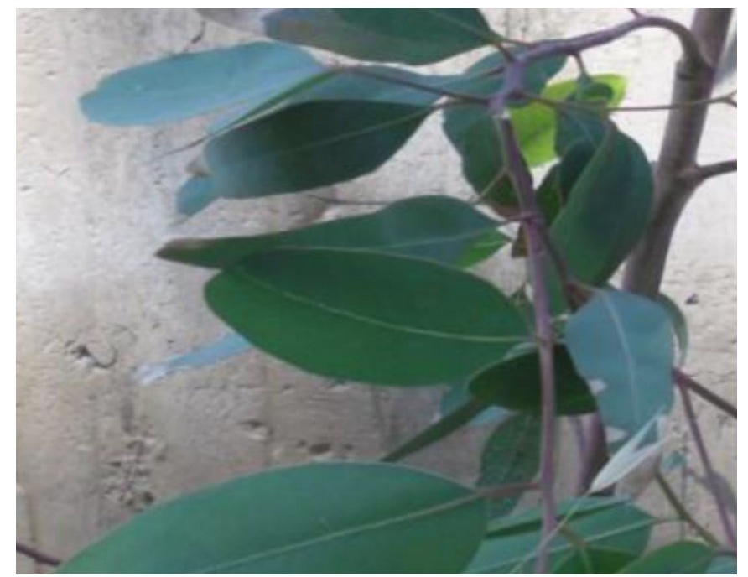

Fig. 1. Photograph of leaves of Eucalyptus globulus.

3.2. UV–Visible spectroscopy
The optical properties of the biosynthesized ZnO nanoparticles were examined using UV–Visible spectroscopy. As shown in Fig. 2, the absorption spectrum exhibited a distinct characteristic peak centered at approximately 360 nm, which is a typical absorption band of ZnO nanoparticles and confirms the successful formation of ZnO in the nanoscale range. The observed UV absorption profile is consistent with the intrinsic optical behavior of ZnO nanostructures.

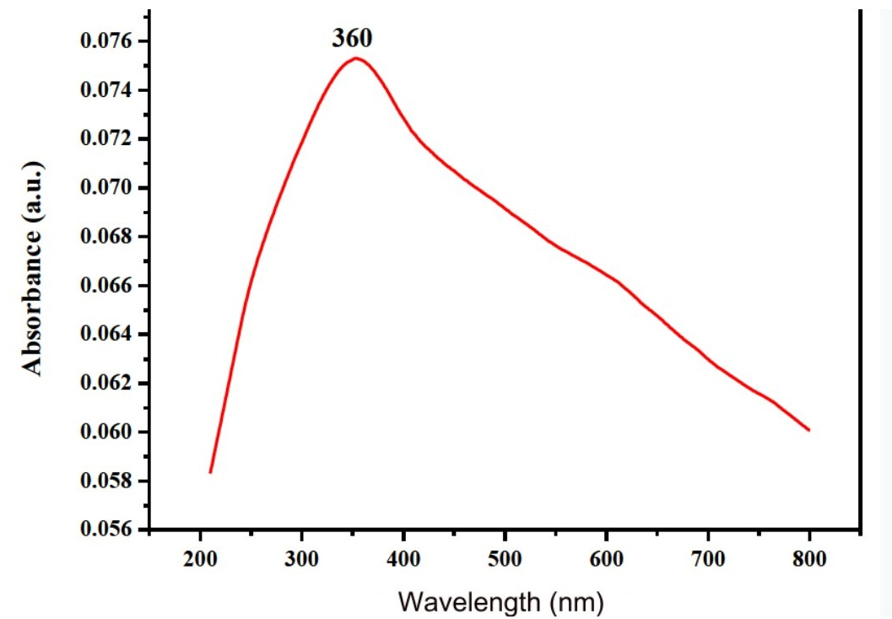
Fig. 2. UV–Visible absorption spectrum of ZnO nanoparticles biosynthesized using Eucalyptus globulus essential oil.

3.3. FTIR spectroscopy (Results)
The FTIR spectrum of the biosynthesized ZnO nanoparticles is shown in Fig. 3. A strong absorption band was observed at 422 cm⁻¹, corresponding to the characteristic Zn–O stretching vibration. Additional bands were detected at 1097 cm⁻¹ and 1419 cm⁻¹, which were attributed to C–O and C=O vibrational modes, respectively. A broad band around 3379 cm⁻¹ was assigned to O–H stretching.

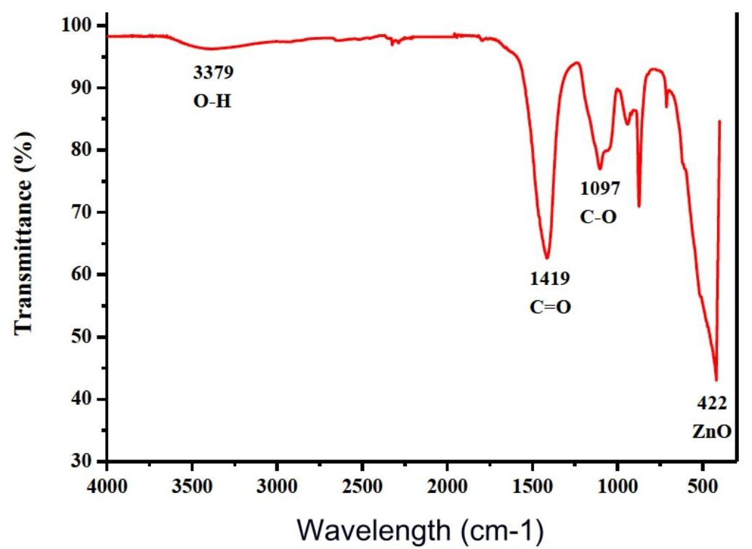
Fig. 3. FTIR spectrum of ZnO nanoparticles biosynthesized using Eucalyptus globulus essential oil.

3.2. XRD analysis of ZnO nanoparticles
The crystalline structure and phase purity of the biosynthesized ZnO nanoparticles were confirmed by X-ray diffraction (XRD), as presented in Fig. 4. The diffraction pattern displayed sharp and well-defined peaks at 2θ values of approximately 31.74°, 34.38°, 36.21°, 47.49°, 56.54°, 62.86°, 66.43°, 67.89°, 68.99°, 72.76°, and 76.94°, which were indexed to the (100), (002), (101), (102), (110), (103), (200), (112), (201), (004), and (202) crystallographic planes of hexagonal wurtzite ZnO. These reflections matched the standard ZnO reference pattern (JCPDS card No. 36-1451), confirming successful formation of crystalline ZnO without detectable secondary impurity phases. The average crystallite size estimated using the Debye–Scherrer equation was approximately 24 nm, indicating the formation of nanocrystalline ZnO.
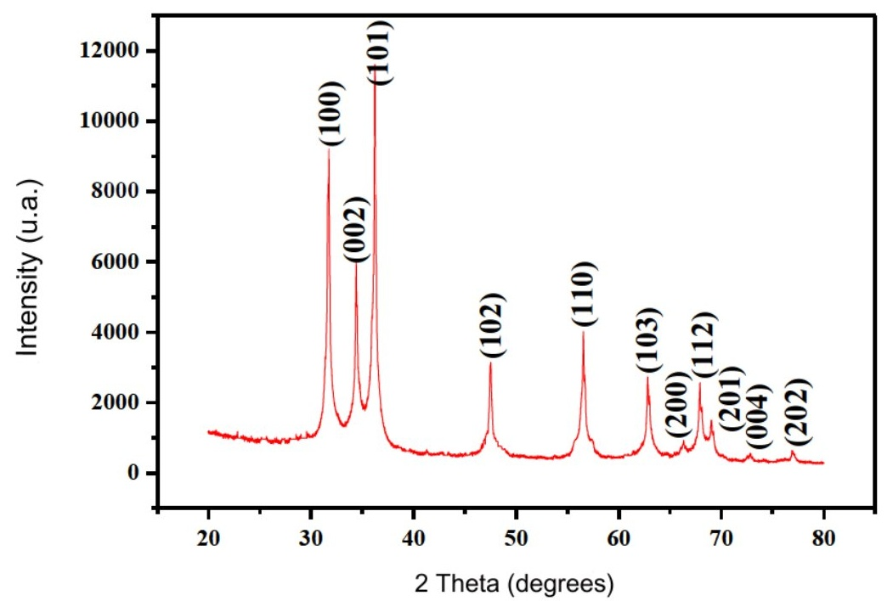
Fig. 4. XRD pattern of ZnO nanoparticles biosynthesized using Eucalyptus globulus essential oil.

3.4. DLS particle size distribution
The hydrodynamic size distribution of the biosynthesized ZnO nanoparticles was determined by dynamic light scattering (DLS), as shown in Fig. 5. The DLS profile indicated a mean hydrodynamic diameter of approximately 40 nm, confirming the nanoscale size distribution of the synthesized ZnO nanoparticles in aqueous suspension.

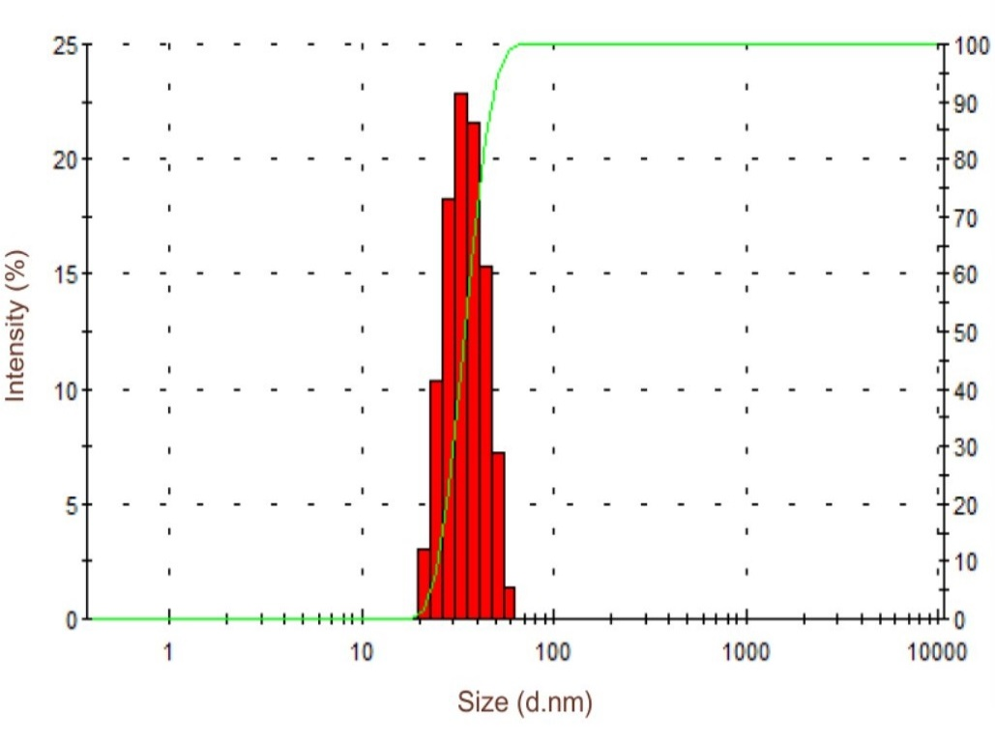
Fig. 5. DLS size distribution of ZnO nanoparticles biosynthesized using Eucalyptus globulus essential oil.

3.6. SEM–EDS analysis
SEM micrographs showed that the ZnO nanoparticles exhibited an agglomerated morphology with mixed spherical and needle-like features (Fig. 6a–c). EDS analysis confirmed the elemental composition, showing only Zn and O peaks without detectable impurities (Fig. 7).
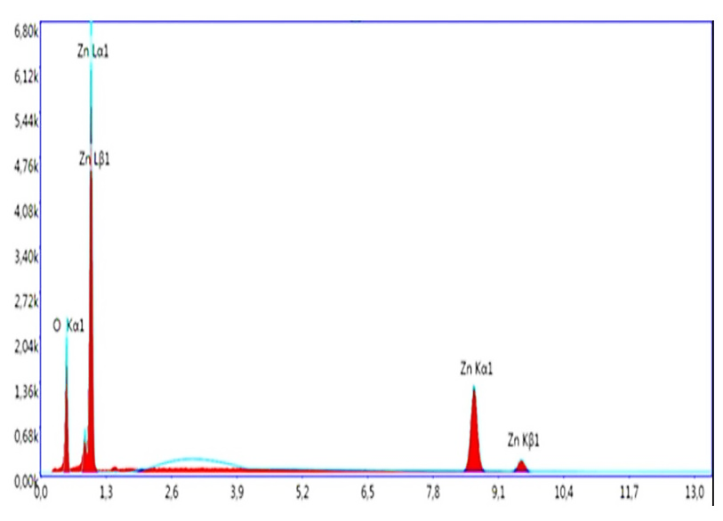
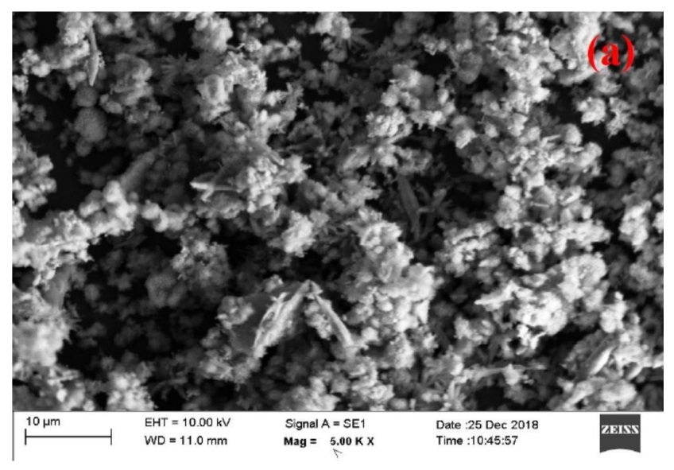

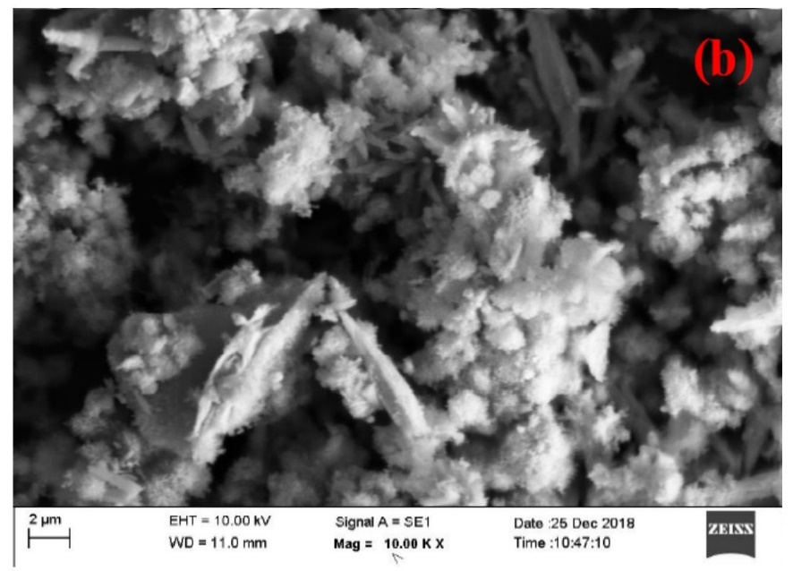
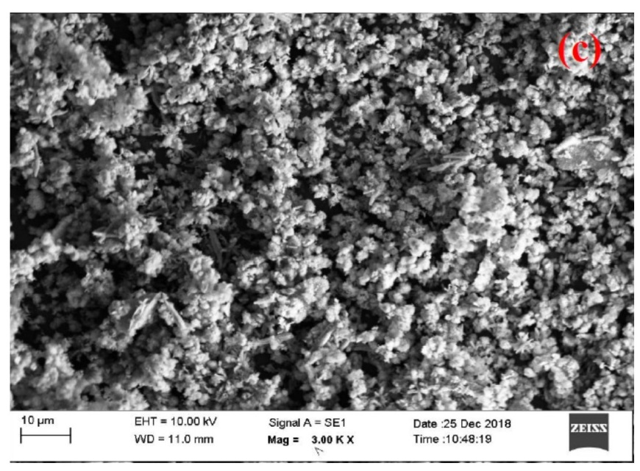
Fig. 6. SEM and DLS size distribution of ZnO nanoparticles biosynthesized using Eucalyptus globulus essential oil.

3.7. TEM analysis
Transmission electron microscopy (TEM) was used to examine the morphology of the biosynthesized ZnO nanoparticles. As shown in Fig. 7a,b, the nanoparticles appeared as agglomerated nanostructures with predominantly irregular spherical and rod/needle-like shapes, confirming their nanoscale dimensions.

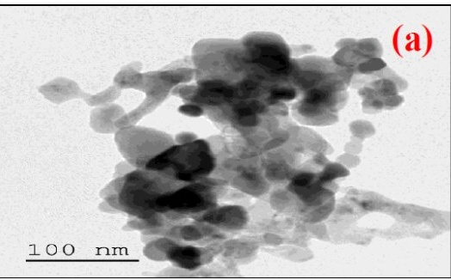
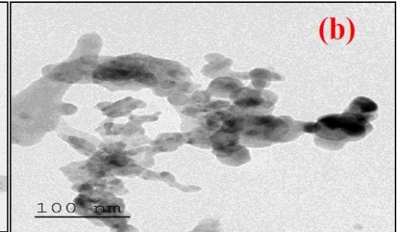
Fig. 7. TEM images of ZnO nanoparticles biosynthesized using Eucalyptus globulus essential oil.

3.8 Antibacterial activity
The biosynthesized ZnO nanoparticles exhibited notable antibacterial activity against the tested clinical isolates. The minimum inhibitory concentration (MIC) values ranged from 0.5 to 128 µg/mL, depending on the bacterial species and strain. Among the tested pathogens, Escherichia coli showed higher sensitivity to ZnO nanoparticles compared to Pseudomonas aeruginosa. The detailed MIC values for the tested bacterial strains are presented in Table 1.
Table 1. Antibacterial activity (MIC) of biosynthesized ZnO nanoparticles

Bacterial Strain | Gram Type | MIC Range (µg/mL)
E. coli | Gram-negative | 0.5–64
P. aeruginosa | Gram-negative | 1–128

3.9 Antibiofilm activity
The ZnO nanoparticles significantly inhibited biofilm formation of the tested pathogens in a concentration-dependent manner. The highest level of biofilm inhibition was observed at higher nanoparticle concentrations. Maximum inhibition reached approximately 95% against Escherichia coli and 97% against Pseudomonas aeruginosa. The percentage of biofilm inhibition for the tested bacterial strains is summarized in Table 2.
Table 2. Antibiofilm activity of biosynthesized ZnO nanoparticles

Bacterial Strain | ZnO NP Concentration (µg/mL) | Biofilm Inhibition (%)
Escherichia coli | 128 | 95
Pseudomonas aeruginosa | 128 | 97

4. Discussion
GC–MS analysis confirmed that Eucalyptus globulus essential oil was rich in oxygenated monoterpenes, with 1,8-cineole (eucalyptol) as the dominant component, followed by L-pinocarveol, α-pinene, and globulol (Table 1). This chemical profile agrees with previous reports describing cineole as the principal bioactive constituent of Eucalyptus essential oil and a key contributor to its antimicrobial properties [42,43]. In addition, oxygenated terpenes and related phytochemicals can play an important role during nanoparticle synthesis by acting as stabilizing and capping agents. Such biomolecules can adsorb onto growing nanocrystal surfaces and influence nucleation and particle growth, supporting the feasibility of essential oil–mediated ZnO nanoparticle fabrication [44,45].
XRD analysis demonstrated the successful formation of crystalline ZnO nanoparticles with a hexagonal wurtzite structure (Fig. 2). The diffraction peaks closely matched the standard ZnO reference pattern (JCPDS card No. 36-1451), and no additional peaks corresponding to secondary phases were detected, indicating high phase purity. The estimated crystallite size (~24 nm) is within the typical range reported for plant-mediated ZnO nanoparticles, which commonly fall between 10 and 50 nm depending on the biological source and synthesis conditions [46–48]. These findings confirm that Eucalyptus globulus essential oil is capable of producing nanocrystalline ZnO under environmentally benign conditions.
FTIR spectroscopy further supported ZnO formation and provided evidence of surface-associated organic groups (Fig. 3). The strong absorption band at ~422 cm⁻¹ corresponds to the characteristic Zn–O stretching vibration and is consistent with previous green synthesis studies reporting Zn–O bands within the 400–500 cm⁻¹ region [46,49]. Additional bands related to O–H, C–O, and C=O functional groups suggest that residual phytochemical moieties may remain associated with the nanoparticle surface, even after washing and calcination. Such surface functionalization has been reported to influence nanoparticle stability, dispersion behavior, and biological interactions [44,45,50]. The hydrodynamic size distribution obtained by DLS indicated an average diameter of ~40 nm (Fig. 4), which is larger than the crystallite size estimated by XRD. This discrepancy is expected because DLS measures hydrated nanoparticle aggregates in suspension rather than primary crystalline domains. Similar size differences between XRD and DLS are commonly reported for green-synthesized ZnO nanoparticles due to partial agglomeration and solvation effects [51,52]. Furthermore, UV–Vis analysis showed a characteristic absorption peak around 360 nm (Fig. 5), confirming the typical optical signature of ZnO nanostructures [53]. Biological evaluation demonstrated that the biosynthesized ZnO nanoparticles exhibited broad antibacterial activity against clinically relevant nosocomial pathogens, with MIC values ranging from 0.5 to 128 µg/mL depending on the tested strain. This antibacterial performance is consistent with previous studies showing that ZnO nanoparticles exert bactericidal activity through multiple mechanisms, including ROS generation, membrane damage, and disruption of intracellular metabolic processes [54,55]. Importantly, the nanoparticles also displayed strong antibiofilm activity, with inhibition reaching 95–97% against Escherichia coli and Pseudomonas aeruginosa. These findings align with earlier reports indicating that ZnO nanoparticles can significantly reduce biofilm biomass, particularly in Gram-negative biofilm-forming pathogens [56,57]. The high antibiofilm performance observed in this study may be partially attributed to the essential oil-derived surface chemistry, since Eucalyptus globulus essential oil has been reported to possess antibiofilm and anti-quorum sensing properties [58]. Therefore, the combined ZnO–phytochemical system may offer enhanced efficacy against both planktonic and biofilm-associated bacterial communities. Despite the promising antibacterial and antibiofilm outcomes, this study has several limitations. First, mechanistic investigations such as ROS quantification, membrane integrity assays, and Zn²⁺ release profiling were not performed and should be addressed in future work. Second, antibiofilm analysis was limited to biomass quantification; additional imaging-based techniques (e.g., CLSM or SEM of biofilms) would provide deeper insight into biofilm disruption. Finally, in vivo efficacy studies are required to validate the biomedical applicability of essential oil-mediated ZnO nanoparticles.
Conclusion
In the present study, zinc oxide nanoparticles (ZnO NPs) were successfully biosynthesized using Eucalyptus globulus essential oil as a green stabilizing agent. GC–MS analysis confirmed a cineole-rich essential oil profile, while XRD verified the formation of crystalline wurtzite ZnO with an average crystallite size of ~24 nm. FTIR indicated Zn–O bond formation and the presence of surface-associated organic functional groups, supporting phytochemical involvement in nanoparticle stabilization. DLS and UV–Vis analyses further confirmed nanoscale size distribution and characteristic ZnO optical absorption. Importantly, the biosynthesized ZnO NPs exhibited strong antibacterial activity against clinically relevant nosocomial isolates and demonstrated significant inhibition of biofilm formation, highlighting their potential as a promising eco-friendly nanomaterial for controlling resistant and biofilm-associated bacterial infections. Future work should focus on detailed mechanistic studies and in vivo validation to support biomedical applications.
Conflict of Interest
The authors declare that they have no known competing financial interests or personal relationships that could have appeared to influence the work reported in this paper.
Declaration of Interest
The authors declare no competing interests.
Ethics statement
The bacterial isolates used in this study were obtained from routine diagnostic laboratory samples. No personal identifiers or patient-related clinical information were collected or used. Therefore, ethical approval was not required.
References
- World Health Organization. (2017). Global action plan on antimicrobial resistance. Geneva: WHO; 2015.
- O'Neill, J. (2016). Tackling drug-resistant infections globally: final report and recommendations.
- Flemming, H., & Wingender, J. (2010). The biofilm matrix. Nat. Publ. Gr. 8, 623–633.
- Høiby, N., Bjarnsholt, T., Givskov, M., Molin, S., & Ciofu, O. (2010). Antibiotic resistance of bacterial biofilms. International journal of antimicrobial agents, 35(4), 322-332.
- Pelgrift, R. Y., & Friedman, A. J. (2013). Nanotechnology as a therapeutic tool to combat microbial resistance. Advanced drug delivery reviews, 65(13-14), 1803-1815.
- Allahverdiyev, A. M., Kon, K. V., Abamor, E. S., Bagirova, M., & Rafailovich, M. (2011). Coping with antibiotic resistance: combining nanoparticles with antibiotics and other antimicrobial agents. Expert review of anti-infective therapy, 9(11), 1035-1052.
- Sirelkhatim, A., Mahmud, S., Seeni, A., Kaus, N. H. M., Ann, L. C., Bakhori, S. K. M., ... & Mohamad, D. (2015). Review on zinc oxide nanoparticles: antibacterial activity and toxicity mechanism. Nano-micro letters, 7(3), 219-242.
- Raghupathi, K. R., Koodali, R. T., & Manna, A. C. (2011). Size-dependent bacterial growth inhibition and mechanism of antibacterial activity of zinc oxide nanoparticles. Langmuir, 27(7), 4020-4028.
- Dwivedi, S., Wahab, R., Khan, F., Mishra, Y. K., Musarrat, J., & Al-Khedhairy, A. A. (2014). Reactive oxygen species mediated bacterial biofilm inhibition via zinc oxide nanoparticles and their statistical determination. PloS one, 9(11), e111289.
- Jones N, Ray B, Ranjit KT, Manna AC. Antibacterial activity of ZnO nanoparticle suspensions on a broad spectrum of microorganisms. FEMS Microbiol Lett. 2008;279(1):71–76.
- De la Rosa E, Sepúlveda-Guzmán S, Reeja-Jayan B, et al. Sol–gel synthesis of ZnO nanoparticles and their antibacterial activity. J Sol-Gel Sci Technol. 2010;55:83–89.
- Devi HS, Velu AS. Synthesis of ZnO nanoparticles by precipitation method and its characterization. Mater Today Proc. 2016;3:189–195.
- Mohan, S., Vellakkat, M., Aravind, A., & U, R. (2020). Hydrothermal synthesis and characterization of Zinc Oxide nanoparticles of various shapes under different reaction conditions. Nano Express, 1(3), 030028.
- Ahmed, S., Chaudhry, S. A., & Ikram, S. (2017). A review on biogenic synthesis of ZnO nanoparticles using plant extracts and microbes: a prospect towards green chemistry. Journal of Photochemistry and Photobiology B: Biology, 166, 272-284.
- Rajan, R., Chandran, K., Harper, S. L., Yun, S. I., & Kalaichelvan, P. T. (2015). Plant extract synthesized silver nanoparticles: An ongoing source of novel biocompatible materials. Industrial Crops and Products, 70, 356-373.
- Carrapiço, A., Martins, M. R., Caldeira, A. T., Mirão, J., & Dias, L. (2023). Biosynthesis of metal and metal oxide nanoparticles using microbial cultures: Mechanisms, antimicrobial activity and applications to cultural heritage. Microorganisms, 11(2), 378.
- Dhakad, A. K., Pandey, V. V., Beg, S., Rawat, J. M., & Singh, A. (2018). Biological, medicinal and toxicological significance of Eucalyptus leaf essential oil: a review. Journal of the Science of Food and Agriculture, 98(3), 833-848.
- Luís, Â., Duarte, A., Gominho, J., Domingues, F., & Duarte, A. P. (2016). Chemical composition, antioxidant, antibacterial and anti-quorum sensing activities of Eucalyptus globulus and Eucalyptus radiata essential oils. Industrial Crops and Products, 79, 274-282.
- Luís, Â., Duarte, A., Gominho, J., Domingues, F., & Duarte, A. P. (2016). Chemical composition, antioxidant, antibacterial and anti-quorum sensing activities of Eucalyptus globulus and Eucalyptus radiata essential oils. Industrial Crops and Products, 79, 274-282.
- Bachir, R. G., & Benali, M. (2012). Antibacterial activity of the essential oils from the leaves of Eucalyptus globulus against Escherichia coli and Staphylococcus aureus. Asian Pacific journal of tropical biomedicine, 2(9), 739-742.
- Wayne, P. (2020). CLSI performance standards for antimicrobial susceptibility testing. CLSI supplements M, 100, 20-30.
- Giske, C. G., Turnidge, J., Cantón, R., & Kahlmeter, G. (2022). Update from the European committee on antimicrobial susceptibility testing (EUCAST). Journal of clinical microbiology, 60(3), e00276-21.
- Clevenger, J. F. (1928). Apparatus for the determination of volatile oil. The Journal of the American Pharmaceutical Association (1912), 17(4), 345-349.
- P Adams, R. (2017). Identification of essential oil components by gas chromatography/mass spectrometry.
- Ahmed, S., Chaudhry, S. A., & Ikram, S. (2017). A review on biogenic synthesis of ZnO nanoparticles using plant extracts and microbes: a prospect towards green chemistry. Journal of Photochemistry and Photobiology B: Biology, 166, 272-284.
- Matinise, N., Fuku, X. G., Kaviyarasu, K., Mayedwa, N., & Maaza, M. J. A. S. S. (2017). ZnO nanoparticles via Moringa oleifera green synthesis: Physical properties & mechanism of formation. Applied surface science, 406, 339-347.
- Ali, M., Ikram, M., Ijaz, M., Ul-Hamid, A., Avais, M., & Anjum, A. A. (2020). Green synthesis and evaluation of n-type ZnO nanoparticles doped with plant extract for use as alternative antibacterials. Applied Nanoscience, 10(10), 3787-3803.
- Barzinjy, A. A., & Azeez, H. H. (2020). Green synthesis and characterization of zinc oxide nanoparticles using Eucalyptus globulus Labill. leaf extract and zinc nitrate hexahydrate salt. SN Applied Sciences, 2(5), 991.
- Azizi, S., Mohamad, R., Bahadoran, A., Bayat, S., Rahim, R. A., Ariff, A., & Saad, W. Z. (2016). Effect of annealing temperature on antimicrobial and structural properties of bio-synthesized zinc oxide nanoparticles using flower extract of Anchusa italica. Journal of Photochemistry and Photobiology B: Biology, 161, 441-449.
- Fakhari, S., Jamzad, M., & Kabiri Fard, H. (2019). Green synthesis of zinc oxide nanoparticles: a comparison. Green chemistry letters and reviews, 12(1), 19-24.
- Patterson, A. L. (1939). The Scherrer formula for X-ray particle size determination. Physical review, 56(10), 978.
- Dobrucka, R., & Długaszewska, J. (2016). Biosynthesis and antibacterial activity of ZnO nanoparticles using Trifolium pratense flower extract. Saudi journal of biological sciences, 23(4), 517-523.
- Srikant, V., & Clarke, D. R. (1998). On the optical band gap of zinc oxide. Journal of applied physics, 83(10), 5447-5451.
- Stetefeld, J., McKenna, S. A., & Patel, T. R. (2016). Dynamic light scattering: a practical guide and applications in biomedical sciences. Biophysical reviews, 8(4), 409-427.
- Goldstein, J. I., Newbury, D. E., Michael, J. R., Ritchie, N. W., Scott, J. H. J., & Joy, D. C. (2017). Scanning electron microscopy and X-ray microanalysis. springer.
- Carter, D. B. W. C. B. (2009). Transmission electron microscopy A textbook for materials science.
- Balouiri, M., Sadiki, M., & Ibnsouda, S. K. (2016). Methods for in vitro evaluating antimicrobial activity: A review. Journal of pharmaceutical analysis, 6(2), 71-79.
- Bauer, A. W., Kirby, W. M., Sherris, J. C., & Turck, M. (1966). Antibiotic susceptibility testing by a standardized single disk method. American journal of clinical pathology, 45(4_ts), 493-496.
- Stepanović, S., Vuković, D., Hola, V., Bonaventura, G. D., Djukić, S., Ćirković, I., & Ruzicka, F. (2007). Quantification of biofilm in microtiter plates: overview of testing conditions and practical recommendations for assessment of biofilm production by staphylococci. Apmis, 115(8), 891-899.
- O'Toole, G. A. (2011). Microtiter dish biofilm formation assay. Journal of visualized experiments: JoVE, (47), 2437.
- Brand-Williams, W., Cuvelier, M. E., & Berset, C. L. W. T. (1995). Use of a free radical method to evaluate antioxidant activity. LWT-Food science and Technology, 28(1), 25-30.
- Dhakad, A. K., Pandey, V. V., Beg, S., Rawat, J. M., & Singh, A. (2018). Biological, medicinal and toxicological significance of Eucalyptus leaf essential oil: a review. Journal of the Science of Food and Agriculture, 98(3), 833-848.
- Luís, Â., Duarte, A., Gominho, J., Domingues, F., & Duarte, A. P. (2016). Chemical composition, antioxidant, antibacterial and anti-quorum sensing activities of Eucalyptus globulus and Eucalyptus radiata essential oils. Industrial Crops and Products, 79, 274-282.
- Ahmed, S., Chaudhry, S. A., & Ikram, S. (2017). A review on biogenic synthesis of ZnO nanoparticles using plant extracts and microbes: a prospect towards green chemistry. Journal of Photochemistry and Photobiology B: Biology, 166, 272-284.
- Matinise, N., Fuku, X. G., Kaviyarasu, K., Mayedwa, N., & Maaza, M. J. A. S. S. (2017). ZnO nanoparticles via Moringa oleifera green synthesis: Physical properties & mechanism of formation. Applied surface science, 406, 339-347.
- Azizi, S., Mohamad, R., Bahadoran, A., Bayat, S., Rahim, R. A., Ariff, A., & Saad, W. Z. (2016). Effect of annealing temperature on antimicrobial and structural properties of bio-synthesized zinc oxide nanoparticles using flower extract of Anchusa italica. Journal of Photochemistry and Photobiology B: Biology, 161, 441-449.
- Ahmed, S., Chaudhry, S. A., & Ikram, S. (2017). A review on biogenic synthesis of ZnO nanoparticles using plant extracts and microbes: a prospect towards green chemistry. Journal of Photochemistry and Photobiology B: Biology, 166, 272-284.
- Barzinjy, A. A., & Azeez, H. H. (2020). Green synthesis and characterization of zinc oxide nanoparticles using Eucalyptus globulus Labill. leaf extract and zinc nitrate hexahydrate salt. SN Applied Sciences, 2(5), 991.
- Dobrucka, R., & Długaszewska, J. (2016). Biosynthesis and antibacterial activity of ZnO nanoparticles using Trifolium pratense flower extract. Saudi journal of biological sciences, 23(4), 517-523.
- Sirelkhatim, A., Mahmud, S., Seeni, A., Kaus, N. H. M., Ann, L. C., Bakhori, S. K. M., ... & Mohamad, D. (2015). Review on zinc oxide nanoparticles: antibacterial activity and toxicity mechanism. Nano-micro letters, 7(3), 219-242.
- Stetefeld, J., McKenna, S. A., & Patel, T. R. (2016). Dynamic light scattering: a practical guide and applications in biomedical sciences. Biophysical reviews, 8(4), 409-427.
- Franklin, N. M., Rogers, N. J., Apte, S. C., Batley, G. E., Gadd, G. E., & Casey, P. S. (2007). Comparative toxicity of nanoparticulate ZnO, bulk ZnO, and ZnCl2 to a freshwater microalga (Pseudokirchneriella subcapitata): the importance of particle solubility. Environmental science & technology, 41(24), 8484-8490.
- Srikant, V., & Clarke, D. R. (1998). On the optical band gap of zinc oxide. Journal of applied physics, 83(10), 5447-5451.
- Raghupathi, K. R., Koodali, R. T., & Manna, A. C. (2011). Size-dependent bacterial growth inhibition and mechanism of antibacterial activity of zinc oxide nanoparticles. Langmuir, 27(7), 4020-4028.
- Jones, N., Ray, B., Ranjit, K. T., & Manna, A. C. (2008). Antibacterial activity of ZnO nanoparticle suspensions on a broad spectrum of microorganisms. FEMS microbiology letters, 279(1), 71-76.
- Dwivedi, S., Wahab, R., Khan, F., Mishra, Y. K., Musarrat, J., & Al-Khedhairy, A. A. (2014). Reactive oxygen species mediated bacterial biofilm inhibition via zinc oxide nanoparticles and their statistical determination. PloS one, 9(11), e111289.
- Lebeaux, D., Ghigo, J. M., & Beloin, C. (2014). Biofilm-related infections: bridging the gap between clinical management and fundamental aspects of recalcitrance toward antibiotics. Microbiology and Molecular Biology Reviews, 78(3), 510-543.
- Merghni, A., Noumi, E., Hadded, O., Dridi, N., Panwar, H., Ceylan, O., ... & Snoussi, M. (2018). Assessment of the antibiofilm and antiquorum sensing activities of Eucalyptus globulus essential oil and its main component 1, 8-cineole against methicillin-resistant Staphylococcus aureus strains. Microbial pathogenesis, 118, 74-80.

