Influence of Indigenous Ecological Agriculture Practices on Sustainable Farming among the Maasai Community in Kajiado County, Kenya

Abstract
Indigenous Ecological Agriculture (IEA) practices have sustained pastoral and agro-pastoral livelihoods for generations, yet their contribution to contemporary sustainable farming remains inadequately documented. This study established the influence of IEA practices on sustainable farming among the Maasai community in Kajiado County, Kenya. A mixed-methods research design was employed, involving a household survey of 320 respondents, focus group discussions, and key informant interviews. Quantitative data were analysed using descriptive statistics and multiple regression analysis, while qualitative data were analysed thematically. The findings reveal that rotational grazing, indigenous soil and water conservation, ethno-veterinary practices, crop–livestock integration, and indigenous climate prediction significantly influence sustainable farming outcomes (R² = .61, p < .05). The study concludes that IEA practices remain critical drivers of environmental sustainability, livelihood resilience, and food security in semi-arid ecosystems. It recommends the integration of indigenous ecological knowledge into agricultural extension and climate adaptation policies.
Keywords: Indigenous ecological agriculture, sustainable farming, Maasai, pastoralism, Kajiado County
1. Introduction
Sustainable farming has become a central concern in global agricultural and environmental policy due to escalating land degradation, climate variability, biodiversity loss, and declining agricultural productivity. Globally, it is estimated that nearly one-third of the world’s soils are degraded, threatening food security and livelihoods, particularly in developing countries (FAO & ITPS, 2015). Climate change further compounds these challenges by increasing the frequency of droughts, floods, and erratic rainfall patterns, thereby undermining agricultural systems that depend heavily on natural conditions (IPCC, 2022). In response, there has been growing recognition of the need for sustainable agricultural approaches that enhance resilience while conserving natural resources. Among these approaches, Indigenous Ecological Agriculture (IEA) has gained attention for its potential to promote sustainability through locally adapted, knowledge-based practices (Altieri & Nicholls, 2017).
At the regional level, Sub-Saharan Africa faces disproportionate impacts of climate variability due to its high dependence on rain-fed agriculture and limited adaptive capacity. The region experiences recurrent droughts, land degradation, and declining soil fertility, which significantly affect agricultural productivity and food security (UNEP, 2019). Pastoral and agro-pastoral systems, which dominate many dryland areas, are particularly vulnerable. However, these systems have historically demonstrated resilience through indigenous knowledge systems, including mobility, herd diversification, and traditional resource governance (Reid et al., 2014). Despite this resilience, modern agricultural policies and development interventions often overlook indigenous practices, favouring external, technology-driven solutions that may not align with local ecological and socio-cultural contexts (Pretty, 2018).
In Kenya, the challenges of sustainable farming are especially pronounced in arid and semi-arid lands (ASALs), which constitute over 80% of the country’s landmass and support about 36% of the population (Government of Kenya, 2021). These areas are characterized by low and erratic rainfall, fragile ecosystems, and frequent droughts, making conventional agricultural practices difficult to sustain. Pastoralism and agro-pastoralism remain the dominant livelihood systems, particularly among communities such as the Maasai, Turkana, and Samburu. In recent years, increasing population pressure, land fragmentation, climate change, and policy shifts have disrupted traditional systems, leading to reduced mobility, overgrazing, and land degradation (Herrero et al., 2016). Consequently, there is an urgent need to explore sustainable farming approaches that are both ecologically viable and culturally appropriate.
At the local level, the Maasai community in Kajiado County has historically relied on Indigenous Ecological Agriculture (IEA) practices to manage land, livestock, and natural resources sustainably. These practices are deeply rooted in long-term ecological observation, cultural norms, and intergenerational knowledge transfer. Key IEA practices include rotational grazing, seasonal mobility, indigenous soil and water conservation techniques, ethno-veterinary medicine, and crop–livestock integration. Such practices have enabled the Maasai to adapt to climatic variability, maintain pasture productivity, and ensure livestock health in a highly unpredictable environment (Reid et al., 2014). However, these systems are increasingly under pressure due to land subdivision, sedentarisation, and the influence of modern agricultural interventions that often disregard indigenous knowledge systems.
Despite the demonstrated resilience and sustainability of IEA practices, they remain undervalued in formal agricultural development programs, which tend to priorities externally introduced technologies and scientific approaches. This marginalization not only undermines sustainable livelihoods but also contributes to the erosion of valuable indigenous knowledge systems (Pretty, 2018). Furthermore, empirical evidence quantifying the contribution of IEA practices to sustainable farming outcomes remains limited, particularly at the household level in pastoral settings. This gap in knowledge constrains the integration of indigenous practices into policy and development planning.
This study therefore seeks to address this gap by examining the influence of Indigenous Ecological Agriculture practices on sustainable farming among the Maasai in Kajiado County. By providing empirical evidence at the household level, the study aims to contribute to a more inclusive and context-specific understanding of sustainable agriculture, thereby informing policy and practice in ASAL regions.
1.1. Statement of the Problem
Sustainable farming in Kajiado County has increasingly been threatened by climate variability, land degradation, and changing land-use patterns that undermine traditional pastoral and agro-pastoral systems (FAO, 2015; Government of Kenya, 2018). Although the Maasai community has long relied on Indigenous Ecological Agriculture Practices (IEAPs) such as rotational grazing, seasonal mobility, and indigenous soil and water conservation techniques, these practices are gradually being eroded due to modernization, land subdivision, and policy shifts (Homewood et al., 2009; FAO & ITPS, 2015). As a result, there is limited understanding of how these indigenous practices continue to influence sustainable farming outcomes in the current socio-economic and environmental context. This knowledge gap constrains the development of culturally appropriate and ecologically sound agricultural interventions in the region (Altieri & Nicholls, 2017).
1.2. Objective of the Study
The main objective of this study is to examine the influence of Indigenous Ecological Agriculture Practices on sustainable farming among the Maasai community in Kajiado County, Kenya.
Specific objectives include:
To identify the key Indigenous Ecological Agriculture Practices used by the Maasai community.
1.3. Significance of the Study
This study is significant to multiple stakeholders. First, it provides empirical evidence on the role of indigenous knowledge systems in promoting sustainable agriculture, which can inform policymakers in the Ministry of Agriculture and county governments in designing inclusive agricultural policies. Second, it benefits development agencies and NGOs by highlighting locally adaptable and low-cost strategies for enhancing resilience to climate change. Third, the findings contribute to academic literature by bridging the gap between indigenous knowledge and modern sustainable agriculture discourse. Finally, it empowers the Maasai community by validating traditional ecological practices that support food security and environmental conservation.
1.4. Justification of the Study
Despite growing interest in sustainable agriculture, most research and interventions in Kenya have focused on modern farming technologies, often overlooking indigenous ecological systems that have sustained pastoral communities for generations. In Kajiado County, increasing environmental stressors such as drought and land fragmentation have made it necessary to reassess the relevance of indigenous practices in supporting sustainability. This study is therefore justified as it seeks to document, analyze, and evaluate the effectiveness of Indigenous Ecological Agriculture Practices in enhancing sustainable farming. The findings will provide a foundation for integrating indigenous knowledge with contemporary agricultural strategies to improve resilience and sustainability in ASAL (Arid and Semi-Arid Lands) regions.
1.5. Influence of IEA Practices on Sustainability (Conceptual Diagram)
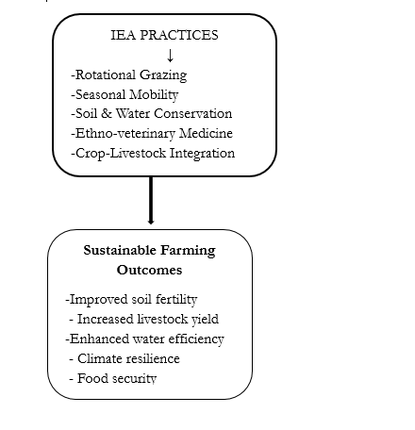
Figure 1: Influence of IEA Practices on Sustainability (Conceptual Diagram)

2. Literature Review
2.1 Indigenous Ecological Agriculture Practices
Indigenous ecological agriculture encompasses farming and land-use practices that are culturally embedded and ecologically informed. Scholars argue that such practices enhance sustainability by promoting biodiversity conservation, nutrient cycling, and ecosystem resilience (Altieri & Nicholls, 2017). In pastoral systems, mobility and rotational grazing reduce grazing pressure and allow rangeland recovery, thereby maintaining long-term productivity (Homewood et al., 2009).
2.2 Sustainable Farming in Pastoral Systems
Sustainable farming integrates environmental integrity, economic viability, and social equity (Pretty, 2018). In pastoral contexts, sustainability extends beyond crop yields to include rangeland health, livestock productivity, and resilience to climatic shocks. Studies in East Africa have shown that traditional grazing institutions can mitigate land degradation and enhance ecosystem resilience when effectively maintained (Galvin, 2009).
2.3 Indigenous Knowledge among the Maasai
The Maasai possess extensive ecological knowledge related to pasture quality, rainfall variability, animal health, and seasonal resource availability. Traditional institutions regulated access to communal grazing areas and enforced sustainable resource use (Homewood et al., 2009). However, land subdivision, sedentarisation, and policy changes have disrupted these systems, raising concerns about the sustainability of Maasai livelihoods.
2.4 Research Gap
While the role of indigenous knowledge in sustainability is widely acknowledged, there is limited quantitative evidence linking specific IEA practices to sustainable farming outcomes among pastoral communities in Kenya. This study provides empirical evidence to address this gap.

3. Methodology
3.1. Study Area
The research was conducted in Kajiado County, a semi-arid region in southern Kenya predominantly inhabited by the Maasai community. Livelihoods are largely based on pastoralism and agro-pastoralism.
Kajiado County ( Figure 2 )is located in the southern part of Kenya, bordering Nairobi County to the north and extending southwards to the Kenya–Tanzania international boundary. Geographically, it lies at approximately latitude 1°51′8.57″S and longitude 36°46′36.59″E. According to the Kenya National Bureau of Statistics, the county had a population of 1,117,840 people and 316,179 households as recorded in the 2019 Kenya Population and Housing Census (KNBS, 2019).
Climatically, Kajiado County falls within Kenya’s arid and semi-arid lands (ASALs) and is predominantly semi-arid. The area experiences a warm to hot climate, with temperatures generally ranging between 20°C and 28°C and an annual mean of25°C. Rainfall is low and erratic, averaging about 500 mm per year, with most precipitation occurring during the long rains in April, while months such as August are typically extremely dry (Government of Kenya, 2008; Jaetzold et al., 2006). These climatic conditions significantly influence land use and livelihood strategies in the county.
Due to these environmental characteristics, livestock rearing remains the dominant economic activity and the primary source of livelihood for a majority of residents. Pastoralism, particularly among the Maasai community, is well adapted to the semi-arid environment, allowing households to cope with limited water resources and variable pasture availability. Livestock production mainly cattle, sheep, and goats plays a central role in food security, income generation, and cultural identity in the region (Evangelou, 2019; Government of Kenya, 2013).
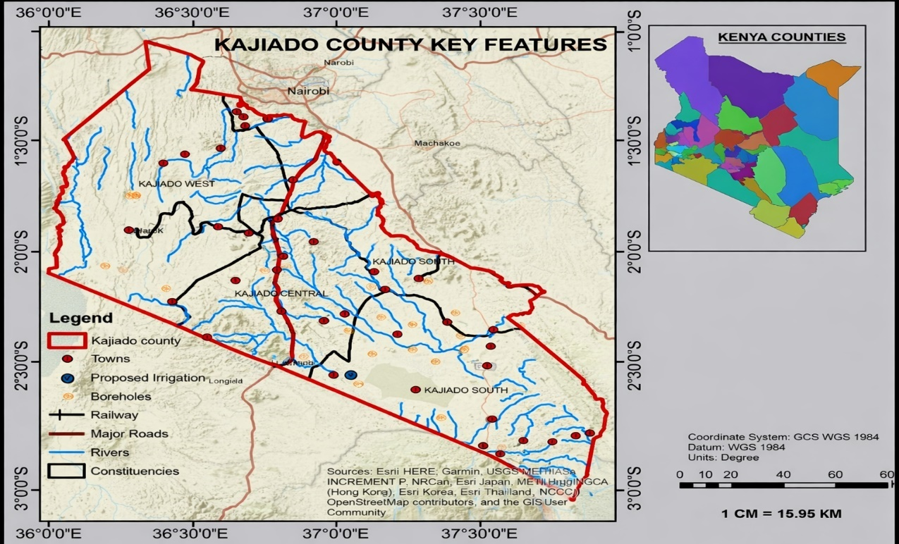
Figure 2: Map of Kajiado County (Field study, 2025)
3.2. Research Design
The study adopted a mixed-methods research design to integrate quantitative measurement with qualitative contextual understanding.
3.3. Sampling Procedure and Sample Size
A multistage sampling technique was employed. Four sub-counties were purposively selected based on ecological and livelihood diversity. A total of 320 household heads were randomly sampled. Key informants included elders, agricultural extension officers, and community leaders.
3.4. Data Collection
Primary data were collected using structured questionnaires, focus group discussions, and key informant interviews. The questionnaire captured data on IEA practices and sustainable farming indicators such as soil conservation, rangeland condition, livestock productivity, food security, and resilience to drought.
3.5. Data Analysis
Quantitative data were analysed using descriptive statistics and multiple regression analysis. Qualitative data were analysed thematically to support and interpret quantitative findings.

4. Results and Discussion
4.1. Indigenous Ecological Agriculture Practices
The most commonly practiced IEA strategies included rotational grazing, indigenous pasture management, ethno-veterinary medicine, and traditional soil and water conservation techniques.
4.2 Sustainable Farming Outcomes
Households practicing IEA reported improved rangeland condition, reduced soil erosion, higher livestock survival during droughts, and reduced dependence on external inputs.

Table 1: Adoption of Indigenous Ecological Agriculture Practices
IEA Practice | Percentage of Households (%)
Rotational grazing | 78
Seasonal mobility | 65
Soil & water conservation | 59
Ethno-veterinary medicine | 72
Crop–livestock integration | 54
Interpretation:
Rotational grazing and ethno-veterinary practices ( Table 1) are the most widely adopted, indicating strong reliance on traditional livestock management systems. Crop–livestock integration shows relatively lower adoption due to increasing sedentarisation. The findings show a high overall adoption of Indigenous Ecological Agriculture (IEA) practices among households in Kajiado County, though with noticeable variation across specific practices.
Rotational grazing (78%) emerges as the most widely practiced strategy, indicating its central role in Maasai pastoral systems. This high adoption reflects its effectiveness in preventing overgrazing, allowing pasture regeneration, and maintaining rangeland health. It also demonstrates strong adherence to traditional grazing management systems that are well adapted to the semi-arid environment. Ethno-veterinary medicine (72%) is also highly practiced, suggesting that households rely heavily on indigenous knowledge for livestock health management. This may be due to the accessibility, affordability, and cultural acceptability of traditional remedies compared to modern veterinary services, especially in remote areas. The continued use of such practices highlights the resilience and relevance of indigenous knowledge systems in sustaining livestock productivity.
Seasonal mobility (65%) shows relatively high adoption but is lower than rotational grazing, possibly reflecting increasing constraints such as land fragmentation, privatization, and settlement expansion. While mobility remains a key adaptive strategy for coping with spatial and temporal variability in pasture and water, its reduced practice suggests a gradual shift away from traditional nomadic systems. Soil and water conservation practices (59%) and crop–livestock integration (54%) show moderate adoption levels. This indicates that while households are incorporating some sustainable land management practices, these may require more labour, knowledge, or resources to implement effectively. The relatively lower uptake of crop–livestock integration may also reflect the pastoral orientation of the Maasai, where crop farming is a relatively recent adaptation influenced by changing socio-economic conditions.
Overall, the findings suggest that IEA practices are widely practiced and remain fundamental to sustainable farming systems in Kajiado County. However, the variation in adoption levels indicates that external pressures such as climate change, land-use changes, and socio-economic transformation are influencing traditional practices. Strengthening and integrating these indigenous practices into formal agricultural policies could enhance sustainability, resilience, and livelihoods in arid and semi-arid regions.

Table 2: Sustainable Farming Outcomes
Indicator | Low (%) | Moderate (%) | High (%)
Soil fertility improvement | 18 | 46 | 36
Livestock productivity | 15 | 40 | 45
Water conservation efficiency | 22 | 48 | 30
Resilience to climate variability | 12 | 42 | 46
Household food security | 20 | 44 | 36
Interpretation:
Most households ( Table 2) reported moderate to high improvements, particularly in livestock productivity and climate resilience, suggesting that IEA practices positively influence sustainability.
The results indicate that most households reported moderate to high levels of sustainable farming outcomes, suggesting that existing farming practices particularly Indigenous Ecological Agriculture (IEA) are contributing positively to livelihoods and environmental management in Kajiado County.
Resilience to climate variability shows the strongest performance, with 46% of households reporting high resilience and only 12% reporting low levels. This suggests that indigenous practices such as mobility, herd diversification, and traditional knowledge systems are effective in helping households cope with droughts and erratic rainfall, which are common in semi-arid environments.
Livestock productivity also records a high proportion (45%) under the “high” category and only 15% under “low,” indicating that livestock-based systems remain productive and sustainable. This is likely supported by practices such as rotational grazing and ethno-veterinary medicine, which enhance animal health and pasture availability.
Soil fertility improvement and household food security show similar patterns, with moderate responses dominating (46% and 44%, respectively) and a substantial proportion reporting high levels (36%). This suggests gradual improvements, possibly driven by soil conservation practices and diversification strategies, although these benefits may not yet be fully optimized across all households.
Water conservation efficiency, however, has the highest proportion of moderate responses (48%) and a relatively lower proportion of high responses (30%), alongside 22% reporting low levels. This indicates that water management remains a challenge, likely due to limited infrastructure, low rainfall, and high evaporation rates in the region.
Overall, the findings demonstrate that while sustainable farming outcomes are generally positive, they are uneven across different indicators. The dominance of moderate responses suggests that many households are in a transition phase, where indigenous practices are contributing to sustainability but require strengthening, support, and integration with modern techniques to achieve consistently high outcomes across all areas.
Table 3: Relationship between IEA Practices and Sustainable Farming
Variable | Correlation Coefficient (r) | Significance (p-value)
Rotational grazing | 0.62 | 0.001
Seasonal mobility | 0.58 | 0.003
Soil & water conservation | 0.64 | 0.000
Ethno-veterinary practices | 0.55 | 0.005
Crop–livestock integration | 0.49 | 0.012
Interpretation:
All IEA practices ( Table 3) show a positive and statistically significant relationship with sustainable farming. Soil and water conservation has the strongest influence. The results show a positive and statistically significant relationship between all Indigenous Ecological Agriculture (IEA) practices and sustainable farming outcomes among households in Kajiado County. This implies that increased adoption of these practices is associated with improved sustainability indicators such as productivity, resilience, and resource conservation.
Soil and water conservation practices exhibit the strongest relationship with sustainable farming (r = 0.64, p = 0.000). This indicates a strong positive correlation, suggesting that households practicing soil and water conservation are more likely to experience improved farming outcomes. The very low p-value confirms that this relationship is highly statistically significant and not due to chance.
Rotational grazing also shows a strong positive correlation (r = 0.62, p = 0.001), reinforcing its importance in maintaining pasture quality, preventing land degradation, and enhancing livestock productivity. This finding highlights the effectiveness of traditional grazing systems in promoting ecological sustainability in semi-arid environments.
Seasonal mobility (r = 0.58, p = 0.003) and ethno-veterinary practices (r = 0.55, p = 0.005) demonstrate moderately strong positive relationships with sustainable farming. These results suggest that mobility enhances access to pasture and water resources, while indigenous livestock health practices contribute to improved animal productivity and reduced vulnerability.
Crop–livestock integration has the lowest but still significant correlation (r = 0.49, p = 0.012), indicating a moderate positive relationship. While this practice contributes to sustainability through diversification and nutrient cycling, its relatively lower influence may be due to limited adoption or the pastoral nature of the Maasai community.
Overall, the findings confirm that all IEA practices significantly influence sustainable farming, with stronger effects observed in natural resource management practices such as soil conservation and grazing systems. The statistically significant p-values (all < 0.05) provide strong evidence that these relationships are reliable, underscoring the critical role of indigenous knowledge in enhancing sustainability in arid and semi-arid regions.
4.3. Adoption of IEA Practices
Rotational Grazing ██████████████████████████████ 78%
Ethno-veterinary ███████████████████████████ 72%
Seasonal Mobility ███████████████████████ 65%
Soil & Water Conservation █████████████████████ 59%
Crop-Livestock Integration █████████████████ 54%

Figure 3: Adoption of IEA Practices (Bar Diagram)
The data ( Figure 3) shows relatively high adoption of Indigenous Ecological Adaptation (IEA) practices among the surveyed households, with clear variation across different strategies. Rotational grazing records the highest adoption level at 78%, indicating it is the most widely accepted and practiced strategy, likely due to its direct benefits on pasture regeneration and livestock productivity. Ethno-veterinary practices also show strong uptake at 72%, suggesting continued reliance on traditional livestock health management systems, possibly due to affordability and accessibility compared to conventional veterinary services.
Seasonal mobility follows at 65%, reflecting moderate adoption and indicating that some pastoralists still rely on movement to cope with spatial and temporal variability in pasture and water availability. Soil and water conservation practices, at 59%, show a moderate level of implementation, implying growing but still limited integration of land management techniques that require labor, knowledge, or external support. Crop–livestock integration has the lowest adoption rate at 54%, suggesting it is the least practiced strategy, possibly due to land constraints, changing livelihood systems, or reduced crop farming in some areas.
Overall, the pattern indicates that practices requiring lower external inputs or aligning closely with traditional pastoral systems (such as rotational grazing and ethno-veterinary knowledge) are more widely adopted. In contrast, more integrated or resource-intensive practices show comparatively lower uptake. This suggests that while indigenous and adaptive strategies are present, their adoption is uneven and influenced by socio-economic, ecological, and institutional factors.
4.4. Sustainable Farming Outcomes (Stacked Representation) 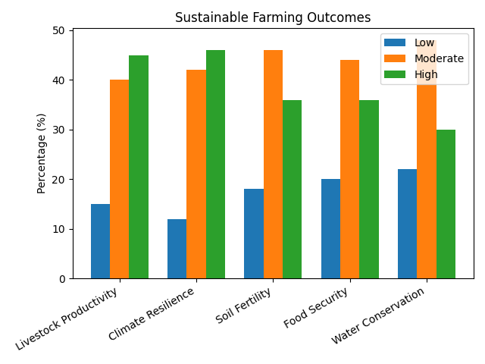
Figure 4: Sustainable Farming Outcomes (Stacked Representation)
The chart on Sustainable Farming Outcomes ( Figure 4) shows a generally positive but mixed impact of sustainable farming practices across five key indicators: livestock productivity, climate resilience, soil fertility, food security, and water conservation. Overall, the “moderate” category dominates most outcomes, indicating that many households experience partial rather than full benefits from sustainable farming interventions.
Livestock productivity records strong performance, with a high outcome level (45%) slightly surpassing moderate (40%) and low (15%), suggesting that sustainable practices are significantly improving animal production. Climate resilience also shows a strong positive trend, with the highest proportion in the “high” category (46%) closely followed by moderate (42%), indicating that farming systems are increasingly adapting well to climate variability.
In contrast, soil fertility and food security are largely concentrated in the moderate category (45% and 44% respectively), with relatively lower high outcomes (36% for both). This suggests that while improvements are evident, they are not yet fully optimized, possibly due to limitations in soil management inputs or persistent socio-economic constraints affecting food access and stability.
Water conservation shows the weakest performance in terms of high outcomes (30%), despite a relatively high moderate level (about 44–48%) and the highest low category (22%). This indicates that water conservation practices are less effectively translating into strong results compared to other outcomes, likely due to water scarcity pressures, infrastructure gaps, or inconsistent adoption of water-saving technologies.
Overall, the findings suggest that sustainable farming practices are contributing positively to agricultural outcomes, but the benefits are uneven. Gains are strongest in livestock productivity and climate resilience, while soil fertility, food security, and especially water conservation require further strengthening to achieve higher levels of sustainability and impact.

4.6. Influence of IEA Practices on Sustainable Farming

Figure 5: Influence of IEA Practices on Sustainable Farming
Interpretation and Discussion of Findings
The results (Figure 5) show that rotational grazing (78%) is the most widely adopted Indigenous Ecological Agriculture Practice among the studied households. This indicates that most Maasai pastoralists strongly rely on controlled grazing systems to manage pasture availability and prevent land degradation. The high uptake suggests that rotational grazing remains a central strategy for sustaining livestock productivity and maintaining rangeland health in Kajiado County, despite increasing environmental pressures.
Ethno-veterinary medicine (72%) also records a high adoption level, reflecting continued reliance on indigenous animal health management systems. This implies that many households still depend on traditional herbal and cultural livestock treatment practices, likely due to their affordability, accessibility, and strong cultural acceptance. It also suggests limited access to or high costs of formal veterinary services in some areas.
Seasonal mobility (65%) shows a relatively strong practice, indicating that pastoral households still move livestock in response to spatial and temporal variations in pasture and water availability. However, the moderate level suggests that mobility is increasingly constrained, possibly due to land subdivision, fencing, and settlement expansion, which reduce access to traditional grazing corridors.
Soil and water conservation practices (59%) are moderately adopted, suggesting growing but not universal awareness of land degradation challenges. This level indicates that while some households are implementing measures such as water harvesting and soil protection structures, others may lack resources, technical knowledge, or incentives to fully adopt them.
Finally, crop–livestock integration (54%) is the least adopted practice among the five, though still above half of respondents. This suggests that although agro-pastoralism is emerging, many households still operate primarily under livestock-based systems. The relatively lower adoption may be due to limited rainfall reliability, land constraints, or continued preference for traditional pastoral livelihoods.
Collectively, the findings indicate that Indigenous Ecological Agriculture Practices remain highly relevant in the Maasai community, with particularly strong emphasis on livestock-centered strategies such as rotational grazing and ethno-veterinary medicine. However, the comparatively lower adoption of crop-related and soil conservation practices suggests a gradual shift influenced by environmental stressors and socio-economic transformation. These results imply that while indigenous knowledge systems are still active, their continuity is increasingly challenged by land-use change, modernization, and climate variability, which may affect long-term sustainability of pastoral livelihoods in Kajiado County
4.4. Summary of Findings
High adoption of traditional practices, especially grazing systems and indigenous livestock treatment. Strong positive relationship between IEA practices and sustainability indicators. Households practicing multiple IEA strategies reported better resilience and productivity. Soil and water conservation practices emerged as the most influential factor.

The findings demonstrate that Indigenous Ecological Agriculture practices significantly influence sustainable farming among the Maasai in Kajiado County. Rotational grazing enhances rangeland regeneration and reduces degradation, consistent with ecological resilience theory (Galvin, 2009). Indigenous soil and water conservation practices improve moisture retention and soil stability, which are critical in semi-arid environments.
The positive influence of ethno-veterinary medicine reflects the effectiveness of indigenous animal health knowledge in reducing livestock mortality and production costs. Crop–livestock integration contributes to nutrient recycling and livelihood diversification, while indigenous climate prediction knowledge supports adaptive decision-making under climatic uncertainty. These findings support earlier studies emphasizing the sustainability potential of indigenous knowledge systems (Altieri & Nicholls, 2017; Pretty, 2018).
5. Conclusion
This study establishes that Indigenous Ecological Agriculture practices have a significant positive influence on sustainable farming among the Maasai community in Kajiado County. By enhancing environmental conservation, livelihood resilience, and food security, IEA practices remain vital to sustainable development in ASAL regions.

References
Altieri, M. A., & Nicholls, C. I. (2017). Agroecology: A brief account of its origins and currents of thought in Latin America. Agroecology and Sustainable Food Systems, 41(3–4), 231–237.
Altieri, M. A., & Nicholls, C. I. (2017). The adaptation and mitigation potential of traditional agriculture in a changing climate. Climatic Change, 140(1), 33–45. https://doi.org/10.1007/s10584-013-0909-y
Evangelou, P. (2019). Livestock production and pastoral livelihoods in Kenya’s ASALs. Nairobi: International Livestock Research Institute (ILRI).
FAO. (2015). Status of the world’s soil resources (SWSR) – main report. Food and Agriculture Organization of the United Nations.
FAO & ITPS. (2015). Status of the world’s soil resources: Main report. Rome: Food and Agriculture Organization of the United Nations.
Galvin, K. A. (2009). Transitions: Pastoralists living with change. Annual Review of Anthropology, 38, 185–198. https://doi.org/10.1146/annurev-anthro-091908-164442
Government of Kenya. (2008). Kajiado District Development Plan 2008–2012. Nairobi: Government Printer.
Government of Kenya. (2013). National Livestock Policy. Nairobi: Ministry of Agriculture, Livestock and Fisheries.
Government of Kenya. (2018). National climate change action plan 2018–2022. Nairobi: Ministry of Environment and Forestry.
Government of Kenya. (2021). Kenya climate change action plan (2018–2022). Nairobi: Ministry of Environment and Forestry.
Government of Kenya. (2021). Kenya climate-smart agriculture strategy. Nairobi: Ministry of Agriculture, Livestock, Fisheries and Cooperatives.
Herrero, M., Thornton, P. K., Power, B., et al. (2016). Farming and the geography of nutrient production for human use: A transdisciplinary analysis. The Lancet Planetary Health, 1(1), e33–e42.
Homewood, K., Kristjanson, P., & Trench, P. C. (2009). Staying Maasai? Livelihoods, conservation and development in East African rangelands. Springer.
IPCC. (2022). Climate change 2022: Impacts, adaptation and vulnerability. Cambridge University Press.
Jaetzold, R., Schmidt, H., Hornetz, B., & Shisanya, C. (2006). Farm management handbook of Kenya Vol. II: Natural conditions and farm management information. Nairobi: Ministry of Agriculture.
Kenya National Bureau of Statistics (KNBS). (2019). 2019 Kenya population and housing census: Volume I – Population by county and sub-county. Nairobi: KNBS.
Pretty, J. (2018). Sustainable intensification of agriculture: Concepts and challenges. Current Opinion in Environmental Sustainability, 8, 5–12.
Pretty, J. (2018). Sustainable intensification of agriculture. Routledge.
Reid, R. S., Fernández-Gimenez, M. E., & Galvin, K. A. (2014). Dynamics and resilience of rangelands and pastoral peoples around the globe. Annual Review of Environment and Resources, 39, 217–242.
UNEP. (2019). Global environment outlook – GEO-6: Healthy planet, healthy people. United Nations Environment Programme.

