Valorization of Agro-industrial Waste in Concrete Mix Design: A Review

.
Abstract

This article presents a review of the literature from the last 10 years (2023-2013) on the incorporation of ash from industrial waste into concrete mixtures to replace Portland cement. This practice has emerged as an economically viable and sustainable solution to reduce waste in the agribusiness sector and to avoid the depletion of natural resources resulting from the growing demand for civil construction in the country. The review was conducted on the Scopus and Web of Science platforms using the keywords “Concrete”, “Ash”, and “Sustainability”, yielding 1266 scientific articles. Of these, only 22 articles were selected because they contained the keywords in their titles. The results of the review demonstrated the predominance of coal fly ash over other waste used to replace Portland cement. Ash amounts range from 5% to 30% across different plant matrices. The axial compression test was used as a performance measure of the concrete's final strength. Finally, the great potential for using ash from rice husks, coal, palm oil, municipal solid waste, and cashew nut shells was demonstrated.

Keywords: Concrete; Ash; Sustainability.

Introduction

Cement is a widely used material in civil construction, composed of various elements, with limestone being the main raw material. It is composed of the mineral calcite (calcium carbonate, CaCO₃) and other materials, such as clays, iron, and silica, in varying proportions. Concrete is formed from cement paste, mortar, and coarse aggregate (crushed stone). The paste is a mixture of cement and water, while the mortar is a mixture of the paste with fine aggregate (sand). A large quantity of carbon dioxide (CO₂), carbon monoxide (CO), sulfur oxides (SOx), nitrogen oxides (NOx), heavy metals, and particulates is generated during the production of Portland cement due to the high amount of energy required to raise the temperature of rotary kilns during the clinkerization and calcination stages of the cement raw material. (CAMÕES, 2005).

Replacing Portland cement with ash from industrial processes in concrete mixes results in cost savings per cubic meter of concrete and can also improve the concrete's initial and final strength. As a fundamental supplier of raw materials to various industrial sectors, forestry plays a key role in fostering Brazil's development, positioning it as a highly competitive player in international markets. Furthermore, this activity plays a crucial role in the environmental landscape, encompassing the safeguarding and rehabilitation of water and soil resources, the mitigation of impacts from greenhouse gas emissions, and the reduction of pressure on the exploitation of native forests.

Brazil stands out as one of the leading exponents of silvicultural practices, achieving high levels of productivity through favorable edaphoclimatic conditions, ample land availability, and a remarkable accumulation of technical and scientific knowledge. The country's forestry sector, focused on the cultivation of planted forests, is responsible for 91% of the total volume of wood produced for industrial purposes, while only 9% comes from managed native forests, according to a report by the Brazilian Tree Institute (IBÁ, 2016).

In the context of environmental preservation, natural areas in Brazil encompass approximately 5.9 million hectares, materialized through Permanent Preservation Areas (APPs), Legal Reserves (RL), and Private Natural Heritage Reserves (RPPNs). Furthermore, approximately 32,700 hectares were restored in 2019 through programs aimed at revitalizing degraded areas. Thus, for every hectare of planted forest, approximately 0.7 hectares of natural ecosystem are preserved, revealing a substantial effort in favor of conservation, according to updated data from IBÁ (2023).
The objective of this review is to analyze the main types of waste materials used and their performance in terms of compressive strength of concrete, based on the percentages adopted in the analyzed mix designs.

2. Materials and Methods

This work consists of a systematic literature review with bibliometric analysis, conducted according to the PRISMA (Preferred Reporting Items for Systematic Reviews and Meta-Analyses) protocol, adapted to studies in the area of engineering and cementitious materials.
The search was conducted in the international databases: Scopus (Elsevier) and Web of Science – Core Collection (Clarivate Analytics). The period analyzed was from January 1, 2013, to July 1, 2023, to evaluate the scientific output of the last decade.
The following Boolean combinations were used: ("Concrete") AND ("Ash") AND ("Sustainability"). The search was applied to the following fields: Title, Abstract, and Keywords. Only scientific articles (Document type: Article) were considered.
Included studies met these criteria: published 2013–2023, focused on incorporating ash in concrete, analyzed mechanical performance (mainly compressive strength), addressed environmental sustainability, and appeared in peer-reviewed journals.
Exclusion criteria: duplicate works, conference papers, book chapters, narrative reviews, technical notes, studies lacking experimental or technical data on concrete, and works using ash only as aggregate, not as cement replacement.

The decision to opt for research platforms was motivated by the relevance of their publications and by their status as databases commonly used in scientific research, as they are easily accessible. Correlations between authors and countries of publication were constructed using VOSviewer (version 1.6.19, free), available at https://www.vosviewer.com/download.
.

3. Results and Discussions

3.1 Analysis of data on the Scopus platform.

The Scopus repository of abstracts and interdisciplinary applications, under the Elsevier publishing umbrella, boasts a remarkably broad collection of information. This comprehensive repository spans 240 academic disciplines and manifests quantitatively, housing a vast collection exceeding 87 million documents. Furthermore, it includes a collection of 335,000 books and links to more than 7,000 distinct publishing entities.
Scopus's distinctive feature is the convergence of automated data collection methods and a detailed curation manual. This hybrid approach culminates in the generation of highly comprehensive and accurate author profiles. Through this approach, Scopus provides a diverse collection of over 17 million author profiles, allowing one to familiarize oneself with the researcher in a manner analogous to exploring academic articles. This process, marked by efficiency and ease of use, significantly contributes to the identification and understanding of intellectual agents and was created to support scientific research and academic production.
As a result of using the search string containing all the words on the Scopus (Elsevier) website, 817 results were found. The search string used was "Concrete" AND "Ash" AND "Sustainability" across the Article Title, Abstract, and Keywords fields, with a 10-year search period (01/01/2013 to 01/07/2023). The document type was limited to Article.
Among the 817 articles researched, Table 1 presents the authors with the highest number of publications and citations found in the repository. It should be noted that there are more authors, but attention was given to those who publish the most.
Authors | Number of Articles Published | Number of citations
ZHANG, Y. | 12 | 417
SETUNGE, S. | 11 | 286
ADESINA, A. | 10 | 242
GUNASEKARA, C. | 10 | 280
LAW, D.W. | 9 | 132
NEHDI, M.L. | 9 | 149
HUSEIEN, G.F. | 8 | 219
BHEEL, N. | 7 | 127
DE BRITO, J. | 7 | 521
JUMAAT, M.Z. | 7 | 353
KURDA, R. | 7 | 366
WANG, J. | 7 | 31

Table 01 – Authors with number of publications and citations in SCOPUS

3.2 Analysis of data on the Web of Science platform.
Formerly known as ISI Web of Knowledge, it is a research platform for accessing bibliographic citation count databases, such as the Science Citation Index (SCI). The repository covers subjects in Information Science, Scientific Communication, Bibliometric Indicators, and Multidisciplinary studies, creating a broad network that makes it easy to locate datasets, conference papers, books, dissertations, preprints, and patents, along with content from the world's leading journals.
The search was conducted in Web of Science using advanced search settings. Specifically, the queries targeted: TI=("Concrete" AND "Ash" AND "Sustainability") for article titles, AB=("Concrete" AND "Ash" AND "Sustainability") for abstracts, and AK=("Concrete" AND "Ash" AND "Sustainability") for keywords. The document type was limited to "Article," and the search period was set from January 1, 2013, to July 1, 2023. The search was performed on August 10, 2023.
A total of 449 articles were identified in the Web of Science - Core Collection, with Table 2 summarizing the most prolific authors by publication and citation count.
Authors | Number of Articles Published | Number of citations
ADESINA, A | 8 | 173
DE BRITO, J | 7 | 459
HUSEIEN, GF | 6 | 128
KURDA, R | 6 | 296
AZAB, M | 5 | 10
NEHDI, ML | 5 | 77
SETUNGE, S | 5 | 203
SILVESTRE, JD | 5 | 437
TAHWIA, AM | 5 | 74
WANG, XY | 5 | 28
ALENGARAM, UJ | 4 | 146
ALI, B | 4 | 44
Table 2 – Authors with number of publications and citations on the Web of Science

3.3 Analysis of data on the two research platforms

The search across both platforms yielded a total of 1266 articles. Figure 1 shows the interrelationship between these authors in all the selected articles.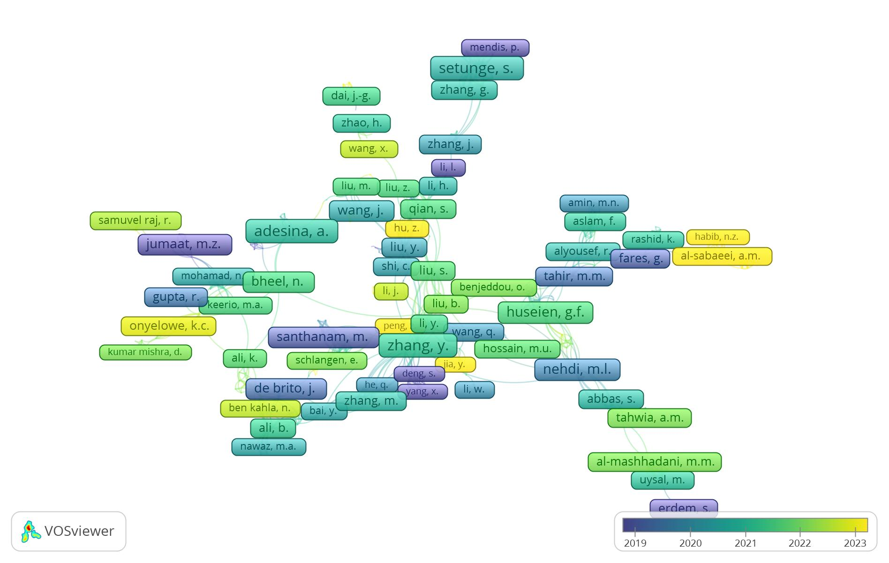
Figure 1 - Interrelation of authors who have published on the subject in the last ten years..

Figure 1 shows that publications are not centered on a single author, and no author has a large number of publications. Zhang, Setunge, Adesina, and Gunaseka have 12, 11, and 10 published articles, respectively, from 2019 to 2023.
Table 3 identifies the 12 leading countries in both publications and citations. In this context, Brazil ranks 26th, having published 11 articles that generated 152 citations. India appears as the country that published the most and as the second-most-cited country in this area. This fact can be explained by India's energy matrix, which is heavily reliant on coal. According to the International Energy Agency (IEA) on December 23, 2020, 75.9% of India's energy matrix came from coal combustion (IEA-2020). This contributes to the generation of a large amount of fly ash.
Country | Number of Articles Published | Number of citations
Índia | 212 | 2699
United States | 84 | 2885
Malaysia | 82 | 1692
China | 74 | 1966
Australia | 54 | 1974
United Kingdom | 50 | 1092
Saudi Arabia | 49 | 664
Canada | 46 | 1237
Pakistan | 42 | 582
Turkey | 39 | 954
Nigeria | 31 | 371
Egypt | 29 | 542

Table 03 – Countries with the number of publications and citations on the Web of Science and Scopus.

In Figure 02, we can see the interrelationships among the countries that published the most articles in this area among the selected articles.

In Figure 03, the interrelationships among the countries most cited in articles in this area across all selected articles are shown. Among these countries, India, the United States, and China stand out as references for concrete, ash, and sustainability.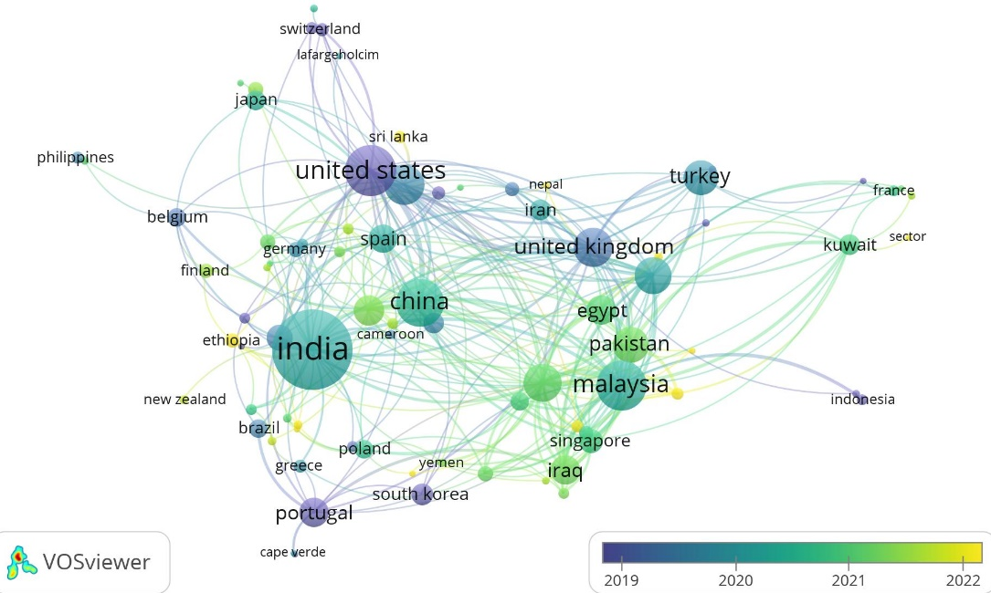.
Figure 2 – Analysis of the countries that published the most during the research period..

Figure 3 also presents a timeline spanning 2019 to 2022, showing this period as the time when articles from the most-cited countries were published.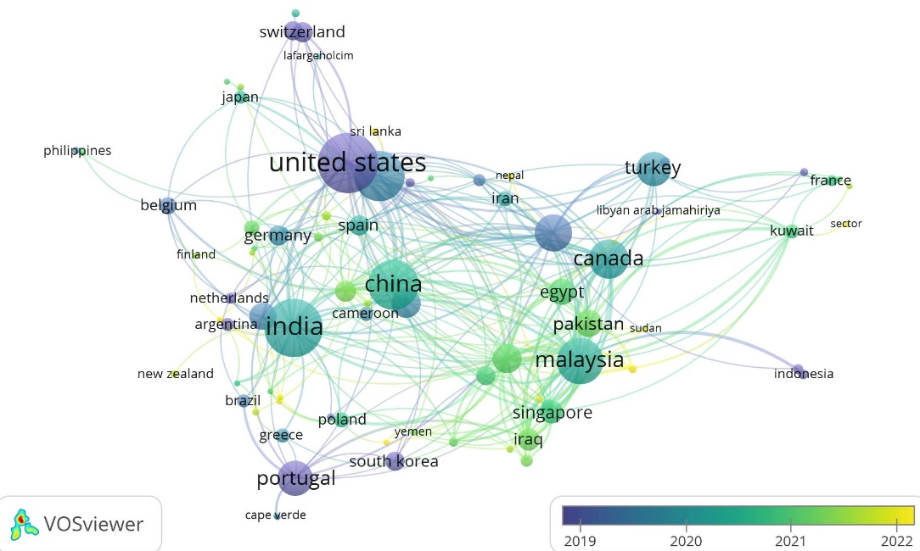
Figure 3 – Interrelation of the countries most frequently cited in other articles

3.4 Analysis of the data obtained using the keywords present in the article title.

The search strategy was refined to include only articles with "Concrete," "Ash," or "Sustainability" in the title or keywords, yielding 22 articles in Scopus (Elsevier) and 14 in Web of Science Core Collection (Clarivate Analytics).
The works found in the two repositories totaled 36 articles, of which 14 were common to both. Therefore, the 22 selected articles were analyzed using the aforementioned keywords.
Table 4 presents the list of authors, along with the number of published articles and citations for the 22 selected articles in the two repositories.
Authors | Articles | Number of citations
ABHISHEK R. | 1 | 1
ABUSHANAB A.; ALNAHHAL W. | 2 | 3
ALSUBARI B. | 1 | 8
AZMEE N. | 1 | 23
DA SILVA S.R. | 1 | 5
JHATIAL A.A. | 1 | 31
KIM K.; SHIN M.; CHA S. | 1 | 27
KUMAR M.; PRASHANT S.; KAMATH M.V. | 1 | 8
LEE J. | 2 | 0
LI Z. | 1 | 1
LIU Z. | 1 | 0
MURALI M. | 1 | 19
NASERI H. | 1 | 21
OROZCO C.R. | 1 | 0
OYEBISI ET AL., 2022B) | 1 | 2
(OYEBISI ET AL., 2022A) | 1 | 0
(OYEBISI ET AL., 2023) | 1 | 13
RID Z.A. | 1 | 1
SARAVANAN M.M.; SIVARAJA M. | 1 | 4
SILVA H.G.C. | 1 | 12
SUBRAMANIAM D.N.; SATHIPARAN N. | 1 | 15
YANG E. H.; LIU Y.; CHEN Z. | 1 | 3
Table 04 – List of most cited authors among the 22 selected articles.

The final analysis sought to identify the correlation network between the authors of the 22 articles, which are listed in Table 4. Figure 4 presents the resulting map from the analysis.
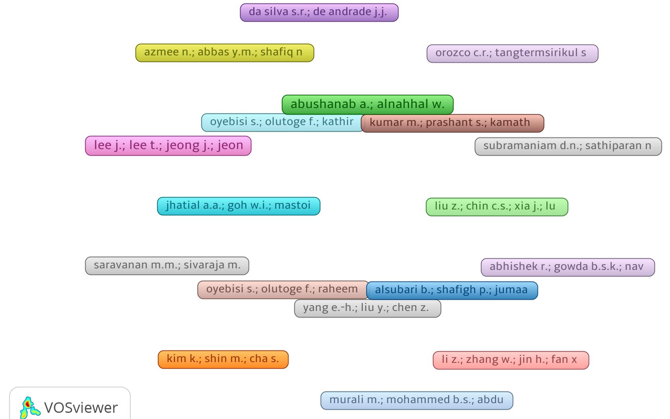

Figure 4 – Correlation map between the authors of the 22 selected articles

Figure 4 showed that no clusters formed among the authors. No connecting lines appeared, indicating no mutual citation even though the same keywords were used. This may be because the final objective of the work is not similar.

3.5 Analysis of published articles containing keywords in the title.

After the conclusion of the first stage of the research, 22 articles were selected to deepen the understanding of studies on the incorporation of ash into concrete, with a view to the sustainability of the process and the product. The parameters of interest researched in the articles were the type and quantity of ash added, its granulometry, oxides present in the ash, and the crystalline structure of these oxides. Table 5 presents this information, which can help understand the viability of using waste materials as a partial substitute for Portland cement.
Authors | Type of  Ashes | Particle Size Distribution of Ash | Oxides found | Crystalline Forms | Amount  of Gray
(KIM; SHIN; CHA, 2013) | Steering wheels  Coal | ========= | SiO₂ | ========= | 30%
(ABUSHANAB; ALNAHHAL, 2021) | Steering wheels  Coal | ========= |  | Labradorite  portlandite | 0%,20%  and 35%
(OROZCO et al., 2023) | Steering wheels  Coal | ========= | Calcium oxide (CaO) | ========= | 0%,25%  and 50%
(SUBRAMANIAM; SATHIPARAN, 2022) | Flywheels  Charcoal and Rice Husk | ========= | ========= | ========= | =========
(OYEBISI et al., 2022a) | Cashew Nut Shells | ========= | ========= | ========= | between 5%  and 20%
(LEE et al., 2020) | Coal | ========= | ========= | ========= | 0% to 70%
(AZMEE et al., 2021) | Steering wheels  Coal | ========= | ultrafine calcium carbonate | ========= | 40% ash, 10% carbonate
(KUMAR; PRASHANT; KAMATH, 2022) | ultrafine calcium carbonate and sewage sludge | ========= | ========= | ========= | 50%
(YANG; LIU; CHEN, 2015) | Municipal solid waste | ========= | ========= | ========= | =========
(RID et al., 2022) | Steering wheels  Charcoal + marble dust | ========= | ========= | ========= | between 5%  and 20%
(LIU et al., 2023) | Steering wheels  Coal | ========= | ========= | ========= | =========
(SILVA et al., 2018) | Steering wheels  Coal | ========= | ========= | ========= | 0% to 50%
(ABHISHEK et al., 2023) | Agricultural Waste | ========= | ========= | ========= | 2,5%
(LI et al., 2023) | Flywheels Coal + blast furnace slag | ========= | ========= | ========= | 0% to 100% as aggregate
(ALSUBARI et al., 2022) | Palm oil | ========= | ========= | ========= | 0%,50%  and 70%
(OYEBISI et al., 2023) | Bagasse ash + calcite powder | ========= | ========= | ========= | 5% to 15%
(OYEBISI et al., 2022b) | corn cob | ========= | ========= | ========= | =========
(SARAVANAN; SIVARAJA, 2018) | Rice husk | ========= | ========= | ========= | 0% to 30%
(DA SILVA; DE ANDRADE, 2017) | Steering wheels  Coal | ========= | ========= | ========= | 0% to 30%
(JHATIAL et al., 2021) | Palm oil + eggshell | oil 150 μm  egg 75 μm | CaO,SiO₂,  al2O3,Fé₂O₃, MgO, k₂O | ========= | 20% to 25% 05% to 15%
(NASERI et al., 2022) | Steering wheels  Coal | ========= | ========= | ========= | =========
(MURALI et al., 2021) | Steering wheels  Charcoal + Crushed rubber | ========= | ========= | ========= | =========
Table 05 – Parameters: types and particle size of ash, oxides, crystalline forms and ash quantity
Analyzing Table 5, we can infer that the main type of ash used is coal fly ash, present in 13 studies. Other agricultural residues, such as rice husks, palm oil, corn cobs, and cashew nut shells, have also been incorporated into concrete as substitutes for cement. Most of the studies analyzed used axial compression testing to verify the resistance and viability of using the residue.
It was observed that none of the studies mentioned the degree of pozzolanic activity of the ashes, a characteristic of fundamental importance for defining the quantity to be used in the adopted concrete or mortar mix. Finally, it is important to emphasize that none of the analyzed works used Eucalyptus alba ash, indicating the potential for further studies using this material's ashes.The percentage of ash used in partial replacements for Portland cement varies, mostly between 5% and 30%. All partial replacements of Portland cement with the adopted ashes yielded good results, each ash with its own specifications. The most commonly used ash was coal fly ash. In most projects incorporating this ash, the results demonstrate its viability, especially regarding compressive strength. This practice suggests a sustainable alternative by partially incorporating cement in concrete production, also standing out for the use of a higher quantity of ash compared to other types.
Coal fly ash contains Si (silica), which reduces concrete permeability and increases its resistance. Another component of coal fly ash is CaO (calcium oxide), which, upon hydration, produces Ca(OH)2. This oxide is consumed during the pozzolanic process and helps reduce the heat of hydration of concrete, thereby increasing its durability against various aggressive agents (TASHIMA, 2012).
In studies of ash parameters, only 5 works referenced particle size distribution, the chemical composition of ash based on oxide characterization, and crystalline forms, highlighting the lack of bibliographic material on the subject.

4. Conclusion

This study systematized the scientific literature from the last decade on the incorporation of ash from industrial and agro-industrial waste as a partial replacement for Portland cement in cementitious matrices. The analysis showed the predominance of coal fly ash, mainly in the 5%-30% range, with satisfactory results for compressive strength and overall mechanical performance of the concrete.

It was observed that the technical feasibility of partially replacing cement with ash is well established in the literature, particularly with respect to environmental sustainability and the reduction of the carbon footprint associated with Portland cement production. However, significant methodological heterogeneity was observed across the studies, particularly in the physicochemical characterization of the ash and its pozzolanic behavior.
Critical analysis revealed significant gaps in the literature. It was observed that few studies provide a detailed characterization of ash, including particle-size distribution, mineralogical composition, crystalline phases, and degree of pozzolanic activity, all of which are crucial to the mechanical performance and durability of concrete.
There is little research on agro-industrial residues such as ash from specific forest species, highlighting unexplored opportunities for future studies.
COMPETING INTERESTS DISCLAIMER:
Authors have declared that they have no known competing financial interests OR non-financial interests OR personal relationships that could have appeared to influence the work reported in this paper.

5. references

ABHISHEK, R. et al. Prediction of Compressive Strength of Corncob Ash Concrete for Environmental Sustainability Using an Artificial Neural Network: A Soft Computing Techniques. Journal of Soft Computing in Civil Engineering, v. 7, n. 2, p. 115–137, 2023.
ABUSHANAB, A.; ALNAHHAL, W. Combined effects of treated domestic wastewater, fly ash, and calcium nitrite toward concrete sustainability. Journal of Building Engineering, v. 44, 2021.
ALONSO, C.; FERNANDEZ, L. Dehydration and rehydration processes of cement paste exposed to high temperature environments. Journal of Materials Science, v. 39, n. 9, p. 3015–3024, maio 2004.
ALSUBARI, B. et al. Self-compacting concrete containing high volume palm oil fuel ash: cost, sustainability, and applications. International Journal of Sustainable Building Technology and Urban Development, v. 13, n. 2, p. 148–154, 2022.
AZMEE, N. et al. Enhancing the microstructure and sustainability of ultra-high-performance concrete using ultrafine calcium carbonate and high-volume fly ash under different curing regimes. Sustainability (Switzerland), v. 13, n. 7, 2021.
CAMÕES, A. Betões de Elevado Desempenho com Incorporação de Cinzas Volantes. Revista de Engenharia Cívil, Azurém, Portugal, v. 23, p.55-64, 2005.
COUTINHO, V. M. Mapeamento das Áreas Plantadas com Eucalyptus spp. no Estado do Paraná. Disponível: file:///C:/Users/User/Downloads/51222-200426-1-PB%20(2).pdf. Acessado em 15/08/2023.
DA SILVA, S. R.; DE ANDRADE, J. J. O. Sustainability in the construction industry: Investigation of the employment potential of construction and demolition waste (CDW) and fly ash in concretes. Espacios, v. 38, n. 27, 2017.
DONNELLY, F. C. et al. Synthesis of CaCO ₃ nano- and micro-particles by dry ice carbonation. Chemical Communications, v. 53, n. 49, p. 6657–6660, 2017.
IBÁ – Indústria Brasileira de Árvores. Anuário Estatístico IBÁ 2016. Brasília, 2016. 96 p
IBÁ – Indústria Brasileira de Árvores. Anuário Estatístico IBÁ 2023. Disponível: https://iba.org/dados-estatisticos. Acessado em 15/08/2023.
IEA- International Energy Agency. Disponível https://www.iea.org/data-and-statistics/charts/electricity-mix-in-india-january-december-2020. Acesso em: 29 set. 2023.
INOZEMTCEV, A. S.; KOROLEV, E. V. A method for the reduction of deformation of high-strength lightweight cement concrete. Advances in Cement Research, v. 28, n. 2, p. 92–98, fev. 2016.
JHATIAL, A. A. et al. Thermo-mechanical properties and sustainability analysis of newly developed eco-friendly structural foamed concrete by reusing palm oil fuel ash and eggshell powder as supplementary cementitious materials. Environmental Science and Pollution Research, v. 28, n. 29, p. 38947–38968, 2021.
KIM, K.; SHIN, M.; CHA, S. Combined effects of recycled aggregate and fly ash towards concrete sustainability. Construction and Building Materials, v. 48, p. 499–507, 2013.
KIM, S.-J.; YANG, K.-H.; MOON, G.-D. Hydration Characteristics of Low-Heat Cement Substituted by Fly Ash and Limestone Powder. Materials, v. 8, n. 9, p. 5847–5861, 1 set. 2015.
KUMAR, M.; PRASHANT, S.; KAMATH, M. V. Enhancing the sustainability of high strength concrete in terms of embodied energy and carbon emission by incorporating sewage sludge and fly ash. Innovative Infrastructure Solutions, v. 7, n. 4, 2022.
LEE, J. et al. Engineering, durability, and sustainability properties analysis of high-volume, PCC ash-based concrete. Sustainability (Switzerland), v. 12, n. 9, 2020.
LI, Z. et al. Research on the durability and Sustainability of an artificial lightweight aggregate concrete made from municipal solid waste incinerator bottom ash (MSWIBA). Construction and Building Materials, v. 365, 2023.
LIU, Z. et al. Exploring the sustainability of concrete with fly ash, recycled coarse aggregate and biomineralisation method by life cycle assessment. Journal of Cleaner Production, v. 406, 2023.
MURALI, M. et al. Utilization of crumb rubber and high-volume fly ash in concrete for environmental sustainability: Rsm-based modeling and optimization. Materials, v. 14, n. 12, 2021.
NASERI, H. et al. Toward sustainability in optimizing the fly ash concrete mixture ingredients by introducing a new prediction algorithm. Environment, Development and Sustainability, v. 24, n. 2, p. 2767–2803, 2022.
OROZCO, C. R. et al. Comparative environmental assessment of low and high CaO fly ash in mass concrete mixtures for enhanced sustainability: Impact of fly ash type and transportation. Environmental Research, v. 234, 2023.
OYEBISI, S. et al. Effects of cashew nutshell ash on the thermal and sustainability properties of cement concrete. Heliyon, v. 8, n. 11, 2022a.
OYEBISI, S. et al. Sustainability assessment of geopolymer concrete synthesized by slag and corncob ash. Case Studies in Construction Materials, v. 17, 2022b.
OYEBISI, S. et al. Sustainability assessment of cement concrete modified with bagasse ash and calcite powder. Materials Today: Proceedings, 2023.
Plataforma Scopus (Elsevier), 2023. Disponível: https://www.elsevier.com/pt-br/solutions/scopus. Acesso em: 20 jul. 2023.
RID, Z. A. et al. Evaluation of combined utilization of marble dust powder and fly ash on the properties and sustainability of high-strength concrete. Environmental Science and Pollution Research, v. 29, n. 19, p. 28005–28019, 2022.
SARAVANAN, M. M.; SIVARAJA, M. Sustainability in construction industry by utilizing rice husk ash in concrete. Ecology, Environment and Conservation, v. 24, p. S45–S47, 2018.
SILVA, H. G. C. et al. Improving sustainability through corrosion resistance of reinforced concrete by using a manufactured blended cement and fly ash. Sustainability (Switzerland), v. 10, n. 6, 2018.
SINGH, L. P. et al. Effect of Morphology and Dispersibility of Silica Nanoparticles on the Mechanical Behaviour of Cement Mortar. International Journal of Concrete Structures and Materials, v. 9, n. 2, p. 207–217, jun. 2015.
SUBRAMANIAM, D. N.; SATHIPARAN, N. Comparative study of fly ash and rice husk ash as cement replacement in pervious concrete: mechanical characteristics and sustainability analysis. International Journal of Pavement Engineering, 2022.
VETTER, M. et al. The use of Raman spectroscopy to monitor phase changes in concrete following high temperature exposure. Construction and Building Materials, v. 204, p. 450–457, abr. 2019.
YANG, E.-H.; LIU, Y.; CHEN, Z. Environmental sustainability through recycling incineration bottom ash for the production of autoclaved aerated concrete. Key Engineering Materials, v. 650, p. 51–70, 2015.

