Impact of brushing schedule on disease incidence and cocoon characteristics of Tasar Silkworm, Antheraea mylitta D., Saturniidae: Lepidoptera

Abstract
The experiment was conducted to study the impact of brushing schedule on disease incidence and cocoon characteristics of tasar silkworm. Silkworms were brushed in seven different schedule, information on diseases incidence, cocoon weight, shell weight, cocoon colour and flimsy cocoon percentage was collected. The results of the experiment revealed that brushing schedule significantly (P≤0.05) influences the disease incidence and cocoon characteristics of tasar silkworm. The early and on time brushing schedule B₂-24.09.22, B₃-29.09.23 and B₁-19.09.22 recorded higher incidence of diseases (09.67 to 09.85 % of virosis and 06.65 to 06.85 % bacteriosis), whereas, delayed brushing lots such as B₅- 07.10.22, B₆-12.10.22 and B₇-20.10.22 recorded minimum incidence of diseases (03.90 to 06.90 % of virosis and 02.85 to 05.75 % of bacteriosis). Moreover, cocoon yield recorded maximum (85.00 cocoons per dfls) in delayed brushing B₅-07.10.22. However, cocoon quality parameters such as cocoon weight (g), shell weight (g) and shell ratio (%) were slightly reduced in delayed brushing lot B₅- 07.10.22 (11.75 g, 1.83 g and 15.93 %), when compared to on time brushing lot B₁-19.09.22 (12.15 g, 1.98 g and 16.49 %). Moreover, cocoon colour also differed from whitish gray to dusty gray in delayed brushing lots and also those lots recorded a comparatively higher number of flimsy cocoons (B₇-04.82 %). However, cocoon yield was maximum in delayed brushing lots in comparison to on time brushing lots. Therefore, we are concluded that delayed brushing lots does not affect the cocoon yield. However, cocoon quality parameters may decrease slightly.
Keywords: Brushing schedule, diseases, cocoon, parameter, quality, yield

1.0 INTRODUCTION
Tasar culture is a forest-based culture provides employment opportunities to approximately 02.50 lakh tribal families of Jharkhand, Chhattisgarh, Bihar, Odisha, Andhra Pradesh, Telangana, Maharashtra, West Bengal, Madya Pradesh and Uttar Pradesh (Singh et al., 2014; Reddy et.al., 2015). Tasar silkworm is primarily cultivated in Terminalia arjuna, Terminalia tomentosa, (Jolly et al., 1974) and other secondary host plants like Shorea robusta, Sidha, Jarul, Saoni, T. paniculata, T. chebula, Haritaki, T. bellerica, Bahera, T. catapa, T. procera, T. glabra, Jamun, Careya arborea, Syzygium cumini, Kumbi, Shorea tailura (Agarwal and Seth, 1999). Tasar silkworm rearing is practiced by tribal population faces heavy crop loss due to unpredictable biotic and abiotic stresses. Ecological factors, temperature, quality of food, photoperiod, relative humidity and season have significant effect on tasar silkworm quality parameters (Sharma and Sarfaraz, 2013). The conventional method of tasar silkworm rearing resulted in 80-90% crop loss due to pests, diseases, predators and natural calamities (Kumar, 2003). Due to outdoor nature of tasar silkworm rearing and lack of control over weather variables (Temperature, relative humidity, rainfall and wind velocity), worms are highly susceptible to virosis and bacteriosis attacks (Singh et al., 1992). Brushing date is key factor in tasar silkworm rearing, where environmental restriction such as early and delayed winter and summer occurs. Singh et al. (2017) reported that decreasing trend of rearing performance in the sense of cocoon quantity and quality occurred when brushing schedule was delayed during first daba bivoltine tasar silkworm rearing. The seasonal variations in the climatic factors substantially effect the cocoon quality parameters such as cocoon weight, shell weight and shell ratio by effecting genotype expression (Chandrakanth et al., 2015). Moreover, (Shreyansh, 2021) reported variation in date of brushing has a significant effect on cocoon quality parameters . Therefore, the right brushing schedule plays an key role for optimum use of weather variables such as temperature, rainfall, relative humidity and wind velocity by tasar silkworm and also concordant with the rearing duration (Aharent and Caviness, 2004). Several authors reported brushing has significant role in success of tasar silkworm rearing. However, level of impact and disease level was not recorded. Keeping the above aspects in mind, present study was focused on “Impact of brushing schedule on disease incidence and cocoon characteristics of Tasar silkworm, A. mylitta D.
3.0 MATERIALS AND METHODS
The field experiment was conducted during second crop bivoltine tasar silkworm rearing 2022-23 at Basic Seed Multiplication and Training Centre (BSM&TC), Madhupur, Deoghar, Jharkhand (24.26° N, 86.64° E), to study the “Impact of brushing schedule on disease incidence and cocoon characteristics of Tasar Silkworm, A. mylitta D”. Madhupur falls under humid subtropical region, cold in winter and is sufficiently hot in summer, which is sub-divided into summer from March to May, monsoon from June to September and winter from October-February. The average rain fall in this region is 1,419.3 mm per year, 80 % rainfall receives during summer and July month receives maximum rainfall. The year to year variation in the annual rainfall is very little ((IMD, 2023).
The Randomized block design with seven treatments and four replicates was used in experimental design. We selected seven dates of brushing viz., B₁- (19.09.22), B₂- (24.09.22), B₃ - (29.09.22), B₄- (03.10.22), _{B}5- (07.10.22), B₆- (12.10.22) and B₇ (12.10.22), out of which B₅, B₆ and B₇ are slightly away (delayed) from brushing schedule of Santhal Pargana (BTSSO, 2022). The experimental purpose, we selected 28 progressive ASR farmers of BSM&TC, Madhupur and distributed 100 dfls per farmer as per brushing schedule. In each brushing dates, dfls distributed to four farmers, which treated as one replication. We supervised the rearing activities periodically and implemented all tasar rearing package of practices. During fourth and fifth instar larval stages, 1000 larvae per farmers were collected and observed for the virosis and bacteriosis visually and microscopically. Virosis was confirmed with symptoms such as lose of clasping power, larvae hang head downwards and attached to the host with its caudal legs and dark brown fluid oozes out as a drop from the mouth and confirmation of polyhedral body, whereas, bacteriosis infected larvae observed based on sealing of anal lips, rectal protrusion and chain like excreta symptoms (Plate 1-3). The disease percentage was calculated by following formula,
$$\text{\% }\text{disease}\text{=}\frac{\text{Number of disease}\text{d larvae observed}}{\text{Number of healthy larvae observed}}\text{×100}$$
Moreover, in each farmer 50 cocoons were collected randomly to asses cocoon quality parameters viz., flimsy cocoons, shell weight, cocoon weight, cocoon colour variation and shell ratio (SR %) respectively. We calculated SR% using following method,
$$\text{S}\text{h}\text{ell} \text{ratio}\text{ \%=}\frac{\text{Shell weight (g)}}{\text{cocoon weight (g)}}\text{×100}$$

- Bacteriosis symptoms in tasar silkworm
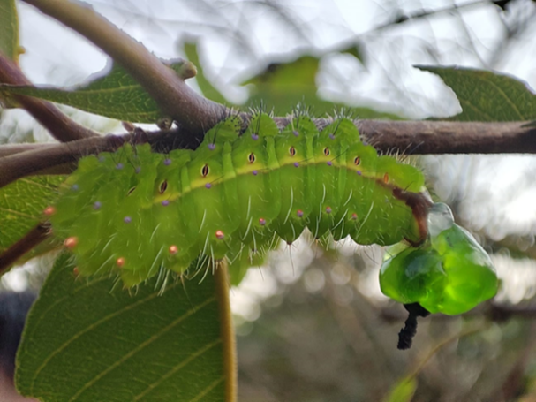 | 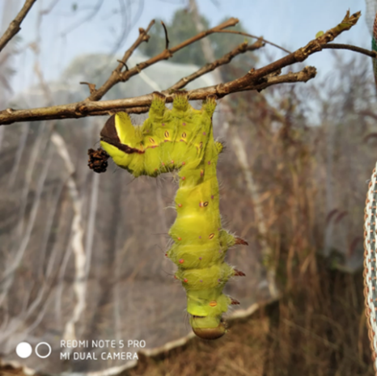
Fig 1. Rectal protrusion | Fig 2. Chain like excreta

- Virosis symptoms in tasar silkworm

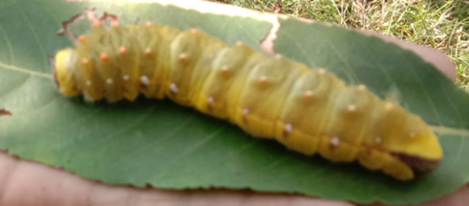 | 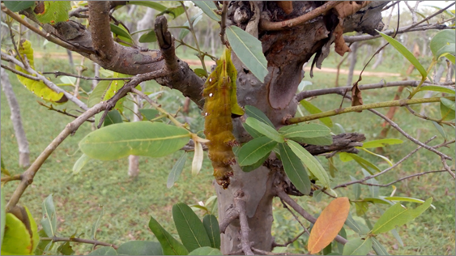
Fig 3. Discoloration of body (Initial symptoms) | Fig 4. Hanging upside down & Oozing out of body fluid

3.1 Statistical analysis
The field collected observational data were subjected to statistical analysis by using standard statistical analysis software tool pack SPSS and data on weather parameters, disease incidence were depicted in graphical form.
4.0 RESULTS AND DISCUSSION
The data analysis of virosis incidence in various brushing schedule experiment revealed that virosis incidence recorded 03.90 to 09.85 %. Minimum virosis incidence was recorded in B7-20.10.22 (03.90 %) followed by B6-12.10.22 (04.82 %) and B5-12.10.22 (06.90 %). Whereas, maximum virosis incidence was recorded in B2-24.09.22 (09.85 %) followed by B3-29.09.22 (9.77 %), B1-19.09.22 (09.67 %) (Table 1). Brushing schedule shown statistically significant (P≤0.05) to virosis (%) incidence. The results of the study indicated that delayed brushing lots less prone to virosis incidence, when compared to scheduled brushing lots in case of second crop DBV in Madhupur, Deoghar region. The early brushed lots exposes to high temperature clubbed with high relative humidity, whereas late brushing lots escapes from them. It may be favourable causes for higher incidence of virosis. The results are in line with Tanada, 1953; Harville,1955; Singh et al. (2021), who reported that higher temperature associated with high relative humidity accelerates the virosis incidence. Moreover, alternation of temperature between high and low during insect development become susceptible to virosis infection (Thompson, 1959; Singh et al. (2014)). The experimental observations revealed that bacteriosis incidence recorded in the range of 02.85 % to 07.05 %. Minimum bacteriosis incidence was recorded in B7-20.10.22 (02.85 %). Whereas, Maximum bacteriosis incidence was recorded in B2-24.09.22 (07.05 %) (Figure 1). The experimental results revealed that bacteriosis incidence was more in early and on time brushing, whereas minimum bacteriosis observed in delayed brushing lots (B5, B6 and B7). Brushing schedule shown significant (P≤0.05) difference to bacteriosis incidence. During early and on time brushing larvae were exposed to rainfall and high relative humidity which leads to outbreak of bacteriosis during current study (Figure 2). This study was supported by d’Herelle, 1914; Singh et al. (2014) who reported bacteriosis incidence is very intensive during rainy July-August than that of other season.
Cocoon weight recorded in the range of 10.75 to 12.15 g. The experimental results revealed that cocoon weight was more in on time brushing lots (B1, B2 and B3), when compared to delayed brushing lots (B5, B6 and B7). The present study contradictory to Shreyansh, 2021 who reported delayed brushing lots showed higher cocoon weight and he justified that during his experiment monsoon and winter got delayed. However, Pandey, 1995; Singh and Singh, (1988)and Chanu et al. (2016) reported that less relative humidity and higher temperature minimize the larval duration and increases the shell weight and cocoon weight which is in agreement with present study. Cocoon weight showed non-significance (P≥0.05) with brushing schedule. However, observations indicated that cocoon weight slightly decreases when brushing schedule delays. Shell weight recorded in the range of 01.64 to 1.98 g. Shell weight observations alike cocoon weight. However, brushing schedule shown significance (P≤0.05) with shell weight. Shell ratio trends observed similar to shell weight and cocoon weight trends. Alike shell weight, shell ratio (%) also shown significance to change in brushing schedule. Shell ratio (%) recorded in the range of 1.64 to 1.98 %). Brushing schedule showed significant (P≤0.05) difference with cocoon yield parameter. Cocoon yield recorded 54.25 to 85.00 cocoons/dfls. During experimental period, all brushing schedule showed good yield. However, maximum cocoon yield was recorded in brushing schedule B5-07.10.22 (85.00 cocoons/dfls) followed by B2-24.09.22 (65.50 cocoons/dfls), B6-12.10.22 (64.75 cocoons/dfls). Though, maximum disease incidence was recorded in B2-24.09.22, cocoon yield was un-affected. During early and on time IInd DBV rearing receives the higher temperature and photoperiod than delayed brushing lots (Figure 3). It may be reason for higher cocoon weight, shell weight and shell ratio (%) . However, delayed brushed lots, less or not exposing to rainfall and receives optimum temperature and relative humidity were major reason for higher cocoon yield. This result was supported by Shreyansh, 2021. Moreover, Legay et al.(1958); Khawaja et al.(1989); Ramachadra el al.(2001) and Kumar et al.(2003) reported impact of high relative humidity and higher temperature on cocoon formation and quality parameters.
The results of brushing schedule experiments revealed whitish gray to dusty gray colour cocoons were recorded. Brushing schedule B1-19.09.22 recorded whitish gray colour cocoons, B2-24.09.22 recorded gray colour cocoons. Whereas, delayed brushing lots such as B5-07.10.22, B6-12.10.22 and B7-20.10.22 recorded dusty gray colour cocoons. The data analysis of flimsy cocoon recorded 01.10 to 04.82 % flimsy cocoons. Out of which maximum flimsy cocoon (%) was recorded in B7-20.10.22 (04.82 %), whereas minimum flimsy cocoon was recorded in B1-19.09.22 (01.10 %). In general, flimsy cocoon per percentage was higher in delayed brushing lots (B5, B6 and B7). However, flimsy cocoon percentage was negligible, when compared to good cocoon yield (Plate. 3)
Plate. 3. Cocoon size variability observed among different brushing schedule
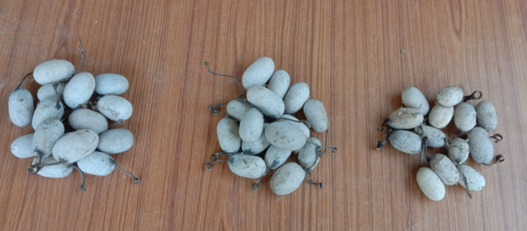
5. CONCLUSION
The delayed brushing lots shown minimum disease incidence (3.90 % virosis & 2.85 % bacteriosis) diseases, when compared to larvae brushed within the schedule. Moreover, delayed brushing lot B5-07.10.22` produced higher number of cocoons (85.00 cocoons/dfls). However, cocoon weight, shell weight, shell ratio got slightly reduces in delayed brushing lots. Moreover, cocoon colour also varied from whitish gray to dusty gray, which may impact the marketability of the farmer produced. However, cocoon produced from delayed brushing lots were slightly inferior in quality. But farmer who done delayed brushing received numerically higher number cocoons. Hence, delayed brushing may be encouraged to farmer income point of view and to avoid losses due to biotic stresses such as pest and diseases.

REFERENCES
Agarwal, H. & Seth, M.K. (1999). Food plants of the Tasar silkworms, Sericulture in India, Eds., 761–777.
Aharent, O.K. & Caviness, C.E. (2004). Natural cross pollination of 12 soybean cultivars. Advance Crop Sci., 34, 376-378.
Chandrakanth, N., Moorthy, S.M., Kariyappa, Ponnuvel, K.M. & Sivaprasad, V. (2015). Reeling performances of F2 and backcross populations under high temperature condition. Journal of Entomology and Zoology Studies., 3(6), 219-222.
Chanu, M.C., Sattar Shah, M.A & Radhakishore. (2016). Effect of temperature and relative humidity on the Oak tasar silkworm, Antheraea prolylai Jolly. Indian journal of entomology., 78(4),314-316.
D’Herelle, F. (1914). Le coccobacille des sauterelles. Ann. Inst. Pasteur., 28, 280-328, 387-407.
Harville, J.P.(1955). Ecology and population dynamics of the California oak moth, Phryganidia californica Packard (Lepidoptera: Dioptidae). Microentomology., 20,83-166.
https://www.btsso.org/ (Accessed on 01.05.2022).
https://city.imd.gov.in/citywx/city_weather_test_try.php?id=13002 (Accessed on 10.04.2023).
Jolly, M. S., Ahsan, M. M. & Khanna, R. P. (1974). A new technique of rearing tasar silkworm, Antheraea mylitta D. Int. Proc, Non Mulb. Seri. pp. 17.
Khawaja. (1989). Comparative studies on the prospects of rearing silkworm (Bombyx mori L.) during autumn and spring seasons at Faisalabad, M.Sc thesis, Department of Entomology University of Agriculture Faisalabad, Pakistan.
Kumar, M.P. (2003).Tropical wild silk cocoons of India, Book, Daya Publishing house, New Delhi.
Legay, J.M.(1958). Recent advances in silkworm nutrition. Annual Review of Entomology., 3, 75– 86.
Kumar, N.S., H. K. Basavaraja., N. M. Reddy. & S. B.Dandin. (2003). Effect of high temperature and high humidity on the quantitative traits of parents, foundation crosses, single and double hybrids of bivoltine silkworm, Bombyx mori L. International Journal of Industrial Entomology., 6 (2), 197–202.
Pandey, R.K.(1995). Seasonal variation in oak leaf quality of Quercus serrata and its impact on oak tasar silkworm rearing. Indian Journal of Sericulture., 34(1): 79-81.
Reddy, P. M., Gupta, V. P. & Lokesh, G. (2015). Impact of trainers training programmes of integrated skill development scheme (ISDS) in tasar technologies. Global Journal of Bio-Science and Biotechnology., 4(1), 17-20.
Ramachandra, Y.L., G. Bali. & S. Padmalatha Rai. (2001). Effect of temperature and relative humidity on spinning behaviour of silkworm (Bombyx mori. L). Indian J. Exp Biol., 39(1), 87–89.
Sharma, k. B. & Sarfaraz Ali. (2013). Impact of environmental factors on the indoor rearing performances of tropical tasar silkworm, Antheraea mylitta D. (Saturniidae: Lepidoptera). An International Quarterly Journal of Environmental Sciences., Special issue, 5, 255-260.
Shreyansh. (2021). Study on cocoon parameters of Daba Bi-voltine tasar eco-race with variation in brushing date of dfls. PGDS thesis, CTR&TI, Central Silk Board, India.
Singh, R.N., Bajpayee, C.M., Jayaswal, J. & Thangavelu. (1992). Perspective of biological control in tasar culture. Indian silk., 31(7), 48-50.
Singh, G.P., M.M. Baig & C.M. Bajpayi. (2021). Recent trends in Tasar silkworm, Antheraea mylitta Drury disease management. Book chapter: Methods in microbiology.,49:175-200.
Singh, J., A. Kumar., S. Mukherjee., G.P. Singh., S. Ray., K.S. Rawat. and Sinha, A.K (2017). Assessment of Brushing Date and Direction on Tasar Silkworm Antheraea mylitta D Production and Protection. Int. J. Curr. Microbiol. App. Sci., 6(10), 4853-4859.
Singh, R.N., M.K. Sinha., C.M. Bajpeyi., A.K. Sinha. & A. Tikader, (2014). Tasar culture. Book. A.P.H. Publishing corporation, 4435-36/ Ansari road darya ganj, New Delhi-110002.
Singh, K.C. and Singh, T.K. (1998). Bionomics of Antheraea proylei Jolly (Lepidoptera: Saturnidae) in Manipur. Bulletin of Entomology., 29(2), 178-185.
Tanada, Y. (1953). Description and characteristics of a granulosis virus of the imported cabbage worm. Proc. Hawaiian Entomol. Soc., 15, 235-260.
Thompson, C.G.(1959).Thermal inhibition of certain polyhedrosis virus diseases. J. insect Pathol., 1:189-190.

Table. 1
Impact of brushing schedule on disease incidence and cocoon characteristics of tasar silkworm during 22-23
Brushing date | % virosis | % Bacteriosis | Cocoon weight (g) | Shell weight (g) | Shell ratio (%) | Yield/dfls | Cocoon colour | Flimsy cocoon (%)
B1 (19.09.22) | 9.67 | 6.65 | 12.15 | 1.98 | 16.49 | 54.25 | Whitish grey | 1.1
B2 (24.09.22) | 9.85 | 7.05 | 12 | 1.95 | 16.33 | 65.5 | Whitsh grey | 1.05
B3 (29.09.22) | 9.77 | 6.85 | 11.95 | 1.94 | 16.26 | 55.25 | grey | 1.25
B4 (03.10.22) | 7.82 | 6.15 | 11.85 | 1.84 | 15.57 | 56.25 | grey | 1.25
B5 (07.10.22) | 6.9 | 5.75 | 11.75 | 1.83 | 15.93 | 85 | grey | 1.225
B6 (12.10.22) | 4.82 | 3.85 | 11.25 | 1.75 | 15.56 | 64.75 | Dusty grey | 2.925
B7 (20.10.22) | 3.9 | 2.85 | 10.75 | 1.64 | 15.12 | 60.5 | dusty grey | 4.825
Ftab | 154.6 | 43.06 | 72.1 | 159.29 | 19.09 | 194.7755102 | 0 | 123.2028725
Fcri | 2.57 | 2.57 | 2.57 | 2.57 | 2.57 | 2.572711641 | 0 | 2.572711641
Alpha | 0.05 | 0.05 | 0.05 | 0.05 | 0.05 | 0.05 | 0 | 0.05
P-value | 2.9E-16 | 9.85E-11 | 6.41 | 2.14E-16 | 1.66264E-07 | 2.71553E-17 | 0 | 2.93662E-15

Figure 5.

