Original Research Article
Rural-Urban Disparity in Child Sex Ratio of Punjab: A Spatio-Temporal Investigation
¹ Dr. Harpreet Singh ² Simranjit Kaur
Assistant Professor, Assistant Professor,
Department of Geography, Department of Geography,
Punjabi University, Patiala-147002. University College Ghanaur, Patiala-140702.
Email: harpreetgeography@gmail.com Email: simrangeo1312@gmail.com

India
harpreetgeography@gmail.com
simrangeo1312@gmail.com
Abstract
The present study seeks to analyse rural-urban disparities in the child sex ratio in Punjab, along with their spatial and regional variations. For this purpose, Census data from 1991, 2001, and 2011 have been used. Tehsils taken as the primary units of analysis. The study also aims to identify the factors responsible to these rural-urban differences in the child sex ratio. It has been found that the almost all areas in the foothill zone of the Himalayas exhibits relatively high rural-urban disparities in child sex ratio in 2001. In 2011, the southern and eastern fringes of Malwa, parts of north-eastern Doaba, and Majha reported relatively high rural-urban disparity in child sex ratio. The study also indicates that relatively low child sex ratio was spatially spread from urban to rural areas of the state.
Keywords: Rural-urban disparity, spatial and regional variations, spatially spread.
1. Introduction
The problem of an unbalanced child sex ratio is especially serious in South Asian countries. Amartya Sen (1990), in his well-known study “100 Million Missing Women,” pointed out the sharp drop in the child sex ratio due to gender discrimination. South Asia has long faced gender inequality, particularly between boys and girls. Even though women’s overall welfare has improved, the child sex ratio keeps falling, showing that deep-rooted inequality remains (Larsen and Hatti, 2008). In India, the declining child sex ratio is a major concern for demographers and scholars, as it brings serious social, economic, cultural, and demographic effects (WHO, 2011).
The Organisation for Economic Co-operation and Development (2018) notes that many Asian countries have made strong progress in education, urban growth, and economic development. Still, gender discrimination against girls is very high, especially in China and India. These countries have deep-rooted patriarchal systems, family structures, and male-dominated societies (Callen and Kee, 1981; Guilmoto and Oliveau, 2007). Because of this, women’s status has not improved much, even with overall development.
Punjab, a state in north-western India, shows this problem clearly with its low child sex ratio. The 2011 Census reported Punjab’s child sex ratio as 846, down from 901 in 1961, showing how serious the issue is. While there was some improvement from 798 in 2001 to 846 in 2011, the number is still much lower than in the past. These trends run counter to what demographic transition theory would predict. The uneven ratio is mainly due to practices like female infanticide and foeticide, often made easier by technologies such as amniocentesis and ultrasound. Population control policies and stronger patriarchal systems have also increased the preference for sons (Mies, 2014). As prosperity has grown, sex-selection technologies have become more available (Kaur, 2015). Son preference, sex-selective abortions, and other social and economic factors also cause differences in the child sex ratio across the state.
The widespread misuse of pre-conception and prenatal diagnostic methods has put girls at serious risk, making them almost an endangered group in Punjab (Department of Health and Family Welfare, Government of Punjab, 2007). New reproductive technologies have made the gender gap even wider. Punjab was one of the first states to use these technologies, and ads for sex-selective abortions became common in Delhi and Punjab in the late 1970s and early 1980s (Patel, 2007). The first ultrasound clinic in the state opened in the late 1970s (Purewal, 2010), and soon many more clinics appeared, especially in cities. These practices not only violate the basic right to life for girls but also lead to an unbalanced sex ratio, creating long-term problems for sustainable development (Gupta and Li, 1999; Cai and Lavely, 2003; Banister, 2004). The ongoing patriarchal mindset and strong preference for sons keep driving the use of these technologies, so there are always fewer girls than boys in the state.
Both rural and urban areas in Punjab show a strong preference for sons. The child sex ratio varies by region and between rural and urban areas. The 2011 Census shows that about 37.48 percent of people live in cities, while 62.52 percent live in villages. Rural Punjab had 844 girls per 1,000 boys, while urban areas had a slightly higher ratio of 852 girls per 1,000 boys. These differences are shaped by social, cultural, economic, and political factors. As a result, girls remain marginalized across the state. It is important to understand the rural-urban gap in the child sex ratio in Punjab. These differences are not just numbers; they reflect deeper social, cultural, and economic forces that shape gender outcomes.
2. Objectives
- To examine the scenario of the child sex ratio of the last few decades in both rural and urban areas of Punjab.
- To analyse the spatial as well as regional variations in the child sex ratio across rural and urban Punjab.
- To access the spatial spread of child sex ratio in both rural and urban areas during study period.
- To identify the underlying socio-economic, cultural, and demographic factors responsible for rural-urban disparity in child sex ratio.
3. Research Methodology
The study is primarily based on secondary data collected from the Census of India. Tehsil has been considered as the spatial unit of analysis. Tehsils have been made comparable by adjusting the data of the 1991 and 2001 Censuses with the 2011 Census. Choropleth maps have been prepared to examine and illustrate the spatial patterns of rural-urban differentials of the child sex ratio.
4. Results and Discussion
4.1. Rural-Urban Disparity in Child Sex Ratio: 1991-2011
India as a whole recorded 13 points of disparity in the rural-urban child sex ratio in 1991. A decade later, in 2001, the rural-urban disparity in India’s child sex ratio increased to 31 points. But in 2011, the rural-urban disparity in India’s child sex ratio dropped to 18 points. On the other hand, in the case of Punjab, the rural-urban disparity in the child sex ratio was 12 points in 1991, 3 points in 2001, and 8 points in 2011, which was always lower than the national average during this period.
It is worthwhile to mention here that there was no rural-urban disparity in the child sex ratio recorded in Gurdaspur and Batala tehsils in 1991. However, in 2001, not a single tehsil reported rural-urban disparity in this regard during this period. In 2011, there was no rural-urban disparity in the child sex ratio recorded in two tehsils of the state, namely, Amloh and Patran (Table 1).
On the basis of rural-urban disparity in child sex ratio during the study period, the state can be classified into the following three categories:
- Areas with relatively high rural-urban disparity in child sex ratio (above 20 points);
- Areas with moderate rural-urban disparity in child sex ratio (between 10-20 points);
- Areas with relatively low rural-urban disparity in child sex ratio (below 10 points).
I. Areas with relatively high rural-urban disparity in child sex ratio (above 20 points):
In 1991, out of all the seventy-seven tehsils of Punjab, forty-two tehsils reported relatively high rural-urban disparity in child sex ratio. The highest disparity (181 points) in this regard was observed in Dhar Kalan tehsil, followed by Jalalabad (109 points), Lehra (84 points), Khamanon (75 points), and Mukerian (71 points). About fifty-eight percent of the tehsils of Majha, fifty-four percent of Malwa, and fifty-three percent of Doaba belonged to this category. Tehsils that recorded relatively high rural-urban disparity in child sex ratio were found scattered across the study area (Map 1).
In 2001, about sixty-two percent of the state's tehsils emerged with relatively high rural-urban disparity in the child sex ratio. Baba Bakala tehsil reported the highest rural-urban disparity (95 points) in this regard, followed by Dhar Kalan (93 points), Dera Bassi (73 points), Ludhiana West (72 points), and Nihal Singhwala (67 points). About seventy-five percent of the tehsils of Majha, sixty percent of Doaba, and sixty percent of Malwa recorded relatively high rural-urban disparity in child sex ratio. It is worth noting that almost all areas in the foothill zone of the Himalayas exhibits relatively high rural-urban disparities in child sex ratio (Map 2).
In 2011, about forty-seven percent of the tehsils of the state recorded relatively high rural-urban disparity in child sex ratio (Table 1). Out of these, Nihal Singhwala recorded a high rural-urban disparity (120 points), followed by Malerkotla (84 points), Khamanon (67 points), Anandpur Sahib (65 points), Khanna (51 points), Dasua (51 points), Fazilka (49 points), Rupnagar (45 points), Gidderbaha (44 points), and Fatehgarh Sahib (43 points). About fifty-three percent of the tehsils of Doaba, forty-eight percent of Malwa, and thirty-three percent of Majha lie in this category. In this way, the southern and eastern fringes of Malwa, parts of north-eastern Doaba, and Majha fall in this category (Map 3).
Mainly, socio-cultural and economic factors are responsible for widening this rural-urban gap in the child sex ratio. Relatively low educational levels among rural females are one of the leading factors behind this disparity. Due to their low levels of education, females in rural areas have relatively low awareness about their rights. They also considered the girl child as a ‘liability’. Generally, they follow the patriarchal norms, which are male-dominated due to their limited exposure to education. Consequently, due to prevailing patriarchal norms, the
Table 1
Rural-Urban Disparity in Child Sex Ratio of Punjab: 1991-2011
Sr. | District/State | Tehsils | 1991 | 2001 | 2011
1 | Amritsar | (i) Ajnala | 57 | 8 | 8
 |  | (ii) Amritsar -I | 51 | 12 | 10
 |  | (iii) Amritsar- II | 14 | 21 | 1
 |  | (iv) Baba Bakala | 28 | 95 | 28
2 | Barnala | (i) Barnala | 21 | 5 | 10
 |  | (ii) Tapa | 14 | 40 | 6
3 | Bathinda | (i) Rampura Phul | 13 | 16 | 19
 |  | (ii) Bathinda | 23 | 46 | 2
 |  | (iii) Talwandi Sabo | 26 | 8 | 28
4 | Faridkot | (i) Faridkot | 8 | 23 | 11
 |  | (ii) Jaitu | 7 | 39 | 6
5 | Fatehgarh Sahib | (i) Bassi Pathana | 10 | 15 | 18
 |  | (ii) Fatehgarh Sahib | 22 | 46 | 43
 |  | (iii) Amloh | 14 | 37 | 0
 |  | (iv) Khamanon | 75 | 36 | 67
6 | Firozpur | (i) Zira | 13 | 10 | 4
 |  | (ii) Firozpur | 26 | 3 | 9
 |  | (iii) Jalalabad | 109 | 49 | 15
 |  | (iv) Fazilka | 22 | 6 | 49
 |  | (v) Abohar | 16 | 7 | 16
7 | Gurdaspur | (i) Dhar Kalan | 181 | 93 | 25
 |  | (ii) Pathankot | 29 | 51 | 18
 |  | (iii) Gurdaspur | 0 | 25 | 13
 |  | (iv) Batala | 0 | 26 | 32
 |  | (v) Dera Baba Nanak | 24 | 31 | 29
8 | Hoshiarpur | (i) Dasua | 34 | 36 | 51
 |  | (ii) Mukerian | 71 | 34 | 35
 |  | (iii) Hoshiarpur | 10 | 28 | 15
 |  | (iv) Garhshankar | 28 | 46 | 28
9 | Jalandhar | (i) Shahkot | 26 | 41 | 31
 |  | (ii) Nakodar | 25 | 9 | 19
 |  | (iii) Phillaur | 3 | 27 | 13
 |  | (iv) Jalandhar - I | 21 | 28 | 28
 |  | (v) Jalandhar - II | 11 | 9 | 42
10 | Kapurthala | (i) Bhulath | 15 | 33 | 19
 |  | (ii) Kapurthala | 21 | 2 | 42
 |  | (iii) Sultanpur Lodhi | 20 | 2 | 17
 |  | (iv) Phagwara | 12 | 24 | 6
11 | Ludhiana | (i) Samrala | 26 | 30 | 5
 |  | (ii) Khanna | 7 | 38 | 51
 |  | (iii) Payal | 31 | 16 | 23
 |  | (iv) Ludhiana (East) | 24 | 10 | 14
 |  | (v) Ludhiana (West) | 7 | 72 | 32
 |  | (vi) Raikot | 15 | 27 | 32
 |  | (vii) Jagraon | 19 | 2 | 22
12 | Mansa | (i) Sardulgarh | 50 | 59 | 14
 |  | (ii) Budhlada | 55 | 8 | 29
 |  | (iii) Mansa | 50 | 18 | 24
13 | Moga | (i) Nihal Singhwala | 47 | 67 | 120
 |  | (ii) Bagha Purana | 60 | 30 | 14
 |  | (iii) Moga | 11 | 21 | 8
14 | Patiala | (i) Samana | 30 | 40 | 38
 |  | (ii) Patran | 37 | 30 | 0
 |  | (iii) Nabha | 8 | 53 | 17
 |  | (iv) Patiala | 9 | 6 | 34
 |  | (v) Rajpura | 23 | 52 | 11
15 | Rupnagar | (i) Anandpur Sahib | 59 | 18 | 65
 |  | (ii) Nangal | 25 | 43 | 17
 |  | (iii) Rupnagar | 5 | 45 | 45
 |  | (iv) Chamkaur Sahib | 5 | 54 | 7
16 | S.A.S Nagar | (i) Kharar | 3 | 26 | 34
 |  | (ii) S.A.S Nagar (Mohali) | 26 | 5 | 36
 |  | (iii) Dera Bassi | 55 | 73 | 39
17 | Sangrur | (i) Malerkotla | 8 | 49 | 84
 |  | (ii) Dhuri | 1 | 56 | 1
 |  | (iii) Sangrur | 42 | 25 | 18
 |  | (iv) Sunam | 15 | 16 | 22
 |  | (v) Lehra | 84 | 21 | 12
 |  | (vi) Moonak | 14 | 12 | 22
18 | S.B.S Nagar | (i) Nawanshahr | 15 | 4 | 16
 |  | (ii) Balachaur | 37 | 15 | 38
19 | Muktsar | (i) Malout | 40 | 5 | 26
 |  | (ii) Gidderbaha | 2 | 9 | 44
 |  | (iii) Muktsar | 24 | 33 | 5
20 | Tarn Taran | (i) Patti | 34 | 22 | 14
 |  | (ii) Tarn Taran | 8 | 30 | 20
 |  | (iii) Khadur Sahib | A.R* | A.R* | A.R*
PUNJAB |  |  | 12 | 3 | 8
INDIA |  |  | 13 | 31 | 18
Source: District Census Handbooks of Punjab, 1991, 2001 and 2011.
A.R* stands for All Rural.

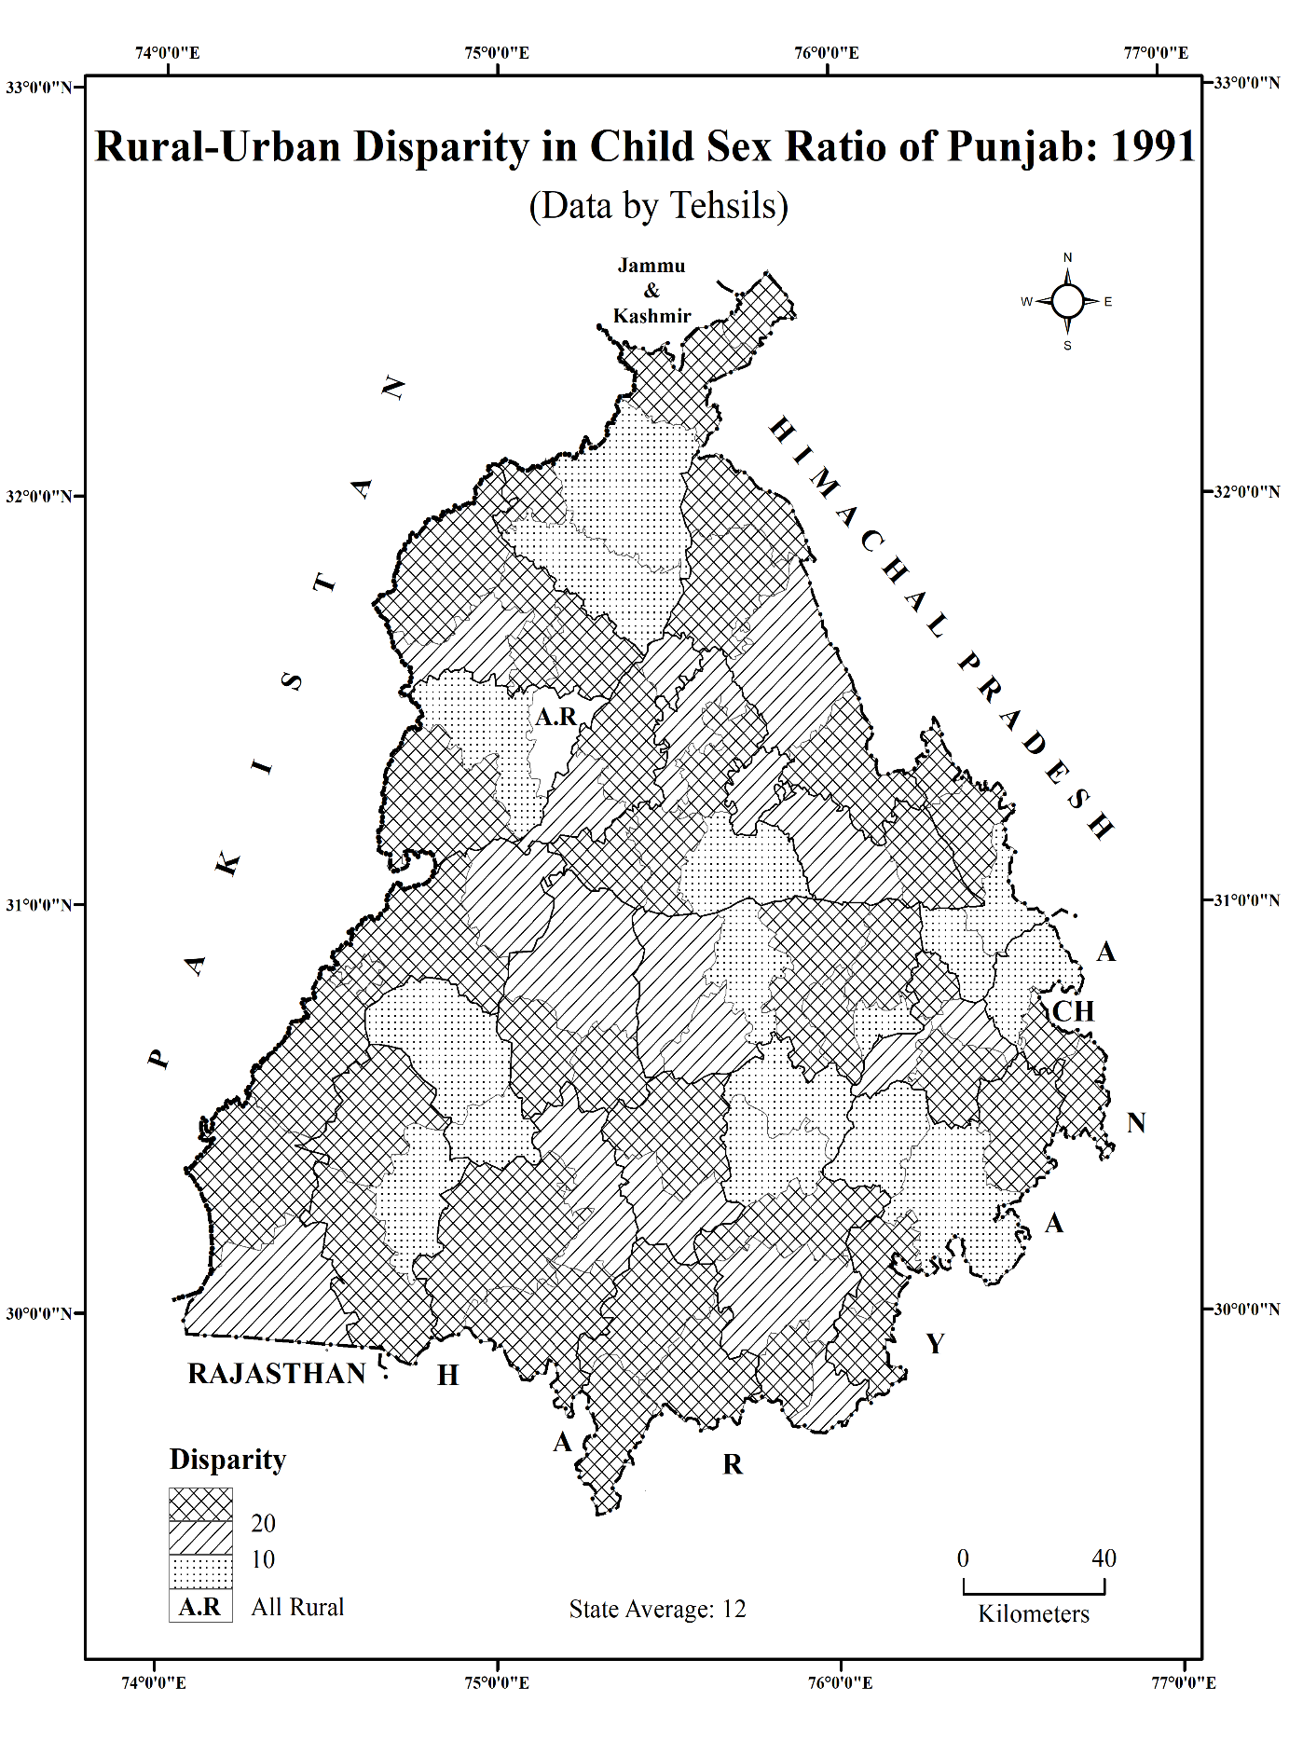
Map 1
Source: District Census Handbooks of Punjab, 1991.

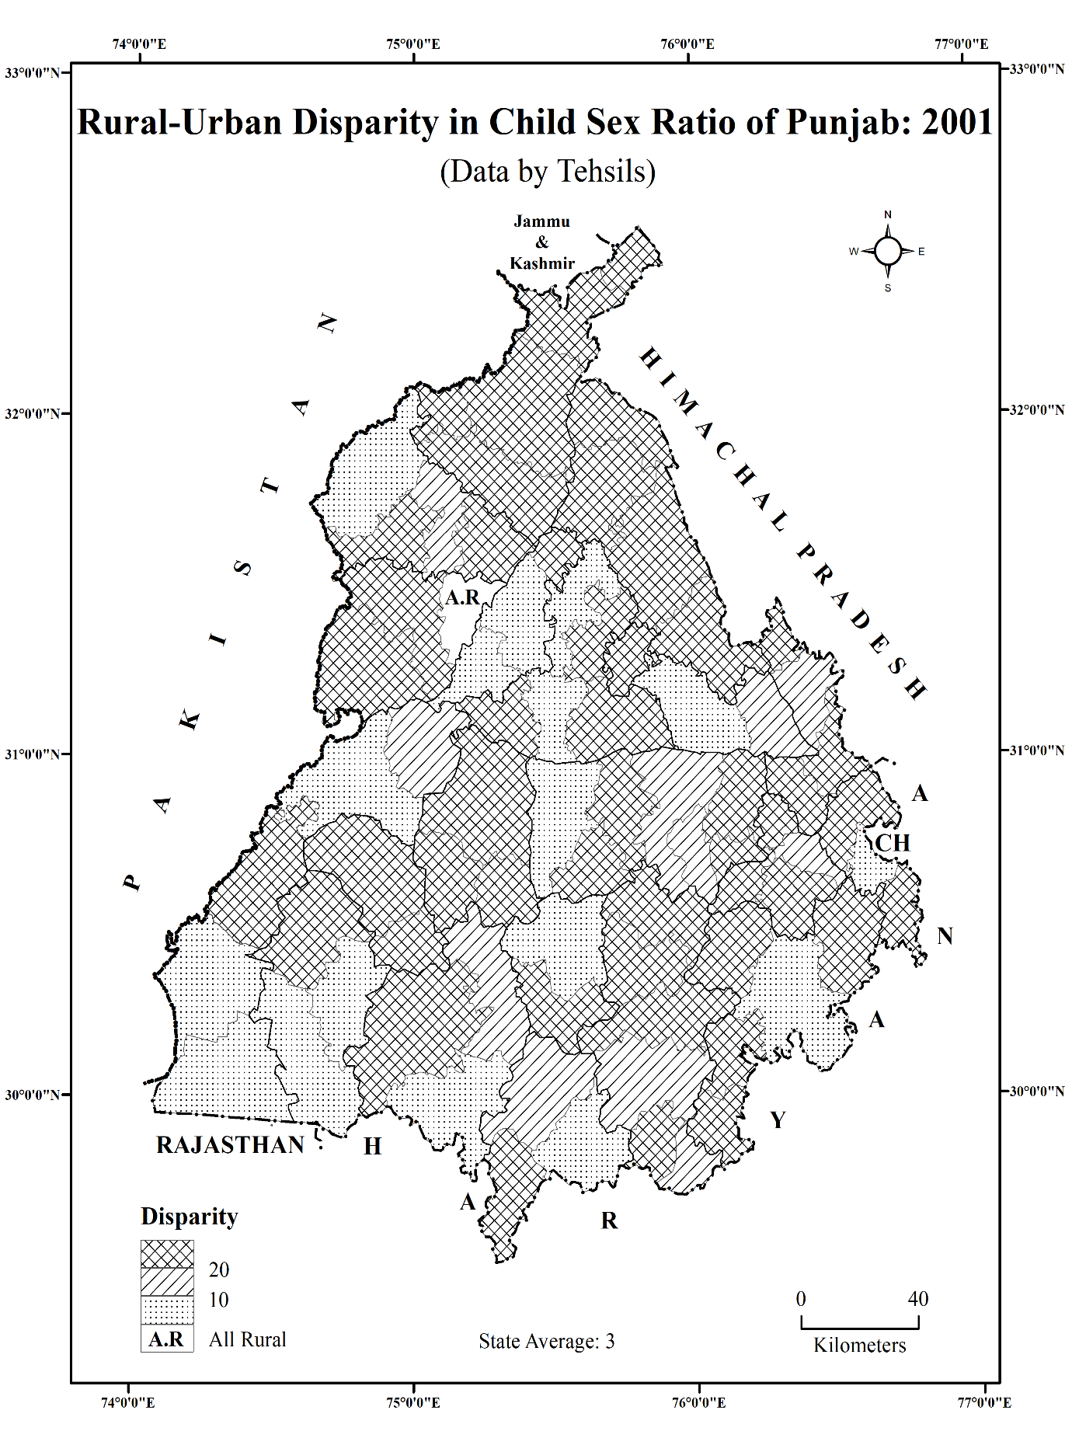
Map 2
Source: District Census Handbooks of Punjab, 2001.

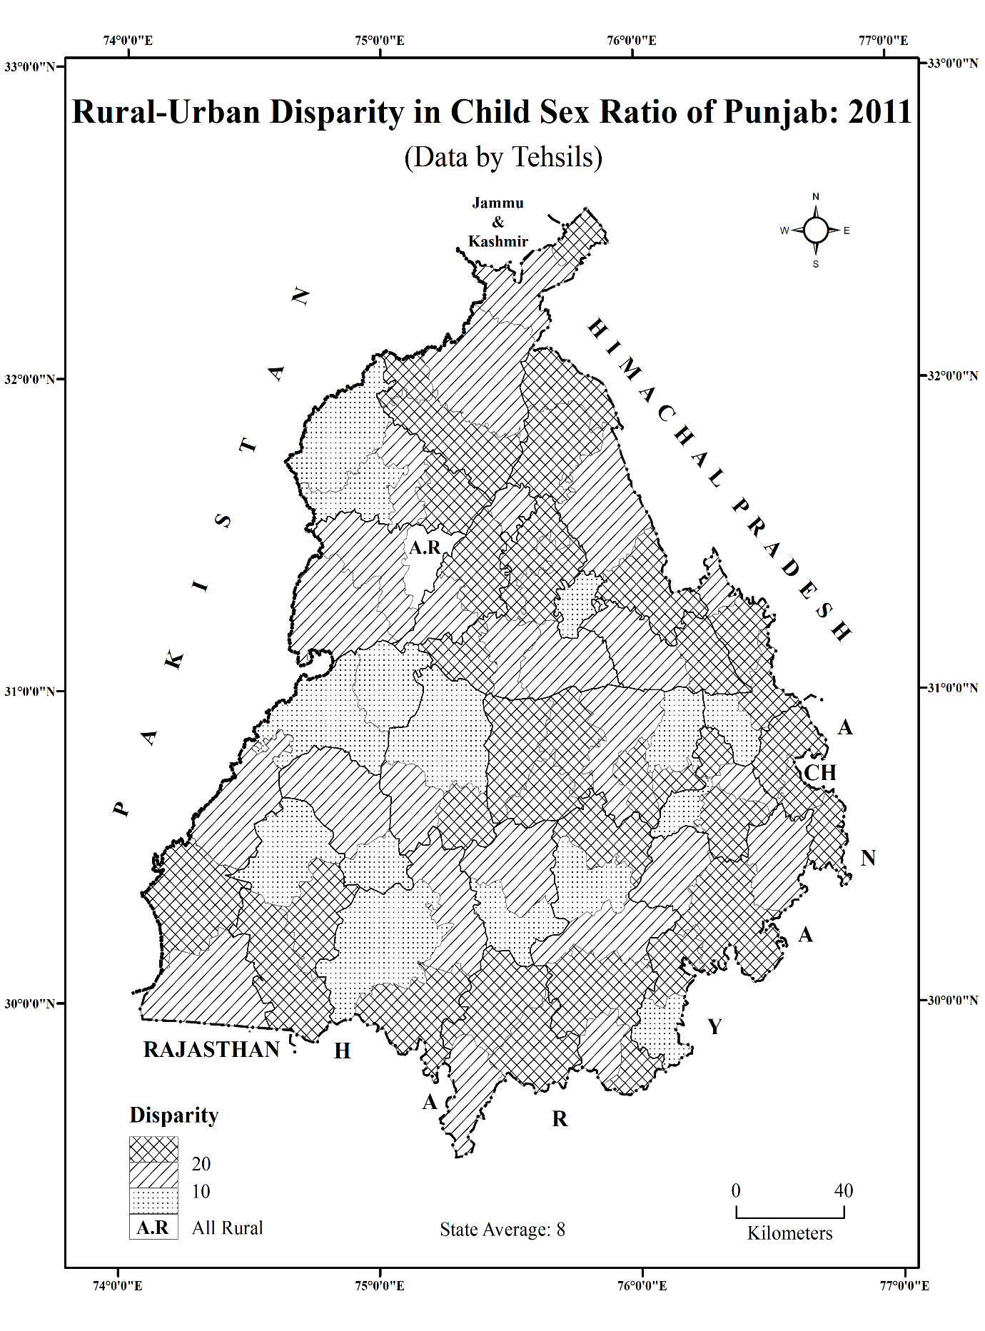
Map 3
Source: District Census Handbooks of Punjab, 2011.

disparity in the rural-urban child sex ratio has increased. Another interesting finding is that a relatively high rural-urban disparity was observed in most areas located far from their district headquarters. The restrictions on rural females’ mobility from their homes are also responsible for lower awareness of their rights. Whereas relatively high levels of awareness among the urban females awaken them to their rights. Consequently, it contributes to this disparity index.
It has also been observed that sex-selective abortions are practiced in rural areas. Over time, several sex determination centres were established, even in the state's rural areas. In this context, a joint team of the Haryana Health Department and Speed Network, Chandigarh, nabbed a gang that has been involved in conducting illegal gender determination tests by installing ultrasound centres at unknown rural localities in Sangrur, Ludhiana, Patiala, and Mansa districts of the Malwa belt (The Tribune, September 23, 2020). Thus, the rapid mushrooming of sex determination centres and their easy availability even in rural areas is also responsible for high rural-urban disparity.
In addition, the midwives (dais) of the rural areas discreetly performed the act of killing the female infants at the village level by performing traditional methods, e.g., they stifle the girl child with a pillow or with a cloth, drop a few sleeping pills, and bury them alive in sealed mud pots (Aravamudan, 2007). These local methods, which are performed by dais (midwives) to neglect the girl child in remote areas, ultimately contribute to this disparity index.
On the other hand, urban areas have a high concentration of private hospitals, diagnostic centres, and ultrasound clinics. This easy availability of medical technology makes it more convenient to determine the sex of the foetus, despite legal restrictions. As a result, sex-selective abortions tend to be more prevalent in cities compared to rural areas. Moreover, urban households generally have higher incomes and purchasing power. This enables families to afford expensive diagnostic tests and procedures related to sex selection. Economic prosperity, rather than eliminating gender bias, sometimes facilitates its perpetuation through technology. It ultimately leads to rural-urban disparity in the child sex ratio.
Besides, urban families of the study area tend to prefer fewer children due to higher living costs, career priorities, and changing lifestyles. When family size is limited (often one or two children), the pressure to have at least one son increases. This leads to deliberate planning and, in some cases, sex-selective practices to ensure a male child. Additionally, urban populations are generally more aware of reproductive health and medical options. However, this awareness does not always translate into gender equality. Instead, knowledge is sometimes misused to make informed but biased reproductive choices. Consequently, skewed sex ratios have been found in urban settings.
II. Areas with moderate rural-urban disparity in child sex ratio (between 10-20 points):
About twenty-three percent of the tehsils had shown moderate rural-urban disparity in child sex ratio in 1991. Out of these, about forty-eight percent of the tehsils were from Malwa and twenty-six percent from Doaba. Surprisingly, only one tehsil of Majha belonged to this category (Table 1). Sultanpur Lodhi tehsil was at the top in this regard.
In 2001, after one decade, only 11 tehsils recorded moderate rural-urban disparity in child sex ratio. Among these, Mansa and Anandpur Sahib were at the highest position in this respect with 18 points each. About eighteen percent of the tehsils of Malwa reported moderate rural-urban disparity in child sex ratio. Only one tehsil each from Majha and Doaba had reported in this regard.
In 2011, almost one-third of the state's tehsils reported moderate rural-urban disparity. The top position in this regard was occupied by Tarn Taran tehsil with 20 points, followed by Nakodar, Bhulath, Rampura Phul, Bassi Pathana, Pathankot, Nangal, Nabha and Sultanpur Lodhi. About forty-two percent of the tehsils of Majha, forty percent of Doaba and twenty-eight percent of Malwa emerged with moderate rural-urban disparity in child sex ratio (Table 1).
III. Areas with relatively low rural-urban disparity in child sex ratio (below 10 points):
Among the state's total tehsils, sixteen showed relatively low rural-urban disparity in the child sex ratio in 1991. Dhuri tehsil recorded the lowest rural-urban disparity in the state, closely followed by Gidderbaha, Kharar and Phillaur. About twenty-five percent of the tehsils in Majha and twenty-four percent in Malwa registered relatively low rural-urban disparity in child sex ratio. Only one tehsil of Doaba was found in the same category (Map 1).
During 1991-2001, seventeen tehsils in the study area reported relatively low rural-urban disparity in child sex ratio. About thirty-three percent of Doaba and twenty-two percent of Malwa showed relatively low rural-urban disparity in child sex ratio during this decade. On the other hand, only one tehsil in Majha falls into this category. In 2001, the lowest rural-urban disparity in the child sex ratio was observed in the Kapurthala, Sultanpur Lodhi, and Jagraon tehsils (Table 1).
In 2011, after 20 years, about nineteen percent of the state's tehsils had relatively low rural-urban disparity in the child sex ratio. Among these, Amritsar-II and Dhuri tehsils recorded the lowest rural-urban disparity in child sex ratio in the state, followed by Bathinda, Zira, Samrala, Muktsar, Jaitu and Phagwara. In this category, twenty-four percent of the tehsils of Malwa showed relatively low rural-urban disparity in this regard. However, only two tehsils in Majha and one in Doaba reported relatively low rural-urban disparity in the child sex ratio (Table 1).
The data reveals some interesting findings that the maximum number of tehsils in the state, which recorded relatively high rural-urban disparity (above 20 points) also recorded relatively low child sex ratio in the rural areas. It has also been observed that the large number of tehsils with relatively low rural-urban disparity (below 10 points) also recorded a low child sex ratio in both the rural and urban areas. It is notable that Majha and Malwa had always recorded low rural-urban disparity in child sex ratio as compared to Doaba, except in 2001 (Map 1, 2 and 3).
4.2. Spatial Spread of Relatively Low Child Sex Ratio (Below 850) in Rural and Urban Punjab
The data indicates that relatively low child sex ratio spread spatially at fast pace from 1991 to 2011 in rural and urban areas of Punjab. The process of spread also helps to understand the dispersal of cultural traits and technology from one area to another. It also affected the child sex ratio of different parts of the state.
In case of rural Punjab, only one tehsil namely, Bhulath registered relatively low child sex ratio in 1991. In spite of official claims regarding improvement in female status in the state the situation has become more worse. The proportion of girl child had sharply declined. In 2001, all the tehsils of rural Punjab except one tehsil found relatively low child sex ratio (Map 4 (b)). But a
Map 4
Spatial Spread of Relatively Low Child Sex Ratio in Rural Punjab: 1991-2011
(Data by Tehsils)
a) 1991  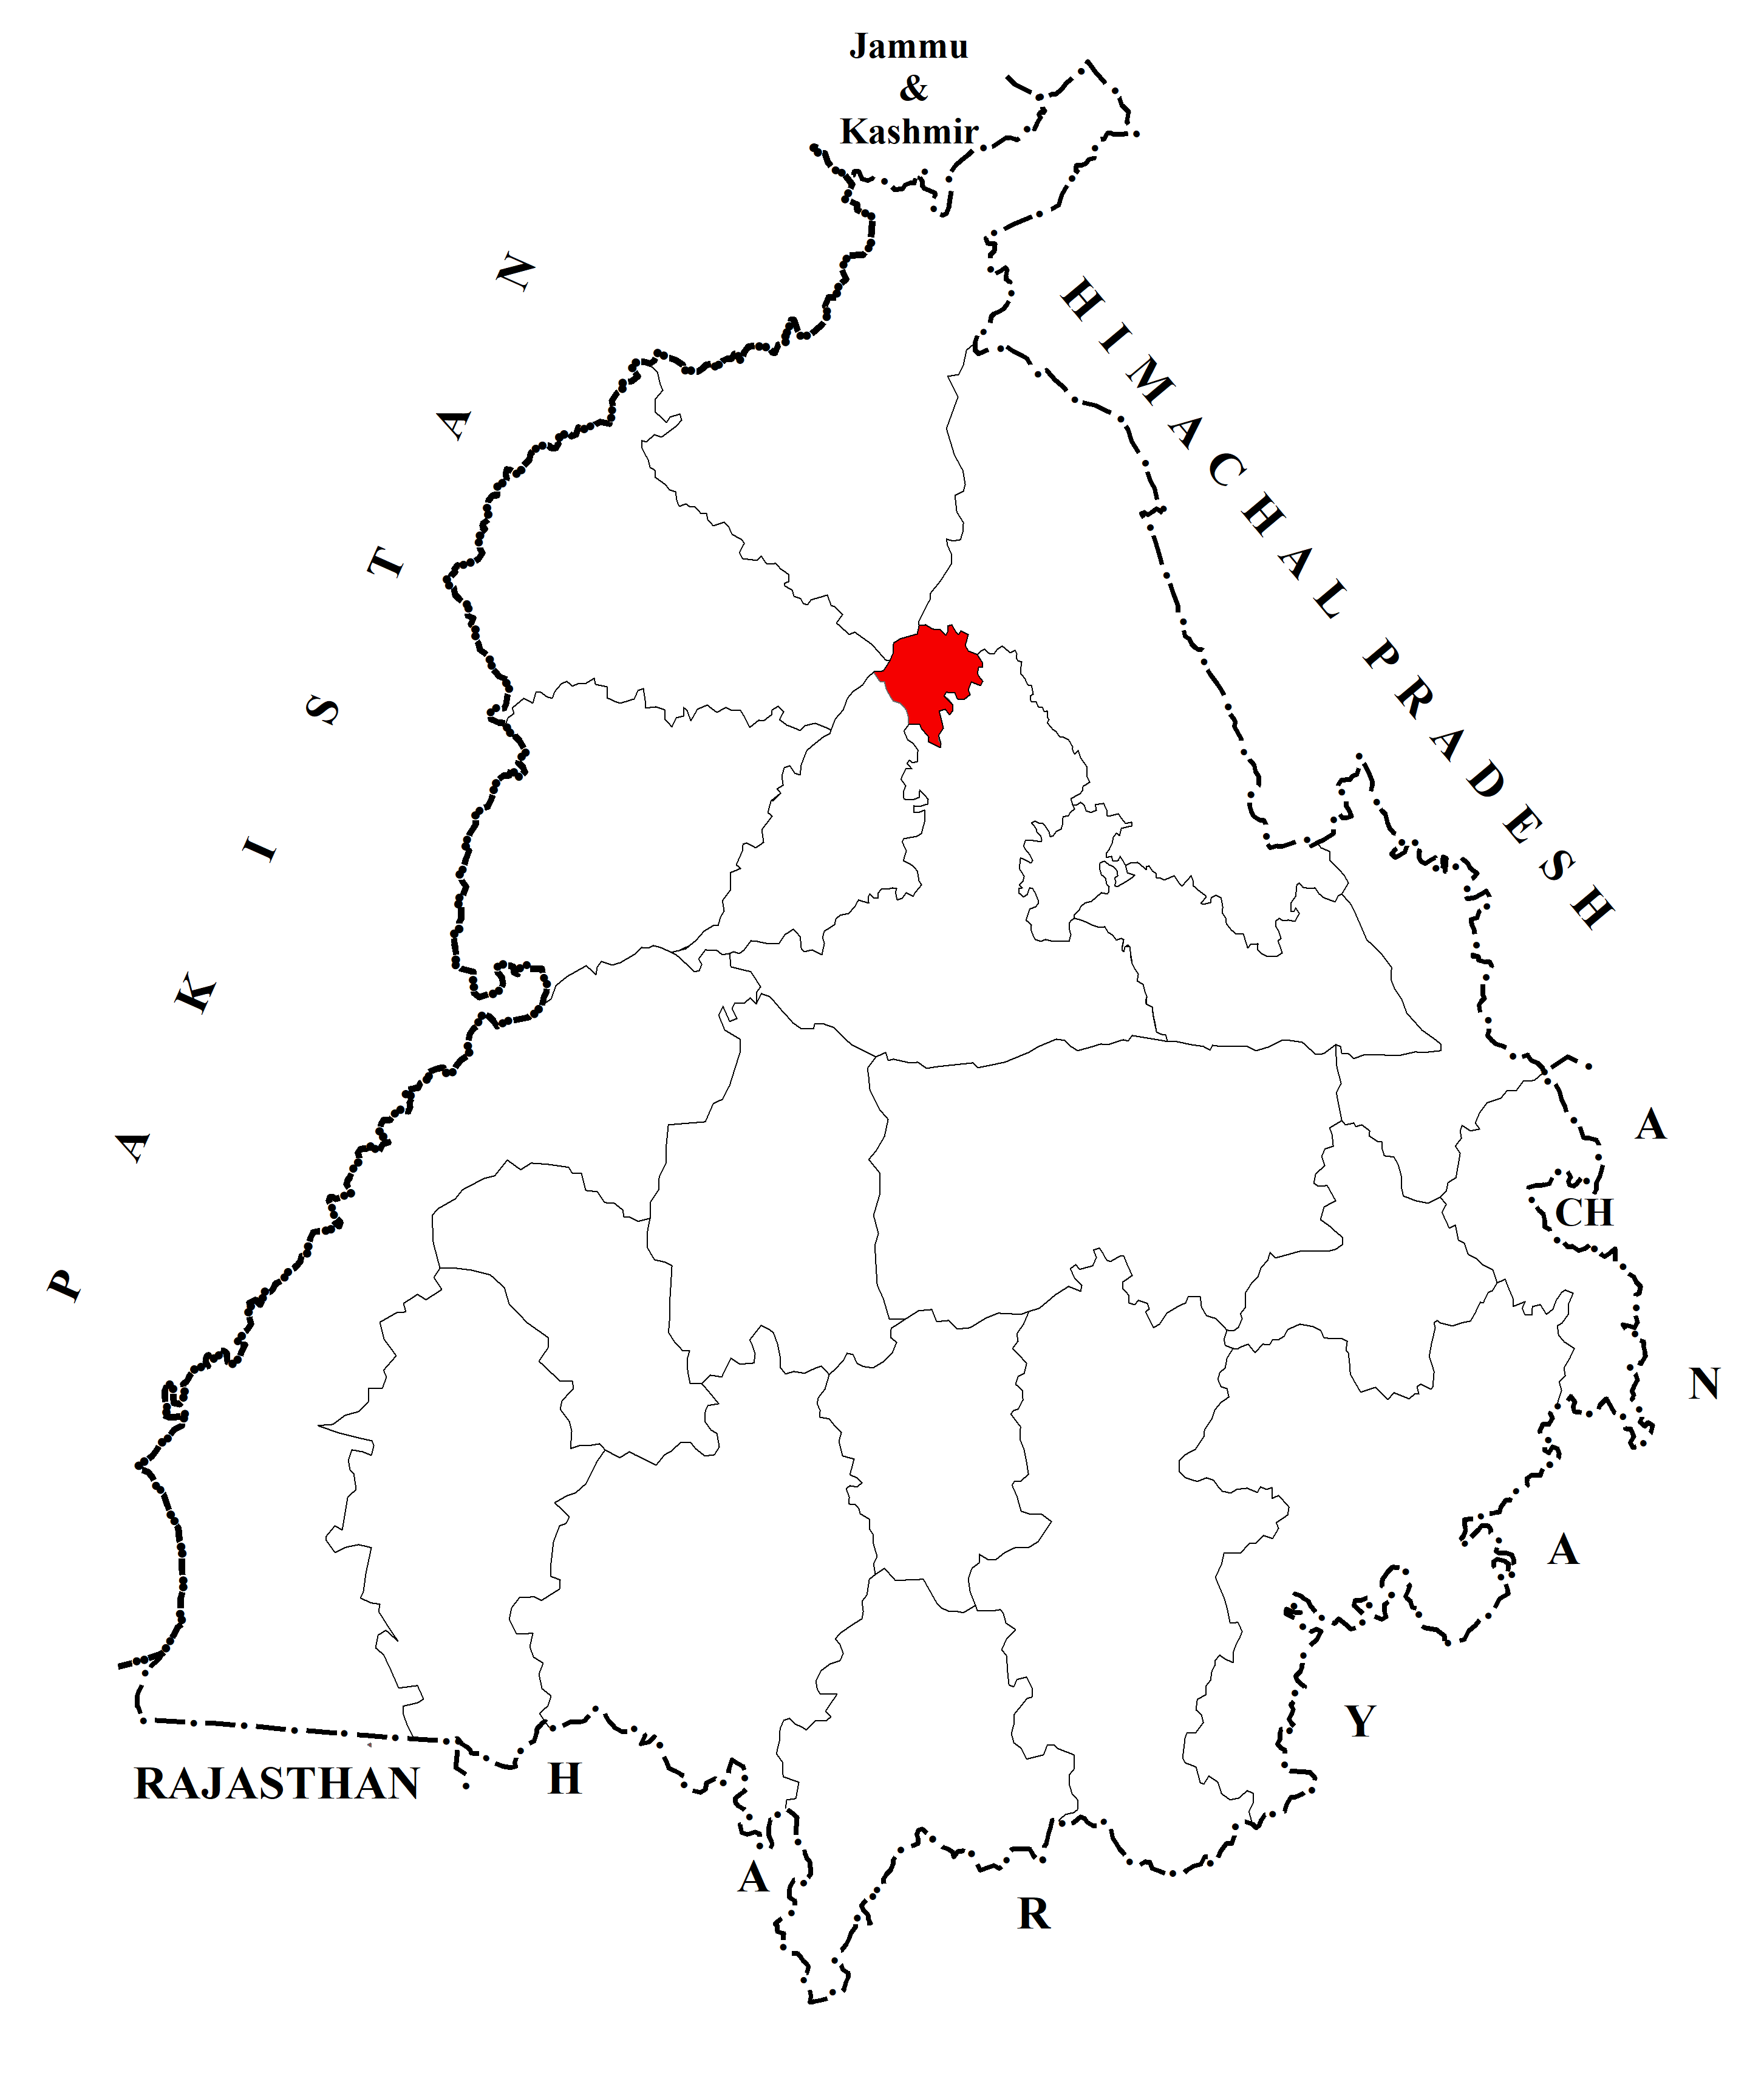 | b) 2001  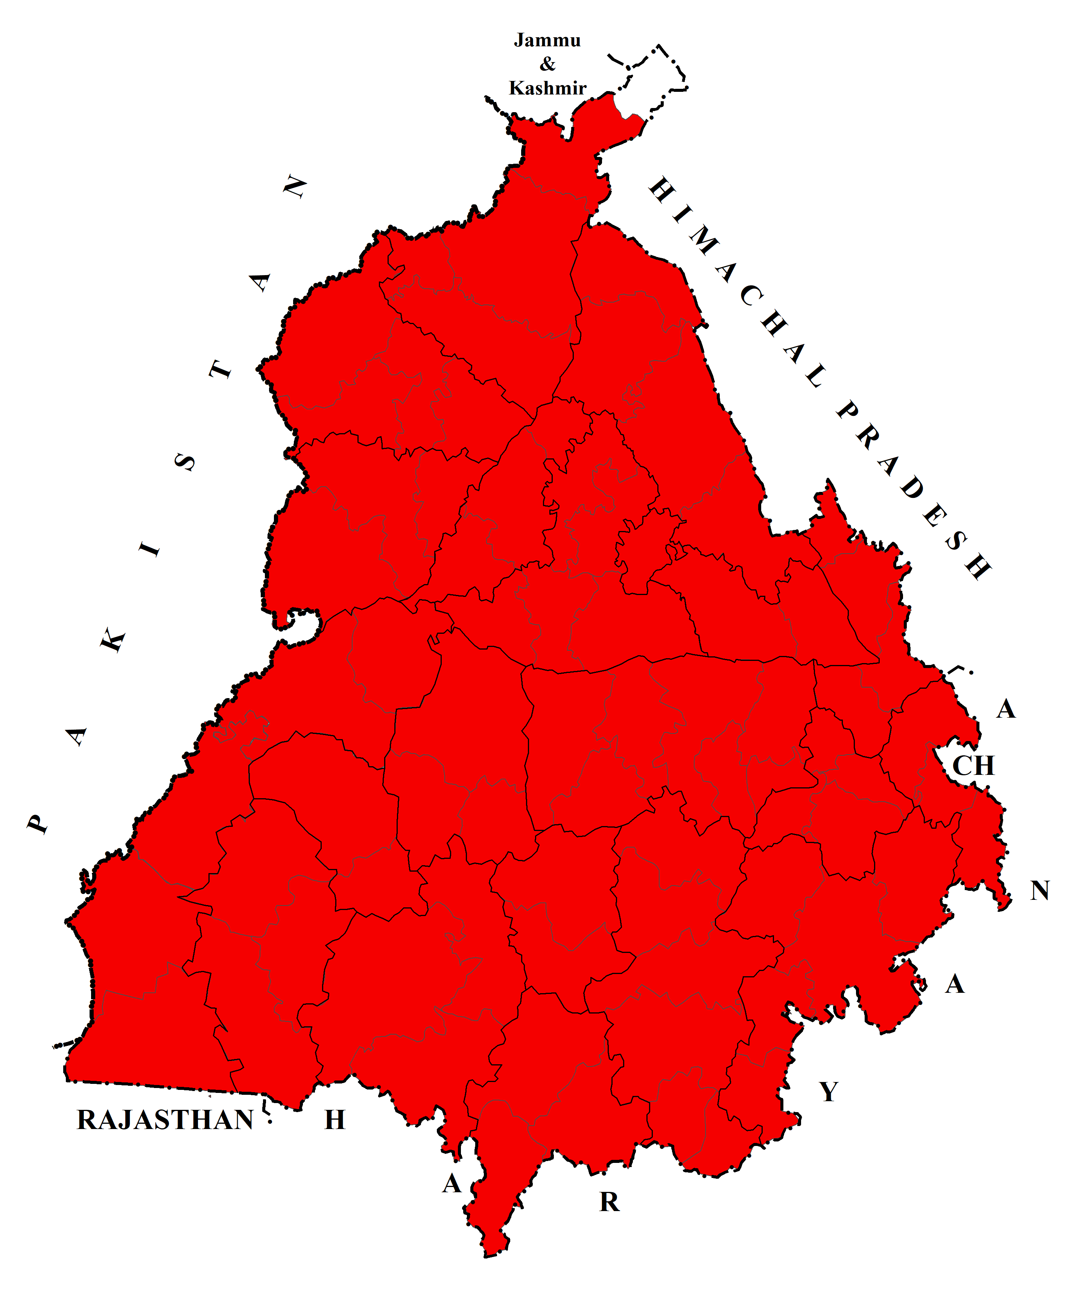
c) 2011  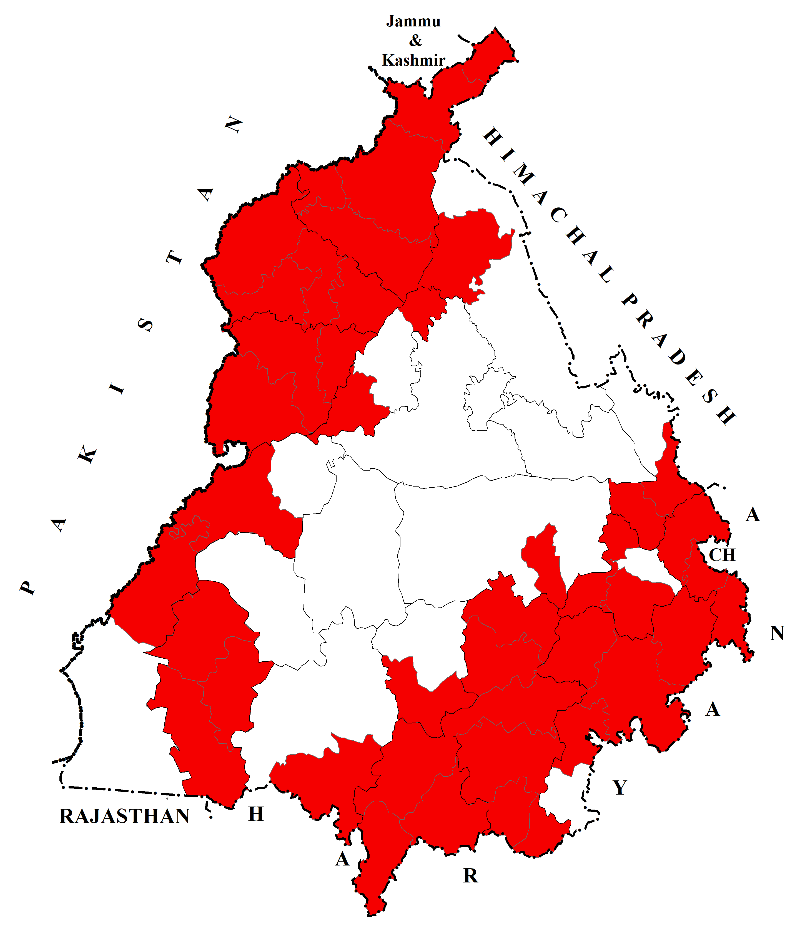 | 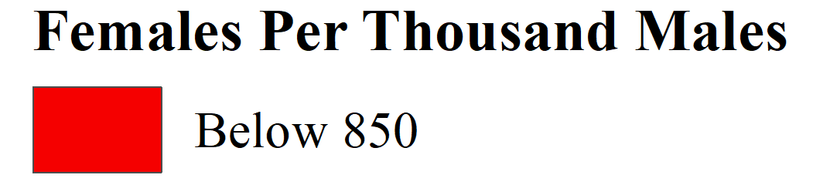  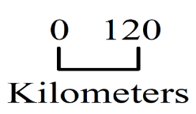
Source: District Census Handbooks of Punjab, 1991, 2001 and 2011.

Map 5
Spatial Spread of Relatively Low Child Sex Ratio in Urban Punjab: 1991-2011
(Data by Tehsils)
a) 1991  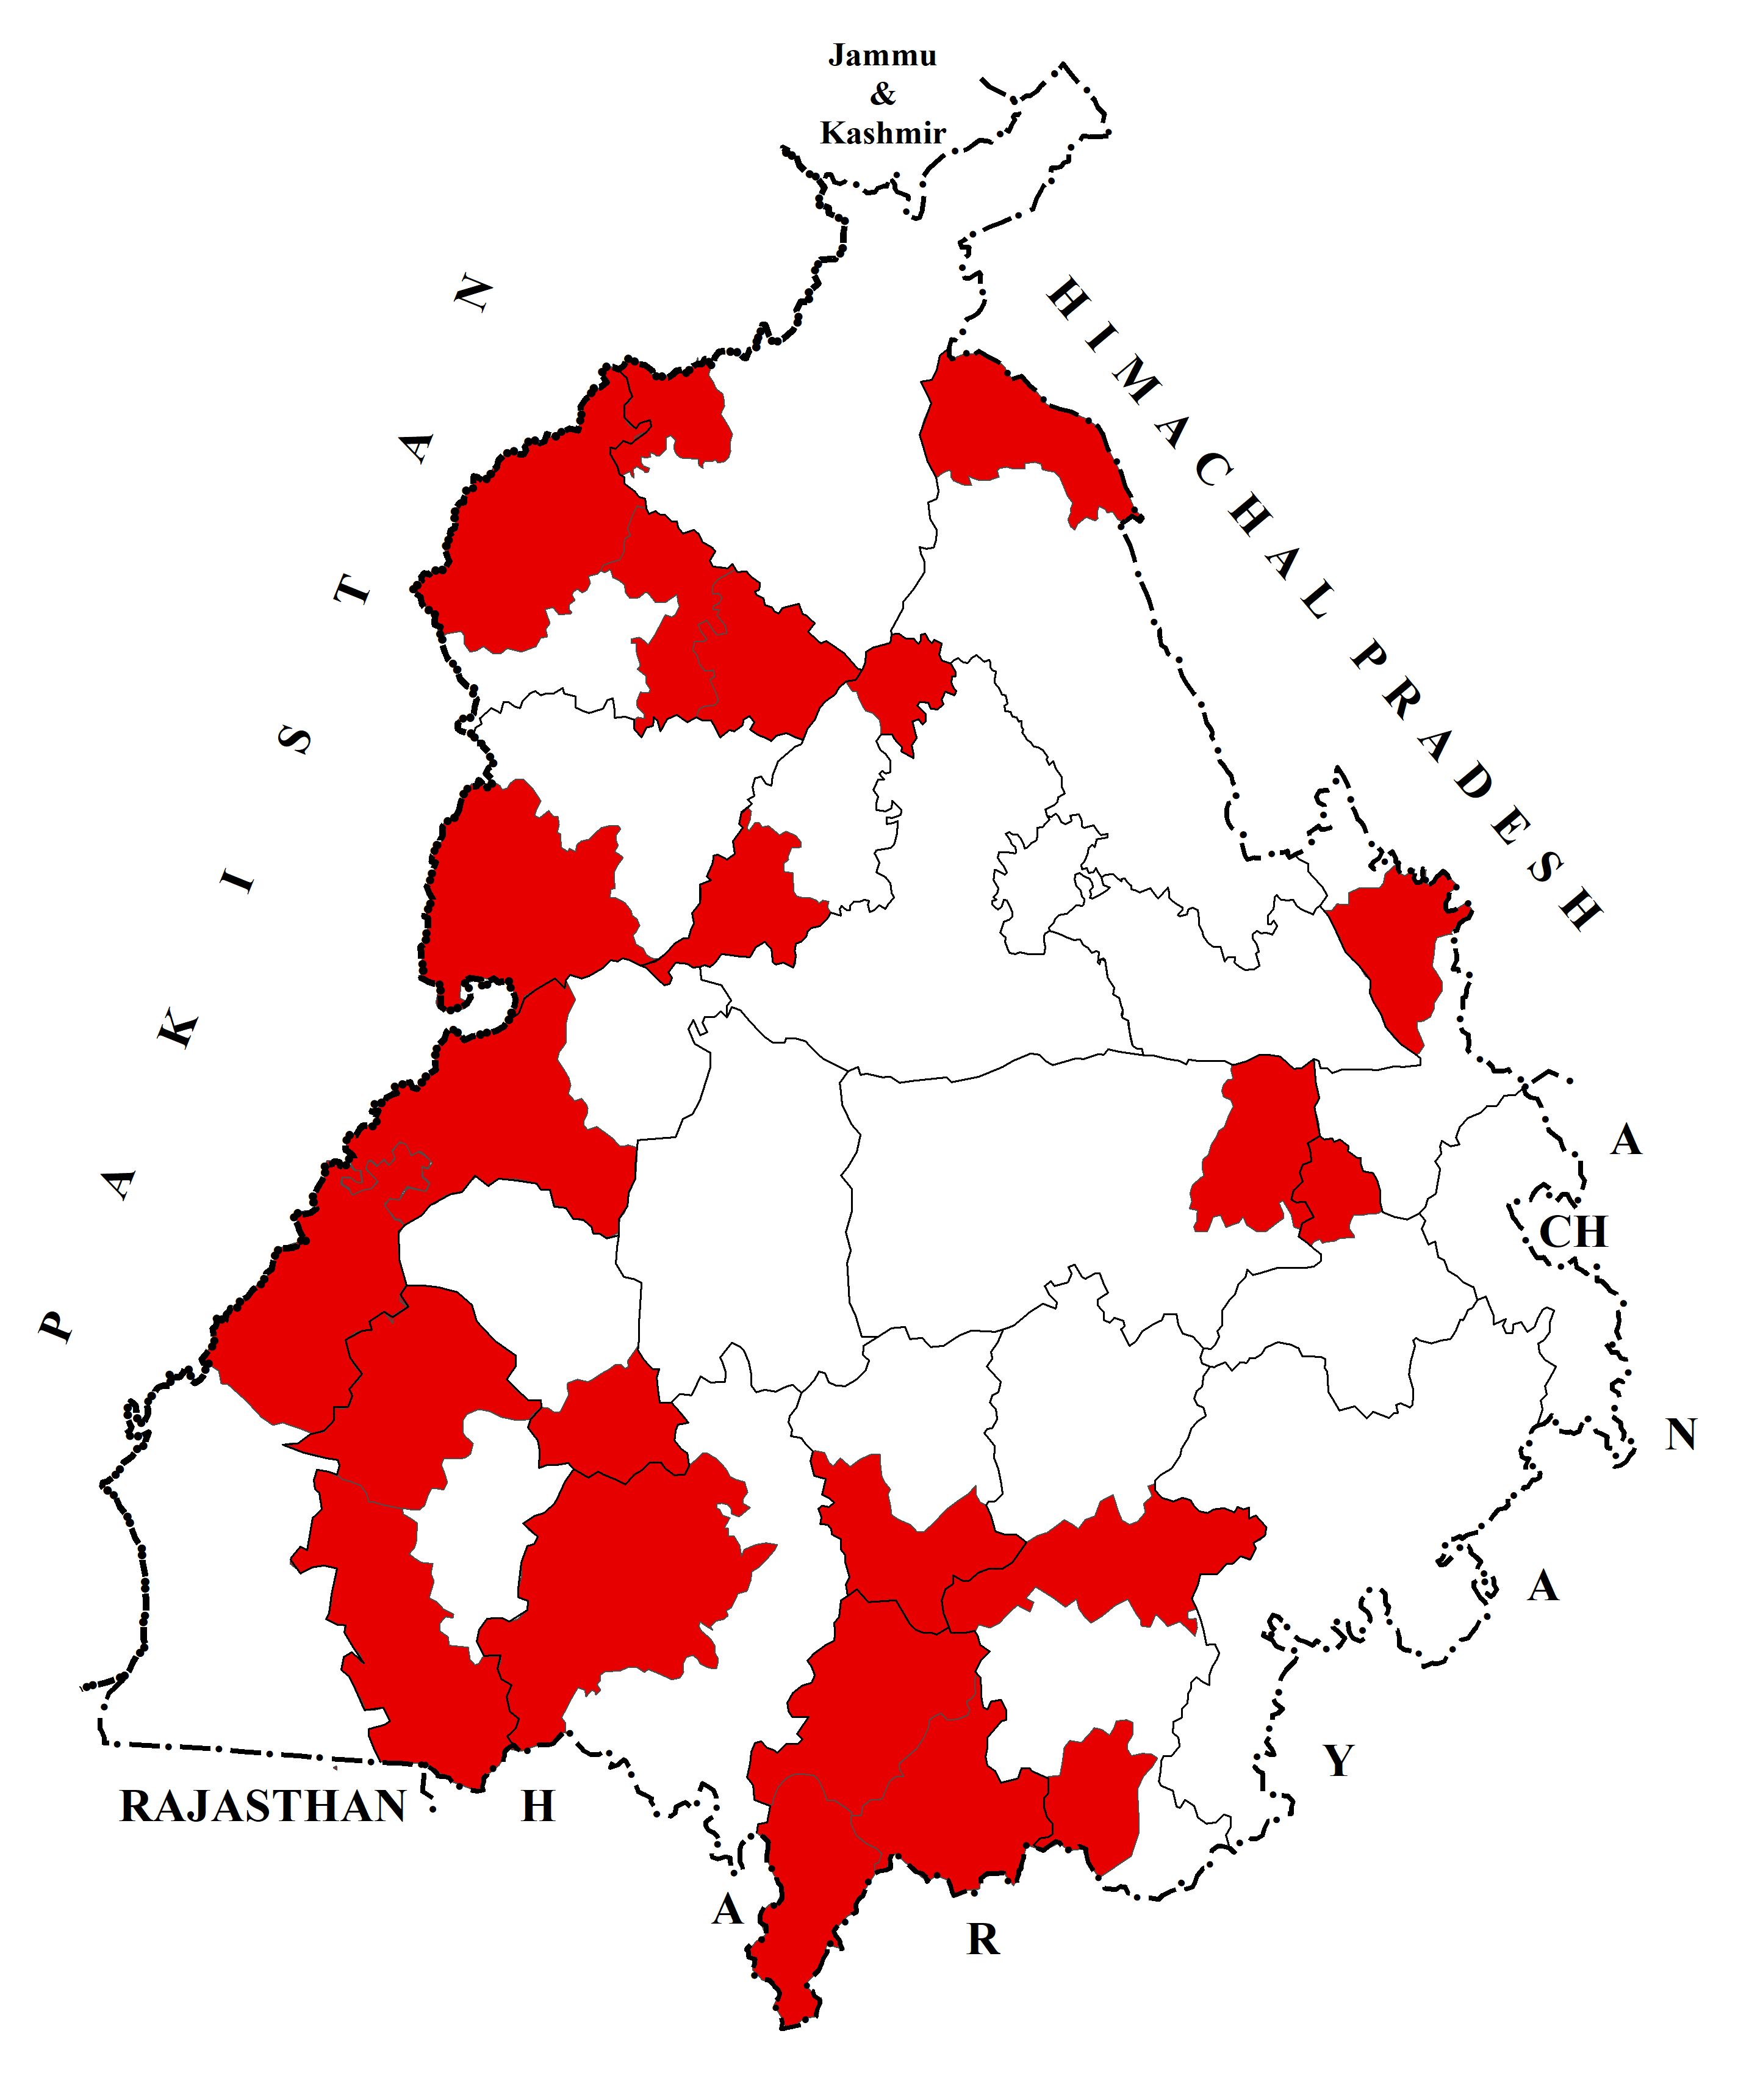 | b) 2001  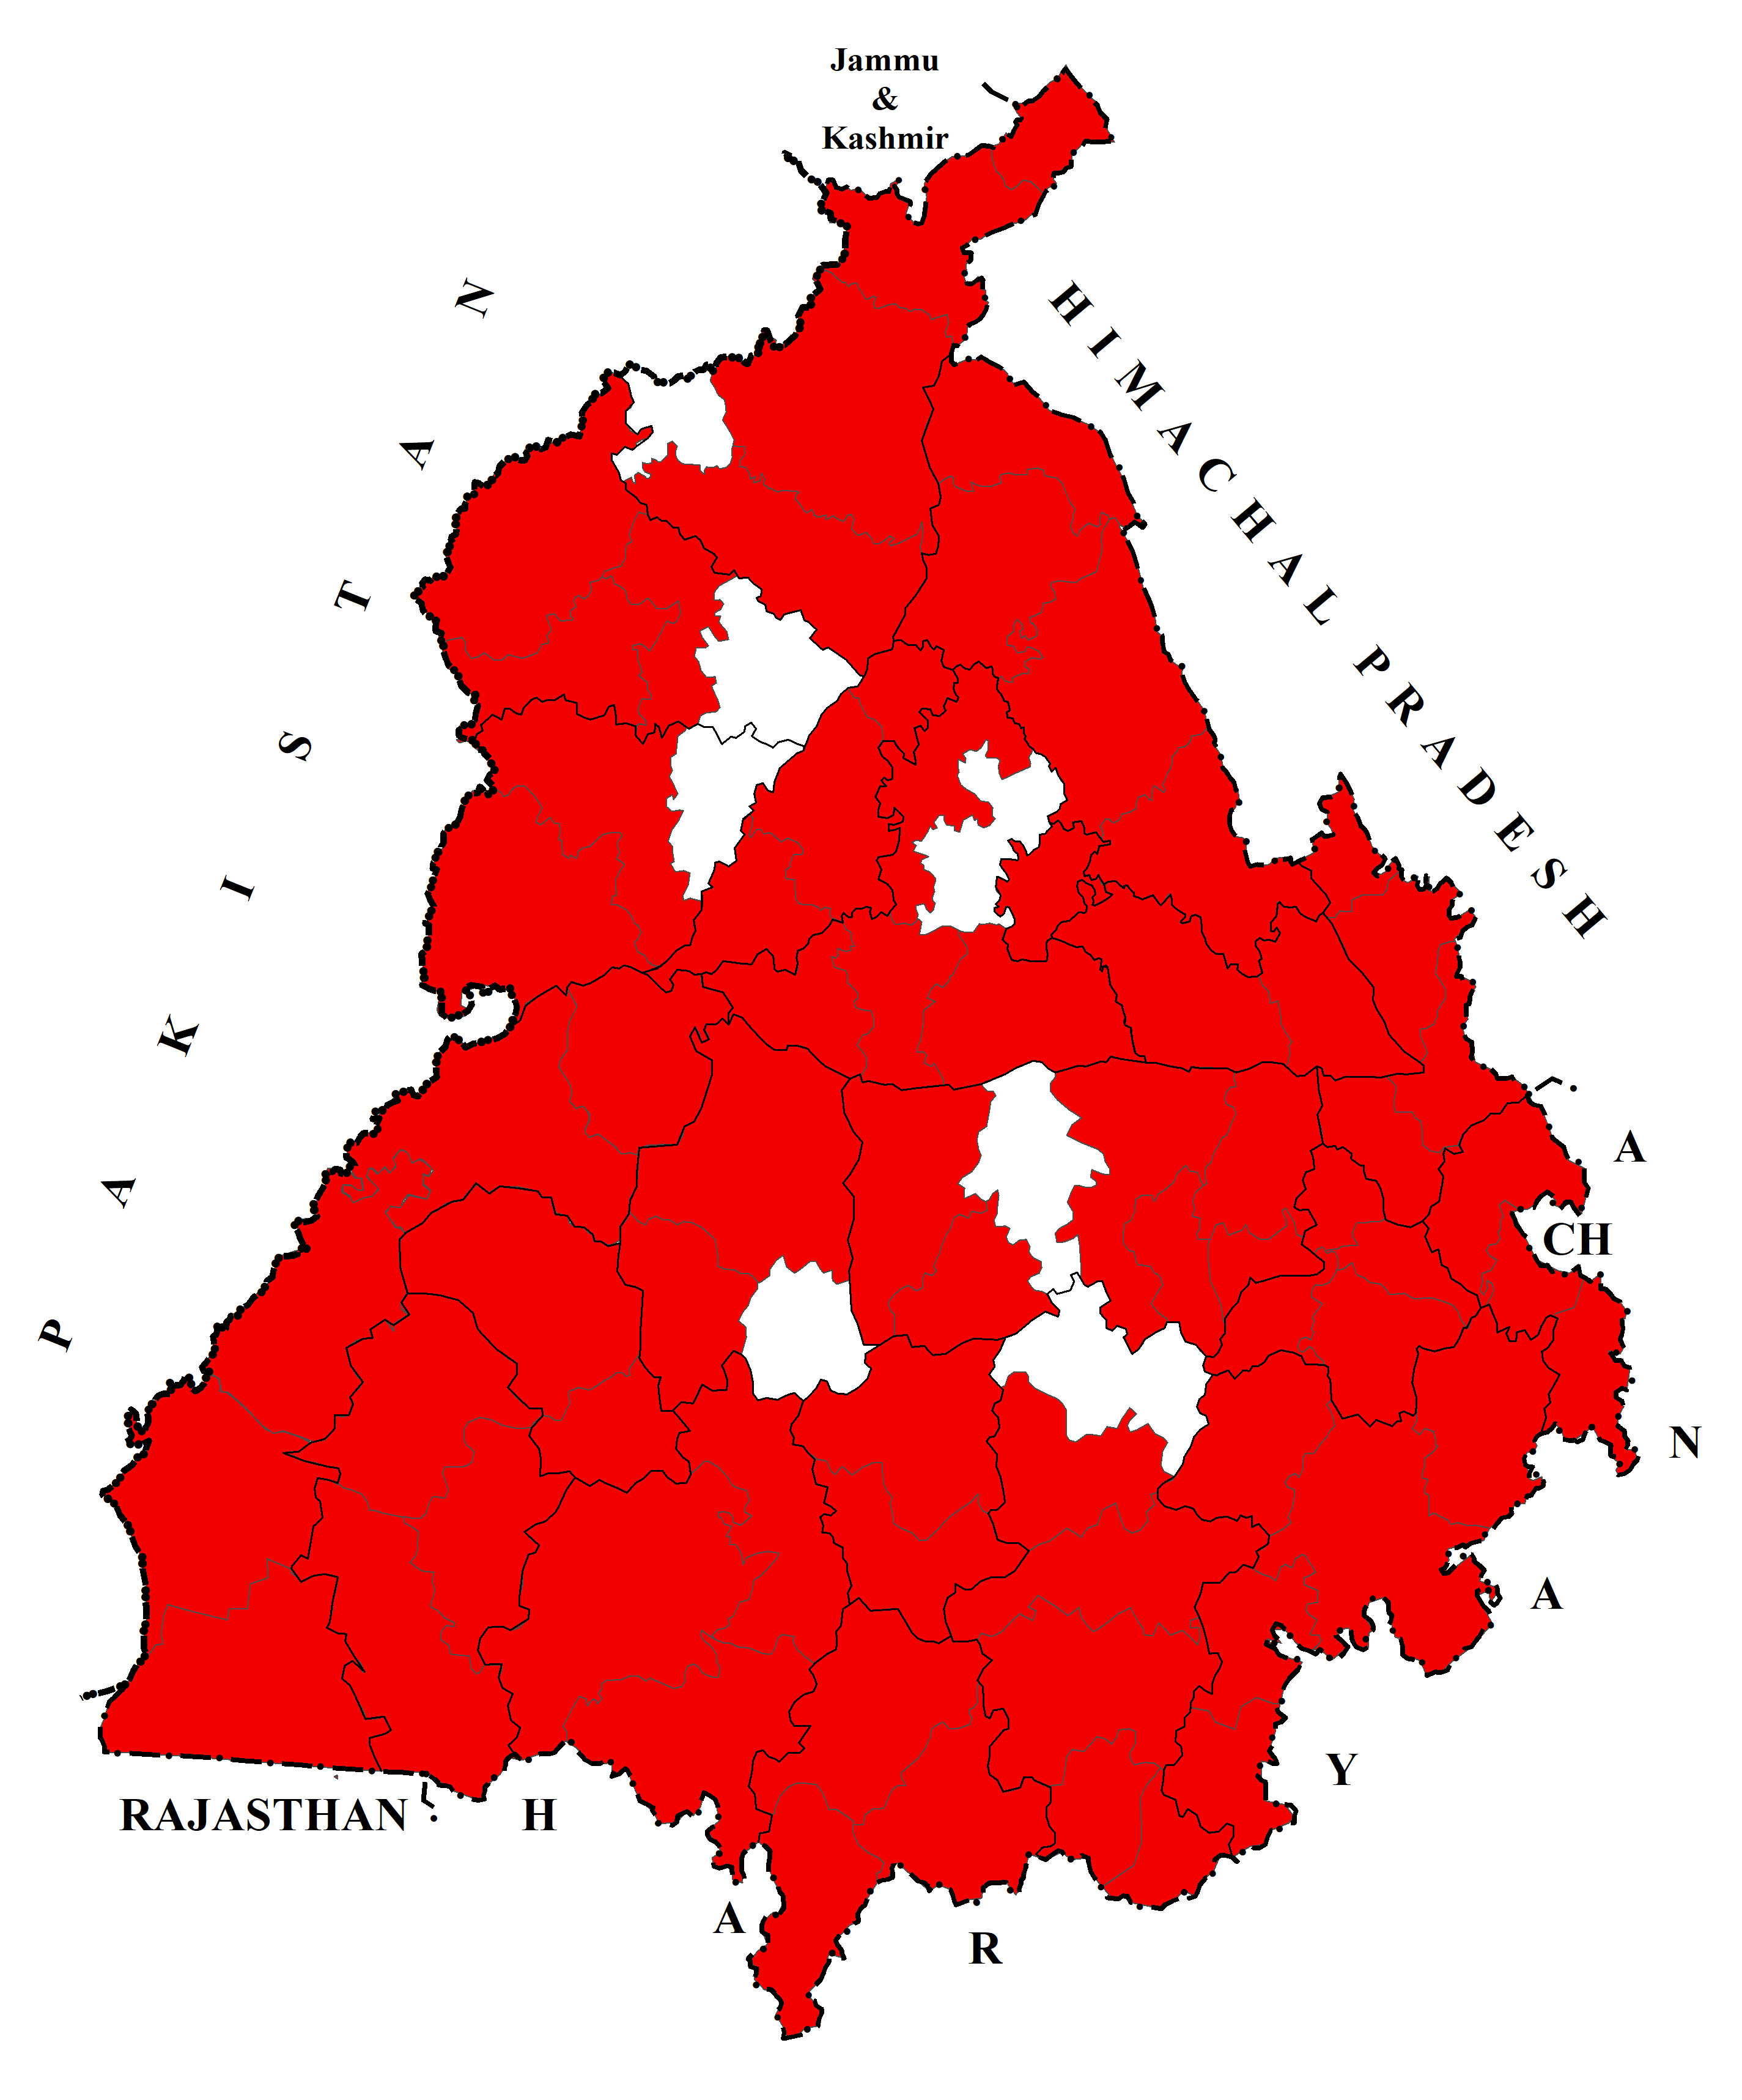
c) 2011
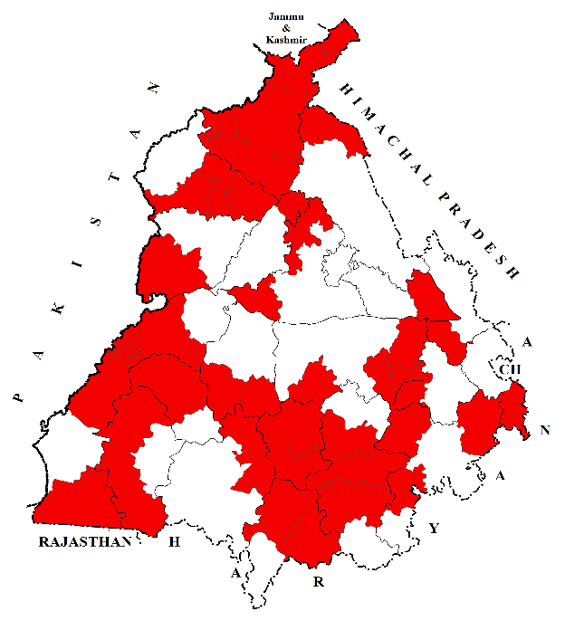
Source: District Census Handbook of Punjab, 1991, 2001 and 2011.

decade later in 2011, the situation of child sex ratio among the rural areas had improved somewhat. Forty-four tehsils of the study area reported relatively low rural child sex ratio in 2011. Majha emerged as the most unfortunate region wherein all the tehsils were in the lowest child sex ratio category (Map 4 (c)). On the other hand, about fifty-eight percent tehsils of Malwa and twenty percent of Doaba registered improvement in this regard. Moreover, almost all the areas along the international border with Pakistan and inter-state border with Haryana had shown relatively low rural child sex ratio. The northern, north-western, southern and south-eastern areas of the state experienced relatively high spread of low rural child sex ratio (Map 4).
In urban Punjab, twenty-two tehsils recorded relatively low child sex ratio in 1991. The highest spread of relatively low urban child sex ratio was reported in Majha followed by Malwa and Doaba (Map 5 (a)). A decade later in 2001, relatively low child sex ratio among the urban areas had been witnessed in ninety-one percent tehsils of the state. Major role in this regard was played by Malwa followed by Doaba and Majha (Map 5 (b)). After twenty years in 2011, fifty-two percent tehsils of the study area had come under relatively low urban child sex ratio category. During these two decades, relatively low urban child sex ratio had spatially spread from north to south and west to east of the state (Map 5). About eighty-three percent tehsils of Majha, more than fifty percent tehsils of Malwa and one-third tehsils of Doaba emerged with relatively low urban child sex ratio even after two decades.
All those tehsils recorded relatively low child sex ratio, where there was low urban child sex ratio in 1991. Thus, it shows that the rural areas of the state were catching up the trends of low child sex ratio of the urban areas. The study indicates that relatively low child sex ratio spread from urban to rural areas of the state. It has been observed that malpractice of female foeticide was responsible for the deterioration of urban as well as rural child sex ratio. The prevalence of strong patriarchal culture and availability of sex-selection techniques pushed the rural as well as the urban areas into worst condition in this regard.
5. Conclusion
The study shows that a clear rural-urban disparity in child sex ratio has been found in Punjab during 1991-2011. Spatial as well as regional variations have been observed in this regard. It has been noted that tehsils that recorded relatively high rural-urban disparity in child sex ratio in 1991 were found scattered across the study area. Another important finding is that almost all areas in the foothill zone of the Himalayas exhibits relatively high rural-urban disparities in child sex ratio in 2001. In 2011, the southern and eastern fringes of Malwa, parts of north-eastern Doaba, and Majha reported relatively high rural-urban disparity in child sex ratio. The study reveals that many socio-cultural and economic factors are responsible for widening this rural-urban gap in the child sex ratio. It has also been found that relatively low child sex ratio (below 850 female children per thousand male children) spread spatially at fast pace from 1991 to 2011 in rural and urban areas of Punjab. The study indicates that relatively low child sex ratio spread from urban to rural areas of the state. It has been noted that the rural areas of the state were catching up the trends of low child sex ratio of the urban areas during 1991-2011.

References
Aravamudan, G. (2007). Disappearing Daughters. Gurgaon, Penguin Books.
Banister, J. (2004). Shortage of Girls in China Today. Journal of Population Research, 21(1), 19-45.
Cai, Y., & Lavely, W. (2003). China’s missing girls: Numerical estimates and effects on population growth. The China Review, 2(3), 13-29.
Callen, V. J., & Kee, P. G. (1981). Sons and Daughters? Cross-Cultural Comparisons of the Sex Preference of Australia, Greek, Italian, Malay, Chinese and Indian Parents in Australia and Malaysia. Population and Environment, 4(2), 97-108.
Department of Health and Family Welfare, Government of Punjab. (2007). Combating Female Foeticide: A Perspective Plan. Chandigarh, Institute for Development and Communication.
Guilmoto, C. Z., & Oliveau, S. (2007). Sex Ratio Imbalances Among Childern At Micro-Level: China and India Compared. New York, Population Association of America 2007 Annual Meeting Proceedings, 1-18.
Gupta, M. D., & Li, S. (1999). Gender bias in China, South Korea and India 1920-1990: The effects of war, famine, and fertility decline. Development and Change, 30(3), 619-652.
Kaur, B. (2015). Sex Ratio of Scheduled Caste population in Punjab: 2011. Population Geography, 37(1&2), 73-86.
Larson, M., & Hatti, N. (2008). Intergenerational Interests, Uncertainty and Discrimination - I: Conceptualising the Process of Declining Child Sex Ratios in India. Sociological Bullentin, 57(1), 82-96.
Mies, M. (2014). Patriarchy and Accumulation on the world scale: Women in the International division of Labour. London, Zed Books.
Organisation for Economic Co-operation and Development (OECD). (2018). Economic Policy Reforms Interim Report, Paris, OECD Publishing.
Patel, T. (ed.). (2007). Sex-Selective Abortion in India: Gender, Society and New Reproductive Technologies. New Delhi, Sage Publications.
Purewal, N. K. (2010). Son Preference: Sex Selection, Gender and Culture in South Asia. New York, Berg Publication.
World Health Organisation. (2011). Preventing Gender-Biased Sex Selection. Geneva, Switzerland, W.H.O. Retrieved on 21, 01, 2020, from https://apps.who.int/iris/bitstream/handle/10665/44577/9789241501460_eng.pdf;jsessionid=7130A85B7C475D75FB370420C2B1204F?sequence=1.

