Laboratory Safety Education in Higher Education: A Five-Dimensional Framework and Institutional Practice

.
ABSTRACT

Aims: To examine the major limitations of current laboratory safety education in universities, construct a five-dimensional reform framework from an educational perspective, and evaluate its practical value through institutional practice.
Study design: This study employed a qualitative case-study design supported by document analysis and literature-based review.
Place and Duration of Study: The study was conducted at Jiangsu University, China, based on laboratory safety education reform practices implemented in recent years.
Methodology: The study analyzed policy documents, institutional regulations, and relevant studies on laboratory safety education in higher education. Current problems were examined from five aspects: educational philosophy, training content and methods, institutional responsibility, access and assessment, and safety culture. On this basis, a five-dimensional reform framework was developed, covering educational philosophy, governance structure, curriculum and training, digital platform support, and safety culture. Jiangsu University was selected as a case to illustrate how the framework was applied through layered responsibility, differentiated training, digital governance, and campus-wide safety activities.
Results: The analysis showed that current university laboratory safety education is still constrained by inadequate conceptual integration, homogeneous teaching content, fragmented responsibility, weak alignment between access and competency assessment, and insufficient cultural support. The institutional case indicated that the reform improved both management effectiveness and educational outcomes. Participation in safety-related activities reached 93%, safety violations decreased by 42%, the hazard rectification rate exceeded 98%, access qualification reached 100%, and satisfaction with safety education increased from 72% to 91%.
Conclusion: Laboratory safety should be understood not only as a management issue, but also as an important educational issue in higher education. A reform model centered on philosophy, governance, curriculum, digital support, and culture may help universities establish a more systematic, sustainable, and education-oriented approach to laboratory safety education.

Keywords: laboratory safety education; higher education reform; Three-Wide Education; experimental teaching; safety culture

1. INTRODUCTION

Laboratory safety is closely related to the quality of experimental teaching, research training, and institutional governance in higher education. University laboratories are not only operational spaces for experiments and scientific research, but also important environments for cultivating students’ practical competence, professional ethics, and risk awareness. In recent years, repeated laboratory accidents have drawn increasing attention to weaknesses in university safety education, including insufficient conceptual integration, weak implementation, limited training effectiveness, and underdeveloped safety culture [1].

To address these concerns, educational authorities in China have issued a series of policy documents and regulatory standards intended to strengthen laboratory safety in higher education [2]. These initiatives have promoted institutional reform in laboratory access, safety supervision, and training management. Yet in many universities, safety education is still treated primarily as a matter of administrative compliance. Training often remains formalistic, access systems are not always linked to actual competence, and responsibilities are dispersed across several departments without strong coordination. Under such conditions, laboratory safety education struggles to form an effective process connecting instruction, practice, assessment, and improvement.

Previous studies have mainly focused on three areas. One line of research emphasizes system construction and responsibility allocation in laboratory safety management. Another explores innovations in teaching methods, including simulation-based and scenario-based safety training [3]. A third highlights the use of digital platforms in access control, safety testing, and information management [4]. While these studies provide valuable insights, a more integrated educational perspective is still needed. In particular, the relationship between laboratory safety education and broader goals such as student development, value formation, and educational quality enhancement remains insufficiently examined [5].

This paper therefore treats laboratory safety not only as a managerial issue, but also as an educational one. Guided by the concept of Three-Wide Education, it seeks to identify the major structural limitations in current university laboratory safety education, develop a five-dimensional reform framework, and examine its application through the institutional practice of Jiangsu University.

2. methodology

This study adopted a qualitative research design combining document analysis, literature review, and institutional case study. First, relevant policy documents and university regulations concerning laboratory safety education, access management, and safety supervision were reviewed in order to identify the broader policy and governance context of the study. Second, published studies on laboratory safety education in higher education were analyzed to summarize existing reform approaches and common challenges [3-5].

On this basis, the study examined current problems in university laboratory safety education from five dimensions: educational philosophy, training content and pedagogical design, institutional responsibility, access and competency assessment, and safety culture. These analytical dimensions were then used to construct a five-dimensional reform framework.

To further explore the practical applicability of this framework, Jiangsu University was selected as a case. The case analysis focused on institutional arrangements, layered responsibility systems, differentiated safety training, digital governance tools, and campus-based cultural activities. The purpose of the case was not statistical generalization, but analytical illustration. Through this design, the study sought to connect conceptual analysis with institutional practice and to show how a more systematic and education-oriented model of laboratory safety may be developed in higher education.

3. results and discussion

3.1 Structural limitations in current laboratory safety education

3.1.1 Inadequate integration of educational philosophy and safety education

Laboratory safety education should extend beyond the communication of rules and procedures. It should also cultivate students’ sense of responsibility, awareness of risk, and capacity for sound judgment in experimental settings. In practice, however, laboratory safety is still frequently regarded as a routine management task or a procedural requirement for access. This weakens its educational significance and limits its role in student development.
In some universities, safety instruction still relies heavily on centralized lectures and standardized materials. These arrangements often give insufficient attention to differences in discipline, laboratory risk, and student learning stage. As a result, the content may remain general and detached from actual laboratory experience. Moreover, safety education is not always effectively incorporated into the wider framework of fostering virtue through education, which makes its long-term influence more difficult to sustain [6].

3.1.2 Insufficient differentiation in content and pedagogical design

A second problem lies in the relative uniformity of training content and methods. Many universities still focus mainly on regulations, warning cases, and basic procedures, while practical exercises, interactive teaching, and scenario-based learning are less developed. Conventional methods such as slide-based lectures, manuals, and passive video learning may help convey information, but they are often less effective in shaping operational competence and stable behavioral habits.

This problem is especially evident in the limited differentiation of training across user groups. Undergraduates, graduate students, faculty members, and laboratory technicians may receive similar safety instruction despite substantial differences in laboratory role, disciplinary background, and exposure to risk. In high-risk fields such as chemistry and materials science, the lack of targeted training reduces both relevance and practical value [7,8].

3.1.3 Fragmentation of institutional responsibility

Laboratory safety education usually involves the participation of several university units, including laboratory management departments, academic affairs offices, safety supervision bodies, and student affairs divisions. While such multi-party participation is necessary, responsibility boundaries are not always clearly defined. This can result in fragmented implementation, weak coordination, and the diffusion of accountability.

At the teaching level, pre-laboratory guidance is not always given sufficient attention, and some safety explanations may be informally delegated to assistants or senior students. In addition, feedback mechanisms and dynamic responsibility tracking are often underdeveloped. Once a safety problem emerges, this lack of clarity may complicate follow-up action and weaken the authority of the system [15,16].

3.1.4 Weak alignment between access systems and competency assessment

Although laboratory access systems have become more common, their connection with actual competency assessment is not always strong. In some institutions, training still consists mainly of brief orientation sessions or simple online tests. Students may formally complete the required procedures, but their practical understanding of laboratory risks and safe operation is not always adequately assessed [7,8].

Some recent reforms have attempted to strengthen this aspect by integrating position requirements, coursework, assessment, and certification into a closed-loop system [9]. Even so, implementation remains constrained by limited staffing, uneven platform support, and insufficient coordination across departments. These limitations reduce the extent to which access mechanisms can move beyond procedural completion toward substantive competence development.

3.1.5 Limited depth in safety culture development

The effectiveness of laboratory safety education depends not only on rules and training systems, but also on the cultivation of a shared safety culture. In many universities, however, safety continues to be perceived mainly as an externally imposed requirement rather than as an internalized norm of professional conduct. Students may complete training simply because it is mandatory, while some teachers and administrators may not consistently model strong safety awareness in daily practice.

In addition, campus communication on safety often relies on static forms such as posters, notices, and routine publicity. Participatory forms, including drills, competitions, peer learning, and reflective discussion, are less frequently embedded in the broader educational process [19,20]. As a result, students may know the requirements without fully translating them into durable habits.

3.2 Representative reform approaches in current practice

3.2.1 Multi-level and modular safety education

A number of universities have explored multi-level and modular safety education systems that differentiate learners according to discipline, year level, and laboratory role [1]. In some cases, general training for new students is combined with targeted training before professional laboratory work and specialized instruction for high-risk activities. This layered structure increases relevance and helps improve institutional implementation.

3.2.2 Closed-loop reform through the integration of position, course, assessment, and certification

Some universities have developed closed-loop systems linking laboratory roles, coursework, assessment, and certification [9]. Under this model, students are expected to complete required learning modules, simulated exercises, and tests before entering specific laboratories. Because certification is tied to actual experimental access, student engagement tends to improve, and access control becomes more substantive.

3.2.3 Development of safety culture under the framework of Three-Wide Education

With the increased emphasis on Three-Wide Education, some universities have started to place laboratory safety within a broader educational framework that includes moral cultivation, professional ethics, and whole-process student development [6,10]. In this approach, safety education extends beyond classroom teaching and is supported by activities such as safety month events, public speaking contests, and student liaison programs.

3.2.4 Digital support for whole-process safety education

Information technology has become an important support mechanism in laboratory safety reform. Some universities have developed digital platforms that integrate training delivery, progress tracking, assessment management, hazard reporting, and access control [4,11]. In more advanced settings, image recognition and data analysis have also been introduced for risk identification and behavioral warning [12,18]. These efforts strengthen traceability and improve the connection between educational processes and laboratory management.

3.2.5 Composite curriculum design for interdisciplinary settings

As laboratory work becomes increasingly interdisciplinary, some universities have begun to develop composite curriculum packages combining general safety modules with training for specific experimental contexts [13]. This is especially relevant for interdisciplinary laboratories, where risk profiles are often more complex and cannot be addressed through a single disciplinary framework.

3.3 A five-dimensional reform framework for laboratory safety education

Based on the analysis above, this study proposes a five-dimensional reform framework for laboratory safety education composed of educational philosophy, governance structure, curriculum and training, digital platform support, and safety culture.

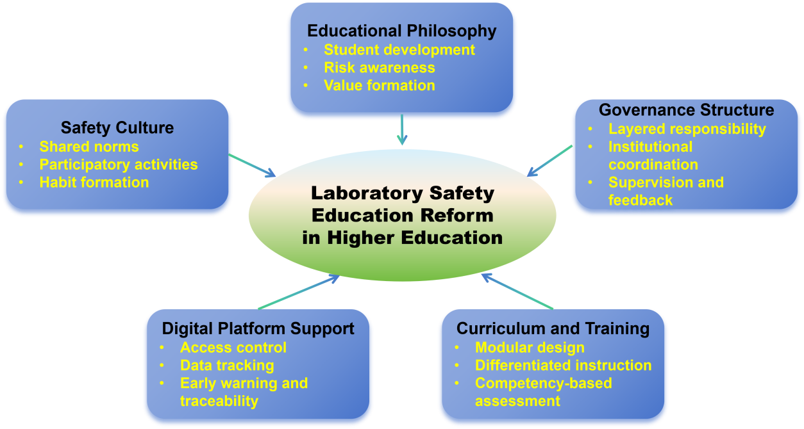
Figure 1. Five-Dimensional Reform Framework for Laboratory Safety Education

Educational philosophy provides the value orientation of reform. Governance structure defines institutional responsibility and coordination. Curriculum and training serve as the pedagogical core. Digital platform support strengthens process integration and traceability. Safety culture sustains long-term influence by turning rules into shared norms and daily practice. These dimensions are mutually connected and together provide a more systematic basis for educational reform in laboratory safety. Figure 1 presents the proposed five-dimensional reform framework, illustrating how educational values, institutional arrangements, pedagogical design, digital support, and safety culture are integrated within a common educational logic. Table 1 summarizes how the principal deficiencies identified in current practice can be translated into specific reform dimensions, institutional responses, and expected outcomes.

Table 1. Reform Translation from Problem Identification to Institutional Response
Problem | Reform Dimension | Institutional Response | Expected Outcome
Administrative view of safety | Educational Philosophy | Reposition safety within student development | Stronger educational orientation
Uniform training content | Curriculum and Training | Introduce modular and differentiated training | Higher relevance and competence
Fragmented responsibility | Governance Structure | Clarify responsibilities across levels | More coherent implementation
Weak access-assessment linkage | Digital Platform Support | Connect training, testing, and access control | Improved traceability and compliance
Limited cultural internalization | Safety Culture | Embed drills, competitions, and dialogue | More durable safety habits

3.4 Institutional practice at Jiangsu University

Figure 2 translates the framework into a path-element-mechanism model and shows how problem diagnosis can be connected with institutional design and concrete reform measures in practice.
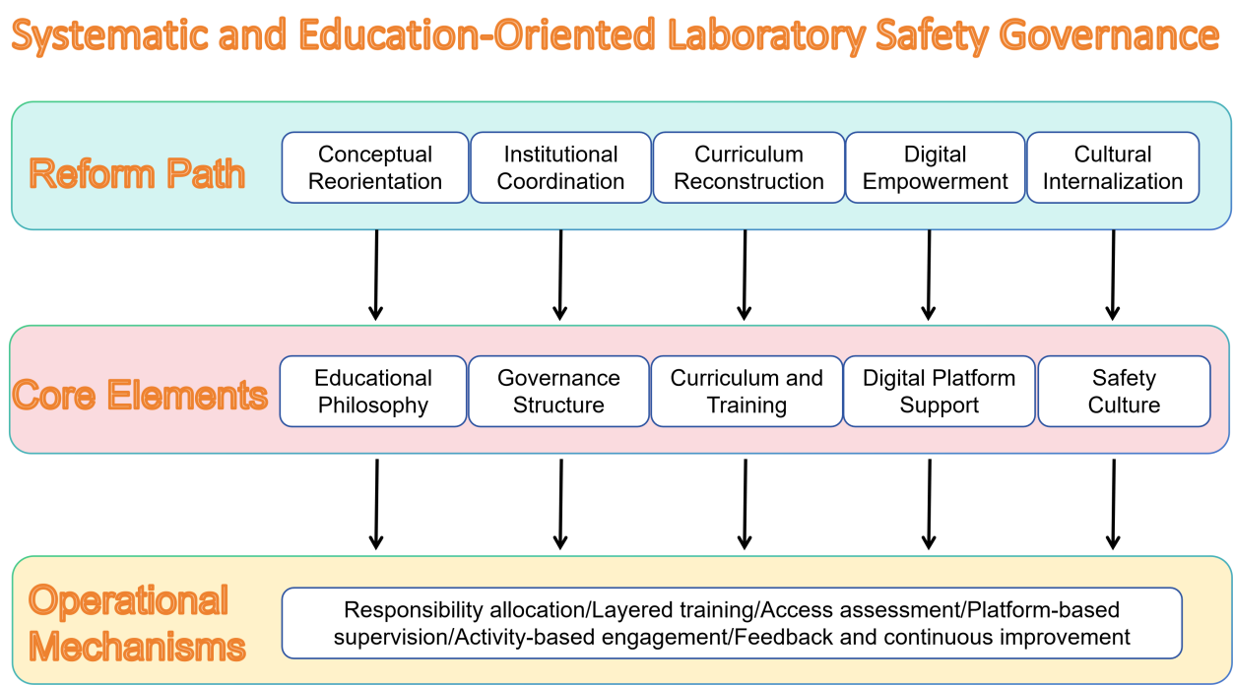

Figure 2. Path-Element-Mechanism Model of Laboratory Safety Education Reform

3.4.1 Repositioning laboratory safety within student development

At Jiangsu University, laboratory safety education has gradually been incorporated into the broader process of student cultivation. A three-level safety education system and related workload requirements have been established, and safety literacy has been linked to graduate evaluation, scholarship review, and laboratory access. In this way, safety education is embedded more directly in student development.

The university also organized themed activities such as Laboratory Safety Culture Month and laboratory safety skills competitions. According to the institutional practice reported in the Chinese manuscript, participation reached 93%, and safety violations decreased by 42% after reform.

3.4.2 Clarifying responsibility through layered governance

The university has established a three-level responsibility system linking the university, secondary units, and individual laboratories. Responsibilities are allocated according to the principle that users are responsible for safety and supervisory units are accountable for oversight [15,16].

Laboratories conduct annual self-inspections, secondary units are responsible for examination and rectification, and the university organizes comprehensive inspections on a regular basis. Reported practice indicates that the hazard rectification rate exceeded 98%.

3.4.3 Strengthening the link between training and assessment

Jiangsu University has also developed differentiated training requirements for different laboratory roles and risk levels. Training modules cover basic safety, high-risk operations, and hazardous chemicals management. These modules are linked directly to laboratory access so that only those who complete the required training and assessment may enter high-risk laboratory spaces [17].

In addition, the university has offered targeted programs such as hazardous chemicals training and graduate student safety administrator training. Reported results show that access qualification reached 100%, and high-risk laboratories recorded no major accidents for two consecutive years.

3.4.4 Advancing safety governance through digital support

A unified information platform has been established and connected with the access control system. The platform verifies whether users have completed required training before entry, records laboratory access and equipment use, and generates safety inspection records automatically. In this way, digital tools support not only management efficiency but also the traceability of safety education and laboratory operation [18].

3.4.5 Reinforcing value recognition through safety culture

The university has also promoted safety culture through both institutional rules and themed activities. Accountability systems have been strengthened, while emergency drills and skills competitions have made safety education more concrete and participatory [19,20]. According to the institutional materials, satisfaction with safety education increased from 72% to 91% after reform.

The findings suggest that laboratory safety should not be treated merely as a matter of technical management. It is also an educational issue closely connected with student development, experimental teaching, and professional norms. When safety education is reduced to a checklist or a formal access requirement, its influence remains limited. When it is embedded in governance, curriculum, digital systems, and campus culture, it becomes more systematic and more sustainable.

The five-dimensional framework developed in this study contributes in three respects. First, it shifts attention from compliance alone to student development. Second, it emphasizes that laboratory safety education depends on the interaction of multiple dimensions rather than a single reform measure. Third, the Jiangsu University case shows that such a framework becomes more persuasive when linked to visible institutional practice and measurable outcomes.

4. Conclusion

Laboratory safety education is an important component of experimental teaching reform and university governance in higher education. Yet in many institutions it remains constrained by inadequate conceptual integration, undifferentiated training, fragmented responsibility structures, weak access mechanisms, and insufficient cultural support. In response, this study has proposed a five-dimensional reform framework centered on educational philosophy, governance structure, curriculum and training, digital platform support, and safety culture.

Drawing on the case of Jiangsu University, the study shows that laboratory safety education can be strengthened when these five dimensions are advanced in a coordinated manner. In this sense, laboratory safety should be understood not only as a matter of risk control, but also as an educational process related to student development, value cultivation, and institutional quality improvement.

This study is based mainly on one institutional case, and future research may compare different university contexts, examine disciplinary differences in implementation, and develop more refined tools for evaluating the long-term outcomes of laboratory safety education. Even so, the framework proposed here may offer a useful reference for universities seeking to build a more systematic, sustainable, and education-oriented model of laboratory safety governance.

Competing interests

The authors declare that no competing interests exist.

Consent

Not applicable.

Ethical approval

This study did not involve human participants or animal subjects. Ethical approval was therefore not required.

COMPETING INTERESTS DISCLAIMER:
Authors have declared that they have no known competing financial interests OR non-financial interests OR personal relationships that could have appeared to influence the work reported in this paper.

References

1 Li, X. M., Li, J., & Song, H. T. (2024). Construction and practice of a multi-level and three-dimensional safety education system. Research and Exploration in Laboratory, 43(1), 135-138.
2 Ministry of Education of the People’s Republic of China. (2023). Notice of the General Office of the Ministry of Education on issuing the Safety Standards for Laboratories in Higher Education Institutions (Jiaokexintinghan [2023] No. 5). Gazette of the Ministry of Education of the People’s Republic of China, (3), 40-51.
3 Liang, W. Y., Zhang, C. F., Yu, X., et al. (2024). Construction and practice of a teaching-assessment linked safety education system for chemical laboratories. University Chemistry, 39(10), 330.
4 Hou, L. L., Chen, Q. C., Lin, Z., et al. (2024). Construction of an information-based laboratory safety management system in universities. Research and Exploration in Laboratory, 43(7), 254-258.
5 Gao, T., Sun, W. F., Han, L., et al. (2025). Reconstruction and practice of laboratory safety education systems from different dimensions. Chemical Enterprise Management, (6), 108-111.
6 Wang, Q. L., Wu, Z. W., & Ai, D. S. (2024). Reflections on university laboratory safety training from the perspective of fostering virtue through education: From safety education to safety-oriented cultivation. China University Teaching, (7), 78-84.
7 Wang, N., & Jin, C. Y. (2024). Construction of a safety education and access system for university chemistry laboratories. Experiment Science and Technology, 22(3), 134-139.
8 Ma, X. P., Zhang, P., Wang, P. X., et al. (2024). Research on the construction of laboratory access systems in scientific research institutions. China Educational Technology & Equipment, (17), 149-151.
9 Zhang, L., Zhang, X. Y., Wang, S. S., et al. (2025). Research on a safety management model for special equipment in university laboratories centered on position, course, assessment, and certification. Experimental Technology and Management, 23(2), 156-160.
10 Ge, C. C., Yu, T., Xing, L., et al. (2024). Construction and management of theoretical courses on laboratory safety. Research and Exploration in Laboratory, 43(6), 219-222.
11 Jiang, L. L., Ye, H. L., & Tian, X. C. (2024). Construction of a laboratory safety management system in Sino-foreign cooperative universities based on the EHS concept. Research and Exploration in Laboratory, 43(6), 109-112.
12 Peng, L. P., & Xiong, H. Q. (2022). Management and practice of laboratory consumables in universities based on an information platform. Research and Exploration in Laboratory, 41(4), 262-266.
13 Li, B. Y., Bi, D. Q., Ai, D. S., et al. (2023). Construction and implementation of a laboratory safety curriculum system for interdisciplinary laboratories in universities. Experimental Technology and Management, 40(11), 7-14.
14 Yang, D. S., Geng, J. M., Li, H. S., et al. (2024). Practical exploration of safety education in university chemistry and chemical engineering laboratories. Research and Exploration in Laboratory, 43(12), 235-240.
15 Yang, D. Z. (2024). Practical exploration of all-staff safety responsibility systems and post safety standardization in universities. Research and Exploration in Laboratory, 43(6), 250-255.
16 Yan, J., Liu, Z., Song, X. F., et al. (2024). Construction of a university laboratory safety management system driven by the safety responsibility system. Research and Exploration in Laboratory, 43(12), 248-251.
17 Hu, C., Wu, Y., Chen, L. Q., et al. (In press). Innovation and exploration of chemical laboratory safety courses based on the strategy of “three-in-one and four-integration”. University Chemistry.
18 Li, J., Zhang, H. Q., Xu, W., et al. (2024). Construction and practice of an evaluation mechanism for students’ laboratory safety literacy. Research and Exploration in Laboratory, 43(8), 254-257.
19 Yu, Y. X. (2024). Exploration and practice of laboratory safety education in universities. China Modern Educational Equipment, (23), 36-38.
20 Liu, H. F., Wang, L. X., Liang, Y. J., et al. (2023). Reform and practice of university laboratory safety education systems from the perspective of new engineering. Research and Exploration in Laboratory, 42(11), 277-282.

