Genotype x Environment Interaction, and Stability Analysis of Bread Wheat (Triticum aestivum L.) Genotypes Using GGE Biplot Approach Across Two Environments

ABSTRACT
The present study was conducted to evaluate the performance and stability of twenty-six wheat (Triticum aestivum L.) genotypes across two environments using a randomized block design with three replications. The genotypes were selected from a larger set of 111 entries evaluated earlier. Combined ANOVA revealed significant differences among genotypes for most traits, indicating genetic variability. A significant genotype × environment (G×E) interaction was also observed for major yield-contributing traits, including grain yield per plant (GYP), grains per ear (GPE), and productive tillers (PT), justifying the use of GGE Biplot analysis.
GGE Biplot analysis showed different genotype performance across environments. For grain yield per plant (GYP), genotypes G17 (HI8777) and G20 (RAJ4238) showed high mean performance along with better stability across environments, whereas genotypes G1 (HD3226) in Punjab (Environment 1) and G21 (HD3321) in Himachal Pradesh (Environment 2) showed adaptability in individual environments. For grains per ear (GPE), genotype G17 (HI8777) was identified as stable and high performing and G17 is superior performer in environment 1 and G26 (PBW550) in environment 2, for productive tillers (PT) genotype G4 (HS490) exhibited relatively better stability, while genotypes G16 (HI1620) in environment 1 and G10 (HPW360) in environment 2 and protein content showed non-significant G×E interaction and minimum variation across environments, indicating stable expression. Genotype G10 (HPW360) exhibited relatively consistent protein content across both environments.

Keywords: Wheat, GGE Biplot analysis, Grain yield, Protein content, Genotype × environment interaction

INTRODUCTION

Wheat (Triticum aestivum L.) is the cornerstone of global food security, providing an important portion of daily calorie intake for millions of people around the world (Joshi et al., 2017). With increasing climate hazards and growing population demands, there is an urgent need to develop stable, high-yielding, and nutritionally rich wheat varieties. One of the key challenges in wheat improvement is the interaction between genotype and environment (G×E), which can significantly influence phenotypic expression and yield stability in Multi-location trials (Yan et al., 2000, Gauch, 2006). Analysis of variance (ANOVA) in an RBD experiment partitions the total variation into three main components: variation due to treatments, variation due to blocks (soil and environmental variation), and experimental error. The significance of treatment effects is helpful to determine whether observed differences among genotypes or treatments are statistically meaningful. Pooled ANOVA helps plant breeders to identify stable and widely adapted genotypes by evaluating the consistency of performance across environments. It is especially important in multi-location trials and stability studies. GGE Biplot analysis is a graphical method used to evaluate genotype performance and stability across multiple environments (Yan et al., 2000; Yan and Tinker, 2006). The GGE concept stands for G (Genotype main effect) plus G × E (Genotype × Environment interaction.
In the present study, twenty-six performing wheat genotypes were evaluated across two distinct environments representing different climatic and soil conditions. These genotypes were selected from a previous experiment of 111 entries evaluated under an augmented block design during Rabi 2022–2023. The current trial was conducted under a randomized block design, aimed to assess grain yield stability and traits such as protein content at two different agro-climatic environments
OBJECTIVES:-.
- To select and evaluate superior wheat Genotypes for quantitative traits across different environments.
- To evaluate the selected wheat Genotypes for qualitative traits, with special reference to Protein content.

MATERIALS AND METHODS
The present study was carried out during the Rabi season of 2023–2024 to evaluate the performance and stability of twenty-six wheat (Triticum aestivum L.) at two locations: the BT Indigenous Seed Production Company Farm in Sainsowal, Punjab, and the Himachal Hybrid Seeds Firm Farm in Lambagaon, Himachal Pradesh (India). These sites differ in climatic conditions. The experimental layout followed a randomized block design (RBD) with three replications per location. Each genotype was grown in a plot size of 2 m × 1.15 m with row-to-row spacing of 23 cm and was sown manually in rows and a 50 cm-wide drainage channel separated each block to avoid cross-contamination and improve irrigation efficiency. The recommended fertilizer dose of 120:60:40 kg/ha (ICAR-Indian Institute of Wheat and Barley Research, Karnal) N: P: K was applied. Nitrogen was split into two doses — half at sowing and half before the first irrigation.
  - Experimental Materials
Table 1: Wheat genotypes.
No. | Genotypes
1 | HD3226
2 | HP3334
3 | HP2002
4 | HS490
5 | BRW3829
6 | HI8757
7 | PBW725
8 | KPL429
9 | HD2733
10 | HPW360
11 | VL907
12 | WH1257
13 | HS507
14 | HD3195
15 | HD2967
16 | HI1620
17 | HI8777
18 | PBW826
19 | HI1634
20 | RAJ4238
21 | HD3321
22 | DBW222
23 | UP2844
24 | DBW305
25 | HI1612
26 | PBW550

  - 3.2 Data collection on thirteen traits of twenty-six wheat genotypes
A total of thirteen traits were recorded. Data were collected from five randomly selected plants per plot for each genotype & except for two (days flowering and days to maturity) recorded on a plot basis.
Table 2: List of thirteen traits recorded from the experiment
Sr.no. | Traits | Abbreviations
1 | Plant height | PH
2 | Ear length | EL
3 | Ear weight | EW
4 | Productive tillers | PT
5 | Spikelets numbers | SN
6 | Harvest index | HI
7 | Protein content | PC
8 | Grains per Ear | GPE
9 | 1000 Kernel Weight | KWT
10 | Grain Yield per Plant | GYP
11 | Biological Yield | BY
12 | Days to 50% Flowering | DF
13 | Days to Maturity | DM

  - 3.3 Data Analysis
  - Data collected from both locations were analysed through the ANOVA(Gauch, 2006) for both environments individually, then combined analysis of variance (ANOVA) to assess the effects of genotype (G), environment (E), and genotype × environment interaction (G×E). Significant G×E interactions suggested further stability analysis using the GGE Biplot methodology (Yan et al., 2000; Yan and Tinker, 2006). This model provided information regarding genotype adaptability, interaction patterns, and identification of stable genotypes across environments despite having only two environments. Statistical analysis of experimental data was performed using R Studio software and Grapes software developed by Kerala Agricultural University.

RESULTS & DISCUSSION
Table no.3 shows a pooled analysis of variance (ANOVA) under randomized block design across different environments, showing significant differences among treatments for most of the traits, indicating the presence of a sufficient amount of genetic variability in our experimental materials. The treatment mean squares (Msq) were significant for plant height (PH), ear length (EL), productive tillers (PT), spikelet number (SN), kernel weight per tiller (KWT), grains per ear (GPE), grain yield per plant (GYP), biological yield (BY), days to flowering (DF), days to maturity (DM), and protein content (PC), which showed that there is good scope for selection and genetic improvement of wheat by exploiting these materials. However, ear width (EW) and harvest index (HI) showed non-significant differences, showing limited variability for these traits. The effect of location was significant for most of the traits, showing a strong environmental influence on trait expression. Traits such as PH, EL, EW, PT, GPE, and DM had significant variation due to location, while grain yield per plant (GYP) and days to flowering (DF) were non-significant, suggesting relatively stable performance of these traits across environments. The significant location effect emphasized the importance of multi-environment testing in evaluating genotype performance. The genotype × environment (G×E) interaction was found to be significant for most of the traits, including PH, EL, EW, PT, SN, KWT, GPE, GYP, and BY, indicating that genotypes responded differently across environments. This suggested that the relative performance of genotypes varied with environmental conditions, justifying the need for stability analysis such as GGE Biplot. Whereas days to flowering (DF), days to maturity (DM), and protein content (PC) showed non-significant interaction effects, indicating their stability across environments. Similar significant genotype × environment interactions for yield and related traits have been reported in wheat by Baloch et al. (2020) and Ajmera et al. (2021) and Purchase et al. (2000) , highlighting the importance of multi-environment testing.

Table 3
Pooled ANOVA for thirteen traits of twenty-six genotypes
Source of variations | Degrees of freedom | PH(Msq) | EL(Msq) | EW(Msq) | PT(Msq) | SN(Msq) | KWT(Msq) | GPE(Msq) | GYP(Msq) | BY(Msq) | HI(Msq) | DF(Msq) | DM(Msq) | PC(Msq)
Location | 1 | 5635.692*** | 1285.351*** | 117.52*** | 490.012*** | 98.654** | 143.698** | 10463.388*** | 30.29ns | 24.897* | 617.099** | 0.273ns | 123.853*** | 0.92**
Treatment | 25 | 491.542*** | 220.738*** | 0.313ns | 361.519*** | 62.533*** | 197.143*** | 629.714*** | 1220.255*** | 32.351*** | 73.955ns | 230.62*** | 55.589*** | 276.271***
Replication with in location | 4 | 23.46 | 11.792 | 0.998 | 29.206 | 0.32 | 1.054 | 2.422 | 0.957 | 1.902 | 23.038 | 23.481 | 220.526 | 0.772
Location x Treatment | 25 | 52.075*** | 33.269*** | 0.448*** | 10.785*** | 8.9*** | 11.85*** | 106.077*** | 11.106*** | 3.886*** | 60.612*** | 0.165ns | 0.346ns | 0.099ns
Error | 100 | 1.486 | 3.285 | 0.049 | 2.815 | 1.299 | 1.39 | 2.405 | 3.791 | 1.177 | 19.245 | 1.369 | 17.559 | 1.237

DF = Degrees of freedom, ***= significant at P≤.001, ** = significant at P ≤ .01, * = significant at P ≤ .05, ns = not significant (P> .05).

Table 4:
Twenty-six Genotypes Mean Performances.
Genotypes | Environment | PH | EL | EW | PT | SN | KWT | GPE | GYP | BY | HI | DF | DM | PC
1 | 1 | 91.3 | 10.0 | 3.4 | 3.9 | 11.9 | 49.5 | 70.6 | 17.6 | 36.1 | 48.8 | 97.3 | 144.3 | 11.8
2 | 1 | 97.3 | 9.7 | 3.2 | 3.6 | 16.0 | 42.8 | 73.4 | 16.5 | 34.0 | 48.7 | 103.7 | 145.0 | 12.0
3 | 1 | 79.0 | 12.0 | 3.6 | 4.3 | 10.1 | 35.4 | 70.8 | 15.9 | 36.0 | 45.7 | 96.3 | 143.7 | 12.0
4 | 1 | 89.0 | 10.9 | 3.7 | 3.5 | 19.5 | 45.8 | 78.5 | 17.5 | 38.2 | 47.4 | 103.7 | 148.7 | 11.2
5 | 1 | 85.0 | 11.1 | 3.3 | 4.1 | 17.8 | 50.7 | 76.4 | 15.5 | 31.0 | 47.3 | 99.0 | 146.7 | 10.6
6 | 1 | 88.7 | 10.5 | 3.2 | 3.7 | 16.0 | 39.1 | 76.3 | 13.9 | 40.3 | 36.5 | 95.3 | 147.0 | 11.3
7 | 1 | 86.7 | 9.7 | 3.4 | 3.4 | 16.9 | 44.4 | 71.4 | 16.3 | 35.2 | 46.2 | 98.0 | 150.3 | 9.4
8 | 1 | 99.3 | 15.3 | 4.2 | 4.3 | 12.5 | 45.3 | 73.0 | 16.8 | 33.4 | 50.3 | 103.7 | 144.3 | 13.1
9 | 1 | 88.7 | 15.6 | 4.0 | 3.5 | 13.9 | 38.1 | 69.3 | 14.1 | 34.2 | 42.7 | 103.7 | 148.3 | 10.8
10 | 1 | 80.0 | 11.9 | 3.6 | 3.6 | 21.3 | 34.9 | 70.9 | 16.2 | 35.8 | 45.3 | 100.7 | 144.3 | 13.4
11 | 1 | 98.3 | 18.0 | 4.3 | 4.5 | 18.3 | 39.8 | 75.6 | 14.4 | 29.8 | 46.7 | 102.0 | 144.3 | 11.4
12 | 1 | 80.0 | 11.1 | 3.4 | 3.3 | 17.8 | 39.4 | 78.7 | 19.7 | 34.2 | 60.1 | 93.3 | 149.3 | 12.2
13 | 1 | 90.3 | 9.6 | 3.2 | 3.9 | 17.1 | 40.9 | 75.0 | 20.8 | 38.8 | 56.2 | 109.3 | 141.0 | 9.3
14 | 1 | 97.3 | 14.4 | 3.9 | 3.4 | 21.7 | 38.7 | 77.0 | 14.3 | 36.3 | 41.1 | 106.3 | 150.7 | 9.8
15 | 1 | 95.3 | 15.4 | 4.1 | 4.3 | 22.1 | 38.0 | 83.2 | 17.5 | 32.9 | 52.8 | 103.7 | 144.7 | 11.4
16 | 1 | 81.7 | 12.3 | 3.4 | 3.5 | 22.4 | 30.2 | 78.5 | 18.0 | 32.8 | 54.4 | 98.3 | 149.7 | 10.6
17 | 1 | 100.0 | 18.2 | 4.6 | 3.7 | 19.0 | 29.6 | 69.8 | 17.1 | 32.6 | 52.2 | 103.3 | 144.3 | 10.5
18 | 1 | 97.7 | 15.6 | 4.0 | 4.2 | 23.1 | 26.8 | 81.5 | 17.1 | 31.7 | 51.4 | 97.0 | 142.7 | 12.8
19 | 1 | 101.3 | 15.5 | 4.3 | 3.5 | 24.7 | 33.1 | 79.1 | 18.4 | 36.5 | 50.4 | 108.0 | 150.7 | 9.7
20 | 1 | 94.3 | 17.5 | 4.4 | 4.3 | 20.2 | 40.1 | 77.9 | 19.5 | 36.8 | 53.3 | 105.3 | 146.7 | 10.7
21 | 1 | 97.7 | 17.3 | 4.2 | 3.7 | 22.3 | 36.6 | 62.8 | 14.9 | 39.8 | 39.5 | 86.7 | 136.7 | 8.5
22 | 1 | 88.7 | 11.8 | 3.5 | 3.1 | 23.4 | 49.5 | 74.6 | 16.3 | 37.3 | 44.9 | 100.3 | 146.3 | 10.2
23 | 1 | 90.7 | 13.8 | 3.6 | 4.1 | 25.6 | 47.8 | 82.8 | 16.3 | 36.5 | 44.5 | 97.3 | 145.7 | 11.3
24 | 1 | 94.0 | 16.0 | 4.0 | 3.7 | 20.7 | 37.7 | 62.0 | 17.9 | 37.3 | 49.9 | 99.0 | 144.7 | 8.8
25 | 1 | 96.3 | 13.3 | 3.5 | 4.1 | 26.8 | 43.0 | 80.0 | 16.4 | 30.8 | 51.1 | 107.0 | 145.3 | 9.8
26 | 1 | 101.3 | 12.5 | 3.6 | 3.6 | 22.1 | 42.3 | 65.6 | 16.2 | 35.8 | 45.2 | 92.3 | 142.3 | 13.0
1 | 2 | 62.0 | 7.1 | 1.8 | 3.1 | 17.3 | 31.4 | 30.6 | 16.2 | 40.5 | 41.0 | 97.3 | 146.7 | 11.9
2 | 2 | 65.1 | 8.3 | 2.0 | 3.0 | 16.5 | 32.3 | 31.9 | 16.8 | 41.4 | 40.6 | 102.7 | 147.3 | 12.0
3 | 2 | 59.7 | 7.9 | 2.6 | 3.1 | 19.3 | 38.4 | 33.7 | 16.3 | 37.7 | 43.9 | 97.3 | 145.7 | 12.2
4 | 2 | 61.0 | 9.6 | 1.7 | 3.3 | 19.9 | 34.4 | 35.1 | 16.5 | 43.3 | 38.4 | 104.0 | 150.3 | 11.2
5 | 2 | 62.1 | 9.0 | 1.8 | 2.9 | 19.1 | 39.0 | 33.7 | 16.6 | 42.5 | 39.2 | 100.3 | 148.3 | 10.6
6 | 2 | 61.6 | 8.6 | 2.3 | 3.0 | 16.2 | 33.3 | 33.3 | 15.8 | 36.3 | 43.9 | 96.3 | 148.7 | 11.5
7 | 2 | 60.6 | 8.2 | 2.2 | 2.9 | 19.9 | 35.5 | 34.3 | 16.7 | 39.1 | 43.0 | 98.0 | 151.3 | 9.4
8 | 2 | 63.9 | 7.8 | 2.1 | 3.0 | 15.3 | 36.9 | 33.7 | 16.1 | 39.0 | 41.9 | 103.3 | 146.0 | 13.3
9 | 2 | 58.6 | 7.9 | 2.3 | 3.2 | 16.1 | 33.2 | 34.2 | 15.9 | 37.3 | 42.8 | 102.0 | 149.7 | 10.8
10 | 2 | 61.4 | 7.7 | 2.2 | 3.0 | 16.5 | 35.1 | 33.9 | 15.7 | 39.3 | 40.0 | 101.0 | 146.0 | 13.6
11 | 2 | 59.6 | 8.1 | 1.8 | 3.1 | 17.7 | 34.5 | 35.5 | 16.3 | 38.2 | 43.1 | 101.7 | 146.0 | 11.6
12 | 2 | 66.6 | 8.9 | 2.1 | 3.3 | 18.5 | 34.7 | 34.0 | 16.2 | 37.5 | 43.9 | 95.0 | 150.7 | 12.5
13 | 2 | 65.4 | 8.6 | 2.4 | 3.0 | 17.3 | 36.7 | 34.1 | 15.7 | 36.4 | 43.7 | 108.3 | 142.7 | 9.3
14 | 2 | 58.6 | 8.4 | 1.9 | 3.0 | 17.5 | 33.4 | 34.3 | 16.3 | 34.9 | 47.0 | 106.0 | 152.0 | 9.7
15 | 2 | 61.9 | 8.8 | 1.8 | 3.0 | 13.2 | 33.4 | 34.2 | 16.4 | 35.2 | 46.7 | 104.0 | 146.7 | 11.6
16 | 2 | 58.4 | 8.2 | 1.8 | 3.0 | 15.3 | 34.7 | 30.1 | 15.9 | 34.0 | 47.0 | 99.0 | 151.0 | 10.6
17 | 2 | 56.8 | 7.4 | 2.1 | 3.0 | 15.3 | 33.1 | 32.6 | 17.1 | 34.8 | 50.0 | 103.0 | 146.0 | 10.6
18 | 2 | 59.7 | 8.9 | 2.5 | 3.0 | 16.5 | 32.9 | 33.7 | 16.6 | 35.6 | 46.9 | 98.0 | 144.3 | 12.8
19 | 2 | 61.1 | 9.0 | 2.4 | 3.0 | 18.1 | 33.8 | 34.9 | 16.3 | 38.1 | 43.4 | 107.3 | 152.3 | 9.6
20 | 2 | 60.5 | 8.2 | 1.5 | 2.9 | 17.1 | 32.8 | 33.5 | 16.5 | 31.3 | 52.8 | 105.0 | 148.0 | 10.6
21 | 2 | 57.9 | 7.8 | 1.6 | 3.3 | 14.5 | 32.2 | 30.7 | 15.3 | 32.5 | 47.2 | 90.0 | 140.0 | 8.5
22 | 2 | 61.4 | 7.5 | 2.1 | 3.0 | 18.0 | 33.1 | 35.9 | 16.4 | 33.2 | 49.8 | 100.0 | 148.0 | 10.3
23 | 2 | 55.1 | 7.5 | 1.9 | 3.0 | 17.9 | 34.5 | 37.3 | 16.6 | 35.4 | 47.4 | 98.7 | 147.3 | 11.5
24 | 2 | 57.2 | 7.4 | 1.8 | 3.2 | 17.7 | 38.8 | 33.6 | 16.2 | 31.8 | 51.0 | 99.3 | 146.7 | 8.9
25 | 2 | 59.2 | 8.0 | 1.6 | 3.3 | 15.7 | 32.3 | 29.8 | 16.4 | 44.4 | 37.0 | 105.3 | 147.3 | 9.6
26 | 2 | 55.8 | 7.8 | 2.1 | 3.0 | 15.9 | 32.8 | 33.1 | 16.3 | 43.0 | 38.0 | 95.3 | 145.0 | 13.2

Table 4 showed that for GYP, genotype 13 showed the highest performance in Environment 1, whereas genotype 17 showed superior yield in Environment 2, indicating the presence of genotype × environment interaction. However, genotype 17 showed relatively consistent performance across both environments, indicating its stable behaviour for grain yield. For grains per ear (GPE), genotype 15 recorded the highest value in Environment 1, while genotype 23 was best in Environment 2, indicating environmental effect on this trait. For productive tillers (PT), genotype 18 showed the highest mean performance in Environment 1, whereas genotype 17 recorded the highest value in Environment 2. However, genotype 17 maintained consistently higher values across both environments, indicating its stable performance for productive tillers. On the other hand, genotype 10 consistently showed the highest protein content in both environments, indicating its stable and superior performance for quality traits. These findings are in a similar trend with earlier reports highlighting the importance of evaluating genotype performance across environments and selecting genotypes based on both mean performance and stability Dehghani et al., 2009; Mohammadi et al., 2016; Akinwale et al., 20220.
The GGE Biplot analysis provided a clear understanding of genotype performance across environments through both polygon (which-won-where) and mean versus stability (AEC) views.

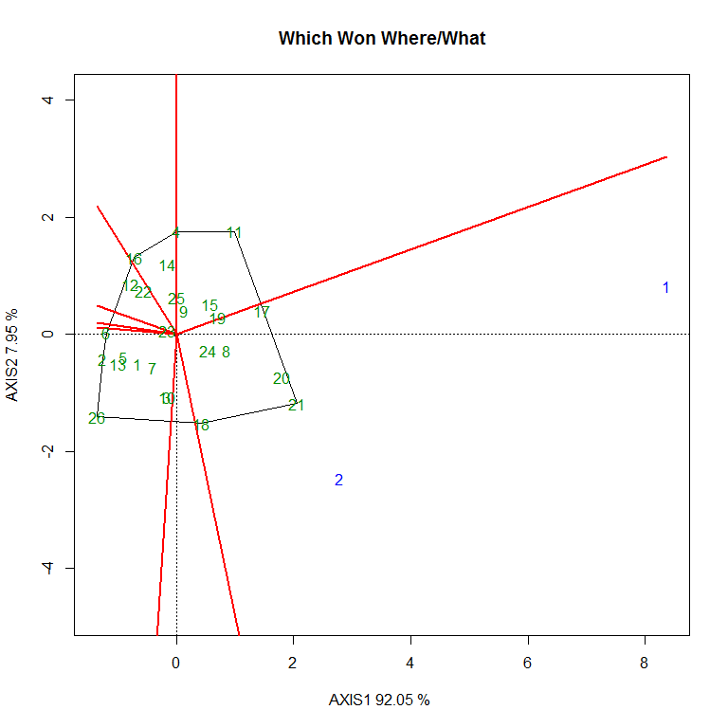
Fig. 1, which won where for GYP

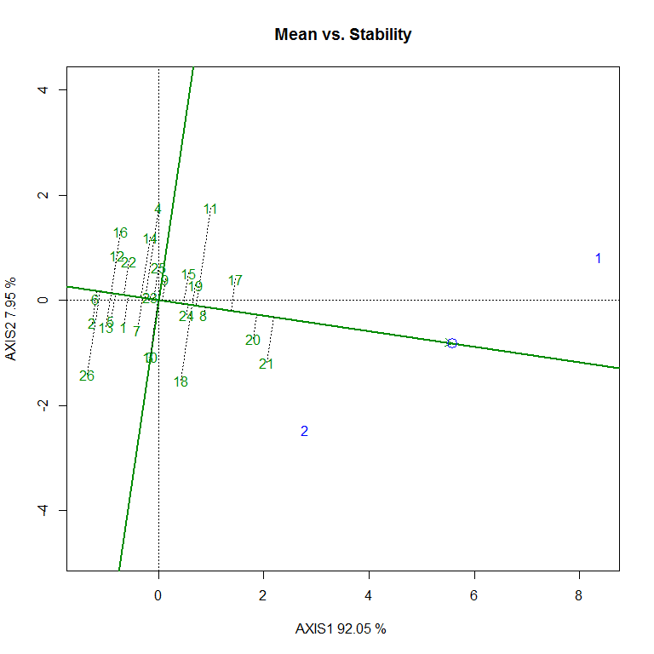
Fig. 2 Mean vs. Stability for GYP
Figure 1. The polygon view showed vertex genotypes, namely G1 (HD3226), G21 (HD3321), G20 (RAJ4238), G18 (PBW826), G26 (PBW550), G16 (HI1620), and G11 (VL907), which represent the most responsive genotypes to environmental variation. G1 (HD3226) won in environment 1, whereas in environment E2, genotype G21 (HD3321) won, indicating the presence of genotype × environment interaction and differential genotype performance under different environmental conditions. The mean versus stability (AEC) view in Fig. 2 showed that genotypes G17 (HI8777) and G20 (RAJ4238) were located towards the positive direction of the AEC axis with smaller deviation, indicating higher mean performance with better stability across environments.
The genotypes that are won in different environments may not necessarily be the most stable across environments. Therefore, genotypes such as G17 (HI8777) and G20 (RAJ4238) can be considered more desirable due to their consistent performance across environments, as the AEC view showed overall performance and stability. Similar patterns of crossover genotype × environment interaction and differential genotype response in wheat have also been reported by Ajmera et al. (2021) and Baloch et al. (2020).

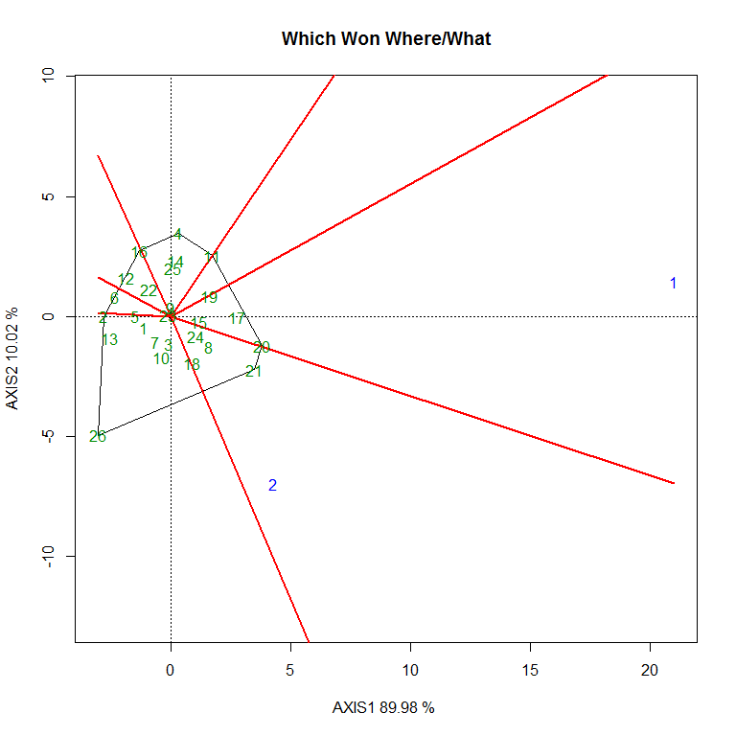
Fig 3, which won where for GPE
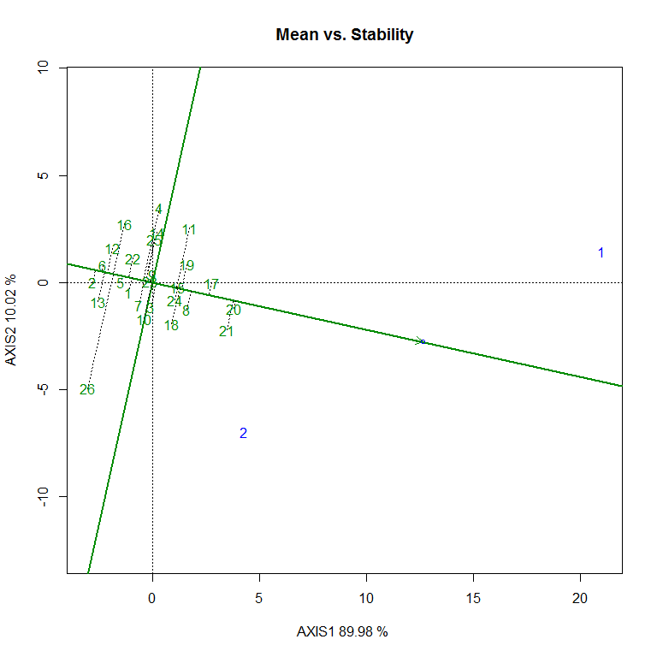
Fig. 4 Mean vs. Stability for GPE
In Fig no:3 showed the identified vertex genotypes, namely G4 (HS490), G11 (VL907), G17 (HI8777), G21 (HD3321), G26 (PBW550), and G13 (HS507), indicating their high responsiveness to environmental variation. The winners in Environments 1 and 2 are, respectively, G17 (HI8777) and G26 (PBW550), indicating the presence of genotype × environment interaction and differential genotype response across environments. The mean versus stability (AEC) view, as given in Figure: 4, further indicated that genotype G17 (HI8777) was positioned towards the positive direction of the AEC axis with smaller deviation, suggesting higher mean performance along with better stability across environments. Genotype G20 (RAJ4238) also showed relatively higher mean performance with moderate stability. Similar trend of genotype × environment interaction and differential genotype response for yield-related traits in wheat has been reported by Mohammadi et al. (2016) and Dehghani et al. (2009).
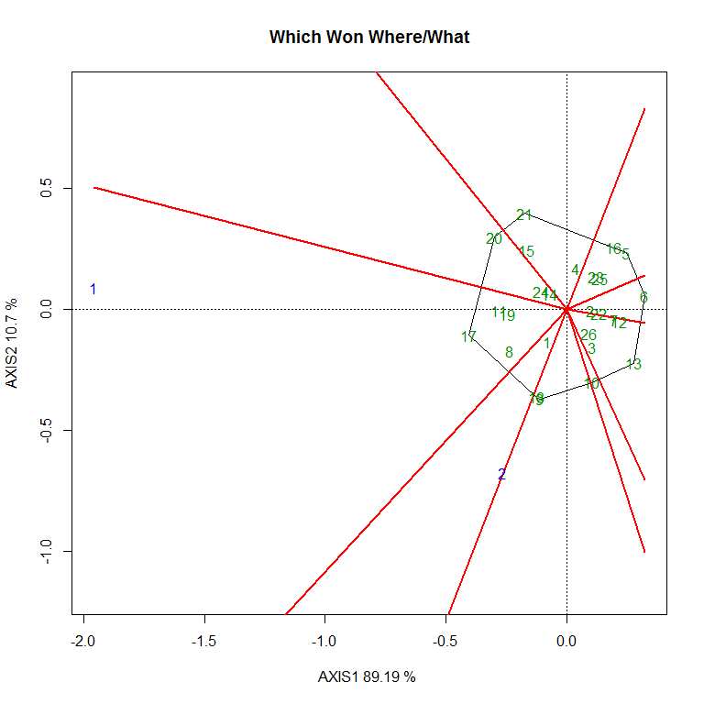
Fig. 5, which won where for PT
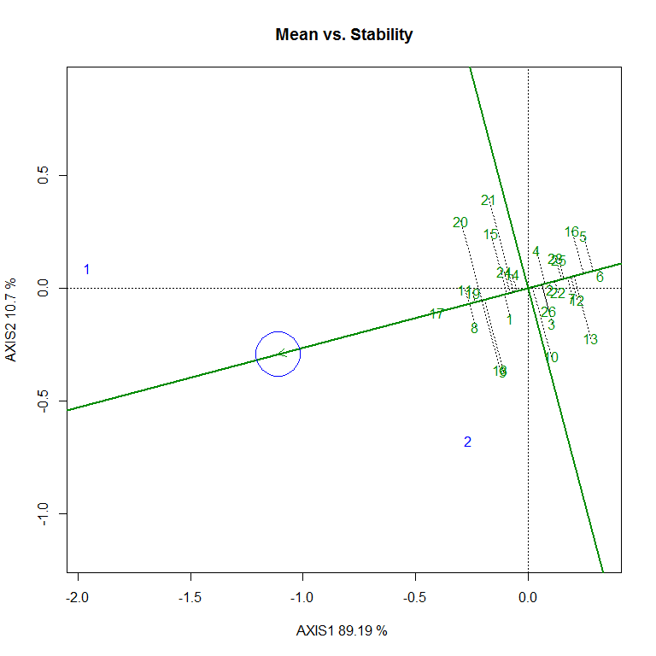
Fig. 6 Mean vs. Stability for PT

The polygon view in Fig. no 5 showed vertex genotypes, namely G20 (RAJ4238), G21 (HD3321), G16 (HI1620), G6 (HI8757), G13 (HS507), and G10 (HPW360), which showed their high responsiveness to environmental variation. The winners in Environments 1 and 2 are respectively G16 (HI1620) and G10 (HPW360), indicating the presence of genotype × environment interaction and differential genotype response across environments. The mean versus stability in Fig. 6 showed that genotype G4 (HS490) was positioned close to the AEC axis with better mean performance with good stability across environments. Genotypes G20 (RAJ4238) and G21 (HD3321) were located towards the higher mean direction but showed relatively greater deviation from the stability axis, indicating lower stability. Similar patterns of genotype × environment interaction and variability in stability for yield-related traits have also been reported by Baloch et al. (2020) and Mohammadi et al. (2016), and Farshadfar et al. (2012).

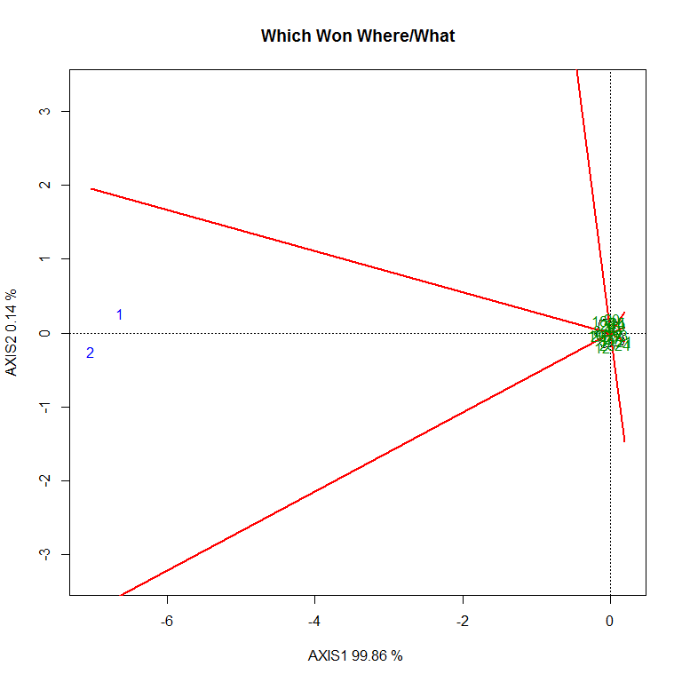
Fig. 7, which won for PC
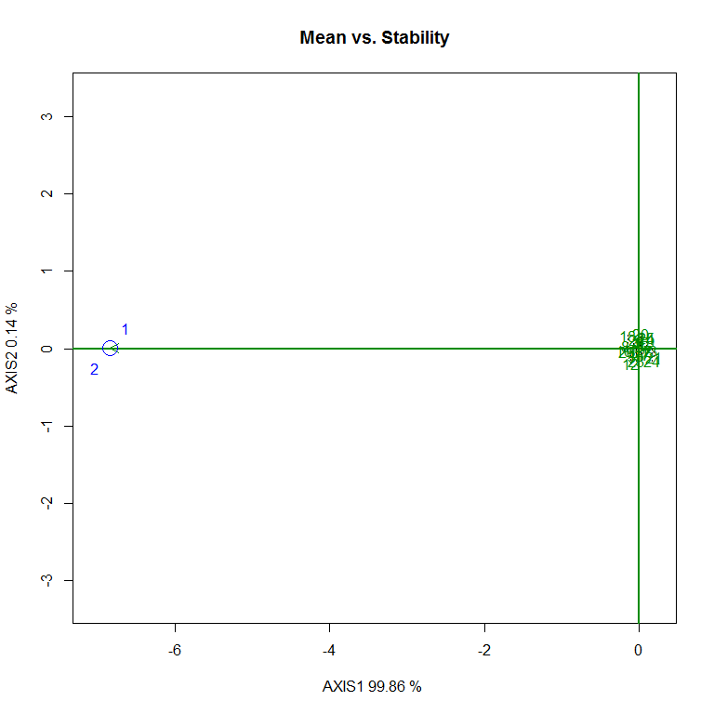
Fig. 8: 8 Mean vs. Stability for PC

The agreement between ANOVA results (non-significant G×E) and GGE Biplot (low dispersion) confirms the stability of protein content across environments, which is also shown here in Figures 7 and 8 that all genotypes were closely clustered near each other in polygon view as well as in the AEC axis, showing minimal variation. Therefore, selection for protein content was primarily based on mean performance, where genotype 10 exhibited the highest and most consistent values across environments. Similar findings of low genotype × environment interaction and stable expression of quality traits in wheat have also been reported by Gupta et al. (2021) and Rao et al. (2020).
All the above findings of the GGE Biplot analysis for the traits GYP-GPE-PT-PC are in accordance with the principles of GGE Biplot analysis described by Yan et al. (2000), Yan and Tinker (2006).

CONCLUSION
Our study showed significant genetic variability among wheat genotypes for most of the traits, as shown in the pooled ANOVA, giving good scope for selection. The significant genotype × environment interaction observed for major yield-related traits such as grain yield per plant (GYP), grains per ear (GPE), and productive tillers (PT) confirmed that genotype performance varied across environments, that spotlighted the importance of genotype across different location is good to identify stable genotypes.
The GGE Biplot analysis provided a clear understanding of genotype performance, stability, and adaptability across the two environments (E1 Punjab and E2 Himachal). For grain yield per plant (GYP), genotypes G17 (HI8777) and G20 (RAJ4238) showed high mean performance along with better stability across environments, whereas genotypes G1 (HD3226) in Environment 1 and G21 (HD3321) in Environment 2 showed adaptability in individual environments. For grains per ear (GPE), genotype G17 (HI8777) was identified as stable and high performing and G17 is superior performer in environment 1 and G26 (PBW550) in environment 2, for productive tillers (PT) genotype G4 (HS490) exhibited relatively better stability, while genotypes G16 (HI1620) in environment 1 and G10 (HPW360) in environment 2 On the other hand the protein content trait showed non-significant genotype × environment interaction, indicating stable expression across both environments (E1 and E2). The GGE Biplot also showed minimal dispersion among genotypes, suggesting that selection for protein content can be effectively based on mean performance, with genotype G10 (HPW360) showing consistently higher values. Overall, the study showed that selection of superior genotypes should be based on both mean performance and stability across environments. Genotypes such as G17 (HI8777) and G20 (RAJ4238) can be recommended for wider adaptation, while genotypes that are good performers in the different environments may be utilized under targeted conditions. Our study was conducted across two environments only, which may limit the overall assessment of genotype × environment interaction and stability. The inclusion of more locations and multi-year evaluation would provide a deeper understanding of genotype performance and adaptability. There are no ethical issues involved in this study. The research was conducted under standard agricultural experimental conditions without involving any human or animal subjects.

Disclaimer (Artificial intelligence)

Author(s) hereby declare that NO generative AI technologies such as Large Language Models (ChatGPT, COPILOT, etc.) and text-to-image generators have been used during the writing or editing of this manuscript.

REFERENCES
- Joshi, A. K., Mishra, B., & Ortiz-Ferrara, G. (2017). Wheat improvement in India: Present status, emerging challenges and future prospects. Indian Journal of Genetics and Plant Breeding, 77(1), 1–18.
- Yan, W., Hunt, L. A., Sheng, Q., &Szlavnics, Z. (2000). Cultivar evaluation and mega-environment investigation based on GGE Biplot. Crop Science, 40(3), 597–605.
- ICAR–Indian Institute of Wheat and Barley Research. 2020. Package of practices for wheat cultivation. ICAR-IIWBR, Karnal, Haryana, India
- Gauch, H. G. (2006). Statistical analysis of yield trials by AMMI and GGE. Crop Science, 46(4), 1488–1500.
- Yan, W., & Tinker, N. A. (2006). Biplot analysis of multi-environment trial data: Principles and applications. Canadian Journal of Plant Science, 86(3), 623–645.
- Baloch, M. J., Veesar, N. F., &Jatoi, W. A. (2020). Stability analysis in wheat genotypes using GGE Biplot and AMMI models. Pak. J. Agri. Agril. Engg. Vet. Sci., 36(1), 8–15.
- Ajmera, R., Singh, V., & Patel, R. (2021). Multi-environment analysis in wheat using AMMI and GGE Biplot models. Journal of Cereal Research, 13(1), 24–30.
- Purchase, J. L., Hatting, H., & Van Deventer, C. S. (2000). Genotype × environment interaction of winter wheat in South Africa: II. Stability analysis of yield performance. South African Journal of Plant and Soil, 17(3), 101–107.
- Akinwale, M. G., Adetimirin, V. O., &Ogunniyan, D. J. (2022). Application of GGE Biplot for genotype evaluation and mega-environment identification in wheat. African Crop Science Journal, 30(2), 123–132.
- Farshadfar, E., Sabaghpour, S. H., &Zali, H. (2012). Comparison of parametric and non-parametric methods for selecting stable and adapted wheat genotypes. Journal of Agricultural Science and Technology, 14(4), 745–756.
- Dehghani, H., Ebadi, A., &Yousefi, A. (2009). Biplot analysis of genotype by environment interaction for barley yield. Agronomy Journal, 101(3), 567–574.
- Mohammadi, R., Farshadfar, E., &Amri, A. (2016). Genotype × environment interaction and stability analysis of rain fed durum wheat genotypes. Crop Journal, 4(2), 126–135.
- Gupta, R., Sharma, P., & Kumar, D. (2021). Genetic analysis for protein content and yield components in bread wheat. Indian Journal of Agricultural Sciences, 91(4), 567–572.
- Rao, V. S., Prasad, K., & Mehta, S. L. (2020). Genotype-environment interaction for grain yield and quality traits in wheat. Wheat Research Journal, 9(1), 42–48.

