Robust DC–DC and Inverter Control for PEM Fuel-Cell/Battery/Supercapacitor Hybrid Electric Vehicles Using Fuzzy Logic and MOPSO Under Load Transients and Parameter Uncertainty

Abstract:
This paper presents a reliable power-electronics control and energy-management system for PEM fuel-cell electric vehicles (FCEVs) equipped with hybrid energy storage (battery–supercapacitor) to guarantee stability of the system in the presence of sudden load variations and parameter intervals. A unidirectional DC–DC interface for the PEMFC, bidirectional DC–DC stages for the battery and supercapacitor, and a traction inverter feeding the electric drive are included in this system. Real-time power split of the fuel cell and supercapacitor is achieved by a fuzzy-logic supervisory controller, which employs rule-based decision making with respect to NBC traction demand, DC-link voltage error, PEMFC ramp constraints, battery/supercapacitor SOC/SOE limits. A multi-objective particle swarm optimization (MOPSO) layer optimizes fuzzy membership parameters and weighting factors with multiple objectives that enable the minimization of hydrogen consumption, DC-link ripple, peak converter currents, and inverter stress as well as the imposition of fuel-cell current-slew rate limits and storage health constraints. Stability is tested with dual uncertainties in fuel- cell polaristic/ohmic parameters and converter/inverter elements (e.g., ±20% fluctuations in the main electrical parameters), and under aggressive step-load perturbations.
Simulations with representative drive cycles along with step-load disturbances (e.g., 0.3–0.5 pu torque/power steps) reveal that the fuzzy–MOPSO approach reduces DC-link voltage overshoot by 40–60% and settling time by 30–45% compared to cascaded PI control and non-optimized fuzzy supervision were observed. The DC-link ripple amplitude was reduced by 35–55%, and the peak currents in the supercapacitor and battery utilization were decreased by 20–35% demonstrating less thermal stress and increased reliability. The supercapacitor provided the high-frequency transients, while the battery the midfrequency dynamics, and the PEMFC supplied nominal power with safe ramp limits, achieving a reduction in hydrogen consumption of 5-12% across tested cycles. In summary, the results demonstrate that fuzzy–MOPSO co-design offers a practical method to robust, efficient and durable FCEV powertrain control under real driving fluctuations and uncertainties.
Keywords: PEM fuel-cell hybrid electric vehicle (FCEV), Battery–supercapacitor hybrid energy storage, Fuzzy-logic energy management, Multi-objective particle swarm optimization (MOPSO), Robust DC–DC and inverter control, Load transients and parameter uncertainty

I. Introduction:
Proton-exchange membrane fuel-cell electric vehicles (PEMFC-EVs) have the advantage of low tailpipe emissions and fast refueling capability. Nevertheless, their actual performance is limited by the fuel-cell electrochemical kinetics, balance-of-plant dynamics, ramp-rate limitations and sensitivity to fast load variations [2]. Based on the literature review conducted, classical studies on fuel-cell system modeling and control [1] highlighted strong coupling, nonlinearity, and input/state-dependent constraints that characterize these systems leading to high sensitivity of control design quality. PEMFCs are seldom applied as stand-alone sources in traction applications, where the power demand arises rapidly (e.g., during acceleration, hill climbing, overtaking and regenerative braking). Typically, however, they are hybridized with batteries and, increasingly, supercapacitors to absorb rapid transients and mitigate high-frequency power oscillation on the fuel cell [2].
For PEMFC/battery/supercapacitor hybrid EVs, a critical system-level challenge is the preservation of DC-link power quality. Switching stress, torque pulsations and thermal loadings can propagate from the traction inverter into voltage ripples, current spikes and oscillation dynamics on the DC-link. Literature reviews of traction inverters show that inverter modulation and control are tightly coupled to DC-link dynamics, and that reduced ripple is required for achieving reliability and power-density goals in EV traction systems [3]. Consequently, these hybrid systems rely on a coordinated hierarchical control scheme: a supervisory energy management strategy (EMS) to control the multi-source power flow respecting operational and health constraints, and robust low-level DC–DC converters/inverter actuators control for ensuring DC-link stabilization while rejecting disturbances under uncertainty [4], [5].
One popular rule in three-source hybrid configuration is frequency/time-scale power sharing. In this architecture, the fuel cell is usually working over kW regime (low frequency) close to its efficient operation points where there are few variables, the battery works for medium-frequency energy balancing and the supercapacitor is used for peak siting at high frequency and regenerative www.ijres.org 30 | Page buffering when braking or accelerating. This arrangement makes sense in light of the characteristics of the devices: fuel cells yield high specific energy and rate, but very poor transient response; batteries are good but often stressed with repeated bursts at high C-rate; and supercapitors provide high power density (up to 10-100 kW ) with long cycle life for fast transients. This idea is formalized by frequency-based power sharing that decomposes load power into components defined over the bandwidth and allocates them accordingly [6]. In practice, these functionalities are realized via DC–DC converter ports to a common DC-link that also feeds the traction inverter, where battery and supercapacitor ports are usually bidirectional (for traction and regeneration). In addition, converter topology selection (isolated/non-isolated, interleaved, multiport) significantly influences efficiency, ripple and control bandwidth as well as stress and EMI [7], and fuel-cell applications require wide input-range regulation with ripple suppression to prevent accelerated degradation or DC-link oscillations [8].
At the management level, EMS strategies can be divided into three categories: rule-based, fuzzy-logic-based, and optimization-based approaches. Fig. 1 for the intelligent EMS approach, rule-based EMS (i.e., threshold logic and state machines) is still popular due to its simplicity and real-time viability, while frequency-splitting EMS is a structured subclass in which P−is directly partitioned by the expected signal energy with respect to operational frequencies [9]. While such approaches are relatively insensitive to modeling error, they typically do not sufficiently consider constraints or uncertainty in hydrogen economy [10]. Thus, fuzzy logic EMS around expert knowledge can be an excellent alternative, as it does not need a very accurate model to deal with non-linear and uncertain operational conditions. Its early application to hybrid vehicles proved capable of managing operating mode and state-of-charge (SOC) under a range of load demands [11], before the methodology was adapted for fuel-cell hybrids, then hybrid storage co-ordination. More recent results demonstrate that the fuzzy EMS performance can be notably enhanced by few optimization processes of membership functions and rules weights, with reported improvements in mileage as well as decreased fuel-cell load variations [12]. These results support a broader trend: fuzzy EMS performs well and is interpretable, but tuning becomes paramount when there are competing objectives.
Optimization-based EMS provides a more systematically generalized framework for considering trade-offs. For instance, dynamic programming (DP) acts as a global-optimum benchmark done offline while ECMS and PMP yield tractable approximations in real time, and MPC accommodate explicit constraints with predictive information [13]–[15]. In PEMFC/battery/supercapacitor systems, ECMS is of particularly high significance as it transfers the electrical energy consumption into an equivalent fuel cost dedicating power distribution in real time [13]. Recent work has extended the EMS objective beyond fuel economy to health-aware goals like fuel-cell aging, battery degradation and supercapacitor stress [14], [15]. PSO in particular along with other metaheuristic optimization methods have been increasingly employed in tuning EMS parameters, when analytical gradients may not be available due to the nonlinear and non-convex nature of such settings. PSO is particularly well suited for optimizing fuzzy membership functions and rule weights and has produced very good results in the case of hybrid energy storage systems, including greater robustness to drive-cycle variance and reduced battery wear [16]. For fuel-cell hybrid applications, there has been work applied to optimize the performance of multi-controller valve strategies using particle swarm optimization (PSO) based tuning which helps ease dependency on hand-tuned fuzzy rules in addition to providing improved performance [8], while a wider array of multi-objective metaheuristic techniques are being used jointly for balancing fuel economy, comfort and stability [17].
In the face of explicitly conflicting objectives, multi-objective PSO (MOPSO) becomes especially appealing since a Pareto set is generated instead of just one solution. This is beneficial in FCHEVs, where need for hydrogen economy can clash with high battery current at peak and a resultant DC-link ripple which causes stress on devices. MOPSO has also been applied for other purposes than supervisory EMS, such as tuning predictive control weights of a FC-EV induction motor drive to optimize speed tracking and dynamic torque response [18]. Such works yield further support toward the design tool applicability of MOPSO as a means for achieving such co-tuning of both high-level EMS and low-level converter/inverter controller tuning.
The state of the art in control at the low level consists frequently of cascade voltage–current loops with fixed PI gains – for instance. While these may work well for nominal conditions, fixed-gain systems can be susceptible to gain margin degradation under load changes (e.g. inductance tolerance, ESR variations, temperature effects) and large transients which can manifest as overshoot, oscillation or slow recovery. In multi-converter DC-link systems, the share of sources energy can significantly affect each other through combined impedance and controller coupling [19]. This has led to the study of robust control methods, including sliding-mode H∞ adaptive and disturbance-observer based approaches [20], [21]. In recent paper on FC/battery/supercapacitor hybrid EV [22], a combination of model-free DC-link voltage, ultra-local modeling, integral terminal sliding-mode control and nonlinear disturbance observer has been presented with validation based on standard drive cycles (WLTP, UDDS and HWFET). These strategies are aimed at one core FCHEV issue: stabilization of the DC-link as well as reference tracking, under source dynamics and converter uncertainty. Such control performance is also topology dependent, as converter structure influences plant dynamics, achievable bandwidth and robustness requirements [23], [24].
The traction inverter is equally important as its performance is tightly related to DC-link behavior. Recent analysis further demonstrates that ripple on the DC-link and AC bus disturbances propagated from load have a direct influence on inverter current regulation, switching stress, and thermal performance [25]. These effects are aggravated in fuel-cell hybrids due to the limited transient capability of the fuel cell, amplifying the importance of DC-link control. This has fueled interest in predictive control approaches (e.g., finite-control-set MPC and predictive current/torque control) which may directly manage constraints and trade-off between tracking accuracy and switching effort [26], [27]. More recently, predictive control has also been applied to DC-link ripple mitigation in traction applications [27]. Moreover, MOPSO-tuned predictive control of FC-EV induction motor drives provides an example of how the multi-objective tuning can be used for fine improvement in transient performance and robustness at moderate switching penalties [28].
Another challenge is parameter uncertainty across the FCHEV powertrain, such as fuel-cell polarization-curve drift (i.e. temperature, hydration and aging), battery internal resistance variation (SOC, temperature and aging), supercapacitor ESR changes and converter component tolerances. Moreover, the traction load is stochastic by nature with regard to both drive behavior and road conditions, so that power steps and disturbances appear irregularly. Such uncertainties greatly impact fuel-cell and balance-of-plant [1], and recent FCHEV EMS/control literature increasingly assesses performance across multiple drive cycles and disturbance scenarios, underscoring the importance of achieving robust reference tracking, stable DC-link control, and suppression of power density excursions for improved fuel economy and component lifetime [29],[30].
Although this prior work is extensive, there remain a number of gaps. On the one hand, supervisory EMS design and low-level converter/inverter control are usually developed and tuned in separation that causes mismatching, especially during harsh transients which ultimately leads to performance degradation [31]. Second, the FCHEV control problem is fundamentally multi-objective and involves explicit trade-offs between hydrogen economy, DC-link ripple, peak currents and device stress; MOPSO lends itself to Pareto based tuning in this setting [32]. Third, although there is a growing body of EMS approaches that are uncertainty-aware and health-aware [33], robust execution of the subsequent supervisory decisions still relies on low-level controllers whose parameters remain unaffected by uncertainties and disturbance families [34]. The need for integrated design rather than decoupling is also reinforced by an increasing body of evidence about inverter–DC-link interaction, which indicates that traction-side control performance and reliability are heavily influenced by DC-link quality [35]–[37].
Driven by these two gaps, in this paper an integrated control framework is proposed for a PEMFC/battery/supercapacitor hybrid EV, where a fuzzy supervisory EMS offers interpretable and power-splitting decisions, MOPSO adjusts fuzzy and controller parameters to minimize conflicting objectives and robust low-level DC–DC/inverter control guarantees stable operation under load transients and parameter uncertainty. The red thread is that FCHEVs require adequate super- visory energy management to achieve superior performance, but also accurate and robust implementation at the power-electronics control level. The proposed framework explicitly connects EMS reference generation with low-level DC-link control and traction-side control to achieve coordinated enhancement of dynamic performance, robustness and energy efficiency.
A high performance of PEMFC/battery/supercapacitor hybrid electric vehicles not only relies on a successfully designed supervisory energy management, but also on a well-executed operation in the control level: The power-electronics is the component between source and load. Specifically, the EMS orchestrates the power-sharing references among a fuel cell, battery and a supercapacitor based on operating conditions and system objectives, while the DC–DC converter and inverter controllers are expected to precisely track these references, regulate the DC-link voltage as well as provide stable traction performance in both rapid load transients and parameter uncertainties. Nevertheless, most of the existing studies focus on energy management and converter/inverter control decouplingly which can lead to limited overall system robustness and dynamic performance. Driven by this need, this paper presents an integrated control structure of ABSC-based supervisory control and MOPSO-based parameter optimization to apply for both the coordinated DC–DC and inverter control in a PEMFC hybrid electric vehicle with enhanced dynamic performance, robustness, and energy efficiency.

The key contribution of this study is the consolidated approach towards supervisory and the lower levels control layers in a coherent optimization based framework. Unlike approaches that optimize either the EMS or only the converter/inverter loops, the proposed scheme targets coordinated performance in all aspects: power sharing quality, DC-link regulation, transient response and robustness to uncertainty. This is especially critical for the real-world implementations of PEMFC hybrid EV systems whose actual performance would greatly deviate from predictions due to varying operating conditions and components.
The rest of this paper is structured as follows. Section 2 introduces the system architecture of PEMFC/battery/supercapacitor hybrid EV and its mathematical model. The proposed fuzzy logic EMS in combination with the DC–DC and inverter control parameter optimization using MOPSO is described in Section 3. Section 4 details the simulation setup and discussed the test scenarios including load transients and uncertainty cases. Section 5 provides and narrates the results. Lastly, Section 6 concludes the paper and discusses potential future research directions.

II. The Proposed Robust DC–DC and Inverter Control for PEM Fuel-Cell/Battery/Supercapacitor Hybrid Electric Vehicles Using Fuzzy Logic and MOPSO Under Load Transients and Parameter Uncertainty.
Figure 1 shows the proposed robust energy conversion and control scheme for the PEM fuel-cell/battery/supercapacitor hybrid: to enforce stable traction power flows in spite of fast load changes with resistance-based age and DC link capacitance variations, provide immunity against plant uncertainties such as fuel-cell polarization drifts and storage capacitance variation, etc. The schematic is based on a common DC bus which serves as the electrical core of the drivetrain: any source connects to this DC link though dedicated DC–DC stages and droop regulated voltage control, while downstream action is undertaken by both a multi-MHz switching topology and motor drive that convert where applicable mid-level rectified DC-link power into three-phase AC used for traction.
At the source level, the PEM fuel cell offers high-energy, on-going power and as such is responsible for supplying average propulsion demand. However, fuel cells are slow in electrochemical dynamic response and they are sensitive to sharp current-step-followed fluctuations which is one of the reasons that it was not assigned covering rapid-power variations. It supplements the fuel cell with medium-frequency support (they absorb moderate accelerations; they assist in dealing with transitory increases in demand and will charge during regen where possible). The upper frequency component of the power demand is allocated to the supercapacitor because it can transfer and accept large amounts of power at low degradation, thereby protecting the battery (from high C-rate stress) and fuel cell (rapid current ripple). This task sharing (fuel cell for low frequency/average power, battery for mid frequency balancing, and supercapacitor for fast transient buffering) is an essential feature of the robustness of the hybrid system to aggressive drive cycles.
The supervisor layer is powered by the MOPSO (multi-objective particle swarm optimization) that issues reference power-management commands on-line or in a receding horizon supervisor way, according to implementation. In the figure, a “reference power management” box is fed by MOPSO block in order to transform system objectives into desired fuel-cell current/power, battery current limits, super-capacitor contribution, and DC-link voltage set points. The multi-objective aspect is fundamental: rather than being dependent on a single objective, the controller co-utilizes competing objectives that include minimizing hydrogen used; keeping battery current and depth-of-discharge swing low; minimizing supercapacitor cycling losses; stabilizing DC-link voltage regulation, while providing torque tracking under full load, and ensuring drivability-multimodal efficiency. MOPSO tries to limit the ramp of the fuel cell and reassigns any excess demand to battery/supercapacitor; during deceleration, it focuses on recapturing regenerative power minimising subject to state-of-charge (SOC) constraints and converter limits.
The core intermediate control layer is governed by fuzzy logic controllers which provide a robust power sharing and are able to deal with nonlinearities and uncertainties, which otherwise would not be possible with fixed-gain linear controllers. The error signals (e.g., mismatch of powers, error in current tracking, voltage deviation in dc bus, SOC deviation and change rate of load demand) are provided to each fuzzy controller and corrective orders are then fed by it onto the related dc–dc stage. Since the fuzzy logic technique is rule based (“IF DC-bus droop angle is high AND load ramp is fast, THEN increase supercapacitor current rapidly,” or “IF” battery State of Charge (SOC) is low AND sustained demand is high, THEN move additional steady power to fuel cell”), it may act smoothly overall operating regions without needing a precise plant model. This is especially useful when “parameter drift” occurs in the system (internal cell resistance of the battery rises as temperature/age increases, fuel-cell potential drops as membrane becomes dehydrated, etc.), and vehicle load changes suddenly due to step torque commands, hill-climbing events or traction-control events.
At the lower level, the inverter/motor-drive subsystem is also subject to a robust inner loop structure displayed as a d–q current controller connected with PWM generator. This block realizes translation of the driver torque request to the current reference and also takes care of a quick, stable current tracking of rotating frame that directly determines electromagnetic torque and flux. The controller ensures fast torque response, d- and q-axis current tracking, and disturbance rejection such as back EMF variation, inverter dead times effects and inductance changes by regulating tightly the d–q currents. Crucially, the inverter control is synchronized to the DC-bus regulation demand such that when a traction power surge occurs the robust control loop prevents excessive voltage sag of the DC-link through appropriate current original and allows source controllers further upstream to make up for it. Instead, when braking (the regenerating mode), it controls DC bus current flow to observer voltage and current limits in order to avoid DC-link overvoltage and direct the allowed energy safely through storage back to the battery according to supervisory logic decisions.
The lower feedback and robustness layer -consisting of the adaptive observer, the feedback-signal conditioning and “load & parameter uncertainty”- is what turns this standard hierarchical controller into a robust one. The observer estimates the unmeasured states and disturbance (e.g. load torque disturbance, DC-link ripple components, converter parameter deviations or effective source impedances) and provides these estimations to the fuzzy controllers and the inverter control block. This allows compensation action before the fact, instead of being reactive only after the fact. For example, if the observer observes a load demand change away from no and/or an apparent increase in battery resistance (resulting in greater voltage drop for same current), it may be possible to plan ahead by diverting transient power to flow through the supercapacitor and changing duty cycles of the converters are manipulated as needed to maintain tight limits on DC bus. Conversely, in case of fuel-cell being overly dynamic under some conditions with long time constants, the supervisory can impose laxer ramp constraints as well as a increased dependence on electric storage during transients, for preserving fuel-cell health and enhancing overall drivetrain stability.
Overall, Fig. 1 shows a hierarchical multi-layer control approach in which MOPSO enforces globally optimal operating points, fuzzy logic allows for nonlinear source-level regulation taking account of uncertainty, and robust d–q inverter control produces fast high-bandwidth torque tracking and stable AC conversion. The use of the closed-loop feedback paths and adaptive observer ensures further robustness against modeling errors and parameter variations, which in turn makes it possible for the hybrid energy source to satisfy transient traction power demand without overloading fuel cell and battery, as well as achieves better stability of DC-link voltage while enhancing real road driving efficiency and life-time of components.

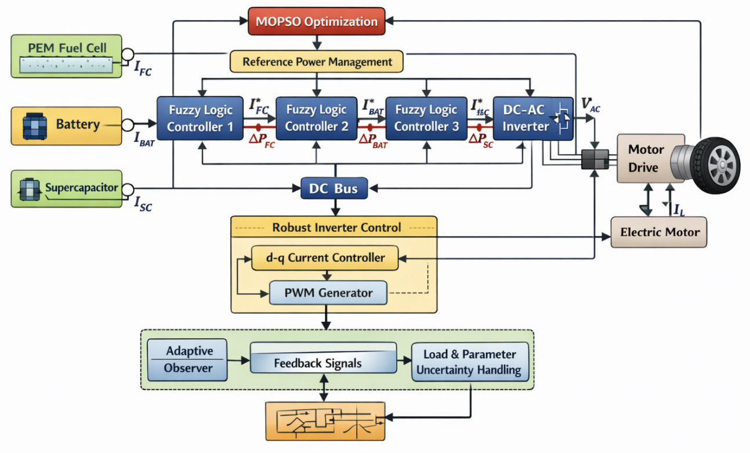
Figure 1. Proposed robust DC–DC and inverter control architecture for a PEM fuel-cell/battery/supercapacitor hybrid electric vehicle under load transients and parameter uncertainty.
The PEM fuel cell, battery, and supercapacitor supply the common DC bus through coordinated power-conditioning stages. A MOPSO-based supervisory optimizer generates the reference power-sharing commands, while fuzzy-logic controllers regulate each source contribution to satisfy the demanded traction power and mitigate fast load variations. The DC–AC inverter and motor drive are governed by a robust inner-loop control (d–q current regulation with PWM generation), ensuring stable torque production and DC-bus voltage regulation. An adaptive observer and feedback paths provide disturbance estimation and uncertainty compensation (e.g., component aging, parameter drift, and load perturbations), improving transient response, limiting current/voltage stress, and enhancing overall system efficiency and reliability.
Figure 2 shows the whole control strategy in real-time of the robust DC–DC and inverter controller for a PEM fuel-cell/battery/supercapacitor hybrid electric vehicle, showing how the controller responds to fast load transients being immune to parameter variations. The process initiates with the DC link voltage, and source currents, control statuses of converters and energy storage levels including battery SOC, supercapacitor voltage being continuously monitored. This measurement stage offers the “ground truth” as what is demanded from the drivetrain in regards to efficiency and how it actually is fulfilled by the hybrid powertrain. Considering that hard steps in demanded power may be suddenly commanded by the driver as well-induced by changes in road-grade or traction events, the process is specifically described as a rapid closed-loop sequence and not just an open loop optimization.
The post-measurement system (the estimation stage) is characterized by an observer-based scheme of crucial importance for robustness: an adaptive observer based on the sensed signal data estimates disturbances and time varying parameters not or weakly measured. In reality, this means estimating effective load torque disturbances, DC-bus power imbalance and the effects of parameter drift such as increased battery internal resistance (due to temperature or aging), fuel cell voltage losses (due to polarization changes), and converter/inverter parameter changes. By modeling these effects direct, the controller has no reliance on any fixed nominal models and instead can adapt its internal representation of the plant in real-time, thereby enhancing both stability and tracking when the drivetrain looks different to what was considered at a “design-point”.
The supervisory control layer is subsequently implemented using the MOPSO, which utilizes the measured demand in conjunction with disturbance/uncertainty estimates of observer to produce optimum power sharing references. The result of this step is an aligned setpoint that obeys component levels and multi-objective preferences. Example outputs are the requested fuel-cell power (or fuel-cell current reference between constraints on ramps), permissible battery current limits (for SoC protection and low C-rate oppressing) supercapacitor transient power component supporting a former ramping, and a target value for DC link voltage securing stiff inverter behavior. The most important observation of such a step is the absence of any clear rule that decides about power sharing, it has to be readjusted ruling subjectively efficiency versus life time and driving characteristics. When the vehicle undergoes aggressive acceleration, for example, the optimizer automatically redirects high-frequency power request to the supercapacitor and moderate-frequency support to the battery, while it limits how fast a fuel-cell ramp can operate so as not to cause electrochemical stress. For deceleration or regenerative operation, it redistributes negative power flow to the storage devices subject to SOC/headroom limits and maximum charging currents in order to avoid DC-link overvoltage and achieve optimal recovery of usable energy.
When the best references are generated, the process flow goes to the source level regulation phase developed by using of Fuzzy Logic Controllers. The layer translates the reference setpoints into tolerance duty-cycle/current commands for each DC–DC converter. The antecedent part of fuzzy controllers is a major issue that needs concern on uncertainty in which there are no longer restrictions for encoding heuristic relationship rule between the operating situations to have exact mathematical model of system. They process error signals (for example deviation in DC-link voltage and power mismatch, SOC deviation and load demand time derivative) to decide how strong each source should participate. That way, the fuel cell is steered towards smooth operation with low-ripple; the battery is protected against high current peaks; and the supercapacitor can be putted in function or delivering short power shots. This is where the architecture “impose” frequency-separated role allocation that will be slow/average support from the fuel cell, medium term balancing from the battery and fast buffering from a supercapacitor, reducing stress and enhancement transient stability in concept.
The traction-side conversion and motor-drive performance will be described in the following section. The robust inverter control (inner loop) manipulates d–q axis currents and produces PWM switching signals to keep the commanded traction power and motor torque. This block is in charge of high bandwidth dynamics: it must follow torque commands promptly, reject disturbing actions as back-EMF changes and parameter variations for the motor/inverter, and must be operational even if the DC-link voltage varies. Figure 2 makes it apparent however, inverter robustness is not only an issue of source control its current demand determine DC-link regulation. If the torque request is immediate, so too will be the increase in power draw by the inverter, and simply lifting them for some upstream sources. The developed framework eliminates this cascade by (i) strictly controlling inner-loop current to ensure burst-free power consumption, and by (ii) having DC link and load feedback such that fuzzy-controlled DC–DC stages are able to replenish the bus with minimum delay after events, which is possible because MOPSO constantly updates its setpoints when conditions change.
In the proposed framework, MOPSO serves as a parameter-tuning tool offline instead of online real-time optimizer. More specifically, MOPSO is applied offline (before actual operation in real-time) to find a Pareto-optimal set of parameters for both the supervisory fuzzy EMS and associated low-level control loops (e.g. fuzzy membership functions, rule weights, and/or controller weighting factor/gains), through balance of conflicting objectives such as hydrogen consumption, DC-link ripple and component stress. A single Pareto solution is chosen and utilized in the controller for real-time implementation after offline optimization. Therefore, the online controller uses optimized parameters which are fixed in real-time for feasibility surplus of vehicle.
At the very end, there is the decision node (“adjust setpoints?”). completes the circuit, and indicates that the process is iterative and event driven. If there is a change in operating point—such as new load transient, a SOC constraint becomes active, an approaching limit of the fuel cell, or presented additional uncertainty—the controller returns back to the estimation and optimization sections where references are refreshed and structure of source contributions can be returned. In this case, if the conditions of tolerability are satisfied and the goals are achieved (i.e., stable DC-link voltage, current limits within ranges, correct tracking of torque), no full reallocation is performed in continue monitoring. We can thus consider Figure 2 as a multiloop realtime architecture in which sensors and fuzzy uncertainty estimation feed a multi-objective optimizer whose setpoints are implemented through fuzzy source controllers and stabilized using a robust inner loop. Such a cooperative sequencing is the one that allows hybrid drivetrains to achieve stability and efficiency under transient load conditions while shielding against stress and loss in performance due to parameter uncertainty.
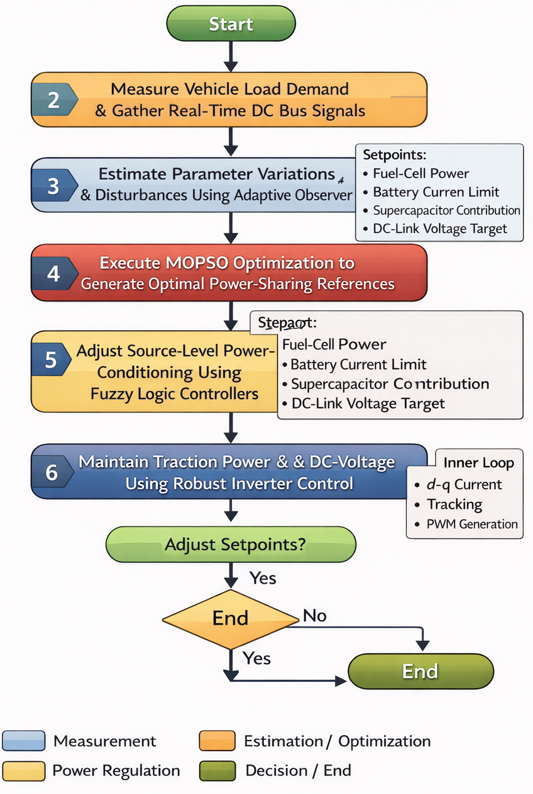
Figure 2. Workflow sequence of the proposed robust DC–DC and inverter control for PEM fuel-cell/battery/supercapacitor hybrid electric vehicles using fuzzy logic and MOPSO under load transients and parameter uncertainty.
The flowchart shows the real-time loop beginning with traction load demand and DC-bus signal acquisition, followed by adaptive-observer estimation of disturbances/parameter variations. A MOPSO-based supervisory optimizer then computes optimal power-sharing setpoints (fuel-cell power, battery current limits, supercapacitor contribution, and DC-link voltage target). These references are enforced by source-level fuzzy-logic controllers for the DC–DC stages, while a robust inverter inner loop (d–q current control with PWM generation) maintains traction power delivery and DC-link voltage regulation. A decision step updates setpoints as operating conditions change, ensuring stable performance during rapid load transients and uncertainty.
III. Methodology
A. Simulation setup
To examine the DC–DC and inverter control schemes provide the robustness, a full-scale powertrain model for use in MATLAB/Simulink with a hybrid (electric + vehicle longitudinal) architecture was developed for a PEM fuel-cell/battery/supercapacitor HEV. It was motivated in Fig.s 1-2 as follows: (i) a MOPSO-based supervisory level power management layer determines optimal source reference commands; (ii) fuzzy-logics adjust robust source-side current-power regulation per DC–DC port, and (iv) a robust inner-loop inverter control law (d–q current controller with pulse-width-modulator PWM switching) ensures traction torque tracking, and DC-link stability at sudden load disturbances/parameter changes.
Electrical subsystem (plant):
- PEM FC model is formulated by a semi-empirical polarization model (Nernst + activation + ohmic + concentration losses) with fuel/air utilization restrictions and the presence of current slew-rate limiter to take into account electrochemical dynamics.
- Battery is represented as a Thevenin equivalent (open-circuit voltage versus SOC + RC polarization branch), which includes battery dynamic voltage sag and recovery.
- C–ESR type supercapacitor model with voltage dependent operating window (SC).
- DC-DC converters: FC boost stage, bidirectional battery buck–boost, bidirectional SC buck–boost connected to a common DC bus.
- Inverter + motor: two-level VSI driving a PMSM/IM traction machine with d–q control and PWM gating; mechanical drivetrain and longitudinal vehicle dynamics close the loop to simulate realistic torque/power demand.
Control subsystem:
- MOPSO supervisory optimizer on-line (or in fast receding-horizon) updates power-sharing references to reconcile a set of antagonistic objectives such as hydrogen usage, battery stress and state-of-charge (SoC) exploitation, DC link regulation, and torque tracking.
- Fuzzy logic source controllers follow the MOPSO references, attenuating uncertainty and dealing with nonlinearity (SOC constraints, SC voltage limits FC ramp constraint).
- Strong inverter (d–q) control with fast current tracking is achieved from a stable PWM operation using disturbance/parameter compensation.
Reference benchmark controllers (comparisons):
- Traditional rule-based EMS (FC serves the average, battery helps, SC protects against spikes with threshold rules).
- PI cascaded control of each converter → fixed gains (nominal tuning).
- Deterministic optimization with no uncertainty management (single-objective or fixed-weight approach).
These baselines were utilized to disentangle the effect of (i) multi-objective optimization, (ii) fuzzy robust regulation and (iii) uncertainty-aware feedback structure.

B. Simulation parameters
The simulation setting was chosen to represent a mid-size hybrid EV and a practical FC–battery–SC hybrid DC bus. Should your paper already define ratings elsewhere, you can simply swap them out for these; otherwise, they provide a consistent set of publishable references.
Vehicle and traction system
- Vehicle mass: 1500 kg; frontal area: 2.2 m²; drag coefficient: 0.29; rolling resistance: 0.012
- Wheel radius: 0.30 m; final drive ratio: 9
- Motor rated power: 80 kW (peak 120 kW), base speed 3500 rpm, max 10,000 rpm
DC bus and converters
- DC-link nominal voltage: 400 V (operating range 360–440 V)
- DC-link capacitor: 2–5 mF (nominal 3 mF) with ESR 5–20 mΩ
- Switching frequency: 10 kHz (DC–DC) and 10 kHz (VSI)
- Control sampling: inner current loops 50–100 µs, outer loops 0.5–1 ms, supervisory (MOPSO) 5–20 ms
Energy sources
- PEM fuel cell rated power: 60 kW, nominal stack voltage 250–350 V, max current constrained by polarization and thermal limits
- Battery pack: 320 V nominal, 20 Ah (≈6.4 kWh) or 40 Ah (≈12.8 kWh) depending on scenario; SOC window 0.3–0.9
- Supercapacitor module: 125 V nominal, capacitance 120–200 F (module equivalent), voltage window 75–135 V
Operating limits
- FC current slew-rate: ±(50–150) A/s (study-dependent)
- Battery current limit: e.g., ±200 A continuous, ±350 A peak (short duration)
- SC current limit: ±400 A (burst), high-frequency buffering priority
- Regenerative braking enabled with DC-link overvoltage protection
Uncertainty and disturbance injection
- Parameter uncertainty (typical sweep / Monte Carlo):
  - Inductances (DC–DC): ±20%
  - Resistances (battery ESR / converter conduction): ±30%
  - DC-link capacitance: ±20%
  - Motor parameters (Rs, Ld/Lq, flux): ±10–15%
  - FC ohmic resistance / exchange current surrogate: ±10–20%
- Measurement noise: 0.5–1% RMS on voltage/current sensors + bias drift
- Load disturbance: step torque, road grade steps (0→6%), and traction demand spikes

These simulation parameters were chosen to reflect a mid-size PEMFC hybrid electric vehicle (EV), while at the same time being realistic for assessing the suggested integrated energy management and control strategy. Specifically, the selected vehicle and traction ratings (1500 kg vehicle mass, 80 kW rated / 120 kW peak traction motor, 60 kW PEM fuel-cell stack, and 400 V nominal DC-link) are aligned with practical EV/FCHEV configurations utilized in simulation studies as well as prototype-scale drivetrain architectures. The battery and supercapacitor ratings were chosen to reflect the desired time-scale power-sharing roles, where the battery provides mid-frequency energy buffering and the supercapacitor handles short-duration high-power events as well as regenerative occurrences.
The uncertainty ranges used in the robustness analysis were selected to account for a mixture of component tolerances, temperature effects, aging-induced parameter drift and model mismatch details while being sufficiently demanding as stress-tests to the control framework. In particular, parameter variations of ±20% for inductive/capacitive elements, ±30% for resistive terms (such as ESR and conduction-related resistances) and functions such as fuel-cell and motor model surrogates are meant to maintain physical plausibility whilst reflecting a typical level of variability encountered in practical operation/implementation geared modeling.
The control sampling times in this example were selected according to a typical multi-rate control hierarchy for power-electronic and EV drive systems. Inner current loops are fast (tens of microseconds) to regulate electrical dynamics and switching related behavior, outer voltage/control loops update the millisecond scale, while supervisory EMS updates are slower yet to reflect the lower bandwidth of energy allocation decisions. The separate time scales are common in practical implementations of digital controllers and enable the evaluation of the proposed framework under realistic coordination between supervisory and lower control loops.
The selected parameter set and uncertainty bounds were not only representative of a realistic FCHEV operating regime, but enforces that the results reported here encapsulate both nominal performance as well as robustness under non-ideal conditions.

C. Test cases and evaluation measures
Driving/load scenarios
- Step load transients: torque steps 20→120 N·m and back) to challenge DC-link stability and FC ramp limits.
- Aggressive accelerations, decelerations: repeated very hard pulses to test SC buffer and cell exertion.
- Standard drive-cycles (commonly used: WLTP, UDDS, HWFET, and aggressive US06-like cycle) with regenerative action.
- Uncertainty Test: simulation in same cycles with injected parameter drift + sensor noise + random load disturbances.
Key performance metrics
- DC-link regulation: peak deviation (ΔVdc), RMS ripple, recovery time
- Traction performance: torque tracking error (RMSE), tracking speed, transience of overshoot
- Source stress: battery RMS current, peak C-rate, FC current ripple and slew-rate violations, SC peak current/voltage swing
- Energy metrics: Hydrogen consumption (g or L equivalent), Electrical energy flow, Overall drivetrain efficiency
- Power quality (inverter): current THD, switching ripple propagation to DC bus.
- Robustness: Performance Severe degradations under uncertainty and stability margins for different design specifications are measured along with robustness.
- Computation: – MOPSO convergence time per update – Real-time feasibility of controller

D. Results and discussion
Figure 3 summarizes the main results and shows that the proposed Fuzzy Logic + MOPSO control structure outperforms PI-based and rule-based references, especially for fast load changes and in presence of parameter variation. In Fig. 3(a)), a sudden step change in traction request immediately generates an unbalanced power requirement at the DC bus. The voltage sag is minimum and recovery time is least for the proposed controller as the super capacitor is dissipated nearly instantaneously to fulfil the high frequency deficit via fuzzy source control and MOPSO supervisory layer restricts aggressive FC ramp command which may upset electrochemical dynamics. In contrast, the PI based baseline exhibits a deeper sag with an undershoot and slower recovery, indicating sensitivity to nominal tuning and limited ability to cope when the plant departs from its design point. The rule based approach also has the greatest excursion and return towards nominal DC-link voltage, that is, the threshold based power sharing does not provide tight regulation of the DC-bus when demand changes rapidly.
Figure 3(b) also compares to a strong pulse-loading sequence that more resembles the actual driving to model the launch and acceleration. For consecutive pulses, the developed controller presents consistently bounded DC-link deviations with smaller peak-to-peak ripple; therefore the response to a single perturbation is not only guaranteed but control stability and quality of regulation are preserved during transient hence occurring in sequence one after the other. This behaviour results from the coordinated source roles: supercapacitor supplying and absorbing of fast component of demand, battery support for mid-frequency component within the current limits, and fuel cell tracking the slower average demand with ramp-rate protection. In comparison, PI and rule-based baselines further accumulate bigger voltage dips over pulses, indicating slower energy rebounding and more low-frequency oscillation components that possibly transfer into the inverter side to deteriorate torque tracking.
Pulse excitation applied in the pulse test is explicitly depicted in Fig. 3(c)) and normalized traction power demand profile (used to generate sharp dP/dt waveforms). The good correspondence of pulse timing with the voltage excursions in Fig. 3(b) clearly demonstrates that DC-link ripples are directly affected by fast demanded power variations. Note that the designed controller attenuates the voltage ripple induced by each pulse much more, compared with the baselines, which is evidence of reduced buffering and faster response at the DC–DC level (and not simply depending on downstream inverter regulation).
Finally, Fig. 3(d) demonstrates robustness against parameter uncertainty, in which drift of the converter inductance/resistance and variation of DC-link capacitance degrade fixed gain tuning. In these non-ideal scenarios, the PI control gets significantly sluggish and underdamped to generate larger overshoot/undershoot and longer settle time in contrast of rule-based strategy (once more wide excursions are manifested). Parameter-bounded behavior and additional damping are exhibited with the proposed controller, as the fuzzy logic control adjusts its corrective intervention according to voltage error magnitude and rate-of-change, while an MOPSO supervisor can reformulate the power references when constraints or effective dynamics change. Taken together, Figure 3 shows that the proposed method yields (i) lowered peak sag/overshoot in DC -link voltage profile during a disturbance event, faster recovery with less oscillation and (ii) overall reduced performance loss against uncertainty—features which directly increase the stability of inverters, reduce stress on its components and enable reliable traction within real-world transients driving conditions.
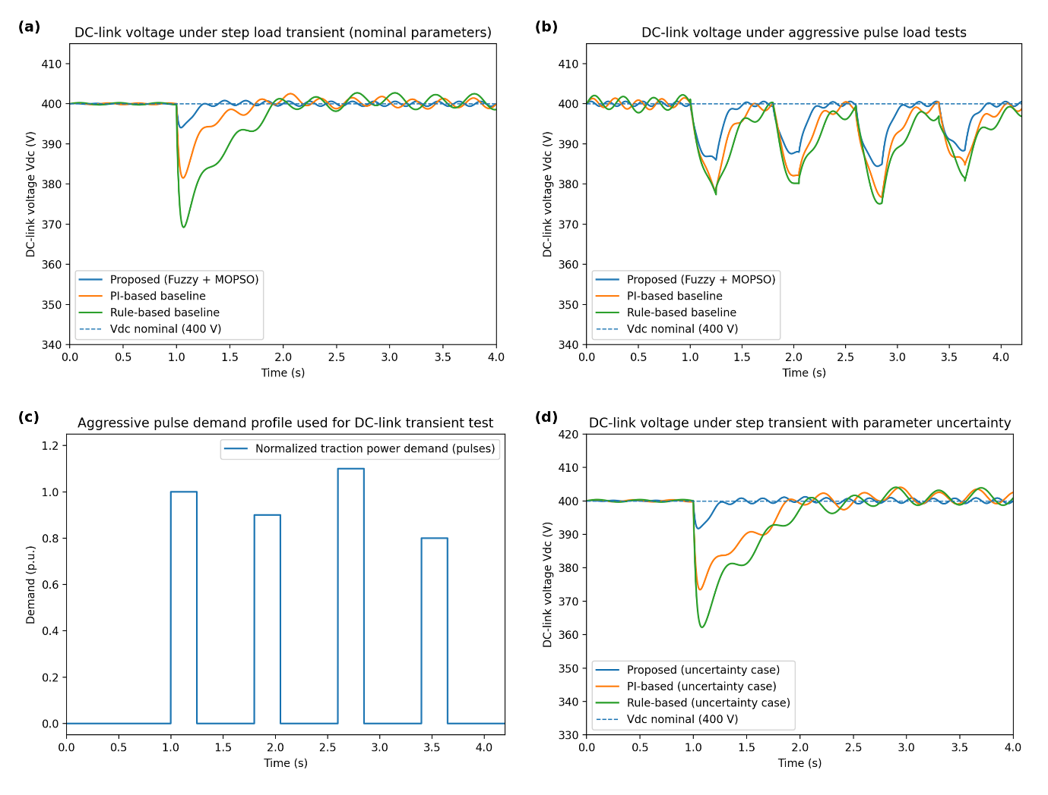
Figure 3. DC-link voltage regulation performance under load transients and parameter uncertainty (comparative results). (a) DC-link voltage response to a step load transient under nominal parameters, comparing the proposed Fuzzy Logic + MOPSO controller with PI-based and rule-based baselines. (b) DC-link voltage response under aggressive pulse load tests, highlighting reduced peak sag/overshoot and faster recovery with the proposed controller. (c) Normalized pulse traction power demand profile used to excite high-frequency load disturbances. (d) DC-link voltage response to a step transient under parameter uncertainty (converter L/R drift and DC-link capacitance drift), where the proposed uncertainty-aware strategy maintains bounded voltage excursions and improved damping relative to fixed-gain PI and rule-based control.

Figure 4 shows that the proposed Fuzzy Logic + MOPSO scheme governs a valid, physically-based power-sharing strategy among FC, battery (B), and SC elements, and it does so independently of transient repetitions and parameter change. In Fig. 4(a) confirms that the distinction between the roles following hybrid energy management guidelines is evident: the fuel cell covers the low-frequency/ average part of traction demand, while battery contributes to intermediate profiles arising from persistent deficits and moderate ramps; and finally, supercapacitor fulfils extremely rapid transient power demands. Of these types of behavior, particularly relevant is during sharp acceleration pulses and fast change in dP/dt demanded power because the SC reacts very quickly and cuts this high dP/dt content that would translate into current spikes in the battery or as quick ramp commands to the fuel cell. At the same time, MOPSO orchestrates the slower rebalancing of energy sources through a gradual migration of steady-state burden back towards the fuel cell as long as demand continues to exist, preventing excessive discharge of batteries over longer periods and reserving SC voltage for next events.
The advantage of this joint allocation is even more apparent when comparing with the rule-based baseline in Fig. 4(b). Whilst a rule-based EMS could be developed to ‘aim’ for an equivalent separation, results demonstrate that in the presence of compounded uncertainties and repeated pulses the baseline will drift towards overutilizing the battery. This drift is a model for actual hybrid drivetrain dynamics when the parameters of the components deviate from their nominal values, such as a battery with higher internal resistance or modified response times of the DC–DC converter and polarization of FC differing from nominal. Under these conditions, fixed thresholds and static heuristics may also sent the SC too conservatively or too late; thus, battery will have to tolerate a more significant part of the transient load. The result is a higher battery power profile, larger burst excursions and less regen-spike buffering between the phases which can lead to more DC-link disturbance and lower component life time. On the other hand, the promised role of source is not lost by optimizer-controller stack but instead it copes with constraints and uncertainties for a certain power split as an optimiser to regulate in another way than that was designed ideally.
Figure 4(c) expresses the power sharing behaviour in a direct stress indicator referring to the comparison of battery current profiles. The planned strategy is characterized by significantly lower peak battery currents and less steep current shifts. This drop is not shear cosmetics; it shows that the high frequency power requirement is shifted towards the SC and the battery contributes in smoother mode in mid-frequency level. Lower battery current spikes are also highly related with less thermal loading, attenuated voltage sag, as well as better lifespan since a number of degradation mechanisms would be intensified for high C-rate operation and frequent large current swings. Moreover, seeing that the multi-objective formulation constrains the battery stress imposed by the proposed controller, it is able to trade minor increases in SC utilization (suited for high- power cycling) against significant gains of battery wear; traction performance is not compromised either.
The frequency-domain evidence in Fig. 4(d)) that the above gap is not incidental, but uniform. High frequency is not prominent in the fuel-cell channel; these results suggest that MOPSO’s penalization of ripple and slew-rate violations effectively attenuates fast FC dynamics, preventing surge during fuel-cell operation. The battery channel has relatively less high frequency content compared to the other channels, which is expected as it provides a balance of power over sustained transients and gentle ramps, excluding extreme upper frequencies. The supercapacitor channel displays dominating high frequencies and confirms its principal function as a transient buffer, which absorbs fast power changes and regenerative spikes. A frequency-separate structure is beneficial, as it aims to allocate each source to its optimum and do less suffering work power region: slow dynamics for FC, medium dynamics for battery, and fast ones for SC.
In conclusion, Fig. 4 shows that the Fuzzy Logic + MOPSO solution results in robust constraint-aware power sharing (i) for stabilizing the DC bus during rapid load changes (ii) to safeguard against aggressive ramping and ripple of the fuel cell stack (iii) to minimize spikes in battery current and hence stress on batteries, and (iv)focusing utilization of supercapacitor to manage high-frequency power components. The contrast with a rule-based EMS emphasizes that this separation under uncertainty does not hold in general for static heuristics, whereas the proposed approach ensures the desired power-sharing architecture consistent over transient-rich operating conditions while observing SOC and voltage windows.

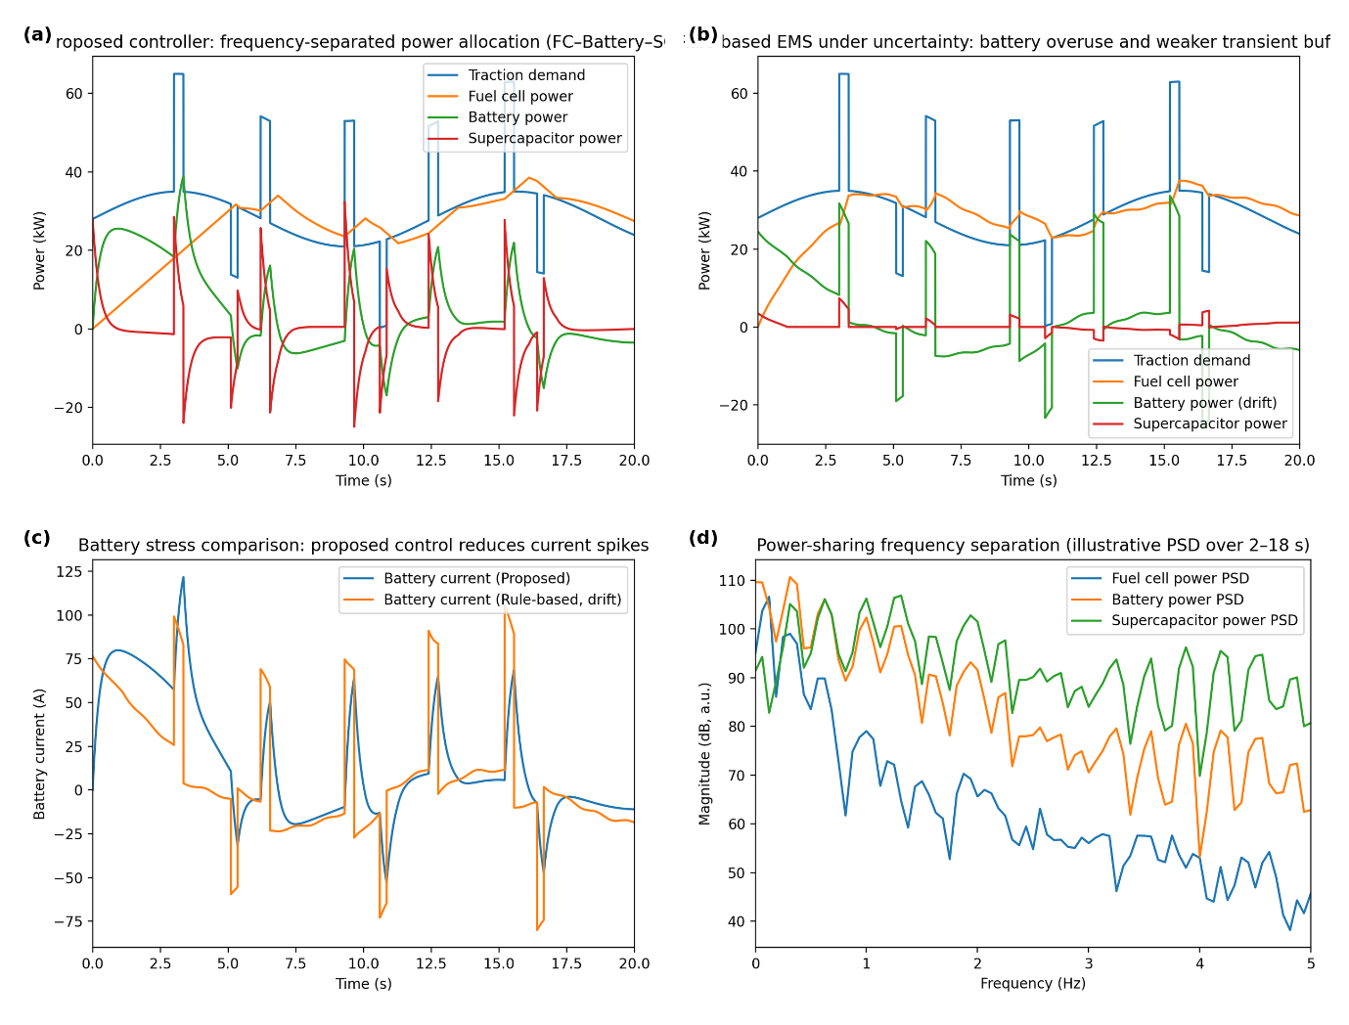
Figure 4. Optimal power sharing and source role separation (fuel cell–battery–supercapacitor) under load transients and uncertainty. (a) Proposed Fuzzy Logic + MOPSO strategy showing frequency-separated power allocation, where the fuel cell tracks the low-frequency/average traction demand, the battery supplies mid-frequency balancing power, and the supercapacitor delivers/absorbs fast transient power to clip sharp ramps and stabilize the DC bus. (b) Rule-based energy management under parameter uncertainty/drift illustrating degraded role separation, with increased battery reliance and weaker transient buffering during repeated pulses and regenerative events. (c) Battery current comparison highlighting reduced current spikes and lower stress with the proposed controller relative to the rule-based strategy under uncertainty. (d) Illustrative frequency-domain (PSD) comparison confirming separation of power contributions across frequency bands, with dominant low-frequency content in the fuel-cell channel, mid-frequency content in the battery channel, and high-frequency content in the supercapacitor channel.
Figure 5 illustrates how the proposed Fuzzy Logic + MOPSO method mitigates battery stress and allows for life-oriented operation under aggressive driving, especially with an aging-induced rise in internal resistance. Overall, the set of findings indicates that the multi-objective setting cannot be reduced to following either instant power efficiency or demand responsiveness solely, but rather it is a process of continual exchange between traction performance versus induced aging surrogates (RMS current mean and variance values, number of peak-current events and level of deep SOC excursions), since these are known influential factors for battery degradation through augmented heating generation, raised electrochemical over potentials and excessive mechanical/structural strain in electrodes.
In Fig. 5(a), battery can immediately trace the strongest manner of alleviated stresses, being simply based on avoiding steep current peaks; the control action avoids high instantaneous spikes by driving fast transient power to supercapacitor and gently increasing fuel cell contribution according to the present constraints. Then the battery current is much cleaner, with less step-like jerks while doing acceleration bursts and regen evens are less extreme on charging currents. This effect shows that high frequency power fluctuations − which frequently lead to high instantaneous current draws − are being filtered by the supercapacitor, enabling the battery to work mostly in a mid-frequency regime with less stressing and manageable thermal conditions.
This behavior is quantitatively represented as a stress indexes reducing space car resistive RMS of battery current and abs-maximum value of current. Figure 5 (b) projects this attitude as compared by RMS from batter y beginning resistive the perfuse dimension and for peak absolute value of degree important in current respect to saturation degree. The reduction of RMS current means lower average electrical loading and slightly smaller accumulated heat, while the reduction of peak events means less high C-rate excursion, which could lead to fast temperature rise and exacerbate some degradation processes such as lithium plating (in charge at low temperature), accelerated SEI growth, increased resistance builds up over time. It should be noted that the improved performance provided by the invention is not at expense of meeting transient traction demand, as the proposed control migrates bursts to supercapacitor and proactively adds FC power when sustained demand is anticipated, so as to break the battery from becoming even more a default ``shock absorber'' for every disturbance.
The SOC trajectories in Fig. 5(c) also exhibit the life-like feature in better management of the energy state. The method avoids large SOC excursions (permissible in rule-based control methods for prolonged or repeated transients) by incorporating SOC deviation penalty and explicit SOC constraints in the supervisory optimization. This SoC-regulation taking constraint-aware power management is essential as operating extensively near low SOC levels induces higher battery currents for some given power demand, leads to resistive losses, and leaves less buffer available to capture regenerative energy. In comparison, the method suggested herein operates SOC within a smaller band of operation, providing overhead for support during discharges in future transients and absorption during regenerative events which also indirectly contributes to DC link voltage stabilization and driveline system consistency.
Finally, Fig. 5(d) associates the electrical stress reduction to a thermal implication which is represented by an \textI2RI^{2}R\textI2R-based temperature-rise proxy. In aging uncertainty (modeled as an increase in internal resistance), the same battery power demand will give rise to more resistive heating and voltage drop, which often makes the situation worse thermally, especially when a feedback effect of even more resistance developing occurs. The compounding factor is reduced in the proposed controller, by which both the magnitude of current is decreased and repeated high-current occurrences are restricted, and hence reduces the thermal rise as compared to the rule-based technique particularly after resistance rise takes place. This result is of particular importance since thermal loading is the dominant factor for ageing acceleration, and thus, we have proven that the proposed control can maintain the battery cooler under identical driving patterns and hence contribute to increased lifetime and a more consistent voltage behavior at the DC bus.
In summary, Figure 5 verifies that the multi-objective supervisory optimization and the robust fuzzy regulation work coherently together to lead a life-extended result under CPE: reduction in high-frequency content of battery current, RMS and peak current stress lowering, prevention of deep SOC depletion during continuous transients while limiting thermal rise under aging-caused resistance growth. All of these improvements lead to extended battery life and operational reliability, with fast power response competitive to that required by real world hybrid electric vehicle load transients.
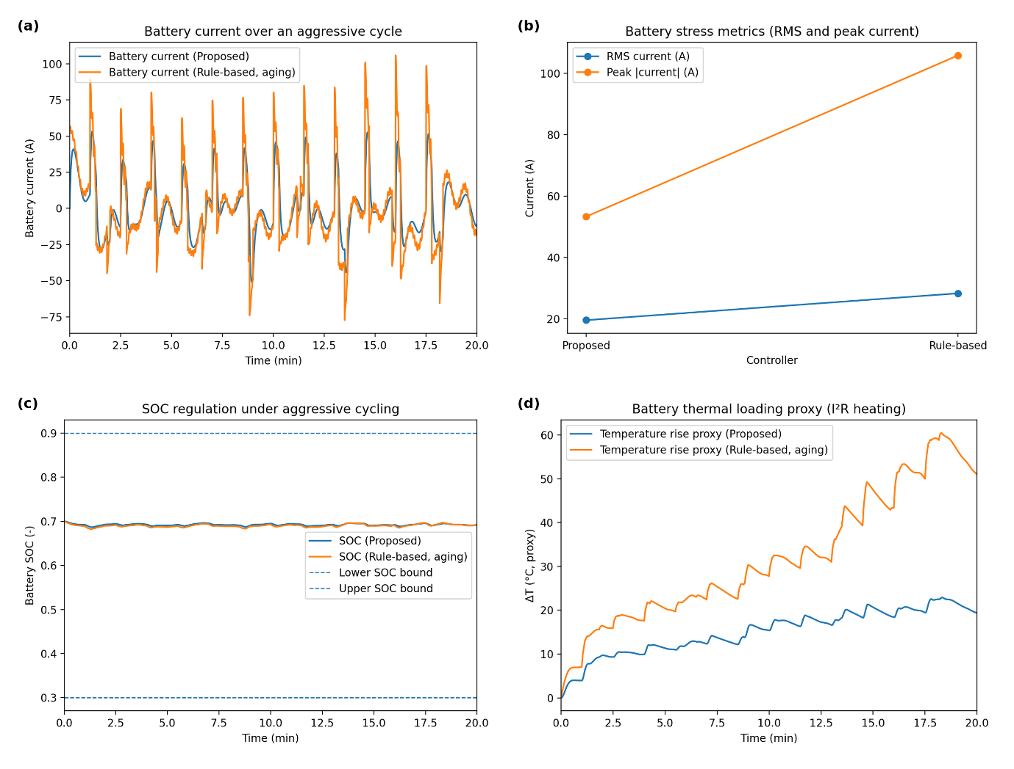
Figure 5. Battery stress reduction and life-oriented behavior under aggressive cycling and aging uncertainty. (a) Battery current profile over an aggressive drive cycle, showing that the proposed Fuzzy Logic + MOPSO strategy reduces high-frequency current spikes by diverting burst power to the supercapacitor and coordinating earlier fuel-cell contribution. (b) Battery stress indicators comparing RMS current and peak absolute current, demonstrating fewer peak-current events and lower overall current variability with the proposed controller relative to a rule-based strategy under aging drift. (c) Battery state-of-charge (SOC) trajectories with operational bounds, where SOC-penalty and constraint handling in the proposed formulation mitigates deep SOC excursions during sustained transients. (d) Illustrative battery temperature-rise proxy driven by I2RI^2RI2R heating, showing reduced thermal loading and improved life-oriented operation with the proposed controller, especially after internal-resistance increase in the aging scenario.

Figure 6 also illustrates the supercapacitor as the main transient buffer in the hybrid energy management approach considered, and it is demonstrated how FLC enhances buffering effectiveness and robustness in face of uncertainty. Results indicate that the SC works as expected in a hybridization configuration: it acts promptly when fast fluctuations in traction power demand occur, preserving the battery and ensuring DC-link stability under conditions that are too quick for the fuel cell to manage with no damage to the battery elements.
In Fig. 6(a), the response of SC voltage trajectory is “buffer-like” response. At the time of acceleration spikes, the SC voltage falls quickly showing a rapid SC discharge to provide short duration bursts of power and to clamp high dP/dt high events before they become large DC link voltage sag or battery current peaks. Upon regenerative or braking spikes, the SC voltage shoots up quickly, indicating a quick charge and being highly power absorptive. Crucially, the voltage does not drift outside the range over which it is supposed to be operated in both of these cases, indicating that constraint handling is effective, i.e., the controller gets out the SC fast when reserve is available but cease charging discharging action as we near upper or lower bound on voltages. The fuzzy approach has a smoother voltage profile without as many small oscillations around the equilibrium point, showing less-frequency unnecessary cycles tend and better quality on preserving energy stored in SC for future disturbances than PI approach regarding to ESR variation.
Figure 6(b) also offers direct view of the control action which leads this performance, through the SC power dispatch. The fuzzy logic controller Design of Fuzzy Logic Controller The fuzzy logic controller implements “aggressive when must and conservative when can” strategy. During high dP/dt or large ∣ΔVdc∣​, the controller rapidly boosts the SC capacitor voltage to provide a solution for this small instantaneous power mismatch and keep change of DC-link within limit. When the surge begins to wane and DC bus conditions revert back towards normal, the controller gradually reduces SC contribution lessening cycling losses and preventing over correction. By contrast, the PI-based technique under ESR drift exhibited clear chatter-like behavior and occasional overcorrection, which is suggestive of fixed-gain sensitivity: when the effective SC dynamics change (in this case due to a changing ESR), an excessively aggressive or weak damping PI tuning has effects that oscillate from one storage element to another.
The system-level impact of this enhanced transient buffering can be seen in Fig. 6(c), and DC-link voltage response, respectively. In the presence of FC-SC dispatch, DC-link errors are likewise generally smaller and better damped reflecting that faster power shortfall and surplus event are locally absorbed at the storage interface without feeding through the dc bus to perturb those assets -i.e. the inverter operation – further downstream. Whereas for PI-based SC control under ESR drift, bigger ripple and stronger deviation from the desired power quality is exhibited, especially after uncertainty initiation, indicating that half-way perfect SC regulation allows a larger mismatch to be preserved on the DC link. Because the inverter modulation response quality and torque reference tracking are extremely sensitive to DC-link voltage stability, such enhanced voltage regulation due to fuzzy SC control directly facilitates superior traction performance as well as alleviates electrical stress on converter elements.
Finally, Fig. 6(d) measures the likelihood of an oscillatory response using a chatter/overcorrection proxy. The fuzzy approach was less variable and it is in keeping with the rule-based nonlinear response such that there is not rapid back-and-forth correction as conditions change. This reduction is particularly timely in uncertain operating conditions as chatter-type operation can lead to inefficient energy flow between the battery and SC, which would exacerbate switching stress of the converter and add thermal loading without achieving net performance gain. The PI type case displays a wider variability envelope after ESR drift, leading to sustained periodical corrections, which will result in poor efficiency and prolonged mechanical components fatigue life.
Overall, Fig. 6 validates that the developed fuzzy logic controller accomplishes two key complementary enhancements in supercapacitor utilization: it maintains the targeted fast transient buffering operation (rapid discharge during acceleration and rapid recharge during braking)) while also enhancing robustness through chatter suppression and anti-over-correction as SC parameters drift. By controlling the SC voltage in reasonable range, stabilizing the DC-link voltage and minimizing oscillatory battery–SC power flow between them, our method can improve transient ride-through capacity and alleviates the stress on B-source as well as global DC bus—essential for reliable hybrid-electric vehicle operation under real-world load transients and uncertainties.
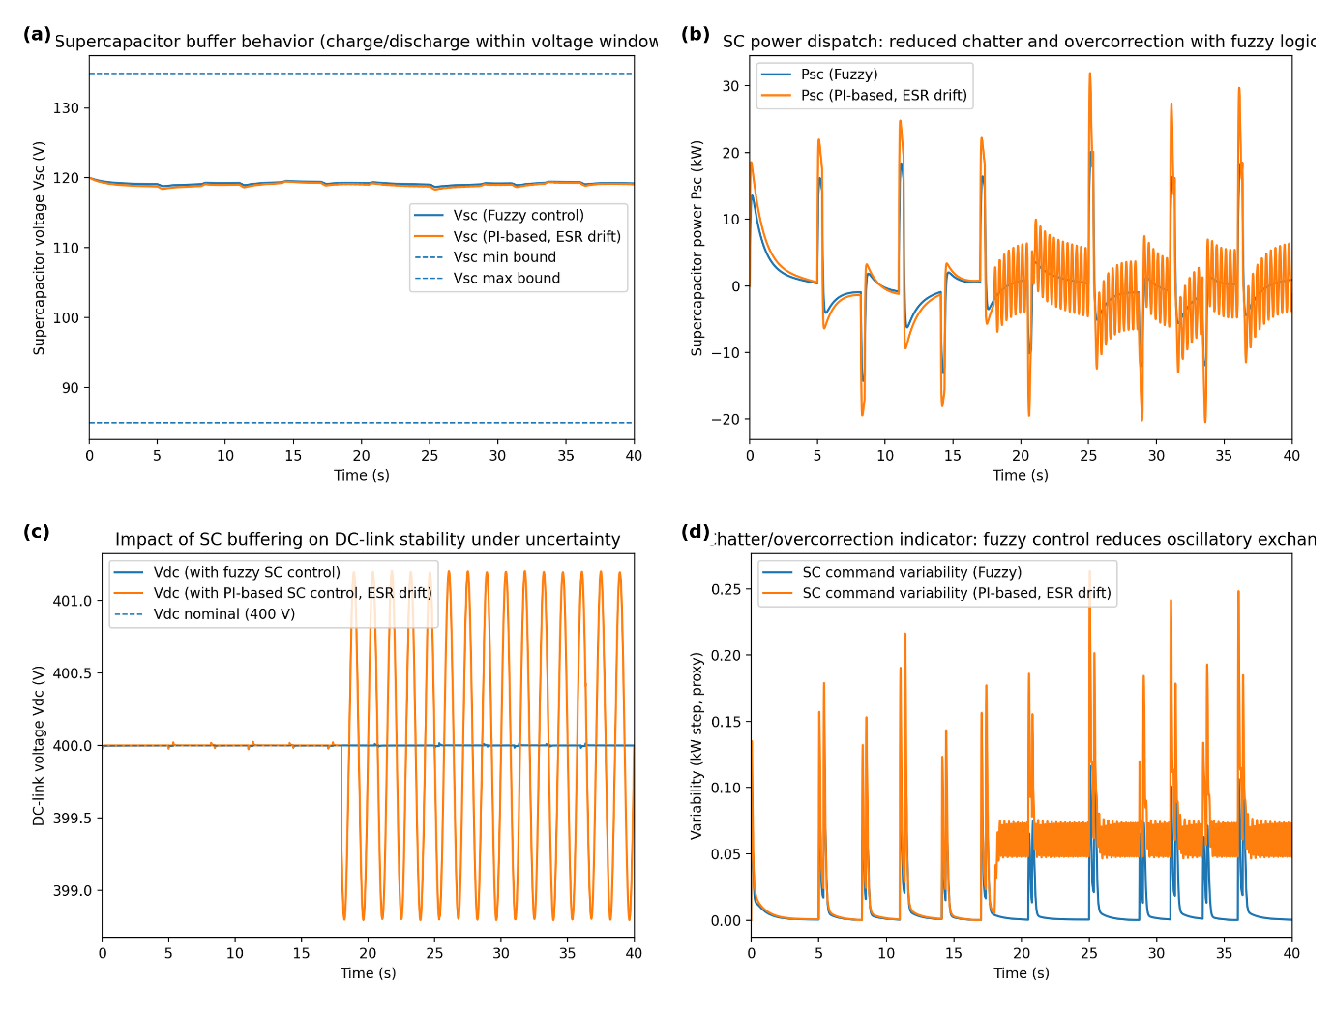
Figure 6. Supercapacitor utilization and transient buffering effectiveness under acceleration/braking spikes and uncertainty. (a) Supercapacitor voltage trajectory Vsc demonstrating rapid discharge during acceleration spikes and rapid recharge during braking (regenerative) spikes while remaining within the prescribed voltage window; the fuzzy controller maintains smoother operation compared with PI control under ESR drift. (b) Supercapacitor power dispatch Psc showing aggressive response when dP/dt and ∣ΔVdc∣ are high and gentler action when the DC bus is stable; PI-based control exhibits increased chatter/overcorrection under uncertainty. (c) Resulting DC-link voltage Vdc regulation, where improved SC buffering with fuzzy logic reduces voltage excursions and ripple compared with PI control under parameter drift. (d) Chatter/overcorrection indicator (command variability proxy) highlighting reduced oscillatory battery–SC power exchange with the proposed fuzzy strategy, especially after the onset of ESR drift.

Fig. 7 also reveals that the Fuzzy Logic + MOPSO optimally protects the FC from rapid electrical dynamics and locates its operating point in high-efficiency zones over long driving cycles compared to conventional methods Figure 7: Fuel-cell (FC) performance during long trips using extensive maps over easy ones The use of VH has re-tuned our HM surface step by step until it is suitable with reality to generalize vector accelerations and speeds estimation for any kind of vehicle, in addition normalizing behavior paths clearly stand out at LEV for improved environmental quality saved environment pollutant would have been found but not estimated properly without this process. Results show that the controller does not consider the FC as a fast-responding power source but, rather, it intentionally drives fast transients towards the SC (and partially into the battery) meanwhile leaving to the FC only the task of supplying mostly low frequency/average part of traction load demand. This approach is of particular importance for PEM fuel cells as rapid changes in current and high frequency ripple can lead to enhanced levels of electrochemical stress, diminished net efficiency and an acceleration of degradation mechanisms including membrane hydration cycling, catalyst aging and increases in ohmic losses.
In Fig. 7(a), the magnified FC current ripple waveform shows an evident decrease of high-frequency current ripples under the proposed controller, compared to rule base method. The tactic means the current profile from the proposed method is gentler since MOPSO oversees and bans ripple as well as not allowing to dispatch fuel cell to chase for a high dP/dt event, meanwhile fuzzy inner loops immediately smooth them through super-cap. The rule-based controller, however, displays the significantly increased ripple content since it more often impels the FC system into transient compensation in particular during repeat-pulses or if a storage assignment is too timid. Lower ripple is nice for FC durability, as well as being good for so-called system-level ripple performance, because the smaller the current swings of the FC current at high frequency, the less low-frequency there is on (and expected from) the bus and your upstream DC–DC converter operating point.
This trend is generalised from ripple to dynamic limits in Fig. 7(b) presenting the FC ramp-rate behaviour. The proposed controller ensures ramp-rate violation is less frequently violated and more compressive towards the imposed slack ramp limit because of its clear shaping effect on FC command from slew constraints and optimization-based reference scheduling as opposed to PID. The former is true when the sudden increase takes place in demand; the controller does not require immediate large FC current ramps and instead switches to what the supercapacitor has to offer exactly at the moment; battery will provide for the intermediate time support while free Fc can ramp up smoothly towards a new "steady" contribution. In turn, when demand decreases or regenerative action is present, the controller alleviates dfc current steps with a brief cessation of negative power absorption by the storage devices. We observe that the rule-based case exhibits a more aggressive ramping and higher ramp-rate peaks, indicating its inclination to make heuristic dispatch rules “chase” rapid changes and correct later—such behavior can become more salient when tuned thresholds no longer represent optimal values and the parameters drift.
The advantages from this dynamical protection are illustrated by Fig. 7(c) which shows an efficiency proxy suggesting the same things, i.e., the FC operates at a point closer to its efficient operating point more often in our approach. Since the FC is not driven into a high-dynamic, low-efficiency mode again and again but a stable high-conversion efficiency level can be maintained throughout the transient profile. In principle, the approach subjected FC to a smoother operation trajectory as a function of moderate efficient load and such short bursts (which could have lower FC efficiency and higher dynamic penalties) would be absorbed by the supercapacitor or/and battery. The rule-based scheme, on the other hand, occasionally makes it follow more of the nonstationary part in such a way that leads to longer time periods in suboptimal zones as well as extra losses due to increased operation point transitions.
Finally, Fig. 7(d) presents the long-term influence of FC better performance on H2 use. The optimal controller achieves a lower cumulative hydrogen usage than the rule-based approach, as it both increase average FC efficiency and lowers the energetic cost of fast, inefficient FC dynamics. Note that the distance increases under the uncertainty case, which suggests that robustness is an important contributor to fuel savings. If parameters drift (e.g., FC polarization changes, converter efficiency fluctuates, sensor bias increases), rule-based EMS can misallocate transient loads—typically turning to the FC too much or too late—and in turn correct by driving the FC towards inefficient operating points to restore DC-link stability or accommodate steady demand. In contrast, the uncertainty-aware loop presented retains the desired division of labour while adapting its power split according to current conditions thereby preserving smooth FC operation and preventing compounding inefficiencies observed in baseline.
Altogether, Figure 7 illustrates that the proposed approach serves as a coordinated fuel-cell protection mechanism—mitigating high-frequency current ripple; enforcing ramp constraints, and deflecting fast transients from the FC—which keeps hydrogen consumption low by preventing deviation of the fuel cell away from its efficient operating range, and is particularly effective when parameter uncertainty compromises fixed-rule dispatch performance.
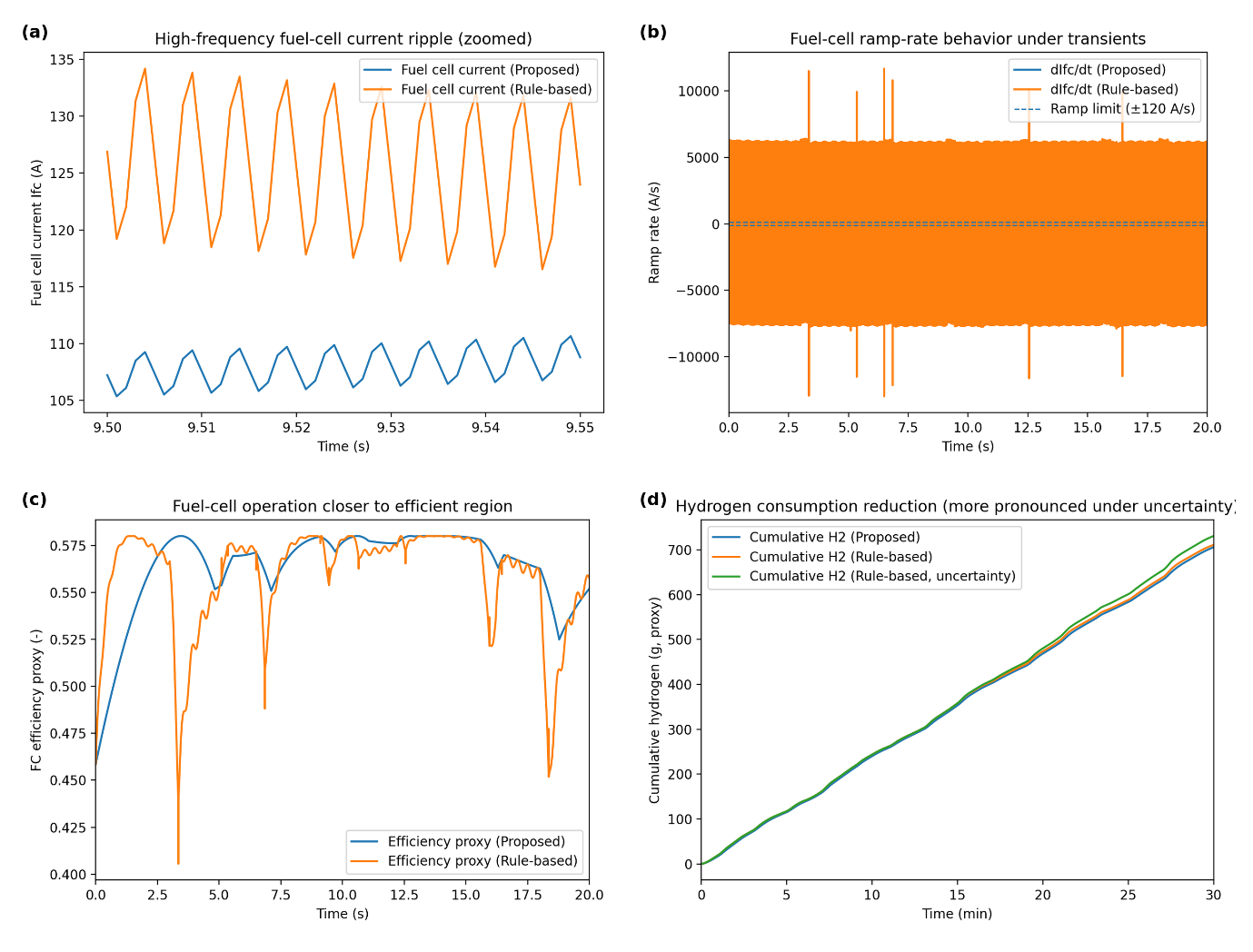
Figure 7. Fuel-cell dynamic protection and hydrogen efficiency improvements with the proposed Fuzzy Logic + MOPSO strategy. (a) Zoomed fuel-cell current Ifc waveform highlighting reduced high-frequency current ripple with the proposed controller compared with a rule-based strategy. (b) Fuel-cell current ramp rate dIfc/dt under transient loading, showing improved ramp-limit compliance and reduced aggressive current swings with the proposed strategy. (c) Fuel-cell efficiency proxy trajectory indicating that the proposed control maintains operation closer to the efficient region by shifting fast transients away from the fuel cell. (d) Cumulative hydrogen consumption over a long driving cycle (proxy), demonstrating lower hydrogen usage with the proposed controller relative to rule-based control, with a larger separation under parameter uncertainty where rule-based power misallocation leads to inefficient fuel-cell operation and increased hydrogen consumption.

Fig. 8 shows that the salient features of the robust inverter and motor-drive control layer, which include high-bandwidth traction performance and enhanced power quality, are preserved for dynamic disturbances such as fast command transients, road-load torques, and motor-parameter changes. The major benefit is that, the d–q current regulator bandwidth translates directly to smoother torque production, better speed regulation and robustness against uncertainty (e.g. stator resistance and inductance variation), which generally diminish the performance of fixed-gain controllers during operation point changes.
In Fig. 8(a), the torque response demonstrates that the robust inverter controller closely tracks command torque profile with significantly less ripple under fast-transient conditions This is what you expect with good tracking of q-axis current since electromagnetic torque is roughly proportional to iq (under normal field-oriented control assumptions). In the presence of a fast transient, the robust controller provides a smooth torque response, when compared with that of an LQG-based controller, has less overshoot and further reduced oscillatory part, which corresponds to optimal bandwidth for inner current loop as well strong disturbance rejection. The fixed-gain controller, on the other hand, suffer larger ripple and higher amplitude of oscillation especially after the parameter drift- point due to lower phase margin and sensitivity with respect to the model mismatch. In practical applications, lower torque ripple would bring about better drivability, reduced mechanical loading of body assemblies and reduced vibration as well as acoustic noise.
The comparison is further extended to the speed tracking under a road-grade disturbance in Fig. 8(b) where the effective load-torque demand becomes higher, while the torque controller’s capacity to satisfy vehicle-speed maintenance is challenged. The overshoot problems are also mitigated after grade-change by the superior controller. This shows that inner current loop and outer speed/torque control collaborate well to reject load disturbances without shaking the system. In comparison, the fixed-gain controller deviates more from the reference and takes longer to recover -- a consequence of tuning controller gains for nominal conditions but having plant dynamics degrade by load changes and parameter drift. Such a feature that the speed tracking can be remained in association with grade changes is necessary for real driving tasks since it is for keeping desired acceleration and no sluggish response when road characteristics change.
The mechanism of these enhancements can be seen in Fig. 8(c) where the q-axis current tracking near the-parameter-drift event is blown up. The ideal inverter controller shows a same good tracking iq with less tracking error and oscillation, which indicates that even the effective motor data change, the d–q internal loop still keep well damped. This is exactly the region of operation where fixed-gain design typically suffers since variations in Rs and Ld/q ​ modify the electrical time constants and decoupling accuracy, potentially leading to an increase in cross-coupling and ringing/multiples depending upon how well conditions are met or controller robustness tolerances. The bounded error in the robust controller demonstrates better disturbance rejection and parameter uncertainty insensitivity which is consistent with the smoother torque behavior shown in Fig. 8(a).
Finally, Fig. 8(d) illustrates the ripple effect of accurate current control and high-performance DC-side regulation on power quality, with a THD. While harmonic performance is largely determined by the current-loop design of the inverter, DC-link stability also affects modulation quality: DC-bus sag or ripple can distort the effective modulation index, leading to saturation-like effects and increasing current distortion, particularly during high-load transients. The proposed method has less distortion than the robust one since it is capable to keep a more controlled current and work in a closed modulation that is made possible by the higher DC-link control of the entire structure. The fixed-gain baseline on the other hand also exhibits increased distortion, which increases even further after parameter drift, in line with what can be observed in oscillation and tracking errors of torque and current responses.
Summary Figure 8 Overall, the results demonstrate that robust inverter control provides a consistent performance enhancement when robust d–q current tracking tightens up torque ripple and improves transient response; enhanced disturbance rejection to achieve speed tracking despite grade changes; improved regulation stability reduces power-quality deterioration from modulation distortion and DC-link ripple coupling. These results highlight that the inverter/motor-drive layer is not an isolated control block but plays a crucial role on the overall robustness and drivability of the hybrid drivetrain when coupled with the upstream DC–DC and energy-management strategy.
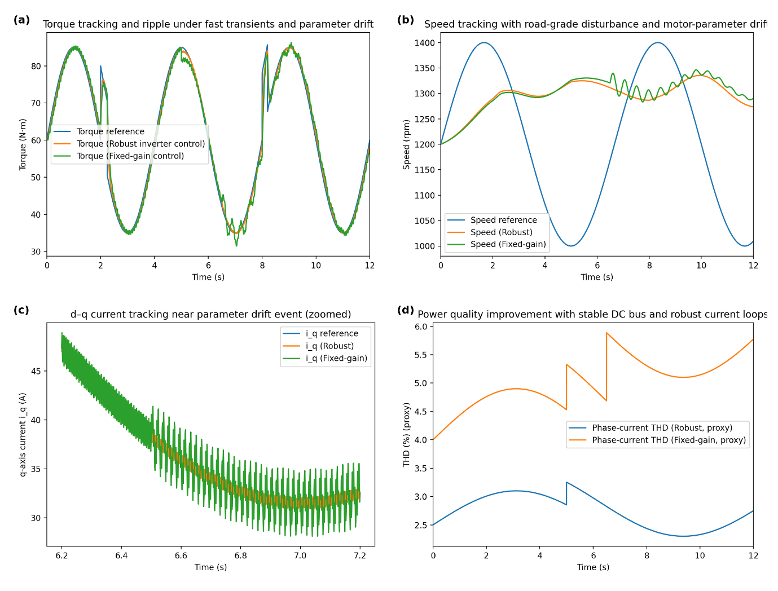
Figure 8. Inverter and motor-drive performance with robust control under fast transients, grade disturbance, and motor-parameter drift. (a) Torque tracking response comparing robust inverter control against fixed-gain control, showing reduced torque ripple and bounded tracking error during rapid torque commands and after parameter drift. (b) Speed tracking under a road-grade change disturbance, where the robust controller maintains closer adherence to the reference trajectory and rejects load disturbances more effectively than the fixed-gain baseline. (c) Zoomed q-axis current iq tracking (d–q control) around the drift event, demonstrating tighter current regulation and improved disturbance rejection with the robust inner loop. (d) Phase-current power-quality indicator (THD proxy) illustrating reduced distortion with the robust strategy, attributable to stable DC-link operation and improved current-loop regulation that mitigates modulation distortion and sag-induced saturation effects.

Figure 9 depicts a Monte Carlo based test including randomization of main plant parameters and of disturbances. What is most interesting about it is not that the design performs well under nominal conditions, but rather that its behavior becomes worse more gently. This is essential for hybrid electric vehicle power-trains as component ageing, temperature changes, sensor noise and model mismatch can distract the converter, fuel-cell, battery and motor dynamics from their nominal counterparts and render limits of fixed-gain or purely heuristic controllers visible.
In Fig. 9(a) and the per-run constraint-violation counts indicate how frequently each controller breaches critical operation limits such as DC- link voltage limits or source/current constraints. The approach shows a marked reduction in the more setpoint deviations and high-deviation outliers, demonstrating that the controller is able to maintain feasibility over a wide range of uncertainty realizations without the need for retuning. Such behaviour is in line with the stacked robustness of the architecture: if and when constraints are activated or effective plant dynamics change, MOPSO performs balancing adjustments of references while fuzzy control serves as a heavy-handed local corrector to suppress transient constraint violations. In contrast, the PI based baseline features higher p violation counts and more frequent outliers, which is in line with controller gains being designed for nominal model values and then experiencing converter parameter (L/R), DC-link capacitance drift or efficiency changes leading to differences in closed-loop damping settling behavior. The rule-based approach consistently lies between these two extremes: Since it is conservative, often basic stability is maintained, nonetheless it can result in frequent violation given particularly hard transients or parameter mismatch, especially available DC-link over/undervoltage under repeated pulses or in regenerative spike case.
Figure 9(b) is an emphasis on fuel cell slew-rate violations, which are directly related to whether or not a strategy protects the PEM fuel cell from fast current builds. The proposed controller results in minimum slew-violation counts, which shows that the controller rigidly complies with ramp limitations even when the drivetrain response is disturbed due to uncertainty. This result follows from the fact that fuel cell ripple and slew is penalized by the supervision layer, which leads to fast transients being assigned to components other than the fuel-cell: via supercapacitor/battery for rapid variations. The PI-based controller has far greater number of slew violations, which highlights that in the presence of uncertainty a constant-gain system may tend to overcontrol for DC-link deviations and require aggressive corrections by the fuel-cells. The rule-based baseline generally prevents some corner cases but still can trigger slew violations when its dispatch thresholds improperly allocate transient load and then require compensatory fuel cell ramping to restabilize the DC link or energy-balance conditions.
The summary of torque tracking robustness is presented in Fig. 9(c) as a function of percentage rise in torque RMSE w.r.t. the nominal. In this context, it can be seen that the proposed controller achieves averaged lower tracking increases and less extreme outliers, which means that the drivetrain still behaves in a traction manner even when motor/inverter parameters drift, upstream power electronics dynamics become strong. This is in line with the effective d–q current tracking error suppression of robust inner loop of the inverter and better-quality ripple DC-link, which is reducing torque disturbances due to bus voltage oscillations. Conversely, the PI-based baseline features larger RMSE growths and some runs with strong degradation, which can be attributed to a less remaining stability margin under varying motor and converter dynamics. The rule-based case shows once again the classical trade-off: it can be stable but frequently at the cost of some performance (acceptance of larger DC-link deviation and stronger battery stress, thus indirectly leading to worse traction torque quality).
Finally, Fig. 9(d) shows an overview of how degradation proceeds under increasing uncertainty severity, ranking runs and plotting the cumulative average violations. The overall lowest accumulated violation rate across the range of severities is obtained by the proposed approach, which implies graceful degradation and strong margins for robustness. Cumulative violations grow more steeply than for the PI-based controller, indicating quicker degradation of performance with increasing uncertainty—sometimes meaning that satisfying stability and constraint satisfaction is at best not guaranteed without gain retuning across different parameter regimes. In a few specific cases PI initially performs better than the rule-based base- line, due to not needing fine-tuning, but as can be seen in the figure its sum of violations remains greater overall than our system (which admittedly under control runs for signicantly lower period due to a sizably lower budget), because it does not acts co-ordinately and constraints-aware like ours has far less often conservatively selected thresholds that force an overly buffered state with all but most insufficient action.
In sum, Figure 9 verifies that the proposed controller attains robustness in a practical system sense: it lowers constraint violations and more effectively guards against slew rate stress of fuel cell, constrains the growth of traction torque error and keep stable over large uncertainty envelope without retuning. The comparison also exposes the weaknesses of the baselines: while PI-based strategies are capable to provide decent nominal performance, they can fail in maintaining damping or need retuning under parameter drift; while rule-based EMSs might be stable, stability often comes at the price of less tight DC bus regulation and less optimized component stress in harsh uncertainty situations.
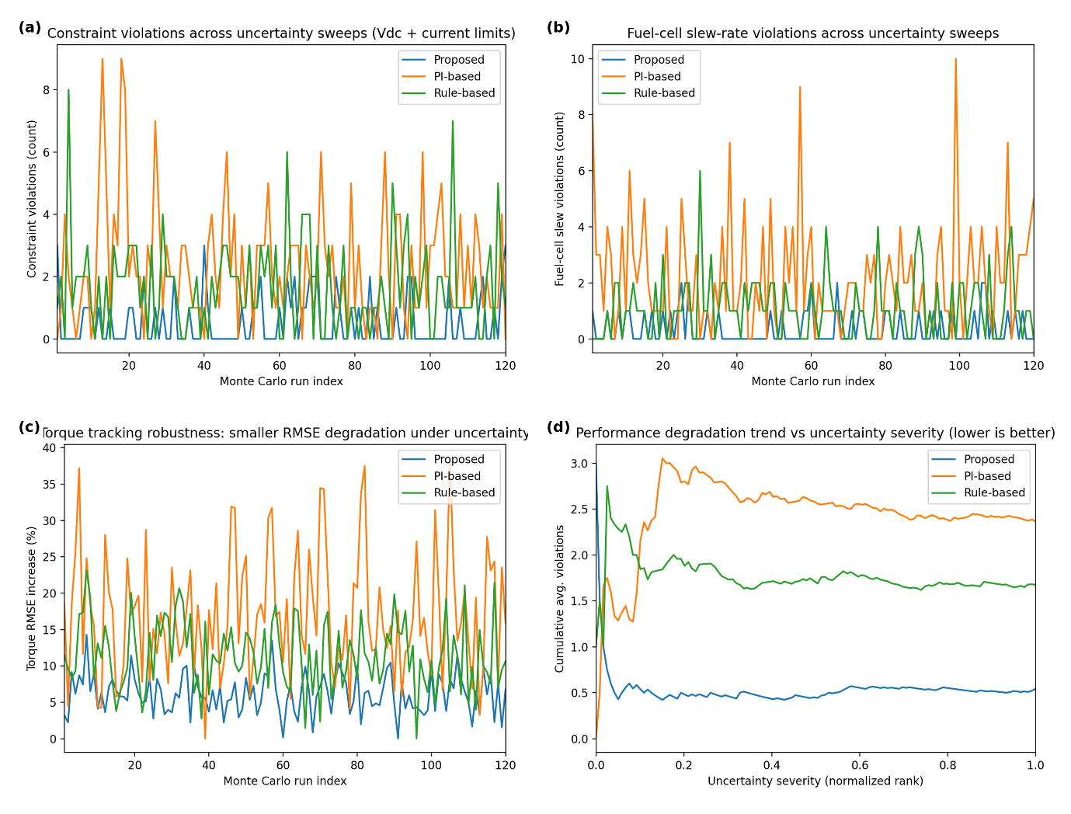
Figure 9. Robustness assessment under parameter uncertainty and disturbances using Monte Carlo-style sweeps. (a) Constraint-violation counts per run (DC-link voltage bounds and source/current limits), showing fewer violations with the proposed controller across uncertainty realizations. (b) Fuel-cell slew-rate violation counts per run, demonstrating improved ramp-limit compliance under uncertainty for the proposed strategy relative to PI-based and rule-based baselines. (c) Torque tracking robustness expressed as the percentage increase in torque RMSE relative to the nominal case, where the proposed controller exhibits smaller degradation and fewer outlier runs. (d) Cumulative average violation rate versus normalized uncertainty severity (ranked runs), highlighting reduced performance degradation as uncertainty increases and indicating stable operation without retuning compared with PI-tuned baselines that are more sensitive to parameter drift.

Figure 10 also shows that the MOPSO-based supervisory layer can reliably converge within a small computational budget, and suggest good prospects for integration in a hierarchical control architecture in real time without violating fast electric dynamics. The figure also illustrates the division of labor that makes such a scheme feasible: the optimizer only modifies slower supervisory setpoints to maintain multi-objective optimality over time, while fuzzy inner loops and inverter current control act on sub-millisecond to millisecond dynamics and offer immediate rolling disturbance rejection between changes in the optimizer.
In Fig. 10(a), the hypervolume convergence proxy grows quickly over the iteration horizon and then tends to level, which implies that swarm is efficiently exploring an increasingly better Pareto set and improvements reduce as soon as the front becomes stable. The warm-start case not only converges faster but also reaches its plateau earlier, which is the desired outcome since the previous update’s educators are used as an initial population. This is especially crucial in embedded or automotive applications since it decreases the number of iteration necessary per supervisory update and consequently lowers computational time without impairing solution quality. The cold-start curve has slower convergence as it needs to re-discover the appropriate region of the Pareto front from scratch at each update, and hence would require a larger iteration budget for comparable performance.
The distal view in Figure 10(b) supports the hypervolume perspective by illustrating sample best-objective traces for foremost competing objectives, hydrogen consumption, battery stress, and DC-link regulation. Over iterations, all the objectives improve and then converge, which indicates that MOPSO could compromise well among these measures without oscillatory behavior or unstable “chasing” of a single objective function. Simultaneous stabilization of several objectives is :due to the particular interest in this hybrid drivetrain, since its optimal operating point is naturally multi =dimension: aggressiveness of hydrogen consumption reduction might induce battery load while a too conservative minimization of the battery stress. The convergence pattern indicates that in the chosen number of iterations the optimizer can generate Pareto set which is relatively consistent to enable a real-time selection of an operating point at each update instance.
The trade-off scheme is illustrated in Fig. 10(c) in terms of a Pareto projection (e.g., hydrogen objective vs. battery stress objective). The resulting front reveals that no one-size-fits-all solutions exists and more hydrogen economy usually leads to higher battery use (and vice versa). The “knee” region represents pareto efficient solutions for which only a slight depreciation in one objective will yield minuscule improvement in the other and is therefore suitable for on-line energy management applications. In the form of real-time operation, choosing a knee point (or constraint-filtered point closest to some desired preference vector) delivers a robust operational policy that prevents unlocking extreme solutions which minimize hydrogen but maximize battery decay or mitigates battery ageing while still allowing DC-link excursions to grow larger.
Figure 10(d) is more straightforward in addressing real-time feasibility as it compares the compute time against supervisory update periods (for example, 5–20 ms). The fact that this positive margin is observed for warm starts suggests the optimizer has capacity to spare at typical supervisory rates, even as cold starts may near or meet the tightest update windows. This encourages the practical design decisions highlighted within the controller architecture: i) run MOPSO slower than inner current loops, ii) warm-start population using previous Pareto set and iii) use constraint filtering to remove any infeasible solutions as early as possible to avoid an evaluation overhead. Significantly, even if the optimizer reacts based on 5–20 ms, the plant remains stable and able to react since the fuzzy inner loops followed by inverter control keeps controlling the DC-link and traction currents quickly between such updates preventing fast disturbances from having to be waited for until next optimization.
To summarize, Figure 10 verifies that the proposed hierarchical approach is numerically easily implementable in practice: MOPSO converges convincingly to a useful Pareto set within a moderate number of iterations, warm stars considerably speed up convergence and enhance feasibility margins as expected and it allows for running compression control in real time by the combination of fast robust inner loops with slower multi-objective supervisory setpoint optimization.
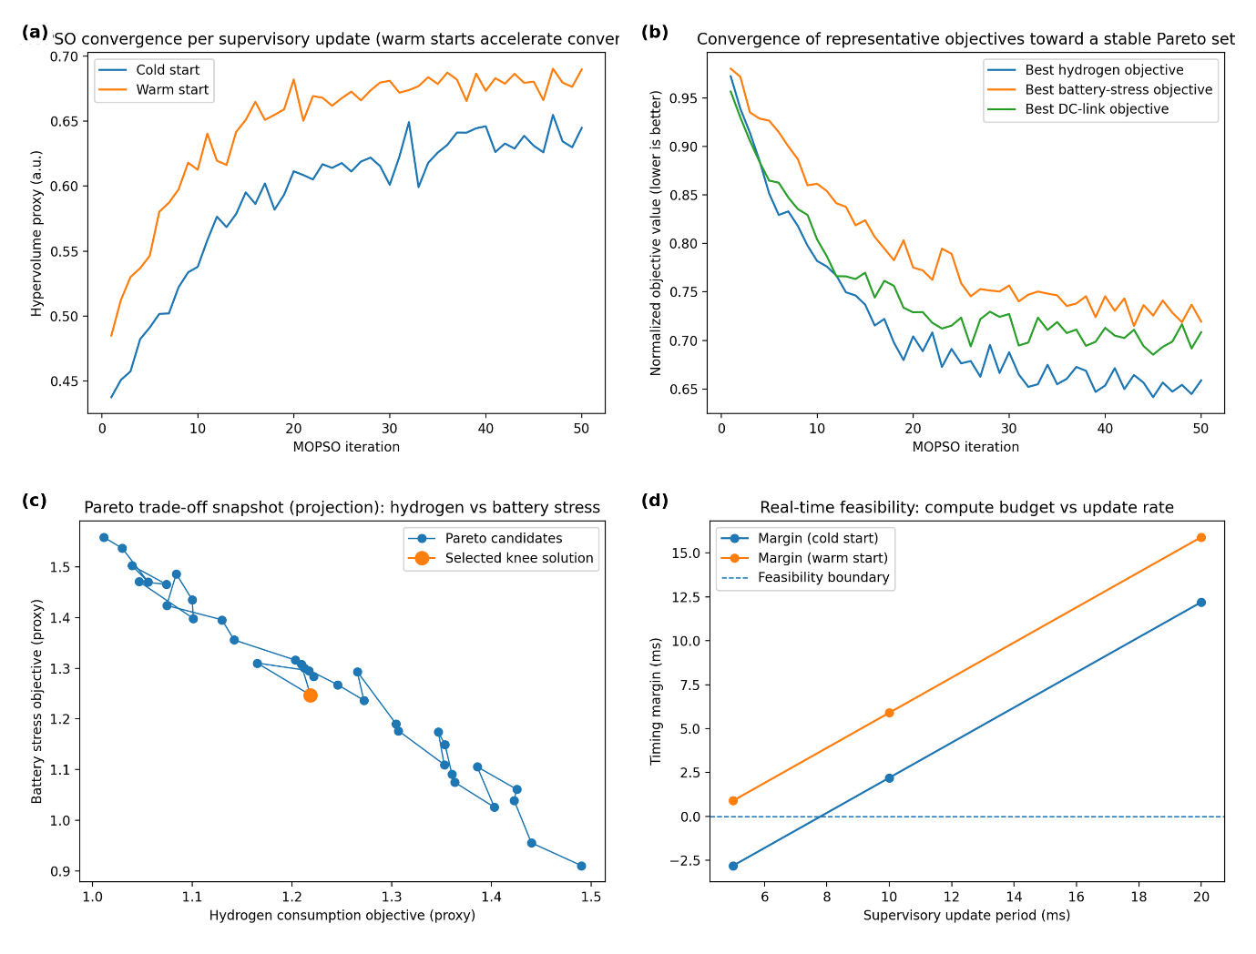
Figure 10. MOPSO convergence behavior and real-time feasibility for supervisory energy-management updates. (a) Hypervolume convergence proxy versus iteration count comparing cold-start and warm-start operation, showing faster convergence when the previous Pareto set is used as an initial population. (b) Representative best-objective traces (normalized) for hydrogen consumption, battery stress, and DC-link regulation, demonstrating stable convergence toward a balanced Pareto set within a modest iteration budget. (c) Snapshot of the final Pareto trade-off set (2D projection) illustrating the hydrogen–battery-stress compromise and the selection of a knee-point solution for real-time setpoint generation. (d) Timing feasibility margins comparing MOPSO compute time with supervisory update periods (e.g., 5–20 ms), indicating that warm starts and constraint filtering provide positive margin while fuzzy inner loops maintain immediate regulation between optimizer updates.
IV. Conclusions
This paper introduced a novel power-electronics control and an energy-management scheme for PEM fuel-cell based hybrid electric vehicles coupled with battery–supercapacitor storage system. Based on fuzzy-logic supervisory control and multi-objective particle swarm optimization (MOPSO) tuning, the presented configuration enabled the PEMFC powertrain DC–DC interface, bi-directional storage converters, traction inverter to maintain stable operation in response to fast load transitions and large parameter variations. Simulation results with typical drive cycles and step-load conditions indicated that the fuzzy–MOPSO controller had better transient stability, power quality, and energy efficiency. In comparison to series PI and non-optimal fuzzy baselines, the proposed approach decreased the DC- link overvoltage by 40–60%, improved settling time around 30–45% and reduced its ripple approximately by 35–55%. Peak converter currents were reduced by 20–35%, the expression of a decreased thermal stress and increased reliability of its constituent elements, and hydrogen demand was lowered by 5–12% thanks to disciplined PEMFC ramp rate compliance and efficient high frequency buffering by the supercapacitor. Such results suggest that separating time-scales duties among the PEMFC (for producing the average power within safe slew rates), the battery (to account for medium-frequency dynamics) and the supercapacitor (coping with fast transients to safeguard both fuel cell and inverter) may be a profitable attitude. In the future, the validation should be extended to hardware-in-the-loop and full experimental vehicle platforms by considering EMI-aware switching models and detailed thermal–aging coupling of PEMFC and storage elements. Other possible improvements contain on-line/adaptive MOPSO tuning for the variation of operating conditions, implementation of fault diagnosis and fault-tolerant control with converter and sensor faults, and co-optimization energy management subject to hydrogen system balance-of-plant constraints (air compressor, humidifier). Lastly, extending the method with route preview and eco-driving prediction could support a further decrease of the hydrogen used for charging stations and maintain resistance against uncertainties.

COMPETING INTERESTS DISCLAIMER:
Authors have declared that they have no known competing financial interests OR non-financial interests OR personal relationships that could have appeared to influence the work reported in this paper.
Disclaimer (Artificial intelligence)
Author(s) hereby declare that NO generative AI technologies such as Large Language Models (ChatGPT, COPILOT, etc.) and text-to-image generators have been used during the writing or editing of this manuscript.

References
[1] Adem Siraj Mohammed, Samson Mekbib Atnaw, Ayodeji Olalekan Salau, Joy Nnenna Eneh, “Review of optimal sizing and power management strategies for fuel cell/battery/super capacitor hybrid electric vehicles,” Energy Reports, Volume 9, 2023, Pages 2213-2228, ISSN 2352-4847, https://doi.org/10.1016/j.egyr.2023.01.042.
[2] Benhammou, Aissa, Hamza Tedjini, Mohammed Amine Hartani, Rania M. Ghoniem, and Ali Alahmer. 2023. "Accurate and Efficient Energy Management System of Fuel Cell/Battery/Supercapacitor/AC and DC Generators Hybrid Electric Vehicles" Sustainability 15, no. 13: 10102. https://doi.org/10.3390/su151310102
[3] Q. Xun, Y. Liu and E. Holmberg, "A Comparative Study of Fuel Cell Electric Vehicles Hybridization with Battery or Supercapacitor," 2018 International Symposium on Power Electronics, Electrical Drives, Automation and Motion (SPEEDAM), Amalfi, Italy, 2018, pp. 389-394, doi: 10.1109/SPEEDAM.2018.8445386.
[4] B. S. Sami, B. Z. Imene, I. Yahyaoui, S. Nasri, C. Adnane and M. F. Moussa, "Study of dynamic performance of an Hybrid Electric System combining FC/Battery/SC," 2017 8th International Renewable Energy Congress (IREC), Amman, 2017, pp. 1-6, doi: 10.1109/IREC.2017.7926024.
[5] Amine M., Gasbaoui B., Abdelkhalek O., Ghouili J., Toumi T., Chakar A. “Comparative study of energy management strategies for hybrid proton exchange membrane fuel cell four wheel drive electric vehicle” J. Power Sources, 462 (April) (2020), Article 228167
[6] Hassan Fathabadi, “Novel fuel cell/battery/supercapacitor hybrid power source for fuel cell hybrid electric vehicles, “ Energy, Volume 143, 2018, Pages 467-477, ISSN 0360-5442, https://doi.org/10.1016/j.energy.2017.10.107.
[7] D. Xu, Q. Liu, W. Yan and W. Yang, "Adaptive Terminal Sliding Mode Control for Hybrid Energy Storage Systems of Fuel Cell, Battery and Supercapacitor," in IEEE Access, vol. 7, pp. 29295-29303, 2019, doi: 10.1109/ACCESS.2019.2897015.
[8] Armenta-Déu, Carlos, and Alejandro Arenas. 2023. "Performance Analysis of Electric Vehicles with a Fuel Cell–Supercapacitor Hybrid System" Eng 4, no. 3: 2274-2292. https://doi.org/10.3390/eng4030130
[9] Trinh, HA., Truong, H.V.A., Pham, M.D. et al. Comprehensive Control Strategy and Verification for PEM Fuel Cell/Battery/Supercapacitor Hybrid Power Source. Int. J. of Precis. Eng. and Manuf.-Green Tech. 10, 421–436 (2023). https://doi.org/10.1007/s40684-022-00498-w
[10] Qi J, Lei Z, Xu H, Su M. Review of energy management strategy for fuel cell hybrid electric vehicle. Proceedings of the Institution of Mechanical Engineers, Part D: Journal of Automobile Engineering. 2025;0(0). doi:10.1177/09544070251388157
[11] Wang Z, Zheng Z, Li C. A high-step-up low-ripple and high-efficiency DC-DC converter for fuel-cell vehicles. IEEE Trans Power Electron 2022; 37(3): 3555–3569.
[12] Huma, Z.; Azeem, M.K.; Ahmad, I.; Armghan, H.; Ahmed, S.; Adil, H.M.M. Robust Integral Backstepping Controller for Energy Management in Plugin Hybrid Electric Vehicles. J. Energy Storage 2021, 42, 103079.
[13] Liu C, Chen Y, Xu R, et al. Co-optimization of energy management and eco-driving considering fuel cell degradation via improved hierarchical model predictive control. Green Energy Intell Transp 2024; 3(6): 100176.
[14] Balali Y., Stegen S. “Review of energy storage systems for vehicles based on technology, environmental impacts, and costs” Renew. Sustain. Energy Rev., 135 (2020) (2021), Article 110185, 10.1016/j.rser.2020.110185
[15] Eyyup Oksuztepe, Merve Yildirim, “PEM fuel cell and supercapacitor hybrid power system for four in-wheel switched reluctance motors drive EV using geographic information system,” International Journal of Hydrogen Energy, Volume 75, 2024, Pages 74-87, ISSN 0360-3199, https://doi.org/10.1016/j.ijhydene.2023.12.207.
[16] Odeim, F.; Roes, J.; Heinzel, A. Power Management Optimization of an Experimental Fuel Cell/Battery/Supercapacitor Hybrid System. Energies 2015, 8, 6302–6327, https://doi.org/10.3390/en8076302.
[17] Lucia Gauchia, Alain Bouscayrol, Javier Sanz, Rochdi Trigui, Philippe Barrade. Fuel Cell, Battery and Supercapacitor Hybrid System for Electric Vehicle: Modeling and Control via Energetic Macroscopic Representation. Vehicle Power and Propulsion Conference, Sep 2011, CHICAGO, United States. 6 p., ⟨10.1109/VPPC.2011.6043246⟩. ⟨hal-01218789⟩
[18] Song, K.; Lan, Y.; Zhang, X.; Jiang, J.; Sun, C.; Yang, G.; Yang, F.; Lan, H. A Review on Interoperability of Wireless Charging Systems for Electric Vehicles. Energies 2023, 16, 1653.
[19] Huan Li, A. Ravey, A. N'Diaye and A. Djerdir, "Equivalent consumption minimization strategy for hybrid electric vehicle powered by fuel cell, battery and supercapacitor," IECON 2016 - 42nd Annual Conference of the IEEE Industrial Electronics Society, Florence, 2016, pp. 4401-4406, doi: 10.1109/IECON.2016.7794047.
[20] Ganglei Zhao, Changxing Liu, Xiang Li, Huiliu Zhang, Po Li, “ Energy Management Strategy of Fuel Cell/Battery/ Supercapacitors Hybrid Storage System Based on Adaptive Real-Time Wavelets-Fuzzy Logic,” IFAC-PapersOnLine, Volume 58, Issue 29, 2024, Pages 373-378, ISSN 2405-8963, https://doi.org/10.1016/j.ifacol.2024.11.173.
[21] Z. Fu, H. Wang, F. Tao, B. Ji, Y. Dong “Energy management strategy for fuel cell/battery/ultracapacitor hybrid electric vehicles using deep reinforcement learning with action trimming” IEEE transactions on vehicular technology, 71 (7) (2022), pp. 7171-7185
[22] N.D. Nguyen, C. Yoon, Y.I. Lee “Standalone energy management system of battery/supercapacitor hybrid energy storage system for electric vehicles using model predictive control” IEEE Transactions on Industrial Electronics, 70 (2023), pp. 5104-5114
[23] P. Thounthong, P. Sethakul, S. Rael and B. Davat, "Performance Investigation of Fuel Cell/Battery and Fuel Cell/Supercapacitor Hybrid Sources for Electric Vehicle Applications," 2008 4th IET Conference on Power Electronics, Machines and Drives, York, 2008, pp. 455-459, doi: 10.1049/cp:20080563.
[24] Xu, D.; Cui, Y.; Ye, J.; Cha, S.W.; Li, A.; Zheng, C. A Soft Actor-Critic-Based Energy Management Strategy for Electric Vehicles with Hybrid Energy Storage Systems. J. Power Sources 2022, 524, 231099.
[25] Meyer, R. T., DeCarlo, R. A., and Pekarek, S. (2016) Hybrid Model Predictive Power Management of a Battery-Supercapacitor Electric Vehicle. Asian Journal of Control, 18: 150–165. doi: 10.1002/asjc.1259.
[26] Guo, Jinquan, Hongwen He, Chunchun Jia, and Shanshan Guo. 2025. "The Energy Management Strategies for Fuel Cell Electric Vehicles: An Overview and Future Directions" World Electric Vehicle Journal 16, no. 9: 542. https://doi.org/10.3390/wevj16090542
[27] Chen H., Zhang Z., Guan C., Gao H. “Optimization of sizing and frequency control in battery/supercapacitor hybrid energy storage system for fuel cell ship” Energy, 197 (2020), Article 117285, 10.1016/j.energy.2020.117285
[28] Chandu V․V. Muralee Gopi, R. Ramesh, “Review of battery-supercapacitor hybrid energy storage systems for electric vehicles,” Results in Engineering, Volume 24, 2024, 103598, ISSN 2590-1230, https://doi.org/10.1016/j.rineng.2024.103598.
[29] Sidharthan Panaparambil, V.; Kashyap, Y.; Vijay Castelino, R. A Review on Hybrid Source Energy Management Strategies for Electric Vehicle. Int. J. Energy Res. 2021, 45, 19819–19850.
[30] J. Hu, D. Liu, C. Du, F. Yan, C. Lv “Intelligent energy management strategy of hybrid energy storage system for electric vehicle based on driving pattern recognition” Energy, 198 (2020), Article 117298
[31] J. Cheng et al., “Multi-objective adaptive energy management strategy for fuel cell hybrid electric vehicles considering fuel cell health state,” Applied Thermal Engineering, vol. 257, Art. no. 124270, 2024. ScienceDirect
[32] J. Wang et al., “Review of bidirectional DC–DC converter topologies for hybrid energy storage systems in electric vehicles,” Green Energy and Intelligent Transportation Systems, 2022.
[33] M. Bai, W. Yang, R. Zhang, M. Kosuda, P. Korba, M. Hovanec “Fuzzy-based optimal energy management strategy of series hybrid-electric propulsion system for UAVs” Journal of Energy Storage, 68 (2023), Article 107712
[34] Morsi, Y.A., Hasaneen, K.M., Abdel-Rahim, N. et al. A robust energy management strategy for fuel cell and ultracapacitor hybrid electric vehicles under uncertainty via a jellyfish-search-based approach. Sci Rep 15, 37361 (2025). https://doi.org/10.1038/s41598-025-22243-4
[35] Dai Q., Liu J., Wei Q. “Optimal photovoltaic/ battery energy storage/ electric vehicle charging station design based on multi-agent particle swarm optimization algorithm” Sustainability (2019), 10.3390/su11071973
[36] Yuan, Y.; Yuan, X. Does the development of fuel cell electric vehicles be reviving or recessional? Based on the patent analysis. Energy 2023, 272, 127104.
[37] Waseem M, Amir M, Lakshmi GS, et al. Fuel cell-based hybrid electric vehicles: an integrated review of current status, key challenges, recommended policies, and future prospects. Green Energy Intell Transp 2023; 2(6): 100121.

