Minireview Article

EVALUATION OF RECREATIONAL TOURISM POTENTIAL IN CITIES USING SWOT ANALYSIS: THE CASE OF AKYAKA REGION

ABSTRACT
Recreational tourism activities are peaceful and enjoyable experiences that individuals participate in to relax physically and mentally during their leisure time. These activities play a significant role in modern tourism development. Akyaka possesses significant socio-cultural and marine tourism potential thanks to its natural and cultural values. However, the main problem is that Akyaka's recreational tourism potential has not been systematically examined, and many recreational areas are inadequately utilized and managed. This lack of structured assessment restricts effective planning and sustainable development. The aim of this study is to evaluate the current state of recreational areas in Akyaka and to determine their development potential. To achieve this aim, field research and direct observation methods were used. Based on on-site observations and photographic documentation, a SWOT analysis was conducted to identify the region's strengths, weaknesses, opportunities, and threats. The findings offer strategic recommendations to ensure more effective and sustainable use of its resources. resources.

Keywords: Recreation, tourism, recreational tourism, SWOT

1.INTRODUCTION
The recreational tourism potential in cities has become an increasingly important issue in tourism planning and sustainable development studies. Evaluating this potential through systematic methods such as SWOT analysis provides a strategic framework for identifying strengths, weaknesses, opportunities, and threats in destination management. In this context, the Akyaka region represents a significant example in terms of its natural, cultural, and coastal resources. Industrialization, technological advancements, and changes in living conditions have increased individuals' need for leisure and entertainment. Recreation and tourism play a significant role in the social, cultural, and economic structure of modern societies (Akyüz, Kul, & Yaşartürk, 2014). Historically, recreational activities were only accessible to a specific social group, but today these activities have become widely preferred forms of leisure and entertainment (Bell et al., 2007). Factors such as urban concentration, population growth, environmental pollution, noise, and stress have increased individuals' desire to reconnect with nature; this reinforces the idea that entertainment is a fundamental element for personal renewal and social well-being (Jitaru et al., 2012). Recreation encompasses voluntary activities undertaken during leisure time, aimed at improving individuals' quality of life through enjoyable, relaxing, and educational experiences (Ankaya et al., 2021). In this context, recreation is considered an important way for urban residents to escape the pressures of daily life and develop a healthier relationship with the environment (Yazici & Pirli, 2022; Pirli et al., 2023). According to Altuğ Turan et al. (2024), argue that urban residents increasingly need easy access to recreational areas in order to maintain their physical and psychological well-being in the context of urban life. In modern planning methods, recreation and tourism are considered key areas contributing to quality of life, environmental sustainability, and economic development (Ko, 2005). Furthermore, cultural events held in urban green spaces, such as film festivals, play an important role in promoting artistic exchange, supporting the development of recreational tourism, and strengthening urban identity (Pirli & Gülgün, 2025). Therefore, evaluating the recreational tourism potential of destinations like Akyaka is important for sustainable and strategic regional planning.
CONCEPTUAL FRAMEWORK OF RECREATIONAL TOURISM POTENTIAL
Recreation is defined as any activity in which individuals voluntarily participate in their free time beyond their compulsory work and life responsibilities and provides physical, mental and social renewal (Buckley, R.,2012). Today's fast lifestyle, increasing time and increasing income levels have led to entertainment gaining greater importance in social life (Karaküçük, 2008). These activities are extremely valuable for individual development, social interaction, and the importance of physical and mental health (Manning, 2007).
Recreational activities have both beneficial and detrimental effects in socio-cultural, environmental and economic fields. While these activities offer various benefits by enhancing cultural interaction, increasing environmental awareness, and providing economic vitality, they can also introduce risks such as overexploitation, environmental degradation, or loss of cultural values (Crawford et al., 1991).
The classification of recreation shows that activities can be examined according to different criteria such as location, time, participant characteristics, objectives and application methods (Saveriades, 2000). Recreational activities are evaluated in different categories such as rural and urban, indoor and outdoor, individual and group, active and passive, daily and holiday, national and international, and vary according to the results that the individual expects from the activity (Pickering et al., 2007). This categorization is essential for comprehending the intricate aspects of recreation and identifying suitable activities during the planning phases.
The concept of tourism includes traveling and staying in places temporarily, enabling individuals to depart from their usual residences The basic characteristics of tourism are based on factors such as consumer status, non-profit process, interaction with cultural and natural values and the realization of pleasant travel The concept of sustainable tourism aims to protect natural and cultural values, maintain ecological balance, minimize environmental impacts and manage tourism activities in accordance with the principles of social justice (Keleş, 2003; Erdem, 2007).
Tourism planning is a flexible and adaptable process that takes into account public participation. It incorporates technology, balances the environment and economy, and promotes land use planning with various functions. The terms recreation and tourism are often considered complementary elements in many cases. Both fields use similar resources for reasons such as leisure, seeking experience and volunteer activities and overlap to a large extent (Brey & Lehto, 2007). The similarities between recreation and tourism are expressed in their development under the influence of individual needs, the ability of all ages and socio-cultural groups to make their preferences both individually and in groups, and their differentiation according to changing economic and social conditions (Manning, 2007). The differences are that recreation usually includes short-term, low-cost activities, while tourism is a long-term travel situation that is mostly organized close to the place of residence, and requires accommodation. While tourism stands out as a strong economic sector, recreation is generally a service provided by the public sector or at low cost (Karaküçük & Akgül, 2016).
The natural, economic, social, cultural and spatial factors that determine the tourism and recreation potential are shaped according to the suitability of the region, carrying capacity, environmental values, accessibility, infrastructure status and user demands.
Tourism and recreational activities can have impacts such as infrastructure development and increased economic activities, ecosystem damage, loss of cultural identity, pollution, and spatial pressure (Bingöl & Arslan, 2021). Maintaining a balance between conservation and use and applying sustainability principles are fundamental elements in the management of tourism and recreational areas (Chiesura, A, 2004).
INTEREST STUDIES
Inskeep (1991) emphasized the importance of examining natural environments, cultural attractions, transportation systems, and visitor characteristics, especially in rural areas, in tourism planning. He also highlighted environmental threats such as urban overcrowding and noise pollution that could negatively impact tourism development.

Saveriades, (2000) study employed a field-based empirical research design to determine the social carrying capacity of tourist facilities. Visitor surveys and structured questionnaires were used to measure tourists' perceptions of crowding and their satisfaction levels. Quantitative statistical analyses were conducted to evaluate acceptable usage limits and identify threshold levels affecting the visitor experience.

Bramwell & Lane (2011) noted that tourism and recreation reinforce each other in urban contexts. However, they also emphasized that overconstruction, loss of space, and inadequate visitor management can lead to serious sustainability issues.

Gössling et al. (2018) adopts a conceptual and literature-based analytical approach. It evaluates overtourism by conducting a comprehensive review of existing academic studies, policy documents, and tourism reports. The research uses qualitative content analysis methods to assess tourism management challenges and policy outcomes.

Phadermrod et al. (2019) adopted a methodological research design focused on developing an improved SWOT analysis framework. The authors combined the traditional SWOT method with Importance-Performance Analysis (IPA). Quantitative evaluation techniques were used to prioritize strategic factors and improve decision-making processes.

Zhang (2021) In sustainable tourism planning, SWOT analysis has been combined with an environmental screening approach. The research reveals that SWOT is not merely a descriptive tool, but can also be used as a strategic planning tool supported by the regular examination of stakeholder opinions and environmental factors. This helps in the more systematic and detailed use of SWOT analysis in sustainable tourism policies.

2. METHODOLOGY
This study was designed as a qualitative case study to evaluate the recreational tourism potential of Akyaka. The research material consists of the geographical, ecological, and socio-spatial characteristics of Akyaka, a coastal settlement located in the Ula district of Muğla province. Akyaka is located in the northeast of the Gulf of Gökova and the southern part of the Gökova Plain. The settlement developed at the point where the Kadın Azmağı River and freshwater sources meet the sea, which gives the region both coastal ecosystem and wetland characteristics. It is located approximately 28 km from the Muğla city center and 18 km from the Ula district center. Furthermore, being located within the Gökova Special Environmental Protection Area necessitates strict ecological and legal protection measures (Chiesura 2004).

The research process consisted of three stages. First, a literature review was conducted to establish the theoretical framework related to SWOT analysis in leisure tourism and tourism planning. Academic publications, books, and official institutional reports were examined. Second, field research was conducted through direct observation of recreation areas, accessibility, environmental characteristics, and visitor usage patterns. Photographic documentation was used to record spatial characteristics. Finally, based on the collected qualitative data, a SWOT analysis was carried out to identify the strengths, weaknesses, opportunities, and threats affecting Akyaka's recreational tourism potential.
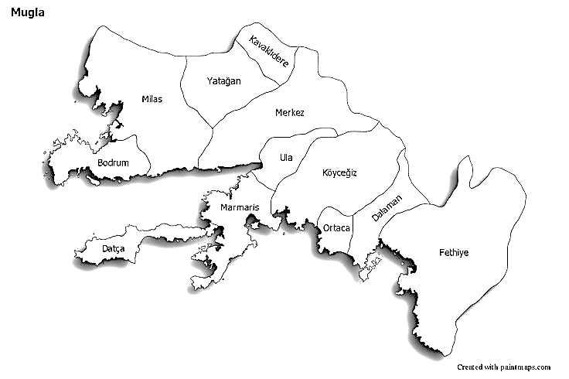
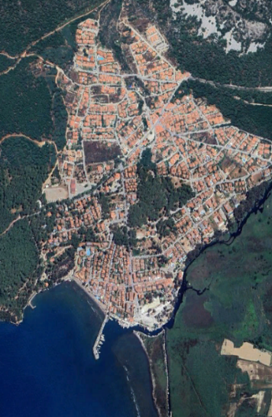
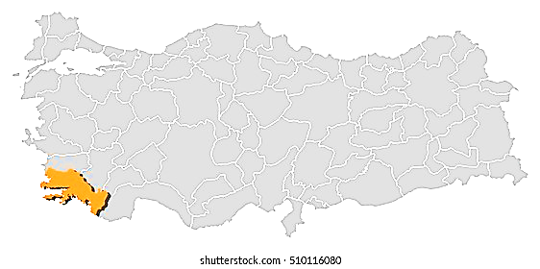

Figure 1. Region location representation.

The research location is situated in the Mediterranean climate zone, experiencing an average yearly precipitation of approximately 900 mm and a temperature range of about 16–17 °C (MGM, 2020). Regional wind patterns along the bay create favorable conditions for wind sports and kitesurfing, particularly on the Akçapınar-Akyaka shoreline. The Akyaka-Gökova area is one of Turkey's most abundant coastal regions regarding biological diversity. This area offers an essential habitat for otters (Lutra lutra), sea turtles (Caretta caretta), numerous waterfowl, and species that move between freshwater and saltwater. (Muğla Provincial Directorate of Culture and Tourism, 2023)

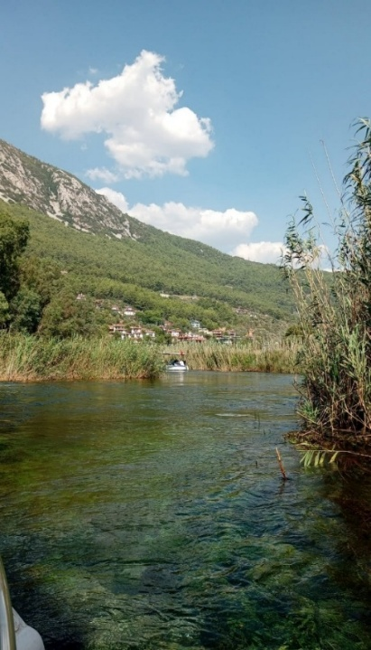
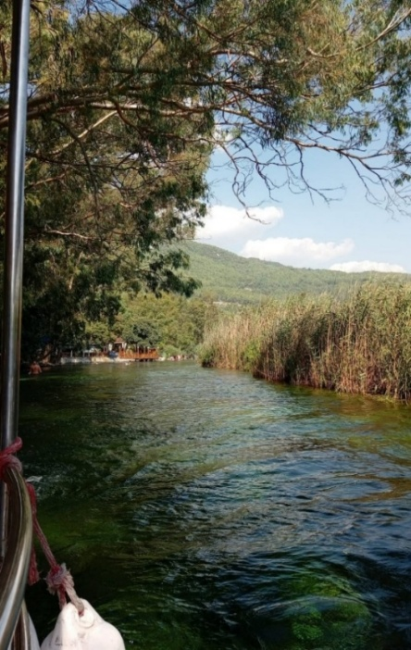

Figure 2. Woman's Desire (Original, 2025)
The Women's River is an area where freshwater meets saltwater, creating a unique ecosystem filled with various aquatic plants, including Nymphaea, Potamogeton, Phragmites, and Typha. This area is found in the natural habitat of the Anatolian sweet mastic tree (Liquidambar orientalis), which faces global threats (Chiesura 2004).

Akyaka benefits from a favorable position due to its closeness to the D400 highway and Dalaman Airport. The economy of the region is based on tourism, fishing, beekeeping, citrus and olive production
Boat tours, canoeing, kitesurfing and coastal walks are frequently organized around the Women's Azmağı; In addition, mineral-rich waters support the development of ecotourism activities. Akyaka and Gökova Basin have a rich cultural structure that reflects the effects of many civilizations. The remains of city walls, rock tombs and defensive structures surrounding the ancient city of Idyma are important archaeological elements in the region.
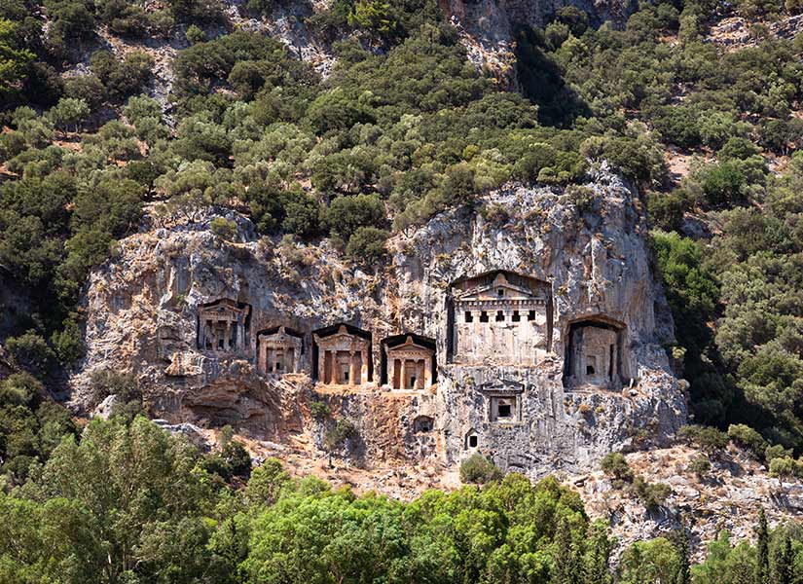
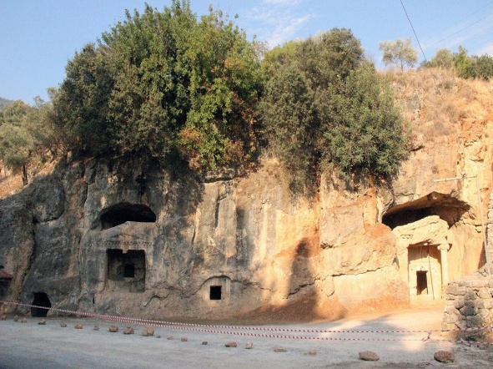

Figure 3. Idyma Ancient City (Original, 2025)
The traditional Muğla house architecture in Akyaka has been sustainably developed with woodwork under the leadership of Nail Çakırhan and features prominent protruding balconies, wide eaves and chimneys unique to Muğla. The old stone aqueducts, historical fountains and irrigation canals around the Azmak Stream are valuable cultural components of the region. The traces of the stone mill in Akçapınar show how traditional agricultural methods have been preserved throughout history. (Muğla Provincial Directorate of Culture and Tourism, 2023)
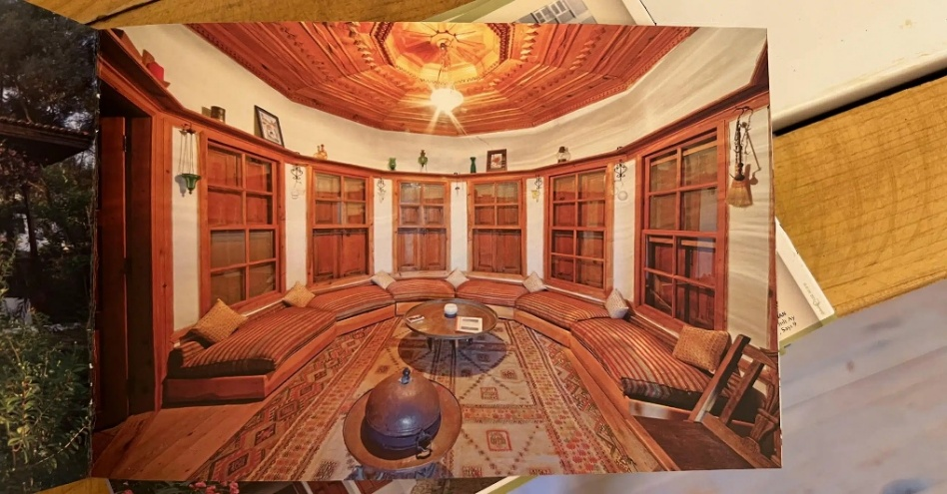
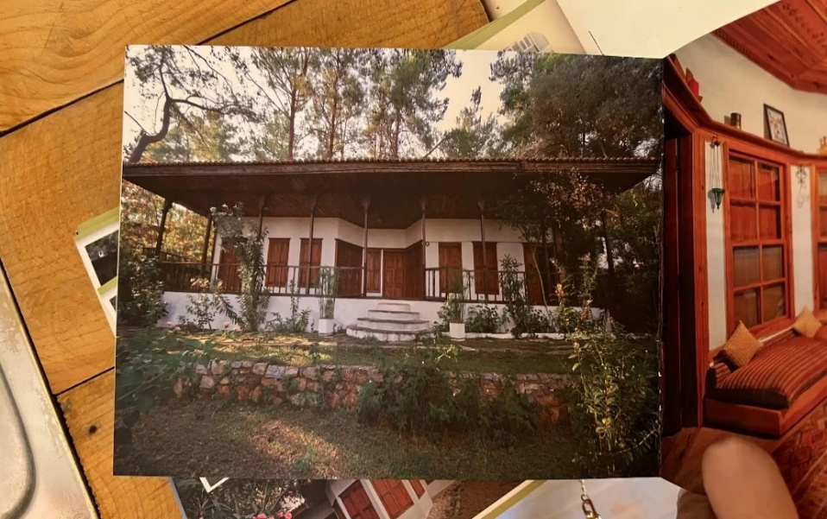

Figure 4. Nail Çakırhan's house architecture (URL-1, URL-2)
3. DISCUSSION
The research method is based on the evaluation of the data collected through literature reviews conducted in Akyaka using SWOT analysis. SWOT is a valuable tool for decision-making by identifying strengths, weaknesses, opportunities, and threats in planning processes (Uçar & Doğru, 2005). The current situation of Akyaka in terms of recreational tourism has been examined with the information obtained from scientific sources. In the study, internal (strengths-weaknesses) and external (opportunities-threats) factors were first determined. A future state analysis was developed using SO, WO, ST, and WT relationships. At the end of this analysis, the recommended recreational tourism activities were combined with the SWOT results and guide planning decisions for sustainable tourism were developed. According to Yazici and Akça (2019), systematic evaluation of recreational areas through structured analytical approaches provides a reliable basis for identifying suitable planning and management strategies. SWOT current situation evaluations made in the context of recreation tourism for Akyaka are presented in the Tables section.
Tables 1 : SWOT analysis

 | STRENGTHS
S1 | Geographical location | - Muğla, Marmaris and Aydın can be reached quickly via the 400 highway  - Proximity to Dalaman Airport will increase the number of international visitors  - Natural bays throughout the bay contribute to maritime transportation.
S2 | Climate | - Summer winds provide the perfect grip for windsurfing.  - The mild winter weather conditions are suitable for bird watching and nature walks.
S3 | Topographic diversity of landscapes | - The impressive panoramic view from Sakar Pass to the bay is among the attractions for visitors.  - The reed beds and swamps surrounding Azmak provide a rich habitat for various species.  - Woodlands and coastal plains are suitable for various types of recreation.
S4 | Richness of flora and fauna | - Sweetgum forests are rare species found in limited areas around the world.  - Migratory birds use reed beds as feeding grounds.
S5 | Cultural and architectural values | - Çakırhan-style woodwork, protruding balconies and Muğla-style chimneys are characteristic features of the region.  - There are stone and wooden structures and old agricultural fields around the village.  - The region has historical water sources, ancient waterways, and cultural environmental elements.
S6 | Water sports and nature tourism | - Azmak offers suitable conditions for canoeing, kitesurfing and paddleboarding.  - The mountainous regions are suitable for hiking and cycling tourism.
 | WEAKNESSES
W1 | Administrative Management | - Inadequate oversight leads to increased repression in some regions.  - There are delays between institutions in the planning stages.  - Usage limits are not always clearly defined.
W2 | Transportation Capacity Problem | - Beaches quickly exceed their capacity.  - Boat traffic in Azmak can negatively affect underwater plants.  - Vehicle traffic and parking space scarcity negatively impact the user experience.
W3 | Infrastructure Deficiencies | - Parking spaces do not meet demand during peak seasons.  - There are no toilets and showers in the recreation areas.  - Guidance and information signs are insufficient.
W4 | Seasonal Factors and Economic Sentiment | - Many businesses cease operations during the winter months, leading to a decline in employment.  - Price increases during the summer months pose financial challenges for local communities.  - Since the economy is based on tourism, it is susceptible to external shocks.
W5 | Coastal and Swamp Sensitivity | - Pedestrian pressure can quickly destroy the dunes.  - Boat movements affect bird breeding grounds.

 | OPPORTUNITIES
O1 | Nature-Based Tourism Trends | - There are global funding opportunities for ecotourism projects.  - The City Slow identity promotes slow living tourism.  - Natural laboratory features can be seen on educational and research trips.
O2 | Promotion and Brand Value Potential | - Azmak's clean water increases its visibility in photos and media.  - Gökova's appearance is a symbolic feature in promotional videos.  - The architecture of Nail Çakırhan offers a unique city identity.
O3 | Sports Tourism Development Opportunities | - Kitesurfing competitions can be organized at the international level.  - Walking and cycling routes can be improved.  - Azmak can be considered an area for canoe training.
O4 | Cultural and Rural Tourism Opportunities | - A cultural route can be created with stone mill foundations and historical waterways.  - Rural architecture provides the necessary infrastructure for agricultural tourism.  - Handicrafts and local products can be traded.
O5 | Gastronomy and Local Product Opportunities | - Fish restaurants create a well-known brand value in the food industry.  - Organic honey and olive oil products can be included in the touristic product category.  - Ecological markets become places that attract visitors.

 | THREATS
T1 | Pressures on the Ecosystem and Overexploitation | - Boat engines can cause water pollution.  - Beach crowding can negatively affect the sand structure.  - Noise and light pollution have negative effects on animals.
T2 | Construction Printing | - The increase in commercial enterprises threatens coastal integrity.  - Sand dunes and reed beds are at risk of mud layers.  - The natural landscape can be irreversibly damaged.
T3 | Environmental Pollution and Waste Issues | - Boat engines can cause oil and fuel leaks.  - Solid waste accumulates in reed deposits and coastal areas.  - Noise pollution negatively affects many living things, especially bird species.
T4 | Effects of Climate Change | - Increasing drought rates can reduce the water flow of the Azmak River.  - Rising temperatures cause stress in aquatic ecosystems.  - The risk of fire increases in red pine forests.
T5 | Exceeding Carrying Capacity | - The kitesurfing area can become dangerous for safety.  - Boat traffic affects underwater vegetation.  - Heavy use of the beach negatively affects the coastal ecosystem.

SWOT Analysis for Future Situation Analysis

SWOT analysis provides an opportunity to strategically evaluate both the current and future situation. Using the internal (S–W) and external (O–T) information obtained within the framework of the current situation assessment, four different types of strategies were created for the future of Akyaka: SO, WT, WO and ST strategies (Uçar and Doğru, 2005).
1. SO Strategy (Strengths + Opportunities)
GOAL 1 (SO): The natural (Azmak Creek, Gökova Bay, Sweetgum Forests) and cultural landscape elements of Akyaka should be used effectively in tourism and recreation activities.
GOAL 2 (SO): Tourism services in Akyaka should be diversified. (Alternatives such as canoeing, hiking, bird watching, cultural visits and agricultural tourism).
GOAL 3 (SO): The values of nature, cultural, entertainment and visual resources should be protected in accordance with sustainable principles and transferred to future generations.

2.WT Strategy (Weaknesses + Threats)
GOAL 1 (WT): Social events to be held in Akyaka should be designed in a way that does not harm sensitive areas such as the Azmak River ecosystem and coastal sand dunes.
GOAL 2 (WT): Local communities, business owners, and visitors should be aware of environmental issues, ecosystem conservation, and sustainable sourcing.
GOAL 3 (WT): Recreational activities should be carried out in designated areas with defined carrying capacity, taking into account the balance between conservation and use.

3. External Work Strategy (Weaknesses + Opportunities)
Targets have been set to reduce weaknesses (W) and strengthen existing opportunities (O).
TARGET 1 (WO): The existing conservation of Akyaka should be carefully protected and effective conservation methods should be strengthened.
GOAL 2 (WO): Proposed recreational facilities should be designed to be in harmony with nature, take into account environmental sensitivities and include the necessary infrastructure.

4. ST Strategy (Minimizing Threats by Using Strengths Well)
GOAL 1 (ST): Public awareness should be increased about the value of Akyaka's natural and cultural areas (Women's Azmağı, sweet forests, Muğla houses).
GOAL 2 (ST): More effective management methods, monitoring systems and control mechanisms should be established in protected areas.
GOAL 3 (ST): It is of great importance to strengthen the promotion of the concept of sustainable tourism in order to support Akyaka's ecotourism identity.

Comparison of Current and Future SWOT Analyses

SO-ST: The national border of Akyaka constitutes the main area of uncertainty for both SO and ST. SO schematically combines natural and cultural values with opportunities to create development recommendations in ecotourism, sports tourism and cultural events. ST can use these positive aspects to minimize threats, enhance protection, and ensure sustainable management. SO aims to improve development, while ST aims to provide protection.
WT-WO: Both strategy groups continue to focus on weak points as a starting point. WT is aimed at risk reduction and protection methods aimed at preventing the increase of weaknesses, while WO options aim to increase weaknesses and support their ecological normalization with existing proposals. WT proposes a defense plan, while WO offers a method of development.
FISSAT-THREATS: Opportunities show that Akyaka has a significant development potential in the fields of ecotourism, sports tourism and cultural promotion. Threats emphasize aspects that jeopardize sustainability because of ecosystem demands, building activities, and environmental dangers. Opportunities signify chances for growth, whereas threats highlight vulnerable areas that need safeguarding.
4. CONCLUSION
Akyaka, with its natural and cultural landscape, biodiversity, coastal and wetland ecosystems, traditional architecture, and unique settlement patterns, has the potential to become one of Türkiye's leading sustainable tourism destinations. However, these characteristics also indicate that the region possesses a delicate ecological structure requiring careful planning, conservation, and sustainable management.
The SWOT analysis conducted in this study shows that Akyaka's strengths, such as natural beauty, favorable climate, biodiversity, and strong cultural identity, can be transformed into strategic opportunities through effective planning and management. Conversely, uncontrolled visitor growth, scattered settlement patterns, environmental pressures, and the risk of exceeding carrying capacity pose significant threats to long-term sustainability.
This study contributes to the literature by offering a systematic measurement framework for evaluating the recreational tourism potential in environmentally friendly regions. The research findings highlight the importance of integrated planning strategies, visitor management policies, environmental protection measures, and community participation to ensure balanced development. Future studies may include quantitative data and stakeholder-based analyses to further strengthen sustainable tourism planning in Akyaka and similar destinations.
5. RECOMMENDATIONS
The following strategies are proposed for the development of Akyaka as a sustainable recreation tourism destination:
- Supporting passive recreational activities such as nature walks, bird watching, plant observation, landscape viewing, and photography that do not lead to depletion while preserving natural and cultural values.
- Increasing environmental education programs to strengthen conservation awareness among the local community, visitors, and tourism businesses.
- Determining visitor usage limits based on the ecological carrying capacity of sensitive ecosystems, especially in the Azmak River and surrounding forest areas.
- Establishing a sustainable balance between the preservation and use of traditional architecture, cultural landscape elements, and rural features that constitute the identity of the region.
- Contributing to local economic development and reducing environmental pressure by diversifying tourism activities.

- Disclaimer (Artificial intelligence)
- Author(s) hereby declare that NO generative AI technologies such as Large Language Models (ChatGPT, COPILOT, etc.) and text-to-image generators have been used during the writing or editing of this manuscript.

6. REFERENCES
- Akyüz, H.; Kul, M. and Yaşartürk, F., (2014). Forests and the environment in terms of recreation, International Journal of Science Culture and Sport, Special Issue 1, 881–890.
- Altuğ Turan, İ., Sönmez Türel, H., Malkoç True, E., Aktaş, E. & Özeren Alkan, M. (2024) A research on daily recreational space usage profile in the context of urban life. Environ Dev Sustain 26, 26495–26515. https://doi.org/10.1007/s10668-023-03739-3
- Ankaya, F., Köse, H., & Gülgün, B., (2021). İzmir / Karagöl Tabiat Parkı’nın Rekreasyonel Potansiyelinin Gülez Yöntemine Göre Değerlendirilmesi. Ziraat, Orman ve Su Ürünlerinde Araştırma ve Değerlendirmeler (pp.89-108), Ankara: Gece Kitaplığı.
- Bell, S.; Tyrväinen, L.; Sievänen, T.; Pröbstl, U. and Simpson, M., 2007, Outdoor recreation and nature tourism: A European perspective, Living Reviews in Landscape Research, 1(2), 1–46.
- Bingöl, B., 2011, A study on recreation planning in terms of conservation and use principles in Dilek Peninsula – Büyük Menderes Delta National Park, PhD Thesis, Ankara University Science Institute, Ankara, 245 p.
- Bramwell, B., & Lane, B. (2011). Critical research on the governance of tourism and sustainability. Journal of Sustainable Tourism, 19(4–5), 411–421. https://doi.org/10.1080/09669582.2011.580586
- Brey, E. T. and Lehto, X. Y., 2007, Relationship between diurnal and holiday activities, Annals of Tourism Research, 34(1), 160–180.
- Buckley, R. (2012). Sustainable tourism: Research and reality. Annals of Tourism Research, 39(2), 528–546. https://doi.org/10.1016/j.annals.2012.02.003
- Chiesura, A. (2004). The role of urban parks for the sustainable city. Landscape and Urban Planning, 68(1), 129–138. https://doi.org/10.1016/j.landurbplan.2004.07.004
- Crawford, D. W.; Jackson, E. L. and Godbey, G., 1991, Hierarchical model of leisure constraints, Leisure Sciences, 13(4), 309–320.
- Erdem, B., 2007, Evaluation of the natural and cultural values of the city of Sivas in terms of landscape architecture and tourism, Master's Thesis, Ankara University Institute of Science, Ankara, 180 p.
- Gössling, S., Scott, D., & Hall, C. M. (2018). Overtourism and its implications for tourism policy and planning. Journal of Sustainable Tourism, 26(4), 1–15. https://doi.org/10.1080/09669582.2017.1354698
- Helms, M. M., & Nixon, J. (2010). Exploring SWOT analysis—Where are we now? A review of academic research from the last decade. Journal of Strategy and Management, 3(3), 215–251. https://doi.org/10.1108/17554251011064837
- Inskeep, E., 1991, Tourism Planning: An Integrated and Sustainable Development Approach, Van Nostrand Reinhold, New York.
- Jitaru, D.; Sambotin, L.; Khalil, F. I.; Mayer, M. and Tirchi, S., 2012, Recreational rural tourism in Europe, Agricultural Management/Lucrari Stiintifice Seria I, Management Agricol, 14(4).
- Karaküçük, S. and Akgül, B. M., 2016, Ecorekreation: Recreation and Environment, Gazi Publishing House, Ankara.
- Karaküçük, S., 2008, Recreation: Evaluation of Leisure Time, Gazi Publishing House, Ankara.
- Keleş, A., 2003, Sustainable Tourism Planning in Turkey and Ecological Approach to Yacht Tourism, Master's Thesis, Ankara University Institute of Social Sciences, Ankara, 119 p.
- Ko, T. G. (2005). Development of a tourism sustainability assessment procedure: A conceptual approach. Tourism Management, 26(3), 431–445. https://doi.org/10.1016/j.tourman.2003.08.012
- Manning, R. (2007). Parks and carrying capacity: Commons without tragedy. Island Press. https://doi.org/10.5822/978-1-61091-442-0
- Phadermrod, B., Crowder, R. M., & Wills, G. B. (2019). Importance–performance analysis based SWOT analysis. International Journal of Information Management, 44, 194–203. https://doi.org/10.1016/j.ijinfomgt.2016.03.009
- Pickering, C. M., & Hill, W. (2007). Impacts of recreation and tourism on plant biodiversity and vegetation in protected areas in Australia. Journal of Environmental Management, 85(3), 791–800. https://doi.org/10.1016/j.jenvman.2006.11.021
- Pirli, A., Pirli D., Gönen, M. & Gülgün, B. (2023). Kent ve Su İlişkisinin Belgesel Filmlerde Temsili: “Asfaltın Altında Dereler Var!” Belgesel Filmi Örneği. Chapter 1. Yazici, K. (Ed.). Peyzaj ve Kentler ‘2023 Çalışmaları’. 3-41 pp. ISBN: 978-625-367-034-4. Iksad Publications
- Pirli, D. & Gülgün, B. (2025). Kültürel Ekosistem Olarak Kentsel Açık Yeşil Alanlar: Film Festivallerinin Sosyo–Mekânsal Ve Ekolojik Performansı. Chapter 5. Karaman, K. & Gülgün, B. (Eds.). Peyzaj ve Kentler ‘2025 Çalışmaları’. 103-130 pp. ISBN: 978-625-378-413-3. Iksad Publications
- Saveriades, A. (2000). Establishing the social tourism carrying capacity for the tourist resorts of the east coast of the Republic of Cyprus. Tourism Management, 21(2), 147–156. https://doi.org/10.1016/S0261-5177(99)00065-8
- Turkish Meteorological General Directorate. (2020). Long-term climate data of Muğla province (1991–2020). Republic of Turkey Ministry of Agriculture and Forestry, Meteorological General Directorate. https://www.mgm.gov.tr
- Uçar, H., & Doğru, E. (2005). Tourism planning and sustainability approaches in Türkiye. Journal of Tourism Research, 16(2), 45–60.
- URL-1, Nail Çakırhan's house architecture, accessed from https://www.herumutortakarar.com/nail-cakirhan-evi/
- URL-2, Nail Çakırhan's house architecture, accessed from https://www.herumutortakarar.com/nail-cakirhan-evi/
- Yazici, K., & Akça, S. B., (2019). Determination Of Suitable Recreational Areas Based On Expert Opinion With Q-Sort Analysis; Boraboy Lake Natural Park (Amasya, Turkey). Fresenius Environmental Bulletin , vol.28, no.5, 3778-3786.
- Yazici K. & Pirli, A. (2022). A Research on Determination of Recreational Potential of Yozgat Çamlığı National Park, Bozok Journal of Agriculture and Natural Sciences, 1(1), 11-23
- Zhang, X., Majid, S., & Foo, S. (2021). Environmental scanning and strategic SWOT analysis in sustainable tourism planning. Sustainability, 13(15), 8532. https://doi.org/10.3390/su13158532

